
BUSINESS PLAN

[YEAR]


Microgreens

Increasing Green to your future.

John Doe

10200 Bolsa Ave, Westminster, CA, 92683

- 359-3153 info@example.com https://example.com

Information provided in this business plan is unique to this business and confidential; therefore, anyone reading this plan agrees not to disclose any of the information in this business plan without prior written permission of the company.
Table of Contents

Executive summary | 5
Problem Definition & Validation | 6
Problem Analysis | 6
Solution | 7
Solution Features | 7
Objectives | 8
Short Term (1 -3 Years) | 8
Long Term (3-5 years) | 8
Mission statement | 8
Keys to success | 9
Financial Highlights | 9
Super Sprouts - 5 Year Highlights | 10

Business overview | 11
Company Ownership/Legal Entity | 12
Location | 12
Interior Operating Facilities | 13
Hours of Operation | 13
Startup summary | 13

Products & Services | 14
Range of Microgreens | 15
Super Sprouts will offer the following Microgreens | 15
Efficient Sourcing & Supply | 17

Market Analysis | 18
Market segmentation | 19
Market Trends | 19
Target market | 20
Customer persona | 20
Competitive Advantage | 21

Microgreens | Business Plan [YEAR] 2/44

SWOT analysis | 22
Strategy & implementation
Strategy & implementation | 24
Marketing and Promotion Programs | 25
Direct Sales | 25
Trade Publications | 25
Trade shows | 26
Website | 26
Targeted Online Advertising | 26
Positioning Statement | 27
Sales strategy | 27
Online Marketing Channels | 28
Offline Marketing Channels | 28
Pricing strategy | 29
Operational Plan
Operational Plan | 30
Business Owners | 31
Organization chart | 31
Management Team | 31
Personnel Plan | 32
Hiring plan | 32
Milestones | 33
Super Sprouts | 33
Financial plan
Financial plan | 34
Important Assumptions | 35
Break-even analysis | 35
Projected Profit and Loss | 36
Projected Cash Flow | 39
Projected Balance Sheet | 40
Business Ratios | 41

Microgreens | Business Plan [YEAR] 3/44

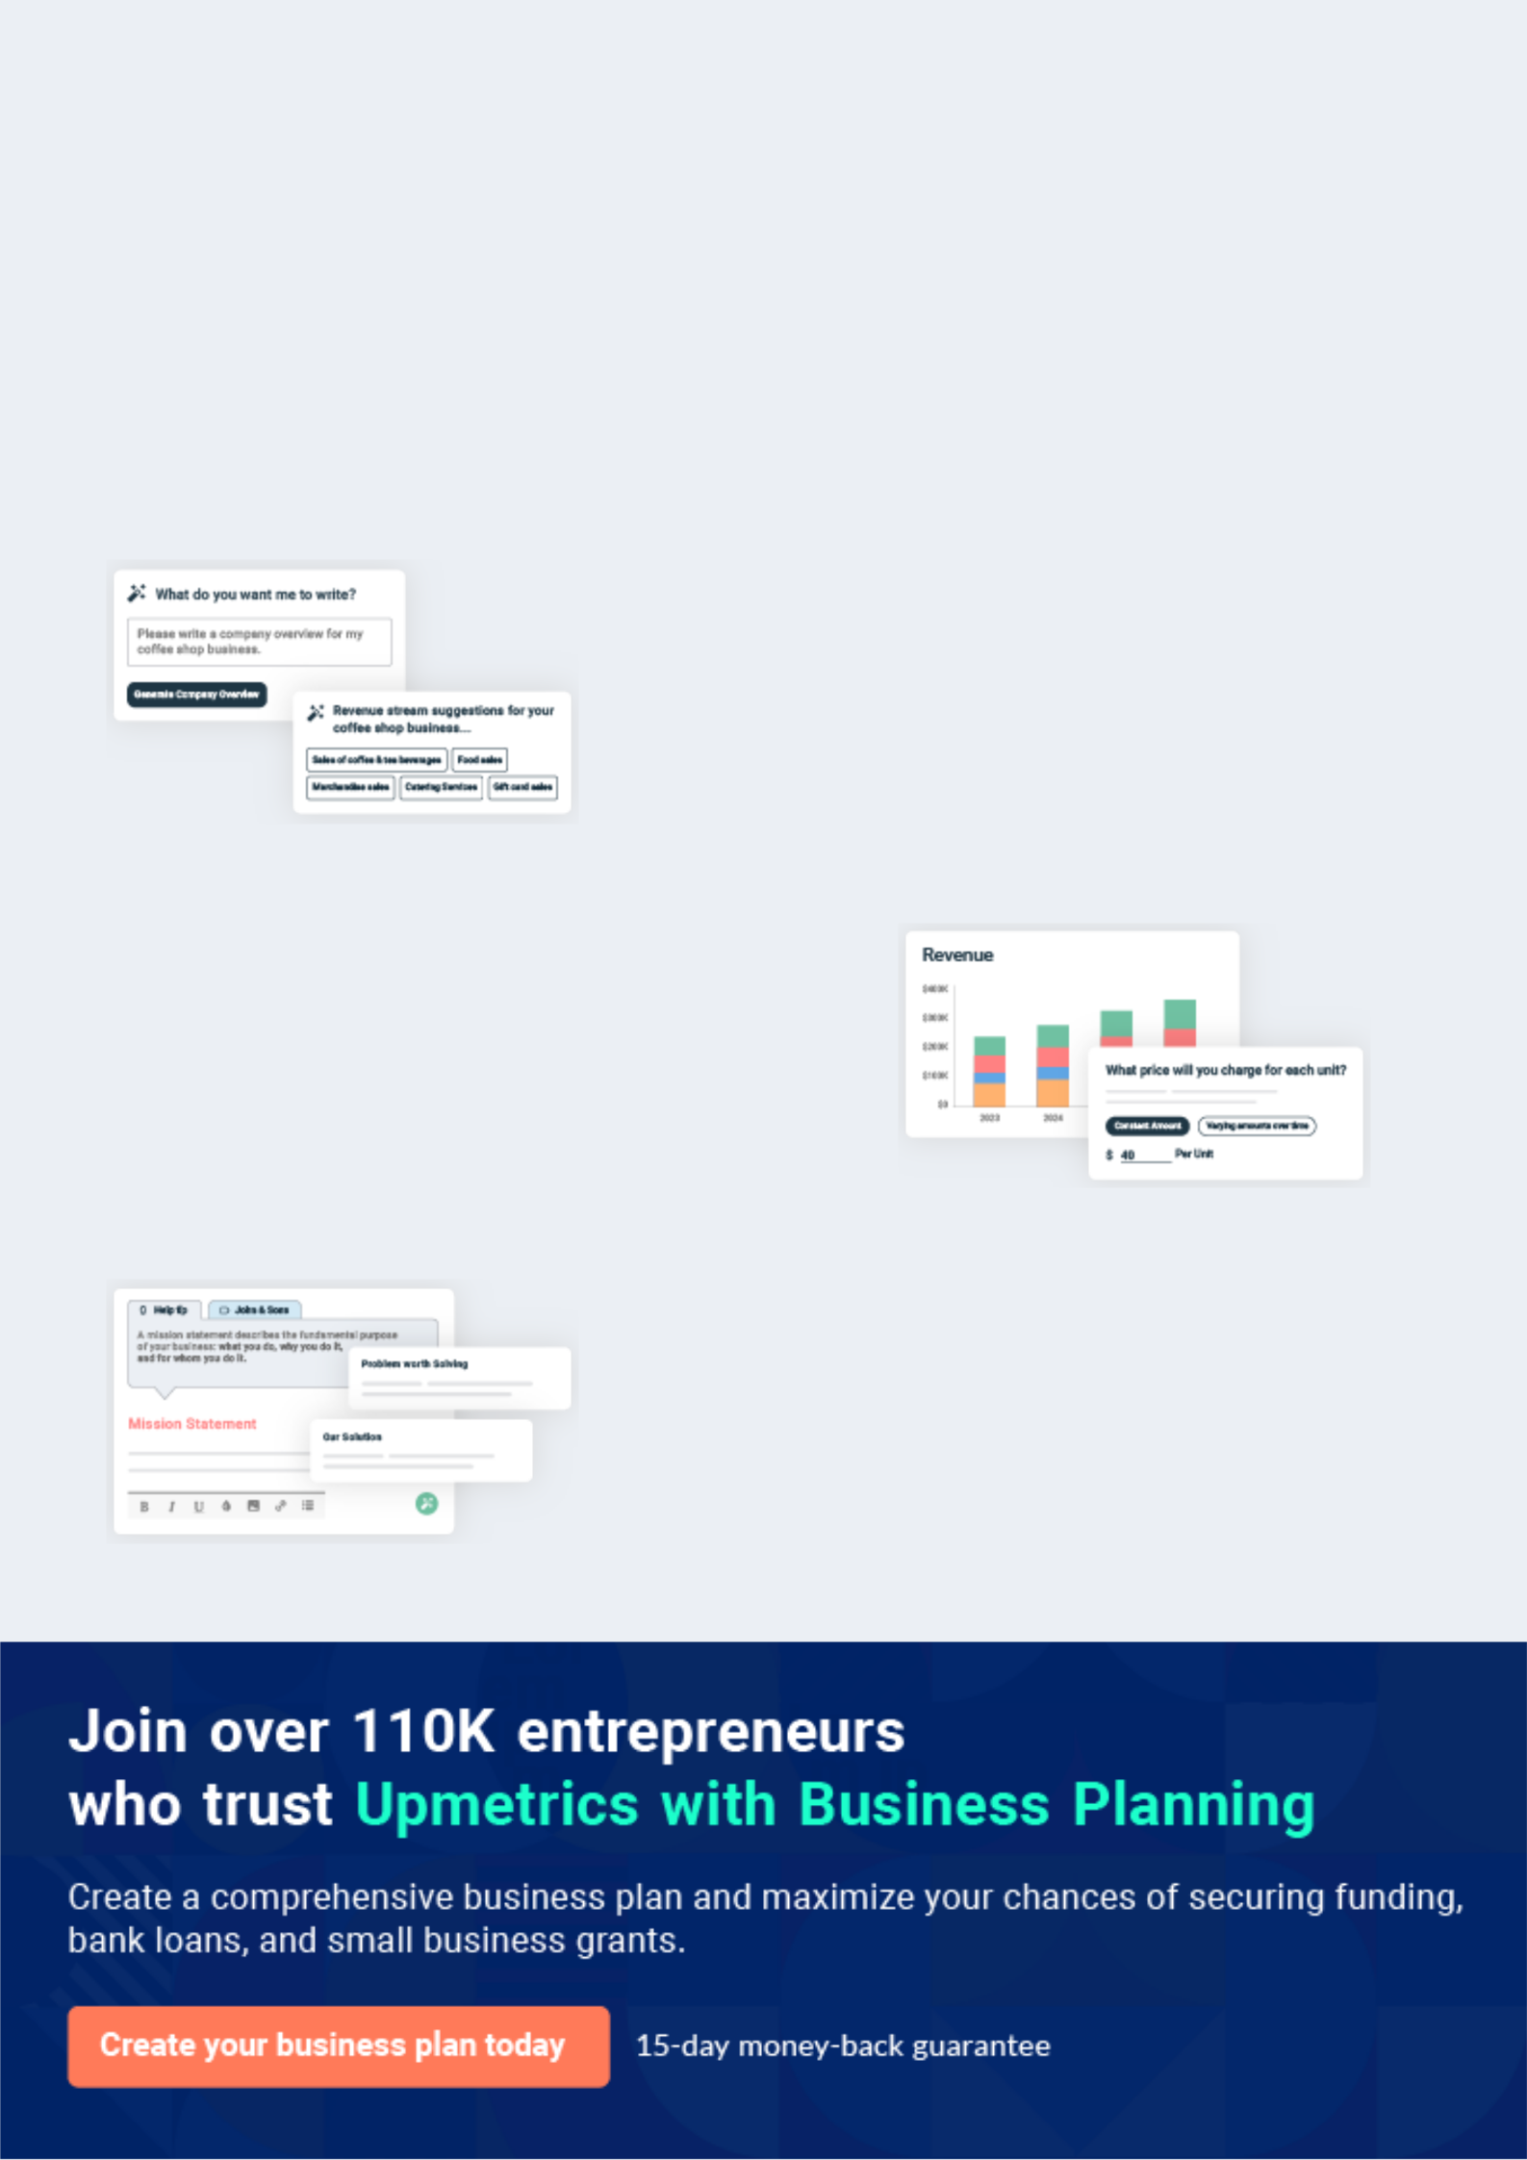
Business planning that’s simpler and faster than you think

Creating a business plan using Upmetrics to start and grow a business is literally the easiest thing in the World. Simply read the instructions and fill in the blanks. It’s as simple as that.

❛ | Upmetrics has everything you need to create a | ❜
❛ | comprehensive business plan. | ❜

AI-powered Upmetrics Assistant

AI-powered insights to streamline your plan

Not sure where to start? Upmetrics’ AI Assistant will automatically generate ideas for each section of your plan and offer improved versions of your writing, adjusting for tone, voice, and grammar or spelling errors.

Financial Forecasting Tool

All the financials are calculated for you

Forget the complex formulas and clumsy spreadsheets — with automatic financials and drag-and-drop forecasting, you can finish your plan faster and be confident that your numbers are accurate.

Business Plan Builder

Guides you like a business mentor

Upmetrics’ step-by-step instructions, prompts, and the library of 400+ sample business plans will guide you through each section of your plan as a business mentor.

1.


Executive summary

Problem Definition & Validation

Objectives

Mission statement

Keys to success

Financial Highlights

Microgreens | Business Plan [YEAR] 5/44

 Super Sprouts
To unlock help try Upmetrics!


Super Sprouts proposes to launch and expand a microgreens business that grows and propagates dietary superfoods. The company will retail and supply wholesale businesses, such as hotels and restaurants.



Start writing here..

Problem Definition & Validation

Problem Analysis


Whom?

Individuals who lack daily physical activity and mostly have computer based, desk jobs

Causes


As more and more work shifts towards computer-based desk jobs, physical activity has come to a minimum. Statistics suggest About 80% of U.S. adults and children aren’t getting enough exercise for optimal health.


Impact

About 31 million adults aged 50 or older are inactive, meaning that they get no physical activity beyond that of daily living. Low levels of physical activity can contribute to heart disease, type 2 diabetes, some kinds of cancer, and obesity.

Microgreens | Business Plan [YEAR] 6/44

Solution
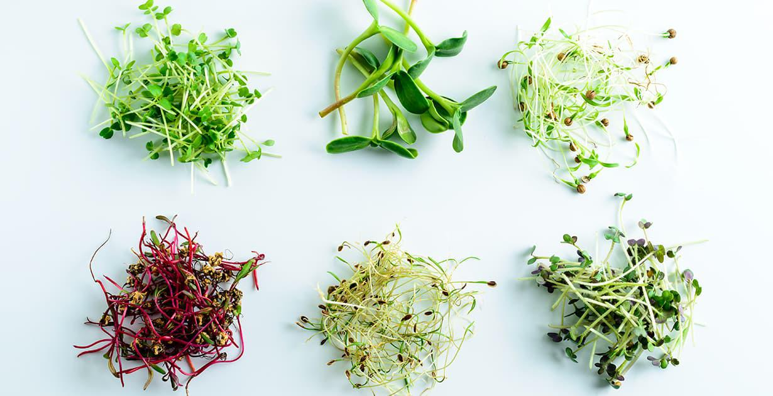

Microgreens contain similar and often greater amounts of these nutrients than mature greens. As such, they may similarly reduce the risk of the following diseases:

Solution Features


Heart Disease | Diabetes | Certain Cancers
Microgreens are a rich source | Antioxidants may help reduce | Antioxidant-rich fruits and
of polyphenols, a class of | Antioxidants may help reduce | Antioxidant-rich fruits and
of polyphenols, a class of | the type of stress that can | vegetables, especially those
antioxidants linked to a lower | the type of stress that can | vegetables, especially those
antioxidants linked to a lower | prevent sugar from properly | rich in polyphenols, may lower
risk of heart disease. Animal | prevent sugar from properly | rich in polyphenols, may lower
risk of heart disease. Animal | entering cells. In lab studies, | the risk of various types of
studies show that microgreens | entering cells. In lab studies, | the risk of various types of
studies show that microgreens | fenugreek microgreens | cancer. Polyphenol-rich
may lower triglyceride and | fenugreek microgreens | cancer. Polyphenol-rich
may lower triglyceride and | appeared to enhance cellular | microgreens may be expected
“bad” LDL cholesterol levels | appeared to enhance cellular | microgreens may be expected
“bad” LDL cholesterol levels | sugar uptake by 25–44% | to have similar effects

Microgreens | Business Plan [YEAR] 7/44

Objectives
To unlock help try Upmetrics!

 Super Sprouts

- To begin commercial operations in Jacksonville by Q1 2021

- To build a wide range of plants, bulbs, and flowers to meet the increasing market
requirement for organic produce | To unlock help try Upmetrics! 

Short Term (1 -3 Years)

Start writing here..

 Super Sprouts

• To gain a competitive edge within the country’s microgreens industry marketplace by establishing a brand that is synonym with locally grown and organic
• To explore GM of plants and how a variety of customization in crops can be achieved
To unlock help try Upmetrics! 

Long Term (3-5 years)

Start writing here..

Mission statement

 Super Sprouts

Our mission is to become a synonym with words like domestic, organic, custom grown, environmentally friendly, and sustainable. We are dedicated to providing a wide variety of microgreens and superfoods to promote good health.



Start writing here..

Microgreens | Business Plan [YEAR] 8/44

Keys to success

Automation



Minimising labour and employment costs through automation can boost productivity and efficiency. This enables Nature Box to deal with fierce foreign competition.


Aligned with market Trends


The ability to alter the balance between the industry’s crops and other agricultural products in response to changes in market conditions is important for a farm’s viability. Ensuring domestic produce helps make this possible for Super Sprouts



Access to Latest Technology

The latest technology can help profit margins and productivity, such as by maximizing water efficiency.

Appropriate climatic conditions

Climatic conditions can dictate the quality and type of plant or flower produced. Being based in Florida, where its warm all year round will significantly benefit the company.

Prompt delivery to market

The perishability of microgreens makes timely delivery imperative for all growers in the market.

Nature Box' local operations will allow the company to ensure prompt delivery to market.

Premium goods/services

Through investments in GM, Super Sprouts can reach various niche markets by producing premium microgreens, for which customers are willing to pay a higher price. This can boost revenue and help the company mitigate growing import competition.

Financial Highlights

 Super Sprouts

The company envisions raising an equity investment of $50,000 through long-term borrowings, which will be used to set up and launch the business in the US. The company expects to maintain a gross margin of over 50% throughout the forecast period and steadily grow its
To unlock help try Upmetrics! 

Start writing here..

Microgreens | Business Plan [YEAR] 9/44

Super Sprouts - 5 Year Highlights
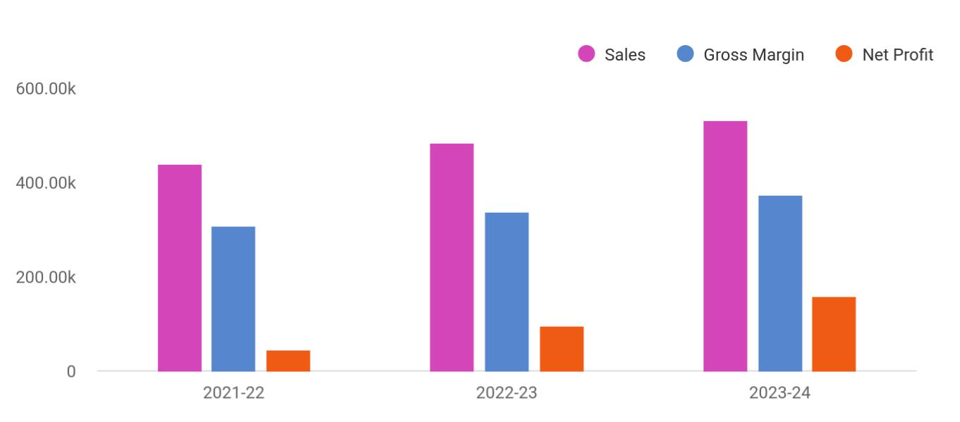

Financial Year | Sales | Gross Margin | Net Profit
2021-22 | 438,937 | 307,255.90 | 43,893.70
2022-23 | 482,830.70 | 337,981.49 | 96,566.14
2023-24 | 531,113.77 | 371,779.64 | 159,334.13

Microgreens | Business Plan [YEAR] 10/44

2.

Business overview

Company Ownership/Legal Entity

Location

Interior Operating Facilities

Hours of Operation

Startup summary

Microgreens | Business Plan [YEAR] 11/44

 Super Sprouts

Super Sprouts will build a reputation through superior quality products grown and sourced from GAP and APEDA approved sources. The company's fresh produce includes Broccoli, Collards, Kael, Peas, Radish, Wheatgrass, Sunflower, Beets, Arugula, and red cabbage. The company
To unlock help try Upmetrics! 

Start writing here..

Company Ownership/Legal Entity

 Super Sprouts

The company will be registered as a limited liability entity with the Department of State. Further, since the company envisions setting up operations in Florida, it will also register with the local county. The business will be wholly owned and managed by the Founder Mr. Grant, who will
To unlock help try Upmetrics! 

Start writing here..

Location

 Super Sprouts

Location is vital for the successful operation of Super Sprout. Ideal weather conditions and connectivity are key to ensure the quality and cost-efficiency of products.
To unlock help try Upmetrics! 

Start writing here..

Microgreens | Business Plan [YEAR] 12/44

Interior Operating Facilities
To unlock help try Upmetrics!

 Super Sprouts

Super Sprouts will be required to purchase automated potting equipment with the intention of reducing labor costs and increasing production. Also required is the construction of heated greenhouses to safely out weather crops. The greenhouses must be large enough to allow the
To unlock help try Upmetrics! 

Start writing here..

Hours of Operation

 Super Sprouts

Super Sprouts will operate an 8-hour workday from 9 am to 5 pm. However, since the company will be required to manage the crops and ensure their safety, a security detail will be added to make sure there is a watch at all times.



Start writing here..

Startup summary

 Super Sprouts

The Founder will infuse a capital sum of $1,200,000 into the company. Approximately £92,350 will be spent on a range of start-up expenses such as marketing, advertising, and professional fees. At the same time, another £602,000 will be earmarked for sales tax payment and the
To unlock help try Upmetrics! 

Start writing here..

Microgreens | Business Plan [YEAR] 13/44

3.

Products & Services

Range of Microgreens

Efficient Sourcing & Supply

Microgreens | Business Plan [YEAR] 14/44

 Super Sprouts

Super Sprouts will operate as retailers and wholesalers of microgreens and other organic fruits and vegetables. The company enjoys access to a top-tier network of packers and farmers providing superior quality, standardized, GAP and APEDA approved products at competitive
To unlock help try Upmetrics! 

Start writing here..

Range of Microgreens

Super Sprouts will offer the following Microgreens
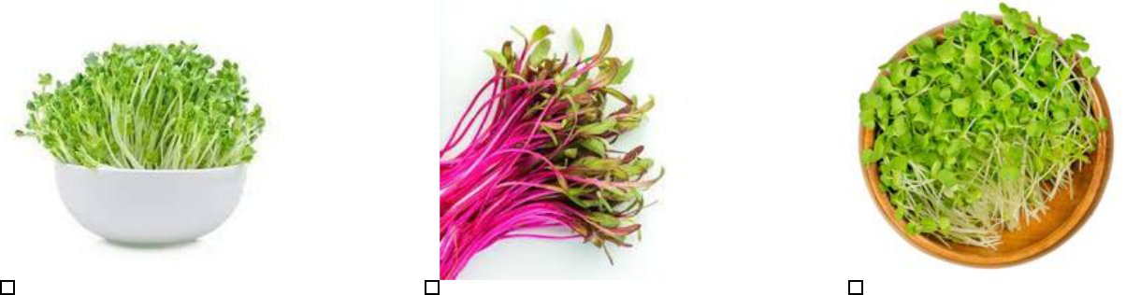

Arugula | Beets | Broccoli
Arugula microgreens have a | Beets take longer to grow than | Broccoli microgreens are one
peppery flavor that make them | other microgreens, but their | of the most nutritious options,
great for salads, eggs, and | mild earthy flavor make them | with one study suggesting they
sandwiches. | well worth the wait! | have the power to decrease
They also grow quickly, | Beet microgreens are vivid red, | malnutrition.
germinating within two days | making them the perfect way | They’re also one of the fastest
and ready to harvest in as little | to add color to salads. | growing varieties, as they’ll be
as 10 days! | Before planting, soak the seeds | ready to harvest in as little as
 | Before planting, soak the seeds | six days!
Plus, arugula microgreens | for about eight hours in cold | six days!
contain eight times the | water and then sow them in a | Unlike most other microgreens,
calcium, five times the | thick layer. | the best time to harvest
vitamins, and four times the |  | broccoli microgreens, is before
iron as iceberg lettuce! |  | their first true leaves form.

Microgreens | Business Plan [YEAR] 15/44

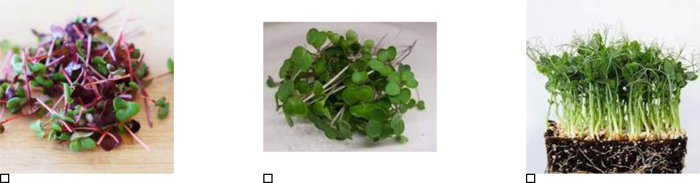

Collards | Kale | Peas
Collard microgreens have a | In microgreen form, kale tastes | Pea microgreens are great to
strong flavor, sometimes even | more like romaine or leaf | grow in containers because
more intense than the fully | lettuce, than it’s fully-grown | they regrow after harvest!
grown vegetable! | flavor. | This means you won’t need to
Plus, they grow quickly and will | Kale microgreens contain four | keep replanting every couple
be ready for harvest in only 10 | times the nutrients as it does | weeks.
days. | when it’s an adult, so it’s extra | Plus, they have eight times the
 | healthy too! | Plus, they have eight times the
Use these thick microgreens as | healthy too! | folic acid of bean sprouts,
a flavorful addition to salads | Plus, they store well, lasting | which is an important vitamin
and sandwiches. | about a week in the refrigerator | for young women.
 | —just make sure to keep them
 | dry.

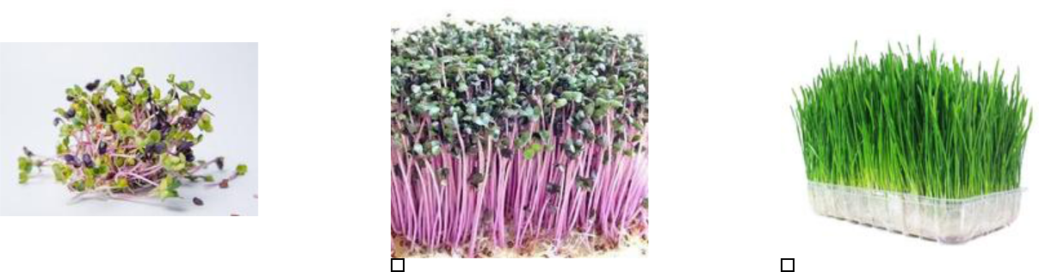

Radish

Like broccoli, radishes are one of the fastest growing microgreens and ready to harvest in as little as six days.

They taste great too, with the same crisp spicy flavor that mature radishes are famous for.

Plus, opal and green daikon varieties have especially high concentrations of vitamin E, which helps slow cell damage.

Red Cabbage | Wheatgrass
With their purple coloring, red | Wheatgrass is the microgreen
cabbage microgreens look as | version of the common wheat
good as they taste. | crop.
They’re also one of the most | And like peas, the shoots
nutritious microgreen options. | will continue to grow after
One study showed they have | harvest, so you can keep on
One study showed they have | growing without replanting!
the potential to lower | growing without replanting!
cholesterol, and another study | This superfood is most
showed they have 280 times | commonly used in juice and
more vitamin A than mature | smoothies, but it goes great in
cabbages. | sauces and soups as well.

Microgreens | Business Plan [YEAR] 16/44

Efficient Sourcing & Supply

 Super Sprouts

Super Sprouts will source its products directly from APEDA (Agricultural and Processed Food Products Export Development Authority) approved pack houses and GAP (Good Agricultural Practice) certified farmers. These standards and certifications ensure the company’s products
To unlock help try Upmetrics! 

Start writing here..
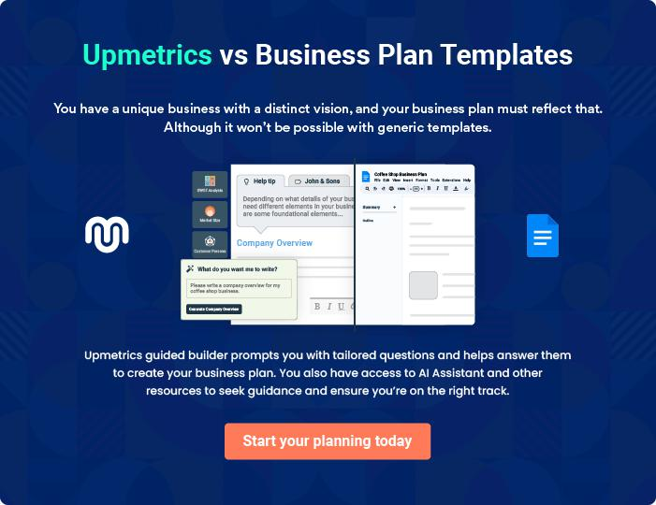

Microgreens | Business Plan [YEAR] 17/44

4.

Market Analysis

Market segmentation

Market Trends

Target market

Microgreens | Business Plan [YEAR] 18/44

 Super Sprouts

The microgreens market is projected to register a CAGR of 7.5% during the forecast period, 2021 - 2026.
To unlock help try Upmetrics! 

Start writing here..

Market segmentation

 Super Sprouts

The Microgreens Market is Segmented by Type (Broccoli, Lettuce and Chicory, Arugula, Basil, Fennel, Carrots, Sunflower, Radish, Peas, and Other Types), Farming (Indoor Farming, Vertical Farming, Commercial Greenhouses, and Other Farming), Growth Medium (Coconut Coir, Peat
To unlock help try Upmetrics! 

Start writing here..

Market Trends

 Super Sprouts

The growing health consciousness has led people to consume a diet full of nutrients, which has led to the adoption of indoor farming practices. Consumers not only practice indoor farming at home, but it is also largely being cultivated in major greenhouses. Thus, the market for
To unlock help try Upmetrics! 

Start writing here..

Microgreens | Business Plan [YEAR] 19/44

Target market

 Super Sprouts

Super Sprouts will strive to become an active choice of health-conscious individuals and gourmet restaurants and hotels across the United States. Individuals looking to boost their
immunity with superfoods will find the range of options available with the company attractive.
To unlock help try Upmetrics! 

Start writing here..


Health Conscious

Consumer

Demographics

Individuals living an active lifestyle who are on the go and do not have time to have a balanced diet

Professional Role

Working individuals

Customer persona


Identifiers / Personality Traits

Health-conscious consumers living in urban areas have the means to bear the cost of the more expensive microgreens. They are educated and are aware of the various health benefits microgreens can offer. Furthermore, these individuals live a very busy life and don't often get the time to have a balanced meal. Hence, a serving of immunity-boosting microgreens can offer the nutrition they need to keep going.

Goals

Live a healthy active life

Challenges

Lack of time to eat a balanced diet

Microgreens | Business Plan [YEAR] 20/44

Competitive Advantage


Price

Automation in planting will help the company reduce its input costs which will reflect in its competitive pricing strategy

Organic

All of the company's offering are free of pesticides and other harmful chemical making them 100% organic

Genetic Mutation

Innovation in plants through genetic mutation will allow the company to offer a wider variety of plants

Range of Plants

The company will ensure stocking a wide selections of microgreens from rare plants to everyday booster greens

Microgreens | Business Plan [YEAR] 21/44

5.

SWOT analysis

Microgreens | Business Plan [YEAR] 22/44

 Super Sprouts

A SWOT (Strength, Weakness, Opportunity, and Threat) analysis is a useful tool for businesses to evaluate their position in the market against the potential internal and external factors that could assist or jeopardize their operations and existence. A SWOT has been conducted for
To unlock help try Upmetrics! 

Start writing here..


Strength

- The company benefits from extensive insight and market expertise.

- The flexible and robust range of products ensures the company's capabilities to cater to a more significant market share.

- The company is based in Florida, which contains the right weather conditions to support year-round growth

- Strategic collaborations with agriculture and horticulturists enrich the products of the company with leading industry experts and technology experts to support genetic mutation


Weakness

- An increasing number of competitors within the industry leads to market share erosion.

- The company is relatively new to the US market, in which seasoned players dominate.

- The high rate of competition within the industry and the fragmented nature of the market makes the sector price sensitive.


Opportunity

- Partnering with leading horticulturist providers to extend their market offering

- Mr. Grant’s skill in tactfully combining customer relationship management and supply networks to achieve an organizational goal opens up opportunities within challenging and risk intensive markets

- The company possess the capabilities to extend its offerings globally

Threat

- Competitors eroding the market

- Low barriers to entry

- Competitors poaching B2B clients

- Any change in the trading regulations of the country will impact the operations of the company

Microgreens | Business Plan [YEAR] 23/44

6.

Strategy & implementation

Marketing and Promotion Programs

Positioning Statement

Sales strategy

Pricing strategy

Microgreens | Business Plan [YEAR] 24/44

 Super Sprouts
To unlock help try Upmetrics!

The company will predominantly rely on online advertising and lead generation strategies as many seeking logistic services first search online for information. As such, a full-fledged online marketing campaign will be launched inclusive of paid, social media, and website campaigns.
To unlock help try Upmetrics! 

Start writing here..

Marketing and Promotion Programs

 Super Sprouts

Super Sprouts will approach potential commercial clients directly, either through cold-calling or e-mail to arrange pitch meetings. The company’s sales representatives will use these opportunities to display the product catalog directly.



Direct Sales

Start writing here..

 Super Sprouts

The Company will advertise in specific trade publications that are targeted towards the appropriate target markets.
To unlock help try Upmetrics! 

Trade Publications

Start writing here..

Microgreens | Business Plan [YEAR] 25/44

 Super Sprouts
To unlock help try Upmetrics!

Super Sprouts will establish a presence at various trade shows that are relevant to the target market. For example, the health and lifestyle event is an annual exhibition that is considered the US’s premier superfoods and healthy food manufacturers and wholesalers
To unlock help try Upmetrics! 

Trade shows

Start writing here..

 Super Sprouts

The Company will operate a professional and compelling website dedicated to hotels, restaurants, and chefs
To unlock help try Upmetrics! 

Website

Start writing here..

 Super Sprouts

The focus will be on Google Ads, which are more likely to drive commercial leads than other online advertising platforms (such as Facebook). The advertising will target specific keywords relevant to Super Sprouts’s offering.



Targeted Online Advertising

Start writing here..

Microgreens | Business Plan [YEAR] 26/44

Positioning Statement

 Super Sprouts

The company seeks to carve a niche for its products in the US market by capitalizing on its homegrown, organic plant grower brand. Consumers are embracing more natural, locally sourced flowers with fewer air miles. Leveraging this trend, the company will continue to
To unlock help try Upmetrics! 

Start writing here..

Sales strategy

 Super Sprouts

Health-conscious individuals, gourmet chefs, restaurants, and hotels form the company’s primary target market. While push marketing efforts will be deployed to reach these companies and make them aware of the range of services provided, pull marketing efforts will drive
To unlock help try Upmetrics! 

Start writing here..

Microgreens | Business Plan [YEAR] 27/44

Online Marketing Channels


Electronic Direct Mail

Marketing

Gourmet chefs and restaurant owners looking for a variety of microgreens will stand out prominently as viable marketing targets for this channel. Super Sprouts will mail professionally designed materials with its value proposition to these companies and provide quotes for its range of microgreens

Social Media | Google Ad Campaigns
Millennials and consumers in | The advertising will target
general spend a considerable | specific keywords relevant to
time browsing social media | Super Sprout's offering
platforms. Reaching to them
through this channel will be
and effective way to capture
attention and position its
services.

Offline Marketing Channels


Networking | Referral | Conferences
Participate in leading | The company will offer referral | The company will participate in
consumers exhibitions and | discounts and packaged | leading conferences and make
lifestyle events. Display a range | services to valued, regular | their presence known through
of samples and distribute | clients | marketing materials and
flyers at these events. The |  | presentations
company will also keep a
record of visitors to their stalls
as leads for its email
marketing campaigns.

Microgreens | Business Plan [YEAR] 28/44

Pricing strategy
To unlock help try Upmetrics!

 Super Sprouts

Super Sprouts will trade a range of microgreens. The direct cost is primarily attributable to the procurement cost of the produce plus transportation. This will allow the company to earn a margin of around 20% on each variety of microgreens.



Start writing here..

Microgreens | Business Plan [YEAR] 29/44

7.

Operational Plan

Management Team

Personnel Plan

Milestones

Microgreens | Business Plan [YEAR] 30/44

 Super Sprouts
To unlock help try Upmetrics!

The team will be headed by Managing Director Mr. Grant who will also oversee the company's operations. Joining Mr. Grant in the Management Team, the company will onboard an office, sales, potting, and shipping staff.



Start writing here..

Business Owners

 |  |  | Mr Grant
100% |  |  | Mr Grant
100% |  |  | 100 Shares
Organization chart


Mr Grant

Managing

Director


Jane Doe  Jane Green  John Doe  Jane Doe
Sales Staff Office Staff Potting Staff Shipping Staff

Management Team

 Super Sprouts

Mr. Grant counts 20 years of administrative and management experience, taking on various business development activities during the period. His ability to attract key players and build strong and lasting business relationships enabled her to grow in capacity and responsibility.
To unlock help try Upmetrics! 

Start writing here..

Microgreens | Business Plan [YEAR] 31/44

Personnel Plan

 Super Sprouts

The company plans to create two full-time equivalent jobs within the first five years of operations.
To unlock help try Upmetrics! 

Start writing here..

Hiring plan

20 |  |  | 5 |  |  |  |  | 25
Filled |  |  | Hired |  |  |  |  | Open
Group By | Position Filled |  |  |  | Time of Hire |  |  | Time of Start |  | Filled On Time
Department |  |  |  |  |  |  |  |  |  | Filled On Time
Sales Staff |  | 1 of 20 |  |  | 10 days |  |  | 121 days |  | 100%
Office Staff |  | 3 of 23 |  |  | 30 days |  |  | 21 days |  | 80%
Potting Staff |  | 4 of 15 |  |  | 158 days |  |  | 127 days |  | 0%
Shipping Staff |  | 5 of 20 |  |  | 149 days |  |  | 136 days |  | 100%

Microgreens | Business Plan [YEAR] 32/44

Milestones

Super Sprouts


Establish

Super Sprouts will rent a property to set up

its office, greenhouse facility and retail

outlet. Additionally the company will

engage in aggressive marketing activities

to ensure its organic brand is well known at

the onset



 | Gain Market Traction
Year 2 | The company will begin expanding its
Year 2 | services beyond Florida to cover other
 | regions around the US.


Diversify

Having externally established the business,

the company will begin internally expanding

its products by exploring genetic mutation

of plants


YEAR 1

Year 3

Grow

>Year3 • Begin expanding across the US

• Consider market expansion beyond US


Microgreens | Business Plan [YEAR] 33/44

8.

Financial plan

Important Assumptions

Break-even analysis

Projected Profit and Loss

Projected Cash Flow

Projected Balance Sheet

Business Ratios

Microgreens | Business Plan [YEAR] 34/44


If you are going to start your own microgreens business, then make sure you will pay special attention to your financial plan. Your financial plan should include the details about how well you manage your incomes and expenses,
To unlock help try Upmetrics! 

Important Assumptions

The company’s financial projections are forecasted on the basis of the following assumptions. These assumptions are quite conservative and are also expected to show deviation but to a limited level such that the company’s major financial strategy will not be affected.

 | Year 1 | Year 2 | Year 3
Plan Month | 1 | 2 | 3
Current Interest Rate | 10,00% | 11,00% | 12,00%
Long-term Interest Rate | 10,00% | 10,00% | 10,00%
Tax Rate | 26,42% | 27,76% | 28,12%
Other | 0 | 0 | 0

Break-even analysis

Monthly Units Break-even | 5530
Monthly Revenue Break-even | $159 740
Assumptions:
Average Per-Unit Revenue | $260,87
Average Per-Unit Variable Cost | $0,89
Estimated Monthly Fixed Cost | $196 410

Microgreens | Business Plan [YEAR] 35/44

Projected Profit and Loss

 | 2024 | 2025 | 2026
Revenue | $339,099.52 | $540,298.31 | $869,921.23
Retail Sales of | $119,378.40 | $214,387.25 | $385,009.75
Microgreens | $119,378.40 | $214,387.25 | $385,009.75
Unit Sales | 23,876 | 42,877 | 77,002
Unit Price | $5 | $5 | $5
Wholesale to Restaurants | $147,597.04 | $210,438.36 | $300,034.68
Unit Sales | 36,899 | 52,610 | 75,009
Unit Price | $4 | $4 | $4
Online Direct Sales | $72,124.08 | $115,472.70 | $184,876.80
Unit Sales | 12,021 | 19,245 | 30,813
Unit Price | $6 | $6 | $6
Cost Of Sales | $17,787.09 | $25,885.43 | $39,121.31
General Costs | $17,787.09 | $25,885.43 | $39,121.31
Production Costs | $4,223.10 | $4,273.50 | $4,324.46
Seed Costs | $1,809.90 | $1,831.50 | $1,853.11
Fertilizer and Nutrients | $2,413.20 | $2,442 | $2,471.35
Operational Costs | $13,563.99 | $21,611.93 | $34,796.85
Labor for Production | $13,563.99 | $21,611.93 | $34,796.85
Revenue Specific Costs | $0 | $0 | $0
Personnel Costs (Direct | $0 | $0 | $0
Labor) | $0 | $0 | $0
Gross Margin | $321,312.43 | $514,412.88 | $830,799.92
Gross Margin (%) | 94.75% | 95.21% | 95.50%

Microgreens | Business Plan [YEAR] 36/44

2024 2025 2026

Operating Expense | $354,061.65 | $374,038.28 | $400,800.53
Payroll Expense (Indirect | $303,000 | $310,946.88 | $319,128.12
Labor) | $303,000 | $310,946.88 | $319,128.12
Management Team | $53,424 | $54,757.44 | $56,128.20
General Manager | $39,960 | $41,158.80 | $42,393.60
Manager Assistant | $13,464 | $13,598.64 | $13,734.60
Production Staff | $168,480 | $171,849.60 | $175,286.40
Production Workers | $168,480 | $171,849.60 | $175,286.40
Sales and Marketing Team | $81,096 | $84,339.84 | $87,713.52
Marketing Specialist | $81,096 | $84,339.84 | $87,713.52
General Expense | $51,061.65 | $63,091.39 | $81,672.41
Operational Costs | $26,573.56 | $28,336.40 | $30,223.58
Utility Expenses | $24,671.10 | $26,192.70 | $27,808.14
Maintenance Costs | $1,902.46 | $2,143.70 | $2,415.44
Marketing and Advertising | $18,414.88 | $28,519.24 | $45,046.14
Digital Marketing | $16,954.98 | $27,014.92 | $43,496.07
Print Advertising | $1,459.90 | $1,504.32 | $1,550.07
Administrative Costs | $6,073.21 | $6,235.75 | $6,402.69
Office Supplies | $1,206.60 | $1,221 | $1,235.40
Legal and Accounting Fees | $4,866.61 | $5,014.75 | $5,167.29
Bad Debt | $0 | $0 | $0
Amortization of Current | $0 | $0 | $0
Assets | $0 | $0 | $0

EBITDA | ($32,749.22) | $140,374.60 | $429,999.39

Microgreens | Business Plan [YEAR] 37/44

Additional Expense

Long Term Depreciation

Gain or loss from Sale of Assets

EBIT

Interest Expense

EBT

Income Tax Expense / Benefit
2024 2025 2026

$12,964.93 | $11,030.77 | $8,977.31
$7,818 | $7,818 | $7,818
$0 | $0 | $0
($40,567.22) | $132,556.60 | $422,181.39
$5,146.94 | $3,212.76 | $1,159.29
($45,714.15) | $129,343.83 | $421,022.08
$0 | $0 | $0

Total Expense | $384,813.67 | $410,954.48 | $448,899.15
Net Income | ($45,714.15) | $129,343.83 | $421,022.08
Net Income (%) | (13.48%) | 23.94% | 48.40%

Retained Earning Opening | $0 | ($60,714.15) | $63,629.68
Owner's Distribution | $15,000 | $5,000 | $5,000
Retained Earning Closing | ($60,714.15) | $63,629.68 | $479,651.76

Microgreens | Business Plan [YEAR] 38/44

Projected Cash Flow

 | 2024 | 2025 | 2026
Cash Received | $339,099.52 | $540,298.31 | $869,921.23
Cash Paid | $376,995.67 | $403,136.48 | $441,081.15
COS & General Expenses | $68,848.74 | $88,976.83 | $120,793.72
Salary & Wages | $303,000 | $310,946.88 | $319,128.12
Interest | $5,146.94 | $3,212.76 | $1,159.29
Sales Tax | $0 | $0 | $0
Income Tax | $0 | $0 | $0
Net Cash From | ($37,896.15) | $137,161.83 | $428,840.08
Operations | ($37,896.15) | $137,161.83 | $428,840.08
Assets Sell | $0 | $0 | $0
Assets Purchase | $55,000 | $0 | $0
Net Cash From | ($55,000) | $0 | $0
Investments | ($55,000) | $0 | $0
Amount Received | $150,000 | $0 | $0
Loan Received | $100,000 | $0 | $0
Common Stock | $0 | $0 | $0
Preferred Stock | $0 | $0 | $0
Owner's Contribution | $50,000 | $0 | $0
Amount Paid | $46,359.35 | $38,293.51 | $40,347.12
Loan Capital | $31,359.34 | $33,293.52 | $35,347.14
Dividends & Distributions | $15,000 | $5,000 | $5,000
Net Cash From | $103,640.65 | ($38,293.51) | ($40,347.12)
Financing | $103,640.65 | ($38,293.51) | ($40,347.12)

Microgreens | Business Plan [YEAR] 39/44

 | 2024 | 2025 | 2026
Summary
Starting Cash | $0 | $10,744.50 | $109,612.82
Cash In | $489,099.52 | $540,298.31 | $869,921.23
Cash Out | $478,355.02 | $441,429.99 | $481,428.27
Change in Cash | $10,744.50 | $98,868.32 | $388,492.96
Ending Cash | $10,744.50 | $109,612.82 | $498,105.78
Projected Balance Sheet
 | 2024 | 2025 | 2026
Assets | $57,926.50 | $148,976.82 | $529,651.78
Current Assets | $10,744.50 | $109,612.82 | $498,105.78
Cash | $10,744.50 | $109,612.82 | $498,105.78
Accounts Receivable | $0 | $0 | $0
Inventory | $0 | $0 | $0
Other Current Assets | $0 | $0 | $0
Long Term Assets | $47,182 | $39,364 | $31,546
Gross Long Term Assets | $55,000 | $55,000 | $55,000
Accumulated Depreciation | ($7,818) | ($15,636) | ($23,454)
Liabilities & Equity | $57,926.51 | $148,976.82 | $529,651.76
Liabilities | $68,640.66 | $35,347.14 | $0
Current Liabilities | $33,293.52 | $35,347.14 | $0
Accounts Payable | $0 | $0 | $0
Income Tax Payable | $0 | $0 | $0

Microgreens | Business Plan [YEAR] 40/44

 | 2024 |  |  | 2025 |  | 2026
Sales Tax Payable | $0 |  |  | $0 |  | $0
Short Term Debt | $33,293.52 |  | $35,347.14 |  |  | $0
Long Term Liabilities | $35,347.14 |  |  | $0 |  | $0
Long Term Debt | $35,347.14 |  |  | $0 |  | $0
Equity | ($10,714.15) |  | $113,629.68 |  |  | $529,651.76
Paid-in Capital | $0 |  |  | $0 |  | $0
Common Stock | $0 |  |  | $0 |  | $0
Preferred Stock | $0 |  |  | $0 |  | $0
Owner's Contribution | $50,000 |  |  | $50,000 |  | $50,000
Retained Earnings | ($60,714.15) |  | $63,629.68 |  |  | $479,651.76
Check | $0 |  |  | $0 |  | $0
Business Ratios
 |  | Year 1 | Year 2 |  | Year 3 | Industry profile
Sales Growth |  | 4,35% | 30,82% |  | 63,29% | 4,00%
Percent of Total Assets
Accounts Receivable |  | 5,61% | 4,71% |  | 3,81% | 9,70%
Inventory |  | 1,85% | 1,82% |  | 1,79% | 9,80%
Other Current Assets |  | 1,75% | 2,02% |  | 2,29% | 27,40%
Total Current Assets |  | 138,53% | 150,99% |  | 163,45% | 54,60%
Long-term Assets |  | -9,47% | -21,01% |  | -32,55% | 58,40%
TOTAL ASSETS |  | 100,00% | 100,00% |  | 100,00% | 100,00%
Current Liabilities |  | 4,68% | 3,04% |  | 2,76% | 27,30%
Long-term Liabilities |  | 0,00% | 0,00% |  | 0,00% | 25,80%
Total Liabilities |  | 4,68% | 3,04% |  | 2,76% | 54,10%

Microgreens | Business Plan [YEAR] 41/44

 | Year 1 | Year 2 | Year 3 | Industry profile
NET WORTH | 99,32% | 101,04% | 102,76% | 44,90%
Percent of Sales
Sales | 100,00% | 100,00% | 100,00% | 100,00%
Gross Margin | 94,18% | 93,85% | 93,52% | 0,00%
Selling, General & Administrative Expenses | 74,29% | 71,83% | 69,37% | 65,20%
Advertising Expenses | 2,06% | 1,11% | 0,28% | 1,40%
Profit Before Interest and Taxes | 26,47% | 29,30% | 32,13% | 2,86%
Main Ratios
Current | 25,86 | 29,39 | 32,92 | 1,63
Quick | 25,4 | 28,88 | 32,36 | 0,84
Total Debt to Total Assets | 2,68% | 1,04% | 0,76% | 67,10%
Pre-tax Return on Net Worth | 66,83% | 71,26% | 75,69% | 4,40%
Pre-tax Return on Assets | 64,88% | 69,75% | 74,62% | 9,00%
Additional Ratios
Net Profit Margin | 19,20% | 21,16% | 23,12% | N.A.
Return on Equity | 47,79% | 50,53% | 53,27% | N.A.
Activity Ratios
Accounts Receivable Turnover | 4,56 | 4,56 | 4,56 | N.A.
Collection Days | 92 | 99 | 106 | N.A.
Inventory Turnover | 19,7 | 22,55 | 25,4 | N.A.
Accounts Payable Turnover | 14,17 | 14,67 | 15,17 | N.A.
Payment Days | 27 | 27 | 27 | N.A.
Total Asset Turnover | 1,84 | 1,55 | 1,26 | N.A.
Debt Ratios
Debt to Net Worth | 0 | -0,02 | -0,04 | N.A.
Current Liab. to Liab. | 1 | 1 | 1 | N.A.
Liquidity Ratios
Net Working Capital | $120 943 | $140 664 | $160 385 | N.A.

Microgreens | Business Plan [YEAR] 42/44

 | Year 1 | Year 2 | Year 3 | Industry profile
Interest Coverage | 0 | 0 | 0 | N.A.
Additional Ratios
Assets to Sales | 0,45 | 0,48 | 0,51 | N.A.
Current Debt/Total Assets | 4% | 3% | 2% | N.A.
Acid Test | 23,66 | 27,01 | 30,36 | N.A.
Sales/Net Worth | 1,68 | 1,29 | 0,9 | N.A.
Dividend Payout | 0 | 0 | 0 | N.A.
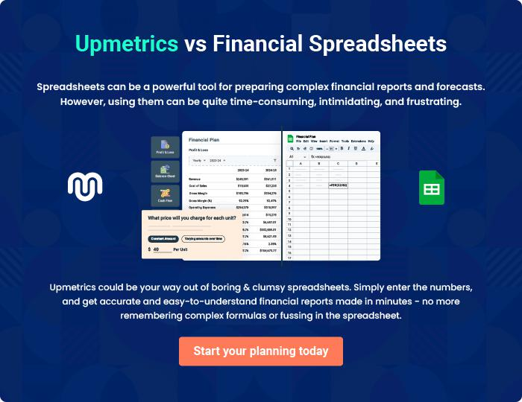

Microgreens | Business Plan [YEAR] 43/44


Create a winning business plan that gets you funded

Creating a stunning and investment-ready plan requires no writing, graphic designing, or financial planning expertise.

Upmetrics has all the features required to help you create a comprehensive business plan—from start to finish. Make no mistakes, it’s the modern way of planning to structure ideas, make plans, and create stunning pitch decks to awe investors.

Pitch decks that impress investors

Create pitch decks that provide a visual representation of your business, engage investors, and make them want to invest in your business idea.

Interactive plans in no time

Import business plan sections like—SWOT analysis, comparison tables, and others to create an interactive business plan. No designing skills are required.

Stunning cover page designs

With Upmetrics, you have the liberty to choose from multiple stunning cover page designs. Choose a creative design and make your plan stand out.

Online sharing made simple

Upmetrics makes online sharing quick and easier for users. Easily share your business plans with a link while tracking reader activity.

500+ sample business plans

Simply import a template from our library of sample plans into the editor and start customizing it to make it yours. It takes only a few clicks to get started.

Collaborate with team in real-time

Invite team members, initiate conversations, discuss ideas & strategies, share feedback, and work on a business plan in real-time.

