


Lanzor Medical Equipments

BUSINESS PLAN

Alleviating Pain • Restoring Health • Extending Life

Prepared By

John Doe

10200 Bolsa Ave, Westminster, CA, 92683

info@example.com

(650) 359-3153 http://www.example.com

Table of Contents

Executive Summary | 7
Lanzor Medical's Business | 8
Overview | 8
Mission | 8
Market and Opportunity | 8
Commercialized Products | 8
Products Under Development | 9
Competition | 9
Competitive Advantages | 9
Marketing and Distribution | 9
Company | 10
Management & Advisors | 10
Frank Martin | 10
Evgeny Shaman | 10
Chen Barak | 11
Dov Gal | 11
Kimberly Patric | 11
Robert Stoddard | 11
Board of Directors | 12
Scientific Advisory Board and Clinical Investigators: | 12
Professional Services: | 12
Financial Summary | 12
Projected Revenue | 13
Projected Net Income | 13

Background | 15
The Heart | 16
Coronary Artery Disease (CAD) | 16
Diagnosing CAD | 16
Treating CAD | 17
Catheter-Based Procedures | 17

Lanzor Medical Equipments | Business Plan [YEAR] 2/48

Products and Technology | 18
Commercialized Products | 19
SmartFlowTM Console | 19
SmartFlow CFR/FFR Module | 19
SmartFlow Multiple lesionTM Module | 20
SmartFlow PTC Module | 20
Products Under Development | 20
SmartFlow@ Pressure Guide Wire (Consumable Product) | 20
Smartflow Renal | 21
Imaging | 21
Myocardial Perfusion (Distal Vascular Bed) | 21
Product Acquisitions | 21
Intellectual Property | 22

Markets and Marketing | 23
Potential Markets | 24
Number of Cath Labs | 24
Number of Cam Procedures | 24
Spending on Oath Lab Equipment | 24
Patient Base | 25
Economic Impact | 25
Market Potential | 25
Interest in Physiologic Data | 25
Competition & Competitive Advantages | 26
Direct Competitors | 26
Indirect Competitors | 27
Summary of Competitive Advantages | 27
Marketing Strategy | 27
Pricing Strategy | 27
Sales and Marketing Strategy | 28
Sales Forecast | 28

Operating Strategy | 29
Milestones | 30

Lanzor Medical Equipments | Business Plan [YEAR] 3/48

Commercialization | 30
Regulatory Approval | 30
Reimbursement | 30
Manufacturing and Distribution | 31
Risks | 31
Market Risks | 31
Competitive Risks | 31
R&D Risks | 32
Legal Risks | 32

Company and Management | 33
Company | 34
History and Structure | 34
Office Locations | 34
Professional Services | 34
Management and Advisors | 34
Management | 34
Frank Martin | 35
Evgeny Shalman | 35
Chen Barak | 35
Dov Gal, D.V.M. | 35
Board of Directors | 36
Frank Martin | 36
Gideon Tolkowsky | 36
Hillel Bachrach | 36
Shmuel Einav | 37
Scientific Advisory Board and Clinical Investigators | 37
Takashi Akasaka | 37
Rafael Beyar | 38
Bernard De Bruyne | 38
Organization Chart | 38
Key Open Positions | 39

Lanzor Medical Equipments | Business Plan [YEAR] 4/48

Financial Plan | 40
Key Assumptions | 41
General Assumptions and Notes | 41
Revenue Assumptions | 41
Expense Assumptions | 41
Financial Projections | 42
Revenues | 42
Net Income | 42
Profit & Loss | 43
Capital Requirements a Use of Proceeds | 46
Exit Strategy | 46

Lanzor Medical Equipments | Business Plan [YEAR] 5/48


Business planning that’s simpler and faster than you think

Creating a business plan using Upmetrics to start and grow a business is literally the easiest thing in the World. Simply read the instructions and fill in the blanks. It’s as simple as that.

❛ | Upmetrics has everything you need to create a | ❜
❛ | comprehensive business plan. | ❜

AI-powered Upmetrics Assistant

AI-powered insights to streamline your plan

Not sure where to start? Upmetrics’ AI Assistant will automatically generate ideas for each section of your plan and offer improved versions of your writing, adjusting for tone, voice, and grammar or spelling errors.

Financial Forecasting Tool

All the financials are calculated for you

Forget the complex formulas and clumsy spreadsheets — with automatic financials and drag-and-drop forecasting, you can finish your plan faster and be confident that your numbers are accurate.

Business Plan Builder

Guides you like a business mentor

Upmetrics’ step-by-step instructions, prompts, and the library of 400+ sample business plans will guide you through each section of your plan as a business mentor.

1.


Executive Summary

Lanzor Medical's Business

Management & Advisors

Financial Summary

Lanzor Medical Equipments | Business Plan [YEAR] 7/48

Lanzor Medical's Business
To unlock help try Upmetrics!

 Lanzor


We design, develop, and are selling unique solutions for the $4.2 billion global market for catheter-based equipment to diagnose and treat cardiovascular disease. Our clinically proven and FDA and EU approved SmartFlow® products represent the next generation in interventional
To unlock help try Upmetrics! 

Overview

Start writing here..

 Lanzor

Achieve and maintain world leadership in the diagnosis and treatment of coronary artery and renal artery disease through novel interventional applications of computational fluid dynamics and related advanced principles.



Mission

Start writing here..

 Lanzor

Our primary target is coronary artery disease (CAD), a blockage of

the arteries that supply blood to the heart, affecting over 12 million Americans. CAD is the
number one killer in developed nations, causing over 500,000 deaths per year in the U.S. and
To unlock help try Upmetrics! 

Market and Opportunity

Start writing here..

 Lanzor

Our products, designed to improve the treatment of narrowing

arteries due to coronary artery disease, are based on the principles of Computational Fluid
Dynamics. Using our proprietary algorithms, we are able to measure various parameters with
To unlock help try Upmetrics! 

Commercialized Products

Start writing here..

Lanzor Medical Equipments | Business Plan [YEAR] 8/48

 Lanzor

We are developing additional modules that will significantly improve the evaluation and treatment of additional cardiovascular conditions. In all cases, existing tools are unreliable, difficult to use, expensive, and frequently lead to poor treatment decisions. We believe that
To unlock help try Upmetrics! 

Products Under Development

Start writing here..

 Lanzor

A number of technologies for diagnosing vascular disease currently exist:

• Direct Competition: RADI Medical Systems (a Swedish company) and JOMED (a Swiss
To unlock help try Upmetrics! 

Competition

Start writing here..

 Lanzor

Our competitive advantages include:

• SmartFlow® product benefits relative to competing technologies:
To unlock help try Upmetrics! 

Competitive Advantages

Start writing here..

 Lanzor

We are now shipping and installing SmartFlow® products. We are developing a small direct sales force to market SmartFlow to leading cath labs worldwide. In parallel, we are developing strategic regional distribution channels, some of which are now in place. In the future, we plan
To unlock help try Upmetrics! 

Marketing and Distribution

Start writing here..

Lanzor Medical Equipments | Business Plan [YEAR] 9/48

 Lanzor

Lanzor Medical, Inc., was incorporated in 2000 as a Delaware C corporation. It is a wholly-owned subsidiary of Lanzor Medical, Ltd., an Israeli company founded in 1997. Corporate and marketing activities are conducted from our Wellesley, MA headquarters, while R&D is
To unlock help try Upmetrics! 

Company

Start writing here..

Management & Advisors


Frank Martin

President and CEO

He Has many years of domestic and international experience in medical devices, biotech and medical electronics. He held several senior domestic and international management positions at Becton-Dickinson and Abbott Labs before becoming a founder and builder of medical device companies, including PLC Systems, CorMedica, and Advanced Biomedical. Mr. Martin serves on the boards of NMT Medical, Inc. (Nasdaq¬NMTI) and several private medical device companies.


Evgeny Shaman

Chief Scientist,

He earned his Ph.D. in applied mathematics at Moscow University, with special expertise in viscous flow and computational fluid dynamics. He has 30 years of industrial experience in the aerospace and cardiovascular fields, where he developed his exceptional know-how in vascular mechanics, hemodynamics, and the interaction of flow and the vessel wall. Dr. Shalman is responsible for the research activities of Lanzor Medical.

Lanzor Medical Equipments | Business Plan [YEAR] 10/48


Chen Barak

VP Operations

He is a graduate of The Technion Israel and University of Texas, Southwestern Texas, in biomedical engineering. She has 12 years of academic and industrial experience in the cardiovascular field. Dr. Barak is responsible for clinical and regulatory affairs, as well as Israeli operations.


Dov Gal

VP Clinical Affairs

He has 19 years of academic and industrial experience in the cardiovascular field, with expertise in clinical research and clinical marketing, as well as commercial experience in medical products. He has held appointments at Harvard and Tufts Medical Schools.


Kimberly Patric

Director

Global Marketing and Sales has 13 years of sales and marketing experience domestically and internationally in the medical device industry. Prior to joining Lanzor, she held various senior positions with interventional cardiology device companies including Endosonics and JOMED. She is a graduate of the University of Massachusetts with dual degrees in business administration and political science.


Robert Stoddard

CFO

He has extensive experience in early-stage medical device and biotech operations, financings, and mergers and acquisitions. Previously, he served as controller, treasurer, and CFO of the U.S. operations of Biogen, Inc., and more recently as CFO of Damon Biotech and Abbott Biotech. He is the Founder and President of RMS Associates, a consulting firm specializing in providing financial services to high tech companies. Mr. Stoddard is a graduate of Princeton University and a CPA.

Lanzor Medical Equipments | Business Plan [YEAR] 11/48

 Lanzor


- Frank Martin, Chairman, and CEO, Florence Medical

- Gideon Tolkowsky, Founding Partner, Veritas Venture Partners
- Hillel Bachrach, President & CEO, Orex Computed Radiography To unlock help try Upmetrics! 

Board of Directors

Start writing here..

 Lanzor

- Takashi Akasaka, M.D., Ph.D., Kawasaki Medical School, Japan

- Rafael Beyar, M.D., D.Sc., The Technion Israel Institute of Technology, Haifa, Israel
• Bernard De Bruyne, M.D., Ph.D., OLV Hospital, Aalst, Belgium To unlock help try Upmetrics! 

Scientific Advisory Board and Clinical Investigators:

Start writing here..

 Lanzor

- Gross, Kleinhendler, Hodak, Halevy, Greenberg and Co, legal council

- Nath & Associates, PLLC, intellectual property counsel
To unlock help try Upmetrics! 

Professional Services:

Start writing here..

Financial Summary

 Lanzor

We expect to achieve profitability in 2004 on strong revenue growth

To unlock help try Upmetrics! 

Start writing here..

Lanzor Medical Equipments | Business Plan [YEAR] 12/48

Projected Revenue
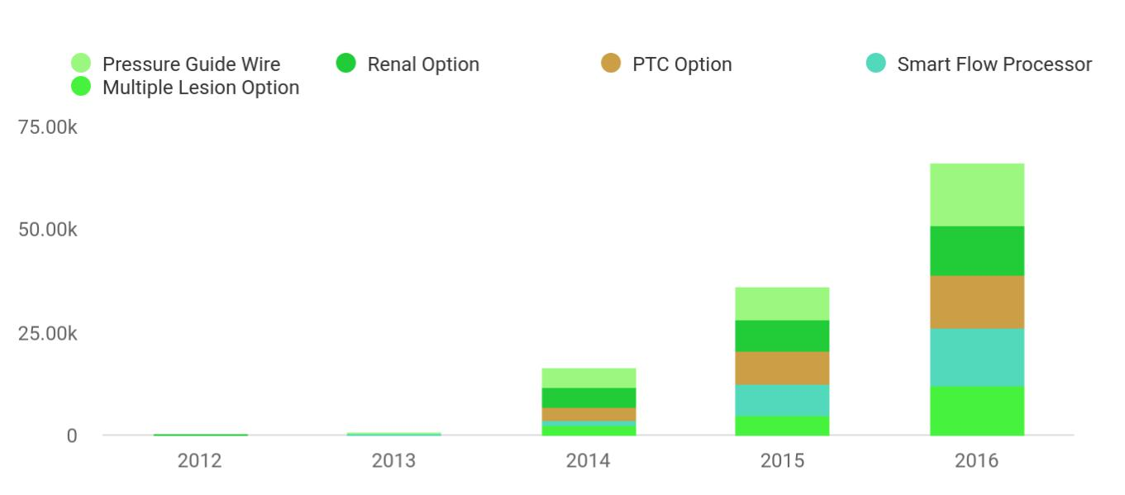

Projected Net Income
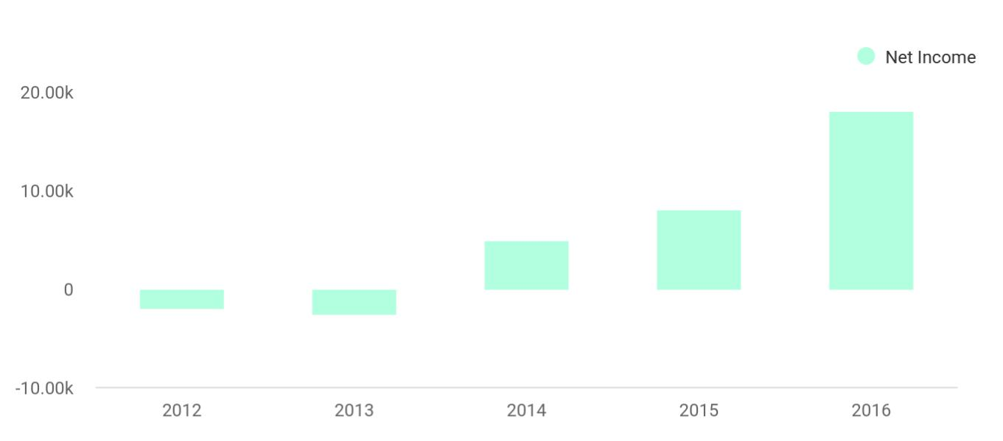

Our summary P&L forecast, in thousands, is as follows:

 | 2012 | 2013 | 2014 | 2015 | 2016 | % of
 |  |  |  |  |  | revenue
Revenues
SmartFlow Processor | 200 | 1,743 | 3,560 | 4,988 | 6,364 | 10%
Multiple Lesion Option | 52 | 156 | 260 | 390 | 520 | 1%
PTC Option | 52 | 260 | 650 | 1,300 | 2,600 | 4%
Renal Option | - | 60 | 360 | 660 | 1,200 | 2%
Pressure Guide Wire | - | - | 14,910 | 30,660 | 50,800 | 83%

Lanzor Medical Equipments | Business Plan [YEAR] 13/48

 | 2012 | 2013 | 2014 | 2015 | 2016 | % of
 |  |  |  |  |  | revenue
Total Revenue | 304 | 2,219 | 19,740 | 37,998 | 61,484 | 100%
Less: Cost of Goods | 140 | 654 | 6.414 | 11.082 | 15.681 | 26%
Gross Margin | 164 | 1.565 | 13.326 | 26,916 | 45.803 | 74%
 | 54% | 71% | 68% | 71% | 74%
Operating Expenses
Operations | 169 | 270 | 859 | 1,470 | 2,438 | 4%
Research & | 1,224 | 1,858 | 2,784 | 3,867 | 5,951 | 10%
Development
Sales & Marketing | 587 | 1,239 | 2,785 | 4,265 | 6,503 | 11%
General & | 316 | 614 | 1,727 | 2,570 | 3,267 | 5%
Administrative
Depreciation | 62 | 95 | 134 | 161 | 223 | 0%
Total Operating | 2,358 | 4.076 | 8.289 | 12,333 | 18.382 | 30%
Expenses
Non-Operating Income | 160 | 250 | 180 | 215 | 470 | 1%
(Expense)
Income Before Tax | (2,034) | (2,261) | 5,217 | 14,798 | 27,891 | 45%
Tax (40%) | 0 | 0 | 369 | 5,919 | 11,156 | 18%
Net Income | (2,034) | (1,011) | 4,848 | 8,879 | 16,734 | 27%

We have sufficient funds to meet our operating objectives through Q2, 2003. To date, we have raised $5.5 million in venture capital led by Veritas Ventures.

We are currently seeking $10 million in capital to finance the aggressive commercialization of our initial products, continued R&D, and the acquisition of complementary products.

Lanzor Medical Equipments | Business Plan [YEAR] 14/48

2.

Background

The Heart

Coronary Artery Disease (CAD)

Diagnosing CAD

Treating CAD

Catheter-Based Procedures

Lanzor Medical Equipments | Business Plan [YEAR] 15/48

The Heart

 Lanzor


The human heart is a fist-sized muscle consisting of four chambers: the left and right atria, and the left and right ventricles. The right atrium receives oxygen-

Start writing here..

Coronary Artery Disease (CAD)

 Lanzor

To unlock help try Upmetrics! 

Cardiovascular disease (CVD) is the leading cause of death in the U.S., claiming 958,775 lives in 1999, versus 549,838 deaths due to all forms of cancer combined. Worldwide, CVD caused 16.7 million deaths in 2000. Approximately 1 in 5 Americans - nearly 62 million - has one or more
To unlock help try Upmetrics! 

Start writing here..

Diagnosing CAD

 Lanzor

Many tests and procedures are available for diagnosing heart conditions including CAD. In approximate order of evasiveness, common diagnostics include:
To unlock help try Upmetrics! 

Start writing here..

Lanzor Medical Equipments | Business Plan [YEAR] 16/48

Treating CAD

 Lanzor

Many surgical and non-surgical treatments for CAD have been developed:

• Lifestyle: When detected early enough, CAD can often be treated through lifestyle
To unlock help try Upmetrics! 

Start writing here..

Catheter-Based Procedures

 Lanzor

Interventional procedures such as PTCAs are catheter-based. In a typical coronary angioplasty procedure, the patient is sedated and an incision is made in a major artery under a local anesthetic, usually the femoral artery in the groin. A sheath is placed at the location of the
To unlock help try Upmetrics! 

Start writing here..

Lanzor Medical Equipments | Business Plan [YEAR] 17/48

3.

Products and Technology

Commercialized Products

Products Under Development

Intellectual Property

Lanzor Medical Equipments | Business Plan [YEAR] 18/48

 Lanzor

Lanzor Medical's core technologies revolve around providing better, faster, and cheaper techniques for diagnosing and treating Coronary Artery Disease (CAD). As such, we believe that our SmartFlow® product line will set new standards in interventional cardiology, and will
To unlock help try Upmetrics! 

Start writing here..

Commercialized Products

 Lanzor

At the core of most of our products are the use of computational fluid dynamics (CFD) and related principles. CFD is the computer-simulated study of how fluids and gasses behave as
they flow through or around various structures. CFD was originally developed for the aerospace
To unlock help try Upmetrics! 

Start writing here..

 Lanzor

The SmartFlow Console is our core hardware platform. It consists of a medical-grade computer, including a touch-screen monitor and keyboard.

SmartFlowTM Console

Start writing here..

 Lanzor


Coronary Flow Reserve (CFR) and Fractional Flow Reserve (FFR), described in section 2.3, are physiological measures important in the diagnosis of stenosis. In clinical practice

SmartFlow CFR/FFR Module

Start writing here..
To unlock help try Upmetrics! 

To unlock help try Upmetrics! 

Lanzor Medical Equipments | Business Plan [YEAR] 19/48

 Lanzor

Very often, patients will have multiple stenoses, or lesions, within a single coronary artery. Treating all of the lesions introduces unnecessary risks and costs, since some of the lesions may be relatively insignificant. However, obtaining an accurate evaluation of the severity of
To unlock help try Upmetrics! 

SmartFlow Multiple lesionTM Module

Start writing here..

 Lanzor

Existing techniques for measuring FFR have one serious drawback: they require repeatedly administering vessel dilating drugs to induce maximum hyperemia or maximum blood flow
conditions. These drugs introduce additional costs and risks, require more time and skill, and
To unlock help try Upmetrics! 

SmartFlow PTC Module

Start writing here..

Products Under Development

 Lanzor

Our R&D team, in collaboration with our U.S., European, and Israeli clinical research centers, is at work on several interrelated projects. These projects are expected to add substantially to our SmartFlow product family and provide sustained growth. Our new products will be launched
To unlock help try Upmetrics! 

Start writing here..

 Lanzor

Guidewires are an integral component of all interventional catheterization procedures. The ability to accurately assess hemodynamic parameters during procedures, enabled by pressure guide wires (PGWs), will grow in importance. We have designed and patented our own
To unlock help try Upmetrics! 

SmartFlow@ Pressure Guide Wire (Consumable Product)

Start writing here..

Lanzor Medical Equipments | Business Plan [YEAR] 20/48

 Lanzor
To unlock help try Upmetrics!

Renal Artery Stenosis (RAS) is the root cause of hypertension in 20-50% of hypertensive patients with cardiovascular disease. It is also a significant cause of reduced renal (kidney) function.



Smartflow Renal

Start writing here..

 Lanzor

We have a research collaboration with a European manufacturer of Quantitative Coronary Angiography equipment in which SmartFlow data will be overlaid onto angiography images. Additional parameters (i.e., vessel wall shear stress and absolute flow) are calculated in our
To unlock help try Upmetrics! 

Imaging

Start writing here..

 Lanzor

One of the remaining challenges in interventional cardiology is in the diagnosis and treatment of microvascular disease. This refers to impaired myocardial perfusion (blood flow) in the smallest arteries and capillaries that directly feed the heart's muscle tissue (distal vascular
To unlock help try Upmetrics! 

Myocardial Perfusion (Distal Vascular Bed)

Start writing here..

 Lanzor

In order to fully utilize our talent, resources, and global distribution channels, we are actively seeking to acquire more complementary products. Several candidates have been identified.
Because these products have not yet been selected, they are not included in the Projected P&L,
To unlock help try Upmetrics! 

Product Acquisitions

Start writing here..

Lanzor Medical Equipments | Business Plan [YEAR] 21/48

Intellectual Property

 Lanzor

We have two patents issued (with 164 total claims) and eight patents pending in the U.S., Europe, and Japan. Our intellectual property covers a range of applications in coronary and peripheral vessels utilizing our core technology of computational fluid dynamics and our
To unlock help try Upmetrics! 

Start writing here..


Lanzor Medical Equipments | Business Plan [YEAR] 22/48

4.

Markets and Marketing

Potential Markets

Competition & Competitive Advantages

Marketing Strategy

Sales Forecast

Lanzor Medical Equipments | Business Plan [YEAR] 23/48

Potential Markets

 Lanzor

The worldwide coronary cath lab equipment market is currently $4.2 billion, of which 60% is in the U.S. The potential market for the SmartFlow® product family is driven by the number of interventional cath labs and the number of procedures performed in these labs. The following
To unlock help try Upmetrics! 

Start writing here..

 Lanzor

According to research firm Frost & Sullivan, there were 6,000 cath labs worldwide in 19%, the latest year for which complete figures were available:
To unlock help try Upmetrics! 

Number of Cath Labs

Start writing here..

 Lanzor

IMV, an independent research firm, surveyed 1,550 U.S. cardiac cath labs in 2001 and estimated that 3.75 million cardiac and non-cardiac procedures were performed in the U.S. in 2000. Of these, 3.40 million were cardiac procedures, while the remaining 0.35 million were primarily
To unlock help try Upmetrics! 

Number of Cam Procedures

Start writing here..

 Lanzor

According to Business Communications, Inc., worldwide spending on cardiac catheter products is expected to be $4.2 billion in 2002:
To unlock help try Upmetrics! 

Spending on Oath Lab Equipment

Start writing here..

Lanzor Medical Equipments | Business Plan [YEAR] 24/48

 Lanzor

As described in the Background chapter, cardiovascular disease (CVD) is the leading cause of death in the U.S., claiming 958,775 lives in 1999, versus 549,838 deaths due to all forms of cancer combined. Worldwide, CVD caused 16.7 million deaths in 1999. Approximately 1 in 5
To unlock help try Upmetrics! 

Patient Base

Start writing here..

 Lanzor

The economic cost of CAD and other cardiovascular diseases is extremely high. However, almost half of the economic cost of CAD is due to the indirect costs of lost productivity:
To unlock help try Upmetrics! 

Economic Impact

Start writing here..

 Lanzor

As described above, approximately 8 million interventional cardiovascular procedures are performed annually worldwide. If we achieve a 10% utilization rate in these procedures, our
disposable products alone (the pressure guide wire, initially priced to distributors at $210 each)
To unlock help try Upmetrics! 

Market Potential

Start writing here..

 Lanzor

Interest in physiologic data has grown rapidly in the past three years as more interventionalists begin to understand the forces at work in the formation of stenotic disease. The SmartFlow product family provides clinical information that other modalities (such as angiography) cannot
To unlock help try Upmetrics! 

Interest in Physiologic Data

Start writing here..

Lanzor Medical Equipments | Business Plan [YEAR] 25/48

Competition & Competitive Advantages

 Lanzor

Our direct competitors are firms offering technologies for measuring blood flow and pressure within the coronary arteries. Thus, our principal competitors are:
To unlock help try Upmetrics! 

Direct Competitors

Start writing here..


RADI Medical Systems AB

Founded in 1985, RADI is a European manufacturer and marketer of pressure guide wires and related technologies. Although RADI focuses on pressure guide wires, it also offers the RADIAnalyzer, designed to measure FFR and CFR. The device has been cleared by the FDA and has received a CE mark. We currently use RADI's Pressure Wire pressure sensing guide wire, and plan to continue doing so until we have completed the development of our own proprietary guide wire technologies.

JOMED N.V.


Founded in 1991, JOMED is a European manufacturer and marketer of products for cardiovascular intervention. The firm has 1,200 employees and offers over 2,000 products. Although the corporate focus is on coronary stents, the company does offer physiology products. The product line is considered to be outdated since a separate system is required for each CFR and FFR. A new system that provides simultaneous CFR/FFR is in development. We currently use JOMED's WaveWire pressure sensing guide wire and plan to continue doing so until we have completed the development of our own proprietary guide wire technologies. We have also entered into a distribution partnership agreement with JOMED. We believe that our measurement technologies are far superior to JOMED technologies, and view them as a supplier, a distribution partner, and a potential acquirer.

Lanzor Medical Equipments | Business Plan [YEAR] 26/48

 Lanzor
To unlock help try Upmetrics!

use of a pressure wire only. Our SmartFlow Multiple Lesion and SmartFlow PTC drug-free FFR products are unmatched by competitors. In addition, the SmartFlow Pressure Guide Wire, under development, has superior handling and cost advantages. These products are expected to
To unlock help try Upmetrics! 

Start writing here..

 Lanzor

Indirect competitors include the various technologies available for diagnosing cardiovascular stenosis. All of the following technologies are visual, and thus subjective, means of evaluating stenoses; as such, they all produce imperfect measurements:



Indirect Competitors

Start writing here..

 Lanzor

We have significant business and clinical advantages in many areas relative to competitors due to the following attributes:
To unlock help try Upmetrics! 

Summary of Competitive Advantages

Start writing here..

Marketing Strategy

 Lanzor

We will employ value-based pricing, rather than cost-plus based pricing. Our current views on achievable pricing are as follows:
To unlock help try Upmetrics! 

Pricing Strategy

Start writing here..

Lanzor Medical Equipments | Business Plan [YEAR] 27/48

 Lanzor
To unlock help try Upmetrics!

Our marketing strategy will be highly targeted. The community of leading interventional cardiologists is small and tightly-knit. If we are able to enlist a small number of the leading interventionalists to use our products, others will follow quickly. Therefore, the bulk of our
To unlock help try Upmetrics! 

Sales and Marketing Strategy

Start writing here..

Sales Forecast

 Lanzor

Direct revenues from instrumentation sales are expected to be relatively modest. However, instrumentation drives disposables sales, so acquiring a substantial installed base is important to our success.



Start writing here..

Lanzor Medical Equipments | Business Plan [YEAR] 28/48

5.

Operating Strategy

Milestones

Commercialization

Risks

Lanzor Medical Equipments | Business Plan [YEAR] 29/48

Milestones

 Lanzor


We have gained significant momentum since our founding, and intend to remain aggressive as we go to market:
To unlock help try Upmetrics! 

Start writing here..

Commercialization

 Lanzor

We received FDA and CE Mark clearance to market the Florence SmartFlow in June 2001. A 510K was cleared in October 2001 for an upgraded version of SmartFlow including our new
Multiple Lesion software. Our Pulse Transmission Coefficient (PTC) software was cleared by
To unlock help try Upmetrics! 

Regulatory Approval

Start writing here..

 Lanzor

Medicare and Medicaid reimbursement for pressure and flow measurements were approved in the U.S. effective January 1, 1999. The CPT codes for physiology measurements are reimbursable when performed with either therapeutic intervention or with angiography.
To unlock help try Upmetrics! 

Reimbursement

Start writing here..

 Lanzor

All of our hardware manufacturing is performed by OEM partners. The SmartFlow Console and stand are manufactured at a cost of goods of $6,500. We have identified and qualified additional manufacturers to take over the production of the console in the event that our
To unlock help try Upmetrics! 

Lanzor Medical Equipments | Business Plan [YEAR] 30/48

Manufacturing and Distribution

Start writing here..

Risks

 Lanzor

We believe that we have taken prudent steps to address the most significant risks facing us, and plan to continue mitigating risks as they are identified.
To unlock help try Upmetrics! 

Start writing here..

 Lanzor


It is well understood and acknowledged that angiograms are an
imperfect measure of coronary blood flow; our products provide
To unlock help try Upmetrics! 

Market Risks

Start writing here..

 Lanzor


 |  | We have several patents issued and pending covering our core
 | Competitors copy our | technologies and methods.
 | Competitors copy our | technologies and methods. | To unlock help try Upmetrics! 

Competitive Risks

Start writing here..

Lanzor Medical Equipments | Business Plan [YEAR] 31/48

 Lanzor


We have proven, through our development of the SmartFlow product line, our ability to develop innovative
To unlock help try Upmetrics! 

R&D Risks

Start writing here..

 Lanzor


This is a risk in all life science companies. The stringent safety requirements of the regulatory approval process help to ensure that
To unlock help try Upmetrics! 

Legal Risks

Start writing here..

Lanzor Medical Equipments | Business Plan [YEAR] 32/48

6.

Company and

Management

Company

Management and Advisors

Organization Chart

Key Open Positions

Lanzor Medical Equipments | Business Plan [YEAR] 33/48

Company

 Lanzor

Lanzor Medical, Inc., was incorporated in 2000 as a Delaware C corporation. It is a wholly owned subsidiary of Lanzor Medical, Ltd., an Israeli company founded in 1997. Corporate and marketing activities are conducted from our Wellesley, MA headquarters, while R&D is
To unlock help try Upmetrics! 

History and Structure

Start writing here..

 Lanzor

The company is headquartered in Wellesley, MA. The area has a strong medical technology base and talent pool that includes Abbott Labs, AbioMed, Biogen, Boston Scientific, DynaGen, Genzyme, Millennium Pharmaceuticals, PolyMedica, Sepracor, and Thermo Cardiosystems, as
To unlock help try Upmetrics! 

Office Locations

Start writing here..

 Lanzor

Corporate Counsel

Osnat Levin
To unlock help try Upmetrics! 

Professional Services

Start writing here..

Management and Advisors

Management

Start writing here..

Lanzor Medical Equipments | Business Plan [YEAR] 34/48

Frank Martin

President and CEO

Mr. Martin has many years of domestic and international experience in medical devices, biotech, and medical electronics. He held several senior domestic and international management positions at Becton-Dickinson and Abbott Labs before becoming a founder and builder of medical device companies including PLC Systems, CorMedica, and Advanced Biomedical. Mr. Martin serves on the boards of NMT Medical, Inc. (Nasdaq-NMTI) and several private medical device companies.

Evgeny Shalman

Chief Scientist

Dr. Shalman earned his Ph.D. in applied mathematics at the Moscow University, with special expertise in viscous flow and computational fluid dynamics. He has 30 years of industrial experience in the aerospace and cardiovascular fields, where he developed his exceptional know-how in vascular mechanics, hemodynamics, and the interaction of flow and the vessel wall. Dr. Shalman is responsible for the research activities of Lanzor Medical.

Chen Barak

Vice President, Operations

Dr. Barak is a graduate of The Technion Israel and University of Texas, Southwestern Texas, in biomedical engineering. She has 12 years of academic and industrial experience in the cardiovascular field. Dr. Barak is responsible for clinical and regulatory affairs, as well as Israeli operations.

Dov Gal, D.V.M.

Vice President, Clinical Affairs

Dr. Gal has 19 years of academic and industrial experience in the cardiovascular field. He has held senior R&D, marketing, and clinical positions in start-up biotech and medical device companies, and was a consultant in the biopharmaceutical industry. Dr. Gal holds D.V.M. and M.B.A. degrees and has completed a research fellowship in interventional cardiology at Tufts Medical School. He has also held appointments at Harvard and Tufts Medical Schools.

Lanzor Medical Equipments | Business Plan [YEAR] 35/48

And Many more people those we have listed in first chapter 'Executive Summary'

Board of Directors

Start writing here..

Frank Martin

Chairman and CEO, Lanzor Medical.

Gideon Tolkowsky

Co-Founder of Lanzor Medical and Founding Partner

Veritas Venture Partners, Israel's pioneering venture capital firm. He began his involvement in venture capital in 1981 through the US-based venture capital firm of Adler & Company, and later through Elron Electronic Industries in the US and Israel. He was a manager of Athena Venture Partners from co-founding it in 1985 until its dissolution in 1997 and has managed Veritas' funds since 1990. Mr. Tolkowsky is a board member of Aisys (Chairman) and Lanzor Medical (Co-Founder) and is a past board member of Accord Networks (Nasdaq), ESC Medical (Nasdaq; now Lumenis) (Chairman), Harmonic Lightwaves, M-Systems Flash Disk Pioneers (Nasdaq), and Ubique, among others. He holds a BS. in aeronautical engineering from The Technion in Haifa and an MBA from Wharton. Mr. Tolkowsky serves as a member of the International Executive Board of Wharton.


Hillel Bachrach

President & CEO

Orex Computed Radiography. Mr. Bachrach has over 25 years of global medical device management experience, with emphasis on marketing, sales, and business development. He has held executive management positions at Odin Medical Technologies, ESC Medical Systems, Candela Laser Corporation, General Electric Medical Systems, and Baxter International. Mr. Bachrach holds a B.S. in Electrical Engineering from The Technion and an M.B.A. from Kellogg Graduate School of Management at Northwestern University.

Lanzor Medical Equipments | Business Plan [YEAR] 36/48


Shmuel Einav

Co-Founder of Lanzor Medical and Berman Professor of Biovascular Engineering, Tel-Aviv University

Professor Einav joined the Faculty of Engineering of Tel-Aviv University in 1974. His expertise is in the fields of cardiovascular bioengineering and biomedical engineering education. He is best known for his research on blood flow through heart valves, coronary circulation, blood-tissue interaction, and blood flow dynamics and turbulent characteristics in occluded arteries. He is a Distinguished Visiting Scholar at Caltech and has held visiting professorships at UCLA, Berkeley, and MIT. Professor Einav earned his B.S. in Mechanical Engineering and his M.S. in Nuclear Engineering from The Technion, Haifa, and his Ph.D. in Biomedical Engineering from SUNY at Stony Brook.

 Lanzor

We have assembled a world-renowned team of interventional cardiologists who act as clinical investigators and advisors. The investigators below are active participants in our clinical, scientific, and strategic efforts. An extensive bibliography of articles and abstracts is available
To unlock help try Upmetrics! 

Scientific Advisory Board and Clinical Investigators

Start writing here..

Takashi Akasaka

M.D., Ph.D

Dr. Akasaka is the Director of the Cardiac Catheterization Laboratory and Associate Professor, Division of Cardiology, at the Kawasaki Medical School in Japan. He is also a Lecturer, The First Department of Medicine, Osaka City University School of Medicine. Dr. Akasaka earned his M.D. at Wakayama Medical College and his Ph.D. at the Osaka City University School of Medicine.

Lanzor Medical Equipments | Business Plan [YEAR] 37/48


Rafael Beyar

M.D., D.Sc

Dr. Beyar is Dean of Medicine and Professor of Medicine and Biomedical Engineering at The Technion Israel Institute of Technology in Haifa, Israel. His research interests include cardiovascular dynamics and function, coronary flow and its relationship to ventricular function, coronary metal stents and the interaction with the arterial wall, interventional cardiology, and three-dimensional imaging and analysis of cardiac function. Dr. Beyar earned his M.D. at Sackler Medical School and his D.Sc. in Biomedical Engineering at The Technion.


Bernard De Bruyne

M.D., Ph.D

Dr. De Bruyne is Associate Director of the Cardiovascular Center of OLV Hospital in Aalst, Belgium. As an interventional cardiologist, his main interests lie in the physiology of coronary atherosclerosis and of myocardial perfusion. In a dose collaboration with Dr. Nico Pijls, he described and validated the concept of coronary pressure-derived fractional flow reserve, a method that is now widely applied in catheterization laboratories to evaluate coronary stenosis physiology.

Organization Chart

 Lanzor

Our organizational structure through the first quarter of 2003 is as follows. As the company grows, we may shift to other roles as necessary to better ensure the success of the company.
To unlock help try Upmetrics! 

Start writing here..

Lanzor Medical Equipments | Business Plan [YEAR] 38/48

Key Open Positions

 Lanzor

Our current staffing priorities are the following positions:

• Clinical Specialist - Prior successful cath lab experience is critical.
To unlock help try Upmetrics! 

Start writing here..

Lanzor Medical Equipments | Business Plan [YEAR] 39/48

7.

Financial Plan

Key Assumptions

Financial Projections

Lanzor Medical Equipments | Business Plan [YEAR] 40/48

Key Assumptions

 Lanzor

• Financial Scope: Our financial projections are essentially based on that of a "pure startup", and the Company's existing financial condition are incorporated as an
approximation only. Audited financials reflecting the Company's FY 2001, and Unaudited
To unlock help try Upmetrics! 

General Assumptions and Notes

Start writing here..

 Lanzor


- Market and Share Growth:

Our sales volume forecasts are as follows:
To unlock help try Upmetrics! 

Revenue Assumptions

Start writing here..

 Lanzor


• Cost of Goods: Unit cost of goods for our products are projected as follows:

Product

2012

2013

2014 | 2015 | 2016
 | To unlock help try Upmetrics! 

Expense Assumptions

Start writing here..

Lanzor Medical Equipments | Business Plan [YEAR] 41/48

Financial Projections

Revenues
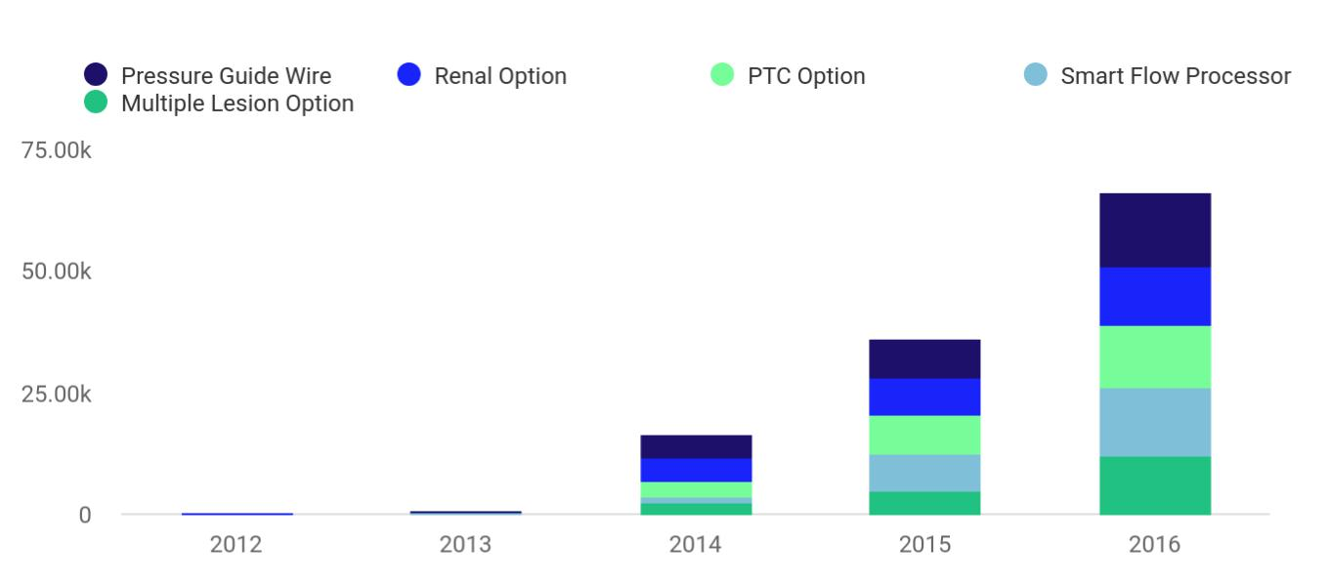

Financial Year | Pressure Guide Wire | Renal Option | PTC Option | Smart Flow Pro Wire | Multiple Lesion Wire
2012 | 100 | 50 | 74 | 40 | 40
2013 | 200 | 150 | 120 | 102 | 105
2014 | 5,000 | 4,500 | 3,200 | 1,400 | 2,400
2015 | 8,000 | 7,500 | 8,000 | 7,600 | 5,000
2016 | 15,000 | 12,000 | 13,000 | 14,000 | 12,000

Net Income
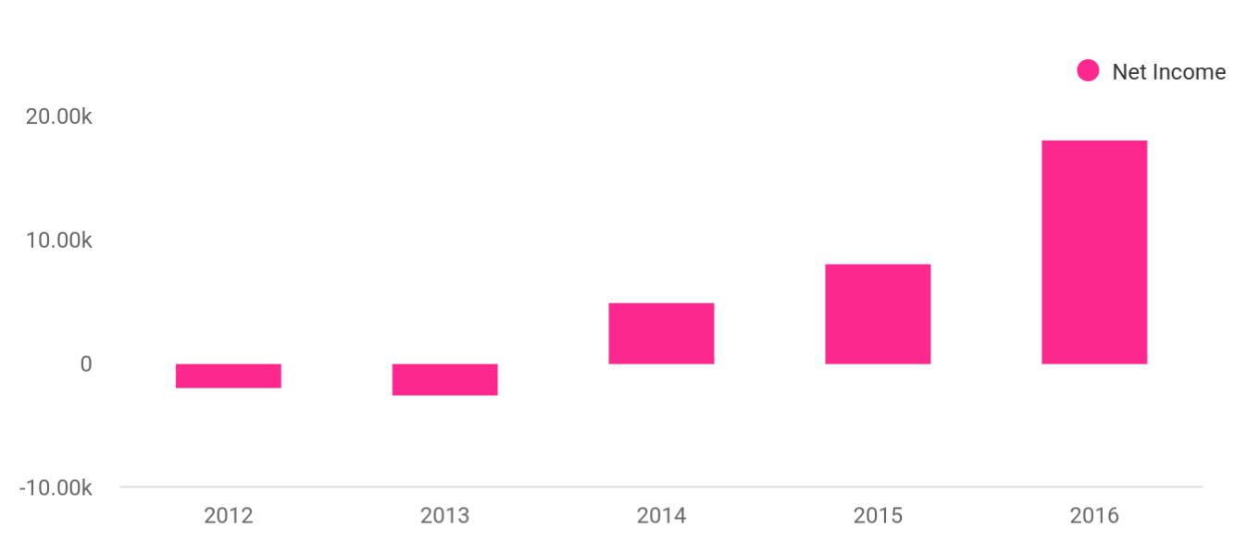

Lanzor Medical Equipments | Business Plan [YEAR] 42/48

Financial Year | Net Income
2012 | -2,000
2013 | -2,500
2014 | 5,000
2015 | 8,000
2016 | 18,000

Profit & Loss

 | 2024 | 2025 | 2026
Revenue | $3,253,861.50 | $6,703,353 | $10,742,530.50
Sale of Medical Devices | $1,200,000 | $1,260,000 | $1,323,000
Unit Sales | 1,200 | 1,260 | 1,323
Unit Price | $1,000 | $1,000 | $1,000
Maintenance Services | $189,316.50 | $238,443 | $331,660.50
Unit Sales | 1,262 | 1,590 | 2,211
Unit Price | $150 | $150 | $150
Equipment Leasing | $1,864,545 | $5,204,910 | $9,087,870
Users | 565 | 1,129 | 1,893
Recurring Charges | $500 | $500 | $500

Cost Of Sales | $1,669,920.34 | $2,798,921.48 | $4,118,828.96
General Costs | $1,669,920.34 | $2,798,921.48 | $4,118,828.96
Production Costs | $1,278,683.72 | $1,975,991.59 | $2,810,005.03
Raw Materials | $670,604.48 | $850,488.61 | $1,078,625.44
Manufacturing Labor | $488,079.24 | $1,005,502.98 | $1,611,379.59
Equipment Depreciation | $120,000 | $120,000 | $120,000
Distribution Costs | $391,236.62 | $822,929.89 | $1,308,823.93

Lanzor Medical Equipments | Business Plan [YEAR] 43/48

Packaging

Shipping and Freight

Revenue Specific Costs

Personnel Costs (Direct Labor)

Gross Margin

Gross Margin (%)

Operating Expense

Payroll Expense (Indirect Labor)

Management Team

CEO

CFO

Sales and Marketing Team

Sales Representatives

Marketing Specialists

Research and Development Team

R&D Engineers

Lab Technicians

General Expense

Office and Administrative Expenses

Office Rent

Utilities

2024 | 2025 | 2026
$65,850.47 | $131,193.76 | $234,570.88
$325,386.15 | $691,736.13 | $1,074,253.05
$0 | $0 | $0
$0 | $0 | $0

$1,583,941.16 $3,904,431.52 $6,623,701.54

48.68% 58.25% 61.66%

$1,958,866.86 | $2,129,039.69 | $2,314,134.46
$1,727,052 | $1,787,731.08 | $1,850,623.32
$343,200 | $358,800 | $375,117.60
$187,200 | $196,560 | $206,388
$156,000 | $162,240 | $168,729.60
$577,500 | $594,825 | $612,669.96
$375,000 | $386,250 | $397,837.80
$202,500 | $208,575 | $214,832.16
$806,352 | $834,106.08 | $862,835.76
$356,352 | $370,606.08 | $385,430.40
$450,000 | $463,500 | $477,405.36
$176,815.86 | $281,308.61 | $403,511.14
$45,600 | $46,416 | $47,247.36
$36,000 | $36,720 | $37,454.40
$9,600 | $9,696 | $9,792.96

Lanzor Medical Equipments | Business Plan [YEAR] 44/48

Office Supplies

Office Supplies

Marketing and Sales

Expenses

Technology and Equipment Expenses

IT Support and

Maintenance

Equipment Lease

Bad Debt

Amortization of Current Assets

EBITDA

Additional Expense

Long Term Depreciation

Gain or loss from Sale of Assets

EBIT

Interest Expense

EBT

Income Tax Expense / Benefit

Total Expense

Net Income

Net Income (%)

2024 | 2025 | 2026
$103,615.86 | $207,100.61 | $328,275.94
$6,000 | $6,000 | $6,000
$97,615.86 | $201,100.61 | $322,275.94
$27,600 | $27,792 | $27,987.84
$9,600 | $9,792 | $9,987.84
$18,000 | $18,000 | $18,000
$0 | $0 | $0
$54,999 | $60,000 | $60,000

($374,925.71) $1,775,391.84 $4,309,567.08

$13,893.86 | $10,025.51 | $5,918.57
$3,600 | $3,600 | $3,600
$0 | $0 | $0
($378,525.71) | $1,771,791.84 | $4,305,967.08
$10,293.87 | $6,425.51 | $2,318.56
($388,819.57) | $1,765,366.33 | $4,303,648.51
$0 | $0 | $0

$3,642,681.07 | $4,937,986.67 | $6,438,881.99
($388,819.57) | $1,765,366.33 | $4,303,648.51
(11.95%) | 26.34% | 40.06%

Lanzor Medical Equipments | Business Plan [YEAR] 45/48

2024 2025 2026

Retained Earning Opening | $0 | ($428,819.57) | $1,316,546.76
Owner's Distribution | $40,000 | $20,000 | $20,000
Retained Earning Closing | ($428,819.57) | $1,316,546.76 | $5,600,195.27

 Lanzor

We have sufficient funds to meet our operating objectives through Q2, 2003. To date, we have raised $5.5 million in venture capital led by Veritas Ventures.
To unlock help try Upmetrics! 

Capital Requirements a Use of Proceeds

Start writing here..

 Lanzor

We will pursue several possible exit strategies:

• Be acquired: Companies that would benefit by acquiring Lanzor include: Medical device
To unlock help try Upmetrics! 

Exit Strategy

Start writing here..

Lanzor Medical Equipments | Business Plan [YEAR] 46/48



Lanzor Medical Equipments | Business Plan [YEAR] | 47/48


Create a winning business plan that gets you funded

Creating a stunning and investment-ready plan requires no writing, graphic designing, or financial planning expertise.

Upmetrics has all the features required to help you create a comprehensive business plan—from start to finish. Make no mistakes, it’s the modern way of planning to structure ideas, make plans, and create stunning pitch decks to awe investors.

Pitch decks that impress investors

Create pitch decks that provide a visual representation of your business, engage investors, and make them want to invest in your business idea.

Interactive plans in no time

Import business plan sections like—SWOT analysis, comparison tables, and others to create an interactive business plan. No designing skills are required.

Stunning cover page designs

With Upmetrics, you have the liberty to choose from multiple stunning cover page designs. Choose a creative design and make your plan stand out.

Online sharing made simple

Upmetrics makes online sharing quick and easier for users. Easily share your business plans with a link while tracking reader activity.

500+ sample business plans

Simply import a template from our library of sample plans into the editor and start customizing it to make it yours. It takes only a few clicks to get started.

Collaborate with team in real-time

Invite team members, initiate conversations, discuss ideas & strategies, share feedback, and work on a business plan in real-time.

