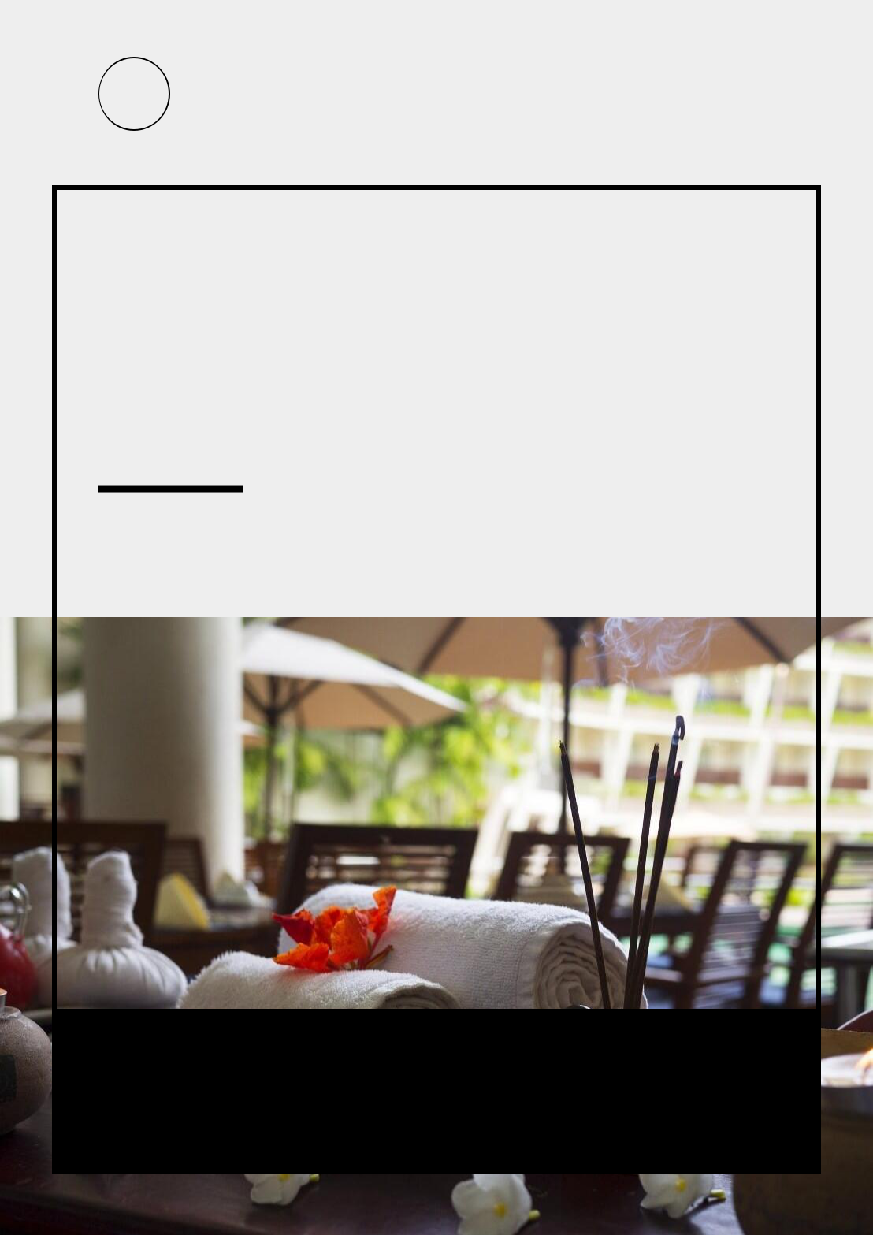


Silver Healing - Massage Therapy

BUSINESS PLAN

A haven for personal healing, growth and discovery.

Prepared By

John Doe

10200 Bolsa Ave, Westminster, CA, 92683

info@example.com

(650) 359-3153 http://www.example.com

Table of Contents

Executive Summary | 5
Objectives | 6
Mission | 6
Financial Summary | 7
Net Income | 7

Operational Plan | 8
Business Description | 9
Service | 9
Retail | 9
Location | 9
Management and Personnel | 10
Owner’s Experience and Background | 10
Technical | 10
Marketing/Sales | 10
Financial | 11
Planning/Organizing | 11
Legal Structure | 11
Permits and Licenses | 12
Accounting & Record Keeping | 12
Insurance | 12

Market Analysis | 13
Market Needs | 14
Target Market | 14
Market Potential | 14

Marketing Plan | 16
Mission Statement | 17
Marketing Outreach Plan | 17
Online/Social Media | 18

Silver Healing - Massage Therapy | Business Plan [YEAR] 2/36

People/Networking | 18
Other Promotion and Publicity | 19
SWOT Analysis | 19
Pricing Strategy | 21
Membership | 22
Gift certificates available. | 22

Financial Plan | 23
Monthly Personal Budget | 24
Expansion Costs | 24
Sources of Financing | 25
Overhead Business Costs | 25
Projected Profit and Loss | 26
Projected Cash Flow | 30
Projected Balance Sheet | 31

Appendix | 34
Sales Forecast | 35
Personnel | 35
Profit and Loss | 35
Cash Flow | 35
Balance Sheet | 35

Silver Healing - Massage Therapy | Business Plan [YEAR] 3/36

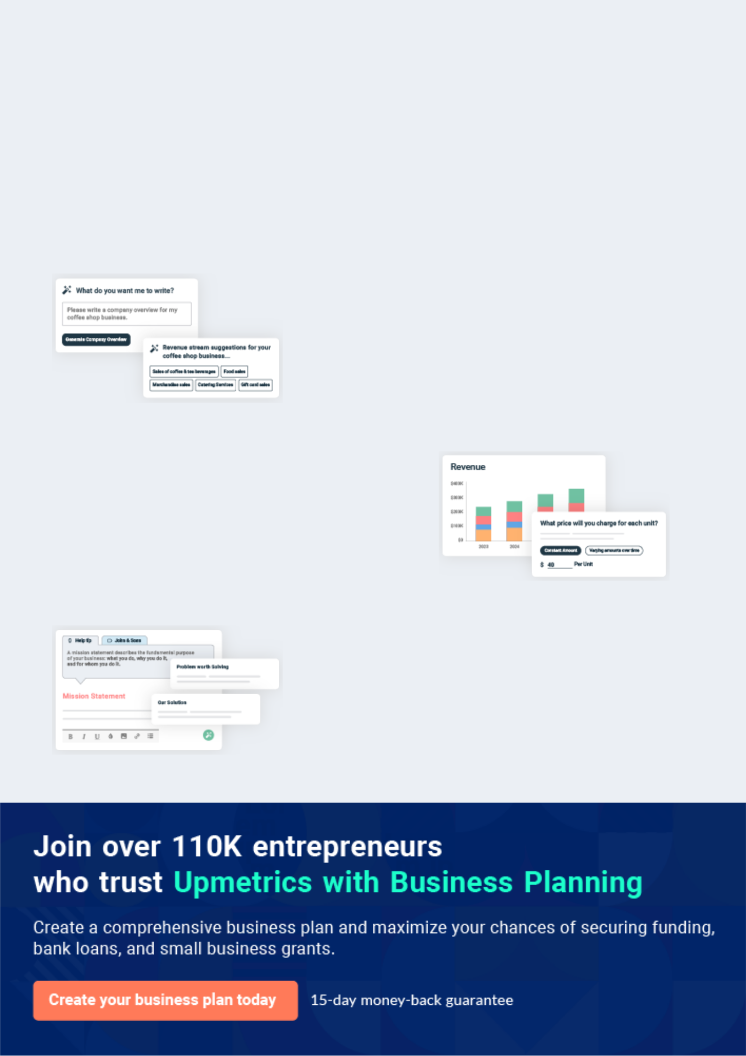
Business planning that’s simpler and faster than you think

Creating a business plan using Upmetrics to start and grow a business is literally the easiest thing in the World. Simply read the instructions and fill in the blanks. It’s as simple as that.

❛ | Upmetrics has everything you need to create a | ❜
❛ | comprehensive business plan. | ❜

AI-powered Upmetrics Assistant

AI-powered insights to streamline your plan

Not sure where to start? Upmetrics’ AI Assistant will automatically generate ideas for each section of your plan and offer improved versions of your writing, adjusting for tone, voice, and grammar or spelling errors.

Financial Forecasting Tool

All the financials are calculated for you

Forget the complex formulas and clumsy spreadsheets — with automatic financials and drag-and-drop forecasting, you can finish your plan faster and be confident that your numbers are accurate.

Business Plan Builder

Guides you like a business mentor

Upmetrics’ step-by-step instructions, prompts, and the library of 400+ sample business plans will guide you through each section of your plan as a business mentor.

1.


Executive Summary

Objectives

Mission

Financial Summary

Silver Healing - Massage Therapy | Business Plan [YEAR] 5/36

 Silver Healing


Silver Healing LLC provides massage and floatation therapy in Northeast Portland. Silver Healing offers state-of-the-art facilities for health and relaxation. We have offered massage
therapy in Northeast Portland since 2009 and are in the process of rebranding and expansion to
To unlock help try Upmetrics! 

Start writing here..

Objectives

 Silver Healing

1. Achieve $39,000 in sales the third month after opening by performing 18 services per day.
2. Achieve $80,000 in sales the six months after opening by performing 34 services per
To unlock help try Upmetrics! 

Start writing here..

Mission

 Silver Healing

Our mission is to run a profitable business by providing high-end therapeutic massage and aesthetician services in a compassionate, upscale, professional environment.
To unlock help try Upmetrics! 

Start writing here..

Silver Healing - Massage Therapy | Business Plan [YEAR] 6/36

Financial Summary

Net Income
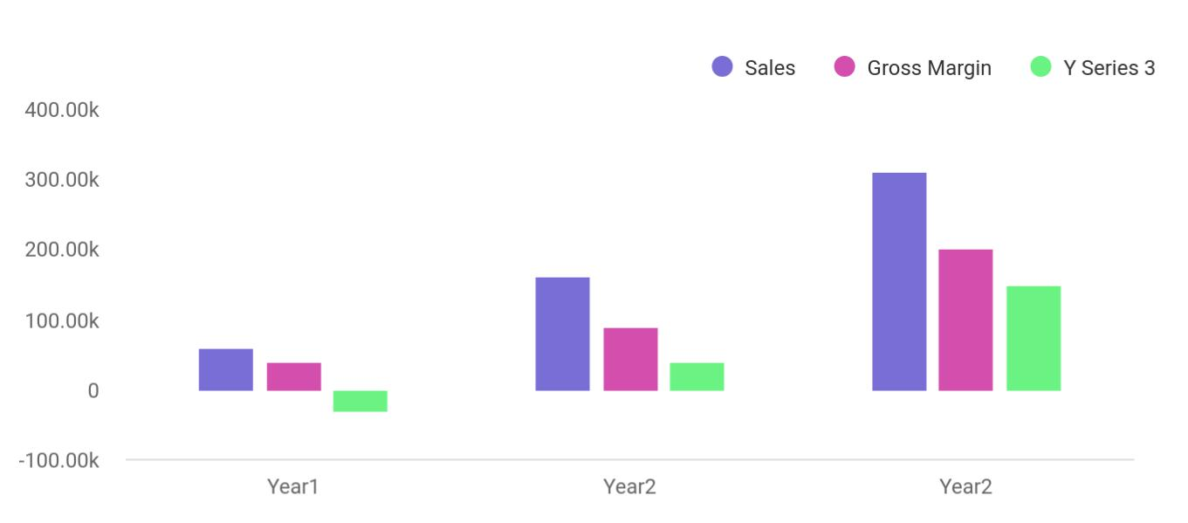

Financial Year | Sales | Gross Margin | Y Series 3
Year1 | 60,000 | 40,000 | -30,000
Year2 | 160,000 | 90,000 | 40,000
Year2 | 310,000 | 200,000 | 150,000

Silver Healing - Massage Therapy | Business Plan [YEAR] 7/36

2.

Operational Plan

Business Description

Location

Management and Personnel

Owner’s Experience and Background

Legal Structure

Permits and Licenses

Accounting & Record Keeping

Insurance

Silver Healing - Massage Therapy | Business Plan [YEAR] 8/36

Business Description
To unlock help try Upmetrics!

 Silver Healing

Silver Healing provides health and wellness to clients by offering floatation and

massage therapy services. By adding the ability to offer floatation therapy in one of our three
state-of-the-art Ocean Float Rooms, combined with massage therapy from highly skilled
To unlock help try Upmetrics! 

Service

Start writing here..

 Silver Healing

Products for sale include pain-relieving Cryoderm topical gel, Chinese herbal liniments for joints, hot/cold packs, foam rollers, specialty pillows (buckwheat and memory foam), Correct
ToesTM, books relating to health and floating, gift certificates, and Epsom salt. Suppliers vary
To unlock help try Upmetrics! 

Retail

Start writing here..

Location

 Silver Healing

Silver Healing will be located at 1412 NE Alberta St. Portland, Oregon 97211. You can reach us at 503-442-7177. Space is serene, comfortable, includes handicap access and state-of-the-art equipment including an electric-lift massage table.



Start writing here..

Silver Healing - Massage Therapy | Business Plan [YEAR] 9/36

Management and Personnel

 Silver Healing

Dana Highfill is the owner and manager. She is responsible for hiring and training 1-2 part-time receptionists, and 1 part-time Licensed Massage Therapists (LMT). Additional staff will be hired as demand increases. Dana will work as a receptionist, to understand clientele and their
To unlock help try Upmetrics! 

Start writing here..

Owner’s Experience and Background

 Silver Healing

Dana has a Bachelor of Industrial Design from Pratt Institute, studied massage at the Oregon School of Massage, and continues to train in Shiatsu with Akira Imai of The Shiatsu Center in
Portland. Since becoming licensed as a massage therapist in 2009, Dana has worked in a wide
To unlock help try Upmetrics! 

Technical

Start writing here..

 Silver Healing

As the owner of Soaring Dragon Massage (now Silver Healing) Dana has grown the business from 5-8 clients per week to 10-18 clients per week over a period of 6 months. Dana attended Mercy Corps NW Business Foundations I & II courses. Dana has consulted with Derek Wyatt,
To unlock help try Upmetrics! 

Marketing/Sales

Start writing here..

Silver Healing - Massage Therapy | Business Plan [YEAR] 10/36

 Silver Healing

In 2015 Dana received the Mercy Corp IDA Grant and used that to complete the first expansion of her business. Dana consistently uses resources such as Mercy Corp NW and PCC’s SBDC to learn new and more efficient ways of keeping track of financial records. The credit score is 816.
To unlock help try Upmetrics! 

Financial

Start writing here..

 Silver Healing

She owns and operates Soaring Dragon Massage. Since 2009 she has consistently grown the business and became a full-time sole proprietor in April 2014.
To unlock help try Upmetrics! 

Planning/Organizing

Start writing here..

Legal Structure

 Silver Healing

Limited Liability Company (LLC)

LLC is the optimal legal structure at this time. It offers the protection of a corporation and tax
To unlock help try Upmetrics! 

Start writing here..

Silver Healing - Massage Therapy | Business Plan [YEAR] 11/36

Permits and Licenses

 Silver Healing

Silver Healing LLC is registered with the state of Oregon. Registry # 1167003-94 Employer ID # 46-4587306
To unlock help try Upmetrics! 

Start writing here..

Accounting & Record Keeping

 Silver Healing

Records include:

Income – Detailed according to the type of service or product and recorded on the
To unlock help try Upmetrics! 

Start writing here..

Insurance

 Silver Healing

Business Personal Property insurance policy as soon as space is leased, expected October 2016.
To unlock help try Upmetrics! 

Start writing here..

Silver Healing - Massage Therapy | Business Plan [YEAR] 12/36

3.

Market Analysis

Market Needs

Target Market

Market Potential

Silver Healing - Massage Therapy | Business Plan [YEAR] 13/36

Market Needs

 Silver Healing

Mind-body techniques are ever more popular as the general public pays attention to their health and recognize what they can do to improve their health. Health care providers now understand the long-term benefits of preventative care. Massage and floatation therapy are excellent forms
To unlock help try Upmetrics! 

Start writing here..

Target Market

 Silver Healing

Clients fall into one of four general categories whether coming in for a float or a message:

Injury
To unlock help try Upmetrics! 

Start writing here..

Market Potential

 Silver Healing

According to the 2014 State of the Float Industry Report by Float Tank Solutions, most float centers offer other forms of wellness services in addition to floating. Massage is the number 1 service paired with floating. Approximately 43% of float centers in the US have 2 tanks, while
To unlock help try Upmetrics! 

Start writing here..

Silver Healing - Massage Therapy | Business Plan [YEAR] 14/36

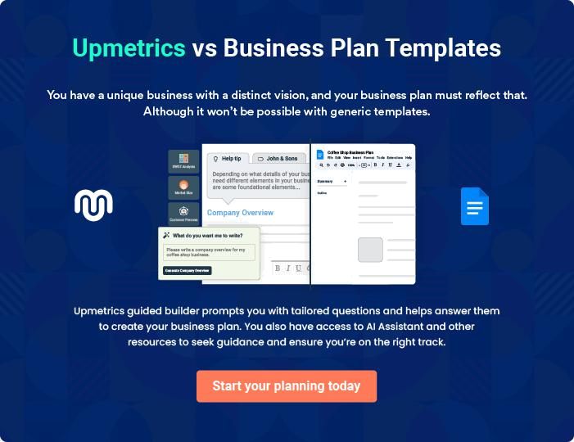

Silver Healing - Massage Therapy | Business Plan [YEAR] | 15/36

4.

Marketing Plan

Mission Statement

Marketing Outreach Plan

SWOT Analysis

Pricing Strategy

Silver Healing - Massage Therapy | Business Plan [YEAR] 16/36

Mission Statement

 Silver Healing

Helping people improve the quality of their lives through massage and floatation therapy.

To unlock help try Upmetrics! 

Start writing here..

Marketing Outreach Plan

 Silver Healing

Clients tend to fall into one or more of the following categories: Injury Recovery, Self-Care/ Relaxation, Alternative Care Users, and Athletes. Each group requires a different marketing
strategy. Online, in-person and publicity outreach plans will have different effects on different
To unlock help try Upmetrics! 

Start writing here..

Silver Healing - Massage Therapy | Business Plan [YEAR] 17/36

Online/Social Media

What | Frequency | How to measure | Target | Cost
What | Frequency | How to measure | Market | Cost
 |  | Number of new | Alt. Care, | $5 - $20/
Google | Clicks per day cost | Number of new | Injury | $5 - $20/
Google | Clicks per day cost | inquiries/month | Injury | day
 |  | inquiries/month | Recovery | day
 |  |  |  | 18%
Yelp | Quarterly deals | Number of purchases | Self-Care | discount
 |  |  |  | off our
 |  |  |  | services
 |  |  | Ads
 | Daily posts to engage | Customer engagement | specific to
Facebook | Daily posts to engage | vs. the number of new | each of the | $10/day
Facebook | & educate | vs. the number of new | each of the | $10/day
 | & educate | customers | 4 main
 |  |  | categories
E-newsletter | Monthly | Number of clicks | Self-Care | $20/month
Healthprofs.com | Monthly | Inquires/month | Alt. Care, | $30/month
Healthprofs.com | Monthly | Inquires/month | Injury | $30/month

People/Networking

What | Frequency | How to | Target Market | Cost
What | Frequency | measure | Target Market | Cost
Attend health, |  | Number of
sports, or |  | Number of | Athletes,
sports, or |  | interactions and | Athletes,
business events | 1 per month | interactions and | Injury | Varies
business events | 1 per month | demographics | Injury | Varies
in the Portland |  | demographics | Recovery
in the Portland |  | collected | Recovery
area |  | collected
Offer discounted | 1 organization |  | Alternative
Offer discounted | 1 organization | Number of new | Care, Self-Care | 15%-40%
floats to | every 2 months | Number of new | Care, Self-Care | 15%-40%
floats to | every 2 months | clients | Injury | discount
organizations | or 6 orgs per year | clients | Injury | discount
organizations | or 6 orgs per year |  | Recovery
Float |  |  | Alternative | Matched pay-it-
scholarships to | Depends on | Number of new | Alternative | Matched pay-it-
scholarships to | Depends on | Number of new | Care, Injury | forward
underserved | demand | clients | Care, Injury | forward
underserved | demand | clients | Recovery | program
communities |  |  | Recovery | program

Silver Healing - Massage Therapy | Business Plan [YEAR] 18/36

What | Frequency |  |  | How to |  |  | Target Market |  |  |  | Cost
What |  |  |  | measure
 | 1-2 per year, i.e. |  |  | Number of gifts
Discounted gift | Holiday Gift |  |  |  |  |  |  |  |  |  | 15%-40%
Discounted gift |  |  |  | certificates sold |  |  | Self-Care
certificates | Certificates |  |  |  |  |  |  |  |  |  | discount
Reach out to |  |  |  |  |  |  | Injury
Reach out to | 3 people each |  |  | Referral network |  |  | Recovery,
health care |  |  |  |  |  |  |  |  |  |  | Varies
health care | month |  |  | increase |  |  | Alternative
practitioners
practitioners |  |  |  |  |  |  | Care
Other Promotion and Publicity
What |  | Frequency |  |  | How to measure |  |  |  | Target Market |  |  | Cost
 |  | 2 per year for |  |  | Number of new |  |  |  | All categories |  |  | $0.35 per
Direct mailing |  |  |  |  |  |  |  |  |  |  |  | postcard
Direct mailing |  | client birthday & |  |  | bookings from that |  |  |  | – specific |  |  | postcard
Postcard |  |  |  |  |  |  |  |  |  |  |  | average
Postcard |  | anniversary with |  |  | client within a |  |  |  | postcard for |  |  | average
 |  |  |  |  |  |  |  |  |  |  |  | $15 per
 |  | us |  |  | month |  |  |  | type of client |  |  | $15 per
 |  |  |  |  |  |  |  |  |  |  |  | month
 |  | Every 3 months to |  |  | Educational |  |  |  | Alternative |  |  | $0.49 per
Direct mailing |  |  |  |  |  |  |  |  |  |  |  | letter –
Direct mailing |  | a different |  |  | Number of new |  |  |  | Care, |  |  | letter –
Brochure |  |  |  |  |  |  |  |  |  |  |  | average $30
Brochure |  | adjacent |  |  | bookings or |  |  |  | Athletes, Self- |  |  | average $30
 |  |  |  |  |  |  |  |  |  |  |  | per
 |  | neighborhood |  |  | inquiries/month |  |  |  | Care |  |  | per
 |  |  |  |  |  |  |  |  |  |  |  | month
 |  |  |  |  |  |  |  |  |  |  |  | $0.35 per
Direct mailing |  | Thank you card to |  |  | Clients retained |  |  |  | All categories |  |  | postcard avg
Postcard |  | all new clients |  |  |  |  |  |  |  |  |  | $15
 |  |  |  |  |  |  |  |  |  |  |  | per month
 |  |  |  |  |  |  |  |  | Injury |  |  | Varies
Magazine and blog |  |  |  |  | # of new |  |  |  | Recovery, |  |  | Varies
Magazine and blog |  | 1 per quarter
articles |  |  |  |  | inquiries/quarter |  |  |  | Alternative
 |  |  |  |  |  |  |  |  | care, Athletes
Anniversary/Client |  | Once per year |  |  | How many people |  |  |  | All categories |  |  | $200-300
celebration event |  |  |  |  | show up |  |  |  |  |  |  | $200-300
1 Month before |  | Membership + a |  |  | Number of new |  |  |  |  |  |  | Varies
opening offers |  | free float + 10% |  |  | members |  |  |  | All categories |  |  | Varies
online, print |  | off retail for $60

SWOT Analysis

Silver Healing - Massage Therapy | Business Plan [YEAR] 19/36


Strength

- Experienced existing business owner and manager

- Owner is an expert in massage therapy and floatation therapy

- Existing massage clientele

- Pro-active marketing plan in place

- Emerging float industry is growing exponentially

- Combining 2 successful growing industries – floatation (15-20 float centers in the US in 2009 to over 271 centers in 2015 according to Time Magazine) and massage therapy (expected to increase 23% by 2022 according to US Dept. of Labor)

- Owner uses business educational resources such as classes, webinars and mentors to improve business practices

- Owner is client oriented

- Population of Portland as a whole utilizes alternative health care

- Owner has the support and guidance of existing float centers in town
Weakness


- Not enough existing clientele to run at capacity immediately following build out

- Owner is new to the float industry

- Owner is new to large scale marketing

- Will need a loan to fund build out and first year

- Owner is currently running the business solo and will need to manage construction/build out and run the existing business

- It will take at least 1 year to gain the experience to run the center optimally

Silver Healing - Massage Therapy | Business Plan [YEAR] 20/36

Opportunity
To unlock help try Upmetrics!

- Now is an ideal time to join the float industry which has been increasing in the public awareness though mass media from “Dr. Oz” to the “New York Times” to “The Simpsons”, more people are familiar with and utilize floating than at any other time

- Build upon existing clientele

- Create a community and a fan base

- Shift the general public perception toward floating as preventative health care

- Participate in floatation research projects, i.e. The Fibromyalgia Project

- Portland is a unique city and one that supports emerging trends

- Profit is high for floats, average spent on materials per float is about $5, COGS 7%

- Profit is average for massage therapy: COGS 45%

- Profit is high for insurance related massage therapy: COGS 18%

- Product sales increase revenue

- Provide an exceptional experience that is not found else where in Portland

- Long term goal to expand Silver Healing’s business model to multiple locations
Threat


- Industry growth could drop off due to an unforeseen shift in the publics interest in wellness

- Loans diminish profitability until they are paid off

- First year will be financially tight while we gain customers and pay off loans

- Competition in the area could increase

- Management of employees (especially LMTs) requires time, money and effort

- Multnomah County Health Department could change their non-regulatory status and decide to regulate float tanks

Pricing Strategy

 Silver Healing

We educate clients about regularly receiving the benefits of floating and massage therapy as part of their self-care practice. Monthly memberships start at $60/month and come with benefits.



Start writing here..

Silver Healing - Massage Therapy | Business Plan [YEAR] 21/36

 Silver Healing

$60 for 1 float per month. Additional floats $55 each. 10% off retail. No contract required. Automatic monthly payments. Cancel at any time. May be shared with 1 person. Personal audio storage up to 2GB. Earn $5 for every referral. No expiration on floats unless you cancel
To unlock help try Upmetrics! 

Membership

Start writing here..

 Silver Healing

The lowest price we offer for a float is $45 or 40% off. The lowest price we offer for massage is $64/hour or 20% off. These prices are not advertised regularly but are reserved for special promotions. We are not interested in attracting clients looking for a deal. We are interested in
To unlock help try Upmetrics! 

Gift certificates available.

Start writing here..

Silver Healing - Massage Therapy | Business Plan [YEAR] 22/36

5.

Financial Plan

Monthly Personal Budget

Expansion Costs

Sources of Financing

Overhead Business Costs

Projected Profit and Loss

Projected Cash Flow

Projected Balance Sheet

Silver Healing - Massage Therapy | Business Plan [YEAR] 23/36

Monthly Personal Budget

 Silver Healing

The owner’s personal monthly expenses total $1,650. Dana will draw $1,800/month as her sole source of income until one full year in the new location. At the one-year mark, Dana will reassess and may increase the owner’s draw to $2000/month until all loans are paid in full.
To unlock help try Upmetrics! 

Start writing here..

Expansion Costs


Silver Healing LLC

Project Budget SOURCES & USES Breakdown

Requirements:
Store supplies | $1,368
Website design | $3,000
Advertising (Launch campaign) | $2,000
Legal & accounting | $200
Store interior paint | $3,500
Marketing | $3,000
Insurance & other contingencies | $500
Signage | $3,145
Store furniture & fixtures | $15,000
Plans & Permits | $9,000
Epoxy & Tile Flooring | $10,000
Plumbing | $7,000
Natural Gas | $2,000
Electrical | $7,000
HVAC | $5,000
Sound Proofing | $13,000

Silver Healing - Massage Therapy | Business Plan [YEAR] 24/36

Silver Healing LLC
Total Expenses | $84,713
Assets
3 Ocean Float Rooms | $124,000
Tankless water heater | $3,471
Computer system | $2,116
Store telecommunication | $200
LG True Steam Washer Dryer | $3,000
Working capital | $27,000
Total Assets | $159,787
Total Expenses plus Assets | $244,500
Funding:
Owner investment | $50,000
Outside financing | $194,500
Total Funding Requirement | $244,500

Sources of Financing


Source

Personal Savings

Bank Loan

Total

Amount

$85,000

$196,725

$281,725

Overhead Business Costs

Silver Healing - Massage Therapy | Business Plan [YEAR] 25/36

Expenses
Rent | $6,000
Utilities
Phone/internet | $140
Gas/Electric | $100
Water | $250
Garbage
Employees | $2500
Paychecks
Health Insurance
Maintenance/repair
Liability insurance | $16
Health insurance
Loan payment | $550
Taxes | $833
Promotion | $258
Professional license fees | $23
Professional fees (legal or accounting) | $300
Office Supplies | $25
Repair / Maintenance | $300
Misc. expense
Total expenses | $11,325

Projected Profit and Loss

Silver Healing - Massage Therapy | Business Plan [YEAR] 26/36

Revenue

Individual Massage

Sessions

Unit Sales

Unit Price

Group Therapy Sessions

Unit Sales

Unit Price

Wellness Workshop Sales

Unit Sales

Unit Price

Cost Of Sales

General Costs

Massage Supplies

Massage Oils

Towels and Linens

Massage Tables

Maintenance

Wellness Workshop

Materials

Printed Materials

Workshop Supplies

Revenue Specific Costs

Personnel Costs (Direct Labor)

2024 | 2025 | 2026
$259,284.20 | $430,054 | $718,913.40
$127,340 | $228,703.20 | $410,720
1,592 | 2,859 | 5,134
$80 | $80 | $80
$56,769.20 | $80,940.80 | $115,403.40
2,838 | 4,047 | 5,770
$20 | $20 | $20
$75,175 | $120,410 | $192,790
150 | 241 | 386
$500 | $500 | $500

$7,440 | $7,200 | $7,320
$7,440 | $7,200 | $7,320
$5,400 | $5,400 | $5,400
$2,400 | $2,400 | $2,400
$1,800 | $1,800 | $1,800
$1,200 | $1,200 | $1,200
$2,040 | $1,800 | $1,920
$600 | $600 | $600
$1,440 | $1,200 | $1,320
$0 | $0 | $0
$0 | $0 | $0

Silver Healing - Massage Therapy | Business Plan [YEAR] 27/36

 | 2024 | 2025 | 2026
Gross Margin | $251,844.20 | $422,854 | $711,593.40
Gross Margin (%) | 97.13% | 98.33% | 98.98%

Operating Expense | $319,020 | $325,154.46 | $331,396.92
Payroll Expense (Indirect | $277,020 | $282,560.40 | $288,211.68
Labor) | $277,020 | $282,560.40 | $288,211.68
Massage Therapists | $100,080 | $102,081.60 | $104,123.28
Senior Massage Therapist | $57,600 | $58,752 | $59,927.04
Junior Massage Therapist | $42,480 | $43,329.60 | $44,196.24
Administrative Staff | $84,900 | $86,598 | $88,329.96
Receptionist | $34,500 | $35,190 | $35,893.80
Office Manager | $50,400 | $51,408 | $52,436.16
Wellness Workshop | $92,040 | $93,880.80 | $95,758.44
Instructors | $92,040 | $93,880.80 | $95,758.44
Yoga Instructor | $42,480 | $43,329.60 | $44,196.24
Nutrition Consultant | $49,560 | $50,551.20 | $51,562.20
General Expense | $42,000 | $42,594.06 | $43,185.24
Facility Costs | $24,000 | $24,300 | $24,604.20
Rent | $18,000 | $18,180 | $18,361.80
Utilities | $6,000 | $6,120 | $6,242.40
Operational Costs | $6,000 | $6,120 | $6,242.40
Massage Supplies | $3,600 | $3,672 | $3,745.44
Equipment Maintenance | $2,400 | $2,448 | $2,496.96
Marketing and Advertising | $12,000 | $12,174.06 | $12,338.64
Digital Marketing | $7,200 | $7,278.06 | $7,344.72
Print Advertising | $4,800 | $4,896 | $4,993.92

Silver Healing - Massage Therapy | Business Plan [YEAR] 28/36

Bad Debt

Amortization of Current Assets

EBITDA

Additional Expense

Long Term Depreciation

Gain or loss from Sale of Assets

EBIT

Interest Expense

EBT

Income Tax Expense / Benefit

Total Expense

Net Income

Net Income (%)

Retained Earning Opening

Owner's Distribution

Retained Earning Closing

2024 | 2025 | 2026
$0 | $0 | $0
$0 | $0 | $0

($67,175.80) $97,699.54 $380,196.48

$5,228.50 | $4,476 | $4,476
$4,476 | $4,476 | $4,476
$0 | $0 | $0
($71,651.80) | $93,223.54 | $375,720.48
$752.49 | $0 | $0
($72,404.30) | $93,223.54 | $375,720.48
$0 | $0 | $0

$331,688.50 | $336,830.46 | $343,192.92
($72,404.30) | $93,223.54 | $375,720.48
(27.92%) | 21.68% | 52.26%

$0 | ($90,404.30) | ($5,180.76)
$18,000 | $8,000 | $8,000
($90,404.30) | ($5,180.76) | $362,539.72

Silver Healing - Massage Therapy | Business Plan [YEAR] 29/36

Projected Cash Flow

 | 2024 | 2025 | 2026
Cash Received | $259,284.20 | $430,054 | $718,913.40
Cash Paid | $327,212.50 | $332,354.46 | $338,716.92
COS & General Expenses | $49,440 | $49,794.06 | $50,505.24
Salary & Wages | $277,020 | $282,560.40 | $288,211.68
Interest | $752.49 | $0 | $0
Sales Tax | $0 | $0 | $0
Income Tax | $0 | $0 | $0
Net Cash From | ($67,928.30) | $97,699.54 | $380,196.48
Operations | ($67,928.30) | $97,699.54 | $380,196.48
Assets Sell | $0 | $0 | $0
Assets Purchase | $30,000 | $0 | $0
Net Cash From | ($30,000) | $0 | $0
Investments | ($30,000) | $0 | $0
Amount Received | $80,000 | $0 | $0
Loan Received | $50,000 | $0 | $0
Common Stock | $30,000 | $0 | $0
Preferred Stock | $0 | $0 | $0
Owner's Contribution | $0 | $0 | $0
Amount Paid | $67,999.99 | $8,000 | $8,000
Loan Capital | $50,000 | $0 | $0
Dividends & Distributions | $18,000 | $8,000 | $8,000
Net Cash From | $12,000.01 | ($8,000) | ($8,000)
Financing | $12,000.01 | ($8,000) | ($8,000)

Silver Healing - Massage Therapy | Business Plan [YEAR] 30/36

 | 2024 | 2025 | 2026
Summary
Starting Cash | $0 | ($85,928.29) | $3,771.25
Cash In | $339,284.20 | $430,054 | $718,913.40
Cash Out | $425,212.49 | $340,354.46 | $346,716.92
Change in Cash | ($85,928.29) | $89,699.54 | $372,196.48
Ending Cash | ($85,928.29) | $3,771.25 | $375,967.73
Projected Balance Sheet
 | 2024 | 2025 | 2026
Assets | ($60,404.29) | $24,819.25 | $392,539.73
Current Assets | ($85,928.29) | $3,771.25 | $375,967.73
Cash | ($85,928.29) | $3,771.25 | $375,967.73
Accounts Receivable | $0 | $0 | $0
Inventory | $0 | $0 | $0
Other Current Assets | $0 | $0 | $0
Long Term Assets | $25,524 | $21,048 | $16,572
Gross Long Term Assets | $30,000 | $30,000 | $30,000
Accumulated Depreciation | ($4,476) | ($8,952) | ($13,428)
Liabilities & Equity | ($60,404.30) | $24,819.24 | $392,539.72
Liabilities | $0 | $0 | $0
Current Liabilities | $0 | $0 | $0
Accounts Payable | $0 | $0 | $0
Income Tax Payable | $0 | $0 | $0

Silver Healing - Massage Therapy | Business Plan [YEAR] 31/36

 | 2024 | 2025 | 2026
Sales Tax Payable | $0 | $0 | $0
Short Term Debt | $0 | $0 | $0
Long Term Liabilities | $0 | $0 | $0
Long Term Debt | $0 | $0 | $0
Equity | ($60,404.30) | $24,819.24 | $392,539.72
Paid-in Capital | $0 | $0 | $0
Common Stock | $30,000 | $30,000 | $30,000
Preferred Stock | $0 | $0 | $0
Owner's Contribution | $0 | $0 | $0
Retained Earnings | ($90,404.30) | ($5,180.76) | $362,539.72

Check | $0 | $0 | $0

Silver Healing - Massage Therapy | Business Plan [YEAR] 32/36

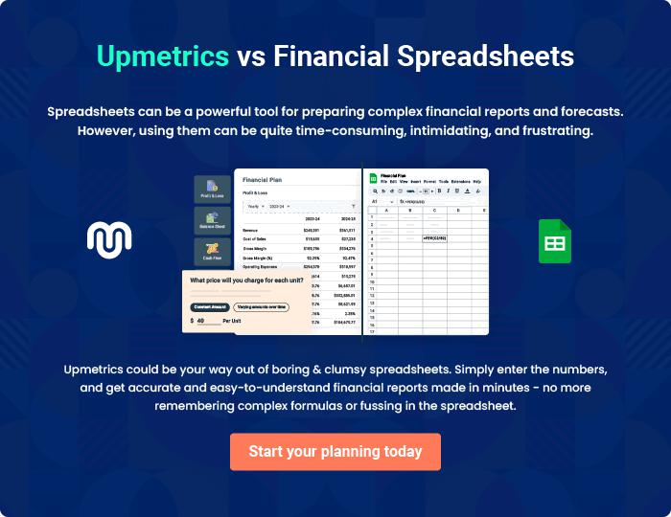

Silver Healing - Massage Therapy | Business Plan [YEAR] | 33/36

6.

Appendix

Sales Forecast

Personnel

Profit and Loss

Cash Flow

Balance Sheet

Silver Healing - Massage Therapy | Business Plan [YEAR] 34/36

Sales Forecast

Insert Monthly Sales Forecast data

Personnel

Insert Monthly Personnel Forecast data

Profit and Loss

Insert Monthly Profit and Loss Projections

Cash Flow

Insert Monthly Cash Flow Projections

Balance Sheet

Insert Monthly Balance Sheet Projections

Silver Healing - Massage Therapy | Business Plan [YEAR] 35/36

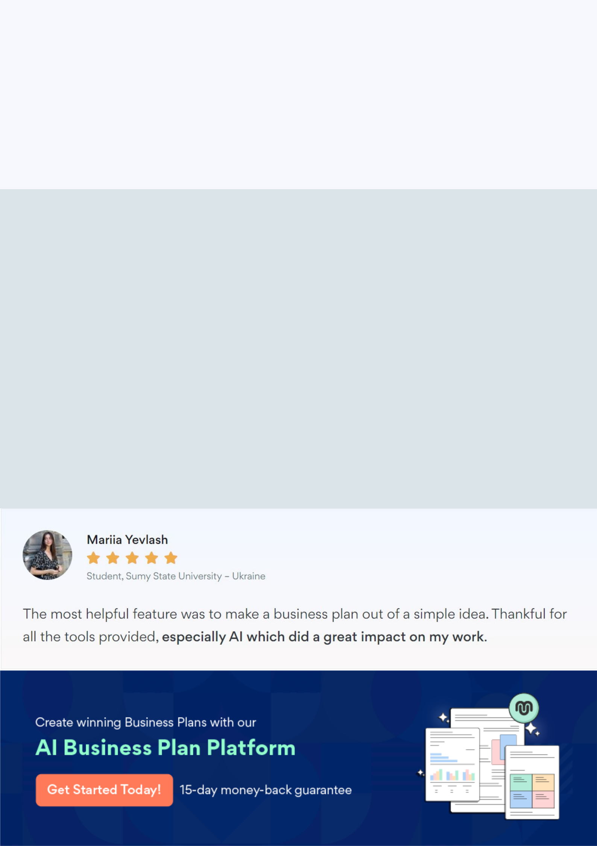
Create a winning business plan that gets you funded

Creating a stunning and investment-ready plan requires no writing, graphic designing, or financial planning expertise.

Upmetrics has all the features required to help you create a comprehensive business plan—from start to finish. Make no mistakes, it’s the modern way of planning to structure ideas, make plans, and create stunning pitch decks to awe investors.

Pitch decks that impress investors

Create pitch decks that provide a visual representation of your business, engage investors, and make them want to invest in your business idea.

Interactive plans in no time

Import business plan sections like—SWOT analysis, comparison tables, and others to create an interactive business plan. No designing skills are required.

Stunning cover page designs

With Upmetrics, you have the liberty to choose from multiple stunning cover page designs. Choose a creative design and make your plan stand out.

Online sharing made simple

Upmetrics makes online sharing quick and easier for users. Easily share your business plans with a link while tracking reader activity.

500+ sample business plans

Simply import a template from our library of sample plans into the editor and start customizing it to make it yours. It takes only a few clicks to get started.

Collaborate with team in real-time

Invite team members, initiate conversations, discuss ideas & strategies, share feedback, and work on a business plan in real-time.

