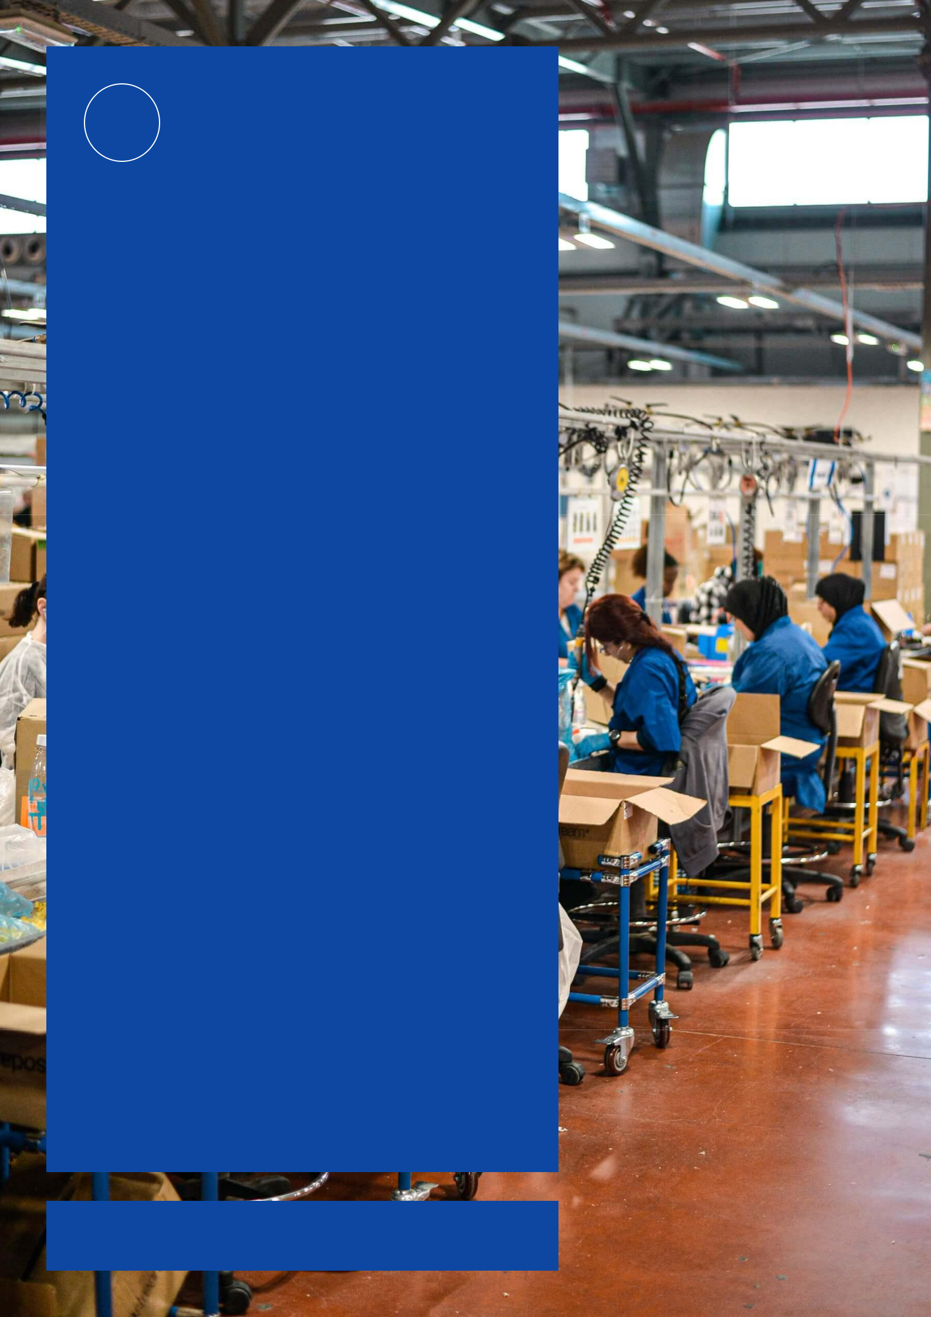


Manufacturing

A Company Of Quality

Business

Plan

[YEAR]

John Doe

10200 Bolsa Ave, Westminster, CA, 92683

- 359-3153 info@example.com http://www.example.com

CONFIDENTIAL

Table of Contents

Executive Summary | 5
Business Profile Summary | 6
Market Research Summary | 6
Marketing Summary | 6
Finance Summary | 7
Net Income | 7

Business Description | 8
Business Overview | 9
Business Description | 9
Unique Value Proposition | 9
Company History | 9
Management | 10
Location | 10
Legal Structure | 10
Vision & Mission | 11
Professional Advisors | 11
Goals & Objectives | 11

Products and Services | 12
Products | 13
Premium Sustainable Leather Designer Bag | 13
Alternate Sustainable Material Bag | 13
Heirloom Limited Edition Bag | 13
Basic Purse | 14

Market Research | 15
Industry Profile & Outlook | 16
Local Market | 16
Key Competitors / SWOT Analysis | 17
Ci Comme Ca | 17

Manufacturing | Business Plan [YEAR] 2/37

Baggit | 18
Target Market | 18
Customer Survey Summary | 19

Sales & Marketing | 20
Pricing Strategy | 21
Alternate Sustainable Material Bag | 21
Premium Sustainable Leather Material Bag | 21
Heirloom Limited Edition Bag | 21
Basic Purse | 22
Marketing Strategy | 22
Digital Marketing | 22
In Person Marketing | 23
Print Marketing | 23

Operations | 24
Location(s) | 25
Legal Issues | 25
Insurance Issues | 25
Human Resources | 26
Jennifer Martinez | 26
Packaging/Shipping/Handling | 26
Manufacturing Assistant | 26
Marketing Designer | 26
Process/Production | 27
Production Flow and Delivery Method of Products and Services | 27
Suppliers | 27
Risk Assessment | 28

Financials | 29
Breakeven analysis | 30
Projected Profit and Loss | 30
Projected Cash Flow | 33
Projected Balance Sheet | 34

Manufacturing | Business Plan [YEAR] 3/37

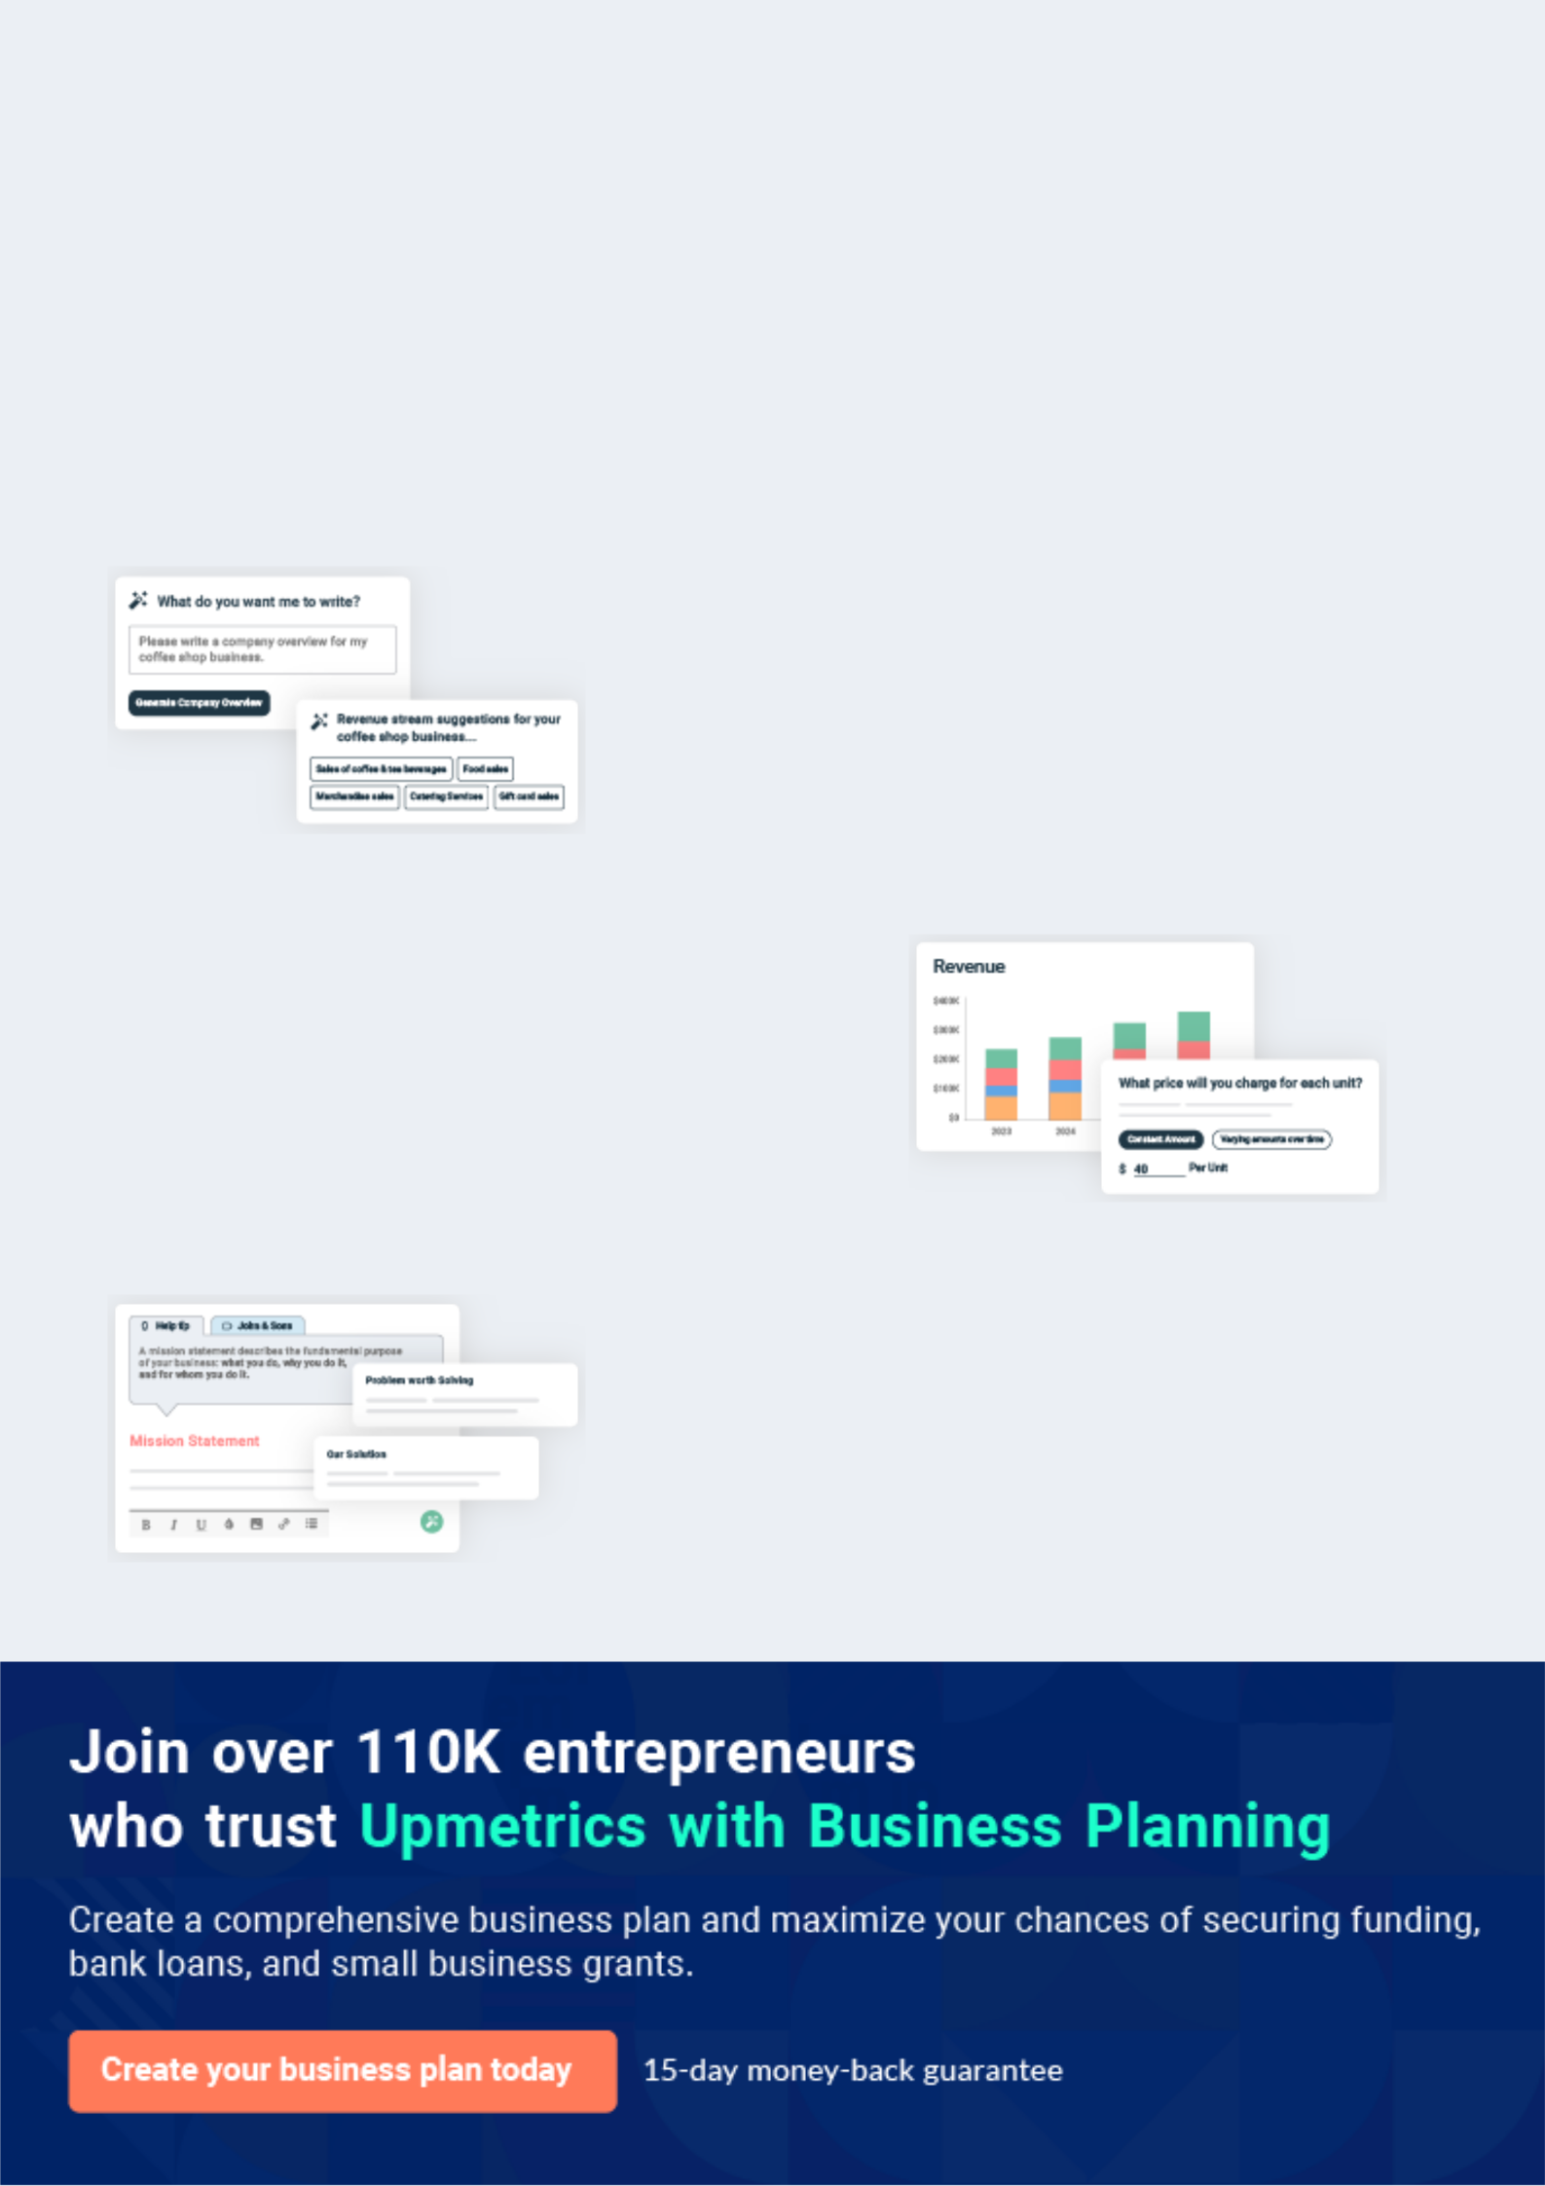
Business planning that’s simpler and faster than you think

Creating a business plan using Upmetrics to start and grow a business is literally the easiest thing in the World. Simply read the instructions and fill in the blanks. It’s as simple as that.

❛ | Upmetrics has everything you need to create a | ❜
❛ | comprehensive business plan. | ❜

AI-powered Upmetrics Assistant

AI-powered insights to streamline your plan

Not sure where to start? Upmetrics’ AI Assistant will automatically generate ideas for each section of your plan and offer improved versions of your writing, adjusting for tone, voice, and grammar or spelling errors.

Financial Forecasting Tool

All the financials are calculated for you

Forget the complex formulas and clumsy spreadsheets — with automatic financials and drag-and-drop forecasting, you can finish your plan faster and be confident that your numbers are accurate.

Business Plan Builder

Guides you like a business mentor

Upmetrics’ step-by-step instructions, prompts, and the library of 400+ sample business plans will guide you through each section of your plan as a business mentor.

1.


Executive Summary

Business Profile Summary

Market Research Summary

Marketing Summary

Finance Summary

Manufacturing | Business Plan [YEAR] 5/37

Business Profile Summary
To unlock help try Upmetrics!

 Baggit


Baggit designs manufacture and sell the highest quality men’s and women’s designer bags and totes. Baggit distributes products through its online store, boutique retailers, and brick and mort ar fashion outlets across North America. Wholesale is a key part of Baggit’s strategy through
To unlock help try Upmetrics! 

Start writing here..

Market Research Summary

 Baggit

Jennifer has built key relationships throughout her career in retail sales, fashion design education, and employment at an overseas manufacturer in Spain who is now a supplier of Baggit. Jennifer plans to leverage these relationships to eventually enter into the major retail
To unlock help try Upmetrics! 

Start writing here..

Marketing Summary

 Baggit

During the first year, Baggit will build on the success of attending local markets, pop-up shops, and boutiques for regular sales. Baggit will attend an average of 4 markets or pop-up shops per month to maintain sales.



Start writing here..

Manufacturing | Business Plan [YEAR] 6/37

Finance Summary

Net Income
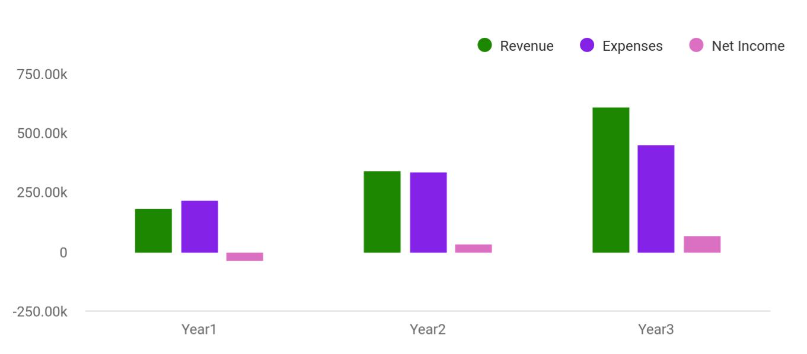

Financial Year | Revenue | Expenses | Net Income
Year1 | 184,074 | 219,452 | -35,378
Year2 | 341,645 | 338,451 | 35,000
Year3 | 612,545 | 451,125 | 70,000

Manufacturing | Business Plan [YEAR] 7/37

2.

Business Description

Business Overview

Company History

Management

Location

Legal Structure

Vision & Mission

Professional Advisors

Goals & Objectives

Manufacturing | Business Plan [YEAR] 8/37

Business Overview

 Baggit

Baggit designs manufacture and sell the highest quality men’s and women’s designer bags and totes. Baggit distributes products through its online store, boutique retailers, and brick and mortar fashion outlets across North America. All of the materials are sustainably sourced and
To unlock help try Upmetrics! 

Business Description

Start writing here..

 Baggit

The top three features of Baggit products and their value to the customer:

1. Intelligent organization compartments using lightweight materials.
To unlock help try Upmetrics! 

Unique Value Proposition

Start writing here..

Company History

 Baggit

Since a young child, Jennifer Martinez has been inspired by her grandmother’s love for Spanish leather-carving and her grandfather’s career as a curator for The Museo Nacional del Prado (Popularly called El Prado) museum in Madrid. Jennifer learned to sew and pattern from her
To unlock help try Upmetrics! 

Start writing here..

Manufacturing | Business Plan [YEAR] 9/37

Management

 Baggit

Jennifer Martinez, 28 years old - 100% Owner/Designer

Jennifer Martinez holds a Bachelor of Design Degree from Emily Carr University. She has been
To unlock help try Upmetrics! 

Start writing here..

Location

 Baggit

Baggit currently operates rent-free from a 600 square foot garage at 252 National Street, Burnaby. After 6 months of operations, the company will require a 1000 square foot additional storage and assembly space. An example of the ideal 1000 square foot space is 1352
To unlock help try Upmetrics! 

Start writing here..

Legal Structure

 Baggit

Baggit is a sole proprietorship, 100% owned by Jennifer Martinez. A sole proprietorship will fulfill all of the company’s requirements for at least the first 2 years.
To unlock help try Upmetrics! 

Start writing here..

Manufacturing | Business Plan [YEAR] 10/37

Vision & Mission
To unlock help try Upmetrics!

 Baggit

In 10 years, the Baggit team will be 100 employees strong and headquartered in Toronto and New York City. The company will have distribution partnerships with major department stores throughout North America such as Nordstrom and Macy’s.



Start writing here..

Professional Advisors

 Baggit

Rex Eagleton: 20-year business owner in the clothing industry.

Rex is a family friend of Jennifer’s and has been an invaluable source for advice and guidance
To unlock help try Upmetrics! 

Start writing here..

Goals & Objectives

Goal | Objectives | Date
 | • Reach $192,000 in sales
 | • Introduce one new product
Goal 1 | • Attend at least 2 trade shows and 3 high-profile fashion shows | Year1
 | • Sell at least 1 exclusive product to a local or national celebrity
 | • Reach $300,000 in sales
Goal 2 | • Presence in a major retail chain | Year2

Manufacturing | Business Plan [YEAR] 11/37

3.

Products and Services

Products

Manufacturing | Business Plan [YEAR] 12/37

Products

 Baggit

All materials for Baggit’s premium line are selected for quality and durability. Materials include chromium-free, vegetable-tanned, high-end leather, and recycled cork.
To unlock help try Upmetrics! 

Premium Sustainable Leather Designer Bag

Start writing here..

 Baggit

All materials for Baggit’s Alternate material line are selected for quality and durability. Materials include Hemp fabric, bamboo, cork, organic wool, and linens.
To unlock help try Upmetrics! 

Alternate Sustainable Material Bag

Start writing here..

 Baggit

Heirloom edition bags are 100% handmade locally and incorporate original artwork from up and coming global artists. Materials used are similar to the premium design models but the hardware used for each bag uses pure materials such as Stainless Steel, Carbon Fibre, Gold,
To unlock help try Upmetrics! 

Heirloom Limited Edition Bag

Start writing here..

Manufacturing | Business Plan [YEAR] 13/37

 Baggit

These entry-level bags employ similar design and functionality as the premium models, but use less-expensive materials and are produced 100% mechanically by the manufacturer. The average material and labor costs for each bag are $20 and shipping is $150 per 100 bags.
To unlock help try Upmetrics! 

Basic Purse

Start writing here..
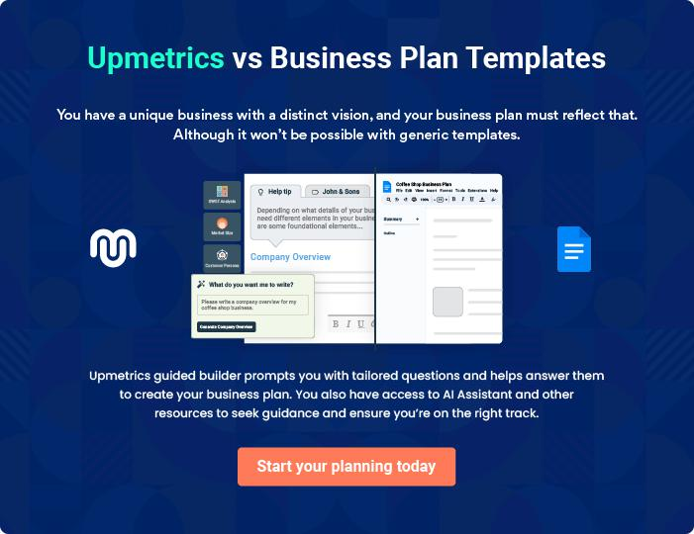

Manufacturing | Business Plan [YEAR] 14/37

4.

Market Research

Industry Profile & Outlook

Local Market

Key Competitors / SWOT Analysis

Target Market

Customer Survey Summary

Manufacturing | Business Plan [YEAR] 15/37

Industry Profile & Outlook

 Baggit

Baggit operates primarily in the Manufacturing industry.

Handbags became a symbol of women's independence in the 20th century, according to
To unlock help try Upmetrics! 

Start writing here..

Local Market

 Baggit

Baggit’s early sales strategy will include targeting small vendors such as boutique clothing and accessory shops, markets and pop-up shops, as well as some trade shows and fairs.
To unlock help try Upmetrics! 

Start writing here..

Manufacturing | Business Plan [YEAR] 16/37

Key Competitors / SWOT Analysis

Ci Comme Ca

Start writing here..

Strength | Weakness
• Uses many different options for materials | • Style across products is not distinct
• Strong reputation | • Confusing website
• Connections in fashion industry | • Brand is not cohesive
• Large social media following and | • Only sells through Etsy
engagement
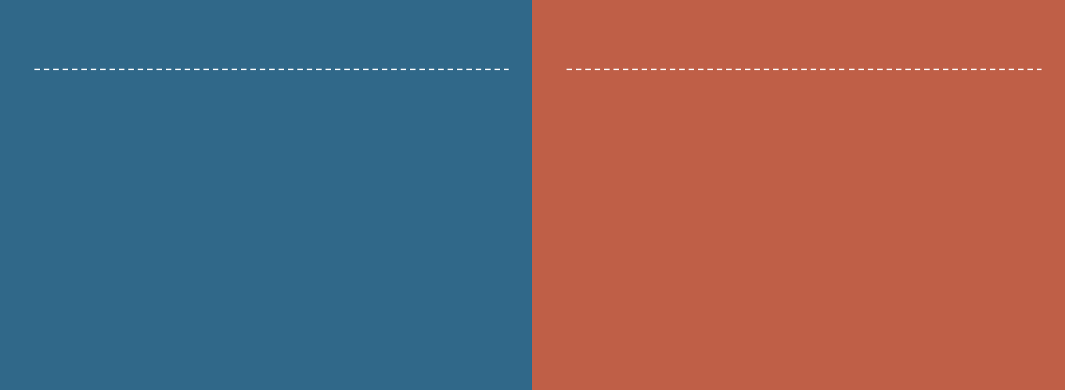

Opportunity

- Could expand distribution

- Leverage large social networks more effectively

Threat

- Vulnerable to crashes and changes because of reliance upon Etsy

Manufacturing | Business Plan [YEAR] 17/37

Baggit

Start writing here..

Strength | Weakness
• Highest quality materials | • Smaller social media networks
• Strong relationships in fashion and retail | • Lower profit margins due to smaller
industries | batches during the first year
• Offers both high-end luxury and
accessible lines of bags

Opportunity

- Develop stronger social media networks

- Increase margins by making larger raw material purchases

- Student interns

- Maximize partnership with previous employers

Threat

- Changes in import regulations

- Fluctuations in currency could affect margins

Target Market

 Baggit

Primary Target Market – End consumer

• 26 – 32-year-old women; 35 – 40-year-old men
To unlock help try Upmetrics! 

Start writing here..

Manufacturing | Business Plan [YEAR] 18/37

Customer Survey Summary

 Baggit

Based on a recent survey poll, Baggit has updated its design and marketing strategy to confirm a target market.
To unlock help try Upmetrics! 

Start writing here..

Manufacturing | Business Plan [YEAR] 19/37

5.

Sales & Marketing

Pricing Strategy

Marketing Strategy

Manufacturing | Business Plan [YEAR] 20/37

Pricing Strategy

 Baggit

This product is priced at the lower end of designer bags and is intended to be used as an everyday bag with more common materials employed. The MSRP for this product is $225.
To unlock help try Upmetrics! 

Alternate Sustainable Material Bag

Start writing here..

 Baggit

This product is priced at the high end of the ‘accessible’ designer bags but the low end of the well-known brand names and is intended to be used for specific purposes and special occasions with higher-end materials and designs used. The average MSRP of this product is
To unlock help try Upmetrics! 

Premium Sustainable Leather Material Bag

Start writing here..

 Baggit

This product is priced at the premium level. Only 2-3 will be made per year and the opportunity to purchase them will only happen 2 times per year on an application basis. They are exclusive and one-of-a-kind items. These high-end bags are used to raise the profile of Baggit products
To unlock help try Upmetrics! 

Heirloom Limited Edition Bag

Start writing here..

Manufacturing | Business Plan [YEAR] 21/37

 Baggit

This product has been created to provide a smaller, more affordable entry level for consumers. It is an everyday purse and a way for customers to discover the quality and style of Baggit products, but without having to invest in a more expensive bag immediately. The MSRP for this
To unlock help try Upmetrics! 

Basic Purse

Start writing here..

Marketing Strategy

 Baggit

Digital Marketing strategies will focus on Instagram, Facebook, Professional Bloggers, and directing traffic to Baggit's website.
To unlock help try Upmetrics! 

Start writing here..

 Baggit

Most Instagram and Facebook posts will be used to engage with customers as opposed to advertising or direct selling with approximately 3 to 4 posts every day rotating between fashion and entertainment info; makeup and fashion tutorials; latest trends from Paris, New York, and
To unlock help try Upmetrics! 

Digital Marketing

Start writing here..

Manufacturing | Business Plan [YEAR] 22/37

 Baggit

Baggit stands out at every event because of the unique and creative displays, for example, turning our display table into a high-end-looking runway using mannequins. At each event, the aim is to collect an email address from each booth visitor by offering something of value in
To unlock help try Upmetrics! 

In Person Marketing

Start writing here..

 Baggit

Circulation of approximately 100 business cards per month at a cost of $300 per year.

Circulation of approximately 500 flyers/per month at a cost of $500 per month.
To unlock help try Upmetrics! 

Print Marketing

Start writing here..

Manufacturing | Business Plan [YEAR] 23/37

6.

Operations

Location(s)

Legal Issues

Insurance Issues

Human Resources

Process/Production

Risk Assessment

Manufacturing | Business Plan [YEAR] 24/37

Location(s)

 Baggit

Currently, Baggit operates out of a 600 square foot garage for its manufacturing, storage, packaging, and shipping. Space includes a fabric and materials storage area, 2 large working tables, 2 sewing machines, and a small product storage area. Working and storage are
To unlock help try Upmetrics! 

Start writing here..

Legal Issues

 Baggit

Baggit anticipates the following legal issues:

• business licenses
To unlock help try Upmetrics! 

Start writing here..

Insurance Issues

 Baggit

Basic Liability Insurance will be obtained through Atkinson and Terry Insurance and will be paid in monthly installments to help increase monthly cash flow.
To unlock help try Upmetrics! 

Start writing here..

Manufacturing | Business Plan [YEAR] 25/37

Human Resources
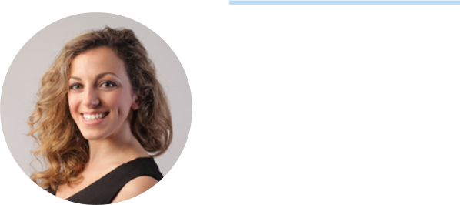

Jennifer Martinez

Owners - jen@example.com

Her responsibilities include building relationships that lead to sales, design work and changes, sewing, cutting and shipping &handling. Jennifer plans to employ staff to take over the manufacturing, shipping, and handling during the first 6 months of operation. The role will be paid a starting salary at $32,500 per year and will aim for 40 - 60 hours per week.

 Baggit

The position is currently filled by family members on a pro bono basis, which will continue until approximately month 6. Position requires approximately 10 hours per week, with responsibilities include boxing, labeling, packaging, organizing and shipping orders. The role
To unlock help try Upmetrics! 

Packaging/Shipping/Handling

Start writing here..

 Baggit

The position will begin as part-time during months 3 and 4 becoming full-time in month 5.

Responsibilities will focus on manufacturing and assembly work (sewing, cutting, gluing, etc.).
This role is key in enabling Jennifer to plan for and attend shows and trade fairs. The role will
To unlock help try Upmetrics! 

Manufacturing Assistant

Start writing here..

 Baggit

Linda Holsworth bringing with her8 years of marketing experience. The position is on a contract basis at approximately $40 per hour and is on an ‘as needed’ basis.
To unlock help try Upmetrics! 

Marketing Designer

Start writing here..

Manufacturing | Business Plan [YEAR] 26/37

Process/Production

 Baggit

Products/Services Production Flow: Raw materials will be ordered 2 months in advance, allowing approximately 30-45 days of manufacturing time to maintain sufficiently. Cutting is done in as large batches as possible and prepared material is organized near the assembly
To unlock help try Upmetrics! 

Production Flow and Delivery Method of Products and Services

Start writing here..

Suppliers

Supplier | Product/Service | Pricing | Terms & Policies
Name | Product/Service | Pricing | Location
 | Industrial leather sewing machine | $1,500
 | Industrial leather sewing machine |  | 30 days shipping
Cal industries | 6” leather skiving machine
Inc. | 6” leather skiving machine | $2,600 | Southern
 | Hot Foil Stamping Machine |  | California, USA
 | Hot Foil Stamping Machine | 600
 |  |  | Minimum order
 | Vegetable-tanned leather hides |  | time of 14 days in
 | Vegetable-tanned leather hides |  | advance
Archdale | Provides entry-level materials as well | $4 - $45 per | 30 day order time
Archdale | as premium materials | $4 - $45 per | 30 day order time
Leather | as premium materials | sq.ft. | for material not in
 | Vegan and alternative leathers |  | stock
 | available |  | North Vancouver,
 |  |  | Canada
 | Premium, authentic Spanish leather | $2 - $35 per sq. | Up to 65 days
 | Premium, authentic Spanish leather | ft. | custom clearance
BC Calzado | hides | ft. | custom clearance
Leather SL | Unique hides finished with traditional | Additional $5 | Min order of 5 hides
 | Unique hides finished with traditional | per sq. ft.
 | Spanish carving patterns | per sq. ft.
 | Spanish carving patterns | shipping | Madrid, Spain

Manufacturing | Business Plan [YEAR] 27/37

Supplier | Product/Service | Pricing | Terms & Policies
Name | Product/Service | Pricing | Location
 | Website design and development | $5,000
Mackrelmoto | Digital marketing campaign |  | Vancouver, Canada
Media | management | $800 per month | Vancouver, Canada
 | Print and banner design work | Per project

Risk Assessment

 Baggit

Cash flow is dependent on making estimated sales at 2 trade shows per year:

The first trade show is already confirmed. Jennifer will apply to attend multiple shows.
To unlock help try Upmetrics! 

Start writing here..

Manufacturing | Business Plan [YEAR] 28/37

7.

Financials

Breakeven analysis

Projected Profit and Loss

Projected Cash Flow

Projected Balance Sheet

Manufacturing | Business Plan [YEAR] 29/37

Breakeven analysis

 Baggit

Average Overhead cost per month: $18,000

Average Product Price: $153

Average Product Cost: $49

Start writing here..

Projected Profit and Loss

To unlock help try Upmetrics! 

 | 2024 | 2025 | 2026
Revenue | $720,051 | $1,187,558.50 | $1,990,421
Women's Designer | $141,938 | $202,402 | $288,552
Handbags | $141,938 | $202,402 | $288,552
Unit Sales | 710 | 1,012 | 1,443
Unit Price | $200 | $200 | $200
Men’s Designer Bags | $100,585 | $127,582.50 | $161,802.50
Unit Sales | 402 | 510 | 647
Unit Price | $250 | $250 | $250
Online Sales | $477,528 | $857,574 | $1,540,066.50
Unit Sales | 3,184 | 5,717 | 10,267
Unit Price | $150 | $150 | $150
Cost Of Sales | $554,401.02 | $578,951.17 | $610,654.42
General Costs | $554,401.02 | $578,951.17 | $610,654.42
Production Costs | $490,000 | $504,700 | $519,841
Material Costs | $250,000 | $257,500 | $265,225
Labor Costs | $240,000 | $247,200 | $254,616

Manufacturing | Business Plan [YEAR] 30/37

 | 2024 | 2025 | 2026
Manufacturing Overheads | $64,401.02 | $74,251.17 | $90,813.42
Utility Costs | $14,401.02 | $23,751.17 | $39,808.42
Equipment Depreciation | $50,000 | $50,500 | $51,005
Revenue Specific Costs | $0 | $0 | $0
Personnel Costs (Direct | $0 | $0 | $0
Labor) | $0 | $0 | $0

Gross Margin | $165,649.98 | $608,607.33 | $1,379,766.58
Gross Margin (%) | 23.01% | 51.25% | 69.32%

Operating Expense | $524,049.19 | $555,645.52 | $601,496.49
Payroll Expense (Indirect | $432,000 | $440,841.60 | $449,874.24
Labor) | $432,000 | $440,841.60 | $449,874.24
Design Team | $103,680 | $106,358.40 | $109,108.56
Lead Designer | $60,480 | $62,294.40 | $64,163.28
Assistant Designer | $43,200 | $44,064 | $44,945.28
Production Staff | $237,600 | $242,352 | $247,199.04
Production Manager | $57,600 | $58,752 | $59,927.04
Production Workers | $180,000 | $183,600 | $187,272
Administrative Staff | $90,720 | $92,131.20 | $93,566.64
Office Manager | $50,400 | $51,408 | $52,436.16
Administrative Assistant | $40,320 | $40,723.20 | $41,130.48
General Expense | $92,049.19 | $114,803.92 | $151,622.25
Facility Costs | $44,047.15 | $47,645.58 | $51,880.69
Rent | $36,000 | $37,440 | $38,937.60
Utilities | $8,047.15 | $10,205.58 | $12,943.09

Manufacturing | Business Plan [YEAR] 31/37

 | 2024 | 2025 | 2026
Marketing and Advertising | $40,802.04 | $59,742.34 | $92,101.64
Digital Marketing | $28,802.04 | $47,502.34 | $79,616.84
Print Advertising | $12,000 | $12,240 | $12,484.80
Administrative Costs | $7,200 | $7,416 | $7,639.92
Office Supplies | $2,400 | $2,424 | $2,448.24
Insurance | $4,800 | $4,992 | $5,191.68
Bad Debt | $0 | $0 | $0
Amortization of Current | $0 | $0 | $0
Assets | $0 | $0 | $0

EBITDA

Additional Expense

Long Term Depreciation

Gain or loss from Sale of Assets

EBIT

Interest Expense

EBT

Income Tax Expense / Benefit

($358,399.21) $52,961.81 $778,270.09

$17,314.93 | $15,380.77 | $13,327.31
$12,168 | $12,168 | $12,168
$0 | $0 | $0
($370,567.21) | $40,793.81 | $766,102.09
$5,146.94 | $3,212.76 | $1,159.29
($375,714.14) | $37,581.04 | $764,942.78
$0 | $0 | $0

Total Expense | $1,095,765.14 | $1,149,977.46 | $1,225,478.22
Net Income | ($375,714.14) | $37,581.04 | $764,942.78
Net Income (%) | (52.18%) | 3.16% | 38.43%

Manufacturing | Business Plan [YEAR] 32/37

 | 2024 | 2025 | 2026
Retained Earning Opening | $0 | ($383,714.14) | ($350,133.10)
Owner's Distribution | $8,000 | $4,000 | $4,000
Retained Earning Closing | ($383,714.14) | ($350,133.10) | $410,809.68

Projected Cash Flow

 | 2024 | 2025 | 2026
Cash Received | $720,051 | $1,187,558.50 | $1,990,421
Cash Paid | $1,083,597.14 | $1,137,809.46 | $1,213,310.22
COS & General Expenses | $646,450.21 | $693,755.09 | $762,276.67
Salary & Wages | $432,000 | $440,841.60 | $449,874.24
Interest | $5,146.94 | $3,212.76 | $1,159.29
Sales Tax | $0 | $0 | $0
Income Tax | $0 | $0 | $0
Net Cash From | ($363,546.14) | $49,749.04 | $777,110.78
Operations | ($363,546.14) | $49,749.04 | $777,110.78
Assets Sell | $0 | $0 | $0
Assets Purchase | $60,000 | $0 | $0
Net Cash From | ($60,000) | $0 | $0
Investments | ($60,000) | $0 | $0
Amount Received | $150,000 | $0 | $0
Loan Received | $100,000 | $0 | $0
Common Stock | $0 | $0 | $0
Preferred Stock | $0 | $0 | $0
Owner's Contribution | $50,000 | $0 | $0

Manufacturing | Business Plan [YEAR] 33/37

 | 2024 | 2025 | 2026
Amount Paid | $39,359.35 | $37,293.51 | $39,347.12
Loan Capital | $31,359.34 | $33,293.52 | $35,347.14
Dividends & Distributions | $8,000 | $4,000 | $4,000
Net Cash From | $110,640.65 | ($37,293.51) | ($39,347.12)
Financing | $110,640.65 | ($37,293.51) | ($39,347.12)
Summary
Starting Cash | $0 | ($312,905.49) | ($300,449.96)
Cash In | $870,051 | $1,187,558.50 | $1,990,421
Cash Out | $1,182,956.49 | $1,175,102.97 | $1,252,657.34
Change in Cash | ($312,905.49) | $12,455.53 | $737,763.66
Ending Cash | ($312,905.49) | ($300,449.96) | $437,313.70
Projected Balance Sheet
 | 2024 | 2025 | 2026
Assets | ($265,073.49) | ($264,785.96) | $460,809.70
Current Assets | ($312,905.49) | ($300,449.96) | $437,313.70
Cash | ($312,905.49) | ($300,449.96) | $437,313.70
Accounts Receivable | $0 | $0 | $0
Inventory | $0 | $0 | $0
Other Current Assets | $0 | $0 | $0
Long Term Assets | $47,832 | $35,664 | $23,496
Gross Long Term Assets | $60,000 | $60,000 | $60,000
Accumulated Depreciation | ($12,168) | ($24,336) | ($36,504)

Manufacturing | Business Plan [YEAR] 34/37

 | 2024 | 2025 | 2026
Liabilities & Equity | ($265,073.48) | ($264,785.96) | $460,809.68
Liabilities | $68,640.66 | $35,347.14 | $0
Current Liabilities | $33,293.52 | $35,347.14 | $0
Accounts Payable | $0 | $0 | $0
Income Tax Payable | $0 | $0 | $0
Sales Tax Payable | $0 | $0 | $0
Short Term Debt | $33,293.52 | $35,347.14 | $0
Long Term Liabilities | $35,347.14 | $0 | $0
Long Term Debt | $35,347.14 | $0 | $0
Equity | ($333,714.14) | ($300,133.10) | $460,809.68
Paid-in Capital | $0 | $0 | $0
Common Stock | $0 | $0 | $0
Preferred Stock | $0 | $0 | $0
Owner's Contribution | $50,000 | $50,000 | $50,000
Retained Earnings | ($383,714.14) | ($350,133.10) | $410,809.68

Check | $0 | $0 | $0

Manufacturing | Business Plan [YEAR] 35/37

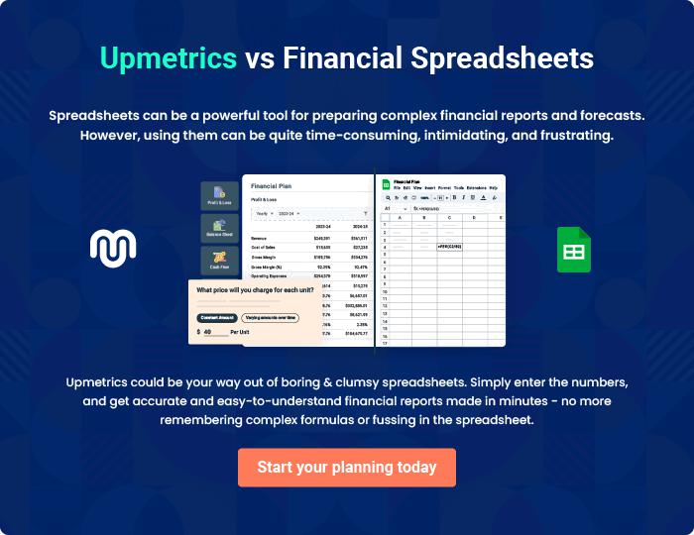

Manufacturing | Business Plan [YEAR] | 36/37

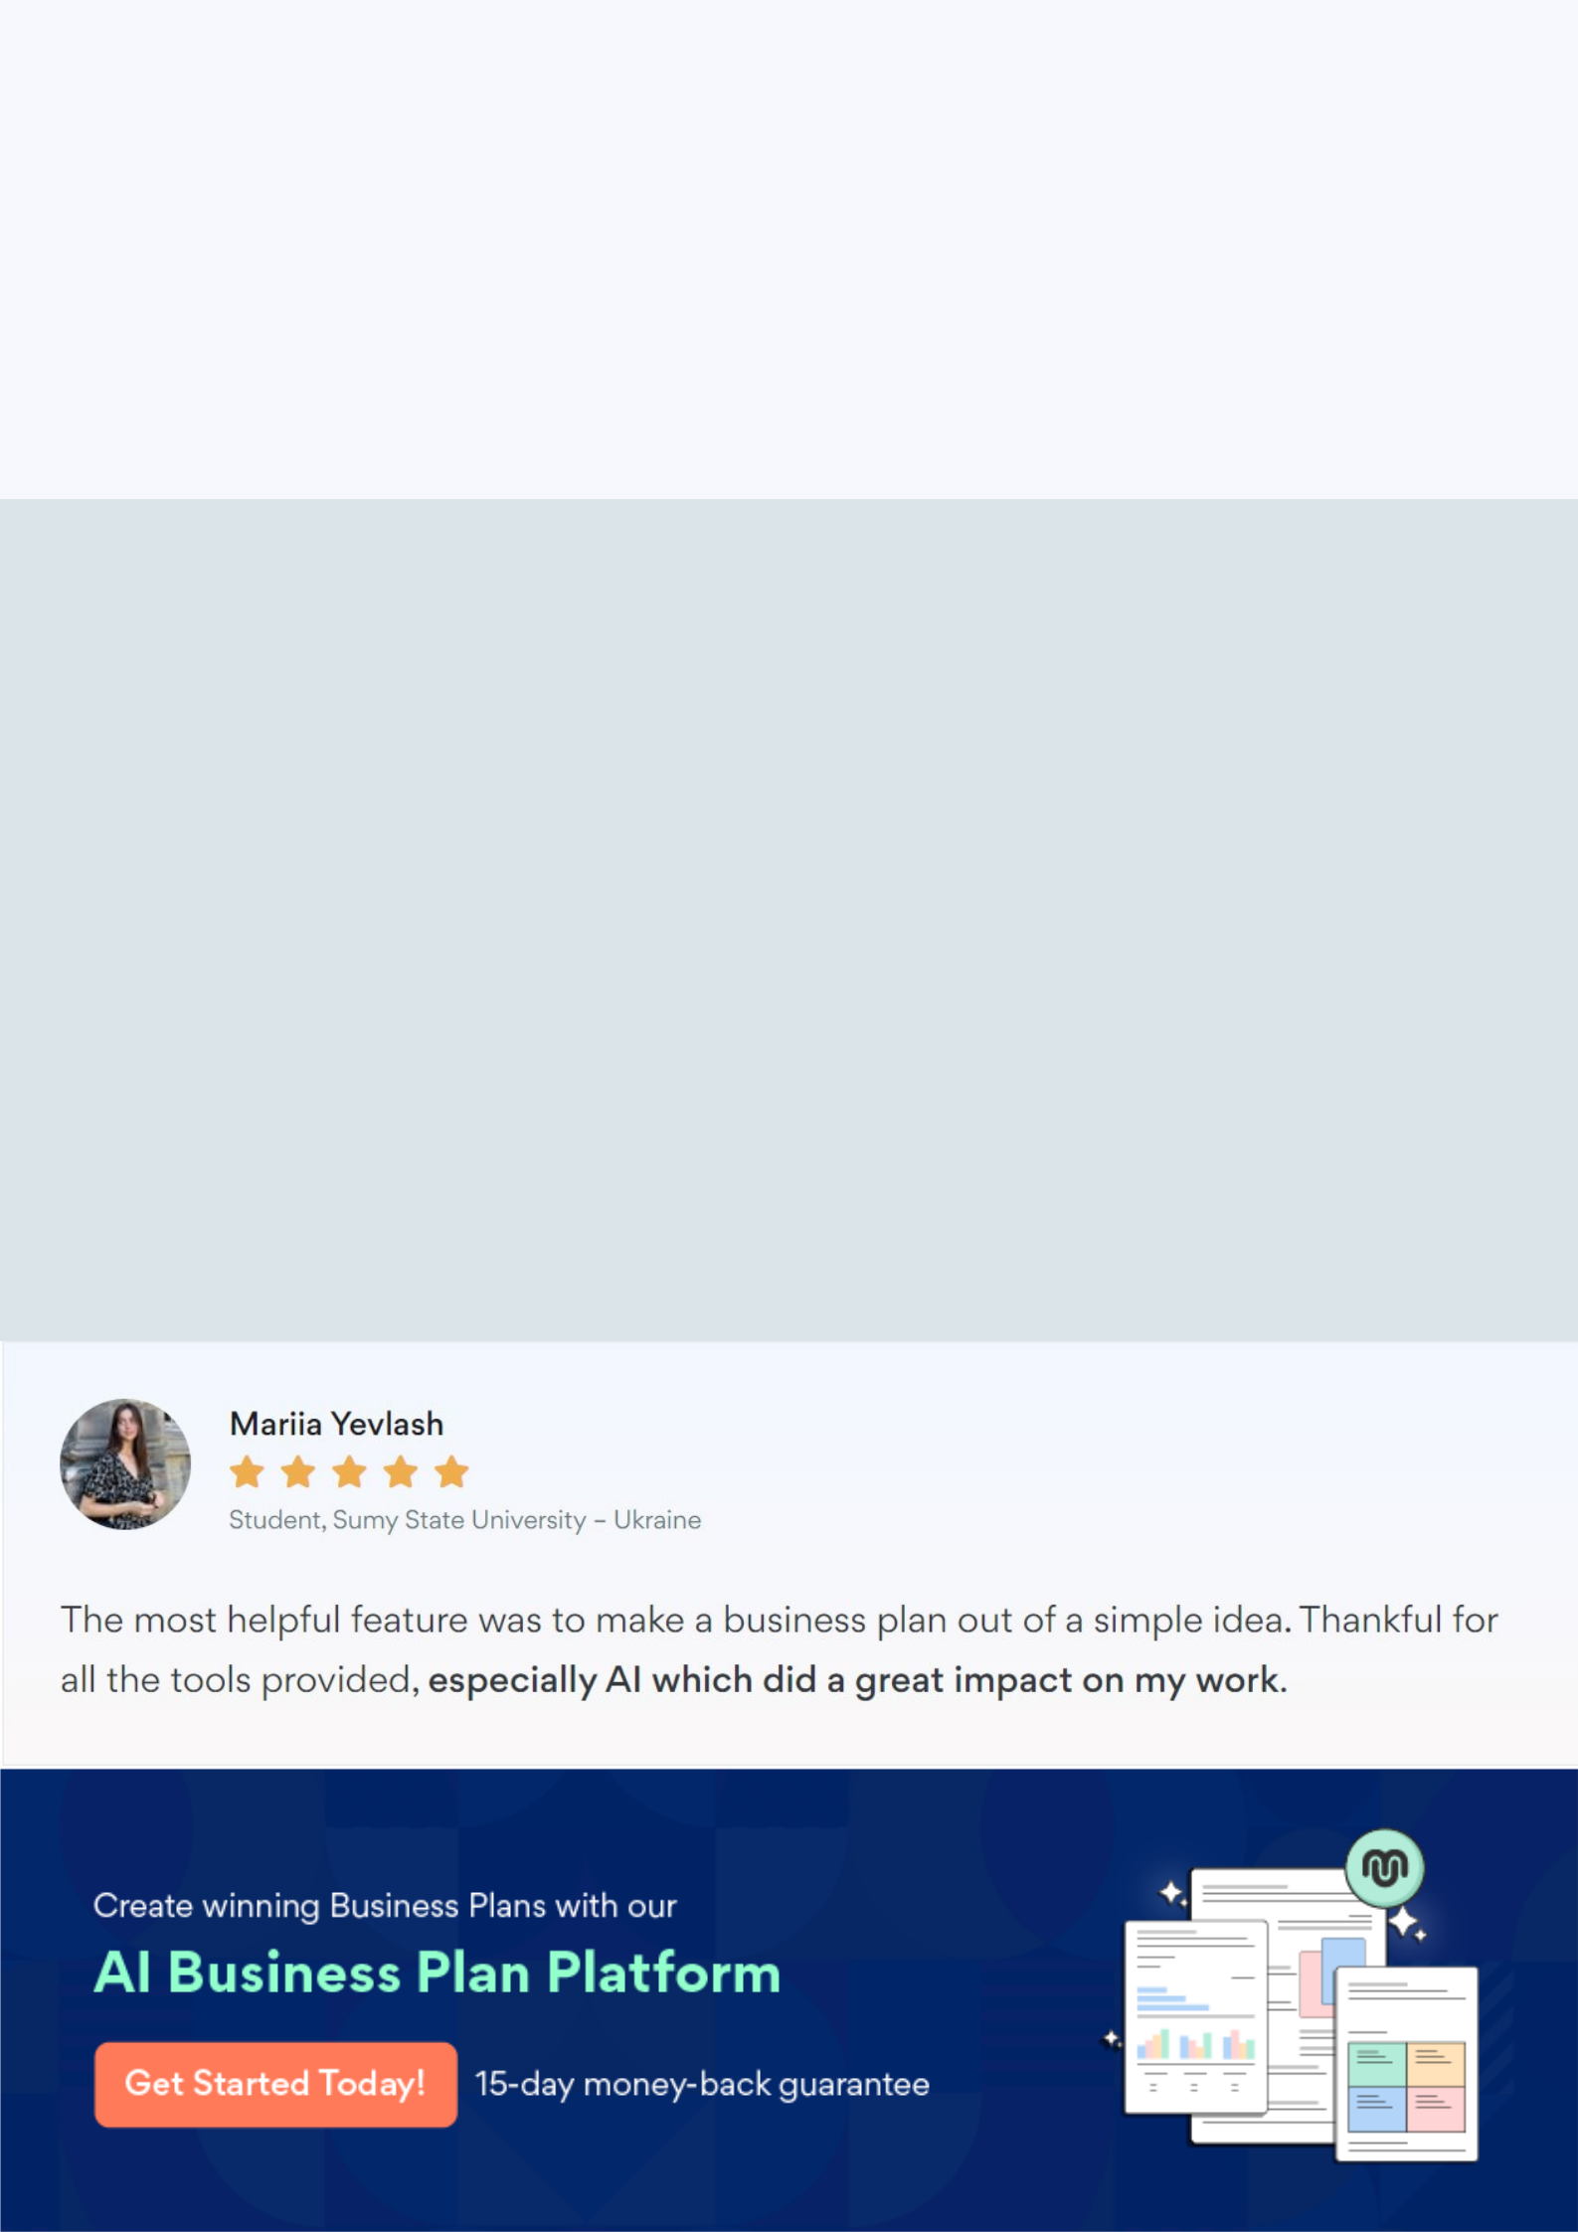
Create a winning business plan that gets you funded

Creating a stunning and investment-ready plan requires no writing, graphic designing, or financial planning expertise.

Upmetrics has all the features required to help you create a comprehensive business plan—from start to finish. Make no mistakes, it’s the modern way of planning to structure ideas, make plans, and create stunning pitch decks to awe investors.

Pitch decks that impress investors

Create pitch decks that provide a visual representation of your business, engage investors, and make them want to invest in your business idea.

Interactive plans in no time

Import business plan sections like—SWOT analysis, comparison tables, and others to create an interactive business plan. No designing skills are required.

Stunning cover page designs

With Upmetrics, you have the liberty to choose from multiple stunning cover page designs. Choose a creative design and make your plan stand out.

Online sharing made simple

Upmetrics makes online sharing quick and easier for users. Easily share your business plans with a link while tracking reader activity.

500+ sample business plans

Simply import a template from our library of sample plans into the editor and start customizing it to make it yours. It takes only a few clicks to get started.

Collaborate with team in real-time

Invite team members, initiate conversations, discuss ideas & strategies, share feedback, and work on a business plan in real-time.

