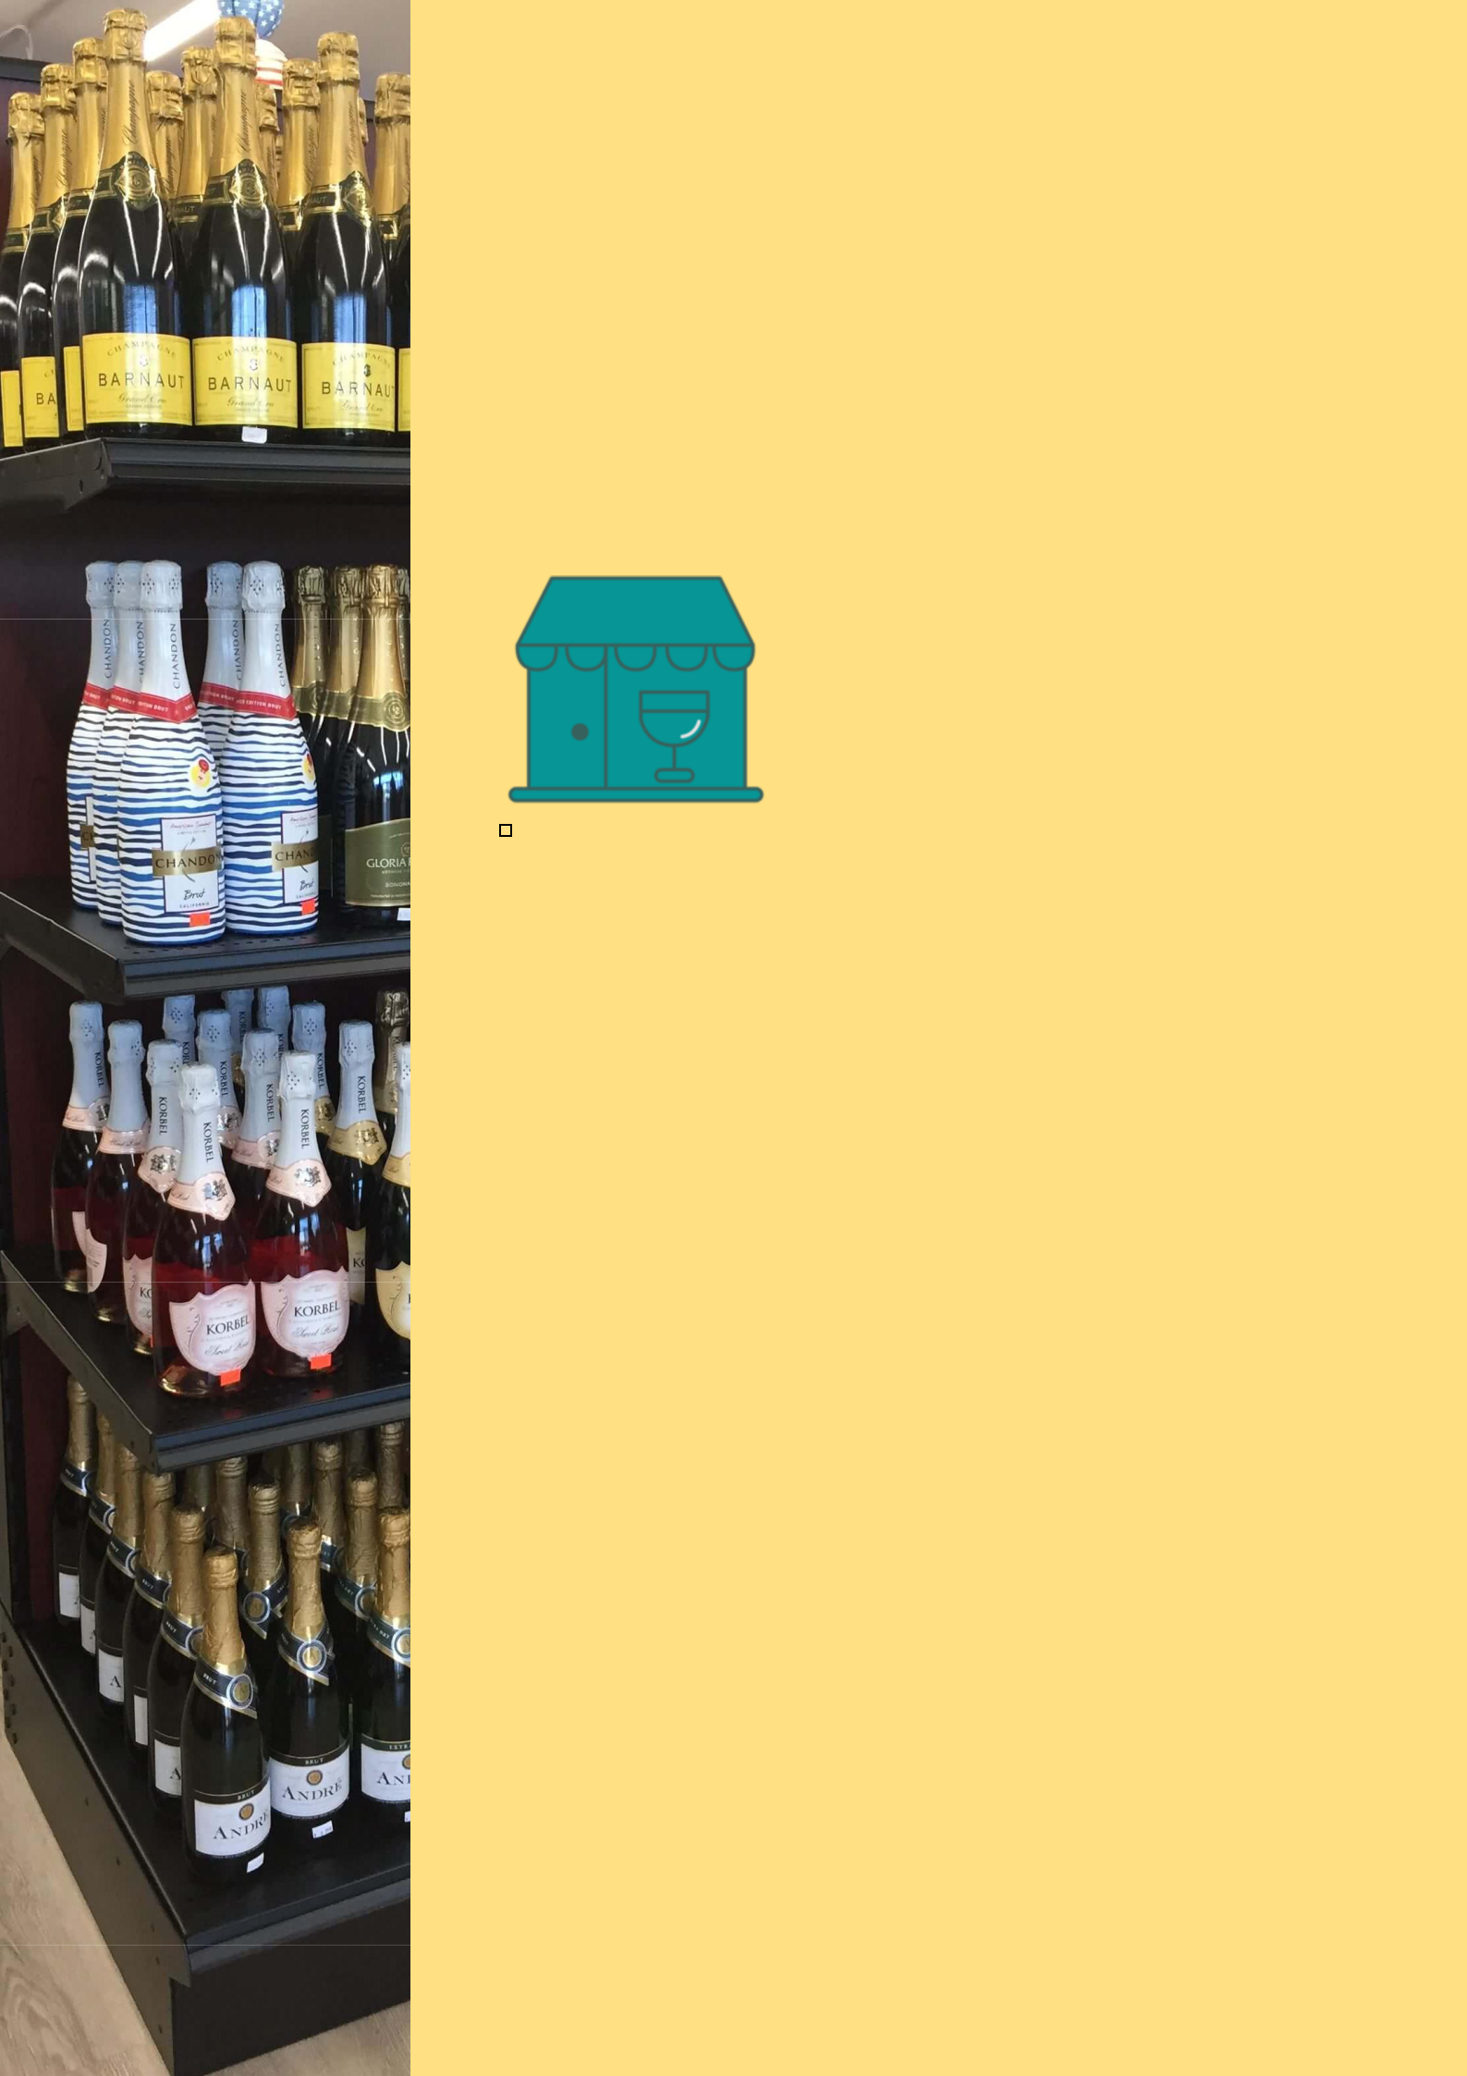
BUSINESS PLAN

[YEAR]

Liquor Store

A Moments of Chilling.

John Doe

10200 Bolsa Ave, Westminster, CA, 92683

- 359-3153 info@example.com http://www.example.com

Information provided in this business plan is unique to this business and confidential; therefore, anyone reading this plan agrees not to disclose any of the information in this business plan without prior written permission of the company.
Table of Contents

Executive Summary | 5
Mission Statement | 6
Vision Statement | 6
Customer Focus | 7
Success Factors | 7
Financial Summary | 7
3 Year profit forecast | 8

Company Summary | 9
History | 10
Business Structure | 10
Store Design | 10
Startup summary | 11
Startup cost | 11
Products and services
Products and services | 14
Market Analysis
Market Analysis | 17
Industry Analysis | 18
Market Segmentation | 18
Market Needs | 19
SWOT Analysis
SWOT Analysis | 20
Strategy & Implementations
Strategy & Implementations | 22
Sales Strategy | 23
Advertising Strategy | 23
Direct Mail | 23
Public Relations | 24
Advertising | 24
Ongoing Customer Communications | 24

Liquor Store | Business Plan [YEAR] 2/39

Pre-Opening Events | 24
Pricing Strategy | 25

Management Summary | 26
Management Team | 27
John Moore | 27
Robert Moore | 28
Personnel Plan | 28

Financial Plan | 29
Important Assumptions | 30
Brake-even Analysis | 30
Projected Profit and Loss | 31
Projected Cash Flow | 33
Projected Balance Sheet | 35
Business Ratios | 36

Liquor Store | Business Plan [YEAR] 3/39

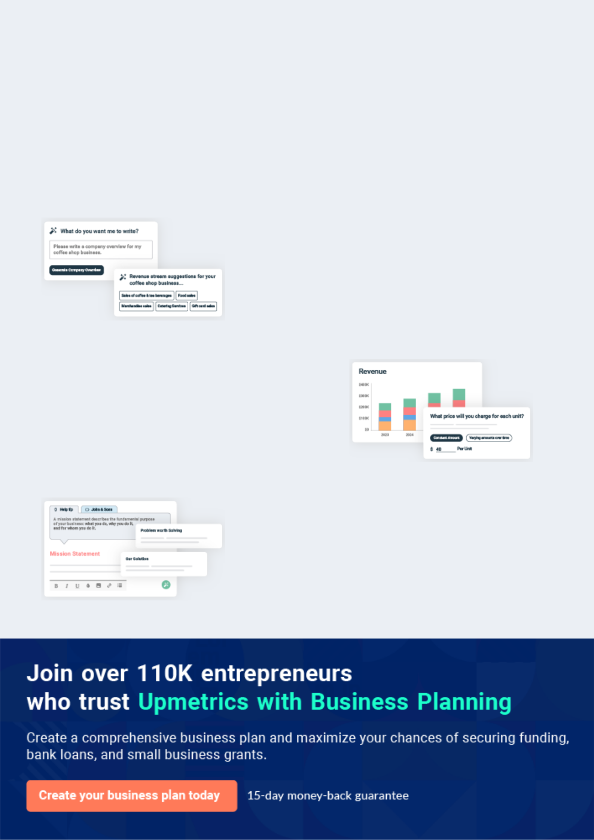
Business planning that’s simpler and faster than you think

Creating a business plan using Upmetrics to start and grow a business is literally the easiest thing in the World. Simply read the instructions and fill in the blanks. It’s as simple as that.

❛ | Upmetrics has everything you need to create a | ❜
❛ | comprehensive business plan. | ❜

AI-powered Upmetrics Assistant

AI-powered insights to streamline your plan

Not sure where to start? Upmetrics’ AI Assistant will automatically generate ideas for each section of your plan and offer improved versions of your writing, adjusting for tone, voice, and grammar or spelling errors.

Financial Forecasting Tool

All the financials are calculated for you

Forget the complex formulas and clumsy spreadsheets — with automatic financials and drag-and-drop forecasting, you can finish your plan faster and be confident that your numbers are accurate.

Business Plan Builder

Guides you like a business mentor

Upmetrics’ step-by-step instructions, prompts, and the library of 400+ sample business plans will guide you through each section of your plan as a business mentor.

1.


Executive Summary

Mission Statement

Vision Statement

Customer Focus

Success Factors

Financial Summary

Liquor Store | Business Plan [YEAR] 5/39

Before you think about how to start a Liquor Store service, you must create a detailed Liquor Store business plan. It will not only guide you in the initial phases of your startup but will also help you later on.
To unlock help try Upmetrics!

 Maxwell Liquor Store
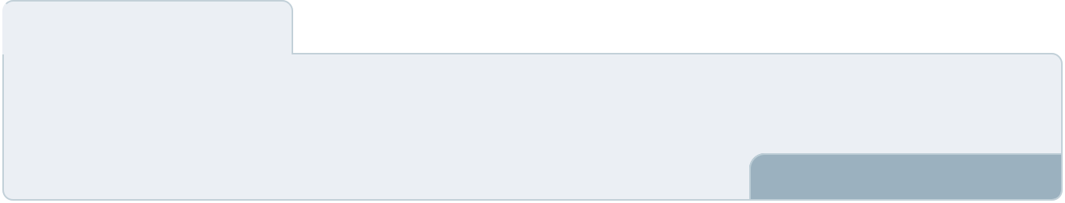



Maxwell Liquor Store is a neighborhood liquor store that will be located in a centralized area between a residential neighborhood and a busy business district in Detroit, Michigan. We are
aware that online in most states in the U.S Michigan is one of the states that allows individuals
To unlock help try Upmetrics! 

Start writing here..

Mission Statement

 Maxwell Liquor Store

Our mission is to establish a liquor store business that will make available a wide range of liquors, wines, and beers from top brands at affordable prices to the residence of Detroit –
Michigan, and other cities in the United States of America and Canada where we intend opening
To unlock help try Upmetrics! 

Start writing here..

Vision Statement

 Maxwell Liquor Store

Our vision is to establish a one-stop liquor store in Detroit – Michigan and in other cities in the United States of America.
To unlock help try Upmetrics! 

Start writing here..

Liquor Store | Business Plan [YEAR] 6/39

Customer Focus

 Maxwell Liquor Store

Maxwell Liquor Store will primarily serve the residents, aged 21 and older who live within a 10-mile radius of our store. The demographics of these customers are as follows:
To unlock help try Upmetrics! 

Start writing here..

Success Factors

 Maxwell Liquor Store

Maxwell Liquor Store is uniquely qualified to succeed for the following reasons:

• There is currently no quality liquor store in the community we are entering. In addition, we
To unlock help try Upmetrics! 

Start writing here..

Financial Summary

 Maxwell Liquor Store

Maxwell Liquor Store is currently seeking $330,000 to launch. Specifically, these funds will be used as follows:
To unlock help try Upmetrics! 

Start writing here..

Liquor Store | Business Plan [YEAR] 7/39

3 Year profit forecast
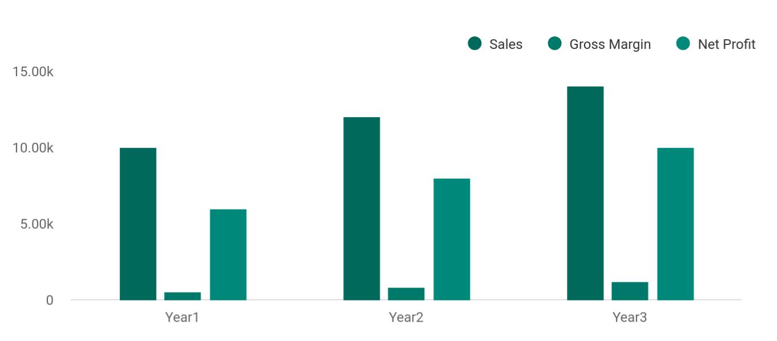

 Maxwell Liquor Store
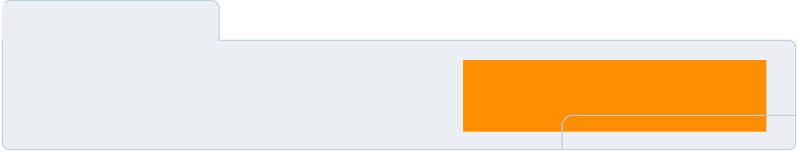

Financial Summary | Year 1 | Year 2 |  | Year 3
 |  |  | To unlock help try Upmetrics! |  | 

Start writing here..

Liquor Store | Business Plan [YEAR] 8/39

2.

Company Summary

History

Business Structure

Store Design

Startup summary

Liquor Store | Business Plan [YEAR] 9/39

 Maxwell Liquor Store

Maxwell Liquor Store is owned by Mr. John Moore who has successfully managed several bars and nightclubs in Los Angeles and Las Vegas prior to opening his own liquor store. It is a family business that will be managed alongside his immediate family member._{To unlock help try Upmetrics!} 

Start writing here..

History

 Maxwell Liquor Store

Upon returning from Fort Lauderdale and surveying the local customer base, John Moore incorporated Maxwell Liquor Store as an S-Corporation in 2015.
To unlock help try Upmetrics! 

Start writing here..

Business Structure

 Maxwell Liquor Store

Maxwell Liquor Store does not intend to start a liquor retailing business like the usual mom and pop business around the street corner; our intention of starting a liquor retail business is to build a standard liquor store that will be a one-stop-shop for liquors, beers, and wines which is
To unlock help try Upmetrics! 

Start writing here..

Store Design

 Maxwell Liquor Store

Maxwell Liquor Store will develop a 5,000 square foot store whose key elements will include the following:
To unlock help try Upmetrics! 

Liquor Store | Business Plan [YEAR] 10/39

Start writing here..

Startup summary

Startup cost
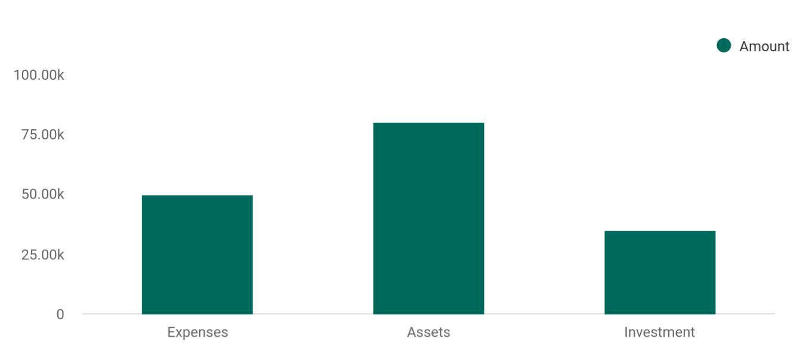

Cost distribution | Amount
Expenses | 50,000
Assets | 80,000
Investment | 35,000

Start-up Expenses | Amount
Legal | $75,500
Consultants | $0
Insurance | $62,750
Rent | $22,500
Research and Development | $42,750
Expensed Equipment | $42,750
Signs | $1,250
TOTAL START-UP EXPENSES | $247,500
Start-up Assets | $0
Cash Required | $322,500

Liquor Store | Business Plan [YEAR] 11/39

Start-up Expenses | Amount
Start-up Inventory | $52,625
Other Current Assets | $222,500
Long-term Assets | $125,000
TOTAL ASSETS | $121,875
Total Requirements | $245,000
START-UP FUNDING | $0
START-UP FUNDING | $273,125
Start-up Expenses to Fund | $121,875
Start-up Assets to Fund | $195,000
TOTAL FUNDING REQUIRED | $0
Assets | $203,125
Non-cash Assets from Start-up | $118,750
Cash Requirements from Start-up | $0
Additional Cash Raised | $118,750
Cash Balance on Starting Date | $121,875
TOTAL ASSETS | $0
Liabilities and Capital | $0
Liabilities | $0
Current Borrowing | $0
Long-term Liabilities | $0
Accounts Payable (Outstanding Bills) | $0
Other Current Liabilities (interest-free) | $0
TOTAL LIABILITIES | $0
Capital | $0
Planned Investment | $0
Investor 1 | $312,500
Investor 2 | $0
Other | $0

Liquor Store | Business Plan [YEAR] 12/39

Start-up Expenses | Amount
Additional Investment Requirement | $0
TOTAL PLANNED INVESTMENT | $695,000
Loss at Start-up (Start-up Expenses) | $313,125
TOTAL CAPITAL | $221,875
TOTAL CAPITAL AND LIABILITIES | $221,875
Total Funding | $265,000

Liquor Store | Business Plan [YEAR] 13/39

3.

Products and services

Liquor Store | Business Plan [YEAR] 14/39

 Maxwell Liquor Store
Beers
Bud Light, Coors Light,
Miller Lite, Budweiser,
Michelob Ultra-Light,
Natural Light, Busch
Light, Bush, Redd's
Apple Ale, Sierra
Nevada Pale Ale, Keystone Light, Pabst Blue Ribbon, Bud Light Lime, Bud Light Platinum Lager etc.
Wines
Martinis
To unlock help try Upmetrics!

Maxwell Liquor Store is going to operate a standard and licensed neighborhood liquor store that will retail a wide range of liquors, beers, and wines just like any other licensed and standard liquor store in the United States and in any part of the world.



Start writing here..


Liquors

Locally Crafted Beers

Pale Beers, Amber Beers, Dark Beers, Hebrew Beers, Gluten Free, Organic Brews, Cider etc

Distilled spirits

Liquor Store | Business Plan [YEAR] 15/39


Non – alcoholic
Tobacco
beverages
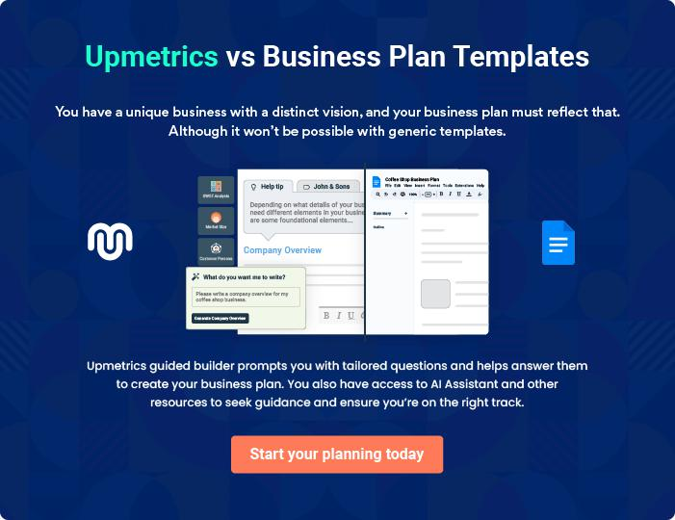

Liquor Store | Business Plan [YEAR] 16/39

4.

Market Analysis

Industry Analysis

Market Segmentation

Market Needs

Liquor Store | Business Plan [YEAR] 17/39

The most important component of an effective Liquor Store services business plan is its accurate marketing analysis. If you are starting on a
smaller scale, you can do marketing analysis yourself by taking help from this
To unlock help try Upmetrics! 

Industry Analysis

 Maxwell Liquor Store

In the United States of America, most of the states have strict control on liquor stores hence it is not easy to secure a license to open one. In Michigan and in few states in the U.S, individuals can actually open their own liquor retail store and it is the practice for them to sell loads of
To unlock help try Upmetrics! 

Start writing here..

Market Segmentation

 Maxwell Liquor Store

The following chart and table show the market analysis for Maxwell Liquor Store.

To unlock help try Upmetrics! 

Start writing here..
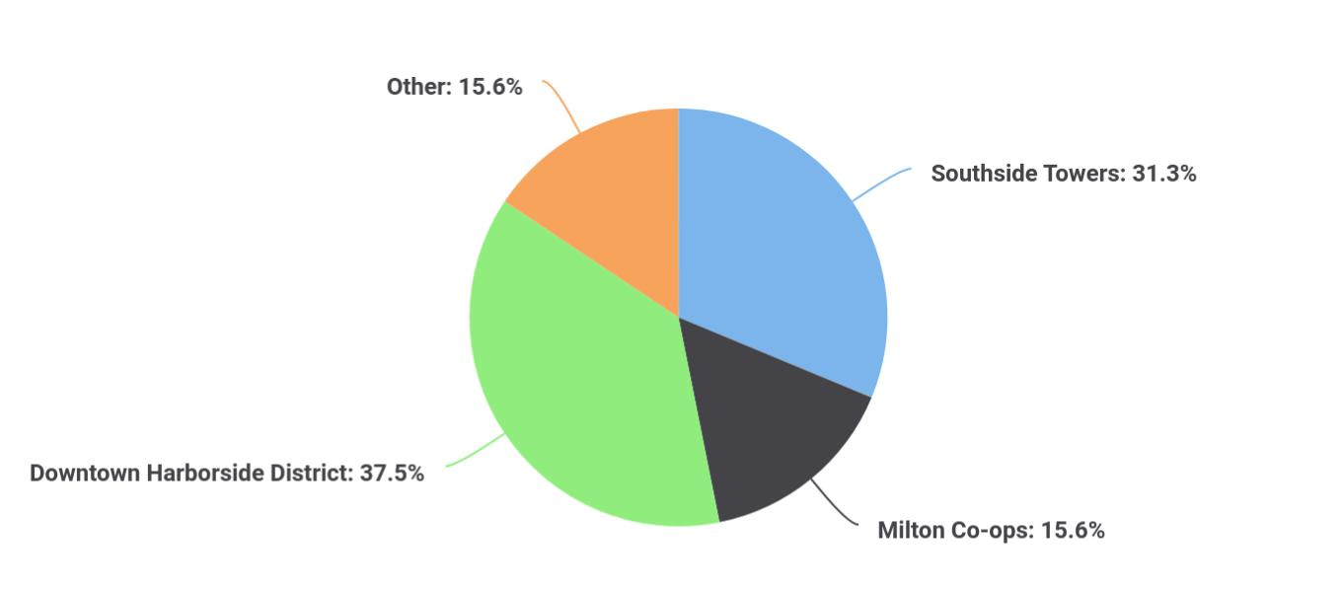

Liquor Store | Business Plan [YEAR] 18/39

 Maxwell Liquor Store
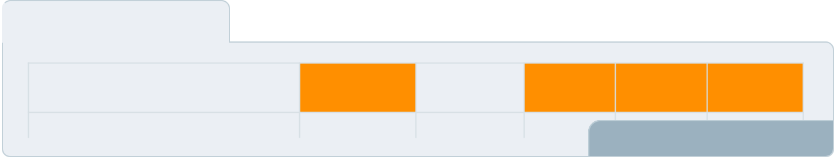

Growth

Year1

Year2

Year3

CAGR

To unlock help try Upmetrics! 

Start writing here..

Market Needs

 Maxwell Liquor Store

Other than the market segment carved out by Beverson’s and a handful of major players, little attention is paid to the opportunities of geographic extensions through direct shipments of wine & spirits throughout Massachusetts. Severson's markets over the Internet and has over
To unlock help try Upmetrics! 

Start writing here..

Liquor Store | Business Plan [YEAR] 19/39

5.

SWOT Analysis

Liquor Store | Business Plan [YEAR] 20/39

 Maxwell Liquor Store

Our intention of starting just one outlet of our liquor retail store in Detroit – Michigan is to test run the business for a period of 2 to 5 years to know if we will invest more money, expand the business and then open other outlets all over Michigan and also sell franchise through the
To unlock help try Upmetrics! 

Start writing here..


Strength

Our location, the business model we will be operating on (a physical store and online liquor store), varieties of payment options, a wide range of liquors, wines, and beers (locally crafted beer inclusive), and our excellent customer service culture will definitely count as a strong strength for Maxwell Liquor Store.


Weakness

A major weakness that may count against us is the fact that we are a new liquor retail outlet and we don’t have the financial capacity to engage in the kind of publicity that we intend to give the business.


Opportunity

The fact that we are going to be operating our liquor retail store in one of the busiest districts in Detroit – Michigan provides us with unlimited opportunities to sell our liquors, wines, and beers to a large number of people.

We have been able to conduct thorough feasibility studies and market surveys and we know what our potential clients will be looking for when they visit our liquor retail store; we are well-positioned to take on the opportunities that will come our way.

Threat

We are quite aware that just like any other business, one of the major threats that we are likely going to face is an economic downturn. It is a fact that the economic downturn affects purchasing power.

Another threat that may likely confront us is the arrival of a new liquor retail outlet in the same location where ours is located or even the arrival of a nightclub and bar.

Liquor Store | Business Plan [YEAR] 21/39

6.

Strategy &

Implementations

Sales Strategy

Advertising Strategy

Pricing Strategy

Liquor Store | Business Plan [YEAR] 22/39

After identifying the market demand, market trends, and the potential customers of the startup, the next step is to define an effective strategy for attracting those customers. Like marketing analysis, sales strategy is also an
To unlock help try Upmetrics!
To unlock help try Upmetrics! 

Sales Strategy

 Maxwell Liquor Store

Management will focus on daily sales revenue goals.

Best value products will be identified to assist customers with smart selections.
To unlock help try Upmetrics! 

Start writing here..

Advertising Strategy

 Maxwell Liquor Store

Maxwell Liquor Store expects its target market to be individuals living within a 10-mile radius of its store. The Company’s promotions strategy to reach these individuals includes:
To unlock help try Upmetrics! 

Start writing here..

 Maxwell Liquor Store

Maxwell Liquor Store will blanket neighborhoods surrounding its locations with direct mail pieces. These pieces will offer discounts and/or provide other inducements for people to visit the store.



Direct Mail

Start writing here..

Liquor Store | Business Plan [YEAR] 23/39

 Maxwell Liquor Store

We will contact all local and area newspapers and television stations and send them a press release describing the opening and unique value proposition of Maxwell Liquor Store.
To unlock help try Upmetrics! 

Public Relations

Start writing here..

 Maxwell Liquor Store

Maxwell Liquor Store will initially advertise in local newspapers and sponsor community events in order to gain awareness.
To unlock help try Upmetrics! 

Advertising

Start writing here..

 Maxwell Liquor Store

Maxwell Liquor Store will maintain a website and publish a monthly email newsletter to tell customers about new events, products, and more.
To unlock help try Upmetrics! 

Ongoing Customer Communications

Start writing here..

 Maxwell Liquor Store

Before opening the store, Maxwell Liquor Store will organize pre-opening events designed for local merchants and press contacts to create buzz and awareness for Maxwell Liquor Store.
To unlock help try Upmetrics! 

Pre-Opening Events

Start writing here..

Liquor Store | Business Plan [YEAR] 24/39

Pricing Strategy

 Maxwell Liquor Store

Pricing is one of the key factors that give leverage to liquor retail stores, it is normal for consumers to go to places (liquor retail outlets) where they can get liquors, wine and beers et al at a cheaper price which is why big player in the liquor, wine, and beer retail industry like attract
To unlock help try Upmetrics! 

Start writing here..

Liquor Store | Business Plan [YEAR] 25/39

7.

Management Summary

Management Team

Personnel Plan

Liquor Store | Business Plan [YEAR] 26/39

 Maxwell Liquor Store
To unlock help try Upmetrics!

Maxwell Liquor Store will be managed by John Moore and James Moore. After the launch of the business, as sales volumes increase, an associate manager may be hired to help with day-to-day store operations.



Start writing here..

Management Team


John Moore

Managing Partner

John has over 25 years of management experience in retail, financial services, and newspaper publishing businesses. After graduating with a B.A. from Bigten State University in 1981, John worked his way up the career ladder in retail management positions for Jensen’s, Hollard’s, and Northbank. In 1986, he became an assistant vice president with Hanson Trust. In 1988, he launched his first business, Atlantic Racquet Club. As the CEO of the organization, he learned, first hand, everything it takes to start and operate a small retail business in a major city. In the 1990s, John worked as a newspaper executive, first for the Metropolis Star and later for the Gotham City Times, whereas director of business operations he was a key member of the management team that launched and grew the gothamcitytimes.com website.

John holds an MBA degree in finance and accounting from Burke University, a B.A. in psychology from Bigten State University, and a Higher Certificate degree from the Wine and Spirit Education Trust.

Liquor Store | Business Plan [YEAR] 27/39


Robert Moore

Managing Partner

James brings over 20 years of wine trade expertise and executive management skills to our company. For the last ten years, James served as the director of food and beverages for the Prestige Athletic Club, an $8 million/year operation where he personally selected the club’s wine list (of over 100 wines), coordinated over 20 wine tastings, taught wine classes, and developed relationships with some of the top winemakers in the world. As a volume buyer for the PAC, he has done business with many of the wine and liquor distributors and importers who cover the metro New York area.

Prior to his position at the PAC, James spent more than a dozen years in restaurant management positions–as restaurant manager of Mr. E’s in Houston, Partner and general manager of the Fieldstone Restaurant in Minneapolis, and restaurant manager for the Pinnacle Hotel in Boston.

After graduating from Telford University in 1983 with a B.A. degree in history, James earned a Higher Certificate with Distinction from the Wine and Spirit Education Trust, and a Certified Sommelier degree from the Sommelier Society of America.

Personnel Plan

 Maxwell Liquor Store
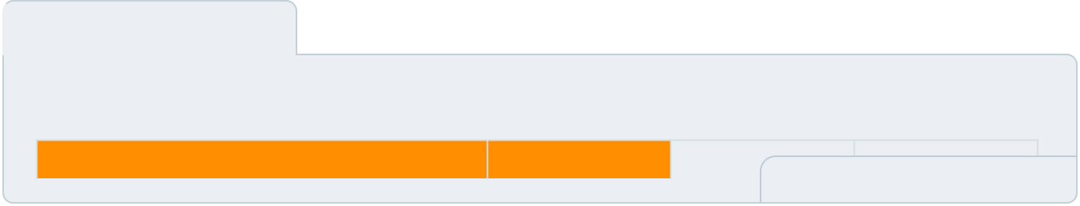

The following table shows the personnel needed for Maxwell Liquor Store.

Personnel Plan

Start writing here..

Year1

Year2 |  | Year3
 | To unlock help try Upmetrics! 

Liquor Store | Business Plan [YEAR] 28/39

8.

Financial Plan

Important Assumptions

Brake-even Analysis

Projected Profit and Loss

Projected Cash Flow

Projected Balance Sheet

Business Ratios

Liquor Store | Business Plan [YEAR] 29/39

The last component of the Liquor Store service business plan is an in-depth financial plan. The financial plan crafts a detailed map of all the expenses needed for the startup and how these expenses will be met by the earned
To unlock help try Upmetrics! 

 Maxwell Liquor Store

The company will be financed by John himself and he will control the direction of the business to make sure that it is expanding at the forecasted rate. As for the Liquor Store service business start-up, no equity funding or outside loans will be required. With the help of financial
To unlock help try Upmetrics! 

Start writing here..

Important Assumptions

The financial projections of the company are forecast on the basis of the following assumptions. These assumptions are quite conservative and are expected to show deviation but to a limited level such that the company’s major financial strategy will not be affected.

 | Year 1 | Year 2 | Year 3
Plan Month | 1 | 2 | 3
Current Interest Rate | 10,00% | 11,00% | 12,00%
Long-term Interest Rate | 10,00% | 10,00% | 10,00%
Tax Rate | 26,42% | 27,76% | 28,12%
Other | 0 | 0 | 0

Brake-even Analysis

Monthly Units Break-even | 5530
Monthly Revenue Break-even | $159 740
Assumptions:
Average Per-Unit Revenue | $260,87
Average Per-Unit Variable Cost | $0,89
Estimated Monthly Fixed Cost | $196 410

Liquor Store | Business Plan [YEAR] 30/39

Projected Profit and Loss

 | 2024 | 2025 | 2026
Revenue | $821,180.52 | $1,651,756.04 | $3,378,572.74
Wine Sales | $357,768 | $805,761.20 | $1,814,734.80
Unit Sales | 17,888 | 40,288 | 90,737
Unit Price | $20 | $20 | $20
Spirits Sales | $253,050.90 | $509,198.10 | $1,024,615.20
Unit Sales | 8,435 | 16,973 | 34,154
Unit Price | $30 | $30 | $30
Beer Sales | $210,361.62 | $336,796.74 | $539,222.74
Unit Sales | 30,052 | 48,114 | 77,032
Unit Price | $7 | $7 | $7

Cost Of Sales | $404,062.69 | $571,536.76 | $886,795.23
General Costs | $404,062.69 | $571,536.76 | $886,795.23
Wine Purchase | $167,154.44 | $246,468.18 | $399,113.19
Red Wine Purchase | $101,460 | $114,327.69 | $128,827.36
White Wine Purchase | $65,694.44 | $132,140.49 | $270,285.83
Spirits Purchase | $236,908.25 | $325,068.58 | $487,682.04
Whiskey Purchase | $171,213.81 | $192,928.09 | $217,396.21
Vodka Purchase | $65,694.44 | $132,140.49 | $270,285.83
Revenue Specific Costs | $0 | $0 | $0
Personnel Costs (Direct | $0 | $0 | $0
Labor) | $0 | $0 | $0

Gross Margin | $417,117.83 | $1,080,219.28 | $2,491,777.51

Liquor Store | Business Plan [YEAR] 31/39

 | 2024 | 2025 | 2026
Gross Margin (%) | 50.79% | 65.40% | 73.75%

Operating Expense | $466,809.84 | $517,137.46 | $604,311.71
Payroll Expense (Indirect | $392,520 | $404,922 | $417,751.80
Labor) | $392,520 | $404,922 | $417,751.80
Store Management | $100,080 | $104,659.20 | $109,450.32
Store Manager | $57,600 | $60,480 | $63,504
Assistant Manager | $42,480 | $44,179.20 | $45,946.32
Sales Staff | $197,400 | $203,322 | $209,421.96
Full-Time Sales Associates | $138,000 | $142,140 | $146,404.32
Part-Time Sales Associates | $59,400 | $61,182 | $63,017.64
Support Staff | $95,040 | $96,940.80 | $98,879.52
Cashiers | $47,520 | $48,470.40 | $49,439.76
Cleaning Staff | $47,520 | $48,470.40 | $49,439.76
General Expense | $74,289.83 | $112,215.46 | $186,559.91
Store Operations | $24,096.68 | $27,152.58 | $30,596.29
Rent | $19,023.72 | $21,436.34 | $24,155.06
Utilities | $5,072.96 | $5,716.24 | $6,441.23
Marketing and Advertising | $34,781.36 | $60,985.34 | $114,239.88
Online Advertising | $24,635.41 | $49,552.66 | $101,357.19
Local Promotions | $10,145.95 | $11,432.68 | $12,882.69
Miscellaneous Expenses | $15,411.79 | $24,077.54 | $41,723.74
Insurance | $7,200 | $7,560 | $7,938
Office Supplies | $8,211.79 | $16,517.54 | $33,785.74
Bad Debt | $0 | $0 | $0

Liquor Store | Business Plan [YEAR] 32/39

Amortization of Current Assets

EBITDA

Additional Expense

Long Term Depreciation

Gain or loss from Sale of Assets

EBIT

Interest Expense

EBT

Income Tax Expense / Benefit

Total Expense

Net Income

Net Income (%)

Retained Earning Opening

Owner's Distribution

Retained Earning Closing

2024 | 2025 | 2026
$0 | $0 | $0

($49,692.01) $563,081.82 $1,887,465.80

$11,869.66 | $10,618.31 | $9,276.53
$5,418 | $5,418 | $5,418
$0 | $0 | $0
($55,110.01) | $557,663.82 | $1,882,047.80
$6,451.64 | $5,200.32 | $3,858.53
($61,561.67) | $552,463.51 | $1,878,189.27
$0 | $0 | $0

$882,742.19 | $1,099,292.53 | $1,500,383.47
($61,561.67) | $552,463.51 | $1,878,189.27
(7.50%) | 33.45% | 55.59%

$0 | ($81,561.67) | $450,901.84
$20,000 | $20,000 | $20,000
($81,561.67) | $450,901.84 | $2,309,091.11

Projected Cash Flow

 | 2024 | 2025 | 2026
Cash Received | $821,180.52 | $1,651,756.04 | $3,378,572.74

Liquor Store | Business Plan [YEAR] 33/39

 | 2024 | 2025 | 2026
Cash Paid | $877,324.19 | $1,093,874.53 | $1,494,965.47
COS & General Expenses | $478,352.53 | $683,752.22 | $1,073,355.14
Salary & Wages | $392,520 | $404,922 | $417,751.80
Interest | $6,451.64 | $5,200.32 | $3,858.53
Sales Tax | $0 | $0 | $0
Income Tax | $0 | $0 | $0
Net Cash From | ($56,143.67) | $557,881.51 | $1,883,607.27
Operations | ($56,143.67) | $557,881.51 | $1,883,607.27

Assets Sell | $0 | $0 | $0
Assets Purchase | $35,000 | $0 | $0
Net Cash From | ($35,000) | $0 | $0
Investments | ($35,000) | $0 | $0

Amount Received | $150,000 | $0 | $0
Loan Received | $100,000 | $0 | $0
Common Stock | $0 | $0 | $0
Preferred Stock | $0 | $0 | $0
Owner's Contribution | $50,000 | $0 | $0
Amount Paid | $37,309.78 | $38,561.13 | $39,902.91
Loan Capital | $17,309.80 | $18,561.12 | $19,902.91
Dividends & Distributions | $20,000 | $20,000 | $20,000
Net Cash From | $112,690.22 | ($38,561.13) | ($39,902.91)
Financing | $112,690.22 | ($38,561.13) | ($39,902.91)

Summary

Starting Cash | $0 | $21,546.55 | $540,866.93

Liquor Store | Business Plan [YEAR] 34/39

 | 2024 | 2025 | 2026
Cash In | $971,180.52 | $1,651,756.04 | $3,378,572.74
Cash Out | $949,633.97 | $1,132,435.66 | $1,534,868.38
Change in Cash | $21,546.55 | $519,320.38 | $1,843,704.36
Ending Cash | $21,546.55 | $540,866.93 | $2,384,571.29

Projected Balance Sheet

 | 2024 | 2025 | 2026
Assets | $51,128.55 | $565,030.93 | $2,403,317.29
Current Assets | $21,546.55 | $540,866.93 | $2,384,571.29
Cash | $21,546.55 | $540,866.93 | $2,384,571.29
Accounts Receivable | $0 | $0 | $0
Inventory | $0 | $0 | $0
Other Current Assets | $0 | $0 | $0
Long Term Assets | $29,582 | $24,164 | $18,746
Gross Long Term Assets | $35,000 | $35,000 | $35,000
Accumulated Depreciation | ($5,418) | ($10,836) | ($16,254)
Liabilities & Equity | $51,128.53 | $565,030.92 | $2,403,317.28
Liabilities | $82,690.20 | $64,129.08 | $44,226.17
Current Liabilities | $18,561.12 | $19,902.91 | $0
Accounts Payable | $0 | $0 | $0
Income Tax Payable | $0 | $0 | $0
Sales Tax Payable | $0 | $0 | $0
Short Term Debt | $18,561.12 | $19,902.91 | $0
Long Term Liabilities | $64,129.08 | $44,226.17 | $44,226.17

Liquor Store | Business Plan [YEAR] 35/39

 | 2024 |  |  | 2025 |  | 2026
Long Term Debt | $64,129.08 |  | $44,226.17 |  |  | $44,226.17
Equity | ($31,561.67) |  | $500,901.84 |  |  | $2,359,091.11
Paid-in Capital | $0 |  |  | $0 |  | $0
Common Stock | $0 |  |  | $0 |  | $0
Preferred Stock | $0 |  |  | $0 |  | $0
Owner's Contribution | $50,000 |  | $50,000 |  |  | $50,000
Retained Earnings | ($81,561.67) |  | $450,901.84 |  |  | $2,309,091.11
Check | $0 |  |  | $0 |  | $0
Business Ratios
 |  | Year 1 | Year 2 |  | Year 3 | Industry Profile
Sales Growth |  | 4,35% | 30,82% |  | 63,29% | 4,00%
Percent of Total Assets
Accounts Receivable |  | 5,61% | 4,71% |  | 3,81% | 9,70%
Inventory |  | 1,85% | 1,82% |  | 1,79% | 9,80%
Other Current Assets |  | 1,75% | 2,02% |  | 2,29% | 27,40%
Total Current Assets |  | 138,53% | 150,99% |  | 163,45% | 54,60%
Long-term Assets |  | -9,47% | -21,01% |  | -32,55% | 58,40%
TOTAL ASSETS |  | 100,00% | 100,00% |  | 100,00% | 100,00%
Current Liabilities |  | 4,68% | 3,04% |  | 2,76% | 27,30%
Long-term Liabilities |  | 0,00% | 0,00% |  | 0,00% | 25,80%
Total Liabilities |  | 4,68% | 3,04% |  | 2,76% | 54,10%
NET WORTH |  | 99,32% | 101,04% |  | 102,76% | 44,90%
Percent of Sales
Sales |  | 100,00% | 100,00% |  | 100,00% | 100,00%

Liquor Store | Business Plan [YEAR] 36/39

 | Year 1 | Year 2 | Year 3 | Industry Profile
Gross Margin | 94,18% | 93,85% | 93,52% | 0,00%
Selling, General & Administrative Expenses | 74,29% | 71,83% | 69,37% | 65,20%
Advertising Expenses | 2,06% | 1,11% | 0,28% | 1,40%
Profit Before Interest and Taxes | 26,47% | 29,30% | 32,13% | 2,86%
Main Ratios
Current | 25,86 | 29,39 | 32,92 | 1,63
Quick | 25,4 | 28,88 | 32,36 | 0,84
Total Debt to Total Assets | 2,68% | 1,04% | 0,76% | 67,10%
Pre-tax Return on Net Worth | 66,83% | 71,26% | 75,69% | 4,40%
Pre-tax Return on Assets | 64,88% | 69,75% | 74,62% | 9,00%
Additional Ratios
Net Profit Margin | 19,20% | 21,16% | 23,12% | N.A.
Return on Equity | 47,79% | 50,53% | 53,27% | N.A.
Activity Ratios
Accounts Receivable Turnover | 4,56 | 4,56 | 4,56 | N.A.
Collection Days | 92 | 99 | 106 | N.A.
Inventory Turnover | 19,7 | 22,55 | 25,4 | N.A.
Accounts Payable Turnover | 14,17 | 14,67 | 15,17 | N.A.
Payment Days | 27 | 27 | 27 | N.A.
Total Asset Turnover | 1,84 | 1,55 | 1,26 | N.A.
Debt Ratios
Debt to Net Worth | 0 | -0,02 | -0,04 | N.A.
Current Liab. to Liab. | 1 | 1 | 1 | N.A.
Liquidity Ratios
Net Working Capital | $120 943 | $140 664 | $160 385 | N.A.
Interest Coverage | 0 | 0 | 0 | N.A.
Additional Ratios
Assets to Sales | 0,45 | 0,48 | 0,51 | N.A.

Liquor Store | Business Plan [YEAR] 37/39

 | Year 1 | Year 2 | Year 3 | Industry Profile
Current Debt/Total Assets | 4% | 3% | 2% | N.A.
Acid Test | 23,66 | 27,01 | 30,36 | N.A.
Sales/Net Worth | 1,68 | 1,29 | 0,9 | N.A.
Dividend Payout | 0 | 0 | 0 | N.A.
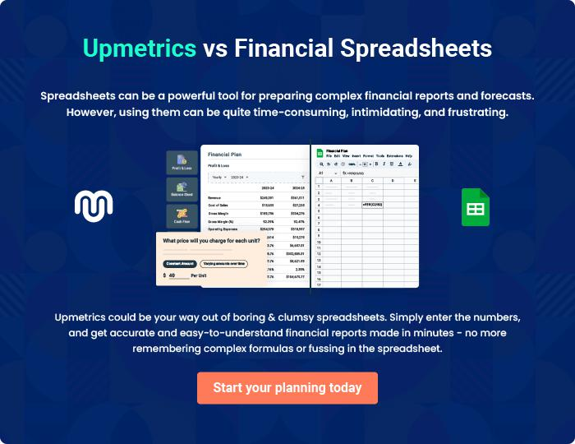

Liquor Store | Business Plan [YEAR] 38/39

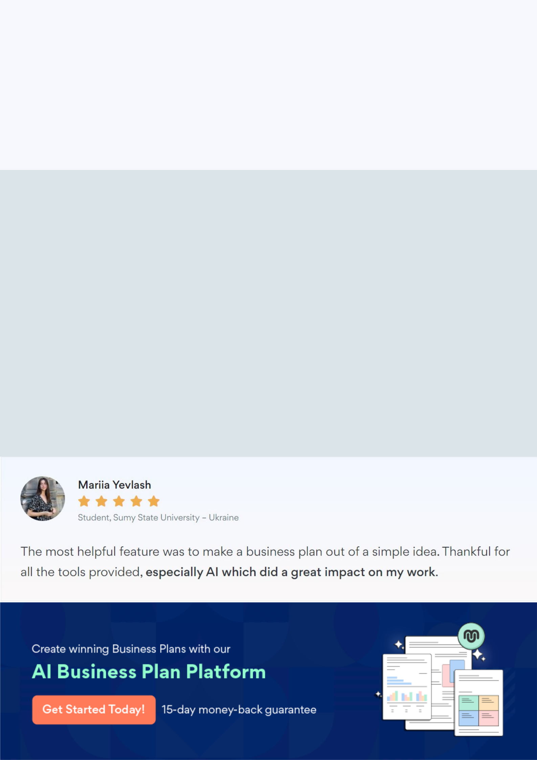
Create a winning business plan that gets you funded

Creating a stunning and investment-ready plan requires no writing, graphic designing, or financial planning expertise.

Upmetrics has all the features required to help you create a comprehensive business plan—from start to finish. Make no mistakes, it’s the modern way of planning to structure ideas, make plans, and create stunning pitch decks to awe investors.

Pitch decks that impress investors

Create pitch decks that provide a visual representation of your business, engage investors, and make them want to invest in your business idea.

Interactive plans in no time

Import business plan sections like—SWOT analysis, comparison tables, and others to create an interactive business plan. No designing skills are required.

Stunning cover page designs

With Upmetrics, you have the liberty to choose from multiple stunning cover page designs. Choose a creative design and make your plan stand out.

Online sharing made simple

Upmetrics makes online sharing quick and easier for users. Easily share your business plans with a link while tracking reader activity.

500+ sample business plans

Simply import a template from our library of sample plans into the editor and start customizing it to make it yours. It takes only a few clicks to get started.

Collaborate with team in real-time

Invite team members, initiate conversations, discuss ideas & strategies, share feedback, and work on a business plan in real-time.

