
Lawn Care

BUSINESS PLAN

Our grass is always greener

Prepared By

John Doe

10200 Bolsa Ave, Westminster, CA, 92683

info@example.com

(650) 359-3153 http://www.example.com

Table of Contents

Executive Summary | 5
Objectives | 6
Mission statement | 6
Vision Statement | 7
Keys to Success | 7
Financial Summary | 7
3 Year profit forecast | 8

Company Summary | 9
History | 10
Business Structure | 10
Startup Summary | 10
Startup cost | 11
Products and services
Products and services | 14
Market Analysis
Market Analysis | 18
Industry Analysis | 19
Market Trends | 19
Market Segmentation | 19
SWOT Analysis
SWOT Analysis | 21
Strategy & Implementations
Strategy & Implementations | 23
Sales Strategy | 24
Advertising Strategy | 24
Social Media/ Online Marketing | 24
Publications | 24
Major Publications | 25
Commute Advertising | 25
Direct Mail | 25

Lawn Care | Business Plan [YEAR] 2/37

Ongoing Customer Communications | 25
Milestones | 26

Financial Plan | 27
Important Assumptions | 28
Brake-even Analysis | 28
Projected Profit and Loss | 29
Projected Cash Flow | 32
Projected Balance Sheet | 33
Business Ratios | 34

Lawn Care | Business Plan [YEAR] 3/37

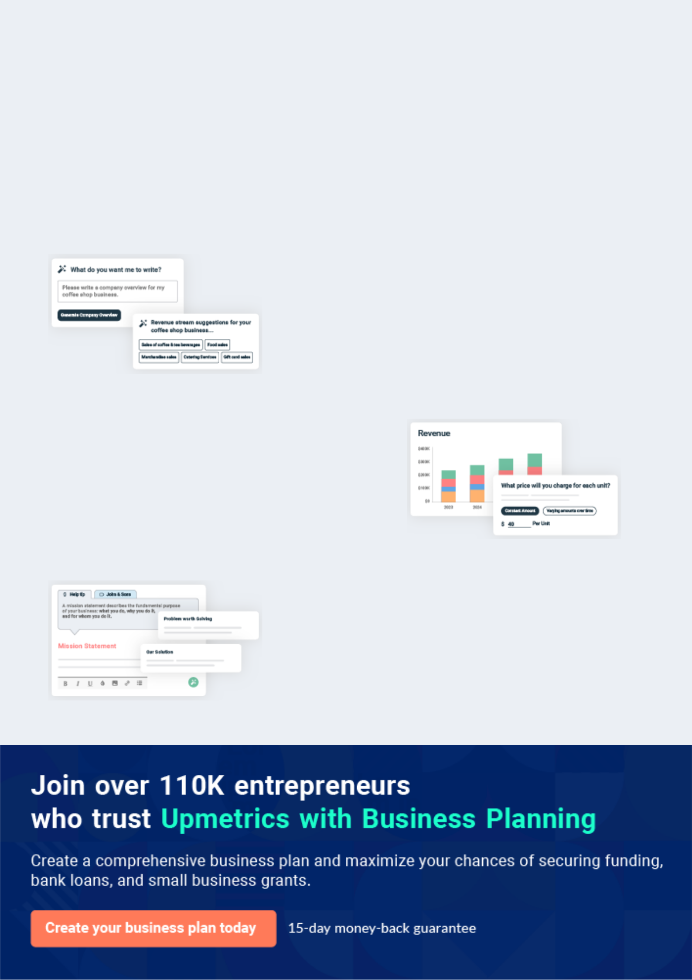
Business planning that’s simpler and faster than you think

Creating a business plan using Upmetrics to start and grow a business is literally the easiest thing in the World. Simply read the instructions and fill in the blanks. It’s as simple as that.

❛ | Upmetrics has everything you need to create a | ❜
❛ | comprehensive business plan. | ❜

AI-powered Upmetrics Assistant

AI-powered insights to streamline your plan

Not sure where to start? Upmetrics’ AI Assistant will automatically generate ideas for each section of your plan and offer improved versions of your writing, adjusting for tone, voice, and grammar or spelling errors.

Financial Forecasting Tool

All the financials are calculated for you

Forget the complex formulas and clumsy spreadsheets — with automatic financials and drag-and-drop forecasting, you can finish your plan faster and be confident that your numbers are accurate.

Business Plan Builder

Guides you like a business mentor

Upmetrics’ step-by-step instructions, prompts, and the library of 400+ sample business plans will guide you through each section of your plan as a business mentor.

1.


Executive Summary

Objectives

Mission statement

Vision Statement

Keys to Success

Financial Summary

Lawn Care | Business Plan [YEAR] 5/37

Before you think about how to start a lawn care service, you must create a detailed lawn care business plan. It will not only guide you in the initial phases of your startup but will also help you later on.
To unlock help try Upmetrics!

 Moore Lawn Care




Moore Lawn Care and Landscape Company is a licensed company that will be based in Detroit, Michigan but will operate in other cities in Michigan, United States of America. We are in the business of helping our clients take proper care of their lawns, as well as create the kind of
To unlock help try Upmetrics! 

Start writing here..

Objectives

 Moore Lawn Care

Our objectives for the first three years of operation are to:

• Create a service-based company whose primary goal is to exceed customers’
To unlock help try Upmetrics! 

Start writing here..

Mission statement

 Moore Lawn Care

The mission of Moore Lawn Care and Landscape is to provide top-quality residential and commercial yard care service. We will strive to attract and maintain customers by providing services in the most timely manner to provide 100% customer satisfaction. Our services will
To unlock help try Upmetrics! 

Start writing here..

Lawn Care | Business Plan [YEAR] 6/37

Vision Statement
To unlock help try Upmetrics!

 Moore Lawn Care

Our Vision at Lawn Care and Landscape Company is to become the preferred choice of homeowners, property managers, and the government when it comes to lawn care and landscaping services in Detroit and other cities in Michigan.



Start writing here..

Keys to Success

 Moore Lawn Care

1. An experienced landscaper with excellent customer service skills.

2. Commitment to high quality and professionalism in every task and encounter.
To unlock help try Upmetrics! 

Start writing here..

Financial Summary

 Moore Lawn Care

Moore Lawn Care and Landscape is seeking total funding of $295,000 of debt capital to launch. The capital will be used for funding capital expenditures and location build-out, purchasing equipment, and materials needed, hiring initial employees, marketing expenses, and working
To unlock help try Upmetrics! 

Start writing here..

Lawn Care | Business Plan [YEAR] 7/37

3 Year profit forecast
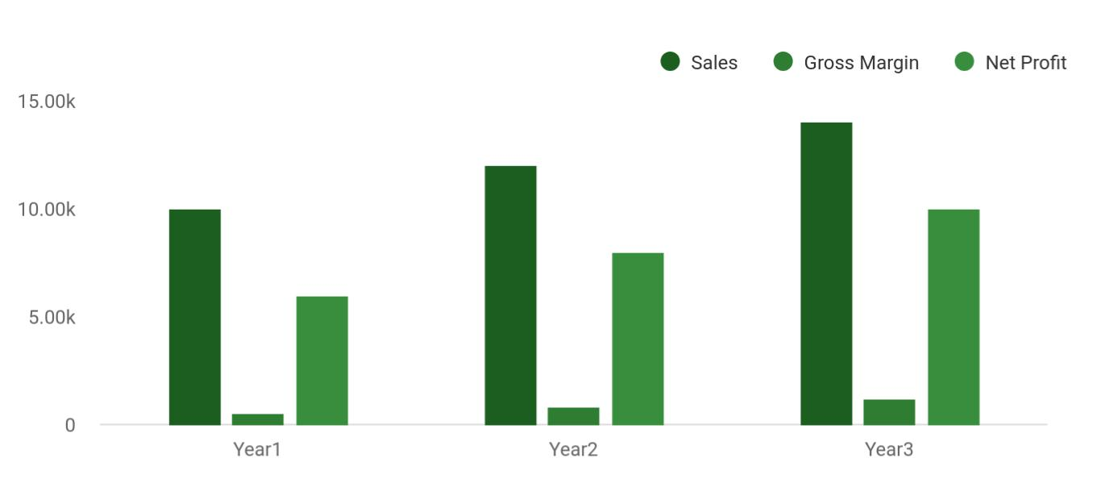

 Moore Lawn Care


Financial Summary | Year 1 | Year 2 |  | Year 3
 |  |  | To unlock help try Upmetrics! |  | 

Start writing here..

Lawn Care | Business Plan [YEAR] 8/37

2.

Company Summary

History

Business Structure

Startup Summary

Lawn Care | Business Plan [YEAR] 9/37

 Moore Lawn Care

Moore Lawn Care and Landscape Company is a private registered company that is owned by John Moore and their family. The company will be fully and single-handedly financed by the owner – Mr. John Moore. Before starting Moore Lawn Care and Landscape Company, he has
To unlock help try Upmetrics! 

Start writing here..

History

 Moore Lawn Care

John Moore, the founder of Moore Lawn Care and Landscape started very young in the landscaping and lawn care business. Ever since John was still in his college years, he was working part-time in a small landscaping company and earning a few bucks off of the
To unlock help try Upmetrics! 

Start writing here..

Business Structure

 Moore Lawn Care

Moore Lawn Care and Landscape Company is a privately owned and managed company. It is a small-scale business which is why we have decided to only retain a handful of employees and if we secure more contracts than our present workforce can handle, we will recruit contract
To unlock help try Upmetrics! 

Start writing here..

Startup Summary

 Moore Lawn Care

Moore Lawn Care and Landscape’s start-up costs include:

• Home office equipment: file cabinet, the computer system (including printer, scanner, and
To unlock help try Upmetrics! 

Lawn Care | Business Plan [YEAR] 10/37

Start writing here..

Startup cost
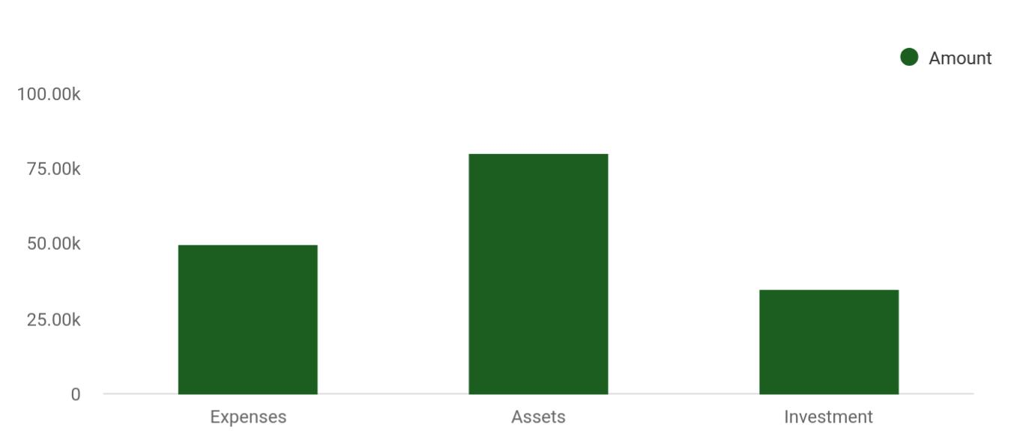

Cost distribution | Amount
Expenses | 50,000
Assets | 80,000
Investment | 35,000

Start-up Expenses | Amount
Legal | $75,500
Consultants | $0
Insurance | $62,750
Rent | $22,500
Research and Development | $42,750
Expensed Equipment | $42,750
Signs | $1,250
TOTAL START-UP EXPENSES | $247,500
Start-up Assets | $0
Cash Required | $322,500
Start-up Inventory | $52,625
Other Current Assets | $222,500

Lawn Care | Business Plan [YEAR] 11/37

Start-up Expenses | Amount
Long-term Assets | $125,000
TOTAL ASSETS | $121,875
Total Requirements | $245,000
START-UP FUNDING | $0
START-UP FUNDING | $273,125
Start-up Expenses to Fund | $121,875
Start-up Assets to Fund | $195,000
TOTAL FUNDING REQUIRED | $0
Assets | $203,125
Non-cash Assets from Start-up | $118,750
Cash Requirements from Start-up | $0
Additional Cash Raised | $118,750
Cash Balance on Starting Date | $121,875
TOTAL ASSETS | $0
Liabilities and Capital | $0
Liabilities | $0
Current Borrowing | $0
Long-term Liabilities | $0
Accounts Payable (Outstanding Bills) | $0
Other Current Liabilities (interest-free) | $0
TOTAL LIABILITIES | $0
Capital | $0
Planned Investment | $0
Investor 1 | $312,500
Investor 2 | $0
Other | $0
Additional Investment Requirement | $0
TOTAL PLANNED INVESTMENT | $695,000

Lawn Care | Business Plan [YEAR] 12/37

Start-up Expenses | Amount
Loss at Start-up (Start-up Expenses) | $313,125
TOTAL CAPITAL | $221,875
TOTAL CAPITAL AND LIABILITIES | $221,875
Total Funding | $265,000

Lawn Care | Business Plan [YEAR] 13/37

3.

Products and services

Lawn Care | Business Plan [YEAR] 14/37

 Moore Lawn Care

Moore Lawn Care and Landscape Company is committed to excellent and timely service delivery and to give its customers value for their money. We know that our customers are the reason why we are in business and we will ensure that we make them our number one priority.
To unlock help try Upmetrics! 

Start writing here..


Lawn mowing/ Sod installation/

maintenance hydro – seeding

Weeding or fertilizer Landscape care/

and/or pest control maintenance

application services

Landscape design/ Landscape

contracting services architecture services

Weekly lawn cut Weeding Beds

Lawn Care | Business Plan [YEAR] 15/37


Trimming
Spring Cleanup
Landscaping

Fall Cleanup Chemical Treatment

Consultancy and
Snow Plowing
Advisory Services

Lawn Care | Business Plan [YEAR] 16/37

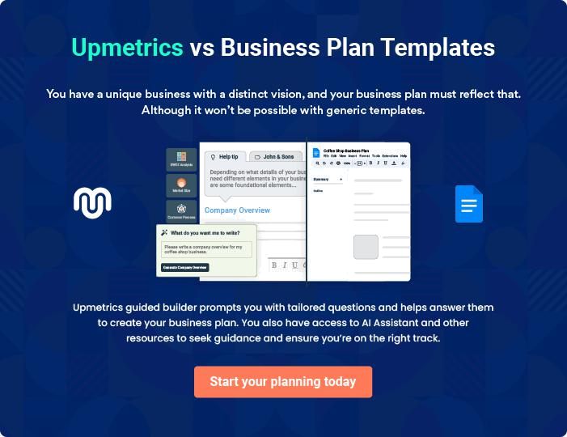

Lawn Care | Business Plan [YEAR] | 17/37

4.

Market Analysis

Industry Analysis

Market Trends

Market Segmentation

Lawn Care | Business Plan [YEAR] 18/37

The most important component of an effective lawn care services business plan is its accurate marketing analysis. If you are starting on a smaller scale, you can do marketing analysis yourself by taking help from this lawn care
To unlock help try Upmetrics! 

Industry Analysis

 Moore Lawn Care

The Lawn Care industry is dependent on the health of the housing and property markets, both of which have grown steadily over the past five years. Additionally, because landscaping services are often discretionary, industry demand is dependent on levels of per capita
To unlock help try Upmetrics! 

Start writing here..

Market Trends

 Moore Lawn Care

One of the common trends in the lawn care and landscaping industry is that it takes consistent effort to convince homeowners to hire the services of lawn care and landscaping companies. The truth is that homeowners who have enough time can actually take care of their lawn; all
To unlock help try Upmetrics! 

Start writing here..

Market Segmentation

 Moore Lawn Care

Moore Lawn Care and Landscape will be targeting families with annual income over $50,000. The median income of $50,000 and above are targeted because they tend to have more disposable income for the care of their lawn, whereas lower-income families will tend to
To unlock help try Upmetrics! 

Start writing here..

Lawn Care | Business Plan [YEAR] 19/37

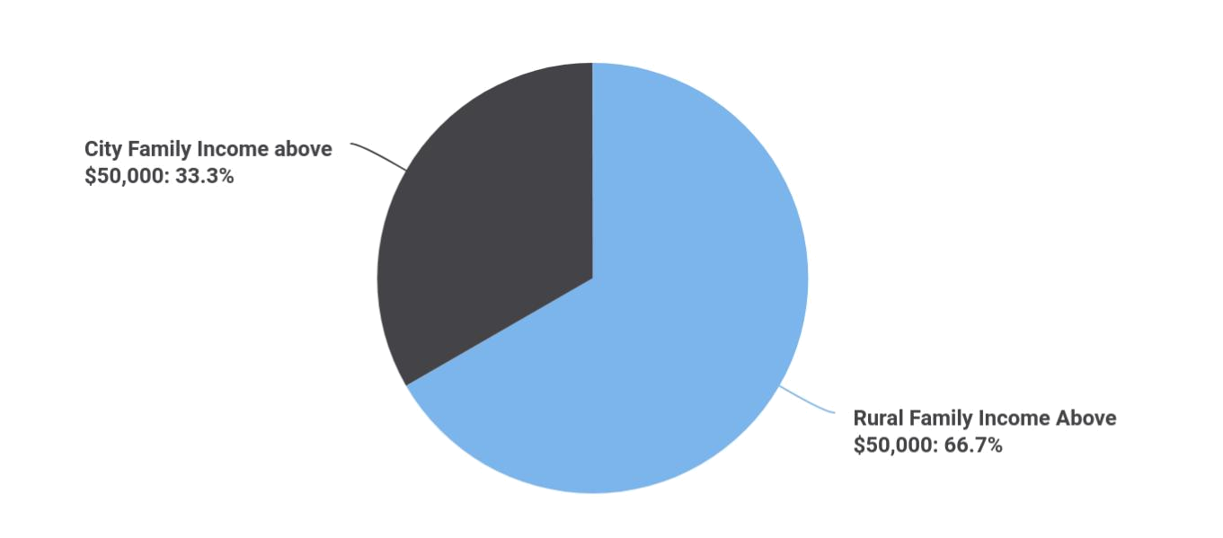

 Moore Lawn Care
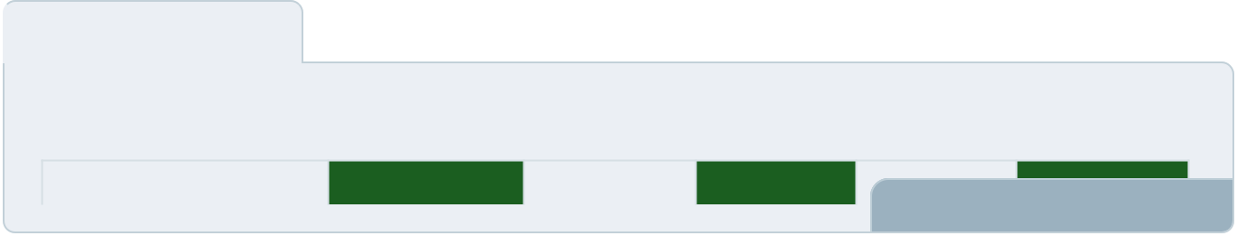

To unlock help try Upmetrics! 

Start writing here..

Lawn Care | Business Plan [YEAR] 20/37

5.

SWOT Analysis

Lawn Care | Business Plan [YEAR] 21/37

 Moore Lawn Care

Moore Lawn Care and Landscape Company do not intend to launch out on a trial and error basis, hence the need to conduct a proper SWOT analysis and prepare a lawn care marketing plan. We know that if we get it right from the outset, we would have succeeded in creating the
To unlock help try Upmetrics! 

Start writing here..


Strength

Our strength as a lawn care and landscape company is the fact that we have healthy relationships with loads of homeowners (residents) within the area where our business is located. We have some of the latest equipment that will help us deliver neat and excellent jobs.

Aside from our relationship (network) and equipment, we can confidently boast that we have some of the qualities that are in high demand in the lawn care and landscaping line of business which are trust, honesty, and relationship management.


Weakness

Our weakness could be that we are a new lawn care and landscaping company in Detroit, Michigan and it will require consistency for us to gain the confidence of our prospective clients (homeowners, property managers, and even the government).


Opportunity

The opportunities that are available to us cannot be quantified; we know that there are loads of homeowners, property managers, and government establishments that will require our services in Detroit and other cities in Michigan.

Threat

Some of the threats that we are likely going to face as a lawn care and landscaping company are global economic downturn that can impact negatively on household spending and the arrival of a competitor (a company that offers the same service as we do) within the same location. There is hardly anything we could do as regards these threats other than to be optimistic that things will continue to work for our good.

Lawn Care | Business Plan [YEAR] 22/37

6.

Strategy &

Implementations

Sales Strategy

Advertising Strategy

Milestones

Lawn Care | Business Plan [YEAR] 23/37

After identifying the market demand, market trends, and the potential customers of the startup, the next step is to define an effective strategy for attracting those customers. Like marketing analysis, sales strategy is also an
To unlock help try Upmetrics! 

Sales Strategy

 Moore Lawn Care

Moore Lawn Care and Landscape's sales strategy will be based on one-on-one communications with potential customers. By going door to door in his own neighborhood, Red can become more familiar to these folks and take advantage of his outgoing personality.
To unlock help try Upmetrics! 

Start writing here..

Advertising Strategy

 Moore Lawn Care

With the majority of the people now online, the company will invest resources in online ads for different social media platforms to reach potential clients. We will create ads that will successfully create positive conversions. A company website will also be developed. This
To unlock help try Upmetrics! 

Social Media/ Online Marketing

Start writing here..

 Moore Lawn Care

Moore Lawn Care and Landscape will place print advertisements in key local publications, including newspapers, area magazines, and local sports programs. Additionally, the Company will print brochures and place them in specific locations frequented by target individuals, such
To unlock help try Upmetrics! 

Publications

Start writing here..

Lawn Care | Business Plan [YEAR] 24/37

 Moore Lawn Care

We will make careful use of advertising in selected larger publications. ABC News has a circulation of XYZ and we can expect to reach a wider geographic region of customers on a limited basis. Advertisements with major publications will be used selectively, based on cost-
To unlock help try Upmetrics! 

Major Publications

Start writing here..

 Moore Lawn Care

We will drive attention toward Moore Lawn Care and Landscape by hiring workers to hold signs alongside highways. Advertising on heavily traveled commute routes is an opportunity to alert large numbers of working individuals with disposable income of our opening.
To unlock help try Upmetrics! 

Commute Advertising

Start writing here..

 Moore Lawn Care

Moore Lawn Care and Landscape will blanket neighborhoods surrounding its locations with direct mail pieces. These pieces will provide general information on Moore Lawn Care and Landscape, offer discounts, and/or provide other inducements for people to purchase our
To unlock help try Upmetrics! 

Direct Mail

Start writing here..

 Moore Lawn Care

Moore Lawn Care and Landscape will maintain a website, social media accounts, and publish a monthly email newsletter to tell customers about new events, products, and more.
To unlock help try Upmetrics! 

Ongoing Customer Communications

Start writing here..

Lawn Care | Business Plan [YEAR] 25/37

Milestones
To unlock help try Upmetrics!

 Moore Lawn Care

We have established some basic milestones to keep the business plan priorities in place. Red is in charge of all goals directly related to yard care and employee practices, while Kikuyu will oversee our marketing materials – brochures, business cards, ads, etc.

Start writing here..



Lawn Care | Business Plan [YEAR] 26/37

7.

Financial Plan

Important Assumptions

Brake-even Analysis

Projected Profit and Loss

Projected Cash Flow

Projected Balance Sheet

Business Ratios

Lawn Care | Business Plan [YEAR] 27/37

The last component of a lawn care service business plan is an in-depth financial plan. The financial plan crafts a detailed map of all the expenses needed for the startup and how these expenses will be met by the earned
To unlock help try Upmetrics! 

 Moore Lawn Care

The company will be financed by John himself and he will control the direction of the business to make sure that it is expanding at the forecasted rate. As for the lawn care service business start-up, no equity funding or outside loans will be required. With the help of financial experts,
To unlock help try Upmetrics! 

Start writing here..

Important Assumptions

The financial projections of the company are forecast on the basis of the following assumptions. These assumptions are quite conservative and are expected to show deviation but to a limited level such that the company’s major financial strategy will not be affected.

 | Year 1 | Year 2 | Year 3
Plan Month | 1 | 2 | 3
Current Interest Rate | 10,00% | 11,00% | 12,00%
Long-term Interest Rate | 10,00% | 10,00% | 10,00%
Tax Rate | 26,42% | 27,76% | 28,12%
Other | 0 | 0 | 0

Brake-even Analysis

Monthly Units Break-even | 5530
Monthly Revenue Break-even | $159 740
Assumptions:
Average Per-Unit Revenue | $260,87
Average Per-Unit Variable Cost | $0,89
Estimated Monthly Fixed Cost | $196 410

Lawn Care | Business Plan [YEAR] 28/37

Projected Profit and Loss

 | 2024 | 2025 | 2026
Revenue | $313,725.60 | $524,584.80 | $885,431.30
Lawn Mowing Services | $37,565 | $60,151 | $96,305
Unit Sales | 376 | 602 | 963
Unit Price | $100 | $100 | $100
Landscaping Services | $191,006.80 | $343,022.60 | $616,021.20
Unit Sales | 9,550 | 17,151 | 30,801
Unit Price | $20 | $20 | $20
Garden Care Services | $85,153.80 | $121,411.20 | $173,105.10
Unit Sales | 2,838 | 4,047 | 5,770
Unit Price | $30 | $30 | $30
Cost Of Sales | $12,682.62 | $14,290.90 | $16,102.99
General Costs | $12,682.62 | $14,290.90 | $16,102.99
Lawn Mowing and | $3,804.92 | $4,287.40 | $4,830.88
Maintenance | $3,804.92 | $4,287.40 | $4,830.88
Fuel for Lawns Mowers | $1,902.46 | $2,143.70 | $2,415.44
Maintenance of Equipment | $1,902.46 | $2,143.70 | $2,415.44
Landscaping Services | $8,877.70 | $10,003.50 | $11,272.11
Plants and Materials | $6,341.24 | $7,145.34 | $8,051.52
Equipment Rental for | $2,536.46 | $2,858.16 | $3,220.59
Projects | $2,536.46 | $2,858.16 | $3,220.59
Revenue Specific Costs | $0 | $0 | $0
Personnel Costs (Direct | $0 | $0 | $0
Labor) | $0 | $0 | $0

Lawn Care | Business Plan [YEAR] 29/37

 | 2024 | 2025 | 2026
Gross Margin | $301,042.98 | $510,293.90 | $869,328.31
Gross Margin (%) | 95.96% | 97.28% | 98.18%

Operating Expense | $351,744.89 | $365,429.29 | $379,736.76
Payroll Expense (Indirect | $339,540 | $351,929.40 | $364,789.92
Labor) | $339,540 | $351,929.40 | $364,789.92
Lawn Maintenance Crew | $186,000 | $191,940 | $198,072.48
Lawn Maintenance Worker | $150,000 | $154,500 | $159,134.88
Team Supervisor | $36,000 | $37,440 | $38,937.60
Administrative Staff | $68,040 | $70,421.40 | $72,886.32
Office Administrator | $43,200 | $44,712 | $46,277.04
Customer Services | $24,840 | $25,709.40 | $26,609.28
Representative | $24,840 | $25,709.40 | $26,609.28
Specialized Services | $85,500 | $89,568 | $93,831.12
Landscape Designer | $64,800 | $68,040 | $71,442
Equipment Operator | $20,700 | $21,528 | $22,389.12
General Expense | $12,204.89 | $13,499.89 | $14,946.84
Operational Expenses | $3,145.53 | $3,491.99 | $3,880.15
utility Bills | $2,536.46 | $2,858.16 | $3,220.59
Office Supplies | $609.07 | $633.83 | $659.56
Marketing and Advertising | $7,341.24 | $8,215.34 | $9,196.42
Online Advertising | $6,341.24 | $7,145.34 | $8,051.52
Print Material | $1,000 | $1,070 | $1,144.90
Vehicle and Equipment | $1,718.12 | $1,792.56 | $1,870.27
Expenses | $1,718.12 | $1,792.56 | $1,870.27
vehicle Maintenance | $1,218.12 | $1,267.56 | $1,319.02
Equipment Insurance | $500 | $525 | $551.25

Lawn Care | Business Plan [YEAR] 30/37

Bad Debt

Amortization of Current Assets

EBITDA

Additional Expense

Long Term Depreciation

Gain or loss from Sale of Assets

EBIT

Interest Expense

EBT

Income Tax Expense / Benefit

Total Expense

Net Income

Net Income (%)

Retained Earning Opening

Owner's Distribution

Retained Earning Closing

2024 | 2025 | 2026
$0 | $0 | $0
$0 | $0 | $0

($50,701.91) $144,864.61 $489,591.55

$9,057.49 | $8,682.11 | $8,279.54
$7,122 | $7,122 | $7,122
$0 | $0 | $0
($57,823.91) | $137,742.61 | $482,469.55
$1,935.49 | $1,560.09 | $1,157.55
($59,759.40) | $136,182.50 | $481,312.01
$0 | $0 | $0

$373,485 | $388,402.30 | $404,119.29
($59,759.40) | $136,182.50 | $481,312.01
(19.05%) | 25.96% | 54.36%

$0 | ($68,759.40) | $66,423.10
$9,000 | $1,000 | $1,000
($68,759.40) | $66,423.10 | $546,735.11

Lawn Care | Business Plan [YEAR] 31/37

Projected Cash Flow

 | 2024 | 2025 | 2026
Cash Received | $313,725.60 | $524,584.80 | $885,431.30
Cash Paid | $366,363 | $381,280.30 | $396,997.29
COS & General Expenses | $24,887.51 | $27,790.79 | $31,049.83
Salary & Wages | $339,540 | $351,929.40 | $364,789.92
Interest | $1,935.49 | $1,560.09 | $1,157.55
Sales Tax | $0 | $0 | $0
Income Tax | $0 | $0 | $0
Net Cash From | ($52,637.40) | $143,304.50 | $488,434.01
Operations | ($52,637.40) | $143,304.50 | $488,434.01
Assets Sell | $0 | $0 | $0
Assets Purchase | $45,000 | $0 | $0
Net Cash From | ($45,000) | $0 | $0
Investments | ($45,000) | $0 | $0
Amount Received | $80,000 | $0 | $0
Loan Received | $30,000 | $0 | $0
Common Stock | $0 | $0 | $0
Preferred Stock | $0 | $0 | $0
Owner's Contribution | $50,000 | $0 | $0
Amount Paid | $14,192.99 | $6,568.37 | $6,970.94
Loan Capital | $5,192.99 | $5,568.39 | $5,970.93
Dividends & Distributions | $9,000 | $1,000 | $1,000
Net Cash From | $65,807.01 | ($6,568.37) | ($6,970.94)
Financing | $65,807.01 | ($6,568.37) | ($6,970.94)

Lawn Care | Business Plan [YEAR] 32/37

 | 2024 | 2025 | 2026
Summary
Starting Cash | $0 | ($31,830.39) | $104,905.74
Cash In | $393,725.60 | $524,584.80 | $885,431.30
Cash Out | $425,555.99 | $387,848.67 | $403,968.23
Change in Cash | ($31,830.39) | $136,736.13 | $481,463.07
Ending Cash | ($31,830.39) | $104,905.74 | $586,368.81
Projected Balance Sheet
 | 2024 | 2025 | 2026
Assets | $6,047.61 | $135,661.74 | $610,002.81
Current Assets | ($31,830.39) | $104,905.74 | $586,368.81
Cash | ($31,830.39) | $104,905.74 | $586,368.81
Accounts Receivable | $0 | $0 | $0
Inventory | $0 | $0 | $0
Other Current Assets | $0 | $0 | $0
Long Term Assets | $37,878 | $30,756 | $23,634
Gross Long Term Assets | $45,000 | $45,000 | $45,000
Accumulated Depreciation | ($7,122) | ($14,244) | ($21,366)
Liabilities & Equity | $6,047.61 | $135,661.72 | $610,002.80
Liabilities | $24,807.01 | $19,238.62 | $13,267.69
Current Liabilities | $5,568.39 | $5,970.93 | $0
Accounts Payable | $0 | $0 | $0
Income Tax Payable | $0 | $0 | $0

Lawn Care | Business Plan [YEAR] 33/37

 | 2024 |  |  | 2025 |  | 2026
Sales Tax Payable | $0 |  |  | $0 |  | $0
Short Term Debt | $5,568.39 |  | $5,970.93 |  |  | $0
Long Term Liabilities | $19,238.62 |  | $13,267.69 |  |  | $13,267.69
Long Term Debt | $19,238.62 |  | $13,267.69 |  |  | $13,267.69
Equity | ($18,759.40) |  | $116,423.10 |  |  | $596,735.11
Paid-in Capital | $0 |  |  | $0 |  | $0
Common Stock | $0 |  |  | $0 |  | $0
Preferred Stock | $0 |  |  | $0 |  | $0
Owner's Contribution | $50,000 |  |  | $50,000 |  | $50,000
Retained Earnings | ($68,759.40) |  | $66,423.10 |  |  | $546,735.11
Check | $0 |  |  | $0 |  | $0
Business Ratios
 |  | Year 1 | Year 2 |  | Year 3 | Industry Profile
Sales Growth |  | 4,35% | 30,82% |  | 63,29% | 4,00%
Percent of Total Assets
Accounts Receivable |  | 5,61% | 4,71% |  | 3,81% | 9,70%
Inventory |  | 1,85% | 1,82% |  | 1,79% | 9,80%
Other Current Assets |  | 1,75% | 2,02% |  | 2,29% | 27,40%
Total Current Assets |  | 138,53% | 150,99% |  | 163,45% | 54,60%
Long-term Assets |  | -9,47% | -21,01% |  | -32,55% | 58,40%
TOTAL ASSETS |  | 100,00% | 100,00% |  | 100,00% | 100,00%
Current Liabilities |  | 4,68% | 3,04% |  | 2,76% | 27,30%
Long-term Liabilities |  | 0,00% | 0,00% |  | 0,00% | 25,80%
Total Liabilities |  | 4,68% | 3,04% |  | 2,76% | 54,10%

Lawn Care | Business Plan [YEAR] 34/37

 | Year 1 | Year 2 | Year 3 | Industry Profile
NET WORTH | 99,32% | 101,04% | 102,76% | 44,90%
Percent of Sales
Sales | 100,00% | 100,00% | 100,00% | 100,00%
Gross Margin | 94,18% | 93,85% | 93,52% | 0,00%
Selling, General & Administrative Expenses | 74,29% | 71,83% | 69,37% | 65,20%
Advertising Expenses | 2,06% | 1,11% | 0,28% | 1,40%
Profit Before Interest and Taxes | 26,47% | 29,30% | 32,13% | 2,86%
Main Ratios
Current | 25,86 | 29,39 | 32,92 | 1,63
Quick | 25,4 | 28,88 | 32,36 | 0,84
Total Debt to Total Assets | 2,68% | 1,04% | 0,76% | 67,10%
Pre-tax Return on Net Worth | 66,83% | 71,26% | 75,69% | 4,40%
Pre-tax Return on Assets | 64,88% | 69,75% | 74,62% | 9,00%
Additional Ratios
Net Profit Margin | 19,20% | 21,16% | 23,12% | N.A.
Return on Equity | 47,79% | 50,53% | 53,27% | N.A.
Activity Ratios
Accounts Receivable Turnover | 4,56 | 4,56 | 4,56 | N.A.
Collection Days | 92 | 99 | 106 | N.A.
Inventory Turnover | 19,7 | 22,55 | 25,4 | N.A.
Accounts Payable Turnover | 14,17 | 14,67 | 15,17 | N.A.
Payment Days | 27 | 27 | 27 | N.A.
Total Asset Turnover | 1,84 | 1,55 | 1,26 | N.A.
Debt Ratios
Debt to Net Worth | 0 | -0,02 | -0,04 | N.A.
Current Liab. to Liab. | 1 | 1 | 1 | N.A.
Liquidity Ratios
Net Working Capital | $120 943 | $140 664 | $160 385 | N.A.

Lawn Care | Business Plan [YEAR] 35/37

 | Year 1 | Year 2 | Year 3 | Industry Profile
Interest Coverage | 0 | 0 | 0 | N.A.
Additional Ratios
Assets to Sales | 0,45 | 0,48 | 0,51 | N.A.
Current Debt/Total Assets | 4% | 3% | 2% | N.A.
Acid Test | 23,66 | 27,01 | 30,36 | N.A.
Sales/Net Worth | 1,68 | 1,29 | 0,9 | N.A.
Dividend Payout | 0 | 0 | 0 | N.A.
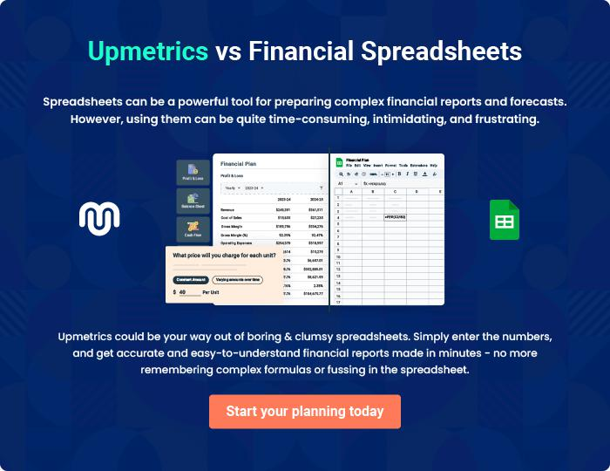

Lawn Care | Business Plan [YEAR] 36/37


Create a winning business plan that gets you funded

Creating a stunning and investment-ready plan requires no writing, graphic designing, or financial planning expertise.

Upmetrics has all the features required to help you create a comprehensive business plan—from start to finish. Make no mistakes, it’s the modern way of planning to structure ideas, make plans, and create stunning pitch decks to awe investors.

Pitch decks that impress investors

Create pitch decks that provide a visual representation of your business, engage investors, and make them want to invest in your business idea.

Interactive plans in no time

Import business plan sections like—SWOT analysis, comparison tables, and others to create an interactive business plan. No designing skills are required.

Stunning cover page designs

With Upmetrics, you have the liberty to choose from multiple stunning cover page designs. Choose a creative design and make your plan stand out.

Online sharing made simple

Upmetrics makes online sharing quick and easier for users. Easily share your business plans with a link while tracking reader activity.

500+ sample business plans

Simply import a template from our library of sample plans into the editor and start customizing it to make it yours. It takes only a few clicks to get started.

Collaborate with team in real-time

Invite team members, initiate conversations, discuss ideas & strategies, share feedback, and work on a business plan in real-time.

