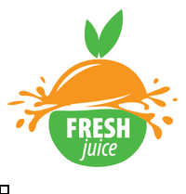

Juice Bar

Juice That Packs A Punch


Business
Plan

[YEAR]

Prepared By

John Doe

10200 Bolsa Ave, Westminster, CA, 92683

info@example.com

(650) 359-3153 http://www.example.com

Table of Contents

Executive Summary | 5
Mission Statement | 6
Vision Statement | 6
Customer Focus | 7
Success Factors | 7
Financial Summary | 7
3 Year profit forecast | 8

Company Summary | 9
History | 10
Business Structure | 10
Startup summary | 11
Startup cost | 11
Store Design | 13
Products and services
Products and services | 14
Market Analysis
Market Analysis | 17
Market Trends | 18
Target Market | 18
SWOT Analysis
SWOT Analysis | 19
Strategy & Implementations
Strategy & Implementations | 22
Sales Strategy | 23
Advertising Strategy | 23
Direct Mail | 23
Public Relations | 24
Advertising | 24
Sampling | 24
Ongoing Customer Communications | 24

Juice Bar | Business Plan [YEAR] 2/36

Pre-Opening Events | 25
Pricing Strategy | 25

Financial Plan | 26
Important Assumptions | 27
Brake-even Analysis | 27
Projected Profit and Loss | 28
Projected Cash Flow | 30
Projected Balance Sheet | 32
Business Ratios | 33

Juice Bar | Business Plan [YEAR] 3/36

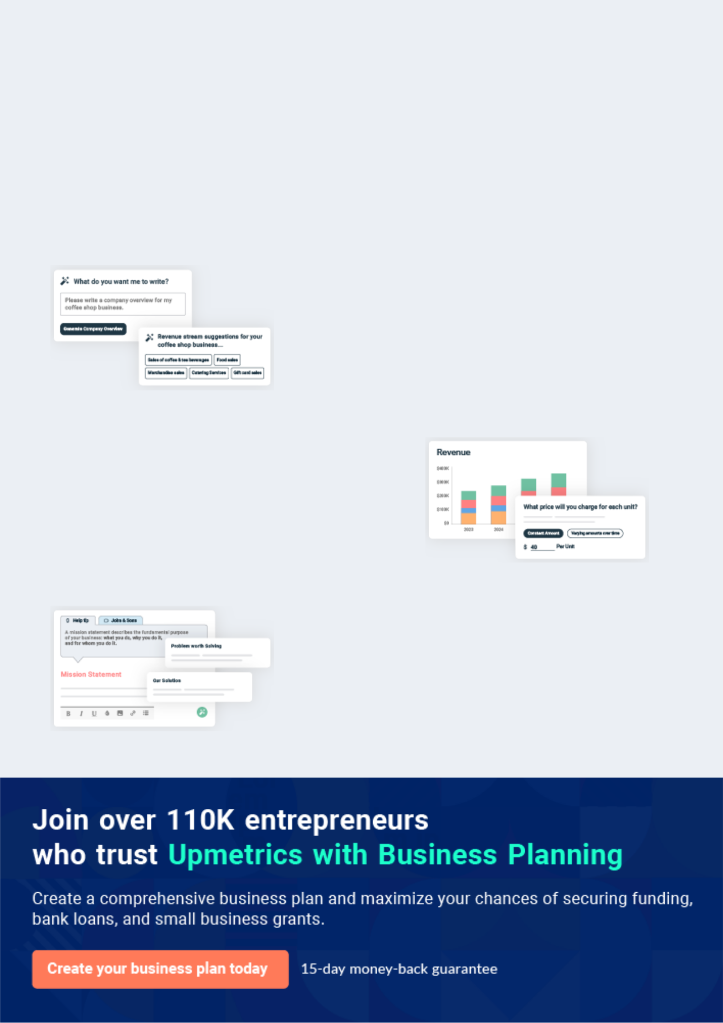
Business planning that’s simpler and faster than you think

Creating a business plan using Upmetrics to start and grow a business is literally the easiest thing in the World. Simply read the instructions and fill in the blanks. It’s as simple as that.

❛ | Upmetrics has everything you need to create a | ❜
❛ | comprehensive business plan. | ❜

AI-powered Upmetrics Assistant

AI-powered insights to streamline your plan

Not sure where to start? Upmetrics’ AI Assistant will automatically generate ideas for each section of your plan and offer improved versions of your writing, adjusting for tone, voice, and grammar or spelling errors.

Financial Forecasting Tool

All the financials are calculated for you

Forget the complex formulas and clumsy spreadsheets — with automatic financials and drag-and-drop forecasting, you can finish your plan faster and be confident that your numbers are accurate.

Business Plan Builder

Guides you like a business mentor

Upmetrics’ step-by-step instructions, prompts, and the library of 400+ sample business plans will guide you through each section of your plan as a business mentor.

1.


Executive Summary

Mission Statement

Vision Statement

Customer Focus

Success Factors

Financial Summary

Juice Bar | Business Plan [YEAR] 5/36

Before you think about how to start a Juice bar business, you must create a detailed Juice bar business plan. It will not only guide you in the initial phases of your startup but will also help you later on.
To unlock help try Upmetrics!
To unlock help try Upmetrics!



 Freshwell Juice Bar


Freshwell Juice Bar, LLC is a licensed fruit juice shop business that will be based in Detroit – Michigan. We are a unique fruit juice brand because we do not just sell assorted fresh fruit juice, but we will also offer consultancy services in line with our area of business.
To unlock help try Upmetrics! 

Start writing here..

Mission Statement

 Freshwell Juice Bar

Our mission is to build a fruit juice shop business that will meet the needs of all our customers in the regions where we have our outlets and to sell franchises all across the United States of America and Canada.



Start writing here..

Vision Statement

 Freshwell Juice Bar

Our vision is to be amongst the top 5 leading fruit juice shops in the United States of America before our 10th anniversary.
To unlock help try Upmetrics! 

Start writing here..

Juice Bar | Business Plan [YEAR] 6/36

Customer Focus
To unlock help try Upmetrics!

 Freshwell Juice Bar

Freshwell Juice Bar will primarily serve the residents who live within a 2-mile radius of our juice bar and workers within a quarter-mile radius. The demographics of these customers are as follows:



Start writing here..

Success Factors

 Freshwell Juice Bar

Freshwell Juice Bar is uniquely qualified to succeed due to the following reasons:

• There is currently no juice bar in the community we are entering. In addition, we have
To unlock help try Upmetrics! 

Start writing here..

Financial Summary

 Freshwell Juice Bar

Freshwell Juice Bar is currently seeking $370,000 to launch. Specifically, these funds will be used as follows:
To unlock help try Upmetrics! 

Start writing here..

Juice Bar | Business Plan [YEAR] 7/36

3 Year profit forecast
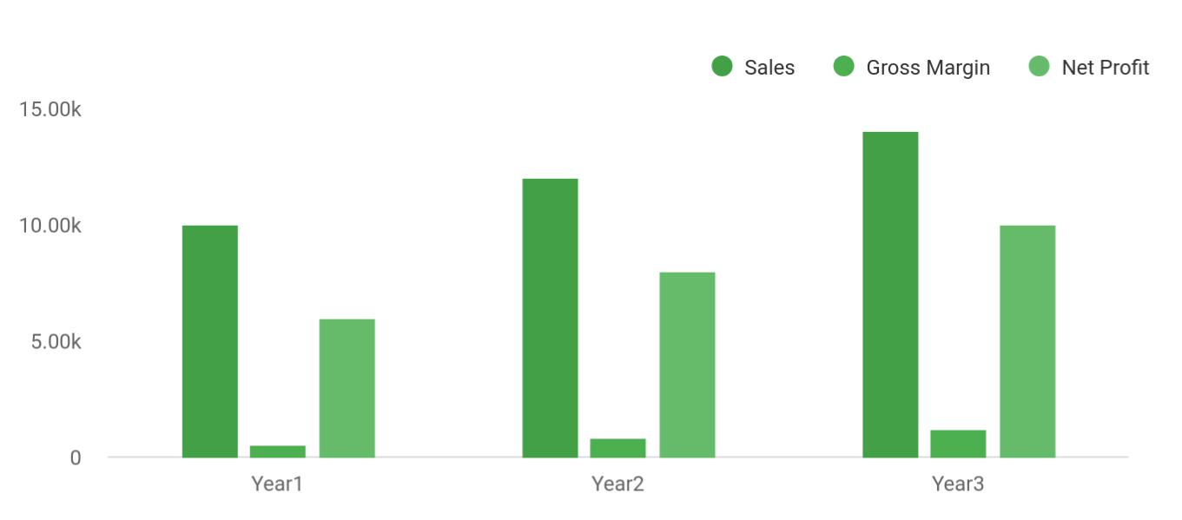

 Freshwell Juice Bar


Financial Summary | Year 1 | Year 2 |  | Year 3
 |  |  | To unlock help try Upmetrics! |  | 

Start writing here..

Juice Bar | Business Plan [YEAR] 8/36

2.

Company Summary

History

Business Structure

Startup summary

Store Design

Juice Bar | Business Plan [YEAR] 9/36

 Freshwell Juice Bar

Freshwell Juice Bar, LLC is owned and managed by Mrs. John Moore is a graduate of MicroBiology from the University of Detroit – Michigan. She has over 7 years of hands-on experience working for some of the leading brands in the fruit and smoothie bar industry.
To unlock help try Upmetrics! 

Start writing here..

History

 Freshwell Juice Bar

Freshwell Juice Bar’s owner, John Moore, has been in the food industry since 2015. She worked as a chef in known hotels and restaurants before deciding to open a juice bar of her own. Her long experience in the food industry gave her an in-depth knowledge of the ins and outs of
To unlock help try Upmetrics! 

Start writing here..

Business Structure

 Freshwell Juice Bar

As part of our plan to build a successful fruit juice business in Detroit – Michigan, we have perfected plans to get it right from the onset which is why we will ensure that we have competent employees in our company. We will ensure that we only hire people that are
To unlock help try Upmetrics! 

Start writing here..

Juice Bar | Business Plan [YEAR] 10/36

Startup summary

Startup cost
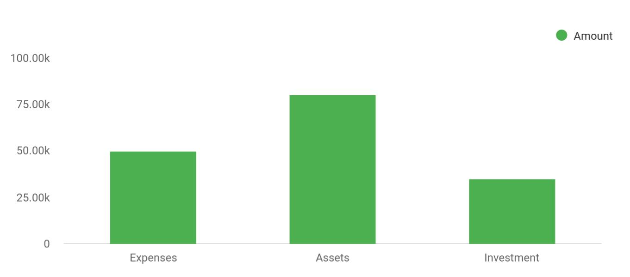

Cost distribution | Amount
Expenses | 50,000
Assets | 80,000
Investment | 35,000

Start-up Expenses | Amount
Legal | $75,500
Consultants | $0
Insurance | $62,750
Rent | $22,500
Research and Development | $42,750
Expensed Equipment | $42,750
Signs | $1,250
TOTAL START-UP EXPENSES | $247,500
Start-up Assets | $0
Cash Required | $322,500
Start-up Inventory | $52,625
Other Current Assets | $222,500

Juice Bar | Business Plan [YEAR] 11/36

Start-up Expenses | Amount
Long-term Assets | $125,000
TOTAL ASSETS | $121,875
Total Requirements | $245,000
START-UP FUNDING | $0
START-UP FUNDING | $273,125
Start-up Expenses to Fund | $121,875
Start-up Assets to Fund | $195,000
TOTAL FUNDING REQUIRED | $0
Assets | $203,125
Non-cash Assets from Start-up | $118,750
Cash Requirements from Start-up | $0
Additional Cash Raised | $118,750
Cash Balance on Starting Date | $121,875
TOTAL ASSETS | $0
Liabilities and Capital | $0
Liabilities | $0
Current Borrowing | $0
Long-term Liabilities | $0
Accounts Payable (Outstanding Bills) | $0
Other Current Liabilities (interest-free) | $0
TOTAL LIABILITIES | $0
Capital | $0
Planned Investment | $0
Investor 1 | $312,500
Investor 2 | $0
Other | $0
Additional Investment Requirement | $0
TOTAL PLANNED INVESTMENT | $695,000

Juice Bar | Business Plan [YEAR] 12/36

Start-up Expenses | Amount
Loss at Start-up (Start-up Expenses) | $313,125
TOTAL CAPITAL | $221,875
TOTAL CAPITAL AND LIABILITIES | $221,875
Total Funding | $265,000

Store Design

 Freshwell Juice Bar

Freshwell Juice Bar will develop a 5,000 square foot store whose key elements will include the following:
To unlock help try Upmetrics! 

Start writing here..

Juice Bar | Business Plan [YEAR] 13/36

3.

Products and services

Juice Bar | Business Plan [YEAR] 14/36

 Freshwell Juice Bar

At Freshwell Juice Bar, LLC we deal in a wide variety of fresh fruit juice, we are an establishment that primarily prepares, serves/sells fresh fruit juice and toppings. As part of our strategy to create multiple sources of income in line with our core business concept, we will run
To unlock help try Upmetrics! 

Start writing here..


Fruit juices Vegetable juices

Holistic juices

Crafted with functional botanicals and
superfood ingredients ^{Fruit Smoothies}

to promote health,

wellness & nutrition.

Training, Advisory

and Consultancy

Services

Juice Bar | Business Plan [YEAR] 15/36

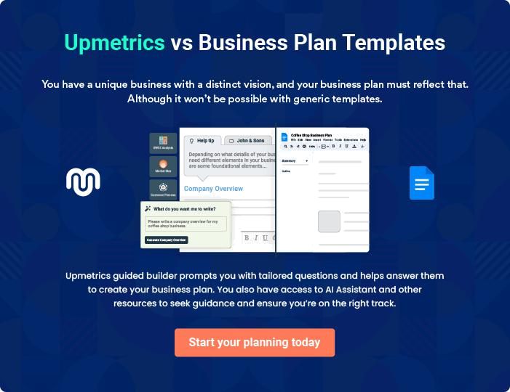

Juice Bar | Business Plan [YEAR] | 16/36

4.

Market Analysis

Market Trends

Target Market

Juice Bar | Business Plan [YEAR] 17/36

The most important component of an effective Juice bar business plan is its accurate marketing analysis. If you are starting on a smaller scale, you can do marketing analysis yourself by taking help from this Juice bar business
To unlock help try Upmetrics!
To unlock help try Upmetrics! 

 Freshwell Juice Bar

The Juice Bar industry has grown steadily over the past five years. The industry is anticipated to grow 1.9% because consumer spending and per capita disposable income is estimated to increase. Demand for industry products will continue to increase along with health-conscious
To unlock help try Upmetrics! 

Start writing here..

Market Trends

 Freshwell Juice Bar

Loads of people are beginning to switch from drinking carbonated drinks to drinking fresh fruit juice and smoothies because of their health benefits. As a matter of fact, the sale of juicers has increased tremendously as most households now make it a point of duty to get one for their
To unlock help try Upmetrics! 

Start writing here..

Target Market

 Freshwell Juice Bar

When it comes to fresh fruit juice, there is indeed a wide range of available customers. In essence, our target market can’t be restricted to just a group of people, but all those who love fresh fruit juice and those who would want to try them out.



Start writing here..

Juice Bar | Business Plan [YEAR] 18/36

5.

SWOT Analysis

Juice Bar | Business Plan [YEAR] 19/36

 Freshwell Juice Bar
To unlock help try Upmetrics!

Our plan of starting our fruit juice shop in just one outlet is to test run the business for a period of 3 to 5 years to know if we will invest more money, expand the business and then open other outlets.



Start writing here..

Juice Bar | Business Plan [YEAR] 20/36


Strength

Our strength lies in the fact that we have a wide range of fruit juice that can meet the needs of a wide range of customers. We have a state-of-the-art facility and equipment that has positioned us to meet customer demands even if demand tripled overnight or if we have a massive order to meet.

Another factor that counts to our advantage is the background of our Chief Executive Officer; she has robust experience in the industry and also good academic qualifications to match the experience acquired which has placed her amongst top professionals in the United States of America. We are not ignoring the fact that offering consultancy services and running a standard and accredited training center is definitely going to count as a positive for us.

Weakness


The fact that we are setting up a fruit juice business in a city with other juice and smoothie bars may likely pose a challenge for us in breaking into the already saturated market in Detroit – Michigan. In essence, our chosen location might be our weakness. But nevertheless, we have plans to launch out with a big bang. We know with that, we will be able to create a positive impression and have a proper handle when it comes to building on already gathered momentum.


Opportunity

The opportunities available to us are unlimited. Loads of people consume fresh fruit juice on daily basis and all that we are going to do to push our products to them is already perfected. There are also loads of people who would want to learn how to produce fresh fruit juice and they will readily find our government-approved fruit juice training center ideal for them to fulfill that goal.

Threat

The threat that is likely going to confront us is the fact that we are competing with already established juice and smoothie bars in Detroit – Michigan and also there are other entrepreneurs who are likely going to launch similar businesses within the location of our business.

Of course, they will compete with us in winning over the available market. Another threat that we are likely going to face is unfavorable government policies and of course economic downturn.

Juice Bar | Business Plan [YEAR] 21/36

6.

Strategy &

Implementations

Sales Strategy

Advertising Strategy

Pricing Strategy

Juice Bar | Business Plan [YEAR] 22/36

After identifying the market demand, market trends, and the potential customers of the startup, the next step is to define an effective strategy for attracting those customers. Like marketing analysis, sales strategy is also an
To unlock help try Upmetrics!
To unlock help try Upmetrics!
To unlock help try Upmetrics! 

Sales Strategy

 Freshwell Juice Bar

We will offer a 10% discount on our servings for the first month of our launch. To introduce our healthy and fresh offerings to the people we’ll offer a 75% discount on all our products for the first two days of our launch. Lastly, we’ll advertise our products and sitting area on social media
To unlock help try Upmetrics! 

Start writing here..

Advertising Strategy

 Freshwell Juice Bar

Freshwell Juice Bar expects its target market to be residents and individuals working within a quarter-mile radius and living within a 2-mile radius of its bar. The Company’s promotions strategy to reach these individuals includes:



Start writing here..

 Freshwell Juice Bar

Freshwell Juice Bar will blanket neighborhoods surrounding its locations with direct mail pieces. These pieces will provide general information on Freshwell Juice Bar, offer discounts, and/or provide other enticements for people to frequent the juice bar.



Direct Mail

Start writing here..

Juice Bar | Business Plan [YEAR] 23/36

 Freshwell Juice Bar

We will contact all local and area newspapers and television stations and send them a press release describing the opening and unique value proposition of Freshwell Juice Bar.
To unlock help try Upmetrics! 

Public Relations

Start writing here..

 Freshwell Juice Bar

Freshwell Juice Bar will initially advertise in local newspapers and sponsor community events in order to gain awareness.
To unlock help try Upmetrics! 

Advertising

Start writing here..

 Freshwell Juice Bar

Freshwell Juice Bar employees will initially give free juice samples to passersby to enable them to taste the quality of our house blend and learn about us.
To unlock help try Upmetrics! 

Sampling

Start writing here..

 Freshwell Juice Bar

Freshwell Juice Bar will maintain a website and publish a monthly email newsletter to tell customers about new events, products, and more.
To unlock help try Upmetrics! 

Ongoing Customer Communications

Start writing here..

Juice Bar | Business Plan [YEAR] 24/36

 Freshwell Juice Bar
To unlock help try Upmetrics!

Before opening the juice bar, Freshwell Juice Bar will organize pre-opening events designed for prospective customers, local merchants, and press contacts. These events will create buzz and awareness for Freshwell Juice Bar in the area.



Pre-Opening Events

Start writing here..

Pricing Strategy

 Freshwell Juice Bar

Fixing prices for fresh juice is not complicated as the prices depend on the size of the container. In view of that, our prices will conform to what is obtainable in the industry but we will ensure that within the first 6 to 12 months our products are sold a little bit below the
To unlock help try Upmetrics! 

Start writing here..

Juice Bar | Business Plan [YEAR] 25/36

7.

Financial Plan

Important Assumptions

Brake-even Analysis

Projected Profit and Loss

Projected Cash Flow

Projected Balance Sheet

Business Ratios

Juice Bar | Business Plan [YEAR] 26/36

The last component of the Juice bar business plan is an in-depth financial plan. The financial plan crafts a detailed map of all the expenses needed for the startup and how these expenses will be met by the earned profits. It is
To unlock help try Upmetrics! 

 Freshwell Juice Bar

The company will be financed by John himself and he will control the direction of the business to make sure that it is expanding at the forecasted rate. As for the Juice bar business start-up, no equity funding or outside loans will be required. With the help of financial experts, John has
To unlock help try Upmetrics! 

Start writing here..

Important Assumptions

The financial projections of the company are forecast on the basis of the following assumptions. These assumptions are quite conservative and are expected to show deviation but to a limited level such that the company’s major financial strategy will not be affected.

 | Year 1 | Year 2 | Year 3
Plan Month | 1 | 2 | 3
Current Interest Rate | 10,00% | 11,00% | 12,00%
Long-term Interest Rate | 10,00% | 10,00% | 10,00%
Tax Rate | 26,42% | 27,76% | 28,12%
Other | 0 | 0 | 0

Brake-even Analysis

Monthly Units Break-even | 5530
Monthly Revenue Break-even | $159 740
Assumptions:
Average Per-Unit Revenue | $260,87
Average Per-Unit Variable Cost | $0,89
Estimated Monthly Fixed Cost | $196 410

Juice Bar | Business Plan [YEAR] 27/36

Projected Profit and Loss

 | 2024 | 2025 | 2026
Revenue | $278,579.60 | $649,256.40 | $1,171,614.15
Fresh Juice Sales | $111,423.20 | $200,100.60 | $359,348.85
Unit Sales | 3,184 | 5,717 | 10,267
Unit Price | $35 | $35 | $35
Smoothie Sales | $45,078 | $72,166.20 | $115,533.90
Unit Sales | 1,503 | 2,406 | 3,851
Unit Price | $30 | $30 | $30
Health Drink Subscriptions | $122,078.40 | $376,989.60 | $696,731.40
Users | 641 | 1,417 | 2,416
Recurring Charges | $30 | $30 | $30
Cost Of Sales | $56,236.43 | $120,377.26 | $210,446.89
General Costs | $56,236.43 | $120,377.26 | $210,446.89
Fresh Ingredients | $47,358.57 | $110,373.60 | $199,174.46
Fruits | $27,857.99 | $64,925.66 | $117,161.46
Vegetables | $19,500.58 | $45,447.94 | $82,013
Packaging & Supplies | $8,877.86 | $10,003.66 | $11,272.43
Cups and Straws | $5,707.17 | $6,430.87 | $7,246.62
Cleaning Supplies | $3,170.69 | $3,572.79 | $4,025.81
Revenue Specific Costs | $0 | $0 | $0
Personnel Costs (Direct | $0 | $0 | $0
Labor) | $0 | $0 | $0
Gross Margin | $222,343.17 | $528,879.14 | $961,167.26

Juice Bar | Business Plan [YEAR] 28/36

 | 2024 | 2025 | 2026
Gross Margin (%) | 79.81% | 81.46% | 82.04%

Operating Expense | $370,655.55 | $386,461.07 | $405,985
Payroll Expense (Indirect | $324,000 | $327,240 | $330,512.04
Labor) | $324,000 | $327,240 | $330,512.04
Management Team | $87,840 | $88,718.40 | $89,605.56
General Manager | $51,840 | $52,358.40 | $52,881.96
Assistant Manager | $36,000 | $36,360 | $36,723.60
Service Staff | $158,400 | $159,984 | $161,583.60
Baristas | $126,720 | $127,987.20 | $129,266.88
Cleaning Staff | $31,680 | $31,996.80 | $32,316.72
Administrative Staff | $77,760 | $78,537.60 | $79,322.88
Accountant | $46,080 | $46,540.80 | $47,006.16
Administrative Assistant | $31,680 | $31,996.80 | $32,316.72
General Expense | $46,655.55 | $59,221.07 | $75,472.95
Operational Costs | $25,364.96 | $28,581.68 | $32,206.58
Rent | $19,023.72 | $21,436.34 | $24,155.06
Utilities | $6,341.24 | $7,145.34 | $8,051.52
Marketing and Advertising | $18,254.13 | $27,276.23 | $39,535.73
Social Media Advertising | $5,571.60 | $12,985.13 | $23,432.29
Local Advertising | $12,682.53 | $14,291.10 | $16,103.44
Administrative Costs | $3,036.46 | $3,363.16 | $3,730.64
Office Supplies | $2,536.46 | $2,858.16 | $3,220.59
Insurance | $500 | $505 | $510.05
Bad Debt | $0 | $0 | $0

Juice Bar | Business Plan [YEAR] 29/36

Amortization of Current Assets

EBITDA

Additional Expense

Long Term Depreciation

Gain or loss from Sale of Assets

EBIT

Interest Expense

EBT

Income Tax Expense / Benefit

Total Expense

Net Income

Net Income (%)

Retained Earning Opening

Owner's Distribution

Retained Earning Closing

2024 | 2025 | 2026
$0 | $0 | $0

($148,312.38) $142,418.07 $555,182.26

$4,583.48 | $3,616.38 | $2,589.63
$2,010 | $2,010 | $2,010
$0 | $0 | $0
($150,322.38) | $140,408.07 | $553,172.26
$2,573.47 | $1,606.38 | $579.64
($152,895.86) | $138,801.69 | $552,592.63
$0 | $0 | $0

$431,475.46 | $510,454.71 | $619,021.52
($152,895.86) | $138,801.69 | $552,592.63
(54.88%) | 21.38% | 47.17%

$0 | ($164,895.86) | ($36,094.17)
$12,000 | $10,000 | $10,000
($164,895.86) | ($36,094.17) | $506,498.46

Projected Cash Flow

 | 2024 | 2025 | 2026
Cash Received | $278,579.60 | $649,256.40 | $1,171,614.15

Juice Bar | Business Plan [YEAR] 30/36

 | 2024 | 2025 | 2026
Cash Paid | $429,465.46 | $508,444.71 | $617,011.52
COS & General Expenses | $102,891.98 | $179,598.33 | $285,919.85
Salary & Wages | $324,000 | $327,240 | $330,512.04
Interest | $2,573.47 | $1,606.38 | $579.64
Sales Tax | $0 | $0 | $0
Income Tax | $0 | $0 | $0
Net Cash From | ($150,885.86) | $140,811.69 | $554,602.63
Operations | ($150,885.86) | $140,811.69 | $554,602.63

Assets Sell | $0 | $0 | $0
Assets Purchase | $15,000 | $0 | $0
Net Cash From | ($15,000) | $0 | $0
Investments | ($15,000) | $0 | $0

Amount Received | $80,000 | $0 | $0
Loan Received | $50,000 | $0 | $0
Common Stock | $0 | $0 | $0
Preferred Stock | $0 | $0 | $0
Owner's Contribution | $30,000 | $0 | $0
Amount Paid | $27,679.72 | $26,646.82 | $27,673.45
Loan Capital | $15,679.73 | $16,646.82 | $17,673.44
Dividends & Distributions | $12,000 | $10,000 | $10,000
Net Cash From | $52,320.28 | ($26,646.82) | ($27,673.45)
Financing | $52,320.28 | ($26,646.82) | ($27,673.45)

Summary

Starting Cash | $0 | ($113,565.58) | $599.29

Juice Bar | Business Plan [YEAR] 31/36

 | 2024 | 2025 | 2026
Cash In | $358,579.60 | $649,256.40 | $1,171,614.15
Cash Out | $472,145.18 | $535,091.53 | $644,684.97
Change in Cash | ($113,565.58) | $114,164.87 | $526,929.18
Ending Cash | ($113,565.58) | $599.29 | $527,528.47

Projected Balance Sheet

 | 2024 | 2025 | 2026
Assets | ($100,575.58) | $11,579.29 | $536,498.47
Current Assets | ($113,565.58) | $599.29 | $527,528.47
Cash | ($113,565.58) | $599.29 | $527,528.47
Accounts Receivable | $0 | $0 | $0
Inventory | $0 | $0 | $0
Other Current Assets | $0 | $0 | $0
Long Term Assets | $12,990 | $10,980 | $8,970
Gross Long Term Assets | $15,000 | $15,000 | $15,000
Accumulated Depreciation | ($2,010) | ($4,020) | ($6,030)
Liabilities & Equity | ($100,575.60) | $11,579.27 | $536,498.46
Liabilities | $34,320.26 | $17,673.44 | $0
Current Liabilities | $16,646.82 | $17,673.44 | $0
Accounts Payable | $0 | $0 | $0
Income Tax Payable | $0 | $0 | $0
Sales Tax Payable | $0 | $0 | $0
Short Term Debt | $16,646.82 | $17,673.44 | $0
Long Term Liabilities | $17,673.44 | $0 | $0

Juice Bar | Business Plan [YEAR] 32/36

 | 2024 |  |  | 2025 |  | 2026
Long Term Debt | $17,673.44 |  |  | $0 |  | $0
Equity | ($134,895.86) |  | ($6,094.17) |  |  | $536,498.46
Paid-in Capital | $0 |  |  | $0 |  | $0
Common Stock | $0 |  |  | $0 |  | $0
Preferred Stock | $0 |  |  | $0 |  | $0
Owner's Contribution | $30,000 |  |  | $30,000 |  | $30,000
Retained Earnings | ($164,895.86) |  | ($36,094.17) |  |  | $506,498.46
Check | $0 |  |  | $0 |  | $0
Business Ratios
 |  | Year 1 | Year 2 |  | Year 3 | Industry Profile
Sales Growth |  | 4,35% | 30,82% |  | 63,29% | 4,00%
Percent of Total Assets
Accounts Receivable |  | 5,61% | 4,71% |  | 3,81% | 9,70%
Inventory |  | 1,85% | 1,82% |  | 1,79% | 9,80%
Other Current Assets |  | 1,75% | 2,02% |  | 2,29% | 27,40%
Total Current Assets |  | 138,53% | 150,99% |  | 163,45% | 54,60%
Long-term Assets |  | -9,47% | -21,01% |  | -32,55% | 58,40%
TOTAL ASSETS |  | 100,00% | 100,00% |  | 100,00% | 100,00%
Current Liabilities |  | 4,68% | 3,04% |  | 2,76% | 27,30%
Long-term Liabilities |  | 0,00% | 0,00% |  | 0,00% | 25,80%
Total Liabilities |  | 4,68% | 3,04% |  | 2,76% | 54,10%
NET WORTH |  | 99,32% | 101,04% |  | 102,76% | 44,90%
Percent of Sales
Sales |  | 100,00% | 100,00% |  | 100,00% | 100,00%

Juice Bar | Business Plan [YEAR] 33/36

 | Year 1 | Year 2 | Year 3 | Industry Profile
Gross Margin | 94,18% | 93,85% | 93,52% | 0,00%
Selling, General & Administrative Expenses | 74,29% | 71,83% | 69,37% | 65,20%
Advertising Expenses | 2,06% | 1,11% | 0,28% | 1,40%
Profit Before Interest and Taxes | 26,47% | 29,30% | 32,13% | 2,86%
Main Ratios
Current | 25,86 | 29,39 | 32,92 | 1,63
Quick | 25,4 | 28,88 | 32,36 | 0,84
Total Debt to Total Assets | 2,68% | 1,04% | 0,76% | 67,10%
Pre-tax Return on Net Worth | 66,83% | 71,26% | 75,69% | 4,40%
Pre-tax Return on Assets | 64,88% | 69,75% | 74,62% | 9,00%
Additional Ratios
Net Profit Margin | 19,20% | 21,16% | 23,12% | N.A.
Return on Equity | 47,79% | 50,53% | 53,27% | N.A.
Activity Ratios
Accounts Receivable Turnover | 4,56 | 4,56 | 4,56 | N.A.
Collection Days | 92 | 99 | 106 | N.A.
Inventory Turnover | 19,7 | 22,55 | 25,4 | N.A.
Accounts Payable Turnover | 14,17 | 14,67 | 15,17 | N.A.
Payment Days | 27 | 27 | 27 | N.A.
Total Asset Turnover | 1,84 | 1,55 | 1,26 | N.A.
Debt Ratios
Debt to Net Worth | 0 | -0,02 | -0,04 | N.A.
Current Liab. to Liab. | 1 | 1 | 1 | N.A.
Liquidity Ratios
Net Working Capital | $120 943 | $140 664 | $160 385 | N.A.
Interest Coverage | 0 | 0 | 0 | N.A.
Additional Ratios
Assets to Sales | 0,45 | 0,48 | 0,51 | N.A.

Juice Bar | Business Plan [YEAR] 34/36

 | Year 1 | Year 2 | Year 3 | Industry Profile
Current Debt/Total Assets | 4% | 3% | 2% | N.A.
Acid Test | 23,66 | 27,01 | 30,36 | N.A.
Sales/Net Worth | 1,68 | 1,29 | 0,9 | N.A.
Dividend Payout | 0 | 0 | 0 | N.A.
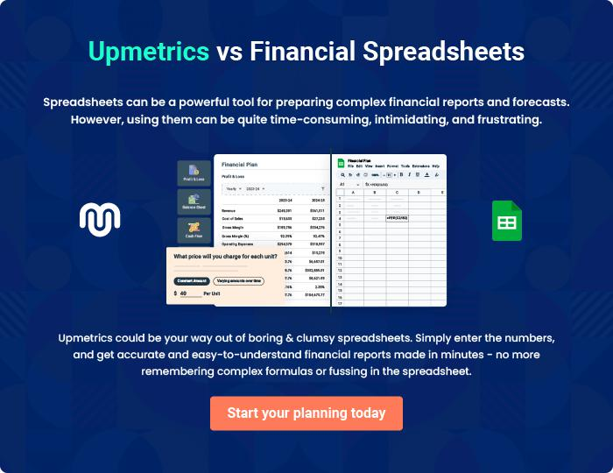

Juice Bar | Business Plan [YEAR] 35/36


Create a winning business plan that gets you funded

Creating a stunning and investment-ready plan requires no writing, graphic designing, or financial planning expertise.

Upmetrics has all the features required to help you create a comprehensive business plan—from start to finish. Make no mistakes, it’s the modern way of planning to structure ideas, make plans, and create stunning pitch decks to awe investors.

Pitch decks that impress investors

Create pitch decks that provide a visual representation of your business, engage investors, and make them want to invest in your business idea.

Interactive plans in no time

Import business plan sections like—SWOT analysis, comparison tables, and others to create an interactive business plan. No designing skills are required.

Stunning cover page designs

With Upmetrics, you have the liberty to choose from multiple stunning cover page designs. Choose a creative design and make your plan stand out.

Online sharing made simple

Upmetrics makes online sharing quick and easier for users. Easily share your business plans with a link while tracking reader activity.

500+ sample business plans

Simply import a template from our library of sample plans into the editor and start customizing it to make it yours. It takes only a few clicks to get started.

Collaborate with team in real-time

Invite team members, initiate conversations, discuss ideas & strategies, share feedback, and work on a business plan in real-time.

