
BUSINESS PLAN

[YEAR]
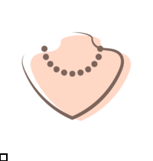

Jewelry

Add Elegance to your appearance

John Doe

10200 Bolsa Ave, Westminster, CA, 92683

- 359-3153 info@example.com http://www.example.com

Information provided in this business plan is unique to this business and confidential; therefore, anyone reading this plan agrees not to disclose any of the information in this business plan without prior written permission of the company.
Table of Contents

Executive summary | 6
Problem Definition & Validation | 7
Solution | 7
Objectives | 8
Short Term (1 -3 Years) | 8
Long Term (3-5 years) | 8
Mission statement | 8
Keys to success | 9
Financial Highlights | 10
Units Sold v/s Revenue Chart | 10

Business overview | 11
Company Ownership/Legal Entity | 12
Location | 12
Interior Operating Facilities | 13
Hours of Operation | 13
Startup summary | 13

Products & Services | 14
Range of Products | 15
Rings | 15
Earrings | 16
Pendant | 16
Bangle | 17
Process | 17
Customer Service | 18
Suppliers | 18

Market Analysis | 20
Market segmentation | 21
Market Trends | 21

Jewelry | Business Plan [YEAR] 2/47

Target market | 22
Adornet Market Distribution | 22
Competitive Advantage | 23
SWOT analysis
SWOT analysis | 24
Strategy & implementation
Strategy & implementation | 27
Distribution Strategy | 28
Marketing and Promotion Programs | 28
Direct Sales | 28
Trade Publications | 29
Trade shows and Lifestyle Exhibitions | 29
Website | 29
Targeted Online Advertising | 29
Positioning Statement | 30
Sales strategy | 30
Online Marketing Channels | 30
Offline Marketing Channels | 31
Pricing strategy | 31
Operational Plan
Operational Plan | 32
Organization chart | 33
Management Team | 33
Personnel Plan | 34
Hiring plan | 34
Jane Doe | 34
John Doe | 35
Milestones | 36
ADORNET | 36
Financial plan
Financial plan | 37
Important Assumptions | 38
Brake-even Analysis | 38
Projected Profit and Loss | 38

Jewelry | Business Plan [YEAR] 3/47

Projected Cash Flow | 41
Projected Balance Sheet | 43
Business Ratios | 44

Jewelry | Business Plan [YEAR] 4/47

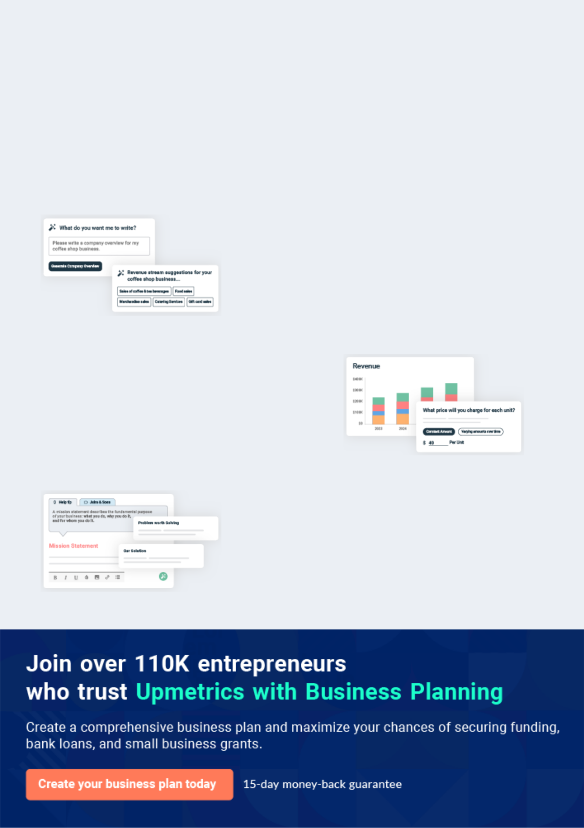
Business planning that’s simpler and faster than you think

Creating a business plan using Upmetrics to start and grow a business is literally the easiest thing in the World. Simply read the instructions and fill in the blanks. It’s as simple as that.

❛ | Upmetrics has everything you need to create a | ❜
❛ | comprehensive business plan. | ❜

AI-powered Upmetrics Assistant

AI-powered insights to streamline your plan

Not sure where to start? Upmetrics’ AI Assistant will automatically generate ideas for each section of your plan and offer improved versions of your writing, adjusting for tone, voice, and grammar or spelling errors.

Financial Forecasting Tool

All the financials are calculated for you

Forget the complex formulas and clumsy spreadsheets — with automatic financials and drag-and-drop forecasting, you can finish your plan faster and be confident that your numbers are accurate.

Business Plan Builder

Guides you like a business mentor

Upmetrics’ step-by-step instructions, prompts, and the library of 400+ sample business plans will guide you through each section of your plan as a business mentor.

1.


Executive summary

Problem Definition & Validation

Solution

Objectives

Mission statement

Keys to success

Financial Highlights

Jewelry | Business Plan [YEAR] 6/47

 Adornet
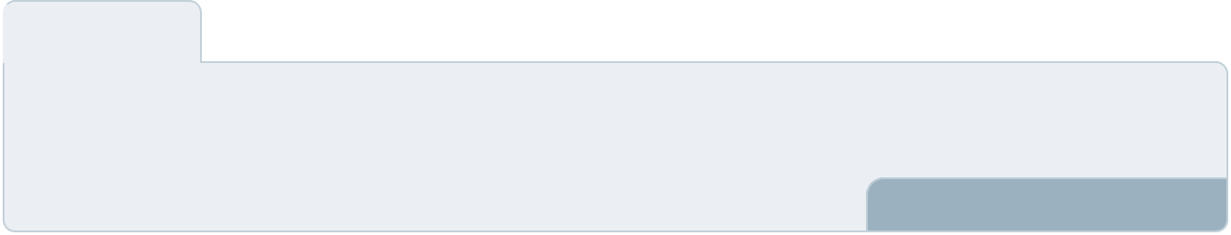

Adornet is a fine jewelry company specializing in the design and manufacture of 18-carat gold, platinum, diamond, and gem-set jewelry. The company carries a wide range of designs from semi-finished mountings, neo-traditional clusters, machine-made wedding rigs to high-value
To unlock help try Upmetrics! 

Start writing here..

Problem Definition & Validation

 Adornet

The main input materials for the industry are gemstones and precious metals such as gold, platinum, and silver. Other metals such as tin, copper, and lead are also used in the production of pewter jewelry. During the past five-year period the prices of these material inputs have
To unlock help try Upmetrics! 

Start writing here..

Solution

 Adornet

The company will ensure sourcing its input materials from vetted suppliers who have a history of successful operations with predictable delivery times. Further, the company will make efforts to improve quality and change consumer perceptions about jewelry made in low-cost countries.
To unlock help try Upmetrics! 

Start writing here..

Jewelry | Business Plan [YEAR] 7/47

Objectives

 Adornet

• To enhance customer service and after-sale services by establishing a representative office in Rhode Island in 2022
• To build a market reputation for quality products and services during the forecast period.
To unlock help try Upmetrics! 

Short Term (1 -3 Years)

Start writing here..

 Adornet

• To establish a presence in Rhode Island and steadily expand operations to slowly cover all of the US within the forecast period
• To reduce operating expenses and aim to grow profitability to more than 35% by Year 5
To unlock help try Upmetrics! 

Long Term (3-5 years)

Start writing here..

Mission statement

 Adornet

To be the epitome of exquisite design and signature fine jewelry in the global marketplace through trust, quality, and tailored services.
To unlock help try Upmetrics! 

Start writing here..

Jewelry | Business Plan [YEAR] 8/47

Keys to success


Experienced Team

Founder Marco will spearhead the US operations. He is supported by unparalleled industry experience having worked for over 20 years within the jewelry sector in a management position that also equips him with superior market knowhow.


Location

Adornet will base its operations in the world’s most significant jewellery quarter. It will take advantage of the associated benefits, networking capabilities and the vast cluster of jewellery retail establishments offered by the region.


Reputation

The company’s signature pieces will sit alongside brands such as Rolex and Cartier which elevates the company’s position providing it with a distinctive market advantage within the global jewellery sector.

Customer Support


Superior customer service is the corner stone on the which Adornet will build and expand its business in the US. Through exceptional after sale services, bespoke designing services and expert advice, the company will establish trust and loyalty within its target market.


Price Advantage

Adornet represents a thriving jewellery manufacturing business based in China. Overseas manufacturing allows the company to rise above the local price fluctuations that effect the market enabling it to offer competitive prices to its customers.


Customized Requirement

Although some operators may have a particular niche, it is generally important for a specialised jewellery design firm to find creative approaches that suit their clients’ needs. Adornet will adapt its services to meet the needs of its market be it retail, wholesale or individual designers.

Jewelry | Business Plan [YEAR] 9/47

Financial Highlights

 Adorenet
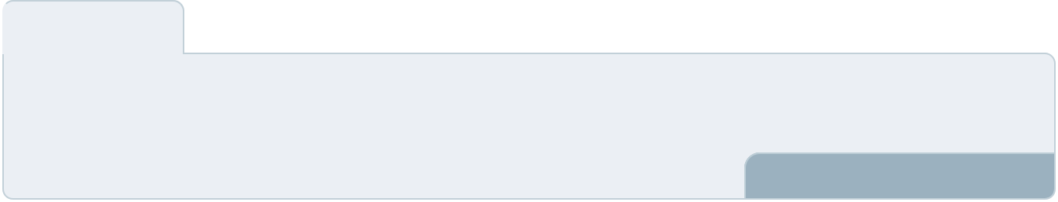

The company envisions raising an equity investment of $50,000 through long-term borrowings, which will be used for the setup and launch of the jewelry store in the US. The company expects to steadily grow its revenues through active efforts in marketing, networking, excellent
To unlock help try Upmetrics! 

Start writing here..

Units Sold v/s Revenue Chart
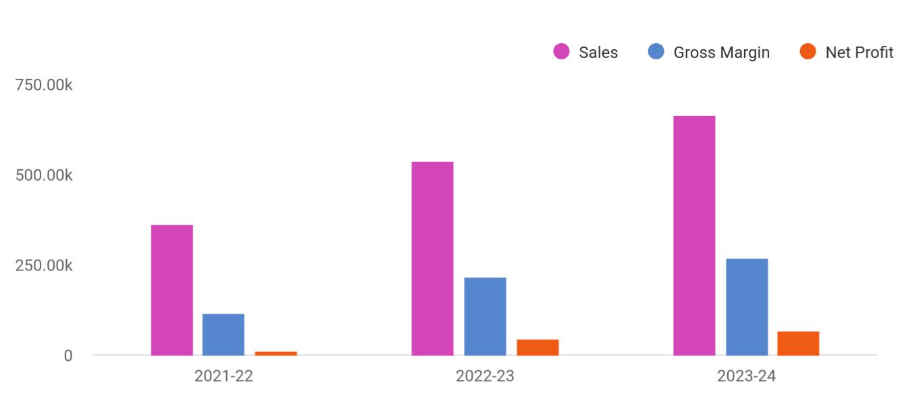

Financial Year | Sales | Gross Margin | Net Profit
2021-22 | 360,723 | 114,289 | 13,038
2022-23 | 538,041 | 216,784 | 44,360
2023-24 | 665,012 | 269,869 | 65,638

Jewelry | Business Plan [YEAR] 10/47

2.

Business overview

Company Ownership/Legal Entity

Location

Interior Operating Facilities

Hours of Operation

Startup summary

Jewelry | Business Plan [YEAR] 11/47

 Adornet

Adornet will be established as a wholesale distributor of fine jewelry in Rhode Island in the United States of America. Exceptional digital marketing capabilities and superior market insight will allow the company to accelerate to the forefront of the jewelry industry, tripling its market
To unlock help try Upmetrics! 

Start writing here..

Company Ownership/Legal Entity

 Adornet

The company will be registered as a limited liability entity with the Department of State. Further, since the company envisions setting up operations in Rhode Island, it will also register with the local county. The business will be wholly owned and managed by the Founder Mr. Marco, who
To unlock help try Upmetrics! 

Start writing here..

Location

 Adornet

The company will establish a business in the Ocean State of Rhode Island by the end of 2022. The region is considered an epicenter for food innovation, design trends, and innovative developments in manufacturing. In fact, the productivity is also very high for certain Rhode
To unlock help try Upmetrics! 

Start writing here..

Jewelry | Business Plan [YEAR] 12/47

Interior Operating Facilities

 Adornet

The company will begin operations from a rented showroom space at the heart of Rhode Island's commercial hub. Initial investments in setting up the interior facilities, consumables,
inventory, and client entertainment space will be set up. Additions to space will be made as the
To unlock help try Upmetrics! 

Start writing here..

Hours of Operation

 Adornet

Adorenet will cater to walk-in as well as online customers, as such it will be required to stay open during business hours. The company envisions opening a showroom at 10 am and remain open till 7 pm to entertain walk-in prospects as well as fulfill online orders.
To unlock help try Upmetrics! 

Start writing here..

Startup summary

 Adornet

A portion of the capital investment of $50,000 will be utilized to finance a range of expenses incurred prior to the launch of the company as indicated in the table below. Accordingly,
approximately $11,500 will be spent on a range of start-up expenses (reflected in the top half of
To unlock help try Upmetrics! 

Start writing here..

Jewelry | Business Plan [YEAR] 13/47

3.

Products & Services

Range of Products

Process

Customer Service

Suppliers

Jewelry | Business Plan [YEAR] 14/47

 Adornet

Adornet values excellent service and are an advocate for high-quality gems and exquisite designs. Creating classic, elegant rings, earrings, bracelets, and other custom jewelry pieces, the company strives to provide efficient and timely service. This will enable the company to
To unlock help try Upmetrics! 

Start writing here..

Range of Products

 Adornet

Adornet specializes in the design and manufacturing of 18-carat gold and platinum, diamond, and gem-set jewelry. Each piece of jewelry is the expression of excellent craftsmanship, along with the selection of top-quality stones and trendy designs. Adornet carries a wide range of
To unlock help try Upmetrics! 

Start writing here..

Rings

Price: $150 USD
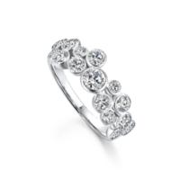

- 18KYW GOLD

- Round Diamond (R11, ROUNG, G COLOR, VS-SI1)

- Round Diamond (R7.5, ROUNG, G COLOR, VS-SI1)

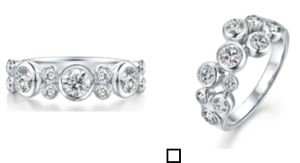

Jewelry | Business Plan [YEAR] 15/47

Earrings

Price: $150 USD
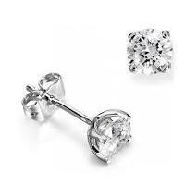

- 18K WHITE GOLD

- Round Diamond (R1.5, ROUNG, G 0.154CT 20 PC 3756.56 578.51 COLOR, VS-SI1)

- Round Diamond (R3.5, ROUNG, G COLOR, VS-SI1)
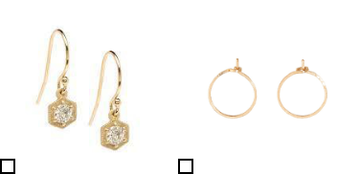

Pendant

Price: $150 USD
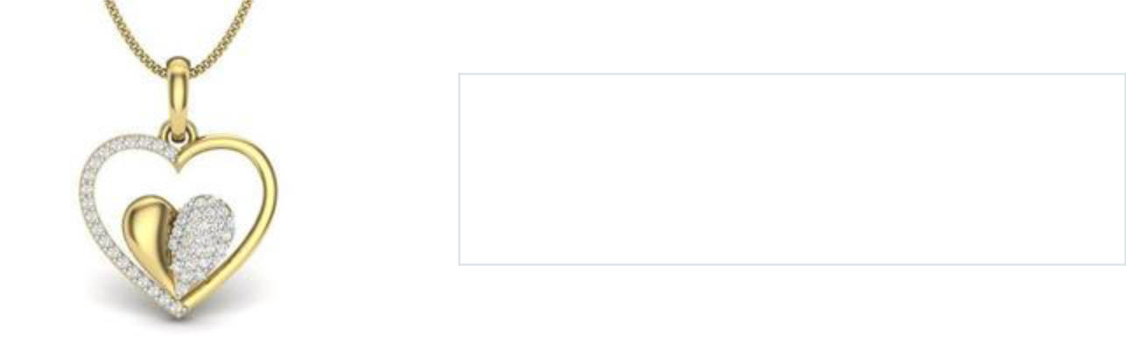

- 18K WHITE GOLD

- Round Diamond (R4.5, ROUNG, G COLOR, VS-SI1)

- Round Diamond (R5.5, ROUNG, G COLOR, VS-SI1)
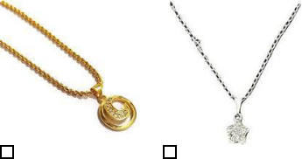

Jewelry | Business Plan [YEAR] 16/47

Bangle

Price: $150 USD
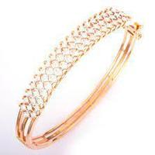

- 18K WHITE GOLD

- Round Diamond (R000, ROUNG, G COLOR, VS-SI1)
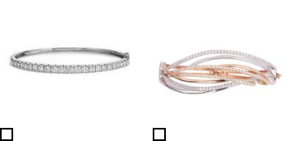

Process

Understanding the Gold Jewellery Manufacturing Process | Jewellers Education

All the jewelry produced is designed by the company’s in-house designers using CAD-CAM facilities brought to life by its automatic prototype machine. Every single step in the production is carried out by expert craftsmen to make sure quality is up to the required standard. Diamonds of all sizes are put through a strict scanning procedure to avoid any CVD (Chemical Vapor Deposition) diamond mixed in the production.

Jewelry | Business Plan [YEAR] 17/47



Design | Prototype | Mass Production
The process begins with the | The 3D models are then used | Mass production of the
concept designing of the | to render a prototype in resin | prototype design takes place in
required piece. Analysing | which is then leveraged to | the selected metal which then
requirements from retailers, | create the first sample in silver | proceeds for stone setting
wholesalers and independent | which is then benchmarked to | handled manually by expert
designers, Adornet creates | create a mould to facilitate | craftsmen. The output is then
bespoke designs based on the | mass production. | polished and put through
specific requirement of each |  | quality control.
B2B client.

Customer Service

 Adornet

Adornet prides itself on the quality of service extended to its customers. This has been the key influencing factor for the company to establish a branch representative in the UK to facilitate better interaction with its significant market segment. As a part of good faith and to maintain a
To unlock help try Upmetrics! 

Start writing here..

Suppliers

 Adornet

The company will establish a network of suppliers who are favorably placed to offer the best quality metal and stones at the most effective price. The diamonds are purchased directly from reputable suppliers to ensure they are conflict-free. Precious stones are procured from a stone
To unlock help try Upmetrics! 

Start writing here..

Jewelry | Business Plan [YEAR] 18/47

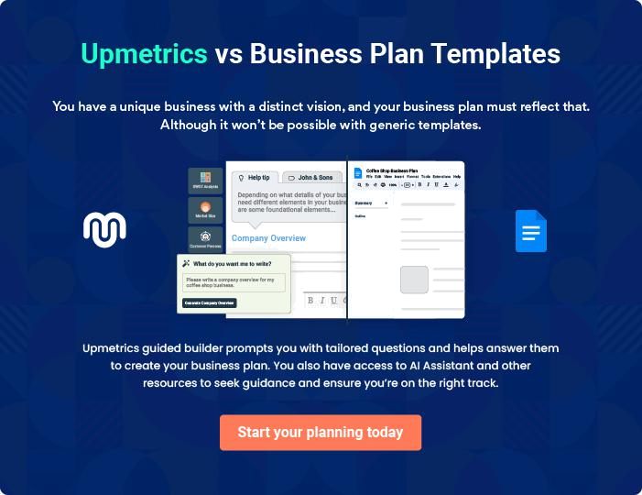

Jewelry | Business Plan [YEAR] | 19/47

4.

Market Analysis

Market segmentation

Market Trends

Target market

Jewelry | Business Plan [YEAR] 20/47

 Adornet

Adornet sources and distributes bespoke and signature jewelry pieces to US designers and retailers. As such, the company will operate in the US’s robust jewelry industry.
To unlock help try Upmetrics! 

Start writing here..

Market segmentation

 Adornet

Jewelry consists of decorative items or accessories which are typically worn on the body or attached to clothing. Jewelry was initially very crude in form, consisting of basic materials like bone, stone, and shell. As time progressed so too did the form and materials used for pieces of
To unlock help try Upmetrics! 

Start writing here..

Market Trends

 Adornet

Consumers are increasingly comfortable shopping online for jewelry—more so since the pandemic—and are much more likely to make high-ticket purchases online than five years ago. According to Gartner L2, the share of online sales across the US and Western European jewelry
To unlock help try Upmetrics! 

Start writing here..

Jewelry | Business Plan [YEAR] 21/47

Target market

 Adornet

With over 4,000 retail establishments and over 1,000 wholesale establishments, the company has a sizeable market opportunity. 80% of the company’s revenue comes from the retail sector while 20% is contributed by the wholesale segment. Adornet has a significant presence in the
To unlock help try Upmetrics! 

Start writing here..

Adornet Market Distribution
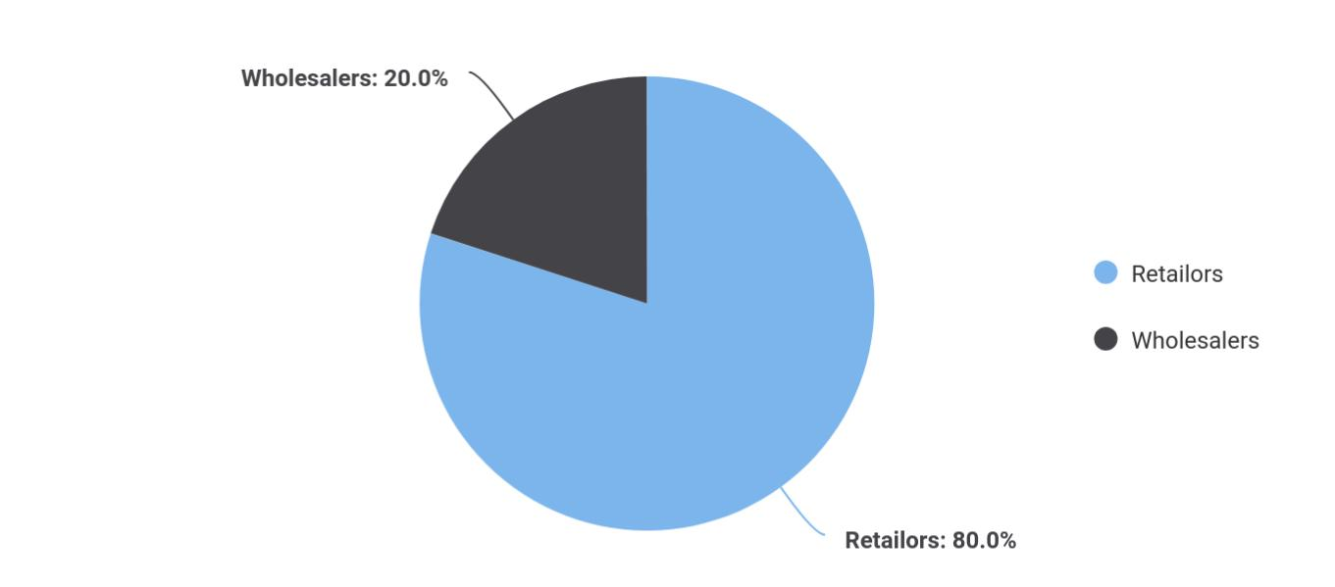

Target Market | Share
Retailors | 0.80
Wholesalers | 0.20

Jewelry | Business Plan [YEAR] 22/47

Competitive Advantage


Ethical Production

Adornet will source its products from overseas markets ensuring ethical production. Furthermore, the company will also use lab-grown diamonds to reduce the company's carbon footprint on the planet

Supply Network

Adornet enjoys superior supply connections and has complete control over the quality of products by thoroughly vetting the suppliers and closely monitoring the manufacturing process.

Distribution Channels

Adornet will distribute its products through both B2B as well as B2C channels. This will allow it to hold a niche in a market where professional skin care products are not freely available in the retail market.

Value Added

Services

Adornet will dedicate itself to the wellbeing of its customers. The company will extend repair, resizing and cleaning services for its products to all its clients for no additional charge.

Price

The company enjoys sole distributorship of the products in the US which allows it to control prices. Adornet will thus be able to secure and distribute products at market beating price points.

Effective Marketing

Adornet will dedicate time and effort towards networking and gaining valuable insight into the prevailing market trends in the US which will allow the company to optimise its marketing strategies and effectively penetrate the market on launch.

Jewelry | Business Plan [YEAR] 23/47

5.

SWOT analysis

Jewelry | Business Plan [YEAR] 24/47

 Adornet

A SWOT (Strength, Weakness, Opportunity, and Threat) analysis is a useful tool for businesses to evaluate their position in the market against the potential internal and external factors that could assist or jeopardize their operations and existence. A SWOT has been conducted for PYT
To unlock help try Upmetrics! 

Start writing here..

Jewelry | Business Plan [YEAR] 25/47


Strength

- Marco has a strong background in Jewellery manufacturing, providing him with unprecedented market acumen

- An established service office in the US allows the company to tap into its significant market segment.

- Manufacturing the jewelry overseas shields the company from the fluctuations in precious metal prices within the local market

- Offering tailored services will give the company a competitive advantage and a deeper market penetration.

- An established supply chain will provide the company with go-to-market capabilities.

- Rooting from an existing business and overseas presence will instill a sense of trust within the customer.

- The company’s unique style and design techniques will give its products an added allure.

- Bespoke Jewellery leading to a unique brand image

Weakness


- New to the US market leading to consumer skepticism regarding its products

- Possible limitations to meet demand due to scale of operations

- Overseas assaying may lead to delay in delivery due to logistic failure


Opportunity

- Expand operations by opening a retail store within the UK

- Partner with other retail outlets to showcase the company brand, thereby increasing brand awareness

- In-house designers provide limitless possibilities in design innovation

- Bespoke jewelry lines targeted specific market segments and occasions

Threat

- Change in government regulations

- Volatile precious metal and gem prices

- Highly competitive industry

- Low barriers to entry leading to more stores offering similar products

Jewelry | Business Plan [YEAR] 26/47

6.

Strategy & implementation

Distribution Strategy

Marketing and Promotion Programs

Positioning Statement

Sales strategy

Pricing strategy

Jewelry | Business Plan [YEAR] 27/47

 Adornet
To unlock help try Upmetrics!

The objectives for the company’s early sales and marketing initiatives will be to generate awareness of Adornet as a new player in the market and to educate potential customers about its portfolio of products. Over time, as Adornet becomes more established and develops a
To unlock help try Upmetrics! 

Start writing here..

Distribution Strategy

 Adornet

The company will reach its customer through both online and offline channels. Adorenet’s comprehensive website will accept orders online and deliver them to the customer’s doorstep. Customers will also have an option to physically visit the company’s showroom to browse and
To unlock help try Upmetrics! 

Start writing here..

Marketing and Promotion Programs

 Adornet

Adornet will approach potential commercial clients directly, either through cold-calling or email, to arrange pitch meetings. The company’s sales representatives will use these opportunities to display the product catalog directly.



Direct Sales

Start writing here..

Jewelry | Business Plan [YEAR] 28/47

 Adornet
To unlock help try Upmetrics!

The Company will advertise in specific trade publications that are targeted towards the appropriate target markets. In the US there are a number of highly specialized publications (e.g. Jewelry and fashion magazine) that will be ideal for reaching these target markets.
To unlock help try Upmetrics! 

Trade Publications

Start writing here..

 Adornet

Adornet will establish a presence at various trade shows that are relevant to the target market. For example, LA Fashion week (US’s leading fashion trade show), HJ Live LA (Provides a platform to source the latest products and equipment from the brands exhibiting at the show).
To unlock help try Upmetrics! 

Trade shows and Lifestyle Exhibitions

Start writing here..

 Adornet

The Company will operate a professional and compelling website, with a dedicated section for commercial clients, to promote its commercial product lines and provide easy ability to contact sales staff.



Website

Start writing here..

 Adornet

The focus will be on Google Ads, which are more likely to drive commercial leads than other online advertising platforms (such as Facebook). The advertising will target specific keywords relevant to Adornets offering (e.g., “exquisite jewelry,” “neo-traditional cluster rings,” “diamond
To unlock help try Upmetrics! 

Targeted Online Advertising

Start writing here..

Jewelry | Business Plan [YEAR] 29/47

Positioning Statement

 Adornet

Adornet will serve as the service and logistic representative of its jewelry brand within the US market. Providing wholesale signature and customer-built jewelry assayed in gold and platinum embedded with superior quality diamond and color stones, the company will serve as the first
To unlock help try Upmetrics! 

Start writing here..

Sales strategy

 Adornet

The company will leverage its existing client network and expand its client base by extending sampling and after-sales services. Employing social media advertising campaigns, e-mail marketing strategies, networking through community clusters, and creating awareness by
To unlock help try Upmetrics! 

Start writing here..

Online Marketing Channels


Electronic Direct Mail

Marketing

Adornet will mail professionally designed materials with its value proposition to these companies and provide quotes for its services.

Social Media

Millennials and consumers in general spend a considerable time browsing social media platforms. Reaching to them through this channel will be and effective way to capture

attention and position its services.

Google Ad Campaigns

The advertising will target

specific keywords relevant to

Adornet's offering (e.g. “exquisite jewelry,” “neo-traditional cluster rings,” “diamond jewelry,” etc.).

Jewelry | Business Plan [YEAR] 30/47

Offline Marketing Channels


Networking | Pop-Up Store | Walk-in
Participate in leading | The company will also hold | The showroom will be
consumers exhibitions and | pop-up stalls at consumer | designed with attractive
fashion events. Display a range | exhibitions. | display of sample of products.
of samples and distribute |  | Visually attractive hoardings
flyers at these events. The |  | and a high street presence will
company will also keep a |  | further attract prospects to
record of visitors to their stalls |  | walk-in and buy high quality
as leads for its email |  | cosmetic products.
marketing campaigns.

Pricing strategy

 Adornet

The average ex-factory price of all signature and custom pieces produced by the company is estimated at under £1,000, with the exception of bracelets that generates an average income of above £1,000 per unit. The direct costs, which are primarily associated with raw material,
To unlock help try Upmetrics! 

Start writing here..

Jewelry | Business Plan [YEAR] 31/47

7.

Operational Plan

Management Team

Personnel Plan

Milestones

Jewelry | Business Plan [YEAR] 32/47

 Adornet
To unlock help try Upmetrics!

The team will be headed by Managing Director Mr. Marco who will also oversee production operations. Joining Mr. Marco in the Management Team will be sales and marketing executives and an office manager.



Start writing here..

Organization chart


Marco

Managing Director
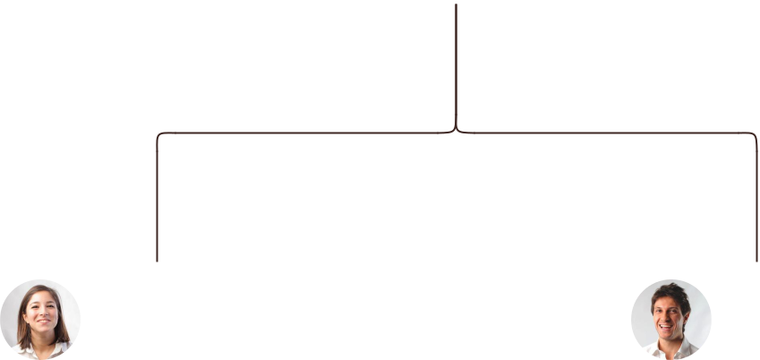

Jane Doe John Doe

Marketing Executives Office Manager

Management Team

 Adornet

Mr. Marco will serve as the Managing Director of Adornet. A highly motivated and dynamic individual, Thomas boasts vast experience in the field of aesthetics having spent a career
spanning 14 years essaying various white-collar roles for aesthetic companies across America.
To unlock help try Upmetrics! 

Start writing here..

Jewelry | Business Plan [YEAR] 33/47

Personnel Plan
To unlock help try Upmetrics!

 Adornet

The company plans to create five full-time equivalent jobs in addition to the management team within the first three years of operations. Salaries for each employee are in line with the industry’s benchmark.



Start writing here..

Hiring plan

2 |  |  |  |  | 1 |  |  |  |  |  | 2
Filled |  |  |  |  | Hired |  |  |  |  |  | Open
Group By |  | Position Filled |  |  |  |  | Time of Hire |  |  |  | Time of Start |  | Filled On Time
Department |  |  |  |  |  |  |  |  |  |  |  |  | Filled On Time
Marketing |  |  | 1 of 20 |  |  |  |  | 10 days |  |  | 121 days |  | 100%
Executive |  |  |  |  |  |  |  |  |  |  |  |  | 100%
Sales Assitant |  |  | 3 of 23 |  |  |  |  | 30 days |  |  | 21 days |  | 80%
Office Manager |  |  | 4 of 15 |  |  |  |  | 158 days |  |  | 127 days |  | 0%


Jane Doe

Office Manager

Ability to cope with fast-paced and pressured work, accuracy, strong attention to detail and a strong analytical mind, ability to notice patterns within statistics, an interest in psychology and behavior, good organizational skills, excellent (spoken and written) communication skills.

Jewelry | Business Plan [YEAR] 34/47


John Doe

Sales Representatives

Preferably bilingual with ability to speak English and French fluently, problem-solving, ability to convert leads into sales, active listener, patience, and understanding of the company’s products and services. Additionally, skills in social media marketing, search engine optimization, newsletter marketing, other forms of digital marketing will also be required

Jewelry | Business Plan [YEAR] 35/47

Milestones

ADORNET
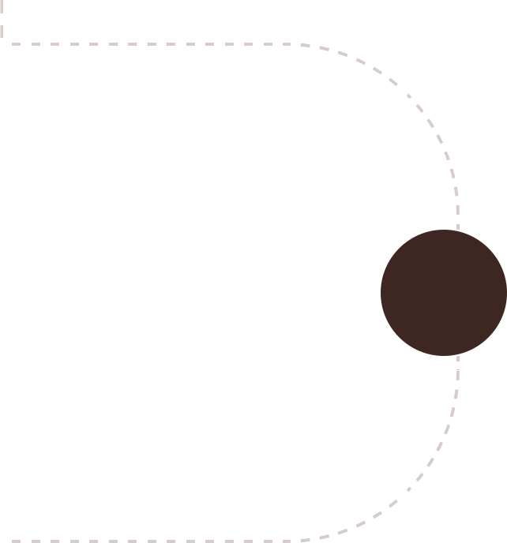

Establish

Adorenet will rent a showroom space at the

heart of Rhode Island's commercial hub

alongside developing a fully optimized and

informative website. During this period, the

company will also acquire initial stocks of

inventory to give as samples and fill up the

showroom shelves. Marketing activities will

also begin during this stage to build

awareness and launch the brand into the

market.



 | Gain Market Traction
Year 2 | The company will begin expanding its
Year 2 | services beyond Rhode Island to cover
 | other regions around the United States


Diversify

Having externally established the business,

the company will begin internally expanding

its range of products


Grow

Year3 • Begin expanding across the US

• Consider market expansion beyond US


Year 1

Year 3

Jewelry | Business Plan [YEAR] 36/47

8.

Financial plan

Important Assumptions

Brake-even Analysis

Projected Profit and Loss

Projected Cash Flow

Projected Balance Sheet

Business Ratios

Jewelry | Business Plan [YEAR] 37/47


If you are going to start your own Jewelry business, then make sure you will pay special attention to your financial plan. Your financial plan should include the details about how well you manage your incomes and expenses, and how
To unlock help try Upmetrics! 

Important Assumptions

The company’s financial projections are forecasted on the basis of the following assumptions. These assumptions are quite conservative and are also expected to show deviation but to a limited level such that the company’s major financial strategy will not be affected.

 | Year 1 | Year 2 | Year 3
Plan Month | 1 | 2 | 3
Current Interest Rate | 10,00% | 11,00% | 12,00%
Long-term Interest Rate | 10,00% | 10,00% | 10,00%
Tax Rate | 26,42% | 27,76% | 28,12%
Other | 0 | 0 | 0

Brake-even Analysis

Monthly Units Break-even | 5530
Monthly Revenue Break-even | $159 740
Assumptions:
Average Per-Unit Revenue | $260,87
Average Per-Unit Variable Cost | $0,89
Estimated Monthly Fixed Cost | $196 410

Projected Profit and Loss

 | 2024 | 2025 | 2026
Revenue | $1,049,491.50 | $1,715,053.50 | $2,888,753
Direct Sales to Customers | $509,342 | $914,718 | $1,642,728

Jewelry | Business Plan [YEAR] 38/47

 | 2024 | 2025 | 2026
Unit Sales | 2,547 | 4,574 | 8,214
Unit Price | $200 | $200 | $200
Online Store Sales | $286,519.50 | $514,540.50 | $924,030
Unit Sales | 1,910 | 3,430 | 6,160
Unit Price | $150 | $150 | $150
Custom Jewelry Orders | $253,630 | $285,795 | $321,995
Unit Sales | 507 | 572 | 644
Unit Price | $500 | $500 | $500

Cost Of Sales | $435,108.10 | $536,852.15 | $667,068.49
General Costs | $435,108.10 | $536,852.15 | $667,068.49
Raw materials | $324,770.23 | $412,520.46 | $526,968.56
Precious Metals | $182,849.95 | $210,176.17 | $238,473.93
Gemstones | $141,920.28 | $202,344.29 | $288,494.63
Production Costs | $110,337.87 | $124,331.69 | $140,099.93
Jewelry Crafting Labor | $88,777.54 | $100,036.83 | $112,723.98
Packaging Materials | $21,560.33 | $24,294.86 | $27,375.95
Revenue Specific Costs | $0 | $0 | $0
Personnel Costs (Direct | $0 | $0 | $0
Labor) | $0 | $0 | $0

Gross Margin | $614,383.40 | $1,178,201.35 | $2,221,684.51
Gross Margin (%) | 58.54% | 68.70% | 76.91%

Operating Expense | $596,324.91 | $637,197.19 | $684,936.79

Jewelry | Business Plan [YEAR] 39/47

 | 2024 | 2025 | 2026
Payroll Expense (Indirect | $453,000 | $465,585 | $478,556.52
Labor) | $453,000 | $465,585 | $478,556.52
Sales Team | $207,000 | $212,805 | $218,805.12
Sales Associate | $99,000 | $100,485 | $101,992.32
Store Manager | $108,000 | $112,320 | $116,812.80
Production Team | $156,000 | $160,080 | $164,270.40
Jewelry Craftsman | $96,000 | $98,880 | $101,846.40
Production Assistant | $60,000 | $61,200 | $62,424
Administrative Staff | $90,000 | $92,700 | $95,481
Office administrator | $42,000 | $43,260 | $44,557.80
Marketing coordinator | $48,000 | $49,440 | $50,923.20
General Expense | $143,324.91 | $171,612.19 | $206,380.27
Marketing and Advertising | $44,388.71 | $50,018.15 | $56,361.59
Online Advertising | $25,364.99 | $28,581.81 | $32,206.53
Print Advertising | $19,023.72 | $21,436.34 | $24,155.06
Rent and Utilities | $86,594.96 | $108,388.70 | $135,846.56
Store Rent | $76,449.01 | $96,956.02 | $122,963.87
Utilities | $10,145.95 | $11,432.68 | $12,882.69
Miscellaneous | $12,341.24 | $13,205.34 | $14,172.12
Office Supplies | $6,341.24 | $7,145.34 | $8,051.52
Business Insurance | $6,000 | $6,060 | $6,120.60
Bad Debt | $0 | $0 | $0
Amortization of Current | $0 | $0 | $0
Assets | $0 | $0 | $0

EBITDA | $18,058.49 | $541,004.16 | $1,536,747.72

Jewelry | Business Plan [YEAR] 40/47

Additional Expense

Long Term Depreciation

Gain or loss from Sale of Assets

EBIT

Interest Expense

EBT

Income Tax Expense / Benefit
2024 2025 2026

$19,534.91 | $12,396 | $12,396
$12,396 | $12,396 | $12,396
$0 | $0 | $0
$5,662.49 | $528,608.16 | $1,524,351.72
$7,138.92 | $0 | $0
($1,476.42) | $528,608.16 | $1,524,351.72
$0 | $0 | $0

Total Expense | $1,050,967.92 | $1,186,445.34 | $1,364,401.28
Net Income | ($1,476.42) | $528,608.16 | $1,524,351.72
Net Income (%) | (0.14%) | 30.82% | 52.77%
Retained Earning Opening | $0 | ($56,476.42) | $457,131.74
Owner's Distribution | $55,000 | $15,000 | $15,000
Retained Earning Closing | ($56,476.42) | $457,131.74 | $1,966,483.46
Projected Cash Flow
 | 2024 | 2025 | 2026
Cash Received | $1,049,491.50 | $1,715,053.50 | $2,888,753
Cash Paid | $1,038,571.92 | $1,174,049.34 | $1,352,005.28
COS & General Expenses | $578,433.01 | $708,464.34 | $873,448.76
Salary & Wages | $453,000 | $465,585 | $478,556.52

Jewelry | Business Plan [YEAR] 41/47

2024 2025 2026

Interest

Sales Tax

Income Tax

Net Cash From

Operations

Assets Sell

Assets Purchase

Net Cash From

Investments

Amount Received

Loan Received

Common Stock

Preferred Stock

Owner's Contribution

Amount Paid

Loan Capital

Dividends & Distributions

Net Cash From

Financing

Summary

$7,138.92 | $0 | $0
$0 | $0 | $0
$0 | $0 | $0
$10,919.58 | $541,004.16 | $1,536,747.72

$0 | $0 | $0
$80,000 | $0 | $0
($80,000) | $0 | $0

$150,000 | $0 | $0
$150,000 | $0 | $0
$0 | $0 | $0
$0 | $0 | $0
$0 | $0 | $0
$205,000.01 | $15,000 | $15,000
$150,000 | $0 | $0
$55,000 | $15,000 | $15,000
($55,000.01) | ($15,000) | ($15,000)

Starting Cash | $0 | ($124,080.43) | $401,923.73
Cash In | $1,199,491.50 | $1,715,053.50 | $2,888,753
Cash Out | $1,323,571.93 | $1,189,049.34 | $1,367,005.28
Change in Cash | ($124,080.43) | $526,004.16 | $1,521,747.72

Jewelry | Business Plan [YEAR] 42/47

 | 2024 | 2025 | 2026
Ending Cash | ($124,080.43) | $401,923.73 | $1,923,671.45

Projected Balance Sheet

 | 2024 | 2025 | 2026
Assets | ($56,476.43) | $457,131.73 | $1,966,483.45
Current Assets | ($124,080.43) | $401,923.73 | $1,923,671.45
Cash | ($124,080.43) | $401,923.73 | $1,923,671.45
Accounts Receivable | $0 | $0 | $0
Inventory | $0 | $0 | $0
Other Current Assets | $0 | $0 | $0
Long Term Assets | $67,604 | $55,208 | $42,812
Gross Long Term Assets | $80,000 | $80,000 | $80,000
Accumulated Depreciation | ($12,396) | ($24,792) | ($37,188)
Liabilities & Equity | ($56,476.42) | $457,131.74 | $1,966,483.46
Liabilities | $0 | $0 | $0
Current Liabilities | $0 | $0 | $0
Accounts Payable | $0 | $0 | $0
Income Tax Payable | $0 | $0 | $0
Sales Tax Payable | $0 | $0 | $0
Short Term Debt | $0 | $0 | $0
Long Term Liabilities | $0 | $0 | $0
Long Term Debt | $0 | $0 | $0
Equity | ($56,476.42) | $457,131.74 | $1,966,483.46
Paid-in Capital | $0 | $0 | $0

Jewelry | Business Plan [YEAR] 43/47

 | 2024 |  |  | 2025 | 2026
Common Stock | $0 |  |  | $0 | $0
Preferred Stock | $0 |  |  | $0 | $0
Owner's Contribution | $0 |  |  | $0 | $0
Retained Earnings | ($56,476.42) |  | $457,131.74 |  | $1,966,483.46
Check | $0 |  |  | $0 | $0
Business Ratios
 |  | Year 1 | Year 2 | Year 3 | Industry profile
Sales Growth |  | 4,35% | 30,82% | 63,29% | 4,00%
Percent of Total Assets
Accounts Receivable |  | 5,61% | 4,71% | 3,81% | 9,70%
Inventory |  | 1,85% | 1,82% | 1,79% | 9,80%
Other Current Assets |  | 1,75% | 2,02% | 2,29% | 27,40%
Total Current Assets |  | 138,53% | 150,99% | 163,45% | 54,60%
Long-term Assets |  | -9,47% | -21,01% | -32,55% | 58,40%
TOTAL ASSETS |  | 100,00% | 100,00% | 100,00% | 100,00%
Current Liabilities |  | 4,68% | 3,04% | 2,76% | 27,30%
Long-term Liabilities |  | 0,00% | 0,00% | 0,00% | 25,80%
Total Liabilities |  | 4,68% | 3,04% | 2,76% | 54,10%
NET WORTH |  | 99,32% | 101,04% | 102,76% | 44,90%
Percent of Sales
Sales |  | 100,00% | 100,00% | 100,00% | 100,00%
Gross Margin |  | 94,18% | 93,85% | 93,52% | 0,00%
Selling, General & Administrative Expenses |  | 74,29% | 71,83% | 69,37% | 65,20%
Advertising Expenses |  | 2,06% | 1,11% | 0,28% | 1,40%
Profit Before Interest and Taxes |  | 26,47% | 29,30% | 32,13% | 2,86%

Jewelry | Business Plan [YEAR] 44/47

 | Year 1 | Year 2 | Year 3 | Industry profile
Main Ratios
Current | 25,86 | 29,39 | 32,92 | 1,63
Quick | 25,4 | 28,88 | 32,36 | 0,84
Total Debt to Total Assets | 2,68% | 1,04% | 0,76% | 67,10%
Pre-tax Return on Net Worth | 66,83% | 71,26% | 75,69% | 4,40%
Pre-tax Return on Assets | 64,88% | 69,75% | 74,62% | 9,00%
Additional Ratios
Net Profit Margin | 19,20% | 21,16% | 23,12% | N.A.
Return on Equity | 47,79% | 50,53% | 53,27% | N.A.
Activity Ratios
Accounts Receivable Turnover | 4,56 | 4,56 | 4,56 | N.A.
Collection Days | 92 | 99 | 106 | N.A.
Inventory Turnover | 19,7 | 22,55 | 25,4 | N.A.
Accounts Payable Turnover | 14,17 | 14,67 | 15,17 | N.A.
Payment Days | 27 | 27 | 27 | N.A.
Total Asset Turnover | 1,84 | 1,55 | 1,26 | N.A.
Debt Ratios
Debt to Net Worth | 0 | -0,02 | -0,04 | N.A.
Current Liab. to Liab. | 1 | 1 | 1 | N.A.
Liquidity Ratios
Net Working Capital | $120 943 | $140 664 | $160 385 | N.A.
Interest Coverage | 0 | 0 | 0 | N.A.
Additional Ratios
Assets to Sales | 0,45 | 0,48 | 0,51 | N.A.
Current Debt/Total Assets | 4% | 3% | 2% | N.A.
Acid Test | 23,66 | 27,01 | 30,36 | N.A.
Sales/Net Worth | 1,68 | 1,29 | 0,9 | N.A.
Dividend Payout | 0 | 0 | 0 | N.A.

Jewelry | Business Plan [YEAR] 45/47

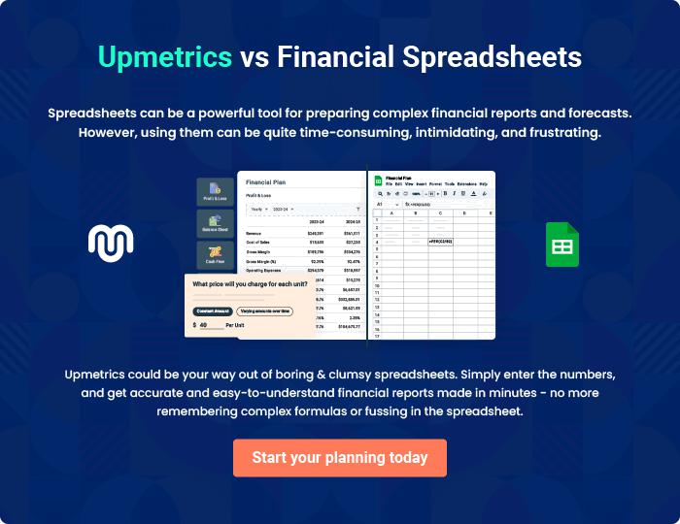

Jewelry | Business Plan [YEAR] | 46/47


Create a winning business plan that gets you funded

Creating a stunning and investment-ready plan requires no writing, graphic designing, or financial planning expertise.

Upmetrics has all the features required to help you create a comprehensive business plan—from start to finish. Make no mistakes, it’s the modern way of planning to structure ideas, make plans, and create stunning pitch decks to awe investors.

Pitch decks that impress investors

Create pitch decks that provide a visual representation of your business, engage investors, and make them want to invest in your business idea.

Interactive plans in no time

Import business plan sections like—SWOT analysis, comparison tables, and others to create an interactive business plan. No designing skills are required.

Stunning cover page designs

With Upmetrics, you have the liberty to choose from multiple stunning cover page designs. Choose a creative design and make your plan stand out.

Online sharing made simple

Upmetrics makes online sharing quick and easier for users. Easily share your business plans with a link while tracking reader activity.

500+ sample business plans

Simply import a template from our library of sample plans into the editor and start customizing it to make it yours. It takes only a few clicks to get started.

Collaborate with team in real-time

Invite team members, initiate conversations, discuss ideas & strategies, share feedback, and work on a business plan in real-time.

