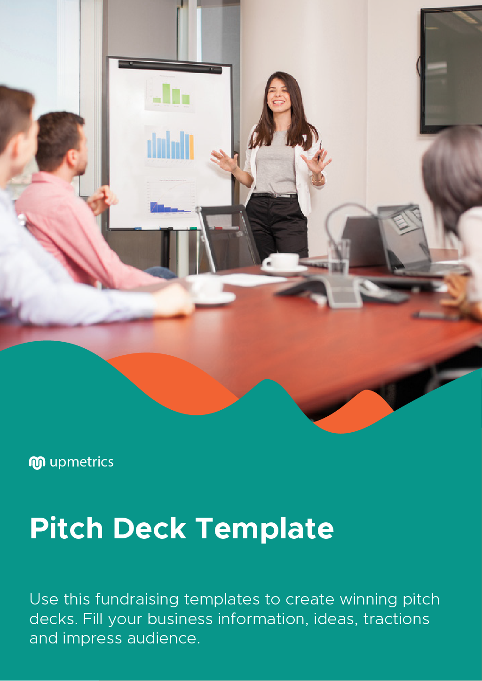

| **Hi There!**  Thanks for downloading this template.    You Can Edit Version To Fit Your Needs. | |
| --- | --- |
| **How to use this template**  Pitching to investors can be both nerve-wracking and exciting. And if all goes well a pitch can turn into a brilliant opportunity that can either help you grow your business or advance in your career.  But all of us know that no single way of pitching can work for everyone or solve different purposes. Also, a pitch that helps you sound convincing and helps you highlight all major points, isn’t exactly easy to create.  But don’t worry. We have created a set of 8 investor pitch templates, their use, and examples to help you write a winning business pitch for yourself or your company.  You can choose amongst these templates to suit your specific purpose and requirements.  Above all, these templates take away the hassle of writing a pitch, so that you can focus on what really matters.  So, go ahead and write your pitch. After all, good things come to those who don’t wait! | |
| Do you want to plan your business faster?  Upmetrics can help you at every step of writing your business plan.  So, what are you waiting for! | Sample Business Plan |
| [**Start writing your business plan today**](https://upmetrics.co/call-to-download?utm_source=investor-pitch-template&utm_medium=create-business-plan&utm_campaign=download)**!** | |

# **Problem Solving Pitch Template**

## **Use this template to describe a business that addresses a customer’s pain point**

Hello [*Audience*]. My name is [*name*], and I am the [*designation*] at [*organization*]. Today we’re trying to achieve [*target*] in exchange for [*share*].

Sometime ago, I came across [*give background information*]. It was [*objective to describe the experience*]. At that moment, I felt that there needs to be a better way to [*activity*].

That gave me the idea to develop [*product/service*] - a solution to the obstacles we face while [*topic*]. By easily [*describe how to use the product/service*], we can get away from the [*negative experience*] while going ahead with the [*activity you described before*].

The estimated market size is [*the size of the target market/ potential revenue*], because of this we know that this venture will work.

I hope we can discuss this further and have a partnership that can help [number] of people.

## **Example**

Hello, investors. My name is Jonathan Stevens, and I am the Chief Operations Officer at Traffic.co. Today, we are seeking $65,000 in exchange for 15% of our growing company.

Sometime ago, I found myself stuck in traffic more often than not as I commuted from my home to my downtown office. As you all might know, this situation was exhausting and took up a lot of my time. At that moment I thought there could be a better way to commute that can help one avoid being stuck in traffic.

That gave me the idea to develop Traffic.co– a solution to the problems we face due to traffic. By identifying alternative routes and smart tracking combined with traffic alerts, we’ve removed any chance of being caught in traffic jams when you’re trying to get home quickly or are in a hurry to get to work.

The estimated market size is 75 million daily commuters, because of this we know this venture will work. I hope we can discuss this further and have a partnership that can help millions of commuters.

**Disaster Prevention Pitch Template**

## **Use this template when describing a business that helps avoid potential negative consequences.**

All of us know that – [*issue*] has been troubling [*group/area*] for [*duration*]. In a recent survey, it was found that [*statistics supporting your point*].

If [*issue*] remains unsolved, [*explain outcome of inaction*].Fortunately, we are working to solve that.

My name is [*name*], the [*designation*] of [*company*] – a solution to [*obstacle*] that helps [*target audience*]. Our [*product/service/business*] [*describe what your product/ service can accomplish in brief*].

Not only does [*product/service/business name*] help [*the topic*], it can also create jobs and revenue. This year, we expect to make [*sales/profit amount*] by penetrating the [*industry name*] market.

But, for that, we’ll need your help –that is why we’re asking for an investment of [*amount*] as well as your partnership to help us get [*positive outcome*].

## **Example**

All of us know that– pollution has been plaguing the environment for time immemorial. In a recent survey, it was found that by the year 2060, pollution will have a permanent effect on our planet.

If the destruction of our planet remains unsolved, Earth might become uninhabitable for future generations. Fortunately, we are working to solve that.

My name is Alex Williams, the Founder of OurPlanet – a solution to pollution that helps remove carbon content from the air and water bodies. Our product removes carbon from the air and water at a massive scale with our revolutionary and one of a kind technology – exponentially reducing the threat of global warming and also making the air more breathable and water more usable.

Not only does OurPlanet help protect our environment, it can also create jobs and revenue.This year, we expect to generate $15,000,000 in profit by penetrating the multi-trillion dollar carbon footprint reduction industry.

But for that, we’ll need your help – that is why we’re asking for an investment of $4,000,000 as well as your partnership to help us save the planet.

**Subject Matter Knowledge Pitch Template**

## **Use this prompt when describing a business in a domain in which you have personal experience and knowledge makes you more credible**

Good [*morning/afternoon/evening*]. I’m [*name*], the [*designation*] of [*industry*] company, [*company name*]. Over the last [*number of years*] years, I’ve gained expertise in the [*industry*] field. Between getting my [industry] degree at [*university*], working as a [*designation*] for [*company*], and leading [*project*] at [*company*], I’ve realized one thing about [*industry*] – [*explain reason that led to company founding*].

That’s why I’m leading the [*company*] – providing [*solution*]. By [*explain actions taken with the product to solve the problem*], we’re able to [*explain outcomes of using the product*]. This product provides a unique solution to [*problem*].

[*Investor name(s)*] – I know from experience that [*product/service name*] is valuable, speaking on behalf of me and the [*number*] of other [*types of roles*] out there. I’d be grateful for your support and guidance to help us get [*company name*] off the ground, and for an investment of [*amount*] in exchange for [*share*], I’m positive that [*company*] will be a household name in the [*industry*] industry. Thank you.

## **Example**

Good evening. I’m Maria Anne, the founder of engineering employee retention company, Enginolutions. Over the past twenty five years, I’ve gained a considerable amount of expertise in the engineering field. Between earning my Master’s degree at Stanford, working as a solutions architect for Microsoft, and leading engineering at Google, I’ve realized one thing about the industry – engineers get ahead real quick.

That’s why I’m leading the company Enginolutions – the provider of engineer-specific employee engagement and management software. By providing the clear performance reports that both engineers and their managers need, we’re able to find out which engineers are highly likely to leave a company and determine how to retain them. This product provides a unique solution to the high engineering turnover rate.

People I know from experience that Enginolutions is valuable, speaking on behalf of myself and thousands of engineers out there. I’d be grateful for your support and guidance to help us get Enginolutions off the ground, and with your investment of just $150,000 in exchange for 25% of the business, I’m confident Enginolutions will be a household name in the engineering industry in the next six years. Thank you.

**Making the most of Demand Pitch Template**

## **Use this template when describing a business that maximizes output from a growing market segment or opportunity.**

My name is [*name*], I’m here for one primary reason– the [*market name*] market has grown more than [*number*] percent in the last [*number*] years.

Since [*include incident*], [*number*] people have [*their action*], which points out that now is the best time for a welcomed innovation in the [*market*] sector.

That’s why I’m here on the behalf of [*company name*] – a new tool designed solely to capitalize on the demand for [*topic*]. Thanks to our registered and patented [*technology type*], we’ve built a one of its kind solution to [*issue*] by [*explain how the solution works*].

Here’s the deal – [*popular trend*] is here to stay, and we cannot avoid the impact it will have on our lives. For [*amount*], you can help us get the primary funds in exchange for [*offering*] in the process. Together, we can make the [*company*] the market leader when it comes to [*subject*].

## **Example**

My name is Edward Jones, I’m here for one primary reason– the remote work market has grown more than 10,000 percent in the last two years.

Since the pandemic, due to government stay-at-home orders, and developing technology, 26million people have gone fully or partially remote in the last 2 years, which points out that now is the best time for a welcomed innovation in the remote work sector.

That’s why I’m here on the behalf of Remotebetter – a new tool designed solely to capitalize on the demand for remote work. Thanks to our registered and patented software, we’ve built a one of its kind solution to the problems faced by remote workforces by bringing coworkers together in a virtual setting for water coolers, defined breaks, whiteboards, and impromptu meetings.

Here’s the deal – remote work is likely to become a norm, and we cannot avoid the impact it will have on our lives. For $1,500,000,you can help us get the primary funds in exchange for 33% of the share. Together, we can make Remotebetter the market leader when it comes to maintaining company culture and making remote work easier.

**Finding an Opportunity Pitch Template**

## **Use this template when you’re presenting to a person you want to work with, work for, or learn from**

Hello [*person’s name*] – I know you're busy, so I’d come straight to the point. My name is [*name*], and I’m looking for an opportunity to work with you and make my place in the [*industry name*] industry.

I’ve felt inspired by your [*aspect you admire*], and have always wanted to work in [*industry*]. To get me where I am today, I’ve [*outline actions you’ve taken for the work you want to do*]. This experience helped me learn [*lessons learned*].

If you’d want to, I’d be so glad if we could sit down for [*time period*] to discuss more about my goals and to hear what advice or opportunities you might recommend for someone like me.

## **Example**

Hello Mr. Rodriguez – I know you’re busy, so I’d come straight to the point. My name is Elaine James, and I’m looking for an opportunity to work with you and make my place in the entertainment industry.

I’ve felt inspired by your films, and have always wanted to work in this industry. To get me to where I am today, I’ve studied film at UCLA, competed in many annual local film festivals, and interned at PIxar Studios. These experiences have made me realize that filmmaking is my life, and I want to spend the rest of it telling stories for the screen just like you have.

If you’d want to, I’d be so glad if we could sit down for sometime to discuss more about my goals and to hear what advice or opportunities you might recommend for someone like me.

**Partnership, a Consultation, or Resources Pitch Template**

## **Use this template when you’re pitching to someone you’d want advice or suggestions from**

Good [*morning/afternoon/evening*], thank you for taking the time to be here today. My name is [*name*] and I am the [*designation*] at [*business name*].

Do you know that [*surprising statistic*]? Well, believe it or not, it’s real– and that’s what I’m working to make possible with [*company name*].

I’m currently developing a solution to [problem], and so far, progress has been considerable. In the last [*time period since starting the project*], we’ve [*outline accomplishments in that time*].

We’re tapping into a revolutionary solution to the problem of [*problem*] – and we’re close to coming up with a solution, but I need your guidance.

Currently, [*company name*]’s biggest obstacles are [*challenge: 1*], [*challenge: 2*], and [*challenge: 3*]. I need your guidance, expertise, and partnership to help me grow [company name] to the heights I know it can get to. Please let me know if you’d want to lend your time and knowledge to learn more about [*company name*] and help it succeed. Thank you.

## **Example**

Good morning, thank you for taking the time to be here today. My name is Lily Jones and I am the founder of Weather Bee.

Do you know that 85% of people wish they could control the weather? Well, believe it or not, it’s real– and that’s what I’m working to make possible with Weather Bee.

I’m currently developing a solution to the inability to control the weather, and so far, progress has been considerable. In the last three years, we’ve identified important ways we can weaken the impact of unpredictable weather.

We’re tapping into a revolutionary solution to the problem of controlling the impact of weather– and we’re close to coming up with a solution, but I need your guidance.

Currently, Weather Bee’s biggest challenges are forecasting hurricanes, reversing typhoons, and blocking the rain. I need your advice, guidance, and partnership to help me grow Weather Bee to the heights it can get to. Please let me know if you’d want to lend your time and knowledge to learn more about Weather Bee and help it succeed. Thank you.

**Sales Pitch Template**

## **Use this template when you’ve got less time to grab the attention of someone who may be interested in buying your product/service.**

Hi [*first name*] – thanks for taking the time to be here today.

Let me begin with a question: [*question relevant to the business*]

Well, that’s what we’re trying to accomplish with [*company*]. In short, we [*explain the use of product/service*].

The reason we feel [*product*] will be a good fit for you is because [*explain benefits for this connection*]. We know you [*explain need of contact*], and [*product*] can aid you with that. On average, our customers see [*successful performance measure*] after using [*product*].

So let me ask you, is [*product/service*] something you’d like to know more about?

## **Example**

Hi Philip – thanks for taking the time to be here today.

Let me begin with a question: do you have trouble managing your contacts with your current CRM?

Well, that’s what we’re trying to solve with Maneco. In short, we combine scaling companies’ contacts all through their marketing, sales, and customer service initiatives.

The reason we feel Maneco will be a good fit for you is because we’ve heard your company is growing at a rapid pace. We know you need a long-term solution for all of your teams to connect with your customers, and Maneco can aid you with that. Over 150,000 customers have entrusted us to help grow their companies better due to the stronger communication they gain between their customer-facing teams.

So let me ask you, is Maneco something you’d like to know more about?

**Product Pitch Template**

## **Use this template when you want to describe your product as clearly as possible.**

The [*product name*] is a tool that aids [*target audience*] [*describe task being fulfill*].

It works as follows: [*explain how the product works*].

With [*product*], you can now [*explain unique benefits of using the product*].

Without [*product*], [*explain cons of not using the product*].

If you want to know more about [*product*], [*outline steps for understanding the product better*].

## **Example**

The Crane Riser is a tool that aids construction workers and architects to operate their cranes easily and without any accidents in a dense city environment.

It works as follows: Crane Riser is an add-on part to an existing crane. It makes the typically rigid operation of handling a crane easy and lessens the consequences of difficult motions – increasing the safety of construction workers, the people around, and infrastructure in the surrounding environment.

With Crane Riser, you can now get construction work done faster, and safer than ever before.

Without Crane Riser, construction companies face the existing risk of high insurance claims, damage to property, injury to workers and other people, and being behind schedule on important jobs.

If you want to know more about Crane Riser, visit us on our business’s website, where you can fix time with me to talk about buying Crane Riser for your business.