

Insurance Company

Secure Your family with lifeMax


Business
Plan

[YEAR]

Prepared By

John Doe

10200 Bolsa Ave, Westminster, CA, 92683

info@example.com

(650) 359-3153 https://example.com

Table of Contents

Executive Summary | 5
Objectives | 6
Mission | 6
Keys to Success | 7
Financial Forecasts | 7
3 Year profit forecast | 7

Business Summary | 8
Overview | 9
Company History | 9
Startup cost | 9
Funding Required | 11
Company Ownership | 12
Company Locations and Facilities | 12

Products and Services | 13
Service Description | 14
Competitive Comparison | 14
Sales Literature | 15
Fulfillment | 15
Technology | 15
Future Services | 16

Market Analysis | 17
Market Segmentation | 18
Market Analysis | 18
Service Business Analysis | 20
Competition and Buying Patterns | 20
Business Participants | 20
Distributing a Service | 20

Insurance Company | Business Plan [YEAR] 2/40

Competitor Analysis | 21
Cal Roberts, Patrick C. Johnson, Rob Champlain | 21
Agents (such as Co-operators) | 21
Mass Markets | 21
Gray Power | 21
Group Plans - teachers, public employees | 21

Strategy and Implementation Summary | 22
Marketing Strategy | 23
Promotion Strategy | 23
Distribution Strategy | 24
Positioning Statement | 24
Pricing Strategy | 24
Sales Strategy | 25
Sales Programs | 25
Sales Forecast | 25
Sales Yearly | 26
Strategic Alliances | 27
Service and Support | 27
Milestones | 27

Management Summary | 28
Organizational Structure | 29
Financial Plan
Financial Plan | 30
Startup Funding | 31
Important Assumptions | 32
Brake-even Analysis | 32
Projected Profit and Loss | 33
Profit Yearly | 34
Gross Margin Yearly | 34
Projected Cash Flow | 35
Projected Balance Sheet | 36
Business Ratios | 37

Insurance Company | Business Plan [YEAR] 3/40

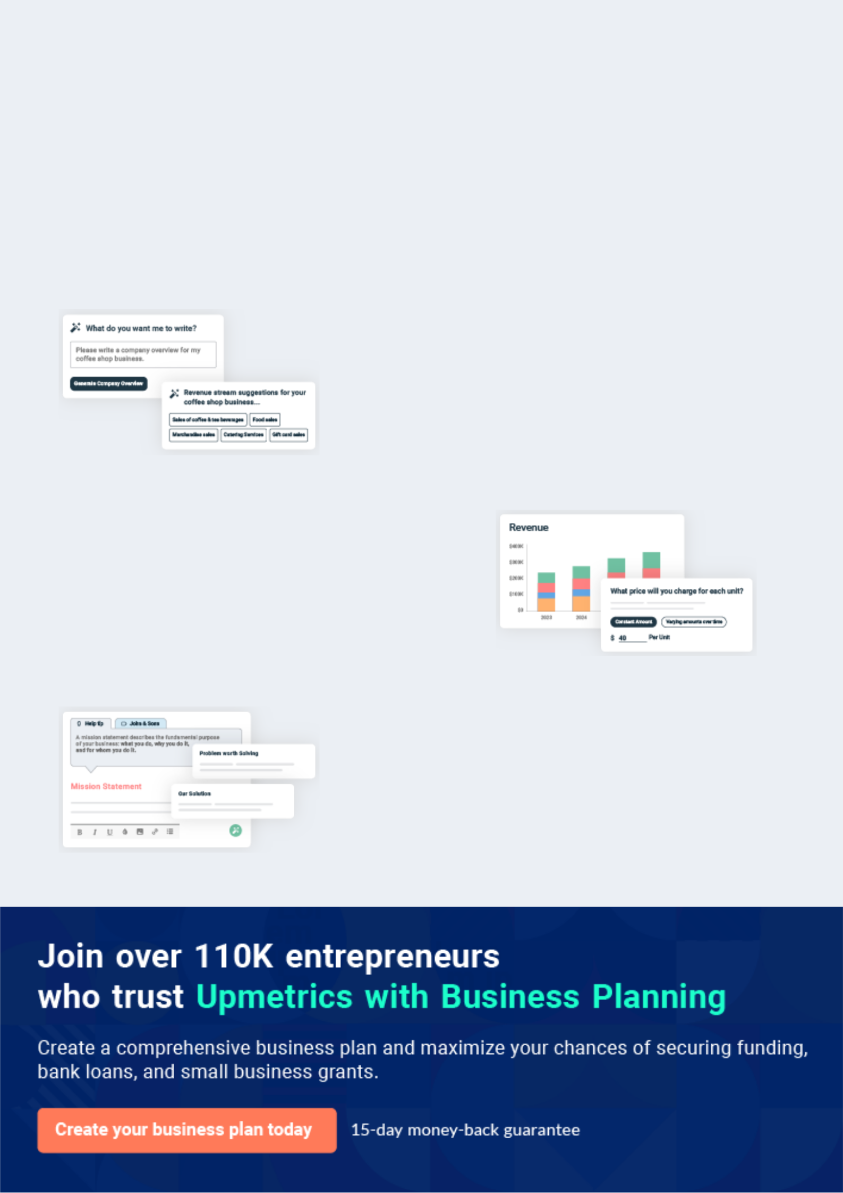
Business planning that’s simpler and faster than you think

Creating a business plan using Upmetrics to start and grow a business is literally the easiest thing in the World. Simply read the instructions and fill in the blanks. It’s as simple as that.

❛ | Upmetrics has everything you need to create a | ❜
❛ | comprehensive business plan. | ❜

AI-powered Upmetrics Assistant

AI-powered insights to streamline your plan

Not sure where to start? Upmetrics’ AI Assistant will automatically generate ideas for each section of your plan and offer improved versions of your writing, adjusting for tone, voice, and grammar or spelling errors.

Financial Forecasting Tool

All the financials are calculated for you

Forget the complex formulas and clumsy spreadsheets — with automatic financials and drag-and-drop forecasting, you can finish your plan faster and be confident that your numbers are accurate.

Business Plan Builder

Guides you like a business mentor

Upmetrics’ step-by-step instructions, prompts, and the library of 400+ sample business plans will guide you through each section of your plan as a business mentor.

1.


Executive Summary

Objectives

Mission

Keys to Success

Financial Forecasts

Insurance Company | Business Plan [YEAR] 5/40

Before you think about how to start Insurance services, you must create a detailed Insurance agent business plan. It will not only guide you in the initial phases of your startup but will also help you later on.
To unlock help try Upmetrics!

 Ex :: Lifemax




Lifemax Insurance is a general insurance company incorporated under the United States’ law as a private Limited Liability Company but has a plan in the nearest future to transform into a public limited liability company. This is so as to enable us to get listed on the New York Stock
To unlock help try Upmetrics! 

Start writing here..

Objectives

 Ex :: Lifemax

• To re-establish Lifemax Insurance Inc. as the market leader in quality and value-priced insurance products in The Woodlands District.
• Establish good working relationships with our present insurance markets by meeting with
To unlock help try Upmetrics! 

Start writing here..

Mission

 Ex :: Lifemax

Lifemax Insurance Inc. is dedicated to providing insurance products that provide quality protection with value pricing. We wish to establish a successful partnership with our clients, our staff members, and our insurance companies, that respect the interests and goals of each
To unlock help try Upmetrics! 

Start writing here..

Insurance Company | Business Plan [YEAR] 6/40

Keys to Success

 Ex :: Lifemax

We believe the keys to success in a small town insurance business are:

• Knowledgeable, friendly staff that can empathize with our consumer's needs and
To unlock help try Upmetrics! 

Start writing here..

Financial Forecasts

3 Year profit forecast
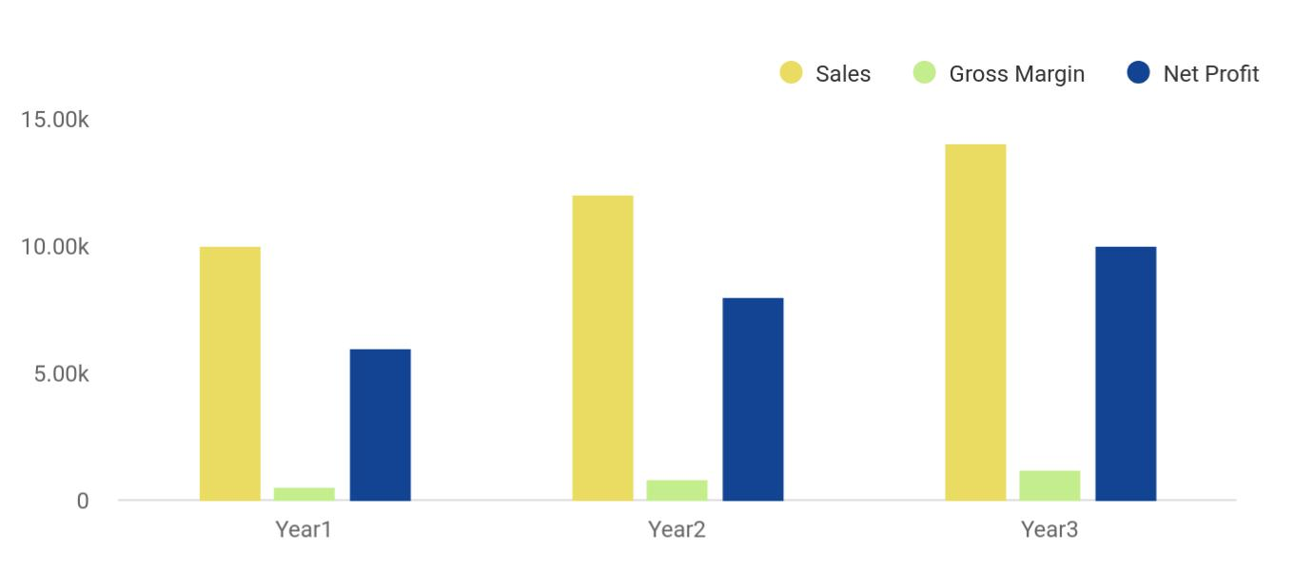

Financial Year | Sales | Gross Margin | Net Profit
Year1 | 10,000 | 500 | 6,000
Year2 | 12,000 | 800 | 8,000
Year3 | 14,000 | 1,200 | 10,000

Insurance Company | Business Plan [YEAR] 7/40

2.

Business Summary

Overview

Company History

Funding Required

Company Ownership

Company Locations and Facilities

Insurance Company | Business Plan [YEAR] 8/40

Overview

 Ex :: Lifemax

Lifemax Insurance primarily markets and services Personal Lines Insurance. Its customers are mostly rural, lower-income families or long time resident senior citizens who demand value priced insurance premiums in keeping with their lower and fixed incomes.
To unlock help try Upmetrics! 

Start writing here..

Company History

 Ex :: Lifemax

Lifemax Insurance was founded as a sole proprietorship in 1938 and was owned and operated by the founder Stan Carrington. He originally ran the operation from his home but moved to the business section of The Woodlands when he outgrew his home-based operation.
To unlock help try Upmetrics! 

Start writing here..

Startup cost
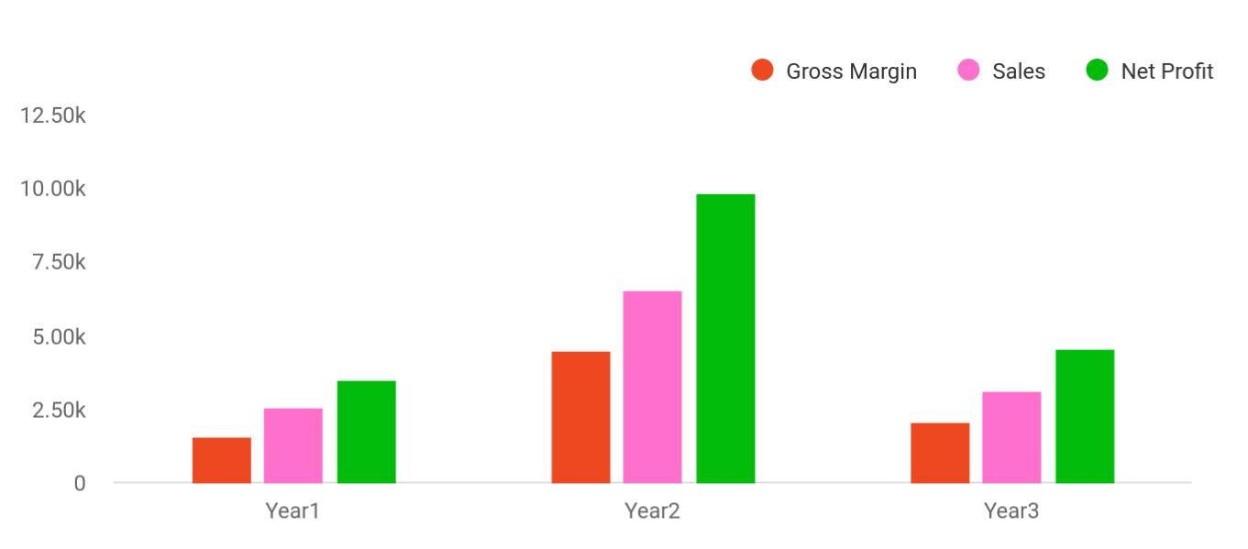

Cost distribution | Gross Margin | Sales | Net Profit
Year1 | 1,550 | 2,548 | 3,456
Year2 | 4,500 | 6,545 | 9,854

Insurance Company | Business Plan [YEAR] 9/40

Cost distribution | Gross Margin | Sales | Net Profit
Year3 | 2,050 | 3,100 | 4,512

PAST PERFORMANCE | YEAR 1 | YEAR 2 | YEAR 3
Sales | $644,023 | $660,593 | $622,309
Gross Margin | $144,174 | $115,204 | $120,525
Gross Margin % | 22.39% | 17.44% | 19.37%
Operating Expenses | $597,440 | $604,559 | $560,266
Collection Period (days) | 0 | 0 | 0
Balance Sheet
Current Assets
Cash | $0 | $0 | $402,640
Accounts Receivable | $0 | $0 | $255,940
Other Current Assets | $0 | $0 | $309,137
TOTAL CURRENT ASSETS | $0 | $0 | $967,717
Long-term Assets
Long-term Assets | $0 | $0 | $465,575
Accumulated Depreciation | $0 | $0 | $181,651
TOTAL LONG-TERM ASSETS | $0 | $0 | $283,924
Total Assets | $0 | $0 | $1,251,641
Current Liabilities
Accounts Payable | $0 | $0 | $336,000
Current Borrowing | $0 | $0 | $0
Other Current Liabilities (interest free) | $0 | $0 | $100,362
TOTAL CURRENT LIABILITIES | $0 | $0 | $436,362
Long-term Liabilities | $0 | $0 | $452,036
TOTAL LIABILITIES | $0 | $0 | $888,398
Paid-in Capital | $0 | $0 | $100
Retained Earnings | $0 | $0 | $88,096

Insurance Company | Business Plan [YEAR] 10/40

PAST PERFORMANCE | YEAR 1 | YEAR 2 | YEAR 3
Earnings | $0 | $0 | $275,047
TOTAL CAPITAL | $0 | $0 | $363,243
Total Capital and Liabilities | $0 | $0 | $1,251,641
Other Inputs
Payment Days | 0 | 0 | 60
Sales on Credit | $0 | $0 | $0
Receivables Turnover | 0.00 | 0.00 | 0.00

Funding Required

STARTUP REQUIREMENTS | AMOUNT
Startup Expenses
Legal (license and permits) | $2,000
Stationery | $2,000
Insurance | $1,000
Rent | $0
Computer | $2,000
Website | $1,000
Total Startup Expenses | $8,000
Startup Assets
Cash Required | $24,000
Other Current Assets | $0
Long-term Assets | $0
Total Assets | $24,000
Total Requirements | $32,000

Insurance Company | Business Plan [YEAR] 11/40

Company Ownership
To unlock help try Upmetrics!

 Ex :: Lifemax

Lifemax Insurance is a privately incorporated company in the Woodlands district and is licensed to transact both Life and General Insurance. The shares are held equally by Dr. Wilcox Carrington and Mrs. Ruth Ferguson.



Start writing here..

Company Locations and Facilities

 Ex :: Lifemax

Our Insurance and Real Estate brokerage operates from two central locations. Our modern attractive office in The Woodlands, at 178 Small Street, is located in a small plaza which is owned by the principals of our brokerage. It comprises 2,000 square feet.
To unlock help try Upmetrics! 

Start writing here..

Insurance Company | Business Plan [YEAR] 12/40

3.

Products and Services

Service Description

Competitive Comparison

Sales Literature

Fulfillment

Technology

Future Services

Insurance Company | Business Plan [YEAR] 13/40

Before starting an Insurance Company, you must take many things into consideration such as you must consider what types of Insurance services will you be providing to your customers. Deciding your services is extremely
To unlock help try Upmetrics!
To unlock help try Upmetrics! 

 Ex :: Lifemax

Lifemax Insurance is committed to providing professional sales and service for its insurance customers. We have established what we consider to be an excellent reputation in our area, and are the largest multi-line insurance broker in our trading area.



Start writing here..

Service Description

 Ex :: Lifemax

Lifemax Insurance provides home, automobile, and business insurance in The Woodlands District. We take pride in knowing that for over 50 years we have helped our clients to find the best coverage at the right price that suits their needs and expectations. In the event of a claim,
To unlock help try Upmetrics! 

Start writing here..

Competitive Comparison

 Ex :: Lifemax

Our company's strength lies in the quality and depth of our products and staff. Our offices, unlike our competition, are open six days a week. Because of our larger staff, we are able to service our clients even when a client's broker is busy or out of the office on inspections.
To unlock help try Upmetrics! 

Start writing here..

Insurance Company | Business Plan [YEAR] 14/40

Sales Literature
To unlock help try Upmetrics!

 Ex :: Lifemax

We have recently produced a pamphlet titled "Insurance Partners" which stresses that a successful insurance partnership between the client, the broker, and the company is based upon a new concept.



Start writing here..

Fulfillment

 Ex :: Lifemax

The key to fulfilling our client's needs is provided by our principals who have over 60 years of experience between them as general insurance brokers, and our staff, many of whom have been insurance brokers well over 10 years. We have one staff member with her A.I.I.C., three
To unlock help try Upmetrics! 

Start writing here..

Technology

 Ex :: Lifemax

We have been fully computerized since 1982 and both offices and some of our producer's homes are connected to our main computer server located in The Woodlands.
To unlock help try Upmetrics! 

Start writing here..

Insurance Company | Business Plan [YEAR] 15/40

Future Services

 Ex :: Lifemax

Although Stan Smith started out as a life insurance agent, the "life" part of our business represents only 1% of our sales. We are looking to strengthen this part of our operation in the future. Due to the complexity and number of life and disability products, we are presently using
To unlock help try Upmetrics! 

Start writing here..
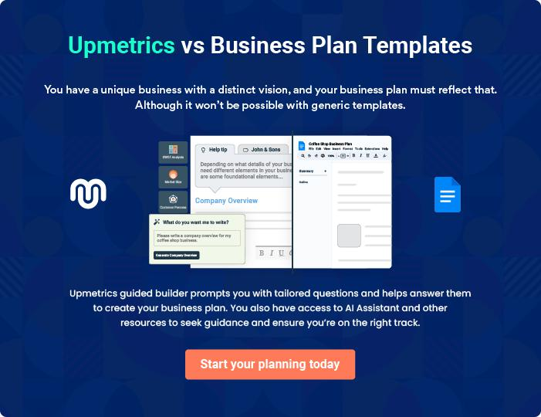

Insurance Company | Business Plan [YEAR] 16/40

4.

Market Analysis

Market Segmentation

Service Business Analysis

Competitor Analysis

Insurance Company | Business Plan [YEAR] 17/40

The most important component of an effective Insurance company business plan is its accurate marketing analysis. If you are starting on a smaller scale, you can do the market analysis yourself by taking help from this Insurance
To unlock help try Upmetrics! 

 Ex :: Lifemax

Recent demographic studies in our area reveal a total year-round population of approximately 13,000, which rises in the summer to approximately 25,000. We have a relatively high number of seniors and many younger, newly-formed families dependent on government assistance living
To unlock help try Upmetrics! 

Start writing here..

Market Segmentation

 Ex :: Lifemax

Our market consists of senior citizens, lower-income young families (many of who are on social assistance), and the small, family-run business (many of which are seasonal and based on the tourist trade). There are a few industrial risks and those that are located here are branches of
To unlock help try Upmetrics! 

Start writing here..

Market Analysis
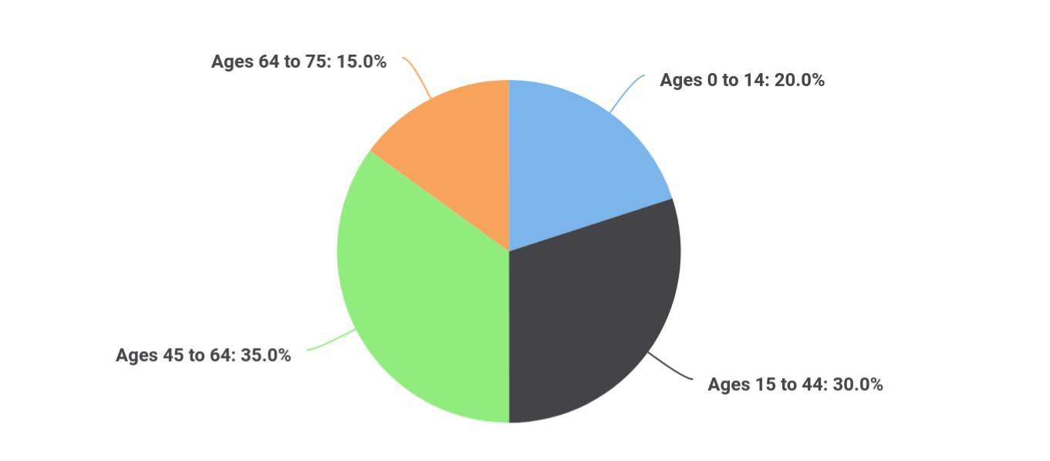

Segments Market share

Ages 0 to 14 20

Insurance Company | Business Plan [YEAR] 18/40

Segments | Market share
Ages 15 to 44 | 30
Ages 45 to 64 | 35
Ages 64 to 75 | 15

Potential Customers | Growth | Year 1 | Year 2 | Year 3 | Year 4 | Year 5 | CAGR
Ages 0 to 14 | 2% | 2,550 | 2,601 | 2,653 | 2,706 | 2,760 | 2.00%
Ages 15 to 44 | 2% | 4,760 | 4,855 | 4,952 | 5,051 | 5,152 | 2.00%
Ages 45 to 64 | 5% | 2,885 | 3,029 | 3,180 | 3,339 | 3,506 | 4.99%
Ages 65 to 74 | 5% | 1,280 | 1,344 | 1,411 | 1,482 | 1,556 | 5.00%
Other | 2% | 1,000 | 1,020 | 1,040 | 1,061 | 1,082 | 1.99%
Total | 3.03% | 12,475 | 12,849 | 13,236 | 13,639 | 14,056 | 3.03%

Insurance Company | Business Plan [YEAR] 19/40

Service Business Analysis
To unlock help try Upmetrics!
To unlock help try Upmetrics!

 Ex :: Lifemax

The past few years have seen tremendous upheaval in the insurance industry. The number of players has decreased in both the broker and company communities. The automobile product has, in the mind of the public, become unaffordable, unavailable, and impossible to understand.
To unlock help try Upmetrics! 

Start writing here..

 Ex :: Lifemax

The main volume of income for our brokerage is generated by automobile premiums because they are relatively higher priced to insure than property and because automobile insurance is mandatory in the region.



Competition and Buying Patterns

Start writing here..

 Ex :: Industry


- Cal Roberts Insurance

- Markets - Royal, Dominion of Canada

• Patrick C. Johnson 

Business Participants

Start writing here..

 Ex :: Industry

Our trading area is rural. Premiums are relatively low and therefore not subject to large brokerages or specialty direct writers mounting aggressive advertising campaigns to bring in business. There are few group plans providing insurance coverage with the exception of our
To unlock help try Upmetrics! 

Distributing a Service

Start writing here..

Insurance Company | Business Plan [YEAR] 20/40

Competitor Analysis

Cal Roberts, Patrick C. Johnson, Rob Champlain

Strengths

Alternate markets, especially small farm mutual, that still continue to give low prices, still continue to write wood stoves, and allow discounts and underwriting terms such as table 1 rates on homeowners within 8 km of fire hall protection.

Weaknesses

Most are smaller, one-man operations that do not have the backup or finances to aggressively impact the marketplace.

Agents (such as Co-operators)

Strengths

Large advertising budget and competitively priced products. Their commercial is difficult to compete against in some cases because they seem to not have the same restrictions on underwriting as our markets. Also they have large capacity to write certain risks.

Weaknesses

One small operation that does not have the same hours as our offices. Staff, because of salary, do not appear to be very knowledgeable or aggressive.

Mass Markets

Strengths

Already known to our clients; will be competitively priced.

Weaknesses

An unknown quantity to our insureds. Also, if their people skills are similar to what they now exhibit, they will have great difficulty empathizing with the client and selling the client what he needs, not what they think he needs.

Gray Power

Strengths Weaknesses

Price A still untried, unknown quantity.

Group Plans - teachers, public employees

Strengths Weaknesses

Low Pricings Very little obviously, since we insure very few of the

professions.

Insurance Company | Business Plan [YEAR] 21/40

5.

Strategy and

Implementation Summary

Marketing Strategy

Sales Strategy

Strategic Alliances

Service and Support

Milestones

Insurance Company | Business Plan [YEAR] 22/40

After identifying the market demand, market trends, and the potential customers of the startup, the next step is to define an effective strategy for attracting those customers. Like marketing analysis, sales strategy is also an
To unlock help try Upmetrics!
To unlock help try Upmetrics!
To unlock help try Upmetrics!
To unlock help try Upmetrics! 

 Ex :: Lifemax

Emphasize service and ongoing support. We must avoid selling only one policy at the lowest price for each customer and concentration on account selling which greatly enhances client retention.



Start writing here..

Marketing Strategy

 Ex :: Lifemax

Emphasize service and support.

Build a partnership business based on account selling.



Start writing here..

 Ex :: Lifemax

We have depended in the past on a small advertisement in our local newspaper, listings in the Yellow Pages, and word of mouth. We must begin to investigate alternate ways to put our name in front of the public.



Promotion Strategy

Start writing here..

Insurance Company | Business Plan [YEAR] 23/40

 Ex :: Lifemax
To unlock help try Upmetrics!

Select Seniors, We will give special attention to this market in our advertising. We will make a concerted effort to support and sponsor seniors programs in our area. We will seek out Cottage associations and offer support and advice to attract new senior clients who are recently retired
To unlock help try Upmetrics! 

Distribution Strategy

Start writing here..

 Ex :: Lifemax

Our target market is The Woodlands District. The ideal client is claims-free aged between 45 -

75 who owns his own home and car and is debt-free. Has exhibited stable family patterns and
is known and respected in the community.


Positioning Statement

Start writing here..

 Ex :: Lifemax

Our customers are especially sensitive to value. We must ensure that our price and service are perceived to be of good value to our client.
To unlock help try Upmetrics! 

Pricing Strategy

Start writing here..

Insurance Company | Business Plan [YEAR] 24/40

Sales Strategy
To unlock help try Upmetrics!

 Ex :: Lifemax

We want to emphasize the benefit of dealing with professionals who live and work in our client's area. We know their needs and their problems and we have a local reputation to protect, unlike an out-of-town market. If the out-of-town broker fails to provide proper cover or advice,
To unlock help try Upmetrics! 

Start writing here..

 Ex :: Lifemax

We are investigating sales incentives for our producers. They must encourage profitable new business and have a retention component. Presently, our producers receive $10 for every new policy written in our office, with the exception of recreational vehicles.

Sales Programs

Start writing here..

 Ex :: Lifemax



The following table and related charts show our present sales forecast. We are projecting sales to grow at a moderate but steady pace for the coming year and to continue into 1997.
To unlock help try Upmetrics! 

Sales Forecast

Start writing here..

Insurance Company | Business Plan [YEAR] 25/40

Sales Yearly
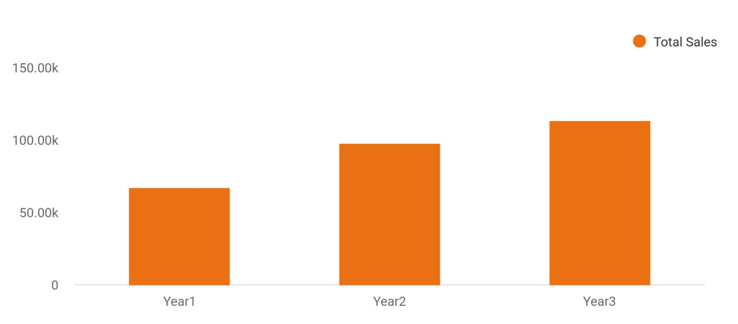

Financial Year | Total Sales
Year1 | 66,840
Year2 | 97,760
Year3 | 113,402

SALES FORECAST | YEAR 1 | YEAR 2 | YEAR 3
Sales | $677,600 | $700,000 | $750,000
Other | $0 | $0 | $0
TOTAL SALES | $677,600 | $700,000 | $750,000
Direct Cost of Sales | 1996 | 1997 | 1998
Sales | $0 | $0 | $0
Other | $0 | $0 | $0
Subtotal Direct Cost of Sales | $0 | $0 | $0

Insurance Company | Business Plan [YEAR] 26/40

Strategic Alliances

 Ex :: Lifemax

Some of our present companies have surveyed us to investigate co-operative advertising but we have not committed to any programs at present.
To unlock help try Upmetrics! 

Start writing here..

Service and Support

Start writing here..

Milestones

We have listed our plan milestones in the table below.

Milestone | Start Date | End Date | Budget | Manager | Department
Select Seniors | 1/1/1996 | 12/31/1996 | $0 | P. Smith | Sales
Broker Acquisition Course | 4/17/1996 | 9/9/1996 | $250 | P. Smith | Finance
Company Contacts | 1/3/1996 | 12/31/1996 | $1,000 | P. Smith | Marketing
Install Release 74 | 4/8/1996 | 7/8/1996 | $0 | J. Smith | Staff
Release 74 Training | 4/2/1996 | 8/2/1996 | $300 | Staff | Staff
Jason - CAIB Course 2 | 5/4/1996 | 6/24/1996 | $395 | J. Smith | Staff
Upload/download Training | 1/7/1996 | 3/1/1996 | $1,000 | J. Smith | Staff
Stephen - Remove Restriction | 1/9/1996 | 1/10/1996 | $400 | Staff | Staff
Mandatory Staff - 3hr | 1/10/1996 | 1/10/1996 | $1,000 | P. Smith | Management
Totals |  |  | $4,345

Insurance Company | Business Plan [YEAR] 27/40

6.

Management Summary

Organizational Structure

Insurance Company | Business Plan [YEAR] 28/40

 Ex :: Lifemax

Lifemax Insurance is slow to hire new people and loyal to those whom we have hired. We hire only when there is a vacancy or growth dictates more staff. Most of our people have been in our organization for over 15 years, which allows our clients and our companies to form long-
To unlock help try Upmetrics! 

Start writing here..

Organizational Structure

 Ex :: Lifemax

Our brokerage is divided by the client instead of the service. Each broker is responsible not only to renew and service a client's insurance, but they also are responsible for collection and claims. We feel a client wants to deal with his or her broker, especially in a claim situation,
To unlock help try Upmetrics! 

Start writing here..

PERSONNEL PLAN | YEAR 1 | YEAR 2 | YEAR 3
Greg Bell | $49,000 | $50,000 | $75,000
Associate Agent | $0 | $35,000 | $75,000
TOTAL PEOPLE | 1 | 2 | 2
Total Payroll | $49,000 | $85,000 | $150,000

Insurance Company | Business Plan [YEAR] 29/40

7.

Financial Plan

Startup Funding

Important Assumptions

Brake-even Analysis

Projected Profit and Loss

Projected Cash Flow

Projected Balance Sheet

Business Ratios

Insurance Company | Business Plan [YEAR] 30/40

The last component of an Insurance company business plan is an in-depth financial plan. The financial plan crafts a detailed map of all the expenses needed for the startup and how these expenses will be met by the earned
To unlock help try Upmetrics! 

 Ex :: Lifemax

The business will finance its growth from a combination of the free cash flows generated by the business and a loan taken out in the second year to finance the move to a small office space in The Woodlands. Beyond the first three years, growth will be possible by adding more agents
To unlock help try Upmetrics! 

Start writing here..

Startup Funding

Lifemax Insurance will be launched with Greg Bell's own resources, including credit card debt, personal savings, and some credit extended by vendors providing start-up services.

STARTUP FUNDING | AMOUNT
Start-up Expenses to Fund | $8,000
Start-up Assets to Fund | $24,000
TOTAL FUNDING REQUIRED | $32,000
Assets
Non-cash Assets from Start-up | $0
Cash Requirements from Start-up | $24,000
Additional Cash Raised | $0
Cash Balance on Starting Date | $24,000
TOTAL ASSETS | $24,000
Liabilities and Capital
Liabilities
Current Borrowing | $4,000
Long-term Liabilities | $0
Accounts Payable (Outstanding Bills) | $1,000
Other Current Liabilities (interest-free) | $0

Insurance Company | Business Plan [YEAR] 31/40

STARTUP FUNDING | AMOUNT
TOTAL LIABILITIES | $5,000
Capital
Planned Investment
Owner | $27,000
Investor | $0
Additional Investment Requirement | $0
TOTAL PLANNED INVESTMENT | $27,000
Loss at Start-up (Start-up Expenses) | ($8,000)
TOTAL CAPITAL | $19,000
TOTAL CAPITAL AND LIABILITIES | $24,000
Total Funding | $32,000

Important Assumptions

We are assuming approximately 50% sales on credit and average interest rates of 10%. These are considered to be conservative in case our predictions are erroneous.

Since Walter is an import/export broker, the firm has no variable costs associated with it.

 | Year 1 | Year 2 | Year 3
Plan Month | 1 | 2 | 3
Current Interest Rate | 10,00% | 11,00% | 12,00%
Long-term Interest Rate | 10,00% | 10,00% | 10,00%
Tax Rate | 26,42% | 27,76% | 28,12%
Other | 0 | 0 | 0

Brake-even Analysis

Monthly Units Break-even | 5530
Monthly Revenue Break-even | $159 740
Assumptions:

Insurance Company | Business Plan [YEAR] 32/40

Average Per-Unit Revenue | $260,87
Average Per-Unit Variable Cost | $0,89
Estimated Monthly Fixed Cost | $196 410

Projected Profit and Loss

 | Year 1 | Year 2 | Year 3
Sales | $309 069 | $385 934 | $462 799
Direct Cost of Sales | $15 100 | $19 153 | $23 206
Other | $0 | $0 | $0
TOTAL COST OF SALES | $15 100 | $19 153 | $23 206
Gross Margin | $293 969 | $366 781 | $439 593
Gross Margin % | 94,98% | 94,72% | 94,46%
Expenses
Payroll | $138 036 | $162 898 | $187 760
Sales and Marketing and Other Expenses | $1 850 | $2 000 | $2 150
Depreciation | $2 070 | $2 070 | $2 070
Leased Equipment | $0 | $0 | $0
Utilities | $4 000 | $4 250 | $4 500
Insurance | $1 800 | $1 800 | $1 800
Rent | $6 500 | $7 000 | $7 500
Payroll Taxes | $34 510 | $40 726 | $46 942
Other | $0 | $0 | $0
Total Operating Expenses | $188 766 | $220 744 | $252 722
Profit Before Interest and Taxes | $105 205 | $146 040 | $186 875
EBITDA | $107 275 | $148 110 | $188 945
Interest Expense | $0 | $0 | $0
Taxes Incurred | $26 838 | $37 315 | $47 792
Net Profit | $78 367 | $108 725 | $139 083

Insurance Company | Business Plan [YEAR] 33/40

 | Year 1 | Year 2 | Year 3
Net Profit/Sales | 30,00% | 39,32% | 48,64%

Profit Yearly
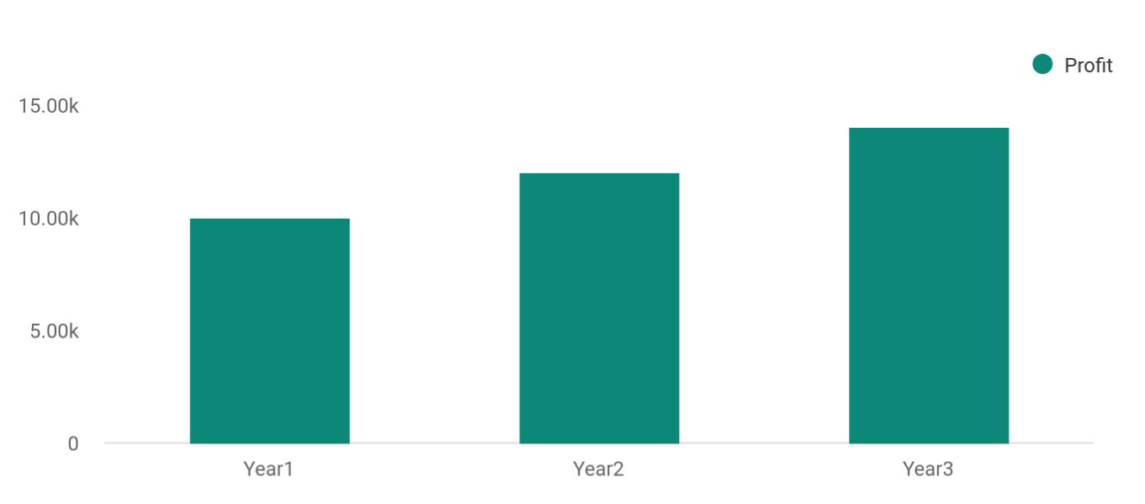

Financial Year | Profit
Year1 | 10,000
Year2 | 12,000
Year3 | 14,000

Gross Margin Yearly
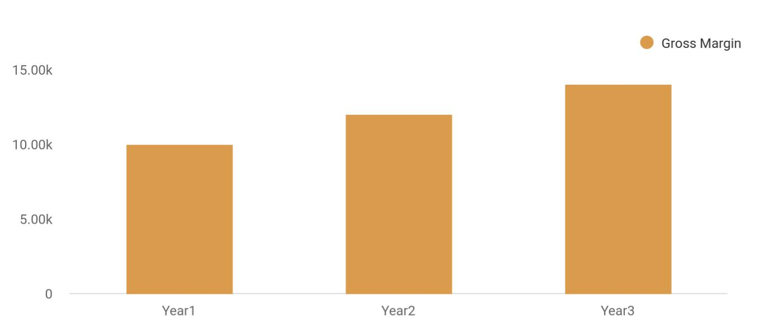

Financial Year Gross Margin

Year1 10,000

Insurance Company | Business Plan [YEAR] 34/40

Financial Year | Gross Margin
Year2 | 12,000
Year3 | 14,000

Projected Cash Flow

Cash Received | Year 1 | Year 2 | Year 3
Cash from Operations
Cash Sales | $40 124 | $45 046 | $50 068
Cash from Receivables | $7 023 | $8 610 | $9 297
SUBTOTAL CASH FROM OPERATIONS | $47 143 | $53 651 | $59 359
Additional Cash Received
Sales Tax, VAT, HST/GST Received | $0 | $0 | $0
New Current Borrowing | $0 | $0 | $0
New Other Liabilities (interest-free) | $0 | $0 | $0
New Long-term Liabilities | $0 | $0 | $0
Sales of Other Current Assets | $0 | $0 | $0
Sales of Long-term Assets | $0 | $0 | $0
New Investment Received | $0 | $0 | $0
SUBTOTAL CASH RECEIVED | $47 143 | $53 651 | $55 359
Expenditures from Operations
Cash Spending | $21 647 | $24 204 | $26 951
Bill Payments | $13 539 | $15 385 | $170 631
SUBTOTAL SPENT ON OPERATIONS | $35 296 | $39 549 | $43 582
Additional Cash Spent
Sales Tax, VAT, HST/GST Paid Out | $0 | $0 | $0
Principal Repayment of Current Borrowing | $0 | $0 | $0
Other Liabilities Principal Repayment | $0 | $0 | $0
Long-term Liabilities Principal Repayment | $0 | $0 | $0

Insurance Company | Business Plan [YEAR] 35/40

Cash Received | Year 1 | Year 2 | Year 3
Purchase Other Current Assets | $0 | $0 | $0
Purchase Long-term Assets | $0 | $0 | $0
Dividends | $0 | $0 | $0
SUBTOTAL CASH SPENT | $35 296 | $35 489 | $43 882
Net Cash Flow | $11 551 | $13 167 | $15 683
Cash Balance | $21 823 | $22 381 | $28 239

Projected Balance Sheet

Assets | Year 1 | Year 2 | Year 3
Current Assets
Cash | $184 666 | $218 525 | $252 384
Accounts Receivable | $12 613 | $14 493 | $16 373
Inventory | $2 980 | $3 450 | $3 920
Other Current Assets | $1 000 | $1 000 | $1 000
TOTAL CURRENT ASSETS | $201 259 | $237 468 | $273 677
Long-term Assets
Long-term Assets | $10 000 | $10 000 | $10 000
Accumulated Depreciation | $12 420 | $14 490 | $16 560
TOTAL LONG-TERM ASSETS | $980 | $610 | $240
TOTAL ASSETS | $198 839 | $232 978 | $267 117
Current Liabilities
Accounts Payable | $9 482 | $10 792 | $12 102
Current Borrowing | $0 | $0 | $0
Other Current Liabilities | $0 | $0 | $0
SUBTOTAL CURRENT LIABILITIES | $9 482 | $10 792 | $12 102
Long-term Liabilities | $0 | $0 | $0
TOTAL LIABILITIES | $9 482 | $10 792 | $12 102

Insurance Company | Business Plan [YEAR] 36/40

Assets | Year 1 | Year 2 | Year 3
Paid-in Capital | $30 000 | $30 000 | $30 000
Retained Earnings | $48 651 | $72 636 | $96 621
Earnings | $100 709 | $119 555 | $138 401
TOTAL CAPITAL | $189 360 | $222 190 | $255 020
TOTAL LIABILITIES AND CAPITAL | $198 839 | $232 978 | $267 117
Net Worth | $182 060 | $226 240 | $270 420

Business Ratios

 | Year 1 | Year 2 | Year 3 | Industry Profile
Sales Growth | 4,35% | 30,82% | 63,29% | 4,00%
Percent of Total Assets
Accounts Receivable | 5,61% | 4,71% | 3,81% | 9,70%
Inventory | 1,85% | 1,82% | 1,79% | 9,80%
Other Current Assets | 1,75% | 2,02% | 2,29% | 27,40%
Total Current Assets | 138,53% | 150,99% | 163,45% | 54,60%
Long-term Assets | -9,47% | -21,01% | -32,55% | 58,40%
TOTAL ASSETS | 100,00% | 100,00% | 100,00% | 100,00%
Current Liabilities | 4,68% | 3,04% | 2,76% | 27,30%
Long-term Liabilities | 0,00% | 0,00% | 0,00% | 25,80%
Total Liabilities | 4,68% | 3,04% | 2,76% | 54,10%
NET WORTH | 99,32% | 101,04% | 102,76% | 44,90%
Percent of Sales
Sales | 100,00% | 100,00% | 100,00% | 100,00%
Gross Margin | 94,18% | 93,85% | 93,52% | 0,00%
Selling, General & Administrative Expenses | 74,29% | 71,83% | 69,37% | 65,20%
Advertising Expenses | 2,06% | 1,11% | 0,28% | 1,40%
Profit Before Interest and Taxes | 26,47% | 29,30% | 32,13% | 2,86%

Insurance Company | Business Plan [YEAR] 37/40

 | Year 1 | Year 2 | Year 3 | Industry Profile
Main Ratios
Current | 25,86 | 29,39 | 32,92 | 1,63
Quick | 25,4 | 28,88 | 32,36 | 0,84
Total Debt to Total Assets | 2,68% | 1,04% | 0,76% | 67,10%
Pre-tax Return on Net Worth | 66,83% | 71,26% | 75,69% | 4,40%
Pre-tax Return on Assets | 64,88% | 69,75% | 74,62% | 9,00%
Additional Ratios
Net Profit Margin | 19,20% | 21,16% | 23,12% | N.A.
Return on Equity | 47,79% | 50,53% | 53,27% | N.A.
Activity Ratios
Accounts Receivable Turnover | 4,56 | 4,56 | 4,56 | N.A.
Collection Days | 92 | 99 | 106 | N.A.
Inventory Turnover | 19,7 | 22,55 | 25,4 | N.A.
Accounts Payable Turnover | 14,17 | 14,67 | 15,17 | N.A.
Payment Days | 27 | 27 | 27 | N.A.
Total Asset Turnover | 1,84 | 1,55 | 1,26 | N.A.
Debt Ratios
Debt to Net Worth | 0 | -0,02 | -0,04 | N.A.
Current Liab. to Liab. | 1 | 1 | 1 | N.A.
Liquidity Ratios
Net Working Capital | $120 943 | $140 664 | $160 385 | N.A.
Interest Coverage | 0 | 0 | 0 | N.A.
Additional Ratios
Assets to Sales | 0,45 | 0,48 | 0,51 | N.A.
Current Debt/Total Assets | 4% | 3% | 2% | N.A.
Acid Test | 23,66 | 27,01 | 30,36 | N.A.
Sales/Net Worth | 1,68 | 1,29 | 0,9 | N.A.
Dividend Payout | 0 | 0 | 0 | N.A.

Insurance Company | Business Plan [YEAR] 38/40

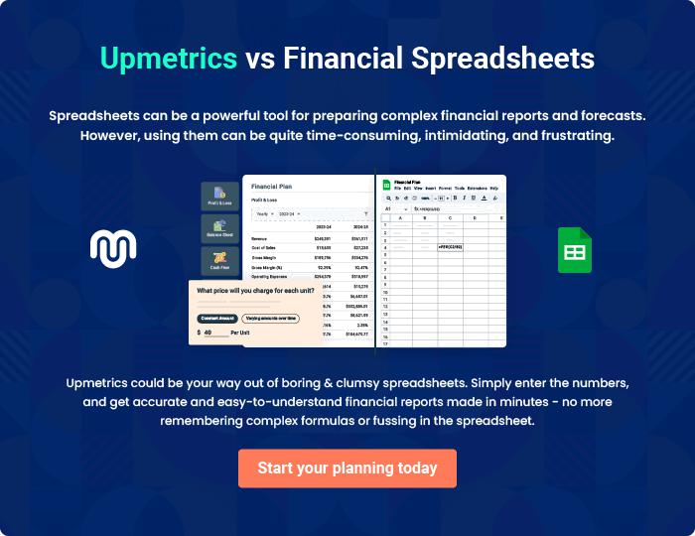

Insurance Company | Business Plan [YEAR] | 39/40


Create a winning business plan that gets you funded

Creating a stunning and investment-ready plan requires no writing, graphic designing, or financial planning expertise.

Upmetrics has all the features required to help you create a comprehensive business plan—from start to finish. Make no mistakes, it’s the modern way of planning to structure ideas, make plans, and create stunning pitch decks to awe investors.

Pitch decks that impress investors

Create pitch decks that provide a visual representation of your business, engage investors, and make them want to invest in your business idea.

Interactive plans in no time

Import business plan sections like—SWOT analysis, comparison tables, and others to create an interactive business plan. No designing skills are required.

Stunning cover page designs

With Upmetrics, you have the liberty to choose from multiple stunning cover page designs. Choose a creative design and make your plan stand out.

Online sharing made simple

Upmetrics makes online sharing quick and easier for users. Easily share your business plans with a link while tracking reader activity.

500+ sample business plans

Simply import a template from our library of sample plans into the editor and start customizing it to make it yours. It takes only a few clicks to get started.

Collaborate with team in real-time

Invite team members, initiate conversations, discuss ideas & strategies, share feedback, and work on a business plan in real-time.

