
HVAC Business

BUSINESS PLAN

We’ll keep you cool when it’s hot

Prepared By

John Doe

10200 Bolsa Ave, Westminster, CA, 92683

info@example.com

(650) 359-3153 http://www.example.com

Table of Contents

Executive summary | 5
Market Validation | 6
Objectives | 6
Short Term (1 -3 Years) | 6
Long Term (3-5 years) | 7
Mission statement | 7
Keys to success | 7
Financial Highlights | 8
Illuminus - 3 Year Financial Highlights | 9

Business overview | 10
Company Ownership/Legal Entity | 11
Location | 11
Interior Operating Facilities | 12
Hours of Operation | 12
Startup summary | 12

Products & Services | 13
Heating, Ventilation, and Air Conditioning Products and Service | 14
Range of Products | 14
Air Conditioners | 14
Heat Pumps | 14
Gas Furnaces | 14
Air Handlers | 15
Thermostat | 15
Customer Service | 16

Market Analysis | 17
Market segmentation | 18
Market Trends | 19

HVAC Business | Business Plan [YEAR] 2/42

Target market | 19
Illuminus Market Distribution | 19
Competitive Advantage | 20
SWOT analysis
SWOT analysis | 21
Strategy & implementation
Strategy & implementation | 23
Distribution Strategy | 24
Marketing and Promotion Programs | 24
Positioning Statement | 25
Sales strategy | 25
Marketing Channels | 25
Pricing strategy | 26
Operational Plan
Operational Plan | 27
Organization chart | 28
Management Team | 29
Personnel Plan | 29
Hiring plan | 29
Jane Doe | 30
John Doe | 30
Milestones | 31
ILLUMINUS | 31
Financial plan
Financial plan | 32
Important Assumptions | 33
Break-even Analysis | 33
Projected Profit and Loss | 34
Projected Cash Flow | 37
Projected Balance Sheet | 38
Business Ratios | 39

HVAC Business | Business Plan [YEAR] 3/42

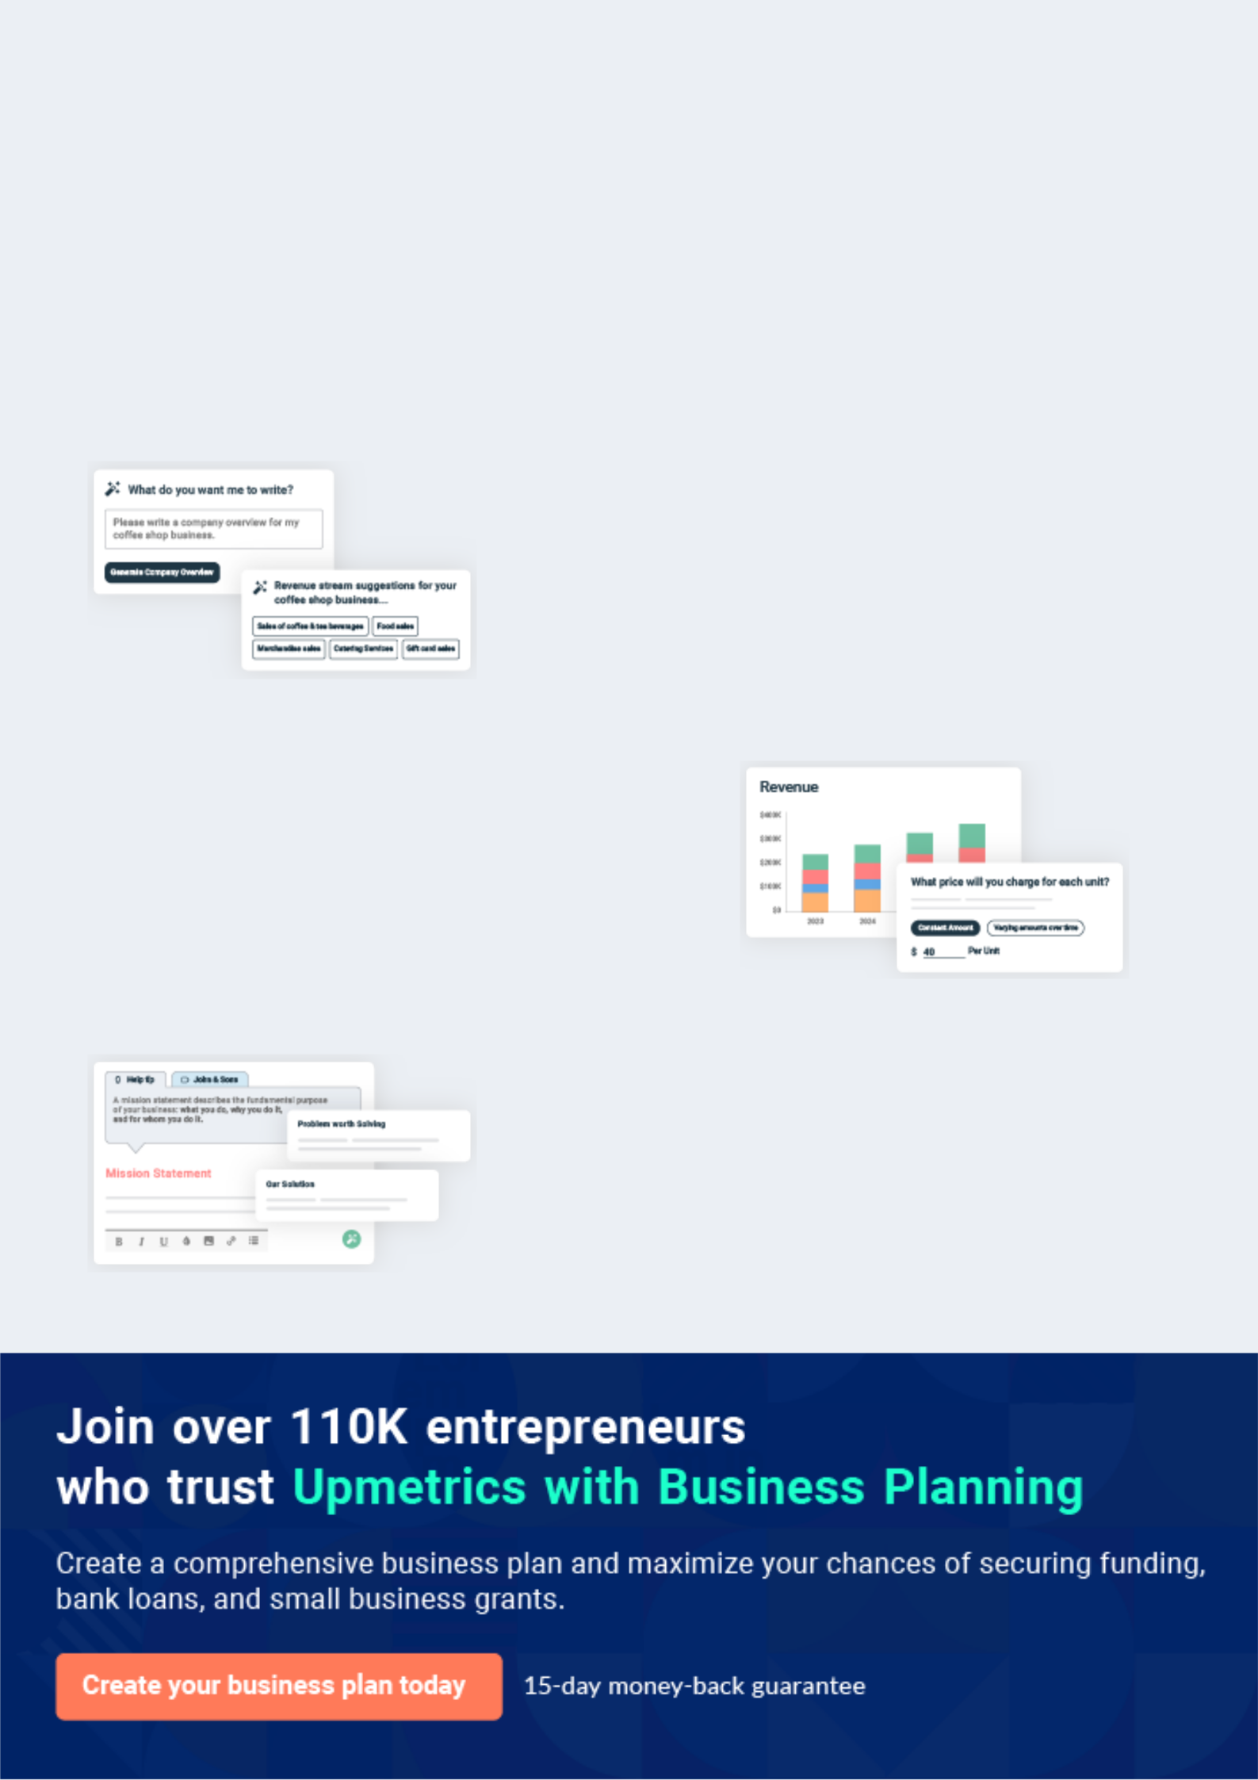
Business planning that’s simpler and faster than you think

Creating a business plan using Upmetrics to start and grow a business is literally the easiest thing in the World. Simply read the instructions and fill in the blanks. It’s as simple as that.

❛ | Upmetrics has everything you need to create a | ❜
❛ | comprehensive business plan. | ❜

AI-powered Upmetrics Assistant

AI-powered insights to streamline your plan

Not sure where to start? Upmetrics’ AI Assistant will automatically generate ideas for each section of your plan and offer improved versions of your writing, adjusting for tone, voice, and grammar or spelling errors.

Financial Forecasting Tool

All the financials are calculated for you

Forget the complex formulas and clumsy spreadsheets — with automatic financials and drag-and-drop forecasting, you can finish your plan faster and be confident that your numbers are accurate.

Business Plan Builder

Guides you like a business mentor

Upmetrics’ step-by-step instructions, prompts, and the library of 400+ sample business plans will guide you through each section of your plan as a business mentor.

1.


Executive summary

Market Validation

Objectives

Mission statement

Keys to success

Financial Highlights

HVAC Business | Business Plan [YEAR] 5/42

 Illuminus


Illuminus is a limited liability company that will import heating, ventilation, and air-conditioning systems (HVAC) for its customers in Miami, Florida. The Company will import individual units under its own brand and manufactured in China, related supplies and materials, design
To unlock help try Upmetrics! 

Start writing here..

Market Validation

 Illuminus

The US HVAC systems market size was valued at USD 15.16 billion in 2020. It is expected to expand at a compound annual growth rate (CAGR) of 6.0% from 2021 to 2028. Availability of
high-efficiency equipment, extreme climate conditions, and growing construction activities are
To unlock help try Upmetrics! 

Start writing here..

Objectives

 Illuminus

• To enhance customer service and after-sale services by establishing a representative office in Miami in 2022
• To build a market reputation for quality products and services during the forecast period.
To unlock help try Upmetrics! 

Short Term (1 -3 Years)

Start writing here..

HVAC Business | Business Plan [YEAR] 6/42

 Illuminus
To unlock help try Upmetrics!

• To expand by opening more satellite offices across the US towards the end of the forecast period.
• To hire 30 employees in the first year and grow to 200 employees in the fifth year.
To unlock help try Upmetrics! 

Long Term (3-5 years)

Start writing here..

Mission statement

 Illuminus

Our mission is to provide quality design, installation, and service for Heating, Ventilation, and Air Conditioning (HVAC) equipment in both residential and light commercial markets and maintaining the highest level of design and engineering possible.



Start writing here..

Keys to success



Economies of Scope

Offering the right mix of indoor and outdoor technical and maintenance services will allow Illuminus to win large contracts and increase their revenue.



Location

Illuminus will take advantage of the associated benefits, networking capabilities and the vast cluster of residential and commercials establishments offered by the region.

Expertise

Founders will indicate their history of providing related services, complete with endorsements of satisfied clientele, in order to generate brand equity for Illuminus.

Price Advantage

Illuminus will import its products from China ensuring best possible price. Keeping a low margin, the company will ensure its products and services are offered at a market competitive price point.

HVAC Business | Business Plan [YEAR] 7/42


Reputation

It is important for Illuminus to develop a reputation locally through the provision of high quality products and services that embody value-for-money and seasoned expertise.
Multi-Skilled Workforce


As Illuminus intends to service a wide variety of customers across multiple sectors and technicalities, the company needs to employ workers that carry suitable experience on flexible terms (so as to minimise fixed costs).

Financial Highlights

 Illuminus

The company envisions raising an equity investment of $50,000 through long-term borrowings, which will be used for the setup and launch of the jewelry store in the US. The company expects to steadily grow its revenues through active efforts in marketing, networking, excellent
To unlock help try Upmetrics! 

Start writing here..

HVAC Business | Business Plan [YEAR] 8/42

Illuminus - 3 Year Financial Highlights
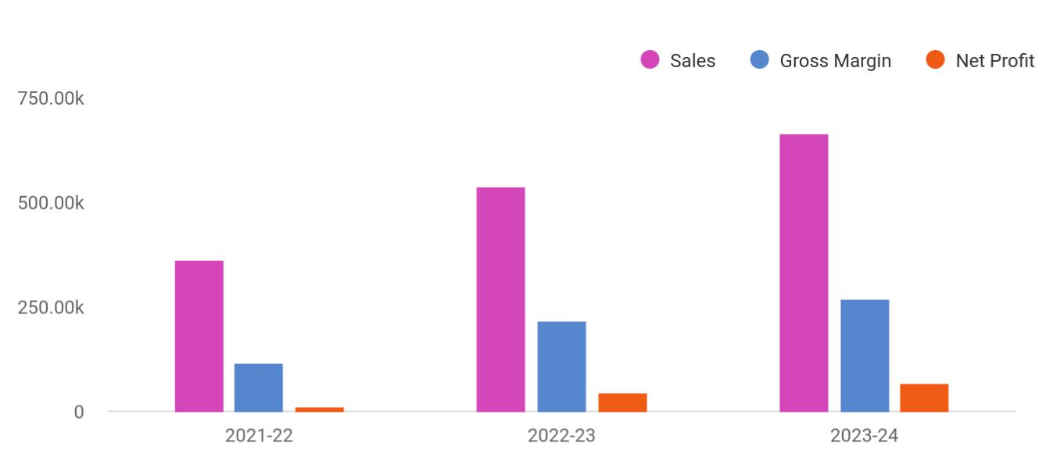

Financial Year | Sales | Gross Margin | Net Profit
2021-22 | 360,723 | 114,289 | 13,038
2022-23 | 538,041 | 216,784 | 44,360
2023-24 | 665,012 | 269,869 | 65,638

HVAC Business | Business Plan [YEAR] 9/42

2.

Business overview

Company Ownership/Legal Entity

Location

Interior Operating Facilities

Hours of Operation

Startup summary

HVAC Business | Business Plan [YEAR] 10/42

 Illuminus
To unlock help try Upmetrics!

Illuminus will provide a complete service portfolio to its clients related to the purchase, installation, and maintenance of HVAC units and systems in Florida. The Company will import branded HVAC products from the Chinese manufacturer and will wholesale the products to
To unlock help try Upmetrics! 

Start writing here..

Company Ownership/Legal Entity

 Illuminus

The company will be registered as a limited liability entity with the Department of State. Further, since the company envisions setting up operations in Florida, it will also register with the local county. The business will be wholly owned and managed by the Founder Mr. Ashton, who will
To unlock help try Upmetrics! 

Start writing here..

Location

 Illuminus

The company will establish a business in Florida by the end of 2022. The region is considered an epicenter for food innovation, design trends, and innovative developments in manufacturing.



Start writing here..

HVAC Business | Business Plan [YEAR] 11/42

Interior Operating Facilities

 Illuminus

The company will begin operations from rented office space at the heart of Miami's commercial hub. Initial investments in setting up the interior facilities, consumables, inventory, and showroom space will be set up. Additions to space will be made as the company expands
To unlock help try Upmetrics! 

Start writing here..

Hours of Operation

 Illuminus

Illuminus will cater to walk-in as well as online customers, as such it will be required to stay open during business hours. The company envisions opening the office at 10 am and remain open till 7 pm to entertain walk-in prospects as well as fulfill online orders.
To unlock help try Upmetrics! 

Start writing here..

Startup summary

 Illuminus

A portion of the capital investment of $50,000 will be utilized to finance a range of expenses incurred prior to the launch of the company as indicated in the table below. Accordingly,
approximately $11,500 will be spent on a range of start-up expenses (reflected in the top half of
To unlock help try Upmetrics! 

Start writing here..

HVAC Business | Business Plan [YEAR] 12/42

3.

Products & Services

Heating, Ventilation, and Air Conditioning Products and Service

Range of Products

Customer Service

HVAC Business | Business Plan [YEAR] 13/42

Heating, Ventilation, and Air Conditioning Products and Service

 Illuminus

Vert Chanel Services Corp.’s primary service will be the sales, installation, and maintenance of new and the repair of existing HVAC systems. The product list includes professional “free match” systems for centralized cooling, mini splits for cooling of individual areas, RV air
To unlock help try Upmetrics! 

Start writing here..

Range of Products

Air Conditioners

Price: $150 USD
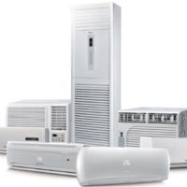

The company will offer a range of air conditioning options from split to single units. In addition, the options will also include energy-saving models and eco-friendly units.

Heat Pumps

Price: $150 USD
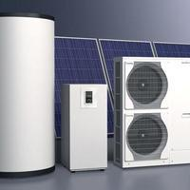

For climates with moderate heating and cooling needs, heat pumps offer an energy-efficient alternative to furnaces and air conditioners.

Gas Furnaces

Price: $150 USD

HVAC Business | Business Plan [YEAR] 14/42

These high-efficiency condensing gas furnaces are perfect for replacing existing equipment or new installations.
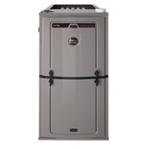

Air Handlers

Price: $150 USD
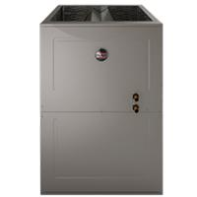

Air handlers work with your air conditioner, heat pump or boiler to circulate air evenly throughout your home.

Thermostat

Price: $150 USD
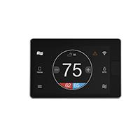

Using a programmable thermostat, you can adjust the times you turn on the heating or air-conditioning according to a pre-set schedule.

HVAC Business | Business Plan [YEAR] 15/42

Customer Service
To unlock help try Upmetrics!

 Illuminus

Illuminus prides itself on the quality of service extended to its customers. As a part of good faith and to maintain a healthy and robust customer relationship, the company will cater to the client's specific needs even if it does not form a part of a package.



Start writing here..
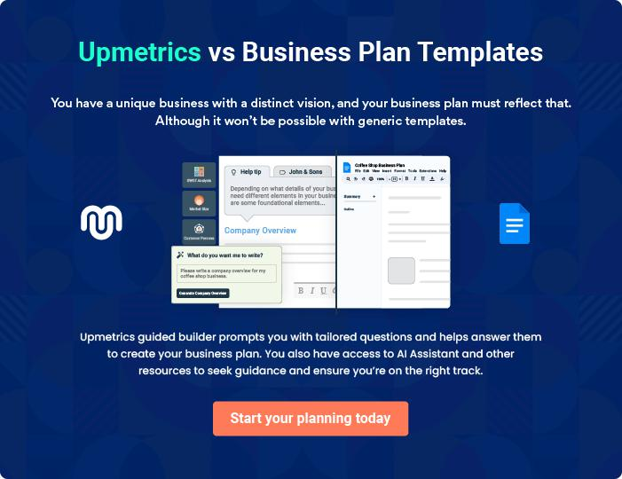

HVAC Business | Business Plan [YEAR] 16/42

4.

Market Analysis

Market segmentation

Market Trends

Target market

HVAC Business | Business Plan [YEAR] 17/42

 Illuminus

According to IBISWorld, one of the world's leading publishers of business intelligence specializing in Industry and procurement research, this industry
distributes pipe, valves and fittings, plumbing fixtures, hydronic and heating, ventilation, and air-
To unlock help try Upmetrics! 

Start writing here..

Market segmentation

 Illuminus

The cooling segment held the largest revenue share in 2020, accounting for over 50% of the overall revenue. The cooling segment comprises air conditioning units, including room air
conditioners, unitary air conditioners, cooling towers, split and packaged systems, and portable
To unlock help try Upmetrics! 

Start writing here..

HVAC Business | Business Plan [YEAR] 18/42

Market Trends

 Illuminus

The market is expected to witness an increase in sales with the availability of tax credit and rebate programs as well as other monetary benefits associated with the purchase of energy-efficient systems. Governments at various levels, namely Federation and state governments
To unlock help try Upmetrics! 

Start writing here..

Target market

 Illuminus

As a new entrant to the HVAC cohort of the US, Illuminus will follow a phased approach in engaging its primary target market. The company will initially focus on winning small- to
medium-scale commercial and residential projects in and about Miami. The objective is to build
To unlock help try Upmetrics! 

Start writing here..

Illuminus Market Distribution
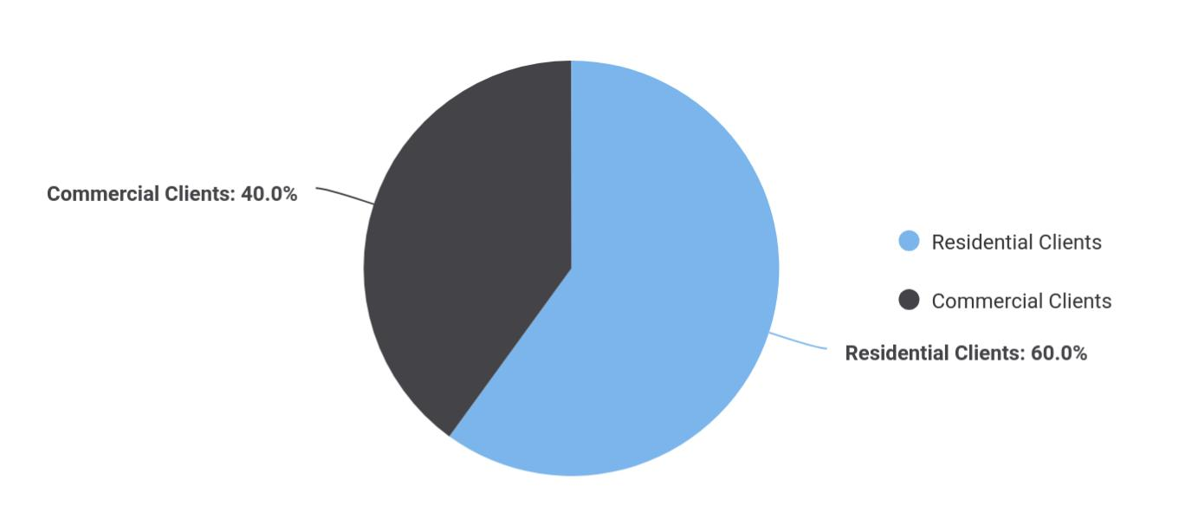

Target Market | Share
Residential Clients | 60
Commercial Clients | 40

HVAC Business | Business Plan [YEAR] 19/42

Competitive Advantage


Value Added

Services

Illuminus will dedicate

itself to the

requirements of its

customers. The

company will extend

specific client focused

services based on their

requirement.

Distribution Channels

Illuminus will distribute its products through both B2B as well as B2C channels.

Price

The company will consciously maintain a low margin for its services which allows it to control prices. Illuminus will thus be able to secure and distribute services at market beating price points.

Effective Marketing

Illuminus will dedicate time and effort towards networking and gaining valuable insight into the prevailing market trends in the US which will allow the company to optimise its marketing strategies and effectively penetrate the market on launch.

HVAC Business | Business Plan [YEAR] 20/42

5.

SWOT analysis

HVAC Business | Business Plan [YEAR] 21/42

 Illuminus

A SWOT (Strength, Weakness, Opportunity, and Threat) analysis is a useful tool for businesses to evaluate their position in the market against the potential internal and external factors that could assist or jeopardize their operations and existence. A SWOT has been conducted for
To unlock help try Upmetrics! 

Start writing here..


Strength

- Extensive experience of the Founders (more than 25 years)

- Prime business location in Miami amidst a growing construction/residential market

- Lean organizational structure

- Offers specialized technical and maintenance services with a focus on quality

- Experience-backed ability to take on larger projects


Weakness

- Is new and hence unknown in the market

- Distance between company location and projects may reduce efficiencies

- A drop in specialized skills availability in Miami (e.g. engineering, construction & property, etc.) may affect Illuminus’ hiring plan

- Material purchase costs have risen over the years (e.g. wires, switches, etc.)


Opportunity

- To expand reach across the US (e.g. by appointing remote teams, opening additional offices in other major cities, etc.)

- To expand services based on the founder's vast experience

- To continue to offer flexible ABC- pricing, avoiding fixed costs, to win more client patronage

Threat

- Low barriers to entry; increasing competition

- Customers defaults

- Slow economic growth in the future could stagnate the construction market in the
US

- Further restrictions in buy-to-let could affect demand

HVAC Business | Business Plan [YEAR] 22/42

6.

Strategy & implementation

Distribution Strategy

Positioning Statement

Sales strategy

Pricing strategy

HVAC Business | Business Plan [YEAR] 23/42

 Illuminus

The objectives for the company’s early sales and marketing initiatives will be to generate awareness of Illuminus as a new player in the market and to educate potential customers about its portfolio of products and services. Over time, as the company becomes more established
To unlock help try Upmetrics! 

Start writing here..

Distribution Strategy

 Illuminus

The company will reach its customer through both online and offline channels. Illuminus's comprehensive website will accept orders online and deliver them to the customer’s doorstep. Customers will also have an option to physically visit the company’s showroom to browse and
To unlock help try Upmetrics! 

Start writing here..

Marketing and Promotion Programs


Website

Launch an engaging and attractive website that is a source of promotional materials


Feedback


Create a healthy feedback loop to gauge shifting trends and align services to meet demand

Email

Compiling attractive market materials which feature service portfolio of Illuminus to be sent as e-mail blasts to prospects

Video


Crafting YouTube videos to provide a sneak-peek into the company’s activities and projects carried out

HVAC Business | Business Plan [YEAR] 24/42

Positioning Statement

 Illuminus

Illuminus’ marketing objective is to position its services as specialized, affordable, and flexible to cater to any type of setting. The company will facilitate both B2B business as well as a B2C business, targeting building owners, construction contractors, and consulting firms.
To unlock help try Upmetrics! 

Start writing here..

Sales strategy

 Illuminus

The company will leverage its existing client network and expand its client base by extending sampling and after-sales services. Employing social media advertising campaigns, e-mail marketing strategies, networking through community clusters, and creating awareness by
To unlock help try Upmetrics! 

Start writing here..

Marketing Channels


Direct Mail Marketing | Social Media | Google Ad Campaigns
Illuminus will mail | Millennials and consumers in | The advertising will target
professionally designed | general spend a considerable | specific keywords relevant to
materials with its value | time browsing social media | Illuminus's offering
proposition to these | platforms. Reaching to them
companies and provide quotes | through this channel will be
for its services. | and effective way to capture
 | attention and position its
 | services.

HVAC Business | Business Plan [YEAR] 25/42

Pricing strategy

 Illuminus

For HVAC products, the company will ensure it imports its product from China at low input costs in order to offer the benefit of lower prices to its customers in the US. For its
maintenance services, the company will price its services based on the number of hours spent
To unlock help try Upmetrics! 

Start writing here..

HVAC Business | Business Plan [YEAR] 26/42

7.

Operational Plan

Management Team

Personnel Plan

Milestones

HVAC Business | Business Plan [YEAR] 27/42

 Illuminus
To unlock help try Upmetrics!

The team will be headed by Managing Director Mr. Ashton who will also oversee project operations. Joining Mr. Ashton in the Management Team will be sales and marketing executives and an office manager.



Start writing here..

Organization chart


Marco

Managing Director


Jane Doe

Project Manager


John Doe

Superviser


John Green Jane Green

Technician Sales Representatives

HVAC Business | Business Plan [YEAR] 28/42

Management Team
To unlock help try Upmetrics!

 Illuminus

Mr. Ashton will serve as the Managing Director of Illuminus. A highly motivated and dynamic individual, Thomas boasts vast experience in the field of aesthetics having spent a career
spanning 14 years essaying various white-collar roles for aesthetic companies across America.
To unlock help try Upmetrics! 

Start writing here..

Personnel Plan

 Illuminus

The company plans to create five full-time equivalent jobs in addition to the management team within the first three years of operations. Salaries for each employee are in line with the industry’s benchmark.



Start writing here..

Hiring plan

8 |  |  |  | 3 |  |  |  |  | 1
Filled |  |  |  | Hired |  |  |  |  | Open
Group By | Position Filled |  |  |  |  | Time of Hire |  |  | Time of Start |  | Filled On Time
Department |  |  |  |  |  |  |  |  |  |  | Filled On Time
Project Manager |  | 1 of 20 |  |  |  | 10 days |  |  | 121 days |  | 100%
Supervisors |  | 3 of 23 |  |  |  | 30 days |  |  | 21 days |  | 80%
Technician |  | 4 of 15 |  |  |  | 158 days |  |  | 127 days |  | 0%
Sales |  | 4 of 15 |  |  |  | 158 days |  |  | 127 days |  | 40%
Representatives |  |  |  |  |  |  |  |  |  |  | 40%

HVAC Business | Business Plan [YEAR] 29/42


Jane Doe

Project Manager - Jane@illuminus.com

Ability to cope with fast-paced and pressured work, accuracy, strong attention to detail and a strong analytical mind, ability to notice patterns within statistics, an interest in psychology and behavior, good organizational skills, excellent (spoken and written) communication skills.


John Doe

Supervisor - John@illuminus.com

Preferably bilingual with ability to speak English and French fluently, problem-solving, ability to convert leads into sales, active listener, patience, and understanding of the company’s products and services. Additionally, skills in social media marketing, search engine optimization, newsletter marketing, other forms of digital marketing will also be required

HVAC Business | Business Plan [YEAR] 30/42

Milestones

ILLUMINUS


Establish

Illuminus will rent a showroom space at the

heart of Florida's commercial hub

alongside developing a fully optimized and

informative website. During this period, the

company will also acquire inventory,

equipment and consumables. Marketing

activities will also begin during this stage to

build awareness and launch the brand into

the market.



 | Gain Market Traction
Year 2 | The company will begin expanding its
Year 2 | services beyond Miami to cover other
 | regions around the United States


Diversify

Having externally established the business,

the company will begin internally expanding

its range of products


Grow

>Year 3 • Begin expanding across the US

• Consider market expansion beyond US


Year 1

Year 3

HVAC Business | Business Plan [YEAR] 31/42

8.

Financial plan

Important Assumptions

Break-even Analysis

Projected Profit and Loss

Projected Cash Flow

Projected Balance Sheet

Business Ratios

HVAC Business | Business Plan [YEAR] 32/42


If you are going to start your own HVAC business, make sure you pay special attention to your financial plan. Your financial plan should include how well you manage your incomes and expenses you will recover investments from
To unlock help try Upmetrics! 

Important Assumptions

The company’s financial projections are forecasted on the basis of the following assumptions. These assumptions are quite conservative and are also expected to show deviation but to a limited level such that the company’s major financial strategy will not be affected.

 | Year 1 | Year 2 | Year 3
Plan Month | 1 | 2 | 3
Current Interest Rate | 10,00% | 11,00% | 12,00%
Long-term Interest Rate | 10,00% | 10,00% | 10,00%
Tax Rate | 26,42% | 27,76% | 28,12%
Other | 0 | 0 | 0

Break-even Analysis

Monthly Units Break-even | 5530
Monthly Revenue Break-even | $159 740
Assumptions:
Average Per-Unit Revenue | $260,87
Average Per-Unit Variable Cost | $0,89
Estimated Monthly Fixed Cost | $196 410

HVAC Business | Business Plan [YEAR] 33/42

Projected Profit and Loss

 | 2024 | 2025 | 2026
Revenue | $2,870,825.20 | $5,740,692.30 | $9,417,654.70
HVAC Installation Services | $1,502,500 | $2,405,575 | $3,851,675
Unit Sales | 601 | 962 | 1,541
Unit Price | $2,500 | $2,500 | $2,500
HVAC Maintenance | $1,152,325.20 | $3,119,117.30 | $5,349,979.70
Contracts | $1,152,325.20 | $3,119,117.30 | $5,349,979.70
Users | 1,327 | 2,604 | 4,183
Recurring Charges | $130 | $130 | $130
Emergency HVAC Repairs | $216,000 | $216,000 | $216,000
Total Hours | 1,440 | 1,440 | 1,440
Hourly Price | $150 | $150 | $150

Cost Of Sales | $689,413.24 | $979,332.06 | $1,348,883.05
General Costs | $689,413.24 | $979,332.06 | $1,348,883.05
HVAC Equipment and | $150,247.25 | $295,539.37 | $481,668.89
Supplies | $150,247.25 | $295,539.37 | $481,668.89
HVAC Units | $6,705.97 | $8,504.74 | $10,786.13
Installation Materials | $143,541.28 | $287,034.63 | $470,882.76
Service and Maintenance | $539,165.99 | $683,792.69 | $867,214.16
Technician Labor | $536,483.63 | $680,390.96 | $862,900.14
Service Equipment | $2,682.36 | $3,401.73 | $4,314.02
Revenue Specific Costs | $0 | $0 | $0
Personnel Costs (Direct | $0 | $0 | $0
Labor) | $0 | $0 | $0

HVAC Business | Business Plan [YEAR] 34/42

 | 2024 | 2025 | 2026
Gross Margin | $2,181,411.96 | $4,761,360.24 | $8,068,771.65
Gross Margin (%) | 75.99% | 82.94% | 85.68%

Operating Expense | $2,235,895.44 | $2,554,707.29 | $2,964,161.60
Payroll Expense (Indirect | $1,926,180 | $1,975,422.48 | $2,025,949.08
Labor) | $1,926,180 | $1,975,422.48 | $2,025,949.08
Management Team | $330,000 | $340,650 | $351,645.72
General Manager | $180,000 | $185,400 | $190,962
Operations Manager | $150,000 | $155,250 | $160,683.72
Technical Staff | $1,284,000 | $1,316,100.48 | $1,349,003.28
HVAC Technicians | $720,000 | $738,000 | $756,450
Service Technicians | $564,000 | $578,100.48 | $592,553.28
Administrative Staff | $312,180 | $318,672 | $325,300.08
Office Administrator | $49,680 | $50,922 | $52,195.08
Customer Service Reps | $262,500 | $267,750 | $273,105
General Expense | $309,715.44 | $579,284.81 | $938,212.52
Office and Administrative | $42,564.01 | $70,777.60 | $119,926.92
Expenses | $42,564.01 | $70,777.60 | $119,926.92
Office Rent | $31,834.25 | $57,169.79 | $102,668.91
Utilities | $10,729.76 | $13,607.81 | $17,258.01
Marketing and Advertising | $253,807.72 | $489,872.85 | $792,242.74
Digital Marketing | $229,666.02 | $459,255.40 | $753,412.39
Print Advertising | $24,141.70 | $30,617.45 | $38,830.35
Miscellaneous | $13,343.71 | $18,634.36 | $26,042.86
Vehicle Maintenance | $8,515.28 | $12,140.69 | $17,309.58
Office Supplies | $4,828.43 | $6,493.67 | $8,733.28

HVAC Business | Business Plan [YEAR] 35/42

Bad Debt

Amortization of Current Assets

EBITDA

Additional Expense

Long Term Depreciation

Gain or loss from Sale of Assets

EBIT

Interest Expense

EBT

Income Tax Expense / Benefit

Total Expense

Net Income

Net Income (%)

Retained Earning Opening

Owner's Distribution

Retained Earning Closing

2024 | 2025 | 2026
$0 | $0 | $0
$0 | $0 | $0

($54,483.48) $2,206,652.94 $5,104,610.04

$18,802.93 | $16,868.77 | $14,815.31
$13,656 | $13,656 | $13,656
$0 | $0 | $0
($68,139.48) | $2,192,996.94 | $5,090,954.04
$5,146.94 | $3,212.76 | $1,159.29
($73,286.41) | $2,189,784.17 | $5,089,794.73
$0 | $0 | $0

$2,944,111.61 | $3,550,908.13 | $4,327,859.97
($73,286.41) | $2,189,784.17 | $5,089,794.73
(2.55%) | 38.14% | 54.05%

$0 | ($90,786.41) | $2,078,997.76
$17,500 | $20,000 | $20,000
($90,786.41) | $2,078,997.76 | $7,148,792.49

HVAC Business | Business Plan [YEAR] 36/42

Projected Cash Flow

 | 2024 | 2025 | 2026
Cash Received | $2,870,825.20 | $5,740,692.30 | $9,417,654.70
Cash Paid | $2,930,455.62 | $3,537,252.12 | $4,314,203.96
COS & General Expenses | $999,128.69 | $1,558,616.87 | $2,287,095.57
Salary & Wages | $1,926,180 | $1,975,422.48 | $2,025,949.08
Interest | $5,146.94 | $3,212.76 | $1,159.29
Sales Tax | $0 | $0 | $0
Income Tax | $0 | $0 | $0
Net Cash From | ($59,630.42) | $2,203,440.18 | $5,103,450.74
Operations | ($59,630.42) | $2,203,440.18 | $5,103,450.74
Assets Sell | $0 | $0 | $0
Assets Purchase | $100,000 | $0 | $0
Net Cash From | ($100,000) | $0 | $0
Investments | ($100,000) | $0 | $0
Amount Received | $150,000 | $0 | $0
Loan Received | $100,000 | $0 | $0
Common Stock | $0 | $0 | $0
Preferred Stock | $0 | $0 | $0
Owner's Contribution | $50,000 | $0 | $0
Amount Paid | $48,859.35 | $53,293.51 | $55,347.12
Loan Capital | $31,359.34 | $33,293.52 | $35,347.14
Dividends & Distributions | $17,500 | $20,000 | $20,000
Net Cash From | $101,140.65 | ($53,293.51) | ($55,347.12)
Financing | $101,140.65 | ($53,293.51) | ($55,347.12)

HVAC Business | Business Plan [YEAR] 37/42

2024 2025 2026

Summary

Starting Cash | $0 | ($58,489.77) | $2,091,656.90
Cash In | $3,020,825.20 | $5,740,692.30 | $9,417,654.70
Cash Out | $3,079,314.97 | $3,590,545.63 | $4,369,551.08
Change in Cash | ($58,489.77) | $2,150,146.67 | $5,048,103.62
Ending Cash | ($58,489.77) | $2,091,656.90 | $7,139,760.52

Projected Balance Sheet

 | 2024 | 2025 | 2026
Assets | $27,854.23 | $2,164,344.90 | $7,198,792.52
Current Assets | ($58,489.77) | $2,091,656.90 | $7,139,760.52
Cash | ($58,489.77) | $2,091,656.90 | $7,139,760.52
Accounts Receivable | $0 | $0 | $0
Inventory | $0 | $0 | $0
Other Current Assets | $0 | $0 | $0
Long Term Assets | $86,344 | $72,688 | $59,032
Gross Long Term Assets | $100,000 | $100,000 | $100,000
Accumulated Depreciation | ($13,656) | ($27,312) | ($40,968)

Liabilities & Equity | $27,854.25 | $2,164,344.90 | $7,198,792.49
Liabilities | $68,640.66 | $35,347.14 | $0
Current Liabilities | $33,293.52 | $35,347.14 | $0
Accounts Payable | $0 | $0 | $0
Income Tax Payable | $0 | $0 | $0

HVAC Business | Business Plan [YEAR] 38/42

 | 2024 |  |  | 2025 |  | 2026
Sales Tax Payable | $0 |  |  | $0 |  | $0
Short Term Debt | $33,293.52 |  | $35,347.14 |  |  | $0
Long Term Liabilities | $35,347.14 |  |  | $0 |  | $0
Long Term Debt | $35,347.14 |  |  | $0 |  | $0
Equity | ($40,786.41) |  | $2,128,997.76 |  |  | $7,198,792.49
Paid-in Capital | $0 |  |  | $0 |  | $0
Common Stock | $0 |  |  | $0 |  | $0
Preferred Stock | $0 |  |  | $0 |  | $0
Owner's Contribution | $50,000 |  |  | $50,000 |  | $50,000
Retained Earnings | ($90,786.41) |  | $2,078,997.76 |  |  | $7,148,792.49
Check | $0 |  |  | $0 |  | $0
Business Ratios
 |  | Year 1 | Year 2 |  | Year 3 | Industry profile
Sales Growth |  | 4,35% | 30,82% |  | 63,29% | 4,00%
Percent of Total Assets
Accounts Receivable |  | 5,61% | 4,71% |  | 3,81% | 9,70%
Inventory |  | 1,85% | 1,82% |  | 1,79% | 9,80%
Other Current Assets |  | 1,75% | 2,02% |  | 2,29% | 27,40%
Total Current Assets |  | 138,53% | 150,99% |  | 163,45% | 54,60%
Long-term Assets |  | -9,47% | -21,01% |  | -32,55% | 58,40%
TOTAL ASSETS |  | 100,00% | 100,00% |  | 100,00% | 100,00%
Current Liabilities |  | 4,68% | 3,04% |  | 2,76% | 27,30%
Long-term Liabilities |  | 0,00% | 0,00% |  | 0,00% | 25,80%
Total Liabilities |  | 4,68% | 3,04% |  | 2,76% | 54,10%

HVAC Business | Business Plan [YEAR] 39/42

 | Year 1 | Year 2 | Year 3 | Industry profile
NET WORTH | 99,32% | 101,04% | 102,76% | 44,90%
Percent of Sales
Sales | 100,00% | 100,00% | 100,00% | 100,00%
Gross Margin | 94,18% | 93,85% | 93,52% | 0,00%
Selling, General & Administrative Expenses | 74,29% | 71,83% | 69,37% | 65,20%
Advertising Expenses | 2,06% | 1,11% | 0,28% | 1,40%
Profit Before Interest and Taxes | 26,47% | 29,30% | 32,13% | 2,86%
Main Ratios
Current | 25,86 | 29,39 | 32,92 | 1,63
Quick | 25,4 | 28,88 | 32,36 | 0,84
Total Debt to Total Assets | 2,68% | 1,04% | 0,76% | 67,10%
Pre-tax Return on Net Worth | 66,83% | 71,26% | 75,69% | 4,40%
Pre-tax Return on Assets | 64,88% | 69,75% | 74,62% | 9,00%
Additional Ratios
Net Profit Margin | 19,20% | 21,16% | 23,12% | N.A.
Return on Equity | 47,79% | 50,53% | 53,27% | N.A.
Activity Ratios
Accounts Receivable Turnover | 4,56 | 4,56 | 4,56 | N.A.
Collection Days | 92 | 99 | 106 | N.A.
Inventory Turnover | 19,7 | 22,55 | 25,4 | N.A.
Accounts Payable Turnover | 14,17 | 14,67 | 15,17 | N.A.
Payment Days | 27 | 27 | 27 | N.A.
Total Asset Turnover | 1,84 | 1,55 | 1,26 | N.A.
Debt Ratios
Debt to Net Worth | 0 | -0,02 | -0,04 | N.A.
Current Liab. to Liab. | 1 | 1 | 1 | N.A.
Liquidity Ratios
Net Working Capital | $120 943 | $140 664 | $160 385 | N.A.

HVAC Business | Business Plan [YEAR] 40/42

 | Year 1 | Year 2 | Year 3 | Industry profile
Interest Coverage | 0 | 0 | 0 | N.A.
Additional Ratios
Assets to Sales | 0,45 | 0,48 | 0,51 | N.A.
Current Debt/Total Assets | 4% | 3% | 2% | N.A.
Acid Test | 23,66 | 27,01 | 30,36 | N.A.
Sales/Net Worth | 1,68 | 1,29 | 0,9 | N.A.
Dividend Payout | 0 | 0 | 0 | N.A.
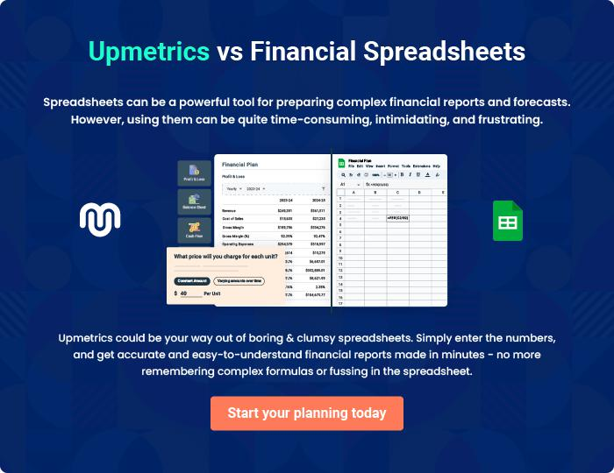

HVAC Business | Business Plan [YEAR] 41/42


Create a winning business plan that gets you funded

Creating a stunning and investment-ready plan requires no writing, graphic designing, or financial planning expertise.

Upmetrics has all the features required to help you create a comprehensive business plan—from start to finish. Make no mistakes, it’s the modern way of planning to structure ideas, make plans, and create stunning pitch decks to awe investors.

Pitch decks that impress investors

Create pitch decks that provide a visual representation of your business, engage investors, and make them want to invest in your business idea.

Interactive plans in no time

Import business plan sections like—SWOT analysis, comparison tables, and others to create an interactive business plan. No designing skills are required.

Stunning cover page designs

With Upmetrics, you have the liberty to choose from multiple stunning cover page designs. Choose a creative design and make your plan stand out.

Online sharing made simple

Upmetrics makes online sharing quick and easier for users. Easily share your business plans with a link while tracking reader activity.

500+ sample business plans

Simply import a template from our library of sample plans into the editor and start customizing it to make it yours. It takes only a few clicks to get started.

Collaborate with team in real-time

Invite team members, initiate conversations, discuss ideas & strategies, share feedback, and work on a business plan in real-time.

