
BUSINESS PLAN

[YEAR]

House Flipping

Where Dreams Come Home

John Doe

10200 Bolsa Ave, Westminster, CA, 92683

- 359-3153 info@example.com http://www.example.com

Information provided in this business plan is unique to this business and confidential; therefore, anyone reading this plan agrees not to disclose any of the information in this business plan without prior written permission of the Company
Table of Contents

Executive Summary | 5
Mission Statement | 6
Vision Statement | 6
Products and Services | 7
Management Team | 7
Success Factors | 7
Financial Summary | 8
3 Year profit forecast | 8

Company Summary | 9
History | 10
Products and Services | 10
Funding Required | 10
Startup cost | 11

Market Analysis | 14
Industry Analysis | 15
Market Trends | 15
Target Market | 15

Strategy & Implementations | 17
Sales Strategy | 18
Advertising Strategy | 18
Industry Networking | 18
Direct Mail | 18
Open House Events | 19
SMS Marketing | 19
Publications | 19
Seminars | 19
Pricing Strategy | 20

House Flipping | Business Plan [YEAR] 2/34

Sales Forecast | 20
Sales | 20

Operations | 21
Personnel plan | 22
Company Staff | 22
Average Salary of Employees | 22
Milestones | 23

Financial Plan | 24
Important Assumptions | 25
Brake-even Analysis | 25
Projected Profit and Loss | 26
Projected Cash Flow | 28
Projected Balance Sheet | 30
Business Ratios | 31

House Flipping | Business Plan [YEAR] 3/34

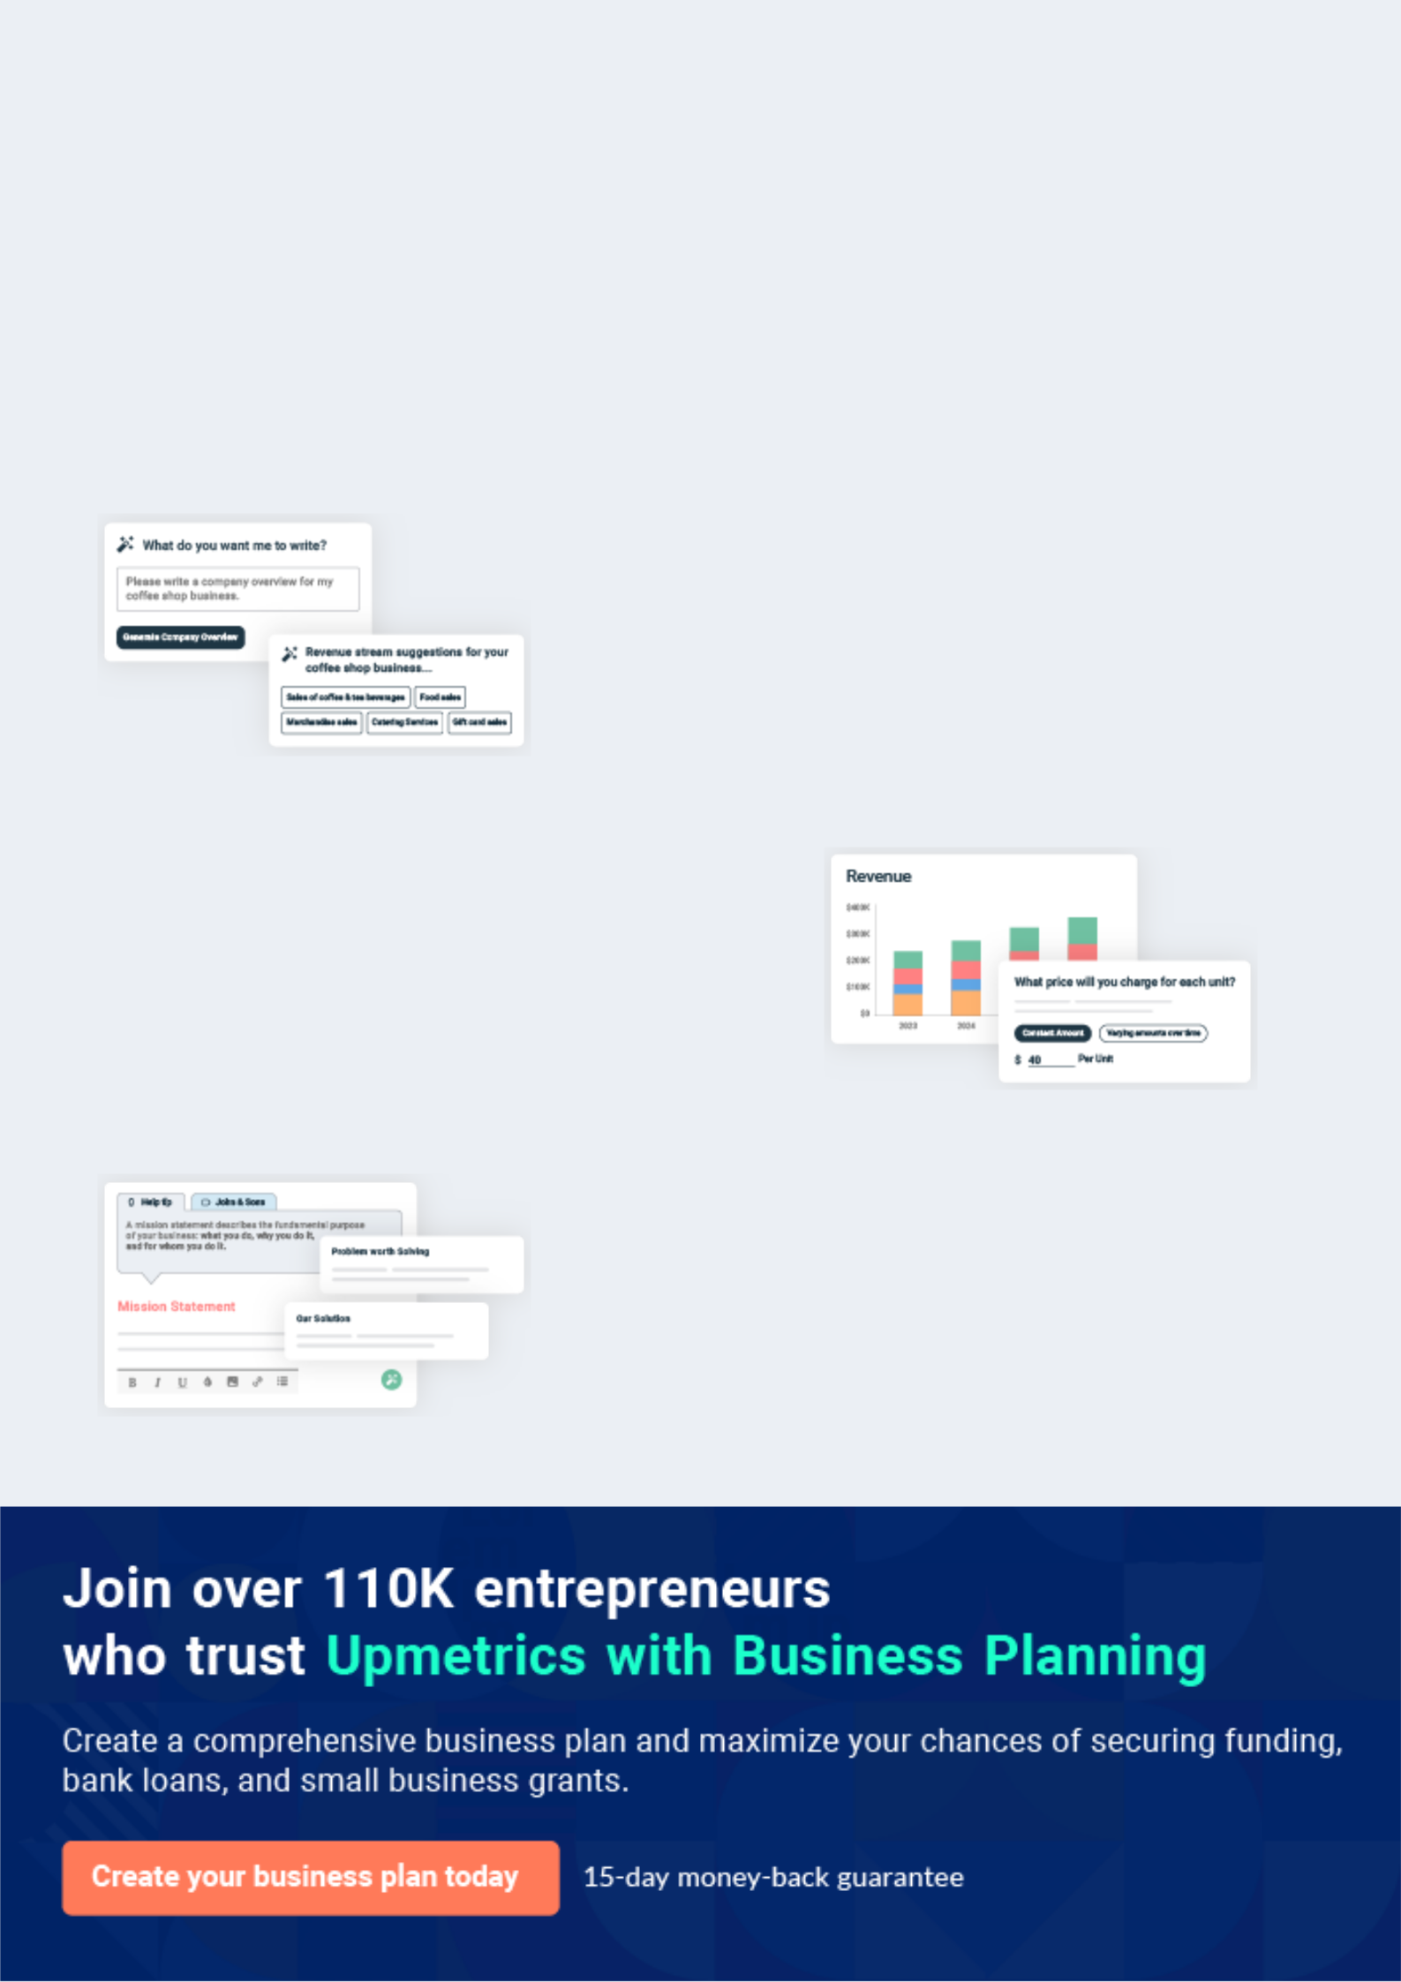
Business planning that’s simpler and faster than you think

Creating a business plan using Upmetrics to start and grow a business is literally the easiest thing in the World. Simply read the instructions and fill in the blanks. It’s as simple as that.

❛ | Upmetrics has everything you need to create a | ❜
❛ | comprehensive business plan. | ❜

AI-powered Upmetrics Assistant

AI-powered insights to streamline your plan

Not sure where to start? Upmetrics’ AI Assistant will automatically generate ideas for each section of your plan and offer improved versions of your writing, adjusting for tone, voice, and grammar or spelling errors.

Financial Forecasting Tool

All the financials are calculated for you

Forget the complex formulas and clumsy spreadsheets — with automatic financials and drag-and-drop forecasting, you can finish your plan faster and be confident that your numbers are accurate.

Business Plan Builder

Guides you like a business mentor

Upmetrics’ step-by-step instructions, prompts, and the library of 400+ sample business plans will guide you through each section of your plan as a business mentor.

1.


Executive Summary

Mission Statement

Vision Statement

Products and Services

Management Team

Success Factors

Financial Summary

House Flipping | Business Plan [YEAR] 5/34

Before you think about how to start a house flipping service, you must create a detailed house flipping business plan. It will not only guide you in the initial phases of your startup but will also help you later on.
To unlock help try Upmetrics!
To unlock help try Upmetrics!

 Kent & Flippers




Kent & Flippers LLC is a licensed & registered real estate startup based in New York, NY 10024, USA. Our aim of starting this house flipping business is to work in conjunction with the government of the United States of America to deliver affordable homes and properties to all
To unlock help try Upmetrics! 

Start writing here..

Mission Statement

 Kent & Flippers

Our mission and values are to help people, businesses and property owners and clients in the United States of America and throughout the world realize their dreams of owning properties or renting properties in the United States of America.



Start writing here..

Vision Statement

 Kent & Flippers

Our vision is to become one of the top 15 house flipping companies in the United States of America with the first 10 years of starting Kent & Flippers LLC.
To unlock help try Upmetrics! 

Start writing here..

House Flipping | Business Plan [YEAR] 6/34

Products and Services

 Kent & Flippers

Kent & Flippers LLC will be able to provide the following services:

• Personalize house designs (both interior and exterior)
To unlock help try Upmetrics! 

Start writing here..

Management Team

 Kent & Flippers

Kent & Flippers LLC’s most valuable asset is the expertise and experience of its founder, John Moore. Mr. John has been a licensed real estate broker for over the past 20 years. He has spent much of his career working in different real estate agencies where he specialized in rentals for
To unlock help try Upmetrics! 

Start writing here..

Success Factors

 Kent & Flippers

Kent & Flippers LLC is uniquely qualified to succeed due to the following reasons:

• Kent & Flippers LLC will fill a specific market niche in the growing community we are
To unlock help try Upmetrics! 

Start writing here..

House Flipping | Business Plan [YEAR] 7/34

Financial Summary
Year 3
To unlock help try Upmetrics!
To unlock help try Upmetrics!

 Kent & Flippers

Kent & Flippers LLC is seeking total funding of $1,000,000 of debt capital to expand its office. The capital will be used for funding capital expenditures and location build-out, hiring initial employees, marketing expenses, and working capital.



Start writing here..

3 Year profit forecast
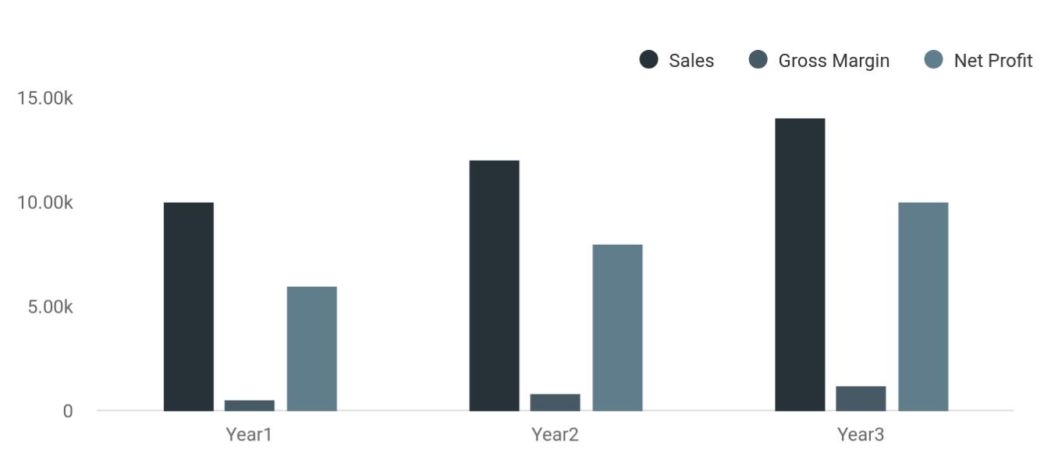

 Kent & Flippers


Financial Summary

Year 1

Year 2



Start writing here..

House Flipping | Business Plan [YEAR] 8/34

2.

Company Summary

History

Products and Services

Funding Required

House Flipping | Business Plan [YEAR] 9/34

 Kent & Flippers
To unlock help try Upmetrics!
To unlock help try Upmetrics!

Kent & Flippers LLC will be owned majorly by Mrs. John Moore and her family. John is a property guru that has worked with top Real Estate Companies in the United States of America for many years prior to starting her own business.



Start writing here..

History

 Kent & Flippers

In Jan 2021, Kent & Flippers LLC launched its first project in New York. It started off with a small house in one of the City’s most popular towns and has now sold over 30 flipped houses in a span of 2 years.



Start writing here..

Products and Services

 Kent & Flippers

Kent & Flippers LLC is set to run a standard and thriving house flipping business within the scope of the real estate industry in the United States of America. Our intention of starting a
house flipping business is to make profits from the industry and we will do all that is permitted
To unlock help try Upmetrics! 

Start writing here..

Funding Required

The detailed startup requirements and expenses are given in the table below.

House Flipping | Business Plan [YEAR] 10/34

Startup cost
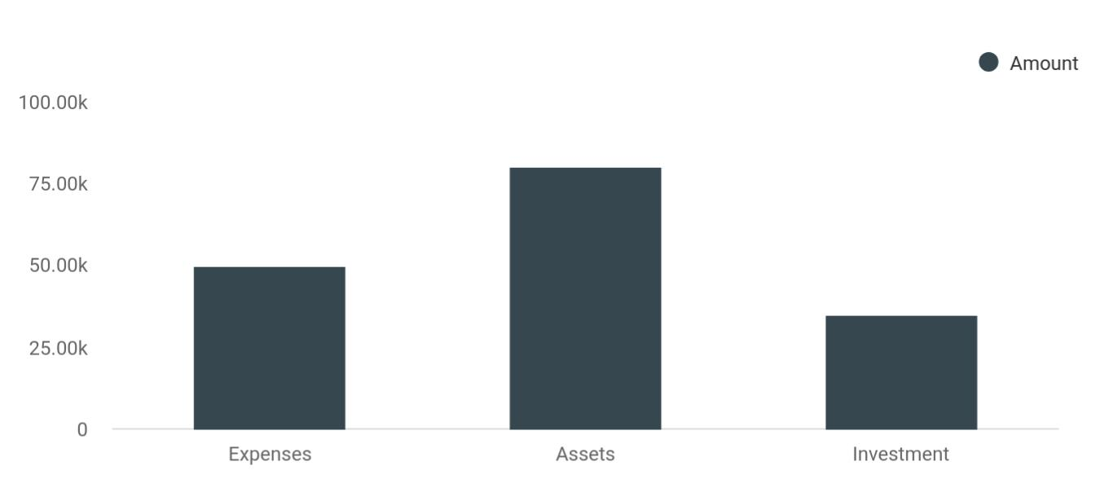

Cost distribution | Amount
Expenses | 50,000
Assets | 80,000
Investment | 35,000

Start-up Expenses | Amount
Legal | $75,500
Consultants | $0
Insurance | $62,750
Rent | $22,500
Research and Development | $42,750
Expensed Equipment | $42,750
Signs | $1,250
TOTAL START-UP EXPENSES | $247,500
Start-up Assets | $0
Cash Required | $322,500
Start-up Inventory | $52,625
Other Current Assets | $222,500
Long-term Assets | $125,000

House Flipping | Business Plan [YEAR] 11/34

Start-up Expenses | Amount
TOTAL ASSETS | $121,875
Total Requirements | $245,000
START-UP FUNDING | $0
START-UP FUNDING | $273,125
Start-up Expenses to Fund | $121,875
Start-up Assets to Fund | $195,000
TOTAL FUNDING REQUIRED | $0
Assets | $203,125
Non-cash Assets from Start-up | $118,750
Cash Requirements from Start-up | $0
Additional Cash Raised | $118,750
Cash Balance on Starting Date | $121,875
TOTAL ASSETS | $0
Liabilities and Capital | $0
Liabilities | $0
Current Borrowing | $0
Long-term Liabilities | $0
Accounts Payable (Outstanding Bills) | $0
Other Current Liabilities (interest-free) | $0
TOTAL LIABILITIES | $0
Capital | $0
Planned Investment | $0
Investor 1 | $312,500
Investor 2 | $0
Other | $0
Additional Investment Requirement | $0
TOTAL PLANNED INVESTMENT | $695,000
Loss at Start-up (Start-up Expenses) | $313,125

House Flipping | Business Plan [YEAR] 12/34


Start-up Expenses

TOTAL CAPITAL

TOTAL CAPITAL AND LIABILITIES

Total Funding
Amount

$221,875

$221,875

$265,000

House Flipping | Business Plan [YEAR] 13/34

3.

Market Analysis

Industry Analysis

Market Trends

Target Market

House Flipping | Business Plan [YEAR] 14/34

The most important component of an effective house flipping business plan is its accurate marketing analysis. If you are starting on a smaller scale, you can do marketing analysis yourself by taking help from this house flipping
To unlock help try Upmetrics!
To unlock help try Upmetrics! 

Industry Analysis

 Kent & Flippers

Last year saw the largest increase in house flipping in 8 years. Over 200,000 single-family homes and condos in the United States were flipped, up 2 percent from the previous year and the highest in over 10 years.



Start writing here..

Market Trends

 Kent & Flippers

The market trend in the real estate industry or within house flippers is that there are no fixed profits projections when engaging in a house flipping deal.
To unlock help try Upmetrics! 

Start writing here..

Target Market

 Kent & Flippers

Our target market cuts across people of different classes and people from all walks of life. We are coming into the real estate industry with a business concept that will enable us to work with the highly placed people in the country and at the same with the lowly placed people who are
To unlock help try Upmetrics! 

Start writing here..

House Flipping | Business Plan [YEAR] 15/34

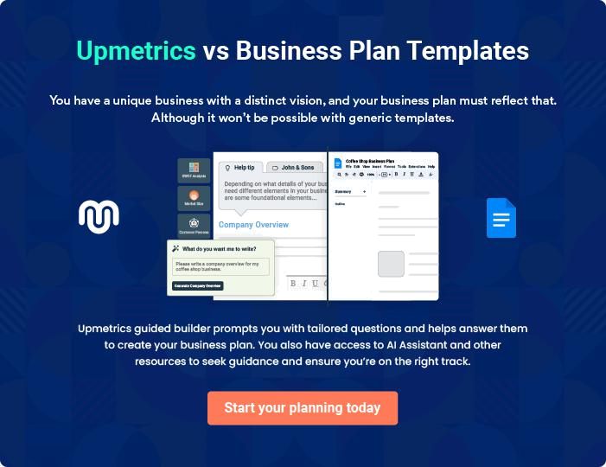

House Flipping | Business Plan [YEAR] | 16/34

4.

Strategy &

Implementations

Sales Strategy

Advertising Strategy

Pricing Strategy

Sales Forecast

House Flipping | Business Plan [YEAR] 17/34

After identifying the market demand, market trends, and the potential customers of the startup, the next step is to define an effective strategy for attracting those customers. Like marketing analysis, sales strategy is also an
To unlock help try Upmetrics! 

Sales Strategy

 Kent & Flippers

To advertise our services:

• We’ll run a campaign through social media (Facebook & Instagram).
To unlock help try Upmetrics! 

Start writing here..

Advertising Strategy

 Kent & Flippers

In order to help promote and publicize their newly flipped homes, Kent & Flippers LLC will build great relationships with local real estate agents. Creating a network of agents that are the first to know when a new property hits the market will be key in selling our homes.
To unlock help try Upmetrics! 

Industry Networking

Start writing here..

 Kent & Flippers

The company will market its newly renovated homes with beautiful marketing pieces that are sent to local residents and real estate agents.
To unlock help try Upmetrics! 

Direct Mail

Start writing here..

House Flipping | Business Plan [YEAR] 18/34

 Kent & Flippers

The company will host creative and appealing open house events to attract top real estate brokers and potential home buyers. Events will be entertaining and include food and drink.
To unlock help try Upmetrics! 

Open House Events

Start writing here..

 Kent & Flippers

SMS marketing can be extremely cost-effective and multi-purposed for both locating motivated sellers and flipping houses quickly. Mass text messages can be sent to lead lists of defaulting homeowners who need to sell as well for announcing new homes we are selling to potential
To unlock help try Upmetrics! 

SMS Marketing

Start writing here..

 Kent & Flippers

Kent & Flippers LLC will list its properties for sale in key local publications, including newspapers, area magazines.
To unlock help try Upmetrics! 

Publications

Start writing here..

 Kent & Flippers

Kent & Flippers LLC will list its properties for sale in key local publications, including newspapers, area magazines.
To unlock help try Upmetrics! 

Seminars

Start writing here..

House Flipping | Business Plan [YEAR] 19/34

Pricing Strategy

 Kent & Flippers

Part of the business strategy is to ensure that we work within the budget of our potential clients to sell excellent properties/houses to them. It is the practice in most parts of the world for properties to be valued by professionals based on the area the facility is located, the type of
To unlock help try Upmetrics! 

Start writing here..

Sales Forecast

Sales
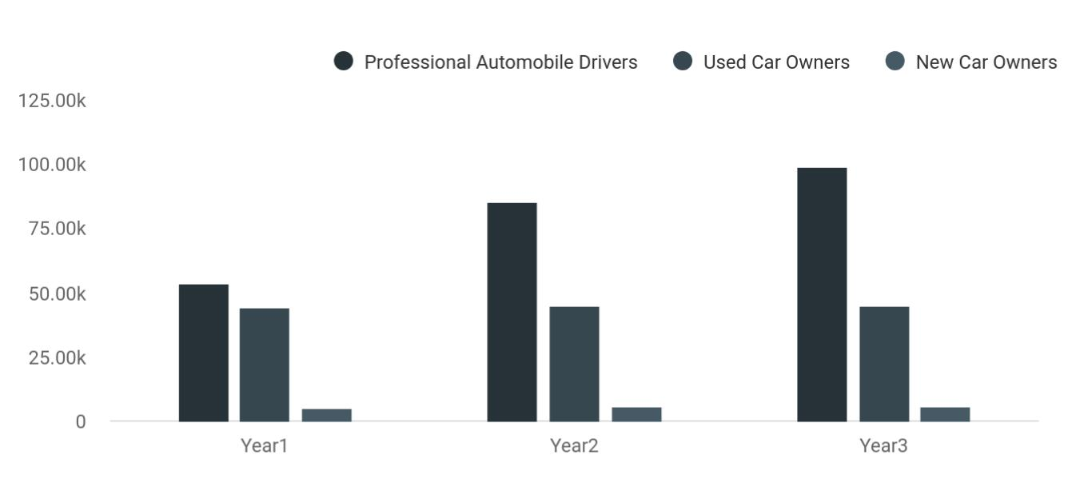

Financial Year | Professional Automobile Drivers | Used Car Owners | New Car Owners
Year1 | 53,625 | 44,245 | 5,280
Year2 | 85,000 | 45,000 | 5,760
Year3 | 99,050 | 45,000 | 5,760

House Flipping | Business Plan [YEAR] 20/34

5.

Operations

Personnel plan

Company Staff

Average Salary of Employees

Milestones

House Flipping | Business Plan [YEAR] 21/34

Personnel plan

 Kent & Flippers

The real estate flipping business is mainly related to time management and negotiations. Therefore, the success of this business largely depends on your employees. Your employees
must have adequate skills to judge the property value, negotiate contracts with property sellers,
To unlock help try Upmetrics! 

Start writing here..

Company Staff

 Kent & Flippers

George will supervise all the business operations and deals himself. However, he’ll hire the following people for his help:
To unlock help try Upmetrics! 

Start writing here..

Average Salary of Employees

 Kent & Flippers


Personnel Plan | Year1 | Year2 |  | Year3
 |  |  | To unlock help try Upmetrics! |  | 

Start writing here..

House Flipping | Business Plan [YEAR] 22/34

Milestones

 Kent & Flippers

Kent & Flippers LLC’s long-term goal is to become the dominant provider of house flipping services in the city area. We seek to the standard by which other providers are judged.
To unlock help try Upmetrics! 

Start writing here..

House Flipping | Business Plan [YEAR] 23/34

6.

Financial Plan

Important Assumptions

Brake-even Analysis

Projected Profit and Loss

Projected Cash Flow

Projected Balance Sheet

Business Ratios

House Flipping | Business Plan [YEAR] 24/34

The last component of a house flipping business plan is an in-depth financial plan. The financial plan crafts a detailed map of all the expenses needed for the startup and how these expenses will be met by the earned profits. It is
To unlock help try Upmetrics! 

 Kent & Flippers

The company will be financed by John himself and he will control the direction of the business to make sure that it is expanding at the forecasted rate. As for the real estate flipping business start-up, no equity funding or outside loans will be required. With the help of financial experts,
To unlock help try Upmetrics! 

Start writing here..

Important Assumptions

The financial projections of the company are forecast on the basis of the following assumptions. These assumptions are quite conservative and are expected to show deviation but to a limited level such that the company’s major financial strategy will not be affected.

 | Year 1 | Year 2 | Year 3
Plan Month | 1 | 2 | 3
Current Interest Rate | 10,00% | 11,00% | 12,00%
Long-term Interest Rate | 10,00% | 10,00% | 10,00%
Tax Rate | 26,42% | 27,76% | 28,12%
Other | 0 | 0 | 0

Brake-even Analysis

Monthly Units Break-even | 5530
Monthly Revenue Break-even | $159 740
Assumptions:
Average Per-Unit Revenue | $260,87
Average Per-Unit Variable Cost | $0,89
Estimated Monthly Fixed Cost | $196 410

House Flipping | Business Plan [YEAR] 25/34

Projected Profit and Loss

 | 2024 | 2025 | 2026
Revenue | $2,549,180 | $10,872,490 | $19,036,750
Property Sales Revenue | $500,000 | $4,596,000 | $6,017,500
Unit Sales | 10 | 92 | 120
Unit Price | $50,000 | $50,000 | $50,000
Rental Income | $1,863,230 | $6,076,690 | $12,804,600
Users | 138 | 343 | 683
Recurring Charges | $2,000 | $2,000 | $2,000
Consulting and Advisory | $185,950 | $199,800 | $214,650
Fees | $185,950 | $199,800 | $214,650
Unit Sales | 186 | 200 | 215
Unit Price | $1,000 | $1,000 | $1,000
Cost Of Sales | $1,563,503.35 | $3,861,433.96 | $6,243,717.61
General Costs | $1,563,503.35 | $3,861,433.96 | $6,243,717.61
Property Renovation Costs | $567,895.65 | $2,093,653.38 | $3,418,280.19
Property Renovation Costs | $567,895.65 | $2,093,653.38 | $3,418,280.19
Acquisition and Holding | $995,607.70 | $1,767,780.58 | $2,825,437.42
Costs | $995,607.70 | $1,767,780.58 | $2,825,437.42
Acquisition Costs | $362,035.10 | $620,557.50 | $951,837.50
Holding Costs | $633,572.60 | $1,147,223.08 | $1,873,599.92
Revenue Specific Costs | $0 | $0 | $0
Personnel Costs (Direct | $0 | $0 | $0
Labor) | $0 | $0 | $0
Gross Margin | $985,676.65 | $7,011,056.04 | $12,793,032.39

House Flipping | Business Plan [YEAR] 26/34

 | 2024 | 2025 | 2026
Gross Margin (%) | 38.67% | 64.48% | 67.20%

Operating Expense | $1,664,163.69 | $2,154,727.86 | $2,650,453.57
Payroll Expense (Indirect | $1,332,000 | $1,371,600 | $1,412,380.80
Labor) | $1,332,000 | $1,371,600 | $1,412,380.80
Management Team | $546,000 | $562,380 | $579,251.40
Executive Director | $234,000 | $241,020 | $248,250.60
Finance Manager | $312,000 | $321,360 | $331,000.80
Sales Team | $750,000 | $772,500 | $795,675
Sales Representatives | $750,000 | $772,500 | $795,675
Support Staff | $36,000 | $36,720 | $37,454.40
Administrative Assistants | $36,000 | $36,720 | $37,454.40
General Expense | $332,163.69 | $783,127.86 | $1,238,072.77
Marketing and Advertising | $247,459 | $669,624.50 | $1,084,137.50
Marketing Campaigns | $120,000 | $126,000 | $132,300
Online Advertising | $127,459 | $543,624.50 | $951,837.50
Office and Administration | $59,060.63 | $82,727.49 | $116,074.13
Office Rent | $49,672.11 | $70,820.50 | $100,973.16
Utilities | $9,388.52 | $11,906.99 | $15,100.97
Legal and Professional Fees | $25,644.06 | $30,775.87 | $37,861.14
Legal Services | $15,000 | $15,600 | $16,224
Accounting Services | $10,644.06 | $15,175.87 | $21,637.14
Bad Debt | $0 | $0 | $0
Amortization of Current | $0 | $0 | $0
Assets | $0 | $0 | $0

House Flipping | Business Plan [YEAR] 27/34

EBITDA

Additional Expense

Long Term Depreciation

Gain or loss from Sale of Assets

EBIT

Interest Expense

EBT

Income Tax Expense / Benefit
2024 2025 2026

($678,487.04) $4,856,328.18 $10,142,578.82

$47,064.09 | $35,846.22 | $23,817.43
$16,980 | $16,980 | $16,980
$0 | $0 | $0
($695,467.04) | $4,839,348.18 | $10,125,598.82
$30,084.09 | $18,866.23 | $6,837.42
($725,551.13) | $4,820,481.96 | $10,118,761.39
$0 | $0 | $0

Total Expense | $3,274,731.13 | $6,052,008.04 | $8,917,988.61
Net Income | ($725,551.13) | $4,820,481.96 | $10,118,761.39
Net Income (%) | (28.46%) | 44.34% | 53.15%
Retained Earning Opening | $0 | ($745,551.13) | $4,064,930.83
Owner's Distribution | $20,000 | $10,000 | $10,000
Retained Earning Closing | ($745,551.13) | $4,064,930.83 | $14,173,692.22
Projected Cash Flow
 | 2024 | 2025 | 2026
Cash Received | $2,549,180 | $10,872,490 | $19,036,750
Cash Paid | $3,257,751.13 | $6,035,028.04 | $8,901,008.61
COS & General Expenses | $1,895,667.04 | $4,644,561.82 | $7,481,790.38

House Flipping | Business Plan [YEAR] 28/34

2024 2025 2026

Salary & Wages

Interest

Sales Tax

Income Tax

Net Cash From

Operations

Assets Sell

Assets Purchase

Net Cash From

Investments

Amount Received

Loan Received

Common Stock

Preferred Stock

Owner's Contribution

Amount Paid

Loan Capital

Dividends & Distributions

Net Cash From

Financing

Summary

$1,332,000 | $1,371,600 | $1,412,380.80
$30,084.09 | $18,866.23 | $6,837.42
$0 | $0 | $0
$0 | $0 | $0
($708,571.13) | $4,837,461.96 | $10,135,741.39

$0 | $0 | $0
$80,000 | $0 | $0
($80,000) | $0 | $0

$800,000 | $0 | $0
$500,000 | $0 | $0
$0 | $0 | $0
$0 | $0 | $0
$300,000 | $0 | $0
$175,178.51 | $176,396.38 | $188,425.11
$155,178.51 | $166,396.37 | $178,425.12
$20,000 | $10,000 | $10,000
$624,821.49 | ($176,396.38) | ($188,425.11)

Starting Cash | $0 | ($163,749.64) | $4,497,315.94
Cash In | $3,349,180 | $10,872,490 | $19,036,750
Cash Out | $3,512,929.64 | $6,211,424.42 | $9,089,433.72

House Flipping | Business Plan [YEAR] 29/34

 | 2024 | 2025 | 2026
Change in Cash | ($163,749.64) | $4,661,065.58 | $9,947,316.28
Ending Cash | ($163,749.64) | $4,497,315.94 | $14,444,632.22

Projected Balance Sheet

 | 2024 | 2025 | 2026
Assets | ($100,729.64) | $4,543,355.94 | $14,473,692.22
Current Assets | ($163,749.64) | $4,497,315.94 | $14,444,632.22
Cash | ($163,749.64) | $4,497,315.94 | $14,444,632.22
Accounts Receivable | $0 | $0 | $0
Inventory | $0 | $0 | $0
Other Current Assets | $0 | $0 | $0
Long Term Assets | $63,020 | $46,040 | $29,060
Gross Long Term Assets | $80,000 | $80,000 | $80,000
Accumulated Depreciation | ($16,980) | ($33,960) | ($50,940)

Liabilities & Equity | ($100,729.64) | $4,543,355.95 | $14,473,692.22
Liabilities | $344,821.49 | $178,425.12 | $0
Current Liabilities | $166,396.37 | $178,425.12 | $0
Accounts Payable | $0 | $0 | $0
Income Tax Payable | $0 | $0 | $0
Sales Tax Payable | $0 | $0 | $0
Short Term Debt | $166,396.37 | $178,425.12 | $0
Long Term Liabilities | $178,425.12 | $0 | $0
Long Term Debt | $178,425.12 | $0 | $0
Equity | ($445,551.13) | $4,364,930.83 | $14,473,692.22

House Flipping | Business Plan [YEAR] 30/34

 | 2024 |  |  | 2025 |  | 2026
Paid-in Capital | $0 |  |  | $0 |  | $0
Common Stock | $0 |  |  | $0 |  | $0
Preferred Stock | $0 |  |  | $0 |  | $0
Owner's Contribution | $300,000 |  | $300,000 |  |  | $300,000
Retained Earnings | ($745,551.13) |  | $4,064,930.83 |  |  | $14,173,692.22
Check | $0 |  |  | $0 |  | $0
Business Ratios
 |  | Year 1 | Year 2 |  | Year 3 | Industry Profile
Sales Growth |  | 4,35% | 30,82% |  | 63,29% | 4,00%
Percent of Total Assets
Accounts Receivable |  | 5,61% | 4,71% |  | 3,81% | 9,70%
Inventory |  | 1,85% | 1,82% |  | 1,79% | 9,80%
Other Current Assets |  | 1,75% | 2,02% |  | 2,29% | 27,40%
Total Current Assets |  | 138,53% | 150,99% |  | 163,45% | 54,60%
Long-term Assets |  | -9,47% | -21,01% |  | -32,55% | 58,40%
TOTAL ASSETS |  | 100,00% | 100,00% |  | 100,00% | 100,00%
Current Liabilities |  | 4,68% | 3,04% |  | 2,76% | 27,30%
Long-term Liabilities |  | 0,00% | 0,00% |  | 0,00% | 25,80%
Total Liabilities |  | 4,68% | 3,04% |  | 2,76% | 54,10%
NET WORTH |  | 99,32% | 101,04% |  | 102,76% | 44,90%
Percent of Sales
Sales |  | 100,00% | 100,00% |  | 100,00% | 100,00%
Gross Margin |  | 94,18% | 93,85% |  | 93,52% | 0,00%
Selling, General & Administrative Expenses |  | 74,29% | 71,83% |  | 69,37% | 65,20%

House Flipping | Business Plan [YEAR] 31/34

 | Year 1 | Year 2 | Year 3 | Industry Profile
Advertising Expenses | 2,06% | 1,11% | 0,28% | 1,40%
Profit Before Interest and Taxes | 26,47% | 29,30% | 32,13% | 2,86%
Main Ratios
Current | 25,86 | 29,39 | 32,92 | 1,63
Quick | 25,4 | 28,88 | 32,36 | 0,84
Total Debt to Total Assets | 2,68% | 1,04% | 0,76% | 67,10%
Pre-tax Return on Net Worth | 66,83% | 71,26% | 75,69% | 4,40%
Pre-tax Return on Assets | 64,88% | 69,75% | 74,62% | 9,00%
Additional Ratios
Net Profit Margin | 19,20% | 21,16% | 23,12% | N.A.
Return on Equity | 47,79% | 50,53% | 53,27% | N.A.
Activity Ratios
Accounts Receivable Turnover | 4,56 | 4,56 | 4,56 | N.A.
Collection Days | 92 | 99 | 106 | N.A.
Inventory Turnover | 19,7 | 22,55 | 25,4 | N.A.
Accounts Payable Turnover | 14,17 | 14,67 | 15,17 | N.A.
Payment Days | 27 | 27 | 27 | N.A.
Total Asset Turnover | 1,84 | 1,55 | 1,26 | N.A.
Debt Ratios
Debt to Net Worth | 0 | -0,02 | -0,04 | N.A.
Current Liab. to Liab. | 1 | 1 | 1 | N.A.
Liquidity Ratios
Net Working Capital | $120 943 | $140 664 | $160 385 | N.A.
Interest Coverage | 0 | 0 | 0 | N.A.
Additional Ratios
Assets to Sales | 0,45 | 0,48 | 0,51 | N.A.
Current Debt/Total Assets | 4% | 3% | 2% | N.A.
Acid Test | 23,66 | 27,01 | 30,36 | N.A.

House Flipping | Business Plan [YEAR] 32/34

 | Year 1 | Year 2 | Year 3 | Industry Profile
Sales/Net Worth | 1,68 | 1,29 | 0,9 | N.A.
Dividend Payout | 0 | 0 | 0 | N.A.
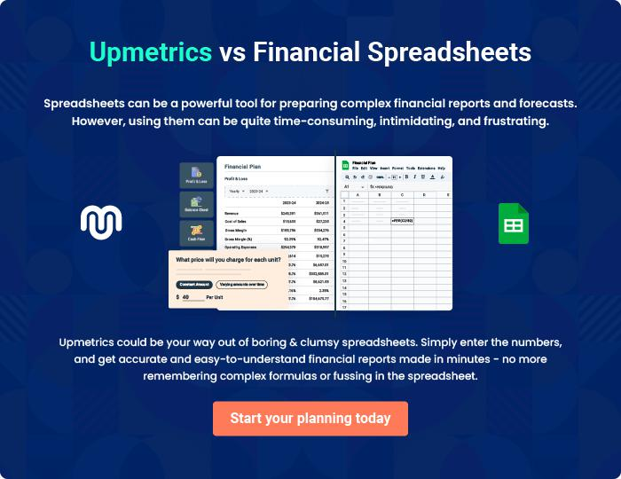

House Flipping | Business Plan [YEAR] 33/34


Create a winning business plan that gets you funded

Creating a stunning and investment-ready plan requires no writing, graphic designing, or financial planning expertise.

Upmetrics has all the features required to help you create a comprehensive business plan—from start to finish. Make no mistakes, it’s the modern way of planning to structure ideas, make plans, and create stunning pitch decks to awe investors.

Pitch decks that impress investors

Create pitch decks that provide a visual representation of your business, engage investors, and make them want to invest in your business idea.

Interactive plans in no time

Import business plan sections like—SWOT analysis, comparison tables, and others to create an interactive business plan. No designing skills are required.

Stunning cover page designs

With Upmetrics, you have the liberty to choose from multiple stunning cover page designs. Choose a creative design and make your plan stand out.

Online sharing made simple

Upmetrics makes online sharing quick and easier for users. Easily share your business plans with a link while tracking reader activity.

500+ sample business plans

Simply import a template from our library of sample plans into the editor and start customizing it to make it yours. It takes only a few clicks to get started.

Collaborate with team in real-time

Invite team members, initiate conversations, discuss ideas & strategies, share feedback, and work on a business plan in real-time.

