
BUSINESS PLAN

[YEAR]


Hot Shot Trucking

Heart of Perfect Trucking

John Doe

10200 Bolsa Ave, Westminster, CA, 92683

- 359-3153 info@example.com http://www.example.com

Information provided in this business plan is unique to this business and confidential; therefore, anyone reading this plan agrees not to disclose any of the information in this business plan without prior written permission of the company.
Table of Contents

Executive summary | 5
Problem Definition & Validation | 6
Solution | 6
Objectives | 7
Short Term (1 -3 Years) | 7
Long Term (3-5 years) | 7
Mission statement | 7
Keys to success | 8
Financial highlights | 8
Euro Trucks - 5 Year Highlights | 9

Business overview | 10
Company Ownership/Legal Entity | 11
Location | 11
Interior Operating Facilities | 12
Hours of Operation | 12
Startup summary | 12

Products & Services | 13
Range of Hauling Gear | 14
Market Analysis
Market Analysis | 16
Market segmentation | 17
Full Truckload Carriers | 17
Less-Than-Truckload Carriers | 17
Couriers | 17
Market Trends | 18
Target market | 18
Competitive Advantage | 18
SWOT analysis
SWOT analysis | 19

Hot Shot Trucking | Business Plan [YEAR] 2/42

Strategy & implementation | 22
Marketing and Promotion Programs | 23
Direct Sales | 23
Trade Publications | 23
Trade shows | 23
Website | 24
Targeted Online Advertising | 24
Positioning Statement | 24
Sales strategy | 24
Online Marketing Channels | 25
Offline Marketing Channels | 26
Pricing strategy | 26

Operational Plan | 27
Organization chart | 28
Management Team | 28
Personnel Plan | 29
Hiring plan | 29
Jane Doe | 29
Amanda Doe | 30
Milestones | 31
Euro Trucks | 31

Financial plan | 32
Important Assumptions | 33
Brake-even Analysis | 33
Projected Profit and Loss | 34
Projected Cash Flow | 36
Projected Balance Sheet | 38
Business Ratios | 39

Hot Shot Trucking | Business Plan [YEAR] 3/42

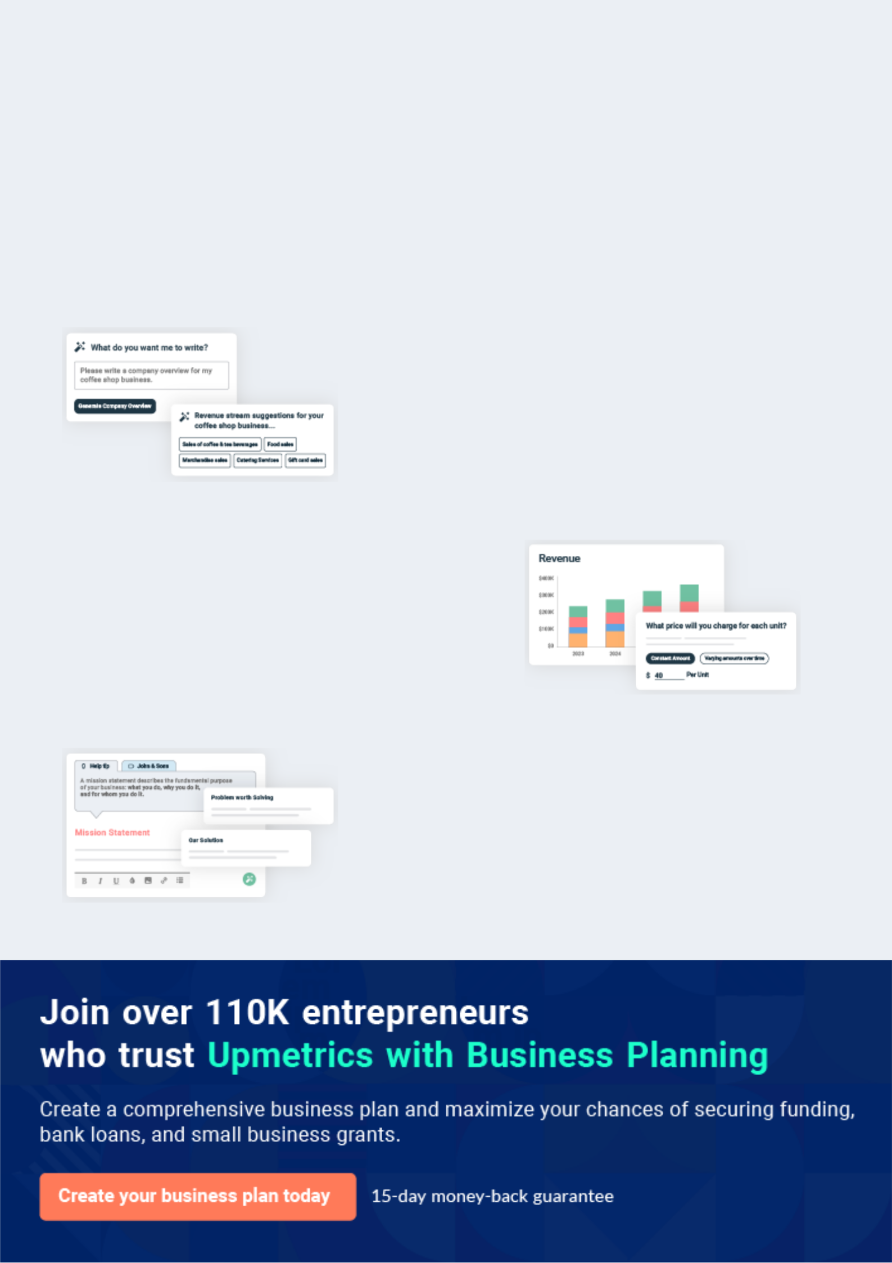
Business planning that’s simpler and faster than you think

Creating a business plan using Upmetrics to start and grow a business is literally the easiest thing in the World. Simply read the instructions and fill in the blanks. It’s as simple as that.

❛ | Upmetrics has everything you need to create a | ❜
❛ | comprehensive business plan. | ❜

AI-powered Upmetrics Assistant

AI-powered insights to streamline your plan

Not sure where to start? Upmetrics’ AI Assistant will automatically generate ideas for each section of your plan and offer improved versions of your writing, adjusting for tone, voice, and grammar or spelling errors.

Financial Forecasting Tool

All the financials are calculated for you

Forget the complex formulas and clumsy spreadsheets — with automatic financials and drag-and-drop forecasting, you can finish your plan faster and be confident that your numbers are accurate.

Business Plan Builder

Guides you like a business mentor

Upmetrics’ step-by-step instructions, prompts, and the library of 400+ sample business plans will guide you through each section of your plan as a business mentor.

1.


Executive summary

Problem Definition & Validation

Solution

Objectives

Mission statement

Keys to success

Financial highlights

Hot Shot Trucking | Business Plan [YEAR] 5/42

 Euro Trucks


Euro Trucks is the primary provider of expedited trucking services in New Jersey. The company will offer a wide range of services to meet the shipping, container, and heavy equipment industry requirements serving clients across the United States. An expansive fleet of vehicles, a
To unlock help try Upmetrics! 

Start writing here..

Problem Definition & Validation

 Euro Trucks

Oil, gas, and manufacturing projects are often complex and time-sensitive. Oftentimes, necessary equipment or parts may be required to be delivered at the project site, failing which critical time may be lost. Most logistic services are incapable of handling last-minute orders,
To unlock help try Upmetrics! 

Start writing here..

Solution

 Euro Trucks

Euro Trucks will offer same-day delivery that ensures clients get their equipment delivered to their destination on time. Meeting the need of shippers to move freight more quickly, cost-effectively, and with less hassle and planning required for most heavy equipment hauling, Euro
To unlock help try Upmetrics! 

Start writing here..

Hot Shot Trucking | Business Plan [YEAR] 6/42

Objectives
To unlock help try Upmetrics!

 Euro Trucks

- To begin commercial operations in New Jersey by Q1 2021

- To build a fleet of five operator-owned vehicles within the first year of commercial
operations | To unlock help try Upmetrics! 

Short Term (1 -3 Years)

Start writing here..

 Euro Trucks

- To gain a competitive edge within the country’s freight and logistics marketplace by establishing a presence in the world’s leading manufacturing sector.

- To build a market reputation for superior networks, efficient services,TounlockandreliablehelptryUpmetrics!delivery 

Long Term (3-5 years)

Start writing here..

Mission statement

 Euro Trucks

Our mission is to become an extension of our client's business operations by providing them with unparalleled freight and logistics management solutions acceding to our core values of reliability, accuracy, integrity, and service.



Start writing here..

Hot Shot Trucking | Business Plan [YEAR] 7/42

Keys to success


Access To Established Network


Euro Trucks boasts access to a robust network of agents spread across United States. This established network will allow the company to meet any shipping requirements of prospective clients with confidence and efficiency.


Effective Marketing


The company will employ direct sales and marketing strategies to personally approach prospective clients so that they may provide a more efficient and highly personalised service.


Access to Skilled Carriers


Euro Trucks will ensure on-boarding only experienced and skilled carriers. Highly experienced personnel will enhance its service offerings in the US

Range of Hauling Gear

The company's fleet of vehicles feature a range of hauling gear from Lowboy to Gooseneck and Bumper pull allowing it to load and carry freight of any size and to any destination

Location

New Jersey is the most well connected state in the USA. Being headquartered here will allow the company to have easy access to regions across the US making management and operations efficient and cost-effective.

Superior Customer Support

Maintaining a laser-like focus on customer satisfaction will be of utmost priority to the company being vital for brand building and to establishing Euro Trucks as the go-to provider of all expedited freight and logistic solutions.

Financial highlights

 Euro Trucks

The company envisions raising an equity investment of $50,000 through long-term borrowings, which will be used to set up and launch the business in the US. The company expects to break even in Year 2 and steadily grow its revenues through active efforts in marketing, networking,
To unlock help try Upmetrics! 

Start writing here..

Hot Shot Trucking | Business Plan [YEAR] 8/42

Euro Trucks - 5 Year Highlights
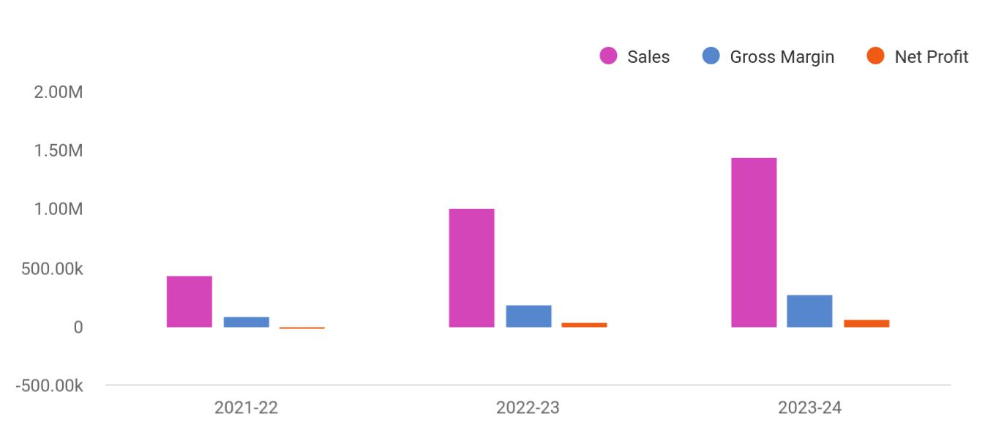

Financial Year | Sales | Gross Margin | Net Profit
2021-22 | 438,937 | 83,512 | -20,568
2022-23 | 1,005,905 | 189,844 | 40,379
2023-24 | 1,437,224 | 271,136 | 65,234

Hot Shot Trucking | Business Plan [YEAR] 9/42

2.

Business overview

Company Ownership/Legal Entity

Location

Interior Operating Facilities

Hours of Operation

Startup summary

Hot Shot Trucking | Business Plan [YEAR] 10/42

 Euro Trucks

Euro Trucks will be established as a limited liability entity. The company will be the primary provider of transport, shipping, and heavy equipment hauling services with an expedited timeline. The company's management has been a part of the logistics industry and holds
To unlock help try Upmetrics! 

Start writing here..

Company Ownership/Legal Entity

 Euro Trucks

The company will be registered as a limited liability entity with the Department of State. Further, since the company envisions setting up operations in New Jersey, it will also register with the local county. The business will be wholly owned and Managed by Founder Ms. Marshall, who
To unlock help try Upmetrics! 

Start writing here..

Location

 Euro Truck


Euro Trucks will begin operations from an office space in New Jersey. Known as the “Crossroads of the East,” New Jersey’s economy is driven by several different industries, with the major league players being manufacturing and distribution. It is considered the greatest
To unlock help try Upmetrics! 

Start writing here..

Hot Shot Trucking | Business Plan [YEAR] 11/42

Interior Operating Facilities

 Euro Trucks

The company will begin operations from a rented office space in a commercial area in New Jersey. Initial investments in setting up the interior facilities, consumables, inventory, and client entertainment space will be set up. Additions to space will be made as the company expands
To unlock help try Upmetrics! 

Start writing here..

Hours of Operation

 Euro Trucks

Euro Trucks will operate an 8-hour workday from 9 am to 5 pm. However, since the company’s services are required to be available 24/7, it will have in-house operators working in shifts ensuring a customer operator is available at any given time to take quick delivery
To unlock help try Upmetrics! 

Start writing here..

Startup summary

 Euro Trucks

The Founder will infuse a capital sum of £50,000 into the company. Approximately £10,200 will be spent on a range of start-up expenses such as marketing, advertising, and professional fees. At the same time, another £7,100 will be earmarked for sales tax payment and the acquisition
To unlock help try Upmetrics! 

Start writing here..

Hot Shot Trucking | Business Plan [YEAR] 12/42

3.

Products & Services

Range of Hauling Gear

Hot Shot Trucking | Business Plan [YEAR] 13/42

 Euro Trucks

Euro Trucks offers same-day delivery that ensures clients get their equipment delivered to their destination on time. With this premium service, a dedicated truck driver will be slotted for every expedited deliver and become responsible for the equipment from the point of pick-up to the
To unlock help try Upmetrics! 

Start writing here..

Range of Hauling Gear

Bumper Pull
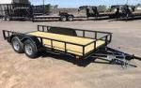
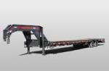

These are shorter, haul less materials, and weigh under 10,001 pounds when combined with your truck. You don’t need a commercial driver’s license (CDL) to haul with these.

Gooseneck

Stability, reliability, and requiring a special hitching system, they are usually 40 feet long, which puts them under the commercial category, and they are great for larger freight.

Deckover
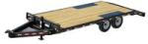
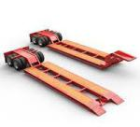

Ideal for heavier hauls such as cars and tractors, these are wide and roomy as well as low to the ground. They can be used both commercially and recreationally.

Lowboy

Lowboy offers the best stability for the heaviest loads and clearing height restrictions in most states is easy. But space can be limiting, so you may not be able to haul multiple items.

Start writing here..

Hot Shot Trucking | Business Plan [YEAR] 14/42

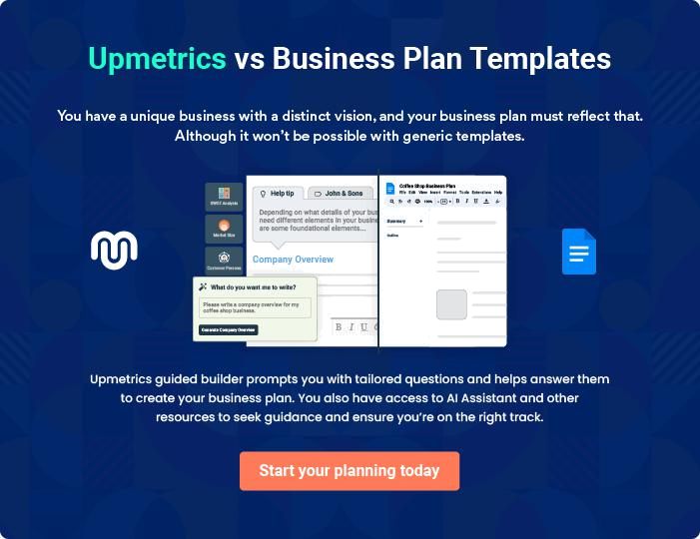

Hot Shot Trucking | Business Plan [YEAR] | 15/42

4.

Market Analysis

Market segmentation

Market Trends

Target market

Hot Shot Trucking | Business Plan [YEAR] 16/42

 Euro Trucks

America's trucking industry is the lifeblood of the U.S. economy. In fact, nearly every good consumed in the U.S. is put on a truck at some point. As a result, the trucking industry hauled 72.5% of all freight transported in the United States in 2019, equating to 11.84 billion tons. The
To unlock help try Upmetrics! 

Start writing here..

Market segmentation

 Euro Trucks

FTL carriers haul large amounts of homogenous cargo, generally enough to fill an entire semi-trailer or container. Fleets in the FTL sector can be either privately owned, for example, by a large manufacturer who needs to distribute their goods, or available on a for-hire basis. For-hire
To unlock help try Upmetrics! 

Full Truckload Carriers

Start writing here..

 Euro Trucks

Conversely, LTL carriers transport shipments larger than parcels but not large enough to fill a full trailer. Many LTL carriers will transport multiple shipments simultaneously to optimize their operations. The largest LTL carrier is FedEx Freight, which in 2019 reported over $7.4 billion in
To unlock help try Upmetrics! 

Less-Than-Truckload Carriers

Start writing here..

 Euro Trucks

Finally, the courier sector is comprised of carriers of non-palletized and light goods, such as parcels. Three main companies dominate this sector in the United States: the U.S. Postal Service, FedEx, and UPS. Revenues in this sector appear higher than for FLT and LTL: FedEx
To unlock help try Upmetrics! 

Couriers

Start writing here..

Hot Shot Trucking | Business Plan [YEAR] 17/42

Market Trends
To unlock help try Upmetrics!

 Euro Trucks

Trucking is providing one of the few bright spots to the flagging U.S. economy as tight capacity and a driver shortage push contract and spot rates higher across vans, flatbeds, and refrigerated trucks.



Start writing here..

Target market

 Euro Trucks

Euro Trucks will provide B2B services to businesses in the construction industry, oil & gas segment, manufacturing sector, food companies who need to transport time-sensitive cargo. Euro Trucks will establish a physical office at the epicenter of the US logistic sector, New
To unlock help try Upmetrics! 

Start writing here..

Competitive Advantage


Access to a Network of Drivers

The company will

operate a

comprehensive network

of drivers who will be

able to meet deliveries

in a timely manner

Myriad Hauling Gear

Euro Trucks will ensure it houses a range of hauling gear to increase its capabilities to carry cargo of any size and weight

Experience Price

The management of the Operating operator

company has been in owned trucks will

the logistics industry reduce the company's

for over a decade initial capital outlay

allowing it to bring which can be

enhanced experience to transferred onto the

the business customer through

competitive pricing

Hot Shot Trucking | Business Plan [YEAR] 18/42

5.

SWOT analysis

Hot Shot Trucking | Business Plan [YEAR] 19/42

 Euro Trucks

A SWOT (Strength, Weakness, Opportunity, and Threat) analysis is a useful tool for businesses to evaluate their position in the market against the potential internal and external factors that could assist or jeopardize their operations and existence. A SWOT has been conducted for PYT
To unlock help try Upmetrics! 

Start writing here..

Hot Shot Trucking | Business Plan [YEAR] 20/42


Strength

- The company benefits from extensive insight and market expertise.

- The flexible and robust range of services ensures the company's capabilities to cater to a more significant market share.

- The company is based in New Jersey, which contains the right talent, infrastructure, support services, and capital availability.

- The Founder’s success portfolio and global clientele provide credibility and increase trust among its potential clients.

- Strategic collaborations enrich the services of the company with leading industry experts and global logistic providers.

Weakness


- An increasing number of competitors within the industry leads to market share erosion.

- The company is relatively new to the US market, in which seasoned players dominate.

- The high rate of competition within the industry and the fragmented nature of the market makes the sector price sensitive.


Opportunity

- Partnering with leading logistic providers to extend their market offering

- Ms. Marshall’s skill in tactfully combining customer relationship management and supply networks to achieve an organizational goal opens up opportunities within challenging and risk intensive markets

- The company possess the capabilities to extend its offerings globally

Threat

- Competitors eroding the market

- Low barriers to entry

- Competitors poaching B2B clients

- Any change in the trading regulations of the country will impact the operations of the company

Hot Shot Trucking | Business Plan [YEAR] 21/42

6.

Strategy & implementation

Marketing and Promotion Programs

Positioning Statement

Sales strategy

Pricing strategy

Hot Shot Trucking | Business Plan [YEAR] 22/42

 Euro Trucks
To unlock help try Upmetrics!
To unlock help try Upmetrics!

The company will predominantly rely on online advertising and lead generation strategies as many seeking logistic services first search online for information. As such, a full-fledged online marketing campaign will be launched inclusive of paid, social media, and website campaigns.
To unlock help try Upmetrics! 

Start writing here..

Marketing and Promotion Programs

 Euro Trucks

Euro Trucks will approach potential commercial clients directly, either through cold-calling or e-mail to arrange pitch meetings. The company’s sales representatives will use these opportunities to display the product catalog directly.



Direct Sales

Start writing here..

 Euro Trucks

The Company will advertise in specific trade publications that are targeted towards the appropriate target markets. To this end, the company has received quotations from a leading trade magazine, HCB.



Trade Publications

Start writing here..

 Euro Trucks

Euro Trucks will establish a presence at various trade shows that are relevant to the target market. For example, the Multimodal event (www.multimodal.org) is an annual exhibition that is considered the US’s premier freight transport, logistics, and supply chain management event.
To unlock help try Upmetrics! 

Trade shows

Start writing here..

Hot Shot Trucking | Business Plan [YEAR] 23/42

 Euro Trucks

The Company will operate a professional and compelling website dedicated to specific industries and specialized cargos
To unlock help try Upmetrics! 

Website

Start writing here..

 Euro Trucks

The focus will be on Google Ads, which are more likely to drive commercial leads than other online advertising platforms (such as Facebook). The advertising will target specific keywords relevant to Euro Truck’s offering (e.g. “freight services”, “Receiving goods to the US” etc.).
To unlock help try Upmetrics! 

Targeted Online Advertising

Start writing here..

Positioning Statement

 Euro Trucks

The company seeks to carve a niche for its services in the US market by capitalizing on its position between the country's leading manufacturing sector and its ability to formulate the most competitive business development strategies through a diversified operation facilitated
To unlock help try Upmetrics! 

Start writing here..

Sales strategy

 Adore


Companies in the construction, oil, gas, and manufacturing industry form the company’s primary target market. While push marketing efforts will be deployed to reach these companies and make them aware of the range of services provided, pull marketing efforts will drive
To unlock help try Upmetrics! 

Hot Shot Trucking | Business Plan [YEAR] 24/42

Start writing here..

Online Marketing Channels


Electronic Direct Mail

Marketing

Companies handling complex onsite projects will stand out prominently as viable marketing targets for this channel. Euro Trucks will mail professionally designed materials with its value proposition to these companies and provide quotes for its hauling and expedited delivery services

Social Media

Millennials and consumers in general spend a considerable time browsing social media platforms. Reaching to them through this channel will be and effective way to capture

attention and position its services.

Google Ad Campaigns

The advertising will target specific keywords relevant to Euro Truck's offering (e.g. “freight services”, “Receiving goods to the US” etc.).

Hot Shot Trucking | Business Plan [YEAR] 25/42

Offline Marketing Channels


Networking | Referral | Conferences
Participate in leading | The company will offer referral | The company will participate in
consumers exhibitions and | discounts and packaged | leading conferences and make
beauty events. Display a range | services to valued, regular | their presence known through
of samples and distribute | clients | marketing materials and
flyers at these events. The |  | presentations
company will also keep a
record of visitors to their stalls
as leads for its email
marketing campaigns.

Pricing strategy

 Euro Trucks

Freight forwarding income depends upon several factors including the size of the shipment, destination, and transportation method. The average shipment income is estimated at $22,802 based on the parent company's historical sales data. The direct cost is primarily associated
To unlock help try Upmetrics! 

Start writing here..

Hot Shot Trucking | Business Plan [YEAR] 26/42

7.

Operational Plan

Management Team

Personnel Plan

Milestones

Hot Shot Trucking | Business Plan [YEAR] 27/42

 Euro Trucks

The team will be headed by Managing Director Ms. Marshall who will also oversee the company's operations. Joining Ms. Marshall in the Management Team, the company will onboard a freight forwarding assistant and a sales and marketing executive to support the
To unlock help try Upmetrics! 

Start writing here..

Organization chart


Ms Marshall

Managing Director


Jane Doe


Freight Forwarding Assistant Amanda Doe

Sales Representatives

Management Team

 Euro Trucks

Ms. Marshall counts over 13 years of administrative and management experience, taking on various business development activities during the period. Her ability to attract key players and build strong and lasting business relationships enabled her to grow in capacity and
To unlock help try Upmetrics! 

Start writing here..

Hot Shot Trucking | Business Plan [YEAR] 28/42

Personnel Plan

 Euro Trucks

The company plans to create two full-time equivalent jobs within the first five years of operations.
To unlock help try Upmetrics! 

Start writing here..

Hiring plan

2 |  |  |  |  | 0 |  |  |  |  | 2
Filled |  |  |  |  | Hired |  |  |  |  | Open
Group By |  |  | FY2021 |  |  |  | FY2022 |  |  | FY2023 |  | FY2024
Department |  |  |  |  |  |  |  |  |  |  |  | FY2024
Freight
Forwarding | 0 |  |  |  |  | 1 |  |  |  | 1 |  | 1
Assistant
Sales &
Marketing | 0 |  |  |  |  | 0 |  |  |  | 1 |  | 1
Assistantq
JD |  | Jane Doe
JD |  | Freight Forwarding Assistant


Ability to cope with fast-paced and pressured work, accuracy, strong attention to detail and a strong analytical mind, ability to notice patterns within statistics, an interest in psychology and behavior, good organizational skills, excellent (spoken and written) communication skills.

Hot Shot Trucking | Business Plan [YEAR] 29/42


Amanda Doe
AD | Sales Representatives
 | Preferably bilingual with ability to speak English and French fluently, problem-
 | solving, ability to convert leads into sales, active listener, patience, and
 | understanding of the company’s products and services. Additionally, skills in
 | social media marketing, search engine optimization, newsletter marketing, other
 | forms of digital marketing will also be required

Hot Shot Trucking | Business Plan [YEAR] 30/42

Milestones

Euro Trucks


Year 2

>Year3

Establish

Euro Trucks will rent an office space at the heart of New Jersey's commercial hub alongside developing a fully optimized and informative website. During this period, the _{YEAR 1} company will also acquire operator

licenses for trucks. Marketing activities will

also begin during this stage to build

awareness and launch the brand into the

market.



Gain Market Traction

The company will begin expanding its

services beyond New Jersey to cover other

regions around the US.


Diversify
Having externally established the business, | Year 3
the company will begin internally expanding | Year 3
its service capabilities


Grow

- Begin expanding across the US

- Consider market expansion beyond US


Hot Shot Trucking | Business Plan [YEAR] 31/42

8.

Financial plan

Important Assumptions

Brake-even Analysis

Projected Profit and Loss

Projected Cash Flow

Projected Balance Sheet

Business Ratios

Hot Shot Trucking | Business Plan [YEAR] 32/42


If you are going to start your own Hot Shot Trucking business, then make sure you will pay special attention to your financial plan. Your financial plan should include the details about how well you manage your incomes and
To unlock help try Upmetrics! 

Important Assumptions

The company’s financial projections are forecasted on the basis of the following assumptions. These assumptions are quite conservative and are also expected to show deviation but to a limited level such that the company’s major financial strategy will not be affected.

 | Year 1 | Year 2 | Year 3
Plan Month | 1 | 2 | 3
Current Interest Rate | 10,00% | 11,00% | 12,00%
Long-term Interest Rate | 10,00% | 10,00% | 10,00%
Tax Rate | 26,42% | 27,76% | 28,12%
Other | 0 | 0 | 0

Brake-even Analysis

Monthly Units Break-even | 5530
Monthly Revenue Break-even | $159 740
Assumptions:
Average Per-Unit Revenue | $260,87
Average Per-Unit Variable Cost | $0,89
Estimated Monthly Fixed Cost | $196 410

Hot Shot Trucking | Business Plan [YEAR] 33/42

Projected Profit and Loss

 | 2024 | 2025 | 2026
Revenue | $2,170,342.50 | $3,838,977 | $6,181,723.50
Hot Shot Trucking | $354,845 | $506,005 | $721,380
Business Plan | $354,845 | $506,005 | $721,380
Unit Sales | 710 | 1,012 | 1,443
Unit Price | $500 | $500 | $500
Long Haul Trucking | $1,307,689.50 | $1,658,644 | $2,103,575.50
Unit Sales | 2,012 | 2,552 | 3,236
Unit Price | $650 | $650 | $650
Equipment Rental | $507,808 | $1,674,328 | $3,356,768
Users | 408 | 974 | 1,811
Recurring Charges | $200 | $200 | $200

Cost Of Sales | $426,517.14 | $521,888.87 | $651,444.41
General Costs | $426,517.14 | $521,888.87 | $651,444.41
Vehicle Operating Costs | $228,517.14 | $317,948.87 | $441,386.21
Vehicle Operating Costs | $120,000 | $126,000 | $132,300
Maintenance and Repairs | $108,517.14 | $191,948.87 | $309,086.21
Personnel Costs | $198,000 | $203,940 | $210,058.20
Driver Salaries | $180,000 | $185,400 | $190,962
Liquor Store Business Plan | $18,000 | $18,540 | $19,096.20
Revenue Specific Costs | $0 | $0 | $0
Personnel Costs (Direct | $0 | $0 | $0
Labor) | $0 | $0 | $0

Gross Margin | $1,743,825.36 | $3,317,088.13 | $5,530,279.09

Hot Shot Trucking | Business Plan [YEAR] 34/42

Gross Margin (%)

Operating Expense

Payroll Expense (Indirect Labor)

Drivers

Truck Drivers

Local Delivery Drivers

Logistics and Operations

Logistics Coordinators

Operations Managers

Administrative and Support Staff

Administrative Assistants

Customer Service

Representatives

General Expense

Fleet and Equipment

Expenses

Vehicle Insurance

Vehicle Leasing Fees

Office and Administration Expenses

Office Rent

Office Supplies

Marketing and Advertising Expenses

Digital Marketing

Print and Media Advertising

2024 | 2025 | 2026
80.35% | 86.41% | 89.46%

$2,302,390.29 | $2,416,471.73 | $2,552,787.13
$1,775,280 | $1,829,582.40 | $1,885,675.80
$1,101,600 | $1,131,192 | $1,161,602.64
$756,000 | $778,680 | $802,040.40
$345,600 | $352,512 | $359,562.24
$406,200 | $423,948 | $442,480.92
$256,200 | $266,448 | $277,105.80
$150,000 | $157,500 | $165,375.12
$267,480 | $274,442.40 | $281,592.24
$106,200 | $108,324 | $110,490.48
$161,280 | $166,118.40 | $171,101.76
$527,110.29 | $586,889.33 | $667,111.35
$408,000 | $416,640 | $425,467.20
$360,000 | $367,200 | $374,544
$48,000 | $49,440 | $50,923.20
$57,703.44 | $74,749.79 | $98,540.88
$36,000 | $36,360 | $36,723.60
$21,703.44 | $38,389.79 | $61,817.28
$61,406.85 | $95,499.54 | $143,103.27
$18,000 | $18,720 | $19,468.80
$43,406.85 | $76,779.54 | $123,634.47

Hot Shot Trucking | Business Plan [YEAR] 35/42

Bad Debt

Amortization of Current Assets

EBITDA

Additional Expense

Long Term Depreciation

Gain or loss from Sale of Assets

EBIT

Interest Expense

EBT

Income Tax Expense / Benefit

Total Expense

Net Income

Net Income (%)

Retained Earning Opening

Owner's Distribution

Retained Earning Closing

Projected Cash Flow

2024 | 2025 | 2026
$0 | $0 | $0
$0 | $0 | $0

($558,564.93) $900,616.42 $2,977,491.95

$10,614.73 | $8,680.57 | $6,627.11
$5,467.80 | $5,467.80 | $5,467.80
$0 | $0 | $0
($564,032.73) | $895,148.62 | $2,972,024.15
$5,146.94 | $3,212.76 | $1,159.29
($569,179.66) | $891,935.85 | $2,970,864.84
$0 | $0 | $0

$2,739,522.16 | $2,947,041.15 | $3,210,858.66
($569,179.66) | $891,935.85 | $2,970,864.84
(26.23%) | 23.23% | 48.06%

$0 | ($594,179.66) | $292,756.19
$25,000 | $5,000 | $5,000
($594,179.66) | $292,756.19 | $3,258,621.03

Hot Shot Trucking | Business Plan [YEAR] 36/42

 | 2024 | 2025 | 2026
Cash Received | $2,170,342.50 | $3,838,977 | $6,181,723.50
Cash Paid | $2,734,054.34 | $2,941,573.37 | $3,205,390.84
COS & General Expenses | $953,627.41 | $1,108,778.20 | $1,318,555.73
Salary & Wages | $1,775,280 | $1,829,582.40 | $1,885,675.80
Interest | $5,146.94 | $3,212.76 | $1,159.29
Sales Tax | $0 | $0 | $0
Income Tax | $0 | $0 | $0
Net Cash From | ($563,711.84) | $897,403.63 | $2,976,332.66
Operations | ($563,711.84) | $897,403.63 | $2,976,332.66

Assets Sell | $0 | $0 | $0
Assets Purchase | $30,500 | $0 | $0
Net Cash From | ($30,500) | $0 | $0
Investments | ($30,500) | $0 | $0

Amount Received | $150,000 | $0 | $0
Loan Received | $100,000 | $0 | $0
Common Stock | $0 | $0 | $0
Preferred Stock | $0 | $0 | $0
Owner's Contribution | $50,000 | $0 | $0
Amount Paid | $56,359.35 | $38,293.51 | $40,347.12
Loan Capital | $31,359.34 | $33,293.52 | $35,347.14
Dividends & Distributions | $25,000 | $5,000 | $5,000
Net Cash From | $93,640.65 | ($38,293.51) | ($40,347.12)
Financing | $93,640.65 | ($38,293.51) | ($40,347.12)

Summary

Hot Shot Trucking | Business Plan [YEAR] 37/42

 | 2024 | 2025 | 2026
Starting Cash | $0 | ($500,571.19) | $358,538.93
Cash In | $2,320,342.50 | $3,838,977 | $6,181,723.50
Cash Out | $2,820,913.69 | $2,979,866.88 | $3,245,737.96
Change in Cash | ($500,571.19) | $859,110.12 | $2,935,985.54
Ending Cash | ($500,571.19) | $358,538.93 | $3,294,524.47

Projected Balance Sheet

 | 2024 | 2025 | 2026
Assets | ($475,538.99) | $378,103.33 | $3,308,621.07
Current Assets | ($500,571.19) | $358,538.93 | $3,294,524.47
Cash | ($500,571.19) | $358,538.93 | $3,294,524.47
Accounts Receivable | $0 | $0 | $0
Inventory | $0 | $0 | $0
Other Current Assets | $0 | $0 | $0
Long Term Assets | $25,032.20 | $19,564.40 | $14,096.60
Gross Long Term Assets | $30,500 | $30,500 | $30,500
Accumulated Depreciation | ($5,467.80) | ($10,935.60) | ($16,403.40)
Liabilities & Equity | ($475,539) | $378,103.33 | $3,308,621.03
Liabilities | $68,640.66 | $35,347.14 | $0
Current Liabilities | $33,293.52 | $35,347.14 | $0
Accounts Payable | $0 | $0 | $0
Income Tax Payable | $0 | $0 | $0
Sales Tax Payable | $0 | $0 | $0
Short Term Debt | $33,293.52 | $35,347.14 | $0

Hot Shot Trucking | Business Plan [YEAR] 38/42

 | 2024 |  |  | 2025 |  | 2026
Long Term Liabilities | $35,347.14 |  |  | $0 |  | $0
Long Term Debt | $35,347.14 |  |  | $0 |  | $0
Equity | ($544,179.66) |  | $342,756.19 |  |  | $3,308,621.03
Paid-in Capital | $0 |  |  | $0 |  | $0
Common Stock | $0 |  |  | $0 |  | $0
Preferred Stock | $0 |  |  | $0 |  | $0
Owner's Contribution | $50,000 |  |  | $50,000 |  | $50,000
Retained Earnings | ($594,179.66) |  | $292,756.19 |  |  | $3,258,621.03
Check | $0 |  |  | $0 |  | $0
Business Ratios
 |  | Year 1 | Year 2 |  | Year 3 | Industry profile
Sales Growth |  | 4,35% | 30,82% |  | 63,29% | 4,00%
Percent of Total Assets
Accounts Receivable |  | 5,61% | 4,71% |  | 3,81% | 9,70%
Inventory |  | 1,85% | 1,82% |  | 1,79% | 9,80%
Other Current Assets |  | 1,75% | 2,02% |  | 2,29% | 27,40%
Total Current Assets |  | 138,53% | 150,99% |  | 163,45% | 54,60%
Long-term Assets |  | -9,47% | -21,01% |  | -32,55% | 58,40%
TOTAL ASSETS |  | 100,00% | 100,00% |  | 100,00% | 100,00%
Current Liabilities |  | 4,68% | 3,04% |  | 2,76% | 27,30%
Long-term Liabilities |  | 0,00% | 0,00% |  | 0,00% | 25,80%
Total Liabilities |  | 4,68% | 3,04% |  | 2,76% | 54,10%
NET WORTH |  | 99,32% | 101,04% |  | 102,76% | 44,90%
Percent of Sales

Hot Shot Trucking | Business Plan [YEAR] 39/42

 | Year 1 | Year 2 | Year 3 | Industry profile
Sales | 100,00% | 100,00% | 100,00% | 100,00%
Gross Margin | 94,18% | 93,85% | 93,52% | 0,00%
Selling, General & Administrative Expenses | 74,29% | 71,83% | 69,37% | 65,20%
Advertising Expenses | 2,06% | 1,11% | 0,28% | 1,40%
Profit Before Interest and Taxes | 26,47% | 29,30% | 32,13% | 2,86%
Main Ratios
Current | 25,86 | 29,39 | 32,92 | 1,63
Quick | 25,4 | 28,88 | 32,36 | 0,84
Total Debt to Total Assets | 2,68% | 1,04% | 0,76% | 67,10%
Pre-tax Return on Net Worth | 66,83% | 71,26% | 75,69% | 4,40%
Pre-tax Return on Assets | 64,88% | 69,75% | 74,62% | 9,00%
Additional Ratios
Net Profit Margin | 19,20% | 21,16% | 23,12% | N.A.
Return on Equity | 47,79% | 50,53% | 53,27% | N.A.
Activity Ratios
Accounts Receivable Turnover | 4,56 | 4,56 | 4,56 | N.A.
Collection Days | 92 | 99 | 106 | N.A.
Inventory Turnover | 19,7 | 22,55 | 25,4 | N.A.
Accounts Payable Turnover | 14,17 | 14,67 | 15,17 | N.A.
Payment Days | 27 | 27 | 27 | N.A.
Total Asset Turnover | 1,84 | 1,55 | 1,26 | N.A.
Debt Ratios
Debt to Net Worth | 0 | -0,02 | -0,04 | N.A.
Current Liab. to Liab. | 1 | 1 | 1 | N.A.
Liquidity Ratios
Net Working Capital | $120 943 | $140 664 | $160 385 | N.A.
Interest Coverage | 0 | 0 | 0 | N.A.
Additional Ratios

Hot Shot Trucking | Business Plan [YEAR] 40/42

 | Year 1 | Year 2 | Year 3 | Industry profile
Assets to Sales | 0,45 | 0,48 | 0,51 | N.A.
Current Debt/Total Assets | 4% | 3% | 2% | N.A.
Acid Test | 23,66 | 27,01 | 30,36 | N.A.
Sales/Net Worth | 1,68 | 1,29 | 0,9 | N.A.
Dividend Payout | 0 | 0 | 0 | N.A.
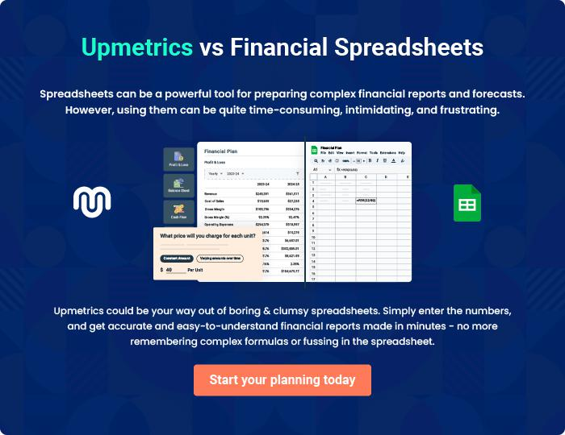

Hot Shot Trucking | Business Plan [YEAR] 41/42


Create a winning business plan that gets you funded

Creating a stunning and investment-ready plan requires no writing, graphic designing, or financial planning expertise.

Upmetrics has all the features required to help you create a comprehensive business plan—from start to finish. Make no mistakes, it’s the modern way of planning to structure ideas, make plans, and create stunning pitch decks to awe investors.

Pitch decks that impress investors

Create pitch decks that provide a visual representation of your business, engage investors, and make them want to invest in your business idea.

Interactive plans in no time

Import business plan sections like—SWOT analysis, comparison tables, and others to create an interactive business plan. No designing skills are required.

Stunning cover page designs

With Upmetrics, you have the liberty to choose from multiple stunning cover page designs. Choose a creative design and make your plan stand out.

Online sharing made simple

Upmetrics makes online sharing quick and easier for users. Easily share your business plans with a link while tracking reader activity.

500+ sample business plans

Simply import a template from our library of sample plans into the editor and start customizing it to make it yours. It takes only a few clicks to get started.

Collaborate with team in real-time

Invite team members, initiate conversations, discuss ideas & strategies, share feedback, and work on a business plan in real-time.

