
 Hookah Lounge

ADDRESS CONTACT

10200 Bolsa Ave, Westminster, CA, 92683 (650) 359-3153

http://www.example.com info@example.com


Business Plan

[YEAR]

Prepared By

John Doe


A Moments of Chill Air

Information provided in this business plan is unique to this business and confidential; therefore, anyone reading this plan agrees not to disclose any of the information in this business plan without prior written permission of the company.

Table of Contents

Executive summary | 5
Problem Definition & Validation | 6
Solution | 6
Objectives | 6
Strategic Objectives | 7
Operational Objectives | 7
Mission statement | 7
Keys to success | 7
Financial Highlights | 8
Shisha - 3 Year Revenue Highlights | 9

Business overview | 10
Company Ownership/Legal Entity | 11
Location | 11
Interior Operating Facilities | 11
Hours of Operation | 12
Startup summary | 12

Products & Services | 13
Hookah Menu | 14
Other menu Listing | 14
Staff Training | 14
Sourcing Ingredients | 15

Market Analysis | 16
Hookah Industry | 17
Cafe Industry | 17
Market segmentation | 17
Market Trends | 18
Target market | 18
Major Target Market | 18

Hookah Lounge | Business Plan [YEAR] 2/41

Minor Target Market | 19
Competitive Advantage | 19
SWOT analysis
SWOT analysis | 20
Strategy & implementation
Strategy & implementation | 23
Distribution Strategy | 24
Marketing and Promotions Strategy | 24
Positioning Statement | 25
The planned positioning of Shisha's Market | 25
Sales strategy | 25
Post- Opening Marketing Channels | 26
Pricing strategy | 26
Operational Plan
Operational Plan | 27
Organization chart | 28
Management Team | 28
Personnel Plan | 29
Jane Doe | 29
Amanda Doe | 29
John Green | 29
Milestones | 30
SHISHA | 30
Financial plan
Financial plan | 31
Important Assumptions | 32
Brake-even Analysis | 32
Projected Profit and Loss | 33
Projected Cash Flow | 36
Projected Balance Sheet | 37
Business Ratios | 38

Hookah Lounge | Business Plan [YEAR] 3/41

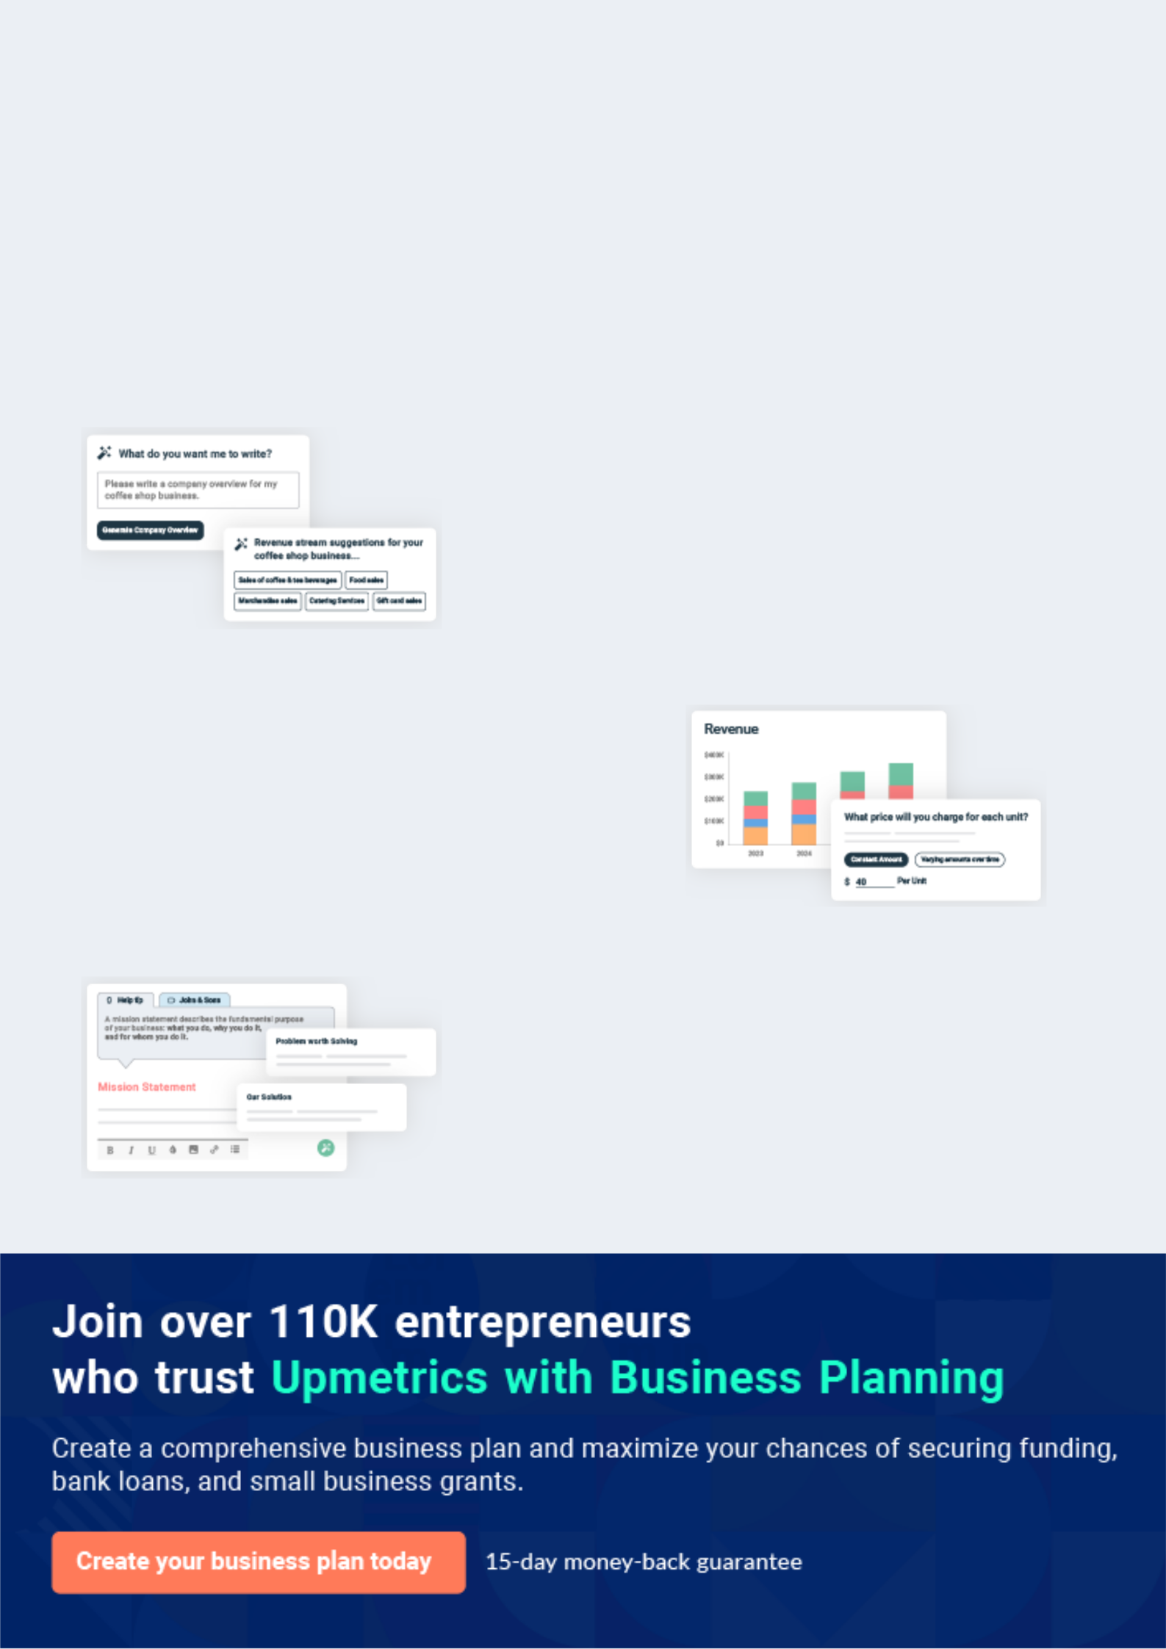
Business planning that’s simpler and faster than you think

Creating a business plan using Upmetrics to start and grow a business is literally the easiest thing in the World. Simply read the instructions and fill in the blanks. It’s as simple as that.

❛ | Upmetrics has everything you need to create a | ❜
❛ | comprehensive business plan. | ❜

AI-powered Upmetrics Assistant

AI-powered insights to streamline your plan

Not sure where to start? Upmetrics’ AI Assistant will automatically generate ideas for each section of your plan and offer improved versions of your writing, adjusting for tone, voice, and grammar or spelling errors.

Financial Forecasting Tool

All the financials are calculated for you

Forget the complex formulas and clumsy spreadsheets — with automatic financials and drag-and-drop forecasting, you can finish your plan faster and be confident that your numbers are accurate.

Business Plan Builder

Guides you like a business mentor

Upmetrics’ step-by-step instructions, prompts, and the library of 400+ sample business plans will guide you through each section of your plan as a business mentor.

1.


Executive summary

Problem Definition & Validation

Solution

Objectives

Mission statement

Keys to success

Financial Highlights

Hookah Lounge | Business Plan [YEAR] 5/41

 Shisha
To unlock help try Upmetrics!


Shisha is a cafe and hookah lounge located in the thriving city of New York. Shisha plans to offer a holistic cafe experience complete with food and beverage. In addition to myriad hookah flavors, Shisha's menu will feature healthy all-day breakfast and lunch options along with freshly
To unlock help try Upmetrics! 

Start writing here..

Problem Definition & Validation

 Shisha

Hookah lounges or bars are generally frequented by youth looking to mingle with friends and "hang." The presence of smoking hookah and the youth culture seemingly make it an inappropriate place for families and children. While hookah smoking is said to be enjoyed by
To unlock help try Upmetrics! 

Start writing here..

Solution

 Shisha

Shisha is a family and children-friendly place. By eliminating alcoholic beverages from the menu and including all-day breakfast and other food options, the company aims to create an
environment that is conducive to families. Furthermore, the founders of the company recognize
To unlock help try Upmetrics! 

Start writing here..

Objectives

 Shisha

• To build a brand reputation within the first five years of operations as a cafe that provides a differentiated yet localized experience that is also synonymous with quality food and
exceptional customer service


Hookah Lounge | Business Plan [YEAR] 6/41

Strategic Objectives
To unlock help try Upmetrics!

Start writing here..

 Shisha

- To begin commercial operations in New York by October 2022

- To hire one full-time assistant in Year 1 and add an additional helper by Year 3 to assist
the founder in running the café | To unlock help try Upmetrics! 

Operational Objectives

Start writing here..

Mission statement

 Shisha

To become an uplifting presence in the local community by weaving the Shisha brand into the fabric of positive relationships and experiences through delicious, gourmet, healthy beverages with a side of comforting food.



Start writing here..

Keys to success



Established Brand

As the company facilitates the value proposition of a recognisable brand that is known for its distinct quality and taste globally, it will be able to quickly achieve a strong foothold within the US.

Extended Offering

Along with the ever popular and flavorful hookahs, Shisha will also serve a variety of beverages along with all day breakfast and meal options making it a fulfilling ‘eating out’ experience for customers who patronise the cafe.

Hookah Lounge | Business Plan [YEAR] 7/41


Product Quality

Consistent with the brand’s mantra of “You only get out what you put in”, Shisha will ensure quality ingredients sourced from local suppliers across all its menu preparations.


Efficient Operations

Shisha will put forth a clear management control system to gauge the performance of organisational resources, including financial, human and operational as well as evaluate the effectiveness of devised and executed organisational strategies in order to achieve efficiency and optimise the bottom line.
Untapped Market


Shisha will be the first non-alcoholic hookah lounge in New York. Being located at the heart of the city would help generate a high footfall, supported by nearby shops, thriving retail landscape, and transit options.


Superior Customer Support

Exceptional customer service will play a pivotal role in the success of Shisha as it will not only be aligned with the café’s aim to bring a smile on its customers but also enable repeat business and customer loyalty by ensuring that workers are polite, friendly and professional.

Financial Highlights

 Shisha

The company envisions raising an equity investment of $50,000 through long-term borrowings, which will be used for the setup and launch of the salon in the US. The company expects to steadily grow its revenues through active efforts in marketing, networking, excellent customer
To unlock help try Upmetrics! 

Start writing here..

Hookah Lounge | Business Plan [YEAR] 8/41

Shisha - 3 Year Revenue Highlights
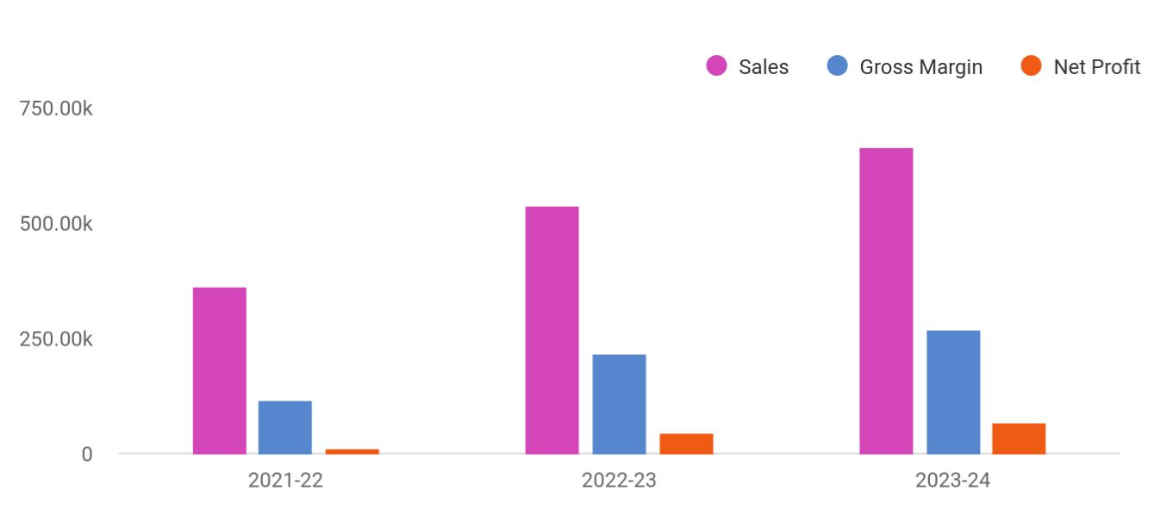

Financial Year | Sales | Gross Margin | Net Profit
2021-22 | 360,723 | 114,289 | 13,038
2022-23 | 538,041 | 216,784 | 44,360
2023-24 | 665,012 | 269,869 | 65,638

Hookah Lounge | Business Plan [YEAR] 9/41

2.

Business overview

Company Ownership/Legal Entity

Location

Interior Operating Facilities

Hours of Operation

Startup summary

Hookah Lounge | Business Plan [YEAR] 10/41

 Shisha

Hookah, also known as Shisha, involves adults smoking flavored tobacco from a water pipe in which they pass a hose and take a puff among family or friends. It centers around conversations and promotes a more connectedness among those participating. Hookah is
To unlock help try Upmetrics! 

Start writing here..

Company Ownership/Legal Entity

 Shisha

The company will be registered as a limited liability entity with the Department of State. Further, since the company envisions setting up operations in New York, it will also register with the local county. The business will be wholly owned and Managed by Founder Mr. Thomas Green,
To unlock help try Upmetrics! 

Start writing here..

Location

 Shisha

Shisha will begin operations from an office space in New York. Known as the “Fashion Capital,” New York state is home to 2.1 million small businesses and 4 million small business employees, which is more than 50 percent of the private workforce. New York’s economy is the
To unlock help try Upmetrics! 

Start writing here..

Interior Operating Facilities

 Shisha

The company will begin operations from a high street space enough to convert into a cafe with a dedicated section for hookah at the heart of LA’s commercial hub. Initial investments in setting up the interior facilities, consumables, inventory, and client entertainment space will be
To unlock help try Upmetrics! 

Hookah Lounge | Business Plan [YEAR] 11/41

Start writing here..

Hours of Operation

 Shisha

Within the specialty independent coffee houses, Shisha will open for the highest number of hours per week (76 hours), followed by Playground Coffee House and Full Court Press. While Playground Coffee House operates for 65 hours per week in total, its operating hours at the
To unlock help try Upmetrics! 

Start writing here..

Startup summary

 Shisha

The founding team will infuse a capital sum of $50,000 through long-term borrowings to meet the company’s start-up requirements. The start-up expenses are estimated at $18,500, primarily consisting of interior renovation, rent, and advertisement expenses. A further sum of $15,000
To unlock help try Upmetrics! 

Start writing here..

Hookah Lounge | Business Plan [YEAR] 12/41

3.

Products & Services

Hookah Menu

Other menu Listing

Staff Training

Sourcing Ingredients

Hookah Lounge | Business Plan [YEAR] 13/41

 Shisha

Once seen as an exotic pastime and cultural phenomenon in the Middle East, hookah smoking spread to Europe and North America in recent years. Hookah, also known as waterpipe smoking, is a unique method of smoking tobacco. It consists of a head (which holds the
To unlock help try Upmetrics! 

Start writing here..

Hookah Menu

 Shisha


To unlock help try Upmetrics! 

Start writing here..

Other menu Listing

 Shisha

Apart from its signature Hookah, Shisha will have a range of other healthy and scrumptious breakfast and lunch options along with a variety of non-alcoholic beverages to round up the cafe offering and make it complete eating out experience. The preliminary menu has been
To unlock help try Upmetrics! 

Start writing here..

Staff Training

 Shisha

Aligning to the brand’s aim to bring a smile to the customer’s face, the staff will be trained to be friendly, efficient, conversant with menu items, as well as unobtrusive. The company will put in place adequate HR processes, including staff contracts, suggested staffing and rota methods,
To unlock help try Upmetrics! 

Hookah Lounge | Business Plan [YEAR] 14/41

Start writing here..

Sourcing Ingredients

 Shisha

The hookah flavors will be procured from its cultural home, Morocco on an order basis as required. For the café’s other food items, Shisha will procure fresh produce and baked goods from local sources. Standard as befitting a café and required by US regulations for operating
To unlock help try Upmetrics! 

Start writing here..
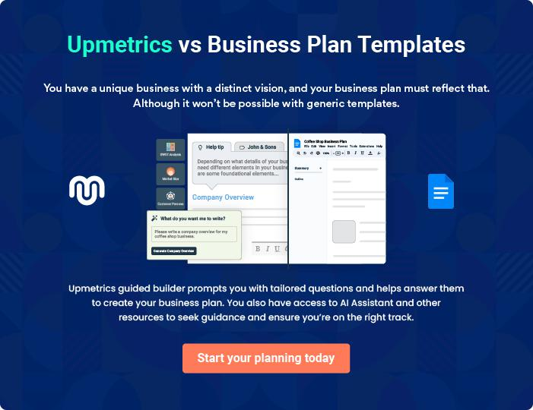

Hookah Lounge | Business Plan [YEAR] 15/41

4.

Market Analysis

Hookah Industry

Cafe Industry

Market segmentation

Market Trends

Target market

Hookah Lounge | Business Plan [YEAR] 16/41

 Shisha
To unlock help try Upmetrics!

While serving hookah is core to the Shisha, it will also serve all-day breakfast and non-alcoholic beverages. As such, the company will operate at the conflux of two industries. The hookah industry as well as the cafe industry in the US.



Start writing here..

Hookah Industry

 Shisha

A hookah is a smoking device with a single or multi-stemmed instrument for vaporizing and smoking flavored tobacco, called shisha, whose vapor or smoke is passed through a water
basin, often glass-based, before inhalation. There are two kinds of hookahs: the traditional ones
To unlock help try Upmetrics! 

Start writing here..

Cafe Industry

 Shisha

The coffee shop industry in the U.S. includes 20,000 stores with combined annual revenue of about $11 billion. Major companies include Starbucks, Dunkin’ Donuts, Caribou, Coffee Bean, and Tea Leaf, and Diedrich (Gloria Jean’s). The industry is highly concentrated at the top and
To unlock help try Upmetrics! 

Start writing here..

Market segmentation

 Shisha

The industry’s growth is at present driven by both social and economic factors. The social trend of consumer preference for cafes over other venues for social gatherings has seen an increase in the last five years as has their interest in coffee blends. The trend towards increasing coffee
To unlock help try Upmetrics! 

Hookah Lounge | Business Plan [YEAR] 17/41

Start writing here..

Market Trends

 Shisha

Consumer taste and personal income drive demand. The profitability of individual companies depends on the ability to secure prime locations, drive store traffic, and deliver high-quality products. Large companies have advantages in purchasing, finance, and marketing. Small
To unlock help try Upmetrics! 

Start writing here..

Target market

 Shisha

Shisha’s target market will be restricted to the locality and surrounding communities to the store’s geographic location in Bristol, United Kingdom. Based on the selected location, Mr. Thomas experience, and the expert's advice, the target market has been segregated to:
To unlock help try Upmetrics! 

Start writing here..

 Shisha


- Teenagers and students

- University students
^{3.} ^{Working professionals} To unlock help try Upmetrics! 

Major Target Market

Start writing here..

 Shisha

- Owners/employees of stores in the surrounding areas

- Tourists and visitors
^{3.} ^{Other passing trade} To unlock help try Upmetrics! 

Hookah Lounge | Business Plan [YEAR] 18/41

Minor Target Market

Start writing here..

Competitive Advantage


Homelike

Atmosphere

Shisha’s simple and welcoming interior design will provide customers a homelike experience with quiet, calm and cosy atmosphere to either have chat with friends and family over a cup of coffee, take a respite from the hustle and bustle of the city, or connect with the café’s fast speed wi-fi internet to carry on the work in a relaxed environment. The tranquillity of the café’s interior will encourage them to frequent the store on a regular basis.

Reputation

Shisha will primarily leverage the reputation of hookah as a traditional socialising factor in the New York market to attract patrons.

Events and Venue Rental

Among the coffee houses in the town, there are very few independent stores that offer a blend of quality food and spacious venues for meetings, events or venue rental for local small businesses, groups, and community. Shisha will be a great venue for casual meetings, networking events and exclusive hire.

Operating Hours

Within the speciality independent coffee houses, Shisha will open for the highest number of hours per week (76 hours),

Hookah Lounge | Business Plan [YEAR] 19/41

5.

SWOT analysis

Hookah Lounge | Business Plan [YEAR] 20/41

 Shisha

A SWOT (Strength, Weakness, Opportunity, and Threat) analysis is a useful tool for businesses to evaluate their position in the market against the potential internal and external factors that could assist or jeopardize their operations and existence. A SWOT has been conducted for PYT
To unlock help try Upmetrics! 

Start writing here..

Hookah Lounge | Business Plan [YEAR] 21/41


Strength

- Founders entrepreneurial spirit and financial acumen

- Founder's passion for the coffee business to share with the local community

- Founder’s capital reserves (self-funding of business)

- Strong support from Licensor

- Founder’s City and Guilds Barista certificate on coffee knowledge

- Flexibility to change the business model to suit the location of operation

- Offering a range of products

- Planned extensions for service offerings such as a loyalty card

- Changing menu options to keep the freshness of offerings

Weakness


- Shisha is a relatively new brand amidst more popular chain and independent outlets so effective local marketing will be needed to enhance the store footfall

- Shisha customers will be the first-time customer of the brand, hence it has to offer above par customer service to ensure repeat visits

- The founder has limited knowledge of New York, its people, and culture, which could be overcome by doing the market research, participating in community events, and engaging with customers through social media


Opportunity

- Extending services – meeting rooms special events

- Expanding product and menu options – healthy menus, Tea Latte

- Increasing consumer demand for coffee houses and cafes

- The café becoming a social hub

- The industry is in a growth phase

- The industry is relatively stable

- The industry has limited revenue volatility

Threat

- Low barriers to entry

- Increasing industry competition

- Existing competition in Bristol

- Potential economic downturn resulting from Brexit

- High expectations for differentiated coffee house experiences

- Substitutes for Coffee becoming more popular

- Other quick-service restaurants becoming more popular

Hookah Lounge | Business Plan [YEAR] 22/41

6.

Strategy & implementation

Distribution Strategy

Marketing and Promotions Strategy

Positioning Statement

Sales strategy

Pricing strategy

Hookah Lounge | Business Plan [YEAR] 23/41

 Shisha
To unlock help try Upmetrics!

Shisha is a café-styled hookah lounge to be established in New York, United States. It will hold a Franchise agreement with a popular hookah brand Morocco, which will enable the business to cultivate its strategy based on the Franchisor’s operating blueprints, offerings, and marketing
To unlock help try Upmetrics! 

Start writing here..

Distribution Strategy

 Shisha

Shisha’s target market will be restricted to the locality and surrounding communities to the outlet’s geographic location in New York. Based on the proposed location in which Shisha will be established, its target market will consist of residents and tourists.

Start writing here..

Marketing and Promotions Strategy

 Shisha



In its first year of operations, Shisha’s main focus will be to attract its major target market audiences through appropriate marketing and advertising strategies. However, ‘owners/
employees of stores in the surrounding areas’ although a part of the minor target market will
To unlock help try Upmetrics! 

Start writing here..

Hookah Lounge | Business Plan [YEAR] 24/41

Positioning Statement

The planned positioning of Shisha's Market


Teenagers & Students


an ‘ideal place for meeting and hanging out with friends

Working Professionals


a place to pick up your morning coffee (or tea) fix and for having informal meetings


University Students

a laid-back atmosphere for study & completing assignments


Owners/Employees

your place for a quick break or quality coffee take-away


Residents Tourists & Visitors

a pit-stop for a break or a hangout place for friends and meet-ups

the place to relax between shopping and sight-seeing

Sales strategy

 Shisha

According to the recent market survey, most customers discover coffee shops mainly through seeing the physical outlet and word of mouth, while a small proportion of customers find a coffee shop through social media. The company will undertake a ‘pre-opening promotional
To unlock help try Upmetrics! 

Start writing here..

Hookah Lounge | Business Plan [YEAR] 25/41

Post- Opening Marketing Channels


Networking | Pop-Up Store | Walk-in
Participate in leading | The company will also hold | The showroom will be
consumers exhibitions and | pop-up stalls at consumer | designed with attractive
beauty events. Display a range | exhibitions. | display of sample of products.
of samples and distribute |  | Visually attractive hoardings
flyers at these events. The |  | and a high street presence will
company will also keep a |  | further attract prospects to
record of visitors to their stalls |  | walk-in and buy high quality
as leads for its email |  | cosmetic products.
marketing campaigns.

Pricing strategy

 Shisha

As Shisha is a hookah lounge, the major portion of its offerings will consist of hookah. Based on the company's trading history, hookah will generate a higher margin (estimated at 75%) as relative to food (estimated at 50%). Shisha will also adopt this pricing strategy where hookah
To unlock help try Upmetrics! 

Start writing here..

Hookah Lounge | Business Plan [YEAR] 26/41

7.

Operational Plan

Management Team

Personnel Plan

Milestones

Hookah Lounge | Business Plan [YEAR] 27/41

 Shisha

The team will be headed by Managing Director Mr. Thomas Green who will also oversee production operations. Joining Mr. Thomas in the Management Team, the company will
onboard an office manager and a beauty advisor to help clients choose the best product for
To unlock help try Upmetrics! 

Start writing here..

Organization chart


Thomas Green

Managing Director
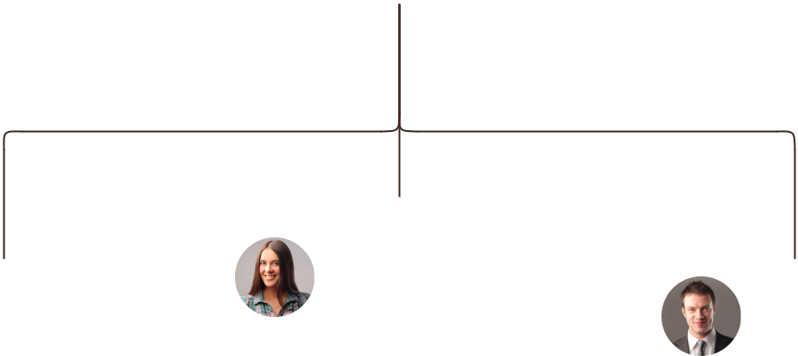

Amanda Doe

Jane Doe | Sales & Marketing | John Doe
Office Manager | Assistant | Marketing Expert


Management Team

 Shisha

Mr. Thomas will serve as the Managing Director of Shisha. A highly motivated and dynamic individual, Thomas boasts vast experience in the field of aesthetics having spent a career
spanning 14 years essaying various white-collar roles for aesthetic companies across America.
To unlock help try Upmetrics! 

Start writing here..

Hookah Lounge | Business Plan [YEAR] 28/41

Personnel Plan
To unlock help try Upmetrics!

 Shisha

The company plans to create six full-time equivalent jobs in addition to the management team within the first three years of operations. Salaries for each employee are in line with the industry’s benchmark.



Start writing here..


Jane Doe

Office Manager

Ability to cope with fast-paced and pressured work, accuracy, strong attention to detail and a strong analytical mind, ability to notice patterns within statistics, an interest in psychology and behavior, good organizational skills, excellent (spoken and written) communication skills.


Amanda Doe

Sales Representatives

Preferably bilingual with ability to speak English and French fluently, problem-solving, ability to convert leads into sales, active listener, patience, and understanding of the company’s products and services. Additionally, skills in social media marketing, search engine optimization, newsletter marketing, other forms of digital marketing will also be required


John Green

Marketing Expert

Excellent verbal skills and a knack for cosmetic products, strong written and verbal communication skills, skilled in customer interaction, and a qualified marketing specialist.

Hookah Lounge | Business Plan [YEAR] 29/41

Milestones

SHISHA


Year 2

Year3

Establish

Shisha will rent a showroom space at the
heart of New York commercial hub
alongside developing a fully optimized and | YEAR 1
informative website. Marketing activities | YEAR 1
will also begin during this stage to build
awareness and launch the brand into the
market.



Gain Market Traction

The company will begin expanding its

services beyond New York to cover other

regions around the US.


Diversify
Having externally established the business, | Year 3
the company will begin internally expanding | Year 3
its range of products


Grow

- Begin expanding across the US

- Consider market expansion beyond US


Hookah Lounge | Business Plan [YEAR] 30/41

8.

Financial plan

Important Assumptions

Brake-even Analysis

Projected Profit and Loss

Projected Cash Flow

Projected Balance Sheet

Business Ratios

Hookah Lounge | Business Plan [YEAR] 31/41


If you are going to start your own hookah lounge business, then make sure you will pay special attention to your financial plan. Your financial plan should include the details about how well you manage your incomes and expenses,
To unlock help try Upmetrics! 

Important Assumptions

The company’s financial projections are forecasted on the basis of the following assumptions. These assumptions are quite conservative and are also expected to show deviation but to a limited level such that the company’s major financial strategy will not be affected.

 | Year 1 | Year 2 | Year 3
Plan Month | 1 | 2 | 3
Current Interest Rate | 10,00% | 11,00% | 12,00%
Long-term Interest Rate | 10,00% | 10,00% | 10,00%
Tax Rate | 26,42% | 27,76% | 28,12%
Other | 0 | 0 | 0

Brake-even Analysis

Monthly Units Break-even | 5530
Monthly Revenue Break-even | $159 740
Assumptions:
Average Per-Unit Revenue | $260,87
Average Per-Unit Variable Cost | $0,89
Estimated Monthly Fixed Cost | $196 410

Hookah Lounge | Business Plan [YEAR] 32/41

Projected Profit and Loss

Revenue

Hookah Sales Revenue Stream

Unit Sales

Unit Price

Beverage Sales Revenue Stream

Unit Sales

Unit Price

Lounge Entry Fees

Revenue Stream

Cost Of Sales

General Costs

Hookah Supplies

Hookah Flavors

Charcoal and Accessories

Beverages

Non-Alcoholic Beverages Alcoholic Beverages
Revenue Specific Costs

Personnel Costs (Direct Labor)

Gross Margin

Gross Margin (%)

2024 | 2025 | 2026
$578,503.87 | $876,346.89 | $1,431,670.01
$172,449.50 | $231,933.50 | $311,927
3,449 | 4,639 | 6,239
$50 | $50 | $50
$105,538.20 | $163,277.10 | $349,428.30
3,518 | 5,443 | 11,648
$30 | $30 | $30
$300,516.17 | $481,136.29 | $770,314.71

$89,312.02 | $134,310.20 | $217,971.11
$89,312.02 | $134,310.20 | $217,971.11
$31,461.65 | $46,675.51 | $74,804.09
$28,925.19 | $43,817.35 | $71,583.50
$2,536.46 | $2,858.16 | $3,220.59
$57,850.37 | $87,634.69 | $143,167.02
$23,140.15 | $35,053.88 | $57,266.82
$34,710.22 | $52,580.81 | $85,900.20
$0 | $0 | $0
$0 | $0 | $0

$489,191.85 $742,036.69 $1,213,698.90

84.56% 84.67% 84.78%

Hookah Lounge | Business Plan [YEAR] 33/41

2024 2025 2026

Operating Expense | $487,829.87 | $540,564.62 | $622,808.53
Payroll Expense (Indirect | $389,520 | $405,264 | $421,662.84
Labor) | $389,520 | $405,264 | $421,662.84
Management Team | $100,800 | $105,840 | $111,132
General Manager | $57,600 | $60,480 | $63,504
Assistant Manager | $43,200 | $45,360 | $47,628
Service Staff | $204,240 | $212,409.60 | $220,905.96
Bartenders | $86,940 | $90,417.60 | $94,034.16
Wait Staff | $117,300 | $121,992 | $126,871.80
Support Staff | $84,480 | $87,014.40 | $89,624.88
Cleaning Staff | $31,680 | $32,630.40 | $33,609.36
Security Personnel | $52,800 | $54,384 | $56,015.52
General Expense | $98,309.88 | $135,300.62 | $201,145.69
Facility Costs | $32,974.47 | $37,156.46 | $41,868.71
Rent | $25,364.99 | $28,581.81 | $32,206.53
Utilities | $7,609.48 | $8,574.65 | $9,662.18
Operational Costs | $63,635.41 | $96,398.16 | $157,483.70
Maintenance | $28,925.19 | $43,817.35 | $71,583.50
Marketing | $34,710.22 | $52,580.81 | $85,900.20
Miscellaneous Expenses | $1,700 | $1,746 | $1,793.28
Insurance | $1,200 | $1,236 | $1,273.08
Licenses and Permits | $500 | $510 | $520.20
Bad Debt | $0 | $0 | $0
Amortization of Current | $0 | $0 | $0
Assets | $0 | $0 | $0

Hookah Lounge | Business Plan [YEAR] 34/41

EBITDA

Additional Expense

Long Term Depreciation

Gain or loss from Sale of Assets

EBIT

Interest Expense

EBT

Income Tax Expense / Benefit
2024 2025 2026

$1,361.99 $201,472.07 $590,890.37

$12,814.93 | $10,880.77 | $8,827.31
$7,668 | $7,668 | $7,668
$0 | $0 | $0
($6,306.01) | $193,804.07 | $583,222.37
$5,146.94 | $3,212.76 | $1,159.29
($11,452.94) | $190,591.30 | $582,063.06
$0 | $0 | $0

Total Expense | $589,956.81 | $685,755.59 | $849,606.95
Net Income | ($11,452.94) | $190,591.30 | $582,063.06
Net Income (%) | (1.98%) | 21.75% | 40.66%

Retained Earning Opening | $0 | ($29,452.94) | $143,138.36
Owner's Distribution | $18,000 | $18,000 | $18,000
Retained Earning Closing | ($29,452.94) | $143,138.36 | $707,201.42

Hookah Lounge | Business Plan [YEAR] 35/41

Projected Cash Flow

 | 2024 | 2025 | 2026
Cash Received | $578,503.87 | $876,346.89 | $1,431,670.01
Cash Paid | $582,288.81 | $678,087.59 | $841,938.95
COS & General Expenses | $187,621.88 | $269,610.82 | $419,116.80
Salary & Wages | $389,520 | $405,264 | $421,662.84
Interest | $5,146.94 | $3,212.76 | $1,159.29
Sales Tax | $0 | $0 | $0
Income Tax | $0 | $0 | $0
Net Cash From | ($3,784.94) | $198,259.30 | $589,731.06
Operations | ($3,784.94) | $198,259.30 | $589,731.06
Assets Sell | $0 | $0 | $0
Assets Purchase | $50,000 | $0 | $0
Net Cash From | ($50,000) | $0 | $0
Investments | ($50,000) | $0 | $0
Amount Received | $150,000 | $0 | $0
Loan Received | $100,000 | $0 | $0
Common Stock | $0 | $0 | $0
Preferred Stock | $0 | $0 | $0
Owner's Contribution | $50,000 | $0 | $0
Amount Paid | $49,359.35 | $51,293.51 | $53,347.12
Loan Capital | $31,359.34 | $33,293.52 | $35,347.14
Dividends & Distributions | $18,000 | $18,000 | $18,000
Net Cash From | $100,640.65 | ($51,293.51) | ($53,347.12)
Financing | $100,640.65 | ($51,293.51) | ($53,347.12)

Hookah Lounge | Business Plan [YEAR] 36/41

 | 2024 | 2025 | 2026
Summary
Starting Cash | $0 | $46,855.71 | $193,821.50
Cash In | $728,503.87 | $876,346.89 | $1,431,670.01
Cash Out | $681,648.16 | $729,381.10 | $895,286.07
Change in Cash | $46,855.71 | $146,965.79 | $536,383.94
Ending Cash | $46,855.71 | $193,821.50 | $730,205.44
Projected Balance Sheet
 | 2024 | 2025 | 2026
Assets | $89,187.71 | $228,485.50 | $757,201.44
Current Assets | $46,855.71 | $193,821.50 | $730,205.44
Cash | $46,855.71 | $193,821.50 | $730,205.44
Accounts Receivable | $0 | $0 | $0
Inventory | $0 | $0 | $0
Other Current Assets | $0 | $0 | $0
Long Term Assets | $42,332 | $34,664 | $26,996
Gross Long Term Assets | $50,000 | $50,000 | $50,000
Accumulated Depreciation | ($7,668) | ($15,336) | ($23,004)
Liabilities & Equity | $89,187.72 | $228,485.50 | $757,201.42
Liabilities | $68,640.66 | $35,347.14 | $0
Current Liabilities | $33,293.52 | $35,347.14 | $0
Accounts Payable | $0 | $0 | $0
Income Tax Payable | $0 | $0 | $0

Hookah Lounge | Business Plan [YEAR] 37/41

 | 2024 |  |  | 2025 |  | 2026
Sales Tax Payable | $0 |  |  | $0 |  | $0
Short Term Debt | $33,293.52 |  | $35,347.14 |  |  | $0
Long Term Liabilities | $35,347.14 |  |  | $0 |  | $0
Long Term Debt | $35,347.14 |  |  | $0 |  | $0
Equity | $20,547.06 |  | $193,138.36 |  |  | $757,201.42
Paid-in Capital | $0 |  |  | $0 |  | $0
Common Stock | $0 |  |  | $0 |  | $0
Preferred Stock | $0 |  |  | $0 |  | $0
Owner's Contribution | $50,000 |  |  | $50,000 |  | $50,000
Retained Earnings | ($29,452.94) |  | $143,138.36 |  |  | $707,201.42
Check | $0 |  |  | $0 |  | $0
Business Ratios
 |  | Year 1 | Year 2 |  | Year 3 | Industry profile
Sales Growth |  | 4,35% | 30,82% |  | 63,29% | 4,00%
Percent of Total Assets
Accounts Receivable |  | 5,61% | 4,71% |  | 3,81% | 9,70%
Inventory |  | 1,85% | 1,82% |  | 1,79% | 9,80%
Other Current Assets |  | 1,75% | 2,02% |  | 2,29% | 27,40%
Total Current Assets |  | 138,53% | 150,99% |  | 163,45% | 54,60%
Long-term Assets |  | -9,47% | -21,01% |  | -32,55% | 58,40%
TOTAL ASSETS |  | 100,00% | 100,00% |  | 100,00% | 100,00%
Current Liabilities |  | 4,68% | 3,04% |  | 2,76% | 27,30%
Long-term Liabilities |  | 0,00% | 0,00% |  | 0,00% | 25,80%
Total Liabilities |  | 4,68% | 3,04% |  | 2,76% | 54,10%

Hookah Lounge | Business Plan [YEAR] 38/41

 | Year 1 | Year 2 | Year 3 | Industry profile
NET WORTH | 99,32% | 101,04% | 102,76% | 44,90%
Percent of Sales
Sales | 100,00% | 100,00% | 100,00% | 100,00%
Gross Margin | 94,18% | 93,85% | 93,52% | 0,00%
Selling, General & Administrative Expenses | 74,29% | 71,83% | 69,37% | 65,20%
Advertising Expenses | 2,06% | 1,11% | 0,28% | 1,40%
Profit Before Interest and Taxes | 26,47% | 29,30% | 32,13% | 2,86%
Main Ratios
Current | 25,86 | 29,39 | 32,92 | 1,63
Quick | 25,4 | 28,88 | 32,36 | 0,84
Total Debt to Total Assets | 2,68% | 1,04% | 0,76% | 67,10%
Pre-tax Return on Net Worth | 66,83% | 71,26% | 75,69% | 4,40%
Pre-tax Return on Assets | 64,88% | 69,75% | 74,62% | 9,00%
Additional Ratios
Net Profit Margin | 19,20% | 21,16% | 23,12% | N.A.
Return on Equity | 47,79% | 50,53% | 53,27% | N.A.
Activity Ratios
Accounts Receivable Turnover | 4,56 | 4,56 | 4,56 | N.A.
Collection Days | 92 | 99 | 106 | N.A.
Inventory Turnover | 19,7 | 22,55 | 25,4 | N.A.
Accounts Payable Turnover | 14,17 | 14,67 | 15,17 | N.A.
Payment Days | 27 | 27 | 27 | N.A.
Total Asset Turnover | 1,84 | 1,55 | 1,26 | N.A.
Debt Ratios
Debt to Net Worth | 0 | -0,02 | -0,04 | N.A.
Current Liab. to Liab. | 1 | 1 | 1 | N.A.
Liquidity Ratios
Net Working Capital | $120 943 | $140 664 | $160 385 | N.A.

Hookah Lounge | Business Plan [YEAR] 39/41

 | Year 1 | Year 2 | Year 3 | Industry profile
Interest Coverage | 0 | 0 | 0 | N.A.
Additional Ratios
Assets to Sales | 0,45 | 0,48 | 0,51 | N.A.
Current Debt/Total Assets | 4% | 3% | 2% | N.A.
Acid Test | 23,66 | 27,01 | 30,36 | N.A.
Sales/Net Worth | 1,68 | 1,29 | 0,9 | N.A.
Dividend Payout | 0 | 0 | 0 | N.A.
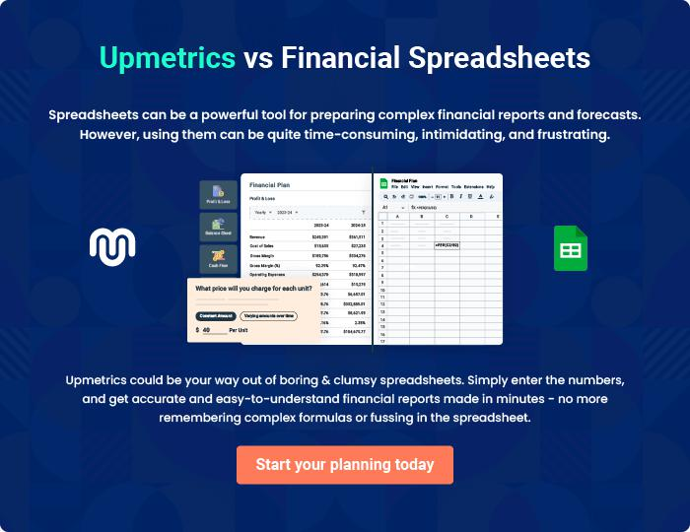

Hookah Lounge | Business Plan [YEAR] 40/41

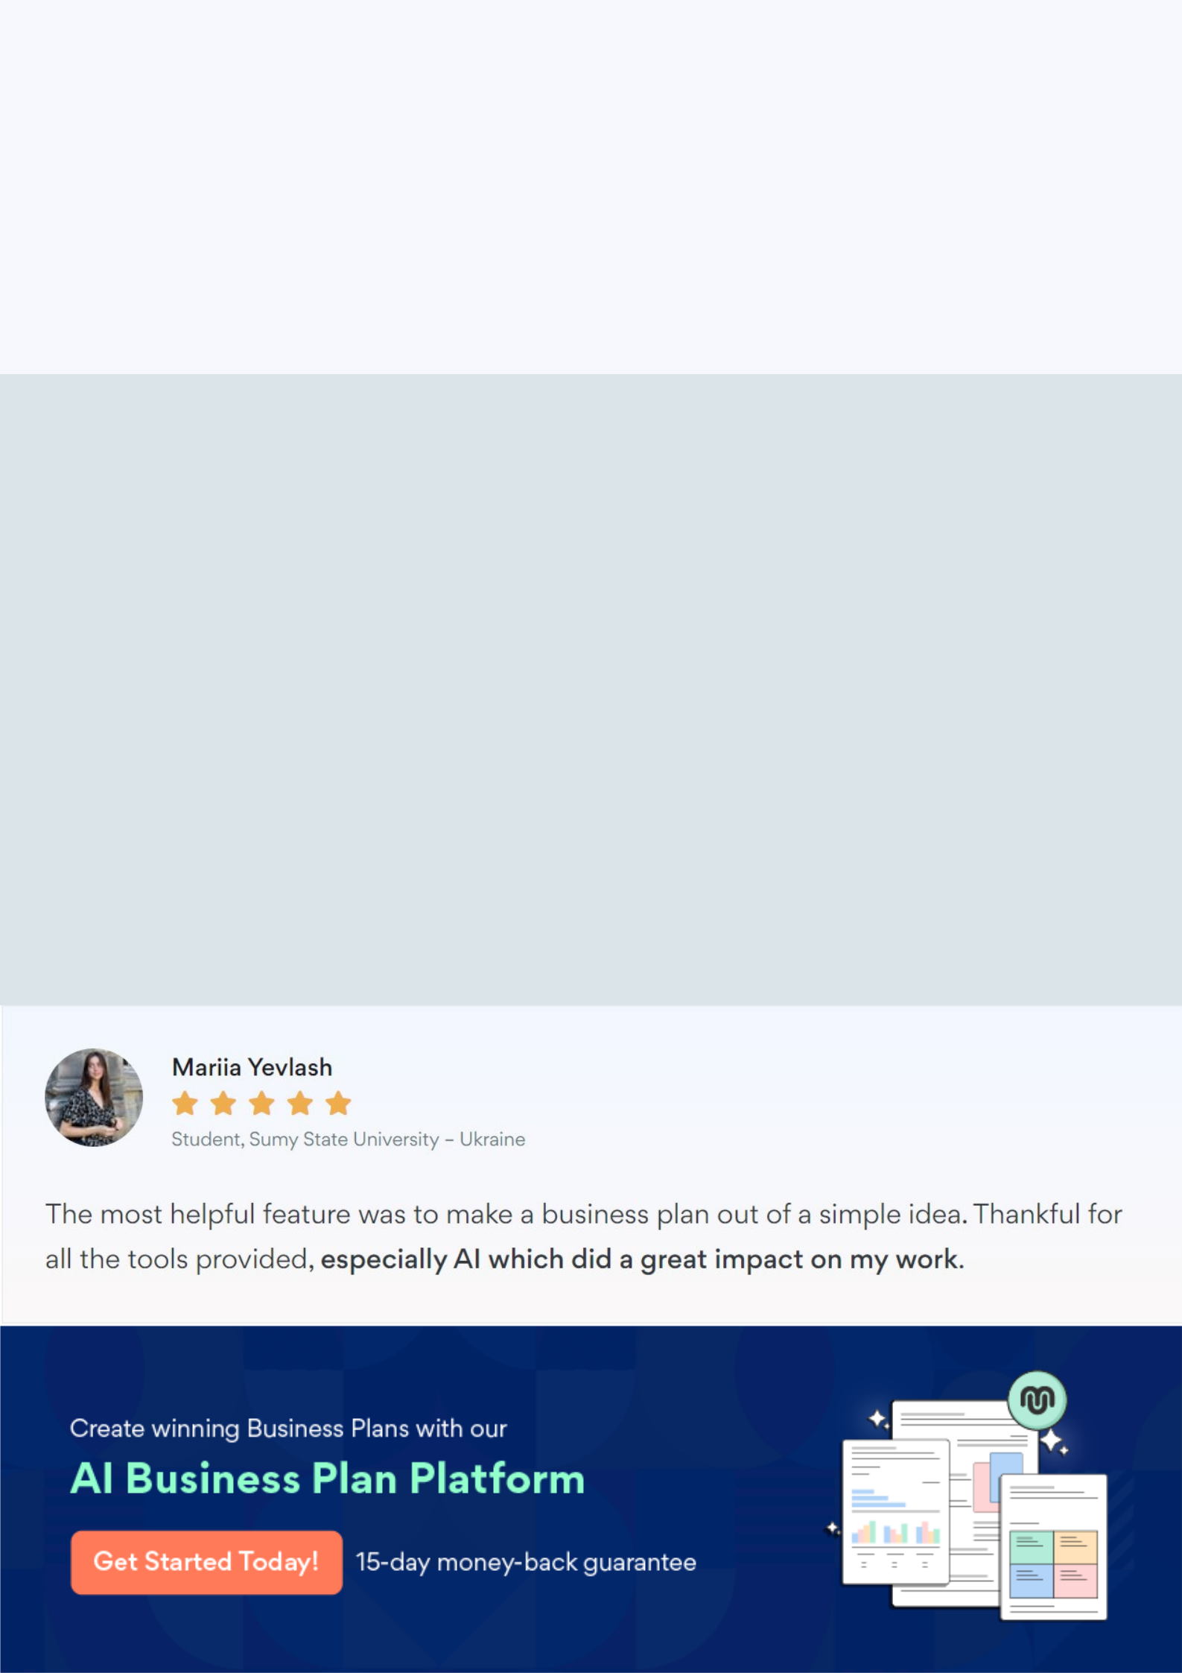
Create a winning business plan that gets you funded

Creating a stunning and investment-ready plan requires no writing, graphic designing, or financial planning expertise.

Upmetrics has all the features required to help you create a comprehensive business plan—from start to finish. Make no mistakes, it’s the modern way of planning to structure ideas, make plans, and create stunning pitch decks to awe investors.

Pitch decks that impress investors

Create pitch decks that provide a visual representation of your business, engage investors, and make them want to invest in your business idea.

Interactive plans in no time

Import business plan sections like—SWOT analysis, comparison tables, and others to create an interactive business plan. No designing skills are required.

Stunning cover page designs

With Upmetrics, you have the liberty to choose from multiple stunning cover page designs. Choose a creative design and make your plan stand out.

Online sharing made simple

Upmetrics makes online sharing quick and easier for users. Easily share your business plans with a link while tracking reader activity.

500+ sample business plans

Simply import a template from our library of sample plans into the editor and start customizing it to make it yours. It takes only a few clicks to get started.

Collaborate with team in real-time

Invite team members, initiate conversations, discuss ideas & strategies, share feedback, and work on a business plan in real-time.

