
BUSINESS PLAN

[YEAR]

Home Health Care

A family of hospitals for your family

John Doe

10200 Bolsa Ave, Westminster, CA, 92683

- 359-3153 info@example.com https://example.com

Information provided in this business plan is unique to this business and confidential; therefore, anyone reading this plan agrees not to disclose any of the information in this business plan without prior written permission of the company.
Table of Contents

Executive Summary | 5
Mission Statement | 6
Vision Statement | 6
Keys to Success | 7
Financial summary | 7
3 Year profit forecast | 7
Financing Needed | 8

Company Summary | 9
Management Team | 10
Personnel Table | 10
Startup Summary | 10
Startup cost | 11
Products and services
Products and services | 14
Market Analysis
Market Analysis | 17
Market Trends | 18
Target Market | 18
Market Segments | 18
Strategy & Implementations
Strategy & Implementations | 19
Advertising Strategy | 20
Pricing Strategy | 20
Sales Plan | 20
Milestones | 21
Financial Plan
Financial Plan | 22
Important Assumptions | 23
Brake-even Analysis | 23

Home Health Care | Business Plan [YEAR] 2/32

Projected Profit and Loss | 24
Projected Cash Flow | 27
Projected Balance Sheet | 28
Business Ratios | 29

Home Health Care | Business Plan [YEAR] 3/32

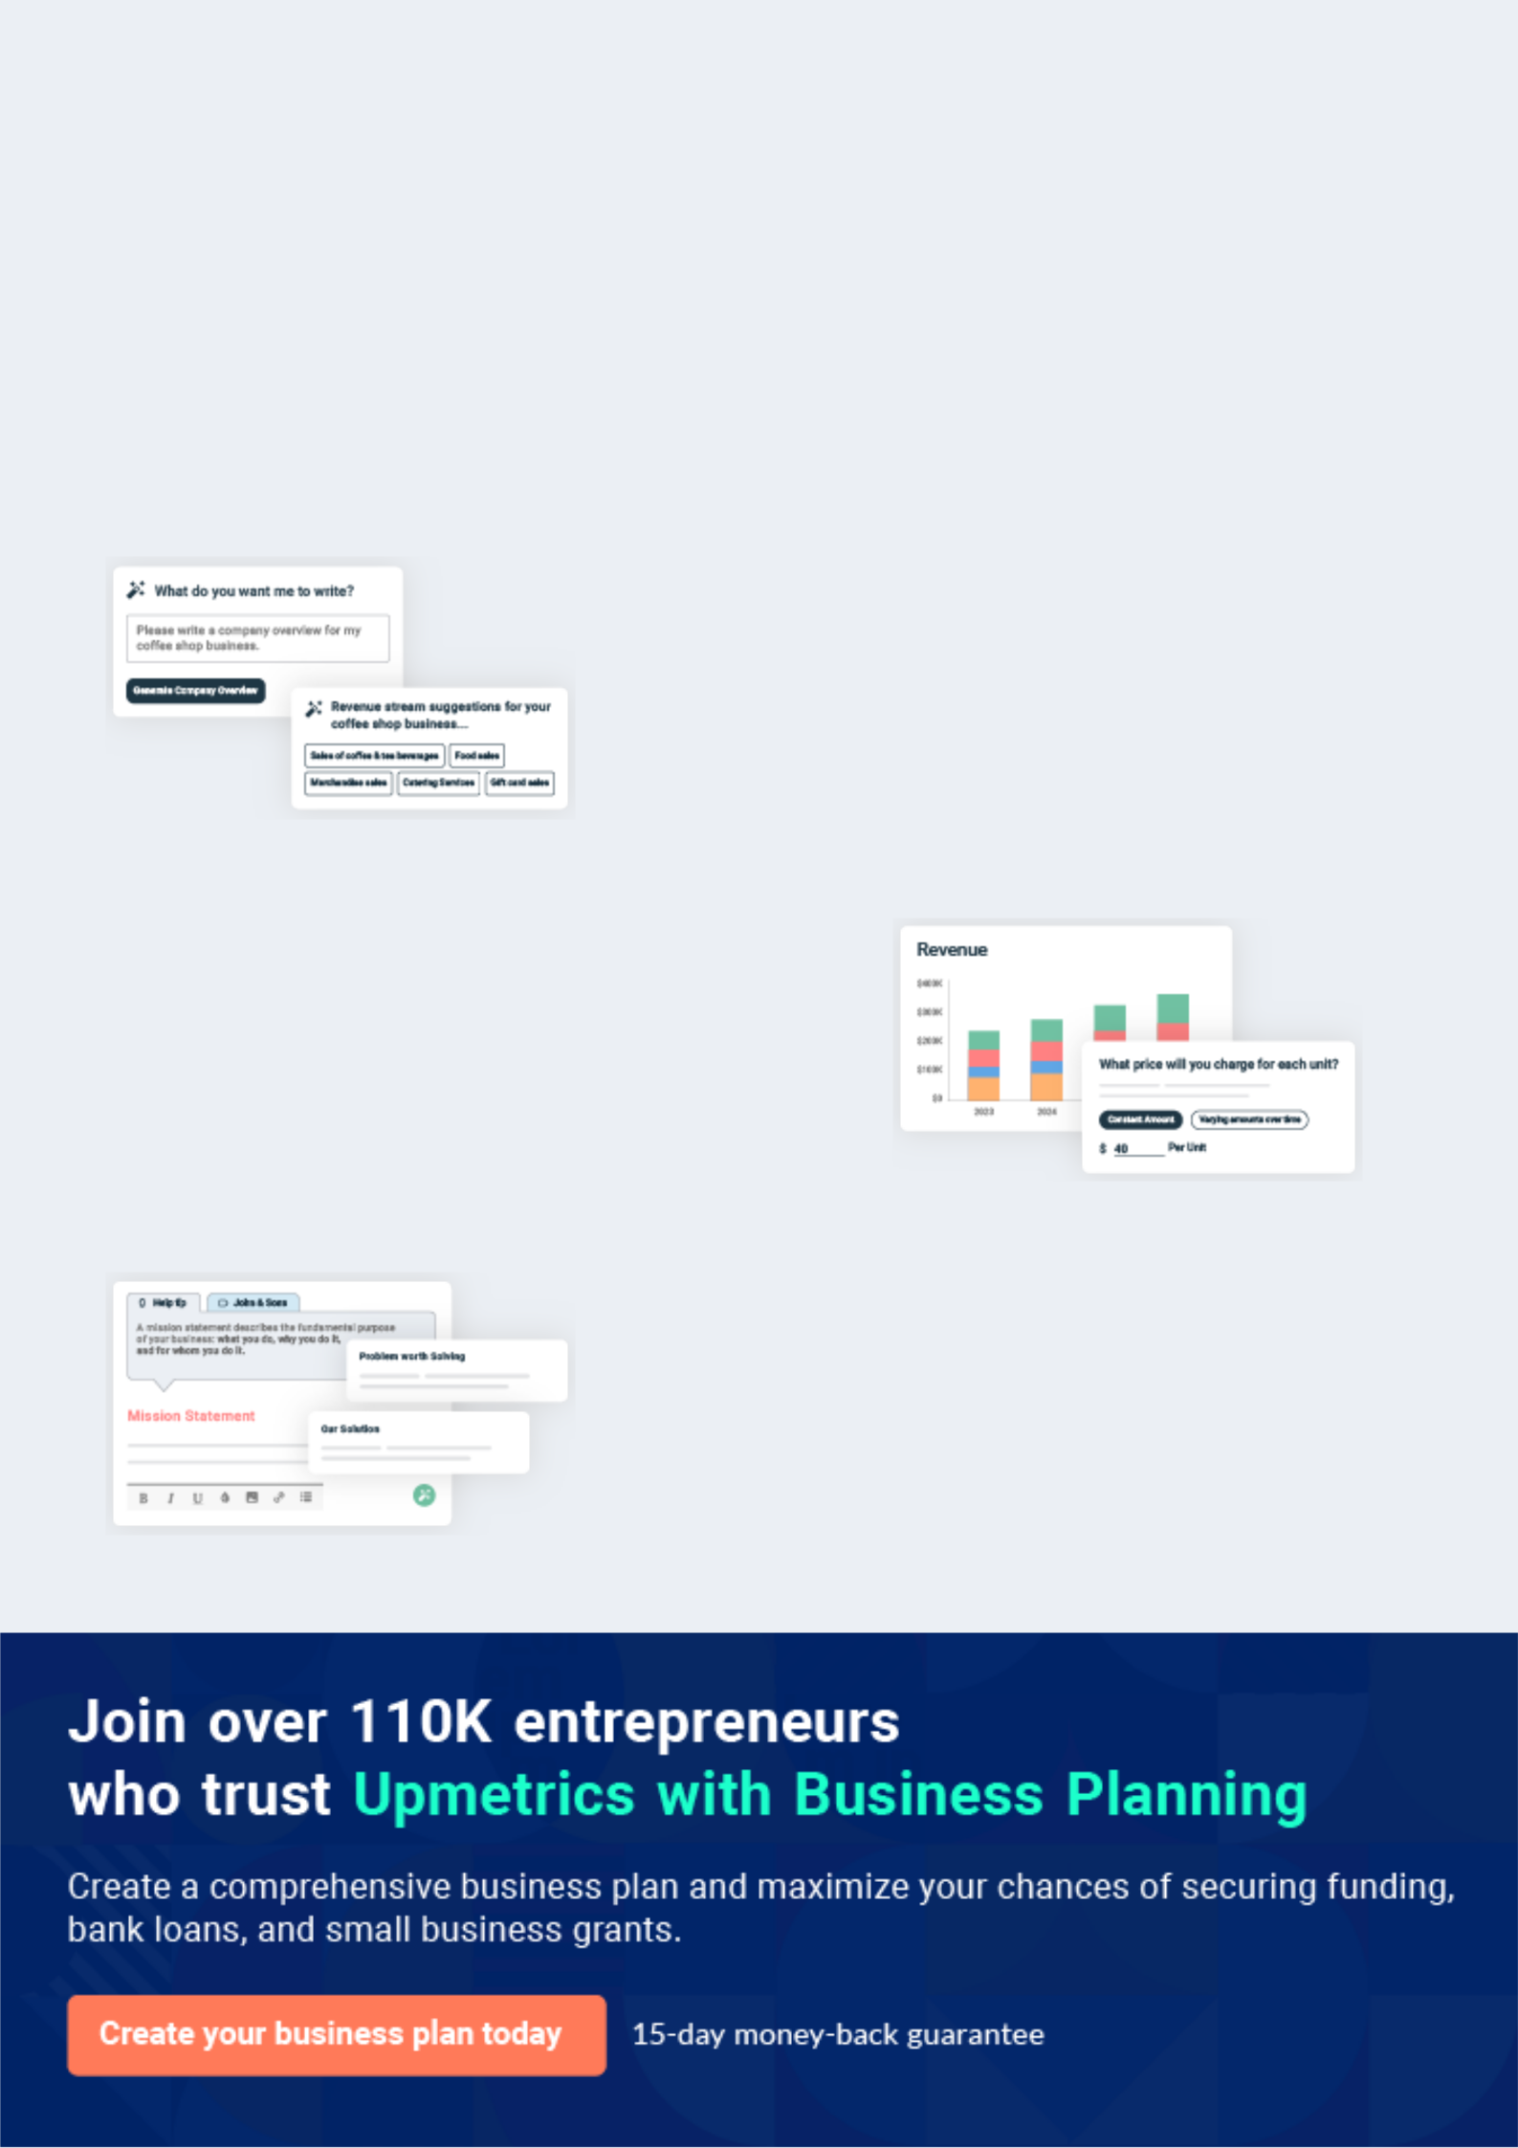
Business planning that’s simpler and faster than you think

Creating a business plan using Upmetrics to start and grow a business is literally the easiest thing in the World. Simply read the instructions and fill in the blanks. It’s as simple as that.

❛ | Upmetrics has everything you need to create a | ❜
❛ | comprehensive business plan. | ❜

AI-powered Upmetrics Assistant

AI-powered insights to streamline your plan

Not sure where to start? Upmetrics’ AI Assistant will automatically generate ideas for each section of your plan and offer improved versions of your writing, adjusting for tone, voice, and grammar or spelling errors.

Financial Forecasting Tool

All the financials are calculated for you

Forget the complex formulas and clumsy spreadsheets — with automatic financials and drag-and-drop forecasting, you can finish your plan faster and be confident that your numbers are accurate.

Business Plan Builder

Guides you like a business mentor

Upmetrics’ step-by-step instructions, prompts, and the library of 400+ sample business plans will guide you through each section of your plan as a business mentor.

1.


Executive Summary

Mission Statement

Vision Statement

Keys to Success

Financial summary

Financing Needed

Home Health Care | Business Plan [YEAR] 5/32

Before you think about how to start a Home Health Care service, you must create a detailed Home Health Care business plan. It will not only guide you in the initial phases of your startup but will also help you later on.
To unlock help try Upmetrics!
To unlock help try Upmetrics!
To unlock help try Upmetrics! 

 Carewell


Carewell Home Healthcare Services is a standard and certified healthcare service provider that will be located in will be based in Detroit, Michigan –the United States of America and we will cover other cities such as Green – acres City, Detroit, Jacksonville, Clearwater, Tampa, Fort
To unlock help try Upmetrics! 

Start writing here..

Mission Statement

 Carewell

• Carewell Home Healthcare Services is in business is to establish a first-class home health care service company that will take care of both highly placed clients and lowly
placed clients as long as they can afford our services.


Start writing here..

Vision Statement

 Carewell

Our vision is to become the number one choice when it comes to home healthcare service delivery in the whole of Michigan and also to be amongst the top 20home health care service providers in the United States of America within the next 10 years.



Start writing here..

Home Health Care | Business Plan [YEAR] 6/32

Keys to Success

 Carewell

Our keys to success:

• Professional quality of services offered
To unlock help try Upmetrics! 

Start writing here..

Financial summary

 Carewell

We are projecting growth and total annual sales very conservatively, with high projected expenses. Our cost of sales is relatively low, as this is a service agency and the primary costs
involved in providing the services are those related to payroll. The costs of sales reflect the cost
To unlock help try Upmetrics! 

Start writing here..

3 Year profit forecast
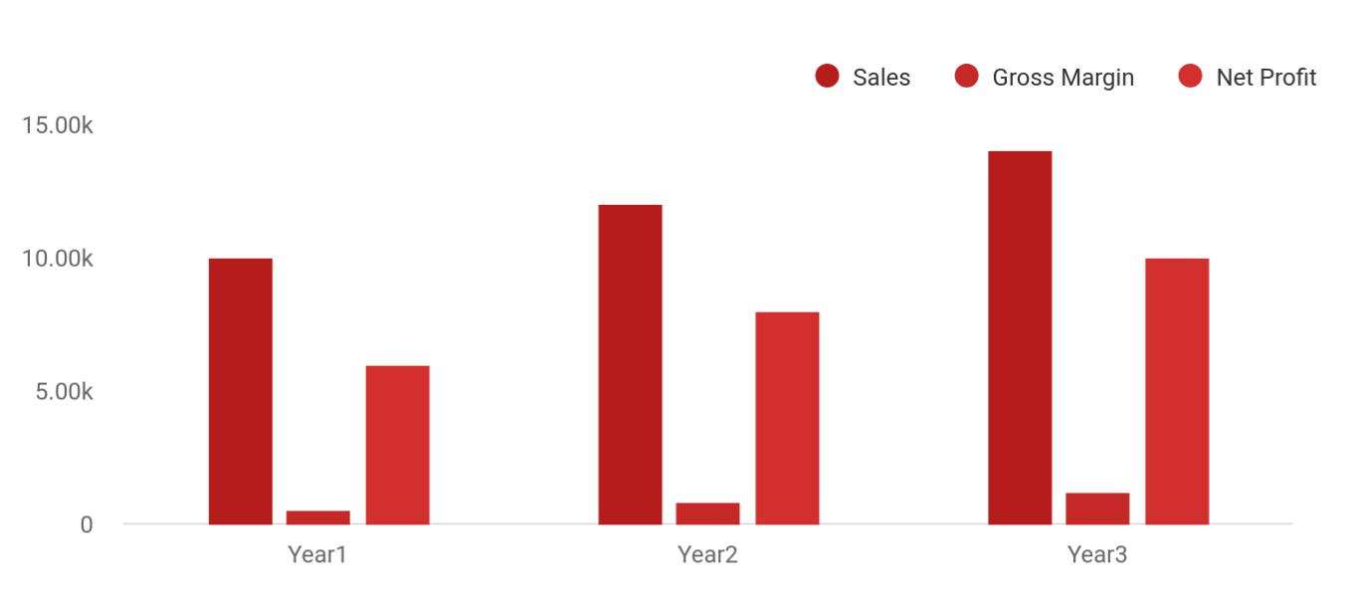

Home Health Care | Business Plan [YEAR] 7/32

 Carewell


Financial Summary | Year 1 | Year 2 |  | Year 3
 |  |  | To unlock help try Upmetrics! |  | 

Start writing here..

Financing Needed

 Carewell

We will use $70,000: $50,000 five year loan and $20,000 cash from Jane Moore

To unlock help try Upmetrics! 

Start writing here..

Home Health Care | Business Plan [YEAR] 8/32

2.

Company Summary

Management Team

Personnel Table

Startup Summary

Home Health Care | Business Plan [YEAR] 9/32

 Carewell

Dr. John Moore is going to be the Chief Executive Officer of the business; He is a qualified and well-trained Medical Doctor with well over 15 years of experience working as a medical doctor and medical researcher with the United States government. He will be ably supported by his
To unlock help try Upmetrics! 

Start writing here..

Management Team

 Carewell

Carewell's initial team will consist of one Administrative Director, one Clinical Director, three employees, and a contracted agency to fulfill the need for Physical Therapists, Occupational Therapists, and Speech Therapists. Initially, both managers will also provide direct service.
To unlock help try Upmetrics! 

Start writing here..

Personnel Table

 Carewell


 Year1

Year2

Year3

To unlock help try Upmetrics! 

Start writing here..

Startup Summary

 Carewell

Total start-up capital and expenses (including legal costs, logo design, stationery, and related expenses) came to approximately $41,700. Start-up assets required and utilized included brewing plants and machinery, pick-ups, office furniture, personal computers, and other office
To unlock help try Upmetrics! 

Home Health Care | Business Plan [YEAR] 10/32

Start writing here..

Startup cost
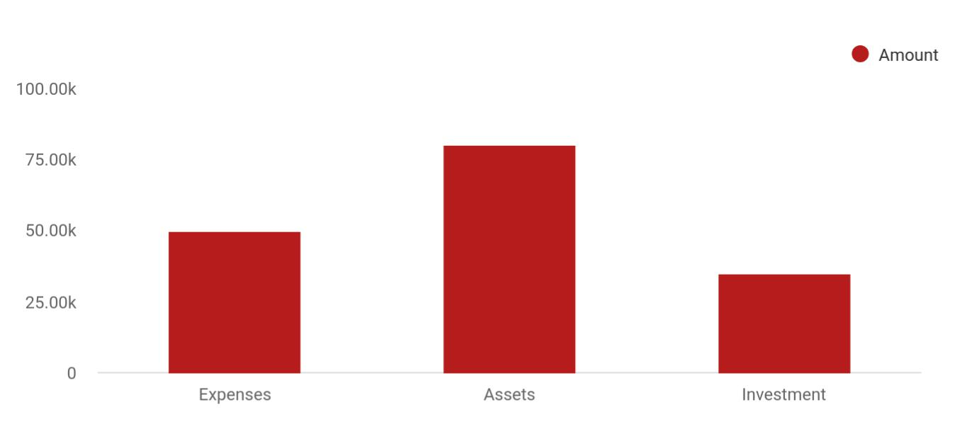

Cost distribution | Amount
Expenses | 50,000
Assets | 80,000
Investment | 35,000

Start-up Expenses | Amount
Legal | $75,500
Consultants | $0
Insurance | $62,750
Rent | $22,500
Research and Development | $42,750
Expensed Equipment | $42,750
Signs | $1,250
TOTAL START-UP EXPENSES | $247,500
Start-up Assets | $0
Cash Required | $322,500
Start-up Inventory | $52,625
Other Current Assets | $222,500

Home Health Care | Business Plan [YEAR] 11/32

Start-up Expenses | Amount
Long-term Assets | $125,000
TOTAL ASSETS | $121,875
Total Requirements | $245,000
START-UP FUNDING | $0
START-UP FUNDING | $273,125
Start-up Expenses to Fund | $121,875
Start-up Assets to Fund | $195,000
TOTAL FUNDING REQUIRED | $0
Assets | $203,125
Non-cash Assets from Start-up | $118,750
Cash Requirements from Start-up | $0
Additional Cash Raised | $118,750
Cash Balance on Starting Date | $121,875
TOTAL ASSETS | $0
Liabilities and Capital | $0
Liabilities | $0
Current Borrowing | $0
Long-term Liabilities | $0
Accounts Payable (Outstanding Bills) | $0
Other Current Liabilities (interest-free) | $0
TOTAL LIABILITIES | $0
Capital | $0
Planned Investment | $0
Investor 1 | $312,500
Investor 2 | $0
Other | $0
Additional Investment Requirement | $0
TOTAL PLANNED INVESTMENT | $695,000

Home Health Care | Business Plan [YEAR] 12/32

Start-up Expenses | Amount
Loss at Start-up (Start-up Expenses) | $313,125
TOTAL CAPITAL | $221,875
TOTAL CAPITAL AND LIABILITIES | $221,875
Total Funding | $265,000

Home Health Care | Business Plan [YEAR] 13/32

3.

Products and services

Home Health Care | Business Plan [YEAR] 14/32

 Carewell

Carewell Home Healthcare Services is in the business of ensuring that our patient/clients are well treated and taken care of and our services will be carried out by highly trained professional physicians, nurses, nurse’s aides, mental health counselors, chiropractors, medication
To unlock help try Upmetrics! 

Start writing here..


Skilled Nursing Nursing Aide

Occupational,

Social Work Physical, and Speech

Therapy

Personal Injury Case Home Medication

Management Management

Personal Assistance

Services

Home Health Care | Business Plan [YEAR] 15/32

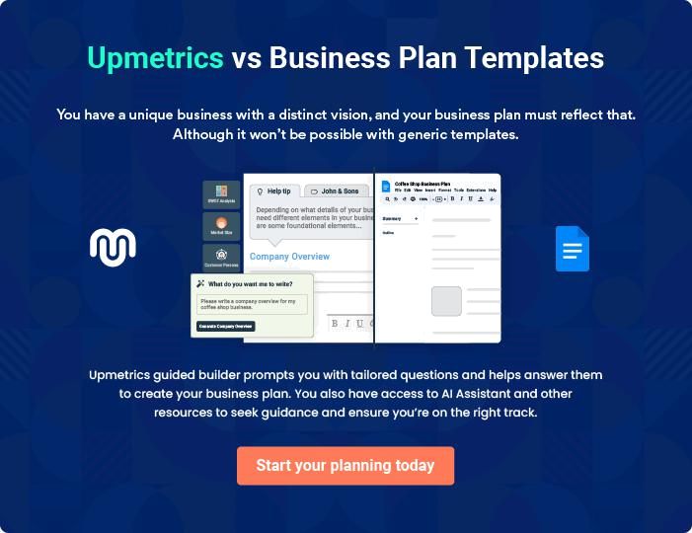

Home Health Care | Business Plan [YEAR] | 16/32

4.

Market Analysis

Market Trends

Target Market

Market Segments

Home Health Care | Business Plan [YEAR] 17/32

The most important component of an effective Home Healthcare business plan is its accurate marketing analysis. If you are starting on a smaller scale, you can do marketing analysis yourself by taking help from this Home
To unlock help try Upmetrics! 

Market Trends

 Carewell

The health industry is indeed a thriving and dynamic industry; with the aid of technology, it is becoming easier to treat, manage and cure some ailments that before now are not easy to handle. No doubt there are many ways of providing healthcare services in this changing era
To unlock help try Upmetrics! 

Start writing here..

Target Market

 Carewell

Carewell Home Healthcare Services is in business to service a wide range of customers in Detroit Beach, Michigan – the United States of America and other cities such as Green – Acres City, Detroit, Jacksonville, Clearwater, Tampa, Fort Lauderdale, North Detroit, West Palm Beach,
To unlock help try Upmetrics! 

Start writing here..

Market Segments

 Carewell

The population base in Southeastern Kansas is aging, and more individuals are opting to stay in their own homes longer and return home following hospitalization, rather than proceeding to a nursing home. Our primary market segment includes those patients — typically in an older age
To unlock help try Upmetrics! 

Start writing here..

Home Health Care | Business Plan [YEAR] 18/32

5.

Strategy &

Implementations

Advertising Strategy

Pricing Strategy

Sales Plan

Milestones

Home Health Care | Business Plan [YEAR] 19/32

After identifying the market demand, market trends, and the potential customers of the startup, the next step is to define an effective strategy for attracting those customers. Like marketing analysis, sales strategy is also an
To unlock help try Upmetrics! 

Advertising Strategy

 Carewell

We in the home health care services business -to become one of the market leaders and also to

maximize profits hence we are going to explore all available conventional and non –
conventional means to promote our home healthcare services business._{To unlock help try Upmetrics!} 

Start writing here..

Pricing Strategy

 Carewell

Carewell Home Healthcare Services will work towards ensuring that all our services are offered at highly competitive prices compare to what is obtainable in The United States of America.
To unlock help try Upmetrics! 

Start writing here..

Sales Plan

 Carewell

Sales in our business mean quality patient service and utmost satisfaction from referring physicians and health care facilities. It is a perpetual business. One doesn’t sell home health care and personal injury case management; rather one sells excellent care, availability, and
To unlock help try Upmetrics! 

Start writing here..

Home Health Care | Business Plan [YEAR] 20/32

Milestones

 Carewell


To unlock help try Upmetrics! 

Start writing here..

Home Health Care | Business Plan [YEAR] 21/32

6.

Financial Plan

Important Assumptions

Brake-even Analysis

Projected Profit and Loss

Projected Cash Flow

Projected Balance Sheet

Business Ratios

Home Health Care | Business Plan [YEAR] 22/32

The last component of a Home Healthcare business plan is an in-depth financial plan. The financial plan crafts a detailed map of all the expenses needed for the startup and how these expenses will be met by the earned
To unlock help try Upmetrics! 

 Carewell

The company will be financed by John himself and he will control the direction of the business to make sure that it is expanding at the forecasted rate. As for the Home Healthcare business start-up, no equity funding or outside loans will be required. With the help of financial experts,
To unlock help try Upmetrics! 

Start writing here..

Important Assumptions

The financial projections of the company are forecast on the basis of the following assumptions. These assumptions are quite conservative and are expected to show deviation but to a limited level such that the company’s major financial strategy will not be affected.

 | Year 1 | Year 2 | Year 3
Plan Month | 1 | 2 | 3
Current Interest Rate | 10,00% | 11,00% | 12,00%
Long-term Interest Rate | 10,00% | 10,00% | 10,00%
Tax Rate | 26,42% | 27,76% | 28,12%
Other | 0 | 0 | 0

Brake-even Analysis

Monthly Units Break-even | 5530
Monthly Revenue Break-even | $159 740
Assumptions:
Average Per-Unit Revenue | $260,87
Average Per-Unit Variable Cost | $0,89
Estimated Monthly Fixed Cost | $196 410

Home Health Care | Business Plan [YEAR] 23/32

Projected Profit and Loss

Revenue

Home Care Services

Unit Sales

Unit Price

Specialized Nursing Care

Unit Sales

Unit Price

Medical Equipment Rental

Cost Of Sales

General Costs

Medical Supplies

Medication and Medical

Equipment

Medical Consumables

Health Care Professional Services

Nursing Staff Salaries

Specialist Consultation

Fees

Revenue Specific Costs

Personnel Costs (Direct Labor)

Gross Margin

Gross Margin (%)

2024 | 2025 | 2026
$761,728.17 | $1,640,308.26 | $3,702,302.24
$455,454 | $1,146,890 | $2,887,992
2,277 | 5,734 | 14,440
$200 | $200 | $200
$198,977.50 | $357,340 | $641,730
796 | 1,429 | 2,567
$250 | $250 | $250
$107,296.67 | $136,078.26 | $172,580.24

$125,790.09 | $223,453.92 | $451,319.05
$125,790.09 | $223,453.92 | $451,319.05
$40,851.83 | $67,749.24 | $130,165.27
$18,000 | $18,540 | $19,096.20
$22,851.83 | $49,209.24 | $111,069.07
$84,938.26 | $155,704.68 | $321,153.78
$60,938.26 | $131,224.68 | $296,184.18
$24,000 | $24,480 | $24,969.60
$0 | $0 | $0
$0 | $0 | $0

$635,938.08 | $1,416,854.34 | $3,250,983.19
83.49% | 86.38% | 87.81%

Home Health Care | Business Plan [YEAR] 24/32

2024 2025 2026

Operating Expense | $1,037,608.07 | $1,092,504.40 | $1,183,765.25
Payroll Expense (Indirect | $981,720 | $1,009,614 | $1,038,327.72
Labor) | $981,720 | $1,009,614 | $1,038,327.72
Nursing Staff | $563,400 | $580,302 | $597,711
Registered Nurses | $289,800 | $298,494 | $307,449
Nursing Assistants | $273,600 | $281,808 | $290,262
Administrative Staff | $191,760 | $198,220.80 | $204,903.60
Office Manager | $70,800 | $73,632 | $76,577.28
Administrative Assistants | $120,960 | $124,588.80 | $128,326.32
Specialty Care Staff | $226,560 | $231,091.20 | $235,713.12
Physical Therapists | $226,560 | $231,091.20 | $235,713.12
General Expense | $55,888.07 | $82,890.39 | $145,437.53
Office and Administrative | $21,600 | $21,996 | $22,399.56
Expenses | $21,600 | $21,996 | $22,399.56
Office Rent | $18,000 | $18,360 | $18,727.20
Utilities | $3,600 | $3,636 | $3,672.36
Marketing and Advertising | $25,851.83 | $52,239.24 | $114,157.48
Online Advertising | $22,851.83 | $49,209.24 | $111,069.07
Print Advertising | $3,000 | $3,030 | $3,088.41
Operational Expenses | $8,436.24 | $8,655.15 | $8,880.49
Insurance | $6,000 | $6,120 | $6,242.40
Maintenance | $2,436.24 | $2,535.15 | $2,638.09
Bad Debt | $0 | $0 | $0
Amortization of Current | $0 | $0 | $0
Assets | $0 | $0 | $0

Home Health Care | Business Plan [YEAR] 25/32

EBITDA

Additional Expense

Long Term Depreciation

Gain or loss from Sale of Assets

EBIT

Interest Expense

EBT

Income Tax Expense / Benefit

2024 | 2025 | 2026
($401,669.99) | $324,349.93 | $2,067,217.94

$14,665.54 | $13,118.20 | $11,475.44
$10,548 | $10,548 | $10,548
$0 | $0 | $0
($412,217.99) | $313,801.93 | $2,056,669.94
$4,117.55 | $2,570.21 | $927.44
($416,335.53) | $311,231.73 | $2,055,742.50
$0 | $0 | $0

Total Expense | $1,178,063.70 | $1,329,076.53 | $1,646,559.74
Net Income | ($416,335.53) | $311,231.73 | $2,055,742.50
Net Income (%) | (54.66%) | 18.97% | 55.53%

Retained Earning Opening | $0 | ($436,335.53) | ($135,103.80)
Owner's Distribution | $20,000 | $10,000 | $10,000
Retained Earning Closing | ($436,335.53) | ($135,103.80) | $1,910,638.70

Home Health Care | Business Plan [YEAR] 26/32

Projected Cash Flow

 | 2024 | 2025 | 2026
Cash Received | $761,728.17 | $1,640,308.26 | $3,702,302.24
Cash Paid | $1,167,515.70 | $1,318,528.53 | $1,636,011.74
COS & General Expenses | $181,678.16 | $306,344.33 | $596,756.58
Salary & Wages | $981,720 | $1,009,614 | $1,038,327.72
Interest | $4,117.55 | $2,570.21 | $927.44
Sales Tax | $0 | $0 | $0
Income Tax | $0 | $0 | $0
Net Cash From | ($405,787.53) | $321,779.73 | $2,066,290.50
Operations | ($405,787.53) | $321,779.73 | $2,066,290.50
Assets Sell | $0 | $0 | $0
Assets Purchase | $70,000 | $0 | $0
Net Cash From | ($70,000) | $0 | $0
Investments | ($70,000) | $0 | $0
Amount Received | $130,000 | $0 | $0
Loan Received | $80,000 | $0 | $0
Common Stock | $0 | $0 | $0
Preferred Stock | $0 | $0 | $0
Owner's Contribution | $50,000 | $0 | $0
Amount Paid | $45,087.46 | $36,634.80 | $38,277.76
Loan Capital | $25,087.45 | $26,634.79 | $28,277.76
Dividends & Distributions | $20,000 | $10,000 | $10,000
Net Cash From | $84,912.54 | ($36,634.80) | ($38,277.76)
Financing | $84,912.54 | ($36,634.80) | ($38,277.76)

Home Health Care | Business Plan [YEAR] 27/32

2024 2025 2026

Summary

Starting Cash | $0 | ($390,874.99) | ($105,730.06)
Cash In | $891,728.17 | $1,640,308.26 | $3,702,302.24
Cash Out | $1,282,603.16 | $1,355,163.33 | $1,674,289.50
Change in Cash | ($390,874.99) | $285,144.93 | $2,028,012.74
Ending Cash | ($390,874.99) | ($105,730.06) | $1,922,282.68

Projected Balance Sheet

 | 2024 | 2025 | 2026
Assets | ($331,422.99) | ($56,826.06) | $1,960,638.68
Current Assets | ($390,874.99) | ($105,730.06) | $1,922,282.68
Cash | ($390,874.99) | ($105,730.06) | $1,922,282.68
Accounts Receivable | $0 | $0 | $0
Inventory | $0 | $0 | $0
Other Current Assets | $0 | $0 | $0
Long Term Assets | $59,452 | $48,904 | $38,356
Gross Long Term Assets | $70,000 | $70,000 | $70,000
Accumulated Depreciation | ($10,548) | ($21,096) | ($31,644)

Liabilities & Equity | ($331,422.98) | ($56,826.04) | $1,960,638.70
Liabilities | $54,912.55 | $28,277.76 | $0
Current Liabilities | $26,634.79 | $28,277.76 | $0
Accounts Payable | $0 | $0 | $0
Income Tax Payable | $0 | $0 | $0

Home Health Care | Business Plan [YEAR] 28/32

 | 2024 |  |  | 2025 |  | 2026
Sales Tax Payable | $0 |  |  | $0 |  | $0
Short Term Debt | $26,634.79 |  | $28,277.76 |  |  | $0
Long Term Liabilities | $28,277.76 |  |  | $0 |  | $0
Long Term Debt | $28,277.76 |  |  | $0 |  | $0
Equity | ($386,335.53) |  | ($85,103.80) |  |  | $1,960,638.70
Paid-in Capital | $0 |  |  | $0 |  | $0
Common Stock | $0 |  |  | $0 |  | $0
Preferred Stock | $0 |  |  | $0 |  | $0
Owner's Contribution | $50,000 |  |  | $50,000 |  | $50,000
Retained Earnings | ($436,335.53) |  | ($135,103.80) |  |  | $1,910,638.70
Check | $0 |  |  | $0 |  | $0
Business Ratios
 |  | Year 1 | Year 2 |  | Year 3 | Industry Profile
Sales Growth |  | 4,35% | 30,82% |  | 63,29% | 4,00%
Percent of Total Assets
Accounts Receivable |  | 5,61% | 4,71% |  | 3,81% | 9,70%
Inventory |  | 1,85% | 1,82% |  | 1,79% | 9,80%
Other Current Assets |  | 1,75% | 2,02% |  | 2,29% | 27,40%
Total Current Assets |  | 138,53% | 150,99% |  | 163,45% | 54,60%
Long-term Assets |  | -9,47% | -21,01% |  | -32,55% | 58,40%
TOTAL ASSETS |  | 100,00% | 100,00% |  | 100,00% | 100,00%
Current Liabilities |  | 4,68% | 3,04% |  | 2,76% | 27,30%
Long-term Liabilities |  | 0,00% | 0,00% |  | 0,00% | 25,80%
Total Liabilities |  | 4,68% | 3,04% |  | 2,76% | 54,10%

Home Health Care | Business Plan [YEAR] 29/32

 | Year 1 | Year 2 | Year 3 | Industry Profile
NET WORTH | 99,32% | 101,04% | 102,76% | 44,90%
Percent of Sales
Sales | 100,00% | 100,00% | 100,00% | 100,00%
Gross Margin | 94,18% | 93,85% | 93,52% | 0,00%
Selling, General & Administrative Expenses | 74,29% | 71,83% | 69,37% | 65,20%
Advertising Expenses | 2,06% | 1,11% | 0,28% | 1,40%
Profit Before Interest and Taxes | 26,47% | 29,30% | 32,13% | 2,86%
Main Ratios
Current | 25,86 | 29,39 | 32,92 | 1,63
Quick | 25,4 | 28,88 | 32,36 | 0,84
Total Debt to Total Assets | 2,68% | 1,04% | 0,76% | 67,10%
Pre-tax Return on Net Worth | 66,83% | 71,26% | 75,69% | 4,40%
Pre-tax Return on Assets | 64,88% | 69,75% | 74,62% | 9,00%
Additional Ratios
Net Profit Margin | 19,20% | 21,16% | 23,12% | N.A.
Return on Equity | 47,79% | 50,53% | 53,27% | N.A.
Activity Ratios
Accounts Receivable Turnover | 4,56 | 4,56 | 4,56 | N.A.
Collection Days | 92 | 99 | 106 | N.A.
Inventory Turnover | 19,7 | 22,55 | 25,4 | N.A.
Accounts Payable Turnover | 14,17 | 14,67 | 15,17 | N.A.
Payment Days | 27 | 27 | 27 | N.A.
Total Asset Turnover | 1,84 | 1,55 | 1,26 | N.A.
Debt Ratios
Debt to Net Worth | 0 | -0,02 | -0,04 | N.A.
Current Liab. to Liab. | 1 | 1 | 1 | N.A.
Liquidity Ratios
Net Working Capital | $120 943 | $140 664 | $160 385 | N.A.

Home Health Care | Business Plan [YEAR] 30/32

 | Year 1 | Year 2 | Year 3 | Industry Profile
Interest Coverage | 0 | 0 | 0 | N.A.
Additional Ratios
Assets to Sales | 0,45 | 0,48 | 0,51 | N.A.
Current Debt/Total Assets | 4% | 3% | 2% | N.A.
Acid Test | 23,66 | 27,01 | 30,36 | N.A.
Sales/Net Worth | 1,68 | 1,29 | 0,9 | N.A.
Dividend Payout | 0 | 0 | 0 | N.A.
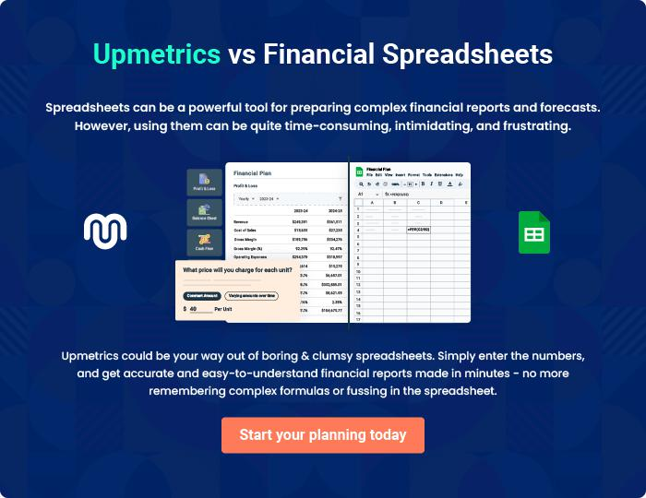

Home Health Care | Business Plan [YEAR] 31/32

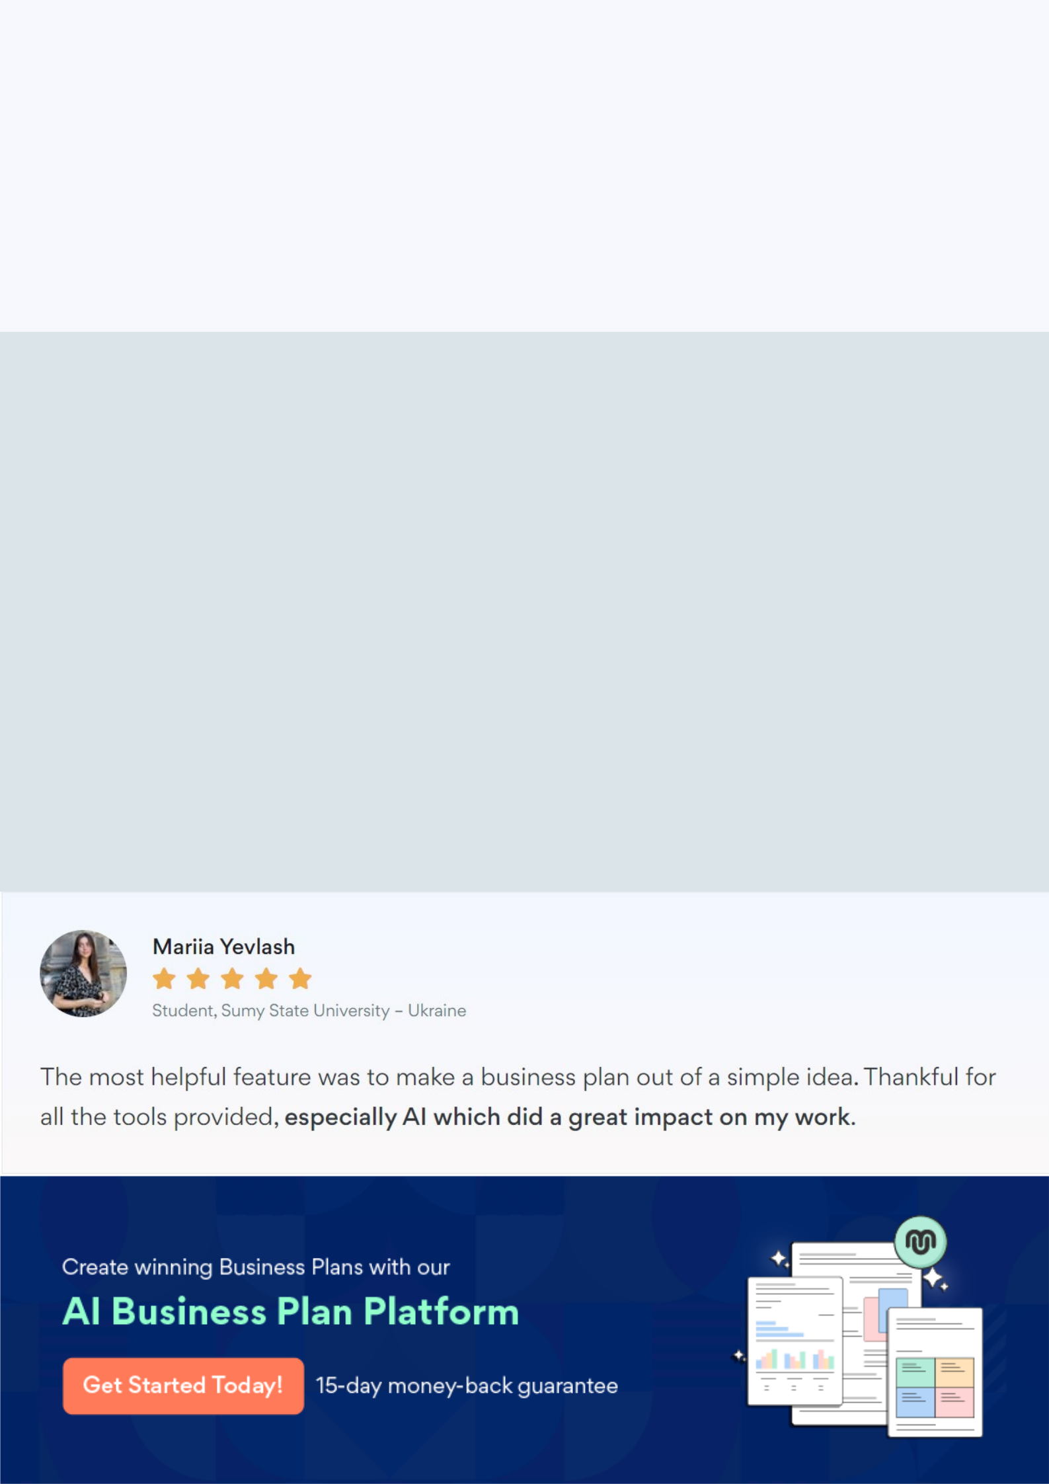
Create a winning business plan that gets you funded

Creating a stunning and investment-ready plan requires no writing, graphic designing, or financial planning expertise.

Upmetrics has all the features required to help you create a comprehensive business plan—from start to finish. Make no mistakes, it’s the modern way of planning to structure ideas, make plans, and create stunning pitch decks to awe investors.

Pitch decks that impress investors

Create pitch decks that provide a visual representation of your business, engage investors, and make them want to invest in your business idea.

Interactive plans in no time

Import business plan sections like—SWOT analysis, comparison tables, and others to create an interactive business plan. No designing skills are required.

Stunning cover page designs

With Upmetrics, you have the liberty to choose from multiple stunning cover page designs. Choose a creative design and make your plan stand out.

Online sharing made simple

Upmetrics makes online sharing quick and easier for users. Easily share your business plans with a link while tracking reader activity.

500+ sample business plans

Simply import a template from our library of sample plans into the editor and start customizing it to make it yours. It takes only a few clicks to get started.

Collaborate with team in real-time

Invite team members, initiate conversations, discuss ideas & strategies, share feedback, and work on a business plan in real-time.

