
Handicrafts


Business
Plan

[YEAR]
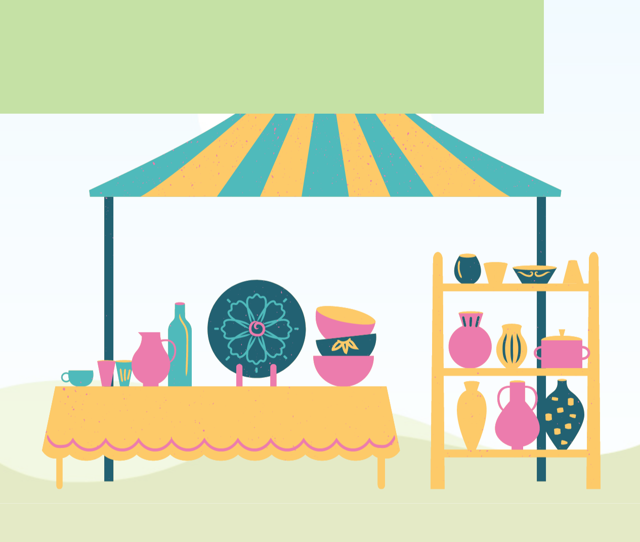

Good Crafts for Good Relations.

Information provided in this business plan is unique to this business and confidential; therefore, anyone reading this plan agrees not to disclose any of the information in this business plan without prior written permission of the Company

 | Prepared By | 10200 Bolsa Ave, Westminster, CA, 92683
 | John Doe | info@example.com
 | (650) 359-3153 | http://www.example.com

Table of Contents

Executive Summary | 5
Business Overview | 6
Mission & Vision Statement | 6
Business Model | 6
Objectives | 7
Non-Financial Objectives | 7
Financial Objectives | 7
Our Corporate Social Responsibility In Action | 7
Our Core Values | 8
Keys To Success | 8
Guiding Principles | 8
Business Target | 9
3 Year profit forecast | 9

Business Description | 10
Company Conceptualization | 11
Registered Name and Corporate Structure | 11
Company Ownership | 11
Company Location And Resources | 12
Funding Required | 12
Startup cost | 12

Products and Services | 15
Products and Services | 16
Handicrafts | 16
Market Analysis
Market Analysis | 18
The United States Market | 19
Model Types Insights | 19
SWOT Analysis | 19

Handicrafts | Business Plan [YEAR] 2/34

Porters’ Five Force Analysis | 21
The Threat Of New Entry | 21
Competitive Rivalry | 21
Buyer Power | 21
Supplier Power | 21
Threat Of Substitution | 22
Route To The Market | 22
Marketing Plans | 22
Growth Plan | 23

Financial Plan | 24
Important Assumptions | 25
Brake-even Analysis | 25
Projected Profit and Loss | 26
Projected Cash Flow | 28
Projected Balance Sheet | 30
Business Ratios | 31

Handicrafts | Business Plan [YEAR] 3/34

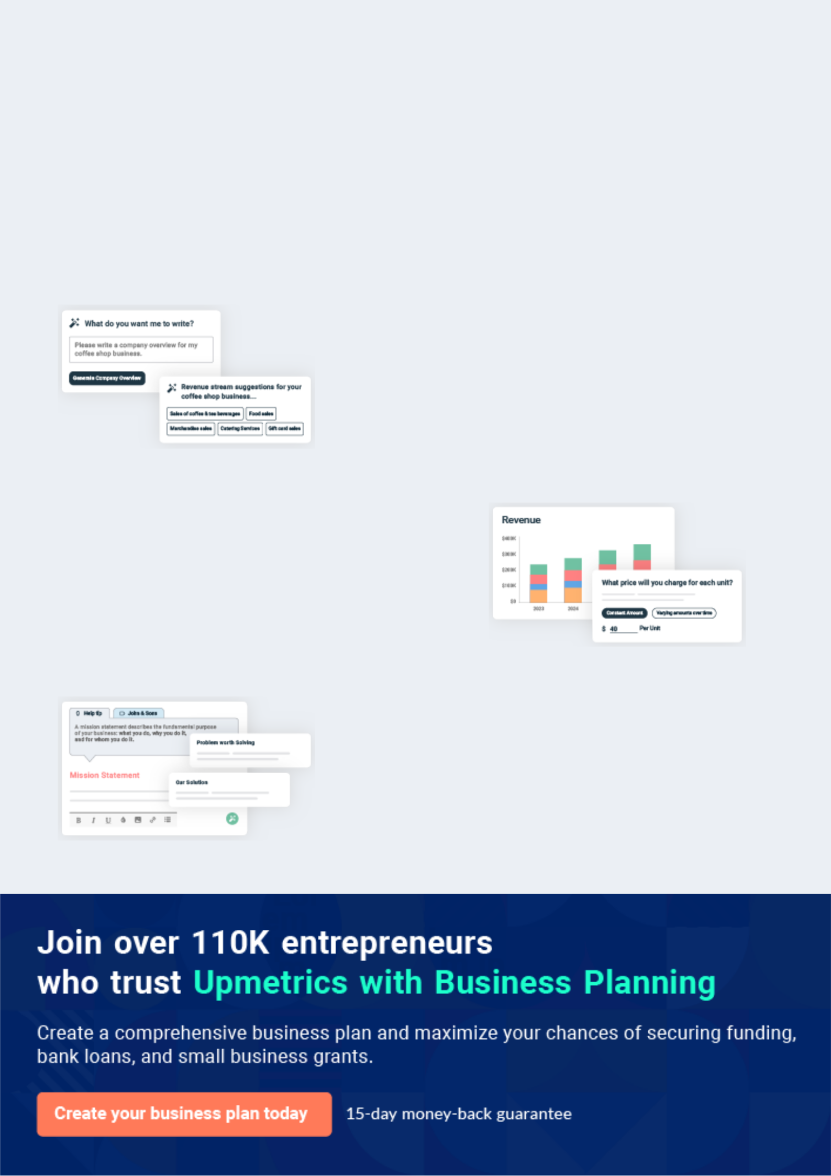
Business planning that’s simpler and faster than you think

Creating a business plan using Upmetrics to start and grow a business is literally the easiest thing in the World. Simply read the instructions and fill in the blanks. It’s as simple as that.

❛ | Upmetrics has everything you need to create a | ❜
❛ | comprehensive business plan. | ❜

AI-powered Upmetrics Assistant

AI-powered insights to streamline your plan

Not sure where to start? Upmetrics’ AI Assistant will automatically generate ideas for each section of your plan and offer improved versions of your writing, adjusting for tone, voice, and grammar or spelling errors.

Financial Forecasting Tool

All the financials are calculated for you

Forget the complex formulas and clumsy spreadsheets — with automatic financials and drag-and-drop forecasting, you can finish your plan faster and be confident that your numbers are accurate.

Business Plan Builder

Guides you like a business mentor

Upmetrics’ step-by-step instructions, prompts, and the library of 400+ sample business plans will guide you through each section of your plan as a business mentor.

1.


Executive Summary

Business Overview

Mission & Vision Statement

Business Model

Objectives

Our Corporate Social Responsibility In Action

Our Core Values

Keys To Success

Guiding Principles

Business Target

Handicrafts | Business Plan [YEAR] 5/34

Before you think about how to start a Handicraft business, you must create a detailed Handicraft business plan. It will not only guide you in the initial phases of your startup but will also help you later on.
To unlock help try Upmetrics!
To unlock help try Upmetrics!

Business Overview

 Moore Products
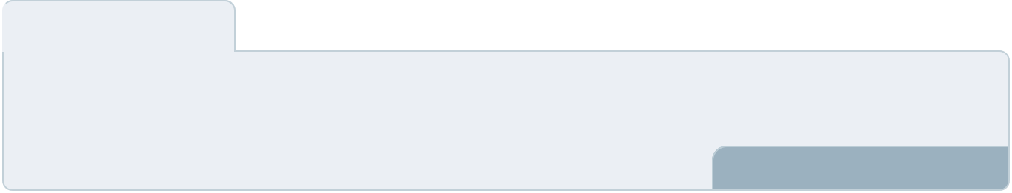



Both locally and internationally, people are fond of purchasing products made in the United States. The United States has cemented its status as a global leader in consumer goods,
product innovation, production, among other spheres. The United States is equally blessed with
To unlock help try Upmetrics! 

Start writing here..

Mission & Vision Statement

 Moore Products

We are envisioned towards becoming the most preferred handicraft company brand in the United States through the provision of quality handbags, chairs, shoes, and locally made pots. We are out:



Start writing here..

Business Model

 Moore Products

The company adopts the B2C business model. The handicrafts have been designed to serve the needs of the clients both locally and abroad. The company enters into a strategic agreement with companies that serve as distributors as well as private individuals who would
To unlock help try Upmetrics! 

Start writing here..

Handicrafts | Business Plan [YEAR] 6/34

Objectives
To unlock help try Upmetrics!

 Moore Products

The following are the aims and objectives of the company. We have chosen to split the objectives of the company into financial and non-financial objectives. Moore Products LLC will have the following goals and objectives:



Start writing here..

 Moore Products

• To provide uniquely made handbags, shoes, chairs, and locally-made pots to the target market locally and internationally.
• To orchestrate the influx of our handicrafts into the market and become the preferred
To unlock help try Upmetrics! 

Non-Financial Objectives

Start writing here..

 Moore Products

- Increase the number of clients by 30% over the next three years of operations

- To generate an estimated revenue of $42,000 by 2021
- To maintain the monthly and yearly increase in revenue generated _{To}from_{unlock}the_{help}business_{tryUpmetrics!} 

Financial Objectives

Start writing here..

Our Corporate Social Responsibility In Action

 Moore Products

At Moore Products LLC, we understand that our business decisions and the methods by which we engage our key stakeholders affect not only our organization, but also in a profound manner, the people, cities, and settings that support our corporate lives as well as our businesses.
To unlock help try Upmetrics! 

Start writing here..

Handicrafts | Business Plan [YEAR] 7/34

Our Core Values

 Moore Products

There are a set of core values, which are at the base of everything that we do and all that we believe in. These guide us to deal with every aspect of any issue we might encounter in our personal and professional lives. These values help us grow inside and outside, personally, and
To unlock help try Upmetrics! 

Start writing here..

Keys To Success

 Moore Products

We have come to make this business a successful business as we aim to record huge success within three years of being in the business. Our target markets are majorly all corporate entities within and outside Texas. To achieve success in our business, we will work with the following
To unlock help try Upmetrics! 

Start writing here..

Guiding Principles

 Moore Products

In our business, we will uphold values such as:

• Service efficiency
To unlock help try Upmetrics! 

Start writing here..

Handicrafts | Business Plan [YEAR] 8/34

Business Target

 Moore Products

Our main business targets are summarized in the following column chart.

To unlock help try Upmetrics! 

Start writing here..

3 Year profit forecast
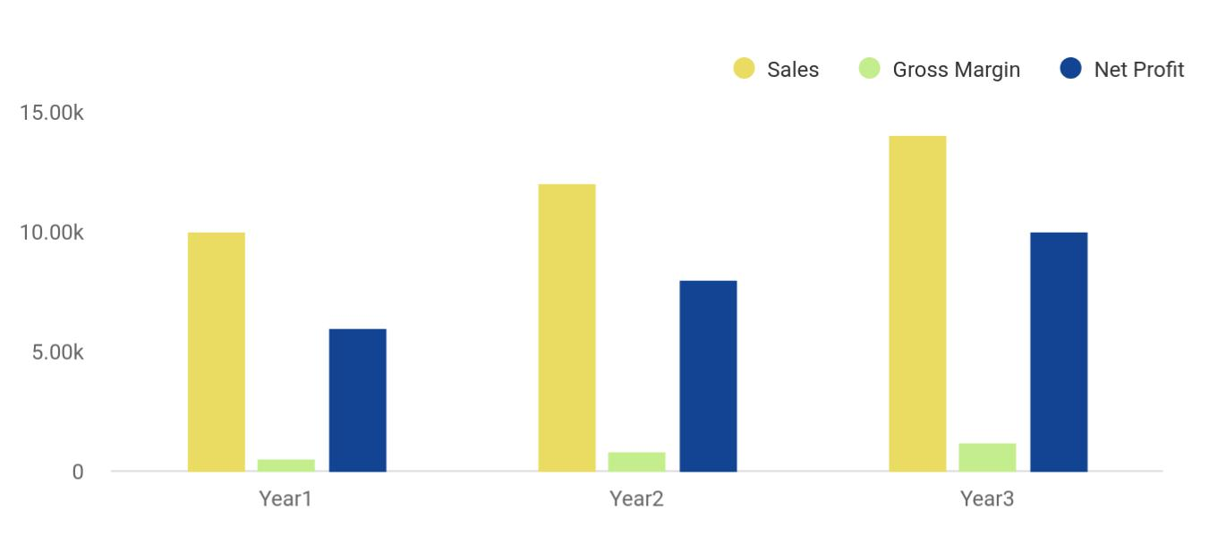

Financial Year | Sales | Gross Margin | Net Profit
Year1 | 10,000 | 500 | 6,000
Year2 | 12,000 | 800 | 8,000
Year3 | 14,000 | 1,200 | 10,000

Handicrafts | Business Plan [YEAR] 9/34

2.

Business Description

Company Conceptualization

Registered Name and Corporate Structure

Company Ownership

Company Location And Resources

Funding Required

Handicrafts | Business Plan [YEAR] 10/34

Company Conceptualization

 Moore Products

We have established the company to create a market for products that are manufactured in the United States locally. Also, it is part of the United States 2030 Vision to promote the local industries to the world, as well as attracting international investors to start their industrial
To unlock help try Upmetrics! 

Start writing here..

Registered Name and Corporate Structure

 Moore Products

Moore Products LLC is incorporated according to the corporate laws of the United States. Moore Products LLC has not commenced its operations at the time of writing this business
plan. In the long run, we will apply for trademark protection as we secure funding to protect our
To unlock help try Upmetrics! 

Start writing here..

Company Ownership

 Moore Products

Jordan Smith is the founder of the company. At the beginning of the company’s operations, he will be the only one involved in the activities. He is an experienced Sales and Marketing professional. However, he has considerable experience in project management, operations
To unlock help try Upmetrics! 

Start writing here..

Handicrafts | Business Plan [YEAR] 11/34

Company Location And Resources

 Moore Products

The company is based in the United States. Despite the effect of COVID-19, the United States economy is growing astronomically. The company’s location is perfect for our type of business, and the founder is already very familiar with the intrinsic quirks of the company’s location. The
To unlock help try Upmetrics! 

Start writing here..

Funding Required

Startup cost
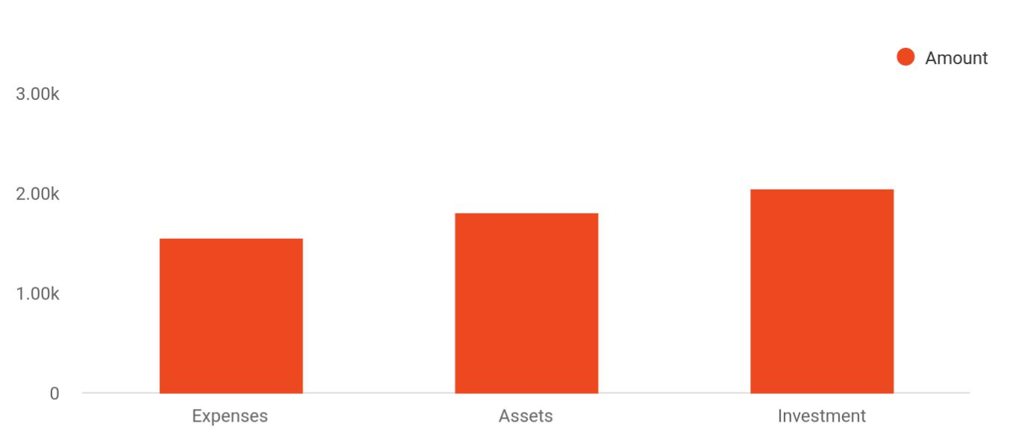

Cost distribution | Amount
Expenses | 1,550
Assets | 1,800
Investment | 2,050

The detailed startup requirements and expenses are given in the table below.


Start-up Expenses

Legal

Consultants

Insurance

Amount

$75,500

$0

$62,750

Handicrafts | Business Plan [YEAR] 12/34

Start-up Expenses | Amount
Rent | $22,500
Research and Development | $42,750
Expensed Equipment | $42,750
Signs | $1,250
TOTAL START-UP EXPENSES | $247,500
Start-up Assets | $0
Cash Required | $322,500
Start-up Inventory | $52,625
Other Current Assets | $222,500
Long-term Assets | $125,000
TOTAL ASSETS | $121,875
Total Requirements | $245,000
START-UP FUNDING | $0
START-UP FUNDING | $273,125
Start-up Expenses to Fund | $121,875
Start-up Assets to Fund | $195,000
TOTAL FUNDING REQUIRED | $0
Assets | $203,125
Non-cash Assets from Start-up | $118,750
Cash Requirements from Start-up | $0
Additional Cash Raised | $118,750
Cash Balance on Starting Date | $121,875
TOTAL ASSETS | $0
Liabilities and Capital | $0
Liabilities | $0
Current Borrowing | $0
Long-term Liabilities | $0
Accounts Payable (Outstanding Bills) | $0

Handicrafts | Business Plan [YEAR] 13/34

Start-up Expenses | Amount
Other Current Liabilities (interest-free) | $0
TOTAL LIABILITIES | $0
Capital | $0
Planned Investment | $0
Investor 1 | $312,500
Investor 2 | $0
Other | $0
Additional Investment Requirement | $0
TOTAL PLANNED INVESTMENT | $695,000
Loss at Start-up (Start-up Expenses) | $313,125
TOTAL CAPITAL | $221,875
TOTAL CAPITAL AND LIABILITIES | $221,875
Total Funding | $265,000

Handicrafts | Business Plan [YEAR] 14/34

3.

Products and Services

Products and Services

Handicrafts | Business Plan [YEAR] 15/34

Before starting a handicraft business, you must take many things into consideration such as you must consider what types of handicraft products will you be providing to your customers. Deciding your services is extremely
To unlock help try Upmetrics! 

 Moore Products

Moore Products LLC is actively involved in the provision of top-quality handicrafts. Among the list of handicrafts that are provided by our company are handbags, shoes, chairs, and locally-made pots. All our products will be uniquely made to represent quality which the United States
To unlock help try Upmetrics! 

Start writing here..

Products and Services

Handicrafts
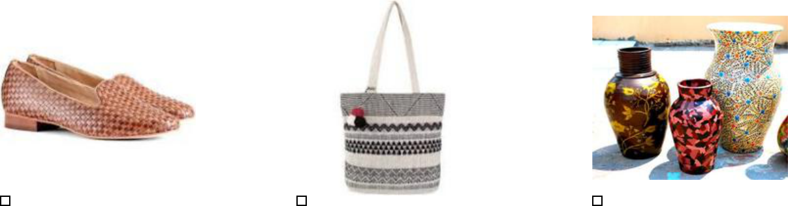

Shoes Bags Pots
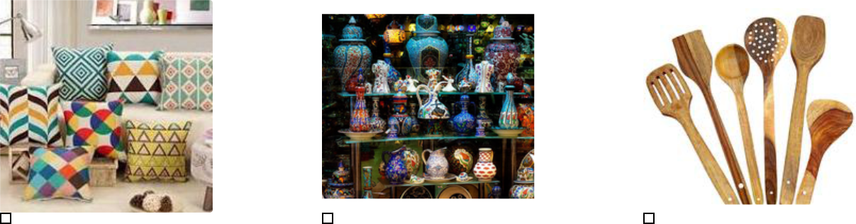

Pillows Arts Cooking Tools

Handicrafts | Business Plan [YEAR] 16/34

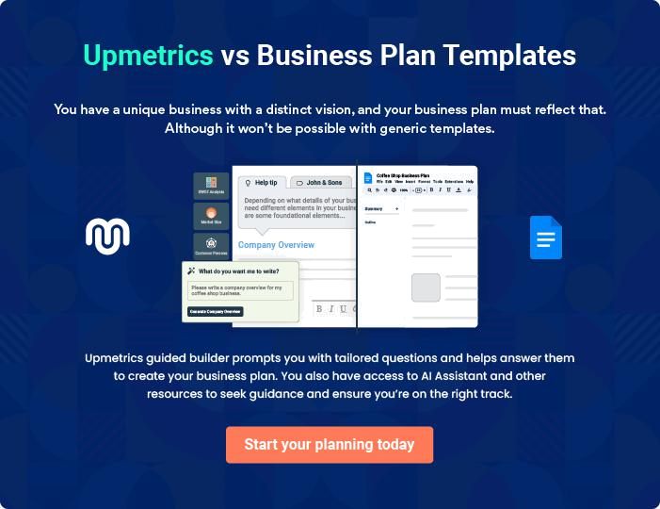

Handicrafts | Business Plan [YEAR] | 17/34

4.

Market Analysis

The United States Market

Model Types Insights

SWOT Analysis

Porters’ Five Force Analysis

Route To The Market

Handicrafts | Business Plan [YEAR] 18/34

The most important component of an effective handicraft business plan is its accurate marketing analysis. If you are starting on a smaller scale, you can do marketing analysis yourself by taking help from this handicraft business
To unlock help try Upmetrics!
To unlock help try Upmetrics! 

The United States Market

 Moore Products

The North American handicrafts market reached a value of around US$ 218 Billion in 2018. Looking forward, the market is projected to reach a value of US$ 402 Billion by 2024, registering a CAGR of nearly 11% during 2019-2024.



Start writing here..

Model Types Insights

 Moore Products

The global handbag market size was valued at USD 47.0 billion in 2018 and is anticipated to witness significant growth in the forecast period. The rising women workforce, along with
increasing brand awareness, is driving the demand for the product over the world. Over the past
To unlock help try Upmetrics! 

Start writing here..

SWOT Analysis

Handicrafts | Business Plan [YEAR] 19/34


Strength

- Project & Operations Management

- Vendor and Stakeholders Management

- Availability of raw materials in the local market, especially, Houston

- Interpersonal & Communications skills

- Capability to attract vast audiences with diverse product needs online

- Power of customer relationship management by collecting data of buyers and sellers registered with the company

- Generation of the reports and statistics that can make the company better and address its weaknesses and threats

Weakness


- Non-availability of Sales & Marketing Personnel

- Non-availability of the IT personnel

- Supply chain, local & international transportation

- Our intellectual property protection

- There are numerous stock lovers still out there whose main purpose is to scam investors

- The sellers being able to enforce the payment method of their choice, which is a favorite among the scammers

- Shipping may be one of the biggest problems


Opportunity

- Providing an online platform to market for Saudi made products locally & internationally

- Variety of products categories

- The target audience is local & worldwide

- Ensure customers’ satisfaction throughout the procurement and transportation process

- Manufacturers can offer their product at a static price and offer it on buying it now

- Buyers can straightaway buy the product without having to wait

- Opportunity to secure dominance of the United States and other countries

Threat

- Contract establishment & Management

- Customers’ intellectual property protection

- New competitors with the same business idea entering the market

- One of the biggest threats is the scammers and the phishers who use an online business name to scam people

- Online users distrusting the services provided by these companies and never coming back

- Seamless integration of seller and buyer

Handicrafts | Business Plan [YEAR] 20/34

Porters’ Five Force Analysis

 Moore Products

The company has been in operation before the writing of this business plan but the company still requires funding from investors. The threat of new entry applies to the companies who are newcomers to the industry. The company may also be considered a startup company and this
To unlock help try Upmetrics! 

The Threat Of New Entry

Start writing here..

 Moore Products

In that our business is modeled to build on the influx of handicrafts into the US market, there are other artisans who are experts and highly skilled at making shoes, bags, pots, and chairs.
The competition in the industry is double-phased; with local artisans as well as the established
To unlock help try Upmetrics! 

Competitive Rivalry

Start writing here..

 Moore Products

Our prices are reasonably structured to be within the confines of fair prices chargeable in the industry. We have no plan to increase these charges but rather to promote the rate at which our target market purchases our products. This is why our handicrafts have been made available at
To unlock help try Upmetrics! 

Buyer Power

Start writing here..

 Moore Products

Our suppliers in the industry are the companies that supply the needed materials that are used in our production. These suppliers are scattered all over Houston. These suppliers often determine our pricing as the company’s pricing is determined by a lot of factors including the
To unlock help try Upmetrics! 

Supplier Power

Start writing here..

Handicrafts | Business Plan [YEAR] 21/34

 Moore Products
To unlock help try Upmetrics!
To unlock help try Upmetrics!

The threat of substitution cannot be overlooked in analyzing the possible success or otherwise of our company. There is really no substitute that completely replaces our product offering in the market. The impact of this threat on our company low.



Threat Of Substitution

Start writing here..

Route To The Market

 Moore Products

To maximize our distribution efficiency, and not over or underproduce, we need to employ a management system to house customers’ goods and keep track of what it contains with precision and accuracy. The management team adopts



Marketing Plans

Start writing here..

Handicrafts | Business Plan [YEAR] 22/34

Growth Plan

Activity | Description | Timeline | Strategies | Target Market
 | • Sourcing the
 | needed raw
 | materials and
 | actively engaging |  | • Provide the shoes,
 | in production |  | bags, chairs, and pots
Product | • Forging |  | both online and offline | • Houston,
Product | partnerships with | Year 1 | • Develop a standard | • Houston,
Development | partnerships with | Year 1 | • Develop a standard | TX
Development | our delivery agent |  | mode of operation | TX
 | • Partner with the |  | • Pitch business ideas
 | needed suppliers |  | to acquire funds
 | of the needed
 | materials
 | • Acquire funding
 |  |  | • Improve on the
 | • Expand operations |  | developed model of
 | • Expand operations |  | operations to
 | by integrating our |  | operations to
 | by integrating our |  | accommodate growth
 | products in more |  | accommodate growth
 | products in more |  | changes
 | online |  | changes
 | online |  | • Introduce aggressive | • Houston
 | marketplaces |  | • Introduce aggressive | • Houston
 | marketplaces |  | marketing campaigns
 | • Reach out to our |  | marketing campaigns | • Texas
 | • Reach out to our |  | to enhance visibility | • Texas
Market | target market |  | to enhance visibility | • America
Market | target market | Year 1 - 3 | • Acquire bigger | • America
Expansion | through both | Year 1 - 3 | • Acquire bigger | • Europe
Expansion | through both |  | warehouses to store | • Europe
 | online and offline |  | warehouses to store
 | online and offline |  | products | • Asia
 | strategies |  | products | • Asia
 | strategies |  |  | • Etc.
 | • Expand delivery |  | • Recruit more | • Etc.
 | • Expand delivery |  | employees towards
 | services |  | employees towards
 | services |  | business growth
 | • Introduce new |  | business growth
 | • Introduce new |  | • Gradually add more
 | product lines |  | • Gradually add more
 | product lines |  | products to our
 |  |  | product mix
 |  |  | • Plan & execute the
Diversification | • Introduce new | Year 3 & UP | operational | • Global
Diversification | product lines | Year 3 & UP | techniques of the new | • Global
 |  |  | divisions

Handicrafts | Business Plan [YEAR] 23/34

5.

Financial Plan

Important Assumptions

Brake-even Analysis

Projected Profit and Loss

Projected Cash Flow

Projected Balance Sheet

Business Ratios

Handicrafts | Business Plan [YEAR] 24/34

The last component of a handicraft business plan is an in-depth financial plan. The financial plan crafts a detailed map of all the expenses needed for the startup and how these expenses will be met by the earned profits. It is
To unlock help try Upmetrics! 

 Moore Products

The company will be financed by Jordan Smith himself and he will control the direction of the business to make sure that it is expanding at the forecasted rate. As for the handicraft business start-up, no equity funding or outside loans will be required. With the help of financial experts,
To unlock help try Upmetrics! 

Start writing here..

Important Assumptions

The financial projections of the company are forecast on the basis of the following assumptions. These assumptions are quite conservative and are expected to show deviation but to a limited level such that the company’s major financial strategy will not be affected.

 | Year 1 | Year 2 | Year 3
Plan Month | 1 | 2 | 3
Current Interest Rate | 10,00% | 11,00% | 12,00%
Long-term Interest Rate | 10,00% | 10,00% | 10,00%
Tax Rate | 26,42% | 27,76% | 28,12%
Other | 0 | 0 | 0

Brake-even Analysis

Monthly Units Break-even | 5530
Monthly Revenue Break-even | $159 740
Assumptions:
Average Per-Unit Revenue | $260,87
Average Per-Unit Variable Cost | $0,89
Estimated Monthly Fixed Cost | $196 410

Handicrafts | Business Plan [YEAR] 25/34

Projected Profit and Loss

 | 2024 | 2025 | 2026
Revenue | $472,499.90 | $579,922.40 | $800,082.45
Handmade Jewelry Sales | $108,000 | $136,864.80 | $245,021.40
Unit Sales | 2,400 | 3,041 | 5,445
Unit Price | $45 | $45 | $45
Custom Craft Orders | $184,499.90 | $263,057.60 | $375,061.05
Unit Sales | 2,838 | 4,047 | 5,770
Unit Price | $65 | $65 | $65
Art and Craft Workshops | $180,000 | $180,000 | $180,000
Total Hours | 2,400 | 2,400 | 2,400
Hourly Price | $75 | $75 | $75
Cost Of Sales | $30,727.14 | $36,998.86 | $49,021.62
General Costs | $30,727.14 | $36,998.86 | $49,021.62
Raw Materials for | $27,429.72 | $33,283.25 | $44,834.86
Handmade Jewelry | $27,429.72 | $33,283.25 | $44,834.86
Beads and Stones | $3,804.70 | $4,287.13 | $4,830.73
Metal and Wire | $23,625.02 | $28,996.12 | $40,004.13
Craft Supplies for Custom | $3,297.42 | $3,715.61 | $4,186.76
Orders | $3,297.42 | $3,715.61 | $4,186.76
Paints and Brushes | $2,536.46 | $2,858.16 | $3,220.59
Crafting Tools | $760.96 | $857.45 | $966.17
Revenue Specific Costs | $0 | $0 | $0
Personnel Costs (Direct | $0 | $0 | $0
Labor) | $0 | $0 | $0

Handicrafts | Business Plan [YEAR] 26/34

 | 2024 | 2025 | 2026
Gross Margin | $441,772.76 | $542,923.54 | $751,060.83
Gross Margin (%) | 93.50% | 93.62% | 93.87%

Operating Expense | $452,963.47 | $470,220.44 | $491,556.12
Payroll Expense (Indirect | $405,960 | $416,599.20 | $427,542.96
Labor) | $405,960 | $416,599.20 | $427,542.96
Sales and Marketing Team | $90,720 | $93,441.60 | $96,244.80
Sales Manager | $50,400 | $51,912 | $53,469.36
Marketing Coordinator | $40,320 | $41,529.60 | $42,775.44
Production Team | $234,600 | $239,292 | $244,077.96
Craftsmen | $193,200 | $197,064 | $201,005.40
Quality Controller | $41,400 | $42,228 | $43,072.56
Administrative Staff | $80,640 | $83,865.60 | $87,220.20
Office Manager | $46,080 | $47,923.20 | $49,840.08
Administrative Assistant | $34,560 | $35,942.40 | $37,380.12
General Expense | $47,003.47 | $53,621.24 | $64,013.15
Office and Administrative | $22,132.54 | $25,889.53 | $32,105.09
Expenses | $22,132.54 | $25,889.53 | $32,105.09
Office Rent | $12,682.53 | $14,291.10 | $16,103.44
Utilities | $9,450.01 | $11,598.43 | $16,001.65
Marketing and Advertising | $10,145.94 | $11,432.47 | $12,882.25
Online Advertising | $6,341.24 | $7,145.34 | $8,051.52
Promotional Materials | $3,804.70 | $4,287.13 | $4,830.73
Miscellaneous and Other | $14,724.99 | $16,299.24 | $19,025.81
Expenses | $14,724.99 | $16,299.24 | $19,025.81
Website Maintenance | $4,724.99 | $5,799.24 | $8,000.81
Business Insurance | $10,000 | $10,500 | $11,025

Handicrafts | Business Plan [YEAR] 27/34

Bad Debt

Amortization of Current Assets

EBITDA

Additional Expense

Long Term Depreciation

Gain or loss from Sale of Assets

EBIT

Interest Expense

EBT

Income Tax Expense / Benefit

Total Expense

Net Income

Net Income (%)

Retained Earning Opening

Owner's Distribution

Retained Earning Closing

Projected Cash Flow

2024 | 2025 | 2026
$0 | $0 | $0
$0 | $0 | $0

($11,190.71) $72,703.10 $259,504.70

$4,775.48 | $3,808.38 | $2,781.63
$2,202 | $2,202 | $2,202
$0 | $0 | $0
($13,392.71) | $70,501.10 | $257,302.70
$2,573.47 | $1,606.38 | $579.64
($15,966.19) | $68,894.72 | $256,723.07
$0 | $0 | $0

$488,466.09 | $511,027.68 | $543,359.38
($15,966.19) | $68,894.72 | $256,723.07
(3.38%) | 11.88% | 32.09%

$0 | ($24,966.19) | $34,928.53
$9,000 | $9,000 | $9,000
($24,966.19) | $34,928.53 | $282,651.60

Handicrafts | Business Plan [YEAR] 28/34

 | 2024 | 2025 | 2026
Cash Received | $472,499.90 | $579,922.40 | $800,082.45
Cash Paid | $486,264.07 | $508,825.68 | $541,157.38
COS & General Expenses | $77,730.59 | $90,620.10 | $113,034.79
Salary & Wages | $405,960 | $416,599.20 | $427,542.96
Interest | $2,573.47 | $1,606.38 | $579.64
Sales Tax | $0 | $0 | $0
Income Tax | $0 | $0 | $0
Net Cash From | ($13,764.17) | $71,096.72 | $258,925.07
Operations | ($13,764.17) | $71,096.72 | $258,925.07

Assets Sell | $0 | $0 | $0
Assets Purchase | $15,000 | $0 | $0
Net Cash From | ($15,000) | $0 | $0
Investments | ($15,000) | $0 | $0

Amount Received | $70,000 | $0 | $0
Loan Received | $50,000 | $0 | $0
Common Stock | $0 | $0 | $0
Preferred Stock | $0 | $0 | $0
Owner's Contribution | $20,000 | $0 | $0
Amount Paid | $24,679.72 | $25,646.82 | $26,673.45
Loan Capital | $15,679.73 | $16,646.82 | $17,673.44
Dividends & Distributions | $9,000 | $9,000 | $9,000
Net Cash From | $45,320.28 | ($25,646.82) | ($26,673.45)
Financing | $45,320.28 | ($25,646.82) | ($26,673.45)

Summary

Handicrafts | Business Plan [YEAR] 29/34

 | 2024 | 2025 | 2026
Starting Cash | $0 | $16,556.11 | $62,006.01
Cash In | $542,499.90 | $579,922.40 | $800,082.45
Cash Out | $525,943.79 | $534,472.50 | $567,830.83
Change in Cash | $16,556.11 | $45,449.90 | $232,251.62
Ending Cash | $16,556.11 | $62,006.01 | $294,257.63

Projected Balance Sheet

 | 2024 | 2025 | 2026
Assets | $29,354.11 | $72,602.01 | $302,651.63
Current Assets | $16,556.11 | $62,006.01 | $294,257.63
Cash | $16,556.11 | $62,006.01 | $294,257.63
Accounts Receivable | $0 | $0 | $0
Inventory | $0 | $0 | $0
Other Current Assets | $0 | $0 | $0
Long Term Assets | $12,798 | $10,596 | $8,394
Gross Long Term Assets | $15,000 | $15,000 | $15,000
Accumulated Depreciation | ($2,202) | ($4,404) | ($6,606)
Liabilities & Equity | $29,354.07 | $72,601.97 | $302,651.60
Liabilities | $34,320.26 | $17,673.44 | $0
Current Liabilities | $16,646.82 | $17,673.44 | $0
Accounts Payable | $0 | $0 | $0
Income Tax Payable | $0 | $0 | $0
Sales Tax Payable | $0 | $0 | $0
Short Term Debt | $16,646.82 | $17,673.44 | $0

Handicrafts | Business Plan [YEAR] 30/34

 | 2024 |  |  | 2025 |  | 2026
Long Term Liabilities | $17,673.44 |  |  | $0 |  | $0
Long Term Debt | $17,673.44 |  |  | $0 |  | $0
Equity | ($4,966.19) |  | $54,928.53 |  |  | $302,651.60
Paid-in Capital | $0 |  |  | $0 |  | $0
Common Stock | $0 |  |  | $0 |  | $0
Preferred Stock | $0 |  |  | $0 |  | $0
Owner's Contribution | $20,000 |  |  | $20,000 |  | $20,000
Retained Earnings | ($24,966.19) |  | $34,928.53 |  |  | $282,651.60
Check | $0 |  |  | $0 |  | $0
Business Ratios
 |  | Year 1 | Year 2 |  | Year 3 | Industry Profile
Sales Growth |  | 4,35% | 30,82% |  | 63,29% | 4,00%
Percent of Total Assets
Accounts Receivable |  | 5,61% | 4,71% |  | 3,81% | 9,70%
Inventory |  | 1,85% | 1,82% |  | 1,79% | 9,80%
Other Current Assets |  | 1,75% | 2,02% |  | 2,29% | 27,40%
Total Current Assets |  | 138,53% | 150,99% |  | 163,45% | 54,60%
Long-term Assets |  | -9,47% | -21,01% |  | -32,55% | 58,40%
TOTAL ASSETS |  | 100,00% | 100,00% |  | 100,00% | 100,00%
Current Liabilities |  | 4,68% | 3,04% |  | 2,76% | 27,30%
Long-term Liabilities |  | 0,00% | 0,00% |  | 0,00% | 25,80%
Total Liabilities |  | 4,68% | 3,04% |  | 2,76% | 54,10%
NET WORTH |  | 99,32% | 101,04% |  | 102,76% | 44,90%
Percent of Sales

Handicrafts | Business Plan [YEAR] 31/34

 | Year 1 | Year 2 | Year 3 | Industry Profile
Sales | 100,00% | 100,00% | 100,00% | 100,00%
Gross Margin | 94,18% | 93,85% | 93,52% | 0,00%
Selling, General & Administrative Expenses | 74,29% | 71,83% | 69,37% | 65,20%
Advertising Expenses | 2,06% | 1,11% | 0,28% | 1,40%
Profit Before Interest and Taxes | 26,47% | 29,30% | 32,13% | 2,86%
Main Ratios
Current | 25,86 | 29,39 | 32,92 | 1,63
Quick | 25,4 | 28,88 | 32,36 | 0,84
Total Debt to Total Assets | 2,68% | 1,04% | 0,76% | 67,10%
Pre-tax Return on Net Worth | 66,83% | 71,26% | 75,69% | 4,40%
Pre-tax Return on Assets | 64,88% | 69,75% | 74,62% | 9,00%
Additional Ratios
Net Profit Margin | 19,20% | 21,16% | 23,12% | N.A.
Return on Equity | 47,79% | 50,53% | 53,27% | N.A.
Activity Ratios
Accounts Receivable Turnover | 4,56 | 4,56 | 4,56 | N.A.
Collection Days | 92 | 99 | 106 | N.A.
Inventory Turnover | 19,7 | 22,55 | 25,4 | N.A.
Accounts Payable Turnover | 14,17 | 14,67 | 15,17 | N.A.
Payment Days | 27 | 27 | 27 | N.A.
Total Asset Turnover | 1,84 | 1,55 | 1,26 | N.A.
Debt Ratios
Debt to Net Worth | 0 | -0,02 | -0,04 | N.A.
Current Liab. to Liab. | 1 | 1 | 1 | N.A.
Liquidity Ratios
Net Working Capital | $120 943 | $140 664 | $160 385 | N.A.
Interest Coverage | 0 | 0 | 0 | N.A.
Additional Ratios

Handicrafts | Business Plan [YEAR] 32/34

 | Year 1 | Year 2 | Year 3 | Industry Profile
Assets to Sales | 0,45 | 0,48 | 0,51 | N.A.
Current Debt/Total Assets | 4% | 3% | 2% | N.A.
Acid Test | 23,66 | 27,01 | 30,36 | N.A.
Sales/Net Worth | 1,68 | 1,29 | 0,9 | N.A.
Dividend Payout | 0 | 0 | 0 | N.A.
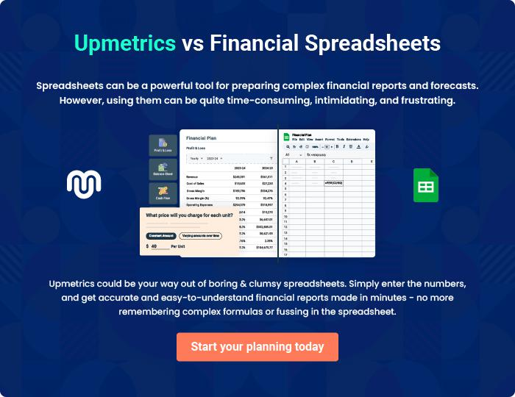

Handicrafts | Business Plan [YEAR] 33/34

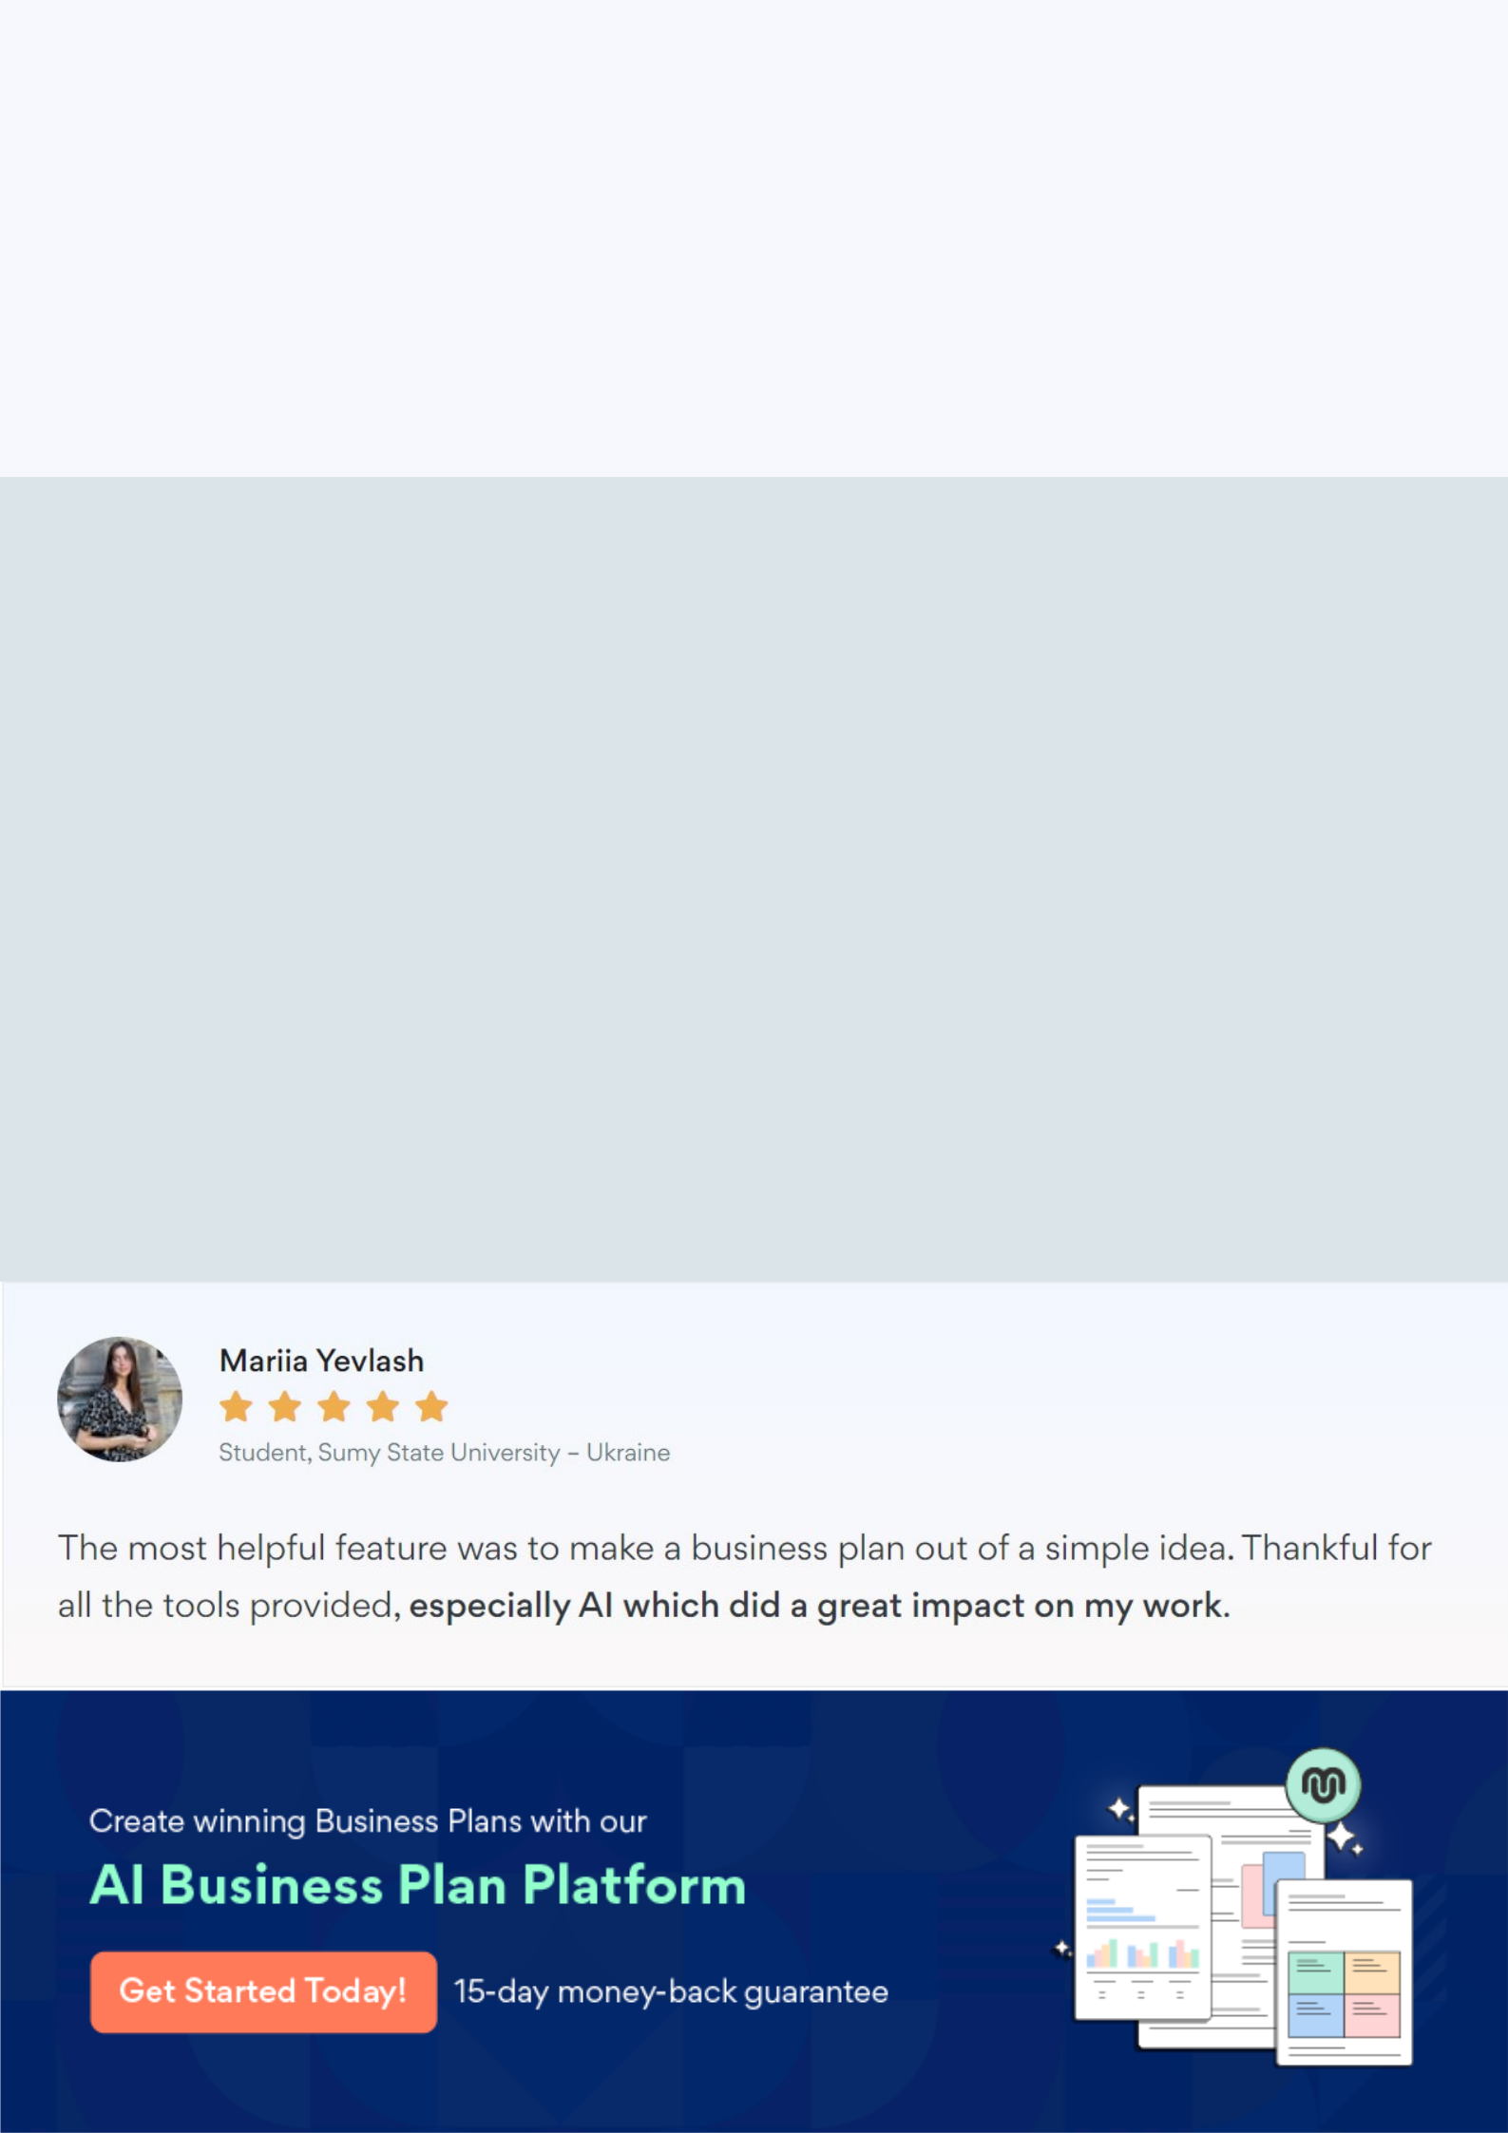
Create a winning business plan that gets you funded

Creating a stunning and investment-ready plan requires no writing, graphic designing, or financial planning expertise.

Upmetrics has all the features required to help you create a comprehensive business plan—from start to finish. Make no mistakes, it’s the modern way of planning to structure ideas, make plans, and create stunning pitch decks to awe investors.

Pitch decks that impress investors

Create pitch decks that provide a visual representation of your business, engage investors, and make them want to invest in your business idea.

Interactive plans in no time

Import business plan sections like—SWOT analysis, comparison tables, and others to create an interactive business plan. No designing skills are required.

Stunning cover page designs

With Upmetrics, you have the liberty to choose from multiple stunning cover page designs. Choose a creative design and make your plan stand out.

Online sharing made simple

Upmetrics makes online sharing quick and easier for users. Easily share your business plans with a link while tracking reader activity.

500+ sample business plans

Simply import a template from our library of sample plans into the editor and start customizing it to make it yours. It takes only a few clicks to get started.

Collaborate with team in real-time

Invite team members, initiate conversations, discuss ideas & strategies, share feedback, and work on a business plan in real-time.

