

Platinum Hair Salon

It's your time to shine

Business

Plan

[YEAR]

John Doe

10200 Bolsa Ave, Westminster, CA, 92683

- 359-3153 info@example.com http://www.example.com

CONFIDENTIAL

Table of Contents

Executive Summary | 5
Business Overview | 6
Mission | 6
Vision | 6
Our Services | 7
Goals and Objectives | 7
Keys to Success | 7

Business Overview | 8
Ownership | 9
Laura Doe | 9
Katarzyna Doe | 9
Legal Business Description | 10
Startup Summary | 10
Startup | 11
Hiring Plan | 12
Location | 12

Products & Services | 13
Products & Services | 14
Services | 14
Products | 14

Market Analysis | 16
Market Trends | 17
Target Market | 17
Market Segmentation | 17
Market Analysis | 17
Customer Profile | 18
Competitive Summary | 18
Competitive Advantage | 18

Platinum Hair Salon | Business Plan [YEAR] 2/34

Strategy and Implementation | 19
Sales & Marketing Strategy | 20
Sources of Income | 20
Sales Forecast | 20
Pricing Strategy | 21
Publicity and Advertising Strategy | 21
Milestones | 21

Management | 22
Personnel Plan | 23
Financial Plan
Financial Plan | 24
Startup Costs | 25
Important Assumptions | 26
Profit & Loss Projections | 26
Balance Sheet Projections | 29
Cashflow Statement | 30
Business Ratios | 31

Platinum Hair Salon | Business Plan [YEAR] 3/34

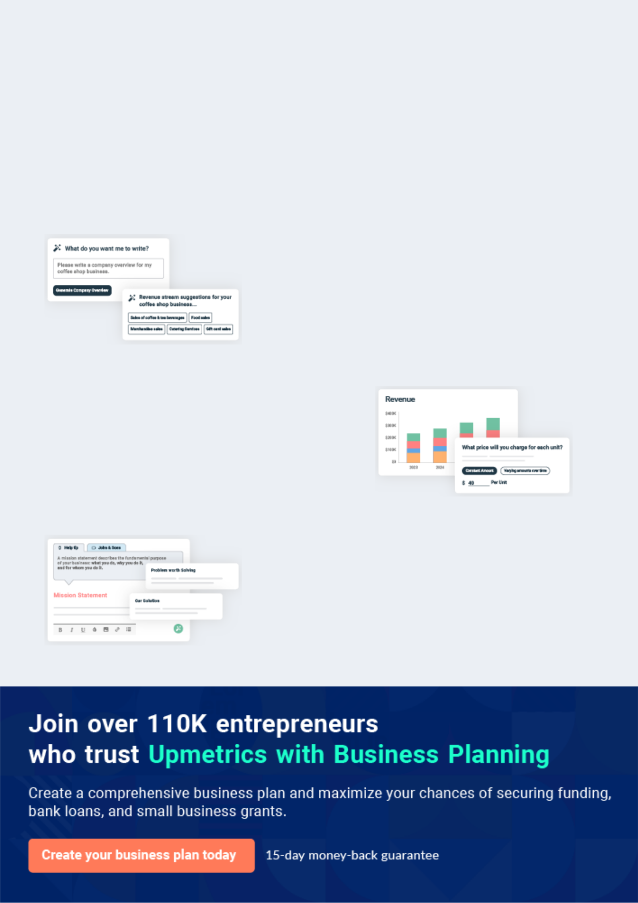
Business planning that’s simpler and faster than you think

Creating a business plan using Upmetrics to start and grow a business is literally the easiest thing in the World. Simply read the instructions and fill in the blanks. It’s as simple as that.

❛ | Upmetrics has everything you need to create a | ❜
❛ | comprehensive business plan. | ❜

AI-powered Upmetrics Assistant

AI-powered insights to streamline your plan

Not sure where to start? Upmetrics’ AI Assistant will automatically generate ideas for each section of your plan and offer improved versions of your writing, adjusting for tone, voice, and grammar or spelling errors.

Financial Forecasting Tool

All the financials are calculated for you

Forget the complex formulas and clumsy spreadsheets — with automatic financials and drag-and-drop forecasting, you can finish your plan faster and be confident that your numbers are accurate.

Business Plan Builder

Guides you like a business mentor

Upmetrics’ step-by-step instructions, prompts, and the library of 400+ sample business plans will guide you through each section of your plan as a business mentor.

1.


Executive Summary

Business Overview

Mission

Vision

Our Services

Goals and Objectives

Keys to Success

Platinum Hair Salon | Business Plan [YEAR] 5/34

Business Overview

 Platinum Hair


Platinum Hair is the only salon to have professional hair services for men and women. Apart from the hair services Platinum Hair the Salon offers a full line of hair products noted for their commitment to the environment. As a concept salon, Platinum Hair is allowed to carry products
To unlock help try Upmetrics! 

Start writing here..

Mission

 Platinum Hair

Our mission as a hair salon company is to develop a highly successful, and profitable – all-round hair salon business which provides quality hairdressing and beauty services in our
community and to become a standard for an ideal hair salon business not only in the State of
To unlock help try Upmetrics! 

Start writing here..

Vision

 Platinum Hair

Our Vision is to become the number one mobile hair salon company in the whole of Arizona with an active presence in major cities in the United States of America and Canada.
To unlock help try Upmetrics! 

Start writing here..

Platinum Hair Salon | Business Plan [YEAR] 6/34

Our Services

 Platinum Hair

Platinum Hair Salon Company is a standard and well – equipped hair salon company that offers a wide range of services that revolves around the Hair Salons industry and other complementary services. We intend to give our customers every reason to always hire our
To unlock help try Upmetrics! 

Start writing here..

Goals and Objectives

 Platinum Hair

Platinum Hair’s objectives for the first three years of operation include:

• The creation of a unique, upscale, innovative environment that will differentiate Platinum
To unlock help try Upmetrics! 

Start writing here..

Keys to Success

 Platinum Hair

Location - salon located on the main street between Ealing and Greenford - provides easy access for Polish customers as well as greater visibility to potential clients.
To unlock help try Upmetrics! 

Start writing here..

Platinum Hair Salon | Business Plan [YEAR] 7/34

2.

Business Overview

Ownership

Legal Business Description

Startup Summary

Hiring Plan

Location

Platinum Hair Salon | Business Plan [YEAR] 8/34

 Platinum Hair

The Platinum Hair will provide a wide range of hairdressing and cosmetics services and products as well as sunbathing services. What will set the salon apart from any competition is our commitment to continued education, providing the latest hair care and beauty techniques,
To unlock help try Upmetrics! 

Start writing here..

Ownership




50%


50%

Laura Doe

Owner & Artistic Director - Laurad@example.com

Laura has been been working as a sole trader providing beautician service in the UK, as well as in Poland. All in all, she has more than 10 years of experience in this field. Laura has been a Beauty Therapist for 10 years. After studying at Mary Reid School of Beauty, she quickly developed the trade skills that have led to her success. Laura worked from home for eight years and built up a good client base. After working from home, She loves dealing with people and has the drive, ambition

and discipline to manage the business and its employees.

Katarzyna Doe

Co-Owner & Neil Technician - Katarzynad@example.com

Katarzyna has been working successfully with a diversity of clientele for around five years now, specializing in nails care and extensions.


Laura Doe

50 Shares


Katarzyna Doe

50 Shares

Platinum Hair Salon | Business Plan [YEAR] 9/34

 Platinum Hair
To unlock help try Upmetrics!

The Company Platinum Hair LLC was established on the 28th of March 2016 by Ms. Laura Smuniak and Ms. Katarzyna Pech, having 50% of shares each. In the future, they are both going to take additional courses in order to raise their qualifications and provide more professional
To unlock help try Upmetrics! 

Start writing here..

Legal Business Description

 Platinum Hair

The legal name of the company is Platinum Hair LLC. The legal

form of the business is LLC. Refer to article papers submitted to the state, June

26, 1997. The business location is in downtown Green Bay, Wisconsin.

Start writing here..

Startup Summary



After spending several months searching for a salon to purchase, the owners decided to start a salon from the ground up. The start-up capital will be used for the design, leasehold improvements, and equipment of the salon.

Startup | Amount
Requirements
Start-up Expenses | [Amount]
Rent deposit | [Amount]
Inventory | [Amount]
Equipment | [Amount]
Supplies | [Amount]
Advertising | [Amount]
Insurance | [Amount]

Platinum Hair Salon | Business Plan [YEAR] 10/34

Startup | Amount
Building Expense | [Amount]
Total Start-up Expenses | [Total Amount]
Start-up Assets
Cash Required | [Amount]
Other Current Assets | [Amount]
Long-term Assets | [Amount]
Total Assets | [Total Amount]
Total Requirements | [Total Amount]

Startup
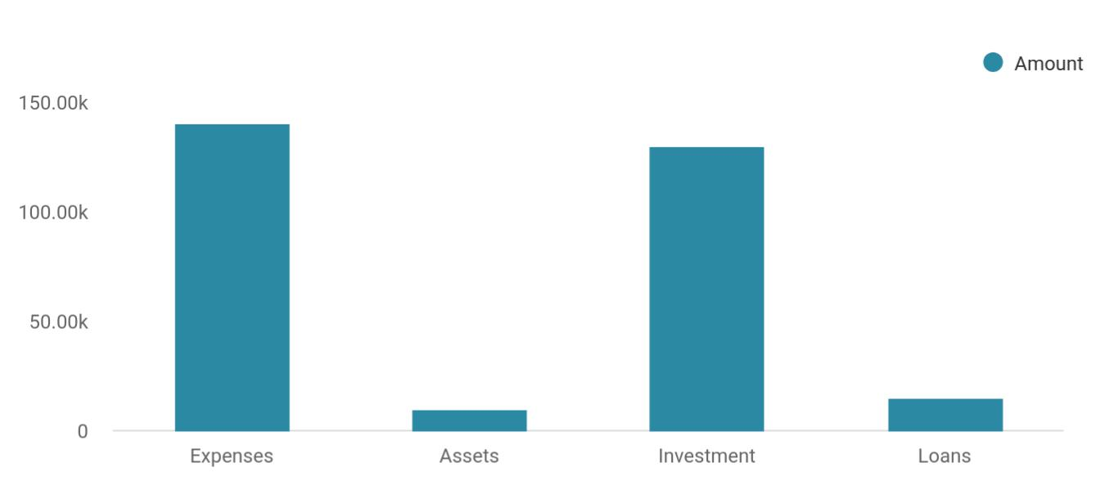

Costs & Funds | Amount
Expenses | 140,000
Assets | 10,000
Investment | 130,000
Loans | 15,000

Platinum Hair Salon | Business Plan [YEAR] 11/34

Hiring Plan
To unlock help try Upmetrics!

 Platinum Hair

There will be initially two hairstylists employed, one who will be the Manager of the salon. I would have another two hairdressers, on a self-employed basis paying $3000 per week,
however, I would like the two stylists initially to build up a client base then bring in more as we
To unlock help try Upmetrics! 

Start writing here..

Location

 Platinum Hair

The salon will be located on Portobello High Street in Phoenix. The salon is roughly 2000 square feet. The location of the salon is ideal as it is situated on the quieter side of Portobello, Joppa with easy parking.



Start writing here..

Platinum Hair Salon | Business Plan [YEAR] 12/34

3.

Products & Services

Products & Services

Services

Products

Platinum Hair Salon | Business Plan [YEAR] 13/34

 Help Tip  Ex :: Industry


The Platinum Hair realizes that great customer service includes complete service under one roof. Platinum Hair will be providing both services and products to better meet our customer needs. Our services including hairdressing, body cosmetics, nail styling, and extensions, and
To unlock help try Upmetrics! 

Products & Services

Start writing here..

Services
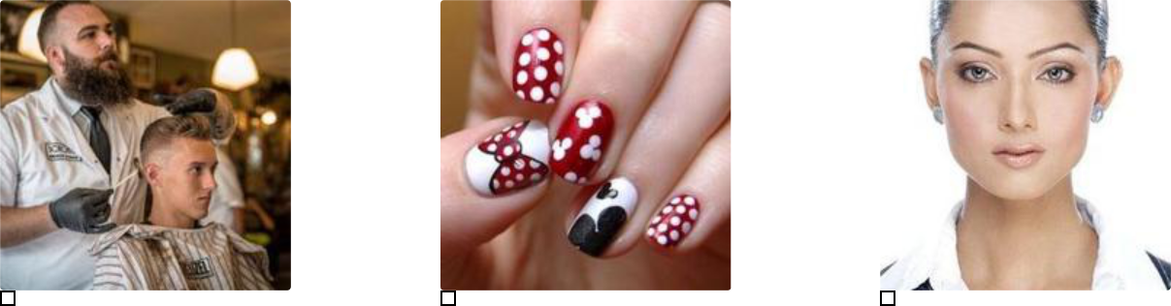

Hair | Nails | Skin Care
Cuts, relaxers, perms, colors, | Manicures, pedicures, polish, | European facials, body waxing,
shampoo, conditioning, curling, | sculptured nails | massage, peelings, facial
reconstructing, weaving, |  | masks, sunbed
waving.

 Platinum Hair

The Platinum Hair will, upon commencement of operation, sell a range of hair and brow products. We will be providing quality hair and brow products. We will be using HD Brows as our product for our brow clients, which has a large celebrity following, and is a reputable provider,
To unlock help try Upmetrics! 

Products

Start writing here..

Platinum Hair Salon | Business Plan [YEAR] 14/34

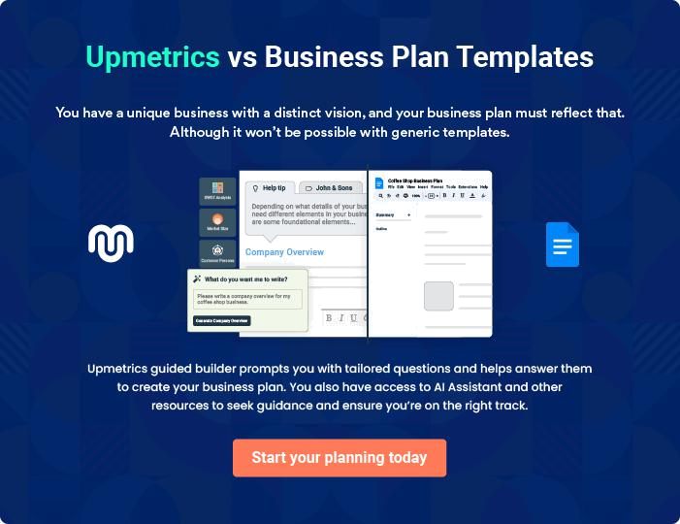

Platinum Hair Salon | Business Plan [YEAR] | 15/34

4.

Market Analysis

Market Trends

Target Market

Market Segmentation

Customer Profile

Competitive Summary

Competitive Advantage

Platinum Hair Salon | Business Plan [YEAR] 16/34

Market Trends

 Platinum Hair

Quite a number of distinct trends have emerged in recent times in the beauty industry which is why salons are positioning their organizations to attract all and sundry. As a matter of fact, this is one of the things that makes most nail studios to spruce up their creativity level so that they
To unlock help try Upmetrics! 

Start writing here..

Target Market

 Platinum Hair

The target market which we are all out to serve is primary the female folks. This is because of the fact that they are the ones who will leave no stone unturned in seeing that they look their best. Whilst some may do this to continue to be attractive to their partners, yet others cannot
To unlock help try Upmetrics! 

Start writing here..

Market Segmentation

 Platinum Hair

Platinum Hair has identified two market segments as follows:

- Local clientele
To unlock help try Upmetrics! 

Start writing here..

Market Analysis

Potential Customers | Growth | Year1 | Year2 | Year3 | Year4 | Year5 | CAGR
Local Customers | 5% | 1,888 | 1,982 | 2,081 | 2,185 | 2,294 | 4.99%
Out of Town Customers | 5% | 35,665 | 37,448 | 39,320 | 41,286 | 43,350 | 5.00%
Total | 5.00% | 37,553 | 39,430 | 41,401 | 43,471 | 45,644 | 5.00%

Platinum Hair Salon | Business Plan [YEAR] 17/34

Customer Profile

 Platinum Hair

Laura's typical client will be

• Between the age of 20 and 50
To unlock help try Upmetrics! 

Start writing here..

Competitive Summary

 Platinum Hair

The Platinum Hair wants to set itself apart from other hair salons that may offer only one or two types of service. We want to offer hair, makeup, and brows in one location and to make it an experience. Young, fun, and on-trend. Laura realized from talking to clients that they desire
To unlock help try Upmetrics! 

Start writing here..

Competitive Advantage

 Platinum Hair

A close study of the beauty industry reveals that the market has become much more intensely competitive over the last decade. As a matter of fact, it is becoming really tough to break even in this market because of the number of people who are in it. However, we are also aware that
To unlock help try Upmetrics! 

Start writing here..

Platinum Hair Salon | Business Plan [YEAR] 18/34

5.

Strategy and

Implementation

Sales & Marketing Strategy

Sources of Income

Sales Forecast

Pricing Strategy

Publicity and Advertising Strategy

Milestones

Platinum Hair Salon | Business Plan [YEAR] 19/34

Sales & Marketing Strategy
To unlock help try Upmetrics!

 Platinum Hair

We are mindful of the fact that there is stiffer competition amongst nail salons in the United States of America; hence we have been able to hire some of the best business developers to handle our sales and marketing.



Start writing here..

Sources of Income

 Platinum Hair

It is the wish of every business to generate income at all times and our salon is one of such businesses. The Platinum Hair salon is established with the aim of maximizing profits in the beauty industry and we are going to go all the way to ensure that we do all it takes to attract
To unlock help try Upmetrics! 

Start writing here..

Sales Forecast

 Platinum Hair

There will always be a need to do some business and sales forecasting as a business. This is because of the drive it gives one to achieve it. In the same vein, The Platinum Hair salon has several sale projections that we will be all out to achieve. For as long as there are female folks
To unlock help try Upmetrics! 

Start writing here..

Platinum Hair Salon | Business Plan [YEAR] 20/34

Pricing Strategy

 Platinum Hair

One of the ways through which we know that we will be able to get more clients within a short period of time is when our pricing is on a moderate level. Being on the moderate level means that we are able to maximize profit in a way that doesn’t put holes in the pocket of pour clients.
To unlock help try Upmetrics! 

Start writing here..

Publicity and Advertising Strategy

 Platinum Hair

We have been able to work with our in house consultants and other brand and publicity specialist to help us map out publicity and advertising strategies that will help us walk our way into the heart of our target market. We are set to take the consulting industry by storm which is
To unlock help try Upmetrics! 

Start writing here..

Milestones

The milestones table and chart show the specific detail about actual program activities that should be taking place during the year. Each one has a starting date, ending date, and budget. During the year Platinum Hair will be keeping track of implementation against the plan, with reports on the timely completion of these activities as planned.

Milestone | Start Date | End Date | Budget | Manager | Department
Building Expense |  |  | $25,000 |  | Owners
Acquire Equipment |  |  | $75,000 |  | Owners
Supplies |  |  | $20,000 |  | Owners
Launch Advertising |  |  | $5,000 |  | Owners
Campaign |  |  | $5,000 |  | Owners
Attain Inventory of Beauty |  |  | $2,000 |  | Owners
Products |  |  | $2,000 |  | Owners
Totals |  |  | $127,000

Platinum Hair Salon | Business Plan [YEAR] 21/34

6.

Management

Personnel Plan

Platinum Hair Salon | Business Plan [YEAR] 22/34

 Platinum Hair

Platinum Hair will be organized and managed in a creative and innovative fashion to generate very high levels of customer satisfaction and to create a working climate conducive to a high degree of personal development and economic satisfaction for employees.
To unlock help try Upmetrics! 

Start writing here..

 Help Tip  Ex :: Industry

The personnel plan calls for a receptionist who will greet customers and receive payments for services and products. Everyone but the receptionist will be contract workers and will be paid a sliding commission scale based on the amount of revenue created. Future plans include the
To unlock help try Upmetrics! 

Personnel Plan

 | Year1 | Year2 | Year3
Owner (Stylist) | $24,000 | $25,000 | $26,000
Receptionist | $14,400 | $15,120 | $15,876
Shampoo Tech | $12,000 | $12,400 | $13,000
Total People | 3 | 4 | 5
Total Payroll | $50,400 | $52,520 | $54,876

Platinum Hair Salon | Business Plan [YEAR] 23/34

7.

Financial Plan

Startup Costs

Important Assumptions

Profit & Loss Projections

Balance Sheet Projections

Cashflow Statement

Business Ratios

Platinum Hair Salon | Business Plan [YEAR] 24/34

 Platinum Hair
To unlock help try Upmetrics!

Platinum Hair's goal is to be a profitable business beginning in the first month. The business will not have to wait long for clients to learn about it since the stylists will already have an existing client base.



Start writing here..

Startup Costs

Starting a hair salon trade can be cost-effective; this is so because, on the average, you are not expected to procure any expensive machines and equipment. Basically what you should be concerned about is the amount needed to secure a standard office facility in a good and busy business district, the amount needed to furniture and equip the office, the amount needed to pay bills, promote the business, and obtain the appropriate business license and certifications.

Basically, this is the area we are looking towards spending our start-up capital on :

Expense | Amount
The Total Fee for incorporating the Business in New York | $750
The budget for Liability insurance, permits, and license | $2500
The Amount needed to acquire a suitable Office facility in a business district for 6 | $40,000
months (Re-Construction of the facility inclusive) | $40,000
The Cost for equipping the office (computers, printers, fax machines, furniture, | $2000
telephones, fittings, safety gadgets and electronics, hair equipment et al) | $2000
The Cost of Launching your official Website | $600
Budget for paying at least two employees for 3 months and utility bills | $30,000
Additional Expenditure (Business cards, Signage, Adverts, and Promotions et al) | $2,500
Miscellaneous | $1,000

Going by the report from the research and feasibility studies, we will need about $150,000 to set up a small scale but standard consulting firm in the United States of America.

Platinum Hair Salon | Business Plan [YEAR] 25/34

Important Assumptions

 Platinum Hair

The financials that are enclosed have a number of assumptions:

Revenues will grow at an annual rate of 15%, increasing 20% in November and December due to
To unlock help try Upmetrics! 

Start writing here..

Profit & Loss Projections

 | 2024 | 2025 | 2026
Revenue | $349,364 | $430,073.40 | $674,964.60
Haircut Services | $120,304 | $166,062 | $294,337
Unit Sales | 2,406 | 3,321 | 5,887
Unit Price | $50 | $50 | $50
Hair Coloring Services | $115,024 | $135,015 | $201,188
Unit Sales | 1,150 | 1,350 | 2,012
Unit Price | $100 | $100 | $100
Hair Treatment and Spa | $114,036 | $128,996.40 | $179,439.60
Unit Sales | 950 | 1,075 | 1,495
Unit Price | $120 | $120 | $120
Cost Of Sales | $33,949.12 | $40,405.89 | $59,997.18
General Costs | $33,949.12 | $40,405.89 | $59,997.18
Salon Supplies | $6,000 | $6,000 | $6,000
Shampoo and Conditioners | $3,600 | $3,600 | $3,600
Hair Styling Tools | $2,400 | $2,400 | $2,400
Hair Treatment Products | $27,949.12 | $34,405.89 | $53,997.18

Platinum Hair Salon | Business Plan [YEAR] 26/34

 | 2024 | 2025 | 2026
Hair Dyes | $17,468.20 | $21,503.69 | $33,748.24
Hair Treatment Chemicals | $10,480.92 | $12,902.20 | $20,248.94
Revenue Specific Costs | $0 | $0 | $0
Personnel Costs (Direct | $0 | $0 | $0
Labor) | $0 | $0 | $0

Gross Margin | $315,414.88 | $389,667.51 | $614,967.42
Gross Margin (%) | 90.28% | 90.60% | 91.11%

Operating Expense | $333,759.12 | $340,262.13 | $359,877.91
Payroll Expense (Indirect | $290,808 | $290,808 | $290,808
Labor) | $290,808 | $290,808 | $290,808
Hair Stylists | $128,400 | $128,400 | $128,400
Senior Hair Stylist | $57,600 | $57,600 | $57,600
Junior Hair Stylist | $70,800 | $70,800 | $70,800
Salon Support Staff | $57,960 | $57,960 | $57,960
Receptionist | $30,360 | $30,360 | $30,360
Salon Assistant | $27,600 | $27,600 | $27,600
Management and | $104,448 | $104,448 | $104,448
Administration | $104,448 | $104,448 | $104,448
Salon Manager | $64,800 | $64,800 | $64,800
Administrative Assistant | $39,648 | $39,648 | $39,648
General Expense | $42,951.12 | $49,454.13 | $69,069.90
Utility and Maintenance | $9,000 | $9,000 | $9,000
Electricity | $6,000 | $6,000 | $6,000
Water and Heating | $3,000 | $3,000 | $3,000
Marketing and Advertising | $21,068.20 | $25,103.69 | $37,348.24

Platinum Hair Salon | Business Plan [YEAR] 27/34

 | 2024 | 2025 | 2026
Social Media Advertising | $17,468.20 | $21,503.69 | $33,748.24
Local Advertising | $3,600 | $3,600 | $3,600
Salon Supplies | $12,882.92 | $15,350.44 | $22,721.66
Hair Care Products | $10,480.92 | $12,902.20 | $20,248.94
Cleaning Supplies | $2,402 | $2,448.24 | $2,472.72
Bad Debt | $0 | $0 | $0
Amortization of Current | $0 | $0 | $0
Assets | $0 | $0 | $0

EBITDA

Additional Expense

Long Term Depreciation

Gain or loss from Sale of Assets

EBIT

Interest Expense

EBT

Income Tax Expense / Benefit

Total Expense

Net Income

Net Income (%)

($18,344.24) $49,405.38 $255,089.50

$8,247.80 | $7,622.15 | $6,951.26
$5,022 | $5,022 | $5,022
$0 | $0 | $0
($23,366.24) | $44,383.38 | $250,067.50
$3,225.82 | $2,600.16 | $1,929.27
($26,592.04) | $41,783.23 | $248,138.24
$0 | $0 | $0

$375,956.04 | $388,290.17 | $426,826.36
($26,592.04) | $41,783.23 | $248,138.24
(7.61%) | 9.72% | 36.76%

Retained Earning Opening | $0 | ($39,592.04) | ($5,808.81)

Platinum Hair Salon | Business Plan [YEAR] 28/34

 | 2024 | 2025 | 2026
Owner's Distribution | $13,000 | $8,000 | $8,000
Retained Earning Closing | ($39,592.04) | ($5,808.81) | $234,329.43

Balance Sheet Projections

 | 2024 | 2025 | 2026
Assets | $31,753.04 | $56,255.70 | $286,442.48
Current Assets | $1,775.04 | $31,299.70 | $266,508.48
Cash | $1,775.04 | $31,299.70 | $266,508.48
Accounts Receivable | $0 | $0 | $0
Inventory | $0 | $0 | $0
Other Current Assets | $0 | $0 | $0
Long Term Assets | $29,978 | $24,956 | $19,934
Gross Long Term Assets | $35,000 | $35,000 | $35,000
Accumulated Depreciation | ($5,022) | ($10,044) | ($15,066)
Liabilities & Equity | $31,753.06 | $56,255.72 | $286,442.51
Liabilities | $41,345.10 | $32,064.53 | $22,113.08
Current Liabilities | $9,280.56 | $9,951.45 | $0
Accounts Payable | $0 | $0 | $0
Income Tax Payable | $0 | $0 | $0
Sales Tax Payable | $0 | $0 | $0
Short Term Debt | $9,280.56 | $9,951.45 | $0
Long Term Liabilities | $32,064.54 | $22,113.08 | $22,113.08
Long Term Debt | $32,064.54 | $22,113.08 | $22,113.08
Equity | ($9,592.04) | $24,191.19 | $264,329.43

Platinum Hair Salon | Business Plan [YEAR] 29/34

 | 2024 | 2025 | 2026
Paid-in Capital | $0 | $0 | $0
Common Stock | $30,000 | $30,000 | $30,000
Preferred Stock | $0 | $0 | $0
Owner's Contribution | $0 | $0 | $0
Retained Earnings | ($39,592.04) | ($5,808.81) | $234,329.43

Check | $0 | $0 | $0

Cashflow Statement

Cash Received

Cash Paid

COS & General Expenses

Salary & Wages

Interest

Sales Tax

Income Tax

Net Cash From

Operations

Assets Sell

Assets Purchase

Net Cash From

Investments

2024 | 2025 | 2026
$349,364 | $430,073.40 | $674,964.60
$370,934.04 | $383,268.17 | $421,804.36
$76,900.24 | $89,860.02 | $129,067.10
$290,808 | $290,808 | $290,808
$3,225.82 | $2,600.16 | $1,929.27
$0 | $0 | $0
$0 | $0 | $0
($21,570.04) | $46,805.23 | $253,160.24

$0 | $0 | $0
$35,000 | $0 | $0
($35,000) | $0 | $0

Amount Received | $80,000 | $0 | $0

Platinum Hair Salon | Business Plan [YEAR] 30/34

 | 2024 | 2025 | 2026
Loan Received | $50,000 | $0 | $0
Common Stock | $30,000 | $0 | $0
Preferred Stock | $0 | $0 | $0
Owner's Contribution | $0 | $0 | $0
Amount Paid | $21,654.92 | $17,280.57 | $17,951.46
Loan Capital | $8,654.90 | $9,280.56 | $9,951.45
Dividends & Distributions | $13,000 | $8,000 | $8,000
Net Cash From | $58,345.08 | ($17,280.57) | ($17,951.46)
Financing | $58,345.08 | ($17,280.57) | ($17,951.46)

Summary

Starting Cash | $0 | $1,775.04 | $31,299.70
Cash In | $429,364 | $430,073.40 | $674,964.60
Cash Out | $427,588.96 | $400,548.74 | $439,755.82
Change in Cash | $1,775.04 | $29,524.66 | $235,208.78
Ending Cash | $1,775.04 | $31,299.70 | $266,508.48

Business Ratios

Business ratios for the years of this plan are shown below. Industry profile ratios based on the Standard Industrial Classification (SIC) Index code 7231, Beauty Shops, are shown for comparison.

Ratio Analysis

 | Year1 | Year2 | Year3 | Industry Profile
Sales Growth | 0.00% | 35.61% | 13.66% | 3.38%
Percent of Total Assets
Other Current Assets | 14.01% | 12.04% | 10.05% | 47.76%

Platinum Hair Salon | Business Plan [YEAR] 31/34

 |  |  | Year1 | Year2 | Year3 | Industry Profile
Total Current | Assets |  | 41.52% | 54.20% | 65.47% | 62.16%
Long-term Assets |  |  | 58.48% | 45.80% | 34.53% | 37.84%
Total Assets |  |  | 100.00% | 100.00% | 100.00% | 100.00%
Current Liabilities |  |  | 2.02% | 2.18% | 2.01% | 24.44%
Long-term Liabilities |  |  | 0.00% | 0.00% | 0.00% | 22.82%
Total Liabilities |  |  | 2.02% | 2.18% | 2.01% | 47.26%
Net Worth |  |  | 97.98% | 97.82% | 97.99% | 52.74%
Percent of Sales
Sales |  |  | 100.00% | 100.00% | 100.00% | 100.00%
Gross Margin |  |  | 93.20% | 95.00% | 95.53% | 100.00%
Selling, General & Administrative Expenses |  |  | 89.76% | 76.40% | 72.15% | 69.91%
Advertising | Expenses |  | 8.24% | 6.08% | 5.35% | 2.38%
Profit Before | Interest and Taxes |  | 4.91% | 26.56% | 33.41% | 2.30%
Main Ratios
Current |  |  | 20.56 | 24.91 | 32.50 | 1.64
Quick |  |  | 20.56 | 24.91 | 32.50 | 1.26
Total Debt to Total |  | Assets | 2.02% | 2.18% | 2.01% | 60.85%
Pre-tax Return on |  | Net Worth | 3.15% | 19.91% | 23.73% | 11.12%

Platinum Hair Salon | Business Plan [YEAR] 32/34

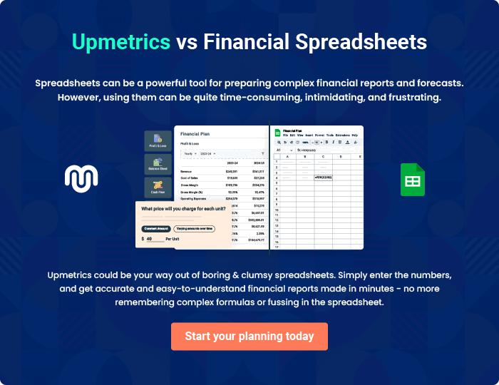

Platinum Hair Salon | Business Plan [YEAR] | 33/34


Create a winning business plan that gets you funded

Creating a stunning and investment-ready plan requires no writing, graphic designing, or financial planning expertise.

Upmetrics has all the features required to help you create a comprehensive business plan—from start to finish. Make no mistakes, it’s the modern way of planning to structure ideas, make plans, and create stunning pitch decks to awe investors.

Pitch decks that impress investors

Create pitch decks that provide a visual representation of your business, engage investors, and make them want to invest in your business idea.

Interactive plans in no time

Import business plan sections like—SWOT analysis, comparison tables, and others to create an interactive business plan. No designing skills are required.

Stunning cover page designs

With Upmetrics, you have the liberty to choose from multiple stunning cover page designs. Choose a creative design and make your plan stand out.

Online sharing made simple

Upmetrics makes online sharing quick and easier for users. Easily share your business plans with a link while tracking reader activity.

500+ sample business plans

Simply import a template from our library of sample plans into the editor and start customizing it to make it yours. It takes only a few clicks to get started.

Collaborate with team in real-time

Invite team members, initiate conversations, discuss ideas & strategies, share feedback, and work on a business plan in real-time.

