
Gift Shop


Business
Plan

[YEAR]
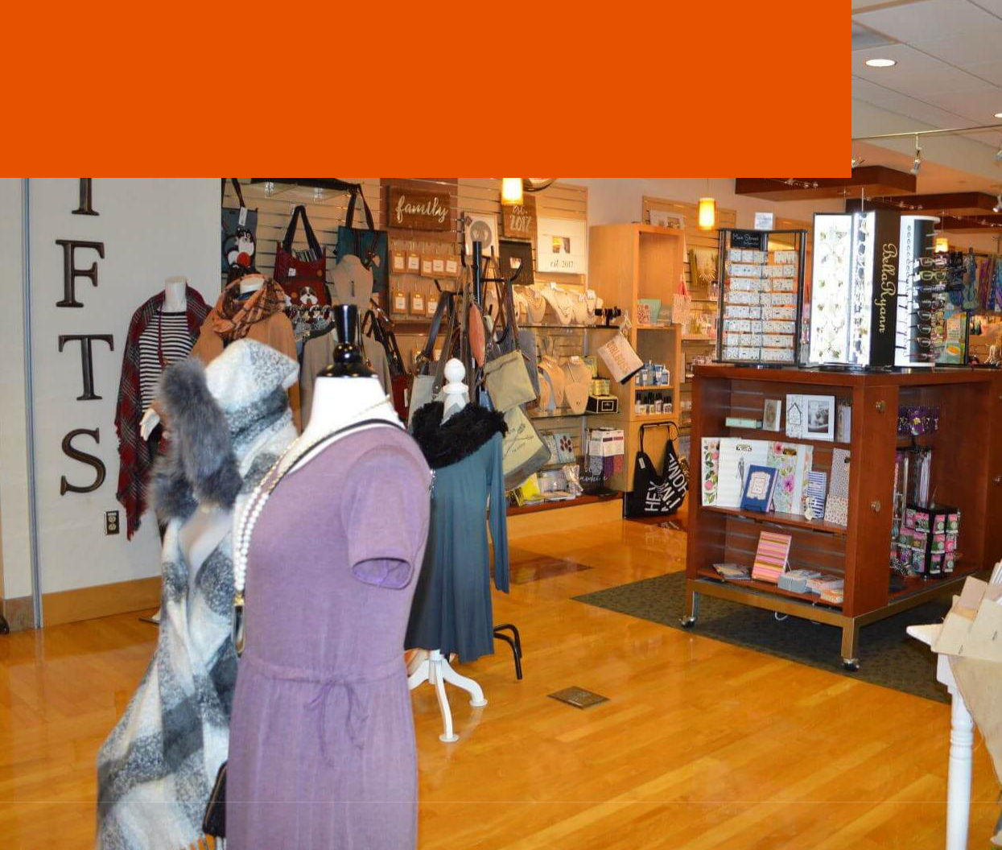

A place where you buy emotions

Information provided in this business plan is unique to this business and confidential; therefore, anyone reading this plan agrees not to disclose any of the information in this business plan without prior written permission of the Company

 | Prepared By | 10200 Bolsa Ave, Westminster, CA, 92683
 | John Doe | info@example.com
 | (650) 359-3153 | http://www.example.com

Table of Contents

Executive Summary | 5
Vision Statement | 6
Mission Statement | 6
Keys to Success | 7
The Business | 7
Target of the Company | 8
3 Year profit forecast | 8

Company Summary | 9
The Purpose of starting a business | 10
Company Ownership | 10
Start-up Summary | 11
Startup cost | 11
Funding Required | 11

Products and Services | 14
Product Description | 15
Printing Products | 15
Customized Apparel | 15
Home Accessories | 16
Personal Care Accents | 16
Pet Products | 16
Specialty Gifts | 16
Service Description | 17
Plastic Gift Cards | 17
Customization Services | 17
V.I.P. Customer Appreciation | 17
Corporate Gift Program | 18

Market Analysis | 19
Market Trends | 20

Gift Shop | Business Plan [YEAR] 2/42

Target Market | 20
Marketing Segmentation | 20
Marketing share | 21
Young & Adults | 21
Senior Citizens | 21
Children & Teens | 22
Market Analysis | 22
Product Pricing | 22

Strategy and Implementation Summary | 23
Competitive Analysis | 24
Key Competitive Strategies | 24
Key Competitive Weaknesses | 25
Marketing Strategy | 25
Pricing Strategy | 25
Promotion Strategy | 25
Marketing Channels | 26
Sales Strategy | 26
Sales Yearly | 26
Sales Forecast | 27
Detailed Sales Forecast | 27

Management Summary | 29
Personnel plan | 30
Average Salary of Employees | 31
Financial Plan
Financial Plan | 32
Important Assumptions | 33
Brake-even Analysis | 33
Projected Profit and Loss | 33
Projected Cash Flow | 36
Projected Balance Sheet | 38
Business Ratios | 39

Gift Shop | Business Plan [YEAR] 3/42

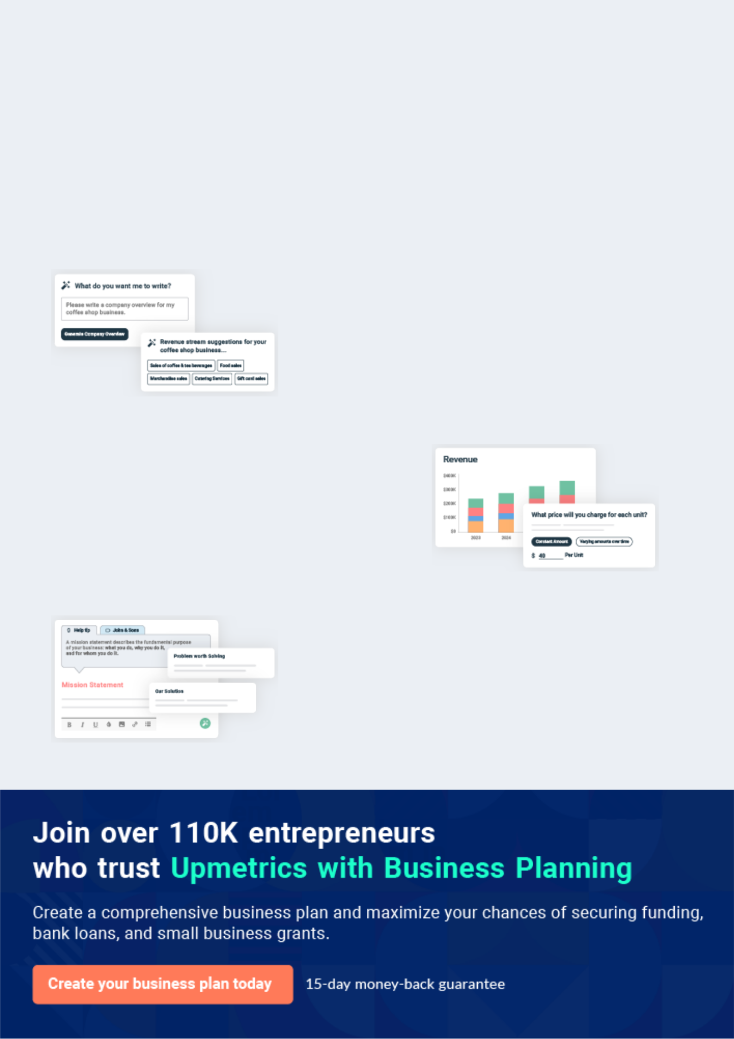
Business planning that’s simpler and faster than you think

Creating a business plan using Upmetrics to start and grow a business is literally the easiest thing in the World. Simply read the instructions and fill in the blanks. It’s as simple as that.

❛ | Upmetrics has everything you need to create a | ❜
❛ | comprehensive business plan. | ❜

AI-powered Upmetrics Assistant

AI-powered insights to streamline your plan

Not sure where to start? Upmetrics’ AI Assistant will automatically generate ideas for each section of your plan and offer improved versions of your writing, adjusting for tone, voice, and grammar or spelling errors.

Financial Forecasting Tool

All the financials are calculated for you

Forget the complex formulas and clumsy spreadsheets — with automatic financials and drag-and-drop forecasting, you can finish your plan faster and be confident that your numbers are accurate.

Business Plan Builder

Guides you like a business mentor

Upmetrics’ step-by-step instructions, prompts, and the library of 400+ sample business plans will guide you through each section of your plan as a business mentor.

1.


Executive Summary

Vision Statement

Mission Statement

Keys to Success

The Business

Target of the Company

Gift Shop | Business Plan [YEAR] 5/42

Before you think about how to start a Gift Shop services, you must create a detailed Gist Shop business plan. It will not only guide you in the initial phases of your startup but will also help you later on.
To unlock help try Upmetrics!

 Ex :: Wellington




Wellington Gifts & Cards Shop, LLC is a registered gift and card shop business that will be located in one of the busiest market districts in Baton Rouge – Louisiana. We have been able to lease a shop facility along a major road that is big enough to fit into the kind of gift shop that
To unlock help try Upmetrics! 

Start writing here..

Vision Statement

 Ex :: Wellington

Our plan is to position Wellington Gifts & Cards Shop, LLC to become the leading brand in the industry in the whole of Louisiana, and also to be amongst the top 10 gift and card shops in the whole of the United States of America within the first 10 years of opening our first gift shop.
To unlock help try Upmetrics! 

Start writing here..

Mission Statement

 Ex :: Wellington

Wellington Gifts & Cards Shop, LLC will at all times demonstrate her commitment to sustainability, both individually and as a firm, by actively participating in our communities and integrating sustainable business practices wherever possible. We will ensure that we hold
To unlock help try Upmetrics! 

Start writing here..

Gift Shop | Business Plan [YEAR] 6/42

Keys to Success

 Ex :: Wellington

• Acquire and personally design a product line of "one-of-kind" handcrafted and unique products.
• Provide customized products and services that are "tailor-made" to each customer's
To unlock help try Upmetrics! 

Start writing here..

The Business

 Ex :: Wellington

Wellington Gifts & Cards Shop, LLC is owned by Mrs. Dora Wellington. She has the experience, qualification, and skill that will help grow the business to profitability within the shortest time frame. Although the business is launching out with just one outlet in Baton Rouge – Louisiana,
To unlock help try Upmetrics! 

Start writing here..

Gift Shop | Business Plan [YEAR] 7/42

Target of the Company

Our target is to be the best and the most popular business of our type in Las Vegas and to earn a profit margin of $10 k per month by the end of the first year.

3 Year profit forecast
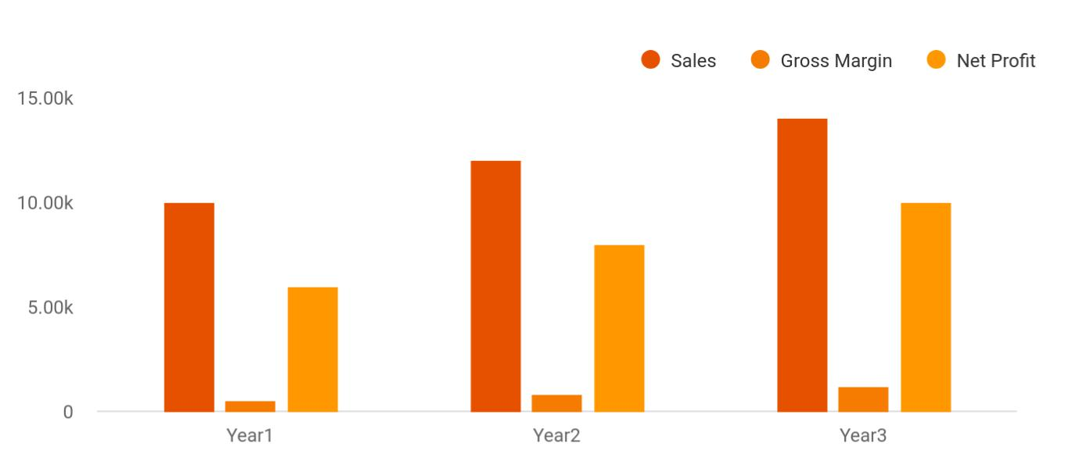

Financial Year | Sales | Gross Margin | Net Profit
Year1 | 10,000 | 500 | 6,000
Year2 | 12,000 | 800 | 8,000
Year3 | 14,000 | 1,200 | 10,000

Gift Shop | Business Plan [YEAR] 8/42

2.

Company Summary

The Purpose of starting a business

Company Ownership

Start-up Summary

Funding Required

Gift Shop | Business Plan [YEAR] 9/42

 Ex :: Wellington
To unlock help try Upmetrics!

Wellington Gifts & Cards Shop, LLC is a privately owned shop. Wellington Gifts & Cards Shop specializes in a variety of unique merchandise ranging from specialty cards and personalized printing services to specialty handcrafted gifts and customized apparel. _{To unlock help try Upmetrics!} 

Start writing here..

The Purpose of starting a business

 Ex :: Wellington

What started out as a hobby for us soon evolved into a promising business venture. People and society are a subject for Mrs. Dora. After working for eight years as a management counselor, she wanted to do something different and interesting. After research on businesses that can
To unlock help try Upmetrics! 

Start writing here..

Company Ownership

 Ex :: Wellington

Wellington Gifts & Cards Shop, LLC is owned by Mrs. Dora who is involved in the operation and management of the company. In August of last year, the business became incorporated and is structured as a privately owned "S" Corporation.



Start writing here..

Gift Shop | Business Plan [YEAR] 10/42

Start-up Summary

 Ex :: Wellington

These figures are based on monthly and start-up expenses needed to open and functionally operate the gift store. The capital needed will come from both owner's personal finances.
To unlock help try Upmetrics! 

Start writing here..

Startup cost
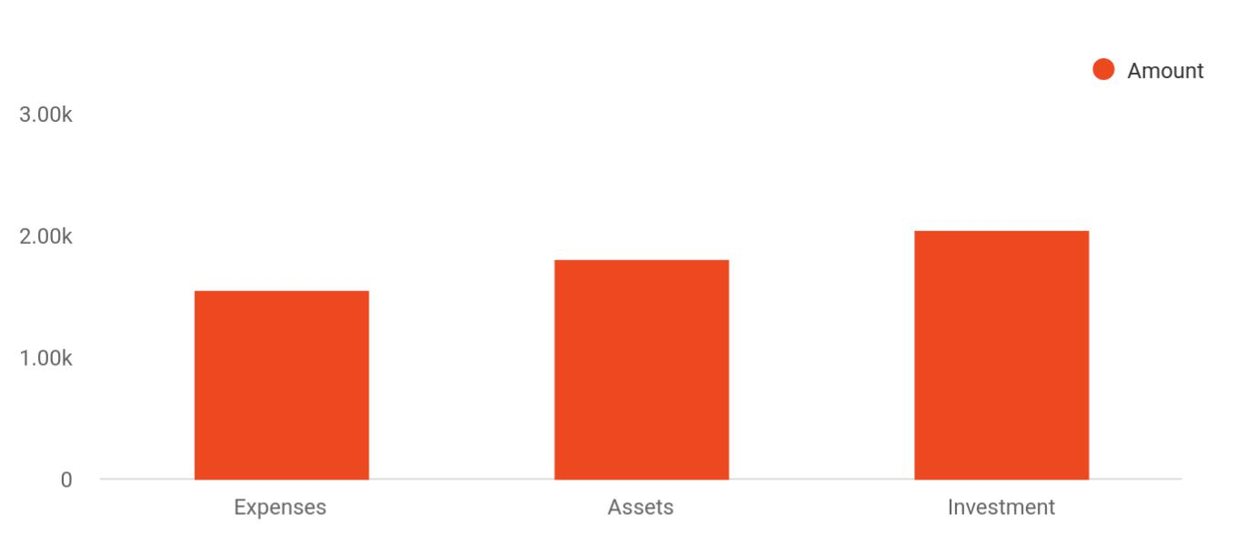

Cost distribution | Amount
Expenses | 1,550
Assets | 1,800
Investment | 2,050

Funding Required

The detailed start-up requirements, start-up expenses, total capital, and liabilities as forecasted by experts, is given below:


Startup Expenses

Legal

Consultants

Amount

$55 300

$0

Gift Shop | Business Plan [YEAR] 11/42

Startup Expenses | Amount
Insurance | $32 750
Rent | $32 500
Research and Development | $32 750
Equipment Expenses | $32 750
Signs | $1 250
TOTAL START-UP EXPENSES | $187 300
Start-up Assets | $220 875
Cash Required | $332 500
Start-up Inventory | $32 625
Other Current Assets | $232 500
Long-term Assets | $235 000
TOTAL ASSETS | $121 875
Total Requirements | $245 000
START-UP FUNDING
START-UP FUNDING | $273 125
Start-up Expenses to Fund | $151 875
Start-up Assets to Fund | $123 000
TOTAL FUNDING REQUIRED | $0
Assets | $23 125
Non-cash Assets from Start-up | $18 750
Cash Requirements from Start-up | $0
Additional Cash Raised | $18 750
Cash Balance on Starting Date | $21 875
TOTAL ASSETS | $373 125
Liabilities and Capital | $0
Liabilities | $0
Current Borrowing | $0
Long-term Liabilities | $0

Gift Shop | Business Plan [YEAR] 12/42

Startup Expenses | Amount
Accounts Payable (Outstanding Bills) | $0
Other Current Liabilities (interest-free) | $0
TOTAL LIABILITIES | $0
Capital | $620 125
Planned Investment | $620 125
Investor 1 | $0
Investor 2 | $0
Other | $0
Additional Investment Requirement | $0
TOTAL PLANNED INVESTMENT | $620 125
Loss at Start-up (Start-up Expenses) | $313 125
TOTAL CAPITAL | $251 875
TOTAL CAPITAL AND LIABILITIES | $251 875
Total Funding | $255 000

Gift Shop | Business Plan [YEAR] 13/42

3.

Products and Services

Product Description

Service Description

Gift Shop | Business Plan [YEAR] 14/42

Before starting a Gift Shop business, you must take many things into consideration such as you must consider what types of services will you be providing to your customers. Deciding your services is extremely important
To unlock help try Upmetrics!
To unlock help try Upmetrics! 

 Ex :: Wellington

We’ll be providing our services by hand to hand manually and through our online site. So, even if you are looking for an online gift shop business plan, you can take help from here.
To unlock help try Upmetrics! 

Start writing here..

Product Description

The following is an overview of our product line by category:

 Ex :: Wellington

The printing products are just an extension of Wellington Gifts & Cards Shop's visually artistic and creative ideas that we offer clients to engage in. Price-points in this category range from $5 - $250+.



Printing Products

Start writing here..

 Ex :: Wellington

Our offering of personalizing a client's favorite garment to reflect a special occasion or individual style will surely enhance their wardrobe. We use graphic imagery along with
decorative studs and rhinestones to create a personal style. Price-points in this category range
To unlock help try Upmetrics! 

Customized Apparel

Start writing here..

Gift Shop | Business Plan [YEAR] 15/42

 Ex :: Wellington
To unlock help try Upmetrics!

Our product line of home accessories is a collection of modern accents that customers can certainly connect with. Price-points in this category range from $5 - $100.
To unlock help try Upmetrics! 

Home Accessories

Start writing here..

 Ex :: Wellington

This category is very popular with customers when it comes to gift-giving or personal use.

Price-points in this category range from $6 - $15.
To unlock help try Upmetrics! 

Personal Care Accents

Start writing here..

 Ex :: Wellington

This trendy category will be very popular with potential customers and convenient for 80% of residential tenants in the complex who own a pet. Price-points in this category range from $5 - $25.



Pet Products

Start writing here..

 Ex :: Wellington

This gift-giving merchandise line will allow customers to express their personal sentiments for special occasions and the gift recipient. Price-points in this category range from $10 - $250.
To unlock help try Upmetrics! 

Specialty Gifts

Start writing here..

Gift Shop | Business Plan [YEAR] 16/42

Service Description

 Ex :: Wellington

To distinguish ourselves from surrounding specialty retailers, we provide numerous customized services that offer customers a satisfying and unique shopping experience.
To unlock help try Upmetrics! 

Start writing here..

 Ex :: Wellington

Gift cards are available to customers when purchasing for gift recipients may become a little difficult. We offer $25 gift cards.
To unlock help try Upmetrics! 

Plastic Gift Cards

Start writing here..

 Ex :: Wellington

To further enhance the customer's shopping experience, we provide customers with the option of customizing almost any item of our product line. Whether it is printing products, specialty gifts, or home accessories customers can choose to have certain items customized to fit their
To unlock help try Upmetrics! 

Customization Services

Start writing here..

 Ex :: Wellington

In recognition of our "loyal" customers, we will provide them with V.I.P. cards. V.I.P. cardholders will receive a special discount on all merchandise for a specified time period
To unlock help try Upmetrics! 

V.I.P. Customer Appreciation

Start writing here..

Gift Shop | Business Plan [YEAR] 17/42

 Ex :: Wellington

Wellington Gifts & Cards Shop would like to branch out and explore business-to-business ventures. We will offer a 15% discount to businesses that purchase for their employees.
To unlock help try Upmetrics! 

Corporate Gift Program

Start writing here..
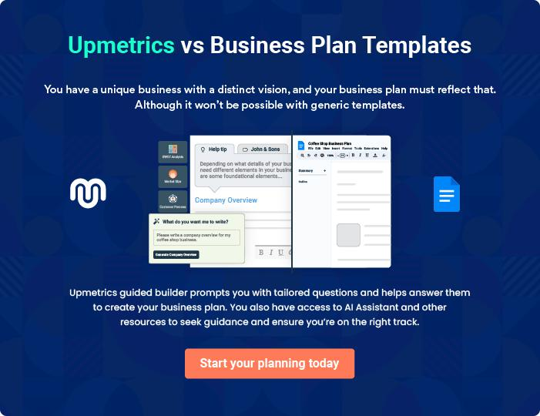

Gift Shop | Business Plan [YEAR] 18/42

4.

Market Analysis

Market Trends

Target Market

Marketing Segmentation

Market Analysis

Product Pricing

Gift Shop | Business Plan [YEAR] 19/42

After having decided on the products you’ll provide in your shop, it's time now to develop a marketing plan for the gift basket business. Knowing just about how to start a souvenir business, is not enough to run your business
To unlock help try Upmetrics! 

Market Trends

 Ex :: Wellington

The Gift Shops & Card Stores industry has risen slowly over the last five years while combating lackluster consumer spending and changing preferences pattern. The introduction of technology and subsequently online retail store has indeed helped in reshaping the industry.
To unlock help try Upmetrics! 

Start writing here..

Target Market

 Ex :: Wellington

When it comes to gift and card sales and delivery business, there is indeed a wide range of available customers. In essence, our target market can’t be restricted to just a group of people, but all those who reside in the location where we intend to open our shops. These are the
To unlock help try Upmetrics! 

Start writing here..

Marketing Segmentation

Our customers belong to every age group. To understand the needs of our customers, Wellington Gifts & Cards Shop has divided them into three groups, as given here:

Gift Shop | Business Plan [YEAR] 20/42

Marketing share
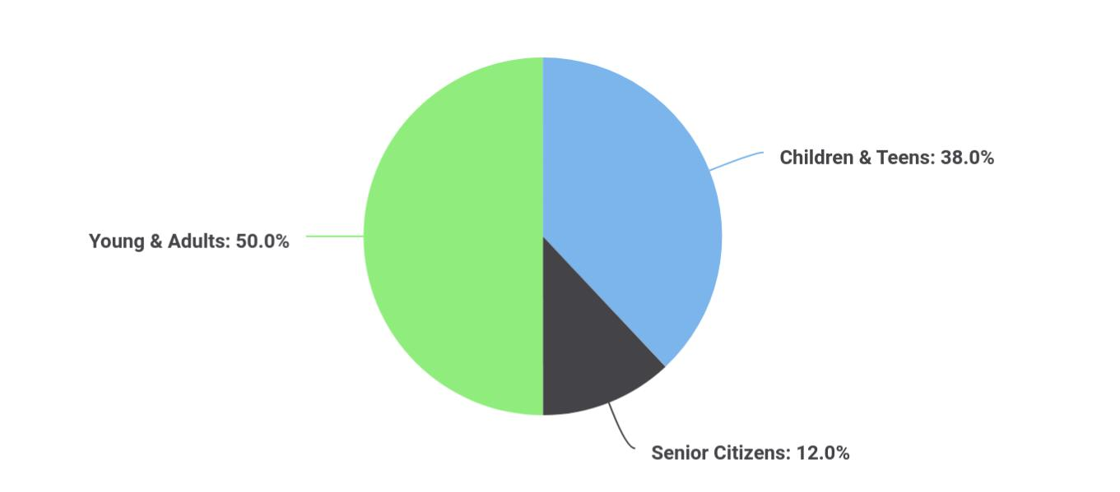

Segments | Market share
Children & Teens | 38
Senior Citizens | 12
Young & Adults | 50

The detailed marketing segmentation of our target audience is as follows:

 Ex :: Wellington

The third category includes the young and adults, they are expected to purchase mostly the specialty gifts or little expensive gifts. As they can afford to give gifts on their own incomes.
To unlock help try Upmetrics! 

Young & Adults

Start writing here..

 Ex :: Wellington

The second category will comprise of the elder citizens, men, and women who give small gifts to their partners, friends, and colleagues. We will be having a wide collection of gift items for this group so that they won’t need to search for the desired item by visiting many shops.
To unlock help try Upmetrics! 

Senior Citizens

Start writing here..

Gift Shop | Business Plan [YEAR] 21/42

 Ex :: Wellington

The biggest group of our target customers will mostly comprise of the children, college going girls and boys who give small and normal priced gifts to their friends. We’ll be having gifts at affordable prices for them to fulfill the need of giving gifts without disturbing their budget.
To unlock help try Upmetrics! 

Children & Teens

Start writing here..

Market Analysis

The detailed market analysis of our potential customers is given in the following table:

Potential Customers | Growth | Year 1 | Year 2 | Year 3 | Year 4 | Year 5 | CAGR
Children & Teens | 48% | 22 334 | 32 344 | 43 665 | 52 544 | 66 432 | 10,00%
Senior Citizens | 32% | 12 867 | 14 433 | 15 999 | 17 565 | 19 131 | 15,32%
Young & Adults | 20% | 11 433 | 13 344 | 16 553 | 18 745 | 20 545 | 13,43%
Total | 100% | 46 634 | 60 121 | 76 217 | 88 854 | 106 108 | 9,54%

Product Pricing

 Ex :: Wellington

Product pricing structures will be based on cost-plus and competitive pricing. Cost-plus pricing is basing the price on the basis of all costs plus a mark-up to cover overhead costs. Our mark-up cost is 33%. All orders will require a 50% deposit upon receiving the final shipment. For bulk
To unlock help try Upmetrics! 

Start writing here..

Gift Shop | Business Plan [YEAR] 22/42

5.

Strategy and

Implementation Summary

Competitive Analysis

Marketing Strategy

Sales Strategy

Gift Shop | Business Plan [YEAR] 23/42

After identifying the market demand, market trends, and the potential customers of the startup, the next step is to define an effective strategy for attracting those customers. Like marketing analysis, sales strategy is also an
To unlock help try Upmetrics! 

Competitive Analysis

Key Competitive Strategies


Customized Services

These "tailor-made" services offer the customer a personal connection to the product that he/she is purchasing. This type of service is not commonly offered in today's retail marketplace.

Handmade/

Handcrafted

Products

The handcrafted

products will be

designed by owner Mrs.

Dora Wellington as well

as outside

entrepreneurs. We will

showcase their crafts

on consignment. This

will also broaden our

own product line.

Printing Services

The added printing products service within the gift shop is unique for a gift shop. This will enable customers to bring in personal photographs and mementos or email digital images to create greeting cards, 12-month calendars or business cards. These types of items then become personal keep-sales and one-of-a-kind type merchandise.

Brand Identity

The proprietary products that we design will be distinguished from other products by brand labels. Our brand name merchandise makes up 50% of our present product line. Promoting "brand recognized" merchandise connects the customers to products that represent high-quality and dedicated customer service.

Gift Shop | Business Plan [YEAR] 24/42

Key Competitive Weaknesses
To unlock help try Upmetrics!
To unlock help try Upmetrics!

Range of Product Line

Although Wellington Gifts & Cards Shop's present product line is unique and high-end merchandise, the range of our products is considered small in relation to more established businesses. Yet these items are engaging and personable.

Location of the Gift Shop

Because the area is in its developing stages of residential and commercial enterprise zones, business traffic is relatively slow. However with time, west midtown will undoubtedly generate a traffic-flow of curious residents and outside customers.

Marketing Strategy

 Ex :: Wellington

Although Wellington Gifts & Cards Shop products are high-end and stylish, our pricing structure remains affordable and in-line with other specialty gift retailers. Our pricing structure is also based on the value the customers place on these products.



Pricing Strategy

Start writing here..

 Ex :: Wellington

Wellington Gifts & Cards Shop will host several seasonal open houses offering special discounts. This promotional strategy will showcase new products and liquidate slow-moving merchandise. The following illustrates the seasonal open houses:



Promotion Strategy

Start writing here..

Gift Shop | Business Plan [YEAR] 25/42

 Ex :: Wellington

Existing customers as well as potential customers will be informed about new merchandise and savings utilizing the following marketing communications channels:
To unlock help try Upmetrics! 

Marketing Channels

Start writing here..

Sales Strategy

 Ex :: Wellington

To advertise its services, Wellington Gifts & Cards Shop will follow the following techniques:

• We will carry out a social media campaign to get introduced to a wider audience
To unlock help try Upmetrics! 

Start writing here..

Sales Yearly
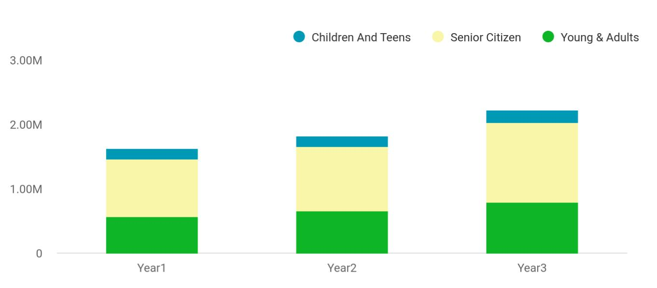

Financial Year | Children And Teens | Senior Citizen | Young & Adults
Year1 | 158,745 | 895,665 | 568,654
Year2 | 164,548 | 1,004,512 | 658,457

Gift Shop | Business Plan [YEAR] 26/42

Financial Year Children And Teens Senior Citizen Young & Adults

Year3 186,541 1,245,587 784,512

Sales Forecast
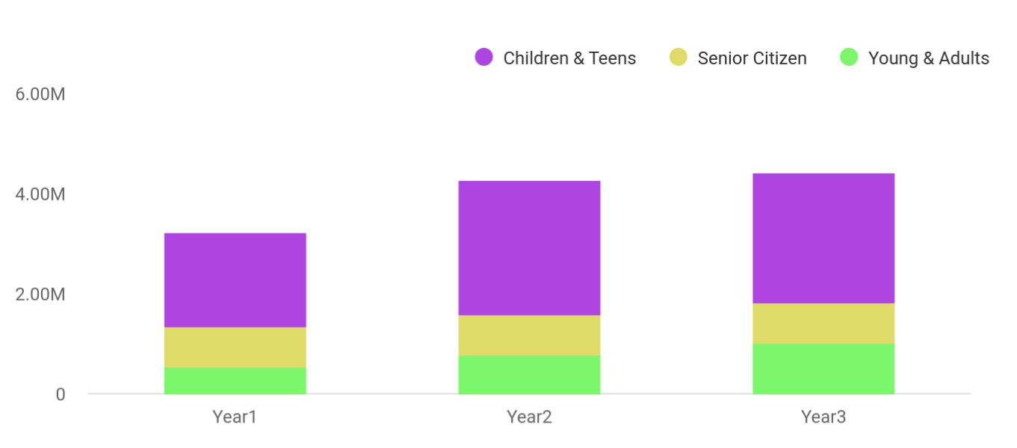

Financial Year | Children & Teens | Senior Citizen | Young & Adults
Year1 | 1,887,030 | 802,370 | 539,320
Year2 | 2,680,320 | 815,430 | 770,230
Year3 | 2,588,240 | 823,540 | 1,002,310

Detailed Sales Forecast

Start writing here..

 | Year 1 | Year 2 | Year 3
Unit Sales
General and Specialize Gifts | 1 887 030 | 2 680 320 | 2 588 240
Decorative Artworks | 802 370 | 815 430 | 823 540
Customized Apparel | 539 320 | 770230 | 1 002 310
Accessories | 265 450 | 322 390 | 393 320
TOTAL UNIT SALES | 3 494 170 | 4 588 370 | 4 807 410
Unit Prices
General and Specialize Gifts | $140,00 | $150,00 | $160,00

Gift Shop | Business Plan [YEAR] 27/42

 | Year 1 | Year 2 | Year 3
Decorative Artworks | $600,00 | $800,00 | $1 000,00
Customized Apparel | $700,00 | $800,00 | $900,00
Accessories | $650,00 | $750,00 | $850,00
Sales
General and Specialize Gifts | $2 149 800 | $2 784 000 | $3 383 200
Decorative Artworks | $120 050 | $194 500 | $268 500
Customized Apparel | $50 110 | $71 600 | $93 000
Accessories | $139 350 | $194 600 | $249 850
Direct Unit Costs
General and Specialize Gifts | $0,70 | $0,80 | $0,90
Decorative Artworks | $0,40 | $0,45 | $0,50
Customized Apparel | $0,30 | $0,35 | $0,40
Accessories | $3,00 | $3,50 | $4,00
Direct Cost of Sales
General and Specialize Gifts | $989 300 | $1 839 000 | $2 679 700
Decorative Artworks | $66 600 | $119 900 | $173 200
Customized Apparel | $17 900 | $35 000 | $52 100
Accessories | $19 400 | $67 600 | $115 800
Subtotal Direct Cost of Sales | $1 294 100 | $1 699 400 | $2 104 700

Gift Shop | Business Plan [YEAR] 28/42

6.

Management Summary

Personnel plan

Average Salary of Employees

Gift Shop | Business Plan [YEAR] 29/42

 Ex :: Wellington

Owner Mrs. Dora Wellington will initially manage the day-to-day operations of the boutique.

Dora has five-years of retail and accounting experience that she has applied to the business.
Both owners have also taken entrepreneurial classes through the local University SBDC (small
To unlock help try Upmetrics! 

Start writing here..

Personnel plan


You can start a gift shop business with a little or no staff, for if you are starting on a smaller scale. Dora will be opening her shop on larger scales and, has decided to provide online services as well, so she will need
To unlock help try Upmetrics! 

 Ex :: Wellington

Dora will act as the General Manager, and will initially hire the following people:

• 1 Co-Manager to help in managing the shop
To unlock help try Upmetrics! 

Start writing here..

Gift Shop | Business Plan [YEAR] 30/42

Average Salary of Employees

The following table shows the forecast data about employees and their salaries for the next three years.

 | Year 1 | Year 2 | Year 3
Co-Manager | $85 000 | $95 000 | $105 000
Accountant | $50 000 | $55 000 | $60 000
Sales Executives | $187 000 | $194 000 | $201 000
Decorators | $55 000 | $60 000 | $65 000
Drivers | $85 000 | $95 000 | $105 000
Customer Care Officer | $50 000 | $55 000 | $60 000
Salesman | $245 000 | $252 000 | $259 000
IT Experts | $85 000 | $95 000 | $105 000
Front Desk Officer | $50 000 | $55 000 | $60 000
Security Officer | $85 000 | $95 000 | $105 000
Total Salaries | $435 000 | $462 000 | $489 000

Gift Shop | Business Plan [YEAR] 31/42

7.

Financial Plan

Important Assumptions

Brake-even Analysis

Projected Profit and Loss

Projected Cash Flow

Projected Balance Sheet

Business Ratios

Gift Shop | Business Plan [YEAR] 32/42

The last component of a Gift Shop business plan is an in-depth financial plan.

The financial plan crafts a detailed map of all the expenses needed for the
startup and how these expenses will be met by the earned profits. It is
To unlock help try Upmetrics! 

Important Assumptions

The financial projections of the company are forecast on the basis of the following assumptions. These assumptions are quite conservative and are expected to show deviation but to a limited level such that the company’s major financial strategy will not be affected.

 | Year 1 | Year 2 | Year 3
Plan Month | 1 | 2 | 3
Current Interest Rate | 10,00% | 11,00% | 12,00%
Long-term Interest Rate | 10,00% | 10,00% | 10,00%
Tax Rate | 26,42% | 27,76% | 28,12%
Other | 0 | 0 | 0

Brake-even Analysis

Monthly Units Break-even | 5530
Monthly Revenue Break-even | $159 740
Assumptions:
Average Per-Unit Revenue | $260,87
Average Per-Unit Variable Cost | $0,89
Estimated Monthly Fixed Cost | $196 410

Projected Profit and Loss

 | 2024 | 2025 | 2026
Revenue | $468,459.71 | $685,043.86 | $1,021,750.56
Souvenir Sales | $119,378.55 | $214,386.90 | $385,007.40

Gift Shop | Business Plan [YEAR] 33/42

 | 2024 | 2025 | 2026
Unit Sales | 7,959 | 14,292 | 25,667
Unit Price | $15 | $15 | $15
Custom Gift Orders | $177,405 | $252,932 | $360,615
Unit Sales | 3,548 | 5,059 | 7,212
Unit Price | $50 | $50 | $50
Online Merchandise Sales | $171,676.16 | $217,724.96 | $276,128.16
Unit Sales | 10,730 | 13,608 | 17,258
Unit Price | $16 | $16 | $16

Cost Of Sales | $133,681.48 | $174,211.22 | $233,779.25
General Costs | $133,681.48 | $174,211.22 | $233,779.25
Souvenir Purchases | $84,893.50 | $111,377.23 | $150,485.19
Bulk Souvenir Purchases | $38,047.52 | $42,872.83 | $48,310.14
Custom Souvenir Orders | $46,845.98 | $68,504.40 | $102,175.05
Online Merchandise | $48,787.98 | $62,833.99 | $83,294.06
Online Merchandise | $25,364.99 | $28,581.81 | $32,206.53
Purchase | $25,364.99 | $28,581.81 | $32,206.53
Shipping Costs | $23,422.99 | $34,252.18 | $51,087.53
Revenue Specific Costs | $0 | $0 | $0
Personnel Costs (Direct | $0 | $0 | $0
Labor) | $0 | $0 | $0

Gross Margin | $334,778.23 | $510,832.64 | $787,971.31
Gross Margin (%) | 71.46% | 74.57% | 77.12%

Operating Expense | $372,206.42 | $395,073.77 | $425,259.07

Gift Shop | Business Plan [YEAR] 34/42

 | 2024 | 2025 | 2026
Payroll Expense (Indirect | $307,800 | $315,414 | $323,224.08
Labor) | $307,800 | $315,414 | $323,224.08
Store Staff | $157,200 | $160,944 | $164,780.88
Store Manager | $60,000 | $61,800 | $63,654
Sales Assistants | $97,200 | $99,144 | $101,126.88
Online Operations | $82,488 | $84,599.76 | $86,767.68
E-Commerce Manager | $46,200 | $47,586 | $49,013.64
Social Media Specialist | $36,288 | $37,013.76 | $37,754.04
Administration | $68,112 | $69,870.24 | $71,675.52
Administrative Assistant | $28,512 | $29,082.24 | $29,663.88
Accountant | $39,600 | $40,788 | $42,011.64
General Expense | $63,906.62 | $79,659.77 | $102,034.99
Store Operations | $31,706.23 | $35,727.15 | $40,258.05
Rent | $25,364.99 | $28,581.81 | $32,206.53
Utilities | $6,341.24 | $7,145.34 | $8,051.52
Marketing and Advertising | $27,227.69 | $38,539.31 | $55,918.26
Online Advertising | $23,422.99 | $34,252.18 | $51,087.53
Promotional Materials | $3,804.70 | $4,287.13 | $4,830.73
Administrative and General | $4,972.70 | $5,393.31 | $5,858.68
Office Supplies | $2,536.46 | $2,858.16 | $3,220.59
Insurance | $2,436.24 | $2,535.15 | $2,638.09
Bad Debt | $0 | $0 | $0
Amortization of Current | $499.80 | $0 | $0
Assets | $499.80 | $0 | $0

EBITDA | ($37,428.19) | $115,758.87 | $362,712.24

Gift Shop | Business Plan [YEAR] 35/42

Additional Expense

Long Term Depreciation

Gain or loss from Sale of Assets

EBIT

Interest Expense

EBT

Income Tax Expense / Benefit
2024 2025 2026

$6,173.48 | $5,206.38 | $4,179.63
$3,600 | $3,600 | $3,600
$0 | $0 | $0
($41,028.19) | $112,158.87 | $359,112.24
$2,573.47 | $1,606.38 | $579.64
($43,601.67) | $110,552.49 | $358,532.61
$0 | $0 | $0

Total Expense | $512,061.38 | $574,491.37 | $663,217.95
Net Income | ($43,601.67) | $110,552.49 | $358,532.61
Net Income (%) | (9.31%) | 16.14% | 35.09%
Retained Earning Opening | $0 | ($61,601.67) | $30,950.82
Owner's Distribution | $18,000 | $18,000 | $18,000
Retained Earning Closing | ($61,601.67) | $30,950.82 | $371,483.43
Projected Cash Flow
 | 2024 | 2025 | 2026
Cash Received | $468,459.71 | $685,043.86 | $1,021,750.56
Cash Paid | $507,961.58 | $570,891.37 | $659,617.95
COS & General Expenses | $197,588.10 | $253,870.99 | $335,814.24
Salary & Wages | $307,800 | $315,414 | $323,224.08

Gift Shop | Business Plan [YEAR] 36/42

2024 2025 2026

Interest

Sales Tax

Income Tax

Net Cash From

Operations

Assets Sell

Assets Purchase

Net Cash From

Investments

Amount Received

Loan Received

Common Stock

Preferred Stock

Owner's Contribution

Amount Paid

Loan Capital

Dividends & Distributions

Net Cash From

Financing

Summary

$2,573.47 | $1,606.38 | $579.64
$0 | $0 | $0
$0 | $0 | $0
($39,501.87) | $114,152.49 | $362,132.61

$0 | $0 | $0
$20,500 | $0 | $0
($20,500) | $0 | $0

$80,000 | $0 | $0
$50,000 | $0 | $0
$0 | $0 | $0
$0 | $0 | $0
$30,000 | $0 | $0
$33,679.72 | $34,646.82 | $35,673.45
$15,679.73 | $16,646.82 | $17,673.44
$18,000 | $18,000 | $18,000
$46,320.28 | ($34,646.82) | ($35,673.45)

Starting Cash | $0 | ($13,681.59) | $65,824.08
Cash In | $548,459.71 | $685,043.86 | $1,021,750.56
Cash Out | $562,141.30 | $605,538.19 | $695,291.40
Change in Cash | ($13,681.59) | $79,505.67 | $326,459.16

Gift Shop | Business Plan [YEAR] 37/42

 | 2024 | 2025 | 2026
Ending Cash | ($13,681.59) | $65,824.08 | $392,283.24

Projected Balance Sheet

 | 2024 | 2025 | 2026
Assets | $2,718.61 | $78,624.28 | $401,483.44
Current Assets | ($13,681.39) | $65,824.28 | $392,283.44
Cash | ($13,681.59) | $65,824.08 | $392,283.24
Accounts Receivable | $0 | $0 | $0
Inventory | $0 | $0 | $0
Other Current Assets | $0.20 | $0.20 | $0.20
Long Term Assets | $16,400 | $12,800 | $9,200
Gross Long Term Assets | $20,000 | $20,000 | $20,000
Accumulated Depreciation | ($3,600) | ($7,200) | ($10,800)
Liabilities & Equity | $2,718.59 | $78,624.26 | $401,483.43
Liabilities | $34,320.26 | $17,673.44 | $0
Current Liabilities | $16,646.82 | $17,673.44 | $0
Accounts Payable | $0 | $0 | $0
Income Tax Payable | $0 | $0 | $0
Sales Tax Payable | $0 | $0 | $0
Short Term Debt | $16,646.82 | $17,673.44 | $0
Long Term Liabilities | $17,673.44 | $0 | $0
Long Term Debt | $17,673.44 | $0 | $0
Equity | ($31,601.67) | $60,950.82 | $401,483.43
Paid-in Capital | $0 | $0 | $0
Gift Shop | Business Plan [YEAR] |  |  | 38/42
 | 2024 |  |  | 2025 |  | 2026
Common Stock | $0 |  |  | $0 |  | $0
Preferred Stock | $0 |  |  | $0 |  | $0
Owner's Contribution | $30,000 |  |  | $30,000 |  | $30,000
Retained Earnings | ($61,601.67) |  | $30,950.82 |  |  | $371,483.43
Check | $0 |  |  | $0 |  | $0
Business Ratios
 |  | Year 1 | Year 2 |  | Year 3 | Industry Profile
Sales Growth |  | 4,35% | 30,82% |  | 63,29% | 4,00%
Percent of Total Assets
Accounts Receivable |  | 5,61% | 4,71% |  | 3,81% | 9,70%
Inventory |  | 1,85% | 1,82% |  | 1,79% | 9,80%
Other Current Assets |  | 1,75% | 2,02% |  | 2,29% | 27,40%
Total Current Assets |  | 138,53% | 150,99% |  | 163,45% | 54,60%
Long-term Assets |  | -9,47% | -21,01% |  | -32,55% | 58,40%
TOTAL ASSETS |  | 100,00% | 100,00% |  | 100,00% | 100,00%
Current Liabilities |  | 4,68% | 3,04% |  | 2,76% | 27,30%
Long-term Liabilities |  | 0,00% | 0,00% |  | 0,00% | 25,80%
Total Liabilities |  | 4,68% | 3,04% |  | 2,76% | 54,10%
NET WORTH |  | 99,32% | 101,04% |  | 102,76% | 44,90%
Percent of Sales
Sales |  | 100,00% | 100,00% |  | 100,00% | 100,00%
Gross Margin |  | 94,18% | 93,85% |  | 93,52% | 0,00%
Selling, General & Administrative Expenses |  | 74,29% | 71,83% |  | 69,37% | 65,20%
Advertising Expenses |  | 2,06% | 1,11% |  | 0,28% | 1,40%
Profit Before Interest and Taxes |  | 26,47% | 29,30% |  | 32,13% | 2,86%

Gift Shop | Business Plan [YEAR] 39/42

 | Year 1 | Year 2 | Year 3 | Industry Profile
Main Ratios
Current | 25,86 | 29,39 | 32,92 | 1,63
Quick | 25,4 | 28,88 | 32,36 | 0,84
Total Debt to Total Assets | 2,68% | 1,04% | 0,76% | 67,10%
Pre-tax Return on Net Worth | 66,83% | 71,26% | 75,69% | 4,40%
Pre-tax Return on Assets | 64,88% | 69,75% | 74,62% | 9,00%
Additional Ratios | Year 1 | Year 2 | Year 3
Net Profit Margin | 19,20% | 21,16% | 23,12% | N.A.
Return on Equity | 47,79% | 50,53% | 53,27% | N.A.
Activity Ratios
Accounts Receivable Turnover | 4,56 | 4,56 | 4,56 | N.A.
Collection Days | 92 | 99 | 106 | N.A.
Inventory Turnover | 19,7 | 22,55 | 25,4 | N.A.
Accounts Payable Turnover | 14,17 | 14,67 | 15,17 | N.A.
Payment Days | 27 | 27 | 27 | N.A.
Total Asset Turnover | 1,84 | 1,55 | 1,26 | N.A.
Debt Ratios
Debt to Net Worth | 0 | -0,02 | -0,04 | N.A.
Current Liab. to Liab. | 1 | 1 | 1 | N.A.
Liquidity Ratios
Net Working Capital | $120 943 | $140 664 | $160 385 | N.A.
Interest Coverage | 0 | 0 | 0 | N.A.
Additional Ratios
Assets to Sales | 0,45 | 0,48 | 0,51 | N.A.
Current Debt/Total Assets | 4% | 3% | 2% | N.A.
Acid Test | 23,66 | 27,01 | 30,36 | N.A.
Sales/Net Worth | 1,68 | 1,29 | 0,9 | N.A.
Dividend Payout | 0 | 0 | 0 | N.A.

Gift Shop | Business Plan [YEAR] 40/42

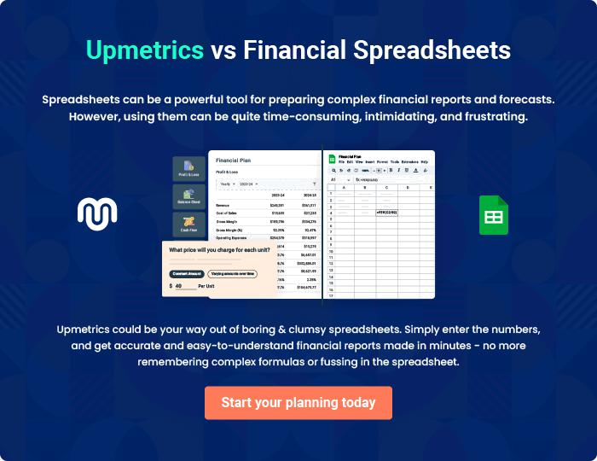

Gift Shop | Business Plan [YEAR] | 41/42


Create a winning business plan that gets you funded

Creating a stunning and investment-ready plan requires no writing, graphic designing, or financial planning expertise.

Upmetrics has all the features required to help you create a comprehensive business plan—from start to finish. Make no mistakes, it’s the modern way of planning to structure ideas, make plans, and create stunning pitch decks to awe investors.

Pitch decks that impress investors

Create pitch decks that provide a visual representation of your business, engage investors, and make them want to invest in your business idea.

Interactive plans in no time

Import business plan sections like—SWOT analysis, comparison tables, and others to create an interactive business plan. No designing skills are required.

Stunning cover page designs

With Upmetrics, you have the liberty to choose from multiple stunning cover page designs. Choose a creative design and make your plan stand out.

Online sharing made simple

Upmetrics makes online sharing quick and easier for users. Easily share your business plans with a link while tracking reader activity.

500+ sample business plans

Simply import a template from our library of sample plans into the editor and start customizing it to make it yours. It takes only a few clicks to get started.

Collaborate with team in real-time

Invite team members, initiate conversations, discuss ideas & strategies, share feedback, and work on a business plan in real-time.

