
- Gas Station

ADDRESS CONTACT

10200 Bolsa Ave, Westminster, CA, 92683 (650) 359-3153

info@example.com http://www.example.com


Business Plan

[YEAR]

Prepared By

John Doe


Information provided in this business plan is unique to this business and confidential; therefore, anyone reading this plan agrees not to disclose any of the information in this business plan without prior written permission of the company.

Table of Contents

Executive Summary | 5
Objectives | 6
Keys to Success | 6
Mission | 7
Financial Summary | 7
3 Year profit forecast | 7

Company Summary | 9
History | 10
Startup Summary | 10
Startup cost | 11

Products and Services | 14
Features | 15
Market Analysis
Market Analysis | 17
Industry Analysis | 18
Market Trends | 18
Market Segmentation | 18
Strategy & Implementations
Strategy & Implementations | 19
Advertising Strategy | 20
Pricing Strategy | 20
Sales Strategy | 20
Sales Forecast | 21
Operations Plan
Operations Plan | 22
Service Functions | 23
Administrative Functions | 23
Milestones | 24

Gas Station | Business Plan [YEAR] 2/35

Financial Plan | 25
Important Assumptions | 26
Brake-even Analysis | 26
Projected Profit and Loss | 27
Projected Cash Flow | 29
Projected Balance Sheet | 31
Business Ratios | 32

Gas Station | Business Plan [YEAR] 3/35

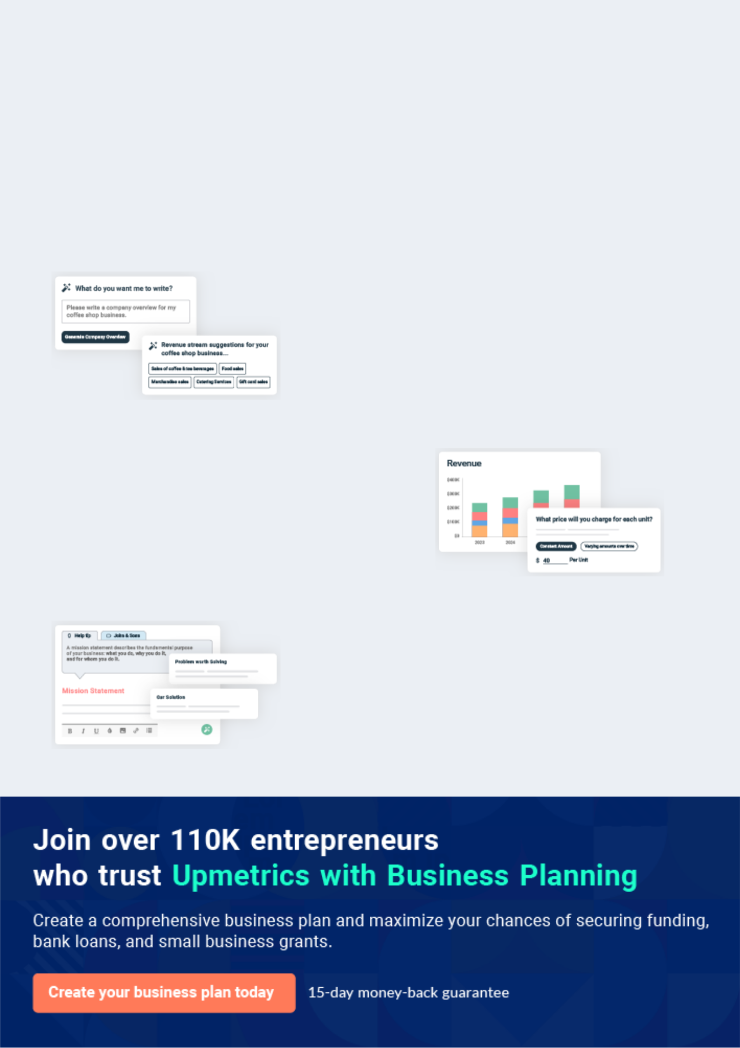
Business planning that’s simpler and faster than you think

Creating a business plan using Upmetrics to start and grow a business is literally the easiest thing in the World. Simply read the instructions and fill in the blanks. It’s as simple as that.

❛ | Upmetrics has everything you need to create a | ❜
❛ | comprehensive business plan. | ❜

AI-powered Upmetrics Assistant

AI-powered insights to streamline your plan

Not sure where to start? Upmetrics’ AI Assistant will automatically generate ideas for each section of your plan and offer improved versions of your writing, adjusting for tone, voice, and grammar or spelling errors.

Financial Forecasting Tool

All the financials are calculated for you

Forget the complex formulas and clumsy spreadsheets — with automatic financials and drag-and-drop forecasting, you can finish your plan faster and be confident that your numbers are accurate.

Business Plan Builder

Guides you like a business mentor

Upmetrics’ step-by-step instructions, prompts, and the library of 400+ sample business plans will guide you through each section of your plan as a business mentor.

1.


Executive Summary

Objectives

Keys to Success

Mission

Financial Summary

Gas Station | Business Plan [YEAR] 5/35

Before you think about how to start a Gas Station service, you must create a detailed Gas Station business plan. It will not only guide you in the initial phases of your startup but will also help you later on.
To unlock help try Upmetrics!

 Maxwell Gas Station




Maxwell Gas Station is a fully registered and licensed standard gas station that will be located along a busy highway in Detroit – Michigan, U.S. Our chains of gas stations that will be scattered all around major cities in the United States of America will adopt full service,
To unlock help try Upmetrics! 

Start writing here..

Objectives

 Maxwell Gas Station

- To capture an increasing share of the commuter traffic passing through Detroit.

- To offer our customers superior products, at an affordable price. _{To unlock help try Upmetrics!} 

Start writing here..

Keys to Success

 Maxwell Gas Station


- Good quality products at competitive prices.

- Excellent customer service that will promote customer loyalty. To unlock help try Upmetrics! 

Start writing here..

Gas Station | Business Plan [YEAR] 6/35

Mission
To unlock help try Upmetrics!

 Maxwell Gas Station

The mission of Maxwell Gas Station is to offer commuters on Highway 310 competitive gas prices and great food. The company will make a healthy profit for its owners and provide a rewarding work environment for its employees.



Start writing here..

Financial Summary

 Maxwell Gas Station

Capital Requirements and Use of Funds

Maxwell is seeking total funding of $260,000 of debt capital to launch its gas station. The
To unlock help try Upmetrics! 

Start writing here..

3 Year profit forecast
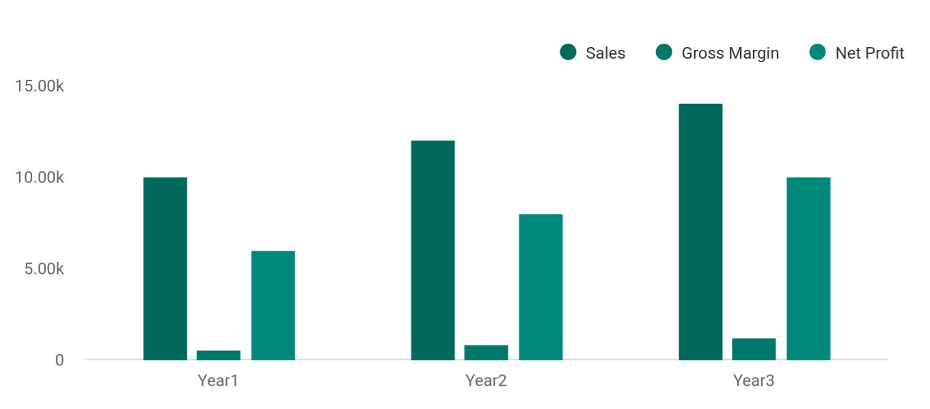

Gas Station | Business Plan [YEAR] 7/35

 Maxwell Gas Station


Financial Summary | Year 1 | Year 2 |  | Year 3
 |  |  | To unlock help try Upmetrics! |  | 

Start writing here..

Gas Station | Business Plan [YEAR] 8/35

2.

Company Summary

History

Startup Summary

Gas Station | Business Plan [YEAR] 9/35

 Maxwell Gas Station

Maxwell is engaged in selling and marketing gasoline and diesel products. We are committed to better, safer, cleaner, more efficient, more innovative, and more accessible energy. We offer refined petroleum products and lubricants for retail and commercial channels.
To unlock help try Upmetrics! 

Start writing here..

History

 Maxwell Gas Station

For 12 years, Maxwell has been City’s leading company for crude oil and gas production. It was in 2015 when Mr. James Moore first established his first gas station. He decided to open up a small gas station after seeing that there is no existing gas station within 5 miles from his
To unlock help try Upmetrics! 

Start writing here..

Startup Summary

 Maxwell Gas Station

John Moore will invest $60,000 in Maxwell Gas Station. Robert aims to secure an SBA of $150,000 to finance the remainder of the start-up costs.
To unlock help try Upmetrics! 

Start writing here..

Gas Station | Business Plan [YEAR] 10/35

Startup cost
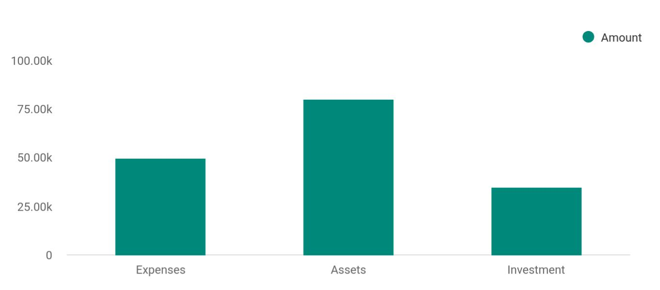

Cost distribution | Amount
Expenses | 50,000
Assets | 80,000
Investment | 35,000

Start-up Expenses | Amount
Legal | $75,500
Consultants | $0
Insurance | $62,750
Rent | $22,500
Research and Development | $42,750
Expensed Equipment | $42,750
Signs | $1,250
TOTAL START-UP EXPENSES | $247,500
Start-up Assets | $0
Cash Required | $322,500
Start-up Inventory | $52,625
Other Current Assets | $222,500
Long-term Assets | $125,000

Gas Station | Business Plan [YEAR] 11/35

Start-up Expenses | Amount
TOTAL ASSETS | $121,875
Total Requirements | $245,000
START-UP FUNDING | $0
START-UP FUNDING | $273,125
Start-up Expenses to Fund | $121,875
Start-up Assets to Fund | $195,000
TOTAL FUNDING REQUIRED | $0
Assets | $203,125
Non-cash Assets from Start-up | $118,750
Cash Requirements from Start-up | $0
Additional Cash Raised | $118,750
Cash Balance on Starting Date | $121,875
TOTAL ASSETS | $0
Liabilities and Capital | $0
Liabilities | $0
Current Borrowing | $0
Long-term Liabilities | $0
Accounts Payable (Outstanding Bills) | $0
Other Current Liabilities (interest-free) | $0
TOTAL LIABILITIES | $0
Capital | $0
Planned Investment | $0
Investor 1 | $312,500
Investor 2 | $0
Other | $0
Additional Investment Requirement | $0
TOTAL PLANNED INVESTMENT | $695,000
Loss at Start-up (Start-up Expenses) | $313,125

Gas Station | Business Plan [YEAR] 12/35


Start-up Expenses

TOTAL CAPITAL

TOTAL CAPITAL AND LIABILITIES

Total Funding
Amount

$221,875

$221,875

$265,000

Gas Station | Business Plan [YEAR] 13/35

3.

Products and Services

Features

Gas Station | Business Plan [YEAR] 14/35

 Maxwell Gas Station

Maxwell Gas Station is a fully registered and licensed standard gas station that is positioned in the gas station industry in the United States of America to maximize profits. Aside from the point that we will be retailing gasoline and diesel, we will also engage in other complimentary
To unlock help try Upmetrics! 

Start writing here..

Features


Gas

Automotive services

e.g. repairs, car washes and general parts

Retailing automotive fuels

e.g. diesel fuel and gasoline

Automotive-repair services

Diesel


Non Automotive fuel

Selling automotive-related goods

Wheel related services

- Providing Wheel Alignment, Wheel Balancing and Vulcanizing Services

•

Gas Station | Business Plan [YEAR] 15/35


Retailing of

Groceries and soft

drinks
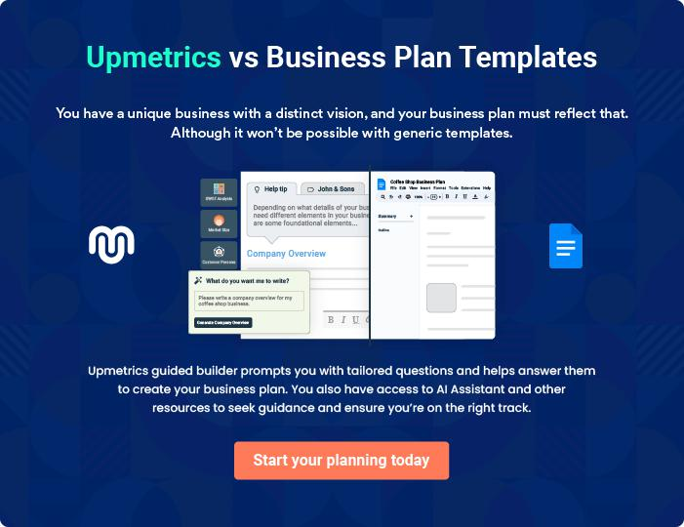

Gas Station | Business Plan [YEAR] 16/35

4.

Market Analysis

Industry Analysis

Market Trends

Market Segmentation

Gas Station | Business Plan [YEAR] 17/35

The most important component of an effective Gas Station business plan is its accurate marketing analysis. If you are starting on a smaller scale, you can do marketing analysis yourself by taking help from this Gas Station
To unlock help try Upmetrics! 

Industry Analysis

 Maxwell Gas Station

The Gas Stations industry has experienced growth over the past five years to 2020. Since the majority of the industry’s business is generated from consumers rather than commercial businesses, consumer spending plays a major role in determining industry performance.
To unlock help try Upmetrics! 

Start writing here..

Market Trends

 Maxwell Gas Station

There is hardly anyone who doesn’t have a need for gas, this is why it is really vital that one key into this industry. One of the trends in the gas station industry is that, in the bid to stay afloat in the highly competitive gas station industry, owners of gas stations now go the extra mile to
To unlock help try Upmetrics! 

Start writing here..

Market Segmentation

 Maxwell Gas Station


The target customers of Maxwell Gas Station are the commuters that use Highway 310.

 To unlock help try Upmetrics! 

Start writing here..

Gas Station | Business Plan [YEAR] 18/35

5.

Strategy &

Implementations

Advertising Strategy

Pricing Strategy

Sales Strategy

Sales Forecast

Gas Station | Business Plan [YEAR] 19/35

After identifying the market demand, market trends, and the potential customers of the startup, the next step is to define an effective strategy for attracting those customers. Like marketing analysis, sales strategy is also an
To unlock help try Upmetrics! 

Advertising Strategy

 Maxwell Gas Station

Despite the fact that our gas station is a standard one with a wide range of other complimentary services and products that can favorably compete with other leading brands in the gas station industry, we will still go ahead to intensify publicity for all our products and
To unlock help try Upmetrics! 

Start writing here..

Pricing Strategy

 Maxwell Gas Station

It is the wish of all businesses to have a pricing system that will yield loads of profits for them; as such we are working on having very competitive pricing. At Maxwell Gas Station, our pricing system is going to be based on what is obtainable in the industry, we don’t intend to charge
To unlock help try Upmetrics! 

Start writing here..

Sales Strategy

 Maxwell Gas Station

Maxwell Gas Station will keep its gas prices competitive with other stations in a fifty-mile radius of the station in order to attract commuters. Customers that purchase more than $10 worth of gas will be given a 15% coupon on purchases in the store during the first month of operation, to
To unlock help try Upmetrics! 

Start writing here..

Gas Station | Business Plan [YEAR] 20/35

Sales Forecast
To unlock help try Upmetrics!

 Maxwell Gas Station

In order to maintain competitive gas prices, the cost of gas to the consumer will never exceed 15% of wholesale cost. Maxwell Gas Station will focus on increasing food sales in order to meet total sales forecast goals.



Start writing here..
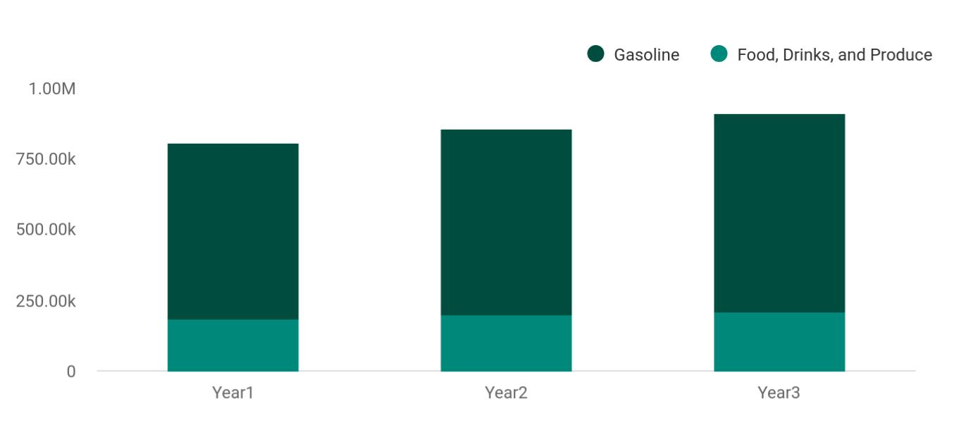

Financial Year | Gasoline | Food, Drinks, and Produce
Year1 | 623,000 | 185,000
Year2 | 660,000 | 198,000
Year3 | 700,000 | 210,000

Gas Station | Business Plan [YEAR] 21/35

6.

Operations Plan

Service Functions

Administrative Functions

Milestones

Gas Station | Business Plan [YEAR] 22/35

 Maxwell Gas Station

Maxwell Gas Station will be open 24/7 so there is an assurance that the clients will be served whenever they arrive at the station.
To unlock help try Upmetrics! 

Start writing here..

Service Functions

 Maxwell Gas Station

• Mechanic

• ^{Gas pump assistance} To unlock help try Upmetrics! 

Start writing here..

Administrative Functions

 Maxwell Gas Station

• General & administrative functions including marketing, bookkeeping, etc.

• Sourcing products and taking inventory for the minimart To unlock help try Upmetrics! 

Start writing here..

Gas Station | Business Plan [YEAR] 23/35

Milestones

 Maxwell Gas Station

Maxwell Gas Station’s long-term goal is to become the dominant provider of gas and related services and products in the city area. The following are a series of steps that lead to our vision of long-term success. Maxwell Gas Station expects to achieve the following milestones in the
To unlock help try Upmetrics! 

Start writing here..

Gas Station | Business Plan [YEAR] 24/35

7.

Financial Plan

Important Assumptions

Brake-even Analysis

Projected Profit and Loss

Projected Cash Flow

Projected Balance Sheet

Business Ratios

Gas Station | Business Plan [YEAR] 25/35

The last component of a Gas Station business plan is an in-depth financial plan. The financial plan crafts a detailed map of all the expenses needed for the startup and how these expenses will be met by the earned profits. It is
To unlock help try Upmetrics! 

 Maxwell Gas Station

The company will be financed by John himself and he will control the direction of the business to make sure that it is expanding at the forecasted rate. As for the Gas Station business start-up, no equity funding or outside loans will be required. With the help of financial experts, John
To unlock help try Upmetrics! 

Start writing here..

Important Assumptions

The financial projections of the company are forecast on the basis of the following assumptions. These assumptions are quite conservative and are expected to show deviation but to a limited level such that the company’s major financial strategy will not be affected.

 | Year 1 | Year 2 | Year 3
Plan Month | 1 | 2 | 3
Current Interest Rate | 10,00% | 11,00% | 12,00%
Long-term Interest Rate | 10,00% | 10,00% | 10,00%
Tax Rate | 26,42% | 27,76% | 28,12%
Other | 0 | 0 | 0

Brake-even Analysis

Monthly Units Break-even | 5530
Monthly Revenue Break-even | $159 740
Assumptions:
Average Per-Unit Revenue | $260,87
Average Per-Unit Variable Cost | $0,89
Estimated Monthly Fixed Cost | $196 410

Gas Station | Business Plan [YEAR] 26/35

Projected Profit and Loss

 | 2024 | 2025 | 2026
Revenue | $4,943,463.50 | $7,349,447.86 | $11,296,293.86
Fuel Sales | $2,148,812.10 | $3,858,957.96 | $6,930,134.06
Unit Sales | 1,432,541 | 2,572,639 | 4,620,089
Unit Price | $1.50 | $1.50 | $1.50
Convenience Store Sales | $2,414,176.20 | $3,061,761.60 | $3,883,058.40
Unit Sales | 160,945 | 204,117 | 258,871
Unit Price | $15 | $15 | $15
Car Wash Services | $380,475.20 | $428,728.30 | $483,101.40
Unit Sales | 38,048 | 42,873 | 48,310
Unit Price | $10 | $10 | $10

Cost Of Sales | $4,424,464.31 | $5,313,860.84 | $6,945,558.55
General Costs | $4,424,464.31 | $5,313,860.84 | $6,945,558.55
Fuel Purchase Costs | $2,941,425.25 | $3,109,026.48 | $3,556,670.41
Regular Gasoline Purchase | $1,800,000 | $1,822,840.05 | $2,107,363.47
Diesel Purchase | $1,141,425.25 | $1,286,186.43 | $1,449,306.94
Convenience Store Goods | $1,483,039.06 | $2,204,834.36 | $3,388,888.14
Snacks Purchase | $741,519.53 | $1,102,417.18 | $1,694,444.07
Beverages Purchase | $741,519.53 | $1,102,417.18 | $1,694,444.07
Revenue Specific Costs | $0 | $0 | $0
Personnel Costs (Direct | $0 | $0 | $0
Labor) | $0 | $0 | $0

Gross Margin | $518,999.19 | $2,035,587.02 | $4,350,735.31

Gas Station | Business Plan [YEAR] 27/35

 | 2024 | 2025 | 2026
Gross Margin (%) | 10.50% | 27.70% | 38.51%

Operating Expense | $513,174.86 | $635,094.53 | $831,620.15
Payroll Expense (Indirect | $267,360 | $275,980.80 | $284,884.08
Labor) | $267,360 | $275,980.80 | $284,884.08
Station Attendants | $67,680 | $69,710.40 | $71,801.76
Cashier | $36,000 | $37,080 | $38,192.40
Pump Attendant | $31,680 | $32,630.40 | $33,609.36
Convenience Store Staff | $88,800 | $92,064 | $95,449.92
Store Manager | $60,000 | $62,400 | $64,896
Sales Clerk | $28,800 | $29,664 | $30,553.92
Car Wash Staff | $110,880 | $114,206.40 | $117,632.40
Car Wash Operator | $33,120 | $34,113.60 | $35,136.96
Cleaning Staff | $77,760 | $80,092.80 | $82,495.44
General Expense | $245,814.86 | $359,113.73 | $546,736.07
Utility Expenses | $34,242.69 | $38,585.52 | $43,479.10
Electricity | $25,364.99 | $28,581.81 | $32,206.53
Water | $8,877.70 | $10,003.71 | $11,272.57
Operational Expenses | $31,706.25 | $35,727.44 | $40,258.50
Maintenance | $19,023.72 | $21,436.34 | $24,155.06
Cleaning | $12,682.53 | $14,291.10 | $16,103.44
Marketing and Advertising | $179,865.92 | $284,800.77 | $462,998.47
Local Advertising | $107,440.62 | $192,947.90 | $346,506.71
Online Marketing | $72,425.30 | $91,852.87 | $116,491.76
Bad Debt | $0 | $0 | $0

Gas Station | Business Plan [YEAR] 28/35

Amortization of Current Assets

EBITDA

Additional Expense

Long Term Depreciation

Gain or loss from Sale of Assets

EBIT

Interest Expense

EBT

Income Tax Expense / Benefit

Total Expense

Net Income

Net Income (%)

Retained Earning Opening

Owner's Distribution

Retained Earning Closing

2024 | 2025 | 2026
$0 | $0 | $0

$5,824.35 $1,400,492.52 $3,519,115.19

$37,049.77 | $32,430.99 | $27,575.91
$14,100 | $14,100 | $14,100
$0 | $0 | $0
($8,275.65) | $1,386,392.52 | $3,505,015.19
$22,949.77 | $18,331 | $13,475.92
($31,225.42) | $1,368,061.53 | $3,491,539.28
$0 | $0 | $0

$4,974,688.94 | $5,981,386.36 | $7,804,754.61
($31,225.42) | $1,368,061.53 | $3,491,539.28
(0.63%) | 18.61% | 30.91%

$0 | ($51,225.42) | $1,296,836.11
$20,000 | $20,000 | $10,000
($51,225.42) | $1,296,836.11 | $4,778,375.39

Projected Cash Flow

 | 2024 | 2025 | 2026
Cash Received | $4,943,463.52 | $7,349,447.89 | $11,296,293.89

Gas Station | Business Plan [YEAR] 29/35

 | 2024 | 2025 | 2026
Cash Paid | $4,960,588.94 | $5,967,286.36 | $7,790,654.61
COS & General Expenses | $4,670,279.17 | $5,672,974.57 | $7,492,294.62
Salary & Wages | $267,360 | $275,980.80 | $284,884.08
Interest | $22,949.77 | $18,331 | $13,475.92
Sales Tax | $0 | $0 | $0
Income Tax | $0 | $0 | $0
Net Cash From | ($17,125.42) | $1,382,161.53 | $3,505,639.28
Operations | ($17,125.42) | $1,382,161.53 | $3,505,639.28

Assets Sell | $0 | $0 | $0
Assets Purchase | $150,000 | $0 | $0
Net Cash From | ($150,000) | $0 | $0
Investments | ($150,000) | $0 | $0

Amount Received | $700,000 | $0 | $0
Loan Received | $500,000 | $0 | $0
Common Stock | $0 | $0 | $0
Preferred Stock | $0 | $0 | $0
Owner's Contribution | $200,000 | $0 | $0
Amount Paid | $110,277.67 | $114,896.45 | $109,751.53
Loan Capital | $90,277.67 | $94,896.44 | $99,751.52
Dividends & Distributions | $20,000 | $20,000 | $10,000
Net Cash From | $589,722.33 | ($114,896.45) | ($109,751.53)
Financing | $589,722.33 | ($114,896.45) | ($109,751.53)

Summary

Starting Cash | $0 | $422,596.91 | $1,689,861.99

Gas Station | Business Plan [YEAR] 30/35

 | 2024 | 2025 | 2026
Cash In | $5,643,463.52 | $7,349,447.89 | $11,296,293.89
Cash Out | $5,220,866.61 | $6,082,182.81 | $7,900,406.14
Change in Cash | $422,596.91 | $1,267,265.08 | $3,395,887.75
Ending Cash | $422,596.91 | $1,689,861.99 | $5,085,749.74

Projected Balance Sheet

 | 2024 | 2025 | 2026
Assets | $558,496.91 | $1,811,661.99 | $5,193,449.74
Current Assets | $422,596.91 | $1,689,861.99 | $5,085,749.74
Cash | $422,596.91 | $1,689,861.99 | $5,085,749.74
Accounts Receivable | $0 | $0 | $0
Inventory | $0 | $0 | $0
Other Current Assets | $0 | $0 | $0
Long Term Assets | $135,900 | $121,800 | $107,700
Gross Long Term Assets | $150,000 | $150,000 | $150,000
Accumulated Depreciation | ($14,100) | ($28,200) | ($42,300)

Liabilities & Equity | $558,496.91 | $1,811,662 | $5,193,449.76
Liabilities | $409,722.33 | $314,825.89 | $215,074.37
Current Liabilities | $94,896.44 | $99,751.52 | $0
Accounts Payable | $0 | $0 | $0
Income Tax Payable | $0 | $0 | $0
Sales Tax Payable | $0 | $0 | $0
Short Term Debt | $94,896.44 | $99,751.52 | $0
Long Term Liabilities | $314,825.89 | $215,074.37 | $215,074.37

Gas Station | Business Plan [YEAR] 31/35

 | 2024 |  |  | 2025 | 2026
Long Term Debt | $314,825.89 |  | $215,074.37 |  | $215,074.37
Equity | $148,774.58 |  | $1,496,836.11 |  | $4,978,375.39
Paid-in Capital | $0 |  |  | $0 | $0
Common Stock | $0 |  |  | $0 | $0
Preferred Stock | $0 |  |  | $0 | $0
Owner's Contribution | $200,000 |  | $200,000 |  | $200,000
Retained Earnings | ($51,225.42) |  | $1,296,836.11 |  | $4,778,375.39
Check | $0 |  |  | $0 | $0
Business Ratios
 |  | Year 1 | Year 2 | Year 3 | Industry Profile
Sales Growth |  | 4,35% | 30,82% | 63,29% | 4,00%
Percent of Total Assets
Accounts Receivable |  | 5,61% | 4,71% | 3,81% | 9,70%
Inventory |  | 1,85% | 1,82% | 1,79% | 9,80%
Other Current Assets |  | 1,75% | 2,02% | 2,29% | 27,40%
Total Current Assets |  | 138,53% | 150,99% | 163,45% | 54,60%
Long-term Assets |  | -9,47% | -21,01% | -32,55% | 58,40%
TOTAL ASSETS |  | 100,00% | 100,00% | 100,00% | 100,00%
Current Liabilities |  | 4,68% | 3,04% | 2,76% | 27,30%
Long-term Liabilities |  | 0,00% | 0,00% | 0,00% | 25,80%
Total Liabilities |  | 4,68% | 3,04% | 2,76% | 54,10%
NET WORTH |  | 99,32% | 101,04% | 102,76% | 44,90%
Percent of Sales
Sales |  | 100,00% | 100,00% | 100,00% | 100,00%

Gas Station | Business Plan [YEAR] 32/35

 | Year 1 | Year 2 | Year 3 | Industry Profile
Gross Margin | 94,18% | 93,85% | 93,52% | 0,00%
Selling, General & Administrative Expenses | 74,29% | 71,83% | 69,37% | 65,20%
Advertising Expenses | 2,06% | 1,11% | 0,28% | 1,40%
Profit Before Interest and Taxes | 26,47% | 29,30% | 32,13% | 2,86%
Main Ratios
Current | 25,86 | 29,39 | 32,92 | 1,63
Quick | 25,4 | 28,88 | 32,36 | 0,84
Total Debt to Total Assets | 2,68% | 1,04% | 0,76% | 67,10%
Pre-tax Return on Net Worth | 66,83% | 71,26% | 75,69% | 4,40%
Pre-tax Return on Assets | 64,88% | 69,75% | 74,62% | 9,00%
Additional Ratios
Net Profit Margin | 19,20% | 21,16% | 23,12% | N.A.
Return on Equity | 47,79% | 50,53% | 53,27% | N.A.
Activity Ratios
Accounts Receivable Turnover | 4,56 | 4,56 | 4,56 | N.A.
Collection Days | 92 | 99 | 106 | N.A.
Inventory Turnover | 19,7 | 22,55 | 25,4 | N.A.
Accounts Payable Turnover | 14,17 | 14,67 | 15,17 | N.A.
Payment Days | 27 | 27 | 27 | N.A.
Total Asset Turnover | 1,84 | 1,55 | 1,26 | N.A.
Debt Ratios
Debt to Net Worth | 0 | -0,02 | -0,04 | N.A.
Current Liab. to Liab. | 1 | 1 | 1 | N.A.
Liquidity Ratios
Net Working Capital | $120 943 | $140 664 | $160 385 | N.A.
Interest Coverage | 0 | 0 | 0 | N.A.
Additional Ratios
Assets to Sales | 0,45 | 0,48 | 0,51 | N.A.

Gas Station | Business Plan [YEAR] 33/35

 | Year 1 | Year 2 | Year 3 | Industry Profile
Current Debt/Total Assets | 4% | 3% | 2% | N.A.
Acid Test | 23,66 | 27,01 | 30,36 | N.A.
Sales/Net Worth | 1,68 | 1,29 | 0,9 | N.A.
Dividend Payout | 0 | 0 | 0 | N.A.
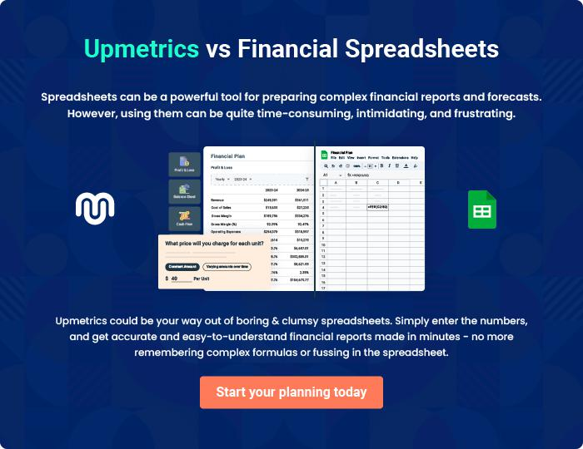

Gas Station | Business Plan [YEAR] 34/35


Create a winning business plan that gets you funded

Creating a stunning and investment-ready plan requires no writing, graphic designing, or financial planning expertise.

Upmetrics has all the features required to help you create a comprehensive business plan—from start to finish. Make no mistakes, it’s the modern way of planning to structure ideas, make plans, and create stunning pitch decks to awe investors.

Pitch decks that impress investors

Create pitch decks that provide a visual representation of your business, engage investors, and make them want to invest in your business idea.

Interactive plans in no time

Import business plan sections like—SWOT analysis, comparison tables, and others to create an interactive business plan. No designing skills are required.

Stunning cover page designs

With Upmetrics, you have the liberty to choose from multiple stunning cover page designs. Choose a creative design and make your plan stand out.

Online sharing made simple

Upmetrics makes online sharing quick and easier for users. Easily share your business plans with a link while tracking reader activity.

500+ sample business plans

Simply import a template from our library of sample plans into the editor and start customizing it to make it yours. It takes only a few clicks to get started.

Collaborate with team in real-time

Invite team members, initiate conversations, discuss ideas & strategies, share feedback, and work on a business plan in real-time.

