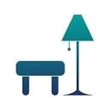
Furniture Company


Business
Plan

[YEAR]
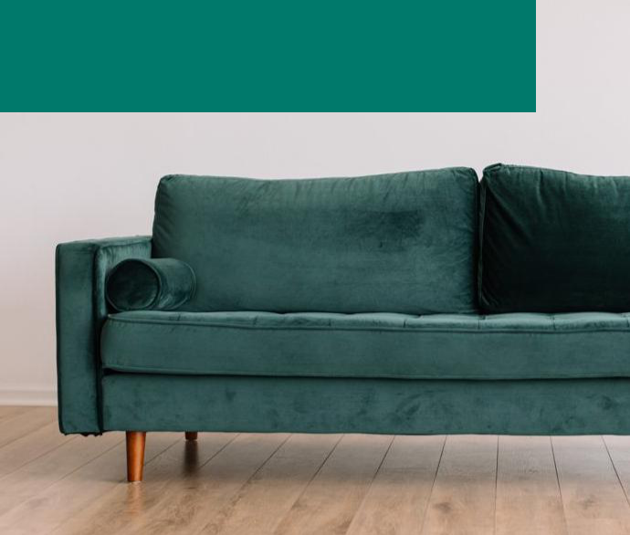

Crafted by highly specialized workers

Information provided in this business plan is unique to this business and confidential; therefore, anyone reading this plan agrees not to disclose any of the information in this business plan without prior written permission of the Company

 | Prepared By | 10200 Bolsa Ave, Westminster, CA, 92683
 | John Doe | info@example.com
 | (650) 359-3153 | https://example.com

Table of Contents

Executive Summary | 5
Business Overview | 6
Mission | 6
Objectives | 6
Success Factors | 7
Financial Highlights | 7
3 Year profit forecast | 7

Business Description | 9
Ownership | 10
Start-up Summary | 10
Startup cost | 10
Funding Required | 11

Products and Services | 12
Products and services | 13
Market Analysis
Market Analysis | 15
Market Trends | 16
Target Market Segment Strategy | 16
Marketing share | 16
Industry Analysis | 17
Competition and Buying Patterns | 17
Strategy
Strategy | 18
Competitive Edge | 19
Sales Strategy | 19
Sales Forecast | 19
Sales Yearly | 20
Detailed Sales Forecast | 20
Milestones | 21

Furniture Company | Business Plan [YEAR] 2/34

Management Summary | 22
Personnel Plan | 23
Financial Plan
Financial Plan | 24
Important Assumptions | 25
Brake-even Analysis | 25
Projected Profit and Loss | 26
Projected Cash Flow | 29
Projected Balance Sheet | 30
Business Ratios | 31

Furniture Company | Business Plan [YEAR] 3/34

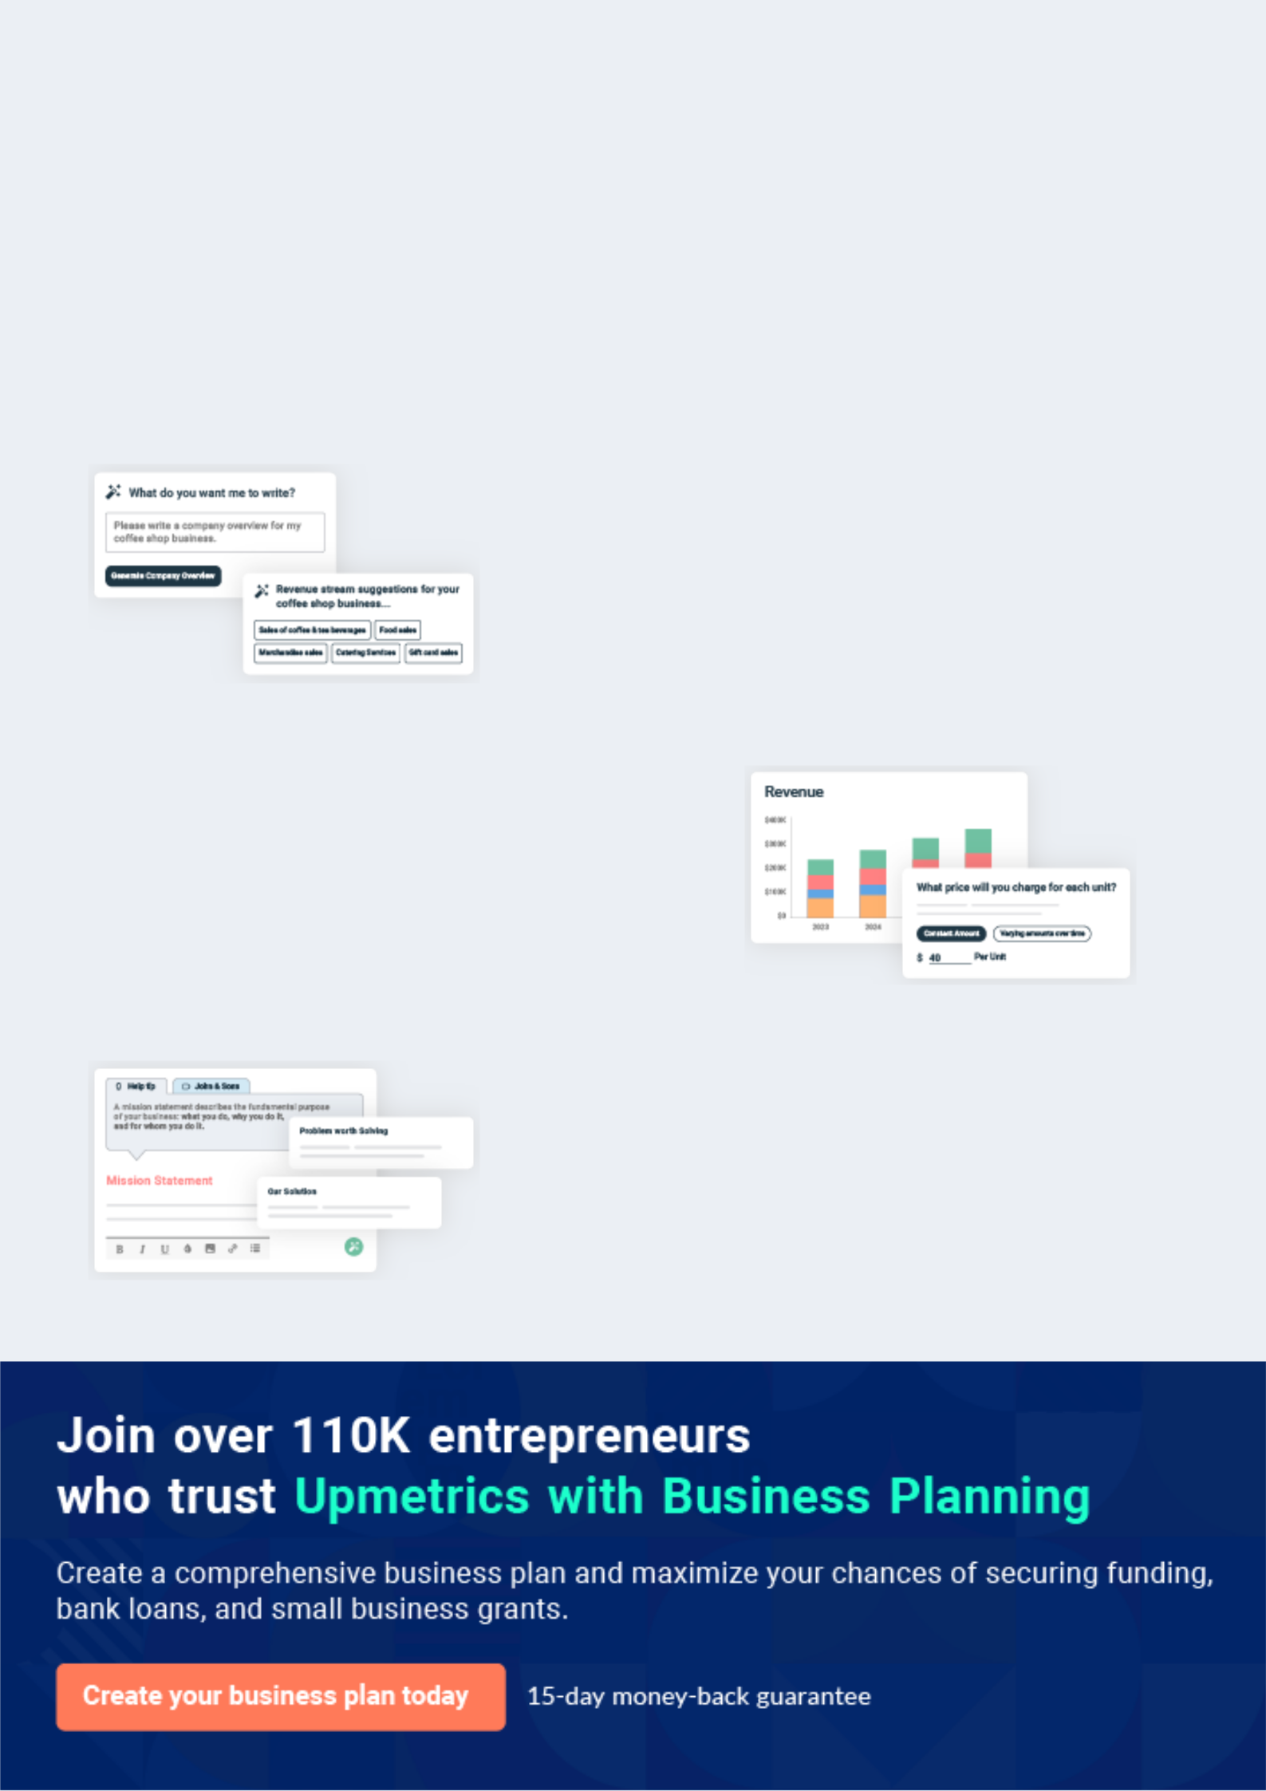
Business planning that’s simpler and faster than you think

Creating a business plan using Upmetrics to start and grow a business is literally the easiest thing in the World. Simply read the instructions and fill in the blanks. It’s as simple as that.

❛ | Upmetrics has everything you need to create a | ❜
❛ | comprehensive business plan. | ❜

AI-powered Upmetrics Assistant

AI-powered insights to streamline your plan

Not sure where to start? Upmetrics’ AI Assistant will automatically generate ideas for each section of your plan and offer improved versions of your writing, adjusting for tone, voice, and grammar or spelling errors.

Financial Forecasting Tool

All the financials are calculated for you

Forget the complex formulas and clumsy spreadsheets — with automatic financials and drag-and-drop forecasting, you can finish your plan faster and be confident that your numbers are accurate.

Business Plan Builder

Guides you like a business mentor

Upmetrics’ step-by-step instructions, prompts, and the library of 400+ sample business plans will guide you through each section of your plan as a business mentor.

1.


Executive Summary

Business Overview

Mission

Objectives

Success Factors

Financial Highlights

Furniture Company | Business Plan [YEAR] 5/34


Before you think about how to start furniture manufacturing services, you must create a detailed furniture manufacturing business plan. It will not only guide you in the initial phases of your startup but will also help you later on.
To unlock help try Upmetrics! 

Business Overview

 Carpentaria


Carpentaria Furniture is a standard and registered furniture manufacturing that will be located in Sharonville - Ohio; in an ideal location highly suitable for the kind of business we want to establish. A company specializing in custom cabinets for the high-end residential, resort, and
To unlock help try Upmetrics! 

Start writing here..

Mission

 Carpentaria

To deliver a high-quality product, on time and within budget while also providing a fast, error-free ordering system.
To unlock help try Upmetrics! 

Start writing here..

Objectives

 Carpentaria

The company objectives are:

• To be a top cabinet supplier to luxury homes in the regional market.
To unlock help try Upmetrics! 

Start writing here..

Furniture Company | Business Plan [YEAR] 6/34

Success Factors
To unlock help try Upmetrics!

 Carpentaria

Carpentaria Furniture is uniquely qualified to succeed for the following reasons:

• There is currently no furniture store devoted to local manufacture in the community we
To unlock help try Upmetrics! 

Start writing here..

Financial Highlights

 Carpentaria

The company owners have provided the capital to cover start-up expenses. The company currently seeks a 3-year commercial loan to cover the operating expenses. Specifically, these funds will be used as follows:



Start writing here..

3 Year profit forecast
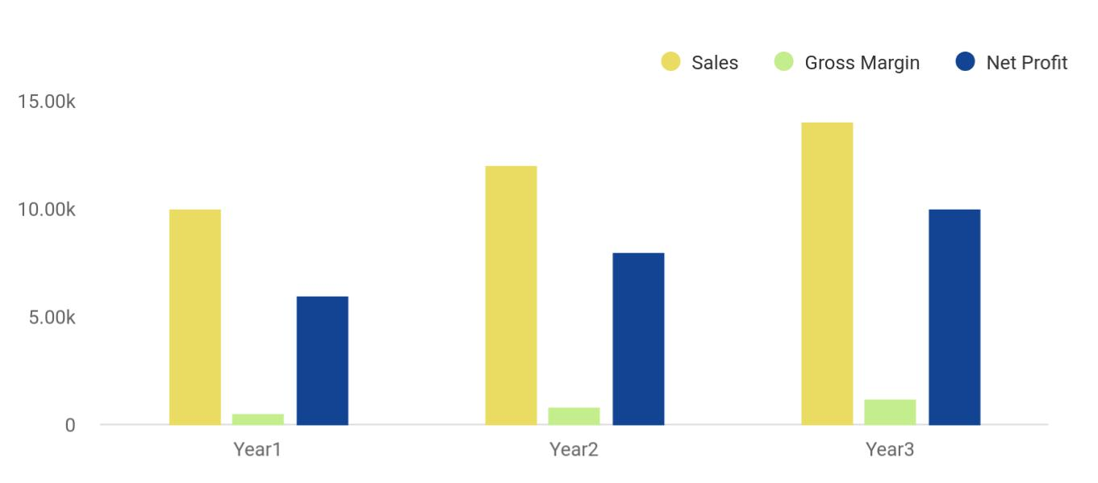

Financial Year | Sales | Gross Margin | Net Profit
Year1 | 10,000 | 500 | 6,000
Year2 | 12,000 | 800 | 8,000

Furniture Company | Business Plan [YEAR] 7/34

Financial Year | Sales | Gross Margin | Net Profit
Year3 | 14,000 | 1,200 | 10,000

 | FY 1 | FY 2 | FY 3 | FY 4 | FY 5
Revenue | $1,080,000 | $2,472,768 | $2,830,825 | $3,240,728 | $3,709,986
Total Expenses | $962,000 | $1,539,107 | $1,719,742 | $1,901,321 | $2,112,641
EBITDA | $118,000 | $933,661 | $1,111,082 | $1,339,407 | $1,597,344
Depreciation | $25,600 | $25,600 | $25,600 | $25,600 | $25,600
EBIT | $92,400 | $908,061 | $1,085,482 | $1,313,807 | $1,571,744
Interest | $29,946 | $26,202 | $22,459 | $18,716 | $14,973
Pre Tax Income | $62,455 | $881,858 | $1,063,023 | $1,295,091 | $1,556,772
Income Tax Expense | $21,859 | $308,650 | $372,058 | $453,282 | $544,870
Net Income | $40,595 | $573,208 | $690,965 | $841,809 | $1,011,902
Number of locations | 1 | 1 | 1 | 1 | 1
Average customers/day | 20 | 22 | 23 | 25 | 27
Number of orders | 3,600 | 7,776 | 8,398 | 9,070 | 9,796

Furniture Company | Business Plan [YEAR] 8/34

2.

Business Description

Ownership

Start-up Summary

Funding Required

Furniture Company | Business Plan [YEAR] 9/34

Ownership

 Carpentaria

Carpentaria Furniture will be owned and operated by Bill Moore who has been in the furniture industry for the last 20 years. Bill has been planning this startup for the last couple of years and, thus, has all resources including the right knowledge for starting a furniture company.
To unlock help try Upmetrics! 

Start writing here..

Start-up Summary

 Carpentaria

Total start-up expenses, including tools, software, stationery, and related expenses are shown below. Bill Moore will provide the bulk of the start-up financing. At the same time, the company plans to receive a 3-year commercial loan facility, which will help meet the cash flow
To unlock help try Upmetrics! 

Start writing here..

Startup cost
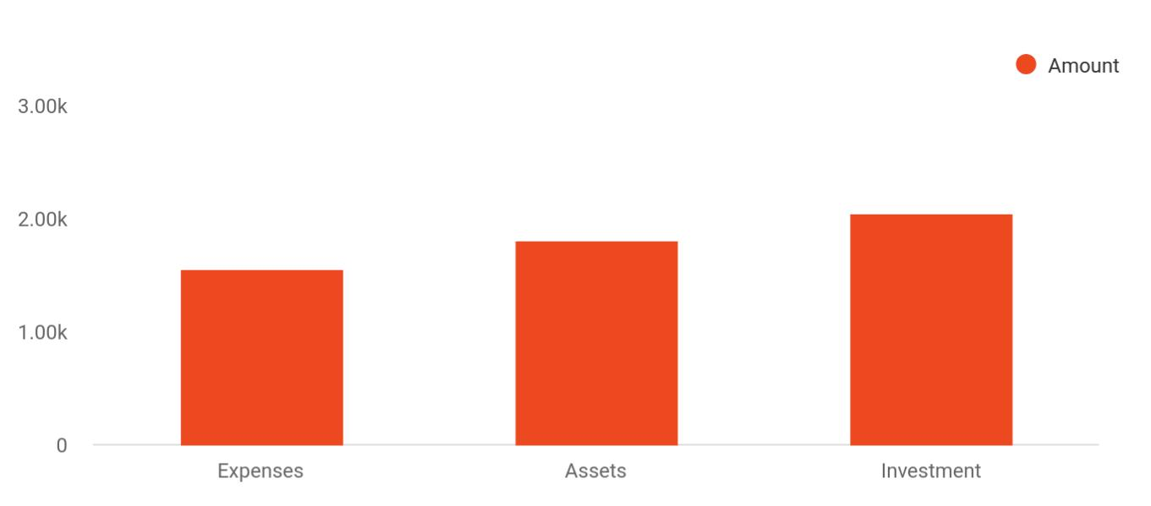

Cost distribution | Amount
Expenses | 1,550
Assets | 1,800

Furniture Company | Business Plan [YEAR] 10/34

Cost distribution Amount

Investment 2,050

Funding Required

The detailed startup requirements and expenses are given in the table below.

START-UP REQUIREMENTS | AMOUNT
Business Cards | $100
Drill Press | $1,916
Cabinet Jacks | $713
Kitchen Builder Software | $2,495
Lateral File | $236
Sign | $1,154
Seat Cushions | $338
Phone Transfer | $64
First/Last/ Deposit | $2,400
Marketing | $4,430
Level Package | $1,005
Sure Trak Software | $499
Estimating Database | $2,200
Software Lease Buyout | $7,092
TOTAL START-UP EXPENSES | $24,642
Start-up Assets
Cash Required | $89,299
Other Current Assets | $14,478
Long-term Assets | $0
TOTAL ASSETS | $103,777
Total Requirements | $128,419

Furniture Company | Business Plan [YEAR] 11/34

3.

Products and Services

Products and services

Furniture Company | Business Plan [YEAR] 12/34

Before starting a furniture manufacturing business, you must take many things into consideration such as you must consider what types of furniture services will you be providing to your customers. Deciding your services is
To unlock help try Upmetrics! 

 Carpentaria

The Wood House will be manufacturing the following supreme-class furniture products for its customers:
To unlock help try Upmetrics! 

Start writing here..

Products and services


Single and double Sofas and luxury

beds wooden chairs

Study and dining
Drawers and chests
tables

Desks and office Bookcases and

chairs cabinets

Furniture Company | Business Plan [YEAR] 13/34

 Carpentaria

Bill has started the furniture business to introduce space-efficient foldable furniture products for minimizing space usage along with the commercial production of usual furniture products. The company will also offer repair and maintenance services like polishing and glazing of old
To unlock help try Upmetrics! 

Start writing here..
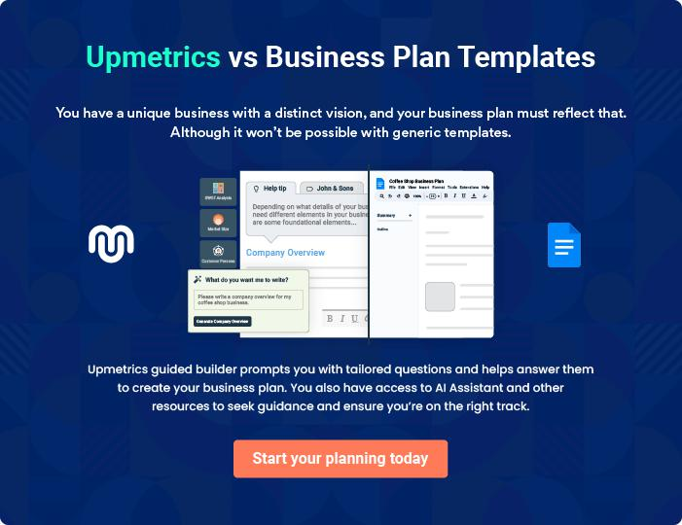

Furniture Company | Business Plan [YEAR] 14/34

4.

Market Analysis

Market Trends

Target Market Segment Strategy

Industry Analysis

Furniture Company | Business Plan [YEAR] 15/34

The most important component of an effective furniture manufacturing business plan is its accurate marketing analysis. If you are starting on a
To unlock help try Upmetrics!
smaller scale, you can do marketing analysis yourself by taking help from this
To unlock help try Upmetrics! 

Market Trends

 Carpentaria

Carpentaria Furniture will be focusing on architects, owners, and contractors in the regional area who are involved in the high-end residential, resort, and commercial development segments.



Start writing here..

Target Market Segment Strategy

 Carpentaria

Carpentaria Furniture will be focusing on contacting contractors and architects that deal with the luxury home market. Making ourselves known to these entities will generate some strong leads, along with getting personal recommendations to the home owners.
To unlock help try Upmetrics! 

Start writing here..

Marketing share
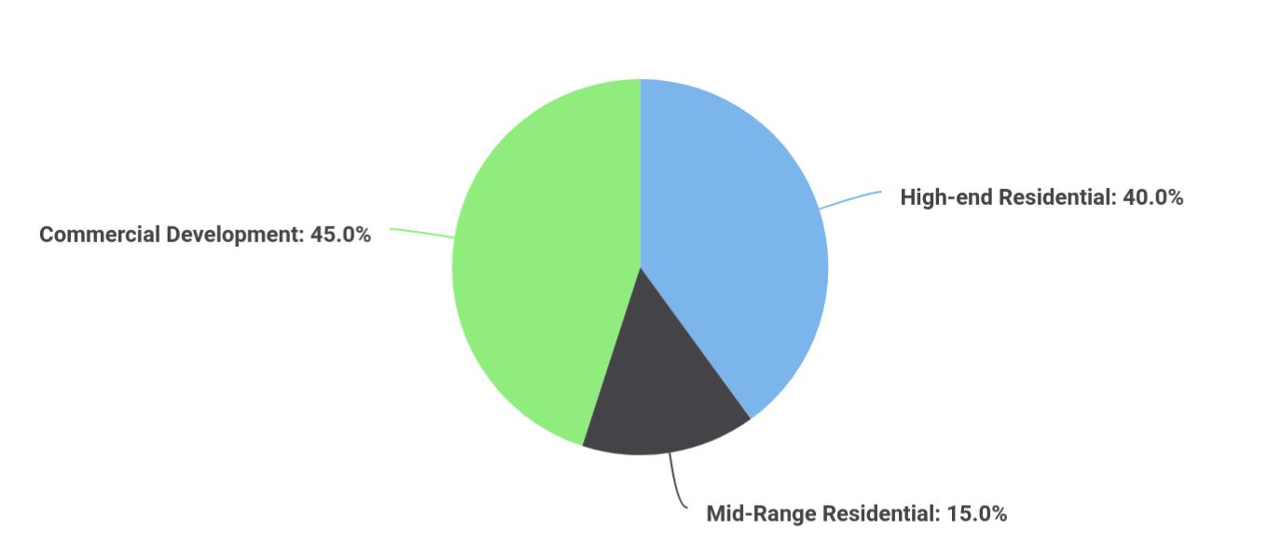

Furniture Company | Business Plan [YEAR] 16/34

Segments | Market share
High-end Residential | 40
Mid-Range Residential | 15
Commercial Development | 45

Potential Customers | Growth | Year 1 | Year 2 | Year 3 | Year 4 | Year 5 | CAGR
High-end residential | 3% | 5,260 | 5,418 | 5,581 | 5,748 | 5,920 | 3.00%
Mid-range residential | 5% | 3,500 | 3,675 | 3,859 | 4,052 | 4,255 | 5.00%
Commercial development | 7% | 10,000 | 10,700 | 11,449 | 12,250 | 13,108 | 7.00%
Total | 5.55% | 18,760 | 19,793 | 20,889 | 22,050 | 23,283 | 5.55%

Industry Analysis

 Carpentaria

There are two main types of cabinet suppliers in the industry.

• Resellers of complete cabinet sets using stock items where the cabinets turn up
To unlock help try Upmetrics! 

Start writing here..

 Carpentaria

The high-end cabinet market understands the concept of service and support and is more likely to pay for it when the offering is clearly stated.
To unlock help try Upmetrics! 

Competition and Buying Patterns

Start writing here..

Furniture Company | Business Plan [YEAR] 17/34

5.

Strategy

Competitive Edge

Sales Strategy

Milestones

Furniture Company | Business Plan [YEAR] 18/34

After identifying the market demand, market trends, and the potential customers of the startup, the next step is to define an effective strategy for attracting those customers. Like marketing analysis, sales strategy is also an
To unlock help try Upmetrics!
To unlock help try Upmetrics! 

 Carpentaria

Sharonville, Ohio is experiencing steady growth in the high-end residential markets and there is a consensus of continued growth in the area. Taking part in this growth, while providing attention to the design development, ordering process, project management, and installation
To unlock help try Upmetrics! 

Start writing here..

Competitive Edge

 Carpentaria

Our competitive edge is our ability to provide high volumes and flexibility in style while maintaining a quality product backed by excellent service.
To unlock help try Upmetrics! 

Start writing here..

Sales Strategy

 Carpentaria

Our sales strategy is to make ourselves known through mailings, print advertising, and personal contact with architects and contractors who are primarily involved with the design/construction of commercial development and luxury homes.



Start writing here..

Sales Forecast

The following table shows the projected cabinet sales. As the company gets established in the market, we anticipate strong sales growth over the next three years.

Furniture Company | Business Plan [YEAR] 19/34

Sales Yearly
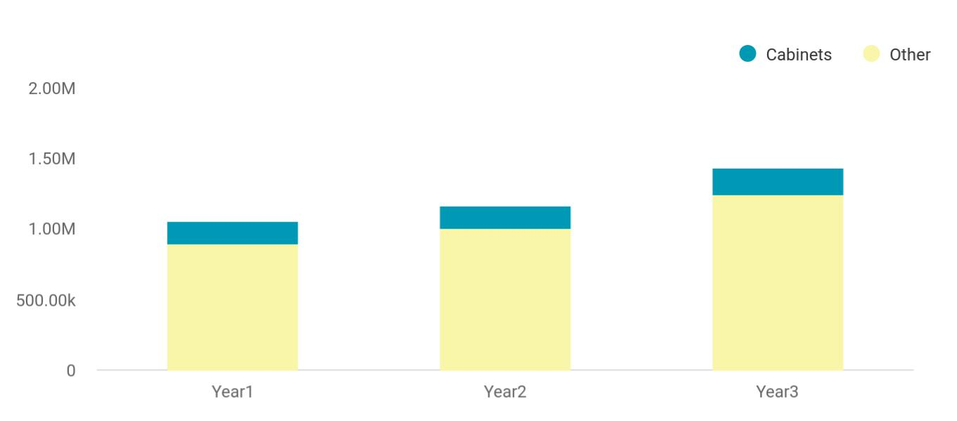

Financial Year | Cabinets | Other
Year1 | 158,745 | 895,665
Year2 | 164,548 | 1,004,512
Year3 | 186,541 | 1,245,587

Detailed Sales Forecast

Detailed sales forecast data is provided in below table:

SALES FORECAST | YEAR 1 | YEAR 2 | YEAR 3
Sales
Cabinets | $442,000 | $1,000,000 | $1,500,000
Other | $0 | $0 | $0
TOTAL SALES | $442,000 | $1,000,000 | $1,500,000
Direct Cost of Sales
Cabinets | $301,600 | $725,000 | $1,087,500
Other | $0 | $0 | $0
Subtotal Direct Cost of Sales | $301,600 | $725,000 | $1,087,500

Furniture Company | Business Plan [YEAR] 20/34

Milestones

The accompanying table lists important program milestones, with dates and managers in charge, and budgets for each. The milestone schedule indicates our emphasis on planning for implementation.

Milestone | Start | End Date | Budget | Manager | Department
Milestone | Date
Business Plan | 1/15/2020 | 1/31/2020 | $2,000 | Brent & | Marketing
 |  |  |  | Marty | Marketing
Online Research | 1/15/2020 | 1/19/2020 | $350 | Brent | Marketing
Open Accounts with | 1/15/2020 | 1/26/2020 | $350 | Brent | Web
Suppliers
Door Research | 1/15/2020 | 1/26/2020 | $500 | Brent & | Web
 |  |  |  | Marty | Web
Design Doors | 1/15/2020 | 1/26/2020 | $450 | Marty | Department
Order Sample Doors | 1/22/2020 | 2/01/2020 | $1,000 | Marty | Department
Design of Sales Literature | 1/22/2020 | 1/31/2020 | $1,000 | Brent & | Department
 |  |  |  | Marty | Department
Print Sales Literature | 2/01/2020 | 2/07/2020 | $300 | Brent | Department
Make Industry Contacts | 1/15/2020 | 2/28/2020 | $1,000 | Marty & | Department
 |  |  |  | Brent | Department
Showroom Feasibility Study | 1/25/2020 | 1/31/2020 | $1,000 | Marty & | Department
 |  |  |  | Brent | Department
Totals |  |  | $7,950

Furniture Company | Business Plan [YEAR] 21/34

6.

Management Summary

Personnel Plan

Furniture Company | Business Plan [YEAR] 22/34

The management plan is also an important component of a furniture manufacturing business plan since it gives you an estimate of the staff
required for your startup as well as the costs incurred on their salaries. So,
To unlock help try Upmetrics! 

 Carpentaria

Bill Moore, the President, has 20 years of construction experience, from general contracting, construction management, and having his own cabinet business.
To unlock help try Upmetrics! 

Start writing here..

Personnel Plan

This table shows salaries for the whole company. Salary increases are kept to a minimum to help the growth of the company. An administrative assistant will be hired later in the year.

Monthly details for this year can be found in the appendix.

PERSONNEL PLAN | YEAR 1 | YEAR 2 | YEAR 3
Bill Moore | $24,000 | $38,000 | $45,000
Managers | $24,000 | $35,000 | $40,000
Carpenters | $18,000 | $60,000 | $85,000
Administration Assistant | $12,000 | $24,000 | $25,000
TOTAL PEOPLE | 4 | 6 | 7
Total Payroll | $78,000 | $157,000 | $195,000

Furniture Company | Business Plan [YEAR] 23/34

7.

Financial Plan

Important Assumptions

Brake-even Analysis

Projected Profit and Loss

Projected Cash Flow

Projected Balance Sheet

Business Ratios

Furniture Company | Business Plan [YEAR] 24/34

The last component of a furniture manufacturing business plan is an in-depth financial plan. The financial plan crafts a detailed map of all the expenses needed for the startup and how these expenses will be met by the earned
To unlock help try Upmetrics! 

 Carpentaria

Below are the initial financial goals for the company:

• Obtain an operating line of credit from a financial institution.
To unlock help try Upmetrics! 

Start writing here..

Important Assumptions

The financial projections of the company are forecast on the basis of the following assumptions. These assumptions are quite conservative and are expected to show deviation but to a limited level such that the company’s major financial strategy will not be affected.

 | Year 1 | Year 2 | Year 3
Plan Month | 1 | 2 | 3
Current Interest Rate | 10,00% | 11,00% | 12,00%
Long-term Interest Rate | 10,00% | 10,00% | 10,00%
Tax Rate | 26,42% | 27,76% | 28,12%
Other | 0 | 0 | 0

Brake-even Analysis

Monthly Units Break-even | 5530
Monthly Revenue Break-even | $159 740
Assumptions:
Average Per-Unit Revenue | $260,87
Average Per-Unit Variable Cost | $0,89
Estimated Monthly Fixed Cost | $196 410

Furniture Company | Business Plan [YEAR] 25/34

Projected Profit and Loss

 | 2024 | 2025 | 2026
Revenue | $2,378,195 | $3,244,874 | $4,682,523
Residential Furniture Sales | $1,064,395 | $1,517,600 | $2,163,715
Unit Sales | 2,129 | 3,035 | 4,327
Unit Price | $500 | $500 | $500
Commercial Furniture | $1,043,320 | $1,294,152 | $1,825,328
Sales | $1,043,320 | $1,294,152 | $1,825,328
Unit Sales | 1,304 | 1,618 | 2,282
Unit Price | $800 | $800 | $800
Custom Furniture | $270,480 | $433,122 | $693,480
Unit Sales | 451 | 722 | 1,156
Unit Price | $600 | $600 | $600
Cost Of Sales | $207,563.58 | $257,601.13 | $324,020.92
General Costs | $207,563.58 | $257,601.13 | $324,020.92
Raw Materials | $73,642.61 | $104,574.36 | $148,562.24
Wood | $70,960.25 | $101,172.63 | $144,248.22
Fabric | $2,682.36 | $3,401.73 | $4,314.02
Manufacturing Supplies | $133,920.97 | $153,026.77 | $175,458.68
Hardware | $126,825.01 | $142,909.63 | $161,034.10
Finishing Supplies | $7,095.96 | $10,117.14 | $14,424.58
Revenue Specific Costs | $0 | $0 | $0
Personnel Costs (Direct | $0 | $0 | $0
Labor) | $0 | $0 | $0
Gross Margin | $2,170,631.42 | $2,987,272.87 | $4,358,502.08

Furniture Company | Business Plan [YEAR] 26/34

 | 2024 | 2025 | 2026
Gross Margin (%) | 91.27% | 92.06% | 93.08%

Operating Expense | $2,181,884.01 | $2,307,339.82 | $2,445,481.94
Payroll Expense (Indirect | $1,441,860 | $1,473,462.60 | $1,505,848.20
Labor) | $1,441,860 | $1,473,462.60 | $1,505,848.20
Production Team | $944,160 | $960,062.40 | $976,237.92
Carpenter | $596,160 | $605,102.40 | $614,178.72
Finisher | $348,000 | $354,960 | $362,059.20
Sales and Marketing | $399,420 | $412,561.80 | $426,144.48
Sales Associate | $283,500 | $292,005 | $300,765.36
Marketing Manager | $115,920 | $120,556.80 | $125,379.12
Administration | $98,280 | $100,838.40 | $103,465.80
Office Administrator | $39,000 | $39,780 | $40,575.60
HR Specialist | $59,280 | $61,058.40 | $62,890.20
General Expense | $740,024.01 | $833,877.22 | $939,633.74
Facility Costs | $69,753.65 | $78,600 | $88,568.62
Rent | $50,729.93 | $57,163.66 | $64,413.56
Utilities | $19,023.72 | $21,436.34 | $24,155.06
Marketing and Sales | $659,490.16 | $743,129.83 | $837,377.08
Advertising | $25,364.99 | $28,581.81 | $32,206.53
Sales Commissions | $634,125.17 | $714,548.02 | $805,170.55
Operational Costs | $10,780.20 | $12,147.39 | $13,688.04
Equipment Maintenance | $10,145.95 | $11,432.68 | $12,882.69
Shipping and Handling | $634.25 | $714.71 | $805.35
Bad Debt | $0 | $0 | $0

Furniture Company | Business Plan [YEAR] 27/34

Amortization of Current Assets

EBITDA

Additional Expense

Long Term Depreciation

Gain or loss from Sale of Assets

EBIT

Interest Expense

EBT

Income Tax Expense / Benefit

Total Expense

Net Income

Net Income (%)

Retained Earning Opening

Owner's Distribution

Retained Earning Closing

2024 | 2025 | 2026
$0 | $0 | $0

($11,252.59) $679,933.05 $1,913,020.14

$82,757.09 | $70,897.87 | $58,352.62
$42,000 | $42,000 | $42,000
$0 | $0 | $0
($53,252.59) | $637,933.05 | $1,871,020.14
$40,757.10 | $28,897.89 | $16,352.62
($94,009.68) | $609,035.18 | $1,854,667.52
$0 | $0 | $0

$2,472,204.68 | $2,635,838.82 | $2,827,855.48
($94,009.68) | $609,035.18 | $1,854,667.52
(3.95%) | 18.77% | 39.61%

$0 | ($174,009.68) | $435,025.50
$80,000 | $0 | $0
($174,009.68) | $435,025.50 | $2,289,693.02

Furniture Company | Business Plan [YEAR] 28/34

Projected Cash Flow

 | 2024 | 2025 | 2026
Cash Received | $2,378,195 | $3,244,874 | $4,682,523
Cash Paid | $2,430,204.68 | $2,593,838.82 | $2,785,855.48
COS & General Expenses | $947,587.59 | $1,091,478.35 | $1,263,654.66
Salary & Wages | $1,441,860 | $1,473,462.60 | $1,505,848.20
Interest | $40,757.10 | $28,897.89 | $16,352.62
Sales Tax | $0 | $0 | $0
Income Tax | $0 | $0 | $0
Net Cash From | ($52,009.68) | $651,035.18 | $1,896,667.52
Operations | ($52,009.68) | $651,035.18 | $1,896,667.52
Assets Sell | $0 | $0 | $0
Assets Purchase | $700,000 | $0 | $0
Net Cash From | ($700,000) | $0 | $0
Investments | ($700,000) | $0 | $0
Amount Received | $800,000 | $0 | $0
Loan Received | $800,000 | $0 | $0
Common Stock | $0 | $0 | $0
Preferred Stock | $0 | $0 | $0
Owner's Contribution | $0 | $0 | $0
Amount Paid | $290,352.63 | $222,211.85 | $234,757.04
Loan Capital | $210,352.62 | $222,211.83 | $234,757.04
Dividends & Distributions | $80,000 | $0 | $0
Net Cash From | $509,647.37 | ($222,211.85) | ($234,757.04)
Financing | $509,647.37 | ($222,211.85) | ($234,757.04)

Furniture Company | Business Plan [YEAR] 29/34

 | 2024 | 2025 | 2026
Summary
Starting Cash | $0 | ($242,362.31) | $186,461.02
Cash In | $3,178,195 | $3,244,874 | $4,682,523
Cash Out | $3,420,557.31 | $2,816,050.67 | $3,020,612.52
Change in Cash | ($242,362.31) | $428,823.33 | $1,661,910.48
Ending Cash | ($242,362.31) | $186,461.02 | $1,848,371.50
Projected Balance Sheet
 | 2024 | 2025 | 2026
Assets | $415,637.69 | $802,461.02 | $2,422,371.50
Current Assets | ($242,362.31) | $186,461.02 | $1,848,371.50
Cash | ($242,362.31) | $186,461.02 | $1,848,371.50
Accounts Receivable | $0 | $0 | $0
Inventory | $0 | $0 | $0
Other Current Assets | $0 | $0 | $0
Long Term Assets | $658,000 | $616,000 | $574,000
Gross Long Term Assets | $700,000 | $700,000 | $700,000
Accumulated Depreciation | ($42,000) | ($84,000) | ($126,000)
Liabilities & Equity | $415,637.69 | $802,461.04 | $2,422,371.52
Liabilities | $589,647.37 | $367,435.54 | $132,678.50
Current Liabilities | $222,211.83 | $234,757.04 | $0
Accounts Payable | $0 | $0 | $0
Income Tax Payable | $0 | $0 | $0

Furniture Company | Business Plan [YEAR] 30/34

 | 2024 |  |  | 2025 |  | 2026
Sales Tax Payable | $0 |  |  | $0 |  | $0
Short Term Debt | $222,211.83 |  | $234,757.04 |  |  | $0
Long Term Liabilities | $367,435.54 |  | $132,678.50 |  |  | $132,678.50
Long Term Debt | $367,435.54 |  | $132,678.50 |  |  | $132,678.50
Equity | ($174,009.68) |  | $435,025.50 |  |  | $2,289,693.02
Paid-in Capital | $0 |  |  | $0 |  | $0
Common Stock | $0 |  |  | $0 |  | $0
Preferred Stock | $0 |  |  | $0 |  | $0
Owner's Contribution | $0 |  |  | $0 |  | $0
Retained Earnings | ($174,009.68) |  | $435,025.50 |  |  | $2,289,693.02
Check | $0 |  |  | $0 |  | $0
Business Ratios
 |  | Year 1 | Year 2 |  | Year 3 | Industry Profile
Sales Growth |  | 4,35% | 30,82% |  | 63,29% | 4,00%
Percent of Total Assets
Accounts Receivable |  | 5,61% | 4,71% |  | 3,81% | 9,70%
Inventory |  | 1,85% | 1,82% |  | 1,79% | 9,80%
Other Current Assets |  | 1,75% | 2,02% |  | 2,29% | 27,40%
Total Current Assets |  | 138,53% | 150,99% |  | 163,45% | 54,60%
Long-term Assets |  | -9,47% | -21,01% |  | -32,55% | 58,40%
TOTAL ASSETS |  | 100,00% | 100,00% |  | 100,00% | 100,00%
Current Liabilities |  | 4,68% | 3,04% |  | 2,76% | 27,30%
Long-term Liabilities |  | 0,00% | 0,00% |  | 0,00% | 25,80%
Total Liabilities |  | 4,68% | 3,04% |  | 2,76% | 54,10%

Furniture Company | Business Plan [YEAR] 31/34

 | Year 1 | Year 2 | Year 3 | Industry Profile
NET WORTH | 99,32% | 101,04% | 102,76% | 44,90%
Percent of Sales
Sales | 100,00% | 100,00% | 100,00% | 100,00%
Gross Margin | 94,18% | 93,85% | 93,52% | 0,00%
Selling, General & Administrative | 74,29% | 71,83% | 69,37% | 65,20%
Expenses
Advertising Expenses | 2,06% | 1,11% | 0,28% | 1,40%
Profit Before Interest and Taxes | 26,47% | 29,30% | 32,13% | 2,86%
Main Ratios
Current | 25,86 | 29,39 | 32,92 | 1,63
Quick | 25,4 | 28,88 | 32,36 | 0,84
Total Debt to Total Assets | 2,68% | 1,04% | 0,76% | 67,10%
Pre-tax Return on Net Worth | 66,83% | 71,26% | 75,69% | 4,40%
Pre-tax Return on Assets | 64,88% | 69,75% | 74,62% | 9,00%
Additional Ratios
Net Profit Margin | 19,20% | 21,16% | 23,12% | N.A.
Return on Equity | 47,79% | 50,53% | 53,27% | N.A.
Activity Ratios
Accounts Receivable Turnover | 4,56 | 4,56 | 4,56 | N.A.
Collection Days | 92 | 99 | 106 | N.A.
Inventory Turnover | 19,7 | 22,55 | 25,4 | N.A.
Accounts Payable Turnover | 14,17 | 14,67 | 15,17 | N.A.
Payment Days | 27 | 27 | 27 | N.A.
Total Asset Turnover | 1,84 | 1,55 | 1,26 | N.A.
Debt Ratios
Debt to Net Worth | 0 | -0,02 | -0,04 | N.A.
Current Liab. to Liab. | 1 | 1 | 1 | N.A.
Liquidity Ratios

Furniture Company | Business Plan [YEAR] 32/34

 | Year 1 | Year 2 | Year 3 | Industry Profile
Net Working Capital | $120 943 | $140 664 | $160 385 | N.A.
Interest Coverage | 0 | 0 | 0 | N.A.
Additional Ratios
Assets to Sales | 0,45 | 0,48 | 0,51 | N.A.
Current Debt/Total Assets | 4% | 3% | 2% | N.A.
Acid Test | 23,66 | 27,01 | 30,36 | N.A.
Sales/Net Worth | 1,68 | 1,29 | 0,9 | N.A.
Dividend Payout | 0 | 0 | 0 | N.A.
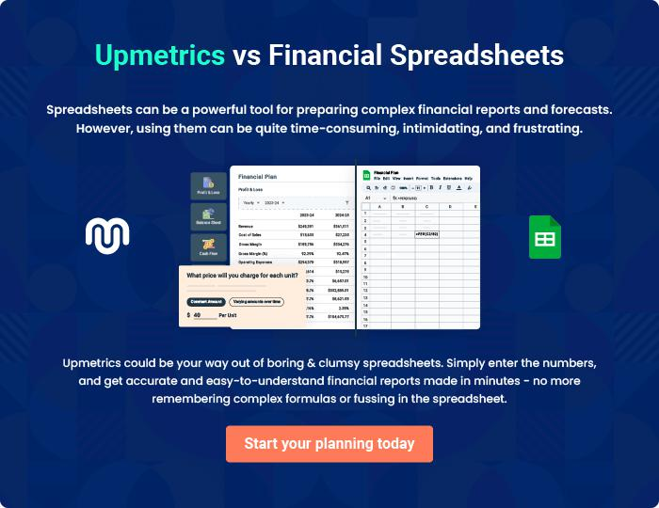

Furniture Company | Business Plan [YEAR] 33/34


Create a winning business plan that gets you funded

Creating a stunning and investment-ready plan requires no writing, graphic designing, or financial planning expertise.

Upmetrics has all the features required to help you create a comprehensive business plan—from start to finish. Make no mistakes, it’s the modern way of planning to structure ideas, make plans, and create stunning pitch decks to awe investors.

Pitch decks that impress investors

Create pitch decks that provide a visual representation of your business, engage investors, and make them want to invest in your business idea.

Interactive plans in no time

Import business plan sections like—SWOT analysis, comparison tables, and others to create an interactive business plan. No designing skills are required.

Stunning cover page designs

With Upmetrics, you have the liberty to choose from multiple stunning cover page designs. Choose a creative design and make your plan stand out.

Online sharing made simple

Upmetrics makes online sharing quick and easier for users. Easily share your business plans with a link while tracking reader activity.

500+ sample business plans

Simply import a template from our library of sample plans into the editor and start customizing it to make it yours. It takes only a few clicks to get started.

Collaborate with team in real-time

Invite team members, initiate conversations, discuss ideas & strategies, share feedback, and work on a business plan in real-time.

