
GL Trucking


Business
Plan

[YEAR]


The freight of your work on our shoulders.

Information provided in this business plan is unique to this business and confidential; therefore, anyone reading this plan agrees not to disclose any of the information in this business plan without prior written permission of the Company

 | Prepared By | 10200 Bolsa Ave, Westminster, CA, 92683
 | John Doe | info@example.com
 | (650) 359-3153 | http://www.example.com

Table of Contents

Executive Summary | 6
Business Overview | 7
Objectives | 7
Mission | 7
Management Team | 8
Larry Smith | 8
John Doe | 8
Keys to success | 8
Financial Summary | 8
Financial Highlights by Year | 9

Company | 10
About GLTC | 11
Company Summary | 11
Company Overview | 11
Management Team | 11
Larry B Smith | 11
John Doe | 11
Hiring Plan | 12

Products and Services | 13
Solution | 14
Features & Services | 15
Competitive Analysis
Competitive Analysis | 17
Competitors | 18
National carriers | 18
SWOT Analysis | 18

GL Trucking | Business Plan [YEAR] 2/38

Target Market | 20
Market Overview | 21
Raw Material Suppliers | 21
Manufacturers | 21
Wholesalers/Distributors | 21
Market Needs | 22
Industry Analysis | 22
Service Business Analysis | 22

Strategy and Implementation | 23
Marketing Plan | 24
Overview | 24
Positioning | 24
Pricing | 24
Promotion | 25
Milestones | 25

Financial Plan | 26
Sales | 27
Sales Forecast | 27
Sales by Month | 27
Personnel Plan | 27
Personnel Table | 27
Budget | 28
Budget Table | 28
Startup Costs | 29
Start-up Summary | 29
Cash Flow Assumptions | 29
Loans and Investments | 29
Loans and Investments Table | 29
Use of Funds | 30

GL Trucking | Business Plan [YEAR] 3/38

Financial Statements | 31
Profit and Loss Statement | 32
Gross Margin by Year | 33
Net Income by Year | 33
Balance Sheet | 33
Cash Flow Statement | 34
Cash Flow by Year | 35

Appendix | 36
Sales Forecast | 37
Sales Forecast Table | 37
Personnel Plan | 37
Personnel Table | 37
Budget | 37
Budget Table | 37
Loans and Investments | 37
Loans and Investments | 37
Financial Statements | 37
Profit and Loss Statement | 37
Balance Sheet | 37
Cash Flow Statement | 37

GL Trucking | Business Plan [YEAR] 4/38

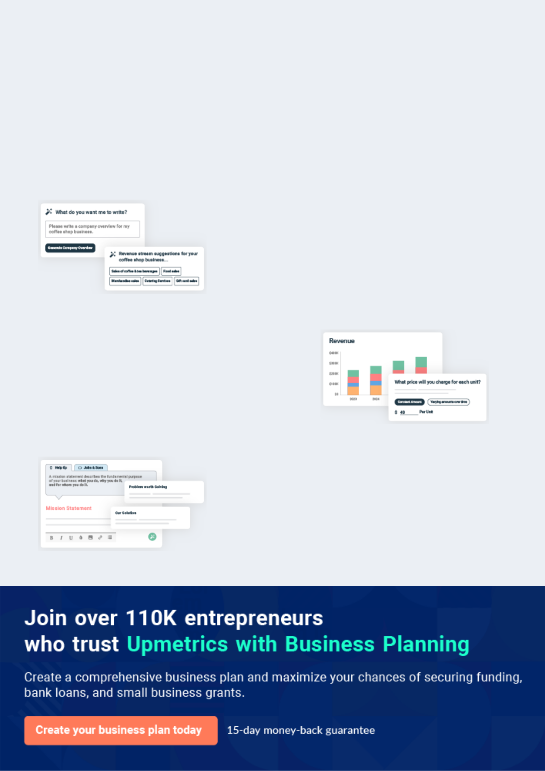
Business planning that’s simpler and faster than you think

Creating a business plan using Upmetrics to start and grow a business is literally the easiest thing in the World. Simply read the instructions and fill in the blanks. It’s as simple as that.

❛ | Upmetrics has everything you need to create a | ❜
❛ | comprehensive business plan. | ❜

AI-powered Upmetrics Assistant

AI-powered insights to streamline your plan

Not sure where to start? Upmetrics’ AI Assistant will automatically generate ideas for each section of your plan and offer improved versions of your writing, adjusting for tone, voice, and grammar or spelling errors.

Financial Forecasting Tool

All the financials are calculated for you

Forget the complex formulas and clumsy spreadsheets — with automatic financials and drag-and-drop forecasting, you can finish your plan faster and be confident that your numbers are accurate.

Business Plan Builder

Guides you like a business mentor

Upmetrics’ step-by-step instructions, prompts, and the library of 400+ sample business plans will guide you through each section of your plan as a business mentor.

1.


Executive Summary

Business Overview

Objectives

Mission

Management Team

Keys to success

Financial Summary

GL Trucking | Business Plan [YEAR] 6/38

Business Overview
To unlock help try Upmetrics!

 GLTC


GL Trucking Company is a new startup medium- and a long-haul flatbed trucking business that will be based in Fort Thomas, Arizona. GL Trucking Company will serve businesses in the Western United States with freight hauling and logistics management services. The business
To unlock help try Upmetrics! 

Start writing here..

Objectives

 GLTC

GL Trucking Company intends to serve businesses in the Western United States with truck-based distribution services.
To unlock help try Upmetrics! 

Start writing here..

Mission

 GLTC

GL Trucking Company will simplify the distribution of goods to our customers, by becoming their partner in operating efficiently and reliably. GL Trucking Company will use management of logistics, on-time, accurate deliveries from destination to destination.



Start writing here..

GL Trucking | Business Plan [YEAR] 7/38

Management Team


Larry Smith

Founder & CEO - larry.s@example.com

Larry B Smith, the CEO, will manage the strategic direction, sales and overall operation of GL Trucking Company. He has over 21 years of experience in the trucking industry.


John Doe

COO - john.doe@example.com

John Doe, A Chief Operating Officer position who has over 8 years of experience in management and truck driving experience. The COO will manage operations, finances, marketing, human resources, and procurement.

Keys to success

 GLTC

The keys to success in the trucking business are:

1. Robust communication systems between drivers, bases, and clients.
To unlock help try Upmetrics! 

Start writing here..

Financial Summary

Listed below are the financial highlights for the next three years.

GL Trucking | Business Plan [YEAR] 8/38

Financial Highlights by Year
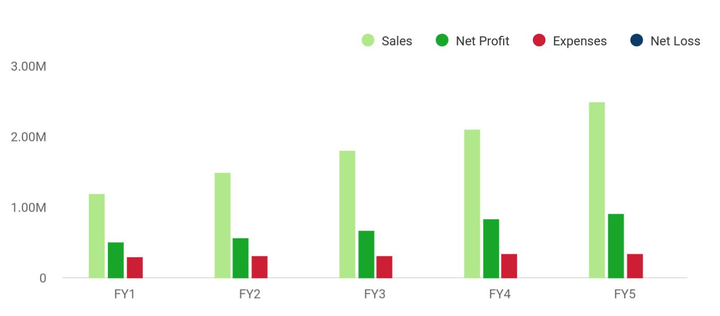

GL Trucking | Business Plan [YEAR] 9/38

2.

Company

About GLTC

Management Team

GL Trucking | Business Plan [YEAR] 10/38

About GLTC
To unlock help try Upmetrics!

 GLTC

GL Trucking Company (GLTC) is a startup trucking company that will be headquartered in Fort Thomas, Arizona, will provide tracking and logistics management solutions for business clients in the Western United States. GL Trucking Company will haul freight from suppliers to
To unlock help try Upmetrics! 

Company Summary

Start writing here..

 GLTC

GL Trucking Company was founded by Larry Smith, who has experience in the trucking industry. GL Trucking Company will be established as a sole proprietorship and will be reclassified as a limited liability company to take on investors.



Company Overview

Start writing here..

Management Team

Larry B Smith

Founder & CEO - larry.s@example.com

Larry B Smith, the CEO, will manage the strategic direction, sales and overall operation of GL Trucking Company. He has over 21 years of experience in the trucking industry.

John Doe

COO - john.doe@example.com

John Doe, A Chief Operating Officer position who has over 8 years of experience in management and truck driving experience. The COO will manage operations, finances, marketing, human resources, and procurement.

GL Trucking | Business Plan [YEAR] 11/38

 GLTC
To unlock help try Upmetrics!

The business will require additional personnel including an administrator, dispatcher, sales, and marketing support associate. In order to launch the company, this individual will be hired by the COO and the CEO, respectively.



Hiring Plan

Start writing here..

GL Trucking | Business Plan [YEAR] 12/38

3.

Products and Services

Solution

Features & Services

GL Trucking | Business Plan [YEAR] 13/38

Solution


GL Trucking Company will offer the following services for businesses in the Western United States:

GL Trucking | Business Plan [YEAR] 14/38

Features & Services


Pick-up and delivery | Truck load Services | Delivery Updates
Pick-up and delivery of goods | Both "less than a truck load" | Online tracking information
with a minimum per-delivery | and "truck load" services. | detailing the location of all
weight of 10,000 lbs to 48,000 |  | GPS-tagged trucks and the
lbs, to locations in its |  | status of deliveries, including
geographic range by 18- |  | expected arrival times for pick-
wheeler trucks hauling flat bed |  | up or delivery.
trailers.


Phone support | Online Services
Phone support for all customer | Preferred client services
questions, delivery changes, | including online accounts,
and scheduling. | regular schedules of shipping,
 | or linking of client order
 | information directly to GL
 | Trucking Companies
 | scheduling software to allow
 | for seamless logistics.

GL Trucking | Business Plan [YEAR] 15/38

To maintain its competitiveness in its core services, GL Trucking Company will NOT offer:

- Storage or warehousing of goods awaiting delivery.

- Packaging and crating.

In the future, GL Trucking Company will add the following services:

• Temperature-controlled shipping to expand the range of customers GL Trucking can appeal to.

Trucks will be operated by qualified and well-trained drivers with spotless records. Drivers will be safety trained and re-tested for knowledge of laws as they change. Software and communication systems will allow the company to track all shipments from the time it is picked up to delivery.
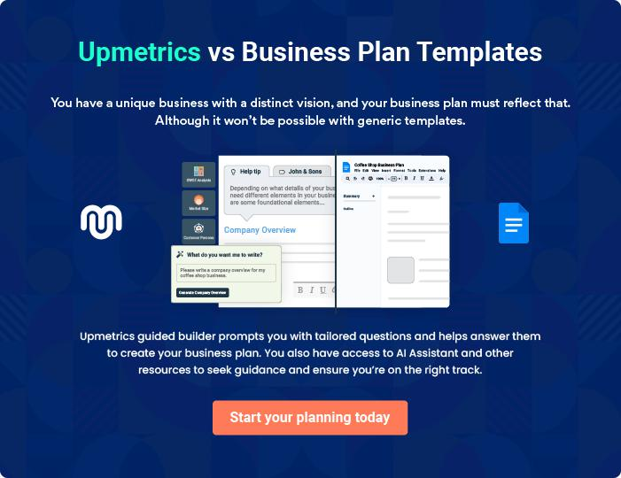

GL Trucking | Business Plan [YEAR] 16/38

4.

Competitive Analysis

Competitors

SWOT Analysis

GL Trucking | Business Plan [YEAR] 17/38

Competitors

 GLTC

In addition to competing with other trucking companies, including national carriers, GL Trucking Company will compete with rail and air cargo transportation. However, for the distances, it intends to travel, and due to the few rail lines over the western states, trucking is at an
To unlock help try Upmetrics! 

National carriers

Start writing here..

SWOT Analysis

 GLTC

GLTC has a valuable inventory of strengths that have contributed to the success of the company since 1983. These strengths include experienced, knowledgeable staff with a clear vision of the trucking industry, market needs and, excellent client services.
To unlock help try Upmetrics! 

Start writing here..


Strength

The staff at GLTC is experienced and knowledgeable in the logistics of the trucking industry, they are courteous and provide excellent services to all of GLTC clients.

Strong relationships with clients, offering flexible arrangements for rush deliveries

Competitive prices provide repeat and referral business.

Long-term contracts with major manufacturing companies in Arizona.

Premium quality service and on-time delivery.

Weakness

The business has been unpredictable during the uncertainty of economic conditions.

GLTC needs new trucks. New trucks will provide better fuel efficiency; better emissions control and lower our cost of overhead to maintain. These new trucks will allow us to expand our services, creating more revenue to pay our debts.

GL Trucking | Business Plan [YEAR] 18/38


Opportunity

Increasing sales opportunities beyond the "100-mile" targeted area.

Current clients with manufacturing plants in other cities and states.

Strategic alliances offering resources for referrals and marketing to extend GLTC reach to potential new clients.
Threat


The downturn in the economy has impacted the sales of GLTC in the first quarter of 2010.

The rising cost of fuel, maintenance, and repairs.

The winter weather in Arizona during the months of December, January, and February can be a safety hazard, getting around the mountains to the main highway can difficult and dangerous for 18 wheeler trucks.

GL Trucking | Business Plan [YEAR] 19/38

5.

Target Market

Market Overview

Market Needs

Industry Analysis

GL Trucking | Business Plan [YEAR] 20/38

Market Overview

 GLTC

The American commercial trucking industry serves as a key link between raw material suppliers, manufacturers, wholesalers, distributors, and retailers in most industries. According to the American Trucking Association, the industry includes dry van, flatbed, refrigerated, and
To unlock help try Upmetrics! 

Start writing here..

 GLTC

Raw Material Suppliers ship large quantities of materials to large manufacturers in the Western United States. A big part of these materials generally does not require refrigeration or temperature control. Manufacturers maintain some on-site storage for these supplies and
To unlock help try Upmetrics! 

Raw Material Suppliers

Start writing here..

 GLTC

Manufacturers often outsource the distribution of their goods to businesses that specialize in serving one type of retailer or business. Their packaged goods are often shipped to only one wholesaler/distributor, creating a regular business in shipping between the two locations.
To unlock help try Upmetrics! 

Manufacturers

Start writing here..

 GLTC

Wholesalers/Distributors that serve large retailers to assemble truckloads of goods from the many manufacturers they serve. While some have their own trucks or distribution means, most of these firms do not have trucks because they are smaller companies or because they attempt
To unlock help try Upmetrics! 

Wholesalers/Distributors

Start writing here..

GL Trucking | Business Plan [YEAR] 21/38

Market Needs

 GLTC

GL Trucking Company will begin by focusing specifically on the segment of manufacturers, wholesalers, and distributors in the Western United States. By serving manufacturers, GL Trucking Company can provide an affordable shipping solution for new and growing
To unlock help try Upmetrics! 

Start writing here..

Industry Analysis

 GLTC

- The U.S. trucking industry includes about 65,000 for-hire carriers and 250,000 independent owner-operators.

• Total industry revenue is nearly $130 billion.
To unlock help try Upmetrics! 

Service Business Analysis

Start writing here..

GL Trucking | Business Plan [YEAR] 22/38

6.

Strategy and

Implementation

Marketing Plan

Milestones

GL Trucking | Business Plan [YEAR] 23/38

Marketing Plan
To unlock help try Upmetrics!

 GLTC

GL Trucking Company will focus its marketing strategy on the following areas:

• Establishing a strong software/Web component to its business to drive adoption of its
To unlock help try Upmetrics! 

Overview

Start writing here..

 GLTC

GL Trucking Company will be sitting in a good position to haul for the copper mines in the Southern Arizona area. The mine has fright going out and fright and equipment moving into the copper mine all the time.



Positioning

Start writing here..

 GLTC

Pricing of our service must remain initially competitive with our rivals. This is typical within the industry and can create higher margins. The average flatbed rate is $ 2.50 to $3.50 cents a mile for all loaded miles. GL Trucking will start out charging $ 2.25 a mile and after 3 years will
To unlock help try Upmetrics! 

Pricing

Start writing here..

GL Trucking | Business Plan [YEAR] 24/38

 GLTC

GL Trucking Company will attempt to rapidly achieve awareness in Arizona and California about its business in the first year, followed by awareness in the other Western states in future years. It will seek to position itself not as the most inexpensive carrier, but as a carrier with the best
To unlock help try Upmetrics! 

Promotion

Start writing here..

Milestones

Milestone | Due Date
Find funding Start GL Trucking Company | October 01, 2012
Purchase Trucks and trailers | October 08, 2012
Insurance and permits | October 08, 2012
Hire drivers | October 09, 2012
Pick up first loads | October 11, 2012

GL Trucking | Business Plan [YEAR] 25/38

7.

Financial Plan

Sales

Personnel Plan

Budget

Startup Costs

Cash Flow Assumptions

Loans and Investments

GL Trucking | Business Plan [YEAR] 26/38

Sales

Sales Forecast

 | FY2013 | FY2014 | FY2015
Unit Sales | 480,000 | 480,000 | 480,000
Price Per Unit | $2.25 | $2.50 | $3.00
Total Sales | $1,080,000 | $1,200,000 | $1,440,000
Direct Cost Per Unit | $0.50 | $0.50 | $0.50
Total Direct Cost | $240,000 | $240,000 | $240,000
Gross Margin | $840,000 | $960,000 | $1,200,000
Gross Margin(%) | 78% | 80% | 83%

Sales by Month
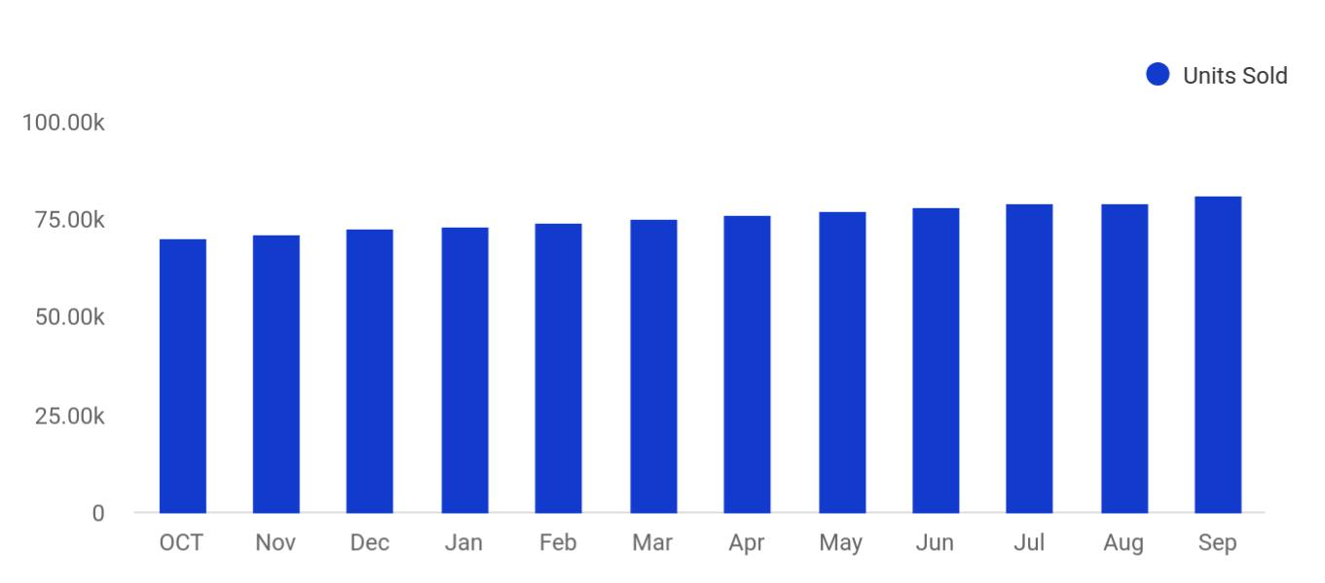

Personnel Plan

Personnel Table

 | FY2013 | FY2014 | FY2015
Truck Driver / Manager | $60,000 | $60,600 | $61,212

GL Trucking | Business Plan [YEAR] 27/38

 | FY2013 | FY2014 | FY2015
Truck Driver | $54,000 | $54,000 | $54,000
Truck Driver | $48,000 | $48,000 | $48,000
Truck Driver | $48,000 | $48,480 | $48,960
Total | $210,000 | $211,080 | $212,172

Budget

Budget Table

 | FY2013 | FY2014 | FY2015
Expenses
Salary | $210,000 | $211,080 | $212,172
Employee Related Expenses | $10,500 | $10,560 | $10,608
Marketing & Promotion | $500 | $500 | $500
Truck and Trailer mantinance | $6,000 | $6,000 | $6,000
Office Supplies | $1,000 | $1,000 | $1,000
Insurance | $5,000 | $5,000 | $5,000
Licenses and Permitting | $900 | $900 | $900
Total Expenses | $233,900 | $235,040 | $236,180
Major Purchases
Trucks and trailers | $780,000 | $0 | $0
Total Major Purchases | $780,000 | $0 | $0

GL Trucking | Business Plan [YEAR] 28/38

Startup Costs

 GLTC

The start-up expenses include some of the basic set-up costs for the GL Trucking office - stationery (business cards and letterhead), computer equipment. Marketing expenses include brochures and website development. Other expenses include legal consultation fees to ensure
To unlock help try Upmetrics! 

Start-up Summary

Start writing here..

Cash Flow Assumptions


Cash Inflow

% of Sales on Credit

Avg Collection Period (Days)

Cash Outflow

- of Purchases on Credit Avg Payment Delay (Days)

100%

45

70%

30

Loans and Investments

Loans and Investments Table

 | FY2013 | FY2014 | FY2015
Investors Investment | $1,500,000 | $0 | $0
Equity investment
Total Amount Received | $1,500,000 | $0 | $0

GL Trucking | Business Plan [YEAR] 29/38

 GLTC

GL Trucking company needs an investment of $1,500,000 to finance the start-up and start operations.
To unlock help try Upmetrics! 

Use of Funds

Start writing here..
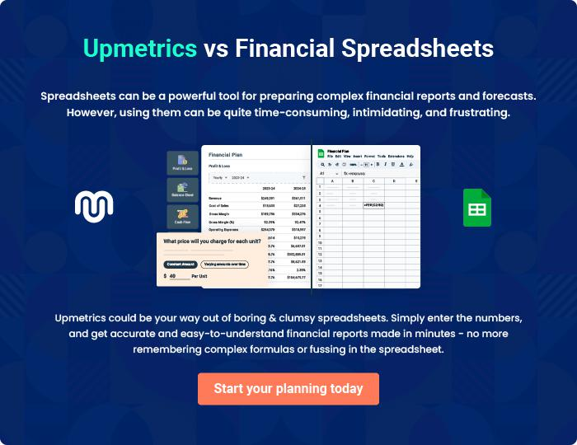

GL Trucking | Business Plan [YEAR] 30/38

8.

Financial Statements

Profit and Loss Statement

Balance Sheet

Cash Flow Statement

GL Trucking | Business Plan [YEAR] 31/38

Profit and Loss Statement

 | FY2013 | FY2014 | FY2015
Revenue | $1,080,000 | $1,200,000 | $1,440,000
Direct Cost | $240,000 | $240,000 | $240,000
Gross Margin | $840,000 | $960,000 | $1,200,000
Gross Margin % | 78% | 80% | 83%
Expenses
Salary | $210,000 | $211,080 | $212,172
Employee Related Expenses | $10,500 | $10,560 | $10,608
Marketing & Promotion | $500 | $500 | $500
Truck and Trailer mantinance | $6,000 | $6,000 | $6,000
Office Supplies | $1,000 | $1,000 | $1,000
Insurance | $5,000 | $5,000 | $5,000
Licenses and Permitting | $900 | $900 | $900
Total Expenses | $233,900 | $235,040 | $236,180
Operating Income | $606,100 | $724,960 | $963,820
Interest Incurred | $0 | $0 | $0
Depreciation and Amortization | $86,667 | $86,667 | $86,667
Income Taxes | $176,607 | $217,020 | $298,232
Net Profit | $342,826 | $421,273 | $578,921
Net Profit / Sales | 32% | 35% | 40%

GL Trucking | Business Plan [YEAR] 32/38

Gross Margin by Year
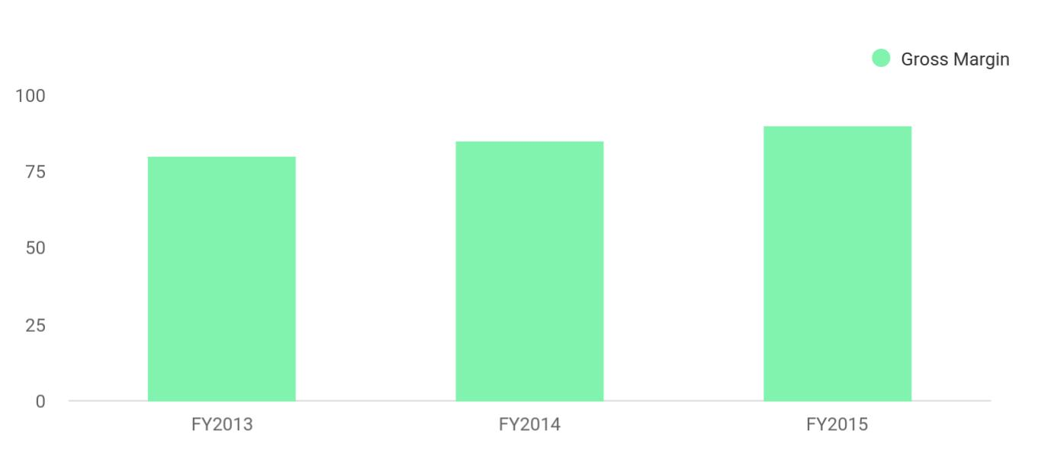

Net Income by Year
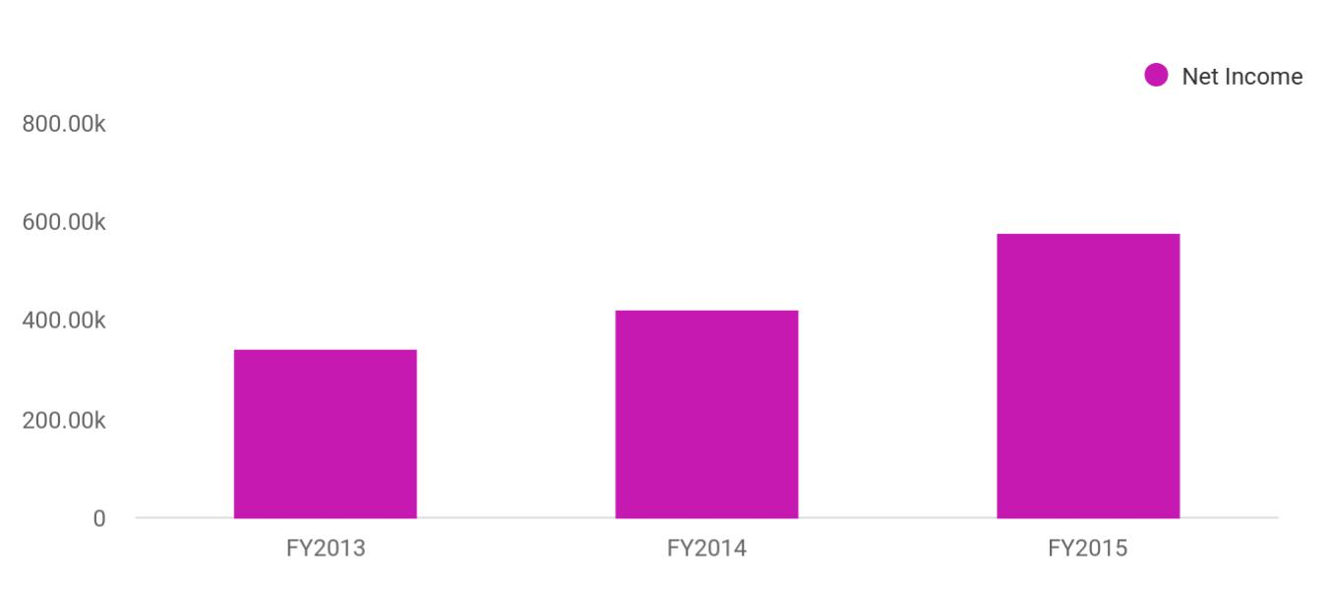

Balance Sheet

As of Period's End | FY2013 | FY2014 | FY2015
Cash | $1,029,276 | $1,522,216 | $2,157,804
Accounts Receivable | $135,000 | $150,000 | $180,000
Inventory | $0 | $0 | $0
Total Current Assets | $1,164,276 | $1,672,216 | $2,337,804
Long-Term Assets | $780,000 | $780,000 | $780,000

GL Trucking | Business Plan [YEAR] 33/38

As of Period's End | FY2013 | FY2014 | FY2015
Accumulated Depreciation | ($86,667) | ($173,334) | ($260,001)
Total Long-Term Assets | $693,333 | $606,666 | $519,999
Total Assets | $1,857,609 | $2,278,882 | $2,857,803
Accounts Payable | $14,783 | $14,783 | $14,783
Sales Taxes Payable | $0 | $0 | $0
Short-Term Debt | $0 | $0 | $0
Total Current Liabilities | $14,783 | $14,783 | $14,783
Long-Term Debt | $0 | $0 | $0
Total Liabilities | $14,783 | $14,783 | $14,783
Paid-In Capital | $1,500,000 | $1,500,000 | $1,500,000
Retained Earnings | $0 | $342,826 | $764,099
Earnings | $342,826 | $421,273 | $578,921
Total Owner's Equity | $1,842,826 | $2,264,099 | $2,843,020
Total Liabilities & Equity | $1,857,609 | $2,278,882 | $2,857,803

Cash Flow Statement

 | FY2013 | FY2014 | FY2015
Operations
Net Profit | $342,826 | $421,273 | $578,921
Depreciation and Amortization | $86,667 | $86,667 | $86,667
Decrease in Accounts Receivable | ($135,000) | ($15,000) | ($30,000)
Decrease in Inventory | $0 | $0 | $0

GL Trucking | Business Plan [YEAR] 34/38

 | FY2013 | FY2014 | FY2015
Increase in Accounts Payable | $14,783 | $0 | $0
Increase in Sales Taxes Payable | $0 | $0 | $0
Net Cash Flow from Operations | $309,276 | $492,940 | $635,588
Investing & Financing
Assets Purchased or Sold | ($780,000) | $0 | $0
Investments Received | $1,500,000 | $0 | $0
Increase in Short-Term Debt | $0 | $0 | $0
Increase in Long-Term Debt | $0 | $0 | $0
Net Cash Flow from Investing & Financing | $720,000 | $0 | $0
Cash at Beginning of Period | $0 | $1,029,276 | $1,522,216
Net Increase in Cash | $1,029,276 | $492,940 | $635,588
Cash at End of Period | $1,029,276 | $1,522,216 | $2,157,804

Cash Flow by Year
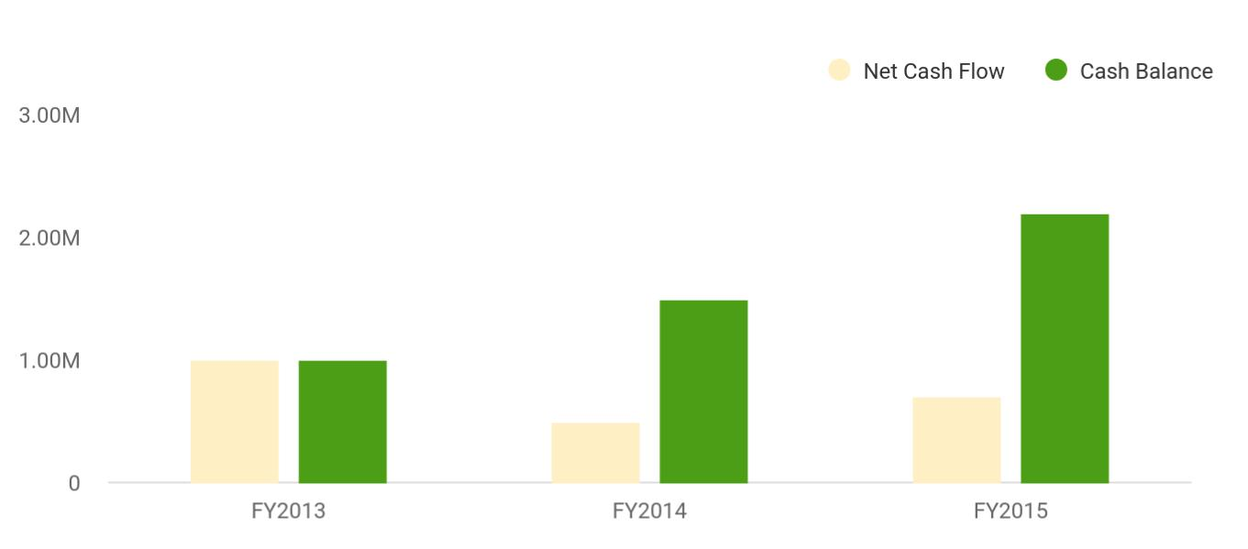

GL Trucking | Business Plan [YEAR] 35/38

9.

Appendix

Sales Forecast

Personnel Plan

Budget

Loans and Investments

Financial Statements

GL Trucking | Business Plan [YEAR] 36/38

Sales Forecast

Sales Forecast Table

Add Sales forecast table with monthly detail.

Personnel Plan

Personnel Table

Add personnel report with monthly detail.

Budget

Budget Table

Add budget table with monthly detail.

Loans and Investments

Loans and Investments

Add Loan and investments reports with monthly detail.

Financial Statements

Profit and Loss Statement

Add Monthly profit & loss statement with monthly detail.

Balance Sheet

Add balance sheet with monthly detail.

Cash Flow Statement

Add Cash Flow Statement with monthly detail.

GL Trucking | Business Plan [YEAR] 37/38


Create a winning business plan that gets you funded

Creating a stunning and investment-ready plan requires no writing, graphic designing, or financial planning expertise.

Upmetrics has all the features required to help you create a comprehensive business plan—from start to finish. Make no mistakes, it’s the modern way of planning to structure ideas, make plans, and create stunning pitch decks to awe investors.

Pitch decks that impress investors

Create pitch decks that provide a visual representation of your business, engage investors, and make them want to invest in your business idea.

Interactive plans in no time

Import business plan sections like—SWOT analysis, comparison tables, and others to create an interactive business plan. No designing skills are required.

Stunning cover page designs

With Upmetrics, you have the liberty to choose from multiple stunning cover page designs. Choose a creative design and make your plan stand out.

Online sharing made simple

Upmetrics makes online sharing quick and easier for users. Easily share your business plans with a link while tracking reader activity.

500+ sample business plans

Simply import a template from our library of sample plans into the editor and start customizing it to make it yours. It takes only a few clicks to get started.

Collaborate with team in real-time

Invite team members, initiate conversations, discuss ideas & strategies, share feedback, and work on a business plan in real-time.

