
BUSINESS PLAN

[YEAR]


Freight Brokerage

Moving your products across all borders

John Doe

10200 Bolsa Ave, Westminster, CA, 92683

- 359-3153 info@example.com http://www.example.com

Information provided in this business plan is unique to this business and confidential; therefore, anyone reading this plan agrees not to disclose any of the information in this business plan without prior written permission of the Company
Table of Contents

Executive Summary | 5
Mission Statement | 6
Vision Statement | 6
Customer Focus | 7
Management Team | 7
Success Factors | 7
Financial Summary | 8
3 Year profit forecast | 8

Company Summary | 9
History | 10
Products and Services | 10
Startup Summary | 10
Startup cost | 11

Market Analysis | 14
Industry Analysis | 15
Market Trends | 15
Target Market | 15
Market Segmentation | 16

Strategy & Implementations | 18
Sales Strategy | 19
Advertising Strategy | 19
Billboards | 19
Referrals | 20
Local Publications | 20
Customer Loyalty Programs | 20
Direct Mail | 20
Milestones | 21
Pricing Strategy | 21

Freight Brokerage | Business Plan [YEAR] 2/35

Operations Plan | 22
Functional Roles | 23
Functional Roles | 23
Administrative Functions | 23
Personnel Plan | 23
Milestones | 24

Financial Plan | 25
Important Assumptions | 26
Brake-even Analysis | 26
Projected Profit and Loss | 27
Projected Cash Flow | 29
Projected Balance Sheet | 31
Business Ratios | 32

Freight Brokerage | Business Plan [YEAR] 3/35

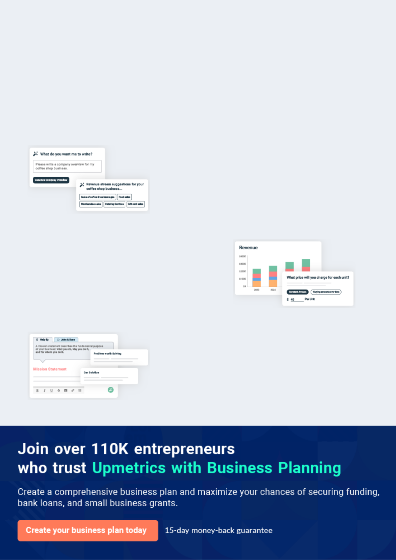
Business planning that’s simpler and faster than you think

Creating a business plan using Upmetrics to start and grow a business is literally the easiest thing in the World. Simply read the instructions and fill in the blanks. It’s as simple as that.

❛ | Upmetrics has everything you need to create a | ❜
❛ | comprehensive business plan. | ❜

AI-powered Upmetrics Assistant

AI-powered insights to streamline your plan

Not sure where to start? Upmetrics’ AI Assistant will automatically generate ideas for each section of your plan and offer improved versions of your writing, adjusting for tone, voice, and grammar or spelling errors.

Financial Forecasting Tool

All the financials are calculated for you

Forget the complex formulas and clumsy spreadsheets — with automatic financials and drag-and-drop forecasting, you can finish your plan faster and be confident that your numbers are accurate.

Business Plan Builder

Guides you like a business mentor

Upmetrics’ step-by-step instructions, prompts, and the library of 400+ sample business plans will guide you through each section of your plan as a business mentor.

1.


Executive Summary

Mission Statement

Vision Statement

Customer Focus

Management Team

Success Factors

Financial Summary

Freight Brokerage | Business Plan [YEAR] 5/35


Before you think about how to start a Freight Brokerage service, you must create a detailed Freight Brokerage business plan. It will not only guide you in the initial phases of your startup but will also help you later on.
To unlock help try Upmetrics! 

 Detroit Freight Brokerage


Detroit Freight Brokerage LLC is a leading and standard freight brokerage firm here in Detroit - Chicago as well as in the whole of the United States of America. Our vision is to ensure that we offer quality management services to all our long and short-distance customers, as well as
To unlock help try Upmetrics! 

Start writing here..

Mission Statement

 Detroit Freight Brokerage

In order to achieve our stated vision, we will ensure that we provide customers with the most satisfying shipping experience. We will also build a business structure that will ensure we achieve our vision of not only attracting but maintaining our various customers as well.
To unlock help try Upmetrics! 

Start writing here..

Vision Statement

 Detroit Freight Brokerage

Our vision is to become a recognized brand in the freight brokerage industry and create a service-based firm that will not only meet but exceed the expectations of our customers.
To unlock help try Upmetrics! 

Start writing here..

Freight Brokerage | Business Plan [YEAR] 6/35

Customer Focus
To unlock help try Upmetrics!

 Detroit Freight Brokerage

Detroit Freight Brokerage will primarily serve manufacturers and distributors operating within a 100-mile radius of New York, as well as local households. The demographics of these customers are as follows:



Start writing here..

Management Team

 Detroit Freight Brokerage

Detroit Freight Brokerage’s most valuable asset is the expertise and experience of its founder, John Moore. With 10 years of experience as a freight broker and a degree in Business Administration from the University of Chicago, he is uniquely qualified to lead the company to
To unlock help try Upmetrics! 

Start writing here..

Success Factors

 Detroit Freight Brokerage

Detroit Freight Brokerage is well-positioned to succeed for the following reasons:

• We will be one of the few freight brokerage companies in the area. Furthermore, we have
To unlock help try Upmetrics! 

Start writing here..

Freight Brokerage | Business Plan [YEAR] 7/35

Financial Summary
Year 3
To unlock help try Upmetrics!
To unlock help try Upmetrics!

 Detroit Freight Brokerage

Detroit Freight Brokerage is seeking total funding of $260,000 of debt capital to launch. The capital will be used for funding capital expenditures and location build-out, hiring initial employees, marketing expenses, and working capital.



Start writing here..

3 Year profit forecast
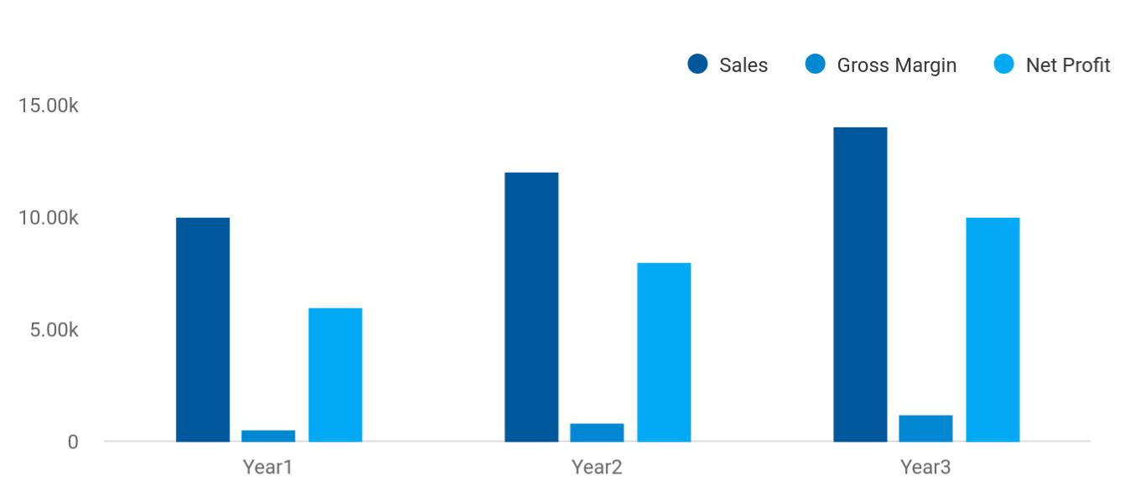

 Detroit Freight Brokerage


Financial Summary

Year 1

Year 2



Start writing here..

Freight Brokerage | Business Plan [YEAR] 8/35

2.

Company Summary

History

Products and Services

Startup Summary

Freight Brokerage | Business Plan [YEAR] 9/35

 Detroit Freight Brokerage
To unlock help try Upmetrics!
To unlock help try Upmetrics!
To unlock help try Upmetrics!

Detroit Freight Brokerage LLC is owned and run by John and Jane Moore, two siblings who have over 25 years of experience in the freights brokerage industry. Their experience in this industry will allow us to achieve our goals and objectives on time.



Start writing here..

History

 Detroit Freight Brokerage

Detroit Freight Brokerage has been Detroit’s leading freight broker for 10 years. It was in 2020 when John established the company’s first office in Detroit. Having worked in progressively responsible positions in the industry throughout his early career, John is well-versed in how to
To unlock help try Upmetrics! 

Start writing here..

Products and Services

 Detroit Freight Brokerage

At Detroit Freight Brokerage, LLC, our intention is to provide management service for long and short distance freight services in an efficient and effective manner to our customers both corporate and domestic in our target market.



Start writing here..

Startup Summary

 Detroit Freight Brokerage

Detroit Freight Brokerage start-up costs include all the equipment needed for an office. Additionally, there will be legal fees, marketing fees, accounting fees, trade association dues, and deposits for the lease.



Freight Brokerage | Business Plan [YEAR] 10/35

Start writing here..

Startup cost
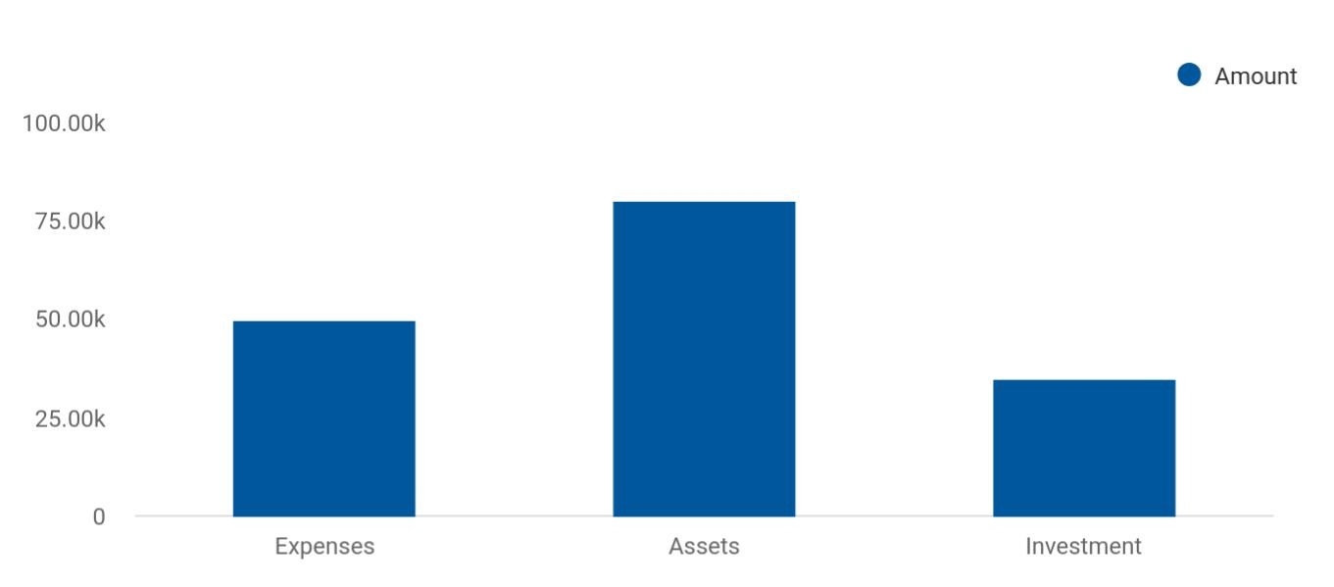

Cost distribution | Amount
Expenses | 50,000
Assets | 80,000
Investment | 35,000

Start-up Expenses | Amount
Legal | $75,500
Consultants | $0
Insurance | $62,750
Rent | $22,500
Research and Development | $42,750
Expensed Equipment | $42,750
Signs | $1,250
TOTAL START-UP EXPENSES | $247,500
Start-up Assets | $0
Cash Required | $322,500
Start-up Inventory | $52,625
Other Current Assets | $222,500

Freight Brokerage | Business Plan [YEAR] 11/35

Start-up Expenses | Amount
Long-term Assets | $125,000
TOTAL ASSETS | $121,875
Total Requirements | $245,000
START-UP FUNDING | $0
START-UP FUNDING | $273,125
Start-up Expenses to Fund | $121,875
Start-up Assets to Fund | $195,000
TOTAL FUNDING REQUIRED | $0
Assets | $203,125
Non-cash Assets from Start-up | $118,750
Cash Requirements from Start-up | $0
Additional Cash Raised | $118,750
Cash Balance on Starting Date | $121,875
TOTAL ASSETS | $0
Liabilities and Capital | $0
Liabilities | $0
Current Borrowing | $0
Long-term Liabilities | $0
Accounts Payable (Outstanding Bills) | $0
Other Current Liabilities (interest-free) | $0
TOTAL LIABILITIES | $0
Capital | $0
Planned Investment | $0
Investor 1 | $312,500
Investor 2 | $0
Other | $0
Additional Investment Requirement | $0
TOTAL PLANNED INVESTMENT | $695,000

Freight Brokerage | Business Plan [YEAR] 12/35

Start-up Expenses | Amount
Loss at Start-up (Start-up Expenses) | $313,125
TOTAL CAPITAL | $221,875
TOTAL CAPITAL AND LIABILITIES | $221,875
Total Funding | $265,000

Freight Brokerage | Business Plan [YEAR] 13/35

3.

Market Analysis

Industry Analysis

Market Trends

Target Market

Market Segmentation

Freight Brokerage | Business Plan [YEAR] 14/35

The most important component of an effective Freight Brokerage business plan is its accurate marketing analysis. If you are starting on a smaller scale, you can do marketing analysis yourself by taking help from this Freight
To unlock help try Upmetrics!
To unlock help try Upmetrics! 

Industry Analysis

 Detroit Freight Brokerage

The Freight Brokerage industry has increased over the past five years, as rising economic activity led to bolstered consumer spending. E-commerce sales and industrial output levels
have each increased, boosting domestic freight volumes as a result and generating demand for
To unlock help try Upmetrics! 

Start writing here..

Market Trends

 Detroit Freight Brokerage

Most of the goods that are transported in the United States of America are carried via trucks. According to statistics, 60% of the annual gross tonnage moved in the United States in the transportation network out of sea, land, and air, are moved by trucks.



Start writing here..

Target Market

 Detroit Freight Brokerage

Even though it might look like the target market is a bit limited to certain individuals and companies for freight businesses, the target market is wider than what might be presumed by us, which is why we have decided to conduct a thorough market survey based on our location
To unlock help try Upmetrics! 

Start writing here..

Freight Brokerage | Business Plan [YEAR] 15/35

Market Segmentation
To unlock help try Upmetrics!

 Detroit Freight Brokerage

Detroit Freight Brokerage will be focusing solely on the freight brokerage of silicon chips. There are two distinct customers in this niche market, manufacturers of the chips, and the buyers of the chips who are processor manufacturers.



Start writing here..
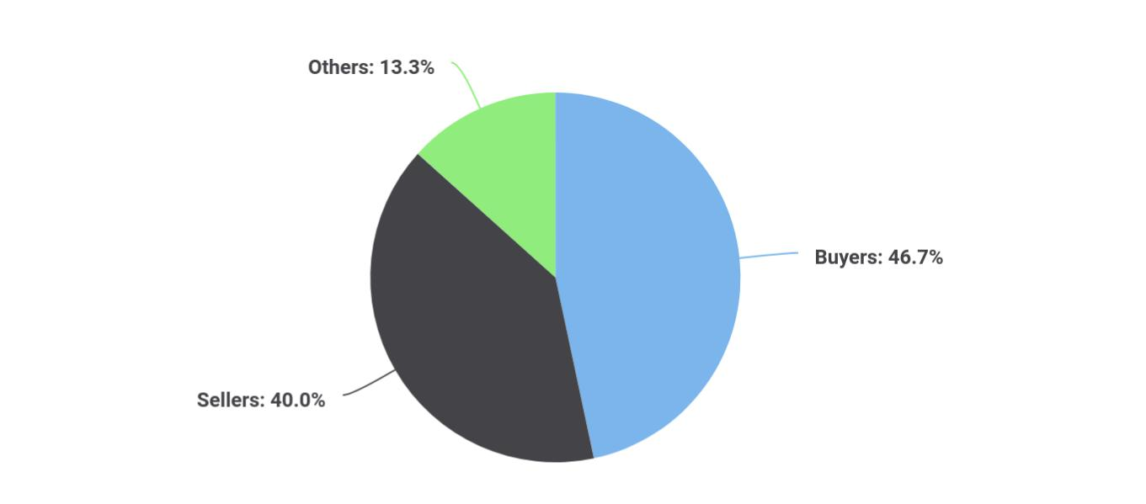

Freight Brokerage | Business Plan [YEAR] 16/35

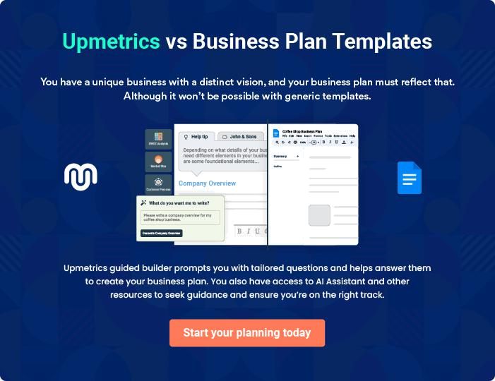

Freight Brokerage | Business Plan [YEAR] | 17/35

4.

Strategy &

Implementations

Sales Strategy

Advertising Strategy

Milestones

Pricing Strategy

Freight Brokerage | Business Plan [YEAR] 18/35

After identifying the market demand, market trends, and the potential customers of the startup, the next step is to define an effective strategy for attracting those customers. Like marketing analysis, sales strategy is also an
To unlock help try Upmetrics!
To unlock help try Upmetrics! 

Sales Strategy

 Detroit Freight Brokerage

The sales strategy will be a two-prong approach, the first prong deals with establishing strategic relationships with the carriers to have a basic portfolio of carriers who excel at
moving silicon chips. The second prong deals with closing deals with chip buyers and sellers to
To unlock help try Upmetrics! 

Start writing here..

Advertising Strategy

 Detroit Freight Brokerage

Detroit Freight Brokerage’s promotions strategy to reach its market includes:

To unlock help try Upmetrics! 

Start writing here..

 Detroit Freight Brokerage

Detroit Freight Brokerage will secure a billboard in the area that captures the attention of residents and local businesses. The billboard will draw attention to the new business and its service offering.



Billboards

Start writing here..

Freight Brokerage | Business Plan [YEAR] 19/35

 Detroit Freight Brokerage
To unlock help try Upmetrics!
To unlock help try Upmetrics!
To unlock help try Upmetrics!
To unlock help try Upmetrics!

Detroit Freight Brokerage understands that the best promotion comes from satisfied customers. The Company will encourage its clients to refer other businesses by providing economic or financial incentives for every new client produced.



Referrals

Start writing here..

 Detroit Freight Brokerage

Detroit Freight Brokerage will run regular advertisements to maintain exposure to relevant markets. Community newspapers and publications, and similar channels will be a major promotion effort.



Local Publications

Start writing here..

 Detroit Freight Brokerage

Detroit Freight Brokerage will send out direct mail pieces to households and businesses within its target area. These pieces will provide general information on Detroit Freight Brokerage and offer discounts.



Customer Loyalty Programs

Start writing here..

 Detroit Freight Brokerage

Detroit Freight Brokerage will create a winning customer loyalty program to keep its best clients coming back again and again. Long-term customers will have the opportunity to participate in the loyalty program, and referrals will be rewarded as well.



Direct Mail

Start writing here..

Freight Brokerage | Business Plan [YEAR] 20/35

Milestones

 Detroit Freight Brokerage

D&L Freight Brokers will have several milestones early on:

1. Business plan completion. This will be done in the first month.
To unlock help try Upmetrics! 

Start writing here..

Pricing Strategy

 Detroit Freight Brokerage

Setting the price for intangible services can be very different from that of physical goods and products; however, setting our own price will be determined on a whole lot of factors as we intend to conduct research that will allow us to know what price is right for us as well as
To unlock help try Upmetrics! 

Start writing here..

Freight Brokerage | Business Plan [YEAR] 21/35

5.

Operations Plan

Functional Roles

Personnel Plan

Milestones

Freight Brokerage | Business Plan [YEAR] 22/35

Functional Roles
To unlock help try Upmetrics!

 Detroit Freight Brokerage

In order to execute on Detroit Freight Brokerage’s business model, the Company needs to perform several functions. Detroit Freight Brokerage anticipates hiring 10 employees, divided into the following roles.



Functional Roles

Start writing here..

 Detroit Freight Brokerage


• General & administrative functions including marketing, bookkeeping, etc.

• Sourcing transport companies/couriers, General liaison To unlock help try Upmetrics! 

Administrative Functions

Start writing here..

Personnel Plan

 Detroit Freight Brokerage

The staff will consist of Steve working full time for DFB in the capacity of the owner and licensed broker.
To unlock help try Upmetrics! 

Start writing here..

Freight Brokerage | Business Plan [YEAR] 23/35

Milestones

 Detroit Freight Brokerage

Detroit Freight Brokerage’s long-term goal is to become the most trusted freight brokerage company in the Detroit area. The following are a series of steps that lead to our vision of long-term success. Detroit Freight Brokerage expects to achieve the following milestones in the
To unlock help try Upmetrics! 

Start writing here..

Freight Brokerage | Business Plan [YEAR] 24/35

6.

Financial Plan

Important Assumptions

Brake-even Analysis

Projected Profit and Loss

Projected Cash Flow

Projected Balance Sheet

Business Ratios

Freight Brokerage | Business Plan [YEAR] 25/35

The last component of a Freight Brokerage business plan is an in-depth financial plan. The financial plan crafts a detailed map of all the expenses needed for the startup and how these expenses will be met by the earned
To unlock help try Upmetrics! 

 Detroit Freight Brokerage

The company will be financed by John himself and he will control the direction of the business to make sure that it is expanding at the forecasted rate. As for the Freight Brokerage business start-up, no equity funding or outside loans will be required. With the help of financial experts,
To unlock help try Upmetrics! 

Start writing here..

Important Assumptions

The financial projections of the company are forecast on the basis of the following assumptions. These assumptions are quite conservative and are expected to show deviation but to a limited level such that the company’s major financial strategy will not be affected.

 | Year 1 | Year 2 | Year 3
Plan Month | 1 | 2 | 3
Current Interest Rate | 10,00% | 11,00% | 12,00%
Long-term Interest Rate | 10,00% | 10,00% | 10,00%
Tax Rate | 26,42% | 27,76% | 28,12%
Other | 0 | 0 | 0

Brake-even Analysis

Monthly Units Break-even | 5530
Monthly Revenue Break-even | $159 740
Assumptions:
Average Per-Unit Revenue | $260,87
Average Per-Unit Variable Cost | $0,89
Estimated Monthly Fixed Cost | $196 410

Freight Brokerage | Business Plan [YEAR] 26/35

Projected Profit and Loss

 | 2024 | 2025 | 2026
Revenue | $3,283,877.10 | $6,689,796.80 | $12,005,732.83
Freight Charges | $1,920,000 | $1,989,272 | $2,350,544
Unit Sales | 2,400 | 2,487 | 2,938
Unit Price | $800 | $800 | $800
Brokerage Commissions | $24,000 | $96,000 | $103,597.73
Ancillary Services | $1,339,877.10 | $4,604,524.80 | $9,551,591.10
Users | 1,286 | 3,199 | 6,133
Recurring Charges | $170 | $170 | $170

Cost Of Sales | $1,687,306.73 | $2,823,662.01 | $4,628,068.57
General Costs | $1,687,306.73 | $2,823,662.01 | $4,628,068.57
Brokerage Costs | $922,344.02 | $1,775,261.31 | $3,186,887.15
Freight Brokerage | $492,581.58 | $1,003,469.54 | $1,800,859.93
Commission | $492,581.58 | $1,003,469.54 | $1,800,859.93
Vehicle Maintenance | $429,762.44 | $771,791.77 | $1,386,027.22
Supply Chain Solutions | $764,962.71 | $1,048,400.70 | $1,441,181.42
Third-Party Logistics | $268,241.69 | $340,195.27 | $431,449.84
Warehousing | $496,721.02 | $708,205.43 | $1,009,731.58
Revenue Specific Costs | $0 | $0 | $0
Personnel Costs (Direct | $0 | $0 | $0
Labor) | $0 | $0 | $0

Gross Margin | $1,596,570.37 | $3,866,134.79 | $7,377,664.26
Gross Margin (%) | 48.62% | 57.79% | 61.45%

Freight Brokerage | Business Plan [YEAR] 27/35

 | 2024 | 2025 | 2026
Operating Expense | $1,896,792.15 | $2,227,517.97 | $2,794,057.93

Payroll Expense (Indirect Labor)

Management Team

General Manager

Operations Manager

Brokerage Staff

Freight Brokers

Customer Service

Representatives

Administrative Staff

Administrative Staff

: Accountants

General Expense

Administrative Expenses

Office Supplies

Utilities

Marketing and Advertising

Digital Marketing

Print Advertising

Technology and

Communication

Software Subscriptions

Telecommunication

Bad Debt

Amortization of Current Assets

$809,760 | $834,112.80 | $859,226.40
$223,200 | $231,336 | $239,773.68
$144,000 | $149,760 | $155,750.40
$79,200 | $81,576 | $84,023.28
$382,320 | $393,789.60 | $405,603.48
$283,200 | $291,696 | $300,447
$99,120 | $102,093.60 | $105,156.48
$204,240 | $208,987.20 | $213,849.24
$138,000 | $140,760 | $143,575.20
$66,240 | $68,227.20 | $70,274.04
$1,087,032.15 | $1,393,405.17 | $1,934,831.53
$485,021.93 | $659,835.21 | $900,576.78
$201,181.34 | $255,146.51 | $323,587.40
$283,840.59 | $404,688.70 | $576,989.38
$596,010.22 | $727,341.96 | $1,027,788.79
$581,818.14 | $707,107.36 | $998,939.14
$14,192.08 | $20,234.60 | $28,849.65
$6,000 | $6,228 | $6,465.96
$3,600 | $3,780 | $3,969
$2,400 | $2,448 | $2,496.96
$0 | $0 | $0
$0 | $0 | $0

Freight Brokerage | Business Plan [YEAR] 28/35

EBITDA

Additional Expense

Long Term Depreciation

Gain or loss from Sale of Assets

EBIT

Interest Expense

EBT

Income Tax Expense / Benefit
2024 2025 2026

($300,221.79) $1,638,616.82 $4,583,606.33

$23,560.80 | $21,317.24 | $18,911.49
$17,544 | $17,544 | $17,544
$0 | $0 | $0
($317,765.79) | $1,621,072.82 | $4,566,062.33
$6,016.82 | $3,773.25 | $1,367.48
($323,782.59) | $1,617,299.58 | $4,564,694.84
$0 | $0 | $0

Total Expense | $3,607,659.69 | $5,072,497.22 | $7,441,037.99
Net Income | ($323,782.59) | $1,617,299.58 | $4,564,694.84
Net Income (%) | (9.86%) | 24.18% | 38.02%
Retained Earning Opening | $0 | ($348,782.59) | $1,258,516.99
Owner's Distribution | $25,000 | $10,000 | $10,000
Retained Earning Closing | ($348,782.59) | $1,258,516.99 | $5,813,211.83
Projected Cash Flow
 | 2024 | 2025 | 2026
Cash Received | $3,283,877.10 | $6,689,796.80 | $12,005,732.83
Cash Paid | $3,590,115.69 | $5,054,953.22 | $7,423,493.99

Freight Brokerage | Business Plan [YEAR] 29/35

 | 2024 | 2025 | 2026
COS & General Expenses | $2,774,338.89 | $4,217,067.18 | $6,562,900.10
Salary & Wages | $809,760 | $834,112.80 | $859,226.40
Interest | $6,016.82 | $3,773.25 | $1,367.48
Sales Tax | $0 | $0 | $0
Income Tax | $0 | $0 | $0
Net Cash From | ($306,238.59) | $1,634,843.58 | $4,582,238.84
Operations | ($306,238.59) | $1,634,843.58 | $4,582,238.84

Assets Sell | $0 | $0 | $0
Assets Purchase | $130,000 | $0 | $0
Net Cash From | ($130,000) | $0 | $0
Investments | ($130,000) | $0 | $0

Amount Received | $170,000 | $0 | $0
Loan Received | $100,000 | $0 | $0
Common Stock | $0 | $0 | $0
Preferred Stock | $0 | $0 | $0
Owner's Contribution | $70,000 | $0 | $0
Amount Paid | $56,035.72 | $43,279.28 | $45,685.02
Loan Capital | $31,035.70 | $33,279.27 | $35,685.03
Dividends & Distributions | $25,000 | $10,000 | $10,000
Net Cash From | $113,964.28 | ($43,279.28) | ($45,685.02)
Financing | $113,964.28 | ($43,279.28) | ($45,685.02)

Summary

Starting Cash | $0 | ($322,274.31) | $1,269,289.99
Cash In | $3,453,877.10 | $6,689,796.80 | $12,005,732.83

Freight Brokerage | Business Plan [YEAR] 30/35

 | 2024 | 2025 | 2026
Cash Out | $3,776,151.41 | $5,098,232.50 | $7,469,179.01
Change in Cash | ($322,274.31) | $1,591,564.30 | $4,536,553.82
Ending Cash | ($322,274.31) | $1,269,289.99 | $5,805,843.81

Projected Balance Sheet

 | 2024 | 2025 | 2026
Assets | ($209,818.31) | $1,364,201.99 | $5,883,211.81
Current Assets | ($322,274.31) | $1,269,289.99 | $5,805,843.81
Cash | ($322,274.31) | $1,269,289.99 | $5,805,843.81
Accounts Receivable | $0 | $0 | $0
Inventory | $0 | $0 | $0
Other Current Assets | $0 | $0 | $0
Long Term Assets | $112,456 | $94,912 | $77,368
Gross Long Term Assets | $130,000 | $130,000 | $130,000
Accumulated Depreciation | ($17,544) | ($35,088) | ($52,632)

Liabilities & Equity | ($209,818.30) | $1,364,202.01 | $5,883,211.83
Liabilities | $68,964.29 | $35,685.02 | $0
Current Liabilities | $33,279.27 | $35,685.02 | $0
Accounts Payable | $0 | $0 | $0
Income Tax Payable | $0 | $0 | $0
Sales Tax Payable | $0 | $0 | $0
Short Term Debt | $33,279.27 | $35,685.02 | $0
Long Term Liabilities | $35,685.02 | $0 | $0
Long Term Debt | $35,685.02 | $0 | $0

Freight Brokerage | Business Plan [YEAR] 31/35

 | 2024 |  |  | 2025 |  | 2026
Equity | ($278,782.59) |  | $1,328,516.99 |  |  | $5,883,211.83
Paid-in Capital | $0 |  |  | $0 |  | $0
Common Stock | $0 |  |  | $0 |  | $0
Preferred Stock | $0 |  |  | $0 |  | $0
Owner's Contribution | $70,000 |  |  | $70,000 |  | $70,000
Retained Earnings | ($348,782.59) |  | $1,258,516.99 |  |  | $5,813,211.83
Check | $0 |  |  | $0 |  | $0
Business Ratios
 |  | Year 1 | Year 2 |  | Year 3 | Industry Profile
Sales Growth |  | 4,35% | 30,82% |  | 63,29% | 4,00%
Percent of Total Assets
Accounts Receivable |  | 5,61% | 4,71% |  | 3,81% | 9,70%
Inventory |  | 1,85% | 1,82% |  | 1,79% | 9,80%
Other Current Assets |  | 1,75% | 2,02% |  | 2,29% | 27,40%
Total Current Assets |  | 138,53% | 150,99% |  | 163,45% | 54,60%
Long-term Assets |  | -9,47% | -21,01% |  | -32,55% | 58,40%
TOTAL ASSETS |  | 100,00% | 100,00% |  | 100,00% | 100,00%
Current Liabilities |  | 4,68% | 3,04% |  | 2,76% | 27,30%
Long-term Liabilities |  | 0,00% | 0,00% |  | 0,00% | 25,80%
Total Liabilities |  | 4,68% | 3,04% |  | 2,76% | 54,10%
NET WORTH |  | 99,32% | 101,04% |  | 102,76% | 44,90%
Percent of Sales
Sales |  | 100,00% | 100,00% |  | 100,00% | 100,00%
Gross Margin |  | 94,18% | 93,85% |  | 93,52% | 0,00%

Freight Brokerage | Business Plan [YEAR] 32/35

 | Year 1 | Year 2 | Year 3 | Industry Profile
Selling, General & Administrative Expenses | 74,29% | 71,83% | 69,37% | 65,20%
Advertising Expenses | 2,06% | 1,11% | 0,28% | 1,40%
Profit Before Interest and Taxes | 26,47% | 29,30% | 32,13% | 2,86%
Main Ratios
Current | 25,86 | 29,39 | 32,92 | 1,63
Quick | 25,4 | 28,88 | 32,36 | 0,84
Total Debt to Total Assets | 2,68% | 1,04% | 0,76% | 67,10%
Pre-tax Return on Net Worth | 66,83% | 71,26% | 75,69% | 4,40%
Pre-tax Return on Assets | 64,88% | 69,75% | 74,62% | 9,00%
Additional Ratios
Net Profit Margin | 19,20% | 21,16% | 23,12% | N.A.
Return on Equity | 47,79% | 50,53% | 53,27% | N.A.
Activity Ratios
Accounts Receivable Turnover | 4,56 | 4,56 | 4,56 | N.A.
Collection Days | 92 | 99 | 106 | N.A.
Inventory Turnover | 19,7 | 22,55 | 25,4 | N.A.
Accounts Payable Turnover | 14,17 | 14,67 | 15,17 | N.A.
Payment Days | 27 | 27 | 27 | N.A.
Total Asset Turnover | 1,84 | 1,55 | 1,26 | N.A.
Debt Ratios
Debt to Net Worth | 0 | -0,02 | -0,04 | N.A.
Current Liab. to Liab. | 1 | 1 | 1 | N.A.
Liquidity Ratios
Net Working Capital | $120 943 | $140 664 | $160 385 | N.A.
Interest Coverage | 0 | 0 | 0 | N.A.
Additional Ratios
Assets to Sales | 0,45 | 0,48 | 0,51 | N.A.
Current Debt/Total Assets | 4% | 3% | 2% | N.A.

Freight Brokerage | Business Plan [YEAR] 33/35

 | Year 1 | Year 2 | Year 3 | Industry Profile
Acid Test | 23,66 | 27,01 | 30,36 | N.A.
Sales/Net Worth | 1,68 | 1,29 | 0,9 | N.A.
Dividend Payout | 0 | 0 | 0 | N.A.
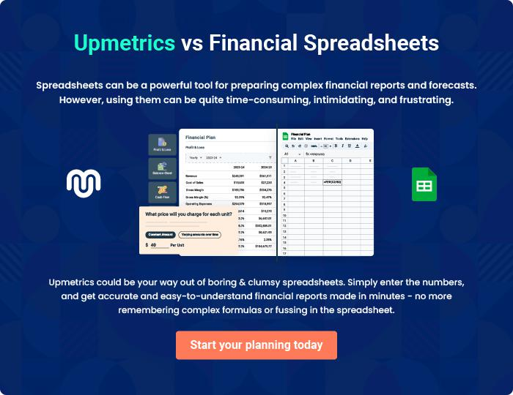

Freight Brokerage | Business Plan [YEAR] 34/35


Create a winning business plan that gets you funded

Creating a stunning and investment-ready plan requires no writing, graphic designing, or financial planning expertise.

Upmetrics has all the features required to help you create a comprehensive business plan—from start to finish. Make no mistakes, it’s the modern way of planning to structure ideas, make plans, and create stunning pitch decks to awe investors.

Pitch decks that impress investors

Create pitch decks that provide a visual representation of your business, engage investors, and make them want to invest in your business idea.

Interactive plans in no time

Import business plan sections like—SWOT analysis, comparison tables, and others to create an interactive business plan. No designing skills are required.

Stunning cover page designs

With Upmetrics, you have the liberty to choose from multiple stunning cover page designs. Choose a creative design and make your plan stand out.

Online sharing made simple

Upmetrics makes online sharing quick and easier for users. Easily share your business plans with a link while tracking reader activity.

500+ sample business plans

Simply import a template from our library of sample plans into the editor and start customizing it to make it yours. It takes only a few clicks to get started.

Collaborate with team in real-time

Invite team members, initiate conversations, discuss ideas & strategies, share feedback, and work on a business plan in real-time.

