
Flower Shop

ADDRESS

CONTACT

10200 Bolsa Ave, Westminster, CA, 92683

(650) 359-3153

http://www.example.com

info@example.com


Business Plan

[YEAR]

Prepared By

John Doe


Flowers, anywhere anytime.

Information provided in this business plan is unique to this business and confidential; therefore, anyone reading this plan agrees not to disclose any of the information in this business plan without prior written permission of the company.

Table of Contents

Executive Summary | 5
Mission Statement | 6
Vision Statement | 6
Keys to Success | 7
Objectives | 7
Financial Summary | 7
3 Year profit forecast | 8

Company Summary | 9
Store Design | 10
Store Operation | 10
Startup Summary | 11
Startup cost | 11

Products and services | 14
Products | 15
Features | 15
Services | 17

Market Analysis | 18
Market Trends | 19
Target Market | 19
Strategy & Implementations
Strategy & Implementations | 20
Sales Strategy | 21
Advertising Strategy | 21
Pricing Strategy | 22
Financial Plan
Financial Plan | 23
Important Assumptions | 24

Flower Shop | Business Plan [YEAR] 2/34

Brake-even Analysis | 24
Projected Profit and Loss | 25
Projected Cash Flow | 27
Projected Balance Sheet | 30
Business Ratios | 31

Flower Shop | Business Plan [YEAR] 3/34

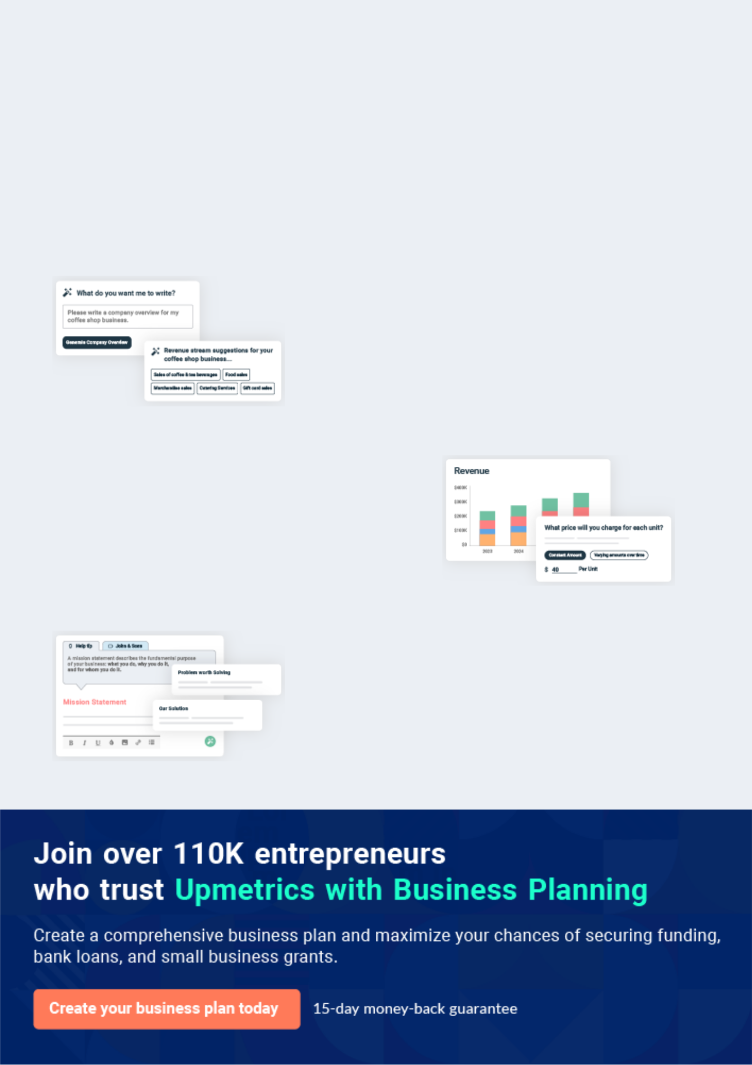
Business planning that’s simpler and faster than you think

Creating a business plan using Upmetrics to start and grow a business is literally the easiest thing in the World. Simply read the instructions and fill in the blanks. It’s as simple as that.

❛ | Upmetrics has everything you need to create a | ❜
❛ | comprehensive business plan. | ❜

AI-powered Upmetrics Assistant

AI-powered insights to streamline your plan

Not sure where to start? Upmetrics’ AI Assistant will automatically generate ideas for each section of your plan and offer improved versions of your writing, adjusting for tone, voice, and grammar or spelling errors.

Financial Forecasting Tool

All the financials are calculated for you

Forget the complex formulas and clumsy spreadsheets — with automatic financials and drag-and-drop forecasting, you can finish your plan faster and be confident that your numbers are accurate.

Business Plan Builder

Guides you like a business mentor

Upmetrics’ step-by-step instructions, prompts, and the library of 400+ sample business plans will guide you through each section of your plan as a business mentor.

1.


Executive Summary

Mission Statement

Vision Statement

Keys to Success

Objectives

Financial Summary

Flower Shop | Business Plan [YEAR] 5/34

Before you think about how to start a flower service, you must create a detailed flower shop business plan. It will not only guide you in the initial phases of your startup but will also help you later on.
To unlock help try Upmetrics!

 Bloom Valley Flower




Bloom Valley Flower Shop, LCC is a standard and registered flower shop business that will be located on one of the busiest roads in Detroit, Michigan. We have been able to lease a facility along a major road that is big enough to fit into the design of the kind of flower shop that we
To unlock help try Upmetrics! 

Start writing here..

Mission Statement

 Bloom Valley Flower

Our mission is to establish a flower shop business that will make available a wide range of both fresh/natural and artificial flowers at affordable prices to the residents of Detroit, Michigan, and other cities in Michigan where we intend opening of chains of flower shops.
To unlock help try Upmetrics! 

Start writing here..

Vision Statement

 Bloom Valley Flower

Our vision is to become the leading flower shop brand in the florist industry in Michigan and to establish a one-stop flower shop in Detroit and in other cities in Michigan.
To unlock help try Upmetrics! 

Start writing here..

Flower Shop | Business Plan [YEAR] 6/34

Keys to Success

 Bloom Valley Flower

- Using technology to develop loyal, frequently-buying male clients instead of traditional, walk-in retail shoppers.
To unlock help try Upmetrics! 

Start writing here..

Objectives

 Bloom Valley Flower

• Generate healthy total revenue of $79,600 in Year One.

• Maintain an average direct cost of sales 40% or lower, and a high gross margin.
To unlock help try Upmetrics! 

Start writing here..

Financial Summary

 Bloom Valley Flower

Prior to starting the business, Bernie went through a couple of flower shop business ideas, so as to make the right decision. Bloom Valley Flower Shop intends to offer different types of flowers for various occasions to a wide range of customers visiting the shop. Bloom Valley
To unlock help try Upmetrics! 

Start writing here..

Flower Shop | Business Plan [YEAR] 7/34

3 Year profit forecast
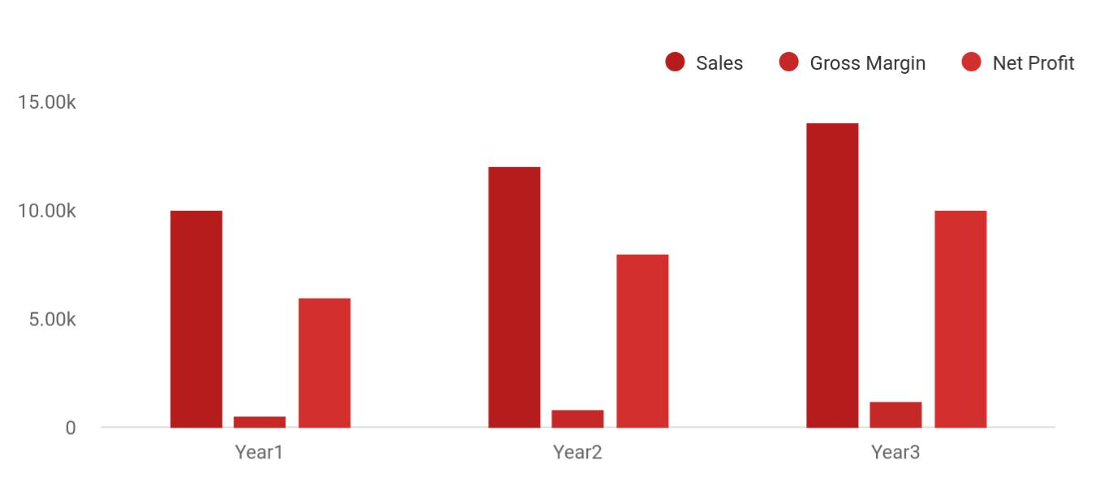

 Bloom Valley Flower


Financial Summary | Year 1 | Year 2 |  | Year 3
 |  |  | To unlock help try Upmetrics! |  | 

Start writing here..

Flower Shop | Business Plan [YEAR] 8/34

2.

Company Summary

Store Design

Store Operation

Startup Summary

Flower Shop | Business Plan [YEAR] 9/34

 Bloom Valley Flower

Bloom Valley Flower Shop, LCC is a family business that is owned by John Moore and Family. John Moore is a florist par excellence; he has a B.Sc. in Business Administration, with well over 15 years of experience in the florist and retailing industry, working for some of the leading
To unlock help try Upmetrics! 

Start writing here..

Store Design

 Bloom Valley Flower

The exterior of a florist shop is estimated to account for the attraction of 35% of all customers. While short term the company will not have a large amount of retail walk-in traffic, Bloom Valley Flower Shop will still create an inviting storefront, one designed to be distinctive and inviting,
To unlock help try Upmetrics! 

Start writing here..

Store Operation

 Bloom Valley Flower

Bloom Valley Flower Shop will be open for operation Monday – Saturday and closed on Sunday and on major holidays. Hours of operation will be 10:00 a.m. – 5:00 p.m. Monday – Friday, and from noon – 4:00 p.m. on Saturday. Hours may be extended during the holidays.
To unlock help try Upmetrics! 

Start writing here..

Flower Shop | Business Plan [YEAR] 10/34

Startup Summary

 Bloom Valley Flower

Total start-up capital and expenses (including legal costs, logo design, stationery, and related expenses) came to approximately $41,700. Start-up assets required and utilized included brewing plants and machinery, pick-ups, office furniture, personal computers, and other office
To unlock help try Upmetrics! 

Start writing here..

Startup cost
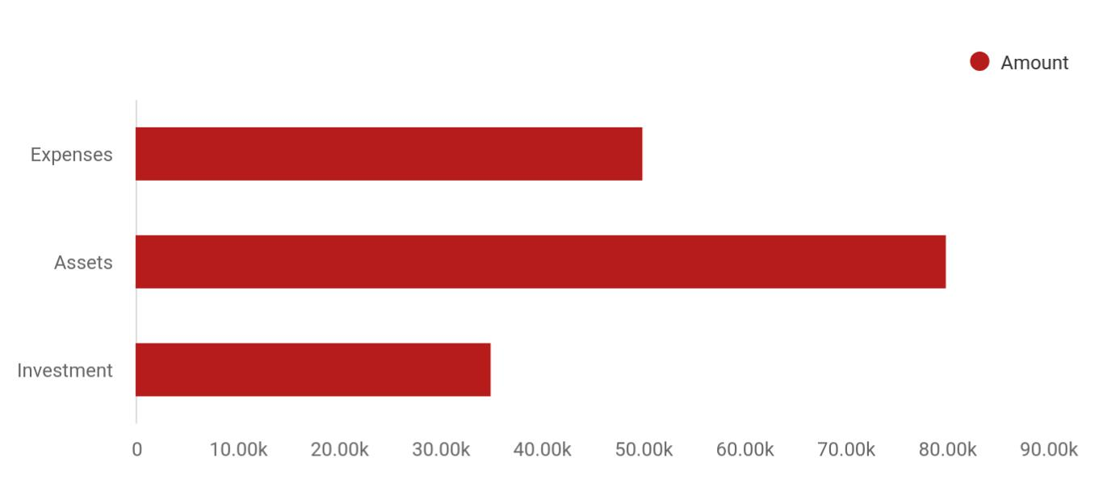

Cost distribution | Amount
Expenses | 50,000
Assets | 80,000
Investment | 35,000

Start-up Expenses | Amount
Legal | $75,500
Consultants | $0
Insurance | $62,750
Rent | $22,500
Research and Development | $42,750
Expensed Equipment | $42,750

Flower Shop | Business Plan [YEAR] 11/34

Start-up Expenses | Amount
Signs | $1,250
TOTAL START-UP EXPENSES | $247,500
Start-up Assets | $0
Cash Required | $322,500
Start-up Inventory | $52,625
Other Current Assets | $222,500
Long-term Assets | $125,000
TOTAL ASSETS | $121,875
Total Requirements | $245,000
START-UP FUNDING | $0
START-UP FUNDING | $273,125
Start-up Expenses to Fund | $121,875
Start-up Assets to Fund | $195,000
TOTAL FUNDING REQUIRED | $0
Assets | $203,125
Non-cash Assets from Start-up | $118,750
Cash Requirements from Start-up | $0
Additional Cash Raised | $118,750
Cash Balance on Starting Date | $121,875
TOTAL ASSETS | $0
Liabilities and Capital | $0
Liabilities | $0
Current Borrowing | $0
Long-term Liabilities | $0
Accounts Payable (Outstanding Bills) | $0
Other Current Liabilities (interest-free) | $0
TOTAL LIABILITIES | $0
Capital | $0

Flower Shop | Business Plan [YEAR] 12/34

Start-up Expenses | Amount
Planned Investment | $0
Investor 1 | $312,500
Investor 2 | $0
Other | $0
Additional Investment Requirement | $0
TOTAL PLANNED INVESTMENT | $695,000
Loss at Start-up (Start-up Expenses) | $313,125
TOTAL CAPITAL | $221,875
TOTAL CAPITAL AND LIABILITIES | $221,875
Total Funding | $265,000

Flower Shop | Business Plan [YEAR] 13/34

3.

Products and services

Products

Services

Flower Shop | Business Plan [YEAR] 14/34

 Bloom Valley Flower
Unique Containers
Bloom Valley will select and offer distinctive vases for the discretionary buyer or for a special occasion, as well as affordable options for routine purchases.
To unlock help try Upmetrics!

Bloom Valley Flower Shop, LCC is in the florist industry / flower shop line of business to make profits and we will ensure we go all the way to make available a wide range of flowers both natural and artificial and other related merchandise to our clients.



Start writing here..

Products

Features


Original Floral Designs, Using A Wide Mix of Flowers

Each Bloom Valley floral arrangement will be a natural, original work of art. The company is committed to making each arrangement unique and custom-designed based on each customer’s needs. Bloom Valley’s floral arrangements will feature a wide range of seasonal flowers. All sample arrangements in the store will be available for purchase.

Flower Shop | Business Plan [YEAR] 15/34


Green and Flowering House Plants

Bloom Valley may occasionally offer a selection of seasonal green and flowering house plants.

Paintings and

Artwork from Local

Artists

To create a gallery

environment, the Bloom

Valley store will feature

paintings and/or

drawings from local

artists, and the artwork

will be for sale. The

company will collect a

small percentage of

each sale (5%).
Gourmet Chocolates

With consumer’s heightened awareness of chocolate brands and a seeming willingness to pay for a better product, Bloom Valley will carry several lines of exclusive gourmet chocolate bars, that is, the brands will not be sold by other metro Atlanta retailers. The sale of gourmet chocolate is a perfect complement to flowers, and encourages consumers to indulge and experience something new because they are worth it.

Flower Shop | Business Plan [YEAR] 16/34

Services

 Bloom Valley Flower

Forget-Me-Not Club. Special occasions account for four out of every ten floral purchases made. To capture a portion of this market and to foster overall romance, Bloom Valley will offer a Frequent Flower Gift Program called the Forget-Me-Not Club designed for men.
To unlock help try Upmetrics! 

Start writing here..
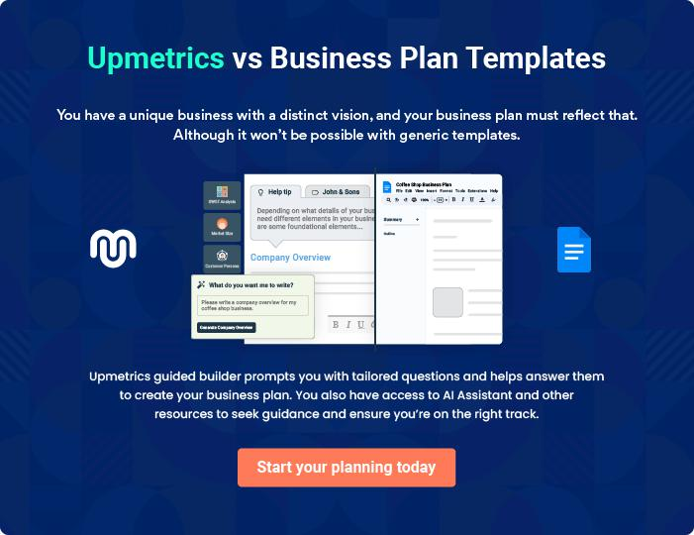

Flower Shop | Business Plan [YEAR] 17/34

4.

Market Analysis

Market Trends

Target Market

Flower Shop | Business Plan [YEAR] 18/34

The most important component of an effective Flower shop business plan is its accurate marketing analysis. If you are starting on a smaller scale, you can do marketing analysis yourself by taking help from this Flower shop
To unlock help try Upmetrics! 

Market Trends

 Bloom Valley Flower

In this era when the online community is growing rapidly, you would do your business a whole lot of favor if you create your own online presence. One of the easiest ways to get people to see you as an expert in your line of business is to blog constantly about flowers. You may also want
To unlock help try Upmetrics! 

Start writing here..

Target Market

 Bloom Valley Flower

There are loads of people who can’t do without flowers either natural or artificial flowers and there are loads of functions such as wedding ceremonies, burial ceremonies, and many other events. This goes to show that if a flower shop is well-positioned, they will continue to sell their
To unlock help try Upmetrics! 

Start writing here..

Flower Shop | Business Plan [YEAR] 19/34

5.

Strategy &

Implementations

Sales Strategy

Advertising Strategy

Pricing Strategy

Flower Shop | Business Plan [YEAR] 20/34

After identifying the market demand, market trends, and the potential customers of the startup, the next step is to define an effective strategy for attracting those customers. Like marketing analysis, sales strategy is also an
To unlock help try Upmetrics! 

 Bloom Valley Flower

In order to continue to be in business and grow, we must continue to sell the flowers and related products that are available in our shop which is why we will go all out to empower our sales and marketing team to deliver. In summary, Bloom Valley Flower Shop, LLC will adopt the
To unlock help try Upmetrics! 

Start writing here..

Sales Strategy

 Bloom Valley Flower

Today, over 90% of Americans cite word-of-mouth as one of the best sources of ideas and information. Word-of-mouth is rated as important as advertising or editorial content, and Americans place one-and-a-half times more value on it today than they did 25 years ago.
To unlock help try Upmetrics! 

Start writing here..

Advertising Strategy

 Bloom Valley Flower

Despite the fact that our flower shop is well located, we will still go ahead to intensify publicity for the business. We are going to explore all available means to promote Bloom Valley Flower
Shop, LLC. Bloom Valley Flower has a long-term plan of opening outlets in various locations all
To unlock help try Upmetrics! 

Start writing here..

Flower Shop | Business Plan [YEAR] 21/34

Pricing Strategy

 Bloom Valley Flower

Pricing is one of the key factors that gives leverage to retailers and flower shops. It is normal for consumers to go to places (flower shops) where they can get flowers and related merchandise at a cheaper price which is why big players in the florist industry will continue to
To unlock help try Upmetrics! 

Start writing here..

Flower Shop | Business Plan [YEAR] 22/34

6.

Financial Plan

Important Assumptions

Brake-even Analysis

Projected Profit and Loss

Projected Cash Flow

Projected Balance Sheet

Business Ratios

Flower Shop | Business Plan [YEAR] 23/34

The last component of a flower shop business plan is an in-depth financial plan. The financial plan crafts a detailed map of all the expenses needed for the startup and how these expenses will be met by the earned profits. It is
To unlock help try Upmetrics! 

 Bloom Valley Flower

The company will be financed by John himself and he will control the direction of the business to make sure that it is expanding at the forecasted rate. As for the flower shop business start-up, no equity funding or outside loans will be required. With the help of financial experts, John
To unlock help try Upmetrics! 

Start writing here..

Important Assumptions

The financial projections of the company are forecast on the basis of the following assumptions. These assumptions are quite conservative and are expected to show deviation but to a limited level such that the company’s major financial strategy will not be affected.

 | Year 1 | Year 2 | Year 3
Plan Month | 1 | 2 | 3
Current Interest Rate | 10,00% | 11,00% | 12,00%
Long-term Interest Rate | 10,00% | 10,00% | 10,00%
Tax Rate | 26,42% | 27,76% | 28,12%
Other | 0 | 0 | 0

Brake-even Analysis

Monthly Units Break-even | 5530
Monthly Revenue Break-even | $159 740
Assumptions:
Average Per-Unit Revenue | $260,87
Average Per-Unit Variable Cost | $0,89
Estimated Monthly Fixed Cost | $196 410

Flower Shop | Business Plan [YEAR] 24/34

Projected Profit and Loss

 | 2024 | 2025 | 2026
Revenue | $333,328.40 | $789,273.90 | $1,366,662.70
Fresh Flower | $67,059.70 | $85,047.40 | $107,861.30
Unit Sales | 6,706 | 8,505 | 10,786
Unit Price | $10 | $10 | $10
Floral Arrangement | $70,960.50 | $101,171.50 | $144,246
Services | $70,960.50 | $101,171.50 | $144,246
Unit Sales | 1,419 | 2,023 | 2,885
Unit Price | $50 | $50 | $50
Flower Arrangement | $195,308.20 | $603,055 | $1,114,555.40
Classes | $195,308.20 | $603,055 | $1,114,555.40
Users | 1,539 | 3,401 | 5,796
Recurring Charges | $20 | $20 | $20

Cost Of Sales | $35,690.12 | $60,900.11 | $92,487.91
General Costs | $35,690.12 | $60,900.11 | $92,487.91
Flower Procurement | $29,348.96 | $53,754.82 | $84,436.59
Fresh Flower Purchase | $12,682.53 | $14,291.10 | $16,103.44
Floral Supplies | $16,666.43 | $39,463.72 | $68,333.15
Class Materials | $6,341.16 | $7,145.29 | $8,051.32
Class Supplies | $3,804.70 | $4,287.13 | $4,830.73
Educational Materials | $2,536.46 | $2,858.16 | $3,220.59
Revenue Specific Costs | $0 | $0 | $0
Personnel Costs (Direct | $0 | $0 | $0
Labor) | $0 | $0 | $0

Flower Shop | Business Plan [YEAR] 25/34

 | 2024 | 2025 | 2026
Gross Margin | $297,638.28 | $728,373.79 | $1,274,174.79
Gross Margin (%) | 89.29% | 92.28% | 93.23%

Operating Expense | $376,863.95 | $359,677.37 | $373,218.59
Payroll Expense (Indirect | $321,132 | $330,674.04 | $340,543.32
Labor) | $321,132 | $330,674.04 | $340,543.32
Management | $79,020 | $82,855.80 | $86,878.80
Manager | $67,500 | $70,875 | $74,418.72
Assistant Manager | $11,520 | $11,980.80 | $12,460.08
Sales and Customer | $165,696 | $169,873.92 | $174,161.28
Services | $165,696 | $169,873.92 | $174,161.28
Sales Associate | $86,400 | $88,992 | $91,661.76
Customer Service | $79,296 | $80,881.92 | $82,499.52
Represntative | $79,296 | $80,881.92 | $82,499.52
Maintenance and Support | $76,416 | $77,944.32 | $79,503.24
Cleaner | $39,600 | $40,392 | $41,199.84
Maintenance Worker | $36,816 | $37,552.32 | $38,303.40
General Expense | $25,743.95 | $29,003.33 | $32,675.27
Utilities | $6,975.43 | $7,860.14 | $8,856.84
Electricity | $4,438.97 | $5,001.98 | $5,636.25
Water | $2,536.46 | $2,858.16 | $3,220.59
Marketing and Advertising | $9,511.93 | $10,718.22 | $12,077.48
Social Media Ads | $4,438.97 | $5,001.98 | $5,636.25
Flyer Distribution | $5,072.96 | $5,716.24 | $6,441.23
Maintenance and Supplies | $9,256.59 | $10,424.97 | $11,740.95
Equipment Maintenance | $4,183.63 | $4,708.73 | $5,299.72
Office Supplies | $5,072.96 | $5,716.24 | $6,441.23

Flower Shop | Business Plan [YEAR] 26/34

Bad Debt

Amortization of Current Assets

EBITDA

Additional Expense

Long Term Depreciation

Gain or loss from Sale of Assets

EBIT

Interest Expense

EBT

Income Tax Expense / Benefit

Total Expense

Net Income

Net Income (%)

Retained Earning Opening

Owner's Distribution

Retained Earning Closing

Projected Cash Flow

2024 | 2025 | 2026
$0 | $0 | $0
$29,988 | $0 | $0

($79,225.67) $368,696.41 $900,956.19

$14,237.98 | $13,314.21 | $12,343.20
$9,648 | $9,648 | $9,648
$0 | $0 | $0
($88,873.67) | $359,048.41 | $891,308.19
$4,589.96 | $3,666.20 | $2,695.19
($93,463.65) | $355,382.20 | $888,612.99
$0 | $0 | $0

$426,792.05 | $433,891.70 | $478,049.71
($93,463.65) | $355,382.20 | $888,612.99
(28.04%) | 45.03% | 65.02%

$0 | ($113,463.65) | $221,918.55
$20,000 | $20,000 | $20,000
($113,463.65) | $221,918.55 | $1,090,531.54

Flower Shop | Business Plan [YEAR] 27/34

 | 2024 | 2025 | 2026
Cash Received | $333,328.40 | $789,273.90 | $1,366,662.70
Cash Paid | $387,156.04 | $424,243.70 | $468,401.71
COS & General Expenses | $61,434.06 | $89,903.45 | $125,163.19
Salary & Wages | $321,132 | $330,674.04 | $340,543.32
Interest | $4,589.96 | $3,666.20 | $2,695.19
Sales Tax | $0 | $0 | $0
Income Tax | $0 | $0 | $0
Net Cash From | ($53,827.64) | $365,030.20 | $898,260.99
Operations | ($53,827.64) | $365,030.20 | $898,260.99

Assets Sell | $0 | $0 | $0
Assets Purchase | $150,000 | $0 | $0
Net Cash From | ($150,000) | $0 | $0
Investments | ($150,000) | $0 | $0

Amount Received | $175,000 | $0 | $0
Loan Received | $100,000 | $0 | $0
Common Stock | $75,000 | $0 | $0
Preferred Stock | $0 | $0 | $0
Owner's Contribution | $0 | $0 | $0
Amount Paid | $38,055.46 | $38,979.23 | $39,950.24
Loan Capital | $18,055.48 | $18,979.24 | $19,950.25
Dividends & Distributions | $20,000 | $20,000 | $20,000
Net Cash From | $136,944.54 | ($38,979.23) | ($39,950.24)
Financing | $136,944.54 | ($38,979.23) | ($39,950.24)

Summary

Flower Shop | Business Plan [YEAR] 28/34

 | 2024 | 2025 | 2026
Starting Cash | $0 | ($66,883.10) | $259,167.87
Cash In | $508,328.40 | $789,273.90 | $1,366,662.70
Cash Out | $575,211.50 | $463,222.93 | $508,351.95
Change in Cash | ($66,883.10) | $326,050.97 | $858,310.75
Ending Cash | ($66,883.10) | $259,167.87 | $1,117,478.62

Flower Shop | Business Plan [YEAR] 29/34

Projected Balance Sheet

 | 2024 | 2025 | 2026
Assets | $43,480.90 | $359,883.87 | $1,208,546.62
Current Assets | ($66,871.10) | $259,179.87 | $1,117,490.62
Cash | ($66,883.10) | $259,167.87 | $1,117,478.62
Accounts Receivable | $0 | $0 | $0
Inventory | $0 | $0 | $0
Other Current Assets | $12 | $12 | $12
Long Term Assets | $110,352 | $100,704 | $91,056
Gross Long Term Assets | $120,000 | $120,000 | $120,000
Accumulated Depreciation | ($9,648) | ($19,296) | ($28,944)
Liabilities & Equity | $43,480.87 | $359,883.83 | $1,208,546.57
Liabilities | $81,944.52 | $62,965.28 | $43,015.03
Current Liabilities | $18,979.24 | $19,950.25 | $0
Accounts Payable | $0 | $0 | $0
Income Tax Payable | $0 | $0 | $0
Sales Tax Payable | $0 | $0 | $0
Short Term Debt | $18,979.24 | $19,950.25 | $0
Long Term Liabilities | $62,965.28 | $43,015.03 | $43,015.03
Long Term Debt | $62,965.28 | $43,015.03 | $43,015.03
Equity | ($38,463.65) | $296,918.55 | $1,165,531.54
Paid-in Capital | $0 | $0 | $0
Common Stock | $75,000 | $75,000 | $75,000
Preferred Stock | $0 | $0 | $0
Owner's Contribution | $0 | $0 | $0

Flower Shop | Business Plan [YEAR] 30/34

 | 2024 |  |  | 2025 |  | 2026
Retained Earnings | ($113,463.65) |  | $221,918.55 |  |  | $1,090,531.54
Check | $0 |  |  | $0 |  | $0
Business Ratios
 |  | Year 1 | Year 2 |  | Year 3 | Industry Profile
Sales Growth |  | 4,35% | 30,82% |  | 63,29% | 4,00%
Percent of Total Assets
Accounts Receivable |  | 5,61% | 4,71% |  | 3,81% | 9,70%
Inventory |  | 1,85% | 1,82% |  | 1,79% | 9,80%
Other Current Assets |  | 1,75% | 2,02% |  | 2,29% | 27,40%
Total Current Assets |  | 138,53% | 150,99% |  | 163,45% | 54,60%
Long-term Assets |  | -9,47% | -21,01% |  | -32,55% | 58,40%
TOTAL ASSETS |  | 100,00% | 100,00% |  | 100,00% | 100,00%
Current Liabilities |  | 4,68% | 3,04% |  | 2,76% | 27,30%
Long-term Liabilities |  | 0,00% | 0,00% |  | 0,00% | 25,80%
Total Liabilities |  | 4,68% | 3,04% |  | 2,76% | 54,10%
NET WORTH |  | 99,32% | 101,04% |  | 102,76% | 44,90%
Percent of Sales
Sales |  | 100,00% | 100,00% |  | 100,00% | 100,00%
Gross Margin |  | 94,18% | 93,85% |  | 93,52% | 0,00%
Selling, General & Administrative Expenses |  | 74,29% | 71,83% |  | 69,37% | 65,20%
Advertising Expenses |  | 2,06% | 1,11% |  | 0,28% | 1,40%
Profit Before Interest and Taxes |  | 26,47% | 29,30% |  | 32,13% | 2,86%
Main Ratios
Current |  | 25,86 | 29,39 |  | 32,92 | 1,63
Quick |  | 25,4 | 28,88 |  | 32,36 | 0,84

Flower Shop | Business Plan [YEAR] 31/34

 | Year 1 | Year 2 | Year 3 | Industry Profile
Total Debt to Total Assets | 2,68% | 1,04% | 0,76% | 67,10%
Pre-tax Return on Net Worth | 66,83% | 71,26% | 75,69% | 4,40%
Pre-tax Return on Assets | 64,88% | 69,75% | 74,62% | 9,00%
Additional Ratios
Net Profit Margin | 19,20% | 21,16% | 23,12% | N.A.
Return on Equity | 47,79% | 50,53% | 53,27% | N.A.
Activity Ratios
Accounts Receivable Turnover | 4,56 | 4,56 | 4,56 | N.A.
Collection Days | 92 | 99 | 106 | N.A.
Inventory Turnover | 19,7 | 22,55 | 25,4 | N.A.
Accounts Payable Turnover | 14,17 | 14,67 | 15,17 | N.A.
Payment Days | 27 | 27 | 27 | N.A.
Total Asset Turnover | 1,84 | 1,55 | 1,26 | N.A.
Debt Ratios
Debt to Net Worth | 0 | -0,02 | -0,04 | N.A.
Current Liab. to Liab. | 1 | 1 | 1 | N.A.
Liquidity Ratios
Net Working Capital | $120 943 | $140 664 | $160 385 | N.A.
Interest Coverage | 0 | 0 | 0 | N.A.
Additional Ratios
Assets to Sales | 0,45 | 0,48 | 0,51 | N.A.
Current Debt/Total Assets | 4% | 3% | 2% | N.A.
Acid Test | 23,66 | 27,01 | 30,36 | N.A.
Sales/Net Worth | 1,68 | 1,29 | 0,9 | N.A.
Dividend Payout | 0 | 0 | 0 | N.A.

Flower Shop | Business Plan [YEAR] 32/34

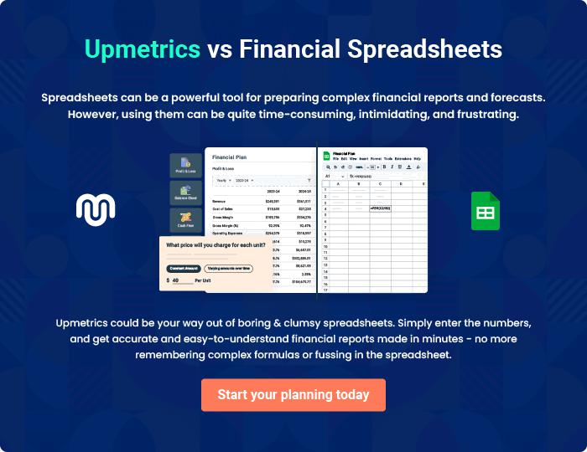

Flower Shop | Business Plan [YEAR] | 33/34


Create a winning business plan that gets you funded

Creating a stunning and investment-ready plan requires no writing, graphic designing, or financial planning expertise.

Upmetrics has all the features required to help you create a comprehensive business plan—from start to finish. Make no mistakes, it’s the modern way of planning to structure ideas, make plans, and create stunning pitch decks to awe investors.

Pitch decks that impress investors

Create pitch decks that provide a visual representation of your business, engage investors, and make them want to invest in your business idea.

Interactive plans in no time

Import business plan sections like—SWOT analysis, comparison tables, and others to create an interactive business plan. No designing skills are required.

Stunning cover page designs

With Upmetrics, you have the liberty to choose from multiple stunning cover page designs. Choose a creative design and make your plan stand out.

Online sharing made simple

Upmetrics makes online sharing quick and easier for users. Easily share your business plans with a link while tracking reader activity.

500+ sample business plans

Simply import a template from our library of sample plans into the editor and start customizing it to make it yours. It takes only a few clicks to get started.

Collaborate with team in real-time

Invite team members, initiate conversations, discuss ideas & strategies, share feedback, and work on a business plan in real-time.

