
BUSINESS PLAN

[YEAR]


Financial Advisor

Adding profit your life

John Doe

10200 Bolsa Ave, Westminster, CA, 92683

- 359-3153 info@example.com http://www.example.com

Information provided in this business plan is unique to this business and confidential; therefore, anyone reading this plan agrees not to disclose any of the information in this business plan without prior written permission of the company.
Table of Contents

Executive Summary | 5
Customer Focus | 6
Success Factors | 6
Mission Statement | 7
Vision Statement | 7
Financial Summary | 7
3 Year profit forecast | 8

Company Summary | 9
History | 10
Business Structure | 10
Startup Summary | 11
Startup cost | 11
Products and services
Products and services | 14
Market Analysis
Market Analysis | 17
Industry Analysis | 18
Market Trends | 18
Target Market | 18
SWOT Analysis
SWOT Analysis | 19
Strategy & Implementations
Strategy & Implementations | 21
Advertising Strategy | 22
Targeted Cold Calls | 22
Referrals | 22
Internet | 22
Publications | 23
Direct Mail | 23
Pricing Strategy | 23

Financial Advisor | Business Plan [YEAR] 2/36

Operational Plan | 24
Milestones | 25
Financial Plan
Financial Plan | 26
Important Assumptions | 27
Brake-even Analysis | 27
Projected Profit and Loss | 28
Projected Cash Flow | 31
Projected Balance Sheet | 32
Business Ratios | 33

Financial Advisor | Business Plan [YEAR] 3/36

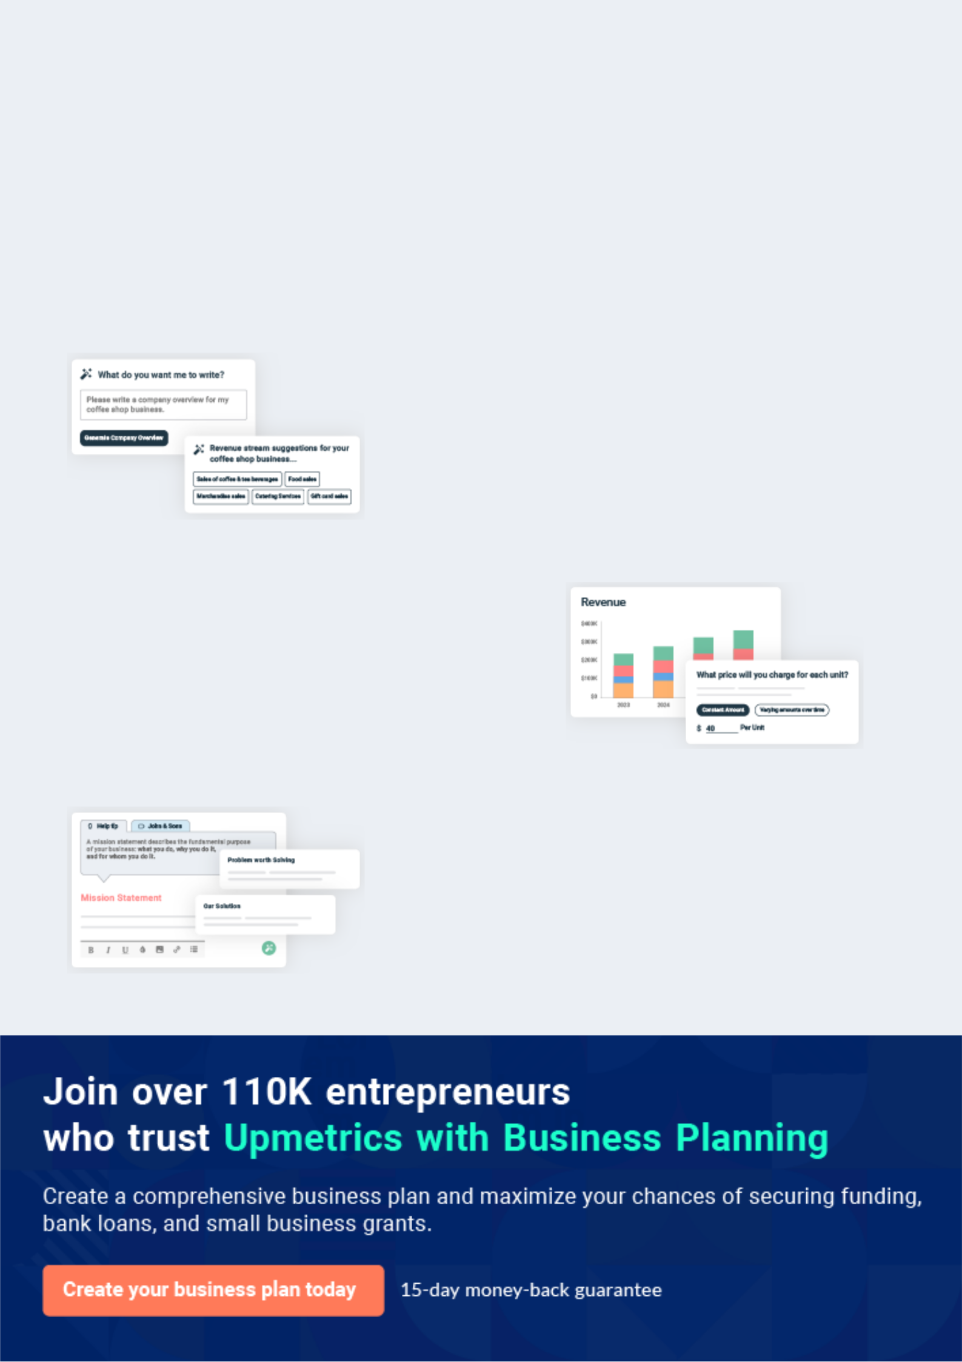
Business planning that’s simpler and faster than you think

Creating a business plan using Upmetrics to start and grow a business is literally the easiest thing in the World. Simply read the instructions and fill in the blanks. It’s as simple as that.

❛ | Upmetrics has everything you need to create a | ❜
❛ | comprehensive business plan. | ❜

AI-powered Upmetrics Assistant

AI-powered insights to streamline your plan

Not sure where to start? Upmetrics’ AI Assistant will automatically generate ideas for each section of your plan and offer improved versions of your writing, adjusting for tone, voice, and grammar or spelling errors.

Financial Forecasting Tool

All the financials are calculated for you

Forget the complex formulas and clumsy spreadsheets — with automatic financials and drag-and-drop forecasting, you can finish your plan faster and be confident that your numbers are accurate.

Business Plan Builder

Guides you like a business mentor

Upmetrics’ step-by-step instructions, prompts, and the library of 400+ sample business plans will guide you through each section of your plan as a business mentor.

1.


Executive Summary

Customer Focus

Success Factors

Mission Statement

Vision Statement

Financial Summary

Financial Advisor | Business Plan [YEAR] 5/36


Before you think about how to start a financial advisor service, you must create a detailed financial advisor business plan. It will not only guide you in the initial phases of your startup but will also help you later on.
To unlock help try Upmetrics! 

 JP & Moore Financial Advisors


JP & Moore Financial Advisors, LLP is a standard financial Consulting firm that will be located in the heart of Madison Street, Michigan City, Michigan. The firm is going to operate as a standard financial consulting firm with bias in offering financial advice and financial
To unlock help try Upmetrics! 

Start writing here..

Customer Focus

 JP & Moore Financial Advisors

JP & Moore Financial Advisors will primarily serve the residents within a 20-mile radius of our location. The demographics of these customers are as follows:
To unlock help try Upmetrics! 

Start writing here..

Success Factors

 JP & Moore Financial Advisors

JP & Moore Financial Advisors is uniquely qualified to succeed due to the following reasons:

• The Company will fill a specific market niche in the growing community we are entering.
To unlock help try Upmetrics! 

Start writing here..

Financial Advisor | Business Plan [YEAR] 6/36

Mission Statement

 JP & Moore Financial Advisors

- Our mission is to make available professional and trusted financial advisory services that assist individual and corporate organizations in operating sustainably.
To unlock help try Upmetrics! 

Start writing here..

Vision Statement

 JP & Moore Financial Advisors

- Our vision is to provide our clients with highly professional financial advisory services, giving them good value for their money.
To unlock help try Upmetrics! 

Start writing here..

Financial Summary

 JP & Moore Financial Advisors

JP & Moore Financial Advisors is currently seeking $125,000 to launch. Specifically, these funds will be used as follows:
To unlock help try Upmetrics! 

Start writing here..

Financial Advisor | Business Plan [YEAR] 7/36

3 Year profit forecast
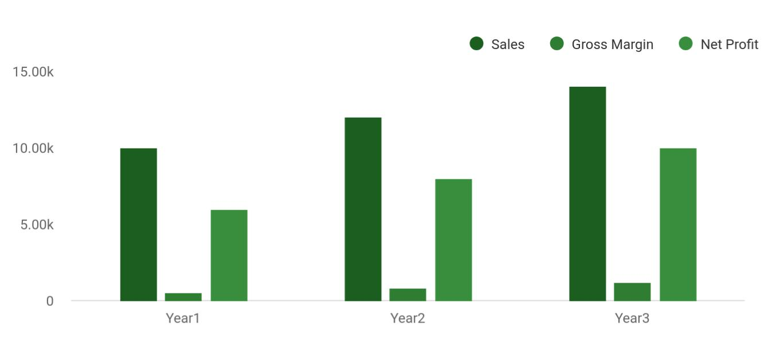

 JP & Moore Financial Advisors


Financial Summary | Year 1 | Year 2 |  | Year 3
 |  |  | To unlock help try Upmetrics! |  | 

Start writing here..

Financial Advisor | Business Plan [YEAR] 8/36

2.

Company Summary

History

Business Structure

Startup Summary

Financial Advisor | Business Plan [YEAR] 9/36

 JP & Moore Financial Advisors
To unlock help try Upmetrics!

JP & Moore Financial Advisors, LLP is founded by John Moore and his business partner James Peter. The organization will be managed by both of them. They both have extensive experience in a diverse range of financial consulting, wealth creation, and wealth management.
To unlock help try Upmetrics! 

Start writing here..

History

 JP & Moore Financial Advisors

Upon returning from Michigan, surveying the local customer base, and finding a potential retail office, John Moore incorporated JP & Moore Financial Advisors as an S-Corporation in JAN 2015.



Start writing here..

Business Structure

 JP & Moore Financial Advisors

JP & Moore Financial Advisors, LLP will build a solid business structure that can support the growth of our organization. We will ensure that we hire competent and well-experienced hands to help us build the business of our dream. Below is the business structure that we will build JP
To unlock help try Upmetrics! 

Start writing here..

Financial Advisor | Business Plan [YEAR] 10/36

Startup Summary

Startup cost
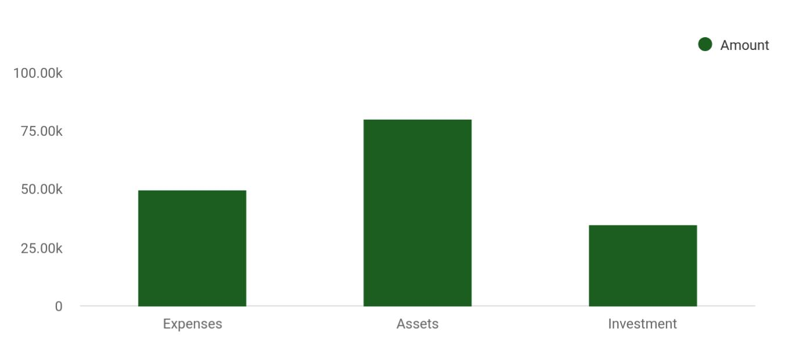

Cost distribution | Amount
Expenses | 50,000
Assets | 80,000
Investment | 35,000

Start-up Expenses | Amount
Legal | $75,500
Consultants | $0
Insurance | $62,750
Rent | $22,500
Research and Development | $42,750
Expensed Equipment | $42,750
Signs | $1,250
TOTAL START-UP EXPENSES | $247,500
Start-up Assets | $0
Cash Required | $322,500
Start-up Inventory | $52,625
Other Current Assets | $222,500

Financial Advisor | Business Plan [YEAR] 11/36

Start-up Expenses | Amount
Long-term Assets | $125,000
TOTAL ASSETS | $121,875
Total Requirements | $245,000
START-UP FUNDING | $0
START-UP FUNDING | $273,125
Start-up Expenses to Fund | $121,875
Start-up Assets to Fund | $195,000
TOTAL FUNDING REQUIRED | $0
Assets | $203,125
Non-cash Assets from Start-up | $118,750
Cash Requirements from Start-up | $0
Additional Cash Raised | $118,750
Cash Balance on Starting Date | $121,875
TOTAL ASSETS | $0
Liabilities and Capital | $0
Liabilities | $0
Current Borrowing | $0
Long-term Liabilities | $0
Accounts Payable (Outstanding Bills) | $0
Other Current Liabilities (interest-free) | $0
TOTAL LIABILITIES | $0
Capital | $0
Planned Investment | $0
Investor 1 | $312,500
Investor 2 | $0
Other | $0
Additional Investment Requirement | $0
TOTAL PLANNED INVESTMENT | $695,000

Financial Advisor | Business Plan [YEAR] 12/36

Start-up Expenses | Amount
Loss at Start-up (Start-up Expenses) | $313,125
TOTAL CAPITAL | $221,875
TOTAL CAPITAL AND LIABILITIES | $221,875
Total Funding | $265,000

Financial Advisor | Business Plan [YEAR] 13/36

3.

Products and services

Financial Advisor | Business Plan [YEAR] 14/36

 JP & Moore Financial Advisors

JP & Moore Financial Advisors, LLP is going to offer a variety of financial advisory services within the scope of the financial consulting industry in the United States of America. Our
intention of starting our financial advisory firm is to make profits from the industry and we will
To unlock help try Upmetrics! 

Start writing here..


Asset Management Financial Planning

investing and managing detailed planning and a

client’s savings structured layout for

depending on portfolio retirement or child’s

preferences. funds for college.

Hourly Advice

advising clients that do not have assets with JP

- Moore Financial Advisors on an hourly basis.

Life Insurance

providing the option of life insurance to clients as part of their long term and retirement planning.

Investment
Wealth Creation and
(Business Portfolio)
Wealth Management
Management

Mortgage, Pension,

Retirement and Income Tax

Investment Advisory Preparation

Services

Financial Advisor | Business Plan [YEAR] 15/36



Financial Advisor | Business Plan [YEAR] | 16/36

4.

Market Analysis

Industry Analysis

Market Trends

Target Market

Financial Advisor | Business Plan [YEAR] 17/36

The most important component of an effective financial advisor services business plan is its accurate marketing analysis. If you are starting on a
smaller scale, you can do marketing analysis yourself by taking help from this
To unlock help try Upmetrics! 

Industry Analysis

 JP & Moore Financial Advisors

The financial advisory services industry is strongly correlated with the strength of the economy as a whole. Last year, industry revenues fell as the market fell, declining by 34% to $37.6 billion. Revenues are expected to recover again this year, reaching the $38 billion mark.
To unlock help try Upmetrics! 

Start writing here..

Market Trends

 JP & Moore Financial Advisors

In recent times, financial advisers / financial consulting firms are at the center of a larger industry-wide change. The steady advancement in technology, changing business regulations, retiring financial professionals, and innovative types of financial services are indeed impacting
To unlock help try Upmetrics! 

Start writing here..

Target Market

 JP & Moore Financial Advisors

Although JP & Moore Financial Advisors, LLP will initially serve individuals clients and small to medium-sized businesses, to be able to compete with the leading financial consulting firms in
the United States. We hope to someday merge or acquire other smaller related consulting firms
To unlock help try Upmetrics! 

Start writing here..

Financial Advisor | Business Plan [YEAR] 18/36

5.

SWOT Analysis

Financial Advisor | Business Plan [YEAR] 19/36

 JP & Moore Financial Advisors

JP & Moore Financial Advisors, LLP engaged the services of a core professional in the area of business consulting and structuring to assist the firm in building a well–structured financial consulting firm that can favorably compete in the highly competitive financial consulting
To unlock help try Upmetrics! 

Start writing here..


Strength

Our core strength lies in the power of our team; our workforce. We have a team that can go all the way to give our clients value for their money. We are well-positioned and we know we will attract loads of clients from the first day we open our doors for business.


Weakness

As a new financial consulting firm, it might take some time for our organization to break into the market; that is perhaps our perceived major weakness.


Opportunity

The opportunities in the financial consulting industry are massive (both individual clients and corporate clients) and we are ready to take advantage of any opportunity that comes our way.

Threat

Some of the threats that we are likely going to face as a financial consulting firm operating in the United States are complex financial landscape, expanding industry compliance, regulation, fears of declining asset values, unfavorable government policies, and the arrival of a competitor within our location of operations and global economic downturn which usually affects purchasing power.

Financial Advisor | Business Plan [YEAR] 20/36

6.

Strategy &

Implementations

Advertising Strategy

Pricing Strategy

Financial Advisor | Business Plan [YEAR] 21/36

After identifying the market demand, market trends, and the potential customers of the startup, the next step is to define an effective strategy for attracting those customers. Like marketing analysis, sales strategy is also an
To unlock help try Upmetrics! 

Advertising Strategy

 JP & Moore Financial Advisors

JP & Moore Financial Advisors will initially invest significant time and energy into contacting potential clients via telephone. In order to improve the effectiveness of this phase of the marketing strategy, a highly focused call list will be used, targeting individuals in areas and
To unlock help try Upmetrics! 

Targeted Cold Calls

Start writing here..

 JP & Moore Financial Advisors

JP & Moore Financial Advisors understands that the best promotion comes from satisfied customers. The Company will encourage its clients to refer their friends and family by providing economic or financial incentives for every new client produced. This strategy will increase in
To unlock help try Upmetrics! 

Referrals

Start writing here..

 JP & Moore Financial Advisors

JP & Moore Financial Advisors will invest resources in two forms of internet promotion— organic search engine optimization and pay-per-click advertising. The Company will develop its website in such a manner as to direct as much traffic from search engines as possible.
To unlock help try Upmetrics! 

Internet

Start writing here..

Financial Advisor | Business Plan [YEAR] 22/36

 JP & Moore Financial Advisors

JP & Moore Financial Advisors will place print advertisements in key local publications, including newspapers, area magazines, and local sports programs. Additionally, the Company will print brochures and place them in specific locations frequented by target individuals, such
To unlock help try Upmetrics! 

Publications

Start writing here..

 JP & Moore Financial Advisors

The Company will use a direct mail campaign to promote its brand and draw clients, as well. The campaign will blanket specific neighborhoods with simple, effective mail advertisements that highlight the credentials and credibility of JP & Moore Financial Advisors as financial
To unlock help try Upmetrics! 

Direct Mail

Start writing here..

Pricing Strategy

 JP & Moore Financial Advisors

Generally, a financial adviser is remunerated either through fees, commissions, or a combination of both. For instance, a financial adviser may be paid in any of the following means; an hourly fee for advisory services. A flat fee, such as $600 per year, for an annual
To unlock help try Upmetrics! 

Start writing here..

Financial Advisor | Business Plan [YEAR] 23/36

7.

Operational Plan

Milestones

Financial Advisor | Business Plan [YEAR] 24/36

 JP & Moore Financial Advisors

JP & Moore Financial Advisors will carry out its day-to-day operations primarily on an appointment basis. Clients will make regularly scheduled appointments to review the contents and progress of their investment portfolio. These will primarily occur in-office or in-home in
To unlock help try Upmetrics! 

Start writing here..

Milestones

 JP & Moore Financial Advisors

JP & Moore Financial Advisors' long-term goal is to become the number-one provider of financial advisory services and investment products in the Michigan area. We seek to be a
household name and the standard by which other providers are judged. We seek to do this by
To unlock help try Upmetrics! 

Start writing here..

Financial Advisor | Business Plan [YEAR] 25/36

8.

Financial Plan

Important Assumptions

Brake-even Analysis

Projected Profit and Loss

Projected Cash Flow

Projected Balance Sheet

Business Ratios

Financial Advisor | Business Plan [YEAR] 26/36

The last component of a financial advisory service business plan is an in-depth financial plan. The financial plan crafts a detailed map of all the
expenses needed for the startup and how these expenses will be met by the
To unlock help try Upmetrics! 

 JP & Moore Financial Advisors

The company will be financed by John himself and he will control the direction of the business to make sure that it is expanding at the forecasted rate. As for the financial advisory service business start-up, no equity funding or outside loans will be required. With the help of financial
To unlock help try Upmetrics! 

Start writing here..

Important Assumptions

The financial projections of the company are forecast on the basis of the following assumptions. These assumptions are quite conservative and are expected to show deviation but to a limited level such that the company’s major financial strategy will not be affected.

 | Year 1 | Year 2 | Year 3
Plan Month | 1 | 2 | 3
Current Interest Rate | 10,00% | 11,00% | 12,00%
Long-term Interest Rate | 10,00% | 10,00% | 10,00%
Tax Rate | 26,42% | 27,76% | 28,12%
Other | 0 | 0 | 0

Brake-even Analysis

Monthly Units Break-even | 5530
Monthly Revenue Break-even | $159 740
Assumptions:
Average Per-Unit Revenue | $260,87
Average Per-Unit Variable Cost | $0,89
Estimated Monthly Fixed Cost | $196 410

Financial Advisor | Business Plan [YEAR] 27/36

Projected Profit and Loss

 | 2024 | 2025 | 2026
Revenue | $205,894 | $226,928.84 | $255,524.28
Client Consultation Fees | $144,000 | $144,000 | $144,000
Total Hours | 960 | 960 | 960
Hourly Price | $150 | $150 | $150
Investment Commission | $28,384 | $40,468.84 | $57,699.28
Personal Finance | $33,510 | $42,460 | $53,825
Workshops | $33,510 | $42,460 | $53,825
Unit Sales | 67 | 85 | 108
Unit Price | $500 | $500 | $500
Cost Of Sales | $45,600 | $46,716 | $47,861.16
General Costs | $45,600 | $46,716 | $47,861.16
Service Delivery Costs | $30,000 | $30,840 | $31,704
Consultant Fees | $24,000 | $24,720 | $25,461.60
Financial Analysis Software | $6,000 | $6,120 | $6,242.40
Subscription | $6,000 | $6,120 | $6,242.40
Workshop Related Costs | $15,600 | $15,876 | $16,157.16
Workshop Material Costs | $3,600 | $3,636 | $3,672.36
Venue Rental for | $12,000 | $12,240 | $12,484.80
Workshops | $12,000 | $12,240 | $12,484.80
Revenue Specific Costs | $0 | $0 | $0
Personnel Costs (Direct | $0 | $0 | $0
Labor) | $0 | $0 | $0
Gross Margin | $160,294 | $180,212.84 | $207,663.12
Gross Margin (%) | 77.85% | 79.41% | 81.27%

Financial Advisor | Business Plan [YEAR] 28/36

2024 2025 2026

Operating Expense | $428,052 | $439,268.08 | $451,345.56
Payroll Expense (Indirect | $369,252 | $378,767.28 | $388,547.76
Labor) | $369,252 | $378,767.28 | $388,547.76
Advisory Team | $153,624 | $157,296.72 | $161,060.88
Senior Financial Advisor | $93,600 | $95,472 | $97,381.44
Junior Financial Advisor | $60,024 | $61,824.72 | $63,679.44
Administrative Staff | $89,928 | $92,158.56 | $94,446.72
Office Manager | $46,728 | $47,662.56 | $48,615.84
Administrative Assistant | $43,200 | $44,496 | $45,830.88
Marketing Team | $125,700 | $129,312 | $133,040.16
Marketing Manager | $70,800 | $72,216 | $73,660.32
Social Media Coordinator | $54,900 | $57,096 | $59,379.84
General Expense | $58,800 | $60,500.80 | $62,797.80
Operational Expenses | $34,800 | $35,528.80 | $36,598.08
Office Rent | $30,000 | $30,600 | $31,212
Utilities | $4,800 | $4,928.80 | $5,386.08
Marketing and Advertising | $18,000 | $18,780 | $19,705.66
Online Advertising | $12,000 | $12,600 | $13,340.26
Print Media Advertising | $6,000 | $6,180 | $6,365.40
Miscellaneous Expenses | $6,000 | $6,192 | $6,494.06
Office Supplies | $2,400 | $2,448 | $2,509.44
Professional Development | $3,600 | $3,744 | $3,984.62
Bad Debt | $0 | $0 | $0
Amortization of Current | $0 | $0 | $0
Assets | $0 | $0 | $0

Financial Advisor | Business Plan [YEAR] 29/36

EBITDA

Additional Expense

Long Term Depreciation

Gain or loss from Sale of Assets

EBIT

Interest Expense

EBT

Income Tax Expense / Benefit
2024 2025 2026

($267,758) ($259,055.24) ($243,682.44)

$7,922.97 | $7,461.11 | $6,975.59
$5,628 | $5,628 | $5,628
$0 | $0 | $0
($273,386) | ($264,683.24) | ($249,310.44)
$2,294.98 | $1,833.10 | $1,347.59
($275,680.97) | ($266,516.35) | ($250,658.03)
$0 | $0 | $0

Total Expense | $481,574.97 | $493,445.19 | $506,182.31
Net Income | ($275,680.97) | ($266,516.35) | ($250,658.03)
Net Income (%) | (133.89%) | (117.44%) | (98.10%)

Retained Earning Opening | $0 | ($475,680.97) | ($942,197.32)
Owner's Distribution | $200,000 | $200,000 | $200,000
Retained Earning Closing | ($475,680.97) | ($942,197.32) | ($1,392,855.35)

Financial Advisor | Business Plan [YEAR] 30/36

Projected Cash Flow

 | 2024 | 2025 | 2026
Cash Received | $205,894 | $226,928.84 | $255,524.28
Cash Paid | $475,946.97 | $487,817.19 | $500,554.31
COS & General Expenses | $104,400 | $107,216.80 | $110,658.96
Salary & Wages | $369,252 | $378,767.28 | $388,547.76
Interest | $2,294.98 | $1,833.10 | $1,347.59
Sales Tax | $0 | $0 | $0
Income Tax | $0 | $0 | $0
Net Cash From | ($270,052.97) | ($260,888.35) | ($245,030.03)
Operations | ($270,052.97) | ($260,888.35) | ($245,030.03)
Assets Sell | $0 | $0 | $0
Assets Purchase | $25,000 | $0 | $0
Net Cash From | ($25,000) | $0 | $0
Investments | ($25,000) | $0 | $0
Amount Received | $150,000 | $0 | $0
Loan Received | $50,000 | $0 | $0
Common Stock | $100,000 | $0 | $0
Preferred Stock | $0 | $0 | $0
Owner's Contribution | $0 | $0 | $0
Amount Paid | $209,027.75 | $209,489.61 | $209,975.13
Loan Capital | $9,027.74 | $9,489.62 | $9,975.13
Dividends & Distributions | $200,000 | $200,000 | $200,000
Net Cash From | ($59,027.75) | ($209,489.61) | ($209,975.13)
Financing | ($59,027.75) | ($209,489.61) | ($209,975.13)

Financial Advisor | Business Plan [YEAR] 31/36

2024 2025 2026

Summary

Starting Cash | $0 | ($354,080.72) | ($824,458.68)
Cash In | $355,894 | $226,928.84 | $255,524.28
Cash Out | $709,974.72 | $697,306.80 | $710,529.44
Change in Cash | ($354,080.72) | ($470,377.96) | ($455,005.16)
Ending Cash | ($354,080.72) | ($824,458.68) | ($1,279,463.84)

Projected Balance Sheet

 | 2024 | 2025 | 2026
Assets | ($334,708.72) | ($810,714.68) | ($1,271,347.84)
Current Assets | ($354,080.72) | ($824,458.68) | ($1,279,463.84)
Cash | ($354,080.72) | ($824,458.68) | ($1,279,463.84)
Accounts Receivable | $0 | $0 | $0
Inventory | $0 | $0 | $0
Other Current Assets | $0 | $0 | $0
Long Term Assets | $19,372 | $13,744 | $8,116
Gross Long Term Assets | $25,000 | $25,000 | $25,000
Accumulated Depreciation | ($5,628) | ($11,256) | ($16,884)

Liabilities & Equity | ($334,708.71) | ($810,714.68) | ($1,271,347.84)
Liabilities | $40,972.26 | $31,482.64 | $21,507.51
Current Liabilities | $9,489.62 | $9,975.13 | $0
Accounts Payable | $0 | $0 | $0
Income Tax Payable | $0 | $0 | $0

Financial Advisor | Business Plan [YEAR] 32/36

 | 2024 |  |  | 2025 |  | 2026
Sales Tax Payable | $0 |  |  | $0 |  | $0
Short Term Debt | $9,489.62 |  | $9,975.13 |  |  | $0
Long Term Liabilities | $31,482.64 |  | $21,507.51 |  |  | $21,507.51
Long Term Debt | $31,482.64 |  | $21,507.51 |  |  | $21,507.51
Equity | ($375,680.97) |  | ($842,197.32) |  |  | ($1,292,855.35)
Paid-in Capital | $0 |  |  | $0 |  | $0
Common Stock | $100,000 |  | $100,000 |  |  | $100,000
Preferred Stock | $0 |  |  | $0 |  | $0
Owner's Contribution | $0 |  |  | $0 |  | $0
Retained Earnings | ($475,680.97) |  | ($942,197.32) |  |  | ($1,392,855.35)
Check | $0 |  |  | $0 |  | $0
Business Ratios
 |  | Year 1 | Year 2 |  | Year 3 | Industry Profile
Sales Growth |  | 4,35% | 30,82% |  | 63,29% | 4,00%
Percent of Total Assets
Accounts Receivable |  | 5,61% | 4,71% |  | 3,81% | 9,70%
Inventory |  | 1,85% | 1,82% |  | 1,79% | 9,80%
Other Current Assets |  | 1,75% | 2,02% |  | 2,29% | 27,40%
Total Current Assets |  | 138,53% | 150,99% |  | 163,45% | 54,60%
Long-term Assets |  | -9,47% | -21,01% |  | -32,55% | 58,40%
TOTAL ASSETS |  | 100,00% | 100,00% |  | 100,00% | 100,00%
Current Liabilities |  | 4,68% | 3,04% |  | 2,76% | 27,30%
Long-term Liabilities |  | 0,00% | 0,00% |  | 0,00% | 25,80%
Total Liabilities |  | 4,68% | 3,04% |  | 2,76% | 54,10%

Financial Advisor | Business Plan [YEAR] 33/36

 | Year 1 | Year 2 | Year 3 | Industry Profile
NET WORTH | 99,32% | 101,04% | 102,76% | 44,90%
Percent of Sales
Sales | 100,00% | 100,00% | 100,00% | 100,00%
Gross Margin | 94,18% | 93,85% | 93,52% | 0,00%
Selling, General & Administrative Expenses | 74,29% | 71,83% | 69,37% | 65,20%
Advertising Expenses | 2,06% | 1,11% | 0,28% | 1,40%
Profit Before Interest and Taxes | 26,47% | 29,30% | 32,13% | 2,86%
Main Ratios
Current | 25,86 | 29,39 | 32,92 | 1,63
Quick | 25,4 | 28,88 | 32,36 | 0,84
Total Debt to Total Assets | 2,68% | 1,04% | 0,76% | 67,10%
Pre-tax Return on Net Worth | 66,83% | 71,26% | 75,69% | 4,40%
Pre-tax Return on Assets | 64,88% | 69,75% | 74,62% | 9,00%
Additional Ratios
Net Profit Margin | 19,20% | 21,16% | 23,12% | N.A.
Return on Equity | 47,79% | 50,53% | 53,27% | N.A.
Activity Ratios
Accounts Receivable Turnover | 4,56 | 4,56 | 4,56 | N.A.
Collection Days | 92 | 99 | 106 | N.A.
Inventory Turnover | 19,7 | 22,55 | 25,4 | N.A.
Accounts Payable Turnover | 14,17 | 14,67 | 15,17 | N.A.
Payment Days | 27 | 27 | 27 | N.A.
Total Asset Turnover | 1,84 | 1,55 | 1,26 | N.A.
Debt Ratios
Debt to Net Worth | 0 | -0,02 | -0,04 | N.A.
Current Liab. to Liab. | 1 | 1 | 1 | N.A.
Liquidity Ratios
Net Working Capital | $120 943 | $140 664 | $160 385 | N.A.

Financial Advisor | Business Plan [YEAR] 34/36

 | Year 1 | Year 2 | Year 3 | Industry Profile
Interest Coverage | 0 | 0 | 0 | N.A.
Additional Ratios
Assets to Sales | 0,45 | 0,48 | 0,51 | N.A.
Current Debt/Total Assets | 4% | 3% | 2% | N.A.
Acid Test | 23,66 | 27,01 | 30,36 | N.A.
Sales/Net Worth | 1,68 | 1,29 | 0,9 | N.A.
Dividend Payout | 0 | 0 | 0 | N.A.
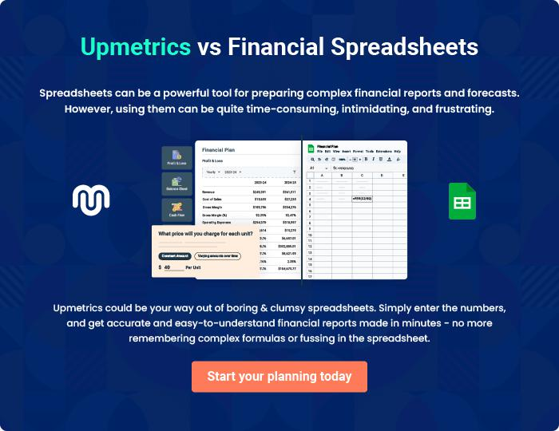

Financial Advisor | Business Plan [YEAR] 35/36


Create a winning business plan that gets you funded

Creating a stunning and investment-ready plan requires no writing, graphic designing, or financial planning expertise.

Upmetrics has all the features required to help you create a comprehensive business plan—from start to finish. Make no mistakes, it’s the modern way of planning to structure ideas, make plans, and create stunning pitch decks to awe investors.

Pitch decks that impress investors

Create pitch decks that provide a visual representation of your business, engage investors, and make them want to invest in your business idea.

Interactive plans in no time

Import business plan sections like—SWOT analysis, comparison tables, and others to create an interactive business plan. No designing skills are required.

Stunning cover page designs

With Upmetrics, you have the liberty to choose from multiple stunning cover page designs. Choose a creative design and make your plan stand out.

Online sharing made simple

Upmetrics makes online sharing quick and easier for users. Easily share your business plans with a link while tracking reader activity.

500+ sample business plans

Simply import a template from our library of sample plans into the editor and start customizing it to make it yours. It takes only a few clicks to get started.

Collaborate with team in real-time

Invite team members, initiate conversations, discuss ideas & strategies, share feedback, and work on a business plan in real-time.

