- Event Venue



Business Plan

[YEAR]
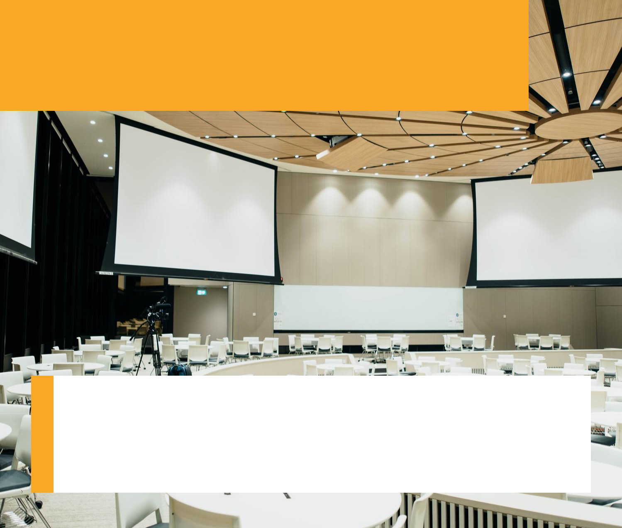

Sit back while we create the experience of a lifetime.

Information provided in this business plan is unique to this business and confidential; therefore, anyone reading this plan agrees not to disclose any of the information in this business plan without prior written permission of the Company

Prepared By

John Doe

10200 Bolsa Ave, Westminster, CA, 92683

info@example.com

(650) 359-3153 http://www.example.com

Table of Contents

Executive Summary | 5
Mission Statement | 6
Vision Statement | 6
Products Served | 7
Customer Focus | 7
Success Factors | 7
Financial Summary | 8
3 Year profit forecast | 8

Company Summary | 9
History | 10
Business Structure | 10
Startup Summary | 10
Startup cost | 11
Products and services
Products and services | 14
Market Analysis
Market Analysis | 17
Industry Analysis | 18
Market Trends | 18
Target Market | 18
SWOT Analysis
SWOT Analysis | 19
Strategy & Implementations
Strategy & Implementations | 21
Advertising Strategy | 22
Phone Prospecting | 22
Public Relations | 22
Ongoing Customer Communications | 23
Pre-Opening Events | 23
Pricing Strategy | 23

Event Venue | Business Plan [YEAR] 2/40

Milestones | 24

Financial Plan | 25
Important Assumptions | 26
Brake-even Analysis | 27
Projected Profit and Loss | 27
Projected Cash Flow | 31
Projected Balance Sheet | 34
Business Ratios | 35

Event Venue | Business Plan [YEAR] 3/40

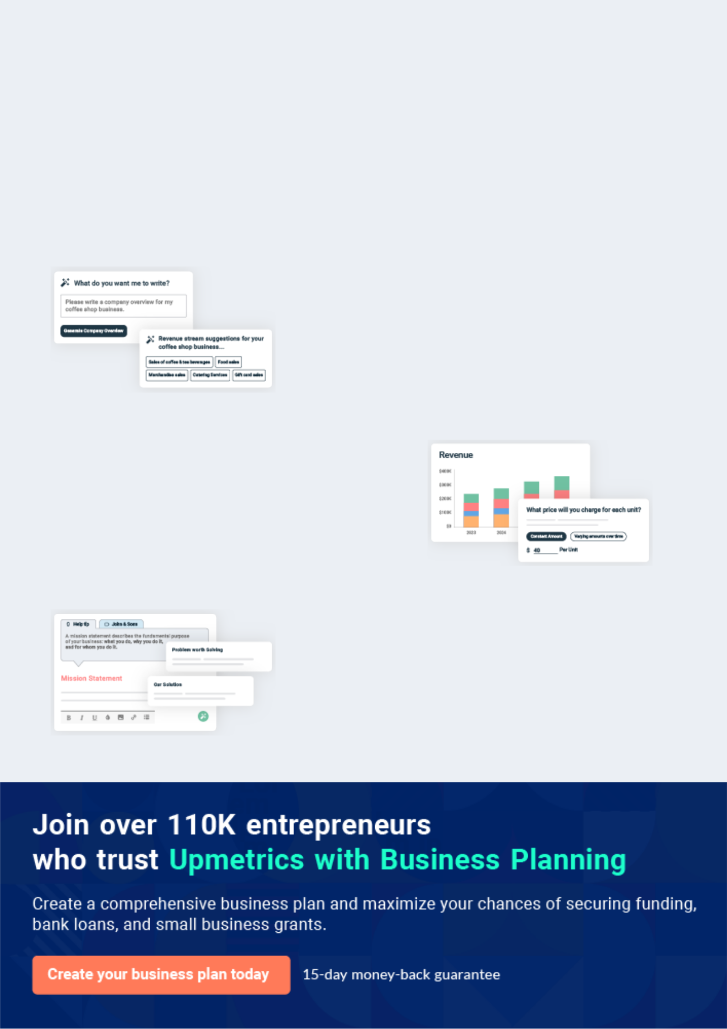
Business planning that’s simpler and faster than you think

Creating a business plan using Upmetrics to start and grow a business is literally the easiest thing in the World. Simply read the instructions and fill in the blanks. It’s as simple as that.

❛ | Upmetrics has everything you need to create a | ❜
❛ | comprehensive business plan. | ❜

AI-powered Upmetrics Assistant

AI-powered insights to streamline your plan

Not sure where to start? Upmetrics’ AI Assistant will automatically generate ideas for each section of your plan and offer improved versions of your writing, adjusting for tone, voice, and grammar or spelling errors.

Financial Forecasting Tool

All the financials are calculated for you

Forget the complex formulas and clumsy spreadsheets — with automatic financials and drag-and-drop forecasting, you can finish your plan faster and be confident that your numbers are accurate.

Business Plan Builder

Guides you like a business mentor

Upmetrics’ step-by-step instructions, prompts, and the library of 400+ sample business plans will guide you through each section of your plan as a business mentor.

1.


Executive Summary

Mission Statement

Vision Statement

Products Served

Customer Focus

Success Factors

Financial Summary

Event Venue | Business Plan [YEAR] 5/40

Before you think about how to start an event venue service, you must create a detailed event venue business plan. It will not only guide you in the initial phases of your startup but will also help you later on.
To unlock help try Upmetrics!
To unlock help try Upmetrics!

 Divine Space




Divine Space, a leading event center is based in Detroit – Michigan, USA. We offer unique and personalized services to all our clients domestic and corporate. We provide event coordination and offer our clients planning expertise as well as an extraordinary wait staff service, in
To unlock help try Upmetrics! 

Start writing here..

Mission Statement

 Divine Space

In order to achieve our vision, we have the required coordination and planning expertise for all types of events, with professional and competent staff that would help make the events of our clients a memorable one.



Start writing here..

Vision Statement

 Divine Space

Our vision as an event center is to exceed the expectations of our clients by giving them a beautiful experience as well as event space for all their types of special events.
To unlock help try Upmetrics! 

Start writing here..

Event Venue | Business Plan [YEAR] 6/40

Products Served
To unlock help try Upmetrics!

 Divine Space

Divine Space offers the following event spaces: Small Party venues, Ballrooms, Social Events and Banquet Hall, Conference Rooms, and Seminar Rooms. We provide spaces that can hold from 30 up to 300 people. Each room can be designed according to the clients’ theme or
To unlock help try Upmetrics! 

Start writing here..

Customer Focus

 Divine Space

Divine Space will primarily serve businesses, organizations, and wealthy individuals within the Detroit area that are looking for venues for their events. We will primarily target the corporate market, private market, and non-profit market.



Start writing here..

Success Factors

 Divine Space

Divine Space is uniquely qualified to succeed due to the following reasons:

There is currently no high-quality event venue in the community we are entering. In addition, we
To unlock help try Upmetrics! 

Start writing here..

Event Venue | Business Plan [YEAR] 7/40

Financial Summary
Year 3
To unlock help try Upmetrics!
To unlock help try Upmetrics!

 Divine Space

Divine Space is seeking total funding of $3,000,000 to launch the event venue. The capital will be used for funding capital expenditures, manpower costs, marketing expenses, and working capital.



Start writing here..

3 Year profit forecast
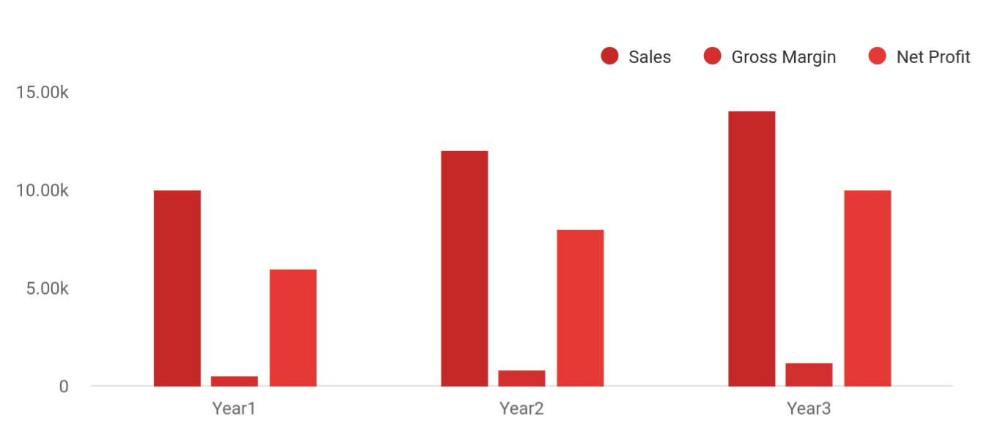

 Divine Space


Financial Summary

Year 1

Year 2



Start writing here..

Event Venue | Business Plan [YEAR] 8/40

2.

Company Summary

History

Business Structure

Startup Summary

Event Venue | Business Plan [YEAR] 9/40

 Divine Space

Finally, our Chief Executive Officer, Ms. John Moore has over 15 years of experience in event coordination as well as in catering. This experience in addition to several certifications in event planning will help take our business to the desired level it intends to attain.
To unlock help try Upmetrics! 

Start writing here..

History

 Divine Space

Divine Space was founded in 2015 in Detroit by James Moore. With over 15 years of experience in the event management industry, he ventured into event venue rentals. After leasing a spacious building for several years, he decided to acquire a property in the middle of the city,
To unlock help try Upmetrics! 

Start writing here..

Business Structure

 Divine Space

Having the right business structure is very important to us as a Divine Space and so we have laid the right plans that will ensure that our foundation is not only right but stays true to our core values and vision as a company. This is why we sourced for and have hired competent
To unlock help try Upmetrics! 

Start writing here..

Startup Summary

 Divine Space

Moore Lawn Care and Landscape’s start-up costs include:

• Home office equipment: file cabinet, the computer system (including printer, scanner, and
To unlock help try Upmetrics! 

Event Venue | Business Plan [YEAR] 10/40

Start writing here..

Startup cost
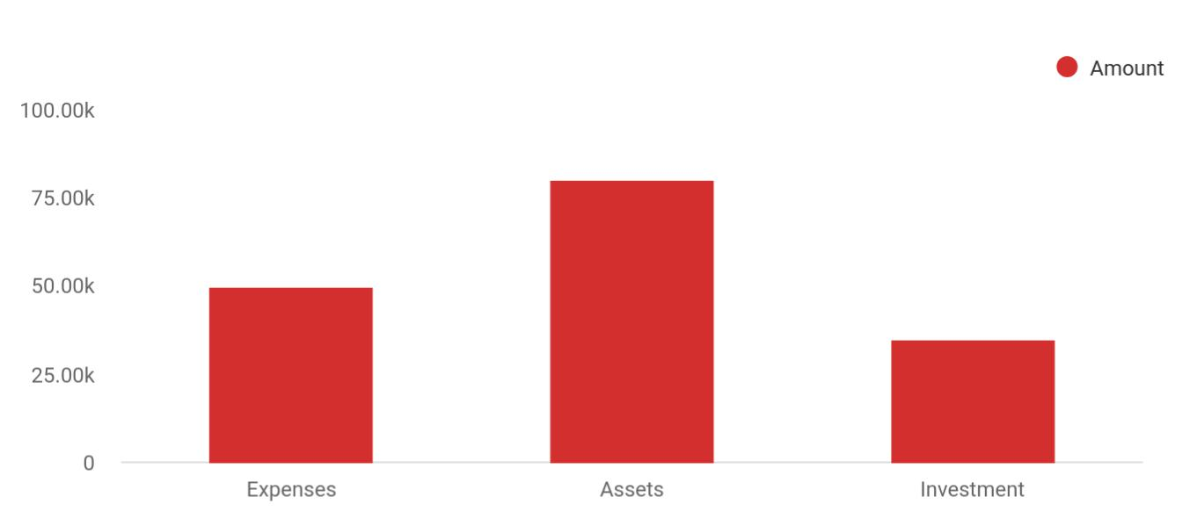

Cost distribution | Amount
Expenses | 50,000
Assets | 80,000
Investment | 35,000

Start-up Expenses | Amount
Legal | $75,500
Consultants | $0
Insurance | $62,750
Rent | $22,500
Research and Development | $42,750
Expensed Equipment | $42,750
Signs | $1,250
TOTAL START-UP EXPENSES | $247,500
Start-up Assets | $0
Cash Required | $322,500
Start-up Inventory | $52,625
Other Current Assets | $222,500

Event Venue | Business Plan [YEAR] 11/40

Start-up Expenses | Amount
Long-term Assets | $125,000
TOTAL ASSETS | $121,875
Total Requirements | $245,000
START-UP FUNDING | $0
START-UP FUNDING | $273,125
Start-up Expenses to Fund | $121,875
Start-up Assets to Fund | $195,000
TOTAL FUNDING REQUIRED | $0
Assets | $203,125
Non-cash Assets from Start-up | $118,750
Cash Requirements from Start-up | $0
Additional Cash Raised | $118,750
Cash Balance on Starting Date | $121,875
TOTAL ASSETS | $0
Liabilities and Capital | $0
Liabilities | $0
Current Borrowing | $0
Long-term Liabilities | $0
Accounts Payable (Outstanding Bills) | $0
Other Current Liabilities (interest-free) | $0
TOTAL LIABILITIES | $0
Capital | $0
Planned Investment | $0
Investor 1 | $312,500
Investor 2 | $0
Other | $0
Additional Investment Requirement | $0
TOTAL PLANNED INVESTMENT | $695,000

Event Venue | Business Plan [YEAR] 12/40

Start-up Expenses | Amount
Loss at Start-up (Start-up Expenses) | $313,125
TOTAL CAPITAL | $221,875
TOTAL CAPITAL AND LIABILITIES | $221,875
Total Funding | $265,000

Event Venue | Business Plan [YEAR] 13/40

3.

Products and services

Event Venue | Business Plan [YEAR] 14/40

 Divine Space

Below is Divine Space’s initial service offerings and amenities provided:

To unlock help try Upmetrics! 

Start writing here..


Small Party venue

Closed space that can hold 30-50 people.

Social Events and Banquet Hall

Event venue that is smaller than the ballrooms and can hold 200 people.

Seminar Rooms

Smaller conference

rooms that are located

near an outdoor space

for outdoor activities.

These can hold 50-100

people.

Ballrooms

Rooms that have a maximum capacity of 300 people.

Conference Rooms

Rooms that are smaller than the ballrooms but larger than the seminar/training rooms that can accommodate up to 250 people.

Event Venue | Business Plan [YEAR] 15/40

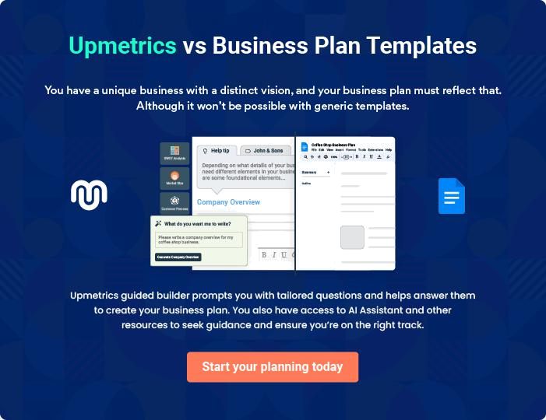

Event Venue | Business Plan [YEAR] | 16/40

4.

Market Analysis

Industry Analysis

Market Trends

Target Market

Event Venue | Business Plan [YEAR] 17/40

The most important component of an effective event venue services business plan is its accurate marketing analysis. If you are starting on a
To unlock help try Upmetrics!
smaller scale, you can do marketing analysis yourself by taking help from this
To unlock help try Upmetrics! 

Industry Analysis

 Divine Space

The Event industry depends on the willingness of households and businesses to spend money on social gatherings. In general, businesses seek event space for holiday dinners, fundraisers, and client appreciation events. Since companies with strong earnings over the course of the
To unlock help try Upmetrics! 

Start writing here..

Market Trends

 Divine Space

Every month there is an event of some sort that is being thrown, which makes having an event center one of the best businesses for any entrepreneur to go into. It should however be noted that this industry has peak periods such as during the middle and end of the year where more
To unlock help try Upmetrics! 

Start writing here..

Target Market

 Divine Space

The target market for this industry is quite huge as there are events that are being thrown every now and then consisting of different types of the crowd, which makes for a huge customer base for event centers.



Start writing here..

Event Venue | Business Plan [YEAR] 18/40

5.

SWOT Analysis

Event Venue | Business Plan [YEAR] 19/40

 Divine Space

Like every successful business out there, we intend to ensure that our event center is of the required standard whilst also offering the best services and so to ensure that we attain this, we hired a reputable business consultant here in Detroit - Michigan, to help us critically look
To unlock help try Upmetrics! 

Start writing here..


Strength

Our strength lies in the fact that we offer diverse services that will meet any requirements of our clients, which allows us to stand apart from our competitors. Also, we have professional and competent staff at hand to ensure that every event no matter the kind is conducted smoothly.

Our halls are not only well designed but also convenient as well as we also have the grounds for customers who want an outdoor ceremony. Finally, the expertise of our Chief Executive Officer, Ms. John Moore who not only has amassed several years of experience but also has several qualifications, is another of our strengths at Divine Space.


Weakness

This industry is saturated with these kinds of businesses; however, we intend to stand apart from our competitors by offering unique services that will attract the customers and offering excellent customer care that will retain most of our customers.


Opportunity

There are various opportunities that abound for us because the halls can be converted to any kind of event that intends to be hosted by our clients. We also can cater to religious bodies who intend to use our halls for regular meetings.

Threat

There are various threats that exist to every business in general, and so the probability of facing threats is not alarming to us. The threats we are likely to face in the course of starting and running the business are the off-peak periods, where there are less likely events to be thrown.

Event Venue | Business Plan [YEAR] 20/40

6.

Strategy &

Implementations

Advertising Strategy

Pricing Strategy

Milestones

Event Venue | Business Plan [YEAR] 21/40

After identifying the market demand, market trends, and the potential customers of the startup, the next step is to define an effective strategy for attracting those customers. Like marketing analysis, sales strategy is also an
To unlock help try Upmetrics! 

Advertising Strategy

 Divine Space

The Company’s promotions strategy to reach its target market are the following:

To unlock help try Upmetrics! 

Start writing here..

 Divine Space

Divine Space will assign salespeople to contact area corporations to arrange for corporate rates for their upcoming company events.
To unlock help try Upmetrics! 

Phone Prospecting

Start writing here..

 Divine Space

We will contact all local and regional area newspapers and television stations to tell them about the event venue opening and the unique value proposition of Divine Space.
To unlock help try Upmetrics! 

Public Relations

Start writing here..

Event Venue | Business Plan [YEAR] 22/40

 Divine Space
To unlock help try Upmetrics!

Divine Space will maintain a website and publish a monthly email newsletter to tell local corporations and past customers about promotions and events.
To unlock help try Upmetrics! 

Ongoing Customer Communications

Start writing here..

 Divine Space

Before opening the venue, Divine Space will organize pre-opening events designed for prospective national customers, local customers, and press contacts. These events will create buzz and awareness for Divine Space in the area.



Pre-Opening Events

Start writing here..

Pricing Strategy

 Divine Space

When it comes to the rates we intend to charge for our services, we have come up with a pricing strategy that will meet the budget of our clients here in Michigan. There are different packages and categories with varying rates available for all our different clients and we have
To unlock help try Upmetrics! 

Start writing here..

Event Venue | Business Plan [YEAR] 23/40

Milestones

 Divine Space


Divine Space expects to achieve the following milestones in the following 24 months:

Date

^{Milestone} To unlock help try Upmetrics! 

Start writing here..

Event Venue | Business Plan [YEAR] 24/40

7.


Financial Plan

Important Assumptions

Brake-even Analysis

Projected Profit and Loss

Projected Cash Flow

Projected Balance Sheet

Business Ratios

Event Venue | Business Plan [YEAR] 25/40

The last component of the event venue service business plan is an in-depth financial plan. The financial plan crafts a detailed map of all the expenses needed for the startup and how these expenses will be met by the earned profits. It is recommended that you use our financial planning tool for guiding you through all financial aspects needed to be considered for starting an
To unlock help try Upmetrics! 

 Divine Space


The company will be financed by John himself and he will control the direction of the business to make sure that it is expanding at the forecasted rate. As for the event venue service business start-up, no equity funding or outside loans will be required. With the help of financial experts, John has developed the following financial plan for his start-up business, which outlines the financial development of the moving service business
To unlock help try Upmetrics! 

Start writing here..

Important Assumptions

The financial projections of the company are forecast on the basis of the following assumptions. These assumptions are quite conservative and are expected to show deviation but to a limited level such that the company’s major financial strategy will not be affected.

 | Year 1 | Year 2 | Year 3
Plan Month | 1 | 2 | 3
Current Interest Rate | 10,00% | 11,00% | 12,00%
Long-term Interest Rate | 10,00% | 10,00% | 10,00%
Tax Rate | 26,42% | 27,76% | 28,12%
Other | 0 | 0 | 0

Event Venue | Business Plan [YEAR] 26/40

Brake-even Analysis

Monthly Units Break-even | 5530
Monthly Revenue Break-even | $159 740
Assumptions:
Average Per-Unit Revenue | $260,87
Average Per-Unit Variable Cost | $0,89
Estimated Monthly Fixed Cost | $196 410

Projected Profit and Loss

 | 2024 | 2025 | 2026
Revenue | $1,000,977.88 | $1,314,814.50 | $1,738,864
Event Hosting | $844,140 | $1,129,400 | $1,493,300
Unit Sales | 422 | 565 | 747
Unit Price | $2,000 | $2,000 | $2,000
Catering Services | $129,400 | $153,990 | $208,595
Unit Sales | 259 | 308 | 417
Unit Price | $500 | $500 | $500

Event Venue | Business Plan [YEAR] 27/40

 | 2024 | 2025 | 2026
Equipment Rentals | $27,437.88 | $31,424.50 | $36,969

Cost Of Sales | $363,542.26 | $473,721.09 | $622,524.90
General Costs | $363,542.26 | $473,721.09 | $622,524.90
Bike Inventory | $306,293.37 | $400,564.35 | $527,943.20
Mountain Bikes | $300,293.37 | $394,444.35 | $521,659.20
Road Bikes | $6,000 | $6,120 | $6,284
Bike Accessories | $57,248.89 | $73,156.74 | $94,581.70
Helmets | $50,048.89 | $65,740.74 | $86,943.22
Locks | $7,200 | $7,416 | $7,638.48
Revenue Specific Costs | $0 | $0 | $0
Personnel Costs (Direct | $0 | $0 | $0
Labor) | $0 | $0 | $0

Gross Margin | $637,435.62 | $841,093.41 | $1,116,339.10
Gross Margin (%) | 63.68% | 63.97% | 64.20%

Event Venue | Business Plan [YEAR] 28/40

 | 2024 | 2025 | 2026
Operating Expense | $665,716.41 | $710,474.72 | $764,959.84
Payroll Expense (Indirect | $564,552 | $583,264.56 | $602,655.24
Labor) | $564,552 | $583,264.56 | $602,655.24
Event Management Team | $270,600 | $280,098 | $289,950
Event Manager | $69,000 | $72,450 | $76,072.56
Event Coordinators | $201,600 | $207,648 | $213,877.44
Technical Staff | $176,880 | $181,262.40 | $185,757.84
Sound Engineers | $92,400 | $94,248 | $96,132.96
Lighting Technicians | $84,480 | $87,014.40 | $89,624.88
Administrative Staff | $117,072 | $121,904.16 | $126,947.40
Office Manager | $51,072 | $52,604.16 | $54,182.28
Receptionists | $66,000 | $69,300 | $72,765.12
General Expense | $101,164.41 | $127,210.16 | $162,304.60
Venue Maintenance | $27,115.52 | $36,413.42 | $49,201.86
Cleaning Services | $7,095.96 | $10,117.14 | $14,424.58
Repair and Maintenance | $20,019.56 | $26,296.28 | $34,777.28
Utilities | $12,000 | $12,456 | $12,929.52

Event Venue | Business Plan [YEAR] 29/40

 | 2024 | 2025 | 2026
Electricity | $9,600 | $9,984 | $10,383.36
Water | $2,400 | $2,472 | $2,546.16
Marketing and Advertising | $62,048.89 | $78,340.74 | $100,173.22
Online Advertising | $50,048.89 | $65,740.74 | $86,943.22
Promotional Events | $12,000 | $12,600 | $13,230
Bad Debt | $0 | $0 | $0
Amortization of Current | $0 | $0 | $0
Assets | $0 | $0 | $0

EBITDA | ($28,280.79) | $130,618.69 | $351,379.26

Additional Expense | $17,782.93 | $15,848.77 | $13,795.31

Long Term Depreciation

Gain or loss from Sale of

Assets

EBIT

Interest Expense

$12,636 | $12,636 | $12,636
$0 | $0 | $0
($40,916.79) | $117,982.69 | $338,743.26
$5,146.94 | $3,212.76 | $1,159.29

Event Venue | Business Plan [YEAR] 30/40

EBT

Income Tax Expense /

Benefit

Total Expense

Net Income

Net Income (%)

Retained Earning Opening

Owner's Distribution

Retained Earning Closing

Projected Cash Flow

Cash Received

Cash Paid

2024 | 2025 | 2026
($46,063.72) | $114,769.92 | $337,583.95
$0 | $0 | $0

$1,047,041.60 | $1,200,044.58 | $1,401,280.05
($46,063.72) | $114,769.92 | $337,583.95
(4.60%) | 8.73% | 19.41%

$0 | ($86,063.72) | $8,706.20
$40,000 | $20,000 | $20,000
($86,063.72) | $8,706.20 | $326,290.15

2024 | 2025 | 2026
$1,000,977.88 | $1,314,814.50 | $1,738,864
$1,034,405.60 | $1,187,408.58 | $1,388,644.05

Event Venue | Business Plan [YEAR] 31/40

 | 2024 | 2025 | 2026
COS & General Expenses | $464,706.67 | $600,931.25 | $784,829.50
Salary & Wages | $564,552 | $583,264.56 | $602,655.24
Interest | $5,146.94 | $3,212.76 | $1,159.29
Sales Tax | $0 | $0 | $0
Income Tax | $0 | $0 | $0
Net Cash From | ($33,427.72) | $127,405.92 | $350,219.95
Operations | ($33,427.72) | $127,405.92 | $350,219.95

Assets Sell | $0 | $0 | $0
Assets Purchase | $80,000 | $0 | $0
Net Cash From | ($80,000) | $0 | $0
Investments | ($80,000) | $0 | $0

Amount Received | $250,000 | $0 | $0
Loan Received | $100,000 | $0 | $0
Common Stock | $0 | $0 | $0
Preferred Stock | $0 | $0 | $0

Event Venue | Business Plan [YEAR] 32/40

 | 2024 | 2025 | 2026
Owner's Contribution | $150,000 | $0 | $0
Amount Paid | $71,359.35 | $53,293.51 | $55,347.12
Loan Capital | $31,359.34 | $33,293.52 | $35,347.14
Dividends & Distributions | $40,000 | $20,000 | $20,000
Net Cash From | $178,640.65 | ($53,293.51) | ($55,347.12)
Financing | $178,640.65 | ($53,293.51) | ($55,347.12)

Summary

Starting Cash | $0 | $65,212.93 | $139,325.34
Cash In | $1,250,977.88 | $1,314,814.50 | $1,738,864
Cash Out | $1,185,764.95 | $1,240,702.09 | $1,443,991.17
Change in Cash | $65,212.93 | $74,112.41 | $294,872.83
Ending Cash | $65,212.93 | $139,325.34 | $434,198.17

Event Venue | Business Plan [YEAR] 33/40

Projected Balance Sheet

 | 2024 | 2025 | 2026
Assets | $132,576.93 | $194,053.34 | $476,290.17
Current Assets | $65,212.93 | $139,325.34 | $434,198.17
Cash | $65,212.93 | $139,325.34 | $434,198.17
Accounts Receivable | $0 | $0 | $0
Inventory | $0 | $0 | $0
Other Current Assets | $0 | $0 | $0
Long Term Assets | $67,364 | $54,728 | $42,092
Gross Long Term Assets | $80,000 | $80,000 | $80,000
Accumulated Depreciation | ($12,636) | ($25,272) | ($37,908)
Liabilities & Equity | $132,576.94 | $194,053.34 | $476,290.15
Liabilities | $68,640.66 | $35,347.14 | $0
Current Liabilities | $33,293.52 | $35,347.14 | $0
Accounts Payable | $0 | $0 | $0
Income Tax Payable | $0 | $0 | $0

Event Venue | Business Plan [YEAR] 34/40

 | 2024 | 2025 | 2026
Sales Tax Payable | $0 | $0 | $0
Short Term Debt | $33,293.52 | $35,347.14 | $0
Long Term Liabilities | $35,347.14 | $0 | $0
Long Term Debt | $35,347.14 | $0 | $0
Equity | $63,936.28 | $158,706.20 | $476,290.15
Paid-in Capital | $0 | $0 | $0
Common Stock | $0 | $0 | $0
Preferred Stock | $0 | $0 | $0
Owner's Contribution | $150,000 | $150,000 | $150,000
Retained Earnings | ($86,063.72) | $8,706.20 | $326,290.15

Check | $0 | $0 | $0

Business Ratios

 | Year 1 | Year 2 | Year 3 | Industry Profile
Sales Growth | 4,35% | 30,82% | 63,29% | 4,00%

Event Venue | Business Plan [YEAR] 35/40

 | Year 1 | Year 2 | Year 3 | Industry Profile
Percent of Total Assets
Accounts Receivable | 5,61% | 4,71% | 3,81% | 9,70%
Inventory | 1,85% | 1,82% | 1,79% | 9,80%
Other Current Assets | 1,75% | 2,02% | 2,29% | 27,40%
Total Current Assets | 138,53% | 150,99% | 163,45% | 54,60%
Long-term Assets | -9,47% | -21,01% | -32,55% | 58,40%
TOTAL ASSETS | 100,00% | 100,00% | 100,00% | 100,00%
Current Liabilities | 4,68% | 3,04% | 2,76% | 27,30%
Long-term Liabilities | 0,00% | 0,00% | 0,00% | 25,80%
Total Liabilities | 4,68% | 3,04% | 2,76% | 54,10%
NET WORTH | 99,32% | 101,04% | 102,76% | 44,90%
Percent of Sales
Sales | 100,00% | 100,00% | 100,00% | 100,00%
Gross Margin | 94,18% | 93,85% | 93,52% | 0,00%
Selling, General & Administrative Expenses | 74,29% | 71,83% | 69,37% | 65,20%
Advertising Expenses | 2,06% | 1,11% | 0,28% | 1,40%
Profit Before Interest and Taxes | 26,47% | 29,30% | 32,13% | 2,86%
Main Ratios

Event Venue | Business Plan [YEAR] 36/40

 | Year 1 | Year 2 | Year 3 | Industry Profile
Current | 25,86 | 29,39 | 32,92 | 1,63
Quick | 25,4 | 28,88 | 32,36 | 0,84
Total Debt to Total Assets | 2,68% | 1,04% | 0,76% | 67,10%
Pre-tax Return on Net Worth | 66,83% | 71,26% | 75,69% | 4,40%
Pre-tax Return on Assets | 64,88% | 69,75% | 74,62% | 9,00%
Additional Ratios
Net Profit Margin | 19,20% | 21,16% | 23,12% | N.A.
Return on Equity | 47,79% | 50,53% | 53,27% | N.A.
Activity Ratios
Accounts Receivable Turnover | 4,56 | 4,56 | 4,56 | N.A.
Collection Days | 92 | 99 | 106 | N.A.
Inventory Turnover | 19,7 | 22,55 | 25,4 | N.A.
Accounts Payable Turnover | 14,17 | 14,67 | 15,17 | N.A.
Payment Days | 27 | 27 | 27 | N.A.
Total Asset Turnover | 1,84 | 1,55 | 1,26 | N.A.
Debt Ratios
Debt to Net Worth | 0 | -0,02 | -0,04 | N.A.
Current Liab. to Liab. | 1 | 1 | 1 | N.A.

Event Venue | Business Plan [YEAR] 37/40

 | Year 1 | Year 2 | Year 3 | Industry Profile
Liquidity Ratios
Net Working Capital | $120 943 | $140 664 | $160 385 | N.A.
Interest Coverage | 0 | 0 | 0 | N.A.
Additional Ratios
Assets to Sales | 0,45 | 0,48 | 0,51 | N.A.
Current Debt/Total Assets | 4% | 3% | 2% | N.A.
Acid Test | 23,66 | 27,01 | 30,36 | N.A.
Sales/Net Worth | 1,68 | 1,29 | 0,9 | N.A.
Dividend Payout | 0 | 0 | 0 | N.A.

Event Venue | Business Plan [YEAR] 38/40

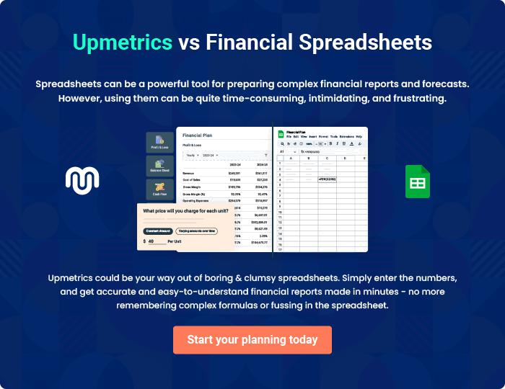

Event Venue | Business Plan [YEAR] | 39/40


Create a winning business plan that gets you funded

Creating a stunning and investment-ready plan requires no writing, graphic designing, or financial planning expertise.

Upmetrics has all the features required to help you create a comprehensive business plan—from start to finish. Make no mistakes, it’s the modern way of planning to structure ideas, make plans, and create stunning pitch decks to awe investors.

Pitch decks that impress investors

Create pitch decks that provide a visual representation of your business, engage investors, and make them want to invest in your business idea.

Interactive plans in no time

Import business plan sections like—SWOT analysis, comparison tables, and others to create an interactive business plan. No designing skills are required.

Stunning cover page designs

With Upmetrics, you have the liberty to choose from multiple stunning cover page designs. Choose a creative design and make your plan stand out.

Online sharing made simple

Upmetrics makes online sharing quick and easier for users. Easily share your business plans with a link while tracking reader activity.

500+ sample business plans

Simply import a template from our library of sample plans into the editor and start customizing it to make it yours. It takes only a few clicks to get started.

Collaborate with team in real-time

Invite team members, initiate conversations, discuss ideas & strategies, share feedback, and work on a business plan in real-time.

