
- Event Planning

ADDRESS CONTACT

10200 Bolsa Ave, Westminster, CA, 92683 (650) 359-3153

http://www.example.com info@example.com


Business Plan

[YEAR]

Prepared By

John Doe


Dream fulfillment

Information provided in this business plan is unique to this business and confidential; therefore, anyone reading this plan agrees not to disclose any of the information in this business plan without prior written permission of the Company

Table of Contents

Executive Summary | 6
Business Overview | 7
Objectives | 7
Management | 8
John Doe | 8
Mission | 8
Keys to Success | 8
Financial Highlight | 9
Net Income & Gross Margin | 9

Business Summary | 10
About Business | 11
Business Ownership | 11
Start-up Summary | 11
Startup Expense | 11
Start-up Assets | 12
Funding | 12
Location | 13
Office Design | 13

Products and Services | 14
Products and Services | 15
Party Pack | 15
Step-by-Step Guides | 15
Event Planning Software | 16
Resources Manual | 16
Event Planners Training Institute | 16
Competitive Comparison | 17

Event Planning | Business Plan [YEAR] 2/37

Market Analysis | 18
Market Segmentation | 19
Private Organizations and Businesses | 19
Public Organizations | 19
Age Breakdowns | 20
Customer Segmentation | 20
Target Market Segment Strategy | 21
Service Business Analysis | 21
Hotels and Conference Centers | 21
Other Event Planners | 22
Employees or Persons wishing to do it themselves | 22

Marketing and Sales | 23
Marketing and Competition | 24
Sales Strategy | 24
Private and Public Organizations | 24
Individuals | 24
Sales Forecast | 25
Sales | 25

Management and Operations | 26
Management Summary | 27
Organizational Structure | 27
Personnel Plan | 27

Financial Plan | 28
Financial Plan | 29
Important Assumptions | 29
General Assumptions | 29
Key Financial Indicators | 29
Benchmark | 30
Break-even Analysis | 30
Income Statement (5 Year Projections) | 31

Event Planning | Business Plan [YEAR] 3/37

Balance Sheet (5 Year Projections) 33

Cash Flow Statement (5 Year projections) | 35

Event Planning | Business Plan [YEAR] 4/37

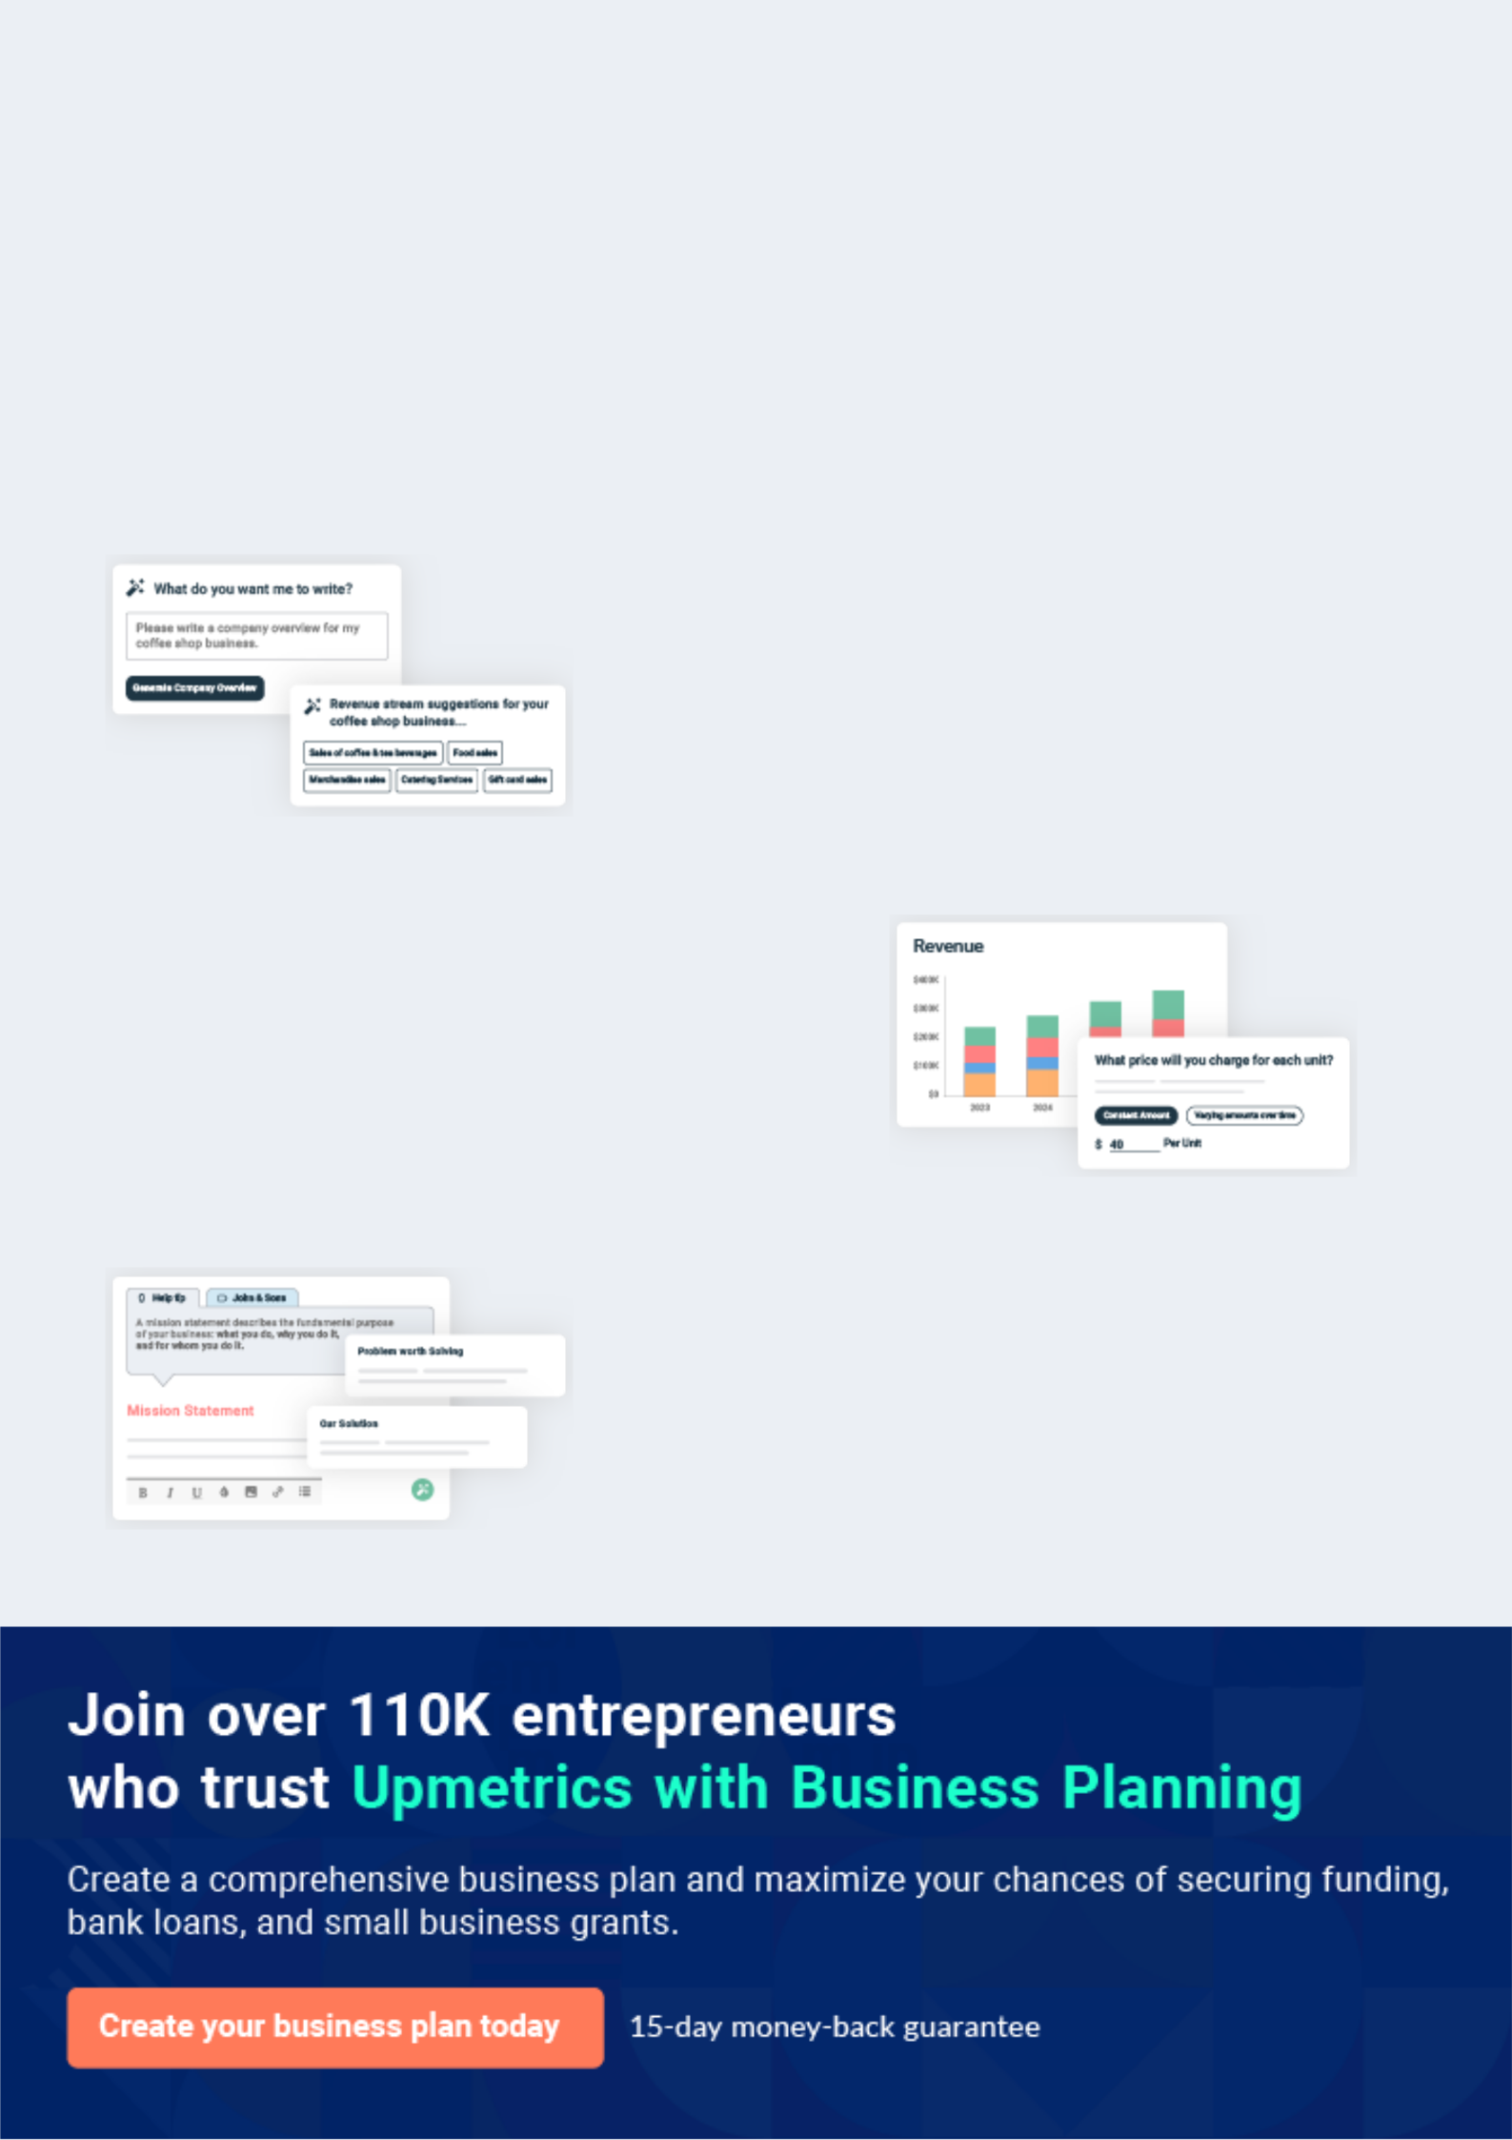
Business planning that’s simpler and faster than you think

Creating a business plan using Upmetrics to start and grow a business is literally the easiest thing in the World. Simply read the instructions and fill in the blanks. It’s as simple as that.

❛ | Upmetrics has everything you need to create a | ❜
❛ | comprehensive business plan. | ❜

AI-powered Upmetrics Assistant

AI-powered insights to streamline your plan

Not sure where to start? Upmetrics’ AI Assistant will automatically generate ideas for each section of your plan and offer improved versions of your writing, adjusting for tone, voice, and grammar or spelling errors.

Financial Forecasting Tool

All the financials are calculated for you

Forget the complex formulas and clumsy spreadsheets — with automatic financials and drag-and-drop forecasting, you can finish your plan faster and be confident that your numbers are accurate.

Business Plan Builder

Guides you like a business mentor

Upmetrics’ step-by-step instructions, prompts, and the library of 400+ sample business plans will guide you through each section of your plan as a business mentor.

1.


Executive Summary

Business Overview

Objectives

Management

Mission

Keys to Success

Financial Highlight

Event Planning | Business Plan [YEAR] 6/37

Business Overview

 Eventel LLC


Welcome to the future of event planning! Eventel, The event planning specialists bring to the community of Portland a new breath of air in the event planning market. By combining old
fashioned values, going the extra mile, and using cutting edge event-planning software, Eventel
To unlock help try Upmetrics! 

Start writing here..

Objectives

 Eventel LLC

Eventel is a small business aimed at the big time. In order to reach its lofty goals, Eventel must focus on the mission behind the vision. It will take all the employees, owners, founders, and vendors daily living the vision that Eventel represents. The vision manifests itself in three ways:
To unlock help try Upmetrics! 

Start writing here..

Event Planning | Business Plan [YEAR] 7/37

Management
To unlock help try Upmetrics!


John Doe

Owner - john.doe@example.com

Eventel will be lead by John Doe. Throughout her life, Ceece has been a planner, and only recently has she truly discovered that she could leverage her passion and skill into a business opportunity. While Greece was pursuing her undergraduate and graduate degrees, she was a chairperson for no less than four different student organizations. After receiving her MBA, she went to work for IBM as a project manager. It was her six years at IBM pursuing project management that truly honed not only her planning/ project management skills but also her interpersonal skills. After her fifth year at IBM, Greece began to get a bit too complacent and began dreaming of leaving to begin her own business. At first, it was a struggle to figure out what she could do on her own. One day on a long bike ride she had an epiphany, realizing that she should begin her own event planning company.

Mission

 Eventel LLC

In an ever-changing, fast-paced world, success is determined by good choices for lasting effects. Communication is essential. Eventel strives to be the best choice for clients by helping to ease their event planning burden. Through consistent, predictable professionalism, Eventel
To unlock help try Upmetrics! 

Start writing here..

Keys to Success

 Eventel LLC

Our keys to success include the commitment to quality by every person who is part of the team. Each of us will be responsible to push ourselves to a higher level of professionalism in three areas:



Start writing here..

Event Planning | Business Plan [YEAR] 8/37

Financial Highlight

Net Income & Gross Margin
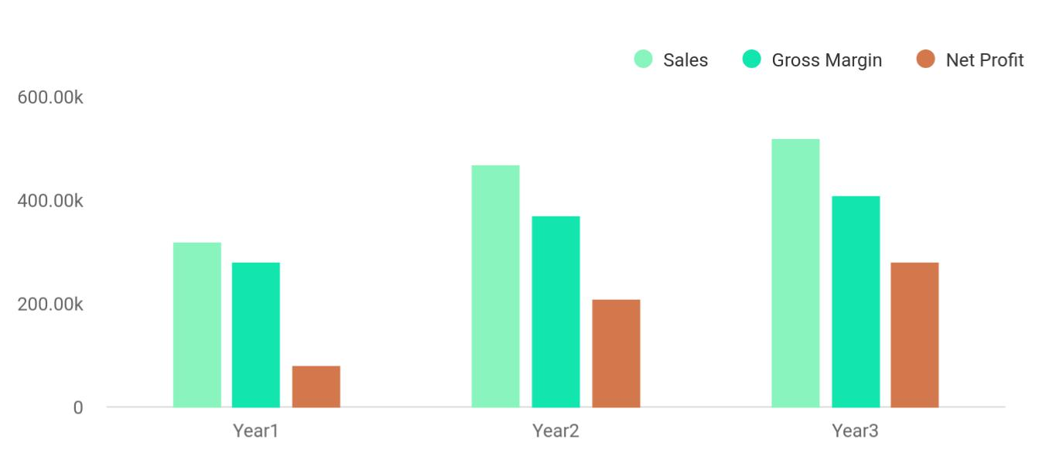

Financial Year | Sales | Gross Margin | Net Profit
Year1 | 320,000 | 280,000 | 80,000
Year2 | 470,000 | 370,000 | 210,000
Year3 | 520,000 | 410,000 | 280,000

Event Planning | Business Plan [YEAR] 9/37

2.

Business Summary

About Business

Business Ownership

Start-up Summary

Location

Office Design

Event Planning | Business Plan [YEAR] 10/37

About Business

 Eventel LLC


To unlock help try Upmetrics! 

Start writing here..

Business Ownership

 Eventel LLC

Eventel is established as a sole proprietorship with the intention of selling the business when it is established to one of the employees invested in the vision of event planning. All aspects of the business will be documented to ensure clients can count on the same results every time. It
To unlock help try Upmetrics! 

Start writing here..

Start-up Summary

 Eventel LLC

Through careful planning on the part of the founders, the startup costs for Eventel is minimal. It began as a home-based business with little overhead, and it continues to demand fewer outlay of funds as a service-based business. The start-up cost investment funds were assets saved
To unlock help try Upmetrics! 

Start writing here..

Startup Expense

Start-up Expenses
Legal | [Amount]
Stationery etc. | [Amount]
Brochures | [Amount]

Event Planning | Business Plan [YEAR] 11/37

Start-up Expenses
Consultants | [Amount]
Insurance | [Amount]
Rent | [Amount]
Research and Development | [Amount]
Expensed Equipment | [Amount]
Other | [Amount]
Total Start-up Expenses | [Total Amount]

Start-up Assets

Start-up Assets Needed
Cash Balance on Starting Date | [Amount]
Start-up Inventory | [Amount]
Other Current Assets | [Amount]
Total Current Assets | [Amount]
Long-term Assets | [Amount]
Total Assets | [Total Amount]
Total Requirements
Funding
Funding
Owner Contribution
Other
Total Investment

Event Planning | Business Plan [YEAR] | 12/37

Location

 Eventel LLC

Eventel is located inside the city limits of Portland, Oregon. It is a home-based business. Most meetings with clients are conducted in social settings, such as restaurants, coffee houses, the client's home, facilities wishing to be used for the event, or over the phone. Although the
To unlock help try Upmetrics! 

Start writing here..

Office Design

 Eventel LLC


The company will maintain a high degree of professionalism. All offices are equipped with the latest in business technology, such as telephone

Start writing here..

To unlock help try Upmetrics! 

Event Planning | Business Plan [YEAR] 13/37

3.

Products and Services

Products and Services

Competitive Comparison

Event Planning | Business Plan [YEAR] 14/37

Products and Services
To unlock help try Upmetrics!

 Eventel LLC

Although Eventel is primarily a service business, we also offer products to aid our customers in planning the event themselves. The following products are tools used inside our operation for the best possible results:



Start writing here..

 Eventel LLC

The Party Pack is a complete kit for any party. It includes decorations, lighting effects guide, disposable theme cameras, cutlery, plates, napkins, cups, punch mix (or recipe), snack supplies (or recipe), tablecloths, theme music (where applicable), invitations, thank-you cards, and a
To unlock help try Upmetrics! 

Party Pack

Start writing here..

 Eventel LLC

These booklets include a calendar to map out the event, a step-by-step guide on what is needed for and how to put together a successful, worry-free event, resource information, popular refreshments with recipes, games, and tips to put their event in the record books. The events
To unlock help try Upmetrics! 

Step-by-Step Guides

Start writing here..

Event Planning | Business Plan [YEAR] 15/37

 Eventel LLC

Due to be released in June 2000, this cutting-edge tool will allow the client all the resources and visual aids for their event planning. They will be able to play with decoration themes, listen to theme music, design invitations, thank-you cards, and RSVP cards, use the interactive planning
To unlock help try Upmetrics! 

Event Planning Software

Start writing here..

 Eventel LLC

This valuable guide acts as a review for all the resources located in the surrounding area. A ranking is given to the various services, such as caterers, decorators, disc jockeys, bands, and facilities. This manual gives the client the freedom of making a choice based on experience.
To unlock help try Upmetrics! 

Resources Manual

Start writing here..

 Eventel LLC

As a member of the Portland community, it is our mission to support our community. Ten hours each month will be devoted to training area students in event planning. This will aid them in planning proms, graduation parties, river clean-ups, homecoming, and other important events.
To unlock help try Upmetrics! 

Event Planners Training Institute

Start writing here..

Event Planning | Business Plan [YEAR] 16/37

Competitive Comparison

 Eventel LLC

Eventel, although young, draws from the age-old tradition of going above and beyond what is expected, every time. Our systems for event planning have been drawn up, evaluated, practiced, worked, and reworked to ensure maximum efficiency while minimizing the possibility of error.
To unlock help try Upmetrics! 

Start writing here..
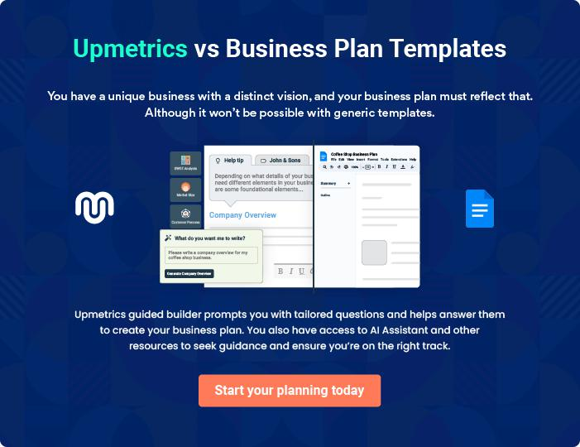

Event Planning | Business Plan [YEAR] 17/37

4.

Market Analysis

Market Segmentation

Customer Segmentation

Target Market Segment Strategy

Service Business Analysis

Event Planning | Business Plan [YEAR] 18/37

 Eventel LLC

The following sections describe the market segmentation, strategies, and industry analysis.

To unlock help try Upmetrics! 

Start writing here..

Market Segmentation

 Eventel LLC

The breakdown of the market for event planning falls in a wide, very diverse grouping. Individuals, as well as organizations, demand the services we provide. In order to provide the greatest depth of information, the market segments have been broken down into private and
To unlock help try Upmetrics! 

Start writing here..

 Eventel LLC

Private organizations make up the single largest portion of Eventel' client base. Private organizations such as businesses, corporations, and political parties host the most events on the largest scales, therefore, these events generate larger revenues per event. The majority of
To unlock help try Upmetrics! 

Private Organizations and Businesses

Start writing here..

 Eventel LLC

Government agencies host many events every year. Eventel hopes to alleviate the pressure of event planning for public employees. The second single largest segment, the public sector, can save money and give back to its community at the same time. These events are moderate in
To unlock help try Upmetrics! 

Public Organizations

Start writing here..

Event Planning | Business Plan [YEAR] 19/37

 Eventel LLC

Under 24: Persons under the age of twenty-four (24) using an event planner are rare at best. We hope to tap the early college graduates who have begun their professional careers but have not yet started their families. These events will focus mainly on themes with moderate to high
To unlock help try Upmetrics! 

Age Breakdowns

Start writing here..

Customer Segmentation
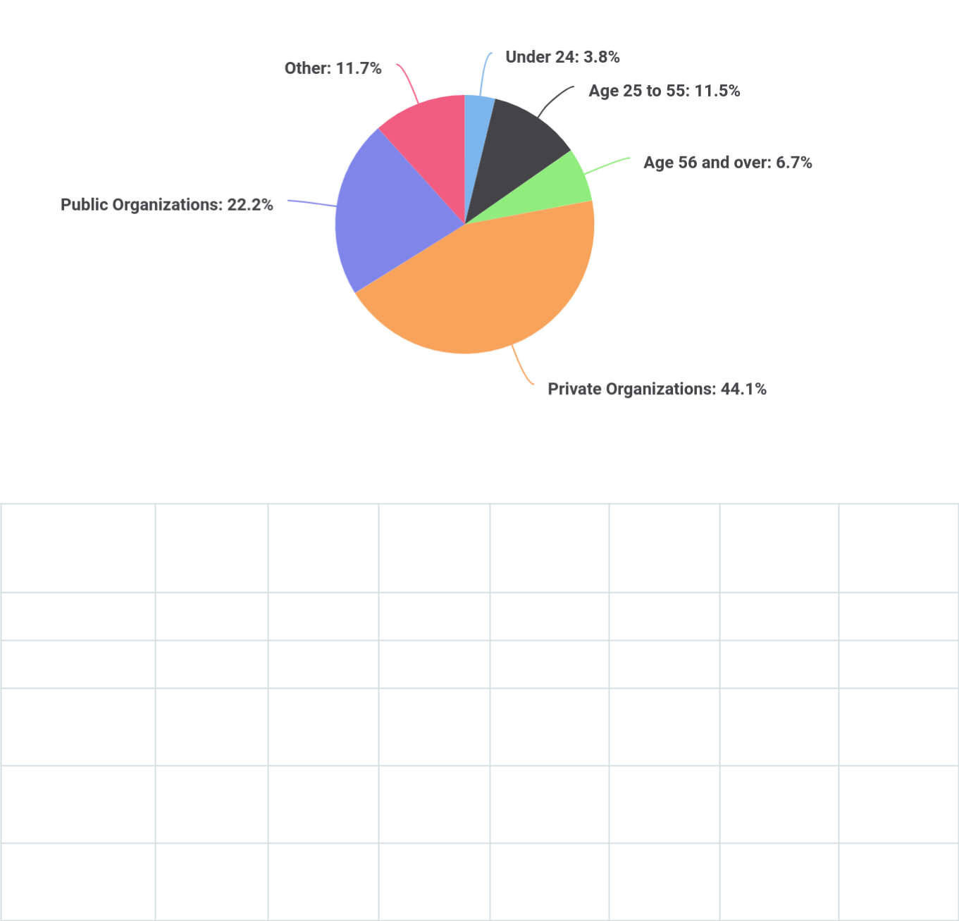

Potential | Growth Year1 | Year2 | Year3 | Year4 | Year5 | CAGR
Customers

Under 24

Age 25 to 55

Age 56 and

over

Private

Organizations

Public

Organizations

Event Planning | Business Plan [YEAR] 20/37

  Potential | Growth Year1 | Year2 | Year3 | Year4 | Year5 | CAGR
Customers

Other

Total

Target Market Segment Strategy

 Eventel LLC

Our target markets are middle to upper-middle-class families, couples, individuals, or private and public organizations. We chose these groups because they are most able to afford event planners, and have the least amount of time to spare for event planning in general. Families
To unlock help try Upmetrics! 

Start writing here..

Service Business Analysis

 Eventel LLC

Eventel is in a unique position of competition. We compete against hotels with conference facilities, conference centers, other event planners both on the large and small scale, persons within an organization who are assigned the task of organizing an event, and people who wish
To unlock help try Upmetrics! 

Start writing here..

 Eventel LLC

Strengths: On-site facilities, equipment, and support staff. Ability to transport and house persons for overnight stays. Able to internalize the costs of transportation and equipment.
To unlock help try Upmetrics! 

Hotels and Conference Centers

Start writing here..

Event Planning | Business Plan [YEAR] 21/37

 Eventel LLC

Strengths: Have been in the market longer, have established a reputation and client base.

Weakness: Reputation precedes them, no systems-based businesses designed to produce
To unlock help try Upmetrics! 

Other Event Planners

Start writing here..

 Eventel LLC

Strengths: Internalized cost of planning the event; able to add tiny personalized touches that have meaning within the group or family.
To unlock help try Upmetrics! 

Employees or Persons wishing to do it themselves

Start writing here..

Event Planning | Business Plan [YEAR] 22/37

5.

Marketing and Sales

Marketing and Competition

Sales Strategy

Sales Forecast

Event Planning | Business Plan [YEAR] 23/37

Marketing and Competition

 Eventel LLC

We have discussed our client base as being predominately middle to upper-middle-class individuals, couples or families, public and private organizations. We must then look at the needs of these markets and cater to them. We promise the same great results, every time.
To unlock help try Upmetrics! 

Start writing here..

Sales Strategy

Eventel deals with a diverse market of clients. Within each market segment, the closing of sales will differ. Each approach is described as follows:

 Eventel LLC

Sales will be concluded one to two days after the end of the event. A follow-up phone call will be placed informing the client of the total cost, a number of attendees, and information about the billing packet that will arrive at their offices. Feedback forms will be included in these
To unlock help try Upmetrics! 

Private and Public Organizations

Start writing here..

 Eventel LLC

Sales will be concluded with a follow-up phone call one to two days after the event. The phone call will explain the total cost of the event, number of attendees, and information concerning the billing. Individual parties of any age group are placed on a billing cycle. Invoices will be sent
To unlock help try Upmetrics! 

Individuals

Start writing here..

Event Planning | Business Plan [YEAR] 24/37

Sales Forecast

Sales
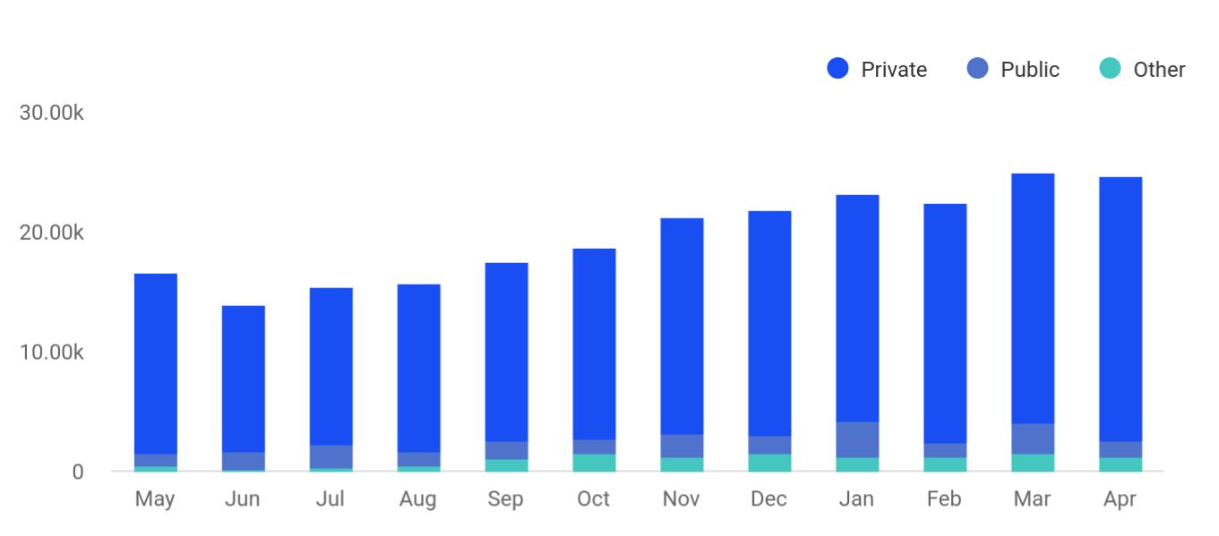

By beginning on a smaller scale, Eventel has the foresight to grow at a rapid pace to keep up with demand. We wish to maintain a steady rate of sales growth; however, we understand that sales of products and services will vary in different months. As noted in the graph and chart, rapid increases during the holiday season will boost sales, then allow that growth to level off at a steady rate.

Sales | Year1 | Year2 | Year3
Private | $206,170 | $276,099 | $299,002
Public | $113,185 | $178,490 | $193,000
Other | $33,794 | $40,081 | $62,777
Total Sales | $353,149 | $494,670 | $554,779
Direct Cost of Sales:

Direct Cost of Sales | Year1 | Year2 | Year3
Private | $312 | $330 | $355
Public | $210 | $246 | $346
Other | $132 | $151 | $189
Total | $654 | $727 | $890

Event Planning | Business Plan [YEAR] 25/37

6.

Management and Operations

Management Summary

Organizational Structure

Personnel Plan

Event Planning | Business Plan [YEAR] 26/37

Management Summary

 Eventel LLC

Information and expense details are presented in the subtopics Organizational Structure and Personnel Plan.
To unlock help try Upmetrics! 

Start writing here..

Organizational Structure

 Eventel LLC

The management team within Eventel will be small in the beginning. The primary employee is the founder, who plans events, then contracts with caterers, decorators, disc jockeys, and bands to fill out the event. A contract labor site manager will be on hand to work the events as a
To unlock help try Upmetrics! 

Start writing here..

Personnel Plan

Personnel Plan | Year1 | Year2 | Year3
Event Specialist | $36,000 | $40,000 | $42,000
Site Manager | $11,097 | $13,750 | $14,560
Other | $8,947 | $9,560 | $10,000
Total People | 7 | 8 | 9
Total Payroll | $56,044 | $63,310 | $66,560

Event Planning | Business Plan [YEAR] 27/37

7.

Financial Plan

Financial Plan

Important Assumptions

Key Financial Indicators

Break-even Analysis

Income Statement (5 Year Projections)

Balance Sheet (5 Year Projections)

Cash Flow Statement (5 Year projections)

Event Planning | Business Plan [YEAR] 28/37

Financial Plan

 Eventel LLC

Service-based businesses require little funds to start up, and as they grow and expand, fewer funds to maintain. The charts and graphs that follow will show that investment up front allows Eventel to function debt-free with little overhead. This gives Eventel a quicker break-even point
To unlock help try Upmetrics! 

Start writing here..

Important Assumptions

 Eventel LLC

Tax rates are noted for information. We carry no loan burden that would be affected by these rates. What hits Eventel the hardest (but not nearly are bad as other service businesses), is the tax rate of 23.5%, which is nearly one-quarter of the total sales. As Eventel continues to grow,
To unlock help try Upmetrics! 

Start writing here..

General Assumptions

General Assumptions | Year1 | Year2 | Year3
Plan Month | 1 | 2 | 2
Current Interest Rate | 8.92% | 8.92% | 8.92%
Long-term Interest Rate | 7.99% | 7.99% | 7.99%
Tax Rate | 24.04% | 24.04% | 24.04%
Sales on Credit % | 60.00% | 60.00% | 60.00%
Other | 0 | 0 | 0

Key Financial Indicators

The break-even point for Eventel is based on the assumption that we will produce 22 events per month and average approximately $521 per event. In the current situation, we average more than this assumption for our public and private organization events. These currently make up 18 of the 22 average events hosted per month.

Event Planning | Business Plan [YEAR] 29/37

Benchmark
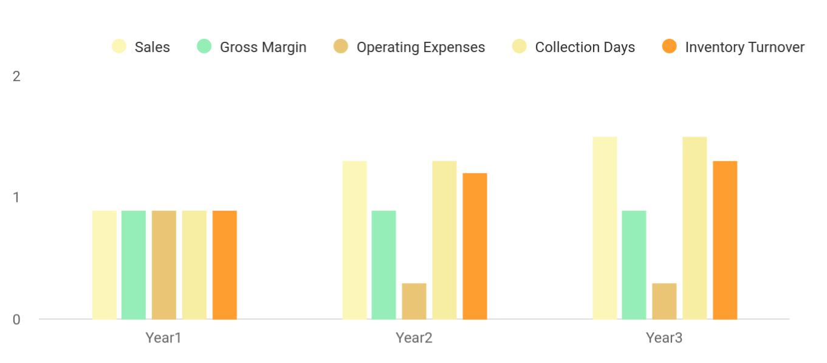

Break-even Analysis

The break-even point will appear more rapidly for Eventel than for other types of home-based businesses. Start-up costs are limited to minimal equipment, there is little or no staff to pay in the beginning, and contracted companies will handle any additional equipment required for the planned events.


Break-even Analysis
Monthly Units Break-even | 22
Monthly Revenue Break-even | $11680

Assumptions
Average Per-Unit Revenue | $521.00
Average Per-Unit Variable Cost | $75.00
Estimated Monthly Fixed Cost | $10,000

Event Planning | Business Plan [YEAR] 30/37

Income Statement (5 Year Projections)

Revenue

Event Planning Services

Unit Sales

Unit Price

Event Management

Workshops

Unit Sales

Unit Price

Online Event Planning Resources

Cost Of Sales

General Costs

Event Supplies

Decoration Materials

Audio-Visual Equipment Rental

Staffing Costs

Event Staff Wages

Contractor Fees

Revenue Specific Costs

Personnel Costs (Direct Labor)

Gross Margin

Gross Margin (%)

2024 | 2025 | 2026
$666,289.59 | $1,147,120.18 | $2,006,077.58
$318,500 | $572,180 | $1,027,120
159 | 286 | 514
$2,000 | $2,000 | $2,000
$212,830 | $303,375 | $432,515
426 | 607 | 865
$500 | $500 | $500
$134,959.59 | $271,565.18 | $546,442.58

$262,869.08 | $451,540.58 | $788,967.54
$262,869.08 | $451,540.58 | $788,967.54
$142,936.98 | $245,058.95 | $427,873.58
$127,336.98 | $228,678.95 | $410,674.58
$15,600 | $16,380 | $17,199
$119,932.10 | $206,481.63 | $361,093.96
$66,628.95 | $114,712.01 | $200,607.74
$53,303.15 | $91,769.62 | $160,486.22
$0 | $0 | $0
$0 | $0 | $0

$403,420.51 | $695,579.60 | $1,217,110.04
60.55% | 60.64% | 60.67%

Event Planning | Business Plan [YEAR] 31/37

2024 2025 2026

Operating Expense | $454,634.48 | $489,998.97 | $545,184.09
Payroll Expense (Indirect | $375,120 | $385,261.56 | $395,688.84
Labor) | $375,120 | $385,261.56 | $395,688.84
Event Planning Team | $142,560 | $145,987.20 | $149,500.32
Senior Event Planner | $57,600 | $59,328 | $61,107.84
Event Coordinator | $84,960 | $86,659.20 | $88,392.48
Administrative Staff | $82,800 | $84,697.56 | $86,639.04
Office Manager | $48,300 | $49,507.56 | $50,745.24
Administrative Assistant | $34,500 | $35,190 | $35,893.80
Marketing and Sales Team | $149,760 | $154,576.80 | $159,549.48
Marketing Manager | $64,800 | $67,068 | $69,415.32
Sales Representative | $84,960 | $87,508.80 | $90,134.16
General Expense | $79,514.48 | $104,737.41 | $149,495.25
Office and Administrative | $30,000 | $30,983.40 | $32,592.60
Expenses | $30,000 | $30,983.40 | $32,592.60
Office Rent | $24,000 | $24,781.80 | $26,225.40
Utilities | $6,000 | $6,201.60 | $6,367.20
Marketing and Advertising | $42,914.48 | $67,052.01 | $110,096.85
Social Media Advertising | $33,314.48 | $57,356.01 | $100,303.89
Print Advertising | $9,600 | $9,696 | $9,792.96
Technology and | $6,600 | $6,702 | $6,805.80
Communication | $6,600 | $6,702 | $6,805.80
Website Maintenance | $3,600 | $3,672 | $3,745.44
Telephone and Internet | $3,000 | $3,030 | $3,060.36
Bad Debt | $0 | $0 | $0

Event Planning | Business Plan [YEAR] 32/37

Amortization of Current Assets

EBITDA

Additional Expense

Long Term Depreciation

Gain or loss from Sale of Assets

EBIT

Interest Expense

EBT

Income Tax Expense / Benefit

Total Expense

Net Income

Net Income (%)

Retained Earning Opening

Owner's Distribution

Retained Earning Closing

2024 | 2025 | 2026
$0 | $0 | $0

($51,213.98) $205,580.63 $671,925.95

$12,296.42 | $11,174.62 | $9,971.75
$9,288 | $9,288 | $9,288
$0 | $0 | $0
($60,501.98) | $196,292.63 | $662,637.95
$3,008.41 | $1,886.63 | $683.75
($63,510.40) | $194,406.01 | $661,954.20
$0 | $0 | $0

$729,799.99 | $952,714.17 | $1,344,123.38
($63,510.40) | $194,406.01 | $661,954.20
(9.53%) | 16.95% | 33%

$0 | ($81,510.40) | $104,895.61
$18,000 | $8,000 | $8,000
($81,510.40) | $104,895.61 | $758,849.81

Balance Sheet (5 Year Projections)

 | 2024 | 2025 | 2026
Assets | ($17,028.18) | $152,738.25 | $788,849.81

Event Planning | Business Plan [YEAR] 33/37

 | 2024 | 2025 | 2026
Current Assets | ($52,740.18) | $126,314.25 | $771,713.81
Cash | ($52,740.18) | $126,314.25 | $771,713.81
Accounts Receivable | $0 | $0 | $0
Inventory | $0 | $0 | $0
Other Current Assets | $0 | $0 | $0
Long Term Assets | $35,712 | $26,424 | $17,136
Gross Long Term Assets | $45,000 | $45,000 | $45,000
Accumulated Depreciation | ($9,288) | ($18,576) | ($27,864)

Liabilities & Equity | ($17,028.19) | $152,738.25 | $788,849.81
Liabilities | $34,482.21 | $17,842.64 | $0
Current Liabilities | $16,639.57 | $17,842.64 | $0
Accounts Payable | $0 | $0 | $0
Income Tax Payable | $0 | $0 | $0
Sales Tax Payable | $0 | $0 | $0
Short Term Debt | $16,639.57 | $17,842.64 | $0
Long Term Liabilities | $17,842.64 | $0 | $0
Long Term Debt | $17,842.64 | $0 | $0
Equity | ($51,510.40) | $134,895.61 | $788,849.81
Paid-in Capital | $0 | $0 | $0
Common Stock | $0 | $0 | $0
Preferred Stock | $0 | $0 | $0
Owner's Contribution | $30,000 | $30,000 | $30,000
Retained Earnings | ($81,510.40) | $104,895.61 | $758,849.81

Event Planning | Business Plan [YEAR] 34/37

 | 2024 | 2025 | 2026
Check | $0 | $0 | $0

Cash Flow Statement (5 Year projections)

 | 2024 | 2025 | 2026
Cash Received | $666,289.59 | $1,147,120.18 | $2,006,077.58
Cash Paid | $720,511.99 | $943,426.17 | $1,334,835.38
COS & General Expenses | $342,383.57 | $556,277.99 | $938,462.79
Salary & Wages | $375,120 | $385,261.56 | $395,688.84
Interest | $3,008.41 | $1,886.63 | $683.75
Sales Tax | $0 | $0 | $0
Income Tax | $0 | $0 | $0
Net Cash From | ($54,222.40) | $203,694.01 | $671,242.20
Operations | ($54,222.40) | $203,694.01 | $671,242.20

Assets Sell | $0 | $0 | $0
Assets Purchase | $45,000 | $0 | $0
Net Cash From | ($45,000) | $0 | $0
Investments | ($45,000) | $0 | $0

Amount Received | $80,000 | $0 | $0
Loan Received | $50,000 | $0 | $0
Common Stock | $0 | $0 | $0
Preferred Stock | $0 | $0 | $0
Owner's Contribution | $30,000 | $0 | $0
Amount Paid | $33,517.78 | $24,639.58 | $25,842.64
Loan Capital | $15,517.79 | $16,639.57 | $17,842.64

Event Planning | Business Plan [YEAR] 35/37

 | 2024 | 2025 | 2026
Dividends & Distributions | $18,000 | $8,000 | $8,000
Net Cash From | $46,482.22 | ($24,639.58) | ($25,842.64)
Financing | $46,482.22 | ($24,639.58) | ($25,842.64)

Summary

Starting Cash | $0 | ($52,740.18) | $126,314.25
Cash In | $746,289.59 | $1,147,120.18 | $2,006,077.58
Cash Out | $799,029.77 | $968,065.75 | $1,360,678.02
Change in Cash | ($52,740.18) | $179,054.43 | $645,399.56
Ending Cash | ($52,740.18) | $126,314.25 | $771,713.81
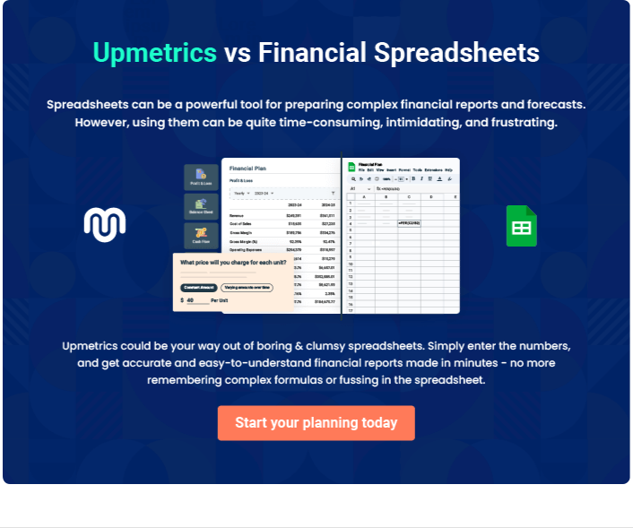

Event Planning | Business Plan [YEAR] 36/37


Create a winning business plan that gets you funded

Creating a stunning and investment-ready plan requires no writing, graphic designing, or financial planning expertise.

Upmetrics has all the features required to help you create a comprehensive business plan—from start to finish. Make no mistakes, it’s the modern way of planning to structure ideas, make plans, and create stunning pitch decks to awe investors.

Pitch decks that impress investors

Create pitch decks that provide a visual representation of your business, engage investors, and make them want to invest in your business idea.

Interactive plans in no time

Import business plan sections like—SWOT analysis, comparison tables, and others to create an interactive business plan. No designing skills are required.

Stunning cover page designs

With Upmetrics, you have the liberty to choose from multiple stunning cover page designs. Choose a creative design and make your plan stand out.

Online sharing made simple

Upmetrics makes online sharing quick and easier for users. Easily share your business plans with a link while tracking reader activity.

500+ sample business plans

Simply import a template from our library of sample plans into the editor and start customizing it to make it yours. It takes only a few clicks to get started.

Collaborate with team in real-time

Invite team members, initiate conversations, discuss ideas & strategies, share feedback, and work on a business plan in real-time.

