
 Crazy Club

ADDRESS CONTACT

10200 Bolsa Ave, Westminster, CA, 92683 (650) 359-3153

http://www.example.com info@example.com
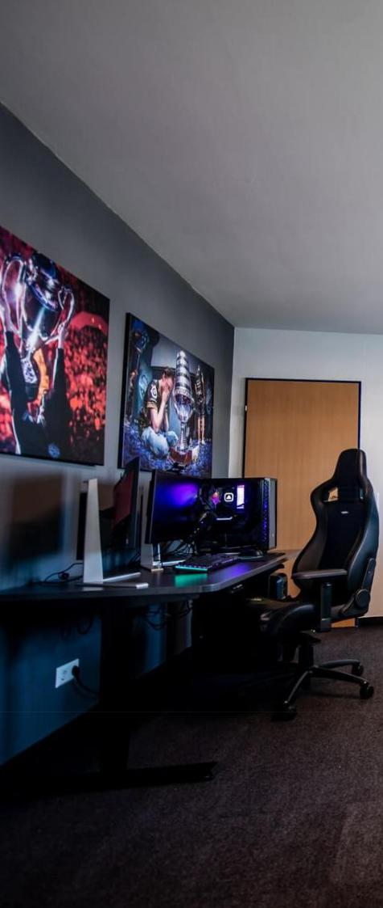

Business Plan

[YEAR]

Prepared By

John Doe


Be Calm, Be a Gamer

Information provided in this business plan is unique to this business and confidential; therefore, anyone reading this plan agrees not to disclose any of the information in this business plan without prior written permission of the Company

Table of Contents

Executive Summary | 5
Services and Amenities | 6
Vision Statement | 6
Mission Statement | 7

Business Overview | 8
Business Structure | 9
Roles and Responsibilities | 9
Chief Coach – CEO | 9
Manager/Technical Adviser | 9
Video Game Instructors/Assistant (5) | 10
Accountant/Cashier | 10
Client Service Executive | 10
Cleaners (3) | 10
SWOT Analysis
SWOT Analysis | 11
Market Analysis
Market Analysis | 14
Market Trends | 15
Target Market | 15
Competitive Advantage | 15
Sales And Marketing Strategy
Sales And Marketing Strategy | 16
Sources of Income | 17
Sales Forecast | 17
No. of players v/s Revenue Chart | 18
Pricing Strategy | 18
Payment Options | 18
Publicity and Advertising Strategy
Publicity and Advertising Strategy | 19

Crazy Club | Business Plan [YEAR] 2/31

Financial Plan | 21
Startup Expenditure (Budget) | 22
Generating Funds/Startup Capital | 22
Projected Profit & Loss | 22
Projected Cash Flow | 25
Projected Balance Sheet | 26
Sustainability and Expansion Strategy
Sustainability and Expansion Strategy | 29

Crazy Club | Business Plan [YEAR] 3/31

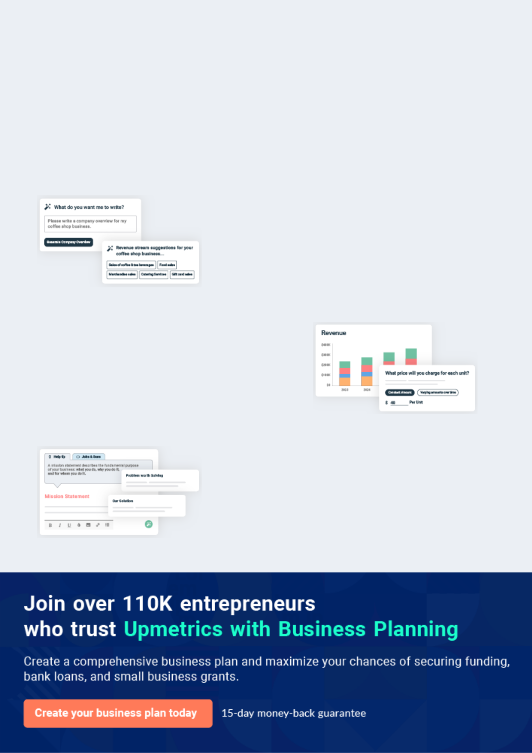
Business planning that’s simpler and faster than you think

Creating a business plan using Upmetrics to start and grow a business is literally the easiest thing in the World. Simply read the instructions and fill in the blanks. It’s as simple as that.

❛ | Upmetrics has everything you need to create a | ❜
❛ | comprehensive business plan. | ❜

AI-powered Upmetrics Assistant

AI-powered insights to streamline your plan

Not sure where to start? Upmetrics’ AI Assistant will automatically generate ideas for each section of your plan and offer improved versions of your writing, adjusting for tone, voice, and grammar or spelling errors.

Financial Forecasting Tool

All the financials are calculated for you

Forget the complex formulas and clumsy spreadsheets — with automatic financials and drag-and-drop forecasting, you can finish your plan faster and be confident that your numbers are accurate.

Business Plan Builder

Guides you like a business mentor

Upmetrics’ step-by-step instructions, prompts, and the library of 400+ sample business plans will guide you through each section of your plan as a business mentor.

1.


Executive Summary

Services and Amenities

Vision Statement

Mission Statement

Crazy Club | Business Plan [YEAR] 5/31

 Crazy Club


Crazy Club eSport, Inc. is a standard, licensed, and highly – competitive professional eSport with headquarters and training facility in Mount Pleasant – South Carolina. We have been able to secure a standard facility in a central and easy to locate the area in Mount Pleasant.
To unlock help try Upmetrics! 

Start writing here..

Services and Amenities

 Crazy Club

Crazy Club eSport, Inc. is in the Video games industry to set up a highly competitive and profitable eSport in Mount Pleasant – South Carolina that will win local, national, and
international eSport competitions, and we have been able to put up a facility that can help us
To unlock help try Upmetrics! 

Start writing here..

Vision Statement

 Crazy Club

Our Vision of starting Crazy Club eSport, Inc. is to build a world-class eSport that can favorably compete with leading eSports all across the globe.
To unlock help try Upmetrics! 

Start writing here..

Crazy Club | Business Plan [YEAR] 6/31

Mission Statement

 Crazy Club

Our mission for establishing Crazy Club eSport, Inc. is to contribute our quota in promoting video game activities in Mount Pleasant – South Carolina, and also to make profits from the industry; we want to become the leading eSport – brand in the whole of Mount Pleasant –
To unlock help try Upmetrics! 

Start writing here..

Crazy Club | Business Plan [YEAR] 7/31

2.

Business Overview

Business Structure

Roles and Responsibilities

Crazy Club | Business Plan [YEAR] 8/31

Business Structure
To unlock help try Upmetrics!

 Crazy Club

Crazy Club eSport, Inc. is in business to become the leading eSport in the whole of Mount Pleasant – South Carolina and we are fully aware that it will take the right facility, management, and organizational structure to achieve our goal.



Start writing here..

Roles and Responsibilities

 Crazy Club

Increases management’s effectiveness by recruiting, selecting, orienting, training, coaching, counselings, and disciplining pro gamers, managers; communicating values, strategies, and objectives; assigning accountability; planning, monitoring, and appraising job results
To unlock help try Upmetrics! 

Chief Coach – CEO

Start writing here..

 Crazy Club

Responsible for overseeing the smooth running of HR and administrative tasks for the school

Regularly hold meetings with key stakeholders (students and member of the school board) to
To unlock help try Upmetrics! 

Manager/Technical Adviser

Start writing here..

Crazy Club | Business Plan [YEAR] 9/31

 Crazy Club

Responsible for operating licensed games for training and competitions

Ensures that the video game machines are well arranged for another playing session after
To unlock help try Upmetrics! 

Video Game Instructors/Assistant (5)

Start writing here..

 Crazy Club

Responsible for preparing financial reports, budgets, and financial statements for the organization
To unlock help try Upmetrics! 

Accountant/Cashier

Start writing here..

 Crazy Club

Welcomes members and potential members/clients by greeting them in person or on the telephone; answering or directing inquiries.
To unlock help try Upmetrics! 

Client Service Executive

Start writing here..

 Crazy Club

Responsible for cleaning in and around the organization

Washes glassware and utensils after each use.
To unlock help try Upmetrics! 

Cleaners (3)

Start writing here..

Crazy Club | Business Plan [YEAR] 10/31

3.

SWOT Analysis

Crazy Club | Business Plan [YEAR] 11/31

 Crazy Club

Crazy Club eSport, Inc. is in business to provide an ideal platform for gamers in Mount Pleasant – South Carolina to grow and compete at eSport competitions and at the same time to make profits. We are aware that there are competitions in the Video games industry, which is why we
To unlock help try Upmetrics! 

Start writing here..


Strength

One of the obvious strengths that will definitely stand as a plus for Crazy Club eSport, Inc. is the fact that our facility is centrally located in a densely populated area in Mount Pleasant – South Carolina; our location is in fact one of our major strengths coupled with the support from stakeholders in the industry. We equally have a team of highly qualified professionals who will work hard to win laurels.


Weakness

We critically looked into our Business model and we were able to identify two major weaknesses. One is the fact that we are a new business and the second is the fact that we may not have the financial resources required to match up with existing eSports in South Carolina when it comes to employing experts in the industry and generating the needed hypes that can drive traffic towards our eSport.


Opportunity

The opportunities in this Green business are massive and it is growing by the day. In 2019, it was estimated that the total audience of e-sports would grow to 454 million viewers and that revenues would increase to over US$1 billion. The increasing availability of online streaming media platforms, particularly YouTube and Twitch has become central to the growth and promotion of e-sports competitions.

Threat

A major threat that may affect our business is unfavorable government policies. For example, despite its large video game market, e-sports in Japan is relatively underdeveloped, and this has been attributed largely to its broad anti-gambling laws which prohibit paid professional gaming tournaments.

Bad press can also affect our business – The legitimacy of e-sports as a sports competition remains in question.

Crazy Club | Business Plan [YEAR] 12/31

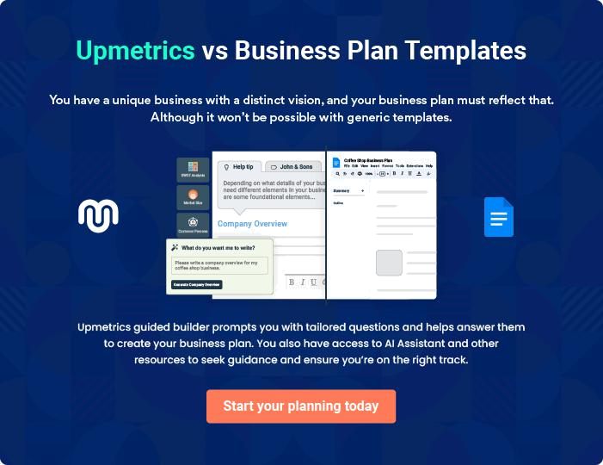

Crazy Club | Business Plan [YEAR] | 13/31

4.

Market Analysis

Market Trends

Target Market

Competitive Advantage

Crazy Club | Business Plan [YEAR] 14/31

Market Trends

 Crazy Club

Prior to this era, video games most often relied on high scores to determine the best player, but this changed with Street Fighter II, where players would instead challenge each other directly, “face-to-face,” to determine the best player, paving the way for the competitive multiplayer and
To unlock help try Upmetrics! 

Start writing here..

Target Market

 Crazy Club

Aside from teenagers and children, the target market for eSport cuts across people of different walks of life. The fact that people visit video games centers for various reasons makes marketing the business interesting. Crazy Club eSport, Inc. will work towards providing
To unlock help try Upmetrics! 

Start writing here..

Competitive Advantage

 Crazy Club

The Video games industry is indeed a prolific and highly competitive industry. Pro gamers will only join your team if they are comfortable with the games you have or if you can provide the enabling environment and facility for them to train, improve, and compete at the international
To unlock help try Upmetrics! 

Start writing here..

Crazy Club | Business Plan [YEAR] 15/31

5.

Sales And Marketing Strategy

Sources of Income

Sales Forecast

Pricing Strategy

Crazy Club | Business Plan [YEAR] 16/31

 Crazy Club

Our marketing strategies will be directed towards achieving specific objectives that support the strategic goals of the organization. The truth is that all that we do will be geared towards creating new market channels, increasing sales via winning competitions, and attracting
To unlock help try Upmetrics! 

Start writing here..

Sources of Income

 Crazy Club

Crazy Club eSport, Inc. is established with the aim of maximizing profits in the Video games industry and we are going to go ensure that we do all it takes to attract sponsorship deals and win competitions on a regular basis. According to the professional eSports organization Riot,
To unlock help try Upmetrics! 

Start writing here..

Sales Forecast

 Crazy Club

We are well-positioned to take on the available market in Mount Pleasant – South Carolina and on our online platforms and we are quite optimistic that we will meet our set target of generating enough income/profits from the first six months of operation and grow the business
To unlock help try Upmetrics! 

Start writing here..

Crazy Club | Business Plan [YEAR] 17/31

No. of players v/s Revenue Chart
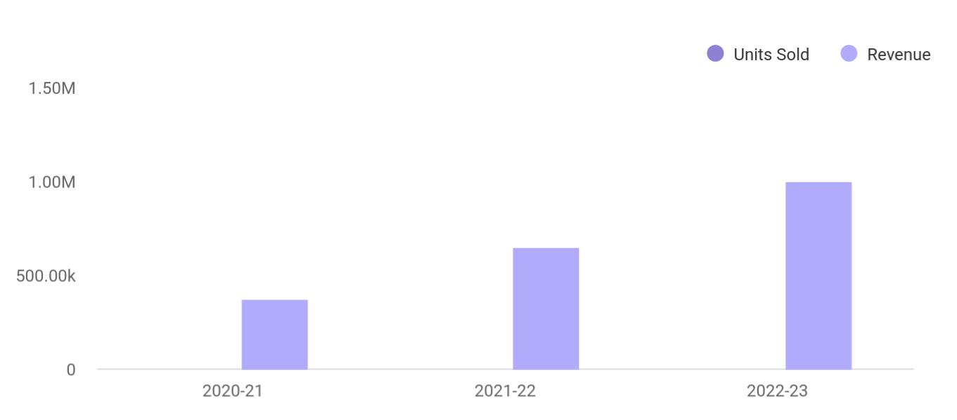

Financial Year | Units Sold | Revenue
2020-21 | 1,550 | 375,000
2021-22 | 1,800 | 650,000
2022-23 | 2,050 | 1,000,000

Pricing Strategy

 Crazy Club

An agency can help eSports teams negotiate, sign, and collect payments for sponsorship, and they also help to manage the relationship between the team and brand. Essentially, brands and eSports teams can benefit from sponsorship deals. Showing that we don’t have direct control
To unlock help try Upmetrics! 

Start writing here..

 Crazy Club

The payment policy adopted by Crazy Club eSport, Inc. is all-inclusive because we are quite aware that different customers prefer different payment options as it suits them but at the same time, we will ensure that we abide by the financial rules and regulation of the United
To unlock help try Upmetrics! 

Payment Options

Start writing here..

Crazy Club | Business Plan [YEAR] 18/31

6.

Publicity and Advertising Strategy

Crazy Club | Business Plan [YEAR] 19/31

 Crazy Club

We have been able to work with our branding and publicity consultants to help us map out publicity and advertising strategies that will help us walk our way into the heart of our target market. We are set to become the number one choice for clients in the whole of Mount
To unlock help try Upmetrics! 

Start writing here..

Crazy Club | Business Plan [YEAR] 20/31

7.

Financial Plan

Startup Expenditure (Budget)

Generating Funds/Startup Capital

Projected Profit & Loss

Projected Cash Flow

Projected Balance Sheet

Crazy Club | Business Plan [YEAR] 21/31

Startup Expenditure (Budget)

 Crazy Club

From our market survey and feasibility studies, we have been able to come up with a detailed budget for achieving our aim of establishing a standard and one-stop eSport in Mount Pleasant – South Carolina, and here are the key areas where we will spend our startup capital; These are
To unlock help try Upmetrics! 

Start writing here..

Generating Funds/Startup Capital

 Crazy Club

Crazy Club eSport, Inc. is owned and managed by Mr. Eddie Jones. He decided to restrict the sourcing of the startup capital for the business to just three major sources.
To unlock help try Upmetrics! 

Start writing here..

Projected Profit & Loss

 | 2024 | 2025 | 2026
Revenue | $1,524,396.30 | $3,490,239.60 | $6,110,484
Tournament Ticket Sales | $300,000 | $306,000 | $312,120
Unit Sales | 6,000 | 6,120 | 6,242
Unit Price | $50 | $50 | $50
Online Streaming | $984,396.30 | $2,920,239.60 | $5,507,964
Subscriptions | $984,396.30 | $2,920,239.60 | $5,507,964
Users | 13,484 | 31,178 | 55,047
Recurring Charges | $10 | $10 | $10
Sponsorship Deals | $240,000 | $264,000 | $290,400

Crazy Club | Business Plan [YEAR] 22/31

 | 2024 | 2025 | 2026
Cost Of Sales | $464,516.97 | $714,250.78 | $1,080,940.61
General Costs | $464,516.97 | $714,250.78 | $1,080,940.61
Tournament Operational | $176,507.52 | $290,450.20 | $455,620.01
Costs | $176,507.52 | $290,450.20 | $455,620.01
Venue Rental | $146,019.59 | $220,645.42 | $333,410.33
Security Services | $30,487.93 | $69,804.78 | $122,209.68
Production Crew | $288,009.45 | $423,800.58 | $625,320.60
Production Crew | $212,880.48 | $303,516.78 | $432,742.48
Equipment Rental | $75,128.97 | $120,283.80 | $192,578.12
Revenue Specific Costs | $0 | $0 | $0
Personnel Costs (Direct | $0 | $0 | $0
Labor) | $0 | $0 | $0

Gross Margin | $1,059,879.33 | $2,775,988.82 | $5,029,543.39
Gross Margin (%) | 69.53% | 79.54% | 82.31%

Operating Expense | $808,363.51 | $952,896.17 | $1,142,887.22
Payroll Expense (Indirect | $670,680 | $694,780.80 | $719,785.68
Labor) | $670,680 | $694,780.80 | $719,785.68
Management Team | $207,000 | $216,384 | $226,198.56
CEO | $110,400 | $115,920 | $121,716
CFO | $96,600 | $100,464 | $104,482.56
Operations Team | $268,800 | $276,864 | $285,169.68
Event Manager | $67,200 | $69,216 | $71,292.48
Technical Support Staff | $201,600 | $207,648 | $213,877.20
Marketing Team | $194,880 | $201,532.80 | $208,417.44
Marketing Director | $80,640 | $83,865.60 | $87,220.20

Crazy Club | Business Plan [YEAR] 23/31

 | 2024 | 2025 | 2026
Social Media Specialist | $53,760 | $55,372.80 | $57,033.96
Public Relations Manager | $60,480 | $62,294.40 | $64,163.28
General Expense | $137,683.51 | $258,115.37 | $423,101.54
Marketing and Advertising | $75,783.55 | $152,821.02 | $260,346.33
Online Advertising | $45,731.89 | $104,707.20 | $183,314.51
Event Promotion | $30,051.66 | $48,113.82 | $77,031.82
Technology and Equipment | $18,000 | $18,480 | $18,973.20
Software Licenses | $6,000 | $6,120 | $6,242.40
Hardware Maintenance | $12,000 | $12,360 | $12,730.80
Administrative and General | $43,899.96 | $86,814.35 | $143,782.01
Office Supplies | $13,412.03 | $17,009.57 | $21,572.33
Utility Bills | $30,487.93 | $69,804.78 | $122,209.68
Bad Debt | $0 | $0 | $0
Amortization of Current | $0 | $0 | $0
Assets | $0 | $0 | $0

EBITDA

Additional Expense

Long Term Depreciation

Gain or loss from Sale of Assets

EBIT

Interest Expense

EBT

Income Tax Expense / Benefit

$251,515.82 $1,823,092.65 $3,886,656.17

$15,694.93 | $13,760.77 | $11,707.31
$10,548 | $10,548 | $10,548
$0 | $0 | $0
$240,967.82 | $1,812,544.65 | $3,876,108.17
$5,146.94 | $3,212.76 | $1,159.29
$235,820.89 | $1,809,331.88 | $3,874,948.86
$0 | $0 | $0

Crazy Club | Business Plan [YEAR] 24/31

2024 2025 2026

Total Expense | $1,288,575.41 | $1,680,907.72 | $2,235,535.14
Net Income | $235,820.89 | $1,809,331.88 | $3,874,948.86
Net Income (%) | 15.47% | 51.84% | 63.41%

Retained Earning Opening | $0 | $217,820.89 | $2,019,152.77
Owner's Distribution | $18,000 | $8,000 | $8,000
Retained Earning Closing | $217,820.89 | $2,019,152.77 | $5,886,101.63

Projected Cash Flow

Cash Received

Cash Paid

COS & General Expenses

Salary & Wages

Interest

Sales Tax

Income Tax

Net Cash From

Operations

Assets Sell

Assets Purchase

Net Cash From

Investments

2024 | 2025 | 2026
$1,524,396.30 | $3,490,239.60 | $6,110,484
$1,278,027.41 | $1,670,359.72 | $2,224,987.14
$602,200.48 | $972,366.15 | $1,504,042.15
$670,680 | $694,780.80 | $719,785.68
$5,146.94 | $3,212.76 | $1,159.29
$0 | $0 | $0
$0 | $0 | $0
$246,368.89 | $1,819,879.88 | $3,885,496.86

$0 | $0 | $0
$70,000 | $0 | $0
($70,000) | $0 | $0

Crazy Club | Business Plan [YEAR] 25/31

 | 2024 | 2025 | 2026
Amount Received | $300,000 | $0 | $0
Loan Received | $100,000 | $0 | $0
Common Stock | $0 | $0 | $0
Preferred Stock | $0 | $0 | $0
Owner's Contribution | $200,000 | $0 | $0
Amount Paid | $49,359.35 | $41,293.51 | $43,347.12
Loan Capital | $31,359.34 | $33,293.52 | $35,347.14
Dividends & Distributions | $18,000 | $8,000 | $8,000
Net Cash From | $250,640.65 | ($41,293.51) | ($43,347.12)
Financing | $250,640.65 | ($41,293.51) | ($43,347.12)

Summary

Starting Cash | $0 | $427,009.54 | $2,205,595.91
Cash In | $1,824,396.30 | $3,490,239.60 | $6,110,484
Cash Out | $1,397,386.76 | $1,711,653.23 | $2,268,334.26
Change in Cash | $427,009.54 | $1,778,586.37 | $3,842,149.74
Ending Cash | $427,009.54 | $2,205,595.91 | $6,047,745.65

Projected Balance Sheet

 | 2024 | 2025 | 2026
Assets | $486,461.54 | $2,254,499.91 | $6,086,101.65
Current Assets | $427,009.54 | $2,205,595.91 | $6,047,745.65
Cash | $427,009.54 | $2,205,595.91 | $6,047,745.65
Accounts Receivable | $0 | $0 | $0
Inventory | $0 | $0 | $0

Crazy Club | Business Plan [YEAR] 26/31

 | 2024 | 2025 | 2026
Other Current Assets | $0 | $0 | $0
Long Term Assets | $59,452 | $48,904 | $38,356
Gross Long Term Assets | $70,000 | $70,000 | $70,000
Accumulated Depreciation | ($10,548) | ($21,096) | ($31,644)

Liabilities & Equity | $486,461.55 | $2,254,499.91 | $6,086,101.63
Liabilities | $68,640.66 | $35,347.14 | $0
Current Liabilities | $33,293.52 | $35,347.14 | $0
Accounts Payable | $0 | $0 | $0
Income Tax Payable | $0 | $0 | $0
Sales Tax Payable | $0 | $0 | $0
Short Term Debt | $33,293.52 | $35,347.14 | $0
Long Term Liabilities | $35,347.14 | $0 | $0
Long Term Debt | $35,347.14 | $0 | $0
Equity | $417,820.89 | $2,219,152.77 | $6,086,101.63
Paid-in Capital | $0 | $0 | $0
Common Stock | $0 | $0 | $0
Preferred Stock | $0 | $0 | $0
Owner's Contribution | $200,000 | $200,000 | $200,000
Retained Earnings | $217,820.89 | $2,019,152.77 | $5,886,101.63

Check | $0 | $0 | $0

Crazy Club | Business Plan [YEAR] 27/31

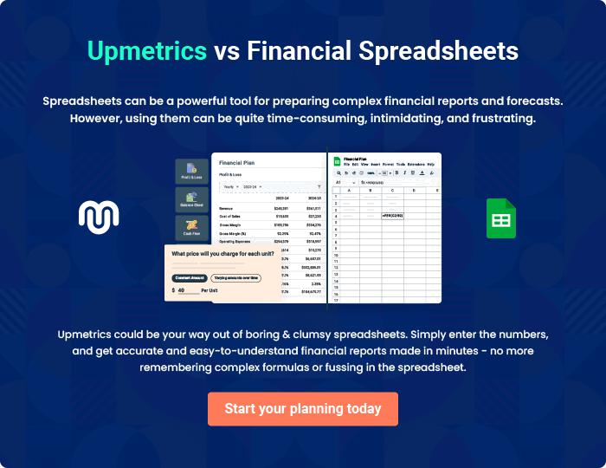

Crazy Club | Business Plan [YEAR] | 28/31

8.

Sustainability and

Expansion Strategy

Crazy Club | Business Plan [YEAR] 29/31

 Crazy Club

The future of a business lies in the number of loyal customers that they have, the capacity and competence of their employees, their investment strategy, and business structure. If all of these factors are missing from a company, then it won’t be too long before the business closes shop.
To unlock help try Upmetrics! 

Start writing here..

Crazy Club | Business Plan [YEAR] 30/31

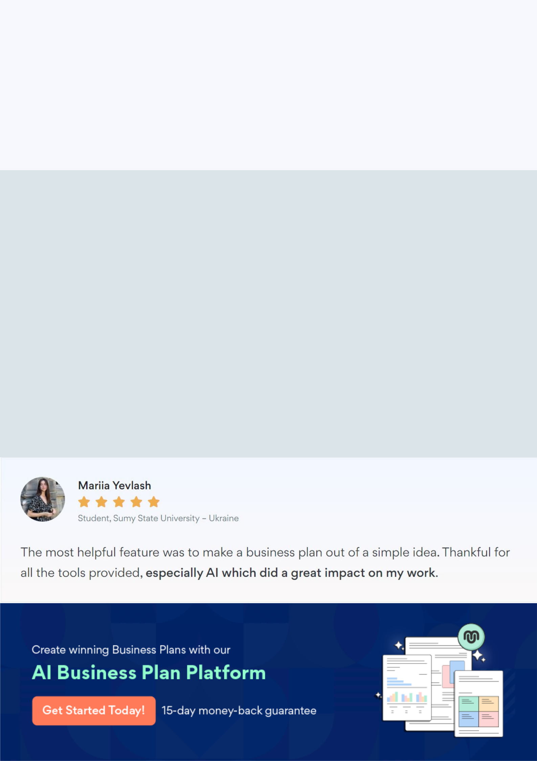
Create a winning business plan that gets you funded

Creating a stunning and investment-ready plan requires no writing, graphic designing, or financial planning expertise.

Upmetrics has all the features required to help you create a comprehensive business plan—from start to finish. Make no mistakes, it’s the modern way of planning to structure ideas, make plans, and create stunning pitch decks to awe investors.

Pitch decks that impress investors

Create pitch decks that provide a visual representation of your business, engage investors, and make them want to invest in your business idea.

Interactive plans in no time

Import business plan sections like—SWOT analysis, comparison tables, and others to create an interactive business plan. No designing skills are required.

Stunning cover page designs

With Upmetrics, you have the liberty to choose from multiple stunning cover page designs. Choose a creative design and make your plan stand out.

Online sharing made simple

Upmetrics makes online sharing quick and easier for users. Easily share your business plans with a link while tracking reader activity.

500+ sample business plans

Simply import a template from our library of sample plans into the editor and start customizing it to make it yours. It takes only a few clicks to get started.

Collaborate with team in real-time

Invite team members, initiate conversations, discuss ideas & strategies, share feedback, and work on a business plan in real-time.

