

Shipping

Company

Always Here to Take Care Of Your Carrying

Business

Plan

[YEAR]

John Doe

10200 Bolsa Ave, Westminster, CA, 92683

- 359-3153 info@example.com http://www.example.com

CONFIDENTIAL

Table of Contents

Executive Summary | 5
Business Overview | 6
Management | 6
Customers | 6
Business Target | 7
3 Year profit forecast | 7

Company Summary | 8
Company Owner | 9
Why the Business is being started | 9
How the Business will be started | 9
Startup cost | 10
Funding Required | 10

Products and Services | 13
Products and services | 14
Market Analysis
Market Analysis | 16
Market Trends | 17
Marketing Segmentation | 17
Market Share | 18
Women | 18
Men | 19
Businesses | 19
Market Analysis | 19
Business Target | 20
Product Pricing | 20
Competitive Advantage | 20
Strategy
Strategy | 21
Competitive Analysis | 22

Shipping Company | Business Plan [YEAR] 2/38

Sales Strategy | 22
Sales Yearly | 23
Sales Forecast | 23
Detailed Sales Forcast | 24

Personnel plan | 26
Average Salary of Employees | 27
Financial Plan
Financial Plan | 28
Important Assumptions | 29
Brake-even Analysis | 29
Projected Profit and Loss | 29
Projected Cash Flow | 32
Projected Balance Sheet | 34
Business Ratios | 35

Shipping Company | Business Plan [YEAR] 3/38

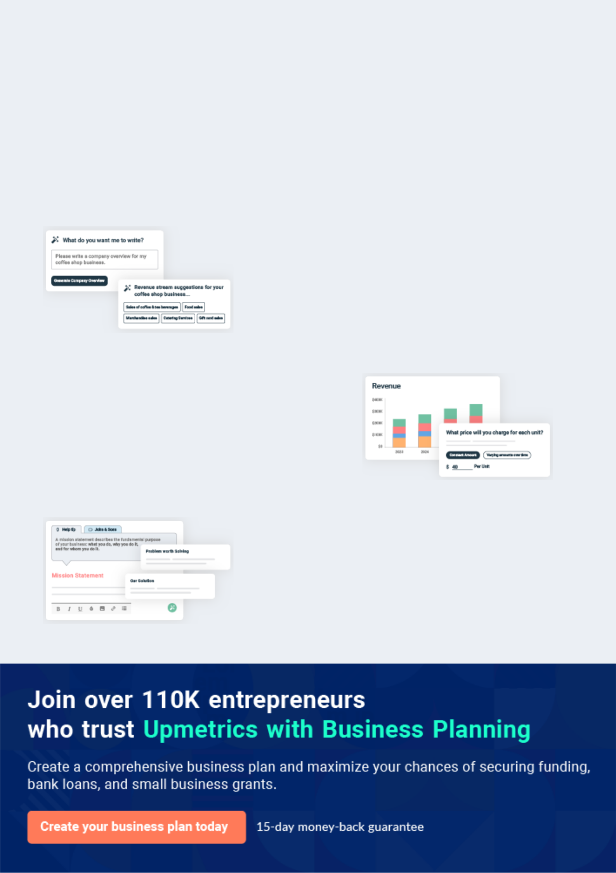
Business planning that’s simpler and faster than you think

Creating a business plan using Upmetrics to start and grow a business is literally the easiest thing in the World. Simply read the instructions and fill in the blanks. It’s as simple as that.

❛ | Upmetrics has everything you need to create a | ❜
❛ | comprehensive business plan. | ❜

AI-powered Upmetrics Assistant

AI-powered insights to streamline your plan

Not sure where to start? Upmetrics’ AI Assistant will automatically generate ideas for each section of your plan and offer improved versions of your writing, adjusting for tone, voice, and grammar or spelling errors.

Financial Forecasting Tool

All the financials are calculated for you

Forget the complex formulas and clumsy spreadsheets — with automatic financials and drag-and-drop forecasting, you can finish your plan faster and be confident that your numbers are accurate.

Business Plan Builder

Guides you like a business mentor

Upmetrics’ step-by-step instructions, prompts, and the library of 400+ sample business plans will guide you through each section of your plan as a business mentor.

1.


Executive Summary

Business Overview

Management

Customers

Business Target

Shipping Company | Business Plan [YEAR] 5/38

Before you think about how to start a Drop Shipping service, you must create a detailed Drop Shipping business plan. It will not only guide you in the initial phases of your startup but will also help you later on.
To unlock help try Upmetrics!
To unlock help try Upmetrics!

Business Overview

 Ex :: Del-Bird




Del-Bird Online is the United States-based international drop – shipping cum online shopping website that offers a wide range of quality products such as electronics, computers, groceries, fashion, home appliances, and kid’s items. Our head office will be located in the heart of San
To unlock help try Upmetrics! 

Start writing here..

Management

 Ex :: Del-Bird

Our inventory management of products is automated, our portal is designed such that it reports get generated instantly when required and our product inventory management is very efficient and easy to maintain.



Start writing here..

Customers

 Ex :: Del-Bird

Del-Bird Online will ensure that all our customers are given first-class treatment irrespective of the number of products they purchase or the part of the world they reside in.
To unlock help try Upmetrics! 

Start writing here..

Shipping Company | Business Plan [YEAR] 6/38

Business Target

 Ex :: Del-Bird

The company’s three-year targets are outlined as follows:

To unlock help try Upmetrics! 

Start writing here..

3 Year profit forecast
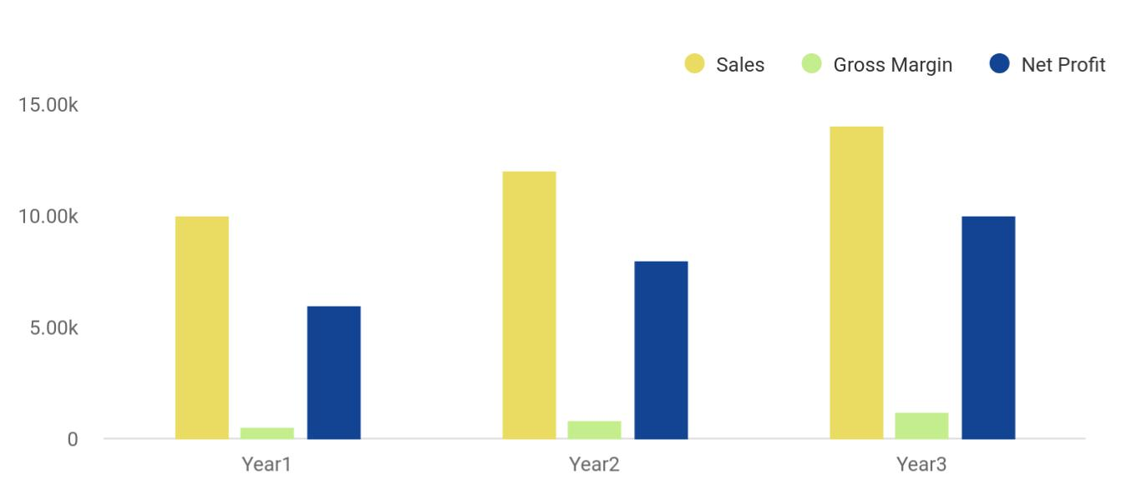

Financial Year | Sales | Gross Margin | Net Profit
Year1 | 10,000 | 500 | 6,000
Year2 | 12,000 | 800 | 8,000
Year3 | 14,000 | 1,200 | 10,000

Shipping Company | Business Plan [YEAR] 7/38

2.

Company Summary

Company Owner

Why the Business is being started

How the Business will be started

Funding Required

Shipping Company | Business Plan [YEAR] 8/38

Company Owner

 Ex :: Del-Bird

Del-Bird Online is owned by Clara Davidson and her immediate family members. Clara Davidson has a Diploma in eCommerce and a degree in Business Administration. She will run the business with other experienced team members who have worked in similar business ventures.
To unlock help try Upmetrics! 

Start writing here..

Why the Business is being started

 Ex :: Del-Bird

The business is being started with the aim of making profits in the online retail industry while also adding value to the customers through excellent drop shopping services.
To unlock help try Upmetrics! 

Start writing here..

How the Business will be started

 Ex :: Del-Bird

The business will be located in a small office located in San Diego but will operate across the United States. In addition to the usual inventory, the company will procure business internet connection along with computers, servers, peripherals, and other office furniture. The startup
To unlock help try Upmetrics! 

Start writing here..

Shipping Company | Business Plan [YEAR] 9/38

Startup cost
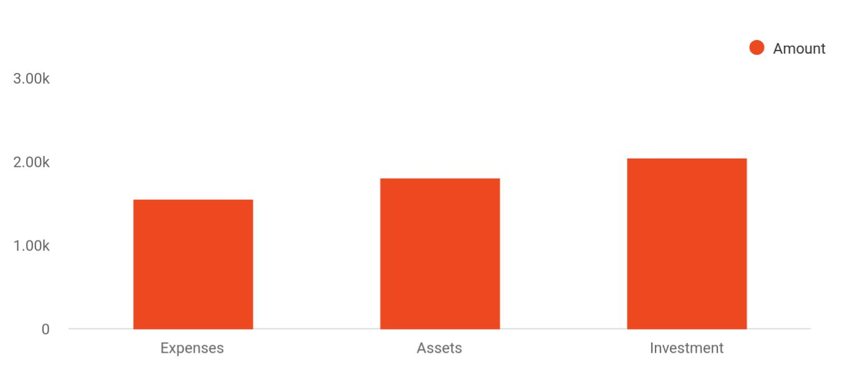

Cost distribution | Amount
Expenses | 1,550
Assets | 1,800
Investment | 2,050

Funding Required

The detailed start-up requirements are given below:

Start-up Expenses | Amount
Legal | $72,500
Dog Beds | $32,250
Dog Shampoos | $62,875
Consultants | $0
Insurance | $32,750
Rent | $222,500
Research and Development | $32,750
Equipment Expenses | $62,750
Signs | $12,250
Dog Chambers | $27,500

Shipping Company | Business Plan [YEAR] 10/38

Start-up Expenses | Amount
Dog Food | $22,000
TOTAL START-UP EXPENSES | $580,125
Start-up Assets | $0
Cash Required | $322,500
Start-up Inventory | $52,625
Other Current Assets | $222,500
Long-term Assets | $125,000
TOTAL ASSETS | $121,875
Total Requirements | $245,000
START-UP FUNDING | $0
START-UP FUNDING | $273,125
Start-up Expenses to Fund | $121,875
Start-up Assets to Fund | $195,000
TOTAL FUNDING REQUIRED | $0
Assets | $203,125
Non-cash Assets from Start-up | $118,750
Cash Requirements from Start-up | $0
Additional Cash Raised | $118,750
Cash Balance on Starting Date | $121,875
TOTAL ASSETS | $0
Liabilities and Capital | $0
Liabilities | $0
Current Borrowing | $0
Long-term Liabilities | $0
Accounts Payable (Outstanding Bills) | $0
Other Current Liabilities (interest-free) | $0
TOTAL LIABILITIES | $0
Capital | $0

Shipping Company | Business Plan [YEAR] 11/38

Start-up Expenses | Amount
Planned Investment | $0
Investor 1 | $312,500
Investor 2 | $0
Other | $0
Additional Investment Requirement | $0
TOTAL PLANNED INVESTMENT | $495,000
Loss at Start-up (Start-up Expenses) | $113,125
TOTAL CAPITAL | $121,875
TOTAL CAPITAL AND LIABILITIES | $121,875
Total Funding | $295,000

Shipping Company | Business Plan [YEAR] 12/38

3.

Products and Services

Products and services

Shipping Company | Business Plan [YEAR] 13/38

If you are starting a Drop Shipping Business, you must focus on the services, you will provide to your customers. This sample business plan of Drop Shipping will guide you on how to start your own dog daycare business.
To unlock help try Upmetrics! 

 Ex :: Del-Bird

You must decide what products you will provide to your customers before thinking about how to set up a dropshipping business because the planning of other subsequent components (such as finding relevant suppliers) depends on your products. Del-Bird Online will provide the
To unlock help try Upmetrics! 

Start writing here..

Products and services


Phones, Computers & Accessories

This category includes smartphones, laptops, tablets and other related accessories such as chargers, earphones, data devices etc.

Women’s Fashion

This category includes women clothing, shoes, handbags, cosmetics, artificial jewellery and other wearable.


Baby, Toys & Kids

This category includes

all kinds of baby

products and toys.

Men’s Fashion

This category includes men clothing, shoes, wrist watches and other wearable.

Home & Living

This category includes household items.

Shipping Company | Business Plan [YEAR] 14/38

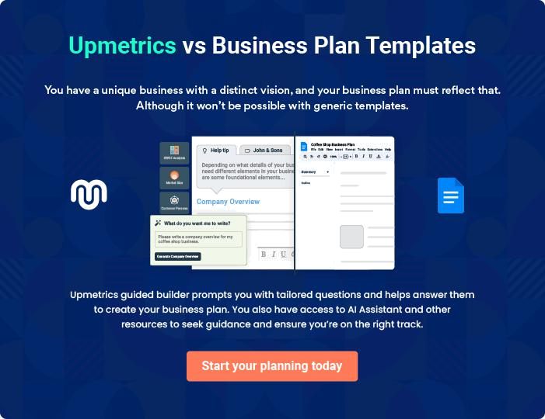

Shipping Company | Business Plan [YEAR] | 15/38

4.

Market Analysis

Market Trends

Marketing Segmentation

Market Analysis

Business Target

Product Pricing

Competitive Advantage

Shipping Company | Business Plan [YEAR] 16/38

The most important component of an effective drop shipping business plan is its accurate marketing analysis. If you are starting this venture on small scale, you can take help from this drop shipping business plan template and
To unlock help try Upmetrics! 

Market Trends

 Ex :: Del-Bird

Dropshipping or E-commerce industry is one of the largest industries in the United States as well as in the rest of the world. In the United States, E-commerce sales were estimated to be
$353.7 billion for 2017. The industry is growing at the forecasted rate of 17% and is estimated
To unlock help try Upmetrics! 

Start writing here..

Marketing Segmentation

 Ex ::Del-Bird


We will target all people living in the United States. Our experts have identified the following type of target audience which can become our future consumers:
To unlock help try Upmetrics! 

Start writing here..

Shipping Company | Business Plan [YEAR] 17/38

Market Share
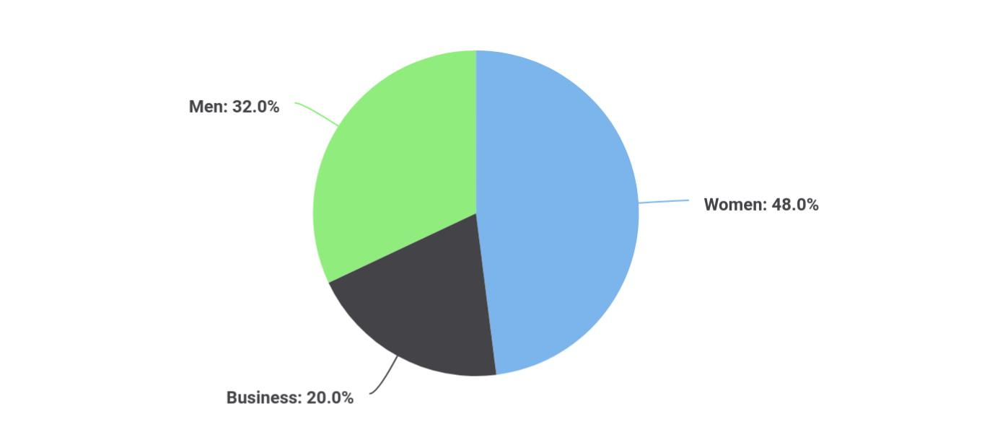

Segments | Market share
Women | 48
Business | 20
Men | 32

The detailed marketing segmentation of our target audience is as follows:

 Ex :: Del-Bird

The biggest consumer of our services will be women in the United States. It has been established by various surveys and studies that women are more likely to make online
purchases than men. That’s why American women will be the biggest contributor to our
To unlock help try Upmetrics! 

Women

Start writing here..

Shipping Company | Business Plan [YEAR] 18/38

 Ex :: Del-Bird

The second-biggest consumer of our products will be men. Although their contribution to our revenue will be less than women still it will be of significant value.
To unlock help try Upmetrics! 

Men

Start writing here..

 Ex :: Del-Bird

We also hope to target the corporate sector for buying the products from our first category, computers, and accessories.
To unlock help try Upmetrics! 

Businesses

Start writing here..

Market Analysis

The detailed market analysis of our potential customers is given in the following table:

Potential | Growth | Year 1 | Year 2 | Year 3 | Year 4 | Year 5 | CAGR
Customers
Women | 48% | 22,334 | 32,344 | 43,665 | 52,544 | 66,432 | 10.00%
Businesses | 18% | 11,433 | 13,344 | 16,553 | 18,745 | 20,545 | 13.43%
Men | 34% | 18,322 | 19,455 | 20,655 | 22,867 | 24,433 | 15.32%
Total | 100% | 52,089 | 65,143 | 80,873 | 94,156 | 111,410 | 9.54%

Shipping Company | Business Plan [YEAR] 19/38

Business Target
To unlock help try Upmetrics!

 Ex :: Del-Bird

• To achieve the net profit margin of $10k/month by the first year, $15k by the second year, and $25k by the third year
• To add 3 more categories of electronic appliances, sports products, and furniture by the
To unlock help try Upmetrics! 

Start writing here..

Product Pricing

 Ex :: Del-Bird

Considering the competition in the E-commerce industry, we have priced all our products in similar ranges as of our competitors. However, the delivery charges are kept slightly less as compared to our competitors.



Start writing here..

Competitive Advantage

 Ex :: Del-Bird

A close study of the drop – shipping line of business and the overall eCommerce industry reveals that the market has become much more intensely competitive over the last decade. As a matter of fact, you have to be highly creative, customer-centric, proactive, and have a robust
To unlock help try Upmetrics! 

Start writing here..

Shipping Company | Business Plan [YEAR] 20/38

5.

Strategy

Competitive Analysis

Sales Strategy

Shipping Company | Business Plan [YEAR] 21/38

Like marketing analysis, sales strategy is also an important component of a drop shipping business plan so it must be planned before you think about how to start a drop-shipping business.
To unlock help try Upmetrics!



Competitive Analysis

 Ex :: Del-Bird

The biggest problem you will face while starting this venture is the intensely competitive environment created by giants like Amazon, eBay, Alibaba, etc. In addition to that, there are tons of other drop shipping business with ranging magnitudes. That’s why, if you are thinking about
To unlock help try Upmetrics! 

Start writing here..

Sales Strategy

 Ex :: Del-Bird

We will carry out a large scale paid social media advertising campaign.

We will use digital marketing strategies, SEO, and SEM practices for promoting our website and
To unlock help try Upmetrics! 

Start writing here..

Shipping Company | Business Plan [YEAR] 22/38

Sales Yearly
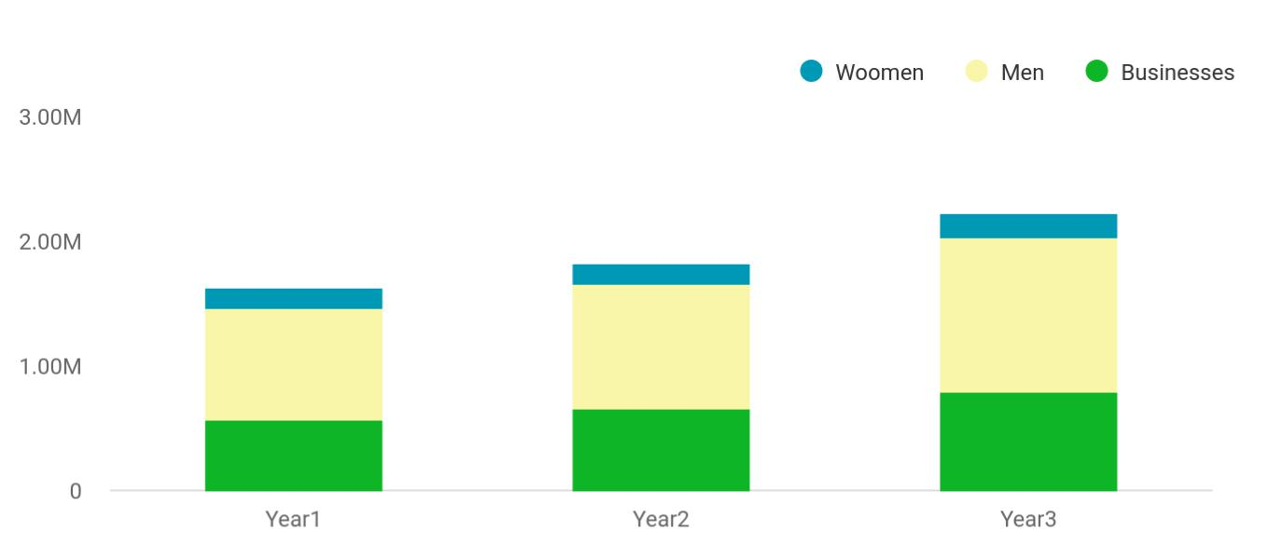

Financial Year | Woomen | Men | Businesses
Year1 | 158,745 | 895,665 | 568,654
Year2 | 164,548 | 1,004,512 | 658,457
Year3 | 186,541 | 1,245,587 | 784,512

Sales Forecast
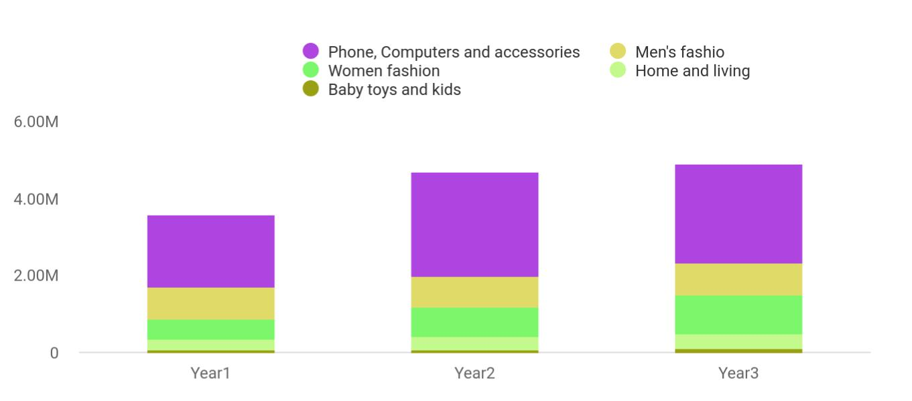

Financial Year | Phone, Computers and accessories | Men's fashio | Women fashion | Home and living | Baby toys and ters and accessories
Year1 | 1,887,030 | 802,370 | 539,320 | 265,450 | 78,512
Year2 | 2,680,320 | 815,430 | 770,230 | 322,390 | 85,451
Year3 | 2,588,240 | 823,540 | 1,002,310 | 393,320 | 98,754

Shipping Company | Business Plan [YEAR] 23/38

Detailed Sales Forcast

Detailed sales forecast data is provided in below table:

Unit Sales | Year 1 | Year 2 | Year 3
Phones, Computers & Accessories | 187,330 | 260,320 | 258,240
Men’s Fashion | 802,370 | 815,430 | 823,540
Women’s Fashion | 539,320 | 770230 | 1,002,310
Home & Living | 265,450 | 322,390 | 393,320
Baby, Toys & Kids | 1,435,320 | 1,250,430 | 1,762,450
TOTAL UNIT SALES | 3,229,790 | 3,418,800 | 4,239,860
Unit Prices | Year 1 | Year 2 | Year 3
Phones, Computers & Accessories | $140.00 | $150.00 | $160.00
Men’s Fashion | $600.00 | $800.00 | $1,000.00
Women’s Fashion | $700.00 | $800.00 | $900.00
Home & Living | $650.00 | $750.00 | $850.00
Baby, Toys & Kids | $140.00 | $120.00 | $100.00
Sales
Web hosting services | $214,800 | $274,000 | $333,200
Phones, Computers & Accessories | $120,050 | $194,500 | $268,500
Men’s Fashion | $50,110 | $71,600 | $93,000
Women’s Fashion | $139,350 | $194,600 | $249,850
Home & Living | $62,350 | $72,300 | $82,250
Baby, Toys & Kids | $40,890 | $75,550 | $90,000
Direct Unit Costs
Phones, Computers & Accessories | $0.70 | $0.80 | $0.90
Men’s Fashion | $0.40 | $0.45 | $0.50
Women’s Fashion | $0.30 | $0.35 | $0.40
Home & Living | $3.00 | $3.50 | $4.00
Baby, Toys & Kids | $0.70 | $0.75 | $0.80
Direct Cost of Sales

Shipping Company | Business Plan [YEAR] 24/38

Unit Sales | Year 1 | Year 2 | Year 3
Phones, Computers & Accessories | $98,300 | $183,000 | $267,700
Men’s Fashion | $66,600 | $119,900 | $173,200
Women’s Fashion | $17,900 | $35,000 | $52,100
Home & Living | $19,400 | $67,600 | $115,800
Baby, Toys & Kids | $27,700 | $69,200 | $110,700
Subtotal Direct Cost of Sales | $294,100 | $699,400 | $1,104,700

Shipping Company | Business Plan [YEAR] 25/38

6.

Personnel plan

Average Salary of Employees

Shipping Company | Business Plan [YEAR] 26/38

After knowing the basics of how to start a dropshipping business, the most important step is to hire hard-working, skilled, and honest professionals to assist you in running your business. Here is the sample personnel plan of
To unlock help try Upmetrics! 

 Ex :: Del-Bird

Del-Bird Online Company is a player in the e-commerce industry that intends starting small in San Diego – California but hope to grow big in order to compete favorably with leading online stores and dropshipping companies both in the United States and on a global stage.
To unlock help try Upmetrics! 

Start writing here..

Average Salary of Employees

The following table shows the forecast data about employees and their salaries for the next three years.

Personnel Plan | Year 1 | Year 2 | Year 3
Chief Executive Officer / President | $45,000 | $52,000 | $59,000
Human Resources and Admin Manager | $145,000 | $152,000 | $159,000
Business Developer | $410,000 | $440,000 | $480,000
Accountant | $55,000 | $65,000 | $75,000
Information Technologist | $60,000 | $63,300 | $70,000
Call Center Agent | $20,000 | $23,300 | $30,000
Total Salaries | $745,000 | $807,600 | $888,000

Shipping Company | Business Plan [YEAR] 27/38

7.

Financial Plan

Important Assumptions

Brake-even Analysis

Projected Profit and Loss

Projected Cash Flow

Projected Balance Sheet

Business Ratios

Shipping Company | Business Plan [YEAR] 28/38

If you are going to start your own dog daycare business, then make sure you will pay special attention to your financial plan. Your financial plan should include the details about how well you manage your incomes and expenses,
To unlock help try Upmetrics! 

Important Assumptions

The company’s financial projections are forecasted on the basis of the following assumptions. These assumptions are quite conservative and are also expected to show deviation but to a limited level such that the company’s major financial strategy will not be affected.

 | Year 1 | Year 2 | Year 3
Plan Month | 1 | 2 | 3
Current Interest Rate | 10,00% | 11,00% | 12,00%
Long-term Interest Rate | 10,00% | 10,00% | 10,00%
Tax Rate | 26,42% | 27,76% | 28,12%
Other | 0 | 0 | 0

Brake-even Analysis

Monthly Units Break-even | 5530
Monthly Revenue Break-even | $159 740
Assumptions:
Average Per-Unit Revenue | $260,87
Average Per-Unit Variable Cost | $0,89
Estimated Monthly Fixed Cost | $196 410

Projected Profit and Loss

 | 2024 | 2025 | 2026
Revenue | $3,016,844.80 | $6,240,260.30 | $13,277,653.80
Electronic Gadgets Sales | $1,591,714 | $2,858,492 | $5,133,432

Shipping Company | Business Plan [YEAR] 29/38

 | 2024 | 2025 | 2026
Unit Sales | 7,959 | 14,292 | 25,667
Unit Price | $200 | $200 | $200
Home Appliances | $1,138,626 | $2,867,257.50 | $7,220,232
Unit Sales | 7,591 | 19,115 | 48,135
Unit Price | $150 | $150 | $150
Fitness Equipment | $286,504.80 | $514,510.80 | $923,989.80
Unit Sales | 4,775 | 8,575 | 15,400
Unit Price | $60 | $60 | $60

Cost Of Sales | $1,690,020.87 | $2,898,639.15 | $5,452,349.39
General Costs | $1,690,020.87 | $2,898,639.15 | $5,452,349.39
Electronic Gadgets | $905,053.44 | $1,872,078.09 | $3,983,296.14
Cost of Electronic Gadgets | $905,053.44 | $1,872,078.09 | $3,983,296.14
Home Appliances | $784,967.43 | $1,026,561.06 | $1,469,053.25
Purchase Cost of | $634,125.17 | $714,548.02 | $805,170.55
Appliances | $634,125.17 | $714,548.02 | $805,170.55
Shipping and Handling | $150,842.26 | $312,013.04 | $663,882.70
Costs | $150,842.26 | $312,013.04 | $663,882.70
Revenue Specific Costs | $0 | $0 | $0
Personnel Costs (Direct | $0 | $0 | $0
Labor) | $0 | $0 | $0

Gross Margin | $1,326,823.93 | $3,341,621.15 | $7,825,304.41
Gross Margin (%) | 43.98% | 53.55% | 58.94%

Operating Expense | $1,450,448.33 | $1,839,305.30 | $2,631,897.48

Shipping Company | Business Plan [YEAR] 30/38

 | 2024 | 2025 | 2026
Payroll Expense (Indirect | $1,096,200 | $1,133,613 | $1,172,416.68
Labor) | $1,096,200 | $1,133,613 | $1,172,416.68
Management Team | $421,200 | $440,388 | $460,460.52
CEO | $234,000 | $245,700 | $257,985
CFO | $187,200 | $194,688 | $202,475.52
Sales Team | $472,500 | $486,675 | $501,275.16
Sales Manager | $135,000 | $139,050 | $143,221.56
Sales Representatives | $337,500 | $347,625 | $358,053.60
Support Staff | $202,500 | $206,550 | $210,681
Customer Support | $157,500 | $160,650 | $163,863
Administrative Assistant | $45,000 | $45,900 | $46,818
General Expense | $354,248.33 | $705,692.30 | $1,459,480.81
Marketing and Advertising | $243,013.40 | $493,988.02 | $1,032,104.68
Online Advertising | $31,834.25 | $57,169.79 | $102,668.91
Social Media Campaigns | $211,179.15 | $436,818.23 | $929,435.77
Operational Costs | $98,552.49 | $197,413.39 | $411,272.72
Website Maintenance | $8,047.15 | $10,205.58 | $12,943.09
Shipping Costs | $90,505.34 | $187,207.81 | $398,329.63
Administrative Expenses | $12,682.44 | $14,290.89 | $16,103.41
Office Supplies | $5,072.96 | $5,716.24 | $6,441.23
Utilities | $7,609.48 | $8,574.65 | $9,662.18
Bad Debt | $0 | $0 | $0
Amortization of Current | $0 | $0 | $0
Assets | $0 | $0 | $0

EBITDA | ($123,624.41) | $1,502,315.86 | $5,193,406.92

Shipping Company | Business Plan [YEAR] 31/38

Additional Expense

Long Term Depreciation

Gain or loss from Sale of Assets

EBIT

Interest Expense

EBT

Income Tax Expense / Benefit
2024 2025 2026

$11,650.80 | $9,407.24 | $7,001.49
$5,634 | $5,634 | $5,634
$0 | $0 | $0
($129,258.41) | $1,496,681.86 | $5,187,772.92
$6,016.82 | $3,773.25 | $1,367.48
($135,275.21) | $1,492,908.62 | $5,186,405.43
$0 | $0 | $0

Total Expense | $3,152,120.01 | $4,747,351.68 | $8,091,248.37
Net Income | ($135,275.21) | $1,492,908.62 | $5,186,405.43
Net Income (%) | (4.48%) | 23.92% | 39.06%
Retained Earning Opening | $0 | ($165,275.21) | $1,297,633.41
Owner's Distribution | $30,000 | $30,000 | $30,000
Retained Earning Closing | ($165,275.21) | $1,297,633.41 | $6,454,038.84
Projected Cash Flow
 | 2024 | 2025 | 2026
Cash Received | $3,016,844.80 | $6,240,260.30 | $13,277,653.80
Cash Paid | $3,146,486.01 | $4,741,717.70 | $8,085,614.37
COS & General Expenses | $2,044,269.21 | $3,604,331.46 | $6,911,830.20
Salary & Wages | $1,096,200 | $1,133,613 | $1,172,416.68

Shipping Company | Business Plan [YEAR] 32/38

2024 2025 2026

Interest

Sales Tax

Income Tax

Net Cash From

Operations

Assets Sell

Assets Purchase

Net Cash From

Investments

Amount Received

Loan Received

Common Stock

Preferred Stock

Owner's Contribution

Amount Paid

Loan Capital

Dividends & Distributions

Net Cash From

Financing

Summary

$6,016.82 | $3,773.25 | $1,367.48
$0 | $0 | $0
$0 | $0 | $0
($129,641.21) | $1,498,542.60 | $5,192,039.43

$0 | $0 | $0
$35,000 | $0 | $0
($35,000) | $0 | $0

$250,000 | $0 | $0
$100,000 | $0 | $0
$0 | $0 | $0
$0 | $0 | $0
$150,000 | $0 | $0
$61,035.72 | $63,279.28 | $65,685.02
$31,035.70 | $33,279.27 | $35,685.03
$30,000 | $30,000 | $30,000
$188,964.28 | ($63,279.28) | ($65,685.02)

Starting Cash | $0 | $24,323.07 | $1,459,586.39
Cash In | $3,266,844.80 | $6,240,260.30 | $13,277,653.80
Cash Out | $3,242,521.73 | $4,804,996.98 | $8,151,299.39
Change in Cash | $24,323.07 | $1,435,263.32 | $5,126,354.41

Shipping Company | Business Plan [YEAR] 33/38

 | 2024 | 2025 | 2026
Ending Cash | $24,323.07 | $1,459,586.39 | $6,585,940.80

Projected Balance Sheet

 | 2024 | 2025 | 2026
Assets | $53,689.07 | $1,483,318.39 | $6,604,038.80
Current Assets | $24,323.07 | $1,459,586.39 | $6,585,940.80
Cash | $24,323.07 | $1,459,586.39 | $6,585,940.80
Accounts Receivable | $0 | $0 | $0
Inventory | $0 | $0 | $0
Other Current Assets | $0 | $0 | $0
Long Term Assets | $29,366 | $23,732 | $18,098
Gross Long Term Assets | $35,000 | $35,000 | $35,000
Accumulated Depreciation | ($5,634) | ($11,268) | ($16,902)
Liabilities & Equity | $53,689.08 | $1,483,318.43 | $6,604,038.84
Liabilities | $68,964.29 | $35,685.02 | $0
Current Liabilities | $33,279.27 | $35,685.02 | $0
Accounts Payable | $0 | $0 | $0
Income Tax Payable | $0 | $0 | $0
Sales Tax Payable | $0 | $0 | $0
Short Term Debt | $33,279.27 | $35,685.02 | $0
Long Term Liabilities | $35,685.02 | $0 | $0
Long Term Debt | $35,685.02 | $0 | $0
Equity | ($15,275.21) | $1,447,633.41 | $6,604,038.84
Paid-in Capital | $0 | $0 | $0

Shipping Company | Business Plan [YEAR] 34/38

 | 2024 |  |  | 2025 | 2026
Common Stock | $0 |  |  | $0 | $0
Preferred Stock | $0 |  |  | $0 | $0
Owner's Contribution | $150,000 |  | $150,000 |  | $150,000
Retained Earnings | ($165,275.21) |  | $1,297,633.41 |  | $6,454,038.84
Check | $0 |  |  | $0 | $0
Business Ratios
 |  | Year 1 | Year 2 | Year 3 | Industry profile
Sales Growth |  | 4,35% | 30,82% | 63,29% | 4,00%
Percent of Total Assets
Accounts Receivable |  | 5,61% | 4,71% | 3,81% | 9,70%
Inventory |  | 1,85% | 1,82% | 1,79% | 9,80%
Other Current Assets |  | 1,75% | 2,02% | 2,29% | 27,40%
Total Current Assets |  | 138,53% | 150,99% | 163,45% | 54,60%
Long-term Assets |  | -9,47% | -21,01% | -32,55% | 58,40%
TOTAL ASSETS |  | 100,00% | 100,00% | 100,00% | 100,00%
Current Liabilities |  | 4,68% | 3,04% | 2,76% | 27,30%
Long-term Liabilities |  | 0,00% | 0,00% | 0,00% | 25,80%
Total Liabilities |  | 4,68% | 3,04% | 2,76% | 54,10%
NET WORTH |  | 99,32% | 101,04% | 102,76% | 44,90%
Percent of Sales
Sales |  | 100,00% | 100,00% | 100,00% | 100,00%
Gross Margin |  | 94,18% | 93,85% | 93,52% | 0,00%
Selling, General & Administrative Expenses |  | 74,29% | 71,83% | 69,37% | 65,20%
Advertising Expenses |  | 2,06% | 1,11% | 0,28% | 1,40%
Profit Before Interest and Taxes |  | 26,47% | 29,30% | 32,13% | 2,86%

Shipping Company | Business Plan [YEAR] 35/38

 | Year 1 | Year 2 | Year 3 | Industry profile
Main Ratios
Current | 25,86 | 29,39 | 32,92 | 1,63
Quick | 25,4 | 28,88 | 32,36 | 0,84
Total Debt to Total Assets | 2,68% | 1,04% | 0,76% | 67,10%
Pre-tax Return on Net Worth | 66,83% | 71,26% | 75,69% | 4,40%
Pre-tax Return on Assets | 64,88% | 69,75% | 74,62% | 9,00%
Additional Ratios
Net Profit Margin | 19,20% | 21,16% | 23,12% | N.A.
Return on Equity | 47,79% | 50,53% | 53,27% | N.A.
Activity Ratios
Accounts Receivable Turnover | 4,56 | 4,56 | 4,56 | N.A.
Collection Days | 92 | 99 | 106 | N.A.
Inventory Turnover | 19,7 | 22,55 | 25,4 | N.A.
Accounts Payable Turnover | 14,17 | 14,67 | 15,17 | N.A.
Payment Days | 27 | 27 | 27 | N.A.
Total Asset Turnover | 1,84 | 1,55 | 1,26 | N.A.
Debt Ratios
Debt to Net Worth | 0 | -0,02 | -0,04 | N.A.
Current Liab. to Liab. | 1 | 1 | 1 | N.A.
Liquidity Ratios
Net Working Capital | $120 943 | $140 664 | $160 385 | N.A.
Interest Coverage | 0 | 0 | 0 | N.A.
Additional Ratios
Assets to Sales | 0,45 | 0,48 | 0,51 | N.A.
Current Debt/Total Assets | 4% | 3% | 2% | N.A.
Acid Test | 23,66 | 27,01 | 30,36 | N.A.
Sales/Net Worth | 1,68 | 1,29 | 0,9 | N.A.
Dividend Payout | 0 | 0 | 0 | N.A.

Shipping Company | Business Plan [YEAR] 36/38

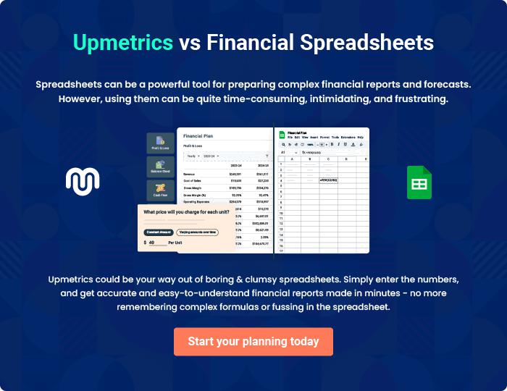

Shipping Company | Business Plan [YEAR] | 37/38


Create a winning business plan that gets you funded

Creating a stunning and investment-ready plan requires no writing, graphic designing, or financial planning expertise.

Upmetrics has all the features required to help you create a comprehensive business plan—from start to finish. Make no mistakes, it’s the modern way of planning to structure ideas, make plans, and create stunning pitch decks to awe investors.

Pitch decks that impress investors

Create pitch decks that provide a visual representation of your business, engage investors, and make them want to invest in your business idea.

Interactive plans in no time

Import business plan sections like—SWOT analysis, comparison tables, and others to create an interactive business plan. No designing skills are required.

Stunning cover page designs

With Upmetrics, you have the liberty to choose from multiple stunning cover page designs. Choose a creative design and make your plan stand out.

Online sharing made simple

Upmetrics makes online sharing quick and easier for users. Easily share your business plans with a link while tracking reader activity.

500+ sample business plans

Simply import a template from our library of sample plans into the editor and start customizing it to make it yours. It takes only a few clicks to get started.

Collaborate with team in real-time

Invite team members, initiate conversations, discuss ideas & strategies, share feedback, and work on a business plan in real-time.

