
Dog Kennel

BUSINESS PLAN

Designed for your furry friend

Prepared By

John Doe

10200 Bolsa Ave, Westminster, CA, 92683

info@example.com

(650) 359-3153 http://www.example.com

Table of Contents

Executive Summary | 5
Products and Services | 6
Mission Statement | 6
Objectives | 7
Customer Focus | 7
Keys to Success | 7
Financial Summary | 8
3 Year profit forecast | 8

Company Summary | 9
History | 10
Startup summary | 10
Startup cost | 11

Products and services | 14
Product and Service Description | 15
Market Analysis
Market Analysis | 17
Market Trends | 18
Market Growth | 18
Service Business Analysis | 19
Business Participants | 19
Strategy & Implementations
Strategy & Implementations | 20
Sales Strategy | 21
Advertising Strategy | 21
Referrals | 21
Internet | 21
Publications | 22
Pricing Strategy | 22

Dog Kennel | Business Plan [YEAR] 2/35

Operations Plan | 23
Milestones | 24
Financial Plan
Financial Plan | 25
Important Assumptions | 26
Brake-even Analysis | 26
Projected Profit and Loss | 27
Projected Cash Flow | 29
Projected Balance Sheet | 31
Business Ratios | 32

Dog Kennel | Business Plan [YEAR] 3/35

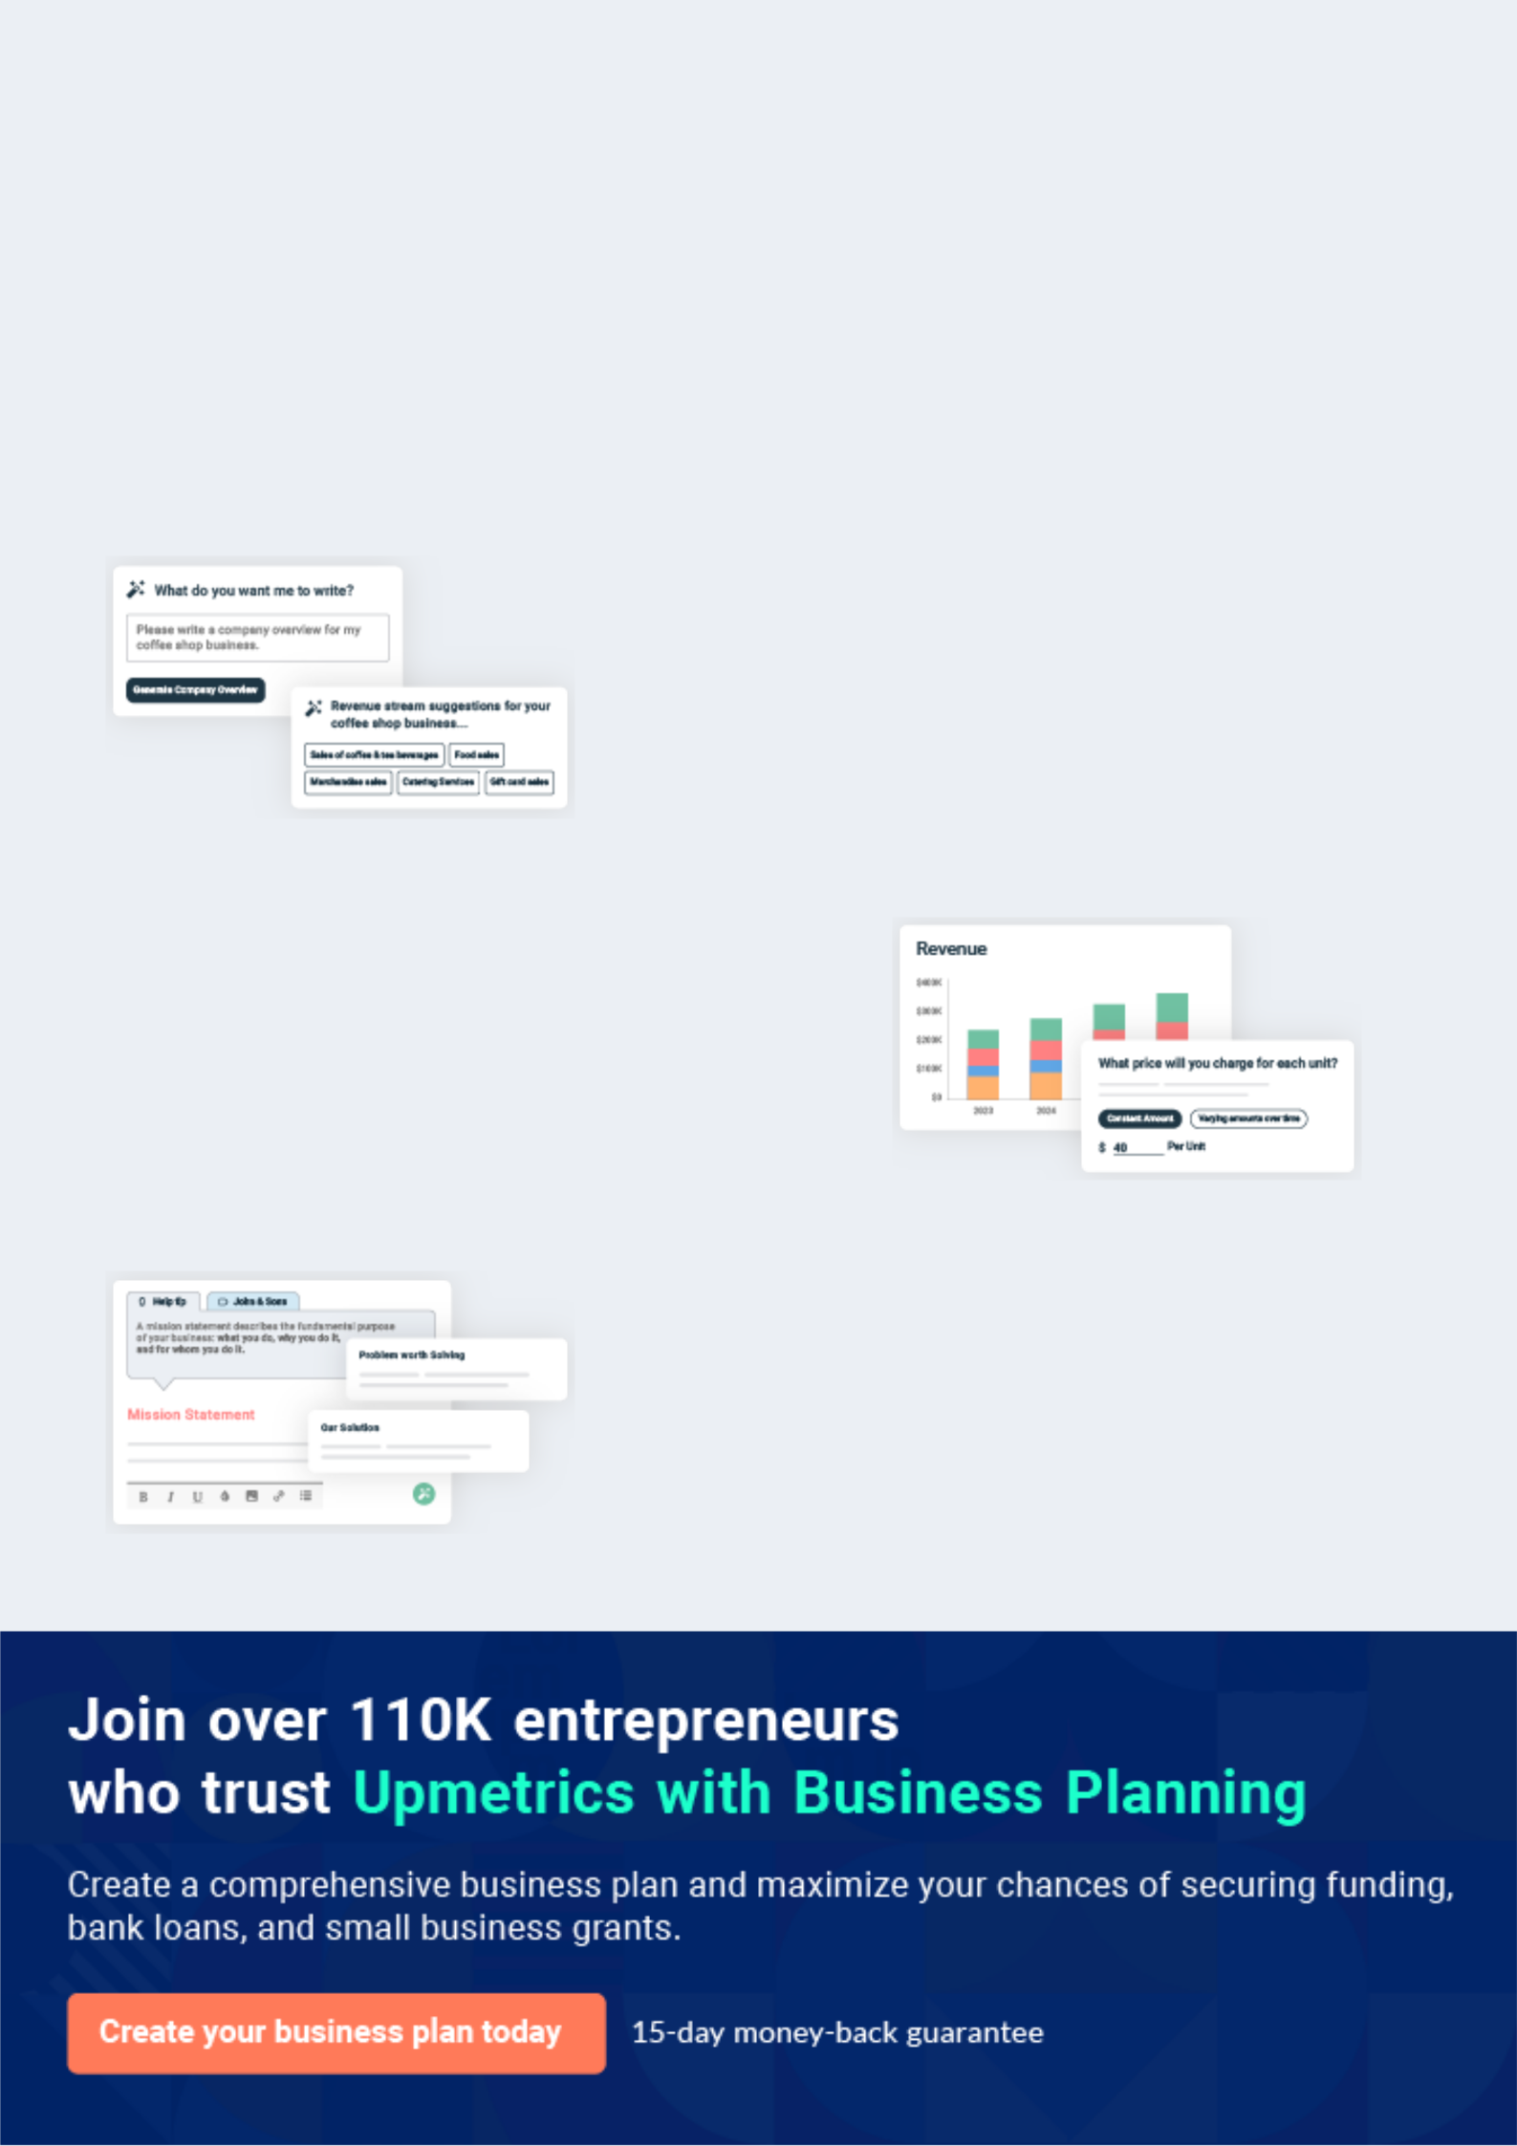
Business planning that’s simpler and faster than you think

Creating a business plan using Upmetrics to start and grow a business is literally the easiest thing in the World. Simply read the instructions and fill in the blanks. It’s as simple as that.

❛ | Upmetrics has everything you need to create a | ❜
❛ | comprehensive business plan. | ❜

AI-powered Upmetrics Assistant

AI-powered insights to streamline your plan

Not sure where to start? Upmetrics’ AI Assistant will automatically generate ideas for each section of your plan and offer improved versions of your writing, adjusting for tone, voice, and grammar or spelling errors.

Financial Forecasting Tool

All the financials are calculated for you

Forget the complex formulas and clumsy spreadsheets — with automatic financials and drag-and-drop forecasting, you can finish your plan faster and be confident that your numbers are accurate.

Business Plan Builder

Guides you like a business mentor

Upmetrics’ step-by-step instructions, prompts, and the library of 400+ sample business plans will guide you through each section of your plan as a business mentor.

1.


Executive Summary

Products and Services

Mission Statement

Objectives

Customer Focus

Keys to Success

Financial Summary

Dog Kennel | Business Plan [YEAR] 5/35

Before you think about how to start a Dog Kennel business, you must create a detailed Dog Kennel business plan. It will not only guide you in the initial phases of your startup but will also help you later on.
To unlock help try Upmetrics!
To unlock help try Upmetrics!

 Tom's Kennel




Tom's Kennel is a full-service animal care facility dedicated to consistently providing high customer satisfaction by rendering excellent service, quality pet care, and furnishing a fun,
clean, enjoyable atmosphere at an acceptable price. We will maintain a friendly creative work
To unlock help try Upmetrics! 

Start writing here..

Products and Services

 Tom's Kennel

Tom's Kennel will focus on providing dog kennel services to moderate to wealthy residents in the area. These services will include daycare, overnight accommodations, pet grooming, dog training, and other specialized services.



Start writing here..

Mission Statement

 Tom's Kennel

To provide excellent animal care in a pet-friendly atmosphere while ensuring our customers, both pet and owner, receive excellent service in a playful safe environment.
To unlock help try Upmetrics! 

Start writing here..

Dog Kennel | Business Plan [YEAR] 6/35

Objectives

 Tom's Kennel


1. Monthly sales increased steadily throughout FY 1.

2. Gross margin higher than 50% on pet products. To unlock help try Upmetrics! 

Start writing here..

Customer Focus

 Tom's Kennel

Tom's Kennel will primarily serve the residents within a 10-mile radius of our location. The demographics of these customers are as follows:
To unlock help try Upmetrics! 

Start writing here..

Keys to Success

 Tom's Kennel

The keys to success in our business are:

• Superior Customer Service: 24-hour high-quality care and service.
To unlock help try Upmetrics! 

Start writing here..

Dog Kennel | Business Plan [YEAR] 7/35

Financial Summary
Year 3
To unlock help try Upmetrics!
To unlock help try Upmetrics!

 Tom's Kennel

Tom's Kennel is seeking total funding of $222,000 of debt capital to open its dog kennel business. The capital will be used for funding capital expenditures and location build-out, hiring initial employees, marketing expenses, and working capital.



Start writing here..

3 Year profit forecast
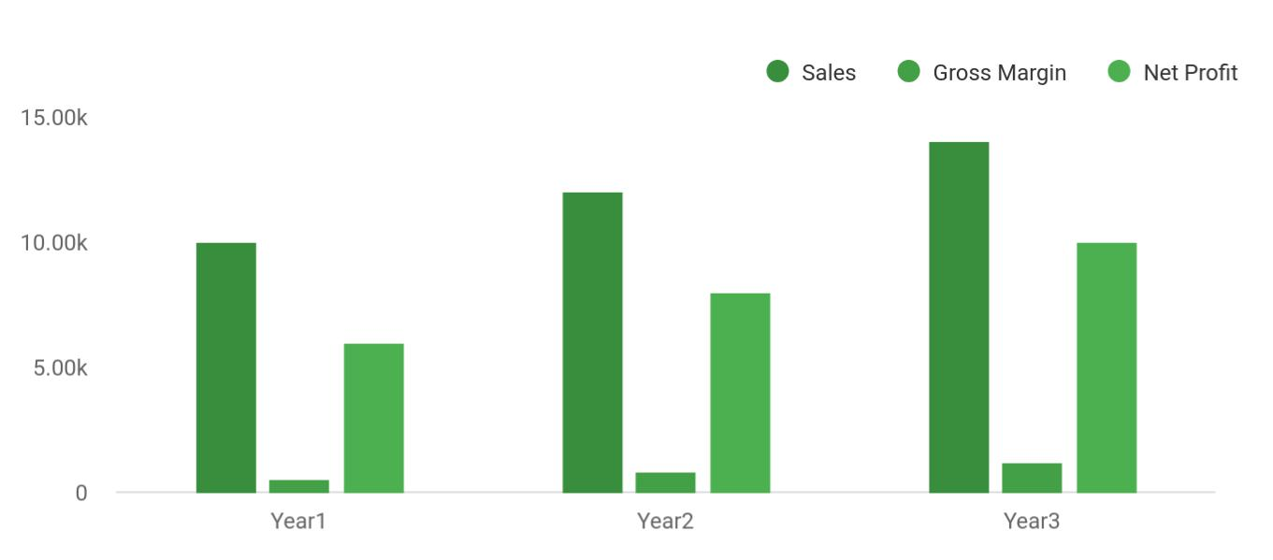

 Tom's Kennel


Financial Summary

Year 1

Year 2



Start writing here..

Dog Kennel | Business Plan [YEAR] 8/35

2.

Company Summary

History

Startup summary

Dog Kennel | Business Plan [YEAR] 9/35

 Tom's Kennel
To unlock help try Upmetrics!

Tom's Kennel will be created as a Detroit Limited Liability Company (LLC) based in Multnomah County, privately owned by its principal operator. To assist people who might not be able to take care of their dogs for any reason, we will provide a wide range of services from bathing their
To unlock help try Upmetrics! 

Start writing here..

History

 Tom's Kennel

John Moore started Tom's Kennel in Jan 2015. Driven by his passion for dogs and because of the increasing number of dog lovers within the city, John Moore decided to open a place where clients can bring their dogs for day/overnight care while they are away for work, business, or
To unlock help try Upmetrics! 

Start writing here..

Startup summary

 Tom's Kennel

Total start-up requirements include legal costs, logo design, stationery, and related expenses. The start-up costs are to be financed partially by the direct owner investment and long-term loan financing. The details are included in the following table and chart.

Start writing here..



Dog Kennel | Business Plan [YEAR] 10/35

Startup cost
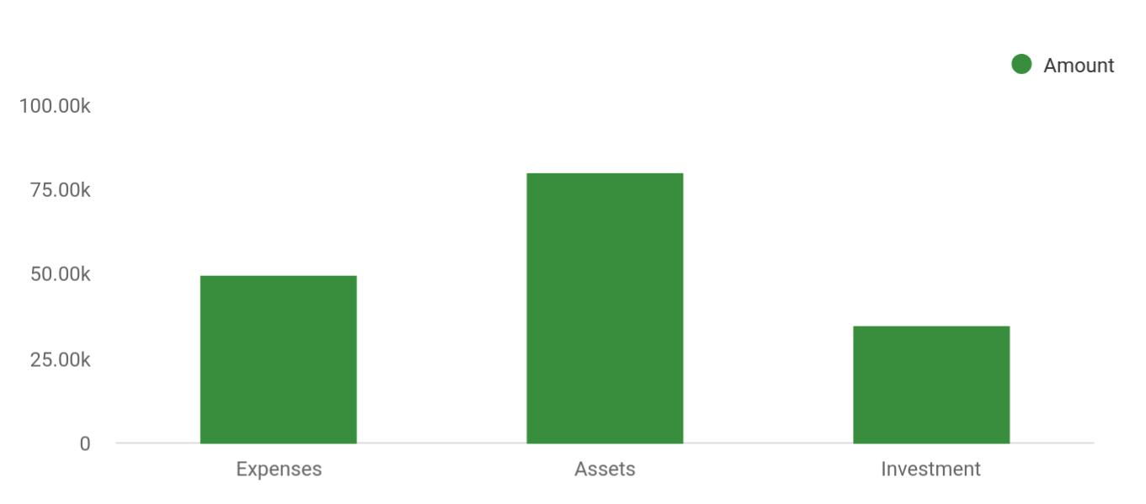

Cost distribution | Amount
Expenses | 50,000
Assets | 80,000
Investment | 35,000

Start-up Expenses | Amount
Legal | $75,500
Consultants | $0
Insurance | $62,750
Rent | $22,500
Research and Development | $42,750
Expensed Equipment | $42,750
Signs | $1,250
TOTAL START-UP EXPENSES | $247,500
Start-up Assets | $0
Cash Required | $322,500
Start-up Inventory | $52,625
Other Current Assets | $222,500
Long-term Assets | $125,000

Dog Kennel | Business Plan [YEAR] 11/35

Start-up Expenses | Amount
TOTAL ASSETS | $121,875
Total Requirements | $245,000
START-UP FUNDING | $0
START-UP FUNDING | $273,125
Start-up Expenses to Fund | $121,875
Start-up Assets to Fund | $195,000
TOTAL FUNDING REQUIRED | $0
Assets | $203,125
Non-cash Assets from Start-up | $118,750
Cash Requirements from Start-up | $0
Additional Cash Raised | $118,750
Cash Balance on Starting Date | $121,875
TOTAL ASSETS | $0
Liabilities and Capital | $0
Liabilities | $0
Current Borrowing | $0
Long-term Liabilities | $0
Accounts Payable (Outstanding Bills) | $0
Other Current Liabilities (interest-free) | $0
TOTAL LIABILITIES | $0
Capital | $0
Planned Investment | $0
Investor 1 | $312,500
Investor 2 | $0
Other | $0
Additional Investment Requirement | $0
TOTAL PLANNED INVESTMENT | $695,000
Loss at Start-up (Start-up Expenses) | $313,125

Dog Kennel | Business Plan [YEAR] 12/35


Start-up Expenses

TOTAL CAPITAL

TOTAL CAPITAL AND LIABILITIES

Total Funding
Amount

$221,875

$221,875

$265,000

Dog Kennel | Business Plan [YEAR] 13/35

3.

Products and services

Product and Service Description

Dog Kennel | Business Plan [YEAR] 14/35

 Tom's Kennel

Tom's Kennel wants to set itself apart from other animal service facilities that may offer only one or two types of services. While talking to several pet owners, I have come to realize they
desire the services I am proposing, but are frustrated because they must go to several different
To unlock help try Upmetrics! 

Start writing here..

Product and Service Description

 Tom's Kennel

Tom's Kennel will be considered an upscale, full-service animal care facility. We will offer a wide range of services, not limited to dogs or cats. Services are as follows:
To unlock help try Upmetrics! 

Start writing here..

Dog Kennel | Business Plan [YEAR] 15/35



Dog Kennel | Business Plan [YEAR] | 16/35

4.

Market Analysis

Market Trends

Market Growth

Service Business Analysis

Dog Kennel | Business Plan [YEAR] 17/35

The most important component of an effective Dog Kennel business plan is its accurate marketing analysis. If you are starting on a smaller scale, you can do marketing analysis yourself by taking help from this Dog Kennel
To unlock help try Upmetrics! 

 Tom's Kennel

Tom's Kennel will focus on dual-income, traveling professional families with hectic schedules. Those trying to strike a balance between the demands of their careers, personal lives, and their pets. Our most important group of customers are those who do not have as much time as they
To unlock help try Upmetrics! 

Start writing here..

Market Trends

 Tom's Kennel

Dog kennel businesses are high in demand and will remain in demand for the next five to ten years. According to IBISWorld, over 139k pet grooming and boarding businesses are running in the United States. In the past five years i.e. from 2016 to 2021, this industry has seen a growth
To unlock help try Upmetrics! 

Start writing here..

Market Growth

 Tom's Kennel

The benefits of sharing our lives with our pets offer owners affection, companionship, and security. For busy families, professionals, and single pet owners, Tom's Kennel offers a peace of mind alternative to leaving their pets home alone. Over 350,000 Portland Metro households
To unlock help try Upmetrics! 

Start writing here..

Dog Kennel | Business Plan [YEAR] 18/35

Service Business Analysis

 Tom's Kennel

The animal care service industry consists of many small individual facilities. Tom's Kennel's direction is to establish itself as a full-service, 24-hour facility, creating customer convenience.
To unlock help try Upmetrics! 

Start writing here..

Dog Kennel | Business Plan [YEAR] 19/35

5.

Strategy &

Implementations

Sales Strategy

Advertising Strategy

Pricing Strategy

Dog Kennel | Business Plan [YEAR] 20/35

After identifying the market demand, market trends, and the potential customers of the startup, the next step is to define an effective strategy for attracting those customers. Like marketing analysis, sales strategy is also an
To unlock help try Upmetrics! 

Sales Strategy

 Tom's Kennel

- We’ll run a social media campaign emphasizing how we can help people taking care of their animals.
To unlock help try Upmetrics! 

Start writing here..

Advertising Strategy

 Tom's Kennel

Tom's Kennel understands that the best promotion comes from satisfied customers. The Company will encourage its clients to refer their friends and neighbors by providing discounts for new client products. This strategy will increase in effectiveness after the business has
To unlock help try Upmetrics! 

Referrals

Start writing here..

 Tom's Kennel

Tom's Kennel will invest resources in two forms of geographically-focused internet promotion organic search engine optimization and pay-per-click advertising. The Company will develop its website in such a manner as to direct as much traffic from search engines as possible.
To unlock help try Upmetrics! 

Internet

Start writing here..

Dog Kennel | Business Plan [YEAR] 21/35

 Tom's Kennel

Tom's Kennel will place print advertisements in key local publications, including newspapers, area magazines, and local sports programs. Additionally, the Company will print brochures and place them in specific locations frequented by target individuals, such as supermarkets and
To unlock help try Upmetrics! 

Publications

Start writing here..

Pricing Strategy

 Tom's Kennel

Tom's Kennel’s pricing will be competitive compared with Max Kennels and lower than James Kennels, although higher than independent pet kennels. For regular, weekly clients, pricing will be based on the average labor needed for a job and a steady fee will be set. For one-time
To unlock help try Upmetrics! 

Start writing here..

Dog Kennel | Business Plan [YEAR] 22/35

6.

Operations Plan

Milestones

Dog Kennel | Business Plan [YEAR] 23/35

 Tom's Kennel
To unlock help try Upmetrics!

Tom's Kennel will book appointments via the internet and call-ins during business hours. Dog kennel services will be available 7 days a week scheduled within time ranges (i.e. 10 am – 4 pm Wednesday) rather than at exact times to allow leeway for jobs that may be longer or shorter
To unlock help try Upmetrics! 

Start writing here..

Milestones

 Tom's Kennel

Tom's Kennel’s long-term goal is to become the highest quality provider of dog kennel services in the Detroit area. We seek to do this by ensuring customer satisfaction and developing a loyal and successful clientele.



Start writing here..

Dog Kennel | Business Plan [YEAR] 24/35

7.

Financial Plan

Important Assumptions

Brake-even Analysis

Projected Profit and Loss

Projected Cash Flow

Projected Balance Sheet

Business Ratios

Dog Kennel | Business Plan [YEAR] 25/35

The last component of the Dog Kennel business plan is an in-depth financial plan. The financial plan crafts a detailed map of all the expenses needed for the startup and how these expenses will be met by the earned profits. It is
To unlock help try Upmetrics! 

 Tom's Kennel

The company will be financed by John himself and he will control the direction of the business to make sure that it is expanding at the forecasted rate. As for the Dog Kennel business start-up, no equity funding or outside loans will be required. With the help of financial experts, John
To unlock help try Upmetrics! 

Start writing here..

Important Assumptions

The financial projections of the company are forecast on the basis of the following assumptions. These assumptions are quite conservative and are expected to show deviation but to a limited level such that the company’s major financial strategy will not be affected.

 | Year 1 | Year 2 | Year 3
Plan Month | 1 | 2 | 3
Current Interest Rate | 10,00% | 11,00% | 12,00%
Long-term Interest Rate | 10,00% | 10,00% | 10,00%
Tax Rate | 26,42% | 27,76% | 28,12%
Other | 0 | 0 | 0

Brake-even Analysis

Monthly Units Break-even | 5530
Monthly Revenue Break-even | $159 740
Assumptions:
Average Per-Unit Revenue | $260,87
Average Per-Unit Variable Cost | $0,89
Estimated Monthly Fixed Cost | $196 410

Dog Kennel | Business Plan [YEAR] 26/35

Projected Profit and Loss

 | 2024 | 2025 | 2026
Revenue | $244,541.90 | $397,087.70 | $649,412
Dog Boarding Services | $79,587.50 | $142,939.50 | $256,700
Unit Sales | 1,592 | 2,859 | 5,134
Unit Price | $50 | $50 | $50
Dog Grooming Services | $56,768.40 | $80,937.20 | $115,396.80
Unit Sales | 1,419 | 2,023 | 2,885
Unit Price | $40 | $40 | $40
Dog Training Classes | $108,186 | $173,211 | $277,315.20
Unit Sales | 1,803 | 2,887 | 4,622
Unit Price | $60 | $60 | $60
Cost Of Sales | $13,313.55 | $17,163.20 | $23,507.91
General Costs | $13,313.55 | $17,163.20 | $23,507.91
Dog Care Supplies | $10,913.55 | $14,727.20 | $21,035.31
Dog Food | $4,800 | $4,800 | $4,800
Grooming Supplies | $6,113.55 | $9,927.20 | $16,235.31
Facility Costs | $2,400 | $2,436 | $2,472.60
Maintenance | $2,400 | $2,436 | $2,472.60
Revenue Specific Costs | $0 | $0 | $0
Personnel Costs (Direct | $0 | $0 | $0
Labor) | $0 | $0 | $0
Gross Margin | $231,228.35 | $379,924.50 | $625,904.09
Gross Margin (%) | 94.56% | 95.68% | 96.38%

Dog Kennel | Business Plan [YEAR] 27/35

2024 2025 2026

Operating Expense | $297,073.66 | $259,209.26 | $275,461.78
Payroll Expense (Indirect | $230,712 | $236,575.80 | $242,600.28
Labor) | $230,712 | $236,575.80 | $242,600.28
Kennel Staff | $103,200 | $106,020 | $108,922.92
Kennel Assistant | $52,800 | $53,856 | $54,933.12
Kennel Manager | $50,400 | $52,164 | $53,989.80
Grooming Staff | $70,320 | $72,264 | $74,263.08
Dog Groomer | $53,760 | $55,372.80 | $57,034.08
Assistant Groomer | $16,560 | $16,891.20 | $17,229
Administrative Staff | $57,192 | $58,291.80 | $59,414.28
Receptionist | $24,192 | $24,796.80 | $25,416.84
Office Manager | $33,000 | $33,495 | $33,997.44
General Expense | $16,381.66 | $22,633.46 | $32,861.50
Facility Expenses | $6,690.83 | $9,795.73 | $14,879.33
Utilities | $1,800 | $1,854 | $1,891.08
Maintenance | $4,890.83 | $7,941.73 | $12,988.25
Operational Supplies | $3,000 | $3,060 | $3,121.20
Cleaning Supplies | $1,200 | $1,224 | $1,248.48
Dog Treats and Toys | $1,800 | $1,836 | $1,872.72
Marketing and Advertising | $6,690.83 | $9,777.73 | $14,860.97
Digital Marketing | $4,890.83 | $7,941.73 | $12,988.25
Print Advertising | $1,800 | $1,836 | $1,872.72
Bad Debt | $0 | $0 | $0
Amortization of Current | $49,980 | $0 | $0
Assets | $49,980 | $0 | $0

Dog Kennel | Business Plan [YEAR] 28/35

EBITDA

Additional Expense

Long Term Depreciation

Gain or loss from Sale of Assets

EBIT

Interest Expense

EBT

Income Tax Expense / Benefit
2024 2025 2026

($65,845.31) $120,715.23 $350,442.31

$48,008.42 | $46,886.62 | $45,683.75
$45,000 | $45,000 | $45,000
$0 | $0 | $0
($110,845.31) | $75,715.23 | $305,442.31
$3,008.41 | $1,886.63 | $683.75
($113,853.73) | $73,828.61 | $304,758.56
$0 | $0 | $0

Total Expense | $358,395.63 | $323,259.09 | $344,653.44
Net Income | ($113,853.73) | $73,828.61 | $304,758.56
Net Income (%) | (46.56%) | 18.59% | 46.93%
Retained Earning Opening | $0 | ($133,853.73) | ($80,025.12)
Owner's Distribution | $20,000 | $20,000 | $20,000
Retained Earning Closing | ($133,853.73) | ($80,025.12) | $204,733.44
Projected Cash Flow
 | 2024 | 2025 | 2026
Cash Received | $244,541.90 | $397,087.70 | $649,412
Cash Paid | $263,415.63 | $278,259.07 | $299,653.44

Dog Kennel | Business Plan [YEAR] 29/35

 | 2024 | 2025 | 2026
COS & General Expenses | $29,695.21 | $39,796.65 | $56,369.41
Salary & Wages | $230,712 | $236,575.80 | $242,600.28
Interest | $3,008.41 | $1,886.63 | $683.75
Sales Tax | $0 | $0 | $0
Income Tax | $0 | $0 | $0
Net Cash From | ($18,873.73) | $118,828.63 | $349,758.56
Operations | ($18,873.73) | $118,828.63 | $349,758.56

Assets Sell | $0 | $0 | $0
Assets Purchase | $200,000 | $0 | $0
Net Cash From | ($200,000) | $0 | $0
Investments | ($200,000) | $0 | $0

Amount Received | $100,000 | $0 | $0
Loan Received | $50,000 | $0 | $0
Common Stock | $0 | $0 | $0
Preferred Stock | $0 | $0 | $0
Owner's Contribution | $50,000 | $0 | $0
Amount Paid | $35,517.78 | $36,639.58 | $37,842.64
Loan Capital | $15,517.79 | $16,639.57 | $17,842.64
Dividends & Distributions | $20,000 | $20,000 | $20,000
Net Cash From | $64,482.22 | ($36,639.58) | ($37,842.64)
Financing | $64,482.22 | ($36,639.58) | ($37,842.64)

Summary

Starting Cash | $0 | ($154,391.51) | ($72,202.46)
Cash In | $344,541.90 | $397,087.70 | $649,412

Dog Kennel | Business Plan [YEAR] 30/35

 | 2024 | 2025 | 2026
Cash Out | $498,933.41 | $314,898.65 | $337,496.08
Change in Cash | ($154,391.51) | $82,189.05 | $311,915.92
Ending Cash | ($154,391.51) | ($72,202.46) | $239,713.46

Projected Balance Sheet

 | 2024 | 2025 | 2026
Assets | ($49,371.51) | ($12,182.46) | $239,733.46
Current Assets | ($154,371.51) | ($72,182.46) | $239,733.46
Cash | ($154,391.51) | ($72,202.46) | $239,713.46
Accounts Receivable | $0 | $0 | $0
Inventory | $0 | $0 | $0
Other Current Assets | $20 | $20 | $20
Long Term Assets | $105,000 | $60,000 | $0
Gross Long Term Assets | $150,000 | $150,000 | $135,000
Accumulated Depreciation | ($45,000) | ($90,000) | ($135,000)
Liabilities & Equity | ($49,371.52) | ($12,182.48) | $254,733.44
Liabilities | $34,482.21 | $17,842.64 | $0
Current Liabilities | $16,639.57 | $17,842.64 | $0
Accounts Payable | $0 | $0 | $0
Income Tax Payable | $0 | $0 | $0
Sales Tax Payable | $0 | $0 | $0
Short Term Debt | $16,639.57 | $17,842.64 | $0
Long Term Liabilities | $17,842.64 | $0 | $0
Long Term Debt | $17,842.64 | $0 | $0

Dog Kennel | Business Plan [YEAR] 31/35

 | 2024 |  |  | 2025 | 2026
Equity | ($83,853.73) |  | ($30,025.12) |  | $254,733.44
Paid-in Capital | $0 |  |  | $0 | $0
Common Stock | $0 |  |  | $0 | $0
Preferred Stock | $0 |  |  | $0 | $0
Owner's Contribution | $50,000 |  |  | $50,000 | $50,000
Retained Earnings | ($133,853.73) |  | ($80,025.12) |  | $204,733.44
Check | $0 |  |  | $0 | ($15,000)
Business Ratios
 |  | Year 1 | Year 2 | Year 3 | Industry Profile
Sales Growth |  | 4,35% | 30,82% | 63,29% | 4,00%
Percent of Total Assets
Accounts Receivable |  | 5,61% | 4,71% | 3,81% | 9,70%
Inventory |  | 1,85% | 1,82% | 1,79% | 9,80%
Other Current Assets |  | 1,75% | 2,02% | 2,29% | 27,40%
Total Current Assets |  | 138,53% | 150,99% | 163,45% | 54,60%
Long-term Assets |  | -9,47% | -21,01% | -32,55% | 58,40%
TOTAL ASSETS |  | 100,00% | 100,00% | 100,00% | 100,00%
Current Liabilities |  | 4,68% | 3,04% | 2,76% | 27,30%
Long-term Liabilities |  | 0,00% | 0,00% | 0,00% | 25,80%
Total Liabilities |  | 4,68% | 3,04% | 2,76% | 54,10%
NET WORTH |  | 99,32% | 101,04% | 102,76% | 44,90%
Percent of Sales
Sales |  | 100,00% | 100,00% | 100,00% | 100,00%
Gross Margin |  | 94,18% | 93,85% | 93,52% | 0,00%

Dog Kennel | Business Plan [YEAR] 32/35

 | Year 1 | Year 2 | Year 3 | Industry Profile
Selling, General & Administrative Expenses | 74,29% | 71,83% | 69,37% | 65,20%
Advertising Expenses | 2,06% | 1,11% | 0,28% | 1,40%
Profit Before Interest and Taxes | 26,47% | 29,30% | 32,13% | 2,86%
Main Ratios
Current | 25,86 | 29,39 | 32,92 | 1,63
Quick | 25,4 | 28,88 | 32,36 | 0,84
Total Debt to Total Assets | 2,68% | 1,04% | 0,76% | 67,10%
Pre-tax Return on Net Worth | 66,83% | 71,26% | 75,69% | 4,40%
Pre-tax Return on Assets | 64,88% | 69,75% | 74,62% | 9,00%
Additional Ratios
Net Profit Margin | 19,20% | 21,16% | 23,12% | N.A.
Return on Equity | 47,79% | 50,53% | 53,27% | N.A.
Activity Ratios
Accounts Receivable Turnover | 4,56 | 4,56 | 4,56 | N.A.
Collection Days | 92 | 99 | 106 | N.A.
Inventory Turnover | 19,7 | 22,55 | 25,4 | N.A.
Accounts Payable Turnover | 14,17 | 14,67 | 15,17 | N.A.
Payment Days | 27 | 27 | 27 | N.A.
Total Asset Turnover | 1,84 | 1,55 | 1,26 | N.A.
Debt Ratios
Debt to Net Worth | 0 | -0,02 | -0,04 | N.A.
Current Liab. to Liab. | 1 | 1 | 1 | N.A.
Liquidity Ratios
Net Working Capital | $120 943 | $140 664 | $160 385 | N.A.
Interest Coverage | 0 | 0 | 0 | N.A.
Additional Ratios
Assets to Sales | 0,45 | 0,48 | 0,51 | N.A.
Current Debt/Total Assets | 4% | 3% | 2% | N.A.

Dog Kennel | Business Plan [YEAR] 33/35

 | Year 1 | Year 2 | Year 3 | Industry Profile
Acid Test | 23,66 | 27,01 | 30,36 | N.A.
Sales/Net Worth | 1,68 | 1,29 | 0,9 | N.A.
Dividend Payout | 0 | 0 | 0 | N.A.
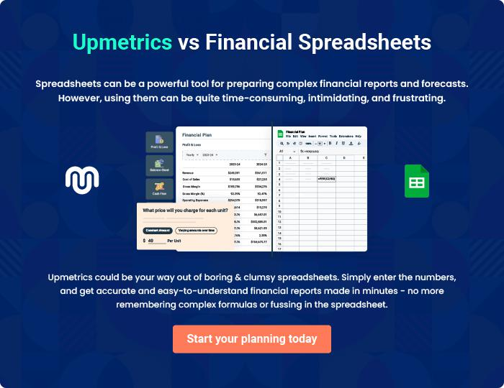

Dog Kennel | Business Plan [YEAR] 34/35


Create a winning business plan that gets you funded

Creating a stunning and investment-ready plan requires no writing, graphic designing, or financial planning expertise.

Upmetrics has all the features required to help you create a comprehensive business plan—from start to finish. Make no mistakes, it’s the modern way of planning to structure ideas, make plans, and create stunning pitch decks to awe investors.

Pitch decks that impress investors

Create pitch decks that provide a visual representation of your business, engage investors, and make them want to invest in your business idea.

Interactive plans in no time

Import business plan sections like—SWOT analysis, comparison tables, and others to create an interactive business plan. No designing skills are required.

Stunning cover page designs

With Upmetrics, you have the liberty to choose from multiple stunning cover page designs. Choose a creative design and make your plan stand out.

Online sharing made simple

Upmetrics makes online sharing quick and easier for users. Easily share your business plans with a link while tracking reader activity.

500+ sample business plans

Simply import a template from our library of sample plans into the editor and start customizing it to make it yours. It takes only a few clicks to get started.

Collaborate with team in real-time

Invite team members, initiate conversations, discuss ideas & strategies, share feedback, and work on a business plan in real-time.

