

Dog Grooming

A great place to have your dog groomed.

Business

Plan

[YEAR]

John Doe

10200 Bolsa Ave, Westminster, CA, 92683

- 359-3153 info@example.com http://www.example.com

CONFIDENTIAL

Table of Contents

Executive Summary | 5
Mission Statement | 6
Vision Statement | 6
Customer Focus | 7
Financial Summary | 7
3 Year profit forecast | 7

Company Summary | 9
History | 10
Startup summary | 11
Startup cost | 11
Products and services
Products and services | 14
Market Analysis
Market Analysis | 17
Market Trends | 18
Target Market | 18
SWOT Analysis
SWOT Analysis | 19
Strategy & Implementations
Strategy & Implementations | 21
Advertising Strategy | 22
Referrals | 22
Internet | 22
Publications | 22
Pricing Strategy | 23
Operational Plan
Operational Plan | 24
Milestones | 25

Dog Grooming | Business Plan [YEAR] 2/36

Financial Plan | 26
Important Assumptions | 27
Brake-even Analysis | 27
Projected Profit and Loss | 28
Projected Cash Flow | 30
Projected Balance Sheet | 33
Business Ratios | 33

Dog Grooming | Business Plan [YEAR] 3/36

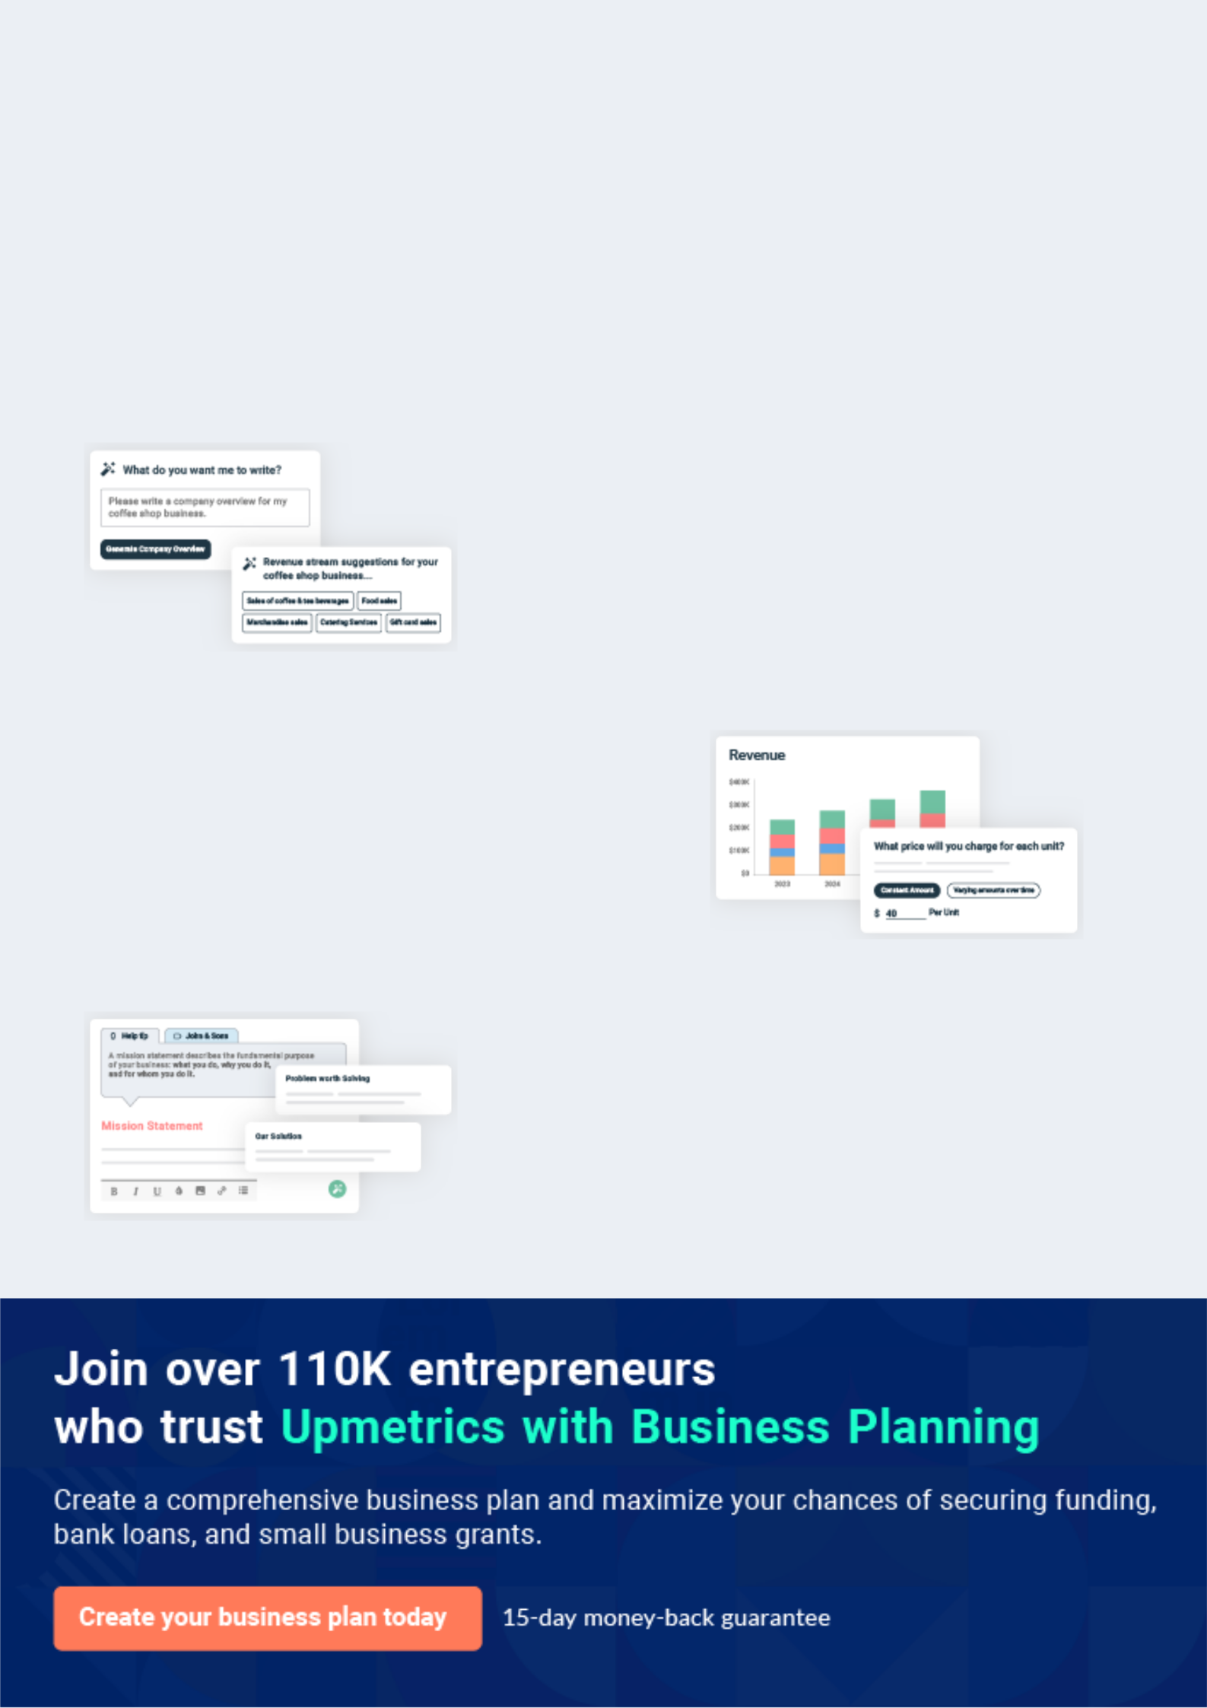
Business planning that’s simpler and faster than you think

Creating a business plan using Upmetrics to start and grow a business is literally the easiest thing in the World. Simply read the instructions and fill in the blanks. It’s as simple as that.

❛ | Upmetrics has everything you need to create a | ❜
❛ | comprehensive business plan. | ❜

AI-powered Upmetrics Assistant

AI-powered insights to streamline your plan

Not sure where to start? Upmetrics’ AI Assistant will automatically generate ideas for each section of your plan and offer improved versions of your writing, adjusting for tone, voice, and grammar or spelling errors.

Financial Forecasting Tool

All the financials are calculated for you

Forget the complex formulas and clumsy spreadsheets — with automatic financials and drag-and-drop forecasting, you can finish your plan faster and be confident that your numbers are accurate.

Business Plan Builder

Guides you like a business mentor

Upmetrics’ step-by-step instructions, prompts, and the library of 400+ sample business plans will guide you through each section of your plan as a business mentor.

1.


Executive Summary

Mission Statement

Vision Statement

Customer Focus

Financial Summary

Dog Grooming | Business Plan [YEAR] 5/36

Before you think about how to start a Dog Grooming business, you must create a detailed Dog Grooming business plan. It will not only guide you in the initial phases of your startup but will also help you later on.
To unlock help try Upmetrics!
To unlock help try Upmetrics! 

 Maxwell Groomers


Maxwell Groomers is a standard and licensed dog grooming and one-stop pet company that will be located in the heart of Detroit in a neatly renovated and secured housing facility; an organization that will carry out all-round services as it relates to dogs and other pets.
To unlock help try Upmetrics! 

Start writing here..

Mission Statement

 Maxwell Groomers

• We have a very strong mission and that is to provide affordable professional and highly effective dog grooming services and other pet-related products and services to a wide

range of clients who own different types of pets. | To unlock help try Upmetrics! 
Start writing here..
Vision Statement

 Maxwell Groomers

Our vision is to create a highly good and effective dog grooming services business that will become the number one choice for both individuals and corporate organizations in Smethport – Pennsylvania and the whole of the United States of America.



Start writing here..

Dog Grooming | Business Plan [YEAR] 6/36

Customer Focus
To unlock help try Upmetrics!

 Maxwell Groomers

Maxwell Groomers is uniquely qualified to succeed due to the following reasons:

• Maxwell Groomers will fill a specific market niche in the growing community we are
To unlock help try Upmetrics! 

Start writing here..

Financial Summary

 Maxwell Groomers

Maxwell Groomers is seeking total funding of $92,000 of debt capital to open its dog grooming salon. The capital will be used for funding capital expenditures and location build-out, hiring initial employees, marketing expenses, and working capital.



Start writing here..

3 Year profit forecast
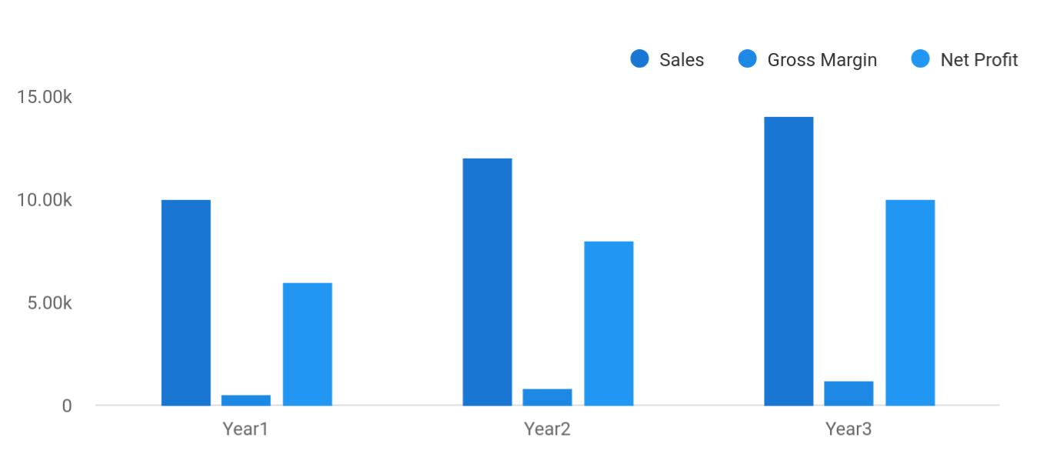

Dog Grooming | Business Plan [YEAR] 7/36

 Maxwell Groomers


Financial Summary | Year 1 | Year 2 |  | Year 3
 |  |  | To unlock help try Upmetrics! |  | 

Start writing here..

Dog Grooming | Business Plan [YEAR] 8/36

2.

Company Summary

History

Startup summary

Dog Grooming | Business Plan [YEAR] 9/36

 Maxwell Groomers
To unlock help try Upmetrics!

Maxwell Groomers is founded by Dr. John Moore and he will run the business with his business partner and Wife Dr. Jane Moore. John is a renowned and licensed Vet Doctor and dog trainer. He has well over 15 years of experience as a vet doctor and dog trainer for various security
To unlock help try Upmetrics! 

Start writing here..

History

 Maxwell Groomers

Founded by John Moore in Jan 2015, Maxwell Groomers started as a home dog grooming service on weekends. John Moore would be contacted by clients for their dog’s grooming and he would either pay them a visit or schedule them to drop their pets by.

Start writing here..



Dog Grooming | Business Plan [YEAR] 10/36

Startup summary

Startup cost
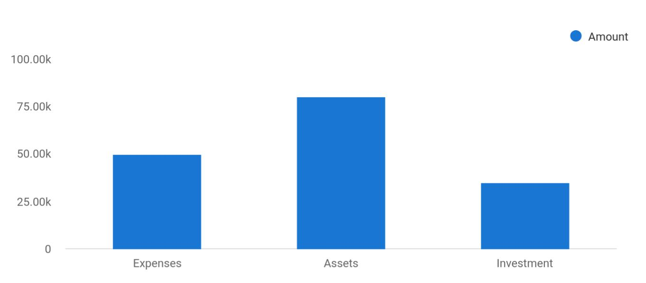

Cost distribution | Amount
Expenses | 50,000
Assets | 80,000
Investment | 35,000

Start-up Expenses | Amount
Legal | $75,500
Consultants | $0
Insurance | $62,750
Rent | $22,500
Research and Development | $42,750
Expensed Equipment | $42,750
Signs | $1,250
TOTAL START-UP EXPENSES | $247,500
Start-up Assets | $0
Cash Required | $322,500
Start-up Inventory | $52,625
Other Current Assets | $222,500

Dog Grooming | Business Plan [YEAR] 11/36

Start-up Expenses | Amount
Long-term Assets | $125,000
TOTAL ASSETS | $121,875
Total Requirements | $245,000
START-UP FUNDING | $0
START-UP FUNDING | $273,125
Start-up Expenses to Fund | $121,875
Start-up Assets to Fund | $195,000
TOTAL FUNDING REQUIRED | $0
Assets | $203,125
Non-cash Assets from Start-up | $118,750
Cash Requirements from Start-up | $0
Additional Cash Raised | $118,750
Cash Balance on Starting Date | $121,875
TOTAL ASSETS | $0
Liabilities and Capital | $0
Liabilities | $0
Current Borrowing | $0
Long-term Liabilities | $0
Accounts Payable (Outstanding Bills) | $0
Other Current Liabilities (interest-free) | $0
TOTAL LIABILITIES | $0
Capital | $0
Planned Investment | $0
Investor 1 | $312,500
Investor 2 | $0
Other | $0
Additional Investment Requirement | $0
TOTAL PLANNED INVESTMENT | $695,000

Dog Grooming | Business Plan [YEAR] 12/36

Start-up Expenses | Amount
Loss at Start-up (Start-up Expenses) | $313,125
TOTAL CAPITAL | $221,875
TOTAL CAPITAL AND LIABILITIES | $221,875
Total Funding | $265,000

Dog Grooming | Business Plan [YEAR] 13/36

3.

Products and services

Dog Grooming | Business Plan [YEAR] 14/36

 Maxwell Groomers

Maxwell Groomers is going to offer varieties of pet-related services (dog walking and dog training services inclusive) within the scope of the pet industry in the United States of America. Our intention of starting our dog grooming services and pet-related business is to help in
To unlock help try Upmetrics! 

Start writing here..


General dog and pet grooming services

Construction and sale of kennels

Supply of well – trained security dogs

General merchandize

of pet related

products

Training / grooming dogs and pets in specific skills

Sale of Puppies

Operating standard vet clinic

Dog Grooming | Business Plan [YEAR] 15/36



Dog Grooming | Business Plan [YEAR] | 16/36

4.

Market Analysis

Market Trends

Target Market

Dog Grooming | Business Plan [YEAR] 17/36

The most important component of an effective Dog Grooming business plan is its accurate marketing analysis. If you are starting on a smaller scale, you can do marketing analysis yourself by taking help from this Dog Grooming
To unlock help try Upmetrics!
To unlock help try Upmetrics! 

 Maxwell Groomers

With revenue doubling over the past decade the Pet Grooming industry has proven to be one of the few established industries to post consistently strong gains over the past decade.
To unlock help try Upmetrics! 

Start writing here..

Market Trends

 Maxwell Groomers

One thing is certain, the trend in the pet industry is such that if you want to be ahead of your competitors, you should be able to be highly creative, simplify your processes and you should be able to have loads of testimonies from your clients.



Start writing here..

Target Market

 Maxwell Groomers

Before starting our dog grooming services and pet-related business, we are sure that there is a wide range of both corporate and individual clients who would absolutely need our services. We will guarantee that we develop calculated pacts with communities and corporate organizations
To unlock help try Upmetrics! 

Start writing here..

Dog Grooming | Business Plan [YEAR] 18/36

5.

SWOT Analysis

Dog Grooming | Business Plan [YEAR] 19/36

 Maxwell Groomers

Maxwell Groomers employed the services of a core professional in the area of business consulting and structuring to assist our organization in building well-structured dog grooming services and pet-related businesses that can favorably compete in the highly competitive pet
To unlock help try Upmetrics! 

Start writing here..


Strength

Our core strength lies in the power of our team; our workforce. We have a team that is considered experts in the pet industry, a team with excellent qualifications and experience in dog walking and pet-related services including veterinary medicine.

Aside from the synergy that exists in our carefully selected workforce, Maxwell Groomers is well positioned in a community with the right demographic; loads of people who own pets. With that, we know we will attract loads of clients from the first day we open our doors for business.


Weakness

As a new dog grooming and pet-related services company in Detroit, it might take some time for our organization to break into the market and gain acceptance especially from top profile clients in the already saturated pet industry; that is perhaps our major weakness. Another perceived weakness is that we may not have the required capital to pump into publicity and advertisement as we would love to do.


Opportunity

No doubt, the opportunities in the pet industry is massive considering the number of individuals and corporate organizations who own dogs and other pets who would want them to acquire new skill sets and to perform excellently well in their jobs or who would want to bring their pets for treatment or to purchase pet supplies.

As a standard dog walking services and pet-related business, we are ready to take advantage of any opportunity that comes our way.

Threat

Every business faces a threat or challenge at any part of the life cycle of the business. These threats can be external or internal. This shows the importance of a business plan because most threats or challenges are to be anticipated and plans put in place to cushion what effect they might bring to the business.

Dog Grooming | Business Plan [YEAR] 20/36

6.

Strategy &

Implementations

Advertising Strategy

Pricing Strategy

Dog Grooming | Business Plan [YEAR] 21/36

After identifying the market demand, market trends, and the potential customers of the startup, the next step is to define an effective strategy for attracting those customers. Like marketing analysis, sales strategy is also an
To unlock help try Upmetrics! 

Advertising Strategy

 Maxwell Groomers

Maxwell Groomers understands that the best promotion comes from satisfied customers. The Company will encourage its clients to refer their friends and neighbors by providing discounts for new client products. This strategy will increase in effectiveness after the business has
To unlock help try Upmetrics! 

Referrals

Start writing here..

 Maxwell Groomers

Maxwell Groomers will invest resources in two forms of geographically-focused internet promotion organic search engine optimization and pay-per-click advertising. The Company will develop its website in such a manner as to direct as much traffic from search engines as
To unlock help try Upmetrics! 

Internet

Start writing here..

 Maxwell Groomers

Maxwell Groomers will place print advertisements in key local publications, including newspapers, area magazines, and local sports programs. Additionally, the Company will print brochures and place them in specific locations frequented by target individuals, such as
To unlock help try Upmetrics! 

Publications

Start writing here..

Dog Grooming | Business Plan [YEAR] 22/36

Pricing Strategy

 Maxwell Groomers

Generally, for dog grooming services business both per hour, billing and flat fees on a weekly or monthly basis apply. As a result of this, Maxwell Groomers will charge our clients flat fees except for a few occasions where there will be a need for us to charge special students on an
To unlock help try Upmetrics! 

Start writing here..

Dog Grooming | Business Plan [YEAR] 23/36

7.

Operational Plan

Milestones

Dog Grooming | Business Plan [YEAR] 24/36

 Maxwell Groomers
To unlock help try Upmetrics!

Maxwell Groomers will carry out its sales operations through the internet and phone calls. Dog grooming services will be scheduled within time ranges (i.e. 10 am – 4 pm Wednesday) rather than at exact times to allow leeway for jobs that may be longer or shorter than expected. After
To unlock help try Upmetrics! 

Start writing here..

Milestones

 Maxwell Groomers

Maxwell Groomers’s long-term goal is to become the highest quality provider of dog grooming services in the Detroit area. We seek to do this by ensuring customer satisfaction and developing a loyal and successful clientele.



Start writing here..

Dog Grooming | Business Plan [YEAR] 25/36

8.

Financial Plan

Important Assumptions

Brake-even Analysis

Projected Profit and Loss

Projected Cash Flow

Projected Balance Sheet

Business Ratios

Dog Grooming | Business Plan [YEAR] 26/36

The last component of the Dog Grooming business plan is an in-depth financial plan. The financial plan crafts a detailed map of all the expenses needed for the startup and how these expenses will be met by the earned
To unlock help try Upmetrics! 

 Maxwell Groomers

The company will be financed by John himself and he will control the direction of the business to make sure that it is expanding at the forecasted rate. As for the Dog Grooming business start-up, no equity funding or outside loans will be required. With the help of financial experts,
To unlock help try Upmetrics! 

Start writing here..

Important Assumptions

The financial projections of the company are forecast on the basis of the following assumptions. These assumptions are quite conservative and are expected to show deviation but to a limited level such that the company’s major financial strategy will not be affected.

 | Year 1 | Year 2 | Year 3
Plan Month | 1 | 2 | 3
Current Interest Rate | 10,00% | 11,00% | 12,00%
Long-term Interest Rate | 10,00% | 10,00% | 10,00%
Tax Rate | 26,42% | 27,76% | 28,12%
Other | 0 | 0 | 0

Brake-even Analysis

Monthly Units Break-even | 5530
Monthly Revenue Break-even | $159 740
Assumptions:
Average Per-Unit Revenue | $260,87
Average Per-Unit Variable Cost | $0,89
Estimated Monthly Fixed Cost | $196 410

Dog Grooming | Business Plan [YEAR] 27/36

Projected Profit and Loss

 | 2024 | 2025 | 2026
Revenue | $275,492.10 | $436,965.35 | $702,376.47
Basic Grooming Services | $119,381 | $214,392 | $385,022
Unit Sales | 2,388 | 4,288 | 7,700
Unit Price | $50 | $50 | $50
Premium Grooming | $113,535 | $161,870 | $230,806
Packages | $113,535 | $161,870 | $230,806
Unit Sales | 1,135 | 1,619 | 2,308
Unit Price | $100 | $100 | $100
Seasonal Specials | $42,576.10 | $60,703.35 | $86,548.47
Cost Of Sales | $8,877.81 | $10,003.62 | $11,272.01
General Costs | $8,877.81 | $10,003.62 | $11,272.01
Grooming Supplies | $4,438.92 | $5,001.86 | $5,636.03
Shampoo & Conditioners | $2,536.46 | $2,858.16 | $3,220.59
Grooming Tools (Brushes, | $1,902.46 | $2,143.70 | $2,415.44
Clippers) | $1,902.46 | $2,143.70 | $2,415.44
Equipment and Facilities | $4,438.89 | $5,001.76 | $5,635.98
Equipment Maintenance | $1,268.20 | $1,428.97 | $1,610.17
Utilities for Grooming Area | $3,170.69 | $3,572.79 | $4,025.81
Revenue Specific Costs | $0 | $0 | $0
Personnel Costs (Direct | $0 | $0 | $0
Labor) | $0 | $0 | $0
Gross Margin | $266,614.29 | $426,961.73 | $691,104.46
Gross Margin (%) | 96.78% | 97.71% | 98.40%

Dog Grooming | Business Plan [YEAR] 28/36

2024 2025 2026

Operating Expense | $304,569.08 | $321,464.01 | $342,248.72
Payroll Expense (Indirect | $263,964 | $271,913.28 | $280,114.08
Labor) | $263,964 | $271,913.28 | $280,114.08
Groomers | $134,100 | $138,744 | $143,552.16
Senior Groomer | $72,000 | $74,160 | $76,384.80
Junior Groomer | $62,100 | $64,584 | $67,167.36
Administrative Staff | $70,800 | $72,924 | $75,111.72
Receptionist | $27,600 | $28,428 | $29,280.84
Office Manager | $43,200 | $44,496 | $45,830.88
Support Staff | $59,064 | $60,245.28 | $61,450.20
Cleaner | $35,952 | $36,671.04 | $37,404.48
Maintenance | $23,112 | $23,574.24 | $24,045.72
General Expense | $40,605.08 | $49,550.73 | $62,134.64
Facility Expenses | $17,755.49 | $20,007.34 | $22,544.67
Rent | $12,682.53 | $14,291.10 | $16,103.44
Utilities | $5,072.96 | $5,716.24 | $6,441.23
Marketing and Advertising | $18,410.70 | $24,541.63 | $33,953.99
Online Advertising | $8,264.75 | $13,108.95 | $21,071.30
Print Media Advertising | $10,145.95 | $11,432.68 | $12,882.69
Operational Costs | $4,438.89 | $5,001.76 | $5,635.98
Cleaning Services | $3,170.69 | $3,572.79 | $4,025.81
Office Supplies | $1,268.20 | $1,428.97 | $1,610.17
Bad Debt | $0 | $0 | $0
Amortization of Current | $0 | $0 | $0
Assets | $0 | $0 | $0

Dog Grooming | Business Plan [YEAR] 29/36

EBITDA

Additional Expense

Long Term Depreciation

Gain or loss from Sale of Assets

EBIT

Interest Expense

EBT

Income Tax Expense / Benefit
2024 2025 2026

($37,954.79) $105,497.72 $348,855.74

$9,755.48 | $8,788.38 | $7,761.63
$7,182 | $7,182 | $7,182
$0 | $0 | $0
($45,136.79) | $98,315.72 | $341,673.74
$2,573.47 | $1,606.38 | $579.64
($47,710.27) | $96,709.34 | $341,094.11
$0 | $0 | $0

Total Expense | $323,202.37 | $340,256.01 | $361,282.36
Net Income | ($47,710.27) | $96,709.34 | $341,094.11
Net Income (%) | (17.32%) | 22.13% | 48.56%
Retained Earning Opening | $0 | ($56,710.27) | $30,999.07
Owner's Distribution | $9,000 | $9,000 | $9,000
Retained Earning Closing | ($56,710.27) | $30,999.07 | $363,093.18
Projected Cash Flow
 | 2024 | 2025 | 2026
Cash Received | $275,492.10 | $436,965.35 | $702,376.47
Cash Paid | $316,020.37 | $333,074.01 | $354,100.36

Dog Grooming | Business Plan [YEAR] 30/36

 | 2024 | 2025 | 2026
COS & General Expenses | $49,482.89 | $59,554.35 | $73,406.65
Salary & Wages | $263,964 | $271,913.28 | $280,114.08
Interest | $2,573.47 | $1,606.38 | $579.64
Sales Tax | $0 | $0 | $0
Income Tax | $0 | $0 | $0
Net Cash From | ($40,528.27) | $103,891.34 | $348,276.11
Operations | ($40,528.27) | $103,891.34 | $348,276.11

Assets Sell | $0 | $0 | $0
Assets Purchase | $45,000 | $0 | $0
Net Cash From | ($45,000) | $0 | $0
Investments | ($45,000) | $0 | $0

Amount Received | $80,000 | $0 | $0
Loan Received | $50,000 | $0 | $0
Common Stock | $0 | $0 | $0
Preferred Stock | $0 | $0 | $0
Owner's Contribution | $30,000 | $0 | $0
Amount Paid | $24,679.72 | $25,646.82 | $26,673.45
Loan Capital | $15,679.73 | $16,646.82 | $17,673.44
Dividends & Distributions | $9,000 | $9,000 | $9,000
Net Cash From | $55,320.28 | ($25,646.82) | ($26,673.45)
Financing | $55,320.28 | ($25,646.82) | ($26,673.45)

Summary

Starting Cash | $0 | ($30,207.99) | $48,036.53
Cash In | $355,492.10 | $436,965.35 | $702,376.47

Dog Grooming | Business Plan [YEAR] 31/36

 | 2024 | 2025 | 2026
Cash Out | $385,700.09 | $358,720.83 | $380,773.81
Change in Cash | ($30,207.99) | $78,244.52 | $321,602.66
Ending Cash | ($30,207.99) | $48,036.53 | $369,639.19

Dog Grooming | Business Plan [YEAR] 32/36

Projected Balance Sheet

Business Ratios

 | Year 1 | Year 2 | Year 3 | Industry Profile
Sales Growth | 4,35% | 30,82% | 63,29% | 4,00%
Percent of Total Assets
Accounts Receivable | 5,61% | 4,71% | 3,81% | 9,70%
Inventory | 1,85% | 1,82% | 1,79% | 9,80%
Other Current Assets | 1,75% | 2,02% | 2,29% | 27,40%
Total Current Assets | 138,53% | 150,99% | 163,45% | 54,60%
Long-term Assets | -9,47% | -21,01% | -32,55% | 58,40%
TOTAL ASSETS | 100,00% | 100,00% | 100,00% | 100,00%
Current Liabilities | 4,68% | 3,04% | 2,76% | 27,30%
Long-term Liabilities | 0,00% | 0,00% | 0,00% | 25,80%
Total Liabilities | 4,68% | 3,04% | 2,76% | 54,10%
NET WORTH | 99,32% | 101,04% | 102,76% | 44,90%
Percent of Sales
Sales | 100,00% | 100,00% | 100,00% | 100,00%
Gross Margin | 94,18% | 93,85% | 93,52% | 0,00%
Selling, General & Administrative Expenses | 74,29% | 71,83% | 69,37% | 65,20%
Advertising Expenses | 2,06% | 1,11% | 0,28% | 1,40%
Profit Before Interest and Taxes | 26,47% | 29,30% | 32,13% | 2,86%
Main Ratios
Current | 25,86 | 29,39 | 32,92 | 1,63
Quick | 25,4 | 28,88 | 32,36 | 0,84
Total Debt to Total Assets | 2,68% | 1,04% | 0,76% | 67,10%
Pre-tax Return on Net Worth | 66,83% | 71,26% | 75,69% | 4,40%
Pre-tax Return on Assets | 64,88% | 69,75% | 74,62% | 9,00%

Dog Grooming | Business Plan [YEAR] 33/36

 | Year 1 | Year 2 | Year 3 | Industry Profile
Additional Ratios
Net Profit Margin | 19,20% | 21,16% | 23,12% | N.A.
Return on Equity | 47,79% | 50,53% | 53,27% | N.A.
Activity Ratios
Accounts Receivable Turnover | 4,56 | 4,56 | 4,56 | N.A.
Collection Days | 92 | 99 | 106 | N.A.
Inventory Turnover | 19,7 | 22,55 | 25,4 | N.A.
Accounts Payable Turnover | 14,17 | 14,67 | 15,17 | N.A.
Payment Days | 27 | 27 | 27 | N.A.
Total Asset Turnover | 1,84 | 1,55 | 1,26 | N.A.
Debt Ratios
Debt to Net Worth | 0 | -0,02 | -0,04 | N.A.
Current Liab. to Liab. | 1 | 1 | 1 | N.A.
Liquidity Ratios
Net Working Capital | $120 943 | $140 664 | $160 385 | N.A.
Interest Coverage | 0 | 0 | 0 | N.A.
Additional Ratios
Assets to Sales | 0,45 | 0,48 | 0,51 | N.A.
Current Debt/Total Assets | 4% | 3% | 2% | N.A.
Acid Test | 23,66 | 27,01 | 30,36 | N.A.
Sales/Net Worth | 1,68 | 1,29 | 0,9 | N.A.
Dividend Payout | 0 | 0 | 0 | N.A.

Dog Grooming | Business Plan [YEAR] 34/36

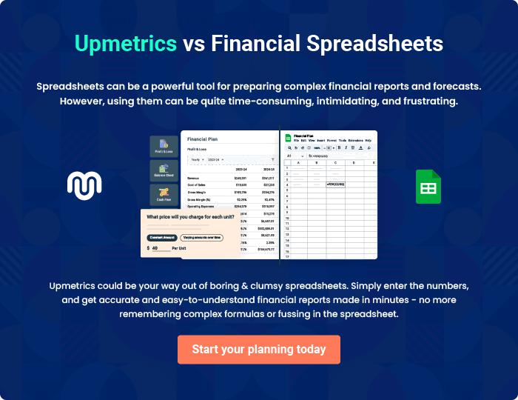

Dog Grooming | Business Plan [YEAR] | 35/36


Create a winning business plan that gets you funded

Creating a stunning and investment-ready plan requires no writing, graphic designing, or financial planning expertise.

Upmetrics has all the features required to help you create a comprehensive business plan—from start to finish. Make no mistakes, it’s the modern way of planning to structure ideas, make plans, and create stunning pitch decks to awe investors.

Pitch decks that impress investors

Create pitch decks that provide a visual representation of your business, engage investors, and make them want to invest in your business idea.

Interactive plans in no time

Import business plan sections like—SWOT analysis, comparison tables, and others to create an interactive business plan. No designing skills are required.

Stunning cover page designs

With Upmetrics, you have the liberty to choose from multiple stunning cover page designs. Choose a creative design and make your plan stand out.

Online sharing made simple

Upmetrics makes online sharing quick and easier for users. Easily share your business plans with a link while tracking reader activity.

500+ sample business plans

Simply import a template from our library of sample plans into the editor and start customizing it to make it yours. It takes only a few clicks to get started.

Collaborate with team in real-time

Invite team members, initiate conversations, discuss ideas & strategies, share feedback, and work on a business plan in real-time.

