
BUSINESS PLAN

[YEAR]


Dispensary

We're With The Marijuana.

John Doe

10200 Bolsa Ave, Westminster, CA, 92683

- 359-3153 info@example.com http://www.example.com

Information provided in this business plan is unique to this business and confidential; therefore, anyone reading this plan agrees not to disclose any of the information in this business plan without prior written permission of the company.
Table of Contents

Executive Summary | 5
Products & Services | 6
Mission Statement | 6
Vision Statement | 7
Competition | 7
Keys to Success | 7
Financial Summary | 8
3 Year profit forecast | 8
Financing Needed | 8

Company Summary | 9
Business Structure | 10
Team | 10
Management Team | 10
Personnel Table | 11
Startup summary | 11
Startup cost | 11
Products and services
Products and services | 14
Market Analysis
Market Analysis | 16
Market Trends | 17
Target Market | 17
Strategy & Implementations
Strategy & Implementations | 18
Sales Plan | 19
Marketing Plan | 19
Twitter | 19
Blog | 20
Facebook | 20
Promotions | 20

Dispensary | Business Plan [YEAR] 2/32

We make the customer feel comfortable | 20
Pricing Strategy | 21
Milestones & Metrics | 21

Financial Plan | 22
Important Assumptions | 23
Brake-even Analysis | 23
Projected Profit and Loss | 24
Projected Cash Flow | 27
Projected Balance Sheet | 28
Business Ratios | 29

Dispensary | Business Plan [YEAR] 3/32

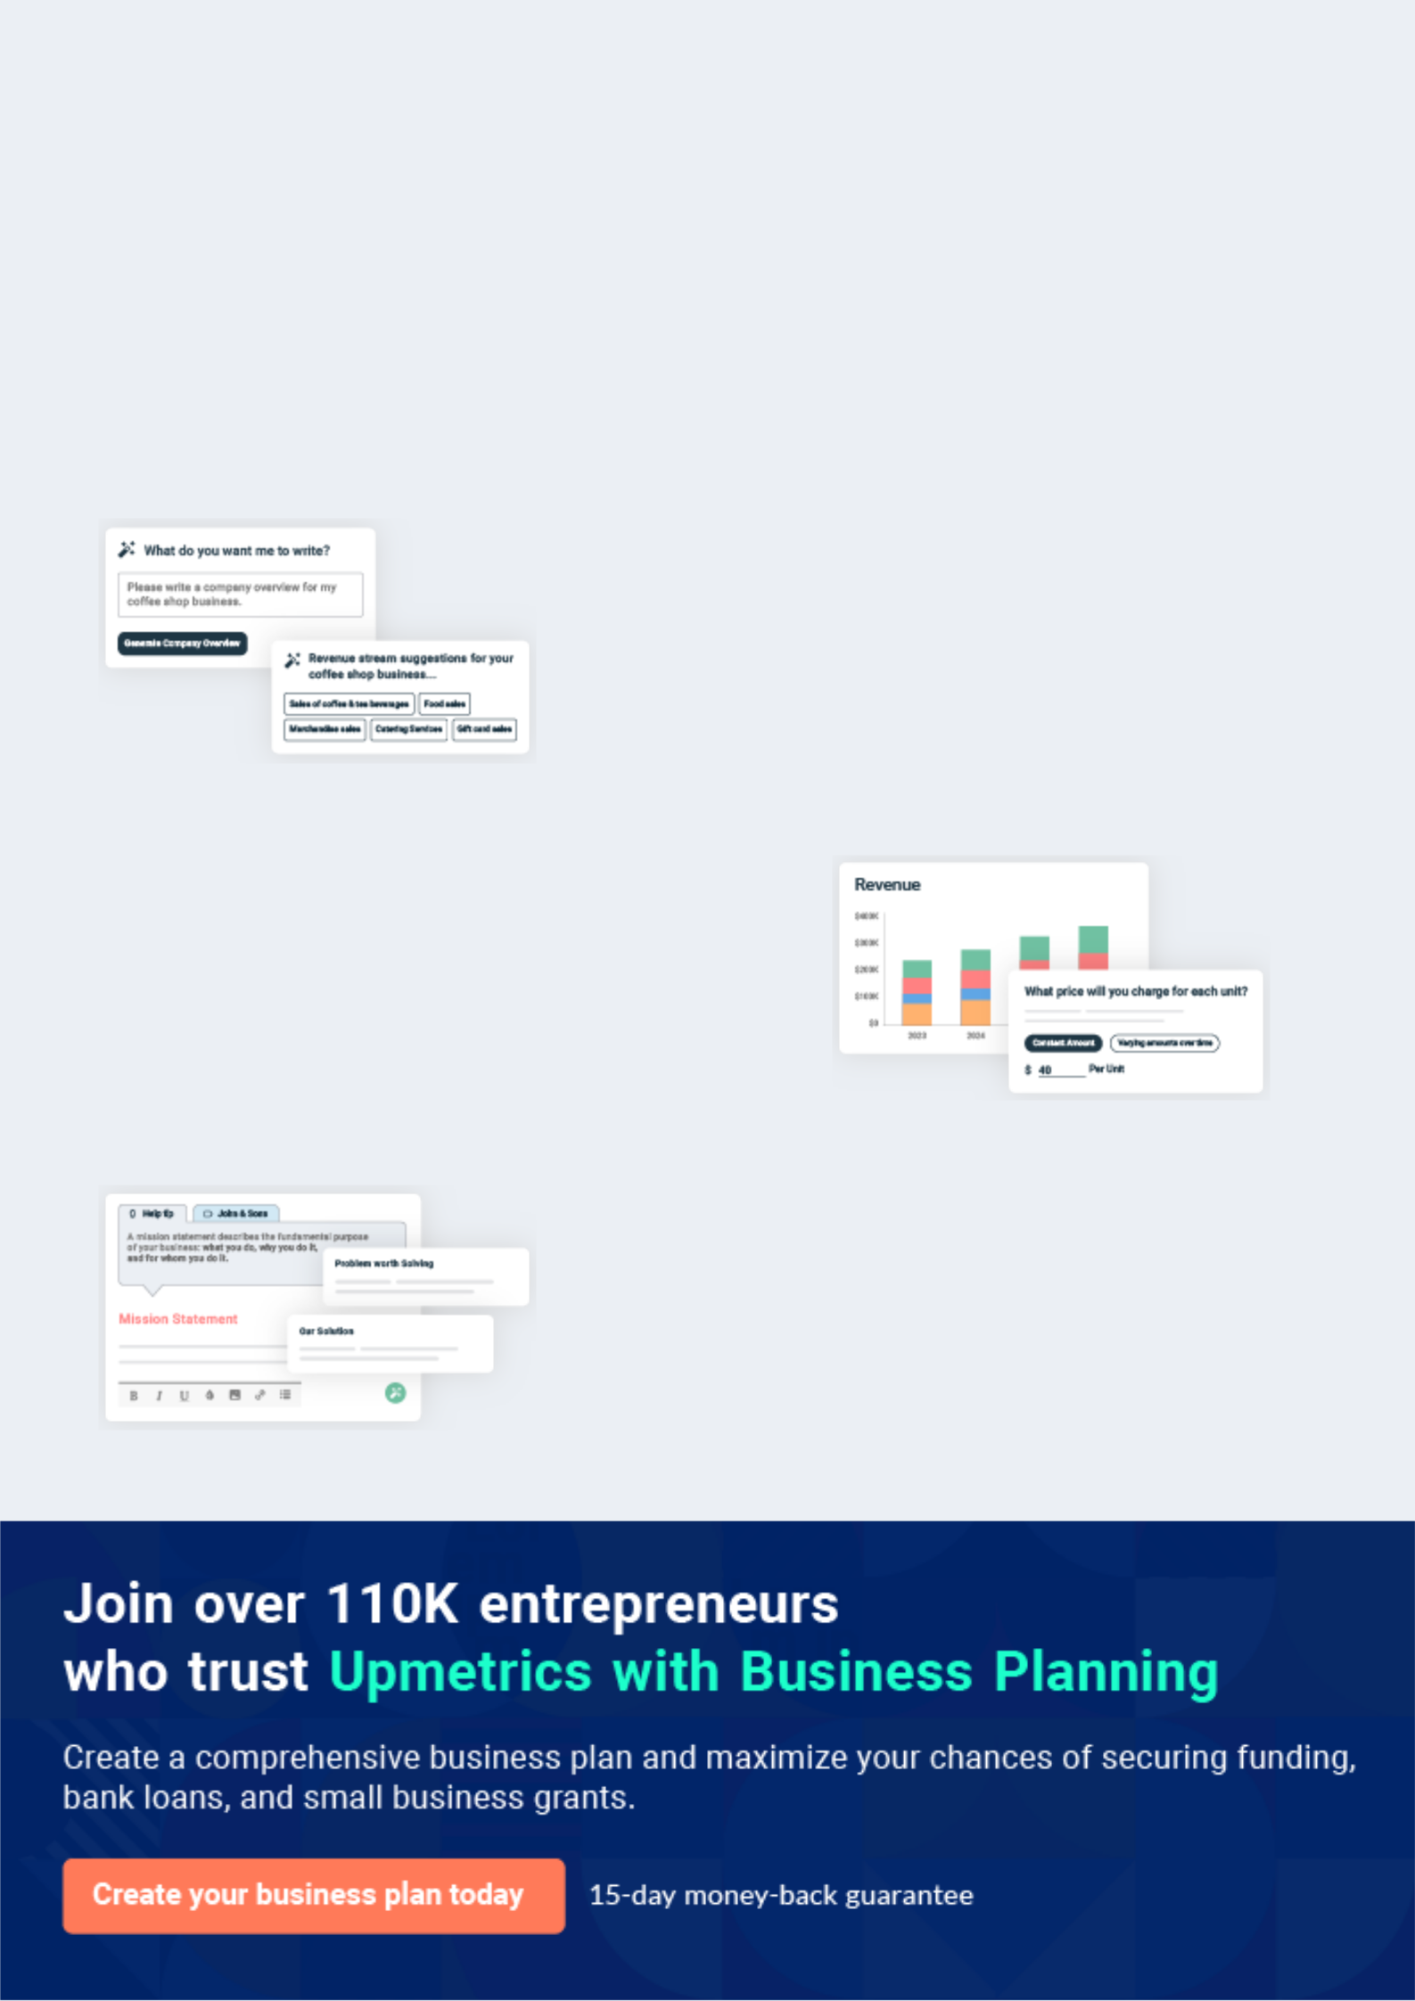
Business planning that’s simpler and faster than you think

Creating a business plan using Upmetrics to start and grow a business is literally the easiest thing in the World. Simply read the instructions and fill in the blanks. It’s as simple as that.

❛ | Upmetrics has everything you need to create a | ❜
❛ | comprehensive business plan. | ❜

AI-powered Upmetrics Assistant

AI-powered insights to streamline your plan

Not sure where to start? Upmetrics’ AI Assistant will automatically generate ideas for each section of your plan and offer improved versions of your writing, adjusting for tone, voice, and grammar or spelling errors.

Financial Forecasting Tool

All the financials are calculated for you

Forget the complex formulas and clumsy spreadsheets — with automatic financials and drag-and-drop forecasting, you can finish your plan faster and be confident that your numbers are accurate.

Business Plan Builder

Guides you like a business mentor

Upmetrics’ step-by-step instructions, prompts, and the library of 400+ sample business plans will guide you through each section of your plan as a business mentor.

1.


Executive Summary

Products & Services

Mission Statement

Vision Statement

Competition

Keys to Success

Financial Summary

Financing Needed

Dispensary | Business Plan [YEAR] 5/32

Before you think about how to start a Marijuana Dispensary services business, you must create a detailed Marijuana Dispensary services business plan. It will not only guide you in the initial phases of your startup but will also
To unlock help try Upmetrics!
To unlock help try Upmetrics! 

 Maxwell Medical Marijuana


Maxwell Medical Marijuana Dispensary Store will be located in one of the busiest streets in Detroit - Michigan, the U.S. We have been able to lease a facility for 5 years with the option of acquiring the property once the property is put up for sale.



Start writing here..

Products & Services

 Maxwell Medical Marijuana

Maxwell Medical Marijuana Dispensary Store will be involved in the retailing of medical marijuana and in the future other prescription drugs and over-the-counter drugs once we are able to secure the required license. We will also be involved in the sale of beauty products,
To unlock help try Upmetrics! 

Start writing here..

Mission Statement

 Maxwell Medical Marijuana

Our mission is to establish a first-class medical marijuana dispensary store that will not only retail medical marijuana but also make available a wide range of generic and branded prescription drugs from top pharmaceutical manufacturing brands at affordable prices to the
To unlock help try Upmetrics! 

Start writing here..

Dispensary | Business Plan [YEAR] 6/32

Vision Statement
To unlock help try Upmetrics!

 Maxwell Medical Marijuana

Our vision is to become the largest medical marijuana dispensary store in the whole of Michigan and also amongst the top 5 leading medical marijuana dispensary stores in the United States of America.



Start writing here..

Competition

 Maxwell Medical Marijuana

We have a lot of competition. In Eugene OR there are 28 recreational marijuana shops, five medical marijuana dispensaries, and two shops selling recreational and medical marijuana. They are all situated downtown where the city has said that it is legal to have the shop. They
To unlock help try Upmetrics! 

Start writing here..

Keys to Success

 Maxwell Medical Marijuana

Our keys to success are:

• name and brand recognition
To unlock help try Upmetrics! 

Start writing here..

Dispensary | Business Plan [YEAR] 7/32

Financial Summary
To unlock help try Upmetrics!

3 Year profit forecast
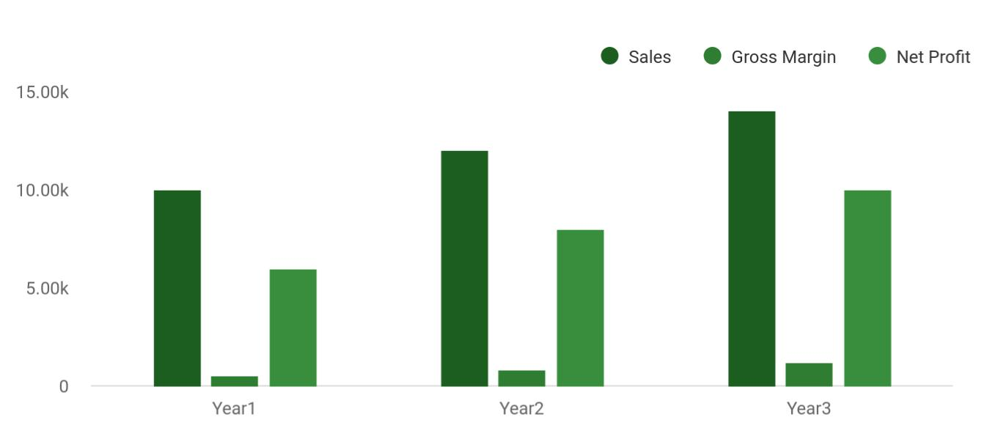

 Maxwell Medical Marijuana


Financial Summary | Year 1 | Year 2 |  | Year 3
 |  |  | To unlock help try Upmetrics! |  | 

Start writing here..

Financing Needed

 Maxwell Medical Marijuana

We’re projecting an estimated $120,000 owner investment needed to finance this business through its early stages. That’s not counting some lower-than-normal salaries as well, during the first year.



Start writing here..

Dispensary | Business Plan [YEAR] 8/32

2.

Company Summary

Business Structure

Team

Startup summary

Dispensary | Business Plan [YEAR] 9/32

 Maxwell Medical Marijuana
Year3
To unlock help try Upmetrics!
To unlock help try Upmetrics!

Maxwell Medical Marijuana Dispensary Store is a family business that is owned and managed by John Moore and their Family. Mrs. John Moore is going to be the Chief Executive Officer of
the business; she has a first Degree in Pharmacy and an MBA from Harvard University. She has
To unlock help try Upmetrics! 

Start writing here..

Business Structure

 Maxwell Medical Marijuana

Maxwell Medical Marijuana Dispensary Store is a business that will be built on a solid foundation. From the outset, we have decided to recruit only qualified people to man various job positions in our organization. We are quite aware of the rules and regulations governing the
To unlock help try Upmetrics! 

Start writing here..

Team

 Maxwell Medical Marijuana

For this initial time frame at least, this is an owner-operated business with additional salaried help from a security guard and a second expert. We may need part-time help as we grow. The plan includes some additional spending on salary later on.



Management Team

Start writing here..

 Maxwell Medical Marijuana


Year1

Year2



Dispensary | Business Plan [YEAR] 10/32

Personnel Table

Start writing here..

Startup summary

Startup cost
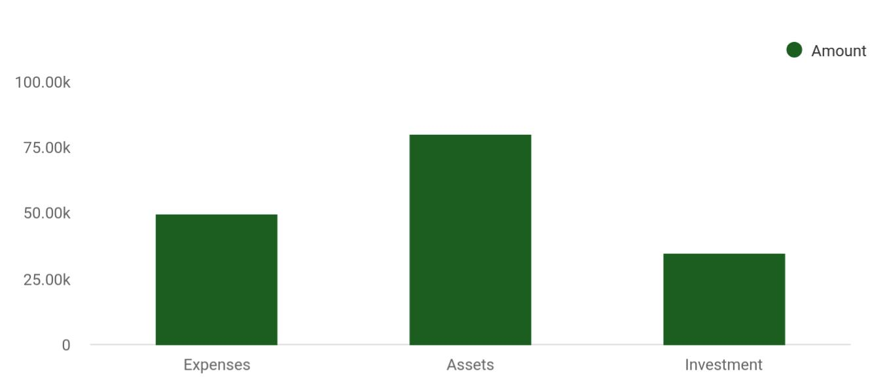

Cost distribution | Amount
Expenses | 50,000
Assets | 80,000
Investment | 35,000

Start-up Expenses | Amount
Legal | $75,500
Consultants | $0
Insurance | $62,750
Rent | $22,500
Research and Development | $42,750
Expensed Equipment | $42,750
Signs | $1,250
TOTAL START-UP EXPENSES | $247,500
Start-up Assets | $0

Dispensary | Business Plan [YEAR] 11/32

Start-up Expenses | Amount
Cash Required | $322,500
Start-up Inventory | $52,625
Other Current Assets | $222,500
Long-term Assets | $125,000
TOTAL ASSETS | $121,875
Total Requirements | $245,000
START-UP FUNDING | $0
START-UP FUNDING | $273,125
Start-up Expenses to Fund | $121,875
Start-up Assets to Fund | $195,000
TOTAL FUNDING REQUIRED | $0
Assets | $203,125
Non-cash Assets from Start-up | $118,750
Cash Requirements from Start-up | $0
Additional Cash Raised | $118,750
Cash Balance on Starting Date | $121,875
TOTAL ASSETS | $0
Liabilities and Capital | $0
Liabilities | $0
Current Borrowing | $0
Long-term Liabilities | $0
Accounts Payable (Outstanding Bills) | $0
Other Current Liabilities (interest-free) | $0
TOTAL LIABILITIES | $0
Capital | $0
Planned Investment | $0
Investor 1 | $312,500
Investor 2 | $0

Dispensary | Business Plan [YEAR] 12/32

Start-up Expenses | Amount
Other | $0
Additional Investment Requirement | $0
TOTAL PLANNED INVESTMENT | $695,000
Loss at Start-up (Start-up Expenses) | $313,125
TOTAL CAPITAL | $221,875
TOTAL CAPITAL AND LIABILITIES | $221,875
Total Funding | $265,000

Dispensary | Business Plan [YEAR] 13/32

3.

Products and services

Dispensary | Business Plan [YEAR] 14/32

 Maxwell Medical Marijuana

Aside from the dispensary of medical marijuana which is our core product, Maxwell Medical Marijuana Dispensary Store will in future also retail a wide range of prescription drugs from different manufacturing brands to customers who are based in Detroit Michigan, and every
To unlock help try Upmetrics! 

Start writing here..
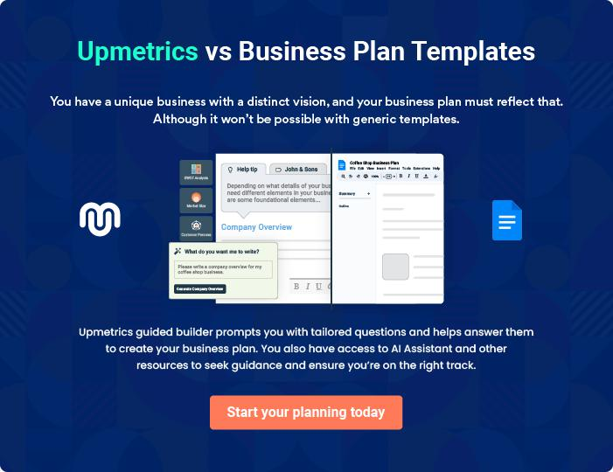

Dispensary | Business Plan [YEAR] 15/32

4.

Market Analysis

Market Trends

Target Market

Dispensary | Business Plan [YEAR] 16/32

The most important component of an effective Marijuana Dispensary services business plan is its accurate marketing analysis. If you are starting on a smaller scale, you can do marketing analysis yourself by taking help
To unlock help try Upmetrics! 

Market Trends

 Maxwell Medical Marijuana

The market trend in the retail pharmacy industry under which medical marijuana dispensary business falls under is directly influenced by a country’s healthcare reform policies. The fact
that the pharmaceutical industry is highly regulated means that any entrepreneur who wants to
To unlock help try Upmetrics! 

Start writing here..

Target Market

 Maxwell Medical Marijuana

Maxwell Medical Marijuana Dispensary Store is in business to service a wide range of customers in Baltimore, Maryland. We will ensure that we target self-pay customers (who do not have drug plans), mail order customers, and walk-in customers, and what have you.
To unlock help try Upmetrics! 

Start writing here..

Dispensary | Business Plan [YEAR] 17/32

5.

Strategy &

Implementations

Sales Plan

Marketing Plan

Pricing Strategy

Milestones & Metrics

Dispensary | Business Plan [YEAR] 18/32

After identifying the market demand, market trends, and the potential customers of the startup, the next step is to define an effective strategy for attracting those customers. Like marketing analysis, sales strategy is also an
To unlock help try Upmetrics! 

Sales Plan

 Maxwell Medical Marijuana

Our Sales plan is:

• We will have a website and a blog to promote customer knowledge
To unlock help try Upmetrics! 

Start writing here..

Marketing Plan

 Maxwell Medical Marijuana

Pot’s image problem has since begun to fade, especially in states like Michigan and Colorado. Two more states, Oregon and Alaska, have legalized the recreational use of marijuana, and several others may soon have the opportunity to join them. But the people who sell the drug are
To unlock help try Upmetrics! 

Start writing here..

 Maxwell Medical Marijuana

We will join the conversation and point customers towards knowledgeable people and blogs as well as our own. We will keep up with the most popular products for those who like to get high.
To unlock help try Upmetrics! 

Twitter

Start writing here..

Dispensary | Business Plan [YEAR] 19/32

 Maxwell Medical Marijuana
To unlock help try Upmetrics!
To unlock help try Upmetrics!

Write about our experiences and recommendations. We will also sign ourselves up and contribute to leafly.com. This is a database that will help those who are looking for cannabis find us.



Blog

Start writing here..

 Maxwell Medical Marijuana

Show our most popular buds as well as the best edible recipes



Facebook

Start writing here..

 Maxwell Medical Marijuana

We will give influencers discounts so they can try our product and see it is in fact what they are looking for. This will allow them to say with certainty we have the best products on the market.
To unlock help try Upmetrics! 

Promotions

Start writing here..

 Maxwell Medical Marijuana

Never underestimate the simplicity of remembering people and making them feel at home in your store.
To unlock help try Upmetrics! 

We make the customer feel comfortable

Start writing here..

Dispensary | Business Plan [YEAR] 20/32

Pricing Strategy

 Maxwell Medical Marijuana

It would be really wrong to go ahead and fix pricing without first determining other factors that surround costing.
To unlock help try Upmetrics! 

Start writing here..

Milestones & Metrics

 Maxwell Medical Marijuana


To unlock help try Upmetrics! 

Start writing here..

Dispensary | Business Plan [YEAR] 21/32

6.

Financial Plan

Important Assumptions

Brake-even Analysis

Projected Profit and Loss

Projected Cash Flow

Projected Balance Sheet

Business Ratios

Dispensary | Business Plan [YEAR] 22/32

The last component of the Marijuana Dispensary services business plan is an in-depth financial plan. The financial plan crafts a detailed map of all the expenses needed for the startup and how these expenses will be met by the
To unlock help try Upmetrics! 

 Maxwell Medical Marijuana

The company will be financed by John himself and he will control the direction of the business to make sure that it is expanding at the forecasted rate. As for the Marijuana Dispensary services business start-up, no equity funding or outside loans will be required. With the help of
To unlock help try Upmetrics! 

Start writing here..

Important Assumptions

The financial projections of the company are forecast on the basis of the following assumptions. These assumptions are quite conservative and are expected to show deviation but to a limited level such that the company’s major financial strategy will not be affected.

 | Year 1 | Year 2 | Year 3
Plan Month | 1 | 2 | 3
Current Interest Rate | 10,00% | 11,00% | 12,00%
Long-term Interest Rate | 10,00% | 10,00% | 10,00%
Tax Rate | 26,42% | 27,76% | 28,12%
Other | 0 | 0 | 0

Brake-even Analysis

Monthly Units Break-even | 5530
Monthly Revenue Break-even | $159 740
Assumptions:
Average Per-Unit Revenue | $260,87
Average Per-Unit Variable Cost | $0,89
Estimated Monthly Fixed Cost | $196 410

Dispensary | Business Plan [YEAR] 23/32

Projected Profit and Loss

 | 2024 | 2025 | 2026
Revenue | $800,037.50 | $1,292,852.50 | $2,333,600.20
Product Sales | $404,037.50 | $871,532.50 | $1,885,249
Unit Sales | 8,081 | 17,431 | 37,705
Unit Price | $50 | $50 | $50
Consultation Services | $60,000 | $61,800 | $63,660
Unit Sales | 600 | 618 | 637
Unit Price | $100 | $100 | $100
Online Sales | $336,000 | $359,520 | $384,691.20
Unit Sales | 4,200 | 4,494 | 4,809
Unit Price | $80 | $80 | $80

Cost Of Sales | $414,904.11 | $593,165.89 | $871,539.89
General Costs | $414,904.11 | $593,165.89 | $871,539.89
Product Acquisition | $323,842.49 | $469,331.35 | $693,669.42
Marijuana Purchase | $283,840.59 | $404,688.70 | $576,989.38
Medical Accessories | $40,001.90 | $64,642.65 | $116,680.04
Purchase | $40,001.90 | $64,642.65 | $116,680.04
Operational Supplies | $91,061.62 | $123,834.54 | $177,870.47
Packaging Materials | $67,060.47 | $85,048.94 | $107,862.48
Utility Costs for Storage | $24,001.15 | $38,785.60 | $70,007.99
Revenue Specific Costs | $0 | $0 | $0
Personnel Costs (Direct | $0 | $0 | $0
Labor) | $0 | $0 | $0

Gross Margin | $385,133.39 | $699,686.61 | $1,462,060.31

Dispensary | Business Plan [YEAR] 24/32

 | 2024 | 2025 | 2026
Gross Margin (%) | 48.14% | 54.12% | 62.65%

Operating Expense | $586,001.90 | $627,922.65 | $697,809.01
Payroll Expense (Indirect | $450,000 | $463,500 | $477,405.24
Labor) | $450,000 | $463,500 | $477,405.24
Dispensary Staff | $202,500 | $208,575 | $214,832.40
Dispensary Manager | $67,500 | $69,525 | $71,610.72
Sales Associates | $135,000 | $139,050 | $143,221.68
Administrative Staff | $97,500 | $100,425 | $103,437.72
Accountant | $60,000 | $61,800 | $63,654
Administrative Assistant | $37,500 | $38,625 | $39,783.72
Security and Maintenance | $150,000 | $154,500 | $159,135.12
Security Guard | $105,000 | $108,150 | $111,394.56
Maintenance Staff | $45,000 | $46,350 | $47,740.56
General Expense | $136,001.90 | $164,422.65 | $220,403.77
Facility Expenses | $66,000 | $68,760 | $71,647.20
Rent | $48,000 | $50,400 | $52,920
Utilities | $18,000 | $18,360 | $18,727.20
Marketing and Advertising | $48,001.15 | $63,505.60 | $95,469.59
Digital Marketing | $24,001.15 | $38,785.60 | $70,007.99
Print Advertising | $24,000 | $24,720 | $25,461.60
Operational Costs | $22,000.75 | $32,157.05 | $53,286.98
CRM Software License | $6,000 | $6,300 | $6,615
Shipping Costs | $16,000.75 | $25,857.05 | $46,671.98
Bad Debt | $0 | $0 | $0

Dispensary | Business Plan [YEAR] 25/32

Amortization of Current Assets

EBITDA

Additional Expense

Long Term Depreciation

Gain or loss from Sale of Assets

EBIT

Interest Expense

EBT

Income Tax Expense / Benefit

Total Expense

Net Income

Net Income (%)

Retained Earning Opening

Owner's Distribution

Retained Earning Closing

2024 | 2025 | 2026
$0 | $0 | $0

($200,868.52) $71,763.96 $764,251.30

$22,634.92 | $21,249.29 | $19,792.76
$15,750 | $15,750 | $15,750
$0 | $0 | $0
($216,618.52) | $56,013.96 | $748,501.30
$6,884.93 | $5,499.30 | $4,042.77
($223,503.44) | $50,514.67 | $744,458.54
$0 | $0 | $0

$1,023,540.94 | $1,242,337.83 | $1,589,141.66
($223,503.44) | $50,514.67 | $744,458.54
(27.94%) | 3.91% | 31.90%

$0 | ($233,003.44) | ($188,488.77)
$9,500 | $6,000 | $6,000
($233,003.44) | ($188,488.77) | $549,969.77

Dispensary | Business Plan [YEAR] 26/32

Projected Cash Flow

 | 2024 | 2025 | 2026
Cash Received | $800,037.50 | $1,292,852.50 | $2,333,600.20
Cash Paid | $1,007,790.95 | $1,226,587.82 | $1,573,391.66
COS & General Expenses | $550,906.03 | $757,588.53 | $1,091,943.66
Salary & Wages | $450,000 | $463,500 | $477,405.24
Interest | $6,884.93 | $5,499.30 | $4,042.77
Sales Tax | $0 | $0 | $0
Income Tax | $0 | $0 | $0
Net Cash From | ($207,753.45) | $66,264.68 | $760,208.54
Operations | ($207,753.45) | $66,264.68 | $760,208.54
Assets Sell | $0 | $0 | $0
Assets Purchase | $125,000 | $0 | $0
Net Cash From | ($125,000) | $0 | $0
Investments | ($125,000) | $0 | $0
Amount Received | $350,000 | $0 | $0
Loan Received | $150,000 | $0 | $0
Common Stock | $200,000 | $0 | $0
Preferred Stock | $0 | $0 | $0
Owner's Contribution | $0 | $0 | $0
Amount Paid | $36,583.36 | $34,468.99 | $35,925.52
Loan Capital | $27,083.35 | $28,468.98 | $29,925.51
Dividends & Distributions | $9,500 | $6,000 | $6,000
Net Cash From | $313,416.64 | ($34,468.99) | ($35,925.52)
Financing | $313,416.64 | ($34,468.99) | ($35,925.52)

Dispensary | Business Plan [YEAR] 27/32

 | 2024 | 2025 | 2026
Summary
Starting Cash | $0 | ($19,336.81) | $12,458.88
Cash In | $1,150,037.50 | $1,292,852.50 | $2,333,600.20
Cash Out | $1,169,374.31 | $1,261,056.81 | $1,609,317.18
Change in Cash | ($19,336.81) | $31,795.69 | $724,283.02
Ending Cash | ($19,336.81) | $12,458.88 | $736,741.90
Projected Balance Sheet
 | 2024 | 2025 | 2026
Assets | $89,913.19 | $105,958.88 | $814,491.90
Current Assets | ($19,336.81) | $12,458.88 | $736,741.90
Cash | ($19,336.81) | $12,458.88 | $736,741.90
Accounts Receivable | $0 | $0 | $0
Inventory | $0 | $0 | $0
Other Current Assets | $0 | $0 | $0
Long Term Assets | $109,250 | $93,500 | $77,750
Gross Long Term Assets | $125,000 | $125,000 | $125,000
Accumulated Depreciation | ($15,750) | ($31,500) | ($47,250)
Liabilities & Equity | $89,913.21 | $105,958.90 | $814,491.93
Liabilities | $122,916.65 | $94,447.67 | $64,522.16
Current Liabilities | $28,468.98 | $29,925.51 | $0
Accounts Payable | $0 | $0 | $0
Income Tax Payable | $0 | $0 | $0

Dispensary | Business Plan [YEAR] 28/32

 | 2024 |  |  | 2025 |  | 2026
Sales Tax Payable | $0 |  |  | $0 |  | $0
Short Term Debt | $28,468.98 |  | $29,925.51 |  |  | $0
Long Term Liabilities | $94,447.67 |  | $64,522.16 |  |  | $64,522.16
Long Term Debt | $94,447.67 |  | $64,522.16 |  |  | $64,522.16
Equity | ($33,003.44) |  | $11,511.23 |  |  | $749,969.77
Paid-in Capital | $0 |  |  | $0 |  | $0
Common Stock | $200,000 |  |  | $200,000 |  | $200,000
Preferred Stock | $0 |  |  | $0 |  | $0
Owner's Contribution | $0 |  |  | $0 |  | $0
Retained Earnings | ($233,003.44) |  | ($188,488.77) |  |  | $549,969.77
Check | $0 |  |  | $0 |  | $0
Business Ratios
 |  | Year 1 | Year 2 |  | Year 3 | Industry Profile
Sales Growth |  | 4,35% | 30,82% |  | 63,29% | 4,00%
Percent of Total Assets
Accounts Receivable |  | 5,61% | 4,71% |  | 3,81% | 9,70%
Inventory |  | 1,85% | 1,82% |  | 1,79% | 9,80%
Other Current Assets |  | 1,75% | 2,02% |  | 2,29% | 27,40%
Total Current Assets |  | 138,53% | 150,99% |  | 163,45% | 54,60%
Long-term Assets |  | -9,47% | -21,01% |  | -32,55% | 58,40%
TOTAL ASSETS |  | 100,00% | 100,00% |  | 100,00% | 100,00%
Current Liabilities |  | 4,68% | 3,04% |  | 2,76% | 27,30%
Long-term Liabilities |  | 0,00% | 0,00% |  | 0,00% | 25,80%
Total Liabilities |  | 4,68% | 3,04% |  | 2,76% | 54,10%

Dispensary | Business Plan [YEAR] 29/32

 | Year 1 | Year 2 | Year 3 | Industry Profile
NET WORTH | 99,32% | 101,04% | 102,76% | 44,90%
Percent of Sales
Sales | 100,00% | 100,00% | 100,00% | 100,00%
Gross Margin | 94,18% | 93,85% | 93,52% | 0,00%
Selling, General & Administrative Expenses | 74,29% | 71,83% | 69,37% | 65,20%
Advertising Expenses | 2,06% | 1,11% | 0,28% | 1,40%
Profit Before Interest and Taxes | 26,47% | 29,30% | 32,13% | 2,86%
Main Ratios
Current | 25,86 | 29,39 | 32,92 | 1,63
Quick | 25,4 | 28,88 | 32,36 | 0,84
Total Debt to Total Assets | 2,68% | 1,04% | 0,76% | 67,10%
Pre-tax Return on Net Worth | 66,83% | 71,26% | 75,69% | 4,40%
Pre-tax Return on Assets | 64,88% | 69,75% | 74,62% | 9,00%
Additional Ratios
Net Profit Margin | 19,20% | 21,16% | 23,12% | N.A.
Return on Equity | 47,79% | 50,53% | 53,27% | N.A.
Activity Ratios
Accounts Receivable Turnover | 4,56 | 4,56 | 4,56 | N.A.
Collection Days | 92 | 99 | 106 | N.A.
Inventory Turnover | 19,7 | 22,55 | 25,4 | N.A.
Accounts Payable Turnover | 14,17 | 14,67 | 15,17 | N.A.
Payment Days | 27 | 27 | 27 | N.A.
Total Asset Turnover | 1,84 | 1,55 | 1,26 | N.A.
Debt Ratios
Debt to Net Worth | 0 | -0,02 | -0,04 | N.A.
Current Liab. to Liab. | 1 | 1 | 1 | N.A.
Liquidity Ratios
Net Working Capital | $120 943 | $140 664 | $160 385 | N.A.

Dispensary | Business Plan [YEAR] 30/32

 | Year 1 | Year 2 | Year 3 | Industry Profile
Interest Coverage | 0 | 0 | 0 | N.A.
Additional Ratios
Assets to Sales | 0,45 | 0,48 | 0,51 | N.A.
Current Debt/Total Assets | 4% | 3% | 2% | N.A.
Acid Test | 23,66 | 27,01 | 30,36 | N.A.
Sales/Net Worth | 1,68 | 1,29 | 0,9 | N.A.
Dividend Payout | 0 | 0 | 0 | N.A.
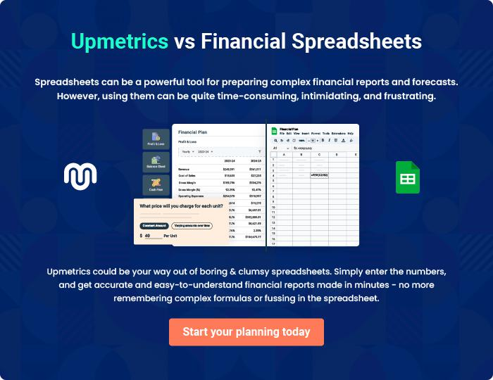

Dispensary | Business Plan [YEAR] 31/32


Create a winning business plan that gets you funded

Creating a stunning and investment-ready plan requires no writing, graphic designing, or financial planning expertise.

Upmetrics has all the features required to help you create a comprehensive business plan—from start to finish. Make no mistakes, it’s the modern way of planning to structure ideas, make plans, and create stunning pitch decks to awe investors.

Pitch decks that impress investors

Create pitch decks that provide a visual representation of your business, engage investors, and make them want to invest in your business idea.

Interactive plans in no time

Import business plan sections like—SWOT analysis, comparison tables, and others to create an interactive business plan. No designing skills are required.

Stunning cover page designs

With Upmetrics, you have the liberty to choose from multiple stunning cover page designs. Choose a creative design and make your plan stand out.

Online sharing made simple

Upmetrics makes online sharing quick and easier for users. Easily share your business plans with a link while tracking reader activity.

500+ sample business plans

Simply import a template from our library of sample plans into the editor and start customizing it to make it yours. It takes only a few clicks to get started.

Collaborate with team in real-time

Invite team members, initiate conversations, discuss ideas & strategies, share feedback, and work on a business plan in real-time.

