 Digital Marketing


Business Plan

[YEAR]


Original.. Fearless.. Independent..

Information provided in this business plan is unique to this business and confidential; therefore, anyone reading this plan agrees not to disclose any of the information in this business plan without prior written permission of the Company

Prepared By

John Doe

10200 Bolsa Ave, Westminster, CA, 92683

info@example.com

(650) 359-3153 http://www.example.com

Table of Contents

Executive Summary | 5
Introduction | 6
Mission Statement | 6
Vision Statement | 6
Keys to Success | 7
Objectives | 7
Financial Highlights | 7
3 Year profit forecast | 8

Business Summary | 9
Company Ownership | 10
Startup Summary | 10
Startup | 11

Products and Services | 13
Services | 14
SWOT Analysis
SWOT Analysis | 17
Market Analysis
Market Analysis | 19
Market Trends | 20
Target Market | 20
Competitive advantage | 20
Strategy
Strategy | 21
Pricing Strategy | 22
Payment Options | 22
Publicity and Advertising Strategy | 23
Sales Forecast | 23
Sales Yearly | 23
Detailed Sales Forecast | 24

Digital Marketing | Business Plan [YEAR] 2/39

Management Plan | 26
Personnel Plan | 27
Average Salaries | 27
Financial Plan
Financial Plan | 29
Important Assumptions | 30
Brake-even Analysis | 30
Projected Profit and Loss | 31
Projected Cash Flow | 34
Projected Balance Sheet | 35
Business Ratios | 36

Digital Marketing | Business Plan [YEAR] 3/39

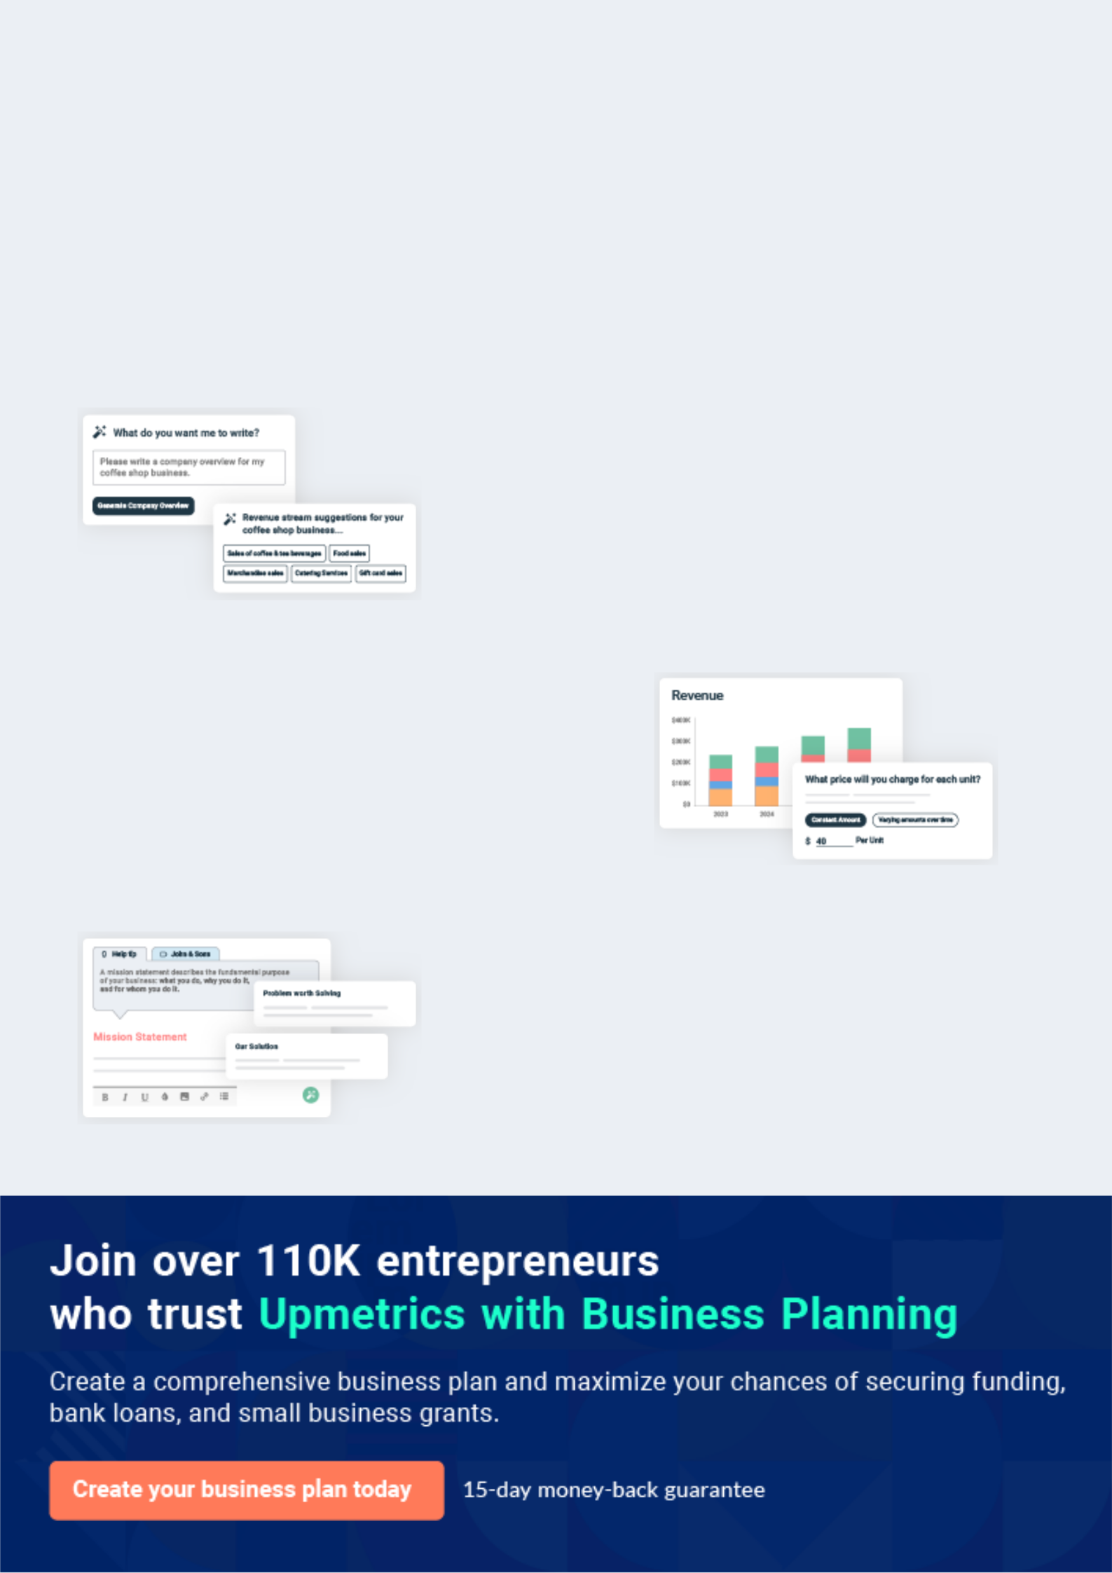
Business planning that’s simpler and faster than you think

Creating a business plan using Upmetrics to start and grow a business is literally the easiest thing in the World. Simply read the instructions and fill in the blanks. It’s as simple as that.

❛ | Upmetrics has everything you need to create a | ❜
❛ | comprehensive business plan. | ❜

AI-powered Upmetrics Assistant

AI-powered insights to streamline your plan

Not sure where to start? Upmetrics’ AI Assistant will automatically generate ideas for each section of your plan and offer improved versions of your writing, adjusting for tone, voice, and grammar or spelling errors.

Financial Forecasting Tool

All the financials are calculated for you

Forget the complex formulas and clumsy spreadsheets — with automatic financials and drag-and-drop forecasting, you can finish your plan faster and be confident that your numbers are accurate.

Business Plan Builder

Guides you like a business mentor

Upmetrics’ step-by-step instructions, prompts, and the library of 400+ sample business plans will guide you through each section of your plan as a business mentor.

1.


Executive Summary

Introduction

Mission Statement

Vision Statement

Keys to Success

Objectives

Financial Highlights

Digital Marketing | Business Plan [YEAR] 5/39

Before you think about how to start a Digital Marketing Agency, you must create a detailed Digital Marketing Agency business plan. It will not only
To unlock help try Upmetrics!
To unlock help try Upmetrics!
guide you in the initial phases of your startup but will also help you later on.
To unlock help try Upmetrics! 

Introduction

 Web Spice Consultancy


Web Spice Consultancy is a U.S based and world-class digital marketing agency. We have been able to secure a standard and well – positioned office facility in a central business district in Cape May – New Jersey.



Start writing here..

Mission Statement

 Web Spice Consultancy

Our mission is to provide professional and highly creative result-oriented digital marketing services and other related advisory and consulting services that will assist businesses,
individuals, and non-profit organizations in promoting their brands and reaching out to a wide
To unlock help try Upmetrics! 

Start writing here..

Vision Statement

 Web Spice Consultancy

Our vision is to establish a standard and world-class digital marketing agencies whose services and brand will not only be accepted in the United States of America but also in other parts of the world.



Start writing here..

Digital Marketing | Business Plan [YEAR] 6/39

Keys to Success

 Web Spice Consultancy

The following keys to success will be observed for the digital marketing agency business plan in the United States:
To unlock help try Upmetrics! 

Start writing here..

Objectives

 Web Spice Consultancy

To build a well – structured advertising agency that can compete in the highly competitive advertising agencies in the United States
To unlock help try Upmetrics! 

Start writing here..

Financial Highlights

 Web Spice Consultancy

The company is seeking $2.5 million of financing to fund the acquisition of Vihaan Advertising and its initial operations. This funding will cover the purchase of Vihaan Advertising, marketing, purchase of extra software, and hardware. Projected revenues for 2021 to 2023 are $200,000,
To unlock help try Upmetrics! 

Start writing here..

Digital Marketing | Business Plan [YEAR] 7/39

3 Year profit forecast
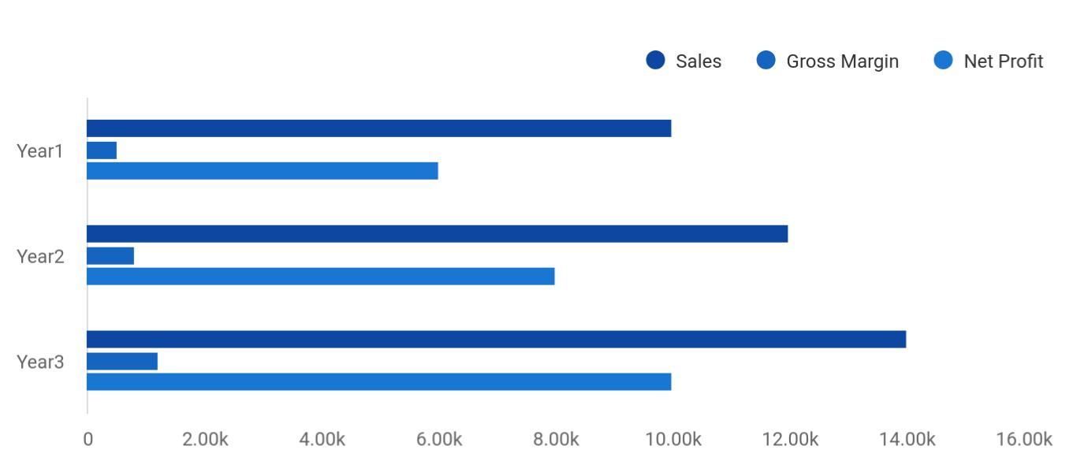

Financial Year | Sales | Gross Margin | Net Profit
Year1 | 10,000 | 500 | 6,000
Year2 | 12,000 | 800 | 8,000
Year3 | 14,000 | 1,200 | 10,000

Digital Marketing | Business Plan [YEAR] 8/39

2.

Business Summary

Company Ownership

Startup Summary

Digital Marketing | Business Plan [YEAR] 9/39

 Web Spice Consultancy
To unlock help try Upmetrics!

Web Spice Consultancy is a U.S based and world-class marketing agency that will be located in Cape May – New Jersey. We have been able to secure a standard and well – positioned office facility in a central business district in Cape May. We are a digital marketing agency that is set
To unlock help try Upmetrics! 

Start writing here..

Company Ownership

 Web Spice Consultancy

Web Spice Consultancy is founded by Rooney Wilberforce and his friend and business partner for many years Festus Holloway. They both graduated from Illinois Institute of Technology with BSc in Business Administration and they have a combined experience that revolves around
To unlock help try Upmetrics! 

Start writing here..

Startup Summary

 Web Spice Consultancy

Rooney Wilberforce and Festus Holloway will invest equally in the company. They will also secure a long-term business loan. The following table and chart show the projected initial start-up costs of Web Spice Consultancy.



Start writing here..

Digital Marketing | Business Plan [YEAR] 10/39

Startup
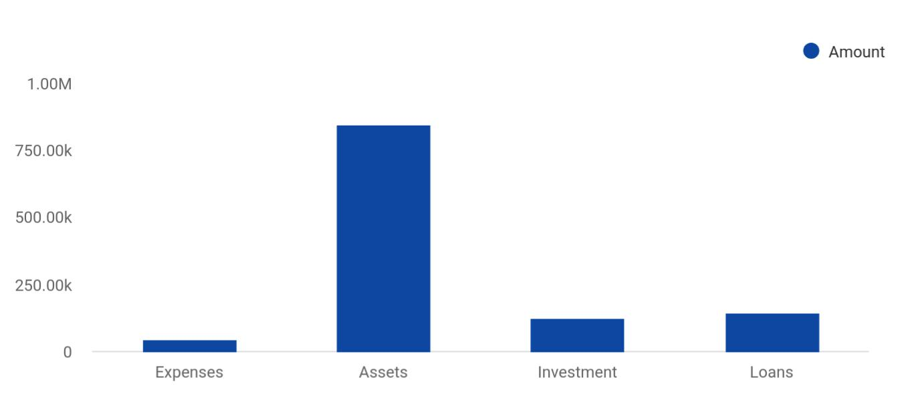

Category | Amount
Expenses | 45,124
Assets | 845,411
Investment | 124,511
Loans | 145,212

STARTUP | AMOUNT
Startup Expenses
Legal | $1,000
Stationery etc. | $1,000
Brochures | $1,000
Advertising | $20,000
Expensed Computer Equipment/Software | $10,000
Insurance | $0
Rent | $1,500
Research and Development | $0
Other | $0
TOTAL STARTUP EXPENSES | $34,500
Startup Assets

Digital Marketing | Business Plan [YEAR] 11/39

STARTUP | AMOUNT
Cash Required | $155,500
Other Current Assets | $10,000
Long-term Assets | $0
TOTAL ASSETS | $165,500
Total Requirements | $200,000

Digital Marketing | Business Plan [YEAR] 12/39

3.

Products and Services

Services

Digital Marketing | Business Plan [YEAR] 13/39

Before starting a digital marketing agency, you must take many things into consideration such as you must consider what types of digital marketing services will you be providing to your clients. Deciding your services is
To unlock help try Upmetrics! 

 Web Spice Consultancy

Web Spice Consultancy was established with the aim of maximizing profits in the Digital Marketing Agencies industry. We want to compete favorably with the leading digital marketing agencies in the United States of America and the world which is why we have put in place a
To unlock help try Upmetrics! 

Start writing here..

Services


Search engine
Banner advertising
optimization (SEO)

Rich media
Video advertising
advertising

Sponsorship Classifieds/

advertising directories

Digital Marketing | Business Plan [YEAR] 14/39


Mobile messaging/
Lead generation
email

Digital display
Mobile advertising
advertising

Other related digital

Social media marketing advisory

management and consulting

services

Digital Marketing | Business Plan [YEAR] 15/39

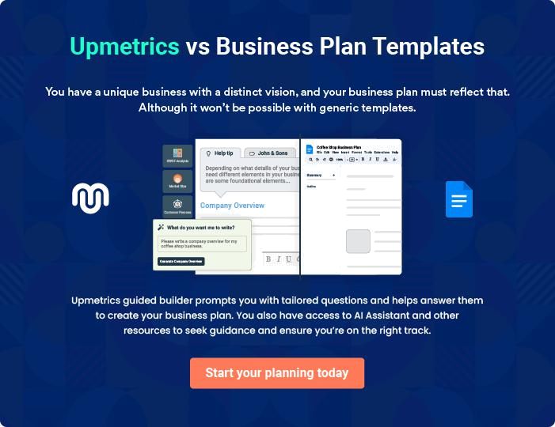

Digital Marketing | Business Plan [YEAR] | 16/39

4.

SWOT Analysis

Digital Marketing | Business Plan [YEAR] 17/39

 Web Spice Consultancy

Web Spice Consultancy engaged the services of a core professional in the area of business consulting and structuring to assist our organization in building a well – structured digital marketing business that can favorably compete in the highly competitive digital marketing
To unlock help try Upmetrics! 

Start writing here..


Strength

Our core strength lies in the power of our team; our workforce. We have a team of creative, result-driven, and highly proficient digital marketing experts, a team with excellent qualifications and experience in various niche areas in the digital marketing agencies industry and other related industry.

Aside from the synergy that exists in our carefully selected digital marketing experts, our services will be measurable, result-driven, and guided by best practices in the industry.


Weakness

As a new digital marketing agency in Cape May – New Jersey, it might take some time for our organization to break into the market and gain acceptance especially from top profile clients in the already saturated and highly competitive digital marketing agencies industry; that is perhaps our major weakness.

Another weakness is that we may not have the required cash to pump into promoting our business especially via mainstream media (TV, Radio and Newspapers, etc) the way we would want to.


Opportunity

No doubt, the opportunities available in the digital marketing agencies industry is massive considering the number of individuals and corporate organizations with an active presence on the internet and of course the pretty large numbers of people who visit the internet / social media platforms on a daily basis and own mobile phones/smartphones and other related gadgets.

As a standard and world-class digital marketing agency, we are ready to take advantage of any opportunity that is available in the industry.

Threat

Just like any other business, one of the major threats that we are likely going to face is an economic downturn. It is a fact that an economic downturn affects purchasing/ spending power. Another threat that may likely confront us is the arrival of a digital marketing agency or even a social media marketing company in the same location where our target market exists and who may want to adopt the same Business model as us.

Digital Marketing | Business Plan [YEAR] 18/39

5.

Market Analysis

Market Trends

Target Market

Competitive advantage

Digital Marketing | Business Plan [YEAR] 19/39

The most important component of an effective Digital Marketing Agency business plan is its accurate market analysis. If you are starting on a smaller scale, you can do the market analysis yourself by taking help from this Digital
To unlock help try Upmetrics! 

Market Trends

 Web Spice Consultancy

No doubt, the Digital Marketing Agencies industry has benefited from the rapid switch from traditional print advertising to digital advertisements. As more consumers generate website traffic through the use of smartphones and tablets, businesses have purchased digital
To unlock help try Upmetrics! 

Start writing here..

Target Market

 Web Spice Consultancy

Before starting our digital marketing agency, we are certain that there is a wide range of both corporate and individual clients who cannot successfully run their businesses without the services and support of a standard digital marketing agency; a company that can help them
To unlock help try Upmetrics! 

Start writing here..

Competitive advantage

 Web Spice Consultancy

Surviving in the business world as a digital marketing agency requires more than your expertise, knowing how to conduct your business but also how to network with key people that matters; decision-makers that can decide who will get a contract or a business deal.
To unlock help try Upmetrics! 

Start writing here..

Digital Marketing | Business Plan [YEAR] 20/39

6.

Strategy

Pricing Strategy

Publicity and Advertising Strategy

Digital Marketing | Business Plan [YEAR] 21/39

After identifying the market demand, market trends, and the potential customers of the startup, the next step is to define an effective strategy for attracting those clients. Like marketing analysis, sales strategy is also an
To unlock help try Upmetrics!
To unlock help try Upmetrics!
To unlock help try Upmetrics!
To unlock help try Upmetrics! 

 Web Spice Consultancy

We are mindful of the fact that there is stiffer competition in the social media marketing industry; hence we have been able to hire some of the best marketing experts to handle our sales and marketing.



Start writing here..

Pricing Strategy

 Web Spice Consultancy

At Web Spice Consultancy we will keep the prices of our services below the average market rate for all of our customers by keeping our overhead low and by collecting payment in advance from corporate organizations who would hire our services.



Start writing here..

 Web Spice Consultancy

At Web Spice Consultancy, our payment policy will be all-inclusive because we are quite aware that different people prefer different payment options as it suits them. Here are the payment options that we will make available to our clients:



Payment Options

Start writing here..

Digital Marketing | Business Plan [YEAR] 22/39

Publicity and Advertising Strategy

 Web Spice Consultancy

We have been able to work with our in house brand and publicity consultants to help us map out publicity and advertising strategies that will help us walk our way into the heart of our target market. We are set to become the number one choice for both corporate clients and individual
To unlock help try Upmetrics! 

Start writing here..

 Web Spice Consultancy

The following is the sales forecast for three years. We have no cost of sales, as all of our deliverables are electronic, and our labor costs are included in the Personnel table.
To unlock help try Upmetrics! 

Sales Forecast

Start writing here..

Sales Yearly
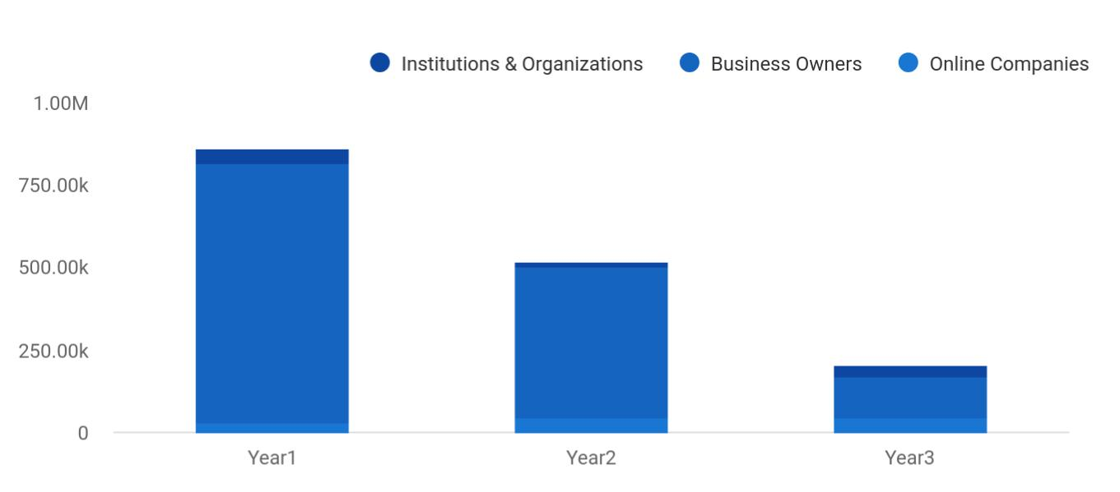

Financial Year | Institutions & Organizations | Business Owners | Online Companies
Year1 | 45,784 | 784,574 | 32,125
Year2 | 12,451 | 457,844 | 45,125
Year3 | 32,541 | 124,515 | 45,125

Digital Marketing | Business Plan [YEAR] 23/39

Detailed Sales Forecast

Detailed sales forecast data is provided in below table:

Sales Forecast | Year 1 | Year 2 | Year 3
Unit Sales
Flyers & brochures | 1,887,030 | 2,680,320 | 2,588,240
Billboards, banners & flags | 802,370 | 815,430 | 823,540
Business & invitation cards | 539,320 | 770,230 | 1,002,310
Digital advertising | 265,450 | 322,390 | 393,320
TOTAL UNIT SALES | 3,494,170 | 4,588,370 | 4,807,410
Unit Prices
Flyers & brochures | $140,00 | $150,00 | $160,00
Billboards, banners & flags | $600,00 | $800,00 | $1 000,00
Business & invitation cards | $700,00 | $800,00 | $900,00
Digital advertising | $650,00 | $750,00 | $850,00
Sales
Flyers & brochures | $2,149,800 | $2,784,000 | $3 383 200
Billboards, banners & flags | $120,050 | $194,500 | $268,500
Business & invitation cards | $50,110 | $71,600 | $93,000
Digital advertising | $139,350 | $194,600 | $249,850
TOTAL SALES
Direct Unit Costs
Flyers & brochures | $0,70 | $0,80 | $0,90
Billboards, banners & flags | $0,40 | $0,45 | $0,50
Business & invitation cards | $0,30 | $0,35 | $0,40
Digital advertising | $3,00 | $3,50 | $4,00
Direct Cost of Sales
Flyers & brochures | $989,300 | $1,839,000 | $2,679,700
Billboards, banners & flags | $66,600 | $119,900 | $173,200
Business & invitation cards | $17,900 | $35,000 | $52,100

Digital Marketing | Business Plan [YEAR] 24/39

Sales Forecast | Year 1 | Year 2 | Year 3
Digital advertising | $19,400 | $67,600 | $115,800
Subtotal Direct Cost of Sales | $1,294,100 | $1,699,400 | $2,104,700

Digital Marketing | Business Plan [YEAR] 25/39

7.

Management Plan

Personnel Plan

Average Salaries

Digital Marketing | Business Plan [YEAR] 26/39

The management plan is also an important component of a Digital Marketing Agency business plan since it gives you an estimate of the staff required for your startup as well as the costs incurred on their salaries. So, make sure to
To unlock help try Upmetrics! 

 Web Spice Consultancy

Rooney Wilberforce will be responsible for tactical elements of the marketing campaign and Festus Holloway will manage the technical aspects of the campaign.
To unlock help try Upmetrics! 

Start writing here..

Personnel Plan

 Web Spice Consultancy

As a matter of fact, a profit-sharing arrangement will be made available to all our senior management staff and it will be based on their performance for a period of five years or more as agreed by the board of trustees of the company. In view of the above, we have decided to
To unlock help try Upmetrics! 

Start writing here..

Average Salaries

Personnel Plan | Year 1 | Year 2 | Year 3
Accountant | $85 000 | $95 000 | $105 000
Receptionist | $45 000 | $50 000 | $55 000
Creative Director | $152 000 | $159 000 | $166 000
Human Resources and Admin Manager | $152 000 | $159 000 | $166 000
Sales and Marketing Executive | $152 000 | $159 000 | $166 000
Client Service Executive | $145 000 | $152 000 | $159 000
Content Creator / Online Traffic Generator | $50 000 | $55 000 | $60 000
Digital Marketing Specialist | $42 000 | $45 000 | $48 000
Web Designer cum Graphic Artist | $42 000 | $45 000 | $48 000

Digital Marketing | Business Plan [YEAR] 27/39

Personnel Plan | Year 1 | Year 2 | Year 3
Total Salaries | $304 000 | $318 000 | $332 000

Digital Marketing | Business Plan [YEAR] 28/39

8.

Financial Plan

Important Assumptions

Brake-even Analysis

Projected Profit and Loss

Projected Cash Flow

Projected Balance Sheet

Business Ratios

Digital Marketing | Business Plan [YEAR] 29/39

The last component of a Digital Marketing Agency Business plan is an in-depth financial plan. The financial plan crafts a detailed map of all the
To unlock help try Upmetrics!
expenses needed for the startup and how these expenses will be met by the
To unlock help try Upmetrics! 

 Web Spice Consultancy

The company is seeking $2.5 million of financing to fund the acquisition of Vihaan Advertising and its initial operations. This funding will cover the purchase of Vihaan Advertising, marketing, purchase of extra software, and hardware.



Start writing here..

Important Assumptions

The financial projections of the company are forecast on the basis of the following assumptions. These assumptions are quite conservative and are expected to show deviation but to a limited level such that the company’s major financial strategy will not be affected.

 | Year 1 | Year 2 | Year 3
Plan Month | 1 | 2 | 3
Current Interest Rate | 10,00% | 11,00% | 12,00%
Long-term Interest Rate | 10,00% | 10,00% | 10,00%
Tax Rate | 26,42% | 27,76% | 28,12%
Other | 0 | 0 | 0

Brake-even Analysis

Monthly Units Break-even | 5530
Monthly Revenue Break-even | $159 740
Assumptions:
Average Per-Unit Revenue | $260,87
Average Per-Unit Variable Cost | $0,89
Estimated Monthly Fixed Cost | $196 410

Digital Marketing | Business Plan [YEAR] 30/39

Projected Profit and Loss

Revenue

SEO and Content

Marketing

Users

Recurring Charges

Social Media Management Services

Users

Recurring Charges

Website Design and Development

Unit Sales

Unit Price

Cost Of Sales

General Costs

Digital Marketing Tools & Software

SEO and Analytics Tools

Social Media Management Tools

Content Creation &

Management

Freelance Content Creation

Graphic Design Software

Revenue Specific Costs

2024 | 2025 | 2026
$3,750,375 | $8,239,585 | $14,423,076.50
$2,164,053 | $4,953,984 | $8,399,117
239 | 420 | 711
$1,200 | $1,200 | $1,200
$1,156,947 | $2,806,501 | $5,266,184.50
177 | 347 | 645
$850 | $850 | $850
$429,375 | $479,100 | $757,775
172 | 192 | 303
$2,500 | $2,500 | $2,500

$1,159,908.52 | $1,597,778.57 | $2,774,493.55
$1,159,908.52 | $1,597,778.57 | $2,774,493.55
$384,140.03 | $840,582.54 | $1,462,929.79
$375,037.50 | $823,958.50 | $1,442,307.65
$9,102.53 | $16,624.04 | $20,622.14
$775,768.49 | $757,196.03 | $1,311,563.76
$768,933.89 | $746,773.51 | $1,298,076.92
$6,834.60 | $10,422.52 | $13,486.84
$0 | $0 | $0

Digital Marketing | Business Plan [YEAR] 31/39

 | 2024 | 2025 | 2026
Personnel Costs (Direct | $0 | $0 | $0
Labor) | $0 | $0 | $0

Gross Margin | $2,590,466.48 | $6,641,806.43 | $11,648,582.95
Gross Margin (%) | 69.07% | 80.61% | 80.76%

Operating Expense | $2,586,902.16 | $4,173,322.61 | $3,916,609.46
Payroll Expense (Indirect | $1,553,328 | $1,715,037.12 | $1,898,775.96
Labor) | $1,553,328 | $1,715,037.12 | $1,898,775.96
Management Team | $600,000 | $696,000 | $808,800
Marketing Director | $360,000 | $432,000 | $518,400
Operations Manager | $240,000 | $264,000 | $290,400
Creative Team | $806,400 | $866,880 | $932,400
Senior Graphic Designer | $403,200 | $423,360 | $444,528
Content Writer | $403,200 | $443,520 | $487,872
Design Team | $146,928 | $152,157.12 | $157,575.96
Graphic Designer | $64,800 | $66,744 | $68,746.32
UX/UI Designer | $82,128 | $85,413.12 | $88,829.64
General Expense | $1,033,574.16 | $2,458,285.49 | $2,017,833.50
Marketing and Advertising | $693,364.74 | $1,879,110.82 | $1,104,701.58
Online Advertising | $90,008.75 | $177,085.55 | $509,381.70
Print Media Advertising | $603,355.99 | $1,702,025.27 | $595,319.88
Office and Administrative | $141,537.19 | $221,313.27 | $304,407.88
Office Rent | $30,000 | $39,812.50 | $42,119.80
Utilities | $111,537.19 | $181,500.77 | $262,288.08
Technology and Equipment | $198,672.23 | $357,861.40 | $608,724.04

Digital Marketing | Business Plan [YEAR] 32/39

 | 2024 | 2025 | 2026
Hardware Maintenance | $3,600 | $4,320 | $4,968
Software Subscriptions | $174,897.23 | $329,583.40 | $576,923.06
Data analysis | $20,175 | $23,958 | $26,832.98
Bad Debt | $0 | $0 | $0
Amortization of Current | $0 | $0 | $0
Assets | $0 | $0 | $0

EBITDA

Additional Expense

Long Term Depreciation

Gain or loss from Sale of Assets

EBIT

Interest Expense

EBT

Income Tax Expense / Benefit

$3,564.32 $2,468,483.82 $7,731,973.49

$20,542.70 | $18,595.48 | $16,507.54
$12,996 | $12,996 | $12,996
$0 | $0 | $0
($9,431.68) | $2,455,487.82 | $7,718,977.49
$7,546.70 | $5,599.50 | $3,511.54
($16,978.38) | $2,449,888.34 | $7,715,465.95
$0 | $0 | $0

Total Expense | $3,767,353.38 | $5,789,696.66 | $6,707,610.55
Net Income | ($16,978.38) | $2,449,888.34 | $7,715,465.95
Net Income (%) | (0.45%) | 29.73% | 53.49%

Retained Earning Opening | $0 | ($101,978.38) | $2,347,909.96
Owner's Distribution | $85,000 | $0 | $0
Retained Earning Closing | ($101,978.38) | $2,347,909.96 | $10,063,375.91

Digital Marketing | Business Plan [YEAR] 33/39

Projected Cash Flow

 | 2024 | 2025 | 2026
Cash Received | $3,750,375 | $8,239,585 | $14,423,076.50
Cash Paid | $3,754,357.38 | $5,776,700.66 | $6,694,614.55
COS & General Expenses | $2,193,482.68 | $4,056,064.06 | $4,792,327.05
Salary & Wages | $1,553,328 | $1,715,037.12 | $1,898,775.96
Interest | $7,546.70 | $5,599.50 | $3,511.54
Sales Tax | $0 | $0 | $0
Income Tax | $0 | $0 | $0
Net Cash From | ($3,982.38) | $2,462,884.34 | $7,728,461.95
Operations | ($3,982.38) | $2,462,884.34 | $7,728,461.95
Assets Sell | $0 | $0 | $0
Assets Purchase | $55,000 | $0 | $0
Net Cash From | ($55,000) | $0 | $0
Investments | ($55,000) | $0 | $0
Amount Received | $320,000 | $0 | $0
Loan Received | $120,000 | $0 | $0
Common Stock | $0 | $0 | $0
Preferred Stock | $0 | $0 | $0
Owner's Contribution | $200,000 | $0 | $0
Amount Paid | $111,935.90 | $28,883.12 | $30,971.06
Loan Capital | $26,935.90 | $28,883.10 | $30,971.06
Dividends & Distributions | $85,000 | $0 | $0
Net Cash From | $208,064.10 | ($28,883.12) | ($30,971.06)
Financing | $208,064.10 | ($28,883.12) | ($30,971.06)

Digital Marketing | Business Plan [YEAR] 34/39

2024 2025 2026

Summary

Starting Cash | $0 | $149,081.72 | $2,583,082.94
Cash In | $4,070,375 | $8,239,585 | $14,423,076.50
Cash Out | $3,921,293.28 | $5,805,583.78 | $6,725,585.61
Change in Cash | $149,081.72 | $2,434,001.22 | $7,697,490.89
Ending Cash | $149,081.72 | $2,583,082.94 | $10,280,573.83

Projected Balance Sheet

 | 2024 | 2025 | 2026
Assets | $191,085.72 | $2,612,090.94 | $10,296,585.83
Current Assets | $149,081.72 | $2,583,082.94 | $10,280,573.83
Cash | $149,081.72 | $2,583,082.94 | $10,280,573.83
Accounts Receivable | $0 | $0 | $0
Inventory | $0 | $0 | $0
Other Current Assets | $0 | $0 | $0
Long Term Assets | $42,004 | $29,008 | $16,012
Gross Long Term Assets | $55,000 | $55,000 | $55,000
Accumulated Depreciation | ($12,996) | ($25,992) | ($38,988)

Liabilities & Equity | $191,085.71 | $2,612,090.95 | $10,296,585.84
Liabilities | $93,064.09 | $64,180.99 | $33,209.93
Current Liabilities | $28,883.10 | $30,971.06 | $0
Accounts Payable | $0 | $0 | $0
Income Tax Payable | $0 | $0 | $0

Digital Marketing | Business Plan [YEAR] 35/39

 | 2024 |  |  | 2025 |  | 2026
Sales Tax Payable | $0 |  |  | $0 |  | $0
Short Term Debt | $28,883.10 |  | $30,971.06 |  |  | $0
Long Term Liabilities | $64,180.99 |  | $33,209.93 |  |  | $33,209.93
Long Term Debt | $64,180.99 |  | $33,209.93 |  |  | $33,209.93
Equity | $98,021.62 |  | $2,547,909.96 |  |  | $10,263,375.91
Paid-in Capital | $0 |  |  | $0 |  | $0
Common Stock | $0 |  |  | $0 |  | $0
Preferred Stock | $0 |  |  | $0 |  | $0
Owner's Contribution | $200,000 |  | $200,000 |  |  | $200,000
Retained Earnings | ($101,978.38) |  | $2,347,909.96 |  |  | $10,063,375.91
Check | $0 |  |  | $0 |  | $0
Business Ratios
 |  | Year 1 | Year 2 |  | Year 3 | Industry Profile
Sales Growth |  | 4,35% | 30,82% |  | 63,29% | 4,00%
Percent of Total Assets
Accounts Receivable |  | 5,61% | 4,71% |  | 3,81% | 9,70%
Inventory |  | 1,85% | 1,82% |  | 1,79% | 9,80%
Other Current Assets |  | 1,75% | 2,02% |  | 2,29% | 27,40%
Total Current Assets |  | 138,53% | 150,99% |  | 163,45% | 54,60%
Long-term Assets |  | -9,47% | -21,01% |  | -32,55% | 58,40%
TOTAL ASSETS |  | 100,00% | 100,00% |  | 100,00% | 100,00%
Current Liabilities |  | 4,68% | 3,04% |  | 2,76% | 27,30%
Long-term Liabilities |  | 0,00% | 0,00% |  | 0,00% | 25,80%
Total Liabilities |  | 4,68% | 3,04% |  | 2,76% | 54,10%

Digital Marketing | Business Plan [YEAR] 36/39

 | Year 1 | Year 2 | Year 3 | Industry Profile
NET WORTH | 99,32% | 101,04% | 102,76% | 44,90%
Percent of Sales
Sales | 100,00% | 100,00% | 100,00% | 100,00%
Gross Margin | 94,18% | 93,85% | 93,52% | 0,00%
Selling, General & Administrative Expenses | 74,29% | 71,83% | 69,37% | 65,20%
Advertising Expenses | 2,06% | 1,11% | 0,28% | 1,40%
Profit Before Interest and Taxes | 26,47% | 29,30% | 32,13% | 2,86%
Main Ratios
Current | 25,86 | 29,39 | 32,92 | 1,63
Quick | 25,4 | 28,88 | 32,36 | 0,84
Total Debt to Total Assets | 2,68% | 1,04% | 0,76% | 67,10%
Pre-tax Return on Net Worth | 66,83% | 71,26% | 75,69% | 4,40%
Pre-tax Return on Assets | 64,88% | 69,75% | 74,62% | 9,00%
Additional Ratios
Net Profit Margin | 19,20% | 21,16% | 23,12% | N.A.
Return on Equity | 47,79% | 50,53% | 53,27% | N.A.
Activity Ratios
Accounts Receivable Turnover | 4,56 | 4,56 | 4,56 | N.A.
Collection Days | 92 | 99 | 106 | N.A.
Inventory Turnover | 19,7 | 22,55 | 25,4 | N.A.
Accounts Payable Turnover | 14,17 | 14,67 | 15,17 | N.A.
Payment Days | 27 | 27 | 27 | N.A.
Total Asset Turnover | 1,84 | 1,55 | 1,26 | N.A.
Debt Ratios
Debt to Net Worth | 0 | -0,02 | -0,04 | N.A.
Current Liab. to Liab. | 1 | 1 | 1 | N.A.
Liquidity Ratios
Net Working Capital | $120 943 | $140 664 | $160 385 | N.A.

Digital Marketing | Business Plan [YEAR] 37/39

 | Year 1 | Year 2 | Year 3 | Industry Profile
Interest Coverage | 0 | 0 | 0 | N.A.
Additional Ratios
Assets to Sales | 0,45 | 0,48 | 0,51 | N.A.
Current Debt/Total Assets | 4% | 3% | 2% | N.A.
Acid Test | 23,66 | 27,01 | 30,36 | N.A.
Sales/Net Worth | 1,68 | 1,29 | 0,9 | N.A.
Dividend Payout | 0 | 0 | 0 | N.A.
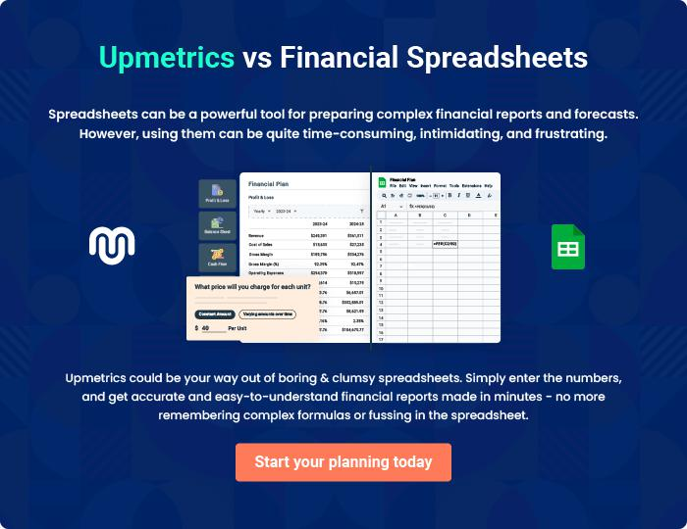

Digital Marketing | Business Plan [YEAR] 38/39


Create a winning business plan that gets you funded

Creating a stunning and investment-ready plan requires no writing, graphic designing, or financial planning expertise.

Upmetrics has all the features required to help you create a comprehensive business plan—from start to finish. Make no mistakes, it’s the modern way of planning to structure ideas, make plans, and create stunning pitch decks to awe investors.

Pitch decks that impress investors

Create pitch decks that provide a visual representation of your business, engage investors, and make them want to invest in your business idea.

Interactive plans in no time

Import business plan sections like—SWOT analysis, comparison tables, and others to create an interactive business plan. No designing skills are required.

Stunning cover page designs

With Upmetrics, you have the liberty to choose from multiple stunning cover page designs. Choose a creative design and make your plan stand out.

Online sharing made simple

Upmetrics makes online sharing quick and easier for users. Easily share your business plans with a link while tracking reader activity.

500+ sample business plans

Simply import a template from our library of sample plans into the editor and start customizing it to make it yours. It takes only a few clicks to get started.

Collaborate with team in real-time

Invite team members, initiate conversations, discuss ideas & strategies, share feedback, and work on a business plan in real-time.

