

Kidzvilla - Child Day Care

Every child is special..


Business
Plan

[YEAR]

Prepared By

John Doe

10200 Bolsa Ave, Westminster, CA, 92683

info@example.com

(650) 359-3153 http://www.example.com

Table of Contents

Executive Summary | 6
Executive Summary | 7
Objectives | 7
Mission | 7
Keys to Success | 8

Business Overview | 9
Company Summary | 10
Ownership | 10
Timothy Bernard Kilpatrick | 10
Start-up Summary | 10
Locations and Facilities | 12

Services | 13
Service Description | 14
Competitive Comparison | 14
Sales Literature | 15
Fulfillment | 15
Technology | 15
Future Services | 16

Market Analysis | 17
Industry Analysis | 18
Market Segmentation | 18
Market Analysis | 18
Target Market Segment Strategy | 19
Market Needs | 19
Market Trends | 19
Market Growth | 20
Service Business Analysis | 20
Business Participants | 20

Kidzvilla - Child Day Care | Business Plan [YEAR] 2/42

Competition and Buying Patterns | 21
Main Competitors | 21

Strategy and Implementation | 22
Strategy and Implementation Summary | 23
Value Proposition | 23
Competitive Edge | 23
Marketing Strategy | 24
Positioning Statement | 24
Pricing Strategy | 24
Promotion Strategy | 24
Marketing Programs | 25
Sales Strategy | 25
Sales Forecast | 25
Sales Programs | 27
Strategic Alliances | 27
Milestones | 27

Web Plan | 29
Web Plan Summary | 30
Website Marketing Strategy | 30
Development Requirements | 30

Management & Organizational Structure | 31
Management Summary | 32
Organizational Structure | 32
Management Team | 32
Timothy B. Kilpatrick | 32
Carolyn Steverson | 33
Candice Harris | 33
Management Team Gaps | 33
Personnel Plan | 34

Kidzvilla - Child Day Care | Business Plan [YEAR] 3/42

Financial Plan | 35
Projected Profit and Loss | 36
Projected Cash Flow | 38
Projected Balance Sheet | 40

Kidzvilla - Child Day Care | Business Plan [YEAR] 4/42

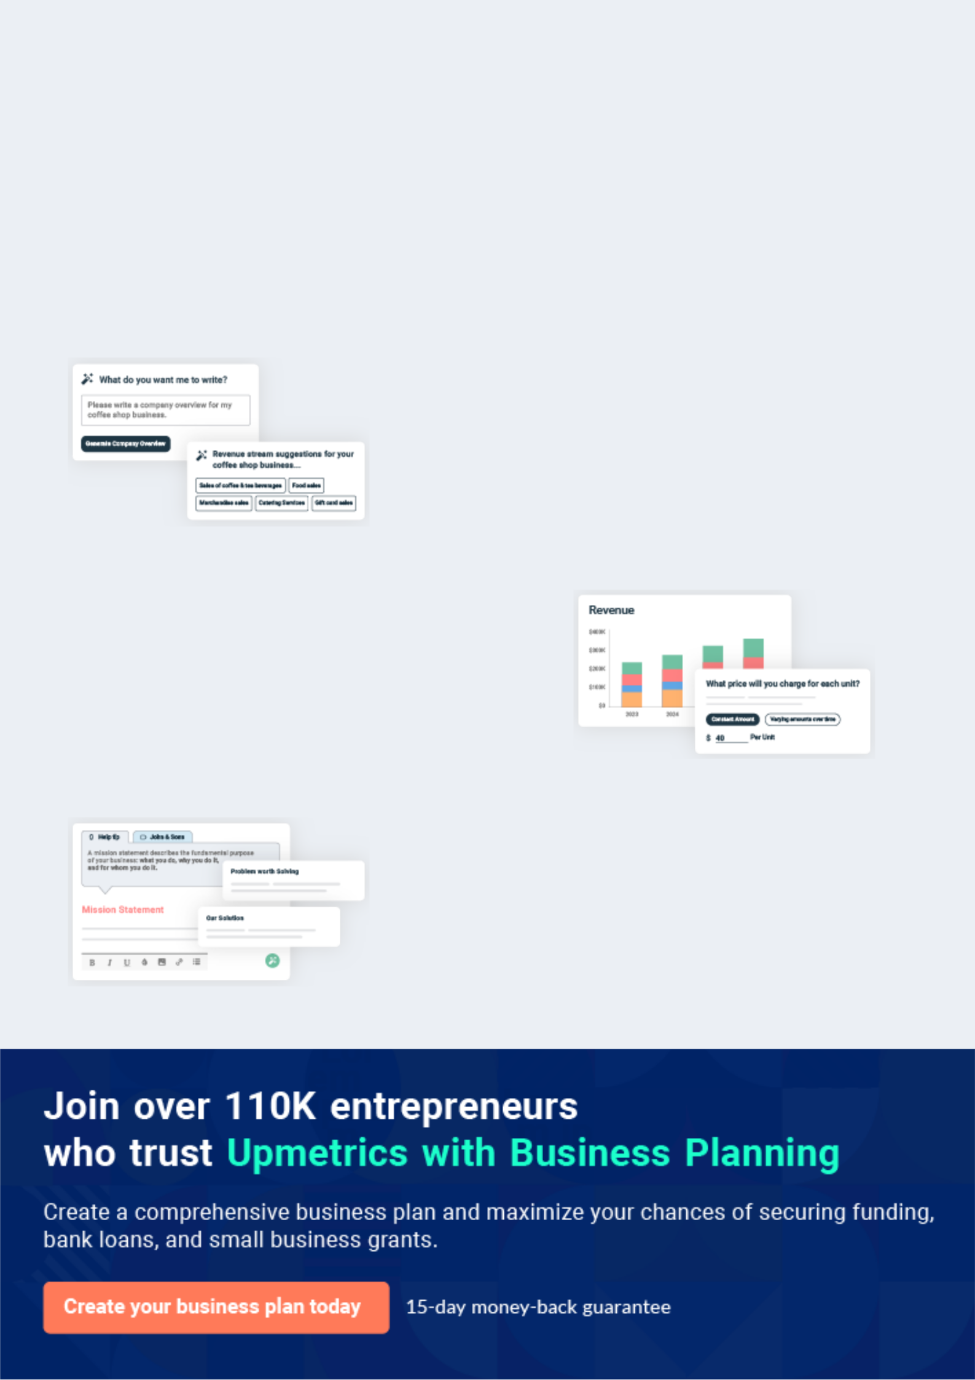
Business planning that’s simpler and faster than you think

Creating a business plan using Upmetrics to start and grow a business is literally the easiest thing in the World. Simply read the instructions and fill in the blanks. It’s as simple as that.

❛ | Upmetrics has everything you need to create a | ❜
❛ | comprehensive business plan. | ❜

AI-powered Upmetrics Assistant

AI-powered insights to streamline your plan

Not sure where to start? Upmetrics’ AI Assistant will automatically generate ideas for each section of your plan and offer improved versions of your writing, adjusting for tone, voice, and grammar or spelling errors.

Financial Forecasting Tool

All the financials are calculated for you

Forget the complex formulas and clumsy spreadsheets — with automatic financials and drag-and-drop forecasting, you can finish your plan faster and be confident that your numbers are accurate.

Business Plan Builder

Guides you like a business mentor

Upmetrics’ step-by-step instructions, prompts, and the library of 400+ sample business plans will guide you through each section of your plan as a business mentor.

1.


Executive Summary

Executive Summary

Objectives

Mission

Keys to Success

Kidzvilla - Child Day Care | Business Plan [YEAR] 6/42

Executive Summary
To unlock help try Upmetrics!

 Kidzvilla


Kidzvilla Community College aims to prepare its students to excel as young leaders of tomorrow by combining an exclusive collegiate-based curriculum tailored specifically for children with enhanced, first-class childcare services. Unlike our competitors, we offer
To unlock help try Upmetrics! 

Start writing here..

Objectives

 Kidzvilla

1. Sales increasing to almost double first-year sales by the end of Fiscal 2004.

- Maintain a high raw gross margin by the end of Fiscal 2003.

- Open the second campus by the end of Fiscal 2004.

To unlock help try Upmetrics! 

Start writing here..

Mission

 Kidzvilla

"Some of the best years in life are the time spent as a child and later our collegiate years..." As working adults in a fast-paced society, we sometimes forget just how precious and fleeting those years are.



Start writing here..

Kidzvilla - Child Day Care | Business Plan [YEAR] 7/42

Keys to Success

 Kidzvilla

The keys to success for KCC are:

• Marketing: differentiating KCC's caregiving and educational services from traditional
To unlock help try Upmetrics! 

Start writing here..

Kidzvilla - Child Day Care | Business Plan [YEAR] 8/42

2.

Business Overview

Company Summary

Ownership

Start-up Summary

Locations and Facilities

Kidzvilla - Child Day Care | Business Plan [YEAR] 9/42

Company Summary
To unlock help try Upmetrics!

 Kidzvilla

Kidzvilla Community College - Lake St. Charles Campus will be located in Riverview, FL. The College will employ six fundamentals that will serve as the driving force for the services offered:



Start writing here..

Ownership


Timothy Bernard Kilpatrick

Founder and president - timothyb@example.com

Kidzvilla Community College is a privately-held proprietorship owned in majority by its founder and president, Timothy Bernard Kilpatrick, Sr. There are also two silent partners, neither of whom owns more than 10%, but will be active participants in daily operations, management decisions, and consulting, though they do not own a financial stake in the company.

Once the operation reaches its anticipated growth and profitability goals, the college plans to franchise and will re-register as a limited liability company or as a corporation, whichever will better suit the future business needs.

Start-up Summary

Start-up | Amount
Start-up Expenses
Legal | $1,000
Stationery | $250
Brochures | $500
Insurance | $1,500
Rent | $8,250
R&D | $500

Kidzvilla - Child Day Care | Business Plan [YEAR] 10/42

Start-up | Amount
Consultants | $1,000
Playground Equipment | $3,500
Playground Prep | $700
Playground Fence | $3,000
Furnishings | $7,500
Toys | $3,000
Buildout | $8,750
Total Start-up Expenses | $39,450
Start-up Assets
Cash Required | $65,550
Other Current Assets | $14,130
Long-term Assets | $0
Total Assets | $79,680
Total Requirements | $119,130
 | Amount
Start-up Funding
Start-up Expenses to Fund | $39,450
Start-up Assets to Fund | $79,680
Total Funding Required | $119,130
Assets
Non-cash Assets from Start-up | $14,130
Cash Requirements from Start-up | $65,550
Additional Cash Raised | $0
Cash Balance on Starting Date | $65,550

Kidzvilla - Child Day Care | Business Plan [YEAR] 11/42

 | Amount
Total Assets | $79,680
Capital
Planned Investment
Owner - Kilpatrick Cash | $45,000
Owner - Kilpatrick Credit Line | $12,500
Other Assets Invested | $1,630
Additional Investment Requirement | $0
Total Planned Investment | $59,130
Loss at Start-up (Start-up Expenses) | ($39,450)
Total Capital | $19,680
Total Capital and Liabilities | $79,680
Total Funding | $119,130

Locations and Facilities

 Kidzvilla

Kidzvilla Community College will begin with one location - a newly constructed 3,600 square foot campus in Riverview, FL located near the entrance of the upscale Lake St. Charles subdivision. The campus is in the Lake St. Charles Medical Professional center and will boast
To unlock help try Upmetrics! 

Start writing here..

Kidzvilla - Child Day Care | Business Plan [YEAR] 12/42

3.

Services

Service Description

Competitive Comparison

Sales Literature

Fulfillment

Technology

Future Services

Kidzvilla - Child Day Care | Business Plan [YEAR] 13/42

 Kidzvilla

Kidzvilla Community College offers upscale child care services and an advanced collegiate based curriculum designed for kids ages 4 months to 5 years and 1st through 5th grades. Normal operating hours will be 6:45 am to 6:30 pm, Monday through Friday - with the
To unlock help try Upmetrics! 

Start writing here..

Service Description

 Kidzvilla

Upon its opening, Kidzvilla Community College will offer four basic services in the Lake St.

Charles community:
To unlock help try Upmetrics! 

Start writing here..

Competitive Comparison

 Kidzvilla

The child care industry as a whole is saturated. However, based on US Census 2000 data, Hillsborough County Child Care Services provider listings, and Hillsborough County building permit records, the city of Riverview, Florida itself is growing and has few licensed child care
To unlock help try Upmetrics! 

Start writing here..

Kidzvilla - Child Day Care | Business Plan [YEAR] 14/42

Sales Literature

 Kidzvilla

A copy of the Kidzvilla Community College informational brochure is attached in an appendix at the end of this document.
To unlock help try Upmetrics! 

Start writing here..

Fulfillment

 Kidzvilla

The key fulfillment and delivery of services will be provided by the campus director, licensed campus instructors, and staff workers. The real core value is the professional strength and industry expertise of the founder and silent partners, staff experience and certifications,
To unlock help try Upmetrics! 

Start writing here..

Technology

 Kidzvilla

Since the company founder has an extensive Information Technology background, it's only natural that Kidzvilla Community College will employ and maintain the latest technology to
enhance its curriculum, office management systems, payment processing, and record-keeping.
To unlock help try Upmetrics! 

Start writing here..

Kidzvilla - Child Day Care | Business Plan [YEAR] 15/42

Future Services
To unlock help try Upmetrics!

 Kidzvilla

Three additional campuses are planned in the rural Tampa marketplace over the next four years. Franchise start-ups will be offered in the Orlando, Miami, and Jacksonville marketplace after 2 years of successful operation.



Start writing here..
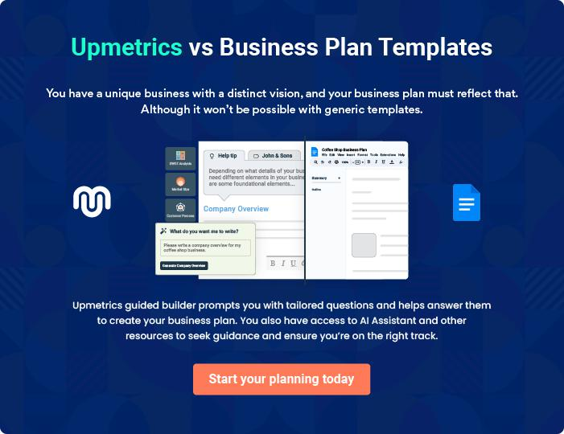

Kidzvilla - Child Day Care | Business Plan [YEAR] 16/42

4.

Market Analysis

Industry Analysis

Market Segmentation

Market Analysis

Target Market Segment Strategy

Service Business Analysis

Main Competitors

Kidzvilla - Child Day Care | Business Plan [YEAR] 17/42

Industry Analysis
To unlock help try Upmetrics!

 Kidzvilla

Kidzvilla Community College offers services that are vitally important in today's fast-paced, dual-income world. As an increasing number of families have become dependent on two incomes, the need for quality childcare has skyrocketed. According to Florida Business
To unlock help try Upmetrics! 

Start writing here..

Market Segmentation

 Kidzvilla

Kidzvilla Community College has a focus on meeting the local community's need for childcare services within the 10-mile radius of Riverview. Students will be taken inflexibly on either a full-time or part-time basis.



Start writing here..

Market Analysis
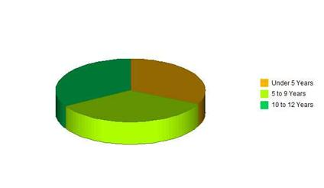

Potential | Growth | Year1 | Year2 | Year3 | Year4 | Year5 | CAGR
Customers
Under 5 | 6% | 2665 | 2825 | 2995 | 3175 | 3366 | 6.01%
Years
5 to 9 Years | 6% | 2865 | 3037 | 3219 | 3412 | 3617 | 6.00%

Kidzvilla - Child Day Care | Business Plan [YEAR] 18/42

Potential | Growth | Year1 | Year2 | Year3 | Year4 | Year5 | CAGR
Customers
10 to 12 | 6% | 2771 | 2937 | 3113 | 3300 | 3498 | 6.00%
Years
Total | 6% | 8301 | 8799 | 9327 | 9887 | 10481 | 6.00%

Target Market Segment Strategy

 Kidzvilla

The target market for Kidzvilla Community College is full-time working couples. Referral marketing, direct-mail campaigns, and community activity days will be the primary types of
marketing strategies utilized. Maintaining and enhancing its reputation with families and in the
To unlock help try Upmetrics! 

Start writing here..

 Kidzvilla

With inflation continuing to rise each year, the typical American family now requires dual or supplemental incomes. This trend has created a need for quality childcare services. We do not see this model changing in the foreseeable future. In fact, based on the growth in the Riverview
To unlock help try Upmetrics! 

Market Needs

Start writing here..

 Kidzvilla

Currently, there are more family caregivers than licensed childcare facilities nationwide. However, this business model can't keep up with the needs of the growing childcare industry. In the family caregiver paradigm, space is limited and quality of care is questionable - in many
To unlock help try Upmetrics! 

Market Trends

Start writing here..

Kidzvilla - Child Day Care | Business Plan [YEAR] 19/42

 Kidzvilla

According to the US Census 2000 data, the population growth rate for Hillsborough County is approximately 2%, which is reflected in the market analysis summary. However, the Riverview
area of Hillsborough County is experiencing a residential construction boom, yielding well over
To unlock help try Upmetrics! 

Market Growth

Start writing here..

Service Business Analysis

 Kidzvilla

Kidzvilla Community College is in the childcare services industry, which includes several models:
To unlock help try Upmetrics! 

Start writing here..

 Kidzvilla

1. Licensed Child Care Centers: Kids Kountry, Lapetite Academy, Mary Go Round Child Care Center and Bloomingdale Academy. While these centers are within the 10-mile radius
target area, none are inside a 5-mile radius of the Lake St. Charles community. None of
To unlock help try Upmetrics! 

Business Participants

Start writing here..

Kidzvilla - Child Day Care | Business Plan [YEAR] 20/42

 Kidzvilla

Price, service, certification, and reputation are critical success factors in the childcare services industry. Kidzvilla Community College will compete well in our market by offering competitive prices, high-quality childcare services, and leading-edge educational programs with certified,
To unlock help try Upmetrics! 

Competition and Buying Patterns

Start writing here..

Main Competitors

 Kidzvilla

- Catholic Church Day Care:

  - Strengths: Large church congregation. Already established in the market.
  - Weaknesses: May not appeal to customers of different religious_{Tounlock}beliefs_{help}. _{try}Unlicensed_{Upmetrics!} 

Start writing here..

Kidzvilla - Child Day Care | Business Plan [YEAR] 21/42

5.

Strategy and

Implementation

Strategy and Implementation Summary

Value Proposition

Competitive Edge

Marketing Strategy

Sales Strategy

Strategic Alliances

Milestones

Kidzvilla - Child Day Care | Business Plan [YEAR] 22/42

Strategy and Implementation Summary
To unlock help try Upmetrics!

 Kidzvilla

Kidzvilla Community College will focus on two subdivisions: 'Lake St. Charles' and 'The Villages of Lake St. Charles,' which are new upscale community developments within a 2 square mile radius and boast over 900 new homes.



Start writing here..

Value Proposition

 Kidzvilla

Kid's Community College's® value proposition is quite clear and quite easily distinguished from others in the market. We offer uniquely premium child care services, as measured by the curriculum and activities offered, experience, and educational level of the instructors,
To unlock help try Upmetrics! 

Start writing here..

Competitive Edge

 Kidzvilla

We start with a critical competitive edge: there is no competitor in our market that is offering our concept, quality of the educational program, and child care services. Our educational approach is unique and we have a resource with over 25 years of childcare expertise and over
To unlock help try Upmetrics! 

Start writing here..

Kidzvilla - Child Day Care | Business Plan [YEAR] 23/42

Marketing Strategy
To unlock help try Upmetrics!
To unlock help try Upmetrics!

 Kidzvilla

Marketing in the child care industry depends largely on reputation and referral. At Kidzvilla Community College that reputation will start within our community bolstered by our involved commitment to those we serve.



Start writing here..

 Kidzvilla

For families who value the importance of higher education and quality childcare services, Kidzvilla Community College offers a great alternative to traditional childcare services and specific interest-based programs. Unlike those programs, KCC combines child care services
To unlock help try Upmetrics! 

Positioning Statement

Start writing here..

 Kidzvilla

Kidzvilla Community College must charge appropriately for the high-end, high-quality educational, and caregiving services we offer. Our revenue structure has to support our cost
structure, so the salaries we pay to assure quality services must be balanced by the revenue we
To unlock help try Upmetrics! 

Pricing Strategy

Start writing here..

 Kidzvilla

We will depend on client referrals, community exposure, and direct mail campaigns as our main way to reach new clients. As we change strategies, however, we need to change the way we promote ourselves:



Promotion Strategy

Start writing here..

Kidzvilla - Child Day Care | Business Plan [YEAR] 24/42

 Kidzvilla

Catered open houses, parent survival days/nights, clubhouse pool parties, and weekend movie matinees are but a few approaches we will utilize to reach out to our community. We will also develop and maintain partnerships with local businesses that cater to the needs of children.
To unlock help try Upmetrics! 

Marketing Programs

Start writing here..

Sales Strategy

 Kidzvilla

Kidzvilla Community College will sell its community college theme, services, and offerings, separating itself from traditional daycare-only offerings.
To unlock help try Upmetrics! 

Start writing here..

 Kidzvilla

The following table and chart give a run-down on forecasted sales. A detailed spreadsheet is also included in the appendix of this business plan.
To unlock help try Upmetrics! 

Sales Forecast

 | Year1 | Year2 | Year3
Unit Sales
Full-time Couples | 199 | 455 | 512
After School Care | 141 | 220 | 248
Summer Camp | 26 | 29 | 31
Part-time | 12 | 14 | 16
Workers/Drop-Ins

Kidzvilla - Child Day Care | Business Plan [YEAR] 25/42

 | Year1 | Year2 | Year3
Total Unit Sales | 378 | 718 | 807
Unit Prices | 2003 | 2004 | 2005
Full-time Couples | $460.00 | $460.00 | $460.00
After School Care | $240.00 | $240.00 | $240.00
Summer Camp | $460.00 | $460.00 | $460.00
Part-time Workers/Drop-Ins | $100.00 | $100.00 | $100.00
Sales
Full-time Couples | $91,540 | $209,300 | $235,520
After School Care | $33,840 | $52,800 | $59,400
Summer Camp | $11,960 | $13,340 | $14,352
Part-time Workers/Drop-Ins | $1,200 | $1,380 | $1,587
Total Sales | $138,540 | $276,820 | $310,859
Direct Unit Costs | 2003 | 2004 | 2005
Full-time Couples | $13.34 | $13.82 | $13.82
After School Care | $4.56 | $4.75 | $4.75
Summer Camp | $13.80 | $13.80 | $13.80
Part-time Workers/Drop-Ins | $0.00 | $0.00 | $0.00
Direct Cost of Sales
Full-time Couples | $2,655 | $6,288 | $7,076
After School Care | $643 | $1,045 | $1,176
Summer Camp | $359 | $400 | $431
Part-time | $0 | $0 | $0
Workers/Drop-Ins
Subtotal Direct Cost of Sales | $3,656 | $7,733 | $8,682

Kidzvilla - Child Day Care | Business Plan [YEAR] 26/42

 Kidzvilla
To unlock help try Upmetrics!

Sales programs will include incentives for obtaining quarterly financial and enrollment goals, probationary period completion, passing county inspections, and maintaining perfect attendance.



Sales Programs

Start writing here..

Strategic Alliances

 Kidzvilla

As mentioned previously, Kidzvilla Community College will form professional alliances with Impact Fitness to offer Drop-In child care services while parents work out. We will also partner with Family Pediatrics to provide referrals of their existing customers. A discounted rate will be
To unlock help try Upmetrics! 

Start writing here..

Milestones

 Kidzvilla

No example added yet..

To unlock help try Upmetrics! 

The accompanying table highlights important start-up milestones, with dates, completion status, responsible parties, and budgets for each. The milestone schedule indicates our emphasis on planning for implementation.

What the table doesn't show is the commitment behind it. Our business plan includes complete provisions for plan-vs.-actual analysis, and we will hold monthly follow-up meetings to discuss the variance and course corrections.

Kidzvilla - Child Day Care | Business Plan [YEAR] 27/42

Milestone | Start Date | End Date | Budget | Manager | Department
Business Plan | 8/1/2002 | 9/30/2002 | $200 | Tim Kilpatrick | Department
Lease RFP | 7/15/2002 | 7/30/2002 | $0 | Tim Kilpatrick | Department
Site Selection | 8/1/2002 | 9/15/2002 | $0 | Tim Kilpatrick | Department
Architect Design | 9/15/2002 | 10/1/2002 | $0 | Zimmer | Department
Secure Additional | 10/1/2002 | 10/30/2002 | $500 | Tim Kilpatrick | Department
Funding
Sign Lease | 10/15/2002 | 10/30/2002 | $4,500 | Tim Kilpatrick | Department
Personnel Plan | 10/1/2002 | 10/30/2002 | $0 | Tim Kilpatrick | Department
Curriculum | 10/1/2002 | 12/31/2002 | $500 | Candice Harris | Department
Development
County | 9/20/2002 | 12/31/2002 | $100 | Tim Kilpatrick | Department
Certification Req
Licensing | 12/1/2002 | 12/31/2002 | $0 | Tim Kilpatrick | Department
Totals |  |  | $5,800

Kidzvilla - Child Day Care | Business Plan [YEAR] 28/42

6.

Web Plan

Web Plan Summary

Website Marketing Strategy

Development Requirements

Kidzvilla - Child Day Care | Business Plan [YEAR] 29/42

Web Plan Summary
To unlock help try Upmetrics!

 Kidzvilla

The Kidzvilla Community College website will be the virtual business card and portfolio for the college, as well as its online "home."
To unlock help try Upmetrics! 

Start writing here..

Website Marketing Strategy

 Kidzvilla

The Kidzvilla Community College website will embody the mission of the college. It will not only offer visitors the opportunity to "look around" the campus, but it will give them a good idea of the level of quality and service they can come to expect from the college.
To unlock help try Upmetrics! 

Start writing here..

Development Requirements

 Kidzvilla

The Kidzvilla Community College website will be developed by the college founder, Timothy B. Kilpatrick, Sr., who has over 17 years of Information Technology experience. Formation Technologies will host the site.



Start writing here..

Kidzvilla - Child Day Care | Business Plan [YEAR] 30/42

7.

Management & Organizational Structure

Management Summary

Organizational Structure

Management Team

Management Team Gaps

Personnel Plan

Kidzvilla - Child Day Care | Business Plan [YEAR] 31/42

Management Summary

 Kidzvilla

The opening management team of Kidzvilla Community College will consist of the founder, a silent partner, a campus director, and an administrative assistant.
To unlock help try Upmetrics! 

Start writing here..

Organizational Structure

 Kidzvilla

Kidzvilla Community College depends on the founder, silent partner, Campus Director, and VP of

Education Operations for management in the following roles:
To unlock help try Upmetrics! 

Start writing here..

Management Team

Timothy B. Kilpatrick

Owner/President - timothy@example.com

Sr. The Owner/President will have overall fiscal responsibility, ensuring that the business is financially sound and attains its planned goals.

17 years Executive Management (VP) and Budgeting experience Advanced degree in Computer Science Proven leadership and employee development ability. Extensive experience with budgeting methodologies and strategic planning, including the Balanced Scorecard approach.

Kidzvilla - Child Day Care | Business Plan [YEAR] 32/42


Carolyn Steverson

Industry Consultant - carolyn@example.com

The Industry Consultant will be relied upon for her industry expertise, providing valuable insight to rules, regulations, and governmental programs that may benefit the college.

25 Year owner of Fat Albert Day Care Center Licensed child care facility owner. Vast knowledge of Hillsborough County Child Care Licensing requirements and government supplemental programs


Candice Harris

Campus Director - candiceh@example.com

The Campus Director will be responsible for daily operations, curriculum oversight, and management of all instructors, caregivers, and tutors.

B.S. Degree in Education 2 years facilities administration/support experience with the University of South Florida

2+ years Regional Operations Manager

5+ years managerial/supervisory experience

3+ years of grant writing, technical writing, workflow, and process documentation experience

Management Team Gaps

 Kidzvilla

The present team requires Child Care Development Associate credentials to support our value proposition and preparation for the 2004 Florida child care requirements. Currently, the Campus Director and Industry Consultant are the only members of the management team who have
To unlock help try Upmetrics! 

Start writing here..

Kidzvilla - Child Day Care | Business Plan [YEAR] 33/42

Personnel Plan

 Kidzvilla

The following table summarizes our personnel expenditures for the first three years, with compensation increasing from approximately $57K in the first year to about $113K in the third. We believe this plan is a fair compromise between fairness and experience and meets the
To unlock help try Upmetrics! 

Personnel Plan

 | Year1 | Year2 | Year3
Campus Director | $23,877 | $25,071 | $26,324
F/T Instructors | $21,760 | $61,440 | $64,512
P/T Instructors | $11,400 | $21,600 | $22,680
Total People | 5 | 8 | 8
Total Payroll | $57,037 | $108,111 | $113,516

Kidzvilla - Child Day Care | Business Plan [YEAR] 34/42

8.

Financial Plan

Projected Profit and Loss

Projected Cash Flow

Projected Balance Sheet

Kidzvilla - Child Day Care | Business Plan [YEAR] 35/42

Projected Profit and Loss

Revenue

Premier Care-Giving

Services

Unit Sales

Unit Price

Collegiate Curriculum Programs

Unit Sales

Unit Price

Community Advancement Programs

Cost Of Sales

General Costs

Care-Giving Supplies

Diapers and Wipes

Snacks and Meals

Educational Materials

Books and Learning

Materials

Technology and Software

Revenue Specific Costs

Personnel Costs (Direct Labor)

2024 | 2025 | 2026
$625,773.13 | $1,123,296.57 | $2,042,787.75
$295,217.50 | $594,065 | $1,195,435
1,181 | 2,376 | 4,782
$250 | $250 | $250
$225,375 | $360,834 | $577,743
751 | 1,203 | 1,926
$300 | $300 | $300
$105,180.63 | $168,397.57 | $269,609.75

$102,151.26 | $175,739.87 | $310,697.40
$102,151.26 | $175,739.87 | $310,697.40
$71,455.01 | $122,333.36 | $215,551.35
$8,877.70 | $10,003.71 | $11,272.57
$62,577.31 | $112,329.65 | $204,278.78
$30,696.25 | $53,406.51 | $95,146.05
$2,536.46 | $2,858.16 | $3,220.59
$28,159.79 | $50,548.35 | $91,925.46
$0 | $0 | $0
$0 | $0 | $0

Gross Margin | $523,621.87 | $947,556.70 | $1,732,090.35

Kidzvilla - Child Day Care | Business Plan [YEAR] 36/42

 | 2024 | 2025 | 2026
Gross Margin (%) | 83.68% | 84.35% | 84.79%

Operating Expense | $576,004.68 | $621,598.05 | $693,693.99
Payroll Expense (Indirect | $490,680 | $499,793.40 | $509,098.20
Labor) | $490,680 | $499,793.40 | $509,098.20
Teaching Staff | $286,560 | $291,081.60 | $295,681.44
Lead Teachers | $120,960 | $122,169.60 | $123,391.44
Assistant Teachers | $165,600 | $168,912 | $172,290
Administrative Staff | $115,800 | $118,791 | $121,865.52
Day Care Director | $45,000 | $46,575 | $48,205.20
Administrative Assistants | $70,800 | $72,216 | $73,660.32
Support Staff | $88,320 | $89,920.80 | $91,551.24
Maintenance Staff | $55,200 | $56,304 | $57,430.08
Kitchen Staff | $33,120 | $33,616.80 | $34,121.16
General Expense | $85,324.68 | $121,804.65 | $184,595.79
Facility Costs | $38,681.78 | $43,587.77 | $49,115.53
Rent | $31,706.31 | $35,727.40 | $40,258.40
Utilities | $6,975.47 | $7,860.37 | $8,857.13
Operational Expenses | $30,103.89 | $50,648.09 | $88,152.74
Insurance | $25,030.93 | $44,931.85 | $81,711.51
Maintenance | $5,072.96 | $5,716.24 | $6,441.23
Marketing and Advertising | $16,539.01 | $27,568.79 | $47,327.52
Online Marketing | $4,023.57 | $5,102.86 | $6,471.76
Community Events | $12,515.44 | $22,465.93 | $40,855.76
Bad Debt | $0 | $0 | $0

Kidzvilla - Child Day Care | Business Plan [YEAR] 37/42

Amortization of Current Assets

EBITDA

Additional Expense

Long Term Depreciation

Gain or loss from Sale of Assets

EBIT

Interest Expense

EBT

Income Tax Expense / Benefit

Total Expense

Net Income

Net Income (%)

Retained Earning Opening

Owner's Distribution

Retained Earning Closing

2024 | 2025 | 2026
$0 | $0 | $0

($52,382.81) $325,958.65 $1,038,396.36

$9,698.44 | $8,077.41 | $6,373.41
$5,418 | $5,418 | $5,418
$0 | $0 | $0
($57,800.81) | $320,540.65 | $1,032,978.36
$4,280.43 | $2,659.39 | $955.41
($62,081.25) | $317,881.24 | $1,032,022.95
$0 | $0 | $0

$687,854.38 | $805,415.33 | $1,010,764.80
($62,081.25) | $317,881.24 | $1,032,022.95
(9.92%) | 28.30% | 50.52%

$0 | ($80,081.25) | $229,799.99
$18,000 | $8,000 | $8,000
($80,081.25) | $229,799.99 | $1,253,822.94

Projected Cash Flow

 | 2024 | 2025 | 2026
Cash Received | $625,773.13 | $1,123,296.57 | $2,042,787.75

Kidzvilla - Child Day Care | Business Plan [YEAR] 38/42

 | 2024 | 2025 | 2026
Cash Paid | $682,436.39 | $799,997.33 | $1,005,346.79
COS & General Expenses | $187,475.95 | $297,544.52 | $495,293.18
Salary & Wages | $490,680 | $499,793.40 | $509,098.20
Interest | $4,280.43 | $2,659.39 | $955.41
Sales Tax | $0 | $0 | $0
Income Tax | $0 | $0 | $0
Net Cash From | ($56,663.26) | $323,299.24 | $1,037,440.96
Operations | ($56,663.26) | $323,299.24 | $1,037,440.96

Assets Sell | $0 | $0 | $0
Assets Purchase | $35,000 | $0 | $0
Net Cash From | ($35,000) | $0 | $0
Investments | ($35,000) | $0 | $0

Amount Received | $150,000 | $0 | $0
Loan Received | $100,000 | $0 | $0
Common Stock | $0 | $0 | $0
Preferred Stock | $0 | $0 | $0
Owner's Contribution | $50,000 | $0 | $0
Amount Paid | $49,684.64 | $41,305.67 | $43,009.66
Loan Capital | $31,684.65 | $33,305.69 | $35,009.66
Dividends & Distributions | $18,000 | $8,000 | $8,000
Net Cash From | $100,315.36 | ($41,305.67) | ($43,009.66)
Financing | $100,315.36 | ($41,305.67) | ($43,009.66)

Summary

Starting Cash | $0 | $8,652.10 | $290,645.67

Kidzvilla - Child Day Care | Business Plan [YEAR] 39/42

 | 2024 | 2025 | 2026
Cash In | $775,773.13 | $1,123,296.57 | $2,042,787.75
Cash Out | $767,121.03 | $841,303 | $1,048,356.45
Change in Cash | $8,652.10 | $281,993.57 | $994,431.30
Ending Cash | $8,652.10 | $290,645.67 | $1,285,076.97

Projected Balance Sheet

 | 2024 | 2025 | 2026
Assets | $38,234.10 | $314,809.67 | $1,303,822.97
Current Assets | $8,652.10 | $290,645.67 | $1,285,076.97
Cash | $8,652.10 | $290,645.67 | $1,285,076.97
Accounts Receivable | $0 | $0 | $0
Inventory | $0 | $0 | $0
Other Current Assets | $0 | $0 | $0
Long Term Assets | $29,582 | $24,164 | $18,746
Gross Long Term Assets | $35,000 | $35,000 | $35,000
Accumulated Depreciation | ($5,418) | ($10,836) | ($16,254)
Liabilities & Equity | $38,234.10 | $314,809.65 | $1,303,822.94
Liabilities | $68,315.35 | $35,009.66 | $0
Current Liabilities | $33,305.69 | $35,009.66 | $0
Accounts Payable | $0 | $0 | $0
Income Tax Payable | $0 | $0 | $0
Sales Tax Payable | $0 | $0 | $0
Short Term Debt | $33,305.69 | $35,009.66 | $0
Long Term Liabilities | $35,009.66 | $0 | $0

Kidzvilla - Child Day Care | Business Plan [YEAR] 40/42

 | 2024 | 2025 | 2026
Long Term Debt | $35,009.66 | $0 | $0
Equity | ($30,081.25) | $279,799.99 | $1,303,822.94
Paid-in Capital | $0 | $0 | $0
Common Stock | $0 | $0 | $0
Preferred Stock | $0 | $0 | $0
Owner's Contribution | $50,000 | $50,000 | $50,000
Retained Earnings | ($80,081.25) | $229,799.99 | $1,253,822.94

Check | $0 | $0 | $0
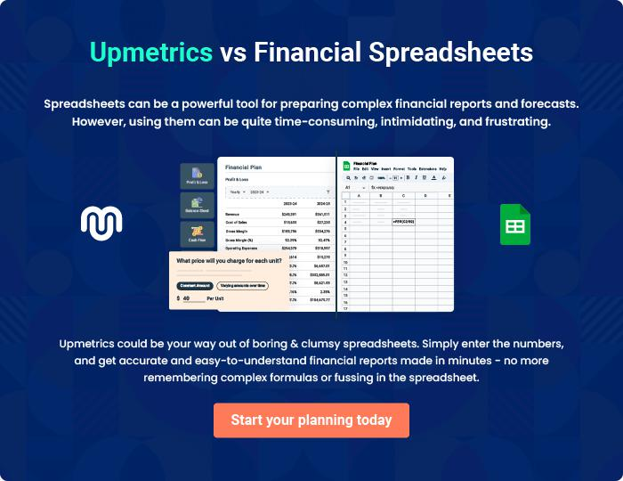

Kidzvilla - Child Day Care | Business Plan [YEAR] 41/42


Create a winning business plan that gets you funded

Creating a stunning and investment-ready plan requires no writing, graphic designing, or financial planning expertise.

Upmetrics has all the features required to help you create a comprehensive business plan—from start to finish. Make no mistakes, it’s the modern way of planning to structure ideas, make plans, and create stunning pitch decks to awe investors.

Pitch decks that impress investors

Create pitch decks that provide a visual representation of your business, engage investors, and make them want to invest in your business idea.

Interactive plans in no time

Import business plan sections like—SWOT analysis, comparison tables, and others to create an interactive business plan. No designing skills are required.

Stunning cover page designs

With Upmetrics, you have the liberty to choose from multiple stunning cover page designs. Choose a creative design and make your plan stand out.

Online sharing made simple

Upmetrics makes online sharing quick and easier for users. Easily share your business plans with a link while tracking reader activity.

500+ sample business plans

Simply import a template from our library of sample plans into the editor and start customizing it to make it yours. It takes only a few clicks to get started.

Collaborate with team in real-time

Invite team members, initiate conversations, discuss ideas & strategies, share feedback, and work on a business plan in real-time.

