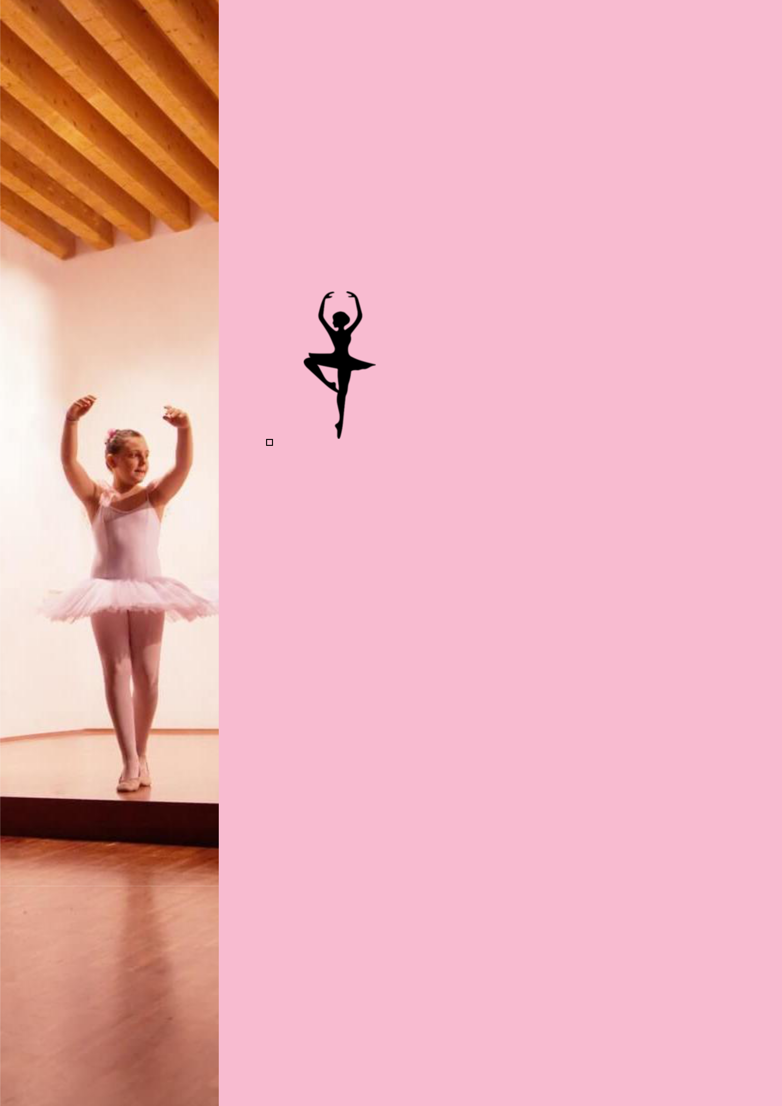
BUSINESS PLAN

[YEAR]

Dance Studio

Lace Your Dancing Shoes.

John Doe

10200 Bolsa Ave, Westminster, CA, 92683

- 359-3153 info@example.com http://www.example.com

Information provided in this business plan is unique to this business and confidential; therefore, anyone reading this plan agrees not to disclose any of the information in this business plan without prior written permission of the company.
Table of Contents

Executive Summary | 5
Mission Statement | 6
Vision Statement | 6
Objectives | 7
Financial Summary | 7
3 Year profit forecast | 7

Company Summary | 9
History | 10
Business Structure | 10
Startup summary | 11
Startup cost | 11

Products and services | 14
Private Lessons | 15
Group Classes | 15
Practice Dances | 15
Facility Rental | 16

Market Analysis | 17
Market Trends | 18
Target Market | 18
Market Segmentation | 18
Children/Teens (19 yrs. and under) | 19
College Students/Young Adults (20-24 yrs) | 19
Single and Married Adults (25-55 yrs) | 20
Seniors/Retired (56+ yrs) | 20
SWOT Analysis
SWOT Analysis | 21

Dance Studio | Business Plan [YEAR] 2/40

Strategy & Implementations | 24
Sales Strategy | 25
Advertising Strategy | 25
Local Publications | 25
Major Publications | 26
Community Events/Organizations | 26
Commute Advertising | 26
Customer Loyalty Programs | 26
Direct Mail | 27
Ongoing Customer Communications | 27
Pre-Opening Events | 27
Pricing Strategy | 27

Web Plan Summary | 28
Website Marketing Strategy | 29
Development Requirements | 29
Financial Plan
Financial Plan | 30
Important Assumptions | 31
Brake-even Analysis | 31
Projected Profit and Loss | 32
Projected Cash Flow | 35
Projected Balance Sheet | 36
Business Ratios | 37

Dance Studio | Business Plan [YEAR] 3/40

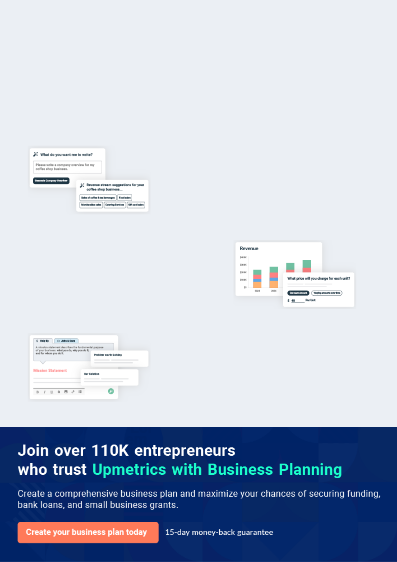
Business planning that’s simpler and faster than you think

Creating a business plan using Upmetrics to start and grow a business is literally the easiest thing in the World. Simply read the instructions and fill in the blanks. It’s as simple as that.

❛ | Upmetrics has everything you need to create a | ❜
❛ | comprehensive business plan. | ❜

AI-powered Upmetrics Assistant

AI-powered insights to streamline your plan

Not sure where to start? Upmetrics’ AI Assistant will automatically generate ideas for each section of your plan and offer improved versions of your writing, adjusting for tone, voice, and grammar or spelling errors.

Financial Forecasting Tool

All the financials are calculated for you

Forget the complex formulas and clumsy spreadsheets — with automatic financials and drag-and-drop forecasting, you can finish your plan faster and be confident that your numbers are accurate.

Business Plan Builder

Guides you like a business mentor

Upmetrics’ step-by-step instructions, prompts, and the library of 400+ sample business plans will guide you through each section of your plan as a business mentor.

1.


Executive Summary

Mission Statement

Vision Statement

Objectives

Financial Summary

Dance Studio | Business Plan [YEAR] 5/40

Before you think about how to start a Dance Studio business, you must create a detailed Dance Studio business plan. It will not only guide you in the initial phases of your startup but will also help you later on.
To unlock help try Upmetrics!
To unlock help try Upmetrics!
To unlock help try Upmetrics! 

 Maxwell Dance Studio


Maxwell Dance Studio is a standard and well-equipped dance studio with state of an art facility in all forms of dance class and choreography. We run a dance studio where kids, teens, and adults experience dance in a fun – fulfilled, and relaxing atmosphere.



Start writing here..

Mission Statement

 Maxwell Dance Studio

Our mission is to provide affordable professional and highly effective dance-related training and services to a wide range of clients that cuts across different divides.
To unlock help try Upmetrics! 

Start writing here..

Vision Statement

 Maxwell Dance Studio

Our vision is to build a highly competitive and effective dance studio business that will become the number one choice for both individuals and corporate organizations in Detroit - Michigan and the whole of the United States of America.



Start writing here..

Dance Studio | Business Plan [YEAR] 6/40

Objectives

 Maxwell Dance Studio

The following are goals and objectives of Maxwell Dance Studio for Year 1 through Year 3:

• Create a dance studio with a warm, supportive atmosphere, which is based on satisfying
To unlock help try Upmetrics! 

Start writing here..

Financial Summary

 Maxwell Dance Studio

Maxwell Dance Studio is currently seeking $200,000 to launch. This will be used towards property acquisition, renovations, and repairs, along with equipment. Moreover, there are several fees needed to be covered in regards to legal and professional services, website
To unlock help try Upmetrics! 

Start writing here..

3 Year profit forecast
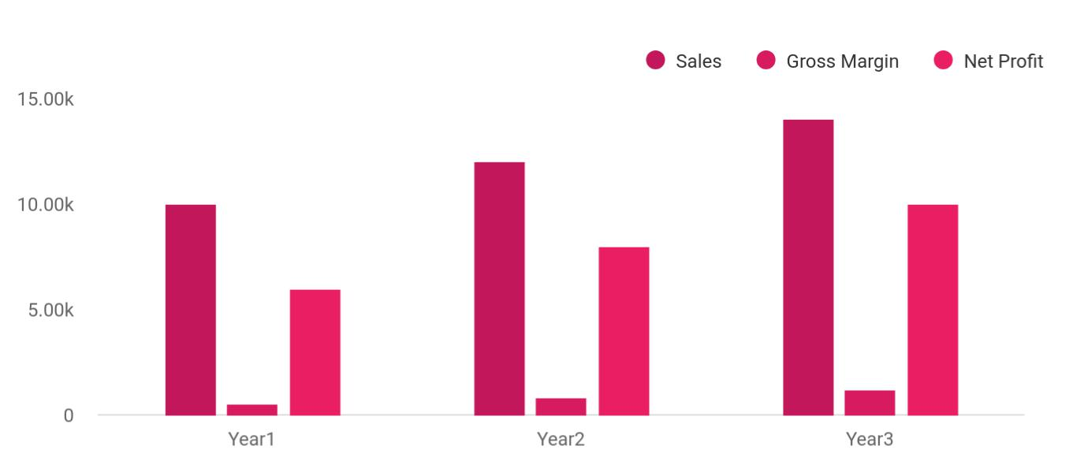

Dance Studio | Business Plan [YEAR] 7/40

 Maxwell Dance Studio


Financial Summary | Year 1 | Year 2 |  | Year 3
 |  |  | To unlock help try Upmetrics! |  | 

Start writing here..

Dance Studio | Business Plan [YEAR] 8/40

2.

Company Summary

History

Business Structure

Startup summary

Dance Studio | Business Plan [YEAR] 9/40

 Maxwell Dance Studio
To unlock help try Upmetrics!

Maxwell Dance Studio is founded by Dr. Jane Moore and she will run the business with her business partner for many years Ms. Ella Jacobs. Dr.Jane Moore is a renowned dancer and choreographer and a former competitive dancer.



Start writing here..

History

 Maxwell Dance Studio

Jane Moore started Maxwell Dance Studio as a one-room ballet studio in Detroit. It was first opened to offer summer hip-hop dance classes to kids; Jane Moore’s diversion from his regular work as a writer. As more people found out about the dance class, the students grew from 20
To unlock help try Upmetrics! 

Start writing here..

Business Structure

 Maxwell Dance Studio

Maxwell Dance Studio will build a solid business structure that can support the growth of our dance studio business.
To unlock help try Upmetrics! 

Start writing here..

Dance Studio | Business Plan [YEAR] 10/40

Startup summary

Startup cost
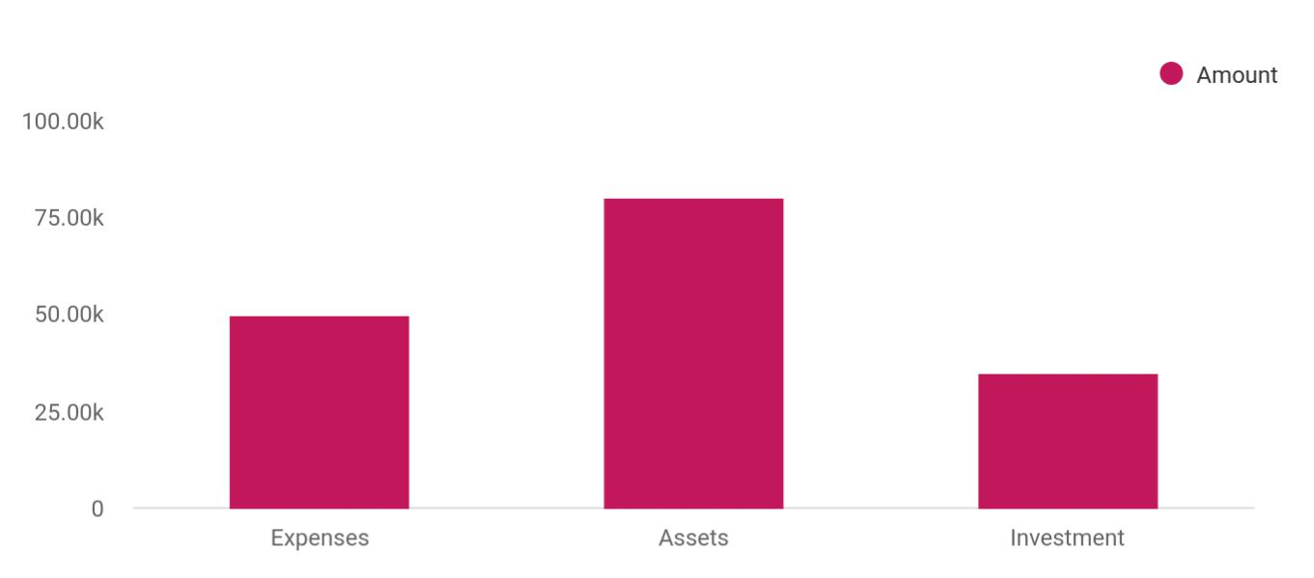

Cost distribution | Amount
Expenses | 50,000
Assets | 80,000
Investment | 35,000

Start-up Expenses | Amount
Legal | $75,500
Consultants | $0
Insurance | $62,750
Rent | $22,500
Research and Development | $42,750
Expensed Equipment | $42,750
Signs | $1,250
TOTAL START-UP EXPENSES | $247,500
Start-up Assets | $0
Cash Required | $322,500
Start-up Inventory | $52,625
Other Current Assets | $222,500

Dance Studio | Business Plan [YEAR] 11/40

Start-up Expenses | Amount
Long-term Assets | $125,000
TOTAL ASSETS | $121,875
Total Requirements | $245,000
START-UP FUNDING | $0
START-UP FUNDING | $273,125
Start-up Expenses to Fund | $121,875
Start-up Assets to Fund | $195,000
TOTAL FUNDING REQUIRED | $0
Assets | $203,125
Non-cash Assets from Start-up | $118,750
Cash Requirements from Start-up | $0
Additional Cash Raised | $118,750
Cash Balance on Starting Date | $121,875
TOTAL ASSETS | $0
Liabilities and Capital | $0
Liabilities | $0
Current Borrowing | $0
Long-term Liabilities | $0
Accounts Payable (Outstanding Bills) | $0
Other Current Liabilities (interest-free) | $0
TOTAL LIABILITIES | $0
Capital | $0
Planned Investment | $0
Investor 1 | $312,500
Investor 2 | $0
Other | $0
Additional Investment Requirement | $0
TOTAL PLANNED INVESTMENT | $695,000

Dance Studio | Business Plan [YEAR] 12/40

Start-up Expenses | Amount
Loss at Start-up (Start-up Expenses) | $313,125
TOTAL CAPITAL | $221,875
TOTAL CAPITAL AND LIABILITIES | $221,875
Total Funding | $265,000

Dance Studio | Business Plan [YEAR] 13/40

3.

Products and services

Private Lessons

Group Classes

Practice Dances

Facility Rental

Dance Studio | Business Plan [YEAR] 14/40

 Maxwell Dance Studio

Maxwell Dance Studio is going to offer varieties of dance-related services within the scope of the dance studio industry in the United States of America. Our intention of starting our dance studio business is to help individuals and organizations learn various dance steps and also
To unlock help try Upmetrics! 

Start writing here..

 Maxwell Dance Studio

Private Lessons offer students the best value for their investment. With a private lesson, the students will work one-on-one with an instructor, receiving personalized instruction and immediate correction. Through experiencing the physical sensation of connected movement,
To unlock help try Upmetrics! 

Private Lessons

Start writing here..

 Maxwell Dance Studio

Group Classes are both an introduction to the experience of dancing with different partners, and a chance for the students to become familiar with a variety of step patterns. Rotation of partners, throughout the class, allows dancers to practice steps with different partners. This
To unlock help try Upmetrics! 

Group Classes

Start writing here..

 Maxwell Dance Studio

Practice Dances will be held once a week to allow students an opportunity to practice the dances learned, in an environment with other students learning the same thing. Instructors will circulate on the dance floor, assisting with questions or demonstration of steps, as well as to
To unlock help try Upmetrics! 

Practice Dances

Start writing here..

Dance Studio | Business Plan [YEAR] 15/40

 Maxwell Dance Studio

Facility Rental will be another service offering. The Majestic is currently a very popular place in Bellingham for weddings, receptions, musical events, etc. We hope to expand the use of the building by including additional options of use (church services on Sunday, exercise/yoga
To unlock help try Upmetrics! 

Facility Rental

Start writing here..
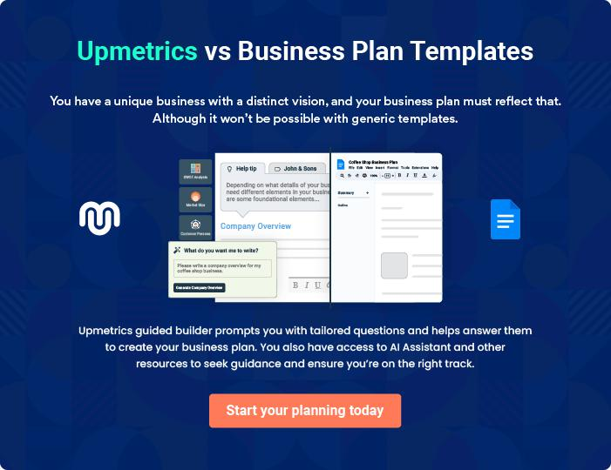

Dance Studio | Business Plan [YEAR] 16/40

4.

Market Analysis

Market Trends

Target Market

Market Segmentation

Dance Studio | Business Plan [YEAR] 17/40

The most important component of an effective Dance Studio business plan is its accurate marketing analysis. If you are starting on a smaller scale, you can do marketing analysis yourself by taking help from this Dance Studio
To unlock help try Upmetrics! 

Market Trends

 Maxwell Dance Studio

One thing is certain, the trend in the dance studio industry is such that if you want to be ahead of your competitors, you should be able to make your dance classes easy for students to adapt to and you should be able to have loads of testimonies from your students. The truth is that, if
To unlock help try Upmetrics! 

Start writing here..

Target Market

 Maxwell Dance Studio

The target market for a dance studio is broad and of course all-encompassing. Maxwell Dance Studio is a dance studio business that is positioned to offer a wide range of dance-related training and dance-related services to a wide range of clients ranging from kids to adults and to
To unlock help try Upmetrics! 

Start writing here..

Market Segmentation

 Maxwell Dance Studio

According to the information published by the Bellingham/Whatcom Chamber of Commerce, Whatcom County had a total population of 166,814 for the year 2000 and is estimated to grow approximately 5% per year to 212,000 by the year 2010. The city of Bellingham had a total
To unlock help try Upmetrics! 

Start writing here..

Dance Studio | Business Plan [YEAR] 18/40

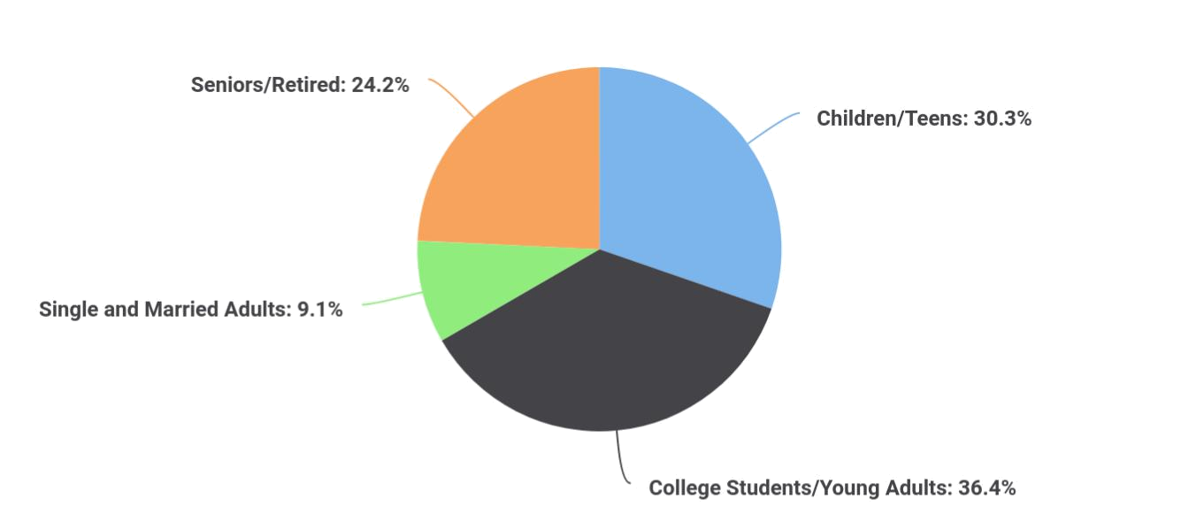

 Maxwell Dance Studio

There are 36,965 children and teens in Whatcom County, according to the 2000 census information. Our plan is to have special classes designed specifically for the younger people.
To unlock help try Upmetrics! 

Children/Teens (19 yrs. and under)

Start writing here..

 Maxwell Dance Studio

There are 16,776 people who fall in this category, according to the Whatcom County 2000 census information.
To unlock help try Upmetrics! 

College Students/Young Adults (20-24 yrs)

Start writing here..

 Maxwell Dance Studio

This will include single and married couples. The Whatcom County 2000 census information showed there were 69,865 people in this age group.
To unlock help try Upmetrics! 

Dance Studio | Business Plan [YEAR] 19/40

Single and Married Adults (25-55 yrs)

Start writing here..

 Maxwell Dance Studio

The people in this group will be a combination of retired and working people. The Whatcom County 2000 census information showed 32,998 people in this age group.
To unlock help try Upmetrics! 

Seniors/Retired (56+ yrs)

Start writing here..

 Maxwell Dance Studio


Potential Customers

Growth

Year1

Year2

Year3 | CAGR
To unlock help try Upmetrics! 

Start writing here..

Dance Studio | Business Plan [YEAR] 20/40

5.

SWOT Analysis

Dance Studio | Business Plan [YEAR] 21/40

 Maxwell Dance Studio

Maxwell Dance Studio engaged the services of a core professional in the area of business consulting and structuring to assist our organization in building a well–structured dance studio business that can favorably compete in the highly competitive dance studio industry in the
To unlock help try Upmetrics! 

Start writing here..

Dance Studio | Business Plan [YEAR] 22/40


Strength

Our core strength lies in the power of our team; our workforce. We have a team that is considered experts in the dance studio industry, a team with excellent qualifications and experience in professional dance and choreography.

Aside from the synergy that exists in our carefully selected faculty members and our strong online presence, Maxwell Dance Studio is well positioned in a community with the right demography and we know we will attract loads of individual and corporate clients from the first day we open our doors for business.

Weakness


As a new dance studio in Detroit - Michigan, it might take some time for our organization to break into the market and gain acceptance especially from top profile clients in the already saturated dance studio industry; that is perhaps our major weakness.


Opportunity

No doubt, the opportunities in the dance studio industry is massive considering the number of individuals and corporate organizations who would want to acquire new dancing skills, young couples who would want to learn wedding dance steps, and corporate organizations who would want to hire the services of professional choreographers and cheerleaders.

As a standard and well-equipped dance studio that is centrally located, we are ready to take advantage of any opportunity that comes our way.

Threat

Every business faces a threat or challenge at any part of the life cycle of the business. These threats can be external or internal. This shows the importance of a business plan because most threats or challenges are to be anticipated and plans put in place to cushion what effect they might bring to the business.

Some of the threats that we are likely going to face as a dance studio business operating in the United States of America are unfavorable government policies that might affect businesses such as ours, the arrival of a competitor within our location of operations.

Dance Studio | Business Plan [YEAR] 23/40

6.

Strategy &

Implementations

Sales Strategy

Advertising Strategy

Pricing Strategy

Dance Studio | Business Plan [YEAR] 24/40

After identifying the market demand, market trends, and the potential customers of the startup, the next step is to define an effective strategy for attracting those customers. Like marketing analysis, sales strategy is also an
To unlock help try Upmetrics!
To unlock help try Upmetrics! 

Sales Strategy

 Maxwell Dance Studio

One of our marketing strategies is to advertise discount specials or introductory offers. These are designed to introduce people to the different dances our studio offers, and the dances our customers want to learn. Our instructors will work with the customer on these specials to
To unlock help try Upmetrics! 

Start writing here..

Advertising Strategy

 Maxwell Dance Studio

Maxwell Dance Studio expects its target market to be individuals working and/or living within a 5-mile radius of its location. Maxwell Dance Studio's promotions strategy to reach these individuals includes:



Start writing here..

 Maxwell Dance Studio

Maxwell Dance Studio will announce its opening several weeks in advance through publicity pieces in multiple local newspapers and publications. Regular advertisements will run to maintain exposure to relevant markets. Community newspapers, school publications, youth
To unlock help try Upmetrics! 

Local Publications

Start writing here..

Dance Studio | Business Plan [YEAR] 25/40

 Maxwell Dance Studio
To unlock help try Upmetrics!

We will make careful use of advertising in selected larger publications. WashingtonPost has a circulation of 50 and we can expect to reach a wider geographic region of customers on a limited basis. Advertisements with major publications will be used selectively, based on cost-
To unlock help try Upmetrics! 

Major Publications

Start writing here..

 Maxwell Dance Studio

Maxwell Dance Studio will promote itself by distributing marketing materials and participating in local community events, such as school fairs, local festivals, homeowner associations, or sporting events.



Community Events/Organizations

Start writing here..

 Maxwell Dance Studio

We will drive attention toward Maxwell Dance Studio by hiring workers to hold signs alongside [route or highway]. Advertising on heavily traveled commute routes is an opportunity to alert large numbers of working individuals with disposable income of our opening.
To unlock help try Upmetrics! 

Commute Advertising

Start writing here..

 Maxwell Dance Studio

Maxwell Dance Studio will create a winning customer loyalty program to keep its best clients coming back again and again. When not actively providing services to customers in the dance studio, our professionals and other employees will make periodic, regular phone calls to
To unlock help try Upmetrics! 

Customer Loyalty Programs

Start writing here..

Dance Studio | Business Plan [YEAR] 26/40

 Maxwell Dance Studio
To unlock help try Upmetrics!
To unlock help try Upmetrics!

Maxwell Dance Studio will blanket neighborhoods surrounding its locations with direct mail pieces. These pieces will provide general information on Maxwell Dance Studio, offer discounts, and/or provide other inducements for people to visit the dance studio.
To unlock help try Upmetrics! 

Direct Mail

Start writing here..

 Maxwell Dance Studio

Maxwell Dance Studio will maintain a website and publish a monthly email newsletter to tell customers about new events, products, and more.
To unlock help try Upmetrics! 

Ongoing Customer Communications

Start writing here..

 Maxwell Dance Studio

Before opening the Dance Studio, Maxwell Dance Studio will organize pre-opening events designed for prospective customers, local merchants, and press contacts. These events will create buzz and awareness for Maxwell Dance Studio in the area.



Pre-Opening Events

Start writing here..

Pricing Strategy

 Maxwell Dance Studio

Maxwell Dance Studios' pricing will be moderate so customers feel they receive great value when patronizing the dance studio. The anticipated price point for membership will be comparable to the surrounding area dance studios.



Start writing here..

Dance Studio | Business Plan [YEAR] 27/40

7.

Web Plan Summary

Website Marketing Strategy

Development Requirements

Dance Studio | Business Plan [YEAR] 28/40

 Maxwell Dance Studio

Maxwell Dance Studio has a Web page, www.example.com, that is designed to provide a convenient way for people to discover our studio. For marketing purposes the Web page will be linked to other dance Web sites and, since it has danced in the title, it will show up on different
To unlock help try Upmetrics! 

Start writing here..

Website Marketing Strategy

 Maxwell Dance Studio

We plan to link our Web site with some prominent Seattle area dance Websites as well as the city Websites, and local recreational sites. We will also link with some national Web sites in order to increase the possibility of people reaching us on the Web. By having the word dance in
To unlock help try Upmetrics! 

Start writing here..

Development Requirements

 Maxwell Dance Studio

We have created and maintained our web page ourselves. We will continue to do so in the future.
To unlock help try Upmetrics! 

Start writing here..

Dance Studio | Business Plan [YEAR] 29/40

8.

Financial Plan

Important Assumptions

Brake-even Analysis

Projected Profit and Loss

Projected Cash Flow

Projected Balance Sheet

Business Ratios

Dance Studio | Business Plan [YEAR] 30/40

The last component of the Dance Studio business plan is an in-depth financial plan. The financial plan crafts a detailed map of all the expenses needed for the startup and how these expenses will be met by the earned
To unlock help try Upmetrics! 

 Maxwell Dance Studio

The company will be financed by John himself and he will control the direction of the business to make sure that it is expanding at the forecasted rate. As for the Dance Studio business start-up, no equity funding or outside loans will be required. With the help of financial experts, John
To unlock help try Upmetrics! 

Start writing here..

Important Assumptions

The financial projections of the company are forecast on the basis of the following assumptions. These assumptions are quite conservative and are expected to show deviation but to a limited level such that the company’s major financial strategy will not be affected.

 | Year 1 | Year 2 | Year 3
Plan Month | 1 | 2 | 3
Current Interest Rate | 10,00% | 11,00% | 12,00%
Long-term Interest Rate | 10,00% | 10,00% | 10,00%
Tax Rate | 26,42% | 27,76% | 28,12%
Other | 0 | 0 | 0

Brake-even Analysis

Monthly Units Break-even | 5530
Monthly Revenue Break-even | $159 740
Assumptions:
Average Per-Unit Revenue | $260,87
Average Per-Unit Variable Cost | $0,89
Estimated Monthly Fixed Cost | $196 410

Dance Studio | Business Plan [YEAR] 31/40

Projected Profit and Loss

 | 2024 | 2025 | 2026
Revenue | $193,549.37 | $469,179.82 | $860,193.08
Dance Classes | $101,080.80 | $326,040 | $626,055.20
Users | 404 | 935 | 1,651
Recurring Charges | $40 | $40 | $40
Private Lessons | $28,800 | $28,800 | $28,800
Total Hours | 720 | 720 | 720
Hourly Price | $40 | $40 | $40
Workshop and Events | $63,668.57 | $114,339.82 | $205,337.88
Cost Of Sales | $8,943.88 | $15,099.69 | $23,644.75
General Costs | $8,943.88 | $15,099.69 | $23,644.75
Dance Class Materials | $5,139.18 | $10,812.56 | $18,814.02
Music Licensing | $1,268.20 | $1,428.97 | $1,610.17
Dance Equipment | $3,870.98 | $9,383.59 | $17,203.85
Facility Costs | $3,804.70 | $4,287.13 | $4,830.73
Studio Maintenance | $3,804.70 | $4,287.13 | $4,830.73
Revenue Specific Costs | $0 | $0 | $0
Personnel Costs (Direct | $0 | $0 | $0
Labor) | $0 | $0 | $0
Gross Margin | $184,605.49 | $454,080.13 | $836,548.33
Gross Margin (%) | 95.38% | 96.78% | 97.25%
Operating Expense | $204,524.09 | $212,439.45 | $220,851.64

Dance Studio | Business Plan [YEAR] 32/40

 | 2024 | 2025 | 2026
Payroll Expense (Indirect | $181,164 | $186,255.12 | $191,492.04
Labor) | $181,164 | $186,255.12 | $191,492.04
Dance Instructors | $98,400 | $101,352 | $104,392.56
Lead Instructor | $43,200 | $44,496 | $45,830.88
Assistant Dance Instructors | $55,200 | $56,856 | $58,561.68
Administrative Staff | $46,140 | $47,331.60 | $48,555.12
Receptionist | $19,260 | $19,645.20 | $20,038.08
Marketing Coordinator | $26,880 | $27,686.40 | $28,517.04
Maintenance Staff | $36,624 | $37,571.52 | $38,544.36
Cleaner | $15,120 | $15,422.40 | $15,730.80
Equipment Maintenance | $21,504 | $22,149.12 | $22,813.56
General Expense | $23,360.09 | $26,184.33 | $29,359.60
Facility Operations | $16,487.23 | $18,578.23 | $20,934.17
Rent | $12,682.53 | $14,291.10 | $16,103.44
Utilities | $3,804.70 | $4,287.13 | $4,830.73
Marketing and Advertising | $3,804.66 | $4,287.13 | $4,830.76
Online Advertising | $2,536.46 | $2,858.16 | $3,220.59
Print Media Advertising | $1,268.20 | $1,428.97 | $1,610.17
Administrative Costs | $3,068.20 | $3,318.97 | $3,594.67
Office Supplies | $1,268.20 | $1,428.97 | $1,610.17
Business Insurance | $1,800 | $1,890 | $1,984.50
Bad Debt | $0 | $0 | $0
Amortization of Current | $0 | $0 | $0
Assets | $0 | $0 | $0

EBITDA | ($19,918.60) | $241,640.68 | $615,696.69

Dance Studio | Business Plan [YEAR] 33/40

Additional Expense

Long Term Depreciation

Gain or loss from Sale of Assets

EBIT

Interest Expense

EBT

Income Tax Expense / Benefit
2024 2025 2026

$7,589.48 | $6,622.38 | $5,595.63
$5,016 | $5,016 | $5,016
$0 | $0 | $0
($24,934.60) | $236,624.68 | $610,680.69
$2,573.47 | $1,606.38 | $579.64
($27,508.08) | $235,018.30 | $610,101.06
$0 | $0 | $0

Total Expense | $221,057.45 | $234,161.52 | $250,092.02
Net Income | ($27,508.08) | $235,018.30 | $610,101.06
Net Income (%) | (14.21%) | 50.09% | 70.93%

Retained Earning Opening | $0 | ($47,508.08) | $167,510.22
Owner's Distribution | $20,000 | $20,000 | $20,000
Retained Earning Closing | ($47,508.08) | $167,510.22 | $757,611.28

Dance Studio | Business Plan [YEAR] 34/40

Projected Cash Flow

 | 2024 | 2025 | 2026
Cash Received | $193,549.37 | $469,179.82 | $860,193.08
Cash Paid | $216,041.45 | $229,145.52 | $245,076.02
COS & General Expenses | $32,303.97 | $41,284.02 | $53,004.35
Salary & Wages | $181,164 | $186,255.12 | $191,492.04
Interest | $2,573.47 | $1,606.38 | $579.64
Sales Tax | $0 | $0 | $0
Income Tax | $0 | $0 | $0
Net Cash From | ($22,492.08) | $240,034.30 | $615,117.06
Operations | ($22,492.08) | $240,034.30 | $615,117.06
Assets Sell | $0 | $0 | $0
Assets Purchase | $25,000 | $0 | $0
Net Cash From | ($25,000) | $0 | $0
Investments | ($25,000) | $0 | $0
Amount Received | $80,000 | $0 | $0
Loan Received | $50,000 | $0 | $0
Common Stock | $0 | $0 | $0
Preferred Stock | $0 | $0 | $0
Owner's Contribution | $30,000 | $0 | $0
Amount Paid | $35,679.72 | $36,646.82 | $37,673.45
Loan Capital | $15,679.73 | $16,646.82 | $17,673.44
Dividends & Distributions | $20,000 | $20,000 | $20,000
Net Cash From | $44,320.28 | ($36,646.82) | ($37,673.45)
Financing | $44,320.28 | ($36,646.82) | ($37,673.45)

Dance Studio | Business Plan [YEAR] 35/40

 | 2024 | 2025 | 2026
Summary
Starting Cash | $0 | ($3,171.80) | $200,215.68
Cash In | $273,549.37 | $469,179.82 | $860,193.08
Cash Out | $276,721.17 | $265,792.34 | $282,749.47
Change in Cash | ($3,171.80) | $203,387.48 | $577,443.61
Ending Cash | ($3,171.80) | $200,215.68 | $777,659.29
Projected Balance Sheet
 | 2024 | 2025 | 2026
Assets | $16,812.20 | $215,183.68 | $787,611.29
Current Assets | ($3,171.80) | $200,215.68 | $777,659.29
Cash | ($3,171.80) | $200,215.68 | $777,659.29
Accounts Receivable | $0 | $0 | $0
Inventory | $0 | $0 | $0
Other Current Assets | $0 | $0 | $0
Long Term Assets | $19,984 | $14,968 | $9,952
Gross Long Term Assets | $25,000 | $25,000 | $25,000
Accumulated Depreciation | ($5,016) | ($10,032) | ($15,048)
Liabilities & Equity | $16,812.18 | $215,183.66 | $787,611.28
Liabilities | $34,320.26 | $17,673.44 | $0
Current Liabilities | $16,646.82 | $17,673.44 | $0
Accounts Payable | $0 | $0 | $0
Income Tax Payable | $0 | $0 | $0

Dance Studio | Business Plan [YEAR] 36/40

 | 2024 |  |  | 2025 |  | 2026
Sales Tax Payable | $0 |  |  | $0 |  | $0
Short Term Debt | $16,646.82 |  | $17,673.44 |  |  | $0
Long Term Liabilities | $17,673.44 |  |  | $0 |  | $0
Long Term Debt | $17,673.44 |  |  | $0 |  | $0
Equity | ($17,508.08) |  | $197,510.22 |  |  | $787,611.28
Paid-in Capital | $0 |  |  | $0 |  | $0
Common Stock | $0 |  |  | $0 |  | $0
Preferred Stock | $0 |  |  | $0 |  | $0
Owner's Contribution | $30,000 |  |  | $30,000 |  | $30,000
Retained Earnings | ($47,508.08) |  | $167,510.22 |  |  | $757,611.28
Check | $0 |  |  | $0 |  | $0
Business Ratios
 |  | Year 1 | Year 2 |  | Year 3 | Industry Profile
Sales Growth |  | 4,35% | 30,82% |  | 63,29% | 4,00%
Percent of Total Assets
Accounts Receivable |  | 5,61% | 4,71% |  | 3,81% | 9,70%
Inventory |  | 1,85% | 1,82% |  | 1,79% | 9,80%
Other Current Assets |  | 1,75% | 2,02% |  | 2,29% | 27,40%
Total Current Assets |  | 138,53% | 150,99% |  | 163,45% | 54,60%
Long-term Assets |  | -9,47% | -21,01% |  | -32,55% | 58,40%
TOTAL ASSETS |  | 100,00% | 100,00% |  | 100,00% | 100,00%
Current Liabilities |  | 4,68% | 3,04% |  | 2,76% | 27,30%
Long-term Liabilities |  | 0,00% | 0,00% |  | 0,00% | 25,80%
Total Liabilities |  | 4,68% | 3,04% |  | 2,76% | 54,10%

Dance Studio | Business Plan [YEAR] 37/40

 | Year 1 | Year 2 | Year 3 | Industry Profile
NET WORTH | 99,32% | 101,04% | 102,76% | 44,90%
Percent of Sales
Sales | 100,00% | 100,00% | 100,00% | 100,00%
Gross Margin | 94,18% | 93,85% | 93,52% | 0,00%
Selling, General & Administrative Expenses | 74,29% | 71,83% | 69,37% | 65,20%
Advertising Expenses | 2,06% | 1,11% | 0,28% | 1,40%
Profit Before Interest and Taxes | 26,47% | 29,30% | 32,13% | 2,86%
Main Ratios
Current | 25,86 | 29,39 | 32,92 | 1,63
Quick | 25,4 | 28,88 | 32,36 | 0,84
Total Debt to Total Assets | 2,68% | 1,04% | 0,76% | 67,10%
Pre-tax Return on Net Worth | 66,83% | 71,26% | 75,69% | 4,40%
Pre-tax Return on Assets | 64,88% | 69,75% | 74,62% | 9,00%
Additional Ratios
Net Profit Margin | 19,20% | 21,16% | 23,12% | N.A.
Return on Equity | 47,79% | 50,53% | 53,27% | N.A.
Activity Ratios
Accounts Receivable Turnover | 4,56 | 4,56 | 4,56 | N.A.
Collection Days | 92 | 99 | 106 | N.A.
Inventory Turnover | 19,7 | 22,55 | 25,4 | N.A.
Accounts Payable Turnover | 14,17 | 14,67 | 15,17 | N.A.
Payment Days | 27 | 27 | 27 | N.A.
Total Asset Turnover | 1,84 | 1,55 | 1,26 | N.A.
Debt Ratios
Debt to Net Worth | 0 | -0,02 | -0,04 | N.A.
Current Liab. to Liab. | 1 | 1 | 1 | N.A.
Liquidity Ratios
Net Working Capital | $120 943 | $140 664 | $160 385 | N.A.

Dance Studio | Business Plan [YEAR] 38/40

 | Year 1 | Year 2 | Year 3 | Industry Profile
Interest Coverage | 0 | 0 | 0 | N.A.
Additional Ratios
Assets to Sales | 0,45 | 0,48 | 0,51 | N.A.
Current Debt/Total Assets | 4% | 3% | 2% | N.A.
Acid Test | 23,66 | 27,01 | 30,36 | N.A.
Sales/Net Worth | 1,68 | 1,29 | 0,9 | N.A.
Dividend Payout | 0 | 0 | 0 | N.A.
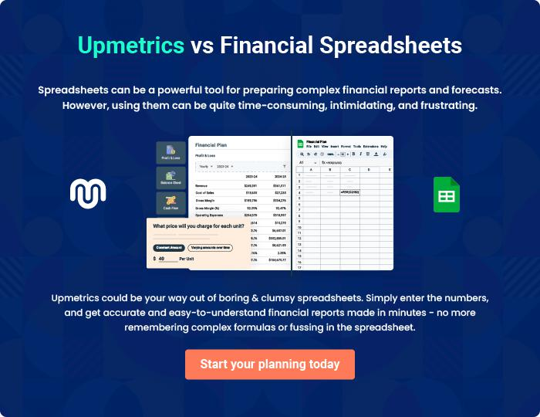

Dance Studio | Business Plan [YEAR] 39/40


Create a winning business plan that gets you funded

Creating a stunning and investment-ready plan requires no writing, graphic designing, or financial planning expertise.

Upmetrics has all the features required to help you create a comprehensive business plan—from start to finish. Make no mistakes, it’s the modern way of planning to structure ideas, make plans, and create stunning pitch decks to awe investors.

Pitch decks that impress investors

Create pitch decks that provide a visual representation of your business, engage investors, and make them want to invest in your business idea.

Interactive plans in no time

Import business plan sections like—SWOT analysis, comparison tables, and others to create an interactive business plan. No designing skills are required.

Stunning cover page designs

With Upmetrics, you have the liberty to choose from multiple stunning cover page designs. Choose a creative design and make your plan stand out.

Online sharing made simple

Upmetrics makes online sharing quick and easier for users. Easily share your business plans with a link while tracking reader activity.

500+ sample business plans

Simply import a template from our library of sample plans into the editor and start customizing it to make it yours. It takes only a few clicks to get started.

Collaborate with team in real-time

Invite team members, initiate conversations, discuss ideas & strategies, share feedback, and work on a business plan in real-time.

