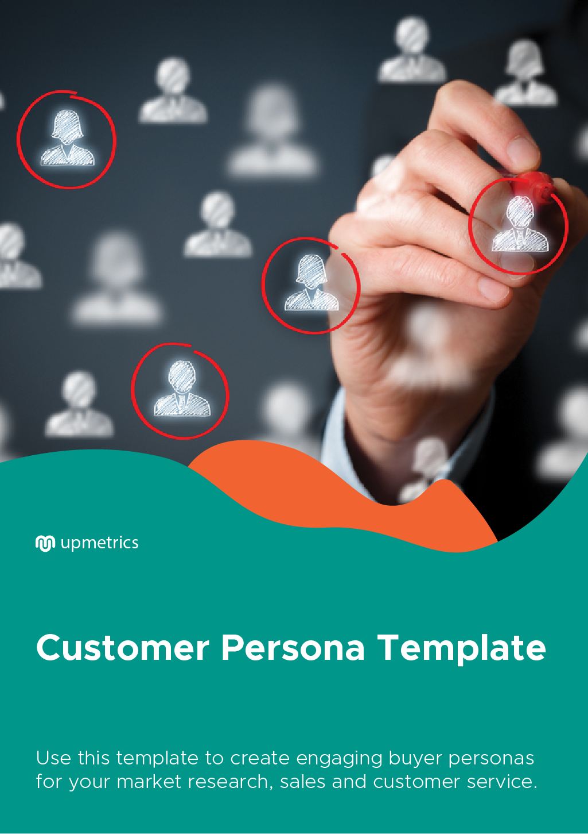

| **Hi There!**  Thanks for downloading this template    You Can Edit Version To Fit Your Needs. |
| --- |
| **What is a Customer Persona?** A customer persona is a description of what your ideal customer would be like. It includes factors like demographics, buying behaviours, challenges your customer faces, etc.  A customer persona can help you in the following way:   1. It can help you understand your target audience better. 2. It helps you formulate better strategies 3. It helps you optimize your product or service to suit your customer’s needs.   The customer persona template will help you create your customer persona and thus in finding your customer’s pain points and address them better.  It also helps you figure out the buying stage of your customers and how you can make them choose your product over everyone else’s. |

| Do you want to plan your business faster?  Upmetrics can help you at every step of writing your business plan.  So, what are you waiting for! | Sample Business Plan |
| --- | --- |
| [**Start writing your business plan today**](https://upmetrics.co/call-to-download?utm_source=customer-persona-template&utm_medium=create-business-plan&utm_campaign=download)**!** | |

|  |  |  |  |
| --- | --- | --- | --- |
| Customer Profile  Profile Icon Png White Clipart - Full Size Clipart (#4968268) - PinClipart  *Bio (About Customer)* | **Goals**  *Primary/secondary goals?*  *Personal vs. professional goals?* | **Challenges**  *What does this person struggle with in relation to meeting goals?*  *What serves as a roadblock for this person’s success?* | |
| **Products / Services Used By Customer**  *Products / Services*  *Products / Services*  *Products / Services* | | |
| **Demographics**   * Career: * Industry: * Location: * Age: * Gender:   **Customer Traits**  *Introvert vs. Extrovert?*  *Interested in trying new things or likes consistency and brands they trust?*  **Professional Role**  *Education? Job? Career Path?* | **Customer Benefits**  *Customer Benefit*  *Customer Benefit*  *Customer Benefit* | | **Customer Problem**  *Customer Problem*  *Customer Problem*  *Customer Problem* |
| **Customer Communication Talking Points**  *Talking Point*  *Talking Point*  *Talking Point* | | **Customer Retention Tactics**  *Retention Tactic*  *Retention Tactic*  *Retention Tactic* |