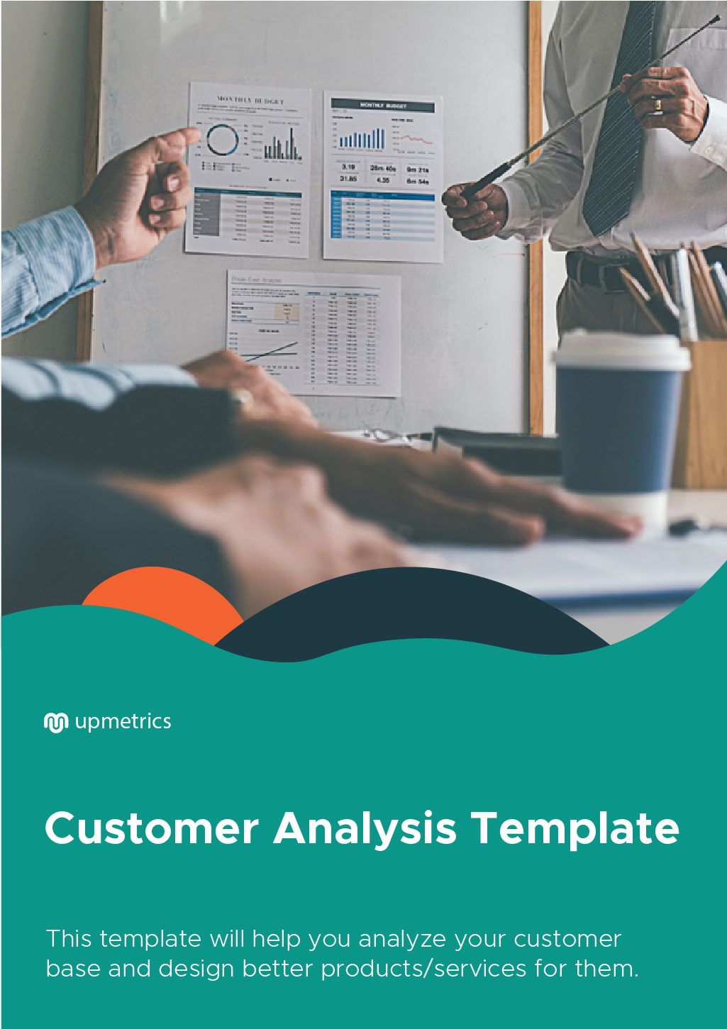

| **Hi There!**  Thanks for downloading this template.    You Can Edit Version to Fit Your Needs. | |
| --- | --- |
| **How to Use This Template**  This template can be used as an outline and guide throughout the writing of your Customer Analysis. It includes editable sections for:   * Introduction * Business Details * Customer Demographics * Market Trends * Customer Needs * Product-Customer Fit   Once you’re ready to begin, delete this page and start filling out your info below. Remember, you can add/edit/delete any copy or sections as you see fit. | |
| **Do you want to plan your business faster?**  Upmetrics can help you at every step of writing your business plan.  So, what are you waiting for! | Sample Business Plan |
| [**Start writing your business plan today**](https://upmetrics.co/call-to-download?utm_source=customer-analysis&utm_medium=create-business-plan&utm_campaign=download)**!** | |

[Add Company Logo Here]

[Write Company Email Address]

[Specify Date of Issuance]

Customer Analysis

Prepared by:

[Person’s Name]

Prepared for:

[Company’s Name]

**1. Introduction**

A customer analysis is central to your marketing plan. From analysing your old customers to stating the characteristics of potential ones, a customer analysis does it all. As it deals with the foundational aspect of a business: Its customers, it is an essential part of your business plan and should not be skipped. After all, it helps you make your plan more effective.

The uses of customer analysis are as follows:

1. It helps you know, understand and analyse your customers. It basically helps you take a deep dive into your customers' problems and buying motivations. Also, it helps you understand how your product or service would fit into their lives.
2. Helps you understand if your customers need your product or service or not. Also, if they’ll be willing to pay for it or not.
3. Allows you to make business plans and strategies that are cost-effective and efficient.

Moving forward, we’ll try to discuss every aspect of a customer analysis template in detail, which are as follows:

1. **Business details**- This section will include all the details about your company, including the products and services your business offers.
2. **Customer demographics-** This section consists of the basic details about your customers like their age, gender, location, profession, and so on.
3. **Market trends-** This section covers the latest market trends prevalent in the industry and how they impact your business. It would also include how you can use these trends for your benefit and what challenges would they bring about for your company.
4. **Customer needs:** Through different methods of qualitative and quantitative research, you’ll find out what are your customers' needs and preferences, what motivates them to buy a product or service, and so on.
5. **Product customer fit:** This section helps you understand whether your product fits the customer’s needs or not.

**2. Business Details**

[Company Name] is currently participating in the sale of [Primary Product Name] and providing [ Type of Services Offered]. The table below shows the updated details of the company.

|  |  |
| --- | --- |
| **BUSINESS DETAILS** | |
| **COMPANY NAME** | [SPECIFY RELEVANT DETAILS] |
| **BUSINESS HEADQUARTERS** | [SPECIFY RELEVANT DETAILS] |
| **EMAIL ADDRESS** | [SPECIFY RELEVANT DETAILS] |
| **CONTACT DETAILS** | [SPECIFY RELEVANT DETAILS] |
| **PRIMARY PRODUCTS** | [SPECIFY RELEVANT DETAILS] |
| **PRIMARY** **SERVICES** | [SPECIFY RELEVANT DETAILS] |
| **START-UP CAPITAL** | [SPECIFY RELEVANT DETAILS] |
| **NUMBER OF EMPLOYEES** | [SPECIFY RELEVANT DETAILS] |
| **MILESTONES** | [SPECIFY RELEVANT DETAILS] |
| **OTHER RELEVANT INFORMATION** | [SPECIFY RELEVANT DETAILS] |

**3. Customer Demographics**

Any business can benefit by specifying its target audience and its basic attributes.  The chart below shows the findings of [Specify Business Name] customer demographics:

|  |  |
| --- | --- |
| **ASPECTS/ POINTS OF CONSIDER:** | **TARGET POPULATION** |
| Geographical location | [NOTE DOWN DETAILS] |
| Psychographic details | [NOTE DOWN DETAILS] |
| Hobbies and Interests | [NOTE DOWN DETAILS] |
| Communication Channels | [NOTE DOWN DETAILS] |
| Size of Base | [NOTE DOWN DETAILS] |

**4. Market Trends**

Market trends play a major role in deciding what customers need and demand. The trends help you understand exactly what makes the customers demand for something. Apart from that, there are various market factors that affect market trends such as the following:

|  |  |
| --- | --- |
| **FACTORS THAT AFFECT MARKET TRENDS** | **HOW CUSTOMERS REACT TO THEM** |
| [NOTE DOWN DETAILS] | [NOTE DOWN DETAILS] |
| [NOTE DOWN DETAILS] | [NOTE DOWN DETAILS] |
| [NOTE DOWN DETAILS] | [NOTE DOWN DETAILS] |
| [NOTE DOWN DETAILS] | [NOTE DOWN DETAILS] |

For putting this document together, the following research methodologies and tools have been used to gather the information  that is relevant to the subject matter:

|  |  |
| --- | --- |
| **RESEARCH METHODOLOGIES** | **PARTICIPANTS/RESPONDENTS** |
| [ SPECIFY DETAILS ex. Survey, data analysis, personal interviews, focus groups, etc.] | [ SPECIFY DETAILS ( indicate the number of participants and the type of respondents needed either future or present customers] |
| [ SPECIFY DETAILS ex. Survey, data analysis, personal interviews, focus groups, etc.] | [ SPECIFY DETAILS ( indicate the number of participants and the type of respondents needed either future or present customers] |
| [ SPECIFY DETAILS ex. Survey, data analysis, personal interviews, focus groups, etc.] | [ SPECIFY DETAILS ( indicate the number of participants and the type of respondents needed either future or present customers] |
| [ SPECIFY DETAILS ex. Survey, data analysis, personal interviews, focus groups, etc.] | [ SPECIFY DETAILS ( indicate the number of participants and the type of respondents needed either future or present customers] |

**5. Customer Needs**

The table below includes the factors that impact the customer needs and their corresponding effects on the customer behaviour and dynamics.

|  |  |
| --- | --- |
| **FACTORS THAT AFFECT CUSTOMER NEEDS** | **HOW CUSTOMERS REACT TO SUCH FACTORS** |
| [ SPECIFY DETAILS ex. Language, motivation, emotional information, environmental issues, economic issues, etc.] | [SPECIFY DETAILS] |
| [ SPECIFY DETAILS ex. Language, motivation, emotional information, environmental issues, economic issues, etc.] | [SPECIFY DETAILS] |
| [ SPECIFY DETAILS ex. Language, motivation, emotional information, environmental issues, economic issues, etc.] | [SPECIFY DETAILS] |
| [ SPECIFY DETAILS ex. Language, motivation, emotional information, environmental issues, economic issues, etc.] | [SPECIFY DETAILS] |

**6. Product-Customer Fit**

This is the final step in completing a customer analysis. It gives information that the managers need to know if the product fits the needs of the customer, or if it appeals to them or not.

To know if the product meets the customer’s needs a product or service analysis must be given. Below are the tables showing the list of products and services of the company and their attributes, advantages provided to the customers, the favourable outcomes, and the type of change the customer will attain if they will consider and get such products and services.

**TABLE 1.**

|  |  |  |  |  |  |
| --- | --- | --- | --- | --- | --- |
| **[COMPANY NAME] PRODUCTS** | | | | | |
| **TARGET POPULATION** | **TYPE OF PRODUCT** | **SPECIAL FEATURES** | **BENEFITS TO THE CUSTOMERS** | **DESIRED OUTCOMES** | **DESIRED**  **TRANSFORMATION** |
| [SPECIFY TARGET POPULATION] | [SPECIFY DETAILS] | [SPECIFY DETAILS] | [SPECIFY DETAILS] | [SPECIFY DETAILS] | [SPECIFY DETAILS] |
| [SPECIFY TARGET POPULATION] | [SPECIFY DETAILS] | [SPECIFY DETAILS] | [SPECIFY DETAILS] | [SPECIFY DETAILS] | [SPECIFY DETAILS] |
| [SPECIFY TARGET POPULATION] | [SPECIFY DETAILS] | [SPECIFY DETAILS] | [SPECIFY DETAILS] | [SPECIFY DETAILS] | [SPECIFY DETAILS] |
| [SPECIFY TARGET POPULATION] | [SPECIFY DETAILS] | [SPECIFY DETAILS] | [SPECIFY DETAILS] | [SPECIFY DETAILS] | [SPECIFY DETAILS] |

**TABLE 2.**

|  |  |  |  |  |  |
| --- | --- | --- | --- | --- | --- |
| **[COMPANY NAME] PRODUCTS** | | | | | |
| **TARGET POPULATION** | **TYPE OF PRODUCT** | **SPECIAL FEATURES** | **BENEFITS TO THE CUSTOMERS** | **DESIRED OUTCOMES** | **DESIRED**  **TRANSFORMATION** |
| [SPECIFY TARGET POPULATION] | [SPECIFY DETAILS] | [SPECIFY DETAILS] | [SPECIFY DETAILS] | [SPECIFY DETAILS] | [SPECIFY DETAILS] |
| [SPECIFY TARGET POPULATION] | [SPECIFY DETAILS] | [SPECIFY DETAILS] | [SPECIFY DETAILS] | [SPECIFY DETAILS] | [SPECIFY DETAILS] |
| [SPECIFY TARGET POPULATION] | [SPECIFY DETAILS] | [SPECIFY DETAILS] | [SPECIFY DETAILS] | [SPECIFY DETAILS] | [SPECIFY DETAILS] |
| [SPECIFY TARGET POPULATION] | [SPECIFY DETAILS] | [SPECIFY DETAILS] | [SPECIFY DETAILS] | [SPECIFY DETAILS] | [SPECIFY DETAILS] |