 Consulting Business


Business Plan

[YEAR]


Strategic process for your profits.

Information provided in this business plan is unique to this business and confidential; therefore, anyone reading this plan agrees not to disclose any of the information in this business plan without prior written permission of the company.

Prepared By

John Doe

10200 Bolsa Ave, Westminster, CA, 92683

info@example.com

(650) 359-3153 http://www.example.com

Table of Contents

Executive summary | 5
Market Validation | 6
Objectives | 6
Short Term (1 -3 Years) | 6
Long Term (3-5 years) | 7
Mission statement | 7
Keys to success | 7
Financial Highlights | 8
CCI - 3 Year Financial Highlights | 8

Business overview | 9
Company Ownership/Legal Entity | 10
Location | 10
Interior Operating Facilities | 11
Hours of Operation | 11
Startup summary | 11

Products & Services | 12
Visa and Government Relations | 13
Business and Investment Consulting Services | 13
Legal and Compliance Services | 14
Human Resources | 14

Market Analysis | 16
Market segmentation | 17
Market Trends | 17
Target market | 18
CCI Market Distribution | 18
Competitive Advantage | 19
SWOT analysis
SWOT analysis | 20

Consulting Business | Business Plan [YEAR] 2/42

Strategy & implementation | 23
Distribution Strategy | 24
Marketing and Promotion Programs | 24
Positioning Statement | 25
Sales strategy | 25
Marketing Channels | 25
Pricing strategy | 26

Operational Plan | 27
Organization chart | 28
Management Team | 29
Personnel Plan | 29
Hiring plan | 29
Jane Doe | 30
John Doe | 30
Milestones | 31
CAPITAL CONSULTANCY INC | 31

Financial plan | 32
Important Assumptions | 33
Brake-even Analysis | 33
Projected Profit and Loss | 34
Projected Cash Flow | 37
Projected Balance Sheet | 38
Business Ratios | 39

Consulting Business | Business Plan [YEAR] 3/42

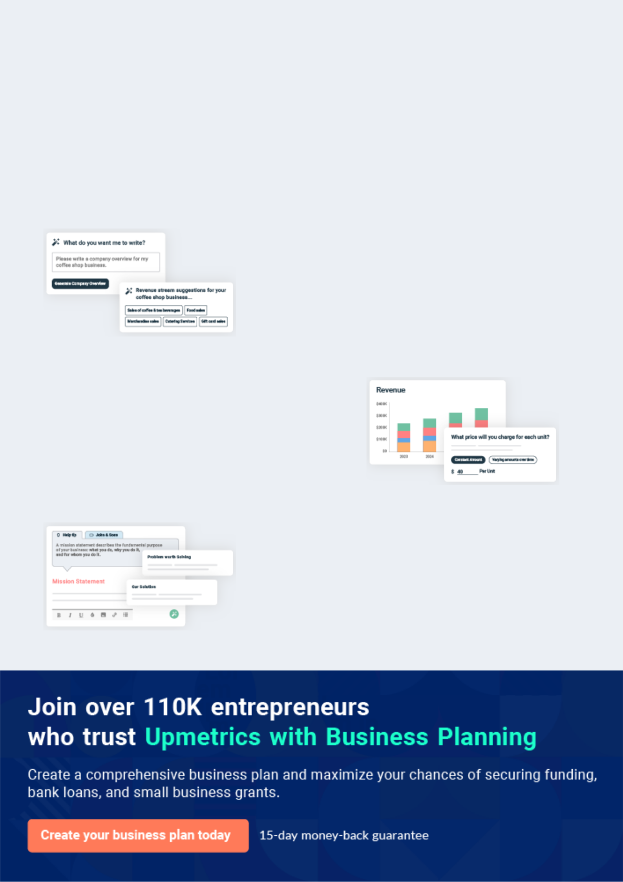
Business planning that’s simpler and faster than you think

Creating a business plan using Upmetrics to start and grow a business is literally the easiest thing in the World. Simply read the instructions and fill in the blanks. It’s as simple as that.

❛ | Upmetrics has everything you need to create a | ❜
❛ | comprehensive business plan. | ❜

AI-powered Upmetrics Assistant

AI-powered insights to streamline your plan

Not sure where to start? Upmetrics’ AI Assistant will automatically generate ideas for each section of your plan and offer improved versions of your writing, adjusting for tone, voice, and grammar or spelling errors.

Financial Forecasting Tool

All the financials are calculated for you

Forget the complex formulas and clumsy spreadsheets — with automatic financials and drag-and-drop forecasting, you can finish your plan faster and be confident that your numbers are accurate.

Business Plan Builder

Guides you like a business mentor

Upmetrics’ step-by-step instructions, prompts, and the library of 400+ sample business plans will guide you through each section of your plan as a business mentor.

1.


Executive summary

Market Validation

Objectives

Mission statement

Keys to success

Financial Highlights

Consulting Business | Business Plan [YEAR] 5/42

 CCI


Capital Consultancy Inc (CCI) will offer professional advice and support to a diverse range of clients in the UK who have corporate or public sector dealings across borders.
To unlock help try Upmetrics! 

Start writing here..

Market Validation

 CCI

As the company’s expertise lies in consultancy services relating to business and relationship management overseas markets, the company will be classified within the Management Consulting industry in the US. The US management consulting market is worth around $64.4
To unlock help try Upmetrics! 

Start writing here..

Objectives

 CCI

• To enhance customer service and after-sale services by establishing a representative office in New York in 2022
• To build a market reputation for quality services during the forecast period.
To unlock help try Upmetrics! 

Short Term (1 -3 Years)

Start writing here..

 CCI

• To expand by opening more satellite offices across the US towards the end of the forecast period.
• To hire 30 employees in the first year and grow to 200 employees in the fifth year.
To unlock help try Upmetrics! 

Consulting Business | Business Plan [YEAR] 6/42

Long Term (3-5 years)

Start writing here..

Mission statement

 CCI

Our Mission is to develop long-term and strategic partnerships with our clients and help them to transform today’s challenges into tomorrow’s successes. And we are committed to meeting and exceeding the expectations in providing excellent service, unexpected quality, and
To unlock help try Upmetrics! 

Start writing here..

Keys to success


Economies of Scope

CCI benefits from a global network of associates which includes a group of highly qualified personnel with relevant and transferable experience/knowhow.


Location

CCI will take advantage of the associated benefits, networking capabilities and the vast cluster of residential and commercials establishments offered by the region.


Quality Service

The management team at CCI is experienced and capable of delivering bespoke solutions that are responsive to challenging market situations. They are committed to providing the best contract delivery terms at competitive prices.

Expertise


Founders will indicate their history of providing related services, complete with endorsements of satisfied clientele, in order to generate brand equity for CCI.

Competent Team


CCI is supported by a dynamic and experienced team of professionals. Collectively, the experiences of the team members range from strategic level positions in government and non-governmental organisations to technical


Multi-Skilled Workforce

As CCI intends to service a wide variety of customers across multiple services of varying technicalities, the company needs to employ workers that carry suitable experience on flexible terms (so as to minimise fixed costs).

Consulting Business | Business Plan [YEAR] 7/42

Financial Highlights

 CCI

The company envisions raising an equity investment of $50,000 through long-term borrowings, which will be used for the setup and launch of the jewelry store in the US. The company expects to steadily grow its revenues through active efforts in marketing, networking, excellent
To unlock help try Upmetrics! 

Start writing here..

CCI - 3 Year Financial Highlights
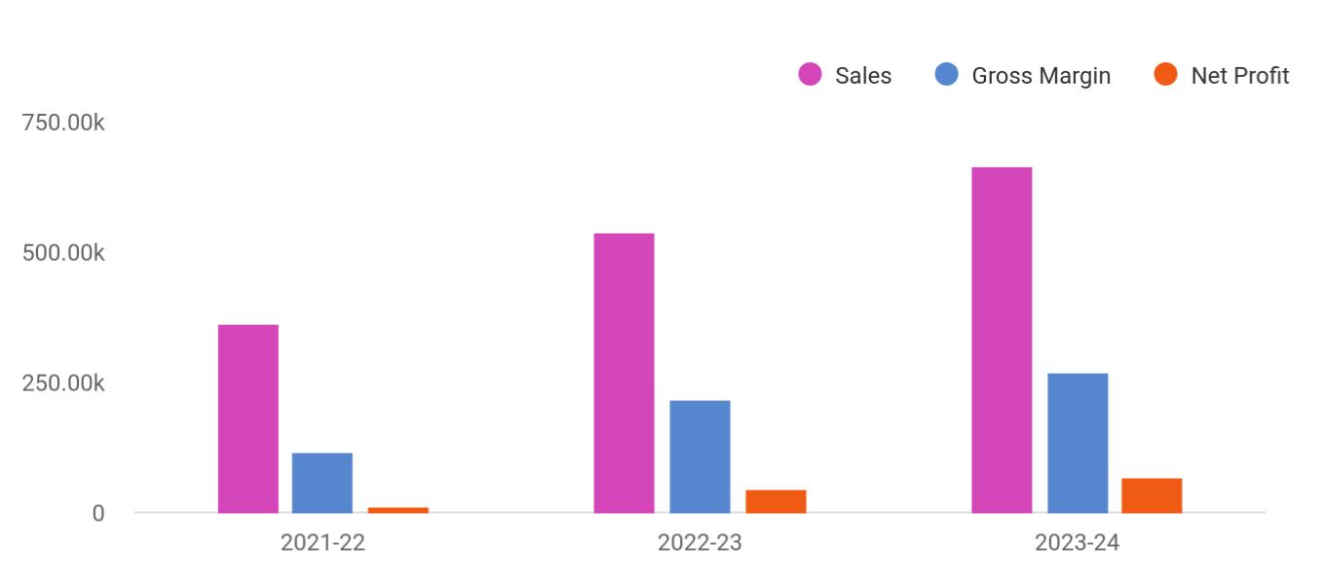

Financial Year | Sales | Gross Margin | Net Profit
2021-22 | 360,723 | 114,289 | 13,038
2022-23 | 538,041 | 216,784 | 44,360
2023-24 | 665,012 | 269,869 | 65,638

Consulting Business | Business Plan [YEAR] 8/42

2.

Business overview

Company Ownership/Legal Entity

Location

Interior Operating Facilities

Hours of Operation

Startup summary

Consulting Business | Business Plan [YEAR] 9/42

 CCI

CCI consists of some of the country’s top legal experts who are conversant in international legal and regulatory frameworks for international businesses operating in the country. The company prides itself in providing high-quality services in the areas of HR/Personnel
To unlock help try Upmetrics! 

Start writing here..

Company Ownership/Legal Entity

 CCI

The company will be registered as a limited liability entity with the Department of State. Further, since the company envisions setting up operations in New York, it will also register with the local county. The business will be wholly owned and managed by the Founder Mr. Ashton, who
To unlock help try Upmetrics! 

Start writing here..

Location

 CCI

The company will establish a business in New York by the end of 2022.

Known as the “Fashion Capital,” New York state is home to 2.1 million small businesses and 4
To unlock help try Upmetrics! 

Start writing here..

Consulting Business | Business Plan [YEAR] 10/42

Interior Operating Facilities

 CCI

The company will begin operations from rented office space at the heart of New York's commercial hub, Manhattan. Initial investments in setting up the interior facilities,
consumables, and client entertainment space will be set up. Additions to space will be made as
To unlock help try Upmetrics! 

Start writing here..

Hours of Operation

 CCI

CCI will cater to walk-in as well as online customers, as such it will be required to stay open during business hours. The company envisions opening the office at 10 am and remain open till 7 pm to entertain walk-in prospects as well as fulfill online consultations.
To unlock help try Upmetrics! 

Start writing here..

Startup summary

 CCI

A portion of the capital investment of $50,000 will be utilized to finance a range of expenses incurred prior to the launch of the company as indicated in the table below. Accordingly,
approximately $11,500 will be spent on a range of start-up expenses (reflected in the top half of
To unlock help try Upmetrics! 

Start writing here..

Consulting Business | Business Plan [YEAR] 11/42

3.

Products & Services

Visa and Government Relations

Business and Investment Consulting Services

Legal and Compliance Services

Human Resources

Consulting Business | Business Plan [YEAR] 12/42

 CCI

The global marketplace is fraught with rising opportunities for investment, trade, and transit with some developing countries offering some of the most flexible investment laws in the world for any kind of foreign investment. The US on the other hand is a developed country with a trade
To unlock help try Upmetrics! 

Start writing here..

Visa and Government Relations

 CCI

Understanding the intricacies of government policy and procedures, political priorities, and detailed knowledge of the people is central to operating in any country. CCI enables its clients to capitalize on the company’s relationships with key audiences and influencers such as the
To unlock help try Upmetrics! 

Start writing here..

Business and Investment Consulting Services

 CCI

With proven expertise in the areas of agriculture, energy, mining, engineering, and telecommunications, CCI understands that achieving growth and return on investment requires not only hard assets but also soft enterprise. In the US, CCI aims to be a pioneer consulting firm
To unlock help try Upmetrics! 

Start writing here..

Consulting Business | Business Plan [YEAR] 13/42

Legal and Compliance Services

 CCI

Compliance with statutory and regulatory requirements of countries is an essential part of running a hassle-free business. Navigating through the complicated legal system and
regulatory culture of overseas markets can be challenging. CCI’s legal services encompass a
To unlock help try Upmetrics! 

Start writing here..

Human Resources

 CCI

CCI is proficient in providing human resource management services. With multiple years of experience in the area, CCI has a significant, in-house database of applicants, as well as access to most of the external resources that are available in the country. The company is experienced
To unlock help try Upmetrics! 

Start writing here..

Consulting Business | Business Plan [YEAR] 14/42

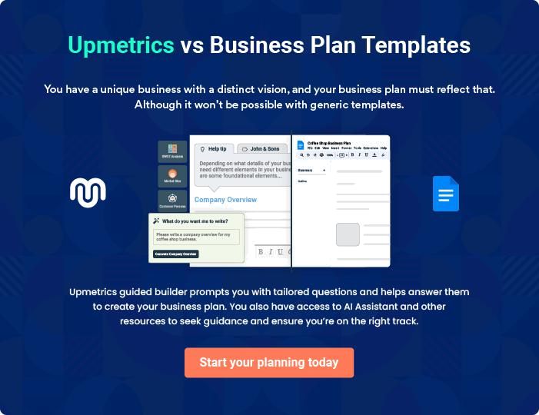

Consulting Business | Business Plan [YEAR] | 15/42

4.

Market Analysis

Market segmentation

Market Trends

Target market

Consulting Business | Business Plan [YEAR] 16/42

 CCI

In 2020, the consulting market size in the United States reached a value of 64.4 billion U.S. dollars. After experiencing continuous growth between 2015 and 2019, due to the impact of the coronavirus (COVID-19) pandemic, the consulting sector decreased by 12.5 per cent throughout
To unlock help try Upmetrics! 

Start writing here..

Market segmentation

 CCI

With a 93% share of the North American consulting industry, the US is the single largest market of the globe, between 5x to 10x larger than the UK and German consulting markets – Europe’s powerhouses – and more than 10x the size of the Australian advisory market. Not just in size,
To unlock help try Upmetrics! 

Start writing here..

Market Trends

 CCI

Over the past years, the North American advisory market has seen continued growth, on the back of a strong recovery from the financial crisis between 2008 and 2010, which traces its origins back to the US following the collapse of Lehman Brothers. In 2011 the industry was
To unlock help try Upmetrics! 

Start writing here..

Consulting Business | Business Plan [YEAR] 17/42

Target market

 CCI

CCI is a consulting company specializing in business management services. The company’s current activities range from providing government services such as work permits and visas to extending legal and compliance-related support services and other management and
To unlock help try Upmetrics! 

Start writing here..

CCI Market Distribution
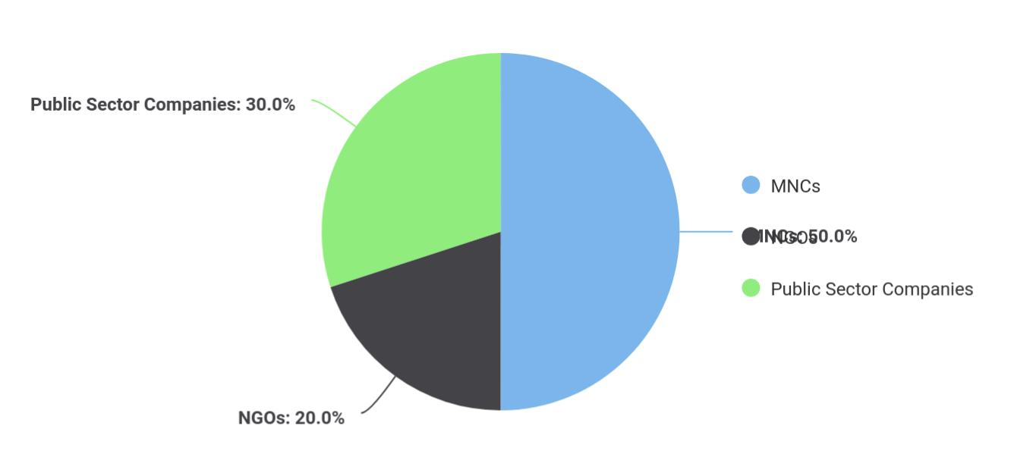

Target Market | Share
MNCs | 50
NGOs | 20
Public Sector Companies | 30

Consulting Business | Business Plan [YEAR] 18/42

Competitive Advantage


Value Added

Services

CCI will dedicate itself to the wellbeing of its customers. The company will extend specific client focused services based on their requirement.

Distribution Channels

CCI will distribute its products through both B2B as well as B2C channels.

Price

The company will consciously maintain a low margin for its services which allows it to control prices. CCI will thus be able to secure and distribute services at market beating price points.

Effective Marketing

CCI will dedicate time and effort towards networking and gaining valuable insight into the prevailing market trends in the US which will allow the company to optimise its marketing strategies and effectively penetrate the market on launch.

Consulting Business | Business Plan [YEAR] 19/42

5.

SWOT analysis

Consulting Business | Business Plan [YEAR] 20/42

 CCI

A SWOT (Strength, Weakness, Opportunity, and Threat) analysis is a useful tool for businesses to evaluate their position in the market against the potential internal and external factors that could assist or jeopardize their operations and existence. A SWOT has been conducted for
To unlock help try Upmetrics! 

Start writing here..

Consulting Business | Business Plan [YEAR] 21/42


Strength

- Spearheaded by extremely skilled Director of operations whose skills in international management sector are exceptional

- Rich pool of in-house expertise

- Large network of associates and partners internationally

- Core values of integrity, competence and innovations inspired loyalty and trust

- Deep relationships across key government agencies and commercial sector players.

- Affiliate contacts across the US, UAE, India, Turkey, Canada, and the USA

- Niche market operations

- Represents a lucrative emerging economy

- Maintain strong relationships with Government agencies both in the US and global markets

Weakness


- A new brand in the US will need time to establish its name and reputation

- Setting up regulatory compliance could take up to 6 months


Opportunity

- Leverage affiliate expertise to expand the offering

- Develop key partnerships with US-based consulting companies that have clients interested in overseas investment

- Leverage presence in the US to facilitate bidirectional investment by companies based overseas

- Expand the portfolio of services

Threat

- Low barriers to entry; increasing competition

- Customers defaults

- Slow economic growth in the future could stagnate the construction market in the
US

- Further restrictions in buy-to-let could affect demand

Consulting Business | Business Plan [YEAR] 22/42

6.

Strategy & implementation

Distribution Strategy

Positioning Statement

Sales strategy

Pricing strategy

Consulting Business | Business Plan [YEAR] 23/42

 CCI

The objectives for the company’s early sales and marketing initiatives will be to generate awareness of CCI as a new player in the market and to educate potential customers about its portfolio of services. Over time, as CCI becomes more established and develops a strong
To unlock help try Upmetrics! 

Start writing here..

Distribution Strategy

 CCI

CCI value proposition relates to businesses operating predominantly in the charitable and public sectors. As such, network marketing is key to the company’s awareness and brand-
building activities. CCI will thus rely on its network of influential government and private sector
To unlock help try Upmetrics! 

Start writing here..

Marketing and Promotion Programs


Website

Launch an engaging and attractive website that is a source of promotional materials


Feedback


Create a healthy feedback loop to gauge shifting trends and align services to meet demand

Email

Compiling attractive market materials which feature service portfolio of CCI to be sent as e-mail blasts to prospects

Video


Crafting YouTube videos to provide a sneak-peek into the company’s activities and projects carried out

Consulting Business | Business Plan [YEAR] 24/42

Positioning Statement
To unlock help try Upmetrics!

 CMS


CCI’s marketing objective is to position its services as specialized, affordable, and flexible to cater to any type of setting. The company will facilitate both B2B business as well as a B2C business, targeting private businesses, both local and international.



Start writing here..

Sales strategy

 CCI

The company will leverage its existing client network and expand its client base by extending sampling and after-sales services. Employing social media advertising campaigns, e-mail marketing strategies, networking through community clusters, and creating awareness by
To unlock help try Upmetrics! 

Start writing here..

Marketing Channels


Direct Mail Marketing | Social Media | Google Ad Campaigns
CCI will mail professionally | Millennials and consumers in | The advertising will target
designed materials with its | general spend a considerable | specific keywords relevant to
value proposition to these | time browsing social media | CCI's offering
companies and provide quotes | platforms. Reaching to them
for its services. | through this channel will be
 | and effective way to capture
 | attention and position its
 | services.

Consulting Business | Business Plan [YEAR] 25/42

Pricing strategy
To unlock help try Upmetrics!

 CCI

The company will price its services based on the number of hours spent on the service. Ensuring low direct input costs, the company will optimize its sourcing and project delivery techniques to maintain and offer services at a low price point.



Start writing here..

Consulting Business | Business Plan [YEAR] 26/42

7.

Operational Plan

Management Team

Personnel Plan

Milestones

Consulting Business | Business Plan [YEAR] 27/42

 CCI
Jane Green
Market Analyst
To unlock help try Upmetrics!

The team will be headed by Managing Director Mr. Ashton who will also oversee project operations. Joining Mr. Ashton in the Management Team will be sales and marketing executives and an office manager.



Start writing here..

Organization chart


Marco

Managing Director


Jane Doe

Project Manager


John Doe

Superviser


John Green


Legal & Advisory

Consulting Business | Business Plan [YEAR] 28/42

Management Team
To unlock help try Upmetrics!

 CCI

Mr. Ashton will serve as the Managing Director of CCI. A highly motivated and dynamic individual, Thomas boasts vast experience in the field of aesthetics having spent a career
spanning 14 years essaying various white-collar roles for aesthetic companies across America.
To unlock help try Upmetrics! 

Start writing here..

Personnel Plan

 CCI

The company plans to create five full-time equivalent jobs in addition to the management team within the first three years of operations. Salaries for each employee are in line with the industry’s benchmark.



Start writing here..

Hiring plan

8 |  |  |  | 3 |  |  |  |  | 1
Filled |  |  |  | Hired |  |  |  |  | Open
Group By | Position Filled |  |  |  |  | Time of Hire |  |  | Time of Start |  | Filled On Time
Department |  |  |  |  |  |  |  |  |  |  | Filled On Time
Maintenance |  | 1 of 20 |  |  |  | 10 days |  |  | 121 days |  | 100%
Workers |  |  |  |  |  |  |  |  |  |  | 100%
Supervisors |  | 3 of 23 |  |  |  | 30 days |  |  | 21 days |  | 80%
Cleaners |  | 4 of 15 |  |  |  | 158 days |  |  | 127 days |  | 0%
Project Managers |  | 4 of 15 |  |  |  | 158 days |  |  | 127 days |  | 40%

Consulting Business | Business Plan [YEAR] 29/42


Jane Doe

Project Manager - Jane@capitalconsulting.com

Ability to cope with fast-paced and pressured work, accuracy, strong attention to detail and a strong analytical mind, ability to notice patterns within statistics, an interest in psychology and behavior, good organizational skills, excellent (spoken and written) communication skills.


John Doe

Supervisor - John@capitalconsulting.com

Preferably bilingual with ability to speak English and French fluently, problem-solving, ability to convert leads into sales, active listener, patience, and understanding of the company’s products and services. Additionally, skills in social media marketing, search engine optimization, newsletter marketing, other forms of digital marketing will also be required

Consulting Business | Business Plan [YEAR] 30/42

Milestones

CAPITAL CONSULTANCY INC
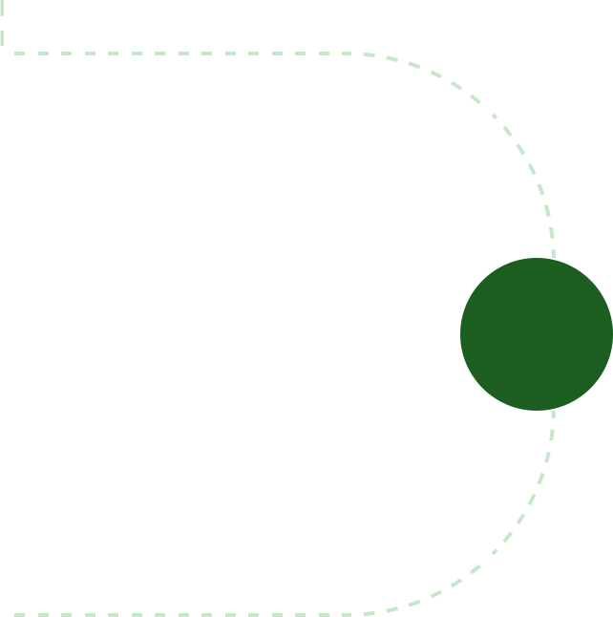

Establish

CCI will rent a showroom space at the heart

of New York's commercial hub alongside

developing a fully optimized and

informative website. During this period, the

company will also acquire cleaning

equipment and consumables. Marketing

activities will also begin during this stage to

build awareness and launch the brand into

the market.



 | Gain Market Traction
Year 2 | The company will begin expanding its
Year 2 | services beyond Rhode Island to cover
 | other regions around the United States


Diversify

Having externally established the business,

the company will begin internally expanding

its range of products


Grow

>Year 3 • Begin expanding across the US

• Consider market expansion beyond US


Year 1

Year 3

Consulting Business | Business Plan [YEAR] 31/42

8.

Financial plan

Important Assumptions

Brake-even Analysis

Projected Profit and Loss

Projected Cash Flow

Projected Balance Sheet

Business Ratios

Consulting Business | Business Plan [YEAR] 32/42


If you are going to start your own consulting business, then make sure you will pay special attention to your financial plan. Your financial plan should include the details about how well you manage your incomes and expenses,
To unlock help try Upmetrics! 

Important Assumptions

The company’s financial projections are forecasted on the basis of the following assumptions. These assumptions are quite conservative and are also expected to show deviation but to a limited level such that the company’s major financial strategy will not be affected.

 | Year 1 | Year 2 | Year 3
Plan Month | 1 | 2 | 3
Current Interest Rate | 10,00% | 11,00% | 12,00%
Long-term Interest Rate | 10,00% | 10,00% | 10,00%
Tax Rate | 26,42% | 27,76% | 28,12%
Other | 0 | 0 | 0

Brake-even Analysis

Monthly Units Break-even | 5530
Monthly Revenue Break-even | $159 740
Assumptions:
Average Per-Unit Revenue | $260,87
Average Per-Unit Variable Cost | $0,89
Estimated Monthly Fixed Cost | $196 410

Consulting Business | Business Plan [YEAR] 33/42

Projected Profit and Loss

 | 2024 | 2025 | 2026
Revenue | $604,856.16 | $903,862.11 | $1,423,858.81
Legal Advisory Services | $318,416 | $572,104 | $1,027,488
Unit Sales | 398 | 715 | 1,284
Unit Price | $800 | $800 | $800
Contract Management | $106,440.16 | $151,758.11 | $216,370.81
HR Consultation Services | $180,000 | $180,000 | $180,000
Total Hours | 1,200 | 1,200 | 1,200
Hourly Price | $150 | $150 | $150

Cost Of Sales | $42,948.79 | $59,805.84 | $88,198.30
General Costs | $42,948.79 | $59,805.84 | $88,198.30
Legal Advisory COGS | $36,948.79 | $53,697.84 | $81,979.06
Research Expenses | $6,705.97 | $8,504.74 | $10,786.13
Legal Document Processing | $30,242.82 | $45,193.10 | $71,192.93
Fees | $30,242.82 | $45,193.10 | $71,192.93
HR Consultation COGS | $6,000 | $6,108 | $6,219.24
Training Material Costs | $3,600 | $3,708 | $3,819.24
HR Software Subscription | $2,400 | $2,400 | $2,400
Fees | $2,400 | $2,400 | $2,400
Revenue Specific Costs | $0 | $0 | $0
Personnel Costs (Direct | $0 | $0 | $0
Labor) | $0 | $0 | $0

Gross Margin | $561,907.37 | $844,056.27 | $1,335,660.51
Gross Margin (%) | 92.90% | 93.38% | 93.81%

Consulting Business | Business Plan [YEAR] 34/42

Operating Expense

Payroll Expense (Indirect Labor)

Legal Department

Senior Legal Advisor

Legal Assistant

HR Department

HR Manager

Recruitment Specialist

IT and Support

IT Administrator

Technical Support

Specialist

General Expense

Office and Administration

Office Rent

Utilities

Technology and

Communication

IT Support and

Maintenance

Internet and Telephone

Marketing and Advertising

Online Marketing

Print Advertising

Bad Debt
2024 2025 2026

$619,259.16 | $677,181.67 | $812,630.35
$400,272 | $411,962.16 | $424,010.52
$143,640 | $147,478.80 | $151,423.44
$96,600 | $99,498 | $102,483
$47,040 | $47,980.80 | $48,940.44
$136,560 | $140,119.20 | $143,774.40
$82,800 | $85,284 | $87,842.52
$53,760 | $54,835.20 | $55,931.88
$120,072 | $124,364.16 | $128,812.68
$69,000 | $71,760 | $74,630.40
$51,072 | $52,604.16 | $54,182.28
$217,987.56 | $265,219.51 | $388,619.84
$33,850.94 | $46,671.59 | $58,140.31
$24,000 | $29,040 | $31,680
$9,850.94 | $17,631.59 | $26,460.31
$69,968.16 | $94,401.75 | $129,131.07
$13,200 | $13,464 | $13,733.28
$56,768.16 | $80,937.75 | $115,397.79
$114,168.46 | $124,146.17 | $201,348.46
$53,682.82 | $33,759.96 | $58,962.58
$60,485.64 | $90,386.21 | $142,385.88
$0 | $0 | $0

Consulting Business | Business Plan [YEAR] 35/42

Amortization of Current Assets

EBITDA

Additional Expense

Long Term Depreciation

Gain or loss from Sale of Assets

EBIT

Interest Expense

EBT

Income Tax Expense / Benefit

Total Expense

Net Income

Net Income (%)

Retained Earning Opening

Owner's Distribution

Retained Earning Closing

2024 | 2025 | 2026
$999.60 | $0 | $0

($57,351.79) $166,874.60 $523,030.15

$8,338.93 | $6,404.77 | $4,351.31
$3,192 | $3,192 | $3,192
$0 | $0 | $0
($60,543.79) | $163,682.60 | $519,838.15
$5,146.94 | $3,212.76 | $1,159.29
($65,690.72) | $160,469.83 | $518,678.84
$0 | $0 | $0

$670,546.88 | $743,392.28 | $905,179.97
($65,690.72) | $160,469.83 | $518,678.84
(10.86%) | 17.75% | 36.43%

$0 | ($85,690.72) | $54,779.11
$20,000 | $20,000 | $20,000
($85,690.72) | $54,779.11 | $553,457.95

Consulting Business | Business Plan [YEAR] 36/42

Projected Cash Flow

 | 2024 | 2025 | 2026
Cash Received | $604,856.16 | $903,862.11 | $1,423,858.81
Cash Paid | $666,355.28 | $740,200.28 | $901,987.97
COS & General Expenses | $260,936.35 | $325,025.35 | $476,818.14
Salary & Wages | $400,272 | $411,962.16 | $424,010.52
Interest | $5,146.94 | $3,212.76 | $1,159.29
Sales Tax | $0 | $0 | $0
Income Tax | $0 | $0 | $0
Net Cash From | ($61,499.12) | $163,661.83 | $521,870.84
Operations | ($61,499.12) | $163,661.83 | $521,870.84
Assets Sell | $0 | $0 | $0
Assets Purchase | $21,000 | $0 | $0
Net Cash From | ($21,000) | $0 | $0
Investments | ($21,000) | $0 | $0
Amount Received | $150,000 | $0 | $0
Loan Received | $100,000 | $0 | $0
Common Stock | $0 | $0 | $0
Preferred Stock | $0 | $0 | $0
Owner's Contribution | $50,000 | $0 | $0
Amount Paid | $51,359.35 | $53,293.51 | $55,347.12
Loan Capital | $31,359.34 | $33,293.52 | $35,347.14
Dividends & Distributions | $20,000 | $20,000 | $20,000
Net Cash From | $98,640.65 | ($53,293.51) | ($55,347.12)
Financing | $98,640.65 | ($53,293.51) | ($55,347.12)

Consulting Business | Business Plan [YEAR] 37/42

 | 2024 | 2025 | 2026
Summary
Starting Cash | $0 | $16,141.53 | $126,509.85
Cash In | $754,856.16 | $903,862.11 | $1,423,858.81
Cash Out | $738,714.63 | $793,493.79 | $957,335.09
Change in Cash | $16,141.53 | $110,368.32 | $466,523.72
Ending Cash | $16,141.53 | $126,509.85 | $593,033.57
Projected Balance Sheet
 | 2024 | 2025 | 2026
Assets | $32,949.93 | $140,126.25 | $603,457.97
Current Assets | $16,141.93 | $126,510.25 | $593,033.97
Cash | $16,141.53 | $126,509.85 | $593,033.57
Accounts Receivable | $0 | $0 | $0
Inventory | $0 | $0 | $0
Other Current Assets | $0.40 | $0.40 | $0.40
Long Term Assets | $16,808 | $13,616 | $10,424
Gross Long Term Assets | $20,000 | $20,000 | $20,000
Accumulated Depreciation | ($3,192) | ($6,384) | ($9,576)
Liabilities & Equity | $32,949.94 | $140,126.25 | $603,457.95
Liabilities | $68,640.66 | $35,347.14 | $0
Current Liabilities | $33,293.52 | $35,347.14 | $0
Accounts Payable | $0 | $0 | $0
Income Tax Payable | $0 | $0 | $0

Consulting Business | Business Plan [YEAR] 38/42

 | 2024 |  |  | 2025 |  | 2026
Sales Tax Payable | $0 |  |  | $0 |  | $0
Short Term Debt | $33,293.52 |  | $35,347.14 |  |  | $0
Long Term Liabilities | $35,347.14 |  |  | $0 |  | $0
Long Term Debt | $35,347.14 |  |  | $0 |  | $0
Equity | ($35,690.72) |  | $104,779.11 |  |  | $603,457.95
Paid-in Capital | $0 |  |  | $0 |  | $0
Common Stock | $0 |  |  | $0 |  | $0
Preferred Stock | $0 |  |  | $0 |  | $0
Owner's Contribution | $50,000 |  |  | $50,000 |  | $50,000
Retained Earnings | ($85,690.72) |  | $54,779.11 |  |  | $553,457.95
Check | $0 |  |  | $0 |  | $0
Business Ratios
 |  | Year 1 | Year 2 |  | Year 3 | Industry profile
Sales Growth |  | 4,35% | 30,82% |  | 63,29% | 4,00%
Percent of Total Assets
Accounts Receivable |  | 5,61% | 4,71% |  | 3,81% | 9,70%
Inventory |  | 1,85% | 1,82% |  | 1,79% | 9,80%
Other Current Assets |  | 1,75% | 2,02% |  | 2,29% | 27,40%
Total Current Assets |  | 138,53% | 150,99% |  | 163,45% | 54,60%
Long-term Assets |  | -9,47% | -21,01% |  | -32,55% | 58,40%
TOTAL ASSETS |  | 100,00% | 100,00% |  | 100,00% | 100,00%
Current Liabilities |  | 4,68% | 3,04% |  | 2,76% | 27,30%
Long-term Liabilities |  | 0,00% | 0,00% |  | 0,00% | 25,80%
Total Liabilities |  | 4,68% | 3,04% |  | 2,76% | 54,10%

Consulting Business | Business Plan [YEAR] 39/42

 | Year 1 | Year 2 | Year 3 | Industry profile
NET WORTH | 99,32% | 101,04% | 102,76% | 44,90%
Percent of Sales
Sales | 100,00% | 100,00% | 100,00% | 100,00%
Gross Margin | 94,18% | 93,85% | 93,52% | 0,00%
Selling, General & Administrative Expenses | 74,29% | 71,83% | 69,37% | 65,20%
Advertising Expenses | 2,06% | 1,11% | 0,28% | 1,40%
Profit Before Interest and Taxes | 26,47% | 29,30% | 32,13% | 2,86%
Main Ratios
Current | 25,86 | 29,39 | 32,92 | 1,63
Quick | 25,4 | 28,88 | 32,36 | 0,84
Total Debt to Total Assets | 2,68% | 1,04% | 0,76% | 67,10%
Pre-tax Return on Net Worth | 66,83% | 71,26% | 75,69% | 4,40%
Pre-tax Return on Assets | 64,88% | 69,75% | 74,62% | 9,00%
Additional Ratios
Net Profit Margin | 19,20% | 21,16% | 23,12% | N.A.
Return on Equity | 47,79% | 50,53% | 53,27% | N.A.
Activity Ratios
Accounts Receivable Turnover | 4,56 | 4,56 | 4,56 | N.A.
Collection Days | 92 | 99 | 106 | N.A.
Inventory Turnover | 19,7 | 22,55 | 25,4 | N.A.
Accounts Payable Turnover | 14,17 | 14,67 | 15,17 | N.A.
Payment Days | 27 | 27 | 27 | N.A.
Total Asset Turnover | 1,84 | 1,55 | 1,26 | N.A.
Debt Ratios
Debt to Net Worth | 0 | -0,02 | -0,04 | N.A.
Current Liab. to Liab. | 1 | 1 | 1 | N.A.
Liquidity Ratios
Net Working Capital | $120 943 | $140 664 | $160 385 | N.A.

Consulting Business | Business Plan [YEAR] 40/42

 | Year 1 | Year 2 | Year 3 | Industry profile
Interest Coverage | 0 | 0 | 0 | N.A.
Additional Ratios
Assets to Sales | 0,45 | 0,48 | 0,51 | N.A.
Current Debt/Total Assets | 4% | 3% | 2% | N.A.
Acid Test | 23,66 | 27,01 | 30,36 | N.A.
Sales/Net Worth | 1,68 | 1,29 | 0,9 | N.A.
Dividend Payout | 0 | 0 | 0 | N.A.
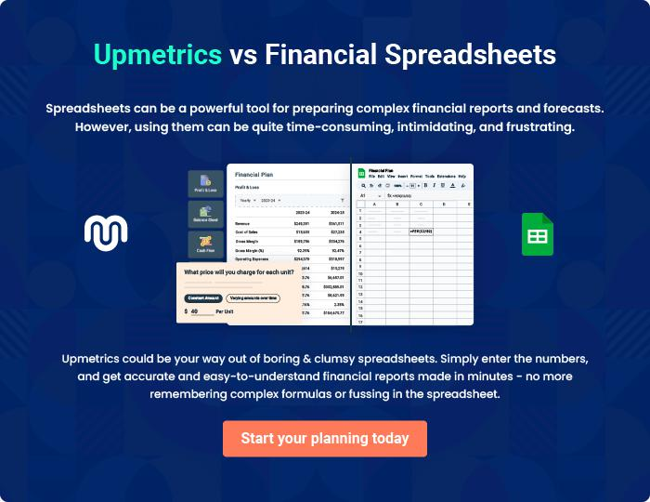

Consulting Business | Business Plan [YEAR] 41/42

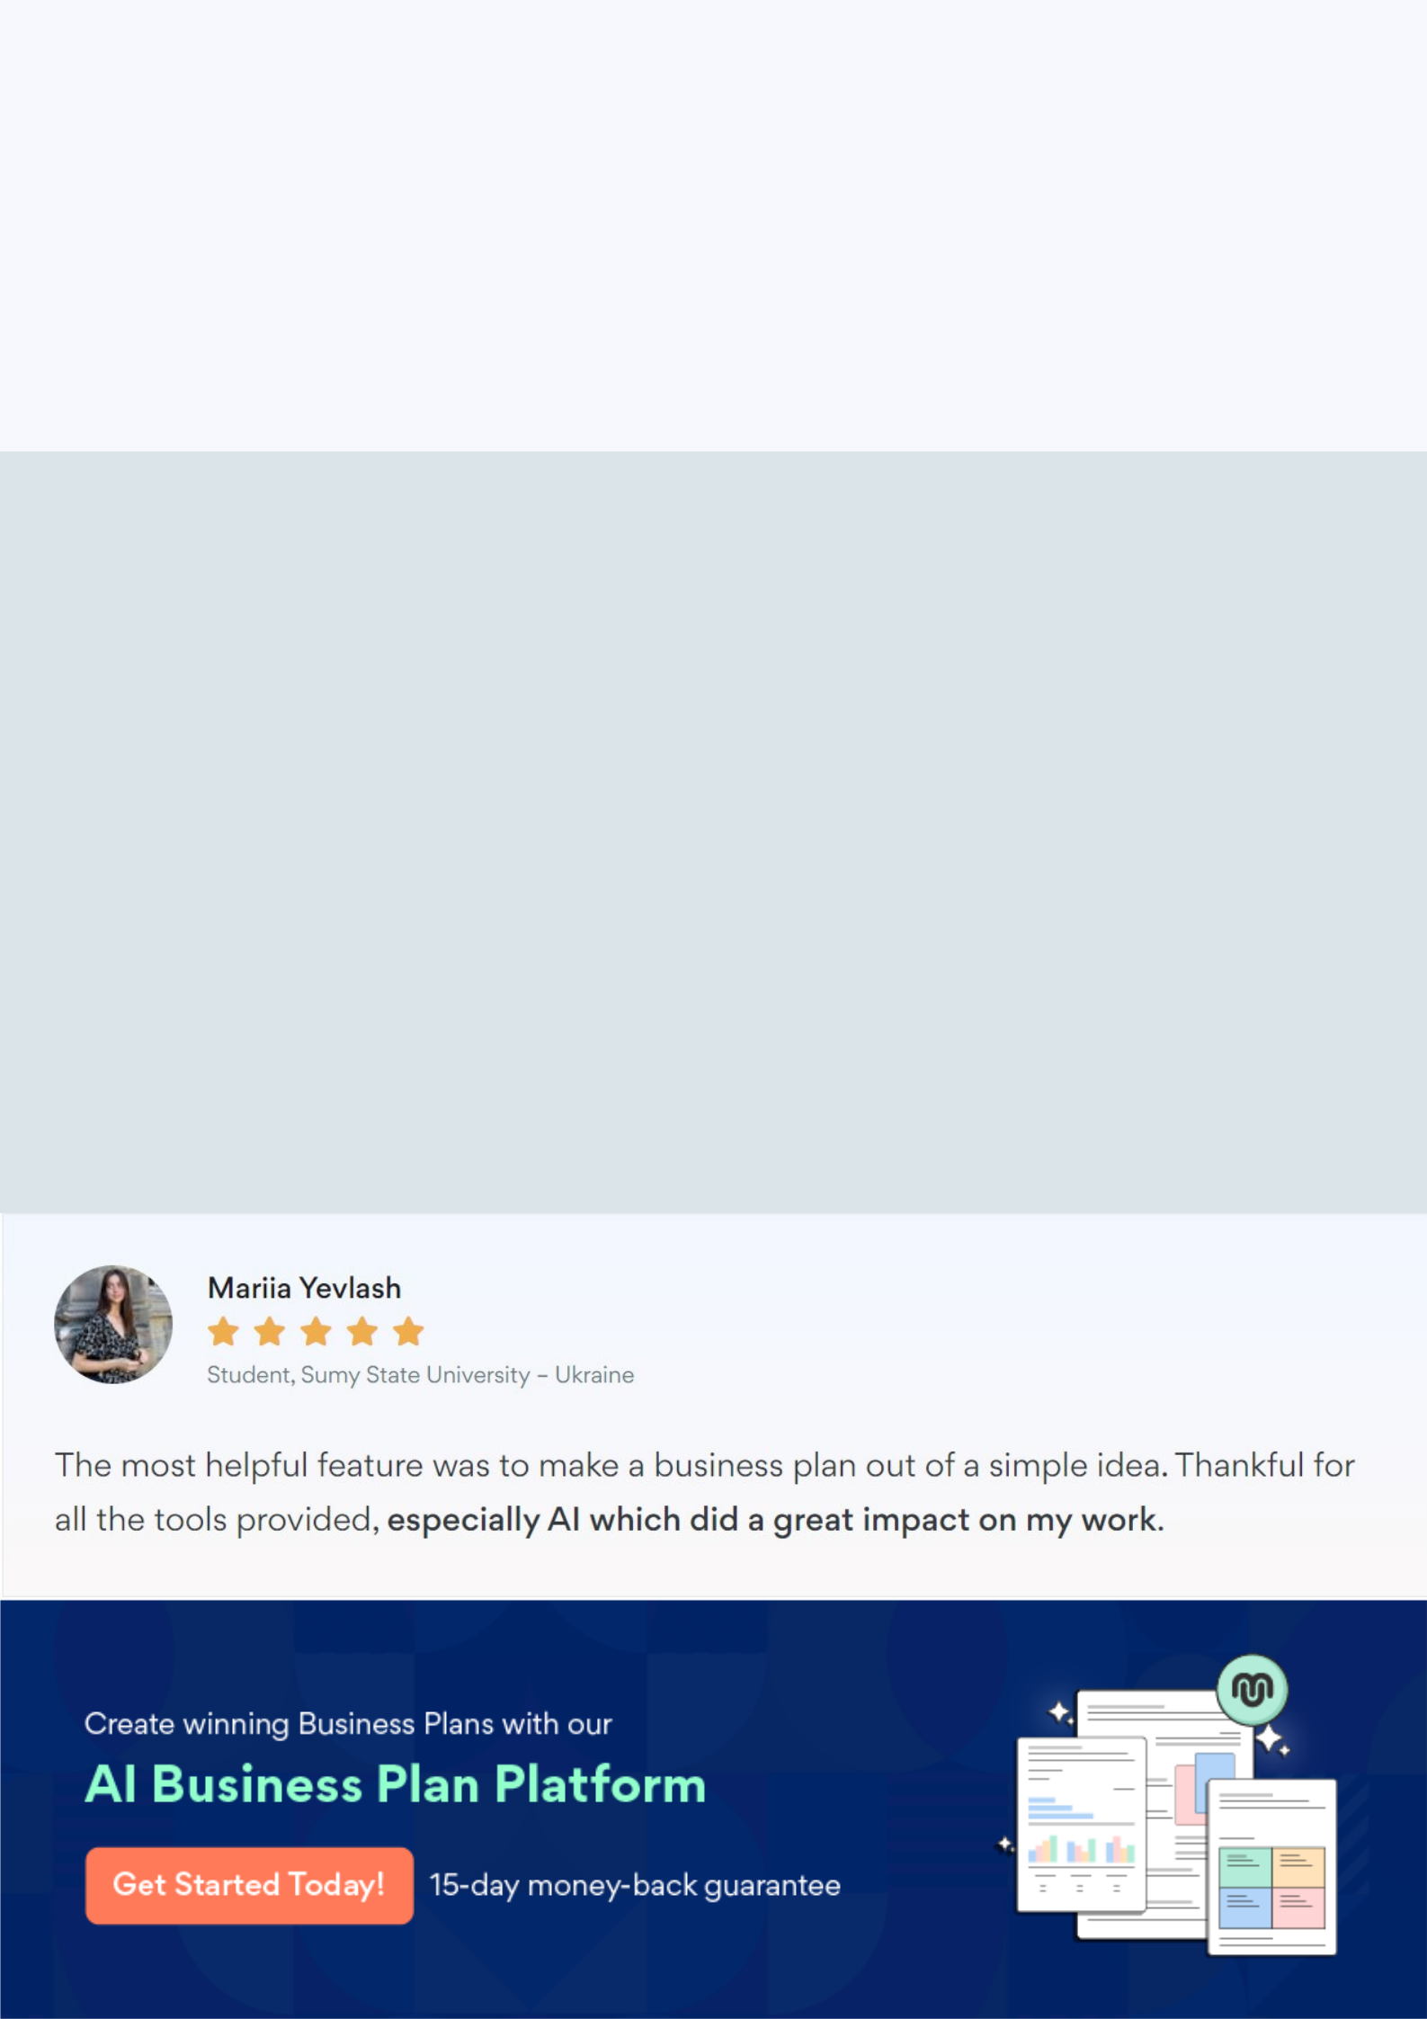
Create a winning business plan that gets you funded

Creating a stunning and investment-ready plan requires no writing, graphic designing, or financial planning expertise.

Upmetrics has all the features required to help you create a comprehensive business plan—from start to finish. Make no mistakes, it’s the modern way of planning to structure ideas, make plans, and create stunning pitch decks to awe investors.

Pitch decks that impress investors

Create pitch decks that provide a visual representation of your business, engage investors, and make them want to invest in your business idea.

Interactive plans in no time

Import business plan sections like—SWOT analysis, comparison tables, and others to create an interactive business plan. No designing skills are required.

Stunning cover page designs

With Upmetrics, you have the liberty to choose from multiple stunning cover page designs. Choose a creative design and make your plan stand out.

Online sharing made simple

Upmetrics makes online sharing quick and easier for users. Easily share your business plans with a link while tracking reader activity.

500+ sample business plans

Simply import a template from our library of sample plans into the editor and start customizing it to make it yours. It takes only a few clicks to get started.

Collaborate with team in real-time

Invite team members, initiate conversations, discuss ideas & strategies, share feedback, and work on a business plan in real-time.

