


HDFL Construction

Dedicated to your living

Business

Plan

[YEAR]

John Doe

10200 Bolsa Ave, Westminster, CA, 92683

- 359-3153 info@example.com http://www.example.com

CONFIDENTIAL

Table of Contents

Executive Summary | 5
Mission Statement | 6
Management and Personnel | 6
Marketing | 6
Financing | 7

Mission Statement, Goals and Objectives | 8
Business Overview | 9
Mission Statement | 9
Goals & Objectives | 10
Goal 1 | 10
Goal 2 | 10

Market Analysis | 11
Industry Analysis | 12
Market Trends | 12
Business Fit in the Industry | 12

Management and Organizational Structure | 14
Organization | 15
Management | 15
Roger d | 15
Paul d | 15
Diane d | 16
Hiring Plan | 16
Risk Management | 16
Record-Keeping Functions | 16
Accounts Payable | 17
Payroll | 17

HDFL Construction | Business Plan [YEAR] 2/30

Marketing Plan | 18
Description of Product and Services | 19
Features and Benefits | 19
Quality | 19
Efficiency | 20
Affordability | 20
Life Cycles/Seasonality | 20
Marketing Strategies | 21
Location/Distribution | 21
Price/Quality Relationship | 21
Promotional Strategies | 21

Financial Plan | 22
Projected Profit and Loss | 23
Projected Cash Flow | 26
Projected Balance Sheet | 27

HDFL Construction | Business Plan [YEAR] 3/30

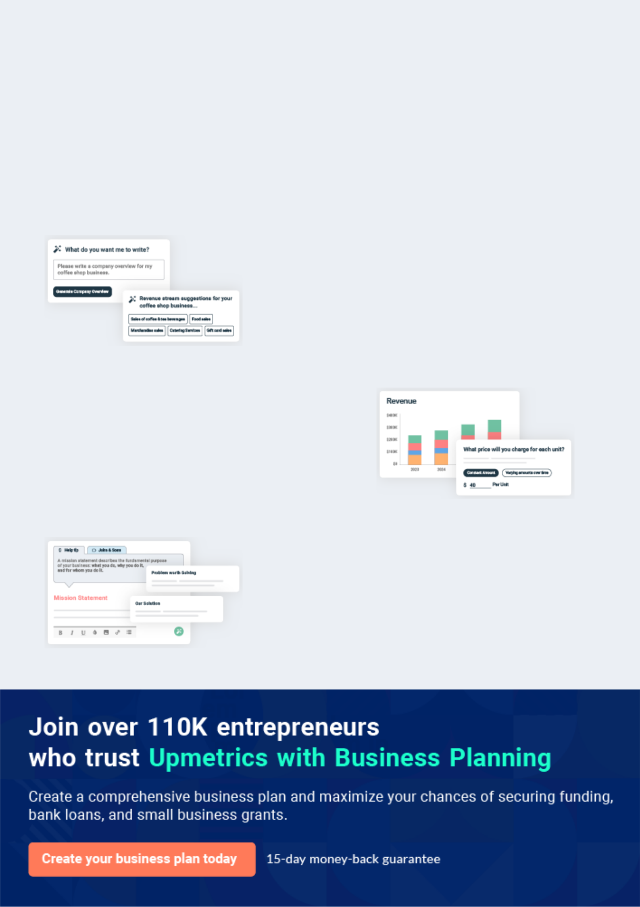
Business planning that’s simpler and faster than you think

Creating a business plan using Upmetrics to start and grow a business is literally the easiest thing in the World. Simply read the instructions and fill in the blanks. It’s as simple as that.

❛ | Upmetrics has everything you need to create a | ❜
❛ | comprehensive business plan. | ❜

AI-powered Upmetrics Assistant

AI-powered insights to streamline your plan

Not sure where to start? Upmetrics’ AI Assistant will automatically generate ideas for each section of your plan and offer improved versions of your writing, adjusting for tone, voice, and grammar or spelling errors.

Financial Forecasting Tool

All the financials are calculated for you

Forget the complex formulas and clumsy spreadsheets — with automatic financials and drag-and-drop forecasting, you can finish your plan faster and be confident that your numbers are accurate.

Business Plan Builder

Guides you like a business mentor

Upmetrics’ step-by-step instructions, prompts, and the library of 400+ sample business plans will guide you through each section of your plan as a business mentor.

1.


Executive Summary

Mission Statement

Management and Personnel

Marketing

Financing

HDFL Construction | Business Plan [YEAR] 5/30

Mission Statement

 HDFL Construction


HDFL Construction strives to build quality affordable homes by providing an honest, fair working relationship with subcontractors, new homeowners, and salespeople in an atmosphere where families can experience the pride and satisfaction of designing their own home.
To unlock help try Upmetrics! 

Start writing here..

Management and Personnel

 HDFL Construction

The owners are seasoned business people with an interest in their community. Both owners have operated their own small businesses previous to beginning HDFL Construction. They offer the company experience in construction, real estate, accounting, marketing, and public
To unlock help try Upmetrics! 

Start writing here..

Marketing

 HDFL Construction

Homes range from 1,000 to 1,300 square feet with builder design or bids on your own home design are provided free of charge. Currently, the price of the homes includes 2 acres of land with a view of the Rockies. These homes are reasonably priced in the $120,000 to $140,000
To unlock help try Upmetrics! 

Start writing here..

HDFL Construction | Business Plan [YEAR] 6/30

Financing

 HDFL Construction

HDFL Construction is interested in obtaining a $40,000 credit line to assist with the cost of building more than one new home at a time.
To unlock help try Upmetrics! 

Start writing here..

HDFL Construction | Business Plan [YEAR] 7/30

2.

Mission Statement, Goals and Objectives

Business Overview

Mission Statement

Goals & Objectives

HDFL Construction | Business Plan [YEAR] 8/30

Business Overview

 HDFL Construction

HDFL Construction provides quality, affordable new homes throughout Landholders County. Speculation custom homes are built within the Wyoming Community Development Authority (WCDA) first-time homebuyer price range. The prospective owners can customize cabinets,
To unlock help try Upmetrics! 

Start writing here..

Mission Statement

 HDFL Construction

HDFL Construction strives to build quality affordable homes by providing an honest, fair working relationship with subcontractors, new homeowners, and salespeople in an atmosphere where families can experience the pride and satisfaction of designing their own home.
To unlock help try Upmetrics! 

Start writing here..

HDFL Construction | Business Plan [YEAR] 9/30

Goals & Objectives

Goal 1

HDFL Construction will develop an infrastructure for long-term planning and organizational structure.

Objective | Lead person | Target Date
Develop a market package detailing standard features
and benefits offered for individuals home with a | Barbara | June 30, 2014
pricing list of enhanced features available at the | Barbara | June 30, 2014
buyer's choosing.
Develop a standard operating procedure for new home | Paul HDFL | June 30, 2014
sites for VA/FHA/WCDA eligibility. | Paul HDFL | June 30, 2014
Review financial controls and accounting system with
Mark Collorbaum, Bottom Line Tax and Accounting for | Diane HDFL | December 31, 2014
Small Business, and make necessary adjustments.

Goal 2

Develop a plan for a business succession plan to establish long-term success for HDFL Construction.

Objective | Lead person | Target Date
Understand possible succession scenarios by having | Barbara | August 31, 2014
bi-monthly meetings beginning immediately. | Barbara | August 31, 2014
Review and provide business “impact” statements for | Barbara | November 30, 2014
discussion. | Barbara | November 30, 2014
After formulating a decision based upon impact
scenarios, seek legal advice on implications and | Barbara | Dec 31, 2014
legalities.

HDFL Construction | Business Plan [YEAR] 10/30

3.

Market Analysis

Industry Analysis

Market Trends

Business Fit in the Industry

HDFL Construction | Business Plan [YEAR] 11/30

Industry Analysis
To unlock help try Upmetrics!

 HDFL Construction

HDFL Construction operates within two industries: New Home Construction and Real Estate. In Landholders County, where the company conducts business, the construction industry accounts for approximately 4.7% of employment.



Start writing here..

Market Trends

 HDFL Construction

In Landholders County there is a fairly stable growth pattern in new home construction. Affordable homes, deemed at $100,000 or less, are lacking throughout Landholders County. As for the cost for land increases in this area, it will be exceedingly more difficult to offer new
To unlock help try Upmetrics! 

Start writing here..

Business Fit in the Industry

 HDFL Construction

HDFL Construction builds two to three custom homes per year. The company works to keep overhead and employee costs low in order to provide homes in a rural setting from $120,000.00 to $140,000.00 in Landholders County. In reviewing statistics in the Landholders County area,
To unlock help try Upmetrics! 

Start writing here..

HDFL Construction | Business Plan [YEAR] 12/30

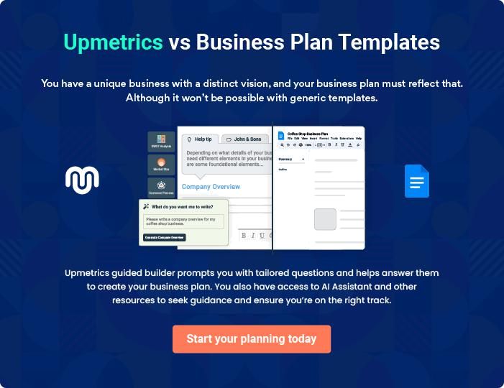

HDFL Construction | Business Plan [YEAR] | 13/30

4.

Management and Organizational Structure

Organization

Management

Hiring Plan

Risk Management

Record-Keeping Functions

HDFL Construction | Business Plan [YEAR] 14/30

Organization

 HDFL Construction

Currently, HDFL Construction is a partnership. The partnership was chosen initially because the business partners wanted to explore the viability of the business relationship. A partnership allowed the most flexibility with the least amount of financial involvement. The business
To unlock help try Upmetrics! 

Start writing here..

Management

 HDFL Construction

“We perform better and work smarter when we make decisions as a team.”

Although our business is a family operated business, we all work on a strictly professional
To unlock help try Upmetrics! 

Start writing here..


Roger d

Owner & Founder - roger@example.com

- Real Estate Broker in the Shanoah Community for 20 years.

- Owner of HDFL Real Estate.

- Extensive knowledge of sales, marketing, and pricing.

- Ten years of experience in the construction industry.


Paul d

Owner - paul@example.com

- Twelve years of experience in the construction industry

- Prior to moving to Shanoah, operated a successful business, North Pacific Land Design, for 10 years that specialized in landscape and construction

- Extensive organizational, time management, and cost control skills

- Twelve years of experience in bidding projects and estimating costs

HDFL Construction | Business Plan [YEAR] 15/30


Diane d

Administrative Assistant - diane@example.com

- Twenty-five years of experience in accounts payable and receivable.

- Excellent organizational skills

- Experienced in managing day-to-day office issues.

Hiring Plan

 HDFL Construction

Currently, we are in the process of interviewing outside advisors for end of the year accounting and legal issues.
To unlock help try Upmetrics! 

Start writing here..

Risk Management

 HDFL Construction

HDFL Construction has several Risk Management strategies it uses to minimize risk and protect company investments. Liability Insurance is maintained on the company in the amount of $500,000.00. Builder’s Risk Insurance is obtained for each new home site in case of loss of
To unlock help try Upmetrics! 

Start writing here..

Record-Keeping Functions

 HDFL Construction

HDFL Construction has a streamlined approach to record-keeping. All home sales are purchased by cash at closing or by a loan obtained by the buyers. In our business, we do not have an “Accounts Receivable.” Our system is based on “Contracts Receivable.” This system is
To unlock help try Upmetrics! 

Start writing here..

HDFL Construction | Business Plan [YEAR] 16/30

 HDFL Construction

On each product delivered to the job site, one of the owners reviews the invoices and physically accounts for the shipment. If there is a problem with the order, it is noted on the shipping receipt and returned to the delivery driver. The store/supplier is then contacted by the owner
To unlock help try Upmetrics! 

Accounts Payable

Start writing here..

 HDFL Construction

The owners record and calculate payroll based on spreadsheets with deductions, etc., already in place. All payroll taxes and reports are completed and submitted by the Administrative Assistant. Quarterly reports are reviewed by the owners and due dates are pre-recorded on the
To unlock help try Upmetrics! 

Payroll

Start writing here..

HDFL Construction | Business Plan [YEAR] 17/30

5.

Marketing Plan

Description of Product and Services

Features and Benefits

Life Cycles/Seasonality

Marketing Strategies

HDFL Construction | Business Plan [YEAR] 18/30

Description of Product and Services

 HDFL Construction

Known for country living and views of the Rocky Mountains with all of the city conveniences, Bison Valley is conveniently located off of Tristar Ranch Road near the Tristar Ranch. HDFL Construction is offering home buyers many of the amenities found in higher-priced homes
To unlock help try Upmetrics! 

Start writing here..

Features and Benefits

 HDFL Construction

Homes range from 1,000 to 1,300 square feet with builder design, or bids on your own home design are provided free of charge. Currently, the price of the homes includes two acres of land with a view of the Rockies. The homes feature 2x6 construction, oversized two-car garage,
To unlock help try Upmetrics! 

Start writing here..

 HDFL Construction

Quality is provided by the craftsmanship and one-to-one customer relationship with the owners. In addition to the personal relationship, the new home buyers will have the opportunity to choose from high-quality “standard” features or enhance their home further with products of
To unlock help try Upmetrics! 

Quality

Start writing here..

HDFL Construction | Business Plan [YEAR] 19/30

 HDFL Construction

The Efficiency of the home will be noticed on the owner's first heating bill. The increased insulation throughout the house and weatherproofing will provide the new homeowners with an Energy Efficient home to enjoy throughout the year. It will also decrease their heating and
To unlock help try Upmetrics! 

Efficiency

Start writing here..

 HDFL Construction

HDFL Construction strives to keep its overhead cost to a minimum in order to offer quality new homes from $120,000.00 to $140,000.00 price range. These prices include land with views of the Rockies! We cut our costs and pass the savings onto the home buyers.
To unlock help try Upmetrics! 

Affordability

Start writing here..

Life Cycles/Seasonality

 HDFL Construction

The new home construction booms from April through October. During this time we offer pricing incentives to people who are willing to wait for their home to be completed in November through April. This allows us to remain consistent throughout the year including an off-peak
To unlock help try Upmetrics! 

Start writing here..

HDFL Construction | Business Plan [YEAR] 20/30

Marketing Strategies

 HDFL Construction

HDFL construction is a home-based business. We meet with customers and promote the company and products at the building site. Administrative functions are performed out of our in-home office. By utilizing new homes under construction as our business site, we are able to
To unlock help try Upmetrics! 

Location/Distribution

Start writing here..

 HDFL Construction

The price/quality relationship of the homes we build would be considered Low Price/High Quality. Many of our customers comment that the homes we build are solid, well-constructed homes. As a testament to that fact: a young couple moving to Shanoah looked at our job site
To unlock help try Upmetrics! 

Price/Quality Relationship

Start writing here..

 HDFL Construction

Packaging and Customer Service

At all times during the construction phase, the job site is kept tidy. Lumber and materials are
To unlock help try Upmetrics! 

Promotional Strategies

Start writing here..

HDFL Construction | Business Plan [YEAR] 21/30

6.

Financial Plan

Projected Profit and Loss

Projected Cash Flow

Projected Balance Sheet

HDFL Construction | Business Plan [YEAR] 22/30

Projected Profit and Loss

Revenue

Residential Construction Projects

Unit Sales

Unit Price

Commercial Construction Projects

Unit Sales

Unit Price

Maintenance and Repair Services

Unit Sales

Unit Price

Cost Of Sales

General Costs

Material Costs

Lumber and Building

Materials

Construction Equipment

Rental

Labor Costs

Skilled Labor Wages

Subcontractor Fees

Revenue Specific Costs

Personnel Costs (Direct Labor)

2024 | 2025 | 2026
$5,050,000 | $5,432,500 | $5,848,630
$2,500,000 | $2,625,000 | $2,757,500
10 | 11 | 11
$250,000 | $250,000 | $250,000
$2,500,000 | $2,750,000 | $3,025,000
5 | 6 | 6
$500,000 | $500,000 | $500,000
$50,000 | $57,500 | $66,130
50 | 58 | 66
$1,000 | $1,000 | $1,000

$1,740,000 | $1,864,400 | $1,999,323.50
$1,740,000 | $1,864,400 | $1,999,323.50
$225,000 | $234,650 | $244,734.50
$145,000 | $152,250 | $159,862.50
$80,000 | $82,400 | $84,872
$1,515,000 | $1,629,750 | $1,754,589
$1,010,000 | $1,086,500 | $1,169,726
$505,000 | $543,250 | $584,863
$0 | $0 | $0
$0 | $0 | $0

HDFL Construction | Business Plan [YEAR] 23/30

Gross Margin

Gross Margin (%)

Operating Expense

Payroll Expense (Indirect Labor)

Management Team

General Manager

Project Manager

On-site Workers

Construction Workers

Administrative Staff

Office Administrators

General Expense

Office and Administrative Expenses

Office Rent

Utilities (Electricity, Water)

Marketing and Sales

Expenses

Advertising and Promotion

Sales Commissions

Operational and Miscellaneous Expenses

Equipment Maintenance

Insurance
2024 2025 2026

$3,310,000 | $3,568,100 | $3,849,306.50
65.54% | 65.68% | 65.82%

$2,139,402.28 | $2,222,183.93 | $2,312,569.15
$1,676,160 | $1,714,363.20 | $1,753,471.20
$468,000 | $482,040 | $496,501.20
$144,000 | $148,320 | $152,769.60
$324,000 | $333,720 | $343,731.60
$910,800 | $929,016 | $947,596.80
$910,800 | $929,016 | $947,596.80
$297,360 | $303,307.20 | $309,373.20
$297,360 | $303,307.20 | $309,373.20
$463,242.28 | $507,820.73 | $559,097.95
$40,626.12 | $52,641.29 | $68,355.37
$33,530.16 | $42,524.15 | $53,930.79
$7,095.96 | $10,117.14 | $14,424.58
$404,000 | $434,600 | $467,890.40
$151,500 | $162,975 | $175,458.90
$252,500 | $271,625 | $292,431.50
$18,616.16 | $20,579.44 | $22,852.18
$10,616.16 | $12,419.44 | $14,528.98
$8,000 | $8,160 | $8,323.20

HDFL Construction | Business Plan [YEAR] 24/30

Bad Debt

Amortization of Current Assets

EBITDA

Additional Expense

Long Term Depreciation

Gain or loss from Sale of Assets

EBIT

Interest Expense

EBT

Income Tax Expense / Benefit

Total Expense

Net Income

Net Income (%)

Retained Earning Opening

Owner's Distribution

Retained Earning Closing

2024 | 2025 | 2026
$0 | $0 | $0
$0 | $0 | $0

$1,170,597.72 $1,345,916.07 $1,536,737.35

$52,363.23 | $46,910.82 | $41,122.08
$24,768 | $24,768 | $24,768
$0 | $0 | $0
$1,145,829.72 | $1,321,148.07 | $1,511,969.35
$27,595.23 | $22,142.81 | $16,354.10
$1,118,234.49 | $1,299,005.25 | $1,495,615.27
$0 | $0 | $0

$3,931,765.51 $4,133,494.75 $4,353,014.73

$1,118,234.49 $1,299,005.25 $1,495,615.27

22.14% 23.91% 25.57%

$0 | $1,038,234.49 | $2,297,239.74
$80,000 | $40,000 | $40,000
$1,038,234.49 | $2,297,239.74 | $3,752,855.01

HDFL Construction | Business Plan [YEAR] 25/30

Projected Cash Flow

 | 2024 | 2025 | 2026
Cash Received | $5,050,000 | $5,432,500 | $5,848,630
Cash Paid | $3,906,997.51 | $4,108,726.75 | $4,328,246.73
COS & General Expenses | $2,203,242.28 | $2,372,220.73 | $2,558,421.45
Salary & Wages | $1,676,160 | $1,714,363.20 | $1,753,471.20
Interest | $27,595.23 | $22,142.81 | $16,354.10
Sales Tax | $0 | $0 | $0
Income Tax | $0 | $0 | $0
Net Cash From | $1,143,002.49 | $1,323,773.25 | $1,520,383.27
Operations | $1,143,002.49 | $1,323,773.25 | $1,520,383.27
Assets Sell | $0 | $0 | $0
Assets Purchase | $180,000 | $0 | $0
Net Cash From | ($180,000) | $0 | $0
Investments | ($180,000) | $0 | $0
Amount Received | $700,000 | $0 | $0
Loan Received | $500,000 | $0 | $0
Common Stock | $0 | $0 | $0
Preferred Stock | $0 | $0 | $0
Owner's Contribution | $200,000 | $0 | $0
Amount Paid | $168,401.57 | $133,853.98 | $139,642.72
Loan Capital | $88,401.57 | $93,853.99 | $99,642.70
Dividends & Distributions | $80,000 | $40,000 | $40,000
Net Cash From | $531,598.43 | ($133,853.98) | ($139,642.72)
Financing | $531,598.43 | ($133,853.98) | ($139,642.72)

HDFL Construction | Business Plan [YEAR] 26/30

2024 2025 2026

Summary

Starting Cash | $0 | $1,494,600.92 | $2,684,520.19
Cash In | $5,750,000 | $5,432,500 | $5,848,630
Cash Out | $4,255,399.08 | $4,242,580.73 | $4,467,889.45
Change in Cash | $1,494,600.92 | $1,189,919.27 | $1,380,740.55
Ending Cash | $1,494,600.92 | $2,684,520.19 | $4,065,260.74

Projected Balance Sheet

 | 2024 | 2025 | 2026
Assets | $1,649,832.92 | $2,814,984.19 | $4,170,956.74
Current Assets | $1,494,600.92 | $2,684,520.19 | $4,065,260.74
Cash | $1,494,600.92 | $2,684,520.19 | $4,065,260.74
Accounts Receivable | $0 | $0 | $0
Inventory | $0 | $0 | $0
Other Current Assets | $0 | $0 | $0
Long Term Assets | $155,232 | $130,464 | $105,696
Gross Long Term Assets | $180,000 | $180,000 | $180,000
Accumulated Depreciation | ($24,768) | ($49,536) | ($74,304)

Liabilities & Equity | $1,649,832.92 | $2,814,984.18 | $4,170,956.75
Liabilities | $411,598.43 | $317,744.44 | $218,101.74
Current Liabilities | $93,853.99 | $99,642.70 | $0
Accounts Payable | $0 | $0 | $0
Income Tax Payable | $0 | $0 | $0

HDFL Construction | Business Plan [YEAR] 27/30

 | 2024 | 2025 | 2026
Sales Tax Payable | $0 | $0 | $0
Short Term Debt | $93,853.99 | $99,642.70 | $0
Long Term Liabilities | $317,744.44 | $218,101.74 | $218,101.74
Long Term Debt | $317,744.44 | $218,101.74 | $218,101.74
Equity | $1,238,234.49 | $2,497,239.74 | $3,952,855.01
Paid-in Capital | $0 | $0 | $0
Common Stock | $0 | $0 | $0
Preferred Stock | $0 | $0 | $0
Owner's Contribution | $200,000 | $200,000 | $200,000
Retained Earnings | $1,038,234.49 | $2,297,239.74 | $3,752,855.01

Check | $0 | $0 | $0

HDFL Construction | Business Plan [YEAR] 28/30

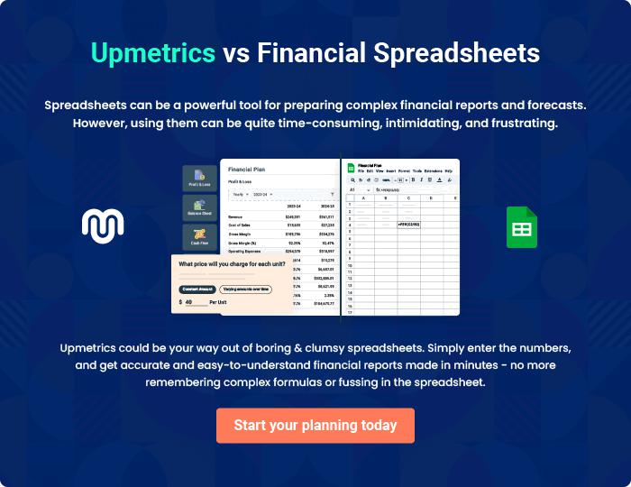

HDFL Construction | Business Plan [YEAR] | 29/30


Create a winning business plan that gets you funded

Creating a stunning and investment-ready plan requires no writing, graphic designing, or financial planning expertise.

Upmetrics has all the features required to help you create a comprehensive business plan—from start to finish. Make no mistakes, it’s the modern way of planning to structure ideas, make plans, and create stunning pitch decks to awe investors.

Pitch decks that impress investors

Create pitch decks that provide a visual representation of your business, engage investors, and make them want to invest in your business idea.

Interactive plans in no time

Import business plan sections like—SWOT analysis, comparison tables, and others to create an interactive business plan. No designing skills are required.

Stunning cover page designs

With Upmetrics, you have the liberty to choose from multiple stunning cover page designs. Choose a creative design and make your plan stand out.

Online sharing made simple

Upmetrics makes online sharing quick and easier for users. Easily share your business plans with a link while tracking reader activity.

500+ sample business plans

Simply import a template from our library of sample plans into the editor and start customizing it to make it yours. It takes only a few clicks to get started.

Collaborate with team in real-time

Invite team members, initiate conversations, discuss ideas & strategies, share feedback, and work on a business plan in real-time.

