

Community Center

Business

Plan

[YEAR]

John Doe

10200 Bolsa Ave, Westminster, CA, 92683

- 359-3153 info@example.com http://www.example.com

CONFIDENTIAL

Table of Contents

Executive Summary | 5
Mission Statement | 6
NPCC Theory & Overview | 6
History of NPCC | 6
Moving forward: The Future of NPCC | 7
Accomplishments | 7
Testimonials | 7
Anonymous | 7
Kehan W. | 8
Etienne Wenger-Trayner | 8
Julian T | 8
Danny M. | 8
Casey D. | 9

The Center | 10
Site | 11
Operations
Operations | 12
Proposed Location & Service Area | 13
Hours of Operation & Staffing | 13
Strategic Theory
Strategic Theory | 15
Goals | 16
Philosophy | 16
Key Strategies | 16
Research & Development | 16
Asset Development | 17
Resiliency | 17
Positioning | 17
Why now and why NPCC? | 18
Why we need a youth & Community center | 18

Community Center | Business Plan [YEAR] 2/37

How local youth & the Community will Benefit from the Center | 18

Marketing Plan | 19
Youth Target Market | 20
Target population | 20
Advertising & Promotions | 20
Youth Center activities | 21
Weekend Events | 21
Field Trip | 21
Outdoor & Recreation Space | 21
Creative & Expressive Arts | 22
Experiential Learning Opportunities | 22
A Hub for Services | 22
Safe Space Guarantee | 23
Check-in Policy | 23
Youth Center rules & Agreements | 23
Social & Environmental Responsibility | 23
Partners | 24

Management Team | 25
Lynn Skrukrud | 26
Halli Ellis | 27
Staffing Matrix | 28

Financial Summary | 29
Assumptions & Projections | 30
Sustainability | 30
Projected Profit and Loss | 30
Projected Cash Flow | 33
Projected Balance Sheet | 34

Community Center | Business Plan [YEAR] 3/37

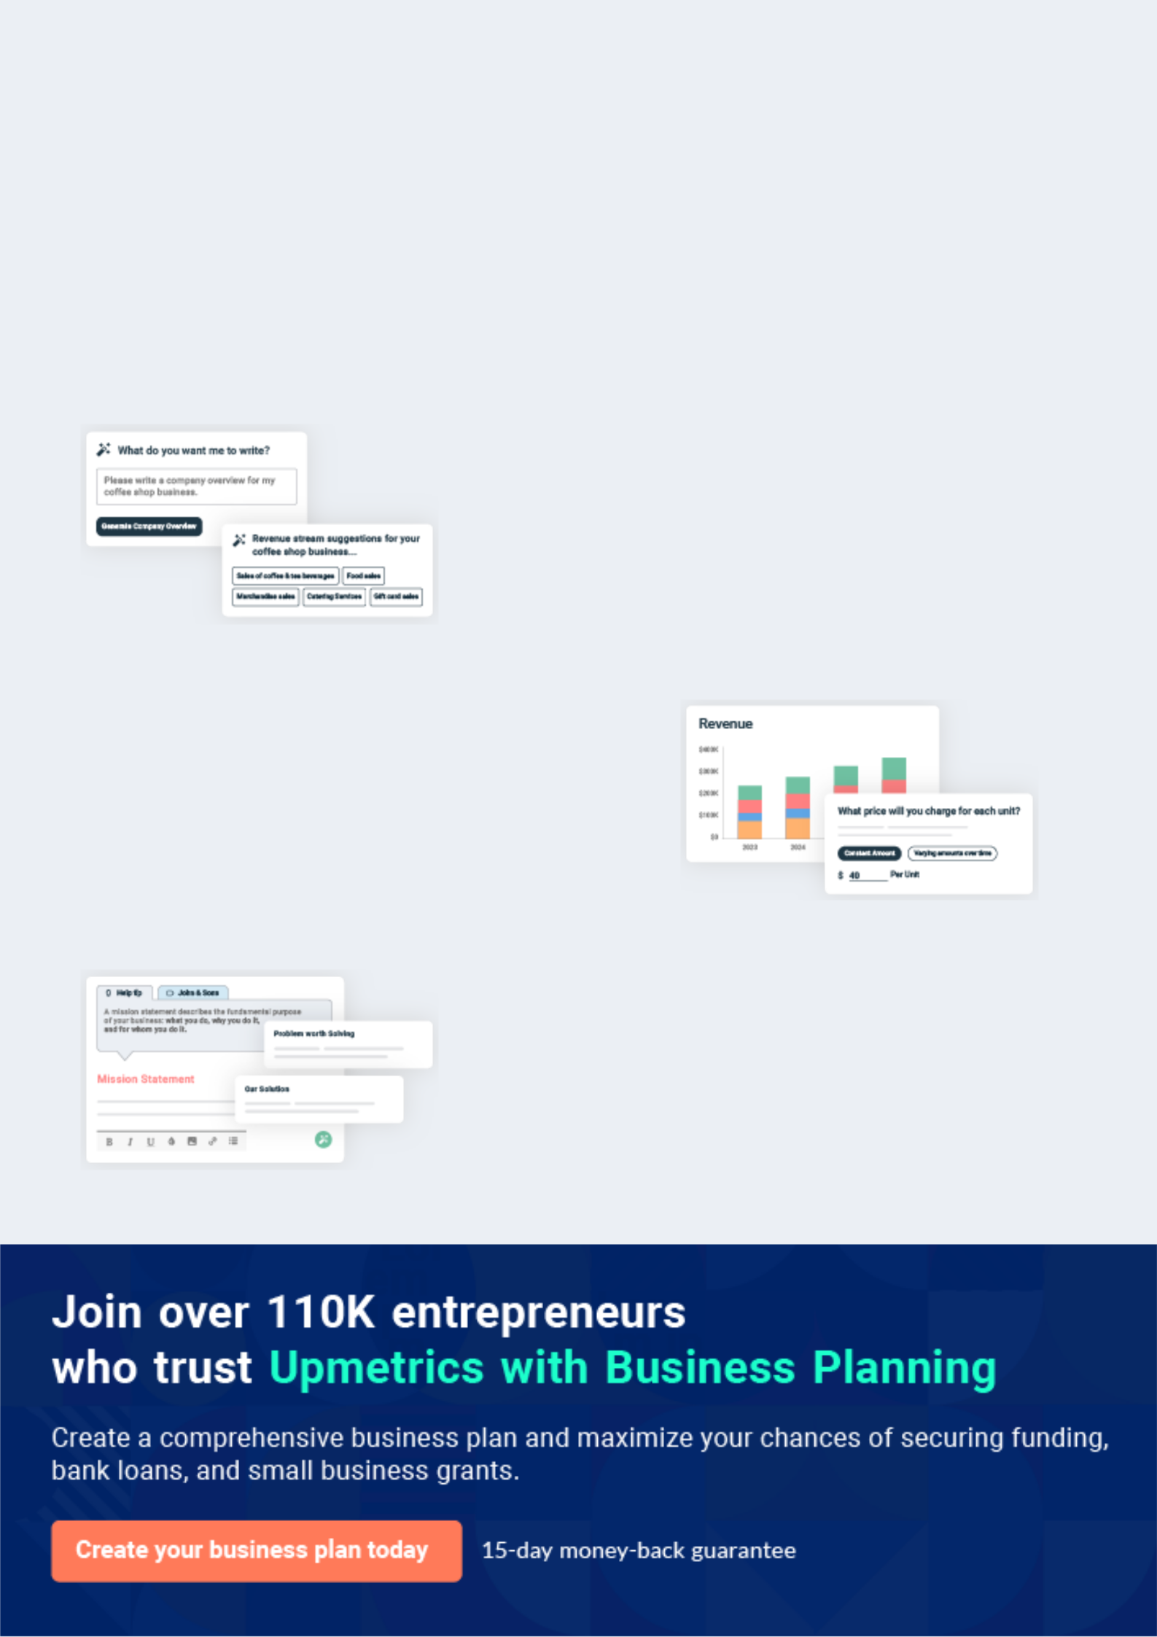
Business planning that’s simpler and faster than you think

Creating a business plan using Upmetrics to start and grow a business is literally the easiest thing in the World. Simply read the instructions and fill in the blanks. It’s as simple as that.

❛ | Upmetrics has everything you need to create a | ❜
❛ | comprehensive business plan. | ❜

AI-powered Upmetrics Assistant

AI-powered insights to streamline your plan

Not sure where to start? Upmetrics’ AI Assistant will automatically generate ideas for each section of your plan and offer improved versions of your writing, adjusting for tone, voice, and grammar or spelling errors.

Financial Forecasting Tool

All the financials are calculated for you

Forget the complex formulas and clumsy spreadsheets — with automatic financials and drag-and-drop forecasting, you can finish your plan faster and be confident that your numbers are accurate.

Business Plan Builder

Guides you like a business mentor

Upmetrics’ step-by-step instructions, prompts, and the library of 400+ sample business plans will guide you through each section of your plan as a business mentor.

1.


Executive Summary

Mission Statement

NPCC Theory & Overview

History of NPCC

Moving forward: The Future of NPCC

Accomplishments

Testimonials

Community Center | Business Plan [YEAR] 5/37

Mission Statement
To unlock help try Upmetrics!

 NPCC


NPCC (Northern Park Community Center) empowers youth to make healthy lifestyle choices by providing New Events and Opportunities in a safe environment that encourages youth success and contributes to a healthier community.



Start writing here..

NPCC Theory & Overview

 NPCC

NPCC is a 501(c)3 organization. The word NPCC is derived from the prefix meaning new, which inspired NPCC’s acronym, New Events & Opportunities. NPCC is a new way of thinking around making the choice to live a healthy lifestyle with an emphasis on healthy alternatives. These
To unlock help try Upmetrics! 

Start writing here..

History of NPCC

 NPCC

NPCC began in the summer of 2008 as the youth sector of the Coalition for a Drug-Free Nevada County. NPCC was created to go beyond traditional substance abuse prevention efforts by actively engaging young people to make healthy choices through positive alternative activities
To unlock help try Upmetrics! 

Start writing here..

Community Center | Business Plan [YEAR] 6/37

Moving forward: The Future of NPCC

 NPCC

Since its start, NPCC has hosted an average of 70 events per year in approximately 25 different locations, drawing thousands of youth to participate in safe, drug-free activities. NPCC has learned that young people appreciate these, and thrive with opportunities to feel safe and
To unlock help try Upmetrics! 

Start writing here..

Accomplishments

 NPCC


- Hosted over 300 events since our start in 2008

- An average of 7000 visits to our events annually
• ^{3000+ Facebook friends} To unlock help try Upmetrics! 

Start writing here..

Testimonials

 NPCC

“Starting age 13 I fell into habits of smoking weed and drinking. At first not much was affected, I maintained school and other obligations pretty well, but after about a year I slipped into more extensive drug use, mainly hallucinogens such as LSD and shrooms. By my freshman year, I
To unlock help try Upmetrics! 

Anonymous

Start writing here..

Community Center | Business Plan [YEAR] 7/37

 NPCC
To unlock help try Upmetrics!

“In the last four years, NPCC has helped me greatly to grow not only as a musician but also as a person.”
To unlock help try Upmetrics! 

Kehan W.

Start writing here..

 NPCC

“I am the father of a young aspiring musician here in Grass Valley. He has played with NPCC a number of times. It has been a great boon and inspiration for him. I have gone to listen to his shows and have been able to observe the scene there. I have come to really appreciate the kind
To unlock help try Upmetrics! 

Etienne Wenger-Trayner

Start writing here..

 NPCC

NPCC has brought so much to me, it started me playing music now I’m in 2 bands, it’s always been a great safe place to hang out with friends, always stuff to do, always great music and young bands playing.”



Julian T

Start writing here..

 NPCC

“All I can really say is thanks for giving me an organization with a purpose that I can actually give a care about. For more and more reasons I've been finding that the message is just
really.....good. Like, more than this being what the kids need, I feel like this is what I need.”
To unlock help try Upmetrics! 

Danny M.

Start writing here..

Community Center | Business Plan [YEAR] 8/37

 NPCC

“I see NPCC shirts every day! Kids love supporting NPCC and coming together to have fun in a drug-free environment. I can't help but hear from people about the next NPCC event or how NPCC is doing something good for our community. Not only is it making a good change but it is
To unlock help try Upmetrics! 

Casey D.

Start writing here..

Community Center | Business Plan [YEAR] 9/37

2.

The Center

Site

Community Center | Business Plan [YEAR] 10/37

 NPCC
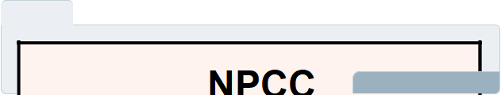

To unlock help try Upmetrics! 

Start writing here..

 NPCC
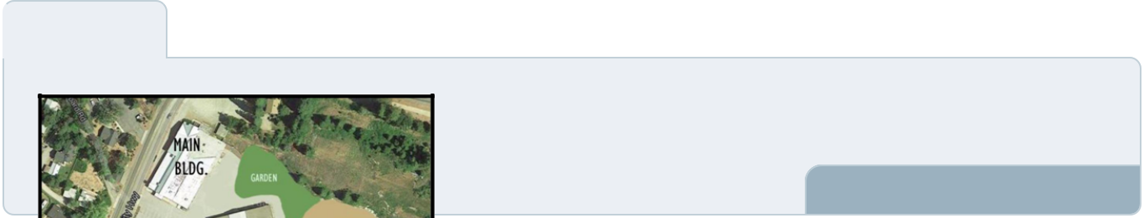

The proposed location for the Youth & Community Center site is a 6.15-acre area. A site of this size will
To unlock help try Upmetrics! 

Site

Start writing here..

Community Center | Business Plan [YEAR] 11/37

3.

Operations

Proposed Location & Service Area

Hours of Operation & Staffing

Community Center | Business Plan [YEAR] 12/37

Proposed Location & Service Area

 NPCC

When considering the location for the NPCC Youth & Community Center there are many important factors to consider. We have examined numerous properties in Western Nevada
County and only 1 site has met our needs completely, the former Meeks Lumber site located at
To unlock help try Upmetrics! 

Start writing here..

Hours of Operation & Staffing

 NPCC

Office

Time


Monday-Wednesday 2:30 pm-6:30 pm
To unlock help try Upmetrics! 

Start writing here..

Community Center | Business Plan [YEAR] 13/37

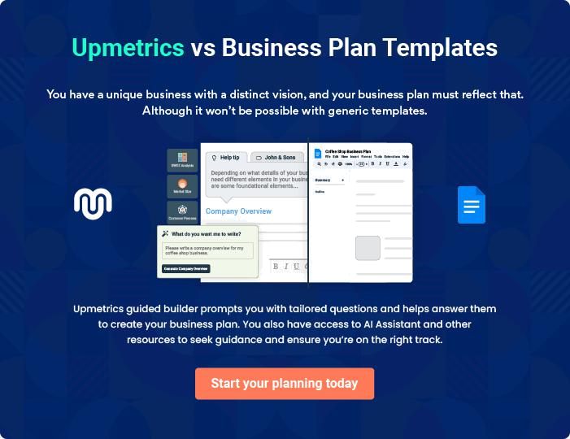

Community Center | Business Plan [YEAR] | 14/37

4.

Strategic Theory

Goals

Philosophy

Positioning

How local youth & the Community will Benefit from the Center

Community Center | Business Plan [YEAR] 15/37

Goals

 NPCC

1. To create new events and opportunities in a safe environment that helps young people develop a sense of purpose.
2. To use our positive influence to help youth build self-esteem and skills for success.
To unlock help try Upmetrics! 

Start writing here..

Philosophy

 NPCC

NPCC provides opportunities for young people to reach their full potential and the skills and confidence to make healthy choices, successfully navigating adolescents. While the focus of NPCC is to keep young people drug and alcohol-free, we believe that the most effective way to
To unlock help try Upmetrics! 

Start writing here..

 NPCC

Healthy Alternatives – One of the biggest complaints that we hear from young people about why youth use drugs are that there is nothing else to do. NPCC strives to provide healthy
alternatives such as concerts, dances, and movie nights. All while encouraging young people to
To unlock help try Upmetrics! 

Key Strategies

Start writing here..

 NPCC

Research in the field of substance abuse and teen health is constantly evolving. What was once highly practiced forms of prevention have proven to be ineffective. What we know now is that one-shot programs and education alone don’t work. Researchers have changed their focus
To unlock help try Upmetrics! 

Research & Development

Start writing here..

Community Center | Business Plan [YEAR] 16/37

 NPCC

are building blocks or factors that young people need to grow up healthy, caring, and responsible. Studies have shown that the more assets a young person has the less likely they are to abuse drugs and engage in illegal activities and the more likely they are to do well in
To unlock help try Upmetrics! 

Asset Development

Start writing here..

 NPCC

this model assumes that stress is inevitable, but even the worst experiences don’t have to lead to disastrous outcomes. Resilient individuals are able to bounce back from or adapt to stressful events. Positive self-esteem, problem-solving, a strong sense of identity and positive role model
To unlock help try Upmetrics! 

Resiliency

Start writing here..

Positioning

 NPCC

There have been numerous attempts at starting teen centers in the Grass Valley area over the last few decades with little success. So, what makes us believe that we can successfully start and run a Youth & Community Center now? To put it simply, NPCC is different.
To unlock help try Upmetrics! 

Start writing here..

Community Center | Business Plan [YEAR] 17/37

 NPCC

With the current state of the economy, youth are in more need of a safe space such as a youth center than ever before. Many parents are working longer hours to make ends meet, leaving youth unsupervised for longer amounts of time. Many families can no longer afford to provide
To unlock help try Upmetrics! 

Why now and why NPCC?

Start writing here..

 NPCC

Unsupervised and unengaged teens – Many teens are on their own after school with no parent or responsible adult around and with nothing to do and/or nothing expected of them.
To unlock help try Upmetrics! 

Why we need a youth & Community center

Start writing here..

How local youth & the Community will Benefit from the Center

 NPCC

- It will give the community a safe and inclusive space to socialize.

- The youth will receive positive guidance and development.
- Provide a supervised, substance-free place to socialize with peers._{To unlock help try Upmetrics!} 

Start writing here..

Community Center | Business Plan [YEAR] 18/37

5.

Marketing Plan

Youth Target Market

Target population

Advertising & Promotions

Youth Center activities

Safe Space Guarantee

Social & Environmental Responsibility

Partners

Community Center | Business Plan [YEAR] 19/37

Youth Target Market

 NPCC

The NPCC Youth & Community Center’s primary target market is 12-19-year-olds because it’s a difficult transition time in their lives and they need support and positive engagement. As middle school students transition from elementary school to high school, they face many challenges.
To unlock help try Upmetrics! 

Start writing here..

Target population

 NPCC

There is approximately 5000 youth between the ages of 12-18 living in Western Nevada County and an additional 3000 between the ages of 19-25. In the NPCC Summer, 2012 Survey eighty-seven percent of youth surveyed believe that we need a place, like a Youth Center, for young
To unlock help try Upmetrics! 

Start writing here..

Advertising & Promotions

 NPCC

When NPCC launched in 2008 we took a unique approach by focusing on positive branding before actually launching the concept of healthy lifestyle choices. This branding strategy
proved to be effective by building up trust and respect from local youth, so that when it became
To unlock help try Upmetrics! 

Start writing here..

Community Center | Business Plan [YEAR] 20/37

Youth Center activities

 NPCC
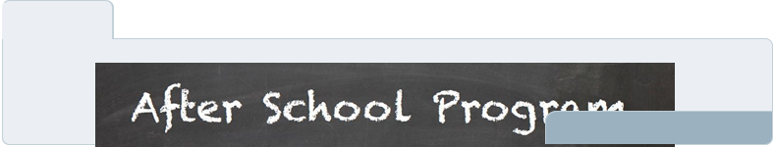

To unlock help try Upmetrics! 

Start writing here..

 NPCC
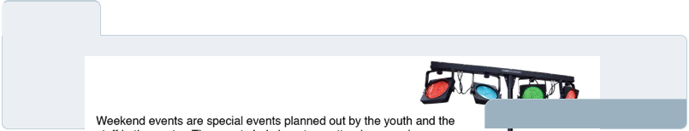

To unlock help try Upmetrics! 

Weekend Events

Start writing here..

 NPCC
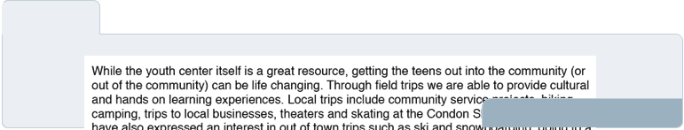

To unlock help try Upmetrics! 

Field Trip

Start writing here..

 NPCC
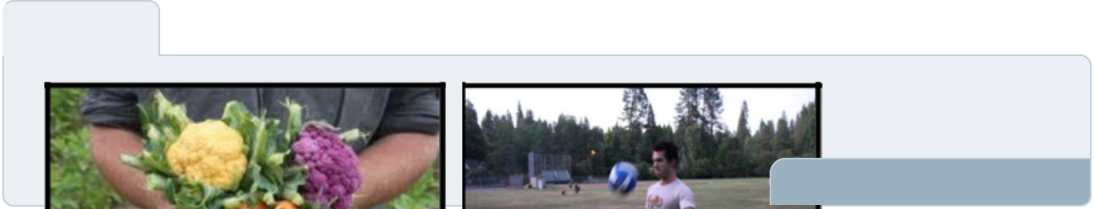

To unlock help try Upmetrics! 

Outdoor & Recreation Space

Start writing here..

Community Center | Business Plan [YEAR] 21/37

 NPCC
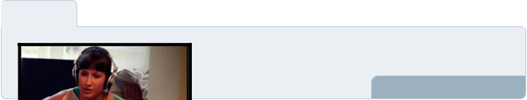

The artistic expression for youth is a vital part of development. At the youth center, there will be an arts and
To unlock help try Upmetrics! 

Creative & Expressive Arts

Start writing here..

 NPCC
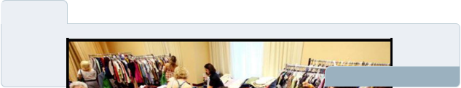

To unlock help try Upmetrics! 

Experiential Learning Opportunities

Start writing here..

 NPCC
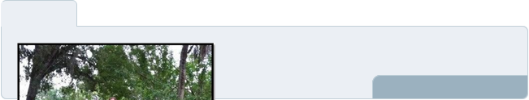

The Center will also bring in numerous community partners to create a hub for local services. One of the
To unlock help try Upmetrics! 

A Hub for Services

Start writing here..

Community Center | Business Plan [YEAR] 22/37

Safe Space Guarantee

 NPCC

KidTrax is a software that tracks attendance through scanning members in and out of the facility. It captures and maintains basic demographic information such as birthdays, gender, and ethnicity and can keep more comprehensive records such as participation in government
To unlock help try Upmetrics! 

Check-in Policy

Start writing here..

 NPCC

All youth attending the center must agree to:

• Be respectful towards oneself, peers, volunteers, and staff
To unlock help try Upmetrics! 

Youth Center rules & Agreements

Start writing here..

Social & Environmental Responsibility

 NPCC

NPCC believes that social and environmental responsibility should be an integral part of not only running an organization but also in what we teach the young people we work with. We are completely committed to running our organization with a strong commitment to reducing
To unlock help try Upmetrics! 

Start writing here..

Community Center | Business Plan [YEAR] 23/37

Partners

 NPCC

Strong collaborations and partnerships are an important and meaningful part of NPCC, allowing us to make a greater impact and expand our efforts to better serve our community.
To unlock help try Upmetrics! 

Start writing here..

Community Center | Business Plan [YEAR] 24/37

6.

Management Team

Staffing Matrix

Community Center | Business Plan [YEAR] 25/37

 NPCC

The NPCC Youth & Community Center will be run by NPCC Co-Founders & Co-Directors Lynn Skrukrud & Halli Ellis. The duo started the organization at the young age of 19 and pursued their college degrees all while continuing to grow and expand the organization. Lynn & Halli bring
To unlock help try Upmetrics! 

Start writing here..
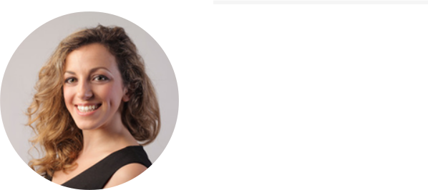

Lynn Skrukrud

Co-Founder - lynnskr@example.com

Lynn has spent over 10 years working in the field of substance abuse prevention and youth development. In high school, Lynn served as the Drug, Alcohol & Tobacco Prevention Commissioner for Nevada Union High School and as a Youth Board Member for the California Youth Advocacy Network, a statewide organization advocating for tobacco prevention. Through her work with the Advocacy Network, she was awarded as the California Youth Advocate of the Year and had her advocacy campaign “Turn the Target Around” featured on the national level.

Lynn has a Bachelor’s of Science in Business with a degree in Management Studies and an emphasis in Entrepreneurship. It’s Lynn’s dream to create a community where all young people grow up healthy, happy, and empowered to make healthy choices and she strives to do just that by continuing to expand NPCC activities and outreach.

Community Center | Business Plan [YEAR] 26/37

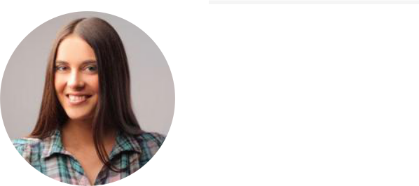
Halli Ellis

Co-Founder - Halli@example.com

Halli began working with youth professionally in 2005 in the Grass Valley School District Afterschool Programs. During her 6 years of employment, she gained valuable insight and experience in program development and received extensive training in youth development. She was promoted to Site Supervisor within 3 years and boosted enrollment from an average of 20 students attending daily to over 60. Halli increased in-kind donations, created new programs that stretched beyond the walls of the classroom, built connections between students, parents, and school staff, and successfully implemented the Youth Development Network’s youth empowerment model.

In 2007 Halli co-founded a dance group called the HWDA and hosted free community dances to encourage people to have fun without the use of drugs. This led to her involvement in the field of substance abuse prevention and the creation of NPCC. Halli received her Bachelor of Arts degree with a major in Sociology from the University of California Santa Cruz in 2013. She took advantage of independent studies at UCSC and focused her research on positive youth development. To supplement her education and gain new skills and experience, Halli volunteered in the Santa Cruz Boys and Girls Club, the FUSE youth group, the Western Service Workers Association, and the Santa Cruz Teen Center which each had their own distinct cultures to learn from. Halli continues to stay involved in youth programs such as the GREAT Summer Youth Academy and devotes her time to provide New Events & Opportunities through NPCC to help youth thrive. Halli is a visionary leader who knows how to connect with people of all ages and is dedicated to creating positive community transformation.

Community Center | Business Plan [YEAR] 27/37

Staffing Matrix

 NPCC


To unlock help try Upmetrics! 

Start writing here..

Community Center | Business Plan [YEAR] 28/37

7.

Financial Summary

Assumptions & Projections

Sustainability

Projected Profit and Loss

Projected Cash Flow

Projected Balance Sheet

Community Center | Business Plan [YEAR] 29/37

Assumptions & Projections

 NPCC

• Purchasing the property and renovating the center will cost approximately $5 million dollars.
• A capital campaign, fundraisers, and grants will be used to raise funds for start-up costs.
To unlock help try Upmetrics! 

Start writing here..

Sustainability

 NPCC

NPCC is committed to creating a financially sustainable center that will serve as an integral piece of our community for years to come. Through our research of other youth centers, we have found that it is vital to create a financially sustainable plan in order to have long term
To unlock help try Upmetrics! 

Start writing here..

Projected Profit and Loss

 | 2024 | 2025 | 2026
Revenue | $463,409.50 | $1,135,843.70 | $2,060,451.30
Event Ticket Sales | $159,171.40 | $285,849.20 | $513,343.20
Unit Sales | 7,959 | 14,292 | 25,667
Unit Price | $20 | $20 | $20
Membership Subscriptions | $244,136.10 | $753,814.50 | $1,393,142.10
Users | 1,282 | 2,834 | 4,830
Recurring Charges | $30 | $30 | $30
Facility Rentals | $60,102 | $96,180 | $153,966
Unit Sales | 301 | 481 | 770

Community Center | Business Plan [YEAR] 30/37

 | 2024 | 2025 | 2026
Unit Price | $200 | $200 | $200

Cost Of Sales | $43,129.05 | $83,614.62 | $141,611.48
General Costs | $12,000 | $12,529.95 | $12,921.72
Event-Related Costs | $12,000 | $12,529.95 | $12,921.72
Event-Related Costs | $6,000 | $6,180 | $6,365.40
Event Supplies | $6,000 | $6,349.95 | $6,556.32
Revenue Specific Costs | $31,129.05 | $71,084.67 | $128,689.76
Event Ticket Sales | $15,917.14 | $28,584.92 | $51,334.32
Event Promotion | $15,917.14 | $28,584.92 | $51,334.32
Membership Subscriptions | $12,206.81 | $37,690.75 | $69,657.14
Facility Cleaning | $12,206.81 | $37,690.75 | $69,657.14
Facility Rentals | $3,005.10 | $4,809 | $7,698.30
Cleaning Services | $3,005.10 | $4,809 | $7,698.30
Personnel Costs (Direct | $0 | $0 | $0
Labor) | $0 | $0 | $0

Gross Margin | $420,280.45 | $1,052,229.08 | $1,918,839.82
Gross Margin (%) | 90.69% | 92.64% | 93.13%

Operating Expense | $674,682.28 | $707,724.71 | $748,655.03
Payroll Expense (Indirect | $640,380 | $652,541.40 | $664,998.72
Labor) | $640,380 | $652,541.40 | $664,998.72
Administrative Staff | $196,500 | $201,045 | $205,699.32
Office Manager | $61,500 | $63,345 | $65,245.32
Administrative Assistants | $135,000 | $137,700 | $140,454

Community Center | Business Plan [YEAR] 31/37

 | 2024 | 2025 | 2026
Program Staff | $264,600 | $270,438 | $276,409.20
Program Coordinator | $54,600 | $56,238 | $57,925.20
Youth Counselors | $210,000 | $214,200 | $218,484
Maintenance Staff | $179,280 | $181,058.40 | $182,890.20
Cleaning Staff | $120,000 | $120,000 | $120,000
Facility Manager | $59,280 | $61,058.40 | $62,890.20
General Expense | $34,302.28 | $55,183.31 | $83,656.31
Administrative Expenses | $16,302.28 | $36,523.31 | $64,310.51
Office Supplies | $2,400 | $2,448 | $2,496.96
Utilities | $13,902.28 | $34,075.31 | $61,813.55
Marketing and Promotion | $6,000 | $6,300 | $6,615
Advertising | $6,000 | $6,300 | $6,615
Facility Related Expenses | $12,000 | $12,360 | $12,730.80
Facility Maintenance | $12,000 | $12,360 | $12,730.80
Bad Debt | $0 | $0 | $0
Amortization of Current | $0 | $0 | $0
Assets | $0 | $0 | $0

EBITDA | ($254,401.83) | $344,504.37 | $1,170,184.79

Additional Expense | $11,579.98 | $10,656.21 | $9,685.20

Long Term Depreciation

Gain or loss from Sale of Assets

EBIT

Interest Expense

$6,990 | $6,990 | $6,990
$0 | $0 | $0
($261,391.83) | $337,514.37 | $1,163,194.79
$4,589.96 | $3,666.20 | $2,695.19

Community Center | Business Plan [YEAR] 32/37

 | 2024 | 2025 | 2026
EBT | ($265,981.81) | $333,848.16 | $1,160,499.59
Income Tax Expense / | $0 | $0 | $0
Benefit | $0 | $0 | $0
Total Expense | $729,391.31 | $801,995.54 | $899,951.71
Net Income | ($265,981.81) | $333,848.16 | $1,160,499.59
Net Income (%) | (57.40%) | 29.39% | 56.32%
Retained Earning Opening | $0 | ($274,981.81) | $54,866.35
Owner's Distribution | $9,000 | $4,000 | $4,000
Retained Earning Closing | ($274,981.81) | $54,866.35 | $1,211,365.94
Projected Cash Flow
 | 2024 | 2025 | 2026
Cash Received | $463,409.50 | $1,135,843.70 | $2,060,451.30
Cash Paid | $722,401.31 | $795,005.54 | $892,961.71
COS & General Expenses | $77,431.33 | $138,797.93 | $225,267.79
Salary & Wages | $640,380 | $652,541.40 | $664,998.72
Interest | $4,589.96 | $3,666.20 | $2,695.19
Sales Tax | $0 | $0 | $0
Income Tax | $0 | $0 | $0
Net Cash From | ($258,991.81) | $340,838.16 | $1,167,489.59
Operations | ($258,991.81) | $340,838.16 | $1,167,489.59
Assets Sell | $0 | $0 | $0
Assets Purchase | $35,000 | $0 | $0

Community Center | Business Plan [YEAR] 33/37

Net Cash From

Investments

Amount Received

Loan Received

Common Stock

Preferred Stock

Owner's Contribution

Amount Paid

Loan Capital

Dividends & Distributions

Net Cash From

Financing

Summary

2024 | 2025 | 2026
($35,000) | $0 | $0

$150,000 | $0 | $0
$150,000 | $0 | $0
$0 | $0 | $0
$0 | $0 | $0
$0 | $0 | $0
$27,055.46 | $22,979.23 | $23,950.24
$18,055.48 | $18,979.24 | $19,950.25
$9,000 | $4,000 | $4,000
$122,944.54 | ($22,979.23) | ($23,950.24)

Starting Cash | $0 | ($171,047.27) | $146,811.66
Cash In | $613,409.50 | $1,135,843.70 | $2,060,451.30
Cash Out | $784,456.77 | $817,984.77 | $916,911.95
Change in Cash | ($171,047.27) | $317,858.93 | $1,143,539.35
Ending Cash | ($171,047.27) | $146,811.66 | $1,290,351.01

Projected Balance Sheet

 | 2024 | 2025 | 2026
Assets | ($143,037.27) | $167,831.66 | $1,304,381.01
Current Assets | ($171,047.27) | $146,811.66 | $1,290,351.01
Cash | ($171,047.27) | $146,811.66 | $1,290,351.01

Community Center | Business Plan [YEAR] 34/37

 | 2024 | 2025 | 2026
Accounts Receivable | $0 | $0 | $0
Inventory | $0 | $0 | $0
Other Current Assets | $0 | $0 | $0
Long Term Assets | $28,010 | $21,020 | $14,030
Gross Long Term Assets | $35,000 | $35,000 | $35,000
Accumulated Depreciation | ($6,990) | ($13,980) | ($20,970)

Liabilities & Equity | ($143,037.29) | $167,831.63 | $1,304,380.97
Liabilities | $131,944.52 | $112,965.28 | $93,015.03
Current Liabilities | $18,979.24 | $19,950.25 | $0
Accounts Payable | $0 | $0 | $0
Income Tax Payable | $0 | $0 | $0
Sales Tax Payable | $0 | $0 | $0
Short Term Debt | $18,979.24 | $19,950.25 | $0
Long Term Liabilities | $112,965.28 | $93,015.03 | $93,015.03
Long Term Debt | $112,965.28 | $93,015.03 | $93,015.03
Equity | ($274,981.81) | $54,866.35 | $1,211,365.94
Paid-in Capital | $0 | $0 | $0
Common Stock | $0 | $0 | $0
Preferred Stock | $0 | $0 | $0
Owner's Contribution | $0 | $0 | $0
Retained Earnings | ($274,981.81) | $54,866.35 | $1,211,365.94

Check | $0 | $0 | $0

Community Center | Business Plan [YEAR] 35/37

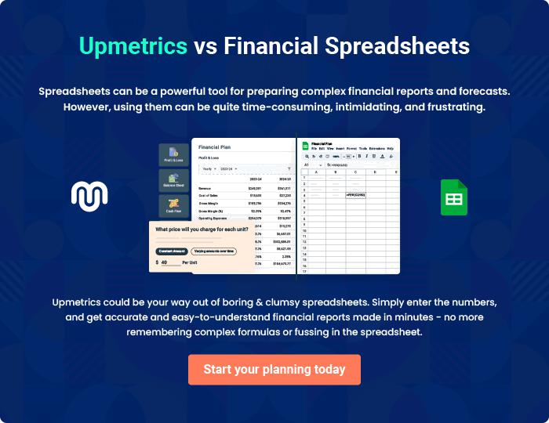

Community Center | Business Plan [YEAR] | 36/37

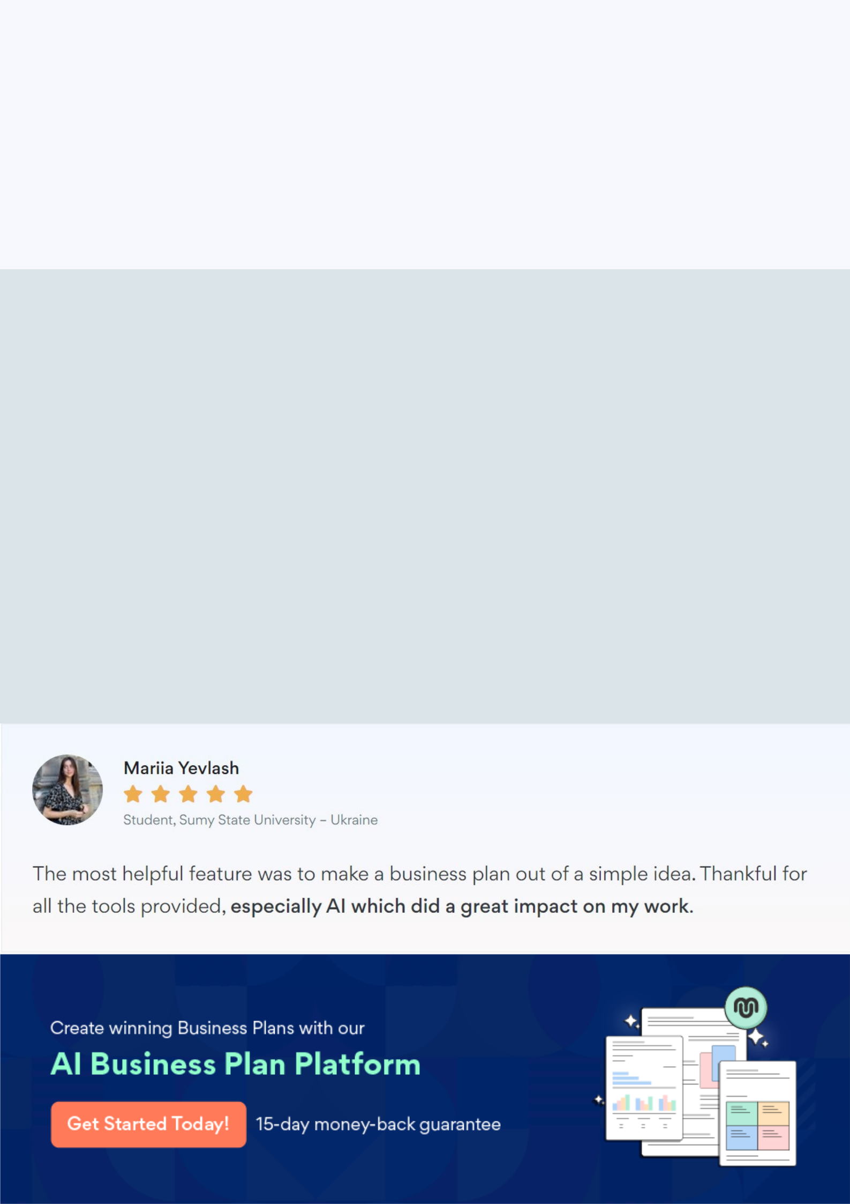
Create a winning business plan that gets you funded

Creating a stunning and investment-ready plan requires no writing, graphic designing, or financial planning expertise.

Upmetrics has all the features required to help you create a comprehensive business plan—from start to finish. Make no mistakes, it’s the modern way of planning to structure ideas, make plans, and create stunning pitch decks to awe investors.

Pitch decks that impress investors

Create pitch decks that provide a visual representation of your business, engage investors, and make them want to invest in your business idea.

Interactive plans in no time

Import business plan sections like—SWOT analysis, comparison tables, and others to create an interactive business plan. No designing skills are required.

Stunning cover page designs

With Upmetrics, you have the liberty to choose from multiple stunning cover page designs. Choose a creative design and make your plan stand out.

Online sharing made simple

Upmetrics makes online sharing quick and easier for users. Easily share your business plans with a link while tracking reader activity.

500+ sample business plans

Simply import a template from our library of sample plans into the editor and start customizing it to make it yours. It takes only a few clicks to get started.

Collaborate with team in real-time

Invite team members, initiate conversations, discuss ideas & strategies, share feedback, and work on a business plan in real-time.

