

Coffee Shop

Coffee is always a good idea

Business

Plan

[YEAR]

John Doe

10200 Bolsa Ave, Westminster, CA, 92683

- 359-3153 info@example.com https://example.com

CONFIDENTIAL

Table of Contents

Executive Summary | 6
Objectives | 7
Mission Statement | 7
Guiding Principles | 8
Keys to Success | 8
Financial Summary | 9
Net Income | 9

Business Overview | 10
Ownership | 11
Owners | 11
John Doe | 11
Legal Form | 12
Start-Up Summary | 12
Location and Facilities | 12

Products and Services | 13
Products/Services Descriptions | 14
Menu | 14
Product/Service Sourcing | 15
Inventory Management | 15
Warehousing and Fulfillment | 15
Future Products/Services | 15

Market Analysis | 17
Industry Analysis | 18
Competitive Landscape | 18
Products, Operations, Technology | 18
Market Size | 19
Industry Participants | 19
Market Segments | 20

Coffee Shop | Business Plan [YEAR] 2/44

Market Tests | 20
Target Market Segment Strategy | 21
Market Needs | 21
Market Growth | 21
Positioning | 21

Competitive Analysis | 22
Competitive Comparison | 23
Main Competitors | 23
Roasterie Cafe | 23
Take Five Coffee Bar | 23
Homer’s Coffee House | 24

Marketing And Sales | 25
SWOT Analysis | 26
Strategy Pyramid | 27
Unique Selling Proposition (USP) | 27
Competitive Edge | 27
Marketing Strategy and Positioning | 28
Positioning Statement | 28
Pricing Strategy | 28
Promotion and Advertising Strategy | 28
Website | 29
Marketing Programs | 29
Sales Strategy | 29
Sales Forecast | 30
Sales Programs | 30
Legal | 31
Milestones | 31
Exit Strategy | 31

Organization and Management | 32
Organizational Structure | 33
Management Team | 33

Coffee Shop | Business Plan [YEAR] 3/44

Management Team Gaps | 33
Personnel Plan | 34

Financial Plan | 35
Important Assumptions | 36
Start-Up Costs | 36
Source and Use of Funds | 37
Projected Profit and Loss | 37
Balance Sheet Projections | 40
Cash Flow Statement | 41

Coffee Shop | Business Plan [YEAR] 4/44

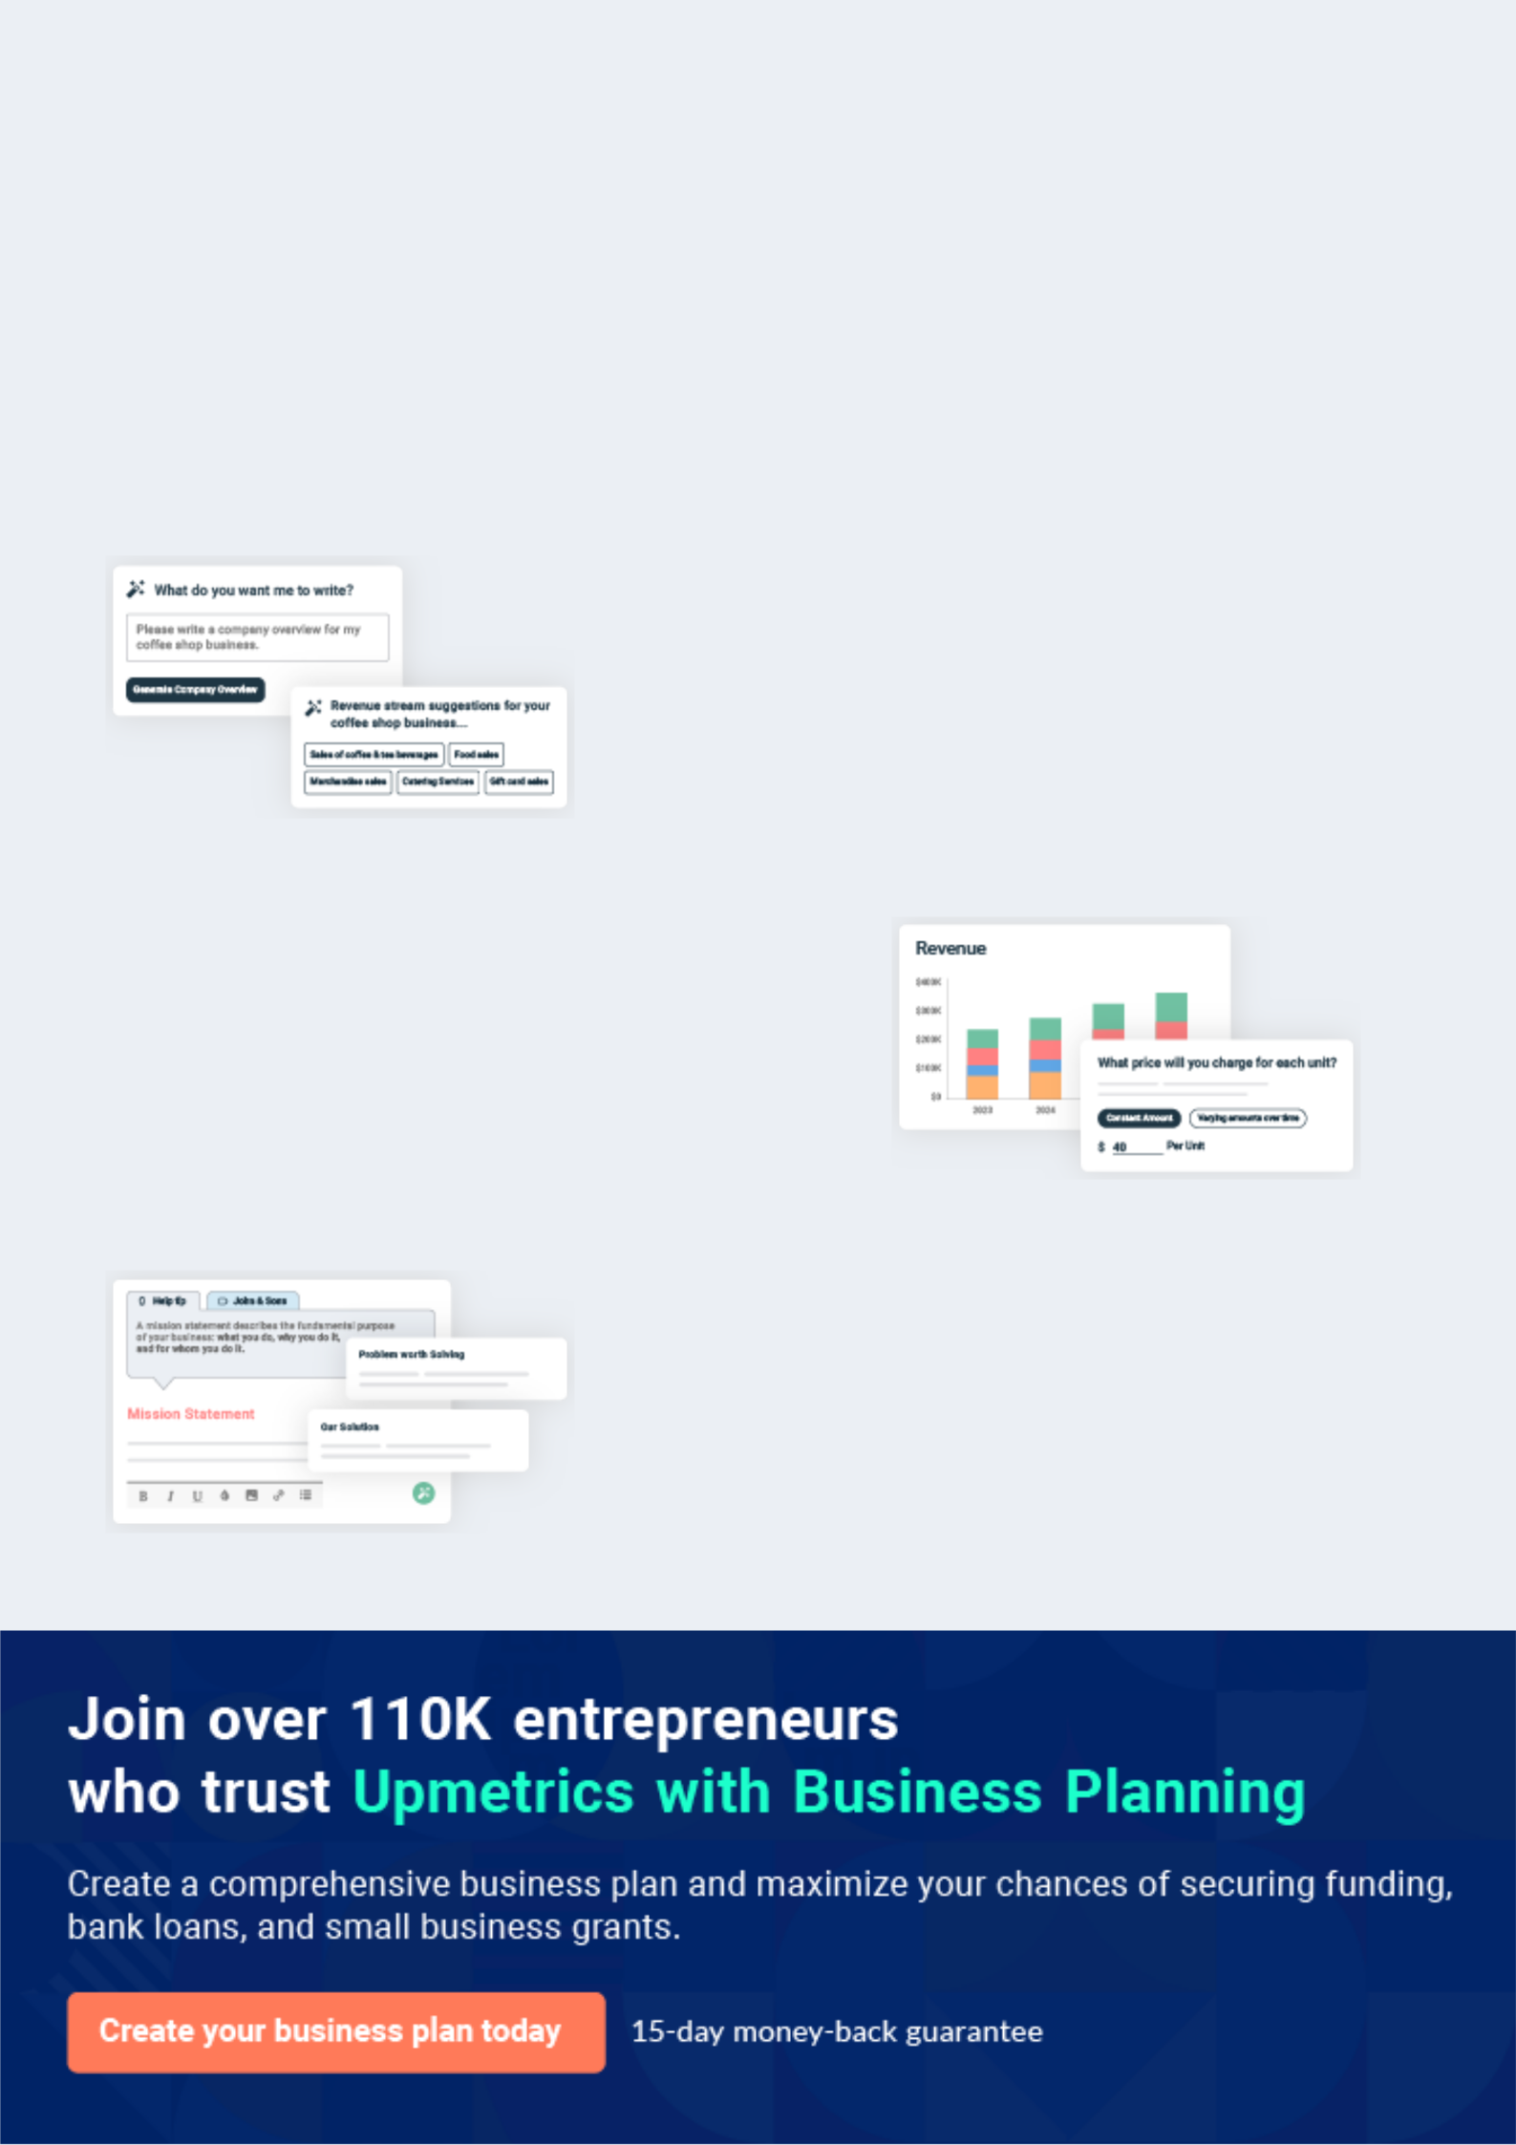
Business planning that’s simpler and faster than you think

Creating a business plan using Upmetrics to start and grow a business is literally the easiest thing in the World. Simply read the instructions and fill in the blanks. It’s as simple as that.

❛ | Upmetrics has everything you need to create a | ❜
❛ | comprehensive business plan. | ❜

AI-powered Upmetrics Assistant

AI-powered insights to streamline your plan

Not sure where to start? Upmetrics’ AI Assistant will automatically generate ideas for each section of your plan and offer improved versions of your writing, adjusting for tone, voice, and grammar or spelling errors.

Financial Forecasting Tool

All the financials are calculated for you

Forget the complex formulas and clumsy spreadsheets — with automatic financials and drag-and-drop forecasting, you can finish your plan faster and be confident that your numbers are accurate.

Business Plan Builder

Guides you like a business mentor

Upmetrics’ step-by-step instructions, prompts, and the library of 400+ sample business plans will guide you through each section of your plan as a business mentor.

1.


Executive Summary

Objectives

Mission Statement

Guiding Principles

Keys to Success

Financial Summary

Coffee Shop | Business Plan [YEAR] 6/44

 Cooper’s Cup


The Cooper’s Cup will be a new cafe located in the Phoenix city of Arizona. The 1,500 square foot café will be located in the newly constructed Market Square Plaza located on the northeast corner of 135th Street and Mission Street. The anchor tenant, the Price Chopper grocery store,
To unlock help try Upmetrics! 

Start writing here..

Objectives

 Cooper’s Cup

The primary objectives of the business plan for Cooper’s Cup are below:

• To increase revenues $36,000 or 5% in Year 2 and $73,000 or 10% by Year 3
To unlock help try Upmetrics! 

Start writing here..

Mission Statement

 Cooper’s Cup

The Cooper’s Cup is committed to its products and employees which they believe is the recipe for market success.
To unlock help try Upmetrics! 

Start writing here..

Coffee Shop | Business Plan [YEAR] 7/44

Guiding Principles

 Cooper’s Cup

The Cooper’s Cup is committed to values such as excellence, passion, quality, integrity, and leadership which allow them to navigate challenges and provide for future opportunities. These core beliefs start with their commitment to their products and their employees. Cooper’s Cup
To unlock help try Upmetrics! 

Start writing here..

Keys to Success

 Cooper’s Cup

The Cooper’s Cup stands out from the competition. Below are their Keys to Success:

Great Products – providing exemplary products at market prices – will make customers want
To unlock help try Upmetrics! 

Start writing here..

Coffee Shop | Business Plan [YEAR] 8/44

Financial Summary

Net Income
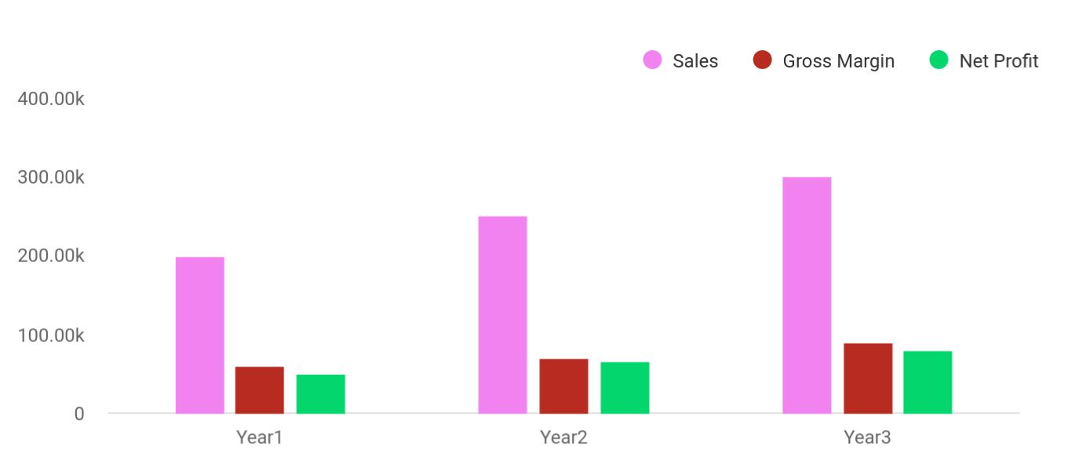

Financial Year | Sales | Gross Margin | Net Profit
Year1 | 200,000 | 60,000 | 50,000
Year2 | 250,000 | 70,000 | 65,000
Year3 | 300,000 | 90,000 | 80,000

Start writing here..

Coffee Shop | Business Plan [YEAR] 9/44

2.

Business Overview

Ownership

Legal Form

Start-Up Summary

Location and Facilities

Coffee Shop | Business Plan [YEAR] 10/44

 Cooper’s Cup

Start writing here..

Ownership

Owners



100%


To unlock help try Upmetrics! 
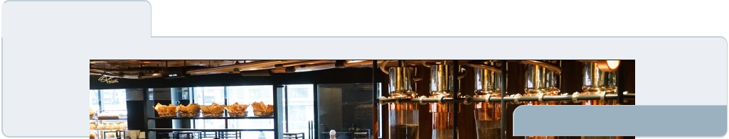

John Doe

100 Shares

John Doe

Owner - johnd@example.com

The Cooper’s Cup will be owned 100% by John Doe. Mr. Doe a graduate of Arizona State University has an undergraduate degree in business administration. During high school, he worked as a waiter in a local hospital coffee shop that purchased its beans from a local roaster. In addition to being an avid coffee drinker himself, this job allowed him to learn about the business first-hand. In college, Doe worked in a campus coffeehouse for four years, eventually rising to the position of assistant manager. Following graduation, Doe secured a business development position for a regional restaurant chain, which provided additional first-hand exposure to the food and beverage industry —especially the steps involved in establishing new locations.

Coffee Shop | Business Plan [YEAR] 11/44

Legal Form

 Cooper’s Cup

The Cooper’s Cup will be formed as an S-Corporation wholly owned by Mr. Doe.

To unlock help try Upmetrics! 

Start writing here..

Start-Up Summary

 Cooper’s Cup

The Cooper’s Cup will have seating for 40 patrons. The rent is $2,075 a month, with a three-five-year lease available. The site consists of 1500 square feet of leased space consisting of a dining room, a coffee bar, two restrooms, and a storage room in the back. To be used as a
To unlock help try Upmetrics! 

Start writing here..

Location and Facilities

 Cooper’s Cup


To unlock help try Upmetrics! 

Start writing here..

Coffee Shop | Business Plan [YEAR] 12/44

3.

Products and Services

Products/Services Descriptions

Product/Service Sourcing

Inventory Management

Warehousing and Fulfillment

Future Products/Services

Coffee Shop | Business Plan [YEAR] 13/44

Products/Services Descriptions


The Cooper’s Cup’s primary offering is gourmet roasted coffees with such varieties such as mocha, carmelicious, white mocha, candy bar latte, and brewed coffee. Complementing the coffee will be a smoothie line including wild berry, strawberry, peach, mango, and lemonade. Rounding out the simple menu line will be pastries obtained with an outside supplier, freshly made and delivered daily. The pastry offerings may vary with seasonality but the primary line will muffins, bread, cookies, scones, and rolls.

Menu
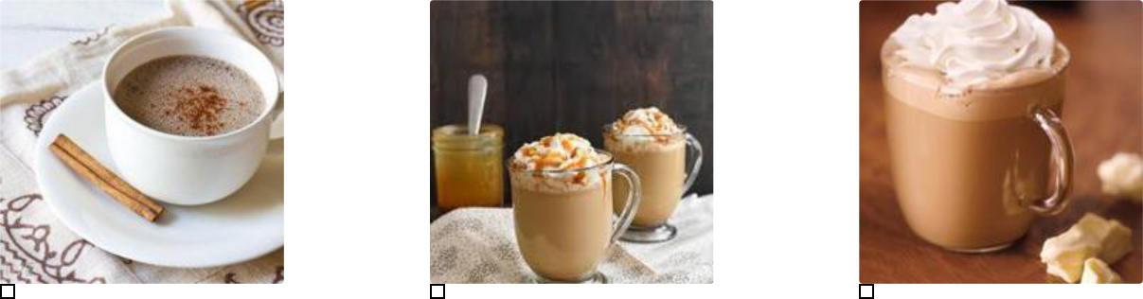

Mocha Carmelicious White mocha
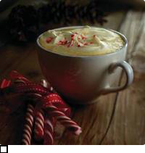

Candy Bar Latte

Coffee Shop | Business Plan [YEAR] 14/44

Product/Service Sourcing
To unlock help try Upmetrics!

 Cooper’s Cup

The Cooper’s Cup has negotiated supplier agreements with several local food-service wholesalers and coffee wholesalers in the Phoenix area that have a reputation for quality and reliability:



Start writing here..

Inventory Management

Warehousing and Fulfillment

Future Products/Services

 Cooper’s Cup

Young families which comprise the third largest market share in Phoenix, are often overlooked in the coffee market. Coffeehouses traditionally have not been considered ‘kid’ friendly. To overcome this hurdle, the Cooper’s Cup has long term plans (5 years) to open a 2nd coffee
To unlock help try Upmetrics! 

Start writing here..

Coffee Shop | Business Plan [YEAR] 15/44

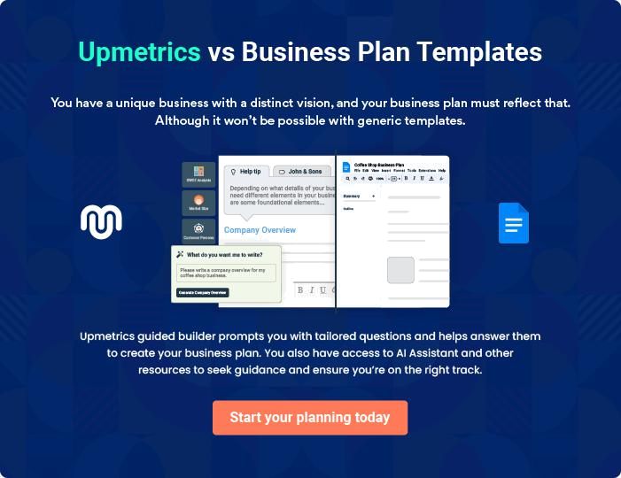

Coffee Shop | Business Plan [YEAR] | 16/44

4.

Market Analysis

Industry Analysis

Market Size

Industry Participants

Market Segments

Market Tests

Target Market Segment Strategy

Coffee Shop | Business Plan [YEAR] 17/44

 Cooper’s Cup

Phoenix, Arizona is an award-winning place to live and work and is considered the leading business community in the Midwest. National publications and organizations recognize
Phoenix for its business environment and livability. Here’s a sampling: 6th Place, America’s Best
To unlock help try Upmetrics! 

Start writing here..

Industry Analysis

 Cooper’s Cup

The US coffee shop industry includes about 20,000 stores with combined annual revenue of about $10 billion. Major companies include Caribou Coffee, International Coffee & Tea (The
Coffee Bean & Tea Leaf), Peet’s Coffee, and Starbucks. The industry is concentrated: the top 50
To unlock help try Upmetrics! 

Start writing here..

 Cooper’s Cup

Consumer taste and personal income drive demand. The profitability of individual companies depends on the ability to secure prime locations, drive store traffic, and deliver high-quality products. Large companies have advantages in purchasing, finance, and marketing. Small
To unlock help try Upmetrics! 

Competitive Landscape

Start writing here..

 Cooper’s Cup

Major products include beverages and food. Beverages include brewed coffee and tea; espresso drinks (cappuccinos, cafe lattes); cold blended beverages; bottled water; soft drinks; and juices. Food includes pastries, bakery items, desserts, sandwiches, and candy. Many coffee
To unlock help try Upmetrics! 

Products, Operations, Technology

Start writing here..

Coffee Shop | Business Plan [YEAR] 18/44

Market Size

 Cooper’s Cup

The US coffee shop industry includes about 20,000 stores with combined annual revenue of about $10 billion. Major companies include Caribou Coffee, International Coffee & Tea (The
Coffee Bean & Tea Leaf), Pet’s Coffee, and Starbucks. The industry is concentrated: the top 50
To unlock help try Upmetrics! 

Start writing here..

Industry Participants

Within 5 miles of the subject, are 37 businesses involved in the coffee industry, including chains, restaurants, and tea houses reporting annual revenues in excess of $54 million. Of these 37 businesses, 20 are Starbucks coffee shops capturing $35.7 million in revenues or 66% of the market share. An additional 8 coffee houses are franchises capturing $9.7 million represent 18% of the market share. The comparables – those closely-held coffee shops/cafes that will compete for the subject’s business represent $8.3 million in annual revenues or 15% of the total market.

The Cooper’s Cup is targeting three primary groups residing in their direct marketing area. These individuals prefer unique venues and avoid the big chains and franchises. They prefer their local neighborhood and will support local businesses if the business warrants.


Name | Count | Revenue | Market Share

Starbucks Coffee

Franchise

Tea House

Totals

Coffee Shop | Business Plan [YEAR] 19/44

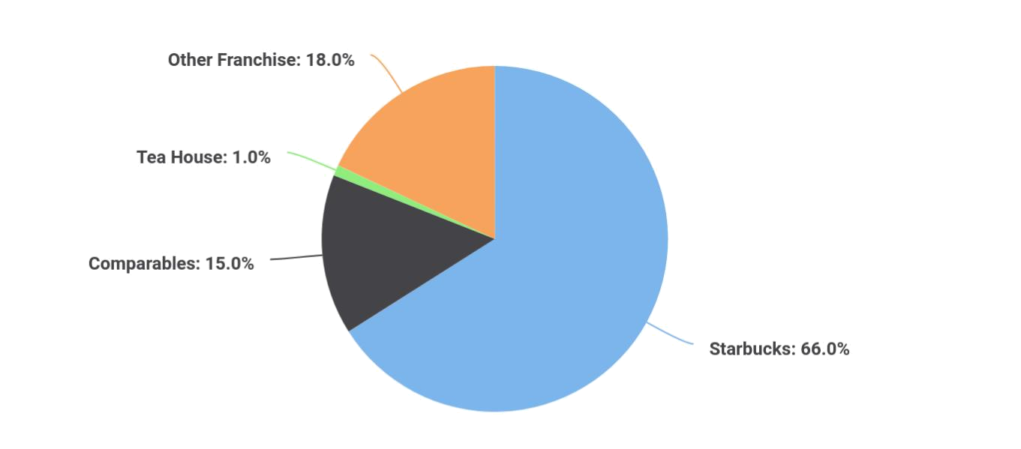

Market Segments

 Cooper’s Cup

The Cooper’s Cup is targeting the three top segments of the population representing 39% of the population in the Phoenix area:
To unlock help try Upmetrics! 

Start writing here..

Market Tests

 Cooper’s Cup

Research from Yelp, FourSquare, and google places, indicates the Phoenix market is in need of a new local cafe. The locals have been clamoring for the current private shops to improve service and/or reduce prices to keep pace with larger chains and franchises, thus providing a
To unlock help try Upmetrics! 

Start writing here..

Coffee Shop | Business Plan [YEAR] 20/44

Target Market Segment Strategy

 Cooper’s Cup

Most adult coffee drinkers said their lifelong habits began during their teenage years. In fact, 54% said they began drinking coffee between 13 and 19. Another 22% reported their coffee cravings started between the ages of 20 and 24. This means that 76% of adult coffee drinkers
To unlock help try Upmetrics! 

Start writing here..

 Cooper’s Cup

• Unique products (specialized roasts, local ingredients, locally-themed or named drinks, custom drinks by the‘star’ barista, etc.)
• Games, puzzles, mind benders, and other activities that encourage customers to linger
To unlock help try Upmetrics! 

Market Needs

Start writing here..

 Cooper’s Cup

Despite the economic woes, 37% of total coffee consumed in the United States in 2011 was classified as “Gourmet.” According to the National Coffee Drinking Study, This suggests consumers were set on drinking good coffee and visiting their local coffee shop even in the
To unlock help try Upmetrics! 

Market Growth

Start writing here..

 Cooper’s Cup

The Russet Mug will position itself as a local coffeehouse or a ‘suburban’ coffeehouse providing a sanctuary for those in the ‘burbs’ without the hassle of having to drive downtown
To unlock help try Upmetrics! 

Positioning

Start writing here..

Coffee Shop | Business Plan [YEAR] 21/44

5.

Competitive Analysis

Competitive Comparison

Main Competitors

Coffee Shop | Business Plan [YEAR] 22/44

Competitive Comparison

 Cooper’s Cup

The research methodology is based on unique coffee shops/cafes in the greater metro area and omits larger chains or franchises. The findings reveal eight unique competitors.
To unlock help try Upmetrics! 

Start writing here..

Main Competitors

 Cooper’s Cup

This competitor has been operating in the greater MSA since 2005 opening its first cafe in Brookside, Arizona, and then at the Leawood location in 2010. The 3,300 square foot cafe
offers an assortment of pastries, bagels, and cookies. Beverages include Harney and Sons
To unlock help try Upmetrics! 

Roasterie Cafe

Start writing here..

 Cooper’s Cup

This competitor operates from a 3,300 square foot space. The cafe has WI-FI. In addition to serving coffees and smoothies, the cafe offers more food offerings with a full-service kitchen offering light breakfasts, and sandwiches, and wraps. In the evenings the cafe has musicians
To unlock help try Upmetrics! 

Take Five Coffee Bar

Start writing here..

Coffee Shop | Business Plan [YEAR] 23/44

 Cooper’s Cup

This competitor operates from a 6,300 square foot space in a shopping center. The shop was established in 2001 and in 2011 reported $2 million in revenues. The shop employs 21 employees and provides music on the weekends. The subject’s advantage is its smaller, cozier,
To unlock help try Upmetrics! 

Homer’s Coffee House

Start writing here..

Coffee Shop | Business Plan [YEAR] 24/44

6.

Marketing And Sales

SWOT Analysis

Strategy Pyramid

Unique Selling Proposition (USP)

Competitive Edge

Marketing Strategy and Positioning

Sales Strategy

Legal

Milestones

Exit Strategy

Coffee Shop | Business Plan [YEAR] 25/44

SWOT Analysis

 Cooper’s Cup

The SWOT analysis examines the cafe’s strengths and weaknesses that need to be addressed.

Further, this section examines the opportunities presented to Cafe as well as potential threats.
To unlock help try Upmetrics! 

Start writing here..


Strength

Based on its smaller size, the fact that it is not a franchise, the Cooper’s Cup is a unique coffee shop concept unlike any other in the Phoenix market.

The owner has firsthand experience, in operating and starting new restaurants,

Handpicked baristas will bring professionalism and enthusiasm to the shop.


Weakness

Franchises are the easiest way and often the safest conduit to start a cafe; the cafe will not have the backing of one of these established entities.

The Cooper’s Cup has a minimal budget and is competing against larger and more established coffeehouses for market share.


Opportunity

The Phoenix demographics support the need for a unique coffee shop. Additional opportunities to target the active and recently retired target market and 45 years+ age group.

A small slice of a much bigger pie is the goal. Only40 percent of the nation’s coffee drinkers are consuming premium ground and whole bean coffee. Encouraging coffee drinkers to become coffee connoisseurs is the key to continued growth.

The local coffeehouse/cafe market is $54 million

Threat

The Morning Glory Coffee shop is currently for sale; should another independent purchase this cafe, it could pose a significant threat to market share.

Coffee Shop | Business Plan [YEAR] 26/44

Strategy Pyramid

 Cooper’s Cup

• In the short-term, a number of promotions and activities are planned around the launch of the business to create awareness. The coffee shop will have a contest offering 20
bottomless mugs and will publicize this promotion via radio advertising, as well as
To unlock help try Upmetrics! 

Start writing here..

Unique Selling Proposition (USP)

 Cooper’s Cup

The Cooper’s Cup truly stands out from a crowded sea of coffee chains and franchises. What sets them apart from the competition is primarily its smaller cozier size combined with premium coffees served by knowledgeable baristas providing so much energy and enthusiasm
To unlock help try Upmetrics! 

Start writing here..

Competitive Edge

 Cooper’s Cup

The Cooper’s Cup’s competitive edge, its size, is also its greatest attribute. Because they are small there is no red tape, and they can easily adjust business hours to say accommodate an after-hours book reading session whereas the corporate chains do not provide such
To unlock help try Upmetrics! 

Start writing here..

Coffee Shop | Business Plan [YEAR] 27/44

Marketing Strategy and Positioning

 Cooper’s Cup

The Cooper’s Cup utilizes a focus strategy on its market. By specifically targeting three primary segments they can cater specifically to their needs.
To unlock help try Upmetrics! 

Start writing here..

 Cooper’s Cup

The Cooper’s Cup is a gourmet coffee lover’s gem. It is truly one of a kind coffee house offering outstanding gourmet coffees and blends, served by enthusiastic and knowledgeable baristas, in a warm, relaxed environment. It is the place to go to visit with friends or cozy up in a quiet
To unlock help try Upmetrics! 

Positioning Statement

Start writing here..

 Cooper’s Cup

The Cooper’s Cup primarily utilizes competition based pricing. The cafe does not utilize coupons and discounts (other than opening promotion) because they believe that the most valuable customer demographic of daily coffee consumers is not influenced by discount
To unlock help try Upmetrics! 

Pricing Strategy

Start writing here..

 Cooper’s Cup

Online Advertising - The Cooper’s Cup will advertise regularly on popular social media sites, such as Facebook. Compared to traditional print advertising, this is a cost-effective tactic that will allow them to reach prospects in a highly targeted way (e.g., based on criteria such as age,
To unlock help try Upmetrics! 

Promotion and Advertising Strategy

Start writing here..

Coffee Shop | Business Plan [YEAR] 28/44

 Cooper’s Cup
To unlock help try Upmetrics!

The Cooper’s Cup will have a simple website identifying its menu items of gourmet coffees, smoothies, and pastries, along with the address, map and hours of operation. The website will also have a calendar of any upcoming events or sponsorships.



Website

Start writing here..

 Cooper’s Cup

The cafe will also rely on signage and draw to its location. Price Chopper brings 10,000 shoppers weekly to its location.
To unlock help try Upmetrics! 

Marketing Programs

Start writing here..

Sales Strategy

 Cooper’s Cup

The Cooper’s Cup will use the following methods to increase sales revenue (as recommended by Andrew Hetzel on Better Coffee, Better Business):
To unlock help try Upmetrics! 

Start writing here..

Coffee Shop | Business Plan [YEAR] 29/44

Sales Forecast

The sales forecast assumes a conservative 5% increase in revenues during Year Two and 10% increase in Year Three. The following chart shows estimated sales over the next three years.

Annual Sales Forecast:


Annual Sales | Year1 | Year2 | Year3
Forecast | Year1 | Year2 | Year3

Products/Service 1

Products/Service 2

Products/Service 3

Total Income

Cost of Sales

Products/Service 1

Products/Service 2

Products/Service 3

Total Cost Of Sales

Gross Margin

 Cooper’s Cup

The Cooper’s Cup will run employee sales contests – The baristas are the salespeople and have a great deal of influence over the customer ordering process. All baristas will be required to have sales and customer service training to make each transaction. The sales contests will
To unlock help try Upmetrics! 

Sales Programs

Start writing here..

Coffee Shop | Business Plan [YEAR] 30/44

Legal

 Cooper’s Cup

The Cooper’s Cup is organized as an S-Corporation formed in the state of Arizona.

To unlock help try Upmetrics! 

Start writing here..

Milestones

Listed below are the milestones for the Cooper’s Cup:

Milestone | Date
Secure occupancy Phoenix location | [Date]
Tenant improvements and build outs | [Date]
Purchase furniture and décor | [Date]
Assemble and hire barista team | [Date]
Advertise on local radio station/mail fliers | [Date]
Open for Business | [Date]

Exit Strategy

 Cooper’s Cup

In the event the store would have to close for business all assets would be sold at auction.

To unlock help try Upmetrics! 

Start writing here..

Coffee Shop | Business Plan [YEAR] 31/44

7.

Organization and Management

Organizational Structure

Management Team

Management Team Gaps

Personnel Plan

Coffee Shop | Business Plan [YEAR] 32/44

Organizational Structure
To unlock help try Upmetrics!

The Cooper’s Cup is formed as an S-Corporation wholly owned by John Doe.

Management Team

 Cooper’s Cup

The Cooper’s Cup will be owned 100% by JohnDoe.Mr. Doe a graduate of Arizona State University, has an undergraduate degree in business administration. During high school, he
worked as a waiter in a local hospital coffee shop that purchased its beans from a local roaster.
To unlock help try Upmetrics! 

Start writing here..

Management Team Gaps

 Cooper’s Cup

The Cooper’s Cup will rely on its POS (Point of Sale) system to generate daily accounting and cost activity reports. Mr. Doe will supply these to an outside bookkeeper for the preparation of annual income taxes.



Start writing here..

Coffee Shop | Business Plan [YEAR] 33/44

Personnel Plan

Initially, the cafe will hire 1 manager, 5 baristas, and 2 part-time servers. In Year 2, the cafe plans to hire 1 additional full-time barista.


Year1 | Year2 | Year3

Manager

Full-time barista

Full-time barista

Full-time barista

Full-time barista

Part-time employee

Part-time employee

Total Personnel costs

Coffee Shop | Business Plan [YEAR] 34/44

8.

Financial Plan

Important Assumptions

Start-Up Costs

Source and Use of Funds

Projected Profit and Loss

Balance Sheet Projections

Cash Flow Statement

Coffee Shop | Business Plan [YEAR] 35/44

Important Assumptions

 Cooper’s Cup

• The sales forecast is conservative and assumes a 5% increase in Year 2 and a 10% in Year 3.
• The analysis accounts for economic seasonality – wherein some months revenues peak
To unlock help try Upmetrics! 

Start writing here..

Start-Up Costs

[Amount]Following are the needed start-up costs associated with the Russet Cup:

Startup Expenses | Amount
Operating Capital | [Amount]
Salaries & Wages | [Amount]
Insurance Premiums | [Amount]
Beginning Inventory | [Amount]
Legal and Accounting Fees | [Amount]
Rent Deposits | [Amount]
Utility Deposits | [Amount]
Supplies | [Amount]
Advertising and Promotions | [Amount]
Licenses | [Amount]
Other Initial Costs | [Amount]
Working Capital (Cash on hands) | [Amount]
Total Startup Expenses | [Total Amount]

Startup Assets | Amount
Real Estate | [Amount]
Buildings | [Amount]
Leasehold improvements | [Amount]

Coffee Shop | Business Plan [YEAR] 36/44

Startup Assets | Amount
Equipment | [Amount]
Furniture and Fixtures | [Amount]
Vehicles | [Amount]
Other Fixed Assets | [Amount]
Total Startup Assets | [Total Amount]

Source and Use of Funds

Source Of Funds | Amount
Owner's Contribution | [Amount]
Commercial Loan | [Amount]
Commercial Mortgage | [Amount]
Line Of Credit | [Amount]
Total Source Of Funds | [Total Amount]
Use Of Funds
Fixed Assets | [Amount]
Operating Capital | [Amount]
Total Use Of Funds | [Total Amount]

Projected Profit and Loss

 | 2024 | 2025 | 2026
Revenue | $406,634.63 | $503,035.18 | $627,242.81
Coffee Sales | $241,417.74 | $306,176.10 | $388,305.06
Unit Sales | 80,473 | 102,059 | 129,435
Unit Price | $3 | $3 | $3
Baked Goods | $142,678.20 | $160,773.95 | $181,164.23

Coffee Shop | Business Plan [YEAR] 37/44

Unit Sales

Unit Price

Beverage Add-ons

Unit Sales

Unit Price

Cost Of Sales

General Costs

Coffee and Related

Ingredients

Coffee Beans

Milk

Bakery Items

Flour and Baking

Ingredients

Packaging for Baked Goods

Revenue Specific Costs

Personnel Costs (Direct Labor)

Gross Margin

Gross Margin (%)

Operating Expense

Payroll Expense (Indirect Labor)

Baristas

2024 | 2025 | 2026
57,071 | 64,310 | 72,466
$2.50 | $2.50 | $2.50
$22,538.69 | $36,085.13 | $57,773.52
45,077 | 72,170 | 115,547
$0.50 | $0.50 | $0.50

$13,200 | $13,380 | $13,563.48
$13,200 | $13,380 | $13,563.48
$9,600 | $9,720 | $9,842.40
$6,000 | $6,120 | $6,242.40
$3,600 | $3,600 | $3,600
$3,600 | $3,660 | $3,721.08
$2,400 | $2,448 | $2,496.96
$1,200 | $1,212 | $1,224.12
$0 | $0 | $0
$0 | $0 | $0

$393,434.63 | $489,655.18 | $613,679.33
96.75% | 97.34% | 97.84%

$384,638.10 | $401,787.30 | $421,014.40
$335,640 | $347,005.20 | $358,779.84
$126,000 | $131,472 | $137,184.48

Coffee Shop | Business Plan [YEAR] 38/44

 | 2024 | 2025 | 2026
Lead Barista | $43,200 | $45,360 | $47,628
Junior Baristas | $82,800 | $86,112 | $89,556.48
Kitchen Staff | $120,360 | $123,970.80 | $127,690.08
Head Chef | $49,560 | $51,046.80 | $52,578.24
Assistant Chefs | $70,800 | $72,924 | $75,111.84
Support Staff | $89,280 | $91,562.40 | $93,905.28
Cashiers | $49,680 | $51,170.40 | $52,705.44
Cleaning Staff | $39,600 | $40,392 | $41,199.84
General Expense | $48,998.10 | $54,782.10 | $62,234.56
Utilities | $3,600 | $3,600 | $3,600
Electricity | $2,400 | $2,400 | $2,400
Water and Sewage | $1,200 | $1,200 | $1,200
Rent and Maintenance | $21,000 | $21,000 | $21,000
Rent | $18,000 | $18,000 | $18,000
Maintenance | $3,000 | $3,000 | $3,000
Marketing and Advertising | $24,398.10 | $30,182.10 | $37,634.56
Online Advertising | $12,199.05 | $15,091.05 | $18,817.28
Print Advertising | $12,199.05 | $15,091.05 | $18,817.28
Bad Debt | $0 | $0 | $0
Amortization of Current | $0 | $0 | $0
Assets | $0 | $0 | $0

EBITDA | $8,796.58 | $87,867.94 | $192,664.97

Additional Expense | $10,123.09 | $8,221.01 | $6,201.62
Long Term Depreciation | $4,962 | $4,962 | $4,962

Coffee Shop | Business Plan [YEAR] 39/44

Gain or loss from Sale of Assets

EBIT

Interest Expense

EBT

Income Tax Expense / Benefit

Total Expense

Net Income

Net Income (%)

Retained Earning Opening

Owner's Distribution

Retained Earning Closing

2024 | 2025 | 2026
$0 | $0 | $0
$3,834.58 | $82,905.94 | $187,702.97
$5,161.09 | $3,259.02 | $1,239.63
($1,326.51) | $79,646.93 | $186,463.35
$0 | $0 | $0

$407,961.19 | $423,388.31 | $440,779.50
($1,326.51) | $79,646.93 | $186,463.35
(0.33%) | 15.83% | 29.73%

$0 | ($19,326.51) | $52,320.42
$18,000 | $8,000 | $8,000
($19,326.51) | $52,320.42 | $230,783.77

Balance Sheet Projections

 | 2024 | 2025 | 2026
Assets | $99,834.58 | $138,740.52 | $280,783.75
Current Assets | $69,796.58 | $113,664.52 | $260,669.75
Cash | $69,796.58 | $113,664.52 | $260,669.75
Accounts Receivable | $0 | $0 | $0
Inventory | $0 | $0 | $0
Other Current Assets | $0 | $0 | $0
Long Term Assets | $30,038 | $25,076 | $20,114
Gross Long Term Assets | $35,000 | $35,000 | $35,000

Coffee Shop | Business Plan [YEAR] 40/44

 | 2024 | 2025 | 2026
Accumulated Depreciation | ($4,962) | ($9,924) | ($14,886)
Liabilities & Equity | $99,834.58 | $138,740.53 | $280,783.77
Liabilities | $69,161.09 | $36,420.11 | $0
Current Liabilities | $32,740.98 | $36,420.11 | $0
Accounts Payable | $0 | $0 | $0
Income Tax Payable | $0 | $0 | $0
Sales Tax Payable | $0 | $0 | $0
Short Term Debt | $32,740.98 | $36,420.11 | $0
Long Term Liabilities | $36,420.11 | $0 | $0
Long Term Debt | $36,420.11 | $0 | $0
Equity | $30,673.49 | $102,320.42 | $280,783.77
Paid-in Capital | $0 | $0 | $0
Common Stock | $0 | $0 | $0
Preferred Stock | $0 | $0 | $0
Owner's Contribution | $50,000 | $50,000 | $50,000
Retained Earnings | ($19,326.51) | $52,320.42 | $230,783.77
Check | $0 | $0 | $0
Cash Flow Statement
 | 2024 | 2025 | 2026
Cash Received | $406,634.68 | $503,035.24 | $627,242.85
Cash Paid | $402,999.19 | $418,426.31 | $435,817.50
COS & General Expenses | $62,198.10 | $68,162.10 | $75,798.04

Coffee Shop | Business Plan [YEAR] 41/44

2024 2025 2026

Salary & Wages

Interest

Sales Tax

Income Tax

Net Cash From

Operations

Assets Sell

Assets Purchase

Net Cash From

Investments

Amount Received

Loan Received

Common Stock

Preferred Stock

Owner's Contribution

Amount Paid

Loan Capital

Dividends & Distributions

Net Cash From

Financing

Summary

$335,640 | $347,005.20 | $358,779.84
$5,161.09 | $3,259.02 | $1,239.63
$0 | $0 | $0
$0 | $0 | $0
$3,635.49 | $84,608.93 | $191,425.35

$0 | $0 | $0
$35,000 | $0 | $0
($35,000) | $0 | $0

$150,000 | $0 | $0
$100,000 | $0 | $0
$0 | $0 | $0
$0 | $0 | $0
$50,000 | $0 | $0
$48,838.91 | $40,740.99 | $44,420.12
$30,838.91 | $32,740.98 | $36,420.11
$18,000 | $8,000 | $8,000
$101,161.09 | ($40,740.99) | ($44,420.12)

Starting Cash | $0 | $69,796.58 | $113,664.52
Cash In | $556,634.68 | $503,035.24 | $627,242.85
Cash Out | $486,838.10 | $459,167.30 | $480,237.62

Coffee Shop | Business Plan [YEAR] 42/44

 | 2024 | 2025 | 2026
Change in Cash | $69,796.58 | $43,867.94 | $147,005.23
Ending Cash | $69,796.58 | $113,664.52 | $260,669.75
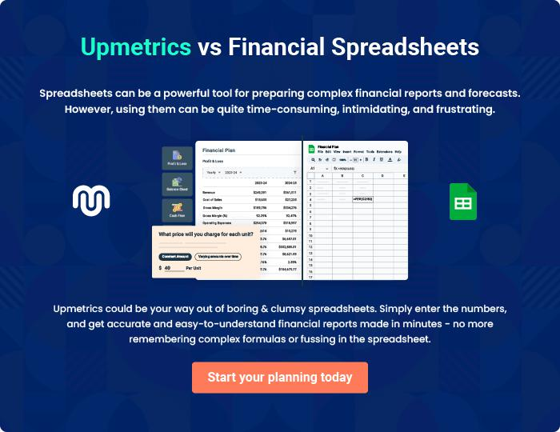

Coffee Shop | Business Plan [YEAR] 43/44

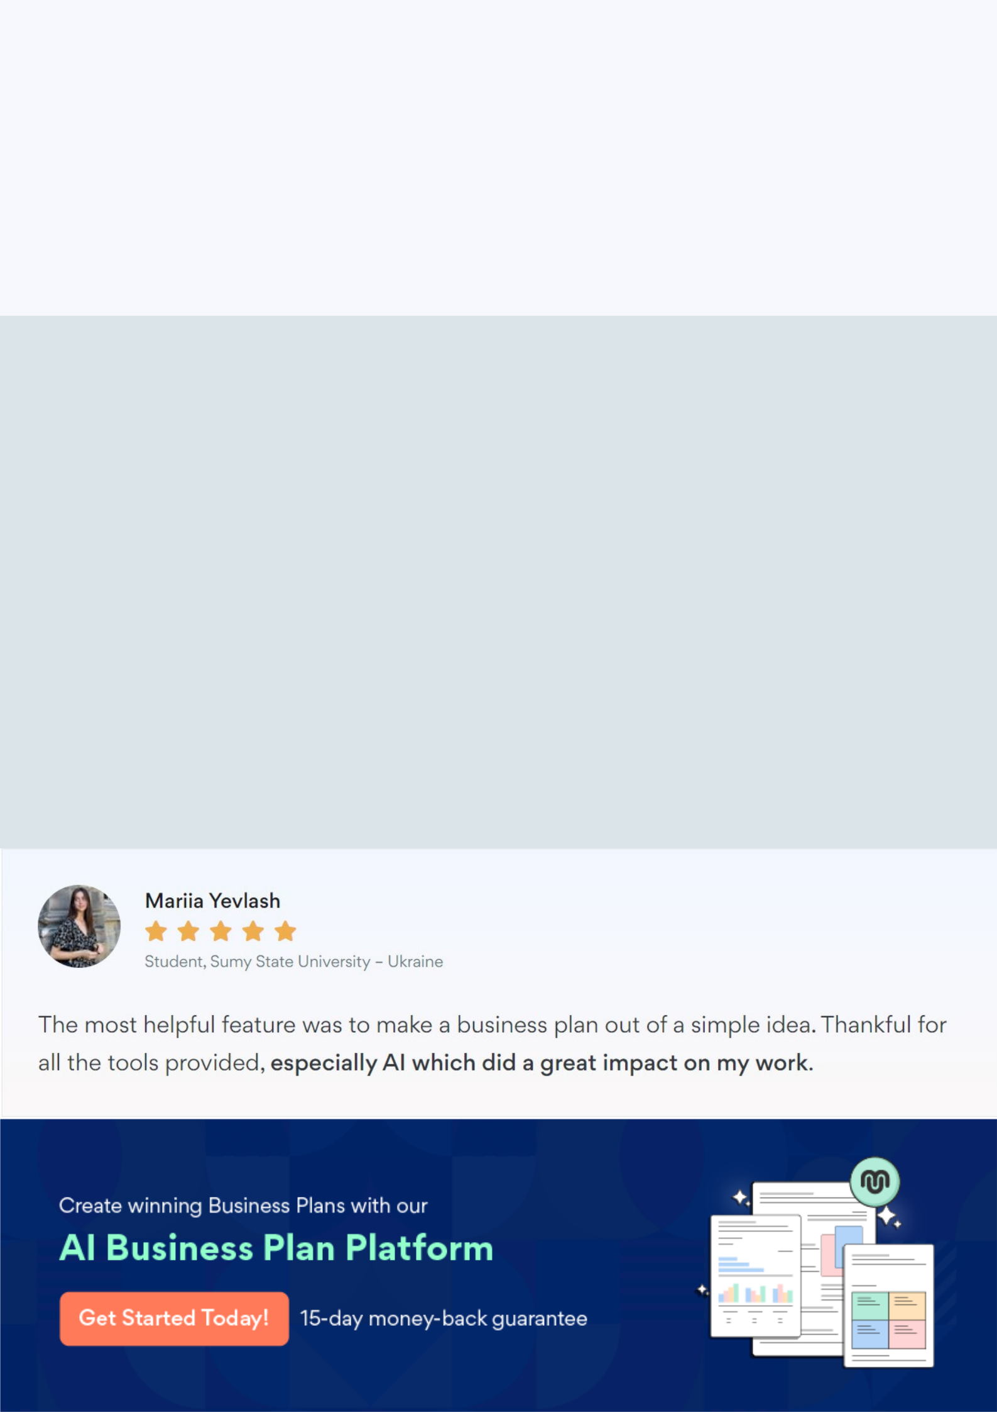
Create a winning business plan that gets you funded

Creating a stunning and investment-ready plan requires no writing, graphic designing, or financial planning expertise.

Upmetrics has all the features required to help you create a comprehensive business plan—from start to finish. Make no mistakes, it’s the modern way of planning to structure ideas, make plans, and create stunning pitch decks to awe investors.

Pitch decks that impress investors

Create pitch decks that provide a visual representation of your business, engage investors, and make them want to invest in your business idea.

Interactive plans in no time

Import business plan sections like—SWOT analysis, comparison tables, and others to create an interactive business plan. No designing skills are required.

Stunning cover page designs

With Upmetrics, you have the liberty to choose from multiple stunning cover page designs. Choose a creative design and make your plan stand out.

Online sharing made simple

Upmetrics makes online sharing quick and easier for users. Easily share your business plans with a link while tracking reader activity.

500+ sample business plans

Simply import a template from our library of sample plans into the editor and start customizing it to make it yours. It takes only a few clicks to get started.

Collaborate with team in real-time

Invite team members, initiate conversations, discuss ideas & strategies, share feedback, and work on a business plan in real-time.

