 Co-Working Space


Business Plan

[YEAR]


Providing building clocks for success

Information provided in this business plan is unique to this business and confidential; therefore, anyone reading this plan agrees not to disclose any of the information in this business plan without prior written permission of the Company

Prepared By

John Doe

10200 Bolsa Ave, Westminster, CA, 92683

info@example.com

(650) 359-3153 https://example.com

Table of Contents

Executive Summary | 5
Company Overview | 6
Partners/Management Team | 6
Service Strategy | 6
Marketing Plan | 7
Financial Plan | 7

Industry Analysis | 8
Industry Drivers | 9
Sharing and Collaboration | 9
Working from Home | 9
Cloud Computing | 9
Having an affordable, professional place to work and meet | 10
Collaborate with community at space | 10
Success Factors and Metrics | 10
Number of members in a co-working space | 10
Age of space (maturity of community) | 11
Other sources of income | 11
Porter’s Five Forces Analysis | 11
Bargaining Power of Suppliers | 11
Bargaining Power of Buyers | 12
Threat of New Entrants | 12
Availability of Substitutes | 12
Rivalry among Competitors | 12

Company Description | 13
Our Mission | 14
Our Vision | 14
Management Team | 15

Products & Services | 16
Co-working Space | 17

Co-Working Space | Business Plan [YEAR] 2/38

Classes & Workshops | 17
Consulting Services | 17
Other Services | 18

Market Analysis | 19
Market Size | 20
Market Segments | 20
Our Competitors | 20
5 Year Sales Goals | 21
5 Year Sales Goals Projections | 21

Marketing Strategy | 22
Promotional Strategy | 23
Pricing | 23
Operations Description
Operations Description | 24
Operations Plan | 25
Management Compensation and Ownership | 25
Staffing Description
Staffing Description | 26
Staffing, Employee Compensation and Work Schedule | 27
Financial Plan
Financial Plan | 28
Important Assumptions | 29
Brake-even Analysis | 29
Projected Profit and Loss | 29
Projected Cash Flow | 32
Projected Balance Sheet | 33
Business Ratios | 35

Co-Working Space | Business Plan [YEAR] 3/38

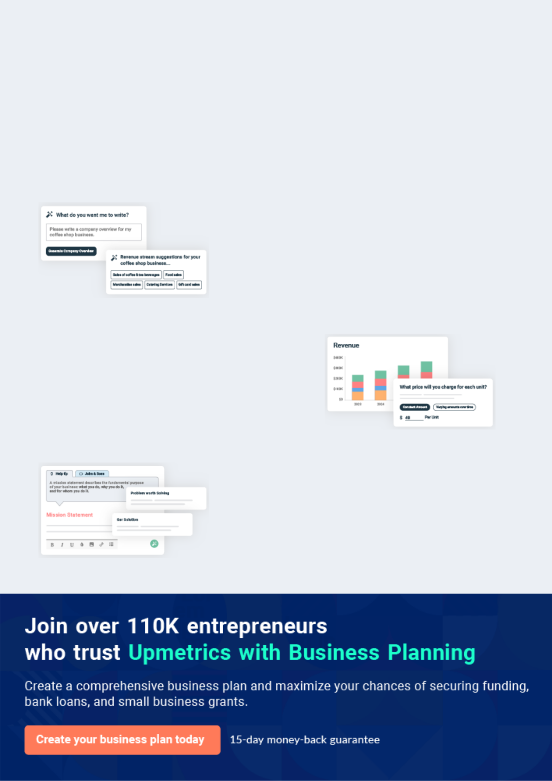
Business planning that’s simpler and faster than you think

Creating a business plan using Upmetrics to start and grow a business is literally the easiest thing in the World. Simply read the instructions and fill in the blanks. It’s as simple as that.

❛ | Upmetrics has everything you need to create a | ❜
❛ | comprehensive business plan. | ❜

AI-powered Upmetrics Assistant

AI-powered insights to streamline your plan

Not sure where to start? Upmetrics’ AI Assistant will automatically generate ideas for each section of your plan and offer improved versions of your writing, adjusting for tone, voice, and grammar or spelling errors.

Financial Forecasting Tool

All the financials are calculated for you

Forget the complex formulas and clumsy spreadsheets — with automatic financials and drag-and-drop forecasting, you can finish your plan faster and be confident that your numbers are accurate.

Business Plan Builder

Guides you like a business mentor

Upmetrics’ step-by-step instructions, prompts, and the library of 400+ sample business plans will guide you through each section of your plan as a business mentor.

1.


Executive Summary

Company Overview

Partners/Management Team

Service Strategy

Marketing Plan

Financial Plan

Co-Working Space | Business Plan [YEAR] 5/38

Company Overview

 Ex :: YoWorks


YoWorks is a revolutionary business idea that will provide freelancers and entrepreneurs in the Batangas region an affordable, creative, and collaborative co-working space - that is a shared working environment where these individuals can work on individual projects yet collaborate
To unlock help try Upmetrics! 

Start writing here..

Partners/Management Team

 Ex :: YoWorks

Our management team is composed of individuals with relevant skills ensuring a holistic management structure. Ronald Gonzales, the Chief Executive Officer (CEO), has years of
experience as a freelancer (in CAD and other engineering projects, strategic planning, finance,
To unlock help try Upmetrics! 

Start writing here..

Service Strategy

 Ex :: YoWorks

YoWorks’ main service will be composed of co-working spaces fit for knowledge workers/ freelancers and entrepreneurs. Offering various packages based on customers’ preferred frequency of visit and perks (Earth - Day Pass, Night sky - Night Pass, Solar -Week Pass, and
To unlock help try Upmetrics! 

Start writing here..

Co-Working Space | Business Plan [YEAR] 6/38

Marketing Plan

 Ex :: YoWorks

The Company has devised an innovative pricing strategy that allows customers to avail of the co-working spaces based on frequency (Pay Per Go/Day Pass, weeks’ worth of usage and month’s worth) and additional services/amenities (free-flowing coffee, scanning, printing,
To unlock help try Upmetrics! 

Start writing here..

Financial Plan

 Ex :: YoWorks

YoWorks will have an active role in providing excellent co-working spaces and other relevant services. In year one, partners will invest $2.5 million in cash to jump-start the operation. The equity capital will be used to complete the development of the Company’s space and initiate
To unlock help try Upmetrics! 

Start writing here..

Co-Working Space | Business Plan [YEAR] 7/38

2.

Industry Analysis

Industry Drivers

Success Factors and Metrics

Porter’s Five Forces Analysis

Co-Working Space | Business Plan [YEAR] 8/38

 Ex :: YoWorks

The co-working space industry can generally be defined as an established workspace designed for individuals and small groups to collectively work, do business, and collaborate in a shared community environment. The challenge of establishing a co-working space is not primarily in
To unlock help try Upmetrics! 

Start writing here..

Industry Drivers

 Ex :: YoWorks

Working with others in a collaborative environment encourages professional networking and business development. In the co-working pyramid of needs (see Appendix 2), it emphasizes that office amenities such as Wi-Fi, desks, and meeting rooms are essentially the basics and
To unlock help try Upmetrics! 

Sharing and Collaboration

Start writing here..

 Ex :: YoWorks

There is an increasing number of professional individuals working from home offices or telecommuting. These could include individuals working for companies that do not have the physical space or have employees that need to travel long distances to get to work. It also
To unlock help try Upmetrics! 

Working from Home

Start writing here..

 Ex :: YoWorks

New technologies are improving the ability for work to be done remotely and through the Internet. Cloud computing is changing the face of the traditional office and the needs of the individual worker. Email and data no longer need to be hosted on traditional servers, making
To unlock help try Upmetrics! 

Cloud Computing

Start writing here..

Co-Working Space | Business Plan [YEAR] 9/38

 Ex :: YoWorks

Among the biggest challenges for a new freelance professional is finding a place to work and meet clients and colleagues. Many end up working at either a coffee shop or at home. Neither is professional or sufficient for the needs of a professional-looking environment. co-working is
To unlock help try Upmetrics! 

Having an affordable, professional place to work and meet

Start writing here..

 Ex :: YoWorks

Shared spaces are rented out through a variety of economic business models to individuals looking for a place to work. co-working attracts many individuals from a range of professions looking to take advantage of shared workspace and become a part of a professional
To unlock help try Upmetrics! 

Collaborate with community at space

Start writing here..

Success Factors and Metrics

 Ex :: YoWorks

Having space that is popular and community-driven may still not be enough to make the business a success, and sustainable revenue and positive cash flow are still crucial. According to the Global co-working Survey, the three main factors that help a co-working space succeed
To unlock help try Upmetrics! 

Start writing here..

 Ex :: YoWorks

While there are no rules that dictate the size necessary for a co-working space to succeed, more members mean higher levels of revenue that can be used to cover fixed costs such as rent, employee wages, and other on-going expenses. While simply increasing the number of
To unlock help try Upmetrics! 

Number of members in a co-working space

Start writing here..

Co-Working Space | Business Plan [YEAR] 10/38

 Ex :: YoWorks

Naturally, as space grows, the community of members evolves and matures. This will take some time as the members will help define the space. The longer space is operating, the more time the community can develop naturally. Research has shown that spaces struggle in the first
To unlock help try Upmetrics! 

Age of space (maturity of community)

Start writing here..

 Ex :: YoWorks

Looking at co-working spaces around the world has shown that the majority of owner-operators have other sources of income. Owners tend to be freelancers themselves and be an expert in a certain area. Many spaces are not established with the goal of lucrative profits, but rather to
To unlock help try Upmetrics! 

Other sources of income

Start writing here..

Porter’s Five Forces Analysis


Michael Porter’s five forces analysis is helpful to determine the relationship among competitive forces in a particular marketplace. co-working is a new
industry that is developing and evolving. The boundaries in which customers,
To unlock help try Upmetrics! 

 Ex :: YoWorks

The co-working industry is not reliant on raw materials or commodities instead its continuous operation relies on utility services such as reliable electricity and high-speed internet. Switching from one supplier to another may not be possible (electricity provider is monopolized) or not
To unlock help try Upmetrics! 

Bargaining Power of Suppliers

Start writing here..

Co-Working Space | Business Plan [YEAR] 11/38

 Ex :: YoWorks

Although buyers are critical because they help define the community and space, their relative bargaining power in this industry is limited. Because co-working is a new, young industry, there are more potential coworkers in the form of freelancers and small business entrepreneurs than
To unlock help try Upmetrics! 

Bargaining Power of Buyers

Start writing here..

 Ex :: YoWorks

For new entrants entering a co-working space, the barriers to entry are moderate to high. While it is not difficult to renovate a space and equip it with shared workstations and office equipment, it still requires working capital investment, time to plan the business, and efforts to
To unlock help try Upmetrics! 

Threat of New Entrants

Start writing here..

 Ex :: YoWorks

Competition from other places to work certainly exists, but the services and features of the business concept make it difficult to make a direct comparison. A co-working space, while
costing more than working from home, offers features and benefits that cannot exist at a home
To unlock help try Upmetrics! 

Availability of Substitutes

Start writing here..

 Ex :: YoWorks

Competition between spaces is difficult to gauge given the newness of the industry. Research from the 2nd Global co-working Survey in 2012 has indicated that multiple co-working spaces in a city have a net positive effect on profitability versus a co-working space with no direct
To unlock help try Upmetrics! 

Rivalry among Competitors

Start writing here..

Co-Working Space | Business Plan [YEAR] 12/38

3.

Company Description

Our Mission

Our Vision

Management Team

Co-Working Space | Business Plan [YEAR] 13/38

 Ex :: YoWorks
To unlock help try Upmetrics!
To unlock help try Upmetrics!

YoWorks is a shared workspaces facility, a premium office, and a collaborative environment for freelancers and entrepreneurs. The design and operations of the functions of the space as convener which bonds people together. The design and layout consider the specific needs of
To unlock help try Upmetrics! 

Start writing here..

Our Mission

 Ex :: YoWorks

Provide a professional working environment where stakeholders can comfortably explore their creativity, passion, and success anchored to the values of connectivity, collaboration, and productive co-working.



Start writing here..

Our Vision

 Ex :: YoWorks

Become the undisputed leader in the co-working space business in the region by revolutionizing the office experience through developing a growing community of co-working individuals happily working together.



Start writing here..

Co-Working Space | Business Plan [YEAR] 14/38

Management Team

 Ex :: YoWorks

The company shall be formed through a partnership type of business.

The partners/management team consists of Celine Francisco, Mariko Manalo, Ronald
To unlock help try Upmetrics! 

Start writing here..
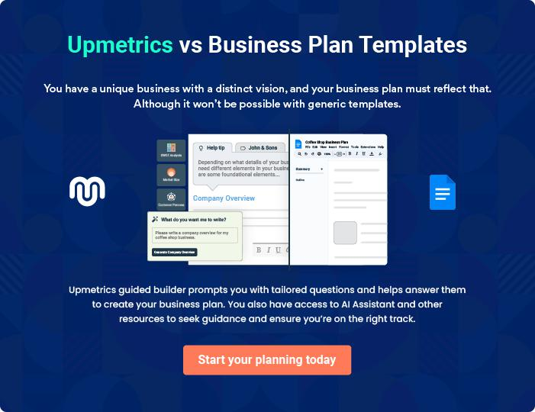

Co-Working Space | Business Plan [YEAR] 15/38

4.

Products & Services

Co-working Space

Classes & Workshops

Consulting Services

Other Services

Co-Working Space | Business Plan [YEAR] 16/38

Co-working Space
To unlock help try Upmetrics!

 Ex :: YoWorks

Providing co-working space serves as the core service of the company. Various packages shall be available for potential members each will suit their specific needs and will be flexible as they adapt to the stages of their growth. Members of our co-working space will get more than just a
To unlock help try Upmetrics! 

Start writing here..

Classes & Workshops

 Ex :: YoWorks

Our talented team will offer a variety of classes and workshops on various technical and management skills development (presentation skills, negotiation skills, problem-solving
analysis, project management, data visualization, service plus, product design and development
To unlock help try Upmetrics! 

Start writing here..

Consulting Services

 Ex :: YoWorks

For businesses that want more hands-on assistance, we will provide consulting services and employee training. Services shall include brainstorming facilitation, branding, innovative marketing, workflow analysis, etc.



Start writing here..

Co-Working Space | Business Plan [YEAR] 17/38

Other Services

 Ex :: YoWorks

We shall offer add-on services such as virtual office and business start-up assistance for members
To unlock help try Upmetrics! 

Start writing here..

Co-Working Space | Business Plan [YEAR] 18/38

5.

Market Analysis

Market Size

Market Segments

Our Competitors

Co-Working Space | Business Plan [YEAR] 19/38

Market Size
To unlock help try Upmetrics!

 Ex :: YoWorks

In the Philippines, as of this writing, over one (1) million are doing freelance work. Meanwhile,

11 million are self-employed (according to the Philippine Commission on Women in 2010). By
tallying the estimated number of freelancers, self-employed, and small business owners in
To unlock help try Upmetrics! 

Start writing here..

Market Segments

 Ex :: YoWorks

There are three market segments identified by YoWorks:

1. freelancers/knowledge workers with the age range of 18 to 66 residing in Batangas (60%
To unlock help try Upmetrics! 

Start writing here..

Our Competitors

 Ex :: YoWorks

YoWorks does not have a direct competitor yet since there are no coworking spaces yet in the Batangas/Lipa area. However, substitutes include cafes, home offices, and offices for commuters living in the Batangas area.



Start writing here..

Co-Working Space | Business Plan [YEAR] 20/38

 Ex :: YoWorks

Based on the maximum seating capacity (122) and assumptions that there will be 40% and 50% capacities on Year 1 and 2, and steady growth on Years 3 to 5, the following sales projections have been calculated. First-year occupants will be composed of the following: 45% day pass,
To unlock help try Upmetrics! 

5 Year Sales Goals

Start writing here..

5 Year Sales Goals Projections
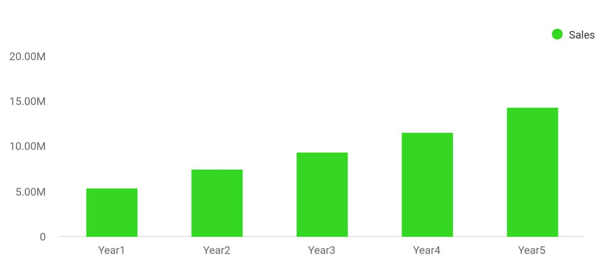

Financial Year | Sales
Year1 | 5,407,058
Year2 | 7,506,781
Year3 | 9,316,095
Year4 | 11,544,080
Year5 | 14,296,696

Co-Working Space | Business Plan [YEAR] 21/38

6.

Marketing Strategy

Promotional Strategy

Pricing

Co-Working Space | Business Plan [YEAR] 22/38

Promotional Strategy

 Ex :: YoWorks

YoWorks will utilize relationship and content marketing strategies and tactics to reach the mentioned target markets to achieve $ 5.4million gross sales by the end of the first year in
business. The first-year budget for marketing including the early promotional strategy cost will
To unlock help try Upmetrics! 

Start writing here..

Pricing

 Ex :: YoWorks

We apply cost-based pricing and competitive-based pricing methods to set prices for our services. Our one-off costs and reoccurring costs are both considerable, thus we cannot ignore the costs when setting our prices. Otherwise, for the “co-working space” service, we will also
To unlock help try Upmetrics! 

Start writing here..

Co-Working Space | Business Plan [YEAR] 23/38

7.

Operations Description

Operations Plan

Management Compensation and Ownership

Co-Working Space | Business Plan [YEAR] 24/38

Operations Plan
To unlock help try Upmetrics!

 Ex :: YoWorks

YoWorks will be accessible 16 hours a day, 7 days a week to its members. Drop-in will be open from 9 am to 5 pm. Each member will be issued a security pass card. Members can avail of the various amenities inclusive of each package we offer. The technology used at YoWorks will be
To unlock help try Upmetrics! 

Start writing here..

Management Compensation and Ownership

 Ex :: YoWorks

Ownership of the business will be engaged through a profit-sharing basis so no regular salaries will be paid. Partners will have an ownership portion of the venture that is equivalent to the equity investment contributed.



Start writing here..

Co-Working Space | Business Plan [YEAR] 25/38

8.

Staffing Description

Staffing, Employee Compensation and Work Schedule

Co-Working Space | Business Plan [YEAR] 26/38

Staffing, Employee Compensation and Work Schedule

 Ex :: YoWorks

YoWorks shall hire staff that will help the management team manage and run the business in its daily operations. Positions, key functions/responsibilities, and basic qualifications are described in Appendix 7. The management team considers its employees as important
To unlock help try Upmetrics! 

Start writing here..

Co-Working Space | Business Plan [YEAR] 27/38

9.

Financial Plan

Important Assumptions

Brake-even Analysis

Projected Profit and Loss

Projected Cash Flow

Projected Balance Sheet

Business Ratios

Co-Working Space | Business Plan [YEAR] 28/38

If you are going to start your own cybersecurity business, then make sure you will pay special attention to your financial plan. Your financial plan should include the details about how well you manage your incomes and expenses,
To unlock help try Upmetrics! 

Important Assumptions

 | Year 1 | Year 2 | Year 3
Plan Month | 1 | 2 | 3
Current Interest Rate | 10,00% | 11,00% | 12,00%
Long-term Interest Rate | 10,00% | 10,00% | 10,00%
Tax Rate | 26,42% | 27,76% | 28,12%
Other | 0 | 0 | 0

Brake-even Analysis

Monthly Units Break-even | 5530
Monthly Revenue Break-even | $159 740
Assumptions:
Average Per-Unit Revenue | $260,87
Average Per-Unit Variable Cost | $0,89
Estimated Monthly Fixed Cost | $196 410

Projected Profit and Loss

 | 2024 | 2025 | 2026
Revenue | $807,802.39 | $1,184,850.96 | $1,797,043.05
Workspace Rentals | $601,015 | $962,190 | $1,540,430
Unit Sales | 1,202 | 1,924 | 3,081
Unit Price | $500 | $500 | $500
Meeting Room Bookings | $180,000 | $180,000 | $180,000

Co-Working Space | Business Plan [YEAR] 29/38

 | 2024 | 2025 | 2026
Total Hours | 6,000 | 6,000 | 6,000
Hourly Price | $30 | $30 | $30
Additional Services | $26,787.39 | $42,660.96 | $76,613.05

Cost Of Sales | $89,926.01 | $104,384.61 | $123,463.24
General Costs | $89,926.01 | $104,384.61 | $123,463.24
Facility Maintenance and | $45,847.98 | $55,456.09 | $67,300.41
Operations | $45,847.98 | $55,456.09 | $67,300.41
Utilities | $26,824.26 | $34,019.75 | $43,145.35
Facility Upkeep | $19,023.72 | $21,436.34 | $24,155.06
Workspace Resources | $44,078.03 | $48,928.52 | $56,162.83
Office Supplies | $8,078.03 | $11,848.52 | $17,970.43
Technology and Equipment | $36,000 | $37,080 | $38,192.40
Revenue Specific Costs | $0 | $0 | $0
Personnel Costs (Direct | $0 | $0 | $0
Labor) | $0 | $0 | $0

Gross Margin | $717,876.38 | $1,080,466.35 | $1,673,579.81
Gross Margin (%) | 88.87% | 91.19% | 93.13%

Operating Expense | $819,444 | $840,784.68 | $862,585.80
Payroll Expense (Indirect | $632,844 | $649,627.08 | $666,869.76
Labor) | $632,844 | $649,627.08 | $666,869.76
Management Team | $187,500 | $193,125 | $198,918.72
General Manager | $97,500 | $100,425 | $103,437.72
Finance Manager | $90,000 | $92,700 | $95,481
Operations Staff | $220,224 | $224,628.48 | $229,121.04

Co-Working Space | Business Plan [YEAR] 30/38

 | 2024 | 2025 | 2026
Facility Maintenance | $129,600 | $132,192 | $134,835.84
Receptionists | $90,624 | $92,436.48 | $94,285.20
Marketing and Sales Team | $225,120 | $231,873.60 | $238,830
Marketing Specialists | $117,120 | $120,633.60 | $124,252.56
Sales Representatives | $108,000 | $111,240 | $114,577.44
General Expense | $186,600 | $191,157.60 | $195,716.04
Facility Costs | $144,600 | $147,861.60 | $151,073.40
Rent | $120,000 | $122,400 | $124,848
Utilities | $24,600 | $25,461.60 | $26,225.40
Operational Expenses | $18,000 | $18,240 | $18,483.60
Office Supplies | $6,000 | $6,120 | $6,242.40
Cleaning Services | $12,000 | $12,120 | $12,241.20
Marketing and Promotion | $24,000 | $25,056 | $26,159.04
Digital Marketing | $9,600 | $10,080 | $10,584
Event Hosting | $14,400 | $14,976 | $15,575.04
Bad Debt | $0 | $0 | $0
Amortization of Current | $0 | $0 | $0
Assets | $0 | $0 | $0

EBITDA

Additional Expense

Long Term Depreciation

Gain or loss from Sale of Assets

EBIT

($101,567.62) $239,681.67 $810,994.01

$16,000.86 | $12,758.77 | $9,350.81
$7,440 | $7,440 | $7,440
$0 | $0 | $0
($109,007.62) | $232,241.67 | $803,554.01

Co-Working Space | Business Plan [YEAR] 31/38

 | 2024 | 2025 | 2026
Interest Expense | $8,560.87 | $5,318.78 | $1,910.81
EBT | ($117,568.48) | $226,922.90 | $801,643.20
Income Tax Expense / | $0 | $0 | $0
Benefit | $0 | $0 | $0
Total Expense | $925,370.87 | $957,928.06 | $995,399.85
Net Income | ($117,568.48) | $226,922.90 | $801,643.20
Net Income (%) | (14.55%) | 19.15% | 44.61%
Retained Earning Opening | $0 | ($137,568.48) | $79,354.42
Owner's Distribution | $20,000 | $10,000 | $10,000
Retained Earning Closing | ($137,568.48) | $79,354.42 | $870,997.62
Projected Cash Flow
 | 2024 | 2025 | 2026
Cash Received | $807,802.39 | $1,184,850.96 | $1,797,043.05
Cash Paid | $917,930.87 | $950,488.06 | $987,959.85
COS & General Expenses | $276,526.01 | $295,542.21 | $319,179.28
Salary & Wages | $632,844 | $649,627.08 | $666,869.76
Interest | $8,560.87 | $5,318.78 | $1,910.81
Sales Tax | $0 | $0 | $0
Income Tax | $0 | $0 | $0
Net Cash From | ($110,128.48) | $234,362.90 | $809,083.20
Operations | ($110,128.48) | $234,362.90 | $809,083.20
Assets Sell | $0 | $0 | $0

Co-Working Space | Business Plan [YEAR] 32/38

2024 2025 2026

Assets Purchase

Net Cash From

Investments

Amount Received

Loan Received

Common Stock

Preferred Stock

Owner's Contribution

Amount Paid

Loan Capital

Dividends & Distributions

Net Cash From

Financing

Summary

$35,000 | $0 | $0
($35,000) | $0 | $0

$350,000 | $0 | $0
$200,000 | $0 | $0
$0 | $0 | $0
$0 | $0 | $0
$150,000 | $0 | $0
$83,369.30 | $76,611.39 | $80,019.33
$63,369.29 | $66,611.38 | $70,019.33
$20,000 | $10,000 | $10,000
$266,630.70 | ($76,611.39) | ($80,019.33)

Starting Cash | $0 | $121,502.22 | $279,253.73
Cash In | $1,157,802.39 | $1,184,850.96 | $1,797,043.05
Cash Out | $1,036,300.17 | $1,027,099.45 | $1,067,979.18
Change in Cash | $121,502.22 | $157,751.51 | $729,063.87
Ending Cash | $121,502.22 | $279,253.73 | $1,008,317.60

Projected Balance Sheet

 | 2024 | 2025 | 2026
Assets | $149,062.22 | $299,373.73 | $1,020,997.60
Current Assets | $121,502.22 | $279,253.73 | $1,008,317.60

Co-Working Space | Business Plan [YEAR] 33/38

 | 2024 | 2025 | 2026
Cash | $121,502.22 | $279,253.73 | $1,008,317.60
Accounts Receivable | $0 | $0 | $0
Inventory | $0 | $0 | $0
Other Current Assets | $0 | $0 | $0
Long Term Assets | $27,560 | $20,120 | $12,680
Gross Long Term Assets | $35,000 | $35,000 | $35,000
Accumulated Depreciation | ($7,440) | ($14,880) | ($22,320)

Liabilities & Equity | $149,062.23 | $299,373.75 | $1,020,997.62
Liabilities | $136,630.71 | $70,019.33 | $0
Current Liabilities | $66,611.38 | $70,019.33 | $0
Accounts Payable | $0 | $0 | $0
Income Tax Payable | $0 | $0 | $0
Sales Tax Payable | $0 | $0 | $0
Short Term Debt | $66,611.38 | $70,019.33 | $0
Long Term Liabilities | $70,019.33 | $0 | $0
Long Term Debt | $70,019.33 | $0 | $0
Equity | $12,431.52 | $229,354.42 | $1,020,997.62
Paid-in Capital | $0 | $0 | $0
Common Stock | $0 | $0 | $0
Preferred Stock | $0 | $0 | $0
Owner's Contribution | $150,000 | $150,000 | $150,000
Retained Earnings | ($137,568.48) | $79,354.42 | $870,997.62

Check | $0 | $0 | $0

Co-Working Space | Business Plan [YEAR] 34/38

Business Ratios

 | Year 1 | Year 2 | Year 3 | Industry Profile
Sales Growth | 4,35% | 30,82% | 63,29% | 4,00%
Percent of Total Assets
Accounts Receivable | 5,61% | 4,71% | 3,81% | 9,70%
Inventory | 1,85% | 1,82% | 1,79% | 9,80%
Other Current Assets | 1,75% | 2,02% | 2,29% | 27,40%
Total Current Assets | 138,53% | 150,99% | 163,45% | 54,60%
Long-term Assets | -9,47% | -21,01% | -32,55% | 58,40%
TOTAL ASSETS | 100,00% | 100,00% | 100,00% | 100,00%
Current Liabilities | 4,68% | 3,04% | 2,76% | 27,30%
Long-term Liabilities | 0,00% | 0,00% | 0,00% | 25,80%
Total Liabilities | 4,68% | 3,04% | 2,76% | 54,10%
NET WORTH | 99,32% | 101,04% | 102,76% | 44,90%
Percent of Sales
Sales | 100,00% | 100,00% | 100,00% | 100,00%
Gross Margin | 94,18% | 93,85% | 93,52% | 0,00%
Selling, General & Administrative Expenses | 74,29% | 71,83% | 69,37% | 65,20%
Advertising Expenses | 2,06% | 1,11% | 0,28% | 1,40%
Profit Before Interest and Taxes | 26,47% | 29,30% | 32,13% | 2,86%
Main Ratios
Current | 25,86 | 29,39 | 32,92 | 1,63
Quick | 25,4 | 28,88 | 32,36 | 0,84
Total Debt to Total Assets | 2,68% | 1,04% | 0,76% | 67,10%
Pre-tax Return on Net Worth | 66,83% | 71,26% | 75,69% | 4,40%
Pre-tax Return on Assets | 64,88% | 69,75% | 74,62% | 9,00%
Additional Ratios
Net Profit Margin | 19,20% | 21,16% | 23,12% | N.A.

Co-Working Space | Business Plan [YEAR] 35/38

 | Year 1 | Year 2 | Year 3 | Industry Profile
Return on Equity | 47,79% | 50,53% | 53,27% | N.A.
Activity Ratios
Accounts Receivable Turnover | 4,56 | 4,56 | 4,56 | N.A.
Collection Days | 92 | 99 | 106 | N.A.
Inventory Turnover | 19,7 | 22,55 | 25,4 | N.A.
Accounts Payable Turnover | 14,17 | 14,67 | 15,17 | N.A.
Payment Days | 27 | 27 | 27 | N.A.
Total Asset Turnover | 1,84 | 1,55 | 1,26 | N.A.
Debt Ratios
Debt to Net Worth | 0 | -0,02 | -0,04 | N.A.
Current Liab. to Liab. | 1 | 1 | 1 | N.A.
Liquidity Ratios
Net Working Capital | $120 943 | $140 664 | $160 385 | N.A.
Interest Coverage | 0 | 0 | 0 | N.A.
Additional Ratios
Assets to Sales | 0,45 | 0,48 | 0,51 | N.A.
Current Debt/Total Assets | 4% | 3% | 2% | N.A.
Acid Test | 23,66 | 27,01 | 30,36 | N.A.
Sales/Net Worth | 1,68 | 1,29 | 0,9 | N.A.
Dividend Payout | 0 | 0 | 0 | N.A.

Co-Working Space | Business Plan [YEAR] 36/38

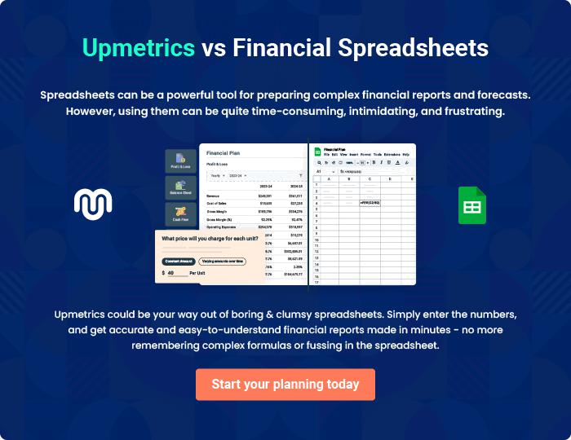

Co-Working Space | Business Plan [YEAR] | 37/38

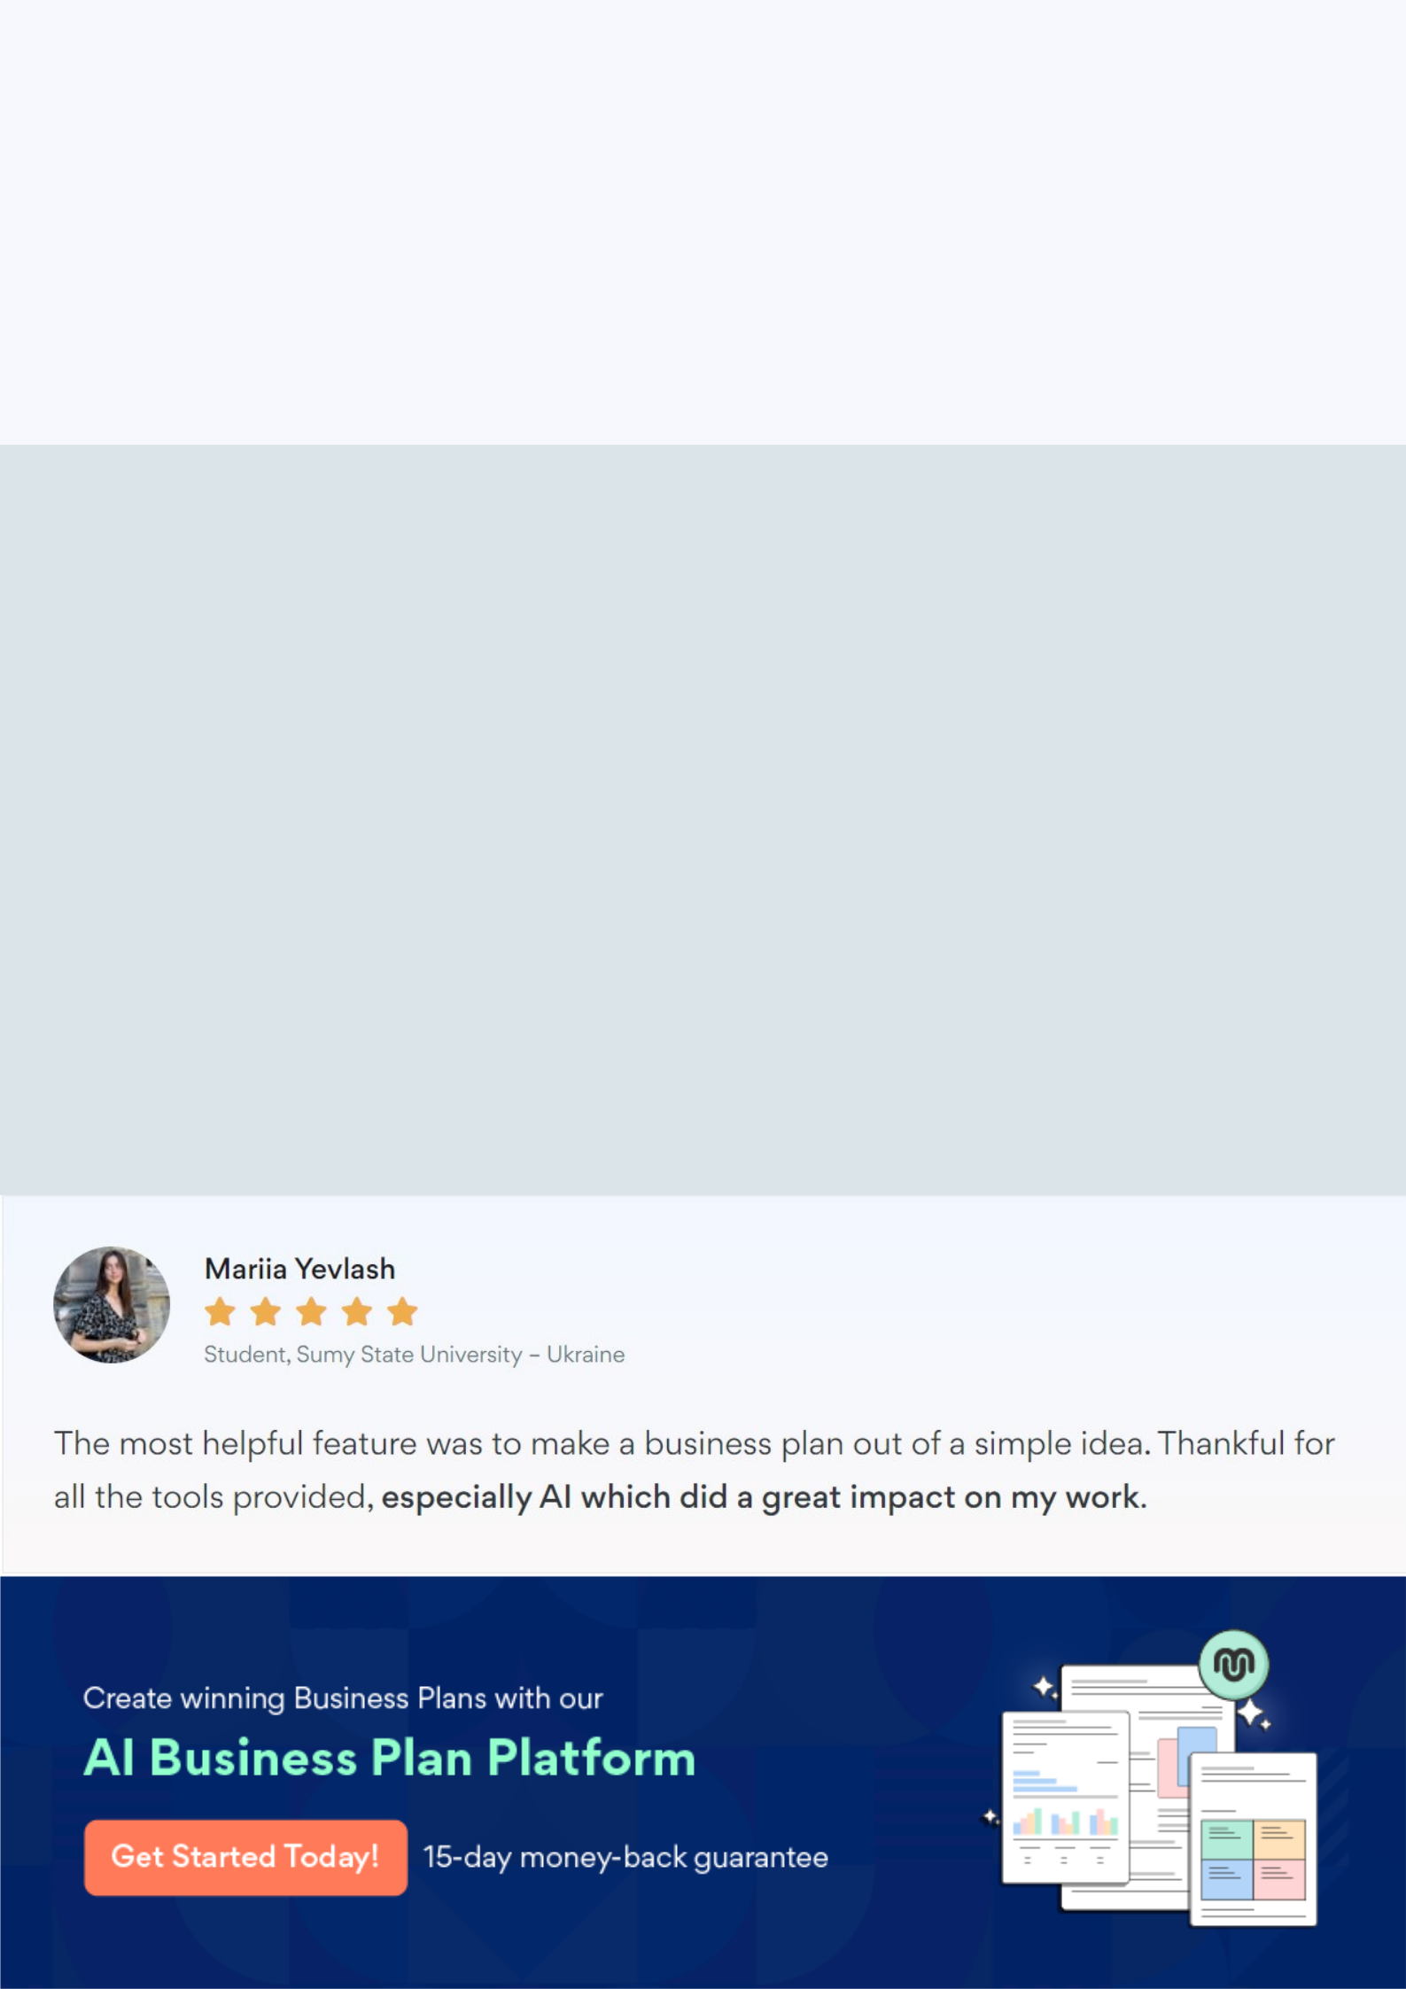
Create a winning business plan that gets you funded

Creating a stunning and investment-ready plan requires no writing, graphic designing, or financial planning expertise.

Upmetrics has all the features required to help you create a comprehensive business plan—from start to finish. Make no mistakes, it’s the modern way of planning to structure ideas, make plans, and create stunning pitch decks to awe investors.

Pitch decks that impress investors

Create pitch decks that provide a visual representation of your business, engage investors, and make them want to invest in your business idea.

Interactive plans in no time

Import business plan sections like—SWOT analysis, comparison tables, and others to create an interactive business plan. No designing skills are required.

Stunning cover page designs

With Upmetrics, you have the liberty to choose from multiple stunning cover page designs. Choose a creative design and make your plan stand out.

Online sharing made simple

Upmetrics makes online sharing quick and easier for users. Easily share your business plans with a link while tracking reader activity.

500+ sample business plans

Simply import a template from our library of sample plans into the editor and start customizing it to make it yours. It takes only a few clicks to get started.

Collaborate with team in real-time

Invite team members, initiate conversations, discuss ideas & strategies, share feedback, and work on a business plan in real-time.

