
BUSINESS PLAN

[YEAR]
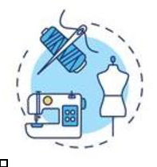

Clothing Manufacturer

Quality never goes out of style.

John Doe

10200 Bolsa Ave, Westminster, CA, 92683

- 359-3153 info@example.com http://www.example.com

Information provided in this business plan is unique to this business and confidential; therefore, anyone reading this plan agrees not to disclose any of the information in this business plan without prior written permission of the company.
Table of Contents

Executive Summary | 5
Mission Statement | 6
Vision Statement | 6
Keys To Success | 7
Financial Summary | 7
3 Year profit forecast | 7
Financial needs | 8

Company Summary | 9
Past Performance | 10
Business Structure | 10
Startup summary | 11
Startup cost | 11
Products and services
Products and services | 14
Market Analysis
Market Analysis | 16
Market Trends | 17
Target Market | 17
SWOT Analysis
SWOT Analysis | 18
Strategy & Implementations
Strategy & Implementations | 20
Sales Plan | 21
Advertising Strategy | 21
Pricing Strategy | 21
Milestones & Metrics | 22
Financial Plan
Financial Plan | 23
Important Assumptions | 24

Clothing Manufacturer | Business Plan [YEAR] 2/33

Brake-even Analysis | 24
Projected Profit and Loss | 25
Projected Cash Flow | 28
Projected Balance Sheet | 29
Business Ratios | 30

Clothing Manufacturer | Business Plan [YEAR] 3/33

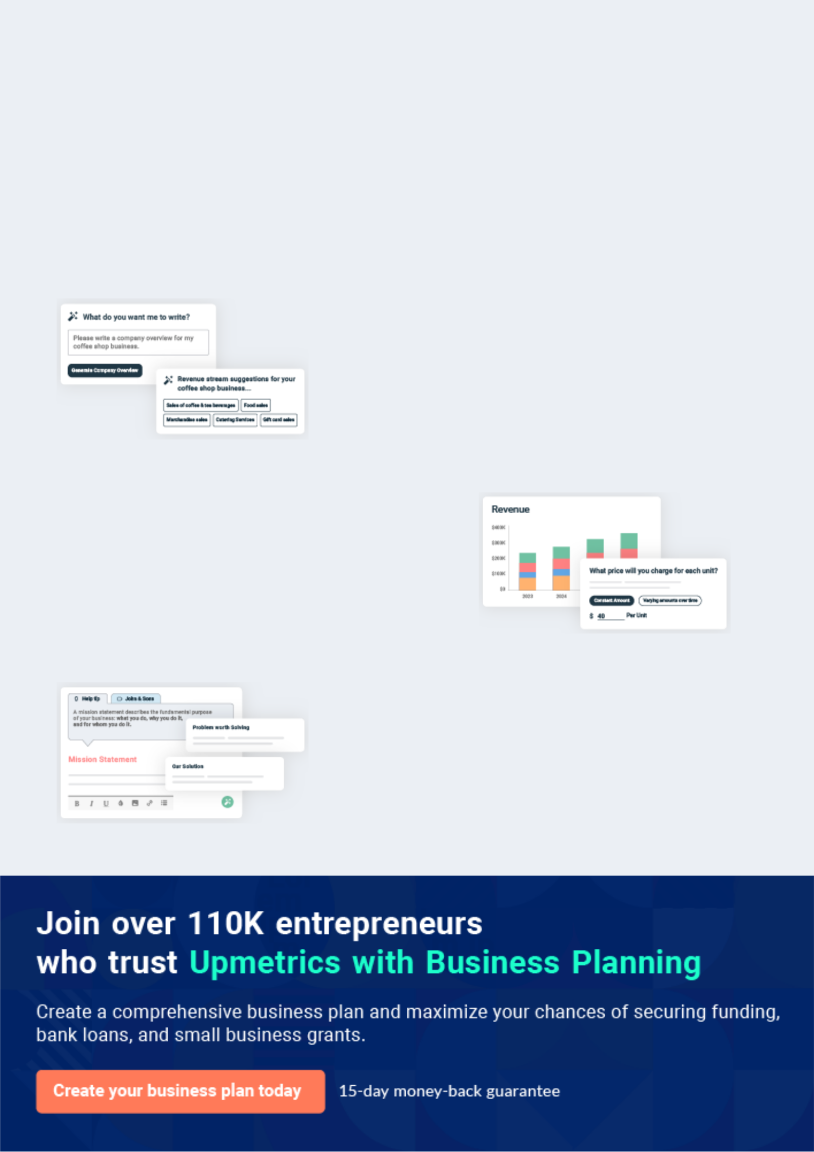
Business planning that’s simpler and faster than you think

Creating a business plan using Upmetrics to start and grow a business is literally the easiest thing in the World. Simply read the instructions and fill in the blanks. It’s as simple as that.

❛ | Upmetrics has everything you need to create a | ❜
❛ | comprehensive business plan. | ❜

AI-powered Upmetrics Assistant

AI-powered insights to streamline your plan

Not sure where to start? Upmetrics’ AI Assistant will automatically generate ideas for each section of your plan and offer improved versions of your writing, adjusting for tone, voice, and grammar or spelling errors.

Financial Forecasting Tool

All the financials are calculated for you

Forget the complex formulas and clumsy spreadsheets — with automatic financials and drag-and-drop forecasting, you can finish your plan faster and be confident that your numbers are accurate.

Business Plan Builder

Guides you like a business mentor

Upmetrics’ step-by-step instructions, prompts, and the library of 400+ sample business plans will guide you through each section of your plan as a business mentor.

1.


Executive Summary

Mission Statement

Vision Statement

Keys To Success

Financial Summary

Financial needs

Clothing Manufacturer | Business Plan [YEAR] 5/33


Before you think about how to start a Clothing Manufacturer business, you must create a detailed Clothing Manufacturer business plan. It will not only guide you in the initial phases of your startup but will also help you later on.
To unlock help try Upmetrics! 

 Maxwell Clothes


Maxwell Clothes, Inc. is an international clothes manufacturing company that will be located in Detroit - Michigan. We have been able to secure a large warehouse in a strategic part of town that will be converted to our clothing manufacturing factory. We were able to outrightly buy over
To unlock help try Upmetrics! 

Start writing here..

Mission Statement

 Maxwell Clothes

Our mission is to establish a cloth manufacturing company that will design and produce high-quality official and casual clothes for male, female, young adults, and children; a cloth manufacturing label that will compete favorably with international clothing labels like Ralph
To unlock help try Upmetrics! 

Start writing here..

Vision Statement

 Maxwell Clothes

Our vision is to establish a cloth manufacturing company whose products will not only be accepted in the United States of America but also in other parts of the world.
To unlock help try Upmetrics! 

Start writing here..

Clothing Manufacturer | Business Plan [YEAR] 6/33

Keys To Success

 Maxwell Clothes

It’s about fashion and style. We live or die with the look.

The distribution will be critical. Although we start online, to grow we need to get the resonance
To unlock help try Upmetrics! 

Start writing here..

Financial Summary

 Maxwell Clothes

The company’s goal is to expand from retail into online, with its own branding, to be sold by the end of the period in other retail stores as well as online.
To unlock help try Upmetrics! 

Start writing here..

3 Year profit forecast
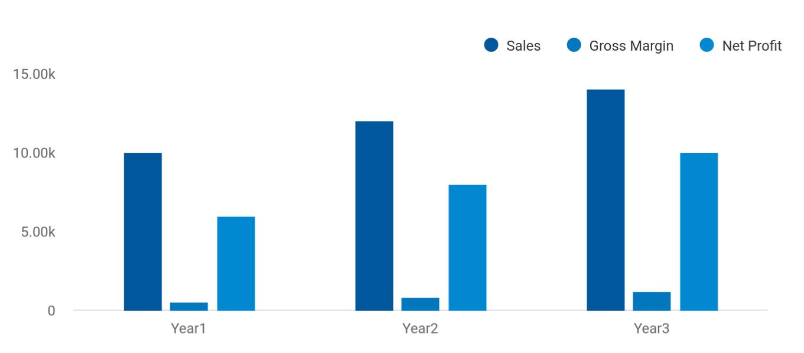

Clothing Manufacturer | Business Plan [YEAR] 7/33

 Maxwell Clothes
To unlock help try Upmetrics!


Financial Summary | Year 1 | Year 2 |  | Year 3
 |  |  | To unlock help try Upmetrics! |  | 

Start writing here..

Financial needs

 Maxwell Clothes

We are looking to expand our design line so our owner will put in $65,000. Further, we are looking for a $115,000 business loan. Both will be paid back by our second year with our already established customer base and relationships.



Start writing here..

Clothing Manufacturer | Business Plan [YEAR] 8/33

2.

Company Summary

Past Performance

Business Structure

Startup summary

Clothing Manufacturer | Business Plan [YEAR] 9/33

 Maxwell Clothes
To unlock help try Upmetrics!

Maxwell Clothes, Inc. is owned by John Moore and his immediate family members. He is an American fashion enthusiast with over two decades of experience in the fashion industry. He will occupy the position of the chief executive officer (CEO) of the organization.
To unlock help try Upmetrics! 

Start writing here..

Past Performance

 Maxwell Clothes

We brought our sales up to $3 million last year, with a 25% gross margin, but no profits. That gross margin was way below industry averages for good reasons as we ramped up, and we project an industry-standard gross of 50% for the future.



Start writing here..

Business Structure

 Maxwell Clothes

Maxwell Clothes, Inc. is a cloth manufacturing company that intends to start small in Detroit - Michigan but looks to grow big in order to compete favorably with leading clothes manufacturing companies both in the United States and on a global stage.
To unlock help try Upmetrics! 

Start writing here..

Clothing Manufacturer | Business Plan [YEAR] 10/33

Startup summary

Startup cost
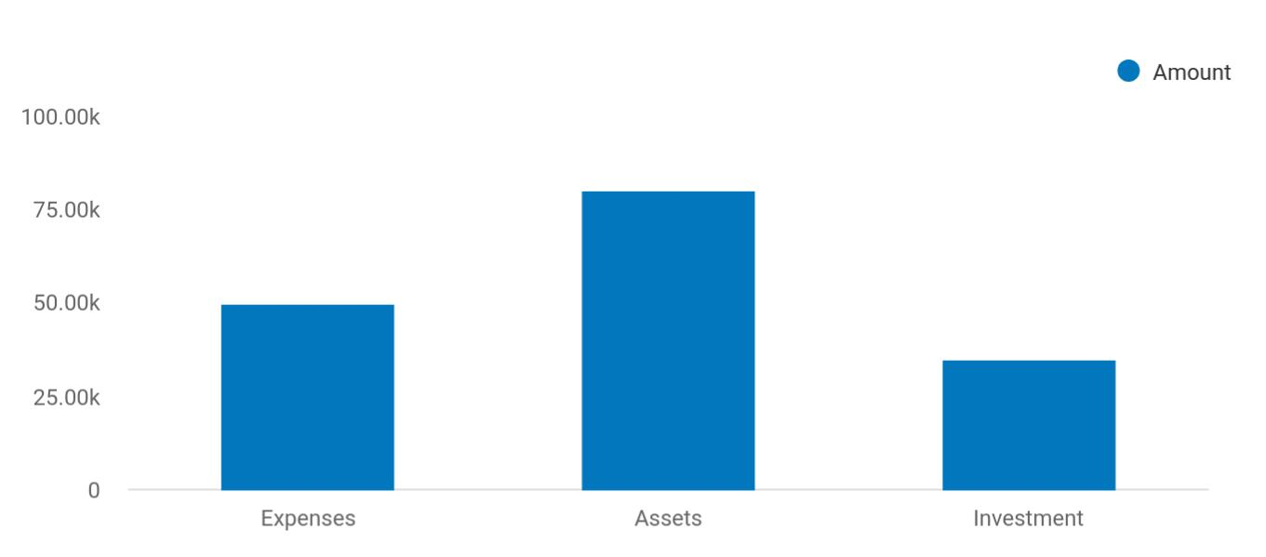

Cost distribution | Amount
Expenses | 50,000
Assets | 80,000
Investment | 35,000

Start-up Expenses | Amount
Legal | $75,500
Consultants | $0
Insurance | $62,750
Rent | $22,500
Research and Development | $42,750
Expensed Equipment | $42,750
Signs | $1,250
TOTAL START-UP EXPENSES | $247,500
Start-up Assets | $0
Cash Required | $322,500
Start-up Inventory | $52,625
Other Current Assets | $222,500

Clothing Manufacturer | Business Plan [YEAR] 11/33

Start-up Expenses | Amount
Long-term Assets | $125,000
TOTAL ASSETS | $121,875
Total Requirements | $245,000
START-UP FUNDING | $0
START-UP FUNDING | $273,125
Start-up Expenses to Fund | $121,875
Start-up Assets to Fund | $195,000
TOTAL FUNDING REQUIRED | $0
Assets | $203,125
Non-cash Assets from Start-up | $118,750
Cash Requirements from Start-up | $0
Additional Cash Raised | $118,750
Cash Balance on Starting Date | $121,875
TOTAL ASSETS | $0
Liabilities and Capital | $0
Liabilities | $0
Current Borrowing | $0
Long-term Liabilities | $0
Accounts Payable (Outstanding Bills) | $0
Other Current Liabilities (interest-free) | $0
TOTAL LIABILITIES | $0
Capital | $0
Planned Investment | $0
Investor 1 | $312,500
Investor 2 | $0
Other | $0
Additional Investment Requirement | $0
TOTAL PLANNED INVESTMENT | $695,000

Clothing Manufacturer | Business Plan [YEAR] 12/33

Start-up Expenses | Amount
Loss at Start-up (Start-up Expenses) | $313,125
TOTAL CAPITAL | $221,875
TOTAL CAPITAL AND LIABILITIES | $221,875
Total Funding | $265,000

Clothing Manufacturer | Business Plan [YEAR] 13/33

3.

Products and services

Clothing Manufacturer | Business Plan [YEAR] 14/33

 Maxwell Clothes

Maxwell Clothes, Inc. is established with the aim of producing high-quality and highly fashionable clothes for men, women, young adults, and children. We know that quality is a key factor that will help us sell our brand, which is why we hired a competent quality assurance
To unlock help try Upmetrics! 

Start writing here..
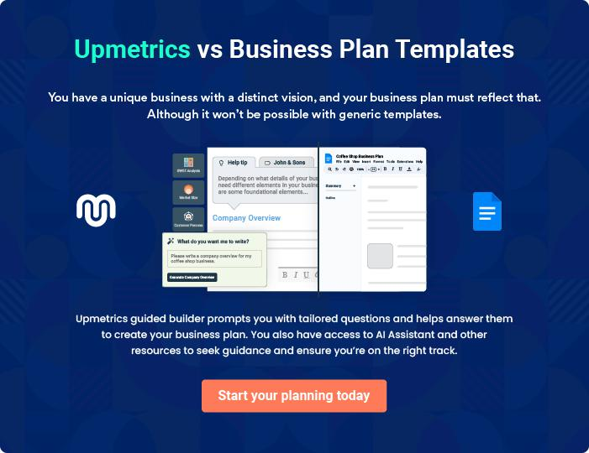

Clothing Manufacturer | Business Plan [YEAR] 15/33

4.

Market Analysis

Market Trends

Target Market

Clothing Manufacturer | Business Plan [YEAR] 16/33

The most important component of an effective Clothing Manufacturer's business plan is its accurate marketing analysis. If you are starting on a
smaller scale, you can do marketing analysis yourself by taking help from this
To unlock help try Upmetrics! 

Market Trends

 Maxwell Clothes

In recent times, the fashion industry relies more on mass-market sales for them to make the kind of income that will sustain the business. The mass market takes care of a wide range of customers that cuts across both the rich and the poor. Most of the new clothing lines that are
To unlock help try Upmetrics! 

Start writing here..

Target Market

 Maxwell Clothes

When it comes to selling clothes, there is indeed a wide range of available customers. In essence, our target market can’t be restricted to just a group of people, but all those who reside in the locations where we intend to open our clothes manufacturing company.
To unlock help try Upmetrics! 

Start writing here..

Clothing Manufacturer | Business Plan [YEAR] 17/33

5.

SWOT Analysis

Clothing Manufacturer | Business Plan [YEAR] 18/33

 Maxwell Clothes

Maxwell Clothes, Inc. intends to build a world-class clothes manufacturing business that will manufacture both corporate and casual clothes for men, women, young adults, and children.
We will be based in Detroit - Michigan, but we will not restrict the sale of our clothes to the U.S
To unlock help try Upmetrics! 

Start writing here..


Strength

Perhaps one of our strongest strengths could be attributed to the quality of employees and the latest machines and equipment that we have in our clothing manufacturing factory. Our chief executive officer, Mr. John Moore will be bringing his vast wealth of experience to the table.


Weakness

A major weakness that may count against us is the fact that we are a new clothes manufacturing company and we don’t have the financial capacity to compete with multibillion-dollar fashion labels when it comes to controlling the market or dictating the trend.


Opportunity

One thing is certain, whether good or bad, people will always look for clothes to wear and on the average, they go for casual clothes because it is cheap. Besides, the opportunity for clothing lines to sell their clothes is massive and we hope to leverage these opportunities to sell our clothes.

Threat

Just like any other business, one of the major threats that we are likely going to face is an economic downturn. It is a fact that the economic downturn affects purchasing power. Another threat that may likely confront us is the arrival of a new clothes manufacturing company in the same location where our target market exists who may want to adopt the same business model like us.

Clothing Manufacturer | Business Plan [YEAR] 19/33

6.

Strategy &

Implementations

Sales Plan

Advertising Strategy

Pricing Strategy

Milestones & Metrics

Clothing Manufacturer | Business Plan [YEAR] 20/33

After identifying the market demand, market trends, and the potential customers of the startup, the next step is to define an effective strategy for attracting those customers. Like marketing analysis, sales strategy is also an
To unlock help try Upmetrics!
To unlock help try Upmetrics! 

Sales Plan

 Maxwell Clothes

Maxwell Clothes intends to build a sales team that will be tasked with generating sales leads on a regional and national basis. They will also be responsible for establishing connections with retail outlets.



Start writing here..

Advertising Strategy

 Maxwell Clothes

Publicity and advertising as it relates to the fashion industry involve being in touch with the organization's target market and being very creative and proactive.
To unlock help try Upmetrics! 

Start writing here..

Pricing Strategy

 Maxwell Clothes

We at Maxwell Clothes, Inc. will make sure that we design and manufacture corporate and casual clothes that will meet the financial capacity of different classes of people in different parts of the world. The prices of all our corporate and casual clothes will be affordable and at
To unlock help try Upmetrics! 

Start writing here..

Clothing Manufacturer | Business Plan [YEAR] 21/33

Milestones & Metrics

 Maxwell Clothes


Milestone | Due Date | Who’s Responsible
 |  |  | To unlock help try Upmetrics! | 

Start writing here..

Clothing Manufacturer | Business Plan [YEAR] 22/33

7.

Financial Plan

Important Assumptions

Brake-even Analysis

Projected Profit and Loss

Projected Cash Flow

Projected Balance Sheet

Business Ratios

Clothing Manufacturer | Business Plan [YEAR] 23/33

The last component of the Clothing Manufacturer business plan is an in-depth financial plan. The financial plan crafts a detailed map of all the
expenses needed for the startup and how these expenses will be met by the
To unlock help try Upmetrics! 

 Maxwell Clothes

The company will be financed by John himself and he will control the direction of the business to make sure that it is expanding at the forecasted rate. As for the Clothing Manufacturer business start-up, no equity funding or outside loans will be required. With the help of financial
To unlock help try Upmetrics! 

Start writing here..

Important Assumptions

The financial projections of the company are forecast on the basis of the following assumptions. These assumptions are quite conservative and are expected to show deviation but to a limited level such that the company’s major financial strategy will not be affected.

 | Year 1 | Year 2 | Year 3
Plan Month | 1 | 2 | 3
Current Interest Rate | 10,00% | 11,00% | 12,00%
Long-term Interest Rate | 10,00% | 10,00% | 10,00%
Tax Rate | 26,42% | 27,76% | 28,12%
Other | 0 | 0 | 0

Brake-even Analysis

Monthly Units Break-even | 5530
Monthly Revenue Break-even | $159 740
Assumptions:
Average Per-Unit Revenue | $260,87
Average Per-Unit Variable Cost | $0,89
Estimated Monthly Fixed Cost | $196 410

Clothing Manufacturer | Business Plan [YEAR] 24/33

Projected Profit and Loss

Revenue

Retail Sales Revenue Stream

Unit Sales

Unit Price

Online Sales Revenue Stream

Unit Sales

Unit Price

Wholesale Revenue

Stream

Unit Sales

Unit Price

Cost Of Sales

General Costs

Raw Materials

Fabric Purchase

Buttons and Zippers

Production Costs

Labor Cost

Manufacturing Overheads

Revenue Specific Costs

Personnel Costs (Direct Labor)

2024 | 2025 | 2026
$1,367,132.15 | $2,586,481.35 | $4,995,002.45
$421,751.50 | $848,663.50 | $1,707,692
8,435 | 16,973 | 34,154
$50 | $50 | $50
$344,352.25 | $775,552.25 | $1,746,691.65
6,261 | 14,101 | 31,758
$55 | $55 | $55
$601,028.40 | $962,265.60 | $1,540,618.80
15,026 | 24,057 | 38,515
$40 | $40 | $40

$447,434.70 | $608,776.89 | $894,033.93
$447,434.70 | $608,776.89 | $894,033.93
$221,943.93 | $250,091.89 | $281,809.69
$190,237.62 | $214,364.49 | $241,551.29
$31,706.31 | $35,727.40 | $40,258.40
$225,490.77 | $358,685 | $612,224.24
$136,713.23 | $258,648.17 | $499,500.26
$88,777.54 | $100,036.83 | $112,723.98
$0 | $0 | $0
$0 | $0 | $0

Clothing Manufacturer | Business Plan [YEAR] 25/33

 | 2024 | 2025 | 2026
Gross Margin | $919,697.45 | $1,977,704.46 | $4,100,968.52
Gross Margin (%) | 67.27% | 76.46% | 82.10%

Operating Expense | $1,289,680.93 | $1,377,739.37 | $1,533,311.77
Payroll Expense (Indirect | $1,161,600 | $1,173,480 | $1,185,483.60
Labor) | $1,161,600 | $1,173,480 | $1,185,483.60
Management Team | $151,800 | $153,318 | $154,851.24
General Manager | $82,800 | $83,628 | $84,464.28
Finance Manager | $69,000 | $69,690 | $70,386.96
Production Staff | $495,000 | $499,950 | $504,949.68
Production Workers | $396,000 | $399,960 | $403,959.60
Quality Control Inspectors | $99,000 | $99,990 | $100,990.08
Sales and Marketing | $514,800 | $520,212 | $525,682.68
Sales Representatives | $462,000 | $466,620 | $471,286.80
Marketing Coordinator | $52,800 | $53,592 | $54,395.88
General Expense | $128,080.93 | $204,259.37 | $347,828.17
Facility Costs | $60,037.69 | $99,030.78 | $174,005.14
Rent | $19,023.72 | $21,436.34 | $24,155.06
Utilities | $41,013.97 | $77,594.44 | $149,850.08
Marketing and Advertising | $23,718.98 | $29,133.88 | $36,065.27
Digital Marketing | $12,682.53 | $14,291.10 | $16,103.44
Print Advertising | $11,036.45 | $14,842.78 | $19,961.83
Operational Expenses | $44,324.26 | $76,094.71 | $137,757.76
Shipping and Logistics | $34,178.31 | $64,662.03 | $124,875.07
Equipment Maintenance | $10,145.95 | $11,432.68 | $12,882.69
Bad Debt | $0 | $0 | $0

Clothing Manufacturer | Business Plan [YEAR] 26/33

Amortization of Current Assets

EBITDA

Additional Expense

Long Term Depreciation

Gain or loss from Sale of Assets

EBIT

Interest Expense

EBT

Income Tax Expense / Benefit

Total Expense

Net Income

Net Income (%)

Retained Earning Opening

Owner's Distribution

Retained Earning Closing

2024 | 2025 | 2026
$0 | $0 | $0

($369,983.48) $599,965.09 $2,567,656.75

$25,762.93 | $23,828.77 | $21,775.31
$20,616 | $20,616 | $20,616
$0 | $0 | $0
($390,599.48) | $579,349.09 | $2,547,040.75
$5,146.94 | $3,212.76 | $1,159.29
($395,746.41) | $576,136.32 | $2,545,881.44
$0 | $0 | $0

$1,762,878.56 | $2,010,345.03 | $2,449,121.01
($395,746.41) | $576,136.32 | $2,545,881.44
(28.95%) | 22.27% | 50.97%

$0 | ($415,746.41) | $140,389.91
$20,000 | $20,000 | $20,000
($415,746.41) | $140,389.91 | $2,666,271.35

Clothing Manufacturer | Business Plan [YEAR] 27/33

Projected Cash Flow

 | 2024 | 2025 | 2026
Cash Received | $1,367,132.15 | $2,586,481.35 | $4,995,002.45
Cash Paid | $1,742,262.56 | $1,989,729.03 | $2,428,505.01
COS & General Expenses | $575,515.63 | $813,036.26 | $1,241,862.10
Salary & Wages | $1,161,600 | $1,173,480 | $1,185,483.60
Interest | $5,146.94 | $3,212.76 | $1,159.29
Sales Tax | $0 | $0 | $0
Income Tax | $0 | $0 | $0
Net Cash From | ($375,130.41) | $596,752.32 | $2,566,497.44
Operations | ($375,130.41) | $596,752.32 | $2,566,497.44
Assets Sell | $0 | $0 | $0
Assets Purchase | $120,000 | $0 | $0
Net Cash From | ($120,000) | $0 | $0
Investments | ($120,000) | $0 | $0
Amount Received | $150,000 | $0 | $0
Loan Received | $100,000 | $0 | $0
Common Stock | $0 | $0 | $0
Preferred Stock | $0 | $0 | $0
Owner's Contribution | $50,000 | $0 | $0
Amount Paid | $51,359.35 | $53,293.51 | $55,347.12
Loan Capital | $31,359.34 | $33,293.52 | $35,347.14
Dividends & Distributions | $20,000 | $20,000 | $20,000
Net Cash From | $98,640.65 | ($53,293.51) | ($55,347.12)
Financing | $98,640.65 | ($53,293.51) | ($55,347.12)

Clothing Manufacturer | Business Plan [YEAR] 28/33

 | 2024 | 2025 | 2026
Summary
Starting Cash | $0 | ($396,489.76) | $146,969.05
Cash In | $1,517,132.15 | $2,586,481.35 | $4,995,002.45
Cash Out | $1,913,621.91 | $2,043,022.54 | $2,483,852.13
Change in Cash | ($396,489.76) | $543,458.81 | $2,511,150.32
Ending Cash | ($396,489.76) | $146,969.05 | $2,658,119.37
Projected Balance Sheet
 | 2024 | 2025 | 2026
Assets | ($297,105.76) | $225,737.05 | $2,716,271.37
Current Assets | ($396,489.76) | $146,969.05 | $2,658,119.37
Cash | ($396,489.76) | $146,969.05 | $2,658,119.37
Accounts Receivable | $0 | $0 | $0
Inventory | $0 | $0 | $0
Other Current Assets | $0 | $0 | $0
Long Term Assets | $99,384 | $78,768 | $58,152
Gross Long Term Assets | $120,000 | $120,000 | $120,000
Accumulated Depreciation | ($20,616) | ($41,232) | ($61,848)
Liabilities & Equity | ($297,105.75) | $225,737.05 | $2,716,271.35
Liabilities | $68,640.66 | $35,347.14 | $0
Current Liabilities | $33,293.52 | $35,347.14 | $0
Accounts Payable | $0 | $0 | $0
Income Tax Payable | $0 | $0 | $0

Clothing Manufacturer | Business Plan [YEAR] 29/33

 | 2024 |  |  | 2025 |  | 2026
Sales Tax Payable | $0 |  |  | $0 |  | $0
Short Term Debt | $33,293.52 |  | $35,347.14 |  |  | $0
Long Term Liabilities | $35,347.14 |  |  | $0 |  | $0
Long Term Debt | $35,347.14 |  |  | $0 |  | $0
Equity | ($365,746.41) |  | $190,389.91 |  |  | $2,716,271.35
Paid-in Capital | $0 |  |  | $0 |  | $0
Common Stock | $0 |  |  | $0 |  | $0
Preferred Stock | $0 |  |  | $0 |  | $0
Owner's Contribution | $50,000 |  |  | $50,000 |  | $50,000
Retained Earnings | ($415,746.41) |  | $140,389.91 |  |  | $2,666,271.35
Check | $0 |  |  | $0 |  | $0
Business Ratios
 |  | Year 1 | Year 2 |  | Year 3 | Industry Profile
Sales Growth |  | 4,35% | 30,82% |  | 63,29% | 4,00%
Percent of Total Assets
Accounts Receivable |  | 5,61% | 4,71% |  | 3,81% | 9,70%
Inventory |  | 1,85% | 1,82% |  | 1,79% | 9,80%
Other Current Assets |  | 1,75% | 2,02% |  | 2,29% | 27,40%
Total Current Assets |  | 138,53% | 150,99% |  | 163,45% | 54,60%
Long-term Assets |  | -9,47% | -21,01% |  | -32,55% | 58,40%
TOTAL ASSETS |  | 100,00% | 100,00% |  | 100,00% | 100,00%
Current Liabilities |  | 4,68% | 3,04% |  | 2,76% | 27,30%
Long-term Liabilities |  | 0,00% | 0,00% |  | 0,00% | 25,80%
Total Liabilities |  | 4,68% | 3,04% |  | 2,76% | 54,10%

Clothing Manufacturer | Business Plan [YEAR] 30/33

 | Year 1 | Year 2 | Year 3 | Industry Profile
NET WORTH | 99,32% | 101,04% | 102,76% | 44,90%
Percent of Sales
Sales | 100,00% | 100,00% | 100,00% | 100,00%
Gross Margin | 94,18% | 93,85% | 93,52% | 0,00%
Selling, General & Administrative Expenses | 74,29% | 71,83% | 69,37% | 65,20%
Advertising Expenses | 2,06% | 1,11% | 0,28% | 1,40%
Profit Before Interest and Taxes | 26,47% | 29,30% | 32,13% | 2,86%
Main Ratios
Current | 25,86 | 29,39 | 32,92 | 1,63
Quick | 25,4 | 28,88 | 32,36 | 0,84
Total Debt to Total Assets | 2,68% | 1,04% | 0,76% | 67,10%
Pre-tax Return on Net Worth | 66,83% | 71,26% | 75,69% | 4,40%
Pre-tax Return on Assets | 64,88% | 69,75% | 74,62% | 9,00%
Additional Ratios
Net Profit Margin | 19,20% | 21,16% | 23,12% | N.A.
Return on Equity | 47,79% | 50,53% | 53,27% | N.A.
Activity Ratios
Accounts Receivable Turnover | 4,56 | 4,56 | 4,56 | N.A.
Collection Days | 92 | 99 | 106 | N.A.
Inventory Turnover | 19,7 | 22,55 | 25,4 | N.A.
Accounts Payable Turnover | 14,17 | 14,67 | 15,17 | N.A.
Payment Days | 27 | 27 | 27 | N.A.
Total Asset Turnover | 1,84 | 1,55 | 1,26 | N.A.
Debt Ratios
Debt to Net Worth | 0 | -0,02 | -0,04 | N.A.
Current Liab. to Liab. | 1 | 1 | 1 | N.A.
Liquidity Ratios
Net Working Capital | $120 943 | $140 664 | $160 385 | N.A.

Clothing Manufacturer | Business Plan [YEAR] 31/33

 | Year 1 | Year 2 | Year 3 | Industry Profile
Interest Coverage | 0 | 0 | 0 | N.A.
Additional Ratios
Assets to Sales | 0,45 | 0,48 | 0,51 | N.A.
Current Debt/Total Assets | 4% | 3% | 2% | N.A.
Acid Test | 23,66 | 27,01 | 30,36 | N.A.
Sales/Net Worth | 1,68 | 1,29 | 0,9 | N.A.
Dividend Payout | 0 | 0 | 0 | N.A.
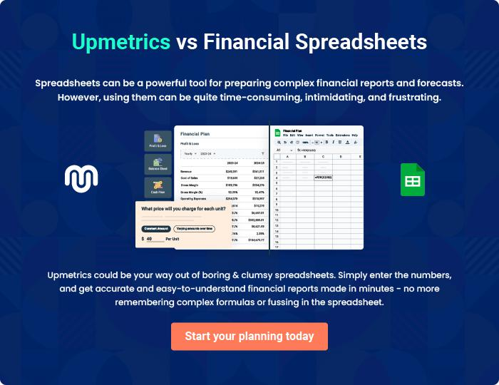

Clothing Manufacturer | Business Plan [YEAR] 32/33


Create a winning business plan that gets you funded

Creating a stunning and investment-ready plan requires no writing, graphic designing, or financial planning expertise.

Upmetrics has all the features required to help you create a comprehensive business plan—from start to finish. Make no mistakes, it’s the modern way of planning to structure ideas, make plans, and create stunning pitch decks to awe investors.

Pitch decks that impress investors

Create pitch decks that provide a visual representation of your business, engage investors, and make them want to invest in your business idea.

Interactive plans in no time

Import business plan sections like—SWOT analysis, comparison tables, and others to create an interactive business plan. No designing skills are required.

Stunning cover page designs

With Upmetrics, you have the liberty to choose from multiple stunning cover page designs. Choose a creative design and make your plan stand out.

Online sharing made simple

Upmetrics makes online sharing quick and easier for users. Easily share your business plans with a link while tracking reader activity.

500+ sample business plans

Simply import a template from our library of sample plans into the editor and start customizing it to make it yours. It takes only a few clicks to get started.

Collaborate with team in real-time

Invite team members, initiate conversations, discuss ideas & strategies, share feedback, and work on a business plan in real-time.

