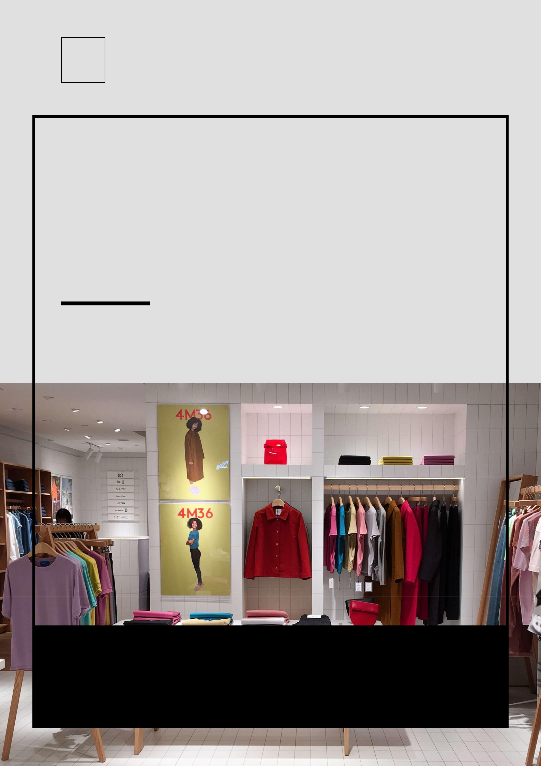


Blozom Boutique

BUSINESS PLAN

A classic never goes out of style

Prepared By

John Doe

10200 Bolsa Ave, Westminster, CA, 92683

info@example.com

(650) 359-3153 http://www.example.com

Table of Contents

Executive Summary | 6
Company Overview | 7
Products & Services | 7
Management Team | 7
Robin Mathews | 7
Joanna Jensen | 8
Market Analysis | 8
Strategy & Implementation | 8
Financial Plan | 8
EBITDA and Net Income | 9
Sources & Use of Funds | 9

Company | 10
Company & Industry | 11
Legal Entity & Ownership | 11
Robin Mathews | 11
Joanna Jensen | 11
Company History To Date | 12
Facilities | 12
Key Assets | 12

Products And Services | 13
Products | 14
Description | 14
List of products | 14
Features & Benefits | 15
Development | 15

Market Analysis | 17
Target Customer | 18
Customer Segmentation | 18

Blozom Boutique | Business Plan [YEAR] 2/43

Market Size | 19
Target Market | 19
Trends | 19
SWOT Analysis | 20

Competitive Analysis | 21
Competition | 22
Competitors | 22
Competitive Advantage | 23
Competitive Pricing | 23

Strategy & Implementation | 24
Philosophy | 25
Internet Strategy | 25
Direct E-mail | 25
Pricing Strategy | 25
Marketing & Promotion Strategy | 26
Public Relations | 26
Advertising | 26
Ongoing Customer Communications | 26
Pre-Opening Events | 27
Fashion Shows | 27
Sales Strategy | 27
Strategic Alliances | 28
Goals | 28
Exit Strategy | 28

Operations Plan | 29
Product Development | 30
Operations | 30
Milestones | 30

Blozom Boutique | Business Plan [YEAR] 3/43

Management | 31
Organizational Structure | 32
Leadership | 32
Staff Members | 32
Hiring Plan | 33

Financial Plan | 34
Fund Requirements | 35
Use Of Funds | 35
Income Statement Projections | 35
Cash Flow Projections | 38
Balance Sheet | 39
Key Assumptions & Forecasts | 40

Blozom Boutique | Business Plan [YEAR] 4/43

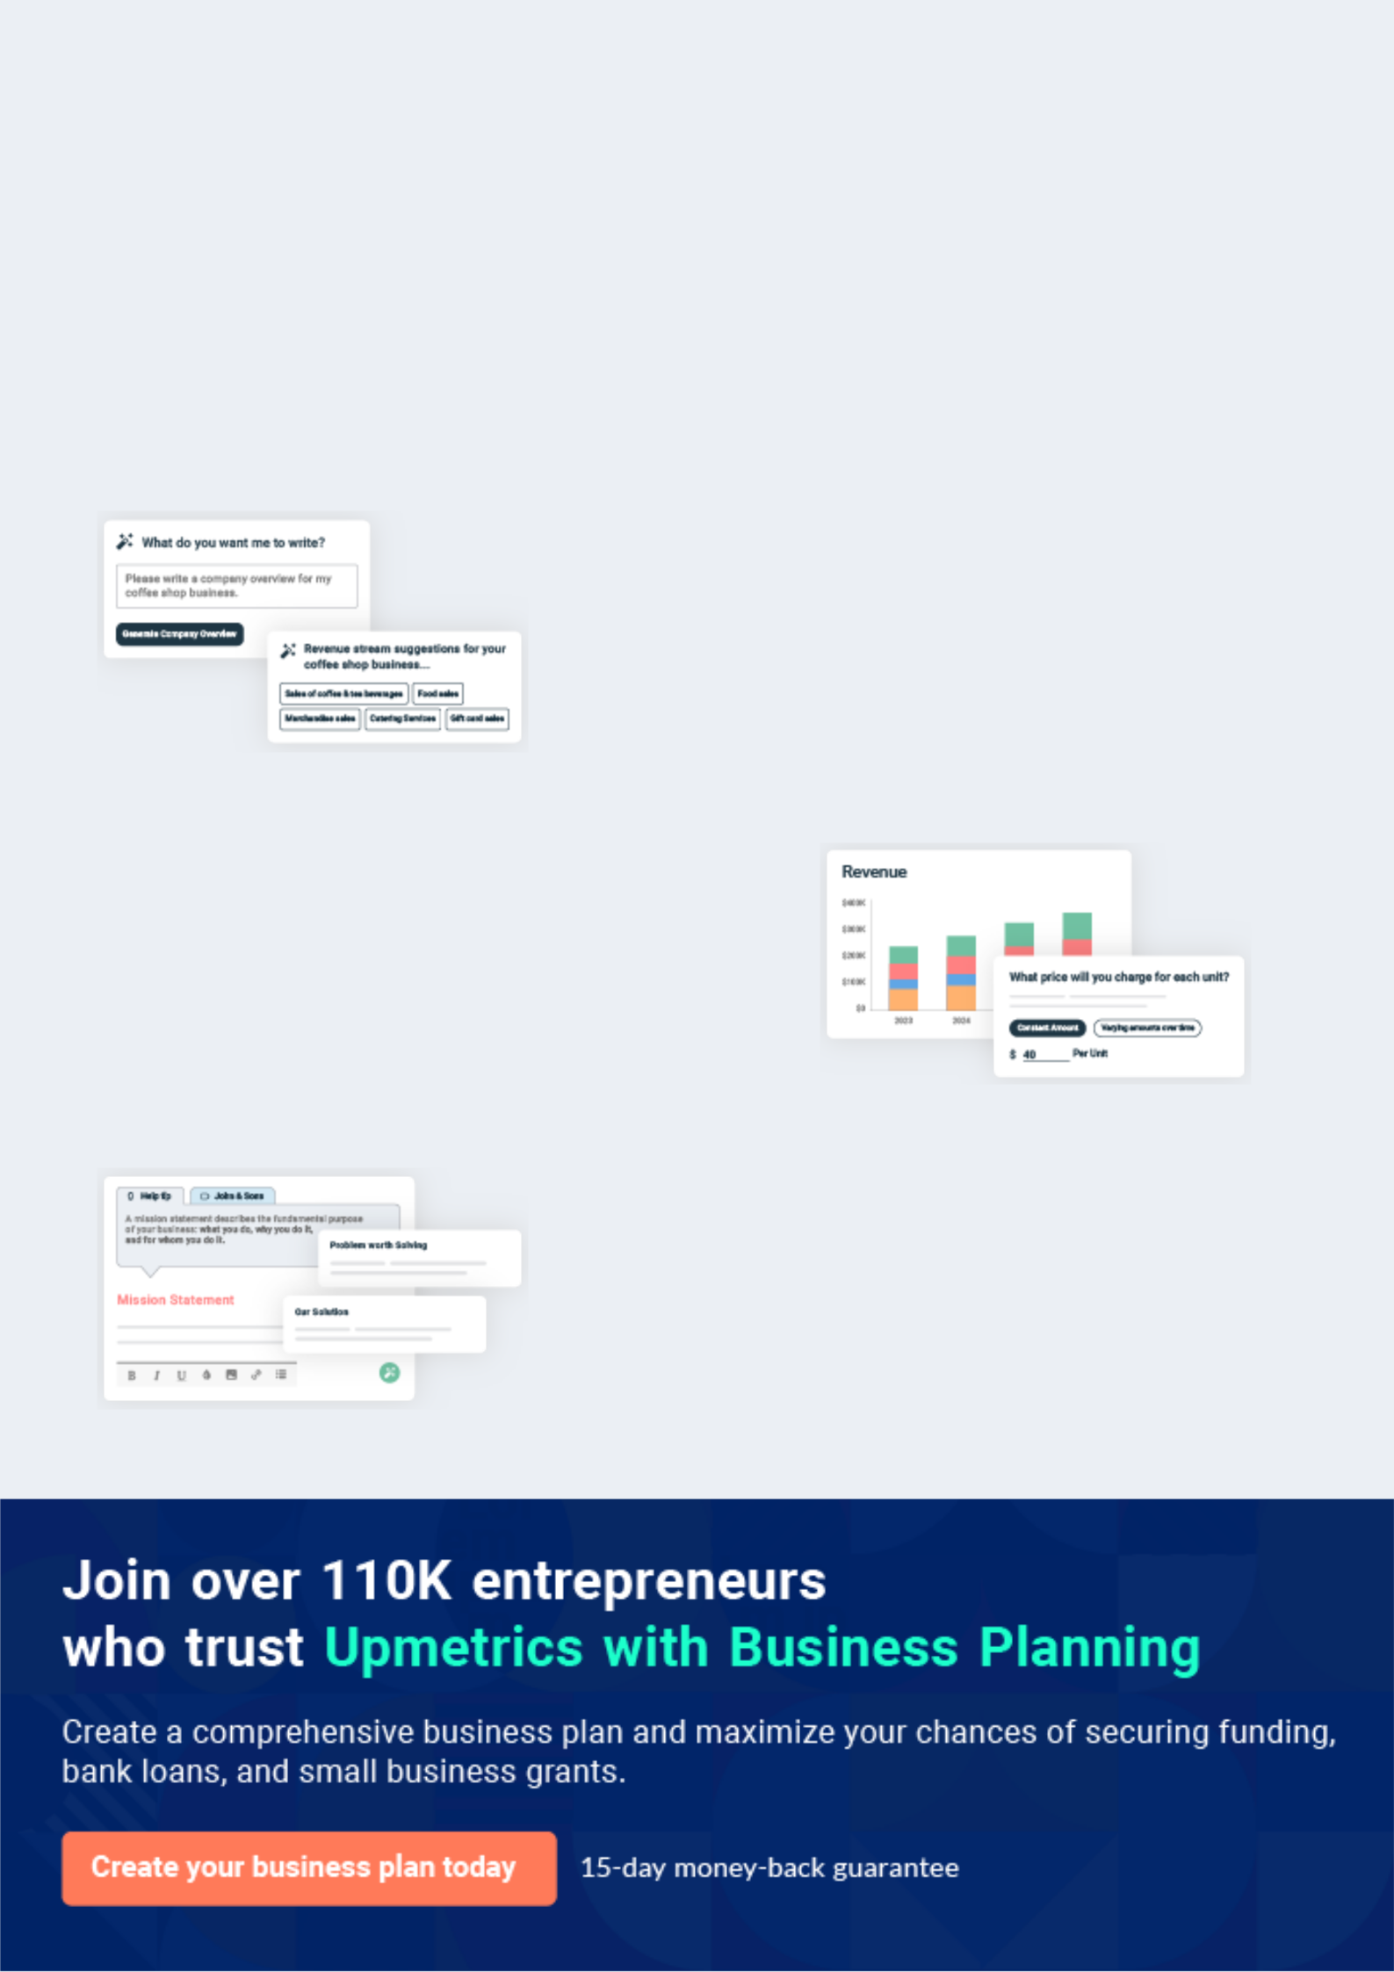
Business planning that’s simpler and faster than you think

Creating a business plan using Upmetrics to start and grow a business is literally the easiest thing in the World. Simply read the instructions and fill in the blanks. It’s as simple as that.

❛ | Upmetrics has everything you need to create a | ❜
❛ | comprehensive business plan. | ❜

AI-powered Upmetrics Assistant

AI-powered insights to streamline your plan

Not sure where to start? Upmetrics’ AI Assistant will automatically generate ideas for each section of your plan and offer improved versions of your writing, adjusting for tone, voice, and grammar or spelling errors.

Financial Forecasting Tool

All the financials are calculated for you

Forget the complex formulas and clumsy spreadsheets — with automatic financials and drag-and-drop forecasting, you can finish your plan faster and be confident that your numbers are accurate.

Business Plan Builder

Guides you like a business mentor

Upmetrics’ step-by-step instructions, prompts, and the library of 400+ sample business plans will guide you through each section of your plan as a business mentor.

1.


Executive Summary

Company Overview

Market Analysis

Strategy & Implementation

Financial Plan

Sources & Use of Funds

Blozom Boutique | Business Plan [YEAR] 6/43

Company Overview

 Blozom


Blozom Boutique is a start-up retail establishment that will sell fashionable clothing to women of the Baby Boom generation. We will locate Blozom Boutique in downtown Pleasantville, Florida, which is a popular retirement and tourist destination. While our initial goal is to open
To unlock help try Upmetrics! 

Start writing here..

 Blozom

The fashion and retail industry tends to be overly youth-focused. However, by closely following generational fashion trends as well as our own customers’ purchasing preferences, we will tailor our inventory to meet the specific needs of our clientele. We will solely focus on our
To unlock help try Upmetrics! 

Products & Services

Start writing here..

 Blozom

Robin Mathews and Joanna Jensen are co-owners and will co-manage Blozom Boutique.

To unlock help try Upmetrics! 

Management Team

Start writing here..


Robin Mathews

Co-Founder & CEO - robin@example.com

Mathews has worked ten years in the retail industry, including four years as the manager of an antique furniture shop. She earned a BA degree in finance from Britannica College in Tampa, Florida.

Blozom Boutique | Business Plan [YEAR] 7/43


Joanna Jensen

Co-Founder - Jensen@example.com

Jensen’s experience lies in the fashion industry. She’s worked with designers, wholesalers, and retailers for roughly 20 years. Jensen holds a BA in fashion merchandising from Colliers Fashion Institute in Miami, Florida.

Market Analysis

 Blozom

The total sales reported in the U.S. retail industry in 2007 (including food service and automotive) exceeded $4 trillion. There are roughly 75 million Baby Boomers, half of which are women. In Pleasantville, the current population is just fewer than 40,000. 54 percent of the total
To unlock help try Upmetrics! 

Start writing here..

Strategy & Implementation

 Blozom

Blozom Boutique recognizes the importance of marketing. And to that end, we plan to promote our retail business with an ambitious, targeted marketing campaign, which will include a grand opening event, local media coverage, print advertising, and a direct-mail campaign. Our goal is
To unlock help try Upmetrics! 

Start writing here..

Financial Plan

 Blozom

Our company will earn revenue from our customers’ purchases of our products. Blozom Boutique’s first-year income statement illustrates a profit margin of at least 52%, with a net income of $44,075 per month – after taxes. Finally, we have determined our break-even point
To unlock help try Upmetrics! 

Start writing here..

Blozom Boutique | Business Plan [YEAR] 8/43

EBITDA and Net Income
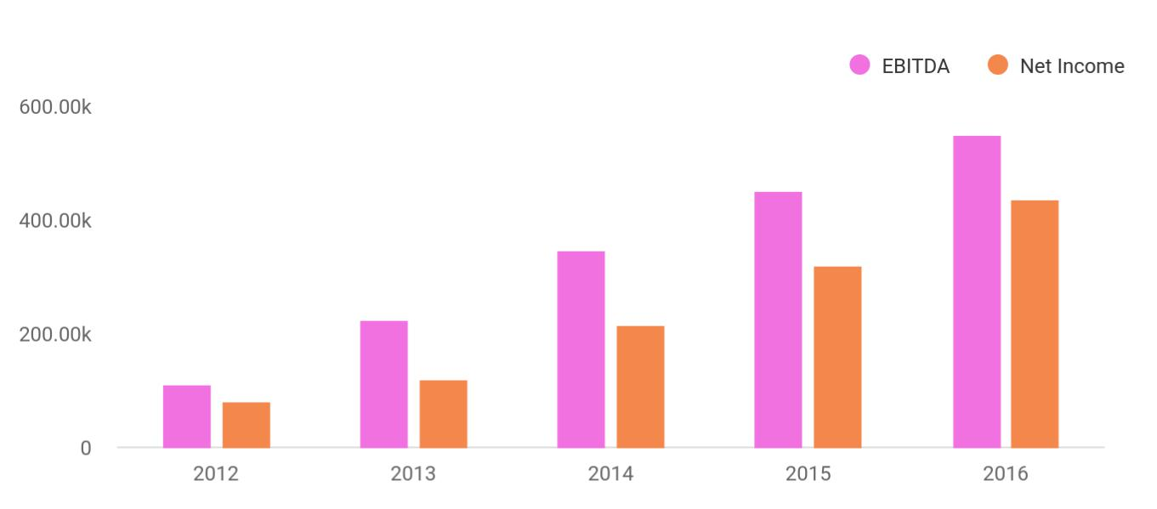

Sources & Use of Funds

 Blozom

Blozom Boutique requires $282,000 to launch successfully. We’ve already raised $62,000 through personal investments and a small community grant.
We are currently seeking additional funding from outside angel investors and business loans.
To unlock help try Upmetrics! 

Start writing here..

Blozom Boutique | Business Plan [YEAR] 9/43

2.

Company

Company & Industry

Legal Entity & Ownership

Company History To Date

Facilities

Key Assets

Blozom Boutique | Business Plan [YEAR] 10/43

Company & Industry
To unlock help try Upmetrics!

 Blozom

Blozom Boutique will be located in downtown Pleasantville, Florida. Our company is a retail establishment selling fashionable women’s clothing to up-and-coming Baby Boomer retirees. Our business operates within the retail industry and is classified under NAICS code 448120 –
To unlock help try Upmetrics! 

Start writing here..

Legal Entity & Ownership

 Blozom

Blozom Boutique is a multi-member Limited Liability Corporation formally organized in Florida. Robin Mathews and Joanna Jensen are the company’s principal owners. We hold equal shares of ownership in the company.



Start writing here..

Robin Mathews

Co-Founder & CEO

Mathews has worked ten years in the retail industry, including four years as the manager of an antique furniture shop. She earned a BA degree in finance from Britannica College in Tampa, Florida.


Joanna Jensen

Co-Founder - Joana@example.com

Jensen’s experience lies in the fashion industry. She’s worked with designers, wholesalers, and retailers for roughly 20 years. Jensen holds a BA in fashion merchandising from Colliers Fashion Institute in Miami, Florida.

Blozom Boutique | Business Plan [YEAR] 11/43

Company History To Date

 Blozom

The Company is a new business aimed at providing women of the Baby Boom generation stylish clothing options to buy and wear. As the company’s founders and as Baby Boomers ourselves, we found that Florida’s current boomer-wear market is missing the mark.
To unlock help try Upmetrics! 

Start writing here..

Facilities

 Blozom

Presently, Blozom Boutique does not have a bricks-and-mortar location. However, we have identified an ideal spot in the downtown district of Pleasantville. The gorgeous area includes
numerous restaurants, an art gallery, a coffee shop, a candy store, and a picturesque park in the
To unlock help try Upmetrics! 

Start writing here..

Key Assets

 Blozom

Our key assets are our co-owners, Robin Mathews and Joanna Jensen, who bring tremendous experience and relationships to this business.
To unlock help try Upmetrics! 

Start writing here..

Blozom Boutique | Business Plan [YEAR] 12/43

3.

Products And Services

Products

Features & Benefits

Development

Blozom Boutique | Business Plan [YEAR] 13/43

Products

Description


Blozom Boutique will sell a combination of widely recognized name brands as well as clothing lines from select fashion designers. We will closely follow generational fashion trends as well as our own customers’ purchasing preferences. Moreover, we will tailor our inventory to meet the needs of our “boomer” clientele. Solely focusing on the styles, colors, and fits to flatter the female Baby Boomer’s figure will be our specialty. While apparel, such as business clothing, casual wear, jeans, and formal wear will be our main staple, we will also offer some accessories such as belts, scarves, and hats.

We will earn profits by selling our merchandise. Our pricing structure will remain flexible, as we will implement suggested retail pricing on common brands as well as the standard practice of key stoning prices. Additionally, we will use a value-based pricing structure, which measures the value of our products to our customers such as easy access, quality, customer service, and styles flattering to our target consumer. We will implement end of season sales, holiday and overstock sales, multi-buy savings, and promotional coupons at strategic intervals.

List of products
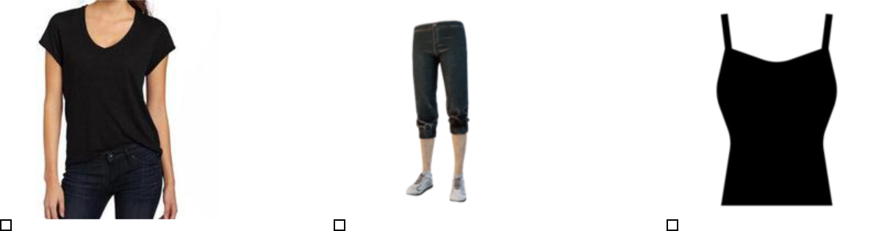

Tops (long sleeve and short Bottoms (pants, skirts, Sleepwear

sleeve) skorts, shorts)

Blozom Boutique | Business Plan [YEAR] 14/43

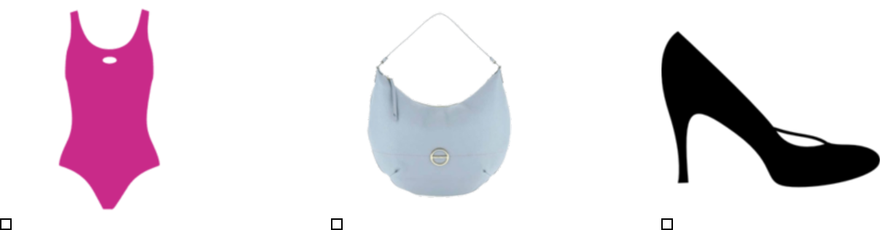

Swimwear Accessories Shoes

Features & Benefits

 Blozom

One key feature that separates Blozom Boutique from all other local boutiques and chain department stores in the area is our commitment to providing women of the Baby Boom
generation stylish, quality clothing options. Because our primary concern will be ensuring our
To unlock help try Upmetrics! 

Start writing here..

Development

 Blozom

As our company grows and our boutique earns a positive reputation, several opportunities will open to us. And we are considering some options already. Should we choose to remain a small local boutique, we will develop and grow our company by increasing existing clothing lines and
To unlock help try Upmetrics! 

Start writing here..

Blozom Boutique | Business Plan [YEAR] 15/43

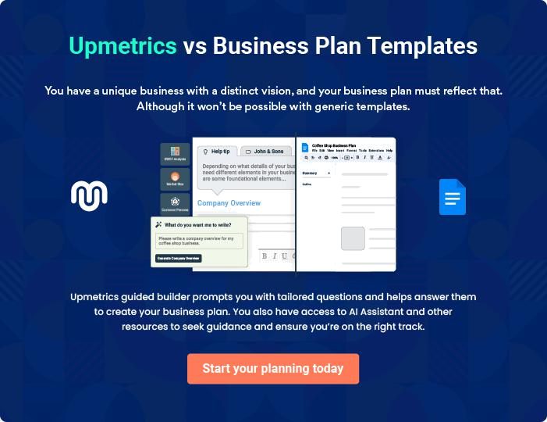

Blozom Boutique | Business Plan [YEAR] | 16/43

4.

Market Analysis

Target Customer

Market Size

Trends

SWOT Analysis

Blozom Boutique | Business Plan [YEAR] 17/43

Target Customer

 Blozom

Blozom Boutique is a business-to-consumer retail company. Female Baby Boomers are our clear target customers. However, we do realize that we will likely attract some younger women with our peripheral products (handbags, scarves, etc.). Moreover, we expect a portion of our
To unlock help try Upmetrics! 

Start writing here..

 Blozom

We will primarily target the following three customer segments:

1. Wealthy Women: The line will attract wealthy women looking to dress fashionably.
To unlock help try Upmetrics! 

Customer Segmentation

Start writing here..
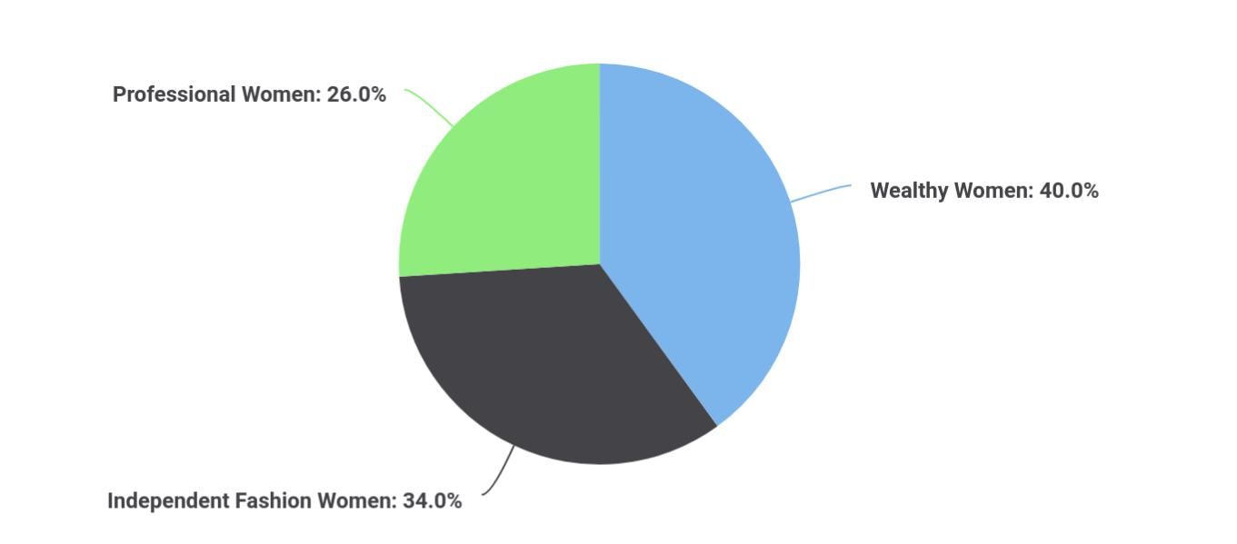

Blozom Boutique | Business Plan [YEAR] 18/43

Market Size

 Blozom

Pleasantville accommodates a robust retail market. While car dealerships, grocers, and home improvement retailers account for a sizable portion of the retail market, the main local shopping district is downtown. With tree-lined streets and quaint shops and restaurants, the
To unlock help try Upmetrics! 

Start writing here..

Target Market

 | Pleasantville
Total Female Population | 40,000
Median Age | 31%
Target Population by age
Age 25 to 34 | 13.08%
Age 35 to 44 | 12.94%
Target Population by Income
Income $50,000 to $74,999 | 18.03%
Income $75,000 to $99,999 | 12.97%
Income $100,000 to $124,999 | 8.65%
Income $125,000 to $149,999 | 5.40%
Income $150,000 to $199,999 | 5.12%
Income $200,000 and Over | 5.34%

Trends

 Blozom

The retail fashion industry is a solid business with ever-changing styles and ever-present consumer demand. While supercenters and megastores ruled the past two decades, more and more consumers are looking for a change. They’re searching for a more serene and customer-
To unlock help try Upmetrics! 

Blozom Boutique | Business Plan [YEAR] 19/43

Start writing here..

SWOT Analysis


Strength

- Experience and understanding of the fashion industry.

- Unique shopping experience with exceptional customer service

- Great downtown location.

- Large and growing consumer base.


Weakness


- Untested market in Pleasantville.

- While market is large, it is a niche market (Baby Boomers).


Opportunity

- Outstanding shopping experience will lead to repeat business.

- Growing online clothing store Blozom Boutique.

- Establish a Blozom Boutique clothing line.

Threat

- Cost and effectiveness of marketing to women “Baby Boomers”.

- New retail shops that may or may not open in the future.

Blozom Boutique | Business Plan [YEAR] 20/43

5.

Competitive Analysis

Competition

Competitive Pricing

Blozom Boutique | Business Plan [YEAR] 21/43

Competition
Caddy Corner Kids
Caddy Corner Kids, which targets parents shopping for children, specializes in children’s clothing, accessories, and toys.
Marjorie Joe’s
Fashion & Gifts Marjorie Joe’s Fashion & Gifts targets older women within our target demographic, but specializes in the more homemade, old-fashioned style clothing.
To unlock help try Upmetrics!

 Blozom

In Pleasantville, there are no direct competitors offering our unique services or targeting Baby Boomers specifically. In the Downtown District, the shops most closely competing with Blozom Boutique are as follows:



Start writing here..

Competitors


EcoWise Boutique

EcoWise Boutique, which targets a younger demographic and specializes in natural fiber clothing. They also carry local art and jewelry.

Kati Kouture

Kati Kouture, which targets younger women, specializes in offering industrial chic clothing with “classic lines and a punk-gothic edge.”

 Blozom

There is one super-store within a 60-mile radius of Pleasantville. The store is similar to Walmart in that it sells lesser quality items at a lower price. But there are two chain department stores. They sell men’s, women’s, and children’s clothing along with home accents, electronics, and
To unlock help try Upmetrics! 

Start writing here..

Blozom Boutique | Business Plan [YEAR] 22/43

Competitive Advantage


Consumer Demand for Unique Designs

Blozom will focus solely on unique clothing not available through mass market channels.

Relationships

Having been in the fashion community for years, [Founder’s Name] knows all of the relevant players and media outlets. As such, it will be relatively easy for us to build branding and awareness of our store.

Management

Our management team has years of fashion experience that allows us to sell to and serve customers in a much more sophisticated manner than our competitors.

Exclusive

To date, our primary competitive advantage is the absence of any store like ours in the Pleasantville area

Competitive Pricing

 | Chelsea | Helmut Lang | Haute Hippie
Sweaters | $30-$40 | $100-$150 | $50-$60
Pants/Jeans | $60-$80 | $150-$200 | $60-$75
Dresses | $40-$60 | $100-$150 | $75-85
Tops | $30-$40 | $75-$150 | $40-$60

Blozom Boutique | Business Plan [YEAR] 23/43

6.

Strategy & Implementation

Philosophy

Internet Strategy

Marketing & Promotion Strategy

Sales Strategy

Strategic Alliances

Goals

Exit Strategy

Blozom Boutique | Business Plan [YEAR] 24/43

Philosophy

 Blozom

Our company’s core business strategy is to combine exceptional and knowledgeable customer service with quality stylish merchandise. And n turn, we’ll provide an enjoyable shopping experience for our customers. Blozom Boutique’s mission is to offer women of the Baby Boom
To unlock help try Upmetrics! 

Start writing here..

Internet Strategy

 Blozom

As the Internet has become a staple of American life and retail merchandising, Blozom Boutique will build a website on which we will sell our products, too. We have secured the domain name BlozomBoutique.com and will begin site development using Shopify or Wix.
To unlock help try Upmetrics! 

Start writing here..

 Blozom

Blozom will utilize an existing client book and begin to capture email addresses at various events and directly through their website. Newsletters will be sent out at the beginning of each month and include updates about the collection, new postings on the company blog, behind the
To unlock help try Upmetrics! 

Direct E-mail

Start writing here..

 Blozom

Blozom pricing will be appropriate for the high quality and level of service associated with the store. Pricing will be on par with Helmut Lang.
To unlock help try Upmetrics! 

Pricing Strategy

Start writing here..

Blozom Boutique | Business Plan [YEAR] 25/43

Marketing & Promotion Strategy

 Blozom

We both have strong marketing backgrounds and recognize the significance of effective marketing. We expect our strategy to draw consumers into Blozom Boutique from the very
beginning. Moreover, we will hire a local PR firm to help us develop and implement a strategic
To unlock help try Upmetrics! 

Start writing here..

 Blozom

We will contact all local and area newspapers and television stations and send them a press release describing the opening and unique value proposition of Blozom.
To unlock help try Upmetrics! 

Public Relations

Start writing here..

 Blozom

Blozom will initially advertise in newspapers and sponsor fashion and charity events in order to gain awareness.
To unlock help try Upmetrics! 

Advertising

Start writing here..

 Blozom

Blozom will maintain a website and publish a monthly email newsletter to tell customers about new events, products, and more.
To unlock help try Upmetrics! 

Ongoing Customer Communications

Start writing here..

Blozom Boutique | Business Plan [YEAR] 26/43

 Blozom
To unlock help try Upmetrics!

Before opening the store, Blozom will organize pre-opening events to create buzz and awareness for Blozom.
To unlock help try Upmetrics! 

Pre-Opening Events

Start writing here..

 Blozom

Fashion shows are generally events where a collection premieres, designer launches, and new runway trends are shown and are thus the most connected and widely attended events for the Company’s targeted members.



Fashion Shows

Start writing here..

Sales Strategy

 Blozom

Blozom Boutique plans to generate sales via strategic marketing efforts. These concentrated efforts will be targeting new and returning customers as well as single-visit tourist consumers. We will also implement a referral program for rewarding customers who refer new customers
To unlock help try Upmetrics! 

Start writing here..

Blozom Boutique | Business Plan [YEAR] 27/43

Strategic Alliances

 Blozom

Blozom Boutique plans to join the Pleasantville Chamber of Commerce as well as the Pleasantville Downtown Merchants Association. These organizations are dedicated to
promoting local businesses within our community and sponsor several events downtown each
To unlock help try Upmetrics! 

Start writing here..

Goals

 Blozom

The following is a list of business goals and milestones we intend to accomplish in our first year of operations.
To unlock help try Upmetrics! 

Start writing here..

Exit Strategy

 Blozom

The co-owners intend to launch and grow Blozom Boutique for many years into the future. In the event that our investors require repayment of their initial investments, plus a large return on their investments, we will seek a partner to buy out the investors’ shares. Another alternative is
To unlock help try Upmetrics! 

Start writing here..

Blozom Boutique | Business Plan [YEAR] 28/43

7.

Operations Plan

Product Development

Operations

Blozom Boutique | Business Plan [YEAR] 29/43

Product Development

 Blozom

We are currently working with several apparel wholesalers, garment manufacturers, and two freelance fashion designers to assemble our inventory. We are also working with city economic-development officials to secure all required permits and occupational licensees. Once we
To unlock help try Upmetrics! 

Start writing here..

Operations

 Blozom

As a retail establishment, Blozom Boutique will conduct business seven days a week from 10 a.m. to 6 p.m. Monday through Thursday, from 10 a.m. to 8 p.m. Friday and Saturday, and 12 p.m. to 6 p.m. on Sunday. During the holiday seasons and during special events, we will extend
To unlock help try Upmetrics! 

Start writing here..

 Blozom


Blozom expects to achieve the following milestones in the following 6 months:

Date

^{Milestone} To unlock help try Upmetrics! 

Milestones

Start writing here..

Blozom Boutique | Business Plan [YEAR] 30/43

8.

Management

Organizational Structure

Leadership

Staff Members

Blozom Boutique | Business Plan [YEAR] 31/43

Organizational Structure

 Blozom

As a small business, we will have a small staff. Both co-owners will assume leadership roles within the company and will be responsible for daily operations, overseeing marketing efforts, buying merchandise, and managing inventory, and all other administrative duties. A small sales
To unlock help try Upmetrics! 

Start writing here..

Leadership

 Blozom

Co-owners, Robin Mathews, and Joanna Jensen created this boutique business plan. Both will co-manage Blozom Boutique. However, daily responsibilities will differ.
To unlock help try Upmetrics! 

Start writing here..

Staff Members

 Blozom

Blozom Boutique will employ a sales staff of 3 part-time employees. These positions are yet to be filled. However, we feel the labor pool is such that finding qualified employees will not be an issue. Our sales associates will be paid an hourly wage, plus commission. We will provide
To unlock help try Upmetrics! 

Start writing here..

Blozom Boutique | Business Plan [YEAR] 32/43

 Blozom

Robin Mathews will serve as the CEO. In order to launch, we need to hire the following personnel:
To unlock help try Upmetrics! 

Hiring Plan

Start writing here..

Blozom Boutique | Business Plan [YEAR] 33/43

9.

Financial Plan

Fund Requirements

Use Of Funds

Income Statement Projections

Cash Flow Projections

Balance Sheet

Key Assumptions & Forecasts

Blozom Boutique | Business Plan [YEAR] 34/43

Fund Requirements

 Blozom

Blozom Boutique will need $282,000 to get our business off the ground. We are currently seeking funding from outside investors and business loans.
To unlock help try Upmetrics! 

Start writing here..

Use Of Funds

 Blozom

We will use the funds we obtain from investment in this boutique business plan to pay for renovations, including the outside facade (to be paid for via PDRC grant), construction of fitting rooms, sales counter, painting, carpeting, lighting, decor, and display fixtures. We will also
To unlock help try Upmetrics! 

Start writing here..

Income Statement Projections

 | 2024 | 2025 | 2026
Revenue | $917,550.80 | $2,210,238.35 | $5,752,603.70
Retail Sales | $427,683.50 | $1,342,257.50 | $4,212,590
Unit Sales | 8,554 | 26,845 | 84,252
Unit Price | $50 | $50 | $50
Online Sales | $429,765.30 | $771,800.85 | $1,386,047.70
Unit Sales | 9,550 | 17,151 | 30,801
Unit Price | $45 | $45 | $45
Custom Orders | $60,102 | $96,180 | $153,966
Unit Sales | 301 | 481 | 770

Blozom Boutique | Business Plan [YEAR] 35/43

 | 2024 | 2025 | 2026
Unit Price | $200 | $200 | $200

Cost Of Sales | $250,987.73 | $574,687.60 | $1,460,820.38
General Costs | $250,987.73 | $574,687.60 | $1,460,820.38
Production Costs | $195,510.16 | $454,287.67 | $1,163,005.54
Fabric Materials | $12,000 | $12,240 | $12,484.80
Manufacturing | $183,510.16 | $442,047.67 | $1,150,520.74
Logistics and Packaging | $55,477.57 | $120,399.93 | $297,814.84
Shipping and Handling | $9,600 | $9,888 | $10,184.64
Packaging | $45,877.57 | $110,511.93 | $287,630.20
Revenue Specific Costs | $0 | $0 | $0
Personnel Costs (Direct | $0 | $0 | $0
Labor) | $0 | $0 | $0

Gross Margin | $666,563.07 | $1,635,550.75 | $4,291,783.32
Gross Margin (%) | 72.65% | 74% | 74.61%

Operating Expense | $694,752.08 | $872,534.58 | $1,310,622.24
Payroll Expense (Indirect | $432,648 | $444,345.96 | $456,364.56
Labor) | $432,648 | $444,345.96 | $456,364.56
Design and Production | $241,800 | $248,169 | $254,706.72
Team | $241,800 | $248,169 | $254,706.72
Fashion Designer | $64,800 | $66,744 | $68,746.32
Tailors | $177,000 | $181,425 | $185,960.40
Sales and Marketing | $105,120 | $108,273.60 | $111,521.76
Sales Manager | $54,720 | $56,361.60 | $58,052.40
Marketing Specialist | $50,400 | $51,912 | $53,469.36

Blozom Boutique | Business Plan [YEAR] 36/43

 | 2024 | 2025 | 2026
Administrative Staff | $85,728 | $87,903.36 | $90,136.08
Office Administrator | $39,648 | $40,440.96 | $41,249.76
HR Manager | $46,080 | $47,462.40 | $48,886.32
General Expense | $152,106.11 | $308,188.61 | $734,257.68
Production and Operation | $30,000 | $30,840 | $31,704
Costs | $30,000 | $30,840 | $31,704
Fabric Procurement | $24,000 | $24,720 | $25,461.60
Equipment Maintenance | $6,000 | $6,120 | $6,242.40
Marketing and Sales | $73,404.08 | $176,819.08 | $460,208.32
Advertising and Promotion | $45,877.57 | $110,511.93 | $287,630.20
Sales Commissions | $27,526.51 | $66,307.15 | $172,578.12
Logistics and Distribution | $48,702.03 | $100,529.53 | $242,345.36
Shipping Costs | $36,702.03 | $88,409.53 | $230,104.16
Warehouse Rent | $12,000 | $12,120 | $12,241.20
Bad Debt | $0 | $0 | $0
Amortization of Current | $109,998 | $120,000 | $120,000
Assets | $109,998 | $120,000 | $120,000

EBITDA | ($28,189.01) | $763,016.16 | $2,981,161.08

Additional Expense | $13,126.93 | $11,192.77 | $9,139.31

Long Term Depreciation

Gain or loss from Sale of Assets

EBIT

Interest Expense

EBT

$7,980 | $7,980 | $7,980
$0 | $0 | $0
($36,169.01) | $755,036.16 | $2,973,181.08
$5,146.94 | $3,212.76 | $1,159.29
($41,315.94) | $751,823.39 | $2,972,021.77

Blozom Boutique | Business Plan [YEAR] 37/43

 | 2024 | 2025 | 2026
Income Tax Expense / | $0 | $0 | $0
Benefit | $0 | $0 | $0
Total Expense | $958,866.74 | $1,458,414.96 | $2,780,581.93
Net Income | ($41,315.94) | $751,823.39 | $2,972,021.77
Net Income (%) | (4.50%) | 34.02% | 51.66%
Retained Earning Opening | $0 | ($61,315.94) | $670,507.45
Owner's Distribution | $20,000 | $20,000 | $20,000
Retained Earning Closing | ($61,315.94) | $670,507.45 | $3,622,529.22
Cash Flow Projections
 | 2024 | 2025 | 2026
Cash Received | $917,550.80 | $2,210,238.35 | $5,752,603.70
Cash Paid | $840,888.73 | $1,330,434.96 | $2,652,601.93
COS & General Expenses | $403,093.80 | $882,876.23 | $2,195,078.06
Salary & Wages | $432,648 | $444,345.96 | $456,364.56
Interest | $5,146.94 | $3,212.76 | $1,159.29
Sales Tax | $0 | $0 | $0
Income Tax | $0 | $0 | $0
Net Cash From | $76,662.07 | $879,803.39 | $3,100,001.77
Operations | $76,662.07 | $879,803.39 | $3,100,001.77
Assets Sell | $0 | $0 | $0
Assets Purchase | $170,000 | $120,000 | $120,000

Blozom Boutique | Business Plan [YEAR] 38/43

Net Cash From

Investments

Amount Received

Loan Received

Common Stock

Preferred Stock

Owner's Contribution

Amount Paid

Loan Capital

Dividends & Distributions

Net Cash From

Financing

Summary

2024 | 2025 | 2026
($170,000) | ($120,000) | ($120,000)

$150,000 | $0 | $0
$100,000 | $0 | $0
$50,000 | $0 | $0
$0 | $0 | $0
$0 | $0 | $0
$51,359.35 | $53,293.51 | $55,347.12
$31,359.34 | $33,293.52 | $35,347.14
$20,000 | $20,000 | $20,000
$98,640.65 | ($53,293.51) | ($55,347.12)

Starting Cash | $0 | $5,302.72 | $711,812.60
Cash In | $1,067,550.80 | $2,210,238.35 | $5,752,603.70
Cash Out | $1,062,248.08 | $1,503,728.47 | $2,827,949.05
Change in Cash | $5,302.72 | $706,509.88 | $2,924,654.65
Ending Cash | $5,302.72 | $711,812.60 | $3,636,467.25

Balance Sheet

 | 2024 | 2025 | 2026
Assets | $57,324.72 | $755,854.60 | $3,672,529.25
Current Assets | $15,304.72 | $721,814.60 | $3,646,469.25
Cash | $5,302.72 | $711,812.60 | $3,636,467.25

Blozom Boutique | Business Plan [YEAR] 39/43

 | 2024 | 2025 | 2026
Accounts Receivable | $0 | $0 | $0
Inventory | $0 | $0 | $0
Other Current Assets | $10,002 | $10,002 | $10,002
Long Term Assets | $42,020 | $34,040 | $26,060
Gross Long Term Assets | $50,000 | $50,000 | $50,000
Accumulated Depreciation | ($7,980) | ($15,960) | ($23,940)

Liabilities & Equity | $57,324.72 | $755,854.59 | $3,672,529.22
Liabilities | $68,640.66 | $35,347.14 | $0
Current Liabilities | $33,293.52 | $35,347.14 | $0
Accounts Payable | $0 | $0 | $0
Income Tax Payable | $0 | $0 | $0
Sales Tax Payable | $0 | $0 | $0
Short Term Debt | $33,293.52 | $35,347.14 | $0
Long Term Liabilities | $35,347.14 | $0 | $0
Long Term Debt | $35,347.14 | $0 | $0
Equity | ($11,315.94) | $720,507.45 | $3,672,529.22
Paid-in Capital | $0 | $0 | $0
Common Stock | $50,000 | $50,000 | $50,000
Preferred Stock | $0 | $0 | $0
Owner's Contribution | $0 | $0 | $0
Retained Earnings | ($61,315.94) | $670,507.45 | $3,622,529.22

Check | $0 | $0 | $0

Key Assumptions & Forecasts

Blozom Boutique | Business Plan [YEAR] 40/43

We base our projections on the assumption that the economy, consumer spending habits and population growth in Pleasant ville will continue for the foreseeable future.

Below please find the key assumptions that went into the financial forecast and a summary of the financial projections over the next five years.

 | Retail Price | % of Collection | Wholesale | Cost of
 | Retail Price | % of Collection | Price | Production
Jackets | $227.00 | 17% | $117.98 | $58.93
Dresses | $220.00 | 22% | $114.23 | $54.92
Tops | $134.00 | 31% | $68.43 | $36.23
Bottoms | $167.00 | 25% | $86.88 | $48.45
Scarves | $78.00 | 3% | $39.53 | $24.03
Accessories | $75.00 | 3% | $38.25 | $24.75

Blozom Boutique | Business Plan [YEAR] 41/43

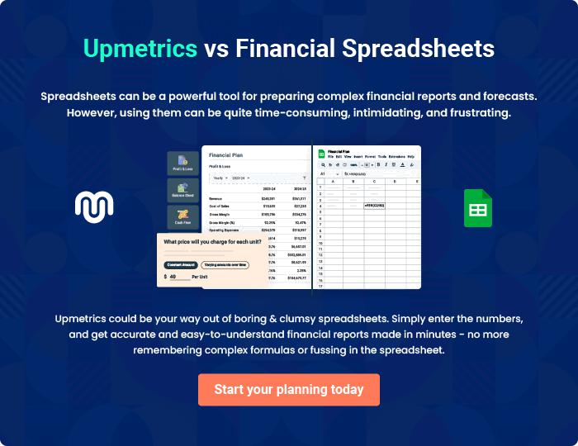

Blozom Boutique | Business Plan [YEAR] | 42/43


Create a winning business plan that gets you funded

Creating a stunning and investment-ready plan requires no writing, graphic designing, or financial planning expertise.

Upmetrics has all the features required to help you create a comprehensive business plan—from start to finish. Make no mistakes, it’s the modern way of planning to structure ideas, make plans, and create stunning pitch decks to awe investors.

Pitch decks that impress investors

Create pitch decks that provide a visual representation of your business, engage investors, and make them want to invest in your business idea.

Interactive plans in no time

Import business plan sections like—SWOT analysis, comparison tables, and others to create an interactive business plan. No designing skills are required.

Stunning cover page designs

With Upmetrics, you have the liberty to choose from multiple stunning cover page designs. Choose a creative design and make your plan stand out.

Online sharing made simple

Upmetrics makes online sharing quick and easier for users. Easily share your business plans with a link while tracking reader activity.

500+ sample business plans

Simply import a template from our library of sample plans into the editor and start customizing it to make it yours. It takes only a few clicks to get started.

Collaborate with team in real-time

Invite team members, initiate conversations, discuss ideas & strategies, share feedback, and work on a business plan in real-time.

