
Riverland - Cattle Farm

ADDRESS

CONTACT

10200 Bolsa Ave, Westminster, CA, 92683

(650) 359-3153

http://www.example.com

info@example.com


Business Plan

[YEAR]

Prepared By

John Doe


No use crying over spilled milk

Information provided in this business plan is unique to this business and confidential; therefore, anyone reading this plan agrees not to disclose any of the information in this business plan without prior written permission of the Company

Table of Contents

Executive Summary | 5
Objectives | 6
Mission | 6
Keys to Success | 7
Financial Summary | 7
Net Income | 7

Business Overview | 8
Business Summary | 9
Business Ownership | 9
John Doe | 9
Jimmy Doe | 9
Company History | 10
Past Performance | 11

Products | 12
Products & Services | 13
Market Analysis
Market Analysis | 14
Market Summary | 15
Market Segmentation | 15
Market Analysis (Pie) | 16
Target Market Segment Strategy | 16
Industry Analysis | 16
Competition and Buying Patterns | 17
Strategy and Implementation
Strategy and Implementation | 18
SWOT Analysis | 19
Competitive Edge | 20
Marketing Strategy | 20

Riverland - Cattle Farm | Business Plan [YEAR] 2/39

Sales Strategy | 20
Sales Forecast | 21
Sales by Year | 21
Milestones | 22
Detailed Budget | 22
Operating and Direct Costs | 23

Management Summary | 25
Management | 26
John Doe | 26
Personnel Plan | 26

Financial Plan | 27
Important Assumptions | 28
Break-even Analysis | 28
Projected Profit and Loss | 29
Projected Cash Flow | 32
Projected Balance Sheet | 33
Business Ratios | 35

Appendix | 37
Sales Forecast | 38
Personnel | 38
Profit and Loss | 38
Cash Flow | 38
Balance Sheet | 38

Riverland - Cattle Farm | Business Plan [YEAR] 3/39

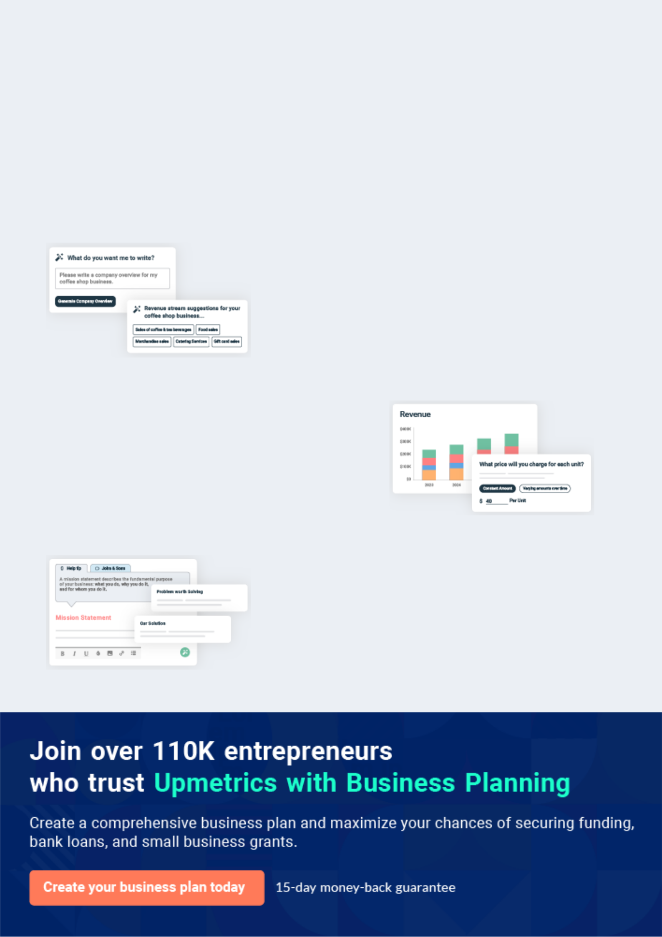
Business planning that’s simpler and faster than you think

Creating a business plan using Upmetrics to start and grow a business is literally the easiest thing in the World. Simply read the instructions and fill in the blanks. It’s as simple as that.

❛ | Upmetrics has everything you need to create a | ❜
❛ | comprehensive business plan. | ❜

AI-powered Upmetrics Assistant

AI-powered insights to streamline your plan

Not sure where to start? Upmetrics’ AI Assistant will automatically generate ideas for each section of your plan and offer improved versions of your writing, adjusting for tone, voice, and grammar or spelling errors.

Financial Forecasting Tool

All the financials are calculated for you

Forget the complex formulas and clumsy spreadsheets — with automatic financials and drag-and-drop forecasting, you can finish your plan faster and be confident that your numbers are accurate.

Business Plan Builder

Guides you like a business mentor

Upmetrics’ step-by-step instructions, prompts, and the library of 400+ sample business plans will guide you through each section of your plan as a business mentor.

1.


Executive Summary

Objectives

Mission

Keys to Success

Financial Summary

Riverland - Cattle Farm | Business Plan [YEAR] 5/39

 Riverland
To unlock help try Upmetrics!


Riverland is a small family-owned cattle farm located in Phoenix, Arizona that sells beef calves and hay. John Doe and Jimmy Doe Both grew up in families that raised cattle and over the last four years have been slowly building up their own farm to where it now has a total of just under
To unlock help try Upmetrics! 

Start writing here..

Objectives

 Riverland

The Objectives of Riverland:

• Operate the farm on company-owned land
To unlock help try Upmetrics! 

Start writing here..

Mission

 Riverland

The mission of Riverland is to own a family operated cattle farm that hires within the community. The company’s goal is to raise, breed, and sell top-quality cattle while teaching others how to tend and take care of them.



Start writing here..

Riverland - Cattle Farm | Business Plan [YEAR] 6/39

Keys to Success

 Riverland

The keys to success for Riverland are:

• Healthy cattle that have all of their shots, enough food, and clean water
To unlock help try Upmetrics! 

Start writing here..

Financial Summary

Net Income
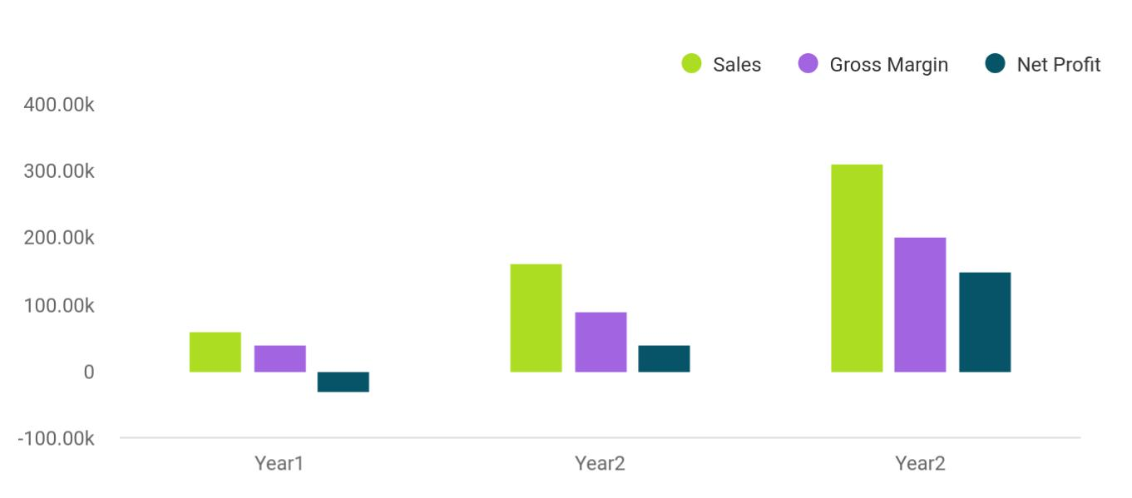

Financial Year | Sales | Gross Margin | Net Profit
Year1 | 60,000 | 40,000 | -30,000
Year2 | 160,000 | 90,000 | 40,000
Year2 | 310,000 | 200,000 | 150,000

Riverland - Cattle Farm | Business Plan [YEAR] 7/39

2.

Business Overview

Business Summary

Business Ownership

Company History

Riverland - Cattle Farm | Business Plan [YEAR] 8/39

Business Summary

 Riverland

Riverland is currently a small cow/ calf operation with an estimated 50 total calves and cows. The farm sells beef calves to individuals and at the cattle auction. The company is completely operated by the Doe family which entails checking, feeding, giving shots, weaning, tagging,
To unlock help try Upmetrics! 

Start writing here..

Business Ownership

 Riverland

Riverland is a private family-owned sole proprietorship. The current owners, John and Jimmy are planning to put the business in an LLC or S-Corporation structure shortly after receiving grant funding. Mr. Doe doesn’t anticipate adding any additional ownership in the future outside
To unlock help try Upmetrics! 

Start writing here..


John Doe

Owner & CEO - johnd@example.com


Jimmy Doe

Owner & CEO - jimmyd@example.com

Riverland - Cattle Farm | Business Plan [YEAR] 9/39

Company History

Riverland is heading into its fourth year of operation. The farm began to purchase cattle and equipment significantly in 2007 and 2009 to put the business in a position to grow. Both John and Jimmy's families had cows and calves when they were growing up and they decided to continue a family tradition. Riverland is now looking to turn the corner and make the farm a full-time operation.

Past Performance | Year1 | Year2 | Year3
Sales | $10,605 | $11,587 | $11,363
Gross Margin | $860 | $11,587 | $11,363
Gross Margin % | 8.11% | 100.00% | 100.00%
Operating Expenses | $33,928 | $24,184 | $43,184
Inventory Turnover | 0.00 | 0.00 | 0.00
Balance Sheet | Year1 | Year2 | Year3
Current Assets
Cash | $4,550 | $5,500 | $9,750
Inventory | $0 | $0 | $0
Other Current Assets | $13,500 | $13,500 | $13,500
Total Current Assets | $18,050 | $19,000 | $23,250
Long-term Assets
Long-term Assets | $71,046 | $94,047 | $94,047
Accumulated Depreciation | $6,025 | $21,527 | $38,700
Total Long-term Assets | $65,021 | $72,520 | $55,347
Total Assets | $83,071 | $91,520 | $78,597
Current Liabilities
Accounts Payable | $654 | $343 | $540
Current Borrowing | $2,600 | $2,300 | $2,100

Riverland - Cattle Farm | Business Plan [YEAR] 10/39

Past Performance | Year1 | Year2 | Year3
Other Current Liabilities (interest free) |  | $0 | $0
Total Current Liabilities | $3,254 | $2,643 | $2,640
Long-term Liabilities | $13,500 | $45,000 | $43,000
Total Liabilities | $16,754 | $47,643 | $45,640
Paid-in Capital | $0 | $0 | $0
Retained Earnings | $89,640 | $87,061 | $46,283
Earnings | ($23,323) | ($43,184) | ($13,326)
Total Capital | $66,317 | $43,877 | $32,957
Total Capital and Liabilities | $83,071 | $91,520 | $78,597
Other Inputs
Payment Days | 30 | 30 | 30

Past Performance
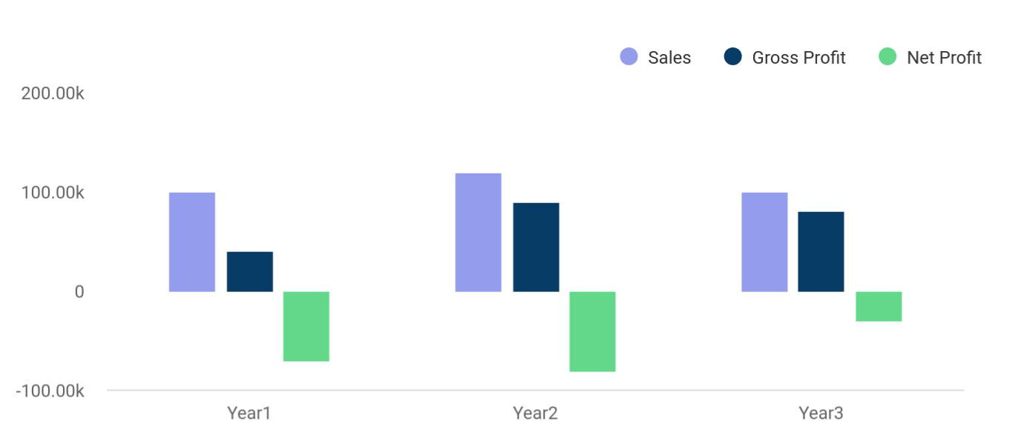

Riverland - Cattle Farm | Business Plan [YEAR] 11/39

3.

Products

Products & Services

Riverland - Cattle Farm | Business Plan [YEAR] 12/39

Products & Services


Riverland sells beef calves. The calves are sold to both individuals with the majority of the cattle going to auction to cattlemen who put them on a feedlot until they are big enough to be sold to the market. The cattle are usually sold at auction in Arizona. There are very few people in the Phoenix, Arizona community that have cattle, so if they want a calf the farm will sell them what they need at a price per pound basis that is similar to the going rate at the auction.


Riverland - Cattle Farm | Business Plan [YEAR] 13/39

4.

Market Analysis

Market Summary

Market Segmentation

Target Market Segment Strategy

Industry Analysis

Riverland - Cattle Farm | Business Plan [YEAR] 14/39

Market Summary

 Riverland

Arizona’s beef cattle industry is an important part of the state's economy. It is even more important to Arizona’s beef agricultural economy. There are cattle produced in every county in Arizona. The beef industry in the state is primarily made up of locally owned family farmers.
To unlock help try Upmetrics! 

Start writing here..

Market Segmentation

The cattle market is a commodities-based market. Prices are determined on a market demand basis. According to the United States Department of Agriculture Economic Research Service, the retail equivalent value of the U.S. beef industry has remained between $70-75 throughout the last five years and beef production has reduced slightly to just over 26 billion pounds annually (2009).

The cattle market constantly fluctuates, but is and will continue to be a staple commodity with steady demand. Large cattle farms face the most uncertainties, due to the effect price drops and increase in feeding costs have on their return that is based on a low margin/ high demand basis.

Market Analysis:

Potential | Growth | Year1 | Year2 | Year3 | Year4 | Year5 | CAGR
Customers
Cattle in | 1% | 1,000,000 | 1,010,000 | 1,020,100 | 1,030,301 | 1,040,604 | 1.00%
Arizona State
Cattle in
Alsbrook | 10% | 500 | 550 | 605 | 666 | 733 | 10.04%
Farms
Total | 1.01% | 1,000,500 | 1,010,550 | 1,020,705 | 1,030,967 | 1,041,337 | 1.01%

Riverland - Cattle Farm | Business Plan [YEAR] 15/39

Market Analysis (Pie)
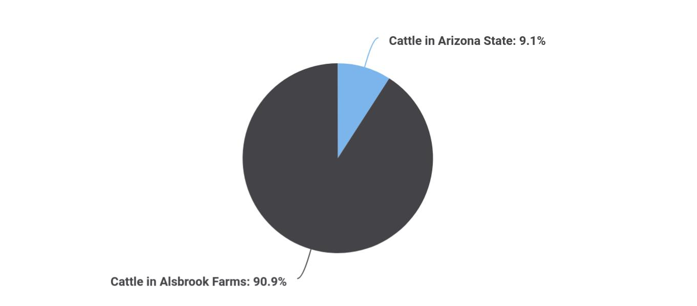

Target Market Segment Strategy

 Riverland

Riverland will focus on selling beef calves from the farm and hay production. These are optimal revenue-producing streams for the farm and will utilize the family's operating resources. The farm will maximize the use of running the farming operation on land that will be purchased by
To unlock help try Upmetrics! 

Start writing here..

Industry Analysis

 Riverland

Beef cattle production in Arizona is based on the inventory of beef cows. Arizona is one of the top producing states in the nation. Arizona ranks ninth in beef cow numbers and is one of the top four states in cow-calf operations. Of the states of the US, only Arizona has more cattle.
To unlock help try Upmetrics! 

Start writing here..

Riverland - Cattle Farm | Business Plan [YEAR] 16/39

 Riverland

Riverland sells beef calves and hay of high quality to various buyers. In the last few years, no one predicted the severity of the market correction and certainly, no one predicted all of the ramifications across world economies and markets. US consumers do not have as much
To unlock help try Upmetrics! 

Competition and Buying Patterns

Start writing here..

Riverland - Cattle Farm | Business Plan [YEAR] 17/39

5.

Strategy and

Implementation

SWOT Analysis

Competitive Edge

Marketing Strategy

Sales Strategy

Milestones

Detailed Budget

Operating and Direct Costs

Riverland - Cattle Farm | Business Plan [YEAR] 18/39

 Riverland

The focus on delivering high quality is the farm's strategy. Its method of implementation is simply a reliance on the farm’s reputation for delivering the best quality in a forthright manner.
To unlock help try Upmetrics! 

Start writing here..

SWOT Analysis


Strength

- Riverland has strength in that it sells a high quality beef calves and hay of high quality to various buyers

- Family owned and operated

- High level of experience in industry

- Selling stable commodity

- Have local market and commodity market to sell to


Weakness


The cattle market is based on the commodities market. It’s a guess what the market will do. Speculation is based on past years. If the demand for beef drops, imports increase or dairy industry reacts to the market pressure, beef prices will drop dramatically. The assumption is the demand for beef will continue.


Opportunity

The focus on delivering high quality is an opportunity for the Riverland in that there is always a market for the very best. There is also opportunity within its reputation for delivering the best quality in a forthright manner.

Threat

If the demand for beef drops, imports increase or dairy industry reacts to the market pressure, beef prices will drop dramatically. The assumption is that the demand for beef will continue.

Riverland - Cattle Farm | Business Plan [YEAR] 19/39

Competitive Edge
To unlock help try Upmetrics!

 Riverland

With high input costs, Riverland continually refines and evaluates how resources are allocated. The farm is family owned and operated, which allows for fluctuation and latitude in duties and operation assignments.



Start writing here..

Marketing Strategy

 Riverland

The marketing strategy is to deliver high-quality beef and a reliance on the Riverland reputation for delivering the best quality in a forthright manner.
To unlock help try Upmetrics! 

Start writing here..

Sales Strategy

 Riverland

Riverland will continue to sell beef cattle to locals as well as to the commodities auction market. The farm will have beef calves sold at the INSERT NAME in Arizona. Additionally, the farm will utilize wholesale buyers that will come to the farm to buy cattle at auction pricing.
To unlock help try Upmetrics! 

Start writing here..

Riverland - Cattle Farm | Business Plan [YEAR] 20/39

Sales Forecast

Riverland anticipates a sharp increase in sales in 2011 and 2012. The farm is currently focusing on scaling up the size of the farm in 2010 and preparing for productive years ahead.

 | Year1 | Year2 | Year3
Sales
Cattle Sales | $23,428 | $160,000 | $300,000
Hay Sales | $5,709 | $12,500 | $15,000
Total Sales | $29,137 | $172,500 | $315,000
Direct Cost of Sales | 2010 | 2011 | 2012
Cattle | $6,499 | $50,000 | $93,000
Other (processing materials) | $300 | $350 | $600
Subtotal Direct Cost of Sales | $6,799 | $50,350 | $93,600

Sales by Year
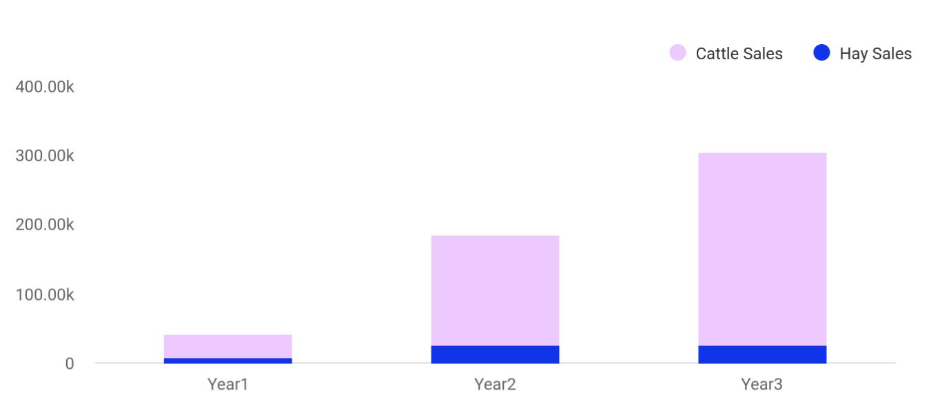

Riverland - Cattle Farm | Business Plan [YEAR] 21/39

Milestones

The accompanying table shows the specific milestones, with responsibilities assigned, dates, and budgets represented in this plan are those which have determined to be the most important.

Milestone | Start | End Date | Budget | Manager | Department
Milestone | Date
Secure Grant Funding | 10/1/2010 | 12/1/2010 | $0 |  | Accounts
($1,944,390) | 10/1/2010 | 12/1/2010 | $0 |  | Accounts
Land Purchase | 10/1/2010 | 12/31/2010 | $480,000 |  | Purchasing
Main Cattle Barn and | 11/1/2010 | 12/1/2011 | $285,920 |  | Purchasing
accessories | 11/1/2010 | 12/1/2011 | $285,920 |  | Purchasing
Personnel | 1/1/2010 | 12/31/2011 | $125,000 |  | Personnel
Existing Operating | 11/1/2010 | 12/31/2011 | $45,100 |  | Accounts
Expenses | 11/1/2010 | 12/31/2011 | $45,100 |  | Accounts
Cows & Calves | 11/1/2010 | 11/1/2012 | $297,990 |  | Purchasing
Equipment & | 11/1/2010 | 12/31/2012 | $710,380 |  | Purchasing
Accessories | 11/1/2010 | 12/31/2012 | $710,380 |  | Purchasing
Totals |  |  | $1,944,390

Detailed Budget

Land (192-acre farm, 3 pastures (already fenced), 5 pounds) | 480,000.00
Cattle Barn (60' x 150' x 20') | 125,000.00
Electrical | 15,000.00
Water & Sprinkler System | 10,000.00
Security System | 10,000.00
Phone Office | 1,200.00
Head Shuttle & Corral (for checking cows) | 15,000.00
Loading Shuttle | 1,000.00
Scale (for weighing cows) | 1,200.00
Water Well | 7,500.00
Drainage System (for barn) | 10,000.00

Riverland - Cattle Farm | Business Plan [YEAR] 22/39

Fans (10 @ $500) |  | 5,000.00
Bio-Security Mats (prevent cows from getting foot rot. 20 @ $250) |  | 5,000.00
Barrel Fans (4@$300) |  | 12,000.00
Automatic Water trough (5@150) |  | 750.00
Panels (16' -corral and inside cattle barn. 400@$100) |  | 40,000.00
Gates (16' @ $164) |  | 9,840.00
Treated Post (500 @ $15) |  | 7,500.00
Misc. Tools & Equipment (shop | brooms, wheelbarrows, scoops, and | 1,430.00
ext.) |  | 1,430.00
Septic System |  | 2,500.00
Computer System (lab top and | desktop computer) | 6,000.00
Total |  | 765,920.00

Operating and Direct Costs

Personnel Budget |  | Amount
 | John Doe | 45,000.00
 | Jimmy Doe | 45,000.00
 | Jane Doe | 30,000.00
 | Health Insurance | 5,000.00
Operating Expenses
 | Existing Vehicles | 32,000.00
 | Cattle Loans | 11,000.00
 | Parts & Supplies | 2,100.00
Cows & Calves
 | Feed, Mineral, & Protein | 15,000.00
 | Wormer | 1,140.00
 | Vet, Medicine, & Supplies | 2,000.00

Riverland - Cattle Farm | Business Plan [YEAR] 23/39

 | Mineral Twister Feeder (10 @ $145) |  | 1,450.00
 | Hay Rings (25 & $500) |  | 7,500.00
 | Cattle Rubs |  | 2,200.00
 | Creep Feeders (10 @ $490) |  | 4,900.00
 | Cabinets (for medical supplies) |  | 1,000.00
 | 250 broad cows (intent to eventually buy 500 | head of | 250,000.00
 | broad cows) |  | 250,000.00
 | Bulls (8 @ $1500) |  | 12,000.00
 | Refrigerator (for meds) |  | 800.00
Total |  |  | 468,090.00

Riverland - Cattle Farm | Business Plan [YEAR] 24/39

6.

Management Summary

Management

Personnel Plan

Riverland - Cattle Farm | Business Plan [YEAR] 25/39

Management

John Doe

Owner & CEO - johnd@example.com

John doe will act as the manager of all operations.

Duties with include:

Checking, feeding, putting out hay, doctoring, giving shots, weaning, putting tags on ears, banding, and paperwork.

Personnel Plan

The personnel plan includes Arnold Doe as well as their son John Doe and Jimmy Doe, who will be responsible for cutting, raking, baling hay, putting out hay, taking calves to sell, and help to work with calves.

All additional staff will be paid on a part-time subcontract basis.

Personnel Plan | Year1 | Year2 | Year3
Arnold Doe | $2,000 | $35,000 | $45,000
John Doe | $2,000 | $35,000 | $45,000
Jimmy Doe | $1,000 | $20,000 | $30,000
Total People | 3 | 3 | 3
Total Payroll | $5,000 | $90,000 | $120,000

Riverland - Cattle Farm | Business Plan [YEAR] 26/39

7.

Financial Plan

Important Assumptions

Break-even Analysis

Projected Profit and Loss

Projected Cash Flow

Projected Balance Sheet

Business Ratios

Riverland - Cattle Farm | Business Plan [YEAR] 27/39

 Riverland
To unlock help try Upmetrics!
To unlock help try Upmetrics!

The financial plan is based on conservative estimates and assumptions. The company’s investments in salaries, operating costs, equipment, land, and cattle are based on receiving grant funding of $1,944,390.



Start writing here..

Important Assumptions

 Riverland

The primary assumption made in this plan is that will receive grant funding. All interest payment assumptions have been made at 10% to give a conservative margin in interest rate fluctuations.



Start writing here..

Break-even Analysis

The Break-even analysis for Riverland assumes an estimated monthly fixed cost of $3,402 with the assumption that the average percent variable cost estimate is 23%; the monthly revenue break-even is $4,438.


Break-even Analysis

Monthly Revenue Break-even

Assumptions:

Average Percent Variable Cost

Estimated Monthly Fixed Cost

$4,438

23%

$3,402

Riverland - Cattle Farm | Business Plan [YEAR] 28/39

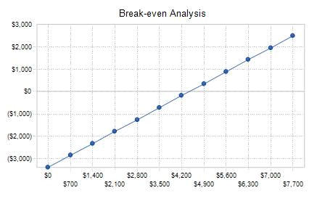

Projected Profit and Loss

 | 2024 | 2025 | 2026
Revenue | $535,295.70 | $682,271.20 | $979,845
Beef Sales | $61,626.20 | $70,570.50 | $97,933.90
Unit Sales | 12,325 | 14,114 | 19,587
Unit Price | $5 | $5 | $5
Dairy Products | $393,669.50 | $527,700.70 | $793,711.10
Unit Sales | 78,734 | 105,540 | 158,742
Unit Price | $5 | $5 | $5
Breeding and Sale of | $80,000 | $84,000 | $88,200
Livestock | $80,000 | $84,000 | $88,200
Unit Sales | 80 | 84 | 88
Unit Price | $1,000 | $1,000 | $1,000

Riverland - Cattle Farm | Business Plan [YEAR] 29/39

Cost Of Sales

General Costs

Livestock Maintenance

Costs

Feed and Nutrition

Veterinary and Health Care

Production and Processing Costs

Dairy Processing

Meat Processing and

Packaging

Revenue Specific Costs

Personnel Costs (Direct Labor)

Gross Margin

Gross Margin (%)

Operating Expense

Payroll Expense (Indirect Labor)

Farm Management

Farm Manager

Assistant Manager

Animal Care

Veterinarian

Herdsmen
2024 2025 2026

$95,294.36 | $117,898.69 | $163,114.96
$95,294.36 | $117,898.69 | $163,114.96
$15,000 | $15,558 | $16,138.20
$9,600 | $9,888 | $10,184.64
$5,400 | $5,670 | $5,953.56
$80,294.36 | $102,340.69 | $146,976.76
$37,470.70 | $47,759 | $68,589.14
$42,823.66 | $54,581.69 | $78,387.62
$0 | $0 | $0
$0 | $0 | $0

$440,001.34 | $564,372.51 | $816,730.04
82.20% | 82.72% | 83.35%

$450,774 | $461,432.28 | $472,332.63
$431,424 | $441,761.28 | $452,356.56
$110,880 | $114,206.40 | $117,632.64
$60,480 | $62,294.40 | $64,163.28
$50,400 | $51,912 | $53,469.36
$166,200 | $170,124 | $174,144.48
$60,000 | $61,800 | $63,654
$106,200 | $108,324 | $110,490.48

Riverland - Cattle Farm | Business Plan [YEAR] 30/39

 | 2024 | 2025 | 2026
General Maintenance | $154,344 | $157,430.88 | $160,579.44
Maintenance Staff | $118,944 | $121,322.88 | $123,749.28
Groundskeeper | $35,400 | $36,108 | $36,830.16
General Expense | $19,350 | $19,671 | $19,976.07
Farm Operating Expenses | $6,000 | $6,156 | $6,291.72
Fencing Maintenance and | $2,400 | $2,448 | $2,472.48
Repair | $2,400 | $2,448 | $2,472.48
Farm Utility Bills | $3,600 | $3,708 | $3,819.24
Machinery and Equipment | $9,500 | $9,605 | $9,713.15
Machinery Maintenance | $3,500 | $3,605 | $3,713.15
Equipment Depreciation | $6,000 | $6,000 | $6,000
Miscellaneous Expenses | $3,850 | $3,910 | $3,971.20
Insurance | $3,000 | $3,060 | $3,121.20
Property Taxes | $850 | $850 | $850
Bad Debt | $0 | $0 | $0
Amortization of Current | $0 | $0 | $0
Assets | $0 | $0 | $0

EBITDA | ($10,772.66) | $102,940.23 | $344,397.41

Additional Expense | $15,609.17 | $13,045.16 | $10,911.55

Long Term Depreciation

Gain or loss from Sale of Assets

EBIT

Interest Expense

EBT

$10,740 | $10,740 | $10,740
$0 | $0 | $0
($21,512.66) | $92,200.23 | $333,657.41
$4,869.15 | $2,305.16 | $171.55
($26,381.83) | $89,895.07 | $333,485.86

Riverland - Cattle Farm | Business Plan [YEAR] 31/39

 | 2024 | 2025 | 2026
Income Tax Expense / | $0 | $0 | $0
Benefit | $0 | $0 | $0
Total Expense | $561,677.53 | $592,376.13 | $646,359.14
Net Income | ($26,381.83) | $89,895.07 | $333,485.86
Net Income (%) | (4.93%) | 13.18% | 34.03%
Retained Earning Opening | $0 | ($38,381.83) | $39,513.24
Owner's Distribution | $12,000 | $12,000 | $12,000
Retained Earning Closing | ($38,381.83) | $39,513.24 | $360,999.10
Projected Cash Flow
 | 2024 | 2025 | 2026
Cash Received | $535,295.70 | $682,271.20 | $979,845
Cash Paid | $550,937.53 | $581,636.13 | $635,619.14
COS & General Expenses | $114,644.36 | $137,569.69 | $183,091.03
Salary & Wages | $431,424 | $441,761.28 | $452,356.56
Interest | $4,869.15 | $2,305.16 | $171.55
Sales Tax | $0 | $0 | $0
Income Tax | $0 | $0 | $0
Net Cash From | ($15,641.83) | $100,635.07 | $344,225.86
Operations | ($15,641.83) | $100,635.07 | $344,225.86
Assets Sell | $0 | $0 | $0
Assets Purchase | $130,000 | $0 | $0

Riverland - Cattle Farm | Business Plan [YEAR] 32/39

Net Cash From

Investments

Amount Received

Loan Received

Common Stock

Preferred Stock

Owner's Contribution

Amount Paid

Loan Capital

Dividends & Distributions

Net Cash From

Financing

Summary

2024 | 2025 | 2026
($130,000) | $0 | $0

$150,000 | $0 | $0
$150,000 | $0 | $0
$0 | $0 | $0
$0 | $0 | $0
$0 | $0 | $0
$53,570.83 | $56,134.84 | $26,294.31
$41,570.85 | $44,134.84 | $14,294.31
$12,000 | $12,000 | $12,000
$96,429.17 | ($56,134.84) | ($26,294.31)

Starting Cash | $0 | ($49,212.66) | ($4,712.43)
Cash In | $685,295.70 | $682,271.20 | $979,845
Cash Out | $734,508.36 | $637,770.97 | $661,913.45
Change in Cash | ($49,212.66) | $44,500.23 | $317,931.55
Ending Cash | ($49,212.66) | ($4,712.43) | $313,219.12

Projected Balance Sheet

 | 2024 | 2025 | 2026
Assets | $70,047.34 | $103,807.57 | $410,999.12
Current Assets | ($49,212.66) | ($4,712.43) | $313,219.12
Cash | ($49,212.66) | ($4,712.43) | $313,219.12

Riverland - Cattle Farm | Business Plan [YEAR] 33/39

 | 2024 | 2025 | 2026
Accounts Receivable | $0 | $0 | $0
Inventory | $0 | $0 | $0
Other Current Assets | $0 | $0 | $0
Long Term Assets | $119,260 | $108,520 | $97,780
Gross Long Term Assets | $130,000 | $130,000 | $130,000
Accumulated Depreciation | ($10,740) | ($21,480) | ($32,220)

Liabilities & Equity | $70,047.32 | $103,807.55 | $410,999.10
Liabilities | $108,429.15 | $64,294.31 | $50,000
Current Liabilities | $44,134.84 | $14,294.31 | $0
Accounts Payable | $0 | $0 | $0
Income Tax Payable | $0 | $0 | $0
Sales Tax Payable | $0 | $0 | $0
Short Term Debt | $44,134.84 | $14,294.31 | $0
Long Term Liabilities | $64,294.31 | $50,000 | $50,000
Long Term Debt | $64,294.31 | $50,000 | $50,000
Equity | ($38,381.83) | $39,513.24 | $360,999.10
Paid-in Capital | $0 | $0 | $0
Common Stock | $0 | $0 | $0
Preferred Stock | $0 | $0 | $0
Owner's Contribution | $0 | $0 | $0
Retained Earnings | ($38,381.83) | $39,513.24 | $360,999.10

Check | $0 | $0 | $0

Riverland - Cattle Farm | Business Plan [YEAR] 34/39

Business Ratios

The table below presents the business ratios for Alsbrook Farms. The Industry Profile comparisons for “Beef Cattle Ranching and Farming” used for reference in this table.

The Standard Industrial Classification (SIC) Code 0212 and the North American Industrial Classification Standard (NAICS) 112111 were used as subset options matching the industry of this business.

 |  | Year1 | Year2 | Year3 | Industry
Sales Growth |  | 156.42% | 492.03% | 82.61% | 1.50%
Percent of Total Assets
Inventory |  | 0.42% | 19.59% | 15.31% | 5.51%
Other Current | Assets | 2.66% | 3.11% | 3.68% | 38.63%
Total Current | Assets | 23.04% | 24.04% | 24.74% | 47.47%
Long-term Assets |  | 76.96% | 75.96% | 75.26% | 52.53%
Total Assets |  | 100.00% | 100.00% | 100.00% | 100.00%
Current Liabilities |  | 0.97% | 2.53% | 0.72% | 19.01%
Long-term Liabilities |  | 2.02% | 1.40% | 0.43% | 79.98%
Total Liabilities |  | 2.98% | 3.93% | 1.15% | 98.99%
Net Worth |  | 97.02% | 96.07% | 98.85% | 1.01%
Percent of Sales
Sales |  | 100.00% | 100.00% | 100.00% | 100.00%
Gross Margin |  | 76.67% | 70.81% | 70.29% | 71.78%
Selling, General & Administrative Expenses |  | 159.96% | 67.03% | 65.16% | 12.72%
Advertising Expenses |  | 0.62% | 0.17% | 0.13% | 0.36%
Profit Before | Interest and Taxes | -63.46% | 8.22% | 8.30% | 5.06%
Main Ratios

Riverland - Cattle Farm | Business Plan [YEAR] 35/39

 |  | Year1 | Year2 | Year3 | Industry
Current |  | 23.81 | 9.51 | 34.16 | 1.46
Quick |  | 23.37 | 1.76 | 13.02 | 1.17
Total Debt to Total | Assets | 2.98% | 3.93% | 1.15% | 98.99%
Pre-tax Return on | Net Worth | -1.24% | 0.48% | 1.17% | 936.59%
Pre-tax Return on | Assets | -1.21% | 0.46% | 1.15% | 9.43%
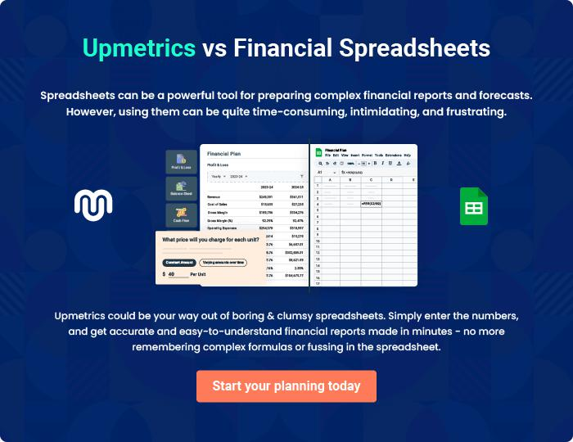

Riverland - Cattle Farm | Business Plan [YEAR] 36/39

8.

Appendix

Sales Forecast

Personnel

Profit and Loss

Cash Flow

Balance Sheet

Riverland - Cattle Farm | Business Plan [YEAR] 37/39

Sales Forecast

Insert Monthly Sales Forecast data

Personnel

Insert Monthly Personnel Forecast data

Profit and Loss

Insert Monthly Profit and Loss Projections

Cash Flow

Insert Monthly Cash Flow Projections

Balance Sheet

Insert Monthly Balance Sheet Projections

Riverland - Cattle Farm | Business Plan [YEAR] 38/39


Create a winning business plan that gets you funded

Creating a stunning and investment-ready plan requires no writing, graphic designing, or financial planning expertise.

Upmetrics has all the features required to help you create a comprehensive business plan—from start to finish. Make no mistakes, it’s the modern way of planning to structure ideas, make plans, and create stunning pitch decks to awe investors.

Pitch decks that impress investors

Create pitch decks that provide a visual representation of your business, engage investors, and make them want to invest in your business idea.

Interactive plans in no time

Import business plan sections like—SWOT analysis, comparison tables, and others to create an interactive business plan. No designing skills are required.

Stunning cover page designs

With Upmetrics, you have the liberty to choose from multiple stunning cover page designs. Choose a creative design and make your plan stand out.

Online sharing made simple

Upmetrics makes online sharing quick and easier for users. Easily share your business plans with a link while tracking reader activity.

500+ sample business plans

Simply import a template from our library of sample plans into the editor and start customizing it to make it yours. It takes only a few clicks to get started.

Collaborate with team in real-time

Invite team members, initiate conversations, discuss ideas & strategies, share feedback, and work on a business plan in real-time.

