
Car Wash


Business
Plan

[YEAR]


It’s more than a car… Keep it clean.

Information provided in this business plan is unique to this business and confidential; therefore, anyone reading this plan agrees not to disclose any of the information in this business plan without prior written permission of the Company

 | Prepared By | 10200 Bolsa Ave, Westminster, CA, 92683
 | John Doe | info@example.com
 | (650) 359-3153 | http://www.example.com

Table of Contents

Executive Summary | 5
Venture Description | 6
Management and Organization Plan | 6
Carmen Perez | 6
Objectives | 7
Marketing Plan | 7
Keys to Success | 7
Financial Plan | 8

Business Summary | 9
Legal Form of Business | 10
Management Team | 10
Carmen Perez | 10
Board of directors | 10
Carmen Perez | 10
Tony Perez | 11
Advisory council | 11
Anne Klinesmet | 11
Ted Hooster | 11
Gerald Lance | 11
Hiring Plan | 12
Compensation and Ownership | 12
Employee Reward and Incentive Plan | 12

Products & Services | 13
Purpose of Our Services | 14
Features and Benefits | 14
Our Services | 14
Related Products/Services and Spin-Offs | 15

Car Wash | Business Plan [YEAR] 2/35

Market Analysis | 16
Industry Profile | 17
Current size | 17
Growth potential | 17
Industry Trends | 17
Other Characteristics | 18
Distribution Channels | 18
Target Market Profile | 18
Customer Profile | 19
Future Markets | 19

Competitive Analysis | 20
Direct Competition | 21
Indirect Competition | 21
Future Competition | 21
Competitive Analysis | 22

Marketing & Sales Plan | 23
Marketing Strategy | 24
Advertising and Promotion | 24
Publicity | 24
Telemarketing/Direct mail | 25
Internet | 25
Trade Shows | 25
Pricing Strategy | 25
Pricing Policies | 26

Financial Plan | 27
Break-even Analysis | 28
Income Statement Projections | 28
Balance Sheet Projections | 31
Cash Flow Statement | 32

Car Wash | Business Plan [YEAR] 3/35

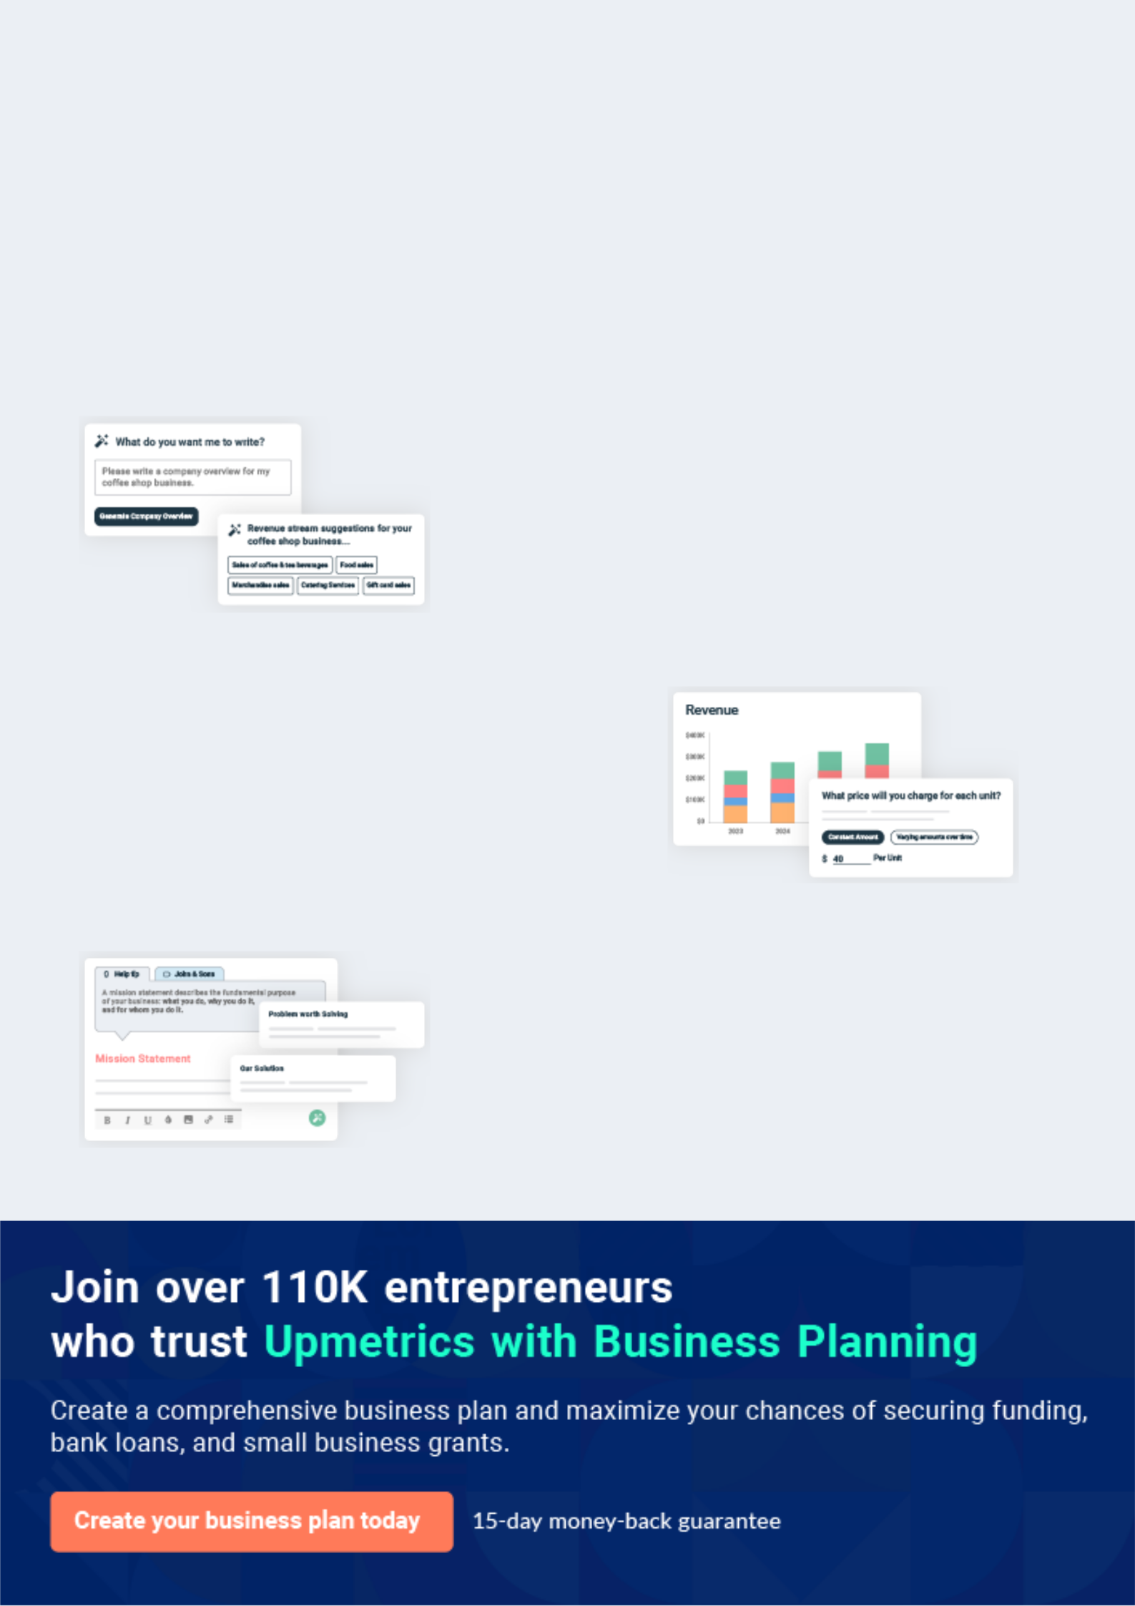
Business planning that’s simpler and faster than you think

Creating a business plan using Upmetrics to start and grow a business is literally the easiest thing in the World. Simply read the instructions and fill in the blanks. It’s as simple as that.

❛ | Upmetrics has everything you need to create a | ❜
❛ | comprehensive business plan. | ❜

AI-powered Upmetrics Assistant

AI-powered insights to streamline your plan

Not sure where to start? Upmetrics’ AI Assistant will automatically generate ideas for each section of your plan and offer improved versions of your writing, adjusting for tone, voice, and grammar or spelling errors.

Financial Forecasting Tool

All the financials are calculated for you

Forget the complex formulas and clumsy spreadsheets — with automatic financials and drag-and-drop forecasting, you can finish your plan faster and be confident that your numbers are accurate.

Business Plan Builder

Guides you like a business mentor

Upmetrics’ step-by-step instructions, prompts, and the library of 400+ sample business plans will guide you through each section of your plan as a business mentor.

1.


Executive Summary

Venture Description

Management and Organization Plan

Objectives

Marketing Plan

Keys to Success

Financial Plan

Car Wash | Business Plan [YEAR] 5/35

Venture Description

 S&G Car Wash


Steve and Gabriel Car Wash Inc. (S&G) plans to build a four-in-one car wash with four self-service bays and one automatic drive-thru. The facility will offer the most modern and efficient self-cleaning equipment in the area, will be a well-lit, nicely landscaped, modern structure that
To unlock help try Upmetrics! 

Start writing here..

Management and Organization Plan

 S&G Car Wash

Sparkle & Gleam Car Wash Inc. (S&G) is a StateA, Subchapter S Corporation formed in April 200B. The corporate form was chosen for its limitation of liability and ease of transferability. The Sub-chapter Selection was made to avoid double taxation. The sole stockholder, President,
To unlock help try Upmetrics! 

Start writing here..


Carmen Perez

CEO - Carmenp@example.com

Carmen has worked full time at a local electrical contracting company for the past 15 years. She is vice president of operations and will continue to work until S&G opens. Formerly, Carmen was employed as a marketing manager for a real estate company. She will handle all day-to-day operations, buying of supplies and marketing of the business.

Car Wash | Business Plan [YEAR] 6/35

Objectives

 S&G Car Wash

The objectives for S&G Car Wash and Detail Service are:

1. To be viewed as a premium car wash and detail service in East Meadow.
To unlock help try Upmetrics! 

Start writing here..

Marketing Plan

 S&G Car Wash

The site of S&G is the most important factor in the success of the business. All factors have been considered, and the corner of Leeds Parkway and Dunbrooke Road in Copperville, StateA has been selected. This location is situated on the northwest corner of the intersection of two
To unlock help try Upmetrics! 

Start writing here..

Keys to Success

 S&G Car Wash

• S&G is situated on the northwest corner of the intersection of two major thoroughfares in this treasured community This site is particularly well-suited for a car wash.
• Direct competition is limited to outdated "tunnel" or friction car washes, lube & washes,
To unlock help try Upmetrics! 

Start writing here..

Car Wash | Business Plan [YEAR] 7/35

Financial Plan

 S&G Car Wash

The overall cost for the start-up of this business is $615,000.This amount is broken down as follows:
To unlock help try Upmetrics! 

Start writing here..

Car Wash | Business Plan [YEAR] 8/35

2.

Business Summary

Legal Form of Business

Management Team

Board of directors

Advisory council

Hiring Plan

Compensation and Ownership

Employee Reward and Incentive Plan

Car Wash | Business Plan [YEAR] 9/35

Legal Form of Business

 S&G Car Wash

Steve & Gabriel Car Wash Inc. is a Subchapter S Corporation, registered by the StateA Secretary of State to do business in StateA. The Subchapter S election, filed with the Internal Revenue Service, offers a reduced tax liability for the owner. The corporate status provides the owner
To unlock help try Upmetrics! 

Start writing here..

Management Team

Carmen Perez

CEO - Carmenp@example.com

Carmen has worked full time at a local electrical contracting company for the past 15 years. She is vice president of operations and will continue to work until S&G opens. Formerly, Carmen was employed as a marketing manager for a real estate company. She will handle all day-to-day car wash operations, buying of supplies, and marketing of the business.

Board of directors

Carmen Perez

Chairman of the Board - Carmenp@example.com

Car Wash | Business Plan [YEAR] 10/35


Tony Perez

Secretory - tonyp@example.com

TonyPerez will serve as corporate secretary and as a member of the board of directors, primarily as an accommodation.

Advisory council

 S&G Car Wash

Currently, four people serve on the advisory council. They bring start-up and on-going management and subject-matter expertise to Carmen Perez. The advisory council members have volunteered to meet together each month during the first year in business to provide
To unlock help try Upmetrics! 

Start writing here..


Anne Klinesmet

Annek@example.com

Owner of two area businesses — a landscaping service and an equipment rental store— to provide an entrepreneurial perspective.


Ted Hooster

tedh@example.com

Independent financial advisor—to assist in building a business that meets Carmen’s personal vision


Gerald Lance

Geraldl@example.com

Certified public accountant—to provide evaluation and guidance concerning financial statement projection and on-going analysis.

Car Wash | Business Plan [YEAR] 11/35

Hiring Plan

 S&G Car Wash

S&G has been created for the purpose of creating a family-owned business that the Perez family can own and operate. There are no plans for management personnel in addition to Carmen Perez. Custodial service, grounds upkeep, machine servicing and repair, and
To unlock help try Upmetrics! 

Start writing here..

Compensation and Ownership

 S&G Car Wash

S&G will employ Carmen at a salary of $24,000 in the first year (that salary is projected to go to $36,000 in the second year). Part-time employees will be paid $10.00 an hour. Carmen holds all of the stock of the company. The company offers minimal benefits to the owner and no
To unlock help try Upmetrics! 

Start writing here..

Employee Reward and Incentive Plan

 S&G Car Wash

S&G will not have a formal employee incentive plan to start. Employees will be motivated through rewards and incentives for jobs well done, goals met, problems solved, and taking initiative. Initially, rewards will be non-monetary, to include paid time off, flexible work hours,
To unlock help try Upmetrics! 

Start writing here..

Car Wash | Business Plan [YEAR] 12/35

3.

Products & Services

Purpose of Our Services

Features and Benefits

Our Services

Related Products/Services and Spin-Offs

Car Wash | Business Plan [YEAR] 13/35

Purpose of Our Services

 S&G Car Wash

Steve & Gabriel customers will:

Save time because of the
To unlock help try Upmetrics! 

Start writing here..

Features and Benefits

 S&G Car Wash

Steve & Gabriel Car Wash will offer technologically advanced, frictionless, touch-free exterior in-bay automatic and self-service car wash facilities. The basic automobile wash consists of the self-service wash options. In-bay automatic upgrade washes consist of an under chassis wash,
To unlock help try Upmetrics! 

Start writing here..

Our Services

 S&G Car Wash

S&G realizes the car wash industry, top to bottom, is a service industry. S&G will establish itself as the premier car wash facility by providing a quality service for a competitive price and by focusing our staff on customer service. We will offer the following services to the City
To unlock help try Upmetrics! 

Start writing here..

Car Wash | Business Plan [YEAR] 14/35

Related Products/Services and Spin-Offs

 S&G Car Wash

S&G constantly monitors the car wash industry and will adopt new technology that offers customers a better product or aids in water conservation and anti-pollution efforts. There are new spin-offs that we might develop which would keep us on top of changing market trends.
To unlock help try Upmetrics! 

Start writing here..
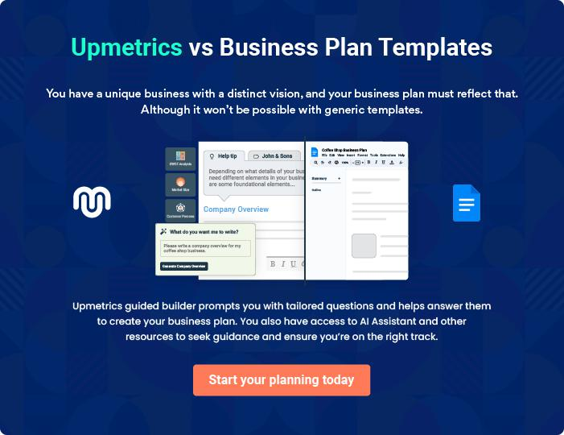

Car Wash | Business Plan [YEAR] 15/35

4.

Market Analysis

Industry Profile

Industry Trends

Other Characteristics

Distribution Channels

Target Market Profile

Customer Profile

Future Markets

Car Wash | Business Plan [YEAR] 16/35

Industry Profile

 S&G Car Wash

The industry has developed to a mature product/service. It is generally agreed that the first automatic car wash was developed around 1914. By 1945 there were 32 car washes across the nation. As the automobile industry grew, the car wash industry grew exponentially. Due to
To unlock help try Upmetrics! 

Current size

Start writing here..

 S&G Car Wash


The Car wash industry and revenue growth in the US and in StateA is increasing at a high rate. U.S. Census industry data for the most recent five-year study shows growth in

Growth potential

Start writing here..

Industry Trends

 S&G Car Wash

To unlock help try Upmetrics! 

Convenient payment methods are an issue in self-service industries. The release of the new dollar coin, increasing use of credit and debit cards, and technologies allowing prepaid payment cards are all indicators of the coming changes. Vendors are developing new technologies that
To unlock help try Upmetrics! 

Start writing here..

Car Wash | Business Plan [YEAR] 17/35

Other Characteristics
To unlock help try Upmetrics!
To unlock help try Upmetrics!

 S&G Car Wash

Car washes are located in all parts of the country. Certain locations, notably the south and west, have higher concentrations of car washes but car washes are a necessity everywhere.
According to car wash industry sources, an abundance of multi-family housing units in an area
To unlock help try Upmetrics! 

Start writing here..

Distribution Channels

 S&G Car Wash

Efficiently running road systems are the distribution system for car washes. Due to the construction of the six corporate campuses surrounding the area, the road system serving S&G runs smoothly and efficiently.



Start writing here..

Target Market Profile

 S&G Car Wash


The Copperville area is the target market. In this market, the following graphs show how the market area closely compares to the ideal customer profile. (Data were

Start writing here..



Car Wash | Business Plan [YEAR] 18/35

Customer Profile
To unlock help try Upmetrics!

 S&G Car Wash

Today’s customers have changed considerably. Fifteen years ago, the primary market was 90% male; today, the clientele varies from 16-year-old females to 75-year-old males and everything in between. Of the car washes operating today, 13% are less than 10 years old and of that 7 % are
To unlock help try Upmetrics! 

Start writing here..

Future Markets

 S&G Car Wash

S&G will look for opportunities in suitable locations to open additional operations. This expansion will not be a priority because extensive research has been done showing that the current location is the best in the city.



Start writing here..

Car Wash | Business Plan [YEAR] 19/35

5.

Competitive Analysis

Direct Competition

Indirect Competition

Future Competition

Competitive Analysis

Car Wash | Business Plan [YEAR] 20/35

Direct Competition

 S&G Car Wash

The location of the car wash is the most important indicator of success. Locating the site too close to the competition will only divide the current market, rather than expand it. Therefore, it is important from a competitive standpoint to locate where there is little competition or where
To unlock help try Upmetrics! 

Start writing here..

Indirect Competition

 S&G Car Wash

S&G will have indirect competition from any other sources of car washes, such as the car owner at home, detailers, charitable fundraisers, and car service businesses. The weather will limit competition from the owner and fundraisers but the other two indirect competitors are in
To unlock help try Upmetrics! 

Start writing here..

Future Competition

 S&G Car Wash

Carmen will periodically visit car washes in the area to assess the continued competitiveness of S&G and stay abreast of new products and equipment in the industry. The establishment of S&G should discourage new similar facilities within close proximity but Carmen will remain
To unlock help try Upmetrics! 

Start writing here..

Car Wash | Business Plan [YEAR] 21/35

Competitive Analysis

 S&G Car Wash

The basis of competition among car washes is location convenience, equipment parameters, and price for services.S&G is the only car wash within a 3-mile radius of the major arteries of Leeds Parkway and Dunbrooke Road. Our price will be similar to the other four car washes
To unlock help try Upmetrics! 

Start writing here..

Car Wash | Business Plan [YEAR] 22/35

6.

Marketing & Sales Plan

Marketing Strategy

Advertising and Promotion

Publicity

Telemarketing/Direct mail

Internet

Trade Shows

Pricing Strategy

Car Wash | Business Plan [YEAR] 23/35

Marketing Strategy
To unlock help try Upmetrics!

 S&G Car Wash

Marketing in our car wash business relies on the name recognition of the Laserwash system as an industry leader and the "curbside" appeal of the site for first-time customers. Quality service will bring customers back time and time again. Also, the use of a local radio station and the
To unlock help try Upmetrics! 

Start writing here..

Advertising and Promotion

 S&G Car Wash

When Steve & Gabriel opens, press releases will go out to the local newspapers, radio and television stations. For the first four Saturdays after the opening, ads will run in the Copperville Times and on two radio stations.



Start writing here..

Publicity

 S&G Car Wash

A new use for the old site of the Copperville Community Center will generate a certain level of interest and we will send press releases to the local media at all stages of the governmental approval process as well as groundbreaking, construction completion and grand opening. In
To unlock help try Upmetrics! 

Start writing here..

Car Wash | Business Plan [YEAR] 24/35

Telemarketing/Direct mail

 S&G Car Wash

Direct mail will be an important part of the media mix. The initial marketing effort will include a direct mail flyer to the 5,000 households closest to the car wash.
To unlock help try Upmetrics! 

Start writing here..

Internet

 S&G Car Wash

Steve & Gabriel does not plan to have an internet presence at this time.

To unlock help try Upmetrics! 

Start writing here..

Trade Shows

 S&G Car Wash

Carmen will attend trade shows from time to time to assess the direction of the industry and to keep abreast of new trends and technologies.
To unlock help try Upmetrics! 

Start writing here..

Pricing Strategy

Pricing is based on local averages of competitors.

Car Wash | Business Plan [YEAR] 25/35

Products & Services | Price
In-bay self-service wash products
• Presoak
• Rinse
• Spot free rinse
• Soapy wash | $1.00 for 3.75 minutes and $0.25 for each
• Soapy wash | additional minute.
• Tire cleaner | additional minute.
• Engine cleaner
• Scrubby brush
• Wax
• Rust Prohibition
Automatic wash bay
• Basic
• Basic with wax | $15 for package
• Deluxe | $15 for package
• Deluxe with wax
Vacuum | $1
Shampoo Machine | $1.00 / 3.2 minutes

 S&G Car Wash

At the present time S&G does not have any quantity discountsor introductory offers. If fleet sales are made or customer demands suggests them, they will be explored.
To unlock help try Upmetrics! 

Pricing Policies

Start writing here..

Car Wash | Business Plan [YEAR] 26/35

7.

Financial Plan

Break-even Analysis

Income Statement Projections

Balance Sheet Projections

Cash Flow Statement

Car Wash | Business Plan [YEAR] 27/35

Break-even Analysis

S&G’s gross margin is figured at 100%. Some car washes deduct applicable supplies (soap) and utilities along with direct labor from gross revenues as a cost of goods sold. However, as a totally self-service operation, S&G has no direct labor and the decision was made to expense all costs as operations cost so that comparisons could be easily made to RMA composite statements, which do not use the cost of goods sold. With no variable expenses and four different services which are projected at different prices and different levels of sales; break-even can only be calculated using projected Net Sales and Total expenses.

Projections indicate that Operating Income will actually be in excess of Operating Expenses within the 2nd Year but Debt Service will prevent true break-even until the 3rd Year.

 | Year1 | Year2 | Year3
Net Sales | [Amount] | [Amount] | [Amount]
Operating Expenses | [Amount] | [Amount] | [Amount]
Operating Income | [Amount] | [Amount] | [Amount]
Interest Expense | [Amount] | [Amount] | [Amount]
Net Income | [Amount] | [Amount] | [Amount]

Income Statement Projections

 | 2024 | 2025 | 2026
Revenue | $478,562 | $1,181,504.85 | $2,167,194.85
Basic Car Wash | $119,378.55 | $214,386.90 | $385,007.40
Unit Sales | 7,959 | 14,292 | 25,667
Unit Price | $15 | $15 | $15
Premium Car Wash | $106,439.75 | $151,757.25 | $216,361.75
Unit Sales | 4,258 | 6,070 | 8,654
Unit Price | $25 | $25 | $25
Monthly Subscription | $252,743.70 | $815,360.70 | $1,565,825.70
Users | 1,348 | 3,118 | 5,505
Recurring Charges | $30 | $30 | $30

Car Wash | Business Plan [YEAR] 28/35

2024 2025 2026

Cost Of Sales | $36,718.30 | $73,756.61 | $125,224.76
General Costs | $36,718.30 | $73,756.61 | $125,224.76
Cleaning Supplies | $10,253.73 | $11,823.19 | $13,644.42
Soap and Detergents | $6,341.24 | $7,145.34 | $8,051.52
Waxes and Polishes | $3,912.49 | $4,677.85 | $5,592.90
Equipment Maintenance | $26,464.57 | $61,933.42 | $111,580.34
Machine Maintenance | $23,928.11 | $59,075.26 | $108,359.75
Towel and Brush | $2,536.46 | $2,858.16 | $3,220.59
Replacement | $2,536.46 | $2,858.16 | $3,220.59
Revenue Specific Costs | $0 | $0 | $0
Personnel Costs (Direct | $0 | $0 | $0
Labor) | $0 | $0 | $0

Gross Margin | $441,843.70 | $1,107,748.24 | $2,041,970.09
Gross Margin (%) | 92.33% | 93.76% | 94.22%

Operating Expense | $637,079.45 | $717,959.45 | $826,443.67
Payroll Expense (Indirect | $552,720 | $568,101.60 | $583,932.84
Labor) | $552,720 | $568,101.60 | $583,932.84
Car Wash Technicians | $369,900 | $380,997 | $392,427.12
Basic Wash Technician | $225,000 | $231,750 | $238,702.80
Premium Wash Technician | $144,900 | $149,247 | $153,724.32
Administrative Staff | $94,500 | $96,135 | $97,807.08
Office Manager | $60,000 | $60,600 | $61,206
Receptionist | $34,500 | $35,535 | $36,601.08
Maintenance Crew | $88,320 | $90,969.60 | $93,698.64

Car Wash | Business Plan [YEAR] 29/35

Equipment Maintenance Technician

General Expense

Facility Expenses

Rent

Utilities

Marketing and Advertising

Local Advertising

Online Marketing

General and Administrative

Office Supplies

Insurance

Bad Debt

Amortization of Current Assets

EBITDA

Additional Expense

Long Term Depreciation

Gain or loss from Sale of Assets

EBIT

Interest Expense

EBT

Income Tax Expense / Benefit

2024 | 2025 | 2026
$88,320 | $90,969.60 | $93,698.64
$84,359.45 | $149,857.86 | $242,510.83
$34,242.69 | $39,227.96 | $47,255
$25,364.99 | $28,581.81 | $32,206.53
$8,877.70 | $10,646.15 | $15,048.47
$40,677.79 | $100,427.92 | $184,211.58
$16,749.68 | $41,352.66 | $75,851.83
$23,928.11 | $59,075.26 | $108,359.75
$9,438.97 | $10,201.98 | $11,044.25
$4,438.97 | $5,001.98 | $5,636.25
$5,000 | $5,200 | $5,408
$0 | $0 | $0
$0 | $0 | $0

($195,235.75) $389,788.79 $1,215,526.41

$8,192.42 | $7,070.62 | $5,867.75
$5,184 | $5,184 | $5,184
$0 | $0 | $0
($200,419.75) | $384,604.79 | $1,210,342.41
$3,008.41 | $1,886.63 | $683.75
($203,428.17) | $382,718.17 | $1,209,658.66
$0 | $0 | $0

Car Wash | Business Plan [YEAR] 30/35

2024 2025 2026

Total Expense | $681,990.17 | $798,786.68 | $957,536.19
Net Income | ($203,428.17) | $382,718.17 | $1,209,658.66
Net Income (%) | (42.51%) | 32.39% | 55.82%

Retained Earning Opening | $0 | ($216,428.17) | $153,290
Owner's Distribution | $13,000 | $13,000 | $13,000
Retained Earning Closing | ($216,428.17) | $153,290 | $1,349,948.66

Balance Sheet Projections

 | 2024 | 2025 | 2026
Assets | ($151,945.95) | $201,132.64 | $1,379,948.66
Current Assets | ($171,761.95) | $186,500.64 | $1,370,500.66
Cash | ($171,761.95) | $186,500.64 | $1,370,500.66
Accounts Receivable | $0 | $0 | $0
Inventory | $0 | $0 | $0
Other Current Assets | $0 | $0 | $0
Long Term Assets | $19,816 | $14,632 | $9,448
Gross Long Term Assets | $25,000 | $25,000 | $25,000
Accumulated Depreciation | ($5,184) | ($10,368) | ($15,552)

Liabilities & Equity | ($151,945.96) | $201,132.64 | $1,379,948.66
Liabilities | $34,482.21 | $17,842.64 | $0
Current Liabilities | $16,639.57 | $17,842.64 | $0
Accounts Payable | $0 | $0 | $0

Car Wash | Business Plan [YEAR] 31/35

 | 2024 | 2025 | 2026
Income Tax Payable | $0 | $0 | $0
Sales Tax Payable | $0 | $0 | $0
Short Term Debt | $16,639.57 | $17,842.64 | $0
Long Term Liabilities | $17,842.64 | $0 | $0
Long Term Debt | $17,842.64 | $0 | $0
Equity | ($186,428.17) | $183,290 | $1,379,948.66
Paid-in Capital | $0 | $0 | $0
Common Stock | $0 | $0 | $0
Preferred Stock | $0 | $0 | $0
Owner's Contribution | $30,000 | $30,000 | $30,000
Retained Earnings | ($216,428.17) | $153,290 | $1,349,948.66
Check | $0 | $0 | $0
Cash Flow Statement
 | 2024 | 2025 | 2026
Cash Received | $478,562 | $1,181,504.85 | $2,167,194.85
Cash Paid | $676,806.17 | $793,602.68 | $952,352.19
COS & General Expenses | $121,077.75 | $223,614.46 | $367,735.60
Salary & Wages | $552,720 | $568,101.60 | $583,932.84
Interest | $3,008.41 | $1,886.63 | $683.75
Sales Tax | $0 | $0 | $0
Income Tax | $0 | $0 | $0
Net Cash From | ($198,244.17) | $387,902.17 | $1,214,842.66
Operations | ($198,244.17) | $387,902.17 | $1,214,842.66

Car Wash | Business Plan [YEAR] 32/35

2024 2025 2026

Assets Sell | $0 | $0 | $0
Assets Purchase | $25,000 | $0 | $0
Net Cash From | ($25,000) | $0 | $0
Investments | ($25,000) | $0 | $0

Amount Received | $80,000 | $0 | $0
Loan Received | $50,000 | $0 | $0
Common Stock | $0 | $0 | $0
Preferred Stock | $0 | $0 | $0
Owner's Contribution | $30,000 | $0 | $0
Amount Paid | $28,517.78 | $29,639.58 | $30,842.64
Loan Capital | $15,517.79 | $16,639.57 | $17,842.64
Dividends & Distributions | $13,000 | $13,000 | $13,000
Net Cash From | $51,482.22 | ($29,639.58) | ($30,842.64)
Financing | $51,482.22 | ($29,639.58) | ($30,842.64)

Summary

Starting Cash | $0 | ($171,761.95) | $186,500.64
Cash In | $558,562 | $1,181,504.85 | $2,167,194.85
Cash Out | $730,323.95 | $823,242.26 | $983,194.83
Change in Cash | ($171,761.95) | $358,262.59 | $1,184,000.02
Ending Cash | ($171,761.95) | $186,500.64 | $1,370,500.66

Car Wash | Business Plan [YEAR] 33/35

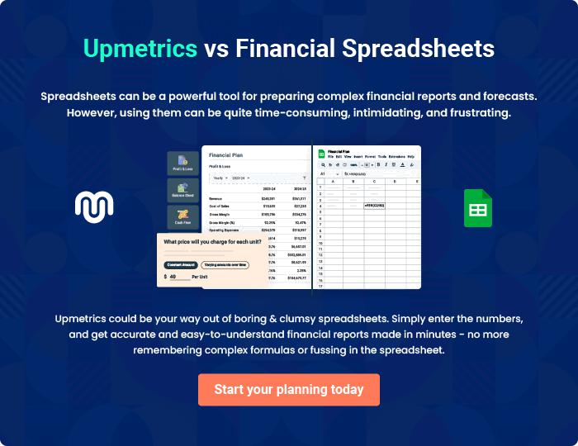

Car Wash | Business Plan [YEAR] | 34/35

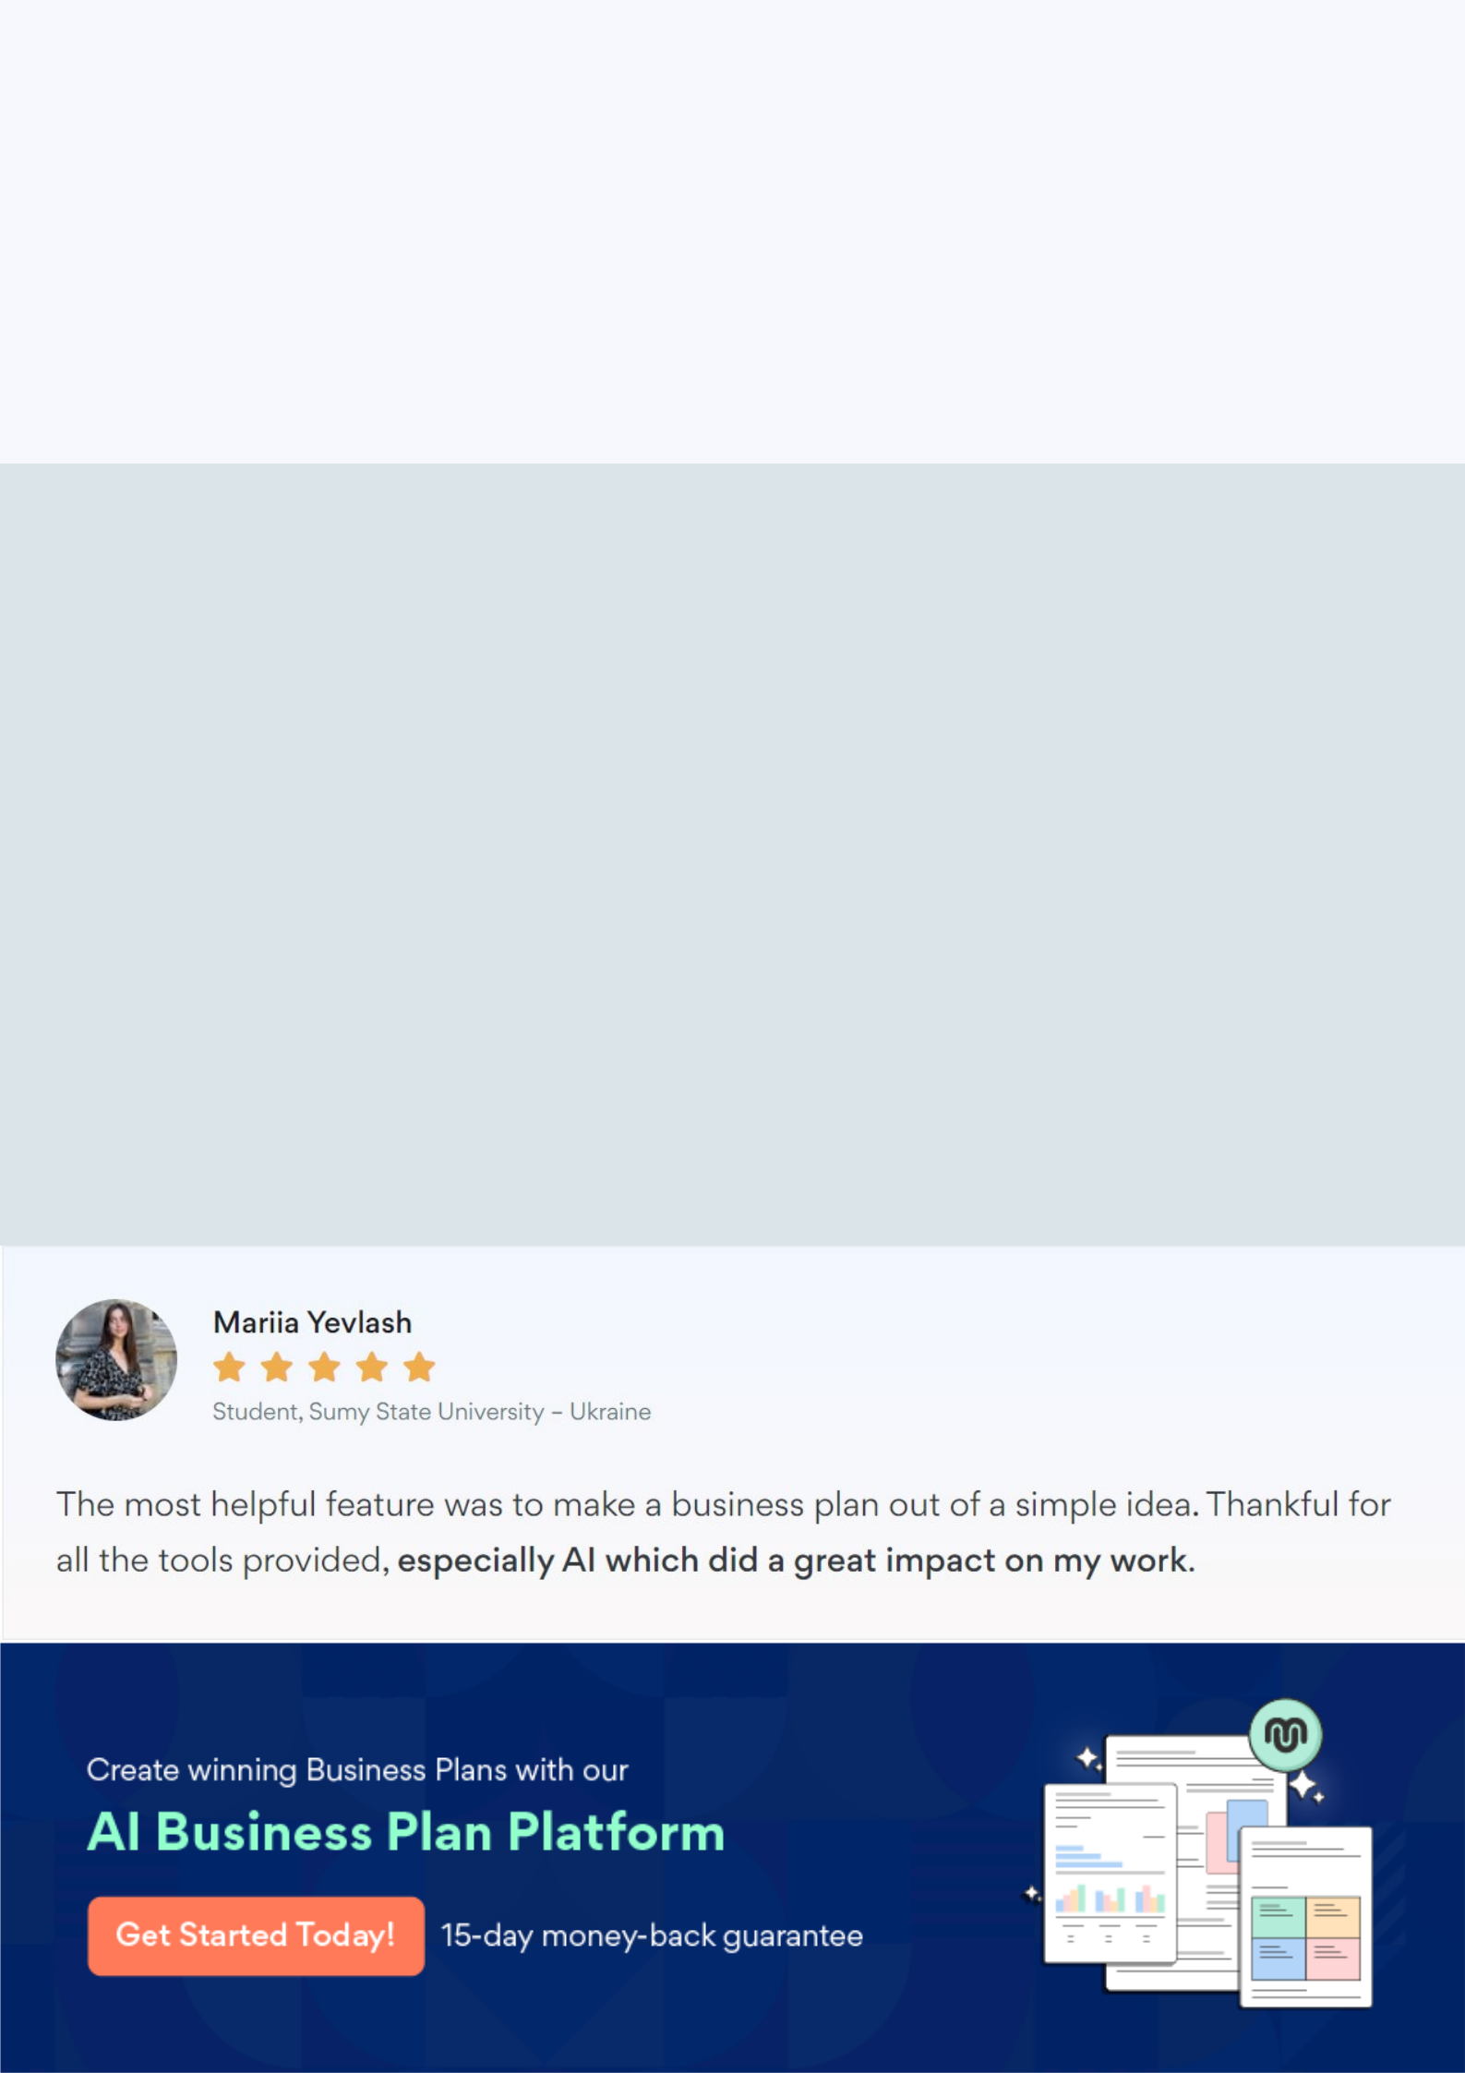
Create a winning business plan that gets you funded

Creating a stunning and investment-ready plan requires no writing, graphic designing, or financial planning expertise.

Upmetrics has all the features required to help you create a comprehensive business plan—from start to finish. Make no mistakes, it’s the modern way of planning to structure ideas, make plans, and create stunning pitch decks to awe investors.

Pitch decks that impress investors

Create pitch decks that provide a visual representation of your business, engage investors, and make them want to invest in your business idea.

Interactive plans in no time

Import business plan sections like—SWOT analysis, comparison tables, and others to create an interactive business plan. No designing skills are required.

Stunning cover page designs

With Upmetrics, you have the liberty to choose from multiple stunning cover page designs. Choose a creative design and make your plan stand out.

Online sharing made simple

Upmetrics makes online sharing quick and easier for users. Easily share your business plans with a link while tracking reader activity.

500+ sample business plans

Simply import a template from our library of sample plans into the editor and start customizing it to make it yours. It takes only a few clicks to get started.

Collaborate with team in real-time

Invite team members, initiate conversations, discuss ideas & strategies, share feedback, and work on a business plan in real-time.

