
AutoCar Detailing

BUSINESS PLAN

Give your car a future look

Prepared By

John Doe

10200 Bolsa Ave, Westminster, CA, 92683

info@example.com

(650) 359-3153 http://www.example.com

Table of Contents

Executive Summary | 5
Business Overview | 6
Management | 6
Customers | 6
Mission and Vision Statement | 7
Business Target | 7
3 Year profit forecast | 8

Business Description | 9
Ownership | 10
Why the Business is being started | 10
How the Business will be started | 10
Startup cost | 11
Funding Required | 11

Products and Services | 14
Products and services | 15
Market Analysis
Market Analysis | 17
Market Trends | 18
Marketing Segmentation | 18
Marketing share | 19
New car owners | 19
Sports car owners | 20
Luxury car owners | 20
Local businesses | 20
Dealerships | 20
Market Analyis | 21
Business Target | 21
Product Pricing | 21

AutoCar Detailing | Business Plan [YEAR] 2/38

Strategy | 22
Competitive Analysis | 23
Sales Strategy | 23
Sales Yearly | 24
Sales Forecast | 24
Detailed Sales Forecast | 25

Personnel plan | 26
Average Salary of Employees | 27
Financial Plan
Financial Plan | 28
Important Assumptions | 29
Brake-even Analysis | 29
Projected Profit and Loss | 30
Projected Cash Flow | 33
Projected Balance Sheet | 34
Business Ratios | 35

AutoCar Detailing | Business Plan [YEAR] 3/38

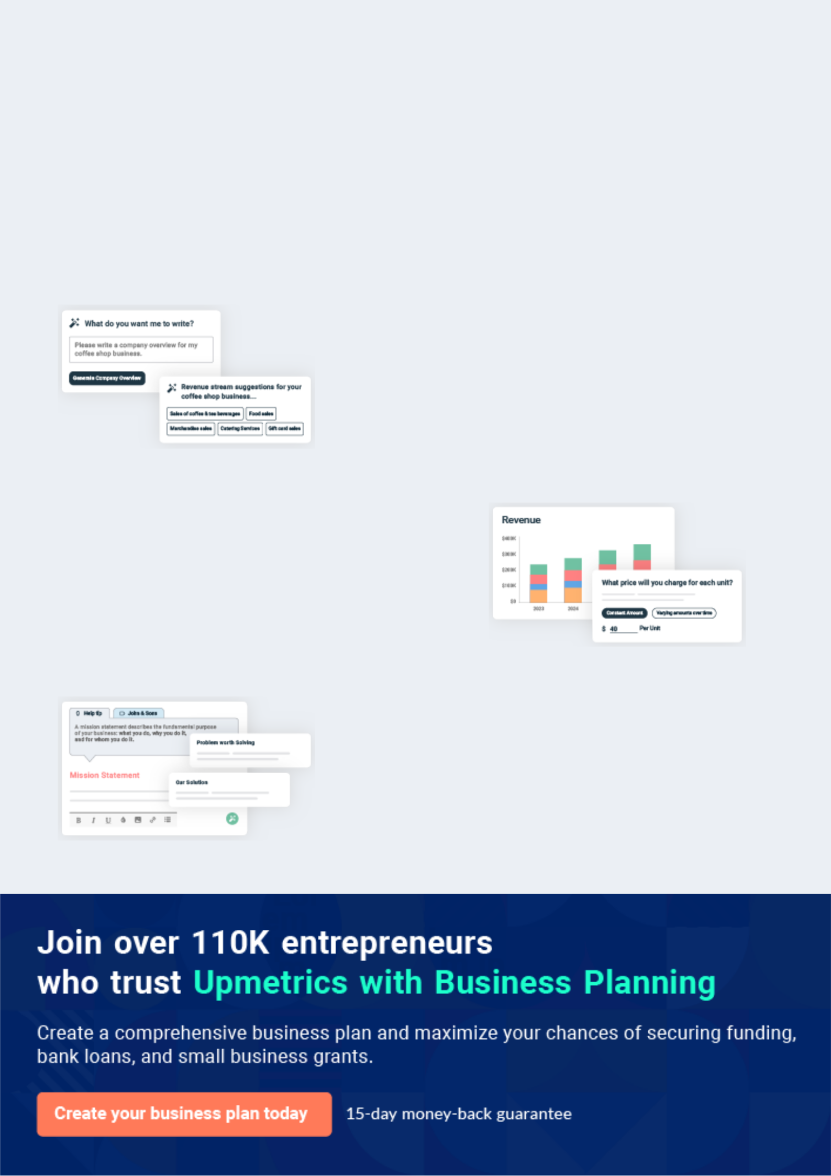
Business planning that’s simpler and faster than you think

Creating a business plan using Upmetrics to start and grow a business is literally the easiest thing in the World. Simply read the instructions and fill in the blanks. It’s as simple as that.

❛ | Upmetrics has everything you need to create a | ❜
❛ | comprehensive business plan. | ❜

AI-powered Upmetrics Assistant

AI-powered insights to streamline your plan

Not sure where to start? Upmetrics’ AI Assistant will automatically generate ideas for each section of your plan and offer improved versions of your writing, adjusting for tone, voice, and grammar or spelling errors.

Financial Forecasting Tool

All the financials are calculated for you

Forget the complex formulas and clumsy spreadsheets — with automatic financials and drag-and-drop forecasting, you can finish your plan faster and be confident that your numbers are accurate.

Business Plan Builder

Guides you like a business mentor

Upmetrics’ step-by-step instructions, prompts, and the library of 400+ sample business plans will guide you through each section of your plan as a business mentor.

1.


Executive Summary

Business Overview

Management

Customers

Mission and Vision Statement

Business Target

AutoCar Detailing | Business Plan [YEAR] 5/38

To unlock help try Upmetrics!
 |  | Before you think about how to start a Car Detailing services, you must create
 |  | a detailed Car Detailing business plan. It will not only guide you in the initial
 |  | phases of your startup but will also help you later on. _{To unlock help try Upmetrics!} 
Business Overview
 Help Tip |  |  AutoCar Detailing


Provide a brief description of your operation. In a few sentences, help people who are unfamiliar with your business develop an understanding of what you produce, the size of your operation, and how you market your products.



Start writing here..

Management

 Ex :: AutoCar


AutoCar Detailing is owned and managed by Richard McMillan and Family. He is a notable figure in the automobile industry in Florida. Aside from this new auto detailing business, the family owns an automobile dealership business and also auto repair workshop all in Florida.
To unlock help try Upmetrics! 

Start writing here..

Customers

 Ex :: AutoCar

We will offer both in – station and out – off station services. Our customers will have the options of choosing from our different packages – we have the plans to serve both individual clients (households) and corporate clients (transport companies, haulage companies, and the
To unlock help try Upmetrics! 

Start writing here..

AutoCar Detailing | Business Plan [YEAR] 6/38

Mission and Vision Statement

 Ex :: AutoCar

Our Vision is to become the number one car wash and auto detailing company in the whole of Florida with an active presence in major cities in the United States of America and Canada.
To unlock help try Upmetrics! 

Start writing here..

Business Target

 Ex :: AutoCar

Our main business targets are summarized in the following column chart.

To unlock help try Upmetrics! 

Start writing here..

AutoCar Detailing | Business Plan [YEAR] 7/38

3 Year profit forecast
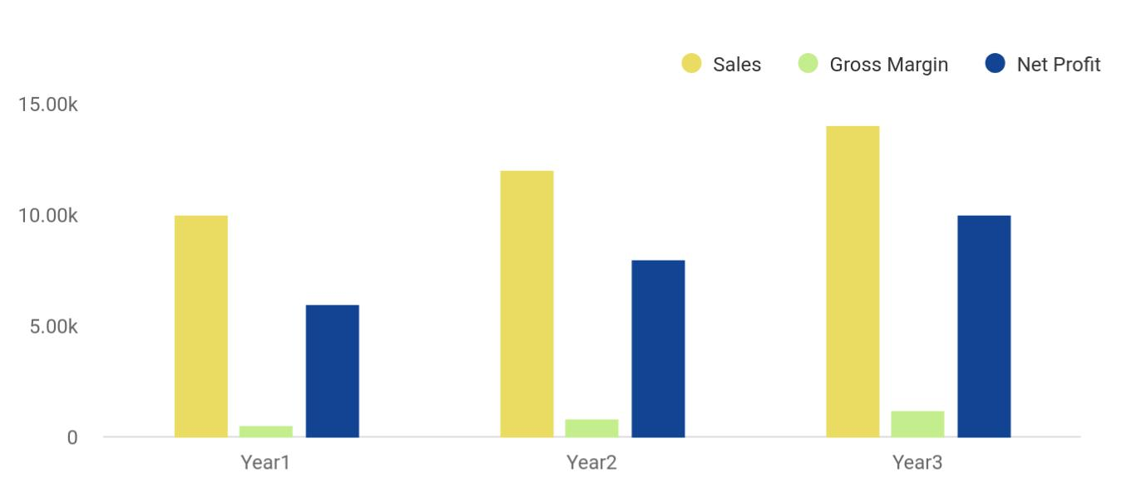

Financial Year | Sales | Gross Margin | Net Profit
Year1 | 10,000 | 500 | 6,000
Year2 | 12,000 | 800 | 8,000
Year3 | 14,000 | 1,200 | 10,000

AutoCar Detailing | Business Plan [YEAR] 8/38

2.

Business Description

Ownership

Why the Business is being started

How the Business will be started

Funding Required

AutoCar Detailing | Business Plan [YEAR] 9/38

Ownership
To unlock help try Upmetrics!

 Ex :: AutoCar

AutoCar Detailing will be owned and operated by Richard McMillan, who has been associated with this industry for more than 9 years. After graduating from High School, Richard started working in Realtek Carwash & Auto Detailers. Within the next 5 years, he was promoted to
To unlock help try Upmetrics! 

Start writing here..

Why the Business is being started

 Ex :: AutoCar

At Autocar Detailing we are passionate in the pursuit of excellence and financial success with uncompromising services and integrity which is why we have decided to start our own auto detailing business; we are in the industry to make a positive mark.



Start writing here..

How the Business will be started

 Ex :: AutoCar

AutoCar Detailing will be started in a leased location adjacent to 6-Sigma Carwash in the main commercial district of Florida, United States. The company will provide in-station services at the facility while providing out-station services, a mobile minibus will be procured. The location
To unlock help try Upmetrics! 

Start writing here..

AutoCar Detailing | Business Plan [YEAR] 10/38

Startup cost
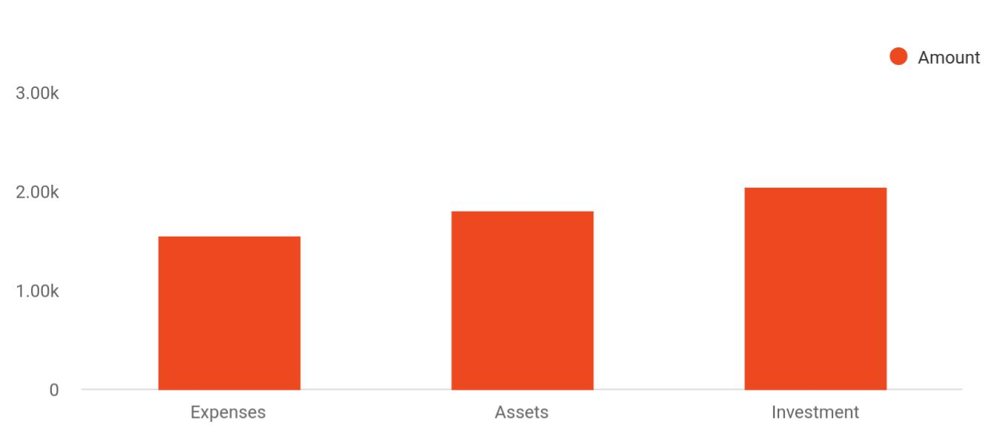

Cost distribution | Amount
Expenses | 1,550
Assets | 1,800
Investment | 2,050

Funding Required

The detailed startup requirements and expenses are given in the table below.

Start-up Expenses | Amount
Legal | $75,500
Consultants | $0
Insurance | $62,750
Rent | $22,500
Research and Development | $42,750
Expensed Equipment | $42,750
Signs | $1,250
TOTAL START-UP EXPENSES | $247,500
Start-up Assets | $0
Cash Required | $322,500

AutoCar Detailing | Business Plan [YEAR] 11/38

Start-up Expenses | Amount
Start-up Inventory | $52,625
Other Current Assets | $222,500
Long-term Assets | $125,000
TOTAL ASSETS | $121,875
Total Requirements | $245,000
START-UP FUNDING | $0
START-UP FUNDING | $273,125
Start-up Expenses to Fund | $121,875
Start-up Assets to Fund | $195,000
TOTAL FUNDING REQUIRED | $0
Assets | $203,125
Non-cash Assets from Start-up | $118,750
Cash Requirements from Start-up | $0
Additional Cash Raised | $118,750
Cash Balance on Starting Date | $121,875
TOTAL ASSETS | $0
Liabilities and Capital | $0
Liabilities | $0
Current Borrowing | $0
Long-term Liabilities | $0
Accounts Payable (Outstanding Bills) | $0
Other Current Liabilities (interest-free) | $0
TOTAL LIABILITIES | $0
Capital | $0
Planned Investment | $0
Investor 1 | $312,500
Investor 2 | $0
Other | $0

AutoCar Detailing | Business Plan [YEAR] 12/38

Start-up Expenses | Amount
Additional Investment Requirement | $0
TOTAL PLANNED INVESTMENT | $695,000
Loss at Start-up (Start-up Expenses) | $313,125
TOTAL CAPITAL | $221,875
TOTAL CAPITAL AND LIABILITIES | $221,875
Total Funding | $265,000

AutoCar Detailing | Business Plan [YEAR] 13/38

3.

Products and Services

Products and services

AutoCar Detailing | Business Plan [YEAR] 14/38

Before starting a mobile auto detailing business, you must take many things into consideration such as you must consider what types of detailing services will you be providing to your customers. Deciding your services is
Interior detailing Interior detailing will be done by cleaning all hard surfaces; seats, dashboard, center console, instrument cluster, door panels, etc. by wiping them down to remove topical dust. After that debris will be removed from carpets by blowing out & vacuuming.
Ceramic coating Ceramic coating will be done by coating the vehicles with a fine layer of quartz for protecting their surface and giving them a shiny look
To unlock help try Upmetrics!
To unlock help try Upmetrics! 

 Ex :: AutoCar

Pristine® Automobile Detailing Services Limited is a standard and well – equipped car wash and auto detailing company that offers a wide range of services that revolves around the car wash and auto detailing industry and other complementary services.



Start writing here..

Products and services


Exterior detailing

Exterior detailing will be done by providing a multi-step, scratch free, manual hand washes for giving an exquisite look to the valuable vehicles of our customers.

Waxing & paint correction

Paint correction will be done by restoring the paint back to its true clarity by removing visible defects followed by waxing to protect and maintain the car’s paint

AutoCar Detailing | Business Plan [YEAR] 15/38

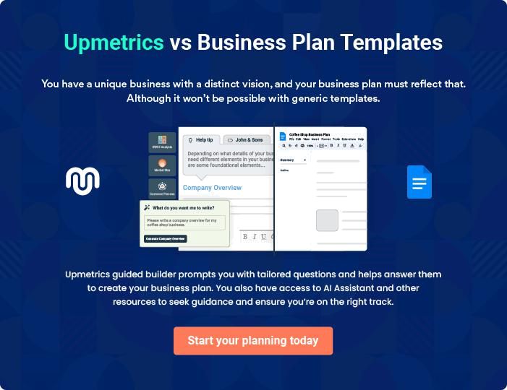

AutoCar Detailing | Business Plan [YEAR] | 16/38

4.

Market Analysis

Market Trends

Marketing Segmentation

Market Analyis

Business Target

Product Pricing

AutoCar Detailing | Business Plan [YEAR] 17/38

The most important component of an effective auto detailing business plan is its accurate marketing analysis. If you are starting on a smaller scale, you can do marketing analysis yourself by taking help from this auto detailing
To unlock help try Upmetrics! 

Market Trends

 Ex :: AutoCar

The market for car wash and auto detailing services is driven by the purchase of cars and the increase in consumers’ spending – in essence, as the general economy of a country grows, more people will buy cars and more people will patronize the services of car wash and auto
To unlock help try Upmetrics! 

Start writing here..

Marketing Segmentation

 Ex :: AutoCar

Our primary target market is the residential community living in Florida. Nearly all people based in the area have their own vehicles either new or leased. Our secondary market will be the car dealerships located in the vicinity. Our experts have identified the following type of target
To unlock help try Upmetrics! 

Start writing here..

AutoCar Detailing | Business Plan [YEAR] 18/38

Marketing share
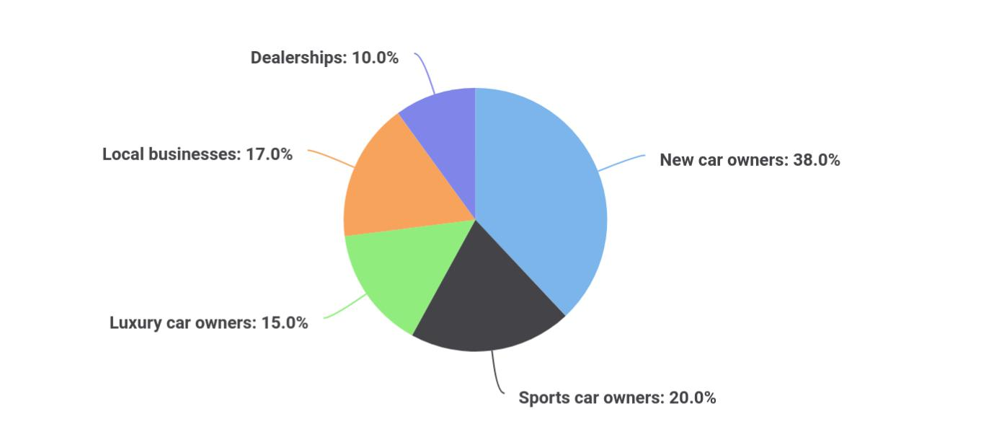

Segments | Market share
New car owners | 38
Sports car owners | 20
Luxury car owners | 15
Local businesses | 17
Dealerships | 10

The detailed marketing segmentation of our target audience is as follows:

 Ex :: AutoCar

This group comprises of customers who have recently bought a new car. These customers are very conscious about their cars and want them to look new as long as possible. Our detailing services will provide the perfect solution to them. In addition to exterior and interior detailing,
To unlock help try Upmetrics! 

New car owners

Start writing here..

AutoCar Detailing | Business Plan [YEAR] 19/38

 Ex :: AutoCar
To unlock help try Upmetrics!
To unlock help try Upmetrics!

Many young and middle-aged men in the neighborhood own expensive sports cars. These people will also need our services for maintaining the exquisite looks of their expensive vehicles.



Sports car owners

Start writing here..

 Ex :: AutoCar

Luxury car owners have totally different requirements and they can easily spend a lot of cash for maintaining their high-end expensive cars and keeping them in the best possible shape. These customers prefer quality to cost that’s why we will offer premium packages for them.
To unlock help try Upmetrics! 

Luxury car owners

Start writing here..

 Ex :: AutoCar

Since we will be located in the main commercial district of the city, we will be surrounded by several companies and local businesses, most of which have fleets of small vans and cars.
Although these businesses own a lot of cars, their contribution to our revenue and sales will be
To unlock help try Upmetrics! 

Local businesses

Start writing here..

 Ex :: AutoCar

There are 5 car dealerships within 6 miles of our location. These car dealers sell old as well as new cars and need their cars to be in the best possible state. That’s why they will regularly require our auto detailing services.



Dealerships

Start writing here..

AutoCar Detailing | Business Plan [YEAR] 20/38

Market Analyis

The detailed market analysis of our potential customers is given in the following table:

Potential Customers | Growth | Year 1 | Year 2 | Year 3 | Year 4 | Year 5 | CAGR
New car owners | 35% | 22,334 | 32,344 | 43,665 | 52,544 | 66,432 | 13.43%
Sports car owners | 15% | 11,433 | 13,344 | 16,553 | 18,745 | 20,545 | 10.00%
Luxury car owners | 18% | 12,867 | 14,433 | 15,999 | 17,565 | 19,131 | 15.32%
Local businesses | 7% | 8,322 | 9,455 | 10,655 | 12,867 | 14,433 | 10.00%
Dealerships | 25% | 10,655 | 11,221 | 12,867 | 14,433 | 15,485 | 16.32%
Total | 100% | 54,956 | 80,797 | 86,872 | 101,721 | 120,541 | 9.54%

Business Target

 Ex :: AutoCar

Our main business targets to be achieved as milestones over the course of the next three years are as follows:
To unlock help try Upmetrics! 

Start writing here..

Product Pricing

 Ex :: AutoCar

Our pricing system is going to be based on what is obtainable in the car wash and auto detailing industry, we don’t intend to charge more (except for premium and customized services) and we don’t intend to charge less than our competitors are offering in Fort
To unlock help try Upmetrics! 

Start writing here..

AutoCar Detailing | Business Plan [YEAR] 21/38

5.

Strategy

Competitive Analysis

Sales Strategy

AutoCar Detailing | Business Plan [YEAR] 22/38

After identifying the market demand, market trends, and the potential customers of the startup, the next step is to define an effective strategy for attracting those customers. Like marketing analysis, sales strategy is also an
To unlock help try Upmetrics! 

Competitive Analysis

 Ex :: AutoCar

As mentioned earlier, there are more than 65,000 similar businesses in the United States and for surviving in such an intensely competitive environment, one needs to have certain competitive advantages. Our biggest competitive advantage is our location which is nearly
To unlock help try Upmetrics! 

Start writing here..

Sales Strategy

 Ex :: AutoCar

After carrying out a detailed analysis, our experts came up with the following brilliant ideas to advertise and sell our services.
To unlock help try Upmetrics! 

Start writing here..

AutoCar Detailing | Business Plan [YEAR] 23/38

Sales Yearly
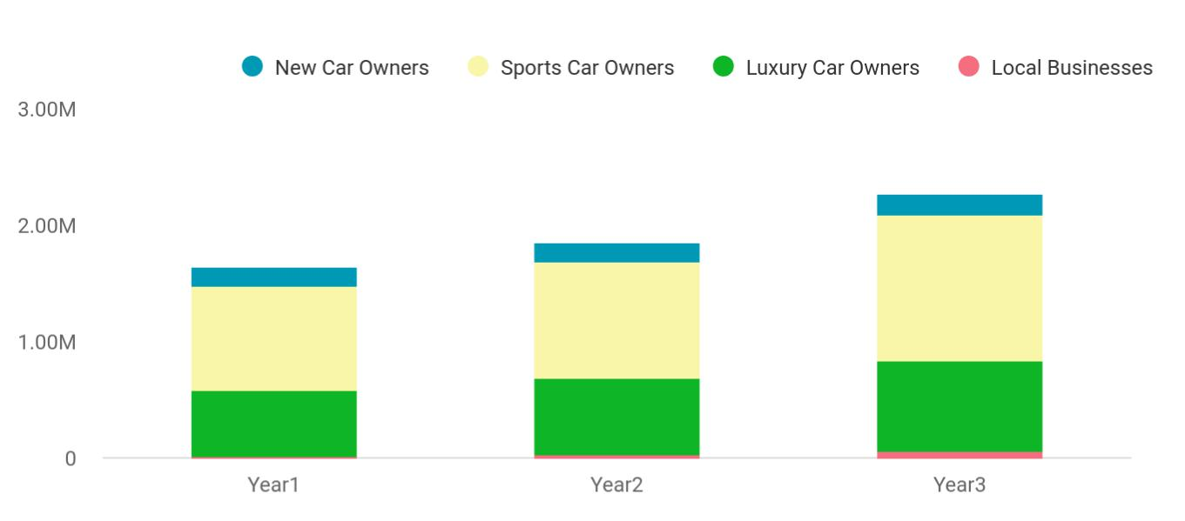

Financial Year | New Car Owners | Sports Car Owners | Luxury Car Owners | Local Businesses
Year1 | 158,745 | 895,665 | 568,654 | 12,451
Year2 | 164,548 | 1,004,512 | 658,457 | 24,578
Year3 | 186,541 | 1,245,587 | 784,512 | 56,452

Sales Forecast
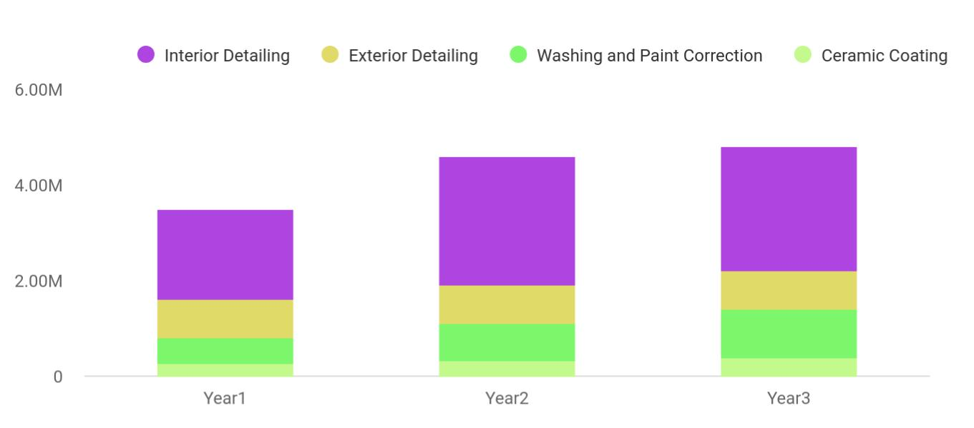

Financial Year | Interior Detailing | Exterior Detailing | Washing and Paint Correction | Ceramic Coating
Year1 | 1,887,030 | 802,370 | 539,320 | 265,450
Year2 | 2,680,320 | 815,430 | 770,230 | 322,390
Year3 | 2,588,240 | 823,540 | 1,002,310 | 393,320

AutoCar Detailing | Business Plan [YEAR] 24/38

Detailed Sales Forecast

Detailed sales forecast data is provided in below table:

Unit Sales | Year 1 | Year 2 | Year 3
Interior detailing | 1,887,030 | 2,680,320 | 2,588,240
Exterior detailing | 802,370 | 815,430 | 823,540
Waxing & paint correction | 539,320 | 770230 | 1,002,310
Ceramic coating | 265,450 | 322,390 | 393,320
TOTAL UNIT SALES | 3,494,170 | 4,588,370 | 4,807,410
Unit Prices
Interior detailing | $140.00 | $150.00 | $160.00
Exterior detailing | $600.00 | $800.00 | $1,000.00
Waxing & paint correction | $700.00 | $800.00 | $900.00
Ceramic coating | $650.00 | $750.00 | $850.00
Sales
Interior detailing | $2,149,800 | $2,784,000 | $3,383,200
Exterior detailing | $120,050 | $194,500 | $268,500
Waxing & paint correction | $50,110 | $71,600 | $93,000
Ceramic coating | $139,350 | $194,600 | $249,850
Direct Unit Costs
Interior detailing | $0.70 | $0.80 | $0.90
Exterior detailing | $0.40 | $0.45 | $0.50
Waxing & paint correction | $0.30 | $0.35 | $0.40
Ceramic coating | $3.00 | $3.50 | $4.00
Direct Cost of Sales
Interior detailing | $989,300 | $1,839,000 | $2,679,700
Exterior detailing | $66,600 | $119,900 | $173,200
Waxing & paint correction | $17,900 | $35,000 | $52,100
Ceramic coating | $19,400 | $67,600 | $115,800
Subtotal Direct Cost of Sales | $1,294,100 | $1,699,400 | $2,104,700

AutoCar Detailing | Business Plan [YEAR] 25/38

6.

Personnel plan

Average Salary of Employees

AutoCar Detailing | Business Plan [YEAR] 26/38

The personnel plan is also an important component of an auto detailing business plan since it gives you an estimate of the staff required for your
startup as well as the costs incurred on their salaries. So, make sure to duly
To unlock help try Upmetrics! 

 Ex :: AutoCar

The success of our car wash and auto detailing business will be anchored on the team, not on any individual. With the wide range of our service offerings, we are only expected to employ more than it is required to run a conventional car wash and auto detailing business.
To unlock help try Upmetrics! 

Start writing here..

Average Salary of Employees

The following table shows the forecast data about the salaries of the employees for the next three years:

 | Year 1 | Year 2 | Year 3
Accountant | $85,000 | $95,000 | $105,000
Sales Executives | $45,000 | $50,000 | $55,000
Workers | $550,000 | $650,000 | $750,000
Technicians | $145,000 | $152,000 | $159,000
Driver | $50,000 | $55,000 | $60,000
Technical Assistant | $87,000 | $94,000 | $101,000
Customer Representative | $42,000 | $45,000 | $48,000
Total Salaries | $1,004,000 | $1,141,000 | $1,278,000

AutoCar Detailing | Business Plan [YEAR] 27/38

7.

Financial Plan

Important Assumptions

Brake-even Analysis

Projected Profit and Loss

Projected Cash Flow

Projected Balance Sheet

Business Ratios

AutoCar Detailing | Business Plan [YEAR] 28/38

The last component of an auto detailing business plan is an in-depth financial plan. The financial plan crafts a detailed map of all the expenses needed for the startup and how these expenses will be met by the earned profits. It is
To unlock help try Upmetrics! 

 Ex :: AutoCar

The company will be financed by Richard himself and he will control the direction of the business to make sure that it is expanding at the forecasted rate. As for the auto detailing
business start-up, no equity funding or outside loans will be required. With the help of financial
To unlock help try Upmetrics! 

Start writing here..

Important Assumptions

The financial projections of the company are forecast on the basis of the following assumptions. These assumptions are quite conservative and are expected to show deviation but to a limited level such that the company’s major financial strategy will not be affected.

 | Year 1 | Year 2 | Year 3
Plan Month | 1 | 2 | 3
Current Interest Rate | 10,00% | 11,00% | 12,00%
Long-term Interest Rate | 10,00% | 10,00% | 10,00%
Tax Rate | 26,42% | 27,76% | 28,12%
Other | 0 | 0 | 0

Brake-even Analysis

Monthly Units Break-even | 5530
Monthly Revenue Break-even | $159 740
Assumptions:
Average Per-Unit Revenue | $260,87
Average Per-Unit Variable Cost | $0,89
Estimated Monthly Fixed Cost | $196 410

AutoCar Detailing | Business Plan [YEAR] 29/38

Projected Profit and Loss

Revenue

Basic Car Detailing Service

Unit Sales

Unit Price

Premium Car Detailing Service

Unit Sales

Unit Price

Subscription-based Car Maintenance Service

Users

Recurring Charges

Cost Of Sales

General Costs

Detailing Supplies and

Materials

Cleaning Products

Detailing Tools

Vehicle and Equipment

Maintenance

Vehicle Maintenance

Equipment Repairs

Revenue Specific Costs

Personnel Costs (Direct Labor)

2024 | 2025 | 2026
$663,491.30 | $1,902,823.20 | $3,709,412.60
$79,587.50 | $142,939.50 | $256,700
1,592 | 2,859 | 5,134
$50 | $50 | $50
$76,110 | $85,765.20 | $96,642
634 | 715 | 805
$120 | $120 | $120
$507,793.80 | $1,674,118.50 | $3,356,070.60
2,721 | 6,492 | 12,069
$30 | $30 | $30

$63,225.29 | $163,658.34 | $309,635.31
$63,225.29 | $163,658.34 | $309,635.31
$10,145.94 | $11,432.47 | $12,882.25
$3,804.70 | $4,287.13 | $4,830.73
$6,341.24 | $7,145.34 | $8,051.52
$53,079.35 | $152,225.87 | $296,753.06
$33,174.60 | $95,141.19 | $185,470.67
$19,904.75 | $57,084.68 | $111,282.39
$0 | $0 | $0
$0 | $0 | $0

AutoCar Detailing | Business Plan [YEAR] 30/38

2024 2025 2026

Gross Margin | $600,266.01 | $1,739,164.86 | $3,399,777.29
Gross Margin (%) | 90.47% | 91.40% | 91.65%

Operating Expense | $715,722.21 | $894,634.41 | $1,149,349.79
Payroll Expense (Indirect | $590,520 | $600,713.88 | $611,092.68
Labor) | $590,520 | $600,713.88 | $611,092.68
Detailing Staff | $345,000 | $350,175.48 | $355,427.64
Senior Detailers | $157,500 | $159,862.68 | $162,260.64
Junior Detailers | $187,500 | $190,312.80 | $193,167
Administrative Staff | $104,400 | $106,596 | $108,843.84
Office Manager | $62,400 | $63,336 | $64,286.04
Receptionist | $42,000 | $43,260 | $44,557.80
Support Staff | $141,120 | $143,942.40 | $146,821.20
Maintenance Crew | $63,360 | $64,627.20 | $65,919.84
Cleaning Staff | $77,760 | $79,315.20 | $80,901.36
General Expense | $125,202.21 | $293,920.53 | $538,257.11
Facility and Utilities | $30,340.03 | $37,255.02 | $45,939.59
Rent | $26,082.44 | $31,184.73 | $37,285.12
Electricity and Water | $4,257.59 | $6,070.29 | $8,654.47
Marketing and Advertising | $86,253.91 | $247,367.05 | $482,223.68
Online Marketing | $53,079.31 | $152,225.86 | $296,753.01
Print Advertising | $33,174.60 | $95,141.19 | $185,470.67
Operational Expenses | $8,608.27 | $9,298.46 | $10,093.84
Insurance | $6,000 | $6,180 | $6,365.40
Maintenance | $2,608.27 | $3,118.46 | $3,728.44

AutoCar Detailing | Business Plan [YEAR] 31/38

Bad Debt

Amortization of Current Assets

EBITDA

Additional Expense

Long Term Depreciation

Gain or loss from Sale of Assets

EBIT

Interest Expense

EBT

Income Tax Expense / Benefit

Total Expense

Net Income

Net Income (%)

Retained Earning Opening

Owner's Distribution

Retained Earning Closing

2024 | 2025 | 2026
$0 | $0 | $0
$0 | $0 | $0

($115,456.20) $844,530.45 $2,250,427.50

$10,244.42 | $9,122.62 | $7,919.75
$7,236 | $7,236 | $7,236
$0 | $0 | $0
($122,692.20) | $837,294.45 | $2,243,191.50
$3,008.41 | $1,886.63 | $683.75
($125,700.62) | $835,407.83 | $2,242,507.75
$0 | $0 | $0

$789,191.92 | $1,067,415.37 | $1,466,904.85
($125,700.62) | $835,407.83 | $2,242,507.75
(18.95%) | 43.90% | 60.45%

$0 | ($143,700.62) | $683,707.21
$18,000 | $8,000 | $8,000
($143,700.62) | $683,707.21 | $2,918,214.96

AutoCar Detailing | Business Plan [YEAR] 32/38

Projected Cash Flow

 | 2024 | 2025 | 2026
Cash Received | $663,491.30 | $1,902,823.20 | $3,709,412.60
Cash Paid | $781,955.92 | $1,060,179.37 | $1,459,668.85
COS & General Expenses | $188,427.50 | $457,578.87 | $847,892.42
Salary & Wages | $590,520 | $600,713.88 | $611,092.68
Interest | $3,008.41 | $1,886.63 | $683.75
Sales Tax | $0 | $0 | $0
Income Tax | $0 | $0 | $0
Net Cash From | ($118,464.62) | $842,643.83 | $2,249,743.75
Operations | ($118,464.62) | $842,643.83 | $2,249,743.75
Assets Sell | $0 | $0 | $0
Assets Purchase | $50,000 | $0 | $0
Net Cash From | ($50,000) | $0 | $0
Investments | ($50,000) | $0 | $0
Amount Received | $80,000 | $0 | $0
Loan Received | $50,000 | $0 | $0
Common Stock | $0 | $0 | $0
Preferred Stock | $0 | $0 | $0
Owner's Contribution | $30,000 | $0 | $0
Amount Paid | $33,517.78 | $24,639.58 | $25,842.64
Loan Capital | $15,517.79 | $16,639.57 | $17,842.64
Dividends & Distributions | $18,000 | $8,000 | $8,000
Net Cash From | $46,482.22 | ($24,639.58) | ($25,842.64)
Financing | $46,482.22 | ($24,639.58) | ($25,842.64)

AutoCar Detailing | Business Plan [YEAR] 33/38

 | 2024 | 2025 | 2026
Summary
Starting Cash | $0 | ($121,982.40) | $696,021.85
Cash In | $743,491.30 | $1,902,823.20 | $3,709,412.60
Cash Out | $865,473.70 | $1,084,818.95 | $1,485,511.49
Change in Cash | ($121,982.40) | $818,004.25 | $2,223,901.11
Ending Cash | ($121,982.40) | $696,021.85 | $2,919,922.96
Projected Balance Sheet
 | 2024 | 2025 | 2026
Assets | ($79,218.40) | $731,549.85 | $2,948,214.96
Current Assets | ($121,982.40) | $696,021.85 | $2,919,922.96
Cash | ($121,982.40) | $696,021.85 | $2,919,922.96
Accounts Receivable | $0 | $0 | $0
Inventory | $0 | $0 | $0
Other Current Assets | $0 | $0 | $0
Long Term Assets | $42,764 | $35,528 | $28,292
Gross Long Term Assets | $50,000 | $50,000 | $50,000
Accumulated Depreciation | ($7,236) | ($14,472) | ($21,708)
Liabilities & Equity | ($79,218.41) | $731,549.85 | $2,948,214.96
Liabilities | $34,482.21 | $17,842.64 | $0
Current Liabilities | $16,639.57 | $17,842.64 | $0
Accounts Payable | $0 | $0 | $0
Income Tax Payable | $0 | $0 | $0

AutoCar Detailing | Business Plan [YEAR] 34/38

 | 2024 |  |  | 2025 |  | 2026
Sales Tax Payable | $0 |  |  | $0 |  | $0
Short Term Debt | $16,639.57 |  | $17,842.64 |  |  | $0
Long Term Liabilities | $17,842.64 |  |  | $0 |  | $0
Long Term Debt | $17,842.64 |  |  | $0 |  | $0
Equity | ($113,700.62) |  | $713,707.21 |  |  | $2,948,214.96
Paid-in Capital | $0 |  |  | $0 |  | $0
Common Stock | $0 |  |  | $0 |  | $0
Preferred Stock | $0 |  |  | $0 |  | $0
Owner's Contribution | $30,000 |  |  | $30,000 |  | $30,000
Retained Earnings | ($143,700.62) |  | $683,707.21 |  |  | $2,918,214.96
Check | $0 |  |  | $0 |  | $0
Business Ratios
 |  | Year 1 | Year 2 |  | Year 3 | Industry Profile
Sales Growth |  | 4,35% | 30,82% |  | 63,29% | 4,00%
Percent of Total Assets
Accounts Receivable |  | 5,61% | 4,71% |  | 3,81% | 9,70%
Inventory |  | 1,85% | 1,82% |  | 1,79% | 9,80%
Other Current Assets |  | 1,75% | 2,02% |  | 2,29% | 27,40%
Total Current Assets |  | 138,53% | 150,99% |  | 163,45% | 54,60%
Long-term Assets |  | -9,47% | -21,01% |  | -32,55% | 58,40%
TOTAL ASSETS |  | 100,00% | 100,00% |  | 100,00% | 100,00%
Current Liabilities |  | 4,68% | 3,04% |  | 2,76% | 27,30%
Long-term Liabilities |  | 0,00% | 0,00% |  | 0,00% | 25,80%
Total Liabilities |  | 4,68% | 3,04% |  | 2,76% | 54,10%

AutoCar Detailing | Business Plan [YEAR] 35/38

 | Year 1 | Year 2 | Year 3 | Industry Profile
NET WORTH | 99,32% | 101,04% | 102,76% | 44,90%
Percent of Sales
Sales | 100,00% | 100,00% | 100,00% | 100,00%
Gross Margin | 94,18% | 93,85% | 93,52% | 0,00%
Selling, General & Administrative Expenses | 74,29% | 71,83% | 69,37% | 65,20%
Advertising Expenses | 2,06% | 1,11% | 0,28% | 1,40%
Profit Before Interest and Taxes | 26,47% | 29,30% | 32,13% | 2,86%
Main Ratios
Current | 25,86 | 29,39 | 32,92 | 1,63
Quick | 25,4 | 28,88 | 32,36 | 0,84
Total Debt to Total Assets | 2,68% | 1,04% | 0,76% | 67,10%
Pre-tax Return on Net Worth | 66,83% | 71,26% | 75,69% | 4,40%
Pre-tax Return on Assets | 64,88% | 69,75% | 74,62% | 9,00%
Additional Ratios
Net Profit Margin | 19,20% | 21,16% | 23,12% | N.A.
Return on Equity | 47,79% | 50,53% | 53,27% | N.A.
Activity Ratios
Accounts Receivable Turnover | 4,56 | 4,56 | 4,56 | N.A.
Collection Days | 92 | 99 | 106 | N.A.
Inventory Turnover | 19,7 | 22,55 | 25,4 | N.A.
Accounts Payable Turnover | 14,17 | 14,67 | 15,17 | N.A.
Payment Days | 27 | 27 | 27 | N.A.
Total Asset Turnover | 1,84 | 1,55 | 1,26 | N.A.
Debt Ratios
Debt to Net Worth | 0 | -0,02 | -0,04 | N.A.
Current Liab. to Liab. | 1 | 1 | 1 | N.A.
Liquidity Ratios
Net Working Capital | $120 943 | $140 664 | $160 385 | N.A.

AutoCar Detailing | Business Plan [YEAR] 36/38

 | Year 1 | Year 2 | Year 3 | Industry Profile
Interest Coverage | 0 | 0 | 0 | N.A.
Additional Ratios
Assets to Sales | 0,45 | 0,48 | 0,51 | N.A.
Current Debt/Total Assets | 4% | 3% | 2% | N.A.
Acid Test | 23,66 | 27,01 | 30,36 | N.A.
Sales/Net Worth | 1,68 | 1,29 | 0,9 | N.A.
Dividend Payout | 0 | 0 | 0 | N.A.
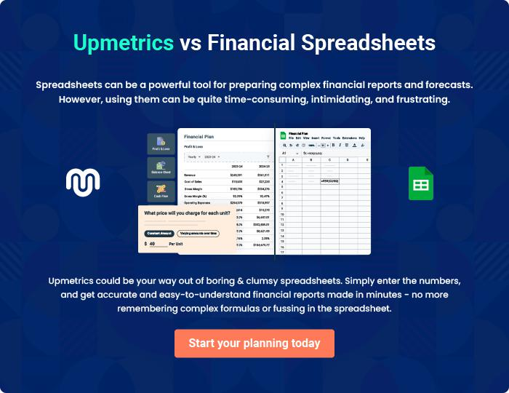

AutoCar Detailing | Business Plan [YEAR] 37/38


Create a winning business plan that gets you funded

Creating a stunning and investment-ready plan requires no writing, graphic designing, or financial planning expertise.

Upmetrics has all the features required to help you create a comprehensive business plan—from start to finish. Make no mistakes, it’s the modern way of planning to structure ideas, make plans, and create stunning pitch decks to awe investors.

Pitch decks that impress investors

Create pitch decks that provide a visual representation of your business, engage investors, and make them want to invest in your business idea.

Interactive plans in no time

Import business plan sections like—SWOT analysis, comparison tables, and others to create an interactive business plan. No designing skills are required.

Stunning cover page designs

With Upmetrics, you have the liberty to choose from multiple stunning cover page designs. Choose a creative design and make your plan stand out.

Online sharing made simple

Upmetrics makes online sharing quick and easier for users. Easily share your business plans with a link while tracking reader activity.

500+ sample business plans

Simply import a template from our library of sample plans into the editor and start customizing it to make it yours. It takes only a few clicks to get started.

Collaborate with team in real-time

Invite team members, initiate conversations, discuss ideas & strategies, share feedback, and work on a business plan in real-time.

