
Campground

BUSINESS PLAN

A day in the lap of nature

Prepared By

John Doe

10200 Bolsa Ave, Westminster, CA, 92683

info@example.com

(650) 359-3153 http://www.example.com

Table of Contents

Executive Summary | 5
Mission Statement | 6
Vision Statement | 6
Financial Summary | 7
3 Year profit forecast | 7
Financial needs | 8

Company Summary | 9
Business Structure | 10
Startup summary | 11
Startup cost | 11

Products and services | 14
Features | 15
Market Analysis
Market Analysis | 17
Market Trends | 18
Target Market | 18
SWOT Analysis
SWOT Analysis | 19
Strategy & Implementations
Strategy & Implementations | 21
Promotion Strategy | 22
Pricing Strategy | 22
Financial Plan
Financial Plan | 23
Important Assumptions | 24
Brake-even Analysis | 24
Projected Profit and Loss | 25
Projected Cash Flow | 27

Campground | Business Plan [YEAR] 2/33

Projected Balance Sheet 28

Business Ratios | 30

Campground | Business Plan [YEAR] 3/33

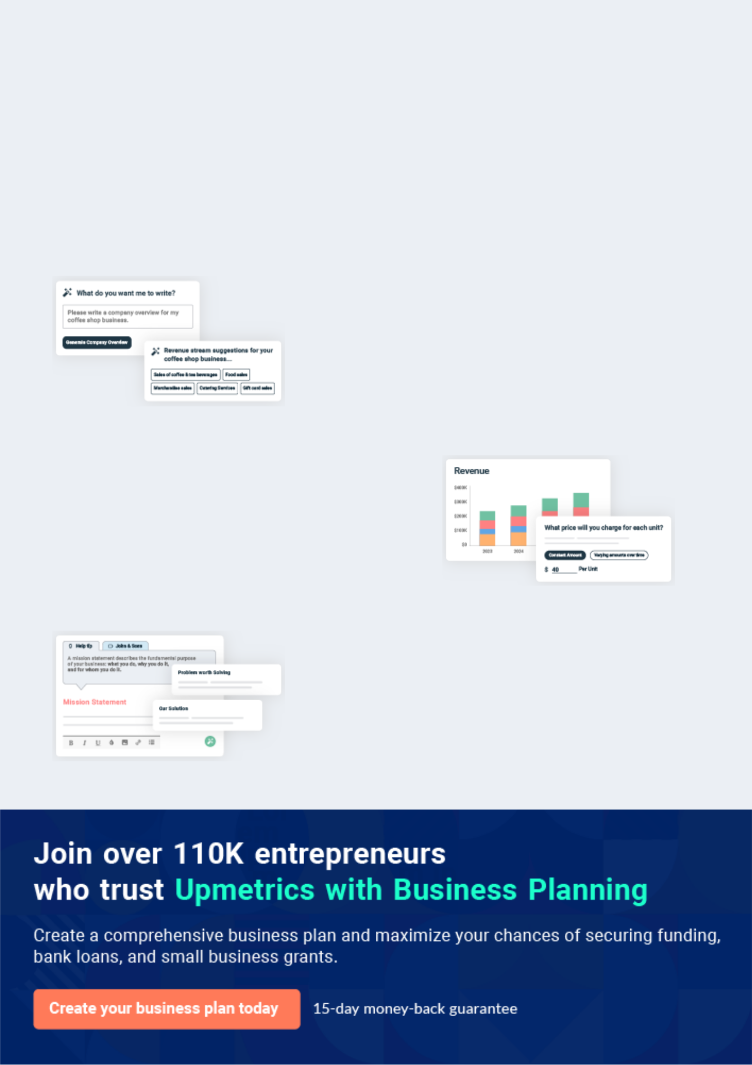
Business planning that’s simpler and faster than you think

Creating a business plan using Upmetrics to start and grow a business is literally the easiest thing in the World. Simply read the instructions and fill in the blanks. It’s as simple as that.

❛ | Upmetrics has everything you need to create a | ❜
❛ | comprehensive business plan. | ❜

AI-powered Upmetrics Assistant

AI-powered insights to streamline your plan

Not sure where to start? Upmetrics’ AI Assistant will automatically generate ideas for each section of your plan and offer improved versions of your writing, adjusting for tone, voice, and grammar or spelling errors.

Financial Forecasting Tool

All the financials are calculated for you

Forget the complex formulas and clumsy spreadsheets — with automatic financials and drag-and-drop forecasting, you can finish your plan faster and be confident that your numbers are accurate.

Business Plan Builder

Guides you like a business mentor

Upmetrics’ step-by-step instructions, prompts, and the library of 400+ sample business plans will guide you through each section of your plan as a business mentor.

1.


Executive Summary

Mission Statement

Vision Statement

Financial Summary

Financial needs

Campground | Business Plan [YEAR] 5/33

Before you think about how to start a Campground business, you must create a detailed Campground business plan. It will not only guide you in the initial phases of your startup but will also help you later on.
To unlock help try Upmetrics!
To unlock help try Upmetrics!

 Greenland Campground




Greenland Campground, LLC is a standard and well-equipped campground and recreational facility that will be located in a serene environment in the outskirt of Detroit - Michigan. Our aim of setting up the business is to contribute our quota in ensuring that families, campers,
To unlock help try Upmetrics! 

Start writing here..

Mission Statement

 Greenland Campground

Our mission for establishing Greenland Campground, LLC is to create a movement in the community that supports the total engagement of families and groups in fun-filled camping and recreational activities.



Start writing here..

Vision Statement

 Greenland Campground

Our vision of starting Greenland Campground, LLC is to build a world-class campground and recreational facility and also to contribute our quota in encouraging families and residents in Detroit and neighboring cities to actively engage in camping and fun-filled recreational
To unlock help try Upmetrics! 

Start writing here..

Campground | Business Plan [YEAR] 6/33

Financial Summary

 Greenland Campground

The company’s goal is to expand from one city into another state as well.

To unlock help try Upmetrics! 

Start writing here..

3 Year profit forecast
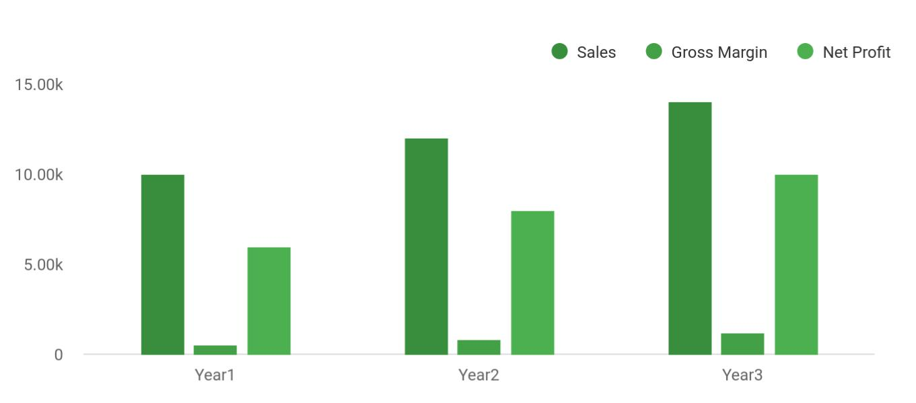

 Greenland Campground


Financial Summary | Year 1 | Year 2 |  | Year 3
 |  |  | To unlock help try Upmetrics! |  | 

Start writing here..

Campground | Business Plan [YEAR] 7/33

Financial needs
To unlock help try Upmetrics!

 Greenland Campground

We are looking to expand our design line so our owner will put in $65,000. Further, we are looking for a $115,000 business loan. Both will be paid back by our second year with our already established customer base and relationships.



Start writing here..

Campground | Business Plan [YEAR] 8/33

2.

Company Summary

Business Structure

Startup summary

Campground | Business Plan [YEAR] 9/33

 Greenland Campground

Greenland Campground, LLC is a registered family business that is owned and managed by John Moore and his immediate family members. John Moore has a degree in Business
Management from the University of Michigan. He has over 10 years of hands-on experience in
To unlock help try Upmetrics! 

Start writing here..

Business Structure

 Greenland Campground

Greenland Campground, LLC is in business to become the leading private camping and recreational facility in the whole of Detroit - Michigan and we are fully aware that it will take the right facility, management, and organization – structure to achieve our goal.
To unlock help try Upmetrics! 

Start writing here..

Campground | Business Plan [YEAR] 10/33

Startup summary

Startup cost
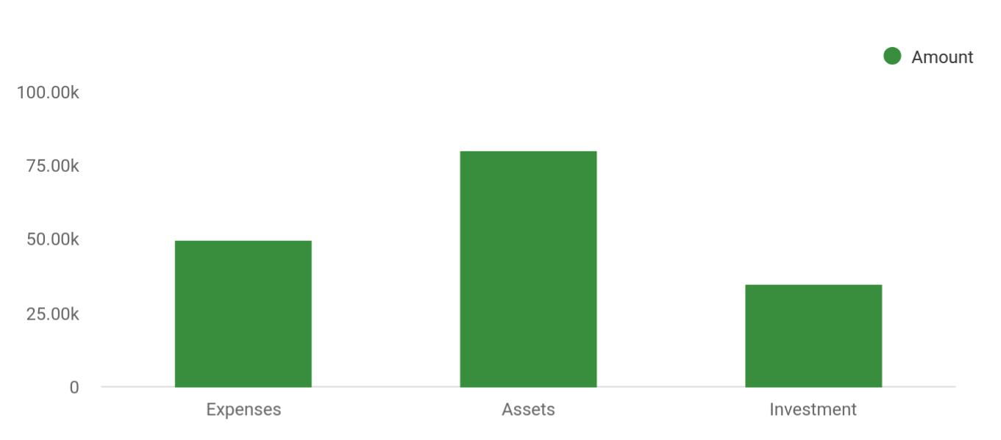

Cost distribution | Amount
Expenses | 50,000
Assets | 80,000
Investment | 35,000

Start-up Expenses | Amount
Legal | $75,500
Consultants | $0
Insurance | $62,750
Rent | $22,500
Research and Development | $42,750
Expensed Equipment | $42,750
Signs | $1,250
TOTAL START-UP EXPENSES | $247,500
Start-up Assets | $0
Cash Required | $322,500
Start-up Inventory | $52,625
Other Current Assets | $222,500

Campground | Business Plan [YEAR] 11/33

Start-up Expenses | Amount
Long-term Assets | $125,000
TOTAL ASSETS | $121,875
Total Requirements | $245,000
START-UP FUNDING | $0
START-UP FUNDING | $273,125
Start-up Expenses to Fund | $121,875
Start-up Assets to Fund | $195,000
TOTAL FUNDING REQUIRED | $0
Assets | $203,125
Non-cash Assets from Start-up | $118,750
Cash Requirements from Start-up | $0
Additional Cash Raised | $118,750
Cash Balance on Starting Date | $121,875
TOTAL ASSETS | $0
Liabilities and Capital | $0
Liabilities | $0
Current Borrowing | $0
Long-term Liabilities | $0
Accounts Payable (Outstanding Bills) | $0
Other Current Liabilities (interest-free) | $0
TOTAL LIABILITIES | $0
Capital | $0
Planned Investment | $0
Investor 1 | $312,500
Investor 2 | $0
Other | $0
Additional Investment Requirement | $0
TOTAL PLANNED INVESTMENT | $695,000

Campground | Business Plan [YEAR] 12/33

Start-up Expenses | Amount
Loss at Start-up (Start-up Expenses) | $313,125
TOTAL CAPITAL | $221,875
TOTAL CAPITAL AND LIABILITIES | $221,875
Total Funding | $265,000

Campground | Business Plan [YEAR] 13/33

3.

Products and services

Features

Campground | Business Plan [YEAR] 14/33

 Greenland Campground

Greenland Campground, LLC is in the campgrounds and RV parks industry to provide camping and recreational facilities for campers, religious organizations, corporate organizations, and families living in Detroit and other neighboring cities and we have been able to put up a facility
To unlock help try Upmetrics! 

Start writing here..

Features


Operating
Operating RV parks
campgrounds

Operating travel
Operating overnight
trailer and caravan
recreational camps
campsites

Operating wilderness Food and drinks

camps court

Other related facility
Ice cream shop
operation

Campground | Business Plan [YEAR] 15/33

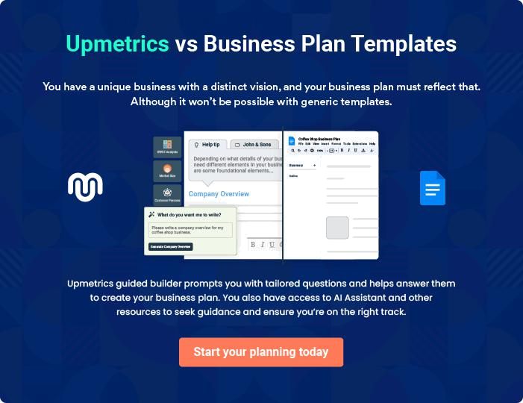

Campground | Business Plan [YEAR] | 16/33

4.

Market Analysis

Market Trends

Target Market

Campground | Business Plan [YEAR] 17/33

The most important component of an effective Campgropund business plan is its accurate marketing analysis. If you are starting on a smaller scale, you can do marketing analysis yourself by taking help from this Campground
To unlock help try Upmetrics! 

Market Trends

 Greenland Campground

The Campgrounds and RV Parks industry has indeed benefited from recent marketing campaigns which are targeted towards encouraging people to participate in recreation activities and camping, as well as consumer trends toward healthy living.
To unlock help try Upmetrics! 

Start writing here..

Target Market

 Greenland Campground

The target market for the campground cuts across people from different backgrounds. The fact that people visit or register in campgrounds and recreational facilities for various reasons makes marketing the business interesting. The target market for campgrounds and recreation
To unlock help try Upmetrics! 

Start writing here..

Campground | Business Plan [YEAR] 18/33

5.

SWOT Analysis

Campground | Business Plan [YEAR] 19/33

 Greenland Campground

Greenland Campground, LLC is in business to provide camping and recreational facilities for families and groups in Detroit - Michigan, and at the same time to make profits. We are aware that there are competitions in the campgrounds and RV parks industry which is why we took
To unlock help try Upmetrics! 

Start writing here..


Strength

One of the obvious strengths that will definitely stand as a plus for Greenland Campground, LLC is the fact that our facility is of great standard and it is strategically located in a densely populated – residential area in Detroit - Michigan; our location is in fact one of our major strengths.

We equally have a team of highly qualified professionals who will work with all our clients to achieve their aims making use of our campground facility and lastly, our gate fee/membership package is one of the best that anybody living in Detroit - Michigan can get; it is cheap and affordable.


Weakness

We critically looked into our Business model and we were able to identify two major weaknesses. One is the fact that we are a new business and the second is the fact that we may not have the financial resources required to match up with existing campground and RV parks as well as family entertainment and recreation facilities and even government own entertainment and recreation facilities in Michigan when it comes to acquiring latest recreational vehicles and generating the needed hypes that can drive traffic towards our facility.


Opportunity

We are centrally located in a densely populated area and of course, an area with the right demographic composition in Detroit

- Michigan and we are open to all the available opportunities that the city has to offer.

Threat

Some of the threats that are likely going to confront Greenland Campground, LLC are unfavorable government policies, inclement weather, demographic/social factors, the downturn in the economy which is likely going to affect consumers spending, and lastly, the emergence of new competitors within the same location where our campground facility is located.

Campground | Business Plan [YEAR] 20/33

6.

Strategy &

Implementations

Promotion Strategy

Pricing Strategy

Campground | Business Plan [YEAR] 21/33

After identifying the market demand, market trends, and the potential customers of the startup, the next step is to define an effective strategy for attracting those customers. Like marketing analysis, sales strategy is also an
To unlock help try Upmetrics! 

Promotion Strategy

 Greenland Campground

We have been able to work with our branding and publicity consultants to help us map out publicity and advertising strategies that will help us walk our way into the heart of our target market. We are set to become the number one choice for both corporate clients and individual
To unlock help try Upmetrics! 

Start writing here..

Pricing Strategy

 Greenland Campground

Our pricing system is going to be based on what is obtainable in the campgrounds and recreational vehicle (RV) parks industry, we don’t intend to charge more (except for premium and customized services) and we don’t intend to charge less than what our competitors are
To unlock help try Upmetrics! 

Start writing here..

Campground | Business Plan [YEAR] 22/33

7.

Financial Plan

Important Assumptions

Brake-even Analysis

Projected Profit and Loss

Projected Cash Flow

Projected Balance Sheet

Business Ratios

Campground | Business Plan [YEAR] 23/33

The last component of the Campground business plan is an in-depth financial plan. The financial plan crafts a detailed map of all the expenses needed for the startup and how these expenses will be met by the earned
To unlock help try Upmetrics! 

 Greenland Campground

The company will be financed by John himself and he will control the direction of the business to make sure that it is expanding at the forecasted rate. As for the Campground business start-up, no equity funding or outside loans will be required. With the help of financial experts, John
To unlock help try Upmetrics! 

Start writing here..

Important Assumptions

The financial projections of the company are forecast on the basis of the following assumptions. These assumptions are quite conservative and are expected to show deviation but to a limited level such that the company’s major financial strategy will not be affected.

 | Year 1 | Year 2 | Year 3
Plan Month | 1 | 2 | 3
Current Interest Rate | 10,00% | 11,00% | 12,00%
Long-term Interest Rate | 10,00% | 10,00% | 10,00%
Tax Rate | 26,42% | 27,76% | 28,12%
Other | 0 | 0 | 0

Brake-even Analysis

Monthly Units Break-even | 5530
Monthly Revenue Break-even | $159 740
Assumptions:
Average Per-Unit Revenue | $260,87
Average Per-Unit Variable Cost | $0,89
Estimated Monthly Fixed Cost | $196 410

Campground | Business Plan [YEAR] 24/33

Projected Profit and Loss

 | 2024 | 2025 | 2026
Revenue | $359,113.76 | $992,059.25 | $1,864,983.35
Campground Fees | $79,587.50 | $142,939.50 | $256,700
Unit Sales | 1,592 | 2,859 | 5,134
Unit Price | $50 | $50 | $50
Childcare Services | $252,702 | $815,100 | $1,565,138
Users | 404 | 935 | 1,651
Recurring Charges | $100 | $100 | $100
Membership Packages | $26,824.26 | $34,019.75 | $43,145.35
Cost Of Sales | $38,197.57 | $72,306.96 | $118,723.16
General Costs | $38,197.57 | $72,306.96 | $118,723.16
Campground Maintenance | $30,638.21 | $63,894.06 | $109,352.62
Utilities | $12,682.53 | $14,291.10 | $16,103.44
Facility Upkeep | $17,955.68 | $49,602.96 | $93,249.18
Childcare Services | $7,559.36 | $8,412.90 | $9,370.54
Childcare Supplies | $6,341.24 | $7,145.34 | $8,051.52
Staff Training | $1,218.12 | $1,267.56 | $1,319.02
Revenue Specific Costs | $0 | $0 | $0
Personnel Costs (Direct | $0 | $0 | $0
Labor) | $0 | $0 | $0
Gross Margin | $320,916.19 | $919,752.29 | $1,746,260.19
Gross Margin (%) | 89.36% | 92.71% | 93.63%

Campground | Business Plan [YEAR] 25/33

 | 2024 | 2025 | 2026
Operating Expense | $551,348.47 | $580,499.47 | $615,271.91
Payroll Expense (Indirect | $506,460 | $518,811 | $531,471.60
Labor) | $506,460 | $518,811 | $531,471.60
Campground Operations | $207,000 | $211,140 | $215,362.80
Staff | $207,000 | $211,140 | $215,362.80
Groundskeepers | $207,000 | $211,140 | $215,362.80
Administrative Staff | $144,900 | $149,247 | $153,724.32
Office Administrators | $144,900 | $149,247 | $153,724.32
Childcare Services | $154,560 | $158,424 | $162,384.48
Childcare Providers | $154,560 | $158,424 | $162,384.48
General Expense | $44,888.47 | $61,688.47 | $83,800.31
Marketing and Advertising | $13,523.53 | $26,986.53 | $45,351.19
Online Advertising | $6,341.24 | $7,145.34 | $8,051.52
Print Media Advertising | $7,182.29 | $19,841.19 | $37,299.67
Utilities and Maintenance | $22,828.48 | $25,723.78 | $28,986.13
Utilities | $10,145.95 | $11,432.68 | $12,882.69
Maintenance | $12,682.53 | $14,291.10 | $16,103.44
Administrative and General | $8,536.46 | $8,978.16 | $9,462.99
Office Supplies | $2,536.46 | $2,858.16 | $3,220.59
Insurance | $6,000 | $6,120 | $6,242.40
Bad Debt | $0 | $0 | $0
Amortization of Current | $0 | $0 | $0
Assets | $0 | $0 | $0

EBITDA | ($230,432.28) | $339,252.82 | $1,130,988.28

Additional Expense | $13,211.05 | $12,120.56 | $10,962.82

Campground | Business Plan [YEAR] 26/33

Long Term Depreciation

Gain or loss from Sale of Assets

EBIT

Interest Expense

EBT

Income Tax Expense / Benefit

2024 | 2025 | 2026
$7,692 | $7,692 | $7,692
$0 | $0 | $0
($238,124.28) | $331,560.82 | $1,123,296.28
$5,519.05 | $4,428.56 | $3,270.82
($243,643.33) | $327,132.26 | $1,120,025.46
$0 | $0 | $0

Total Expense | $602,757.09 | $664,926.99 | $744,957.89
Net Income | ($243,643.33) | $327,132.26 | $1,120,025.46
Net Income (%) | (67.85%) | 32.98% | 60.06%
Retained Earning Opening | $0 | ($261,643.33) | $47,488.93
Owner's Distribution | $18,000 | $18,000 | $18,000
Retained Earning Closing | ($261,643.33) | $47,488.93 | $1,149,514.39
Projected Cash Flow
 | 2024 | 2025 | 2026
Cash Received | $359,113.76 | $992,059.25 | $1,864,983.35
Cash Paid | $595,065.09 | $657,234.99 | $737,265.89
COS & General Expenses | $83,086.04 | $133,995.43 | $202,523.47
Salary & Wages | $506,460 | $518,811 | $531,471.60
Interest | $5,519.05 | $4,428.56 | $3,270.82
Sales Tax | $0 | $0 | $0
Income Tax | $0 | $0 | $0

Campground | Business Plan [YEAR] 27/33

 | 2024 | 2025 | 2026
Net Cash From | ($235,951.33) | $334,824.26 | $1,127,717.46
Operations | ($235,951.33) | $334,824.26 | $1,127,717.46

Assets Sell | $0 | $0 | $0
Assets Purchase | $70,000 | $0 | $0
Net Cash From | ($70,000) | $0 | $0
Investments | ($70,000) | $0 | $0

Amount Received | $150,000 | $0 | $0
Loan Received | $100,000 | $0 | $0
Common Stock | $0 | $0 | $0
Preferred Stock | $0 | $0 | $0
Owner's Contribution | $50,000 | $0 | $0
Amount Paid | $35,680.31 | $36,770.80 | $37,928.54
Loan Capital | $17,680.31 | $18,770.80 | $19,928.54
Dividends & Distributions | $18,000 | $18,000 | $18,000
Net Cash From | $114,319.69 | ($36,770.80) | ($37,928.54)
Financing | $114,319.69 | ($36,770.80) | ($37,928.54)

Summary

Starting Cash | $0 | ($191,631.64) | $106,421.82
Cash In | $509,113.76 | $992,059.25 | $1,864,983.35
Cash Out | $700,745.40 | $694,005.79 | $775,194.43
Change in Cash | ($191,631.64) | $298,053.46 | $1,089,788.92
Ending Cash | ($191,631.64) | $106,421.82 | $1,196,210.74

Projected Balance Sheet

Campground | Business Plan [YEAR] 28/33

 | 2024 | 2025 | 2026
Assets | ($129,323.64) | $161,037.82 | $1,243,134.74
Current Assets | ($191,631.64) | $106,421.82 | $1,196,210.74
Cash | ($191,631.64) | $106,421.82 | $1,196,210.74
Accounts Receivable | $0 | $0 | $0
Inventory | $0 | $0 | $0
Other Current Assets | $0 | $0 | $0
Long Term Assets | $62,308 | $54,616 | $46,924
Gross Long Term Assets | $70,000 | $70,000 | $70,000
Accumulated Depreciation | ($7,692) | ($15,384) | ($23,076)

Liabilities & Equity | ($129,323.64) | $161,037.82 | $1,243,134.74
Liabilities | $82,319.69 | $63,548.89 | $43,620.35
Current Liabilities | $18,770.80 | $19,928.54 | $0
Accounts Payable | $0 | $0 | $0
Income Tax Payable | $0 | $0 | $0
Sales Tax Payable | $0 | $0 | $0
Short Term Debt | $18,770.80 | $19,928.54 | $0
Long Term Liabilities | $63,548.89 | $43,620.35 | $43,620.35
Long Term Debt | $63,548.89 | $43,620.35 | $43,620.35
Equity | ($211,643.33) | $97,488.93 | $1,199,514.39
Paid-in Capital | $0 | $0 | $0
Common Stock | $0 | $0 | $0
Preferred Stock | $0 | $0 | $0
Owner's Contribution | $50,000 | $50,000 | $50,000
Retained Earnings | ($261,643.33) | $47,488.93 | $1,149,514.39

Campground | Business Plan [YEAR] 29/33

 | 2024 |  | 2025 | 2026
Check | $0 |  | $0 | $0
Business Ratios
 | Year 1 | Year 2 | Year 3 | Industry Profile
Sales Growth | 4,35% | 30,82% | 63,29% | 4,00%
Percent of Total Assets
Accounts Receivable | 5,61% | 4,71% | 3,81% | 9,70%
Inventory | 1,85% | 1,82% | 1,79% | 9,80%
Other Current Assets | 1,75% | 2,02% | 2,29% | 27,40%
Total Current Assets | 138,53% | 150,99% | 163,45% | 54,60%
Long-term Assets | -9,47% | -21,01% | -32,55% | 58,40%
TOTAL ASSETS | 100,00% | 100,00% | 100,00% | 100,00%
Current Liabilities | 4,68% | 3,04% | 2,76% | 27,30%
Long-term Liabilities | 0,00% | 0,00% | 0,00% | 25,80%
Total Liabilities | 4,68% | 3,04% | 2,76% | 54,10%
NET WORTH | 99,32% | 101,04% | 102,76% | 44,90%
Percent of Sales
Sales | 100,00% | 100,00% | 100,00% | 100,00%
Gross Margin | 94,18% | 93,85% | 93,52% | 0,00%
Selling, General & Administrative Expenses | 74,29% | 71,83% | 69,37% | 65,20%
Advertising Expenses | 2,06% | 1,11% | 0,28% | 1,40%
Profit Before Interest and Taxes | 26,47% | 29,30% | 32,13% | 2,86%
Main Ratios
Current | 25,86 | 29,39 | 32,92 | 1,63
Quick | 25,4 | 28,88 | 32,36 | 0,84
Total Debt to Total Assets | 2,68% | 1,04% | 0,76% | 67,10%

Campground | Business Plan [YEAR] 30/33

 | Year 1 | Year 2 | Year 3 | Industry Profile
Pre-tax Return on Net Worth | 66,83% | 71,26% | 75,69% | 4,40%
Pre-tax Return on Assets | 64,88% | 69,75% | 74,62% | 9,00%
Additional Ratios
Net Profit Margin | 19,20% | 21,16% | 23,12% | N.A.
Return on Equity | 47,79% | 50,53% | 53,27% | N.A.
Activity Ratios
Accounts Receivable Turnover | 4,56 | 4,56 | 4,56 | N.A.
Collection Days | 92 | 99 | 106 | N.A.
Inventory Turnover | 19,7 | 22,55 | 25,4 | N.A.
Accounts Payable Turnover | 14,17 | 14,67 | 15,17 | N.A.
Payment Days | 27 | 27 | 27 | N.A.
Total Asset Turnover | 1,84 | 1,55 | 1,26 | N.A.
Debt Ratios
Debt to Net Worth | 0 | -0,02 | -0,04 | N.A.
Current Liab. to Liab. | 1 | 1 | 1 | N.A.
Liquidity Ratios
Net Working Capital | $120 943 | $140 664 | $160 385 | N.A.
Interest Coverage | 0 | 0 | 0 | N.A.
Additional Ratios
Assets to Sales | 0,45 | 0,48 | 0,51 | N.A.
Current Debt/Total Assets | 4% | 3% | 2% | N.A.
Acid Test | 23,66 | 27,01 | 30,36 | N.A.
Sales/Net Worth | 1,68 | 1,29 | 0,9 | N.A.
Dividend Payout | 0 | 0 | 0 | N.A.

Campground | Business Plan [YEAR] 31/33

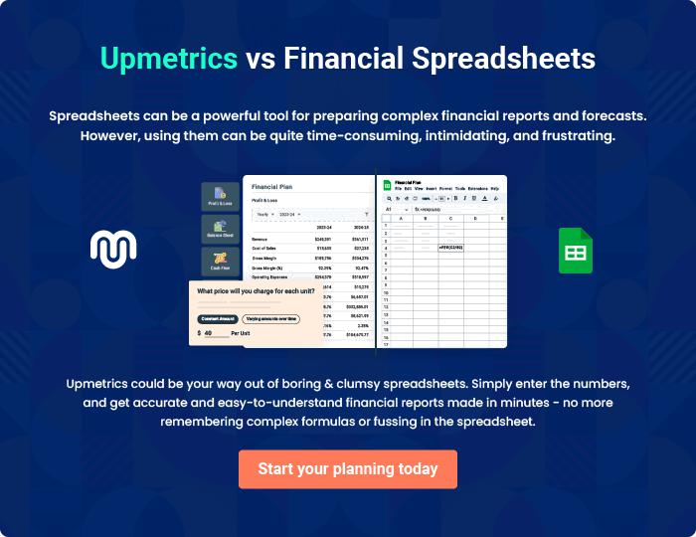

Campground | Business Plan [YEAR] | 32/33

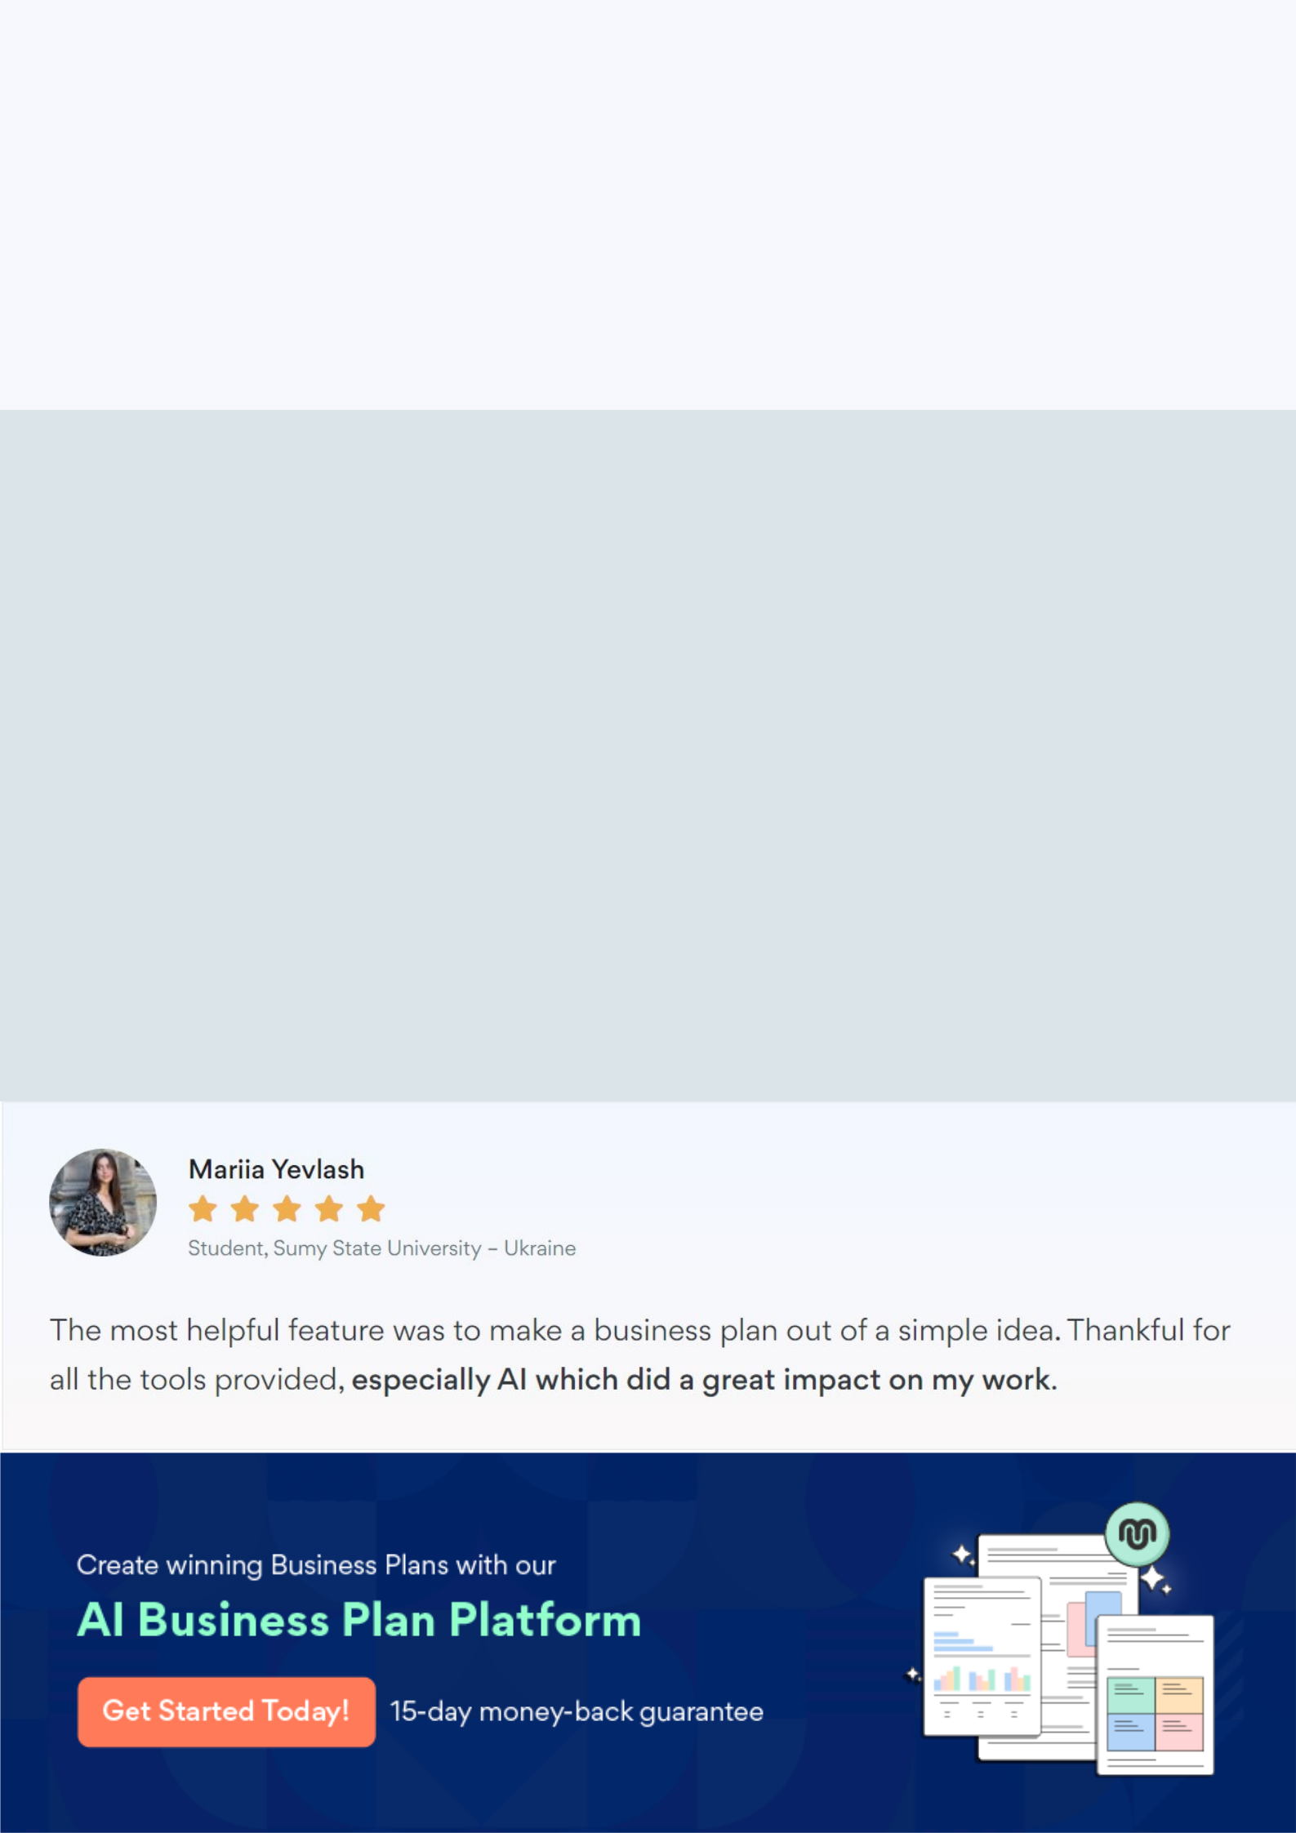
Create a winning business plan that gets you funded

Creating a stunning and investment-ready plan requires no writing, graphic designing, or financial planning expertise.

Upmetrics has all the features required to help you create a comprehensive business plan—from start to finish. Make no mistakes, it’s the modern way of planning to structure ideas, make plans, and create stunning pitch decks to awe investors.

Pitch decks that impress investors

Create pitch decks that provide a visual representation of your business, engage investors, and make them want to invest in your business idea.

Interactive plans in no time

Import business plan sections like—SWOT analysis, comparison tables, and others to create an interactive business plan. No designing skills are required.

Stunning cover page designs

With Upmetrics, you have the liberty to choose from multiple stunning cover page designs. Choose a creative design and make your plan stand out.

Online sharing made simple

Upmetrics makes online sharing quick and easier for users. Easily share your business plans with a link while tracking reader activity.

500+ sample business plans

Simply import a template from our library of sample plans into the editor and start customizing it to make it yours. It takes only a few clicks to get started.

Collaborate with team in real-time

Invite team members, initiate conversations, discuss ideas & strategies, share feedback, and work on a business plan in real-time.

