
Biztalk Call Center

BUSINESS PLAN

Adding Care through Calls

Prepared By

John Doe

10200 Bolsa Ave, Westminster, CA, 92683

info@example.com

(650) 359-3153 http://www.example.com

Table of Contents

Executive Summary | 5
Mission Statement | 6
Vision Statement | 6
Customer Focus | 7
Objectives | 7
Financial Summary | 7
3 Year profit forecast | 7

Company Summary | 9
Business Structure | 10
Startup summary | 10
Startup cost | 11
Products and services
Products and services | 14
Market Analysis
Market Analysis | 17
Market Trends | 18
Market Segmentation | 18
Corporate Organizations | 19
Advertising and Marketing Agencies | 19
Political Parties | 19
Religious Organizations | 19
SWOT Analysis
SWOT Analysis | 20
Strategy & Implementations
Strategy & Implementations | 22
Sales Strategy | 23
Advertising Strategy | 23
Sales Forecast | 23

Biztalk Call Center | Business Plan [YEAR] 2/35

Financial Plan | 25
Important Assumptions | 26
Brake-even Analysis | 26
Projected Profit and Loss | 27
Projected Cash Flow | 30
Projected Balance Sheet | 31
Business Ratios | 32

Biztalk Call Center | Business Plan [YEAR] 3/35

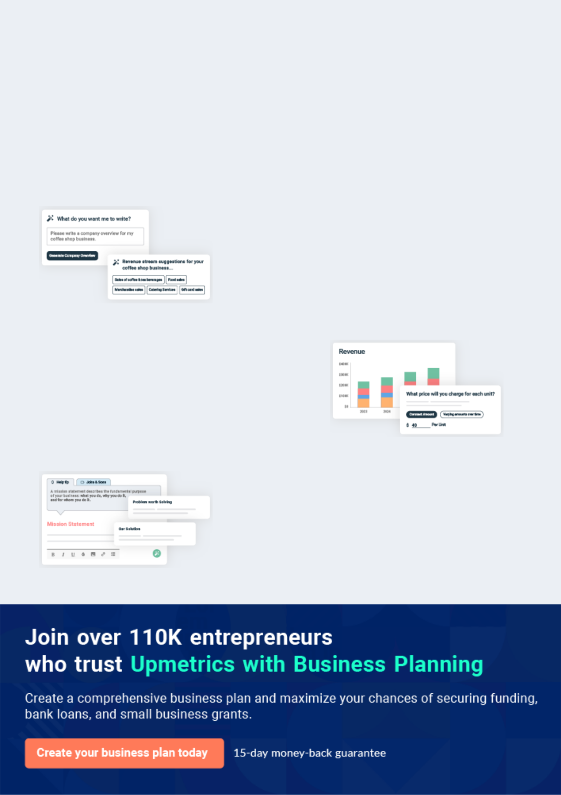
Business planning that’s simpler and faster than you think

Creating a business plan using Upmetrics to start and grow a business is literally the easiest thing in the World. Simply read the instructions and fill in the blanks. It’s as simple as that.

❛ | Upmetrics has everything you need to create a | ❜
❛ | comprehensive business plan. | ❜

AI-powered Upmetrics Assistant

AI-powered insights to streamline your plan

Not sure where to start? Upmetrics’ AI Assistant will automatically generate ideas for each section of your plan and offer improved versions of your writing, adjusting for tone, voice, and grammar or spelling errors.

Financial Forecasting Tool

All the financials are calculated for you

Forget the complex formulas and clumsy spreadsheets — with automatic financials and drag-and-drop forecasting, you can finish your plan faster and be confident that your numbers are accurate.

Business Plan Builder

Guides you like a business mentor

Upmetrics’ step-by-step instructions, prompts, and the library of 400+ sample business plans will guide you through each section of your plan as a business mentor.

1.


Executive Summary

Mission Statement

Vision Statement

Customer Focus

Objectives

Financial Summary

Biztalk Call Center | Business Plan [YEAR] 5/35

Before you think about how to start a Call Center business, you must create a detailed Call Center business plan. It will not only guide you in the initial phases of your startup but will also help you later on.
To unlock help try Upmetrics!

 Biztalk Calling




Biztalk Calling Services, LLC is a one-stop, standard and licensed call center that is fully equipped with the latest technology in the telemarketing and call center industry. Our call
center will be located in the heart of Woodbridge, Detroit - Michigan, U.S, and we are positioned
To unlock help try Upmetrics! 

Start writing here..

Mission Statement

 Biztalk Calling

It is the mission of BCS to provide our clients with top-quality call center services 24 hours a day that provides the greatest chance of communicating with end customers. We do B2B and B2C services including both inbound and outbound calls. We have a dedicated and well-trained
To unlock help try Upmetrics! 

Start writing here..

Vision Statement

 Biztalk Calling

Our vision is to become the number one call center agent in the whole of Detroit, Michigan within the first five years of starting the business.
To unlock help try Upmetrics! 

Start writing here..

Biztalk Call Center | Business Plan [YEAR] 6/35

Customer Focus

 Biztalk Calling

Biztalk's keys to long-term survivability and profitability are:

• Create long-term contracts that demand constant monitoring or on-call services.
To unlock help try Upmetrics! 

Start writing here..

Objectives

 Biztalk Calling

The three-year goals for Biztalk Calling Services LLC (BCS) are:

• Achieve break-even by year two.
To unlock help try Upmetrics! 

Start writing here..

Financial Summary

3 Year profit forecast
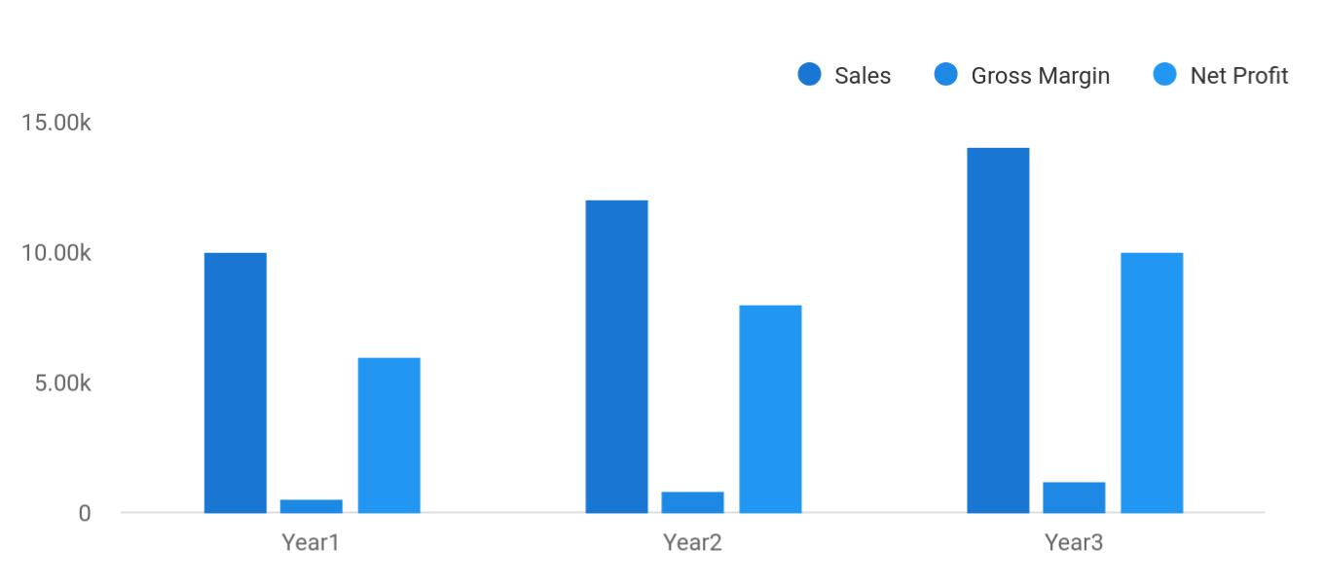

Biztalk Call Center | Business Plan [YEAR] 7/35

 Biztalk Calling


Financial Summary | Year 1 | Year 2 |  | Year 3
 |  |  | To unlock help try Upmetrics! |  | 

Start writing here..

Biztalk Call Center | Business Plan [YEAR] 8/35

2.

Company Summary

Business Structure

Startup summary

Biztalk Call Center | Business Plan [YEAR] 9/35

 Biztalk Calling

Biztalk Calling Services will be a limited liability company registered in the state of Delaware for tax purposes. Its founder is Mr. John Moore, a former telemarketing head with Medfone, Inc. Mr. Gibbs has brought together a highly respected group of telemarketing and customer
To unlock help try Upmetrics! 

Start writing here..

Business Structure

 Biztalk Calling

The success of any business is to a larger extent dependent on the business structure of the organization and the people who occupy the available role. Biztalk Calling Services, LLC will
build a solid business structure that can support the growth of our call center agency business.
To unlock help try Upmetrics! 

Start writing here..

Startup summary

 Biztalk Calling

The start-up assets required are shown in the tables below. This includes expenses and the cash needed to support operations until revenues reach an acceptable level. Most of the company’s liabilities will come from outside private investors and management investment,
To unlock help try Upmetrics! 

Start writing here..

Biztalk Call Center | Business Plan [YEAR] 10/35

Startup cost
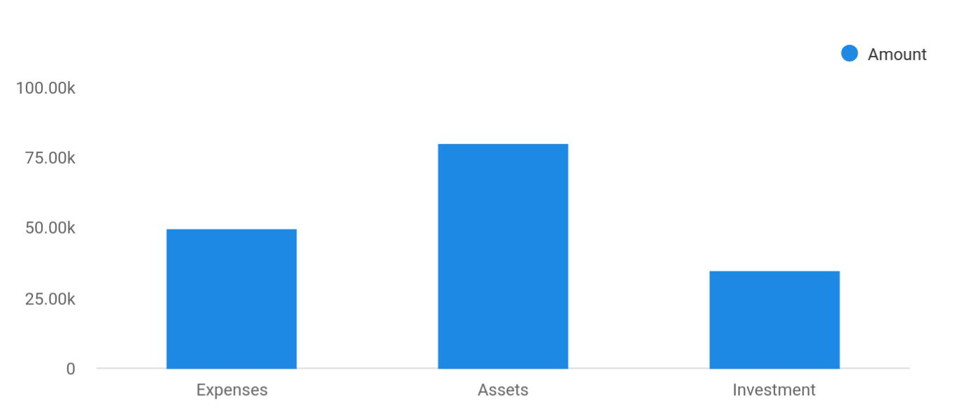

Cost distribution | Amount
Expenses | 50,000
Assets | 80,000
Investment | 35,000

Start-up Expenses | Amount
Legal | $75,500
Consultants | $0
Insurance | $62,750
Rent | $22,500
Research and Development | $42,750
Expensed Equipment | $42,750
Signs | $1,250
TOTAL START-UP EXPENSES | $247,500
Start-up Assets | $0
Cash Required | $322,500
Start-up Inventory | $52,625
Other Current Assets | $222,500
Long-term Assets | $125,000

Biztalk Call Center | Business Plan [YEAR] 11/35

Start-up Expenses | Amount
TOTAL ASSETS | $121,875
Total Requirements | $245,000
START-UP FUNDING | $0
START-UP FUNDING | $273,125
Start-up Expenses to Fund | $121,875
Start-up Assets to Fund | $195,000
TOTAL FUNDING REQUIRED | $0
Assets | $203,125
Non-cash Assets from Start-up | $118,750
Cash Requirements from Start-up | $0
Additional Cash Raised | $118,750
Cash Balance on Starting Date | $121,875
TOTAL ASSETS | $0
Liabilities and Capital | $0
Liabilities | $0
Current Borrowing | $0
Long-term Liabilities | $0
Accounts Payable (Outstanding Bills) | $0
Other Current Liabilities (interest-free) | $0
TOTAL LIABILITIES | $0
Capital | $0
Planned Investment | $0
Investor 1 | $312,500
Investor 2 | $0
Other | $0
Additional Investment Requirement | $0
TOTAL PLANNED INVESTMENT | $695,000
Loss at Start-up (Start-up Expenses) | $313,125

Biztalk Call Center | Business Plan [YEAR] 12/35


Start-up Expenses

TOTAL CAPITAL

TOTAL CAPITAL AND LIABILITIES

Total Funding
Amount

$221,875

$221,875

$265,000

Biztalk Call Center | Business Plan [YEAR] 13/35

3.

Products and services

Biztalk Call Center | Business Plan [YEAR] 14/35

 Biztalk Calling

Biztalk Calling Services, LLC is going to offer varieties of services within the scope of the telemarketing and call center industry in the United States of America. Our intention of starting our call center in Woodbridge – Detroit is to make profits from the telemarketing and call center
To unlock help try Upmetrics! 

Start writing here..


Providing telephone answering services

Providing wake up call services

Providing telephone solicitation services

Providing customer service via call centers

Providing contract or

fee-basis

telemarketing

services

Providing voice mailbox services

Providing massage services

Technical support services

Biztalk Call Center | Business Plan [YEAR] 15/35


Related call center
Debt collection
advisory and
services
consultancy services

 Biztalk Calling

BCS is not a telemarketing company; we do not create marketing campaigns for our clients. Experience has shown that many companies desire to create their own marketing campaign since they already have marketing personnel with extensive contact and experience in the
To unlock help try Upmetrics! 

Start writing here..
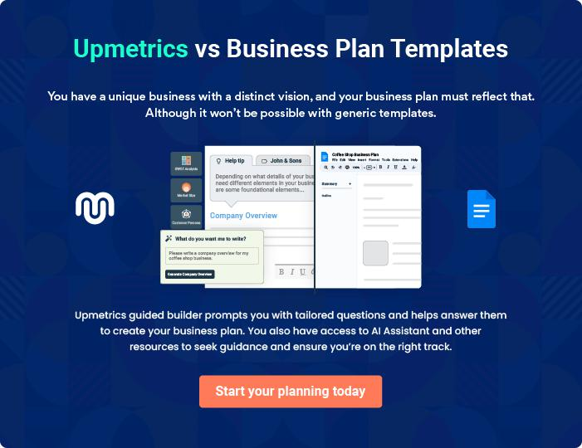

Biztalk Call Center | Business Plan [YEAR] 16/35

4.

Market Analysis

Market Trends

Market Segmentation

Biztalk Call Center | Business Plan [YEAR] 17/35

The most important component of an effective Call Center business plan is its accurate marketing analysis. If you are starting on a smaller scale, you can do marketing analysis yourself by taking help from this Call Center
To unlock help try Upmetrics! 

Market Trends

 Biztalk Calling

The Telemarketing and Call Center industry is indeed witnessing steady growth over the years especially in countries such as the United States, China, India, the Philippines, and even in the
united kingdom. Though some players in this industry would prefer to build their call centers in
To unlock help try Upmetrics! 

Start writing here..

Market Segmentation

 Biztalk Calling

Given the increasing popularity of the call center industry, Biztalk Calling Services understands the value of coming up with sustainable marketing strategies to acquire a larger market share. Being the second-largest city in the United States, Detroit is a business hub with many
To unlock help try Upmetrics! 

Start writing here..
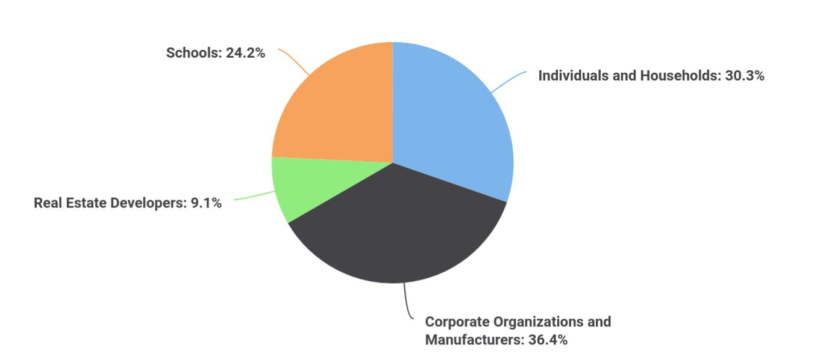

Biztalk Call Center | Business Plan [YEAR] 18/35

 Biztalk Calling

Corporate organizations rely on an infrastructure that allows seamless communication to achieve various business objectives. For this reason, every corporate entity needs a robust and flexible call center service that has the capability to accommodate business needs. With high
To unlock help try Upmetrics! 

Corporate Organizations

Start writing here..

 Biztalk Calling

One of the main services offered by Biztalk Calling Services is marketing and lead generation. Call centers play a major role in advertising and brand awareness which attracts marketing agencies intending to roll out advertising campaigns for various products and services. Thanks
To unlock help try Upmetrics! 

Advertising and Marketing Agencies

Start writing here..

 Biztalk Calling

Political parties have been identified as a potential customer group to reach out to in this call center business plan sample. Political parties often conduct fundraising and campaigns which need a professional call center facility to handle all communication aspects on behalf of a
To unlock help try Upmetrics! 

Political Parties

Start writing here..

 Biztalk Calling

With many religious organizations operating in Detroit, the demand for call centers is high as religious establishments are always in need of call centers to support various organization functions. Just like political parties, religious organizations engage in numerous fundraising
To unlock help try Upmetrics! 

Religious Organizations

Start writing here..

Biztalk Call Center | Business Plan [YEAR] 19/35

5.

SWOT Analysis

Biztalk Call Center | Business Plan [YEAR] 20/35

 Biztalk Calling

We are aware of the importance of knowing our areas of strength and weaknesses, and we have gone to a good length to make that known.
To unlock help try Upmetrics! 

Start writing here..


Strength

Our core strength lies in our service offerings, the power of our team, and the state-of-the-art call center equipment and software applications that we have. We have a team that can go all the way to give our clients value for their money. We are well-positioned in the heart of Woodbridge, Detroits and we know we will attract loads of clients from the first day we open our call center for business.


Weakness

As a new call center in Detroit, it might take some time for our organization to break into the market and attract some well– established corporate clients; that is perhaps our major weakness. Another weakness is that we may not have the required cash to pump into the promotion of our business the way we would want to.


Opportunity

The opportunities in the telemarketing and call center industry are massive especially in Detroit, and we are ready to take advantage of any opportunity that comes our way.

Threat

Technology and the internet which of course is a major tool for the advancement and gains achieved in the telemarketing and call center industry can also pose a threat to the industry. The truth is that with the advancement of technology, it is now easier for organizations to leverage software applications to conduct their telemarketing, market research, and communicate with their clients.

Biztalk Call Center | Business Plan [YEAR] 21/35

6.

Strategy &

Implementations

Sales Strategy

Advertising Strategy

Sales Forecast

Biztalk Call Center | Business Plan [YEAR] 22/35

After identifying the market demand, market trends, and the potential customers of the startup, the next step is to define an effective strategy for attracting those customers. Like marketing analysis, sales strategy is also an
To unlock help try Upmetrics! 

Sales Strategy

 Biztalk Calling

Biztalk's management will be focusing on leveraging its employee’s established reputations and contacts in the telemarketing industry to generate contracts. Both Mr. Gibbs and Mr. Hannover have been in the industry for many years and experience shows that many of their existing
To unlock help try Upmetrics! 

Start writing here..

Advertising Strategy

 Biztalk Calling

We have been able to work with brand and publicity specialists to help us map out publicity and advertising strategies that will help us walk our way into the heart of our target market. We are set to take the telemarketing and call center industry by storm which is why we have made
To unlock help try Upmetrics! 

Start writing here..

Sales Forecast

 Biztalk Calling

Sales are based on the various contract projects we anticipate acquiring in the various market segments. Revenues are based on average costs per project/contract based on estimated time and complexity of contract plus an undisclosed profit margin. The company does not have any
To unlock help try Upmetrics! 

Start writing here..

Biztalk Call Center | Business Plan [YEAR] 23/35

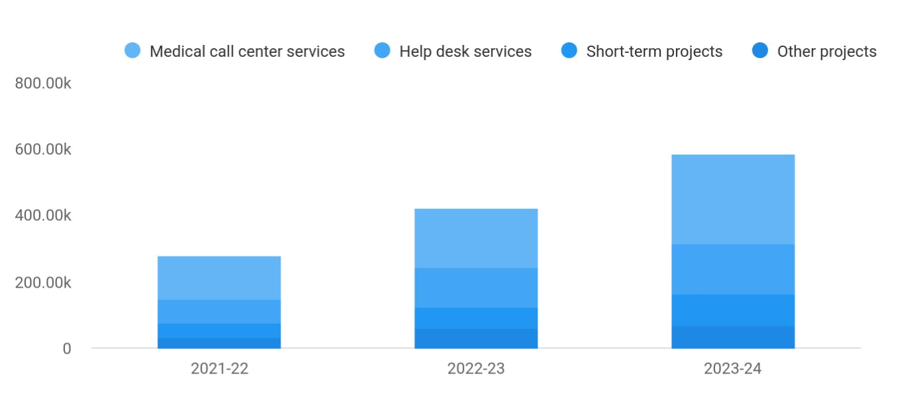

Financial Year | Medical call center services | Help desk services | Short-term projecr services | Other projects
2021-22 | 132,000 | 69,000 | 43,500 | 33,500
2022-23 | 180,000 | 120,000 | 65,000 | 58,000
2023-24 | 270,000 | 150,000 | 96,000 | 69,000

Biztalk Call Center | Business Plan [YEAR] 24/35

7.

Financial Plan

Important Assumptions

Brake-even Analysis

Projected Profit and Loss

Projected Cash Flow

Projected Balance Sheet

Business Ratios

Biztalk Call Center | Business Plan [YEAR] 25/35

The last component of the Call Center business plan is an in-depth financial plan. The financial plan crafts a detailed map of all the expenses needed for the startup and how these expenses will be met by the earned profits. It is
To unlock help try Upmetrics! 

 Biztalk Calling

The company will be financed by John himself and he will control the direction of the business to make sure that it is expanding at the forecasted rate. As for the Call Center business start-up, no equity funding or outside loans will be required. With the help of financial experts, John
To unlock help try Upmetrics! 

Start writing here..

Important Assumptions

The financial projections of the company are forecast on the basis of the following assumptions. These assumptions are quite conservative and are expected to show deviation but to a limited level such that the company’s major financial strategy will not be affected.

 | Year 1 | Year 2 | Year 3
Plan Month | 1 | 2 | 3
Current Interest Rate | 10,00% | 11,00% | 12,00%
Long-term Interest Rate | 10,00% | 10,00% | 10,00%
Tax Rate | 26,42% | 27,76% | 28,12%
Other | 0 | 0 | 0

Brake-even Analysis

Monthly Units Break-even | 5530
Monthly Revenue Break-even | $159 740
Assumptions:
Average Per-Unit Revenue | $260,87
Average Per-Unit Variable Cost | $0,89
Estimated Monthly Fixed Cost | $196 410

Biztalk Call Center | Business Plan [YEAR] 26/35

Projected Profit and Loss

Revenue

Inbound Customer Service

Unit Sales

Unit Price

Outbound Sales Calls

Unit Sales

Unit Price

Technical Support

Services

Total Hours

Hourly Price

Cost Of Sales

General Costs

Call Center Operations

Call Center Technology

Costs

Telecommunication

Expenses

Personnel-Related Costs

Employee Training Costs

Staff Welfare Expenses

Revenue Specific Costs

Personnel Costs (Direct Labor)

2024 | 2025 | 2026
$1,294,881.85 | $3,615,672.10 | $10,452,522.75
$474,431 | $1,194,708 | $3,008,474.50
9,489 | 23,894 | 60,169
$50 | $50 | $50
$748,450.85 | $2,348,964.10 | $7,372,048.25
21,384 | 67,113 | 210,630
$35 | $35 | $35
$72,000 | $72,000 | $72,000
2,400 | 2,400 | 2,400
$30 | $30 | $30

$111,035.19 | $232,945.42 | $581,403.26
$111,035.19 | $232,945.42 | $581,403.26
$90,109.09 | $209,365.43 | $554,832.69
$25,364.99 | $28,581.81 | $32,206.53
$64,744.10 | $180,783.62 | $522,626.16
$20,926.10 | $23,579.99 | $26,570.57
$19,023.72 | $21,436.34 | $24,155.06
$1,902.38 | $2,143.65 | $2,415.51
$0 | $0 | $0
$0 | $0 | $0

Biztalk Call Center | Business Plan [YEAR] 27/35

 | 2024 | 2025 | 2026
Gross Margin | $1,183,846.66 | $3,382,726.68 | $9,871,119.49
Gross Margin (%) | 91.43% | 93.56% | 94.44%

Operating Expense | $1,954,225.08 | $2,100,475.47 | $2,451,838.77
Payroll Expense (Indirect | $1,819,992 | $1,852,189.44 | $1,885,059.48
Labor) | $1,819,992 | $1,852,189.44 | $1,885,059.48
Management Team | $157,152 | $161,130.24 | $165,213
Manager | $83,520 | $86,025.60 | $88,606.32
Assistant Manager | $73,632 | $75,104.64 | $76,606.68
Call Center Agents | $1,269,600 | $1,287,264 | $1,305,204
Senior Agents | $496,800 | $506,736 | $516,871.20
Junior Agents | $772,800 | $780,528 | $788,332.80
Support Staff | $393,240 | $403,795.20 | $414,642.48
IT Support | $269,040 | $277,111.20 | $285,424.80
Administrative Assistants | $124,200 | $126,684 | $129,217.68
General Expense | $134,233.08 | $248,286.03 | $566,779.29
Office and Administrative | $50,996.34 | $79,029.56 | $152,835.38
Expenses | $50,996.34 | $79,029.56 | $152,835.38
Office Rent | $38,047.52 | $42,872.83 | $48,310.14
Utility Bills | $12,948.82 | $36,156.73 | $104,525.24
Marketing and Advertising | $51,262.62 | $100,895.25 | $241,256.98
Digital Marketing | $25,364.99 | $28,581.81 | $32,206.53
Print Advertising | $25,897.63 | $72,313.44 | $209,050.45
Technology and | $31,974.12 | $68,361.22 | $172,686.93
Infrastructure | $31,974.12 | $68,361.22 | $172,686.93
Software Licenses | $12,550.88 | $14,126.14 | $15,899.08
IT Support | $19,423.24 | $54,235.08 | $156,787.85

Biztalk Call Center | Business Plan [YEAR] 28/35

Bad Debt

Amortization of Current Assets

EBITDA

Additional Expense

Long Term Depreciation

Gain or loss from Sale of Assets

EBIT

Interest Expense

EBT

Income Tax Expense / Benefit

Total Expense

Net Income

Net Income (%)

Retained Earning Opening

Owner's Distribution

Retained Earning Closing

2024 | 2025 | 2026
$0 | $0 | $0
$0 | $0 | $0

($770,378.42) $1,282,251.21 $7,419,280.72

$17,438.04 | $14,888.84 | $12,128.04
$10,548 | $10,548 | $10,548
$0 | $0 | $0
($780,926.42) | $1,271,703.21 | $7,408,732.72
$6,890.04 | $4,340.83 | $1,580.03
($787,816.46) | $1,267,362.37 | $7,407,152.68
$0 | $0 | $0

$2,082,698.31 | $2,348,309.73 | $3,045,370.07
($787,816.46) | $1,267,362.37 | $7,407,152.68
(60.84%) | 35.05% | 70.86%

$0 | ($807,816.46) | $439,545.91
$20,000 | $20,000 | $20,000
($807,816.46) | $439,545.91 | $7,826,698.59

Biztalk Call Center | Business Plan [YEAR] 29/35

Projected Cash Flow

 | 2024 | 2025 | 2026
Cash Received | $1,294,881.85 | $3,615,672.10 | $10,452,522.75
Cash Paid | $2,072,150.31 | $2,337,761.73 | $3,034,822.07
COS & General Expenses | $245,268.27 | $481,231.45 | $1,148,182.55
Salary & Wages | $1,819,992 | $1,852,189.44 | $1,885,059.48
Interest | $6,890.04 | $4,340.83 | $1,580.03
Sales Tax | $0 | $0 | $0
Income Tax | $0 | $0 | $0
Net Cash From | ($777,268.46) | $1,277,910.37 | $7,417,700.68
Operations | ($777,268.46) | $1,277,910.37 | $7,417,700.68
Assets Sell | $0 | $0 | $0
Assets Purchase | $70,000 | $0 | $0
Net Cash From | ($70,000) | $0 | $0
Investments | ($70,000) | $0 | $0
Amount Received | $150,000 | $0 | $0
Loan Received | $100,000 | $0 | $0
Common Stock | $0 | $0 | $0
Preferred Stock | $0 | $0 | $0
Owner's Contribution | $50,000 | $0 | $0
Amount Paid | $50,713.64 | $53,262.84 | $56,023.50
Loan Capital | $30,713.64 | $33,262.85 | $36,023.51
Dividends & Distributions | $20,000 | $20,000 | $20,000
Net Cash From | $99,286.36 | ($53,262.84) | ($56,023.50)
Financing | $99,286.36 | ($53,262.84) | ($56,023.50)

Biztalk Call Center | Business Plan [YEAR] 30/35

 | 2024 | 2025 | 2026
Summary
Starting Cash | $0 | ($747,982.10) | $476,665.43
Cash In | $1,444,881.85 | $3,615,672.10 | $10,452,522.75
Cash Out | $2,192,863.95 | $2,391,024.57 | $3,090,845.57
Change in Cash | ($747,982.10) | $1,224,647.53 | $7,361,677.18
Ending Cash | ($747,982.10) | $476,665.43 | $7,838,342.61
Projected Balance Sheet
 | 2024 | 2025 | 2026
Assets | ($688,530.10) | $525,569.43 | $7,876,698.61
Current Assets | ($747,982.10) | $476,665.43 | $7,838,342.61
Cash | ($747,982.10) | $476,665.43 | $7,838,342.61
Accounts Receivable | $0 | $0 | $0
Inventory | $0 | $0 | $0
Other Current Assets | $0 | $0 | $0
Long Term Assets | $59,452 | $48,904 | $38,356
Gross Long Term Assets | $70,000 | $70,000 | $70,000
Accumulated Depreciation | ($10,548) | ($21,096) | ($31,644)
Liabilities & Equity | ($688,530.10) | $525,569.42 | $7,876,698.59
Liabilities | $69,286.36 | $36,023.51 | $0
Current Liabilities | $33,262.85 | $36,023.51 | $0
Accounts Payable | $0 | $0 | $0
Income Tax Payable | $0 | $0 | $0

Biztalk Call Center | Business Plan [YEAR] 31/35

 | 2024 |  |  | 2025 |  | 2026
Sales Tax Payable | $0 |  |  | $0 |  | $0
Short Term Debt | $33,262.85 |  | $36,023.51 |  |  | $0
Long Term Liabilities | $36,023.51 |  |  | $0 |  | $0
Long Term Debt | $36,023.51 |  |  | $0 |  | $0
Equity | ($757,816.46) |  | $489,545.91 |  |  | $7,876,698.59
Paid-in Capital | $0 |  |  | $0 |  | $0
Common Stock | $0 |  |  | $0 |  | $0
Preferred Stock | $0 |  |  | $0 |  | $0
Owner's Contribution | $50,000 |  |  | $50,000 |  | $50,000
Retained Earnings | ($807,816.46) |  | $439,545.91 |  |  | $7,826,698.59
Check | $0 |  |  | $0 |  | $0
Business Ratios
 |  | Year 1 | Year 2 |  | Year 3 | Industry Profile
Sales Growth |  | 4,35% | 30,82% |  | 63,29% | 4,00%
Percent of Total Assets
Accounts Receivable |  | 5,61% | 4,71% |  | 3,81% | 9,70%
Inventory |  | 1,85% | 1,82% |  | 1,79% | 9,80%
Other Current Assets |  | 1,75% | 2,02% |  | 2,29% | 27,40%
Total Current Assets |  | 138,53% | 150,99% |  | 163,45% | 54,60%
Long-term Assets |  | -9,47% | -21,01% |  | -32,55% | 58,40%
TOTAL ASSETS |  | 100,00% | 100,00% |  | 100,00% | 100,00%
Current Liabilities |  | 4,68% | 3,04% |  | 2,76% | 27,30%
Long-term Liabilities |  | 0,00% | 0,00% |  | 0,00% | 25,80%
Total Liabilities |  | 4,68% | 3,04% |  | 2,76% | 54,10%

Biztalk Call Center | Business Plan [YEAR] 32/35

 | Year 1 | Year 2 | Year 3 | Industry Profile
NET WORTH | 99,32% | 101,04% | 102,76% | 44,90%
Percent of Sales
Sales | 100,00% | 100,00% | 100,00% | 100,00%
Gross Margin | 94,18% | 93,85% | 93,52% | 0,00%
Selling, General & Administrative Expenses | 74,29% | 71,83% | 69,37% | 65,20%
Advertising Expenses | 2,06% | 1,11% | 0,28% | 1,40%
Profit Before Interest and Taxes | 26,47% | 29,30% | 32,13% | 2,86%
Main Ratios
Current | 25,86 | 29,39 | 32,92 | 1,63
Quick | 25,4 | 28,88 | 32,36 | 0,84
Total Debt to Total Assets | 2,68% | 1,04% | 0,76% | 67,10%
Pre-tax Return on Net Worth | 66,83% | 71,26% | 75,69% | 4,40%
Pre-tax Return on Assets | 64,88% | 69,75% | 74,62% | 9,00%
Additional Ratios
Net Profit Margin | 19,20% | 21,16% | 23,12% | N.A.
Return on Equity | 47,79% | 50,53% | 53,27% | N.A.
Activity Ratios
Accounts Receivable Turnover | 4,56 | 4,56 | 4,56 | N.A.
Collection Days | 92 | 99 | 106 | N.A.
Inventory Turnover | 19,7 | 22,55 | 25,4 | N.A.
Accounts Payable Turnover | 14,17 | 14,67 | 15,17 | N.A.
Payment Days | 27 | 27 | 27 | N.A.
Total Asset Turnover | 1,84 | 1,55 | 1,26 | N.A.
Debt Ratios
Debt to Net Worth | 0 | -0,02 | -0,04 | N.A.
Current Liab. to Liab. | 1 | 1 | 1 | N.A.
Liquidity Ratios
Net Working Capital | $120 943 | $140 664 | $160 385 | N.A.

Biztalk Call Center | Business Plan [YEAR] 33/35

 | Year 1 | Year 2 | Year 3 | Industry Profile
Interest Coverage | 0 | 0 | 0 | N.A.
Additional Ratios
Assets to Sales | 0,45 | 0,48 | 0,51 | N.A.
Current Debt/Total Assets | 4% | 3% | 2% | N.A.
Acid Test | 23,66 | 27,01 | 30,36 | N.A.
Sales/Net Worth | 1,68 | 1,29 | 0,9 | N.A.
Dividend Payout | 0 | 0 | 0 | N.A.
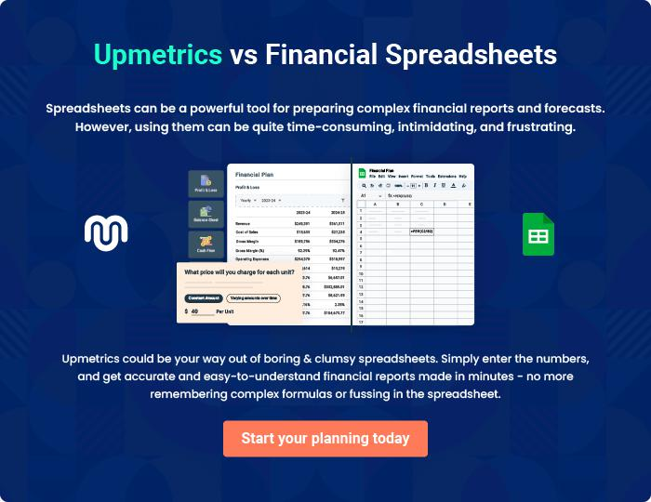

Biztalk Call Center | Business Plan [YEAR] 34/35


Create a winning business plan that gets you funded

Creating a stunning and investment-ready plan requires no writing, graphic designing, or financial planning expertise.

Upmetrics has all the features required to help you create a comprehensive business plan—from start to finish. Make no mistakes, it’s the modern way of planning to structure ideas, make plans, and create stunning pitch decks to awe investors.

Pitch decks that impress investors

Create pitch decks that provide a visual representation of your business, engage investors, and make them want to invest in your business idea.

Interactive plans in no time

Import business plan sections like—SWOT analysis, comparison tables, and others to create an interactive business plan. No designing skills are required.

Stunning cover page designs

With Upmetrics, you have the liberty to choose from multiple stunning cover page designs. Choose a creative design and make your plan stand out.

Online sharing made simple

Upmetrics makes online sharing quick and easier for users. Easily share your business plans with a link while tracking reader activity.

500+ sample business plans

Simply import a template from our library of sample plans into the editor and start customizing it to make it yours. It takes only a few clicks to get started.

Collaborate with team in real-time

Invite team members, initiate conversations, discuss ideas & strategies, share feedback, and work on a business plan in real-time.

