

[Your Company Name]

[Your Tagline]


Business
Case

[YEAR]

Prepared By

John Doe

10200 Bolsa Ave, Westminster, CA, 92683

info@example.com

(650) 359-3153 http://www.example.com

Table of Contents

Executive Summary | 5
Business Problem
Business Problem | 7
Environmental Analysis (include Business Process as applicable) | 8
Current Business Process | 8
Objectives | 8
Problem Analysis | 8
Business Problem | 9
Business Opportunity | 9
Available Options
Available Options | 10
Option 1 | 11
Description | 11
Benefits, Goals and Measurement Criteria | 11
Costs and Funding Plan | 12
Feasibility | 13
Risks | 14
Issues | 14
Assumptions | 15
Option 2 | 15
Description | 15
Benefits, Goals and Measurement Criteria | 15
Costs and Funding Plan | 16
Feasibility | 16
Risks | 16
Issues | 16
Assumptions | 17
Recommended Option
Recommended Option | 18
Option Rankings | 19
Option Recommended | 20

[Your Company Name] | Business Case [YEAR] 2/26

Implementation Approach | 21
Project Initiation | 22
Project Planning | 22
Project Execution | 22
Project Closure | 23
Project Management | 23

Appendix | 24
Supporting Documentation | 25

[Your Company Name] | Business Case [YEAR] 3/26

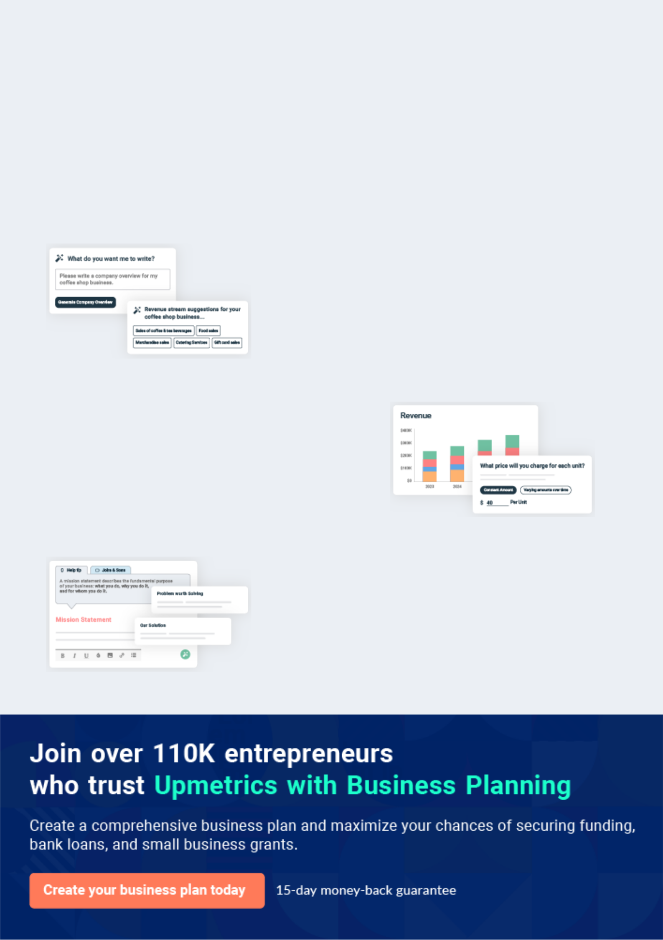
Business planning that’s simpler and faster than you think

Creating a business plan using Upmetrics to start and grow a business is literally the easiest thing in the World. Simply read the instructions and fill in the blanks. It’s as simple as that.

❛ | Upmetrics has everything you need to create a | ❜
❛ | comprehensive business plan. | ❜

AI-powered Upmetrics Assistant

AI-powered insights to streamline your plan

Not sure where to start? Upmetrics’ AI Assistant will automatically generate ideas for each section of your plan and offer improved versions of your writing, adjusting for tone, voice, and grammar or spelling errors.

Financial Forecasting Tool

All the financials are calculated for you

Forget the complex formulas and clumsy spreadsheets — with automatic financials and drag-and-drop forecasting, you can finish your plan faster and be confident that your numbers are accurate.

Business Plan Builder

Guides you like a business mentor

Upmetrics’ step-by-step instructions, prompts, and the library of 400+ sample business plans will guide you through each section of your plan as a business mentor.

1.


Executive Summary

[Your Company Name] | Business Case [YEAR] 5/26


The Executive Summary is the first page of your business plan(for Readers), but it should be the last chapter you write. It acts as both the introduction to, and the summary of, your entire idea. It is a short summary of the entire
To unlock help try Upmetrics! 

Start writing here..

[Your Company Name] | Business Case [YEAR] 6/26

2.

Business Problem

Environmental Analysis (include Business Process as applicable)

Problem Analysis

[Your Company Name] | Business Case [YEAR] 7/26

Environmental Analysis (include Business Process as applicable)

 Help Tip


Outline the core aspects of the business environment which have derived the need for this project to take place. These may include:
To unlock help try Upmetrics! 

Start writing here..

 Help Tip

Describe the current as-is business process. May be combined with the Description of the Problem section.
To unlock help try Upmetrics! 

Current Business Process

Start writing here..

 Help Tip

List and describe the business goals and objectives the project will satisfy.

To unlock help try Upmetrics! 

Objectives

Start writing here..

Problem Analysis

 Help Tip

Outline the fundamental business problem or opportunity which the resulting project will directly address.
To unlock help try Upmetrics! 

Start writing here..

[Your Company Name] | Business Case [YEAR] 8/26

 Help Tip

Provide a summary of the core business problem, including:

• A generic description of the core issue to hand
To unlock help try Upmetrics! 

Business Problem

Start writing here..

 Help Tip

Provide information about the opportunity in terms of the current business process, the market trends, competitive environment, and expected market penetration if a feasibility study is not available to provide this context information. Outline the business opportunity which has been
To unlock help try Upmetrics! 

Business Opportunity

Start writing here..

[Your Company Name] | Business Case [YEAR] 9/26

3.

Available Options

Option 1

Option 2

[Your Company Name] | Business Case [YEAR] 10/26

This section provides a full listing of all solution options, their benefits, costs, feasibility, risks, and issues. Options suggested may include doing nothing, doing something that will achieve a similar result, or doing something that
To unlock help try Upmetrics!
To unlock help try Upmetrics!
To unlock help try Upmetrics! 

Option 1

 Help Tip

Provide a summarized description of the option identified. This will include the general approach to be taken and a summary of the core elements of the solution (e.g. people, process, organization, technology).



Description

Start writing here..

 Help Tip

Describe the tangible and intangible benefits to the company upon the implementation of the solution. One of the obvious benefits described will be that the business problem/opportunity outlined above will be addressed. Complete the following table:



Benefits, Goals and Measurement Criteria

Category | Benefit | Value
 | • New revenue generated | $ x
Financial | • New revenue generated | $ x
 | • Reduction in costs | $ x
 | • Increased profit margin
 | • Improved operational efficiency | x %
 | • Improved operational efficiency | x hrs
Operational | • Reduction in product time to market | x %
 | • Enhanced quality of product/service

[Your Company Name] | Business Case [YEAR] 11/26

Category | Benefit | Value
 | • Increased market awareness | x %
 | • Increased market awareness | x %
 | • Greater market share | x %
Market | • Greater market share | Describe
Market | • Additional competitive advantage | Describe
 | • Improved customer satisfaction | x %
 | • Improved customer satisfaction | x %
Customer | • Increased customer retention | Describe
 | • Greater customer loyalty
 | • Increased staff satisfaction | x %
 | • Increased staff satisfaction | Describe
Staff | • Improved organizational culture | x %
 | • Longer staff retention

 Help Tip

Describe the tangible and intangible costs to the company upon the implementation of the solution. The costs of the actual project should be included (e.g. equipment procured) as well as any negative impact on the business resulting from the delivery of the project (e.g.
To unlock help try Upmetrics! 

Costs and Funding Plan

Category | Cost | Value | Budgeted
 | • Salaries of project staff | $ x
People | • Salaries of project staff | $ x | YES
 | • Contractors / outsourced parties | $ x | NO
 | • Training courses |  | YES
 | • Building premises for the project team | $ x | NO
 | • Building premises for the project team | $ x | NO
Physical | • Equipment and materials | $ x | NO
 | • Tools (computers, phones…)

[Your Company Name] | Business Case [YEAR] 12/26

Category | Cost | Value | Budgeted
 | • Advertising/branding | $ x
 | • Advertising/branding | $ x | YES
Marketing | • Promotional materials | $ x | NO
 | • PR and communications |  | NO
 | • Operational downtime | $ x
 | • Operational downtime | $ x | NO
Organizational | • Short-term loss in productivity | Describe | NO
 | • Cultural change |  | NO
Identify Funding Sources and Amounts:


Funding Source

Amount

Notes

 Help Tip

Describe the feasibility of the solution. To adequately complete this section, a Feasibility Study may need to be initiated to quantify the likelihood of achieving the desired project result. To assess the overall feasibility of this option, break the solution down into components, and rate
To unlock help try Upmetrics! 

Feasibility

Component | Rating | Method Used to Determine Feasibility
Component | (1-10) | Method Used to Determine Feasibility
New Technology | 5 | A technology Prototype was created to assess the solution
New People | 8 | A survey was completed to identify skill-set availability
New Processes | 3 | Processes within similar organizations were reviewed
New Assets | 9 | Physical assets were inspected

[Your Company Name] | Business Case [YEAR] 13/26

 Help Tip
To unlock help try Upmetrics!

Summaries the most apparent risks associated with the adoption of this solution. Risks are defined as “any event which may adversely affect the ability of the solution to produce the required deliverable”. Risks may be Strategic, Environmental, Financial, Operational, Technical,
To unlock help try Upmetrics! 

Risks

Description | Likelihood | Impact | Mitigating Actions
Inability to recruit skilled | Low | Very | Outsource the project to a company
Inability to recruit skilled |  | Very | with proven industry experience and
resource |  | High | with proven industry experience and
resource |  | High | appropriately skilled staff
The technology solution is |  |  | Complete a pilot project to prove the
unable to deliver the required | Medium | High | technology solution will deliver the
results |  |  | required results
Additional capital expenditure |  |  | Maintain strict cost management
may be required in addition to | Medium | Medium | Maintain strict cost management
may be required in addition to | Medium | Medium | processes during the project
that approved |  |  | processes during the project

 Help Tip

Summarize the highest priority issues associated with the adoption of this option. Issues are defined as “any event which currently adversely affects the ability of the solution to produce the required deliverables”. Complete the following table:



Issues

Description | Priority | Resolution Actions
Required capital expenditure | High | Request | funding approval as part of this proposal
funds have not been budgeted | High | Request | funding approval as part of this proposal
Required computer software is |  | Design | solution based on the current software
only at the ‘beta’ phase and has not | Medium | version and adopt changes to solution once the
yet been released live |  | final version of the software has been released

[Your Company Name] | Business Case [YEAR] 14/26

Description | Priority | Resolution Actions
Regulatory approval must be |  | Initiate the Regulatory approval process early so
sought to implement the final | Low | Initiate the Regulatory approval process early so
sought to implement the final | Low | that it does not delay the final roll-out process.
solution |  | that it does not delay the final roll-out process.

 Help Tip

List the major assumptions associated with the adoption of this option. Examples include:

• There will be no legislative, business strategy, or policy changes during this project
To unlock help try Upmetrics! 

Assumptions

Start writing here..

Option 2

 Help Tip

As defined above in description section of Option 1

To unlock help try Upmetrics! 

Description

Start writing here..

 Help Tip

As defined above in Benefits, Goals and Measurement Criteria section of Option 1

To unlock help try Upmetrics! 

Benefits, Goals and Measurement Criteria

Start writing here..

[Your Company Name] | Business Case [YEAR] 15/26

 Help Tip

As defined above in Costs and Funding Plan section of Option 1

To unlock help try Upmetrics! 

Costs and Funding Plan

Start writing here..

 Help Tip

As defined above in Feasibility section of Option 1

To unlock help try Upmetrics! 

Feasibility

Start writing here..

 Help Tip

As defined above in Risks section of Option 1

To unlock help try Upmetrics! 

Risks

Start writing here..

 Help Tip

As defined above in Issues section of Option 1

To unlock help try Upmetrics! 

Issues

Start writing here..

[Your Company Name] | Business Case [YEAR] 16/26

 Help Tip

As defined above in Assumptions section of Option 1

To unlock help try Upmetrics! 

Assumptions

Start writing here..
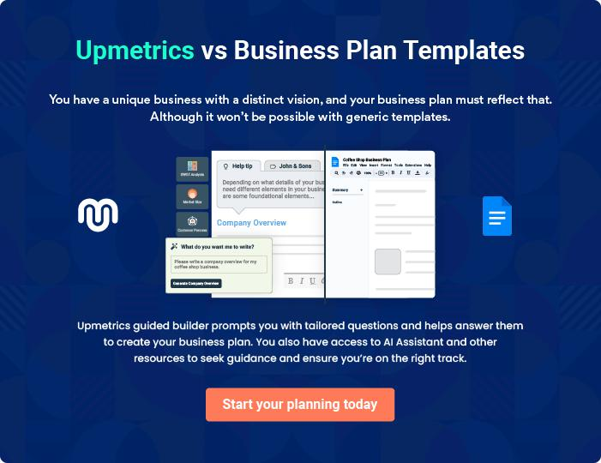

[Your Company Name] | Business Case [YEAR] 17/26

4.

Recommended Option

Option Rankings

Option Recommended

[Your Company Name] | Business Case [YEAR] 18/26

This section compares the key characteristics of each solution option and recommends a preferred solution option for implementation.
To unlock help try Upmetrics! 

Option Rankings

 Help Tip

Identify the criteria by which each of the solution options will be assessed. Then agree on a rating mechanism for each criterion so that ratings can be added to determine a total score for each option. NB Ratings may be weighted to stress the importance of the criteria being
To unlock help try Upmetrics! 


Criteria | Option 1 | Option 2 | Option 3
Benefits
• Increased revenue
• Reduced expenditure
• Improved efficiency | [1-10 Rating] | [1-10 Rating] | [1-10 Rating]
• Enhanced quality | [1-10 Rating] | [1-10 Rating] | [1-10 Rating]
• Other

Costs

- People

- Physical

- Marketing

- Organizational

- Other

Feasibility

- Technology components

- People components

- Process components

- Asset components

- Other

[Your Company Name] | Business Case [YEAR] 19/26

To unlock help try Upmetrics!
Criteria | Option 1 | Option 2 | Option 3

Risks

- Resourcing

- Technology

- Organizational

- Other

Total Score

Option Recommended

 Help Tip

Based primarily on the highest Total Score achieved above, list here the ‘Recommended Option’ for Business Case approval. Summarize the primary reasons why this option was chosen over the other options previously identified.



Start writing here..

[Your Company Name] | Business Case [YEAR] 20/26

5.

Implementation Approach

Project Initiation

Project Planning

Project Execution

Project Closure

Project Management

[Your Company Name] | Business Case [YEAR] 21/26

This section provides an overview of the general approach undertaken to deliver the preferred solution option and derive the resultant business benefits.
To unlock help try Upmetrics!



Project Initiation

 Help Tip

Outline the method by which the project will be defined, the project team formulated and the project office established.
To unlock help try Upmetrics! 

Start writing here..

Project Planning

 Help Tip

Define the overall planning process to ensure that the project phases, activities, and tasks are undertaken in a co-coordinated fashion.
To unlock help try Upmetrics! 

Start writing here..

Project Execution

 Help Tip

Identify the generic phases and activities required to complete the ‘build’ phase of the project.

To unlock help try Upmetrics! 

Start writing here..

[Your Company Name] | Business Case [YEAR] 22/26

Project Closure
To unlock help try Upmetrics!

 Help Tip

List the generic steps necessary to release the deliverables to the business (once complete), close the project office, reallocate staff, and perform a Post Implementation Review of the project.



Start writing here..

Project Management

 Help Tip

Describe in brief how the following aspects of the project will be managed:

• Time Management
To unlock help try Upmetrics! 

Start writing here..

[Your Company Name] | Business Case [YEAR] 23/26

6.

Appendix

Supporting Documentation

[Your Company Name] | Business Case [YEAR] 24/26

Supporting Documentation

 Help Tip

Attach any documentation you believe is relevant to the Business Case. For example:

• Problem / Opportunity research materials
To unlock help try Upmetrics! 

Start writing here..

[Your Company Name] | Business Case [YEAR] 25/26

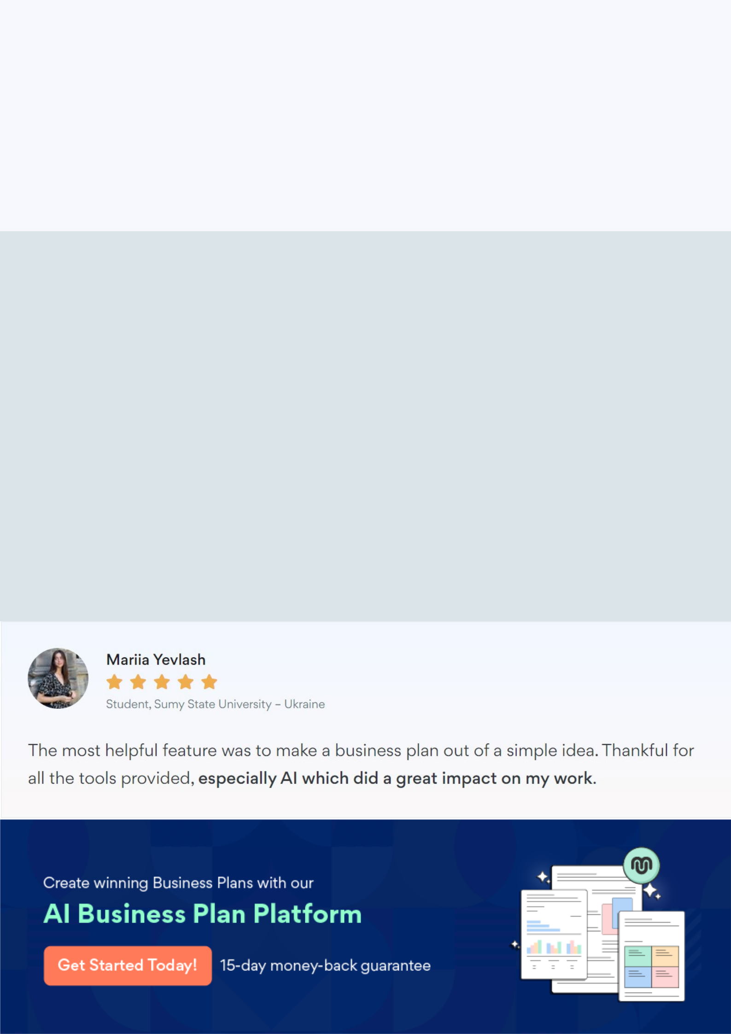
Create a winning business plan that gets you funded

Creating a stunning and investment-ready plan requires no writing, graphic designing, or financial planning expertise.

Upmetrics has all the features required to help you create a comprehensive business plan—from start to finish. Make no mistakes, it’s the modern way of planning to structure ideas, make plans, and create stunning pitch decks to awe investors.

Pitch decks that impress investors

Create pitch decks that provide a visual representation of your business, engage investors, and make them want to invest in your business idea.

Interactive plans in no time

Import business plan sections like—SWOT analysis, comparison tables, and others to create an interactive business plan. No designing skills are required.

Stunning cover page designs

With Upmetrics, you have the liberty to choose from multiple stunning cover page designs. Choose a creative design and make your plan stand out.

Online sharing made simple

Upmetrics makes online sharing quick and easier for users. Easily share your business plans with a link while tracking reader activity.

500+ sample business plans

Simply import a template from our library of sample plans into the editor and start customizing it to make it yours. It takes only a few clicks to get started.

Collaborate with team in real-time

Invite team members, initiate conversations, discuss ideas & strategies, share feedback, and work on a business plan in real-time.

