
BUSINESS PLAN

[YEAR]

Box Truck

A truck fills your house and office.

John Doe

10200 Bolsa Ave, Westminster, CA, 92683

- 359-3153 info@example.com http://www.example.com

Information provided in this business plan is unique to this business and confidential; therefore, anyone reading this plan agrees not to disclose any of the information in this business plan without prior written permission of the company.
Table of Contents

Executive summary | 5
Problem Definition & Validation | 6
Solution | 6
Objectives | 6
Short Term (1 -3 Years) | 7
Long Term (3-5 years) | 7
Mission statement | 7
Keys to success | 7
Financial highlights | 8
M&P - 5 Year Highlights | 9

Business overview | 10
Company Ownership/Legal Entity | 11
Location | 11
Interior Operating Facilities | 11
Hours of Operation | 12
Startup summary | 12

Products & Services | 13
Service Offerings | 14
Market Analysis
Market Analysis | 16
Market segmentation | 17
Market Trends | 17
Target market | 17
Competitive Advantage | 18
SWOT analysis
SWOT analysis | 19

Box Truck | Business Plan [YEAR] 2/41

Strategy & implementation | 22
Marketing and Promotion Programs | 23
Direct Sales | 23
Trade Publications | 23
Trade shows | 23
Website | 24
Targeted Online Advertising | 24
Positioning Statement | 24
Sales strategy | 24
Online Marketing Channels | 25
Offline Marketing Channels | 25
Pricing strategy | 26

Operational Plan | 27
Organization chart | 28
Management Team | 28
Personnel Plan | 29
Hiring plan | 29
Milestones | 30
Movers & Packers LLC | 30

Financial plan | 31
Important Assumptions | 32
Brake-even Analysis | 32
Projected Profit and Loss | 33
Projected Cash Flow | 35
Projected Balance Sheet | 37
Business Ratios | 38

Box Truck | Business Plan [YEAR] 3/41

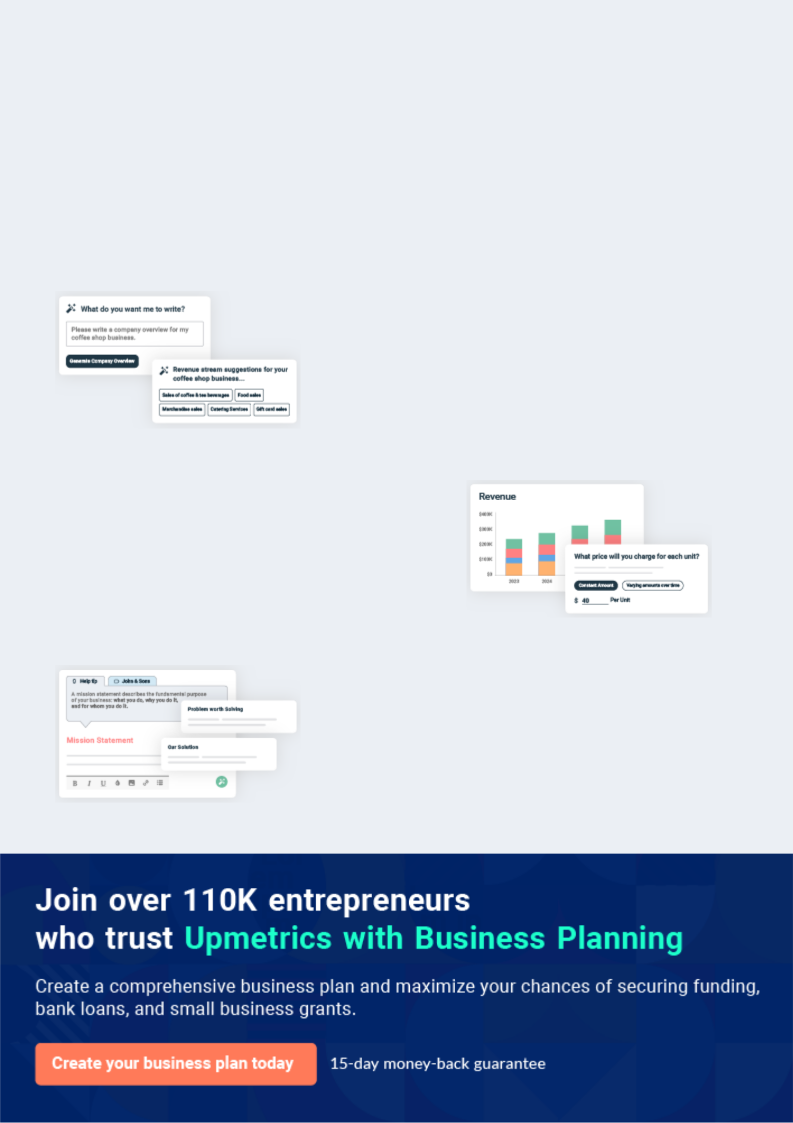
Business planning that’s simpler and faster than you think

Creating a business plan using Upmetrics to start and grow a business is literally the easiest thing in the World. Simply read the instructions and fill in the blanks. It’s as simple as that.

❛ | Upmetrics has everything you need to create a | ❜
❛ | comprehensive business plan. | ❜

AI-powered Upmetrics Assistant

AI-powered insights to streamline your plan

Not sure where to start? Upmetrics’ AI Assistant will automatically generate ideas for each section of your plan and offer improved versions of your writing, adjusting for tone, voice, and grammar or spelling errors.

Financial Forecasting Tool

All the financials are calculated for you

Forget the complex formulas and clumsy spreadsheets — with automatic financials and drag-and-drop forecasting, you can finish your plan faster and be confident that your numbers are accurate.

Business Plan Builder

Guides you like a business mentor

Upmetrics’ step-by-step instructions, prompts, and the library of 400+ sample business plans will guide you through each section of your plan as a business mentor.

1.


Executive summary

Problem Definition & Validation

Solution

Objectives

Mission statement

Keys to success

Financial highlights

Box Truck | Business Plan [YEAR] 5/41

 M&P


Movers and Packers LLC (here on out also referred to as "M&P") is a box truck company based in Brooklyn Park, Minnesota, providing long and short-distance transportation of domestic and commercials goods. The company's services will encompass warehousing and storage,
To unlock help try Upmetrics! 

Start writing here..

Problem Definition & Validation

 M&P

According to the American Moving and Storage Association (AMSA), America's moving and storage industry features some of the country's most complex and diverse businesses. It consists of large corporations as well as family-owned concerns. Despite the robust nature of
To unlock help try Upmetrics! 

Start writing here..

Solution

 M&P

M&P proposes a unique model where it uses operator-owned box trucks to meet moving contracts. Any individual who owns a box truck can register with the company to monetize their vehicle. Once registered, the company will put the owner-operator on the roster schedule which
To unlock help try Upmetrics! 

Start writing here..

Objectives

 M&P

- To begin commercial operations in Minnesota by Q1 2022

- To build a fleet of five operator-owned vehicles within the first year of commercial
operations. | To unlock help try Upmetrics! 

Box Truck | Business Plan [YEAR] 6/41

Short Term (1 -3 Years)

Start writing here..

 M&P

• To gain a competitive edge within the country’s moving and storage industry by establishing a presence in the world’s leading manufacturing sector.
• To build a market reputation for superior networks, efficient services, and reliable delivery
To unlock help try Upmetrics! 

Long Term (3-5 years)

Start writing here..

Mission statement

 M&P

Our mission is to build a successful box truck business that operates not just in Minnesota but all of the United States. We wish to achieve this by becoming the preferred choice of moving partner for light-duty furniture/appliances through a reliable network of material handlers and
To unlock help try Upmetrics! 

Start writing here..

Keys to success



Access To Established Network

M&P boasts access to a robust network of transport agents. This established network will allow the company to meet any shipping requirements of prospective clients with confidence and efficiency.

Owner-Operator

The company will facilitate its operations through owner operated box trucks which will significantly reduce the company's initial capital outlay while making its services flexible.

Box Truck | Business Plan [YEAR] 7/41

Effective Marketing


The company will employ direct sales and marketing strategies to personally approach prospective clients so that they may provide a more efficient and highly personalised service.


Access to Skilled Carriers

M&P will ensure on-boarding only experienced and skilled carriers. Highly experienced personnel will enhance its service offerings in the US
Location


Minnesota benefits from low operating costs, competitive tax rates and streamlined regulatory processes. This will reduce the company's overheads which can then be translated into competitive pricing.

Superior Customer Support


Maintaining a laser-like focus on customer satisfaction will be of utmost priority to the company being vital for brand building and to establishing M&P as the go-to provider of all moving and storage solutions.

Financial highlights

 M&P

The company envisions raising an equity investment of $50,000 through long-term borrowings, which will be used to set up and launch the business in the US. The company expects to break even in Year 2 and steadily grow its revenues through active efforts in marketing, networking,
To unlock help try Upmetrics! 

Start writing here..

Box Truck | Business Plan [YEAR] 8/41

M&P - 5 Year Highlights
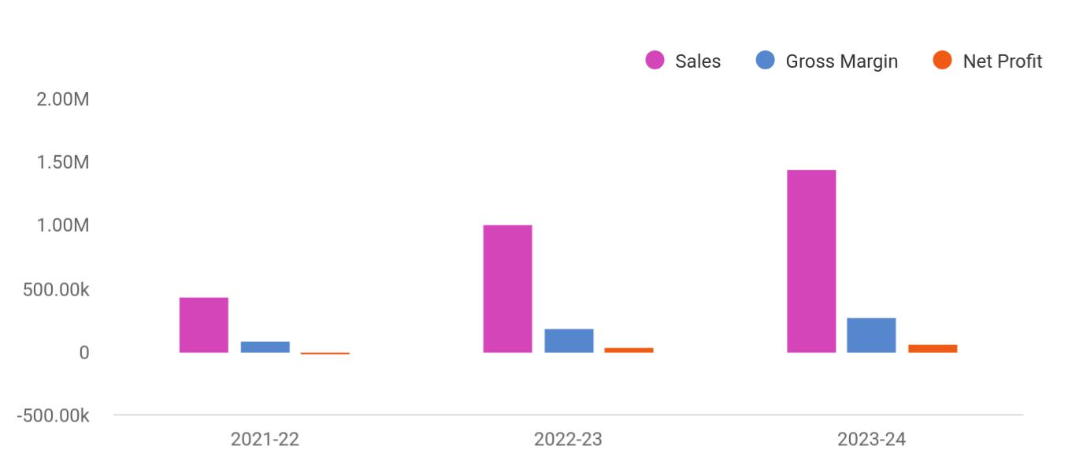

Financial Year | Sales | Gross Margin | Net Profit
2021-22 | 438,937 | 83,512 | -20,568
2022-23 | 1,005,905 | 189,844 | 40,379
2023-24 | 1,437,224 | 271,136 | 65,234

Box Truck | Business Plan [YEAR] 9/41

2.

Business overview

Company Ownership/Legal Entity

Location

Interior Operating Facilities

Hours of Operation

Startup summary

Box Truck | Business Plan [YEAR] 10/41

 M&P

Movers and Packers LLC will be established as a limited liability entity. The company will be the primary provider of packing, moving, and storing light-duty furniture and appliances for owners of residential and commercial properties. The company's services will also extend to
To unlock help try Upmetrics! 

Start writing here..

Company Ownership/Legal Entity

 M&P

The company will be registered as a limited liability entity with the Department of State. Further, since the company envisions setting up operationsMinnesota, it will also register with the local county. The business will be wholly owned and Managed by Founder Mr. Atkins, who will also
To unlock help try Upmetrics! 

Start writing here..

Location

 M&P

M&P will begin operations from an office space in Brooklyn Park, Minnesota. Known as the “North Start State,” Minnesota has an outstanding business climate with a history of leading the nation for new business 5-year survival rate and Main Street Entrepreneurship. Minnesota
To unlock help try Upmetrics! 

Start writing here..

Interior Operating Facilities

 M&P

The company will begin operations from a rented office space in a commercial area in Minnesota. Initial investments will be made to set up an office, website, and management
software to schedule, manage and facilitate moving contracts. Additions to space will be made
To unlock help try Upmetrics! 

Box Truck | Business Plan [YEAR] 11/41

Start writing here..

Hours of Operation

 M&P

M&P will operate an 8-hour workday from 9 am to 5 pm. All moving contracts will be facilitated during the 8-hour workday. Any contracts received after the workday shift will be moved to the next working shift. This ensures contract transporters of the company have a healthy work-life
To unlock help try Upmetrics! 

Start writing here..

Startup summary

 M&P

The Founder will infuse a capital sum of £50,000 into the company. Approximately £10,200 will be spent on a range of start-up expenses such as marketing, advertising, and professional fees. At the same time, another £7,100 will be earmarked for sales tax payment and the acquisition
To unlock help try Upmetrics! 

Start writing here..

Box Truck | Business Plan [YEAR] 12/41

3.

Products & Services

Service Offerings

Box Truck | Business Plan [YEAR] 13/41

 M&P

M&P is established to increase revenues by increasing the number of contracts for the moving and storage industry. Competing favorably with leading operators within the industry, the company creates a niche by deploying owner-operated box trucks to facilitate moving
To unlock help try Upmetrics! 

Start writing here..

Service Offerings


Transport

Local and long-distance transportation of household and office goods


Storage


Warehousing and storage services for individuals who wish to keep their appliances or furniture for long term storage


Packing Logistics

Safe and scratch-proof packing of Process, distribution, and logistics

furniture and appliance for the consulting and advisory Services

purpose of moving

Start writing here..

Box Truck | Business Plan [YEAR] 14/41

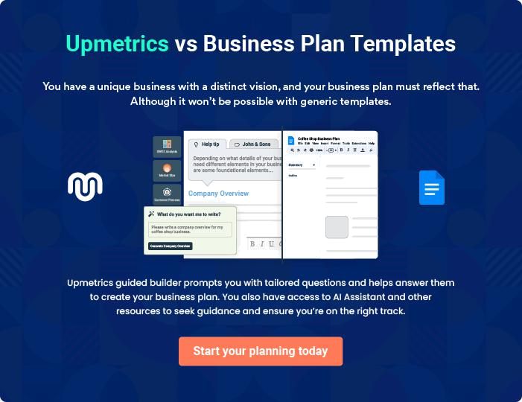

Box Truck | Business Plan [YEAR] | 15/41

4.

Market Analysis

Market segmentation

Market Trends

Target market

Box Truck | Business Plan [YEAR] 16/41

 M&P

M&P will provide moving, packing, and storage services for light-duty furniture and other appliances. As such, the company's services are classified under the United States Moving and Storage industry. The moving services market in the US is expected to grow by USD 1.95 billion,
To unlock help try Upmetrics! 

Start writing here..

Market segmentation

 M&P

The moving industry is segmented into residential commercial sectors. The residential segment had the largest market share in the moving services market in 2019, and the segment will offer several growth opportunities to market vendors during the forecast period. The rise in
To unlock help try Upmetrics! 

Start writing here..

Market Trends

 M&P

According to AMSA’s study on interstate moves, approximately 21.7% of people moving will hire a mover for long hauls across the country. This is based on a study of 3 million interstate moves, where 650,000 people hired a mover, 1 million rented a truck and 1.35 million moved
To unlock help try Upmetrics! 

Start writing here..

Target market

 M&P

M&P's target market comprises any individual who has cause to move light goods and materials from one location to another.
To unlock help try Upmetrics! 

Box Truck | Business Plan [YEAR] 17/41

Start writing here..

Competitive Advantage


Access to a Network of Drivers

The company will

operate a

comprehensive network

of drivers who will be

able to meet deliveries

in a timely manner

Experience

The management of the company has been in the logistics industry for over a decade allowing it to bring enhanced experience to the business

Flexible

M&P will not deploy a one-size-fits-all solution. It will take into consideration the clients needs and provide a range of services from packing to moving and storage based on their requirement

Price

Operating operator owned trucks will reduce the company's initial capital outlay which can be transferred onto the customer through competitive pricing

Box Truck | Business Plan [YEAR] 18/41

5.

SWOT analysis

Box Truck | Business Plan [YEAR] 19/41

 M&P

A SWOT (Strength, Weakness, Opportunity, and Threat) analysis is a useful tool for businesses to evaluate their position in the market against the potential internal and external factors that could assist or jeopardize their operations and existence. A SWOT has been conducted for PYT
To unlock help try Upmetrics! 

Start writing here..

Box Truck | Business Plan [YEAR] 20/41


Strength

- The company benefits from extensive insight and market expertise.

- The flexible and robust range of services ensures the company's capabilities to cater to a more significant market share.

- The company is based in Minnesota, which contains the right talent, infrastructure, support services, and capital availability.

- The Founder’s success portfolio and global clientele provide credibility and increase trust among its potential clients.

- Strategic collaborations enrich the services of the company with leading industry experts and global logistic providers.

Weakness


- An increasing number of competitors within the industry leads to market share erosion.

- The company is relatively new to the US market, in which seasoned players dominate.

- The high rate of competition within the industry and the fragmented nature of the market makes the sector price sensitive.


Opportunity

- Partnering with leading logistic providers to extend their market offering

- Mr. Atkins’s skill in tactfully combining customer relationship management and supply networks to achieve an organizational goal opens up opportunities within challenging and risk intensive markets

- The company possess the capabilities to extend its offerings globally

Threat

- Competitors eroding the market

- Low barriers to entry

- Competitors poaching B2B clients

- Any change in the trading regulations of the country will impact the operations of the company

Box Truck | Business Plan [YEAR] 21/41

6.

Strategy & implementation

Marketing and Promotion Programs

Positioning Statement

Sales strategy

Pricing strategy

Box Truck | Business Plan [YEAR] 22/41

 M&P
To unlock help try Upmetrics!

The company will predominantly rely on online advertising and lead generation strategies as many seeking logistic services first search online for information. As such, a full-fledged online marketing campaign will be launched inclusive of paid, social media, and website campaigns.
To unlock help try Upmetrics! 

Start writing here..

Marketing and Promotion Programs

 M&P

M&P will approach potential commercial clients directly, either through cold-calling or e-mail to arrange pitch meetings. The company’s sales representatives will use these opportunities to display the product catalog directly.



Direct Sales

Start writing here..

 M&P

The Company will advertise in specific trade publications that are targeted towards the appropriate target markets such as the Boston Magazine.
To unlock help try Upmetrics! 

Trade Publications

Start writing here..

 M&P

Euro Trucks will establish a presence at various trade shows that are relevant to the target market. For example, the Multimodal event (www.multimodal.org) is an annual exhibition that is considered the US’s premier freight transport, logistics, and supply chain management event.
To unlock help try Upmetrics! 

Trade shows

Start writing here..

Box Truck | Business Plan [YEAR] 23/41

 M&P

The Company will operate a professional and compelling website dedicated to specific industries and specialized cargos
To unlock help try Upmetrics! 

Website

Start writing here..

 M&P

The focus will be on Google Ads, which are more likely to drive commercial leads than other online advertising platforms (such as Facebook). The advertising will target specific keywords relevant to M&P’s offering (e.g. “moving services”, “temporary storage solutions” etc.).
To unlock help try Upmetrics! 

Targeted Online Advertising

Start writing here..

Positioning Statement

 M&P

The company seeks to carve a niche for its services in the US market by capitalizing on its position between the country's thriving moving industry and its ability to formulate the most competitive business development strategies through a diversified operation facilitated by a
To unlock help try Upmetrics! 

Start writing here..

Sales strategy

 M&P

Americans shifting houses and offices form the company's primary target market. While push marketing efforts will be deployed to reach these companies and make them aware of the range of services provided, pull marketing efforts will drive engagement for the company's
To unlock help try Upmetrics! 

Box Truck | Business Plan [YEAR] 24/41

Start writing here..

Online Marketing Channels


Direct Mail Marketing | Social Media | Google Ad Campaigns
Individuals shifting houses or | Millennials and consumers in | The advertising will target
offices will stand out | general spend a considerable | specific keywords relevant to
prominently as viable | time browsing social media | M&P's offering (e.g. “moving
marketing targets for this | platforms. Reaching to them | services”, “temporary storage
channel. M&P will mail | through this channel will be | solutions” etc.).
professionally designed | and effective way to capture
materials with its value | attention and position its
proposition to individuals who | services.
may have just registered a
property permit or bought a
house

Offline Marketing Channels


Networking | Referral | Conferences
Being a part of trade | The company will offer referral | The company will participate in
association such as | discounts and packaged | leading conferences and make
International Association of | services to valued, regular | their presence known through
Movers. | clients | marketing materials and
 |  | presentations

Box Truck | Business Plan [YEAR] 25/41

Pricing strategy

 M&P

Moving contract income depends upon several factors including the size of the shipment, destination, and transportation method. The average shipment income is estimated at $22,802 based on the parent company's historical sales data. The direct cost is primarily associated
To unlock help try Upmetrics! 

Start writing here..

Box Truck | Business Plan [YEAR] 26/41

7.

Operational Plan

Management Team

Personnel Plan

Milestones

Box Truck | Business Plan [YEAR] 27/41

 M&P

The team will be headed by Managing Director Mr. Atkins who will also oversee the company's operations. Joining Mr. Atkins in the Management Team, the company will onboard a Transport and Logistics manager and a sales and marketing executive to support the company's
To unlock help try Upmetrics! 

Start writing here..

Organization chart


Mr Atkins

Managing Director


Jane Doe


Transport and logistics manager John Doe

Sales Representatives

Management Team

 M&P

Mr. Atkins counts over 13 years of administrative and management experience, taking on various business development activities during the period. His ability to attract key players and build strong and lasting business relationships enabled her to grow in capacity and
To unlock help try Upmetrics! 

Start writing here..

Box Truck | Business Plan [YEAR] 28/41

Personnel Plan

 M&P

The company plans to create two full-time equivalent jobs within the first five years of operations.
To unlock help try Upmetrics! 

Start writing here..

Hiring plan

2 |  |  |  | 0 |  |  |  | 2
Filled |  |  |  | Hired |  |  |  | Open
Group By |  | FY2021 |  |  | FY2022 |  |  | FY2023 |  | FY2024
Department |  |  |  |  |  |  |  |  |  | FY2024
Transport &
Logistics | 0 |  |  |  | 1 |  |  | 1 |  | 1
Manager
Sales &
Marketing | 0 |  |  |  | 0 |  |  | 1 |  | 1
Assistantq

Box Truck | Business Plan [YEAR] 29/41

Milestones

Movers & Packers LLC
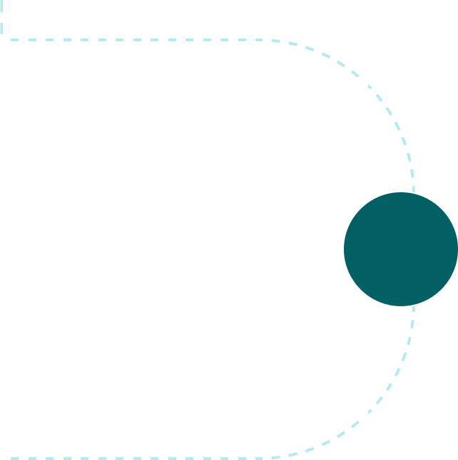

Year 2

>Year3

Establish

M&P will rent an office space at the heart of

Miinesota's commercial hub alongside

developing a fully optimized and
informative website. During this period, the _{YEAR 1} company will also acquire operator

licenses for trucks. Marketing activities will

also begin during this stage to build

awareness and launch the brand into the

market.



Gain Market Traction

The company will begin expanding its

services beyond Minnesota to cover other

regions around the US.


Diversify
Having externally established the business, | Year 3
the company will begin internally expanding | Year 3
its service capabilities


Grow

- Begin expanding across the US

- Consider market expansion beyond US


Box Truck | Business Plan [YEAR] 30/41

8.

Financial plan

Important Assumptions

Brake-even Analysis

Projected Profit and Loss

Projected Cash Flow

Projected Balance Sheet

Business Ratios

Box Truck | Business Plan [YEAR] 31/41


If you are going to start your own Box Truck business, then make sure you will pay special attention to your financial plan. Your financial plan should
include the details about how well you manage your incomes and expenses,
To unlock help try Upmetrics! 

Important Assumptions

The company’s financial projections are forecasted on the basis of the following assumptions. These assumptions are quite conservative and are also expected to show deviation but to a limited level such that the company’s major financial strategy will not be affected.

 | Year 1 | Year 2 | Year 3
Plan Month | 1 | 2 | 3
Current Interest Rate | 10,00% | 11,00% | 12,00%
Long-term Interest Rate | 10,00% | 10,00% | 10,00%
Tax Rate | 26,42% | 27,76% | 28,12%
Other | 0 | 0 | 0

Brake-even Analysis

Monthly Units Break-even | 5530
Monthly Revenue Break-even | $159 740
Assumptions:
Average Per-Unit Revenue | $260,87
Average Per-Unit Variable Cost | $0,89
Estimated Monthly Fixed Cost | $196 410

Box Truck | Business Plan [YEAR] 32/41

Projected Profit and Loss

 | 2024 | 2025 | 2026
Revenue | $1,009,573.43 | $1,742,288.91 | $3,039,171.32
Moving Services | $477,524 | $857,568 | $1,540,088
Unit Sales | 2,388 | 4,288 | 7,700
Unit Price | $200 | $200 | $200
Packing Services | $397,928.50 | $714,623 | $1,283,358
Unit Sales | 7,959 | 14,292 | 25,667
Unit Price | $50 | $50 | $50
Storage Rentals | $134,120.93 | $170,097.91 | $215,725.32

Cost Of Sales | $171,891.48 | $214,058.71 | $305,630.27
General Costs | $171,891.48 | $214,058.71 | $305,630.27
Vehicle-Related Costs | $44,191.48 | $59,582.83 | $88,524.69
Fuel Costs | $24,000 | $24,737.05 | $27,741.25
Maintenance and Repairs | $20,191.48 | $34,845.78 | $60,783.44
Personnel-Related Costs | $127,700 | $154,475.88 | $217,105.58
Driver Salaries | $120,000 | $123,229.91 | $144,737.04
Loading/Unloading Labor | $7,700 | $31,245.97 | $72,368.54
Revenue Specific Costs | $0 | $0 | $0
Personnel Costs (Direct | $0 | $0 | $0
Labor) | $0 | $0 | $0

Gross Margin | $837,681.95 | $1,528,230.20 | $2,733,541.05
Gross Margin (%) | 82.97% | 87.71% | 89.94%

Box Truck | Business Plan [YEAR] 33/41

Operating Expense

Payroll Expense (Indirect Labor)

Driving Staff

Drivers

Packing and Loading Staff

Packers

Loaders

Administrative Staff

Office Manager

Administrative Assistants

General Expense

Vehicle Operating Expenses

Insurance

Vehicle Lease

Office and Administrative Expenses

Office Rent

Utilities

Marketing and Sales

Expenses

Advertising

Sales Commissions

Bad Debt

Amortization of Current Assets

2024 | 2025 | 2026
$810,950.74 | $900,299.42 | $1,041,851.36
$684,180 | $702,012.60 | $720,326.40
$262,500 | $270,375 | $278,486.40
$262,500 | $270,375 | $278,486.40
$269,280 | $274,665.60 | $280,158.72
$161,280 | $164,505.60 | $167,795.52
$108,000 | $110,160 | $112,363.20
$152,400 | $156,972 | $161,681.28
$62,400 | $64,272 | $66,200.16
$90,000 | $92,700 | $95,481.12
$126,770.74 | $198,286.82 | $321,524.96
$36,807.77 | $60,064.81 | $100,496.36
$6,520.58 | $7,796.13 | $9,321.21
$30,287.19 | $52,268.68 | $91,175.15
$29,388.56 | $33,684.67 | $38,678.29
$25,364.99 | $28,581.81 | $32,206.53
$4,023.57 | $5,102.86 | $6,471.76
$60,574.41 | $104,537.34 | $182,350.31
$40,382.93 | $69,691.56 | $121,566.87
$20,191.48 | $34,845.78 | $60,783.44
$0 | $0 | $0
$0 | $0 | $0

Box Truck | Business Plan [YEAR] 34/41

EBITDA

Additional Expense

Long Term Depreciation

Gain or loss from Sale of Assets

EBIT

Interest Expense

EBT

Income Tax Expense / Benefit

2024 | 2025 | 2026
$26,731.21 | $627,930.78 | $1,691,689.69

$26,240.44 | $24,619.41 | $22,915.41
$21,960 | $21,960 | $21,960
$0 | $0 | $0
$4,771.21 | $605,970.78 | $1,669,729.69
$4,280.43 | $2,659.39 | $955.41
$490.77 | $603,311.37 | $1,668,774.28
$0 | $0 | $0

Total Expense | $1,009,082.66 | $1,138,977.54 | $1,370,397.04
Net Income | $490.77 | $603,311.37 | $1,668,774.28
Net Income (%) | 0.05% | 34.63% | 54.91%
Retained Earning Opening | $0 | ($17,509.23) | $567,802.14
Owner's Distribution | $18,000 | $18,000 | $18,000
Retained Earning Closing | ($17,509.23) | $567,802.14 | $2,218,576.42
Projected Cash Flow
 | 2024 | 2025 | 2026
Cash Received | $1,009,573.43 | $1,742,288.91 | $3,039,171.32
Cash Paid | $987,122.66 | $1,117,017.54 | $1,348,437.04
COS & General Expenses | $298,662.22 | $412,345.53 | $627,155.23

Box Truck | Business Plan [YEAR] 35/41

2024 2025 2026

Salary & Wages

Interest

Sales Tax

Income Tax

Net Cash From

Operations

Assets Sell

Assets Purchase

Net Cash From

Investments

Amount Received

Loan Received

Common Stock

Preferred Stock

Owner's Contribution

Amount Paid

Loan Capital

Dividends & Distributions

Net Cash From

Financing

Summary

$684,180 | $702,012.60 | $720,326.40
$4,280.43 | $2,659.39 | $955.41
$0 | $0 | $0
$0 | $0 | $0
$22,450.77 | $625,271.37 | $1,690,734.28

$0 | $0 | $0
$120,000 | $0 | $0
($120,000) | $0 | $0

$150,000 | $0 | $0
$100,000 | $0 | $0
$0 | $0 | $0
$0 | $0 | $0
$50,000 | $0 | $0
$49,684.64 | $51,305.67 | $53,009.66
$31,684.65 | $33,305.69 | $35,009.66
$18,000 | $18,000 | $18,000
$100,315.36 | ($51,305.67) | ($53,009.66)

Starting Cash | $0 | $2,766.13 | $576,731.83
Cash In | $1,159,573.43 | $1,742,288.91 | $3,039,171.32
Cash Out | $1,156,807.30 | $1,168,323.21 | $1,401,446.70

Box Truck | Business Plan [YEAR] 36/41

 | 2024 | 2025 | 2026
Change in Cash | $2,766.13 | $573,965.70 | $1,637,724.62
Ending Cash | $2,766.13 | $576,731.83 | $2,214,456.45

Projected Balance Sheet

 | 2024 | 2025 | 2026
Assets | $100,806.13 | $652,811.83 | $2,268,576.45
Current Assets | $2,766.13 | $576,731.83 | $2,214,456.45
Cash | $2,766.13 | $576,731.83 | $2,214,456.45
Accounts Receivable | $0 | $0 | $0
Inventory | $0 | $0 | $0
Other Current Assets | $0 | $0 | $0
Long Term Assets | $98,040 | $76,080 | $54,120
Gross Long Term Assets | $120,000 | $120,000 | $120,000
Accumulated Depreciation | ($21,960) | ($43,920) | ($65,880)
Liabilities & Equity | $100,806.12 | $652,811.80 | $2,268,576.42
Liabilities | $68,315.35 | $35,009.66 | $0
Current Liabilities | $33,305.69 | $35,009.66 | $0
Accounts Payable | $0 | $0 | $0
Income Tax Payable | $0 | $0 | $0
Sales Tax Payable | $0 | $0 | $0
Short Term Debt | $33,305.69 | $35,009.66 | $0
Long Term Liabilities | $35,009.66 | $0 | $0
Long Term Debt | $35,009.66 | $0 | $0
Equity | $32,490.77 | $617,802.14 | $2,268,576.42

Box Truck | Business Plan [YEAR] 37/41

 | 2024 |  |  | 2025 |  | 2026
Paid-in Capital | $0 |  |  | $0 |  | $0
Common Stock | $0 |  |  | $0 |  | $0
Preferred Stock | $0 |  |  | $0 |  | $0
Owner's Contribution | $50,000 |  | $50,000 |  |  | $50,000
Retained Earnings | ($17,509.23) |  | $567,802.14 |  |  | $2,218,576.42
Check | $0 |  |  | $0 |  | $0
Business Ratios
 |  | Year 1 | Year 2 |  | Year 3 | Industry profile
Sales Growth |  | 4,35% | 30,82% |  | 63,29% | 4,00%
Percent of Total Assets
Accounts Receivable |  | 5,61% | 4,71% |  | 3,81% | 9,70%
Inventory |  | 1,85% | 1,82% |  | 1,79% | 9,80%
Other Current Assets |  | 1,75% | 2,02% |  | 2,29% | 27,40%
Total Current Assets |  | 138,53% | 150,99% |  | 163,45% | 54,60%
Long-term Assets |  | -9,47% | -21,01% |  | -32,55% | 58,40%
TOTAL ASSETS |  | 100,00% | 100,00% |  | 100,00% | 100,00%
Current Liabilities |  | 4,68% | 3,04% |  | 2,76% | 27,30%
Long-term Liabilities |  | 0,00% | 0,00% |  | 0,00% | 25,80%
Total Liabilities |  | 4,68% | 3,04% |  | 2,76% | 54,10%
NET WORTH |  | 99,32% | 101,04% |  | 102,76% | 44,90%
Percent of Sales
Sales |  | 100,00% | 100,00% |  | 100,00% | 100,00%
Gross Margin |  | 94,18% | 93,85% |  | 93,52% | 0,00%
Selling, General & Administrative Expenses |  | 74,29% | 71,83% |  | 69,37% | 65,20%

Box Truck | Business Plan [YEAR] 38/41

 | Year 1 | Year 2 | Year 3 | Industry profile
Advertising Expenses | 2,06% | 1,11% | 0,28% | 1,40%
Profit Before Interest and Taxes | 26,47% | 29,30% | 32,13% | 2,86%
Main Ratios
Current | 25,86 | 29,39 | 32,92 | 1,63
Quick | 25,4 | 28,88 | 32,36 | 0,84
Total Debt to Total Assets | 2,68% | 1,04% | 0,76% | 67,10%
Pre-tax Return on Net Worth | 66,83% | 71,26% | 75,69% | 4,40%
Pre-tax Return on Assets | 64,88% | 69,75% | 74,62% | 9,00%
Additional Ratios
Net Profit Margin | 19,20% | 21,16% | 23,12% | N.A.
Return on Equity | 47,79% | 50,53% | 53,27% | N.A.
Activity Ratios
Accounts Receivable Turnover | 4,56 | 4,56 | 4,56 | N.A.
Collection Days | 92 | 99 | 106 | N.A.
Inventory Turnover | 19,7 | 22,55 | 25,4 | N.A.
Accounts Payable Turnover | 14,17 | 14,67 | 15,17 | N.A.
Payment Days | 27 | 27 | 27 | N.A.
Total Asset Turnover | 1,84 | 1,55 | 1,26 | N.A.
Debt Ratios
Debt to Net Worth | 0 | -0,02 | -0,04 | N.A.
Current Liab. to Liab. | 1 | 1 | 1 | N.A.
Liquidity Ratios
Net Working Capital | $120 943 | $140 664 | $160 385 | N.A.
Interest Coverage | 0 | 0 | 0 | N.A.
Additional Ratios
Assets to Sales | 0,45 | 0,48 | 0,51 | N.A.
Current Debt/Total Assets | 4% | 3% | 2% | N.A.
Acid Test | 23,66 | 27,01 | 30,36 | N.A.

Box Truck | Business Plan [YEAR] 39/41

 | Year 1 | Year 2 | Year 3 | Industry profile
Sales/Net Worth | 1,68 | 1,29 | 0,9 | N.A.
Dividend Payout | 0 | 0 | 0 | N.A.
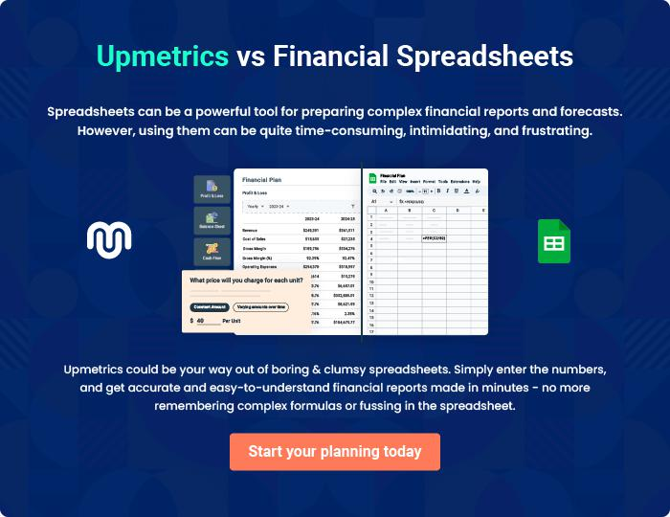

Box Truck | Business Plan [YEAR] 40/41


Create a winning business plan that gets you funded

Creating a stunning and investment-ready plan requires no writing, graphic designing, or financial planning expertise.

Upmetrics has all the features required to help you create a comprehensive business plan—from start to finish. Make no mistakes, it’s the modern way of planning to structure ideas, make plans, and create stunning pitch decks to awe investors.

Pitch decks that impress investors

Create pitch decks that provide a visual representation of your business, engage investors, and make them want to invest in your business idea.

Interactive plans in no time

Import business plan sections like—SWOT analysis, comparison tables, and others to create an interactive business plan. No designing skills are required.

Stunning cover page designs

With Upmetrics, you have the liberty to choose from multiple stunning cover page designs. Choose a creative design and make your plan stand out.

Online sharing made simple

Upmetrics makes online sharing quick and easier for users. Easily share your business plans with a link while tracking reader activity.

500+ sample business plans

Simply import a template from our library of sample plans into the editor and start customizing it to make it yours. It takes only a few clicks to get started.

Collaborate with team in real-time

Invite team members, initiate conversations, discuss ideas & strategies, share feedback, and work on a business plan in real-time.

